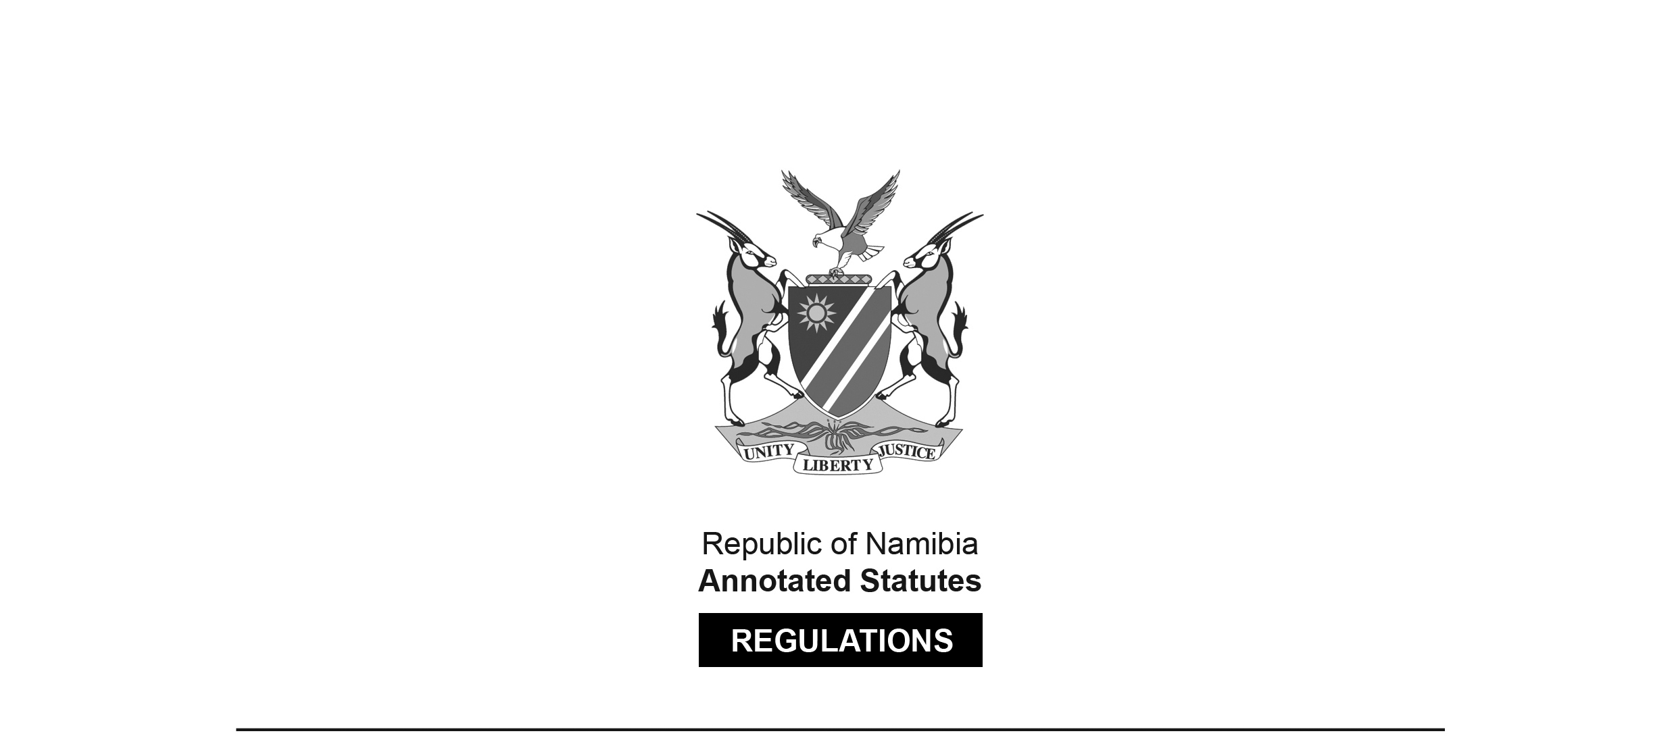

REGULATIONS SURVIVING IN TERMS OF

Health Professions Act 16 of 2024

section 95(10)

Regulations relating to Scope of Practice of Physiotherapist

Government Notice 122 of 2010

([GG 4502](http://www.lac.org.na/laws/2010/4502.pdf))

came into force on date of publication: 16 June 2010

These regulations were made in terms of section 55 of the Allied Health Professions Act 7 of 2004, which was repealed by the Health Professions Act 16 of 2024. Pursuant to section 95(10) of the Health Professions Act 16 of 2024, they are deemed to have been made under that Act.

The Government Notice which publishes these regulations notes that they were made   
on the recommendation of the Allied Health Professions Council of Namibia.

ARRANGEMENT OF REGULATIONS

1. Definitions

2. Scope of practice of physiotherapists

**Definitions**

**1.** In these regulations, unless the context otherwise indicates, a word or expression defined in the Act has that meaning, and -

“dentist” means a person registered as such under the Medical and Dental Act, 2004 (Act No. 10 of 2004);

“medical practitioner” means a person registered as such under the Medical and Dental Act, 2004 (Act No. 10 of 2004);

“medicine” means the practising of medicine by a medical practitioner or a dentist; and “the Act” means the Allied Health Professions Act, 2004 (Act No. 7 of 2004).

**[****The Allied Health Professions Act 7 of 2004 and the Medical and Dental Act 10 of 2004   
have both been replaced by the Health Professions Act 16 of 2024.]**

**Scope of practice of physiotherapists**

**2.** (1) The acts especially pertaining to physiotherapists are the acts performed, at the request of a medical practitioner, as supplementary treatment, procedures, therapy, care, rehabilitation and services in the fields of -

(a) orthopaedics, including the treatment of fractures, dislocations, ligamentous and soft tissue lesions, joint deformities and diseases, infections of bones (including those of the spine), amputations and complications relating thereto;

(b) neurology and neurosurgery, including participation in intensive care and rehabilitation;

(c) respiratory diseases and thoracic surgery, including inhalation therapy and participation in the intensive care of the patient;

(d) cardio-vascular diseases and surgery;

(e) obstetrics and gynaecology, including pre-operative and post-operative surgical, and antenatal and post-natal, conditions, pelvic infections and other gynaecological conditions;

(f) intensive care, including coronary care, organ transplants, dialysis, respiratory failure, tetanus, extensive paralysis, unconsciousness, accident services (multiple injuries) and burns;

(g) rehabilitation, including the restoring of a patient to his or her maximum potential both in work and sport, and the adaptation to permanent disabilities;

(h) sports medicine, including prophylaxis and the treatment of all injuries and disabilities directly pertaining to sport;

(i) paediatrics, including all related fields of medicine and surgery, consisting of cerebral palsy, care of children with minimal brain dysfunction, developmental abnormalities, and the prevention of orthopaedic and postural deformities;

(j) geriatrics, including the care of the aged in all related fields of medicine and surgery, prophylaxis, rehabilitation and recreational activities;

(k) treatment of physical ailments of psychiatric patients, relaxation therapy, maintaining or restoring of physical fitness, organising of medical games, sports and recreational activities;

(l) other surgical fields, including general, plastic, urological, maxillo-facial, opthalmological, ear, nose and throat, and other surgical fields that may require physiotherapy treatment and services;

(m) other medical fields, including rheumatology, dermatology, ear, nose and throat, constitutional fields, Hansen’s fields, cancer and any other medical fields that may require physiotherapy services; and

(n) community care, including prophylactic physiotherapy services, district and domiciliary services, day hospital organisations, rehabilitation centres, schools and industries.

(2) When performing any of the acts in the fields prescribed by subregulation (1), a physiotherapist may -

(a) apply the scientific use of movement techniques based upon physiological principles, supplemented when necessary by massage, manipulation, electrotherapy and other physical and supportive measures, including advice to, and the education of, the patient for the prevention and treatment of injury, disease and disorders, and the facilitation of normal physiological processes and functional activities, used to assist the rehabilitation and restoration of functions, including the achievement of personal independence;

(b) apply procedures in the fields covered by physiotherapy as a supplementary service to medicine, including -

(i) the physiotherapeutic examination of a patient according to his or her condition as diagnosed by a medical practitioner or dentist, including the continuous assessment of the patient’s response to the physiotherapy treatment and his or her progress;

(ii) the assessment of -

(aa) joint range;

(bb) muscle power, strength, tone, endurance and co-ordination;

(cc) righting, balance and equilibrium reactions;

(dd) postural abnormalities and functional ability;

(ee) the need for rehabilitation and the degree of independence attained;

(ff) the level of sensory and motor development;

(gg) the circumference, length, volume, excursion and other relevant measurements of limbs;

(hh) the effect of pain on movement, rest and function; and

(ii) gait and other locomotor abnormalities;

(iii) physical fitness tests, cardiac (exercise) tolerance tests, respiratory excursion and exercise tolerance tests and measurements;

(iv) sensory tests, including stereognosis;

(v) perception tests, observation and palpitation; and

(vi) inspection of X-rays and X-ray reports;

(vii) the assessment of -

(aa) skin temperature and conditions;

(bb) the effects of soft tissue scars, adhesions and contractions on movement and functions;

(cc) nerve condition and innervative tests; and

(dd) reflex heating tests requirements for the use of artificial limbs, prostheses, aids, appliances, callipers, splints, supports, corsets and collars, and the need for the use of a wheelchair;

(viii) any other special tests or methods of assessment by means of physiotherapy that may be required for the management of patients and for the submission of reports to the referring medical practitioner or dentist;

(c) select treatment techniques and supportive devices according to the diagnosis of, and in consultation with, the referring medical practitioner or dentists, based on the results of the procedures applied as prescribed by paragraph (b), and in conjunction with other registered allied or complementary health practitioners involved in the treatment, management or rehabilitation of the patient, including -

(i) any of the procedures prescribed by these regulations; and

(ii) advice on the selection of a wheelchair and on the selection or manufacturing of permanent or temporary prosthesis, aids, appliances, splints, callipers, supports, collars, corsets, walking aids or any other physiotherapeutic device or method that may be required;

(d) educate and advise the patient or those responsible for his or her care, according to the condition diagnosed by, and in consultation with, the referring medical practitioner or dentist, or other person involved in the treatment, management or rehabilitation of the patient, including -

(i) prophylactic physiotherapy;

(ii) prevention of joint, muscle and back strain;

(iii) the lifting and handling of patients and heavy objects;

(iv) prevention of the recurrence of mechanical disorders;

(v) functional activities, rest positions and working postures;

(vi) recreational and sports activities, and kinetic handling in industry;

(vii) education for childbirth;

(viii) the handling of a disabled person in a hospital, at home, at work, and during transportation, and recreational and sports activities;

(ix) the care and handling of the aged, children and infants;

(x) the use of respirators;

(xi) postural drainage in hospital or at home;

(xii) the use of prescribed aids and appliances; and

(xiii) the physiotherapy field that may be required;

(e) give and apply movement and exercise therapy, and the application of kinesiological and neuro-physiological principles of -

(i) passive movements, including -

(aa) relaxed passive movements;

(bb) mobilisation techniques, including spinal and peripheral;

(cc) manipulation, including spinal and peripheral, without anaesthetic;

(dd) soft tissue stretching; and

(ee) traction, including spinal and peripheral;

(ii) active movements, including -

(aa) the facilitation of -

(ab) muscle contraction by the use of cold and sensory stimulation, both epicritic and pro-prioceptive, followed by activation;

(ac) basic and selective movement patterns and reflex mechanisms, including automatic righting, balance and equilibrium reactions in the development sequence;

(ad) the inhibition of abnormal sensory input, muscle tone, reflex mechanisms or associated reactions;

(bb) assisted exercises by means of manual, mechanical and hydrotherapy techniques;

(cc) free exercises, including exercises and activities, both subjective and objective, to obtain relaxation, increase joint range, re-educate muscle function, increase muscle power and endurance, correct posture and re-educate postural and gait mechanisms;

(dd) resisted exercises, including exercises by -

(ab) manual, mechanical and hydrotherapy techniques; and

(ac) power and endurance programmes;

(ee) the re-education or rehabilitation of functional activities, including -

(ab) basic movement patterns and gait, both assisted and unassisted; and

(ac) transference, wheelchair activities and other motor activities required for daily living and sport;

(ff) the use of gymnasia, gymnastic therapeutic apparatus, specially constructed children’s apparatus, toys and adapted training circuits;

(gg) sporting activities, including swimming, riding and wheelchair sports;

(hh) group activities, including ward classes, out-patient classes, prenatal and post-natal classes, and remedial games;

(ii) breathing exercises, including postural drainage, mobilising exercises for the thorax, inhalation therapy, including the use of intermittent positive pressure, suction and respiratory function tests;

(jj) the use of splints, supports and prostheses, including -

(ab) training in the use of splints, supports and prostheses for motor activities, including isolated contraction for the activation of powered splints; and

(ac) the adaptation of all the prescribed methods for all age groups, including infants, children, adolescents and the aged;

(f) use various massage techniques, including transverse frictions and connective tissue massage;

(g) apply electrotherapy, including -

(i) high frequency currents;

(ii) low frequency currents;

(iii) ultra sound; and

(iv) radiation, excluding X-rays and cosmic rays;

(h) apply heat and cold treatment;

(i) apply hydrotherapy;

(j) apply mechanical aids, including -

(i) splints and supports, including the manufacturing thereof;

(ii) braces, prostheses and other therapeutic and supportive devices; and

(iii) the selection of wheelchairs.