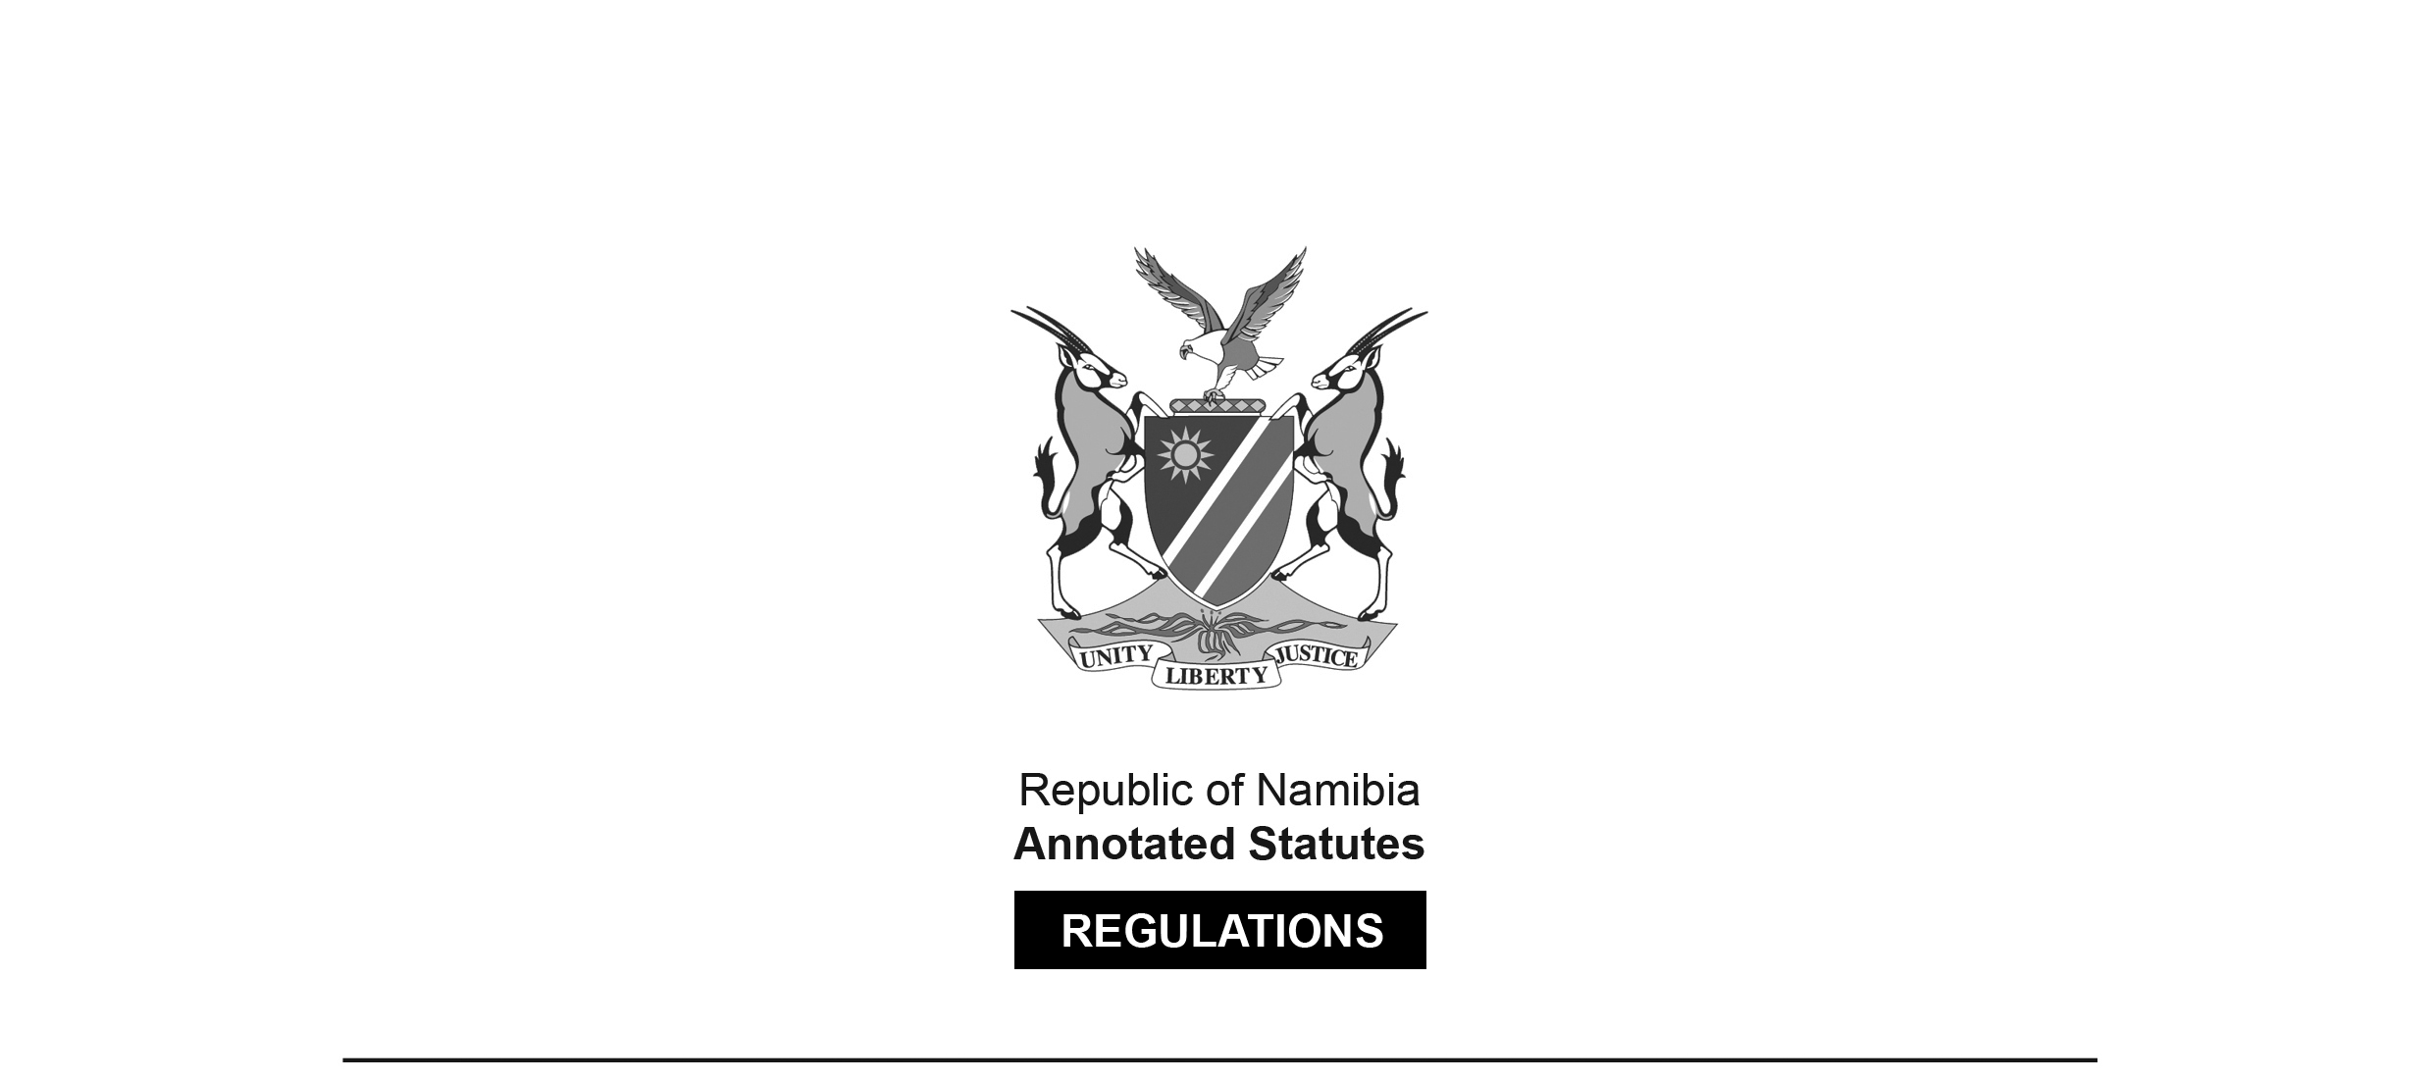

REGULATIONS SURVIVING IN TERMS OF

Health Professions Act 16 of 2024

section 95(10)

Regulations relating to Scope of Practice of Oral Hygiene

Government Notice 197 of 2008

([GG 4103](http://www.lac.org.na/laws/2008/4103.pdf))

came into force on date of publication: 18 August 2008

These regulations were made in terms of section 59 of the Medical and Dental Act 10 of 2004, which was repealed by the Health Professions Act 16 of 2024. Pursuant to section 95(10) of the Health Professions Act 16 of 2024, they are deemed to have been made under that Act.

The Government Notice which publishes these regulations notes that they were   
made on the recommendation of the Medical and Dental Council of Namibia.

as amended by

Government Notice 210 of 2015 **(**[GG 5831](http://www.lac.org.na/laws/2015/5831.pdf)**)**

came into force on date of publication: 16 September 2015

The Government Notice which publishes these amendments notes that they were   
made on the recommendation of the Medical and Dental Council of Namibia.

ARRANGEMENT OF REGULATIONS

1. Definitions

2. Scope of practice of oral hygiene

3. Performing of professional acts by student in oral hygiene

**Definitions**

**1.** In these regulations, unless the context otherwise indicates, a word or expression defined in the Act has that meaning, and -

“the Act” means the Medical and Dental Act, 2004 (Act No. 10 of 2004).

**[The** Medical and Dental Act **10 of 2004   
has been replaced by the Health Professions Act 16 of 2024.]**

**Scope of practice of oral hygiene**

**2.** (1) Subject to subregulation (2), an oral hygienist may perform the following acts -

[The introductory words of regulation 2 are substituted by GN 210/2015. GN 210/2015 states that this “regulation” is being substituted for “regulation 2”, but this is obviously an error.]

(a) the provisional examination and charting of conditions of the mouth, with particulars reference to the face, soft tissues, teeth, occlusion and periodontium;

(b) the scaling, root planning and polishing of teeth, including the trimming and polishing of restorations and the administering of local anaesthetic when required for these procedures;

[paragraph (b) substituted by GN 210/2015]

(c) the performing of dental radiography;

(d) the topical application of agents appropriate to the practice of oral hygiene, including caries preventive agents, tooth-desensitizing agents, surface anaesthetics and plague-controlling agents;

(e) the application and removal of periodontal packs;

(f) the taking of impressions and the casting of study and primary work models:

(g) the placement of temporary fillings as an emergency measure prior to the referral to a dentist or dental therapist;

(h) the temporary cementing of inlays, crowns and bridges;

(i) the placement of glass ionomers cement on sensitive dentine abrasion lesions;

(j) the placement of soft lining in dentures as tissue conditioners;

(k) the taking of cytological smears, including for the purpose of testing for candida infection;

(l) the discussion of treatment options with, and the explaining of treatment procedures to patients;

[There should be a comma after the phrase   
“and the explaining of treatment procedures to”.]

(m) the discussion of treatment fees;

(n) the performing of the following functions in orthodontics -

(i) cephalometric tracing;

(ii) the relief of trauma caused by intra- and extra-oral appliances, including the cutting of the distal arch wires and the removal of the complete arch wire;

(iii) the placement of pre-activated orthodontic appliances and the removal of orthodontic attachments, bands, appliances and arch wires;

(iv) the fitting of orthodontic retainers; and

(o) the administering of applicable local analgesia appropriate to the scope of the profession of oral hygiene.

(2) An oral hygienist referred in subregulation (1) may perform the acts referred to in that subregulation only if he is supervised by a dentist and the dentist is readily available to assist the oral hygienist in the performance of his or her acts.

[Subregulation (2) is inserted by GN 210/2015.   
The reference to “he” should be “he or she”.]

**Performing of professional acts by student in oral hygiene**

**3.** A student in oral hygiene may perform, as part of his or her education, tuition and training, and on the instructions, and under the direct supervision, of a dentist or an oral hygienist, any of the acts prescribed by regulation 2.