REGULATIONS MADE IN TERMS OF

Forest Act 12 of 2001
section 48(1) and (2)

Forest Regulations
Government Notice 170 of 2015
(GG 5801)
came into force on date of publication: 3 August 2015

The Government Notice which publishes these regulations notes that
they were made with the concurrence of the Minister of Finance.

ARRANGEMENT OF REGULATIONS

1. Definitions
2. Certificate of designation as forest officers
3. Certificate of appointment as honorary forest officers
4. Certificate of designation or appointment as licensing officers
5. Documents to be attached to application for licence under sections 22, 23, 27, 28, 29, 30 and 33 of Act
6. Constitution, functions and procedures of management authority and fire management area
7. Requirements for marking of forest produce
8. Measures to be taken for forest protection, prevention of fires and protection of soil and water resources
9. Recording and reporting of information on use of forest and forest produce
10. Access to state forest reserves and activities which may be undertaken in state forest reserves
11. Certification of forest produce and conditions of production and harvesting
12. Harvesting, transportation, processing, sale, importation, transit and exportation of forest produce and issuing of permits, licences and other documents required for those activities
13. Plants or species of any plant declared to be protected plants
14. Identification document and apparel of authorised officers
15. Places where animals can be detained and manner in which animals can be seized and detained
16. Costs payable under section 44(3) for seizing and detaining animals
17. Fees for application made in terms of section 27, 28, 29, 30 or 33 and other fees payable under Act
18. Establishment of State forest reserves, regional forest reserves and forest management areas and protected areas
19. Establishment of community forest
20. Offences and penalties
21. Appeal to Minister

ANNEXURE 1
Forms

1. (A) Certificate of Designation as Forest Officer
(B) Certificate of Appointment as Honorary Forest Officer
2. Certificate of Appointment as Licensing Officer
3. Application for Declaration as State Forest Reserve/Regional Forest Reserve/Forest Management Area/Protected Area
4. Application for Declaration as Community Forest
5. Community Forest Agreement
6. Certificate of Declaration as Community Forest
7. Application for Bush Control Licence
Licence Conditions for Bush Control Licence
Licence Conditions for Charcoal Production Licence
8. Forest Licence for Farming with Honey Producing Organisms
9. Forest Licence for Harvesting and Permit for Transporting Honey and Honey Producing Organisms
Licence Conditions for Keeping Honey Producing Organisms
10. Application for Licence for Forest Produce
11. Forest Resource Inspection Report
12. Forest Licence for Harvesting
13. Forest Permit for Transporting
14. Forest Permit for Exporting
15. Forest Permit for Importing
16. Forest Permit for Transit
17. Forest Permit for Marketing
Licence/Permit Conditions - Harvesting, Transport and Marketing
Permit Conditions - Export
Permit Conditions - Import Permit Conditions - Transit
18. Certificate of Impounded Animals Trespassing in Classified Forest
19. Appeal to Minister
20. Report Back - Summary of Forest Produce Used
21. Report Back - Summary of Activities Executed

ANNEXURE 2
Protected Plant Species

ANNEXURE 3
Fees for Forest Produce

[The word “meters” appears in both the US spelling (“meters”) and
the British spelling (“metres”) in this Government Gazette.]

Definitions

1. In these regulations a word or expression to which a meaning has been assigned in the Act has that meaning, and unless the context otherwise indicates -

“Directorate” means the Directorate that administers forestry;

“fire cutlines” means a strip of width 10 meters or more constructed for the prevention of fire spreading when forests or portions thereof are burnt;

“management plans” means an agreement between the Minister and a management body which contains all operational work and administration of a community forest; and

“rehabilitation agreement” means an agreement contemplated in regulation 8(14).

Certificates of designation as forest officers

2. The Minister must issue to a person designated as forest officer under section 7 of the Act with a certificate of designation in the form of Form 1(A) as set out in Annexure 1 that must be shown to any interested person on demand.

Certificates of appointment as honorary forest officers

3. The Minister must issue to a person appointed as honorary forest officer under section 8 of the Act with a certificate of appointment in the form of Form 1(B) as set out in Annexure 1 that must be shown to any interested person on demand.

Certificates of designation or appointment as licensing officers

4. The Minister must issue to a person designated or appointed as licensing officer under section 9(1) or (2) of the Act with a certificate of designation or appointment in the form of Form 2 as set out in Annexure 1 that must be shown to any interested person on demand.

Documents to be attached to application for licence under sections 22, 23, 27, 28, 29, 30 and 33 of Act

5. (1) Subject to sections 22, 23, 27, 28, 29, 30 and 33 of the Act, applications are made on Forms 7 and 10 set out in Annexure 1 and are submitted with -

(a) written permission from the land owner where forest produce is to be vested by a person other than the owner;

(b) permission letter from the Traditional Authority where forest produce is to be harvested on communal land other than classified forest areas;

(c) written permission from the chairperson of a conservancy where forest produce is to be harvested from the farm that is part of a Conservancy; and

(d) proof of ownership of the farm if the applicant is a farm owner.

(2) All applicants must submit certified copies of any one of the following identification documents such as -

(a) an identity document;

(b) an Electoral Commission of Namibia voter card;

(c) a passport; or

(d) a driving licence.

(3) The forest officer must carry out a forest resource inspection after the application for licence has been received and compile a forest resource inspection report in a form of Form 11 as set out in Annexure 1.

Constitution, functions and procedures of management authority and fire management area

6. (1) The management authority of a community forest consists of not more than 20 members, including -

(a) a chairperson;

(b) a deputy-chairperson;

(c) a treasurer;

(d) a deputy-treasurer;

(e) a secretary;

(f) a deputy-secretary; and

(g) an advisor,

as members of the executive committee.

(2) A person to be elected as a member of the management authority must -

(a) be at least 18 years of age; and

(b) have any customary land rights in respect of such community.

(3) In addition to the general requirements referred to in subregulation (2), candidates for the treasurer, secretary, deputy-treasurer and deputy-secretary must have a minimum qualification of a passed symbol for grade 8 and be able to read and write in English.

(4) A term of office of the elected members of the management authority is three years and a member may be re-elected after the expiry of that term.

(5) A person may not, for purposes of subregulation (1), be appointed to or removed from office unless specifically provided for as set out in the management plans.

(6) The responsibilities and powers of a community forest committee are as provided for in the existing documents of a community forest such as the management plan and other agreements between the Minister and the respective management body.

(7) The functions of management authority of a community forest are -

(a) to manage the community forest according to the management plans;

(b) to develop a constitution of the authority with the consent of the Director which must include -

(i) a preamble;

(ii) the name and address of the community forest or fire management area;

(iii) the structure of fire management committee;

(iv) the goals and objectives;

(v) the operating principles;

(vi) the membership and beneficiaries;

(vii) the rights and obligations of general members;

(viii) holding of meetings of committees, subunits and general meetings;

(ix) financial management;

(x) liability for fire damage;

(xi) property;

(xii) dispute resolution;

(xiii) dissolution of the fire management body;

(xiv) amendment of constitution; and

(xv) adoption of constitution; and

(c) to establish a fire crew team for the fire management area.

Requirements for marking of forest produce

7. (1) Timbers derived from indigenous species, imported or harvested locally, must have a mark affixed to it.

(2) The mark to be affixed on timber derived from indigenous species under subsection (1) is a triangle shaped metal marking hammer with dimensions 25mm x 25mm x 25mm and contains the following information -

(a) top part: office identification number with a letter size of 5mm x 5mm;

(b) middle part: abbreviation of the forestry region, two letters with a letter size of 5mm x 5mm; and

(c) lower part: the abbreviation “NAM” with a letter size of 5mm x 5mm.

Measures to be taken for forest protection, prevention of fires and protection of soil and water resources

8. (1) A person involved in fire cutline construction must take measures for forest protection, prevention of fires and protection of soil and water resources and in so doing, be trained by an authorised forest officer.

(2) During the construction of fire cutlines, no fire is used.

(3) Fire cutlines have a minimum width of 15 meters.

(4) Fire cutlines is constructed within or surrounding a fire hazardous area.

(5) A fire cutline has to be connected to a natural or mandate barrier with minimum width of 15 metres.

(6) Fire cutlines are constructed right after the end of the rainy season.

(7) An area of at least 15 meters around a burning kiln should be cleared of any flammable materials with the exception of trees during the production of charcoal.

(8) A person engaged in the production of charcoal must ensure that -

(a) fire fighting equipment are on site; and

(b) where kilns are lit there is constant supervision by an authorised officer or any other person so delegated.

(9) A person who causes a fire to spread and causes damage to any property or forest resources must pay compensation to a person who suffers damage as a result of that fire.

(10) A member of the committee dealing with fire management or an authorised officer may require any person to assist in controlling or extinguishing of a fire which is likely to cause damage to properties, lives and any natural resource.

(11) A person who applies for the controlled burning for the purpose of bush control or the removal of old overgrown grass must inform all neighbours in writing and obtain written approval from the neighbours 24 days before the burning is done.

(12) A person in charge of a controlled burning as contemplated in subregulation (11) must -

(a) light the fire only after a cutline of at least three metres surrounding the intended area to be burnt is constructed;

(b) the fire is lit from three sides of the area at the same time and is allowed to burn to the centre, while the fourth side serves as an escape route for animals;

(c) make available on site sufficient fire fighting equipment and labour when the area is to be burnt; and

(d) ensure that no burning is done when the day temperature is exceeding 25 degrees Celsius or wind exceeding 20 kilometres per hour or in combination thereof during the months of April to July.

(13) A person may not dispose of flammable material near or within a classified forest, protected area, forest management area or fire hazard area.

(14) A person who through any resources utilisation activities may cause damage to any piece of land or vegetation through resources utilisation or any activities that may cause damage to the environment must enter into a rehabilitation agreement, prior to the execution of such activities, with the forestry authority on rehabilitation measures that may be employed -

(a) during the execution of such activities; or

(b) immediately after the termination of such activities.

(15) A rehabilitation agreement referred to in subregulation (1) must specifying what tree species are to be planted, at what density, the time frame in which the activities must take place, and what mechanisms is to be put in place.

Recording and reporting of information on use of forests and forest produce

9. (1) A holder of a licence for the removal of forest produce must report on the species and actual quantity of the forest produce removed when submitting the next licence application or at the end of the financial year in the form of Form 20 of Annexure 1.

(2) For purposes of clearing by burning, rehabilitating or planting the holder of a licence must report on the area cleared by burning, rehabilitated or planted when submitting the next licence application or at the end of the financial year in the form of Form 21 of Annexure 1.

Access to state forest reserves and activities which may be undertaken in state forest reserves

10. (1) A person with access to state forest reserves may not -

(a) cultivate in the state forest; and

(b) introduce alien plant species or any invasive plant into state forest.

(2) Local communities must obtain authorisation to carry out activities in the state forest such as harvesting of timber, collection of firewood, honey, wild fruits and medical plants as well as any other activities of similar nature within and affecting a state forest in the form of Forms 8 to 16 as set out in Annexure 1.

(3) The number of animals may not exceed the carrying capacity of the piece of land allocated for grazing purposes.

(4) The carrying capacity has to be determined every year as it is currently dependant on the amount of edible grass or shrubs available on a piece of land for a specific year.

(5) The carrying capacity has to be determined every year as it is currently dependant on the amount of rainfall for a specific season.

(6) The formula for carrying capacity for cattle = $\frac{kg/ha*0.35}{10 kg*365}$

(7) Formula explanation kg/ha= dry mass of grass per hectare
0.35 = utilisation factor
10kg = amount of dry grass matter consumed by an adult
cow per day
365 number of days per year.

(8) To determine the carrying capacity for sheep, the stocking rate is multiplied by six.

Certification of forest produce and conditions of production and harvesting

11. (1) A company, accredited by the Forest Stewardship Council (FSC) a council established as a legal entity in February 1994 in Mexico, may certify a forest produce to be traded within or outside Namibia.

(2) A land user who wishes his or her forest produce to be certified for trade within or outside Namibia by a company contemplated in subregulation (1) may do so on voluntary basis on application to such company.

Harvesting, transportation, processing, sale, importation, transit, and exportation of forest produce and issuing of permits, licences and other documents required for those activities

12. (1) A person is not authorised to harvest, transport, sell, market, transit, export or import forest produce without a valid licence for harvesting or permit for transport, marketing, transit, export or import as set out in the form of Forms 12 to 16 as set out in Annexure 1.

(2) A person with a general dealers licence is exempted from having a marketing licence however he or she must be able to prove that such forest produce was obtained legally by producing copies of the third party’s harvesting licence, marketing licence and transport permit issued under the Act.

(3) A person may not export any unprocessed forest produce, including semi-processed planks unless authorised by the Director for special purposes such as research, education, cultural and disease identification for which relevant documents are to be provided as a pre-requisite.

(4) The true copy of a licence issued under this regulation must accompany the forest produce in respect of which it is issued until the forest produce is processed or exported and must be produced on request to any authorised officer.

(5) A person intending to transport imported forest produce must, at the port of entry into Namibia or the nearest forestry office, apply for an import permit and produce the export permit from the country where the forest produce has been exported.

(6) A person may not be issued with a marketing licence, transporting or exporting permit without a harvesting licence, receipt of procurement or any other proof of obtaining forest produce certified by the relevant authorising officers.

(7) A person may not farm or trade with honey producing organisms unless authorised to do so in the form of Forms 8 and 9 as set out in Annexure 1.

(8) Except where honey producing organisms are fed, a person may not harvest during the months of September to December of each year.

Plants or species of any plant declared to be protected plants

13. (1) The conditions under which a protected plant or plant species are conserved, cultivated, used or destroyed by any person are as follows:

(a) Endemism - 100% of individuals belonging to that taxon occur within the borders of Namibia;

(b) Near Endemic - at least 75% of the individuals belonging to that taxon occur within the borders of Namibia;

(c) Restricted range - Records exist in ≤ 32 Quarter Degree Squares (QDSs), which are not necessarily adjacent;

(d) Ecosystem Services (ES) - The species provides important Ecosystem Services such as preventing soil erosion in riverbeds, stabilizing river banks and river beds, or is widely regarded as a keystone species;

(e) Value - economic, scientific or cultural;

(f) Extent of use (EU) - heavily utilized species or subject to unsustainable harvesting;

(g) Regeneration rate - Slow or episodic recruitment, few numbers of individuals germinating naturally or through propagation;

(h) Population size - low number of individual plants in a specific area.

(2) The plant or plant species that are declared as protected species are listed in Annexure 2.

Identification document and apparel of authorised officers

14. (1) The identification document contains -

(a) on the face of the document -

(i) the coat of arms of the Republic of Namibia;

(ii) the name of the Ministry;

(iii) the name and logo of the Directorate;

(iv) the name of the authorized officer;

(v) the post designation of authorized officer;

(vi) the ID number of the authorized officer;

(vii) a passport sized photo of the authorized officer; and

(viii) the duty station or area of jurisdiction; and

(b) on the back side of the document, the disclaimer information.

(2) The apparel is in the form of an approved uniform worn by the authorised officer, and the epaulettes must contain -

(a) the name of the Ministry;

(b) the coat of arms of the Republic of Namibia; and

(c) the name of the Directorate.

Places where animals can be detained and manner in which animals can be seized and detained

15. (1) An animal seized and detained as contemplated in section 44(2) of the Act is detained on the classified forest in a pound that meets the following specifications -

(a) the fence is made of material that does not cause any injury to the animal;

(b) water and food are available in the pound;

(c) the pound is kept clean to prevent the spreading of pests and diseases;

(d) the number of animals to be kept in a pound is determined by the size and type of animal, and the area needed per animal for large stock is between 0.30 and 1.60 square metres and between 0.20 and 0.40 square metres for small stock;

(e) the pound is properly secured to prevent animals from escaping; and

(f) the pound is located at a place of easy access and has a loading bay for loading the animals.

(2) A person claiming the stray animal must produce a receipt, original stock card or national identification document during collection of the strayed animal.

(3) A pound master is first appointed before an animal is seized or detained, and a stray animal -

(a) is reported to the pound master; and

(b) is registered and a certificate in the form of Form18 as set out in Annexure 1 is issued.

(4) The pound master -

(a) is not accountable for any loss or death of an impounded animal unless such circumstances arise as a result of gross negligence of such pound master;

(b) must take proper care of an impounded animal;

(c) must make sure that an impounded animal is not be abused, misused or used whilst impounded; and

(d) must report sick and dead animals to Veterinary Services and the cost incurred are to be recovered from the owner of the animal.

Costs payable under section 44(3) for seizing and detaining animals

16. The fees payable for seized and detained animals are set out in Annexure 3, Schedule 5.

Fees for application made in terms of section 27, 28, 29, 30 or 33 and other fees payable under Act

17. The fees payable as contemplated in section 27, 28, 29, 30 or 33 of the Act are set out in Annexure 3, Schedules 6 and 7.

Establishment of State forest reserves, regional forest reserves and forest management areas and protected areas

18. The form and manner in which an application for establishing a State forest reserve, regional forest reserve and forest management area or protected area is in the form of Form 3 as set out in Annexure 1.

Establishment of community forests

19. An application for establishing a community forest, a community forest agreement and a certificate of declaration as community forest are in the form of Forms 4, 5 and 6 as set out in Annexure 1, respectively.

Offences and penalties

20. A person who contravenes or fails to comply with -

(a) any of these regulations; or

(b) any condition attached to a licence,

commits an offence and is liable to a fine not exceeding N$5 000 or to imprisonment for a period not exceeding two years, or to both such fine and such imprisonment.

Appeal to Minister

21. An appellant may appeal to the Minister against the decision of the Director or licensing officer as described in section 47 (1) of the Act in the form of Form 19 as set out in Annexure 1.

ANNEXURES

To view content without printing, scroll down.

To print at full scale (A4), double-click the icon below.

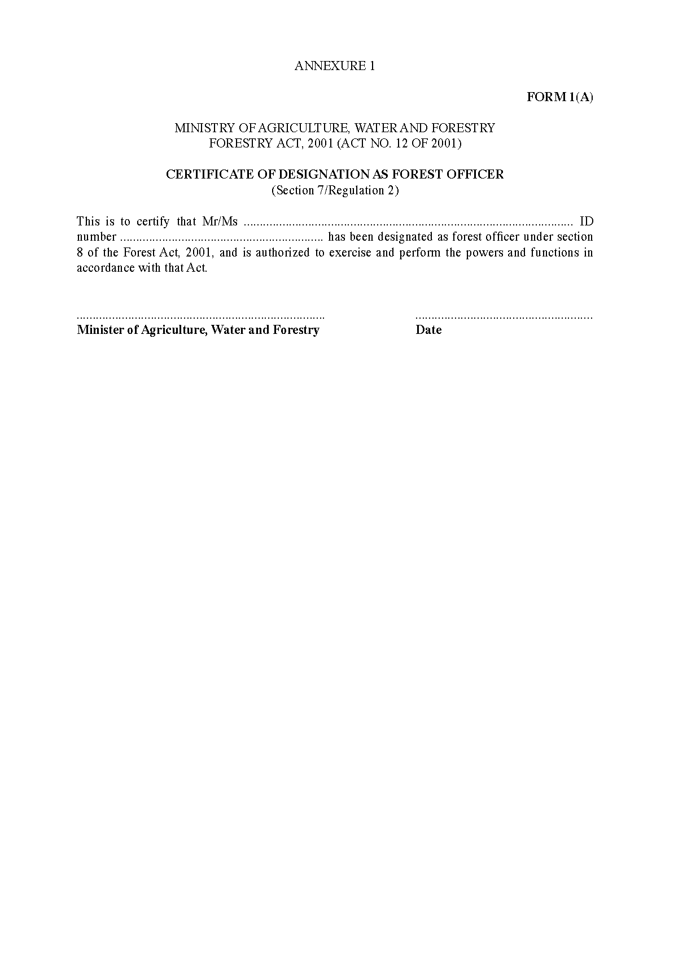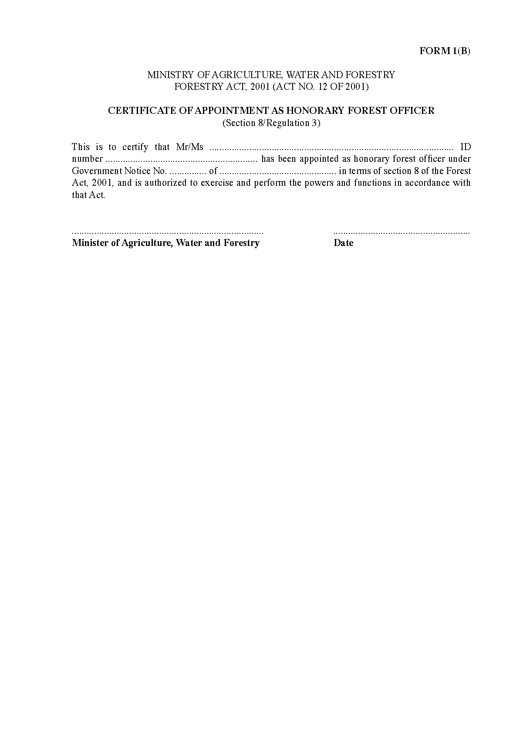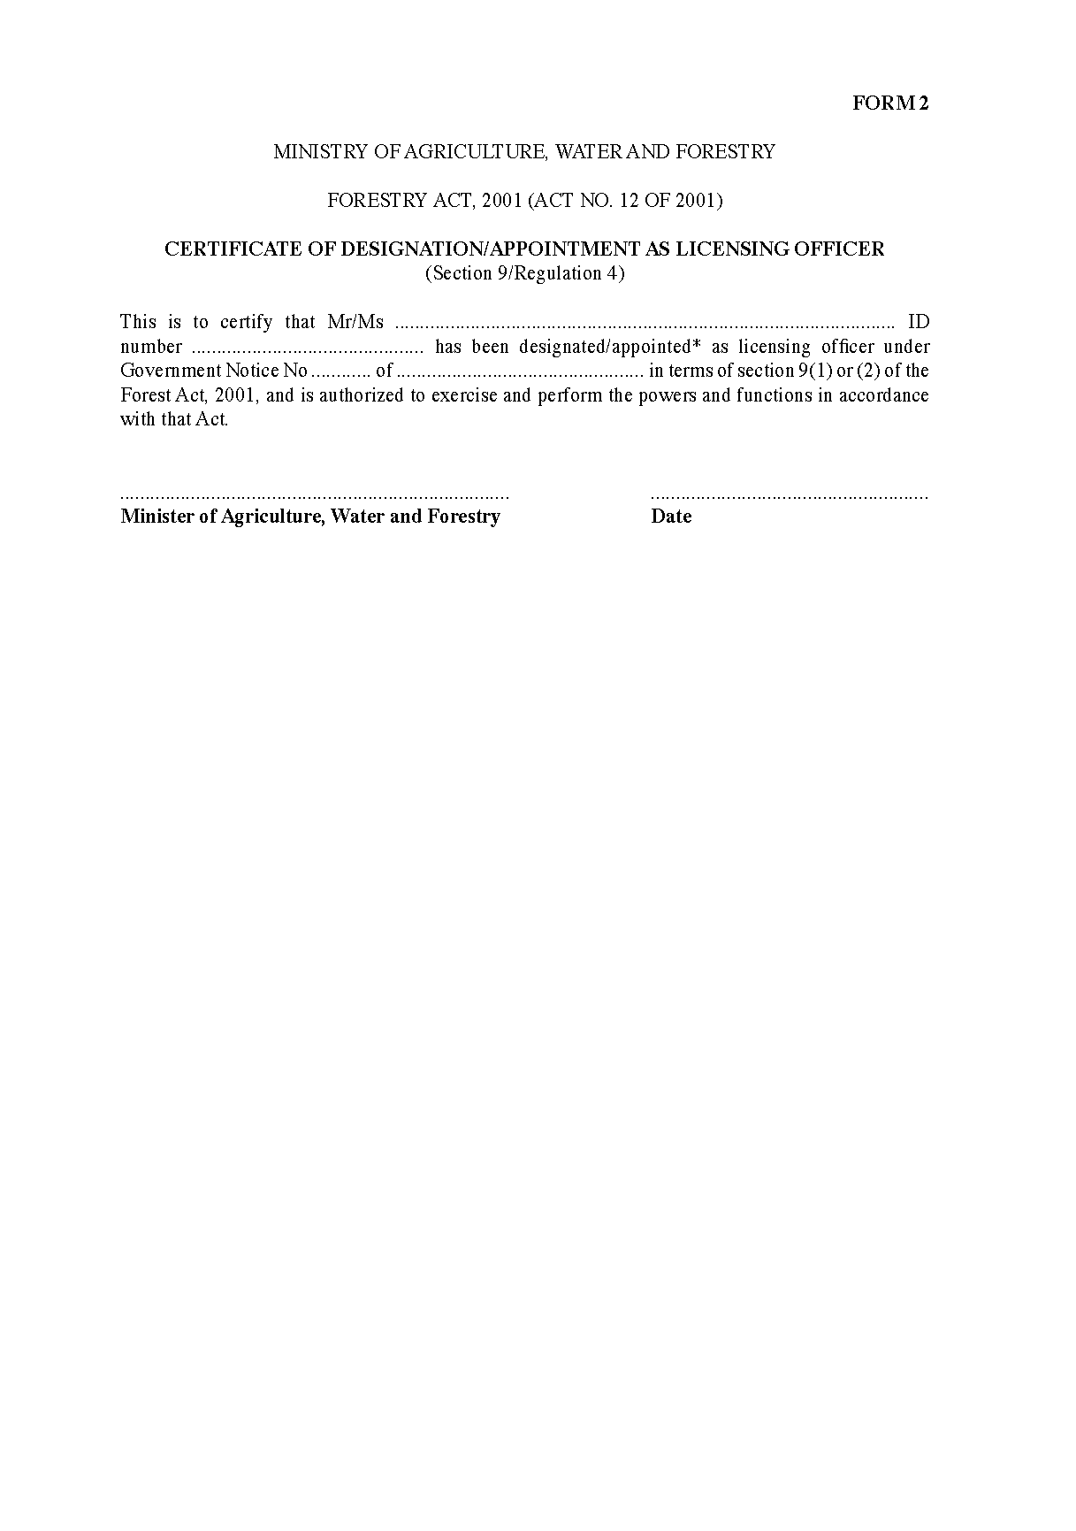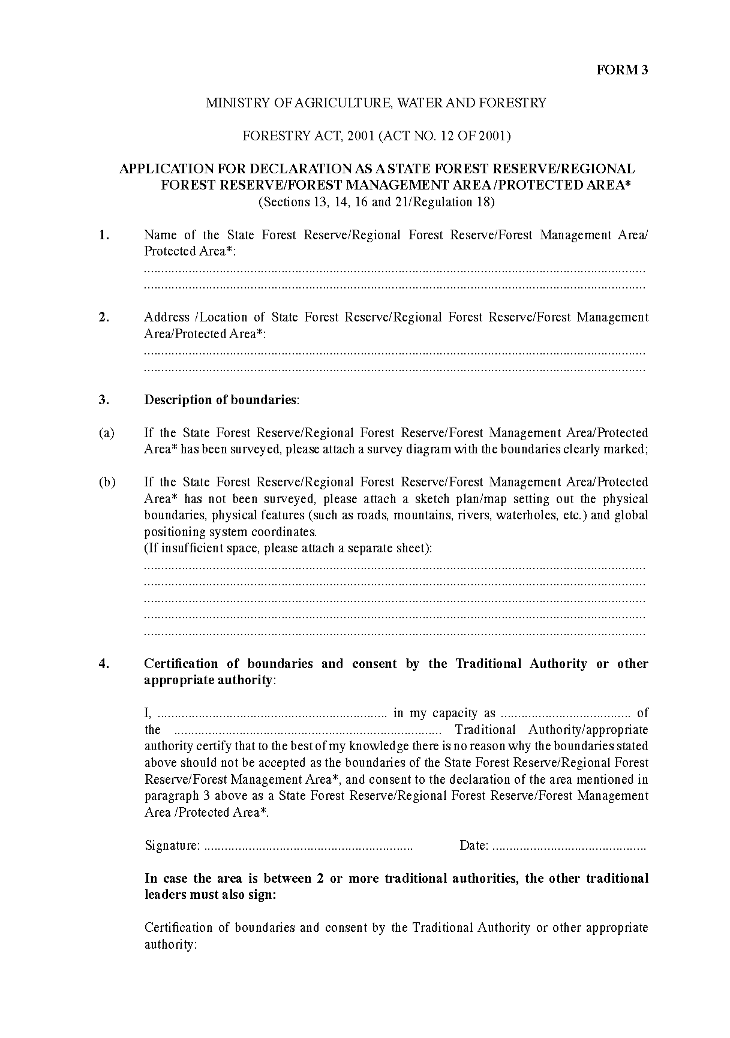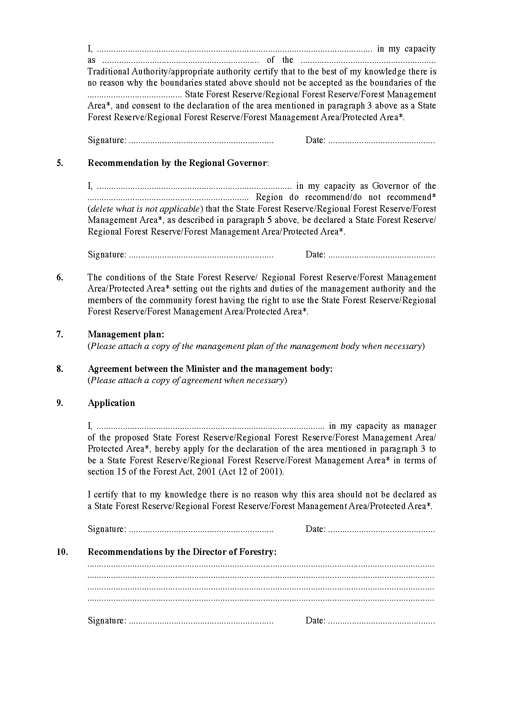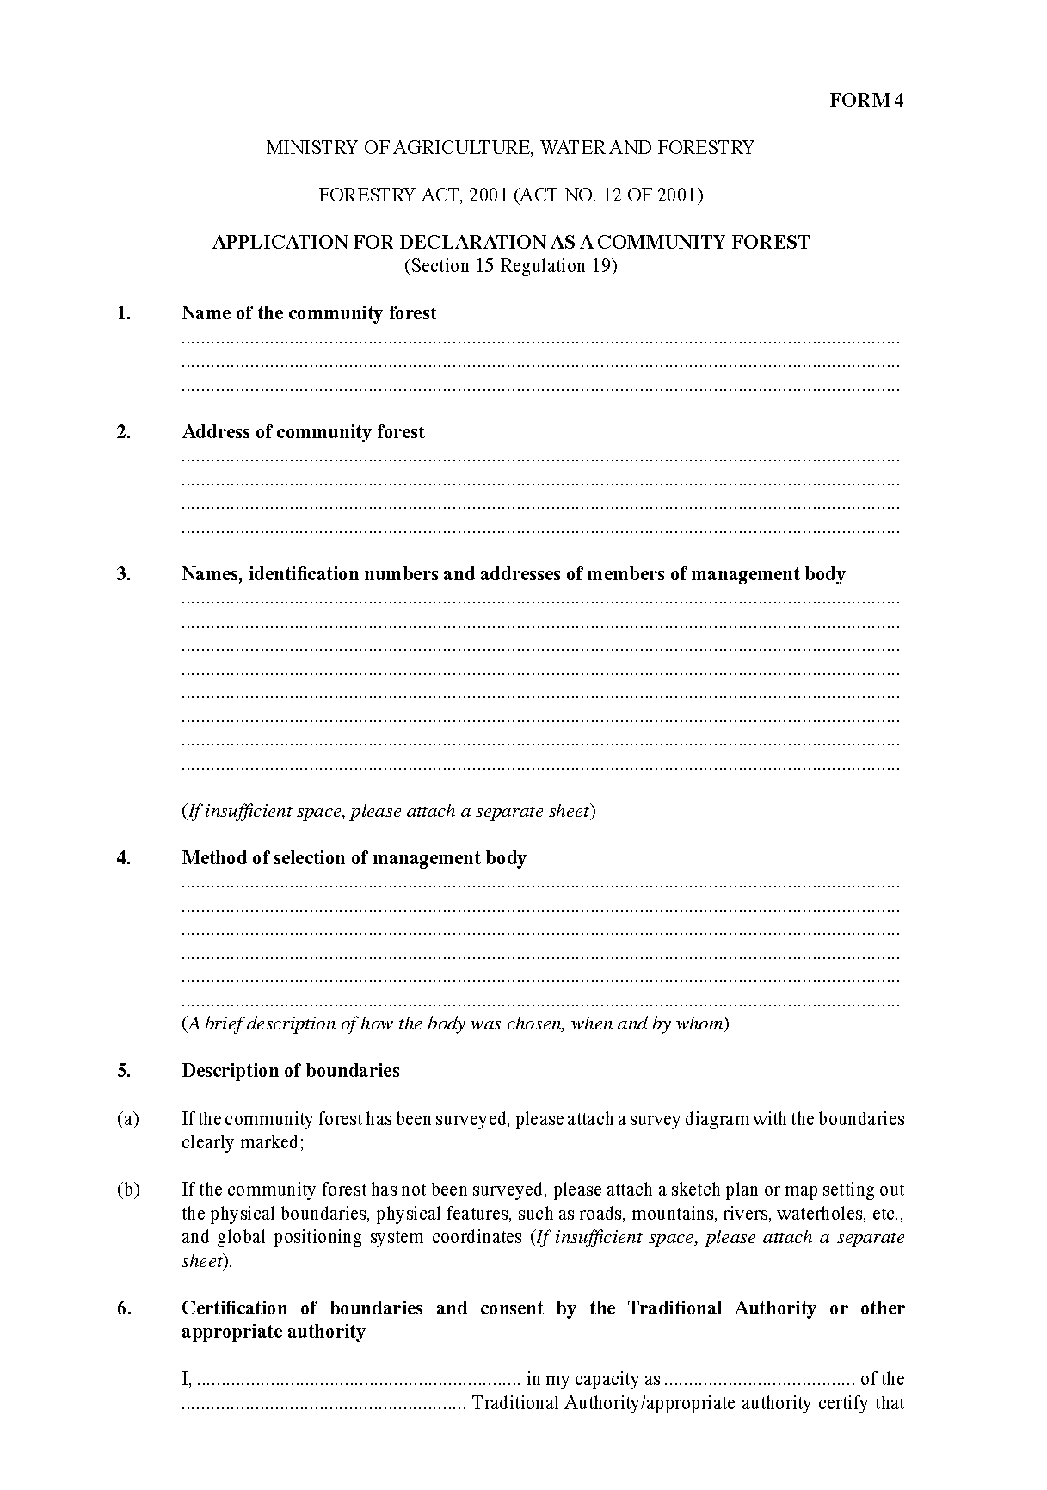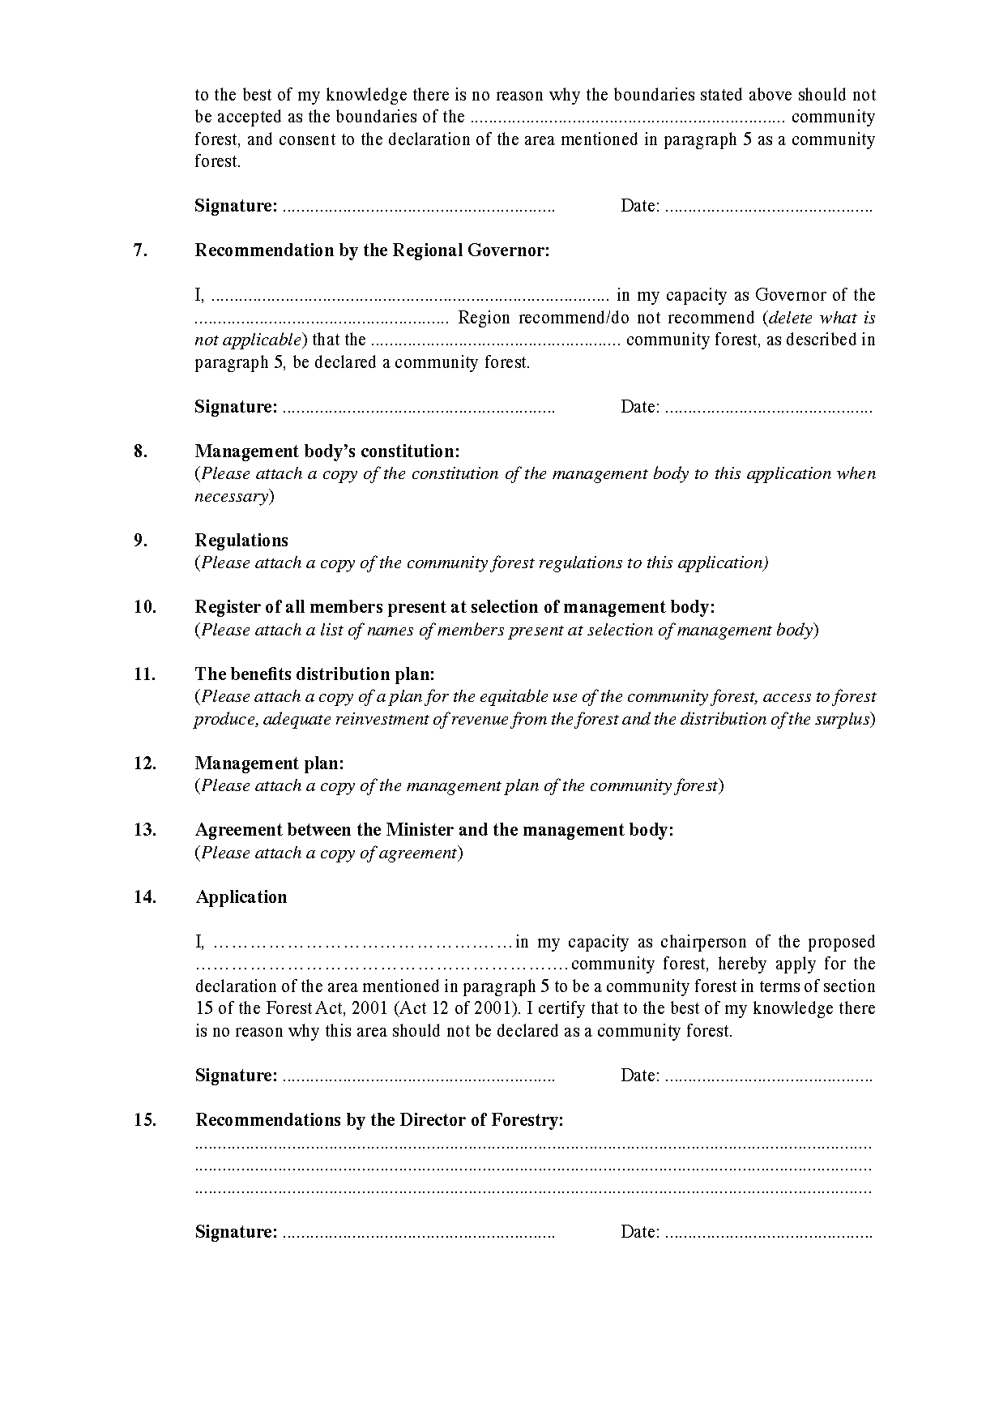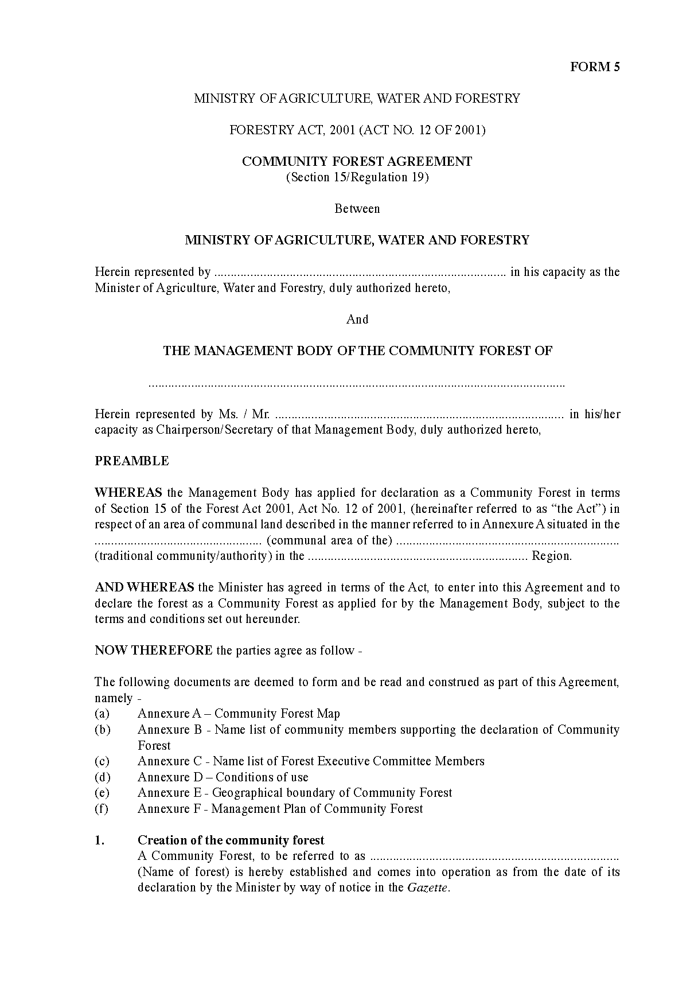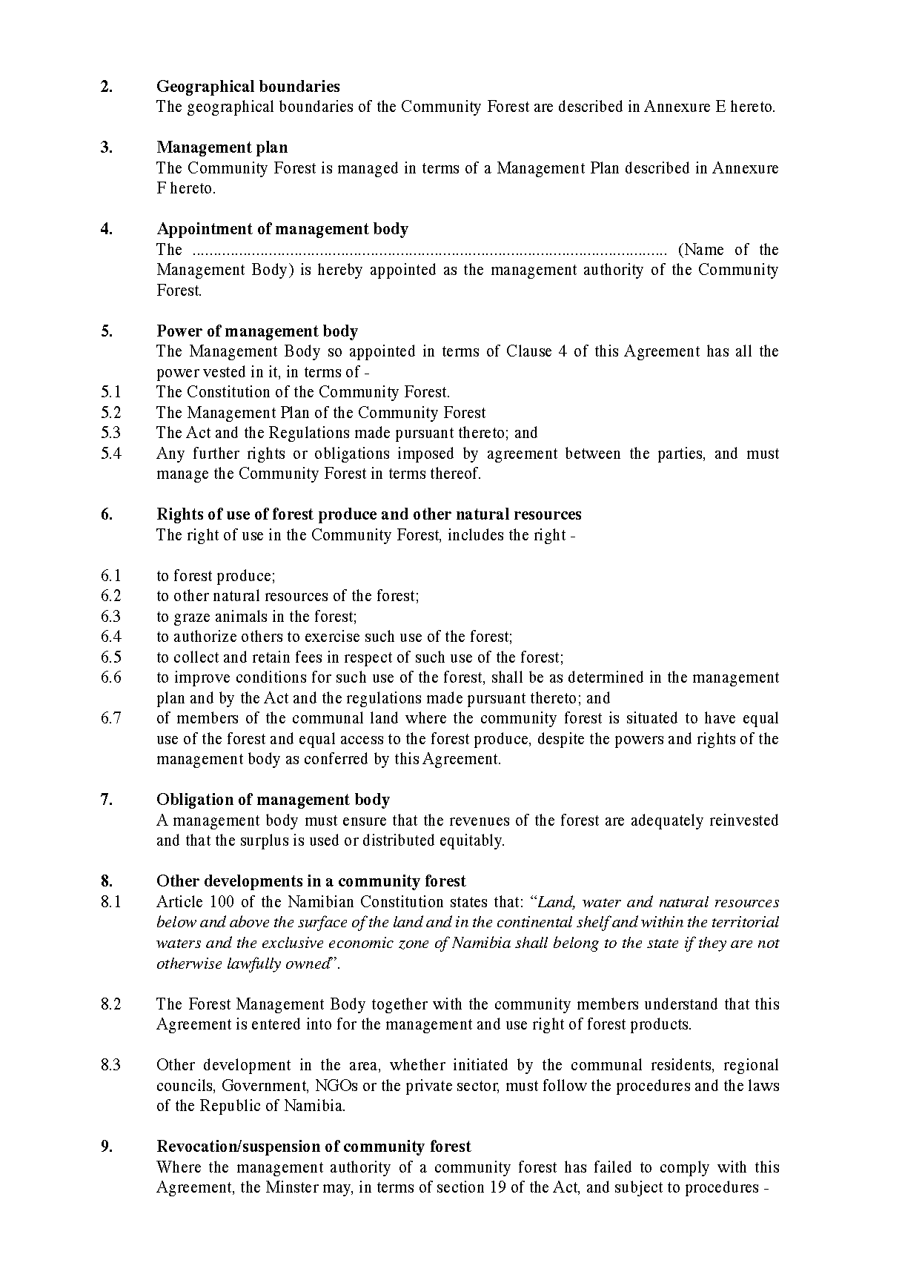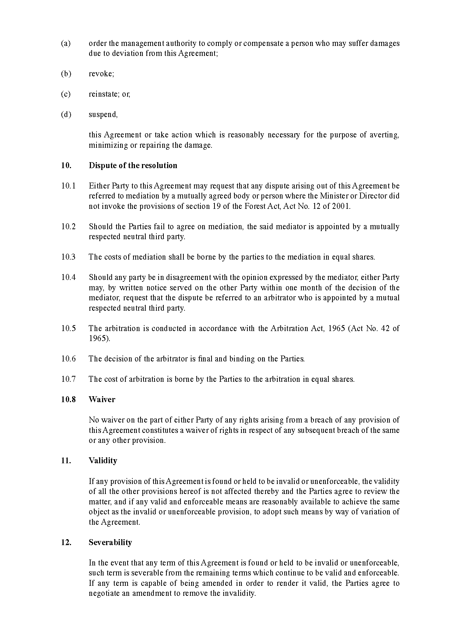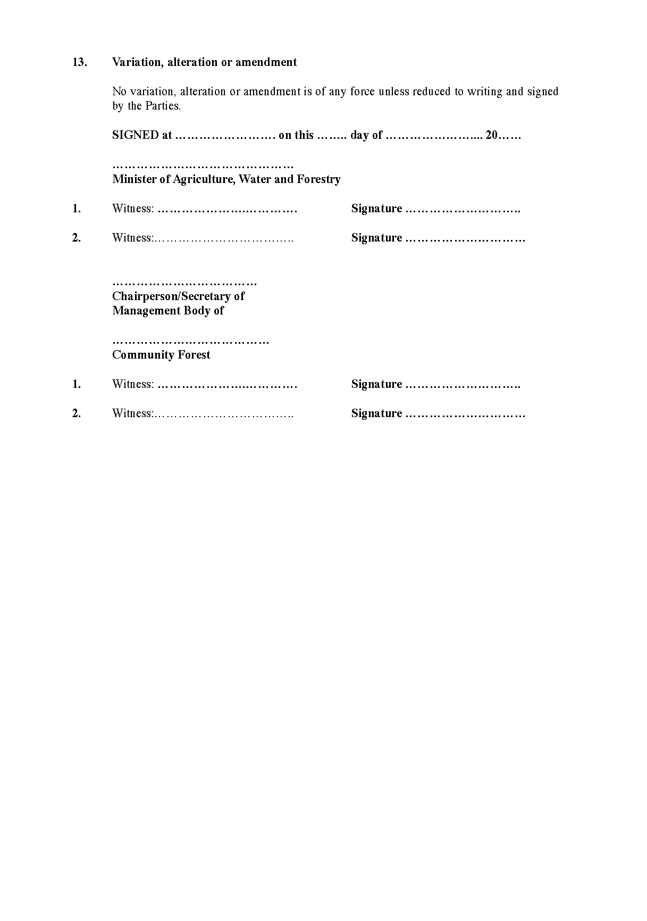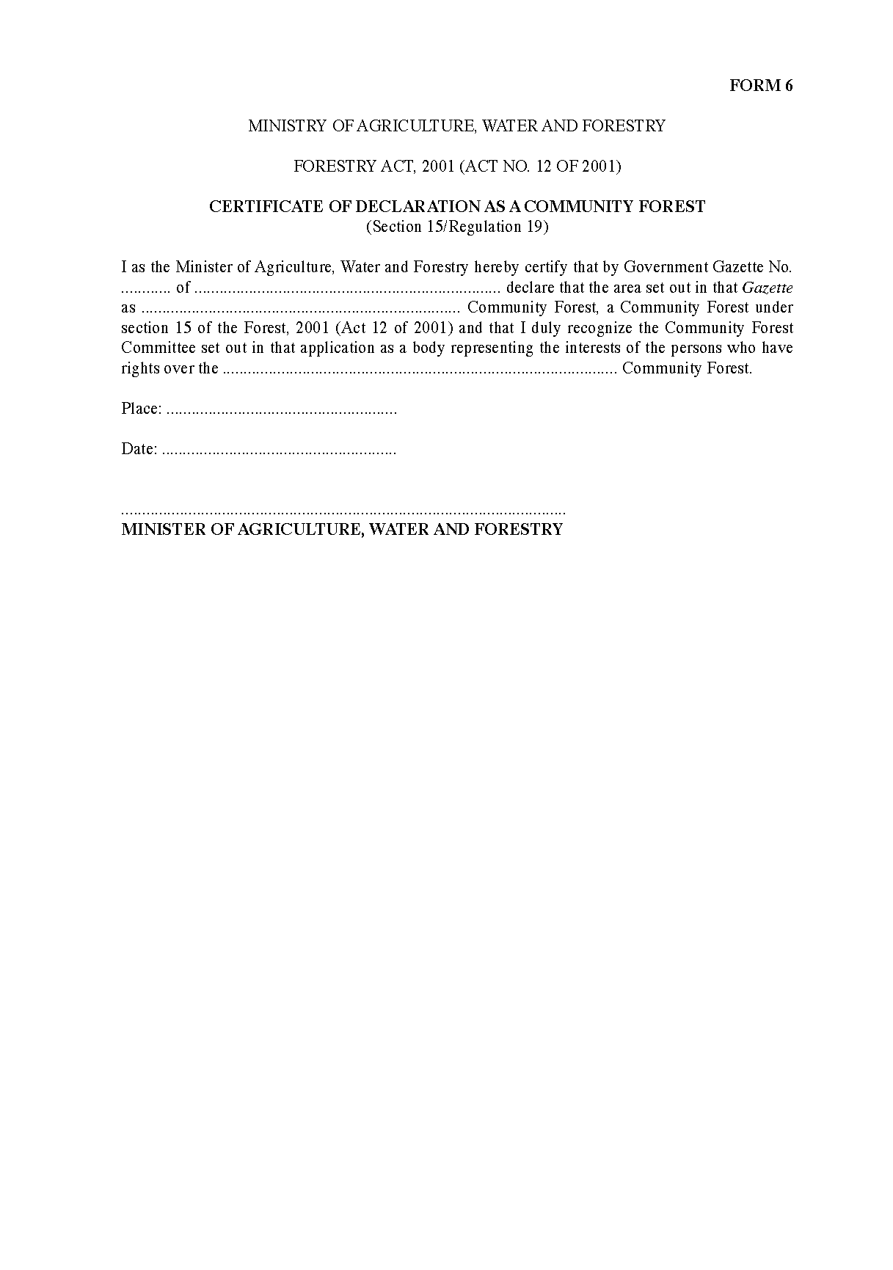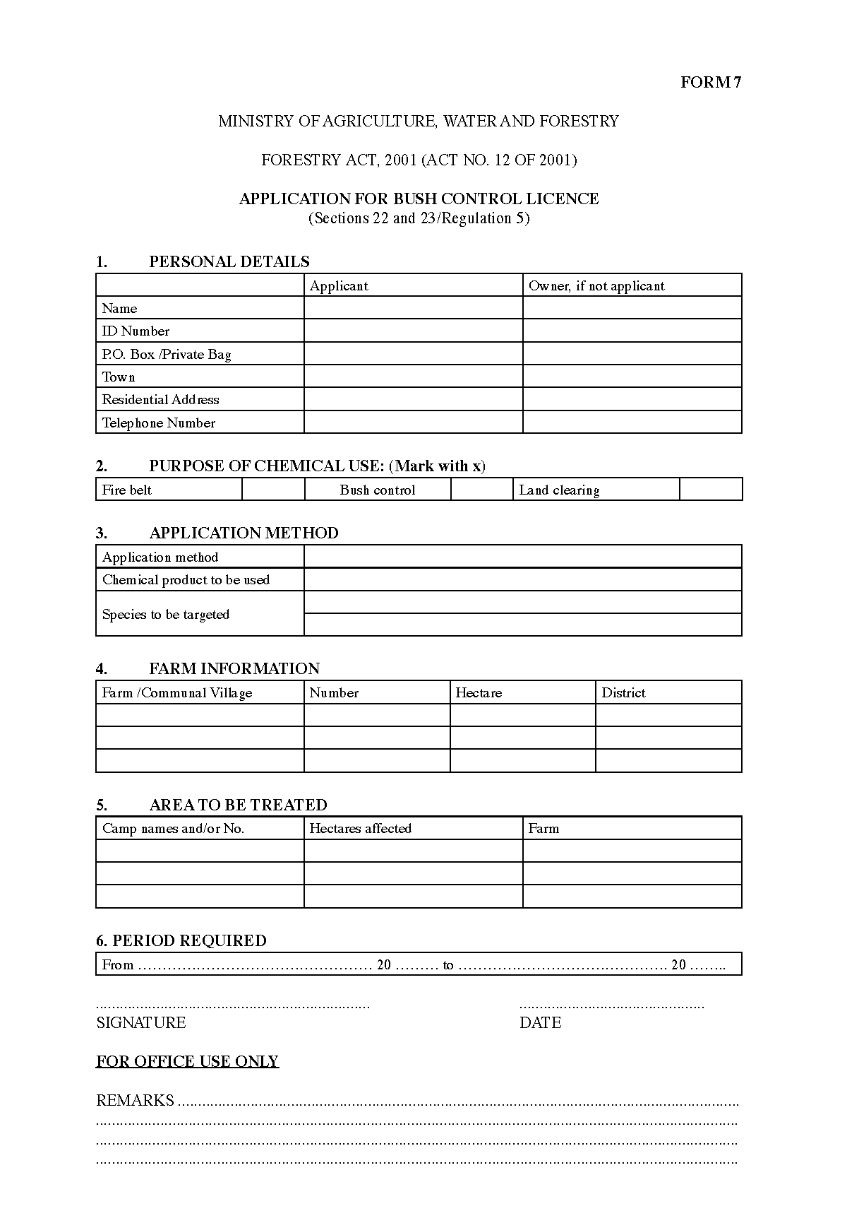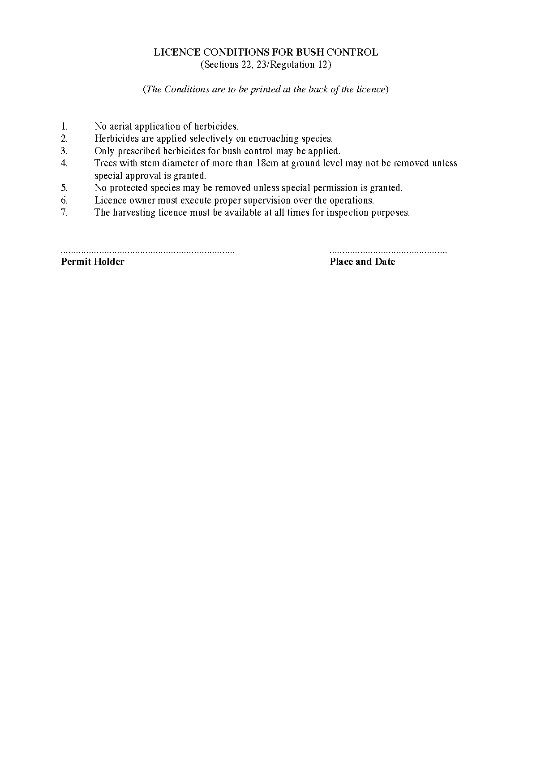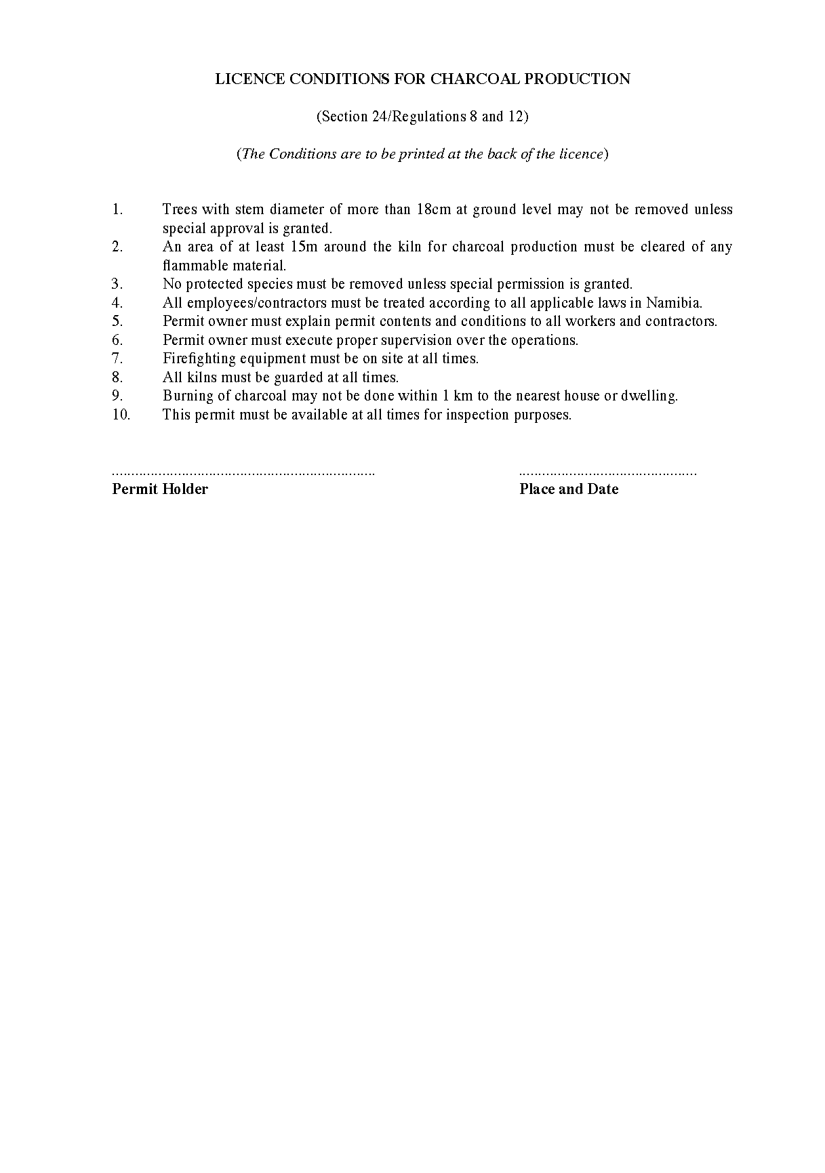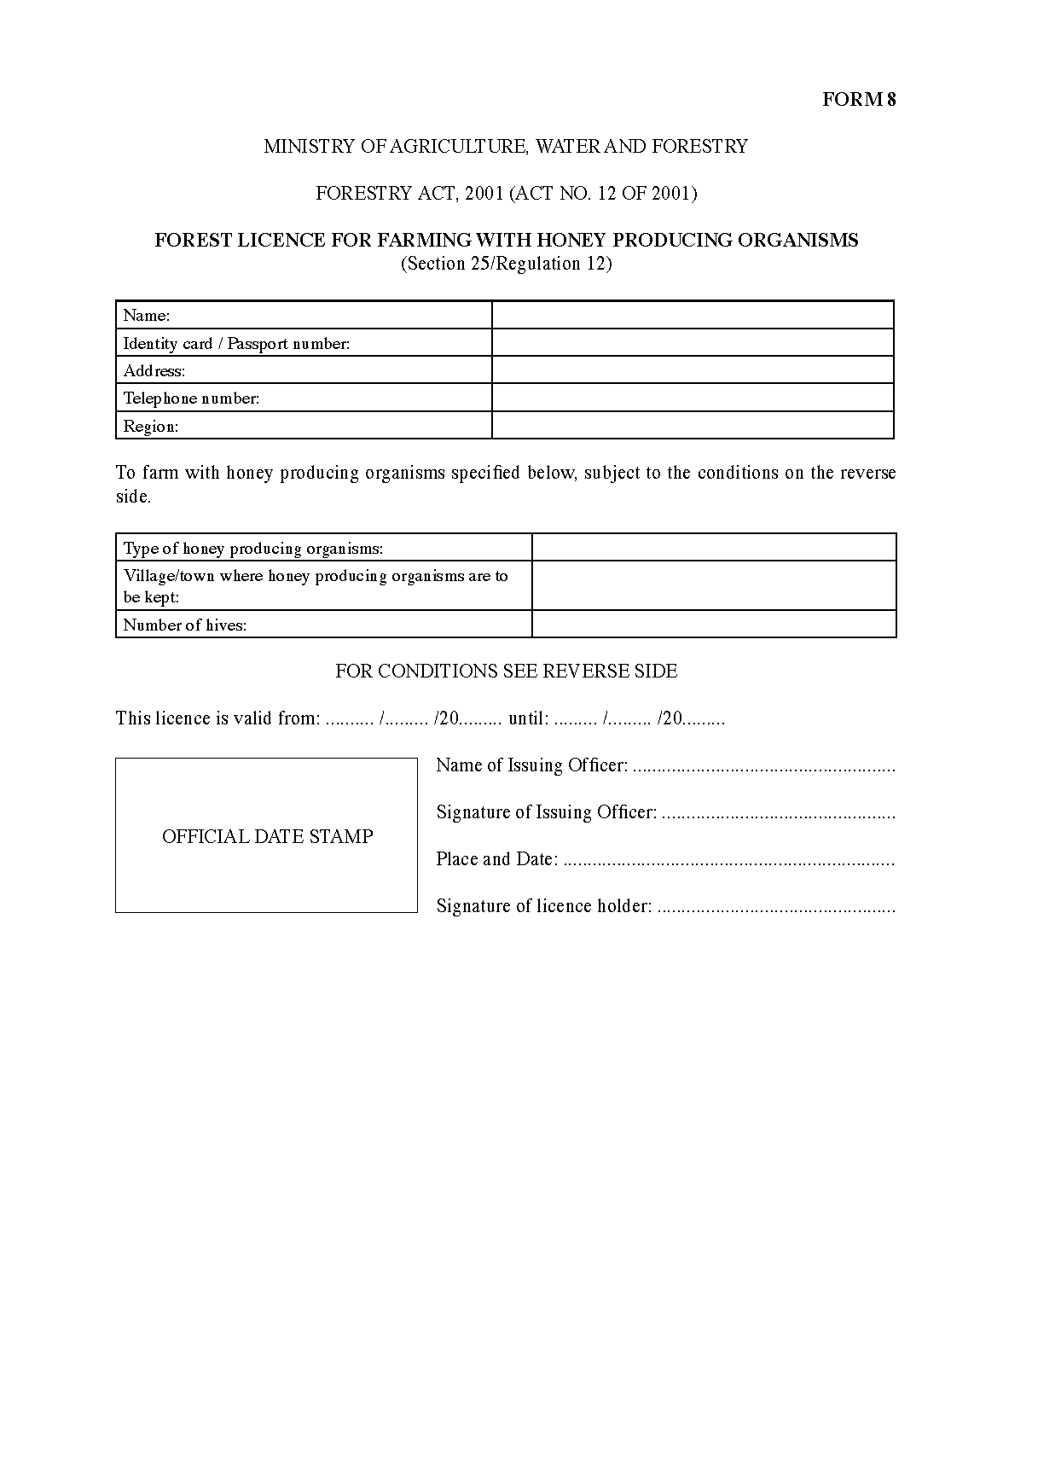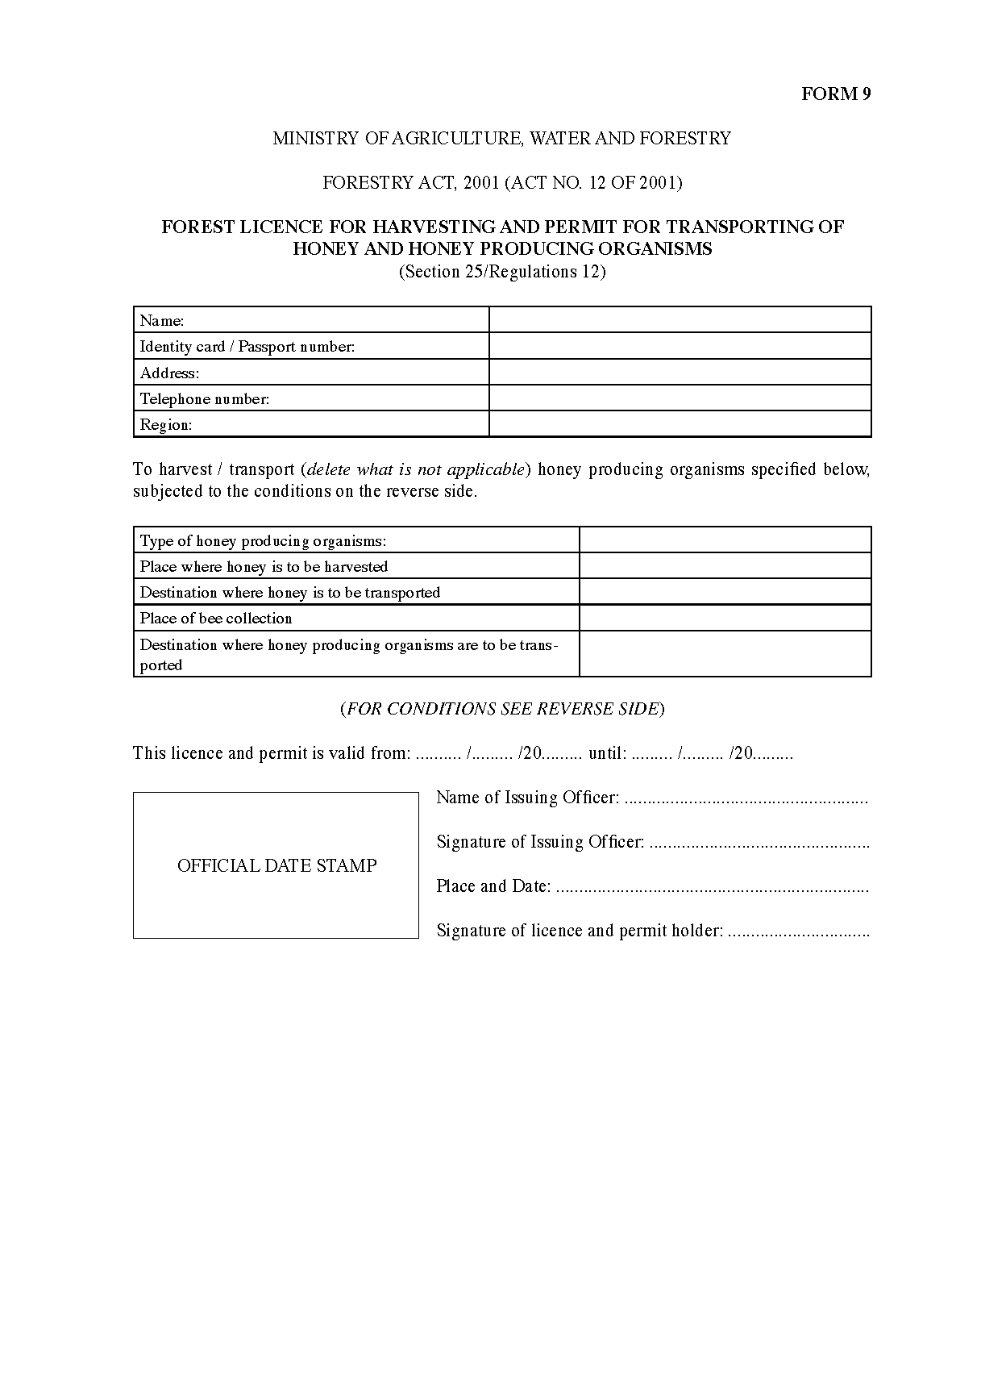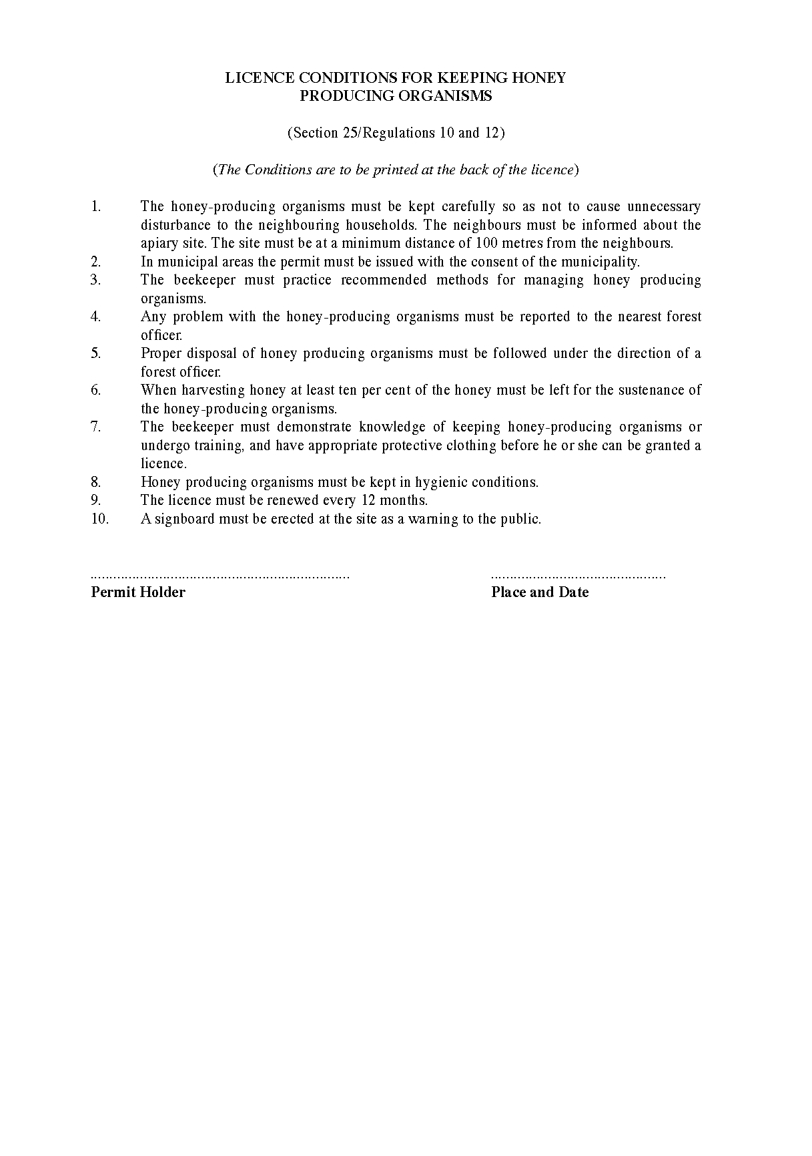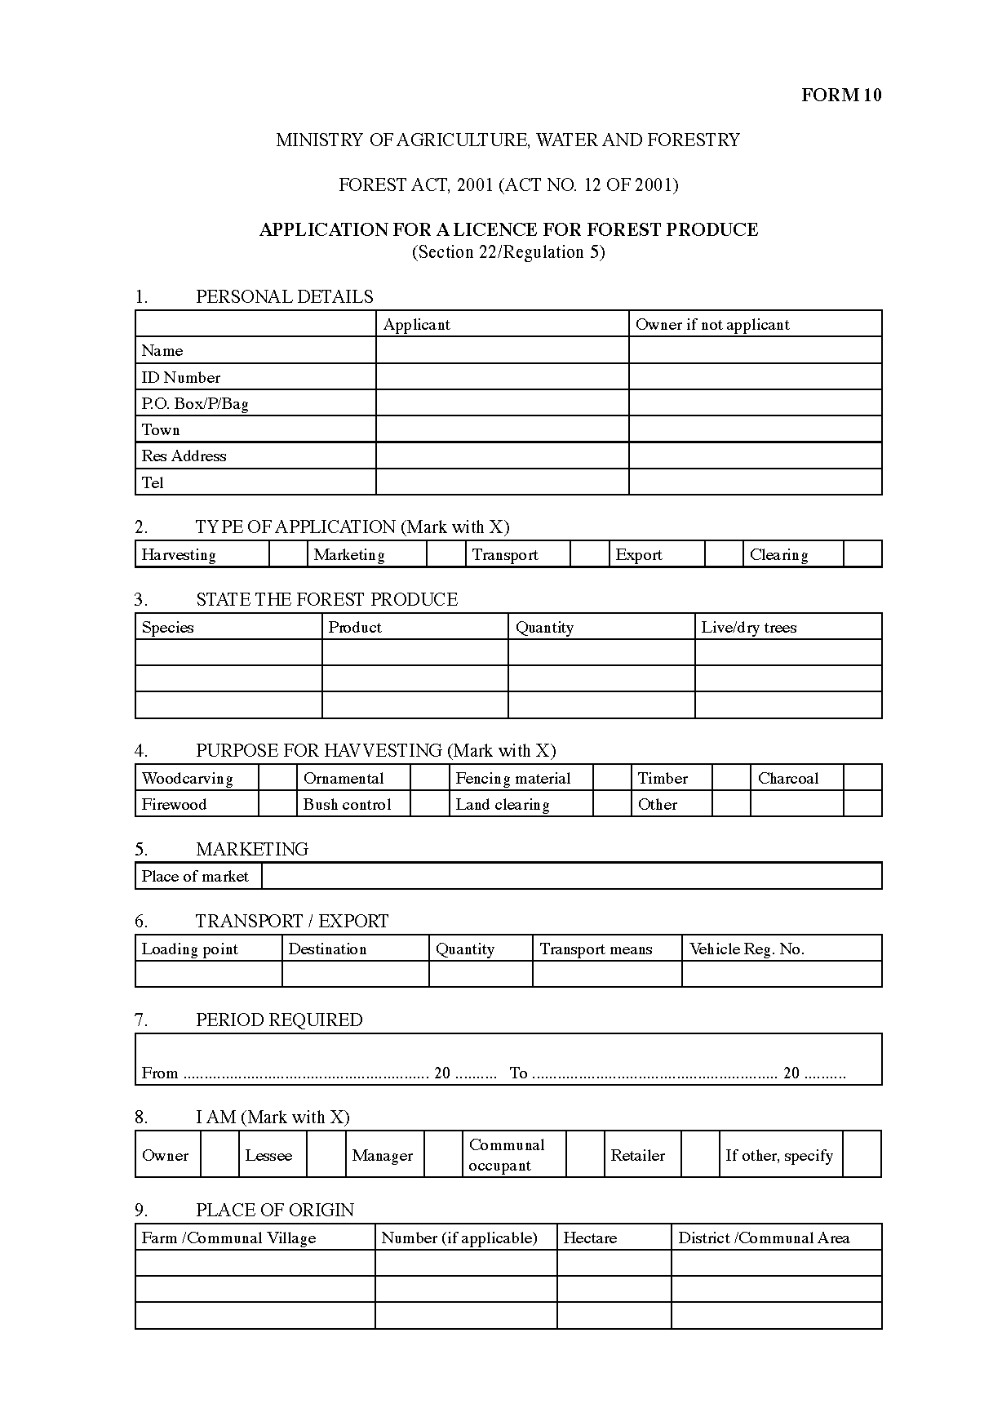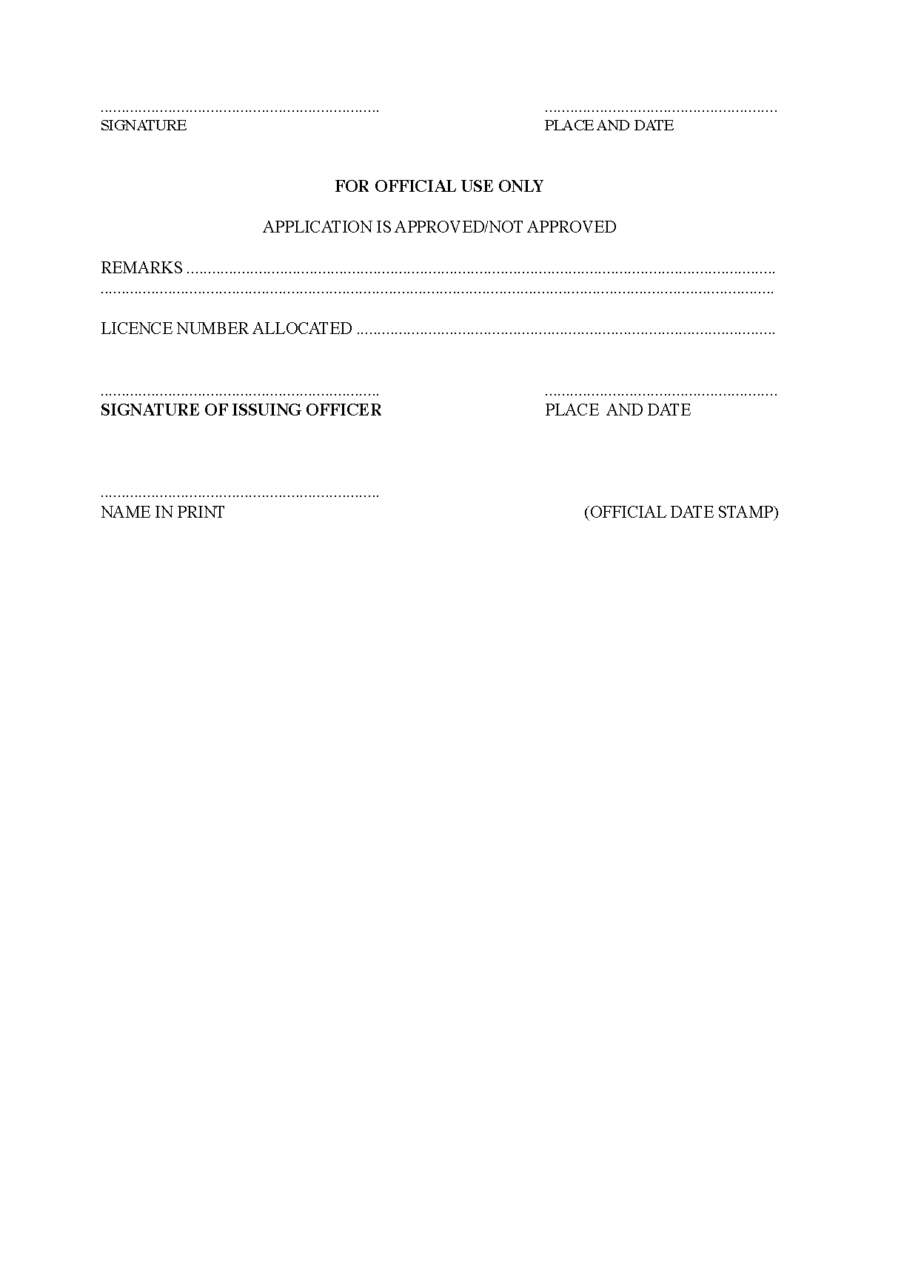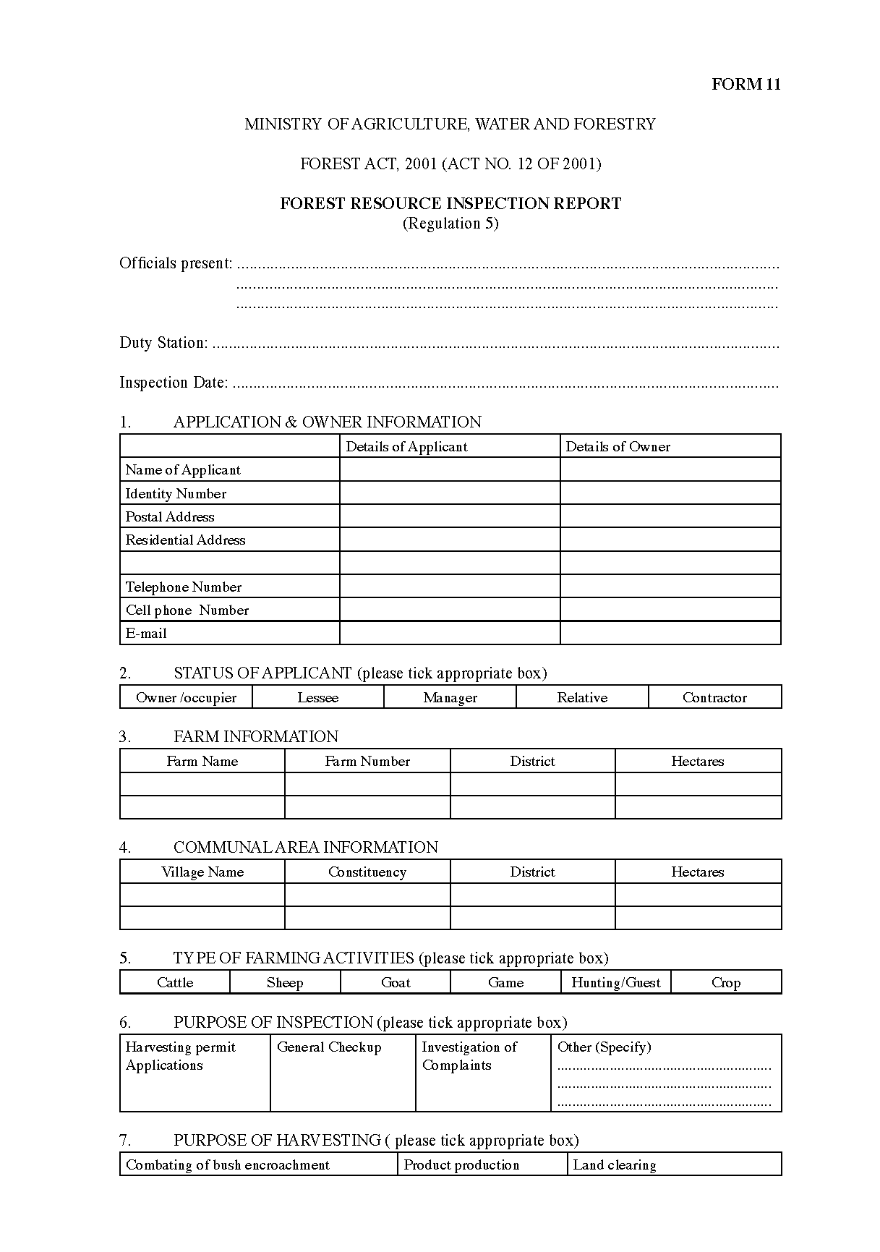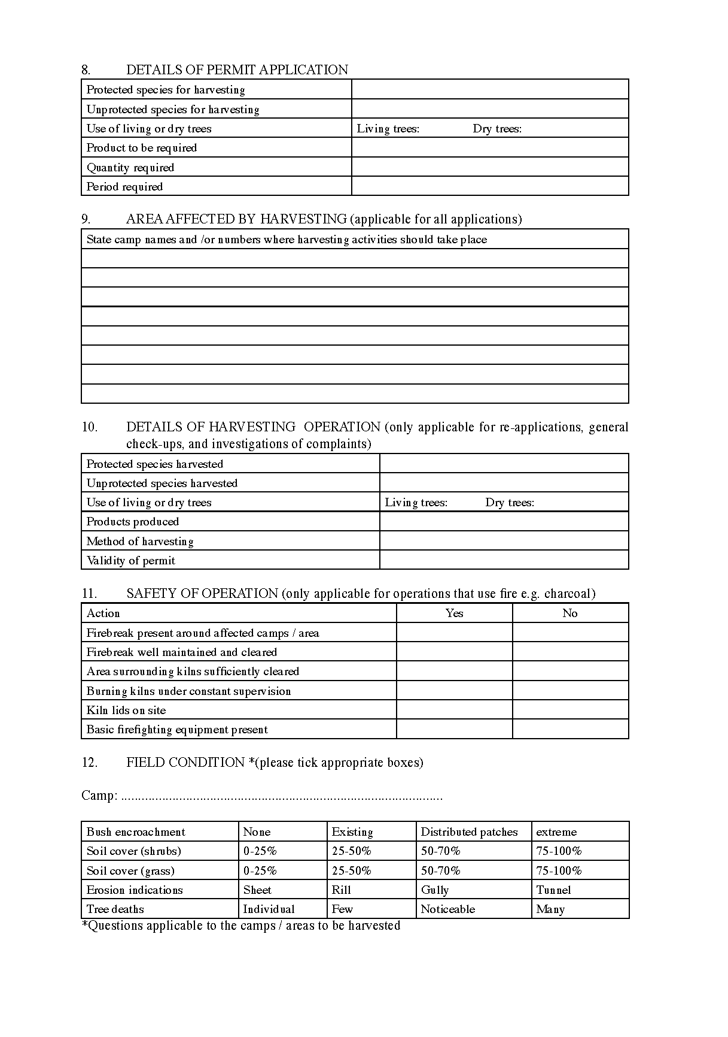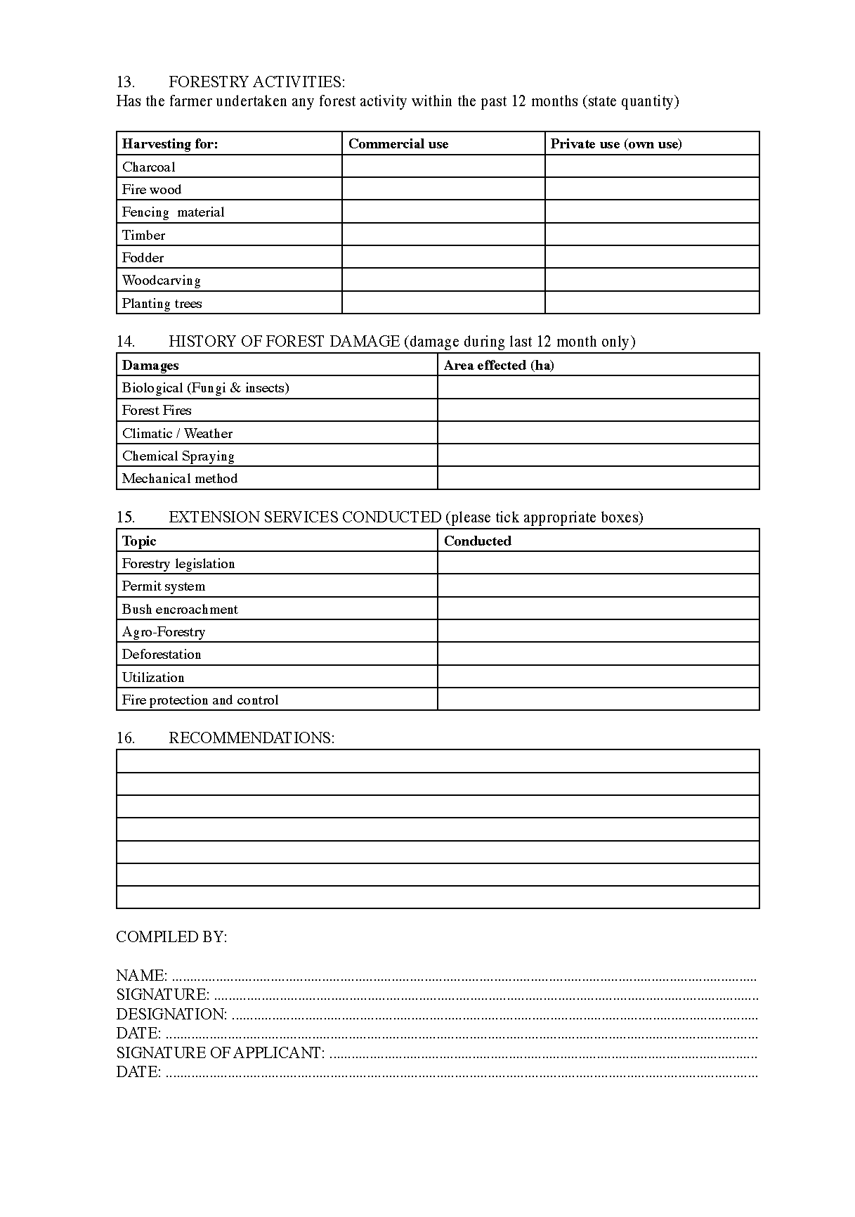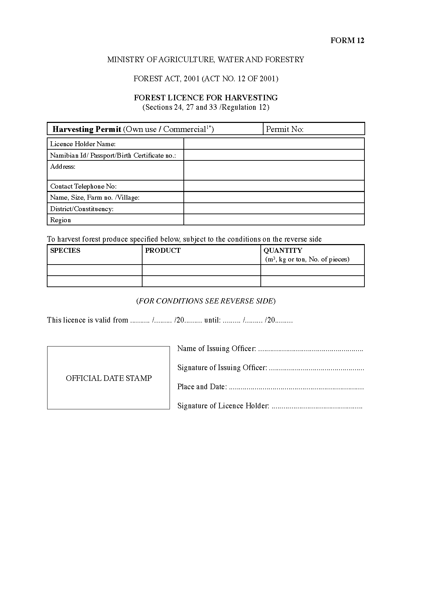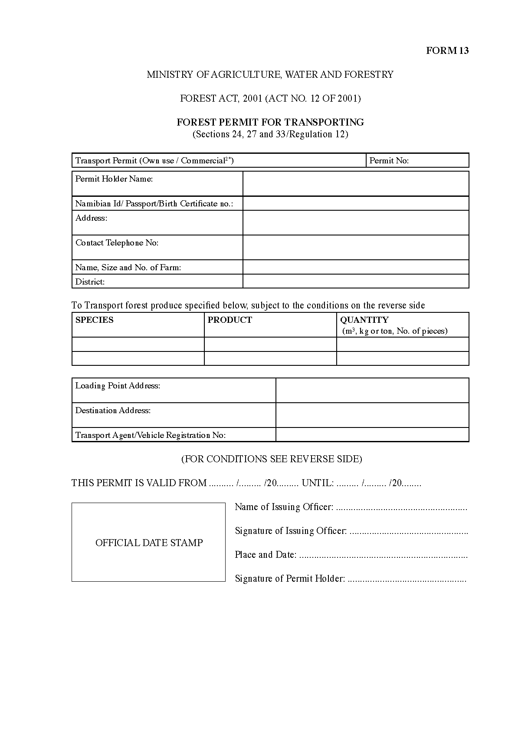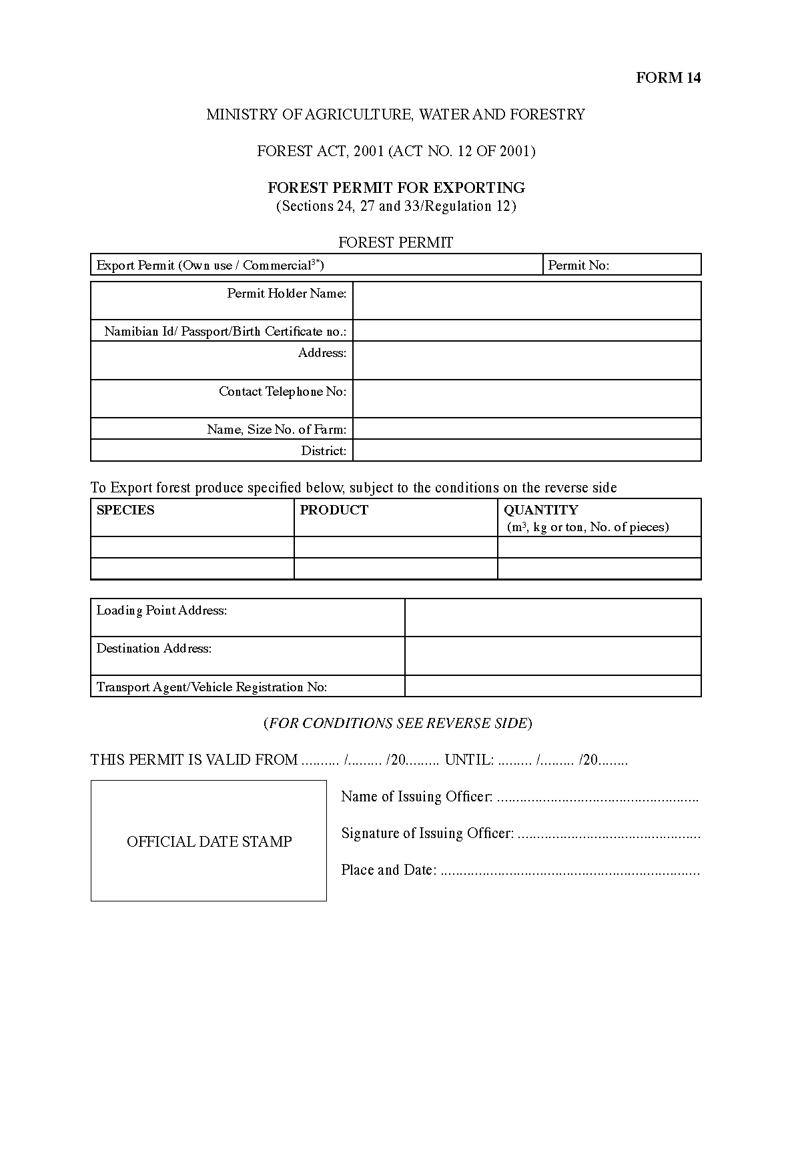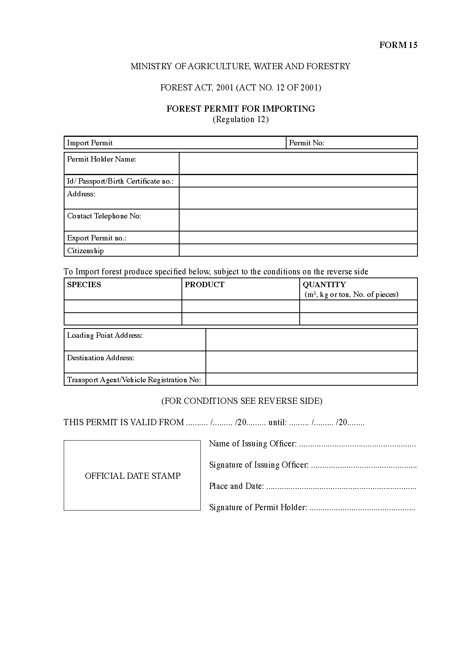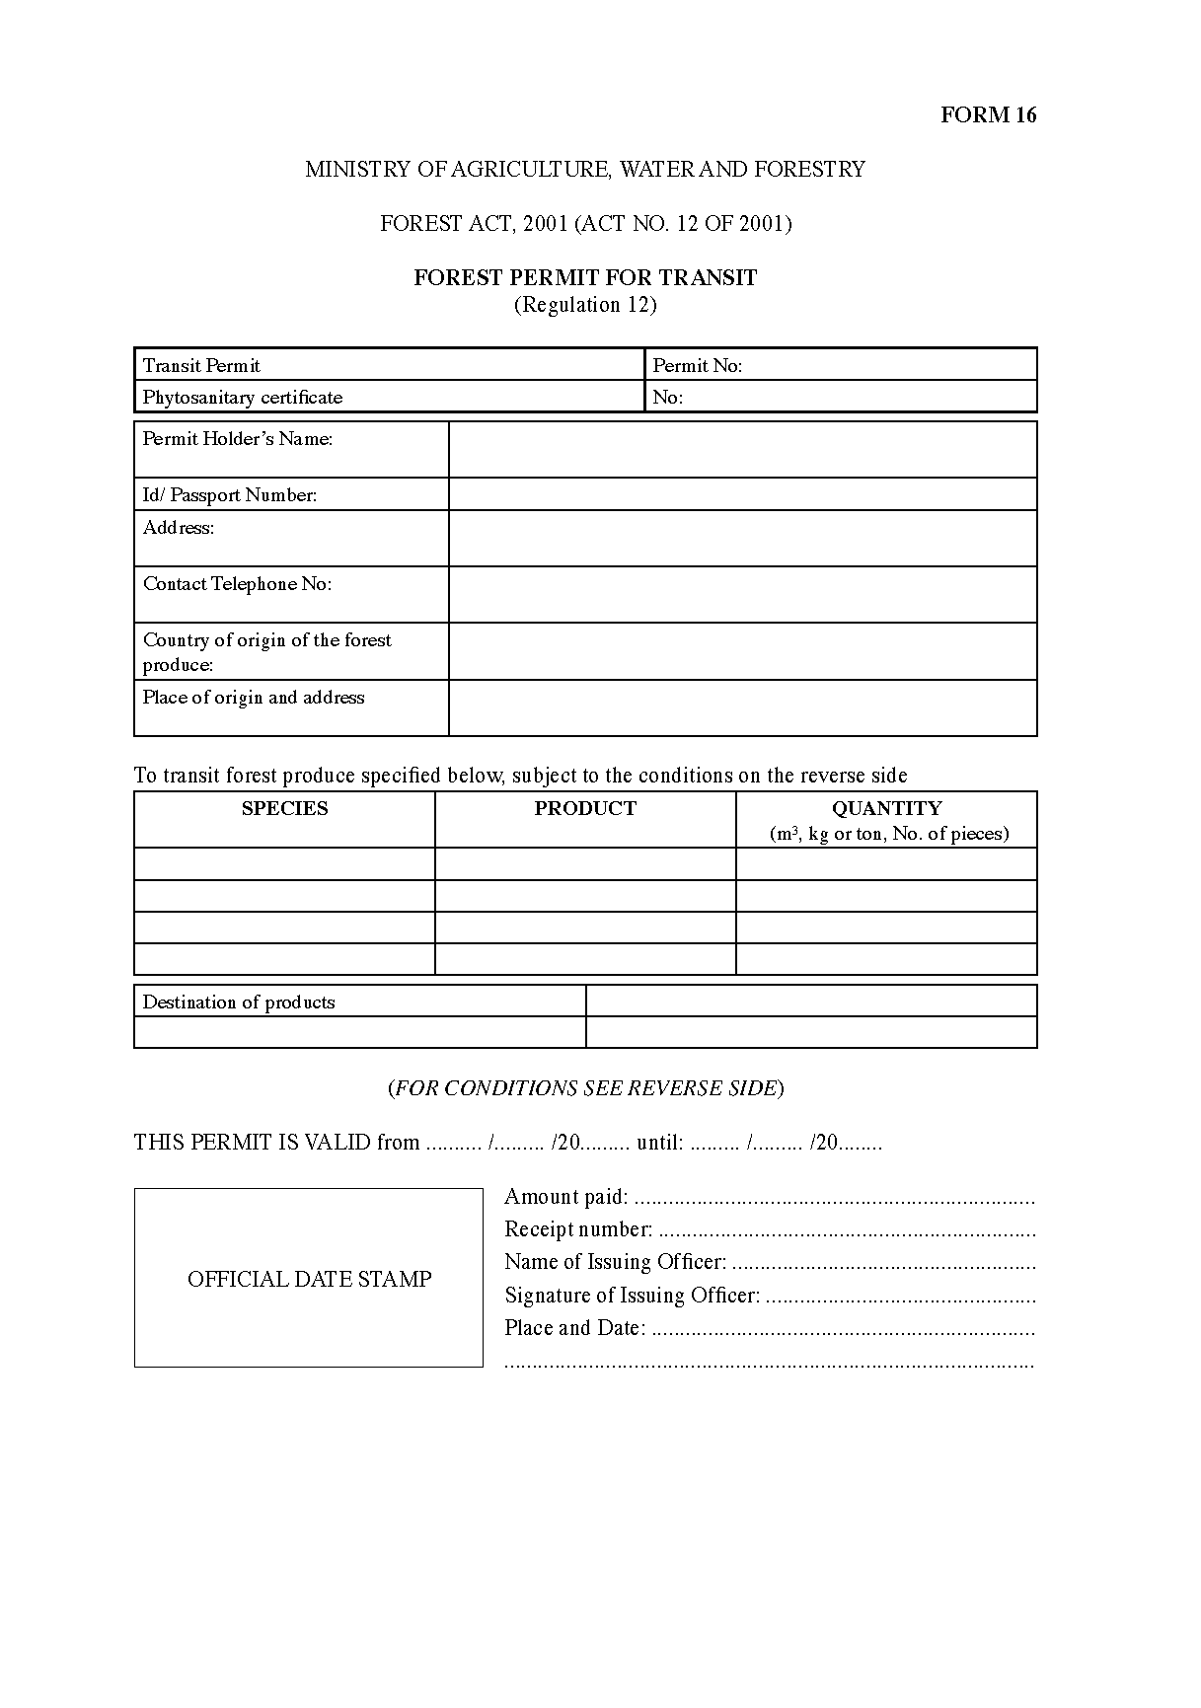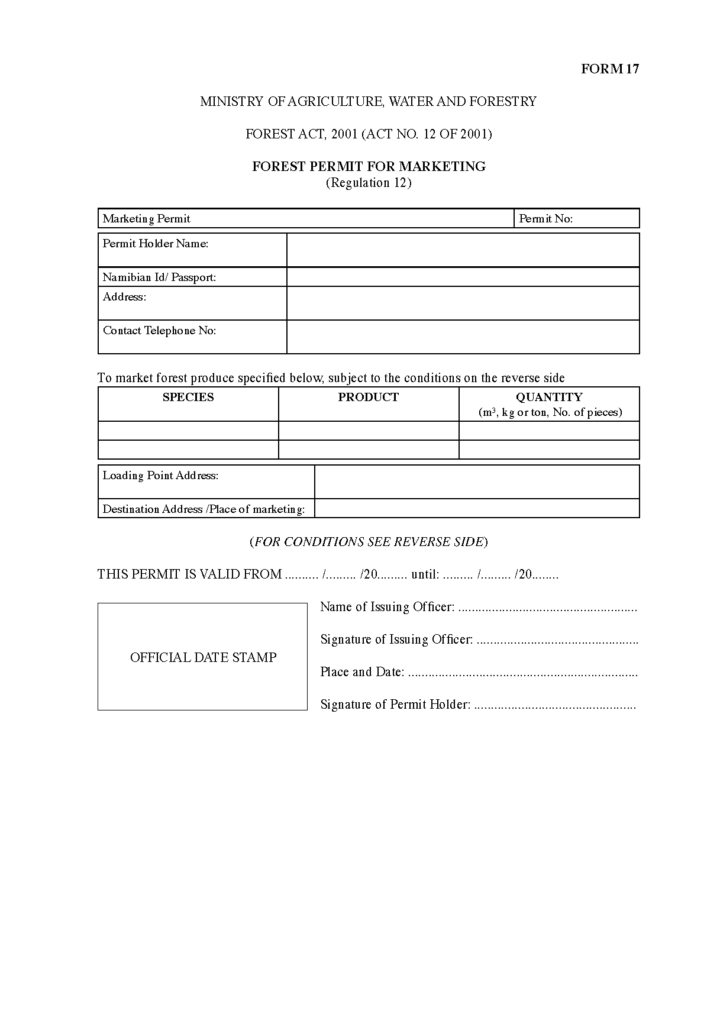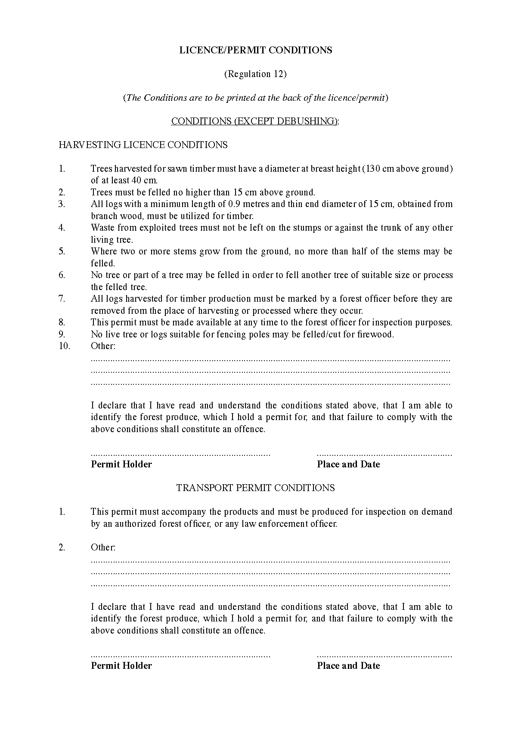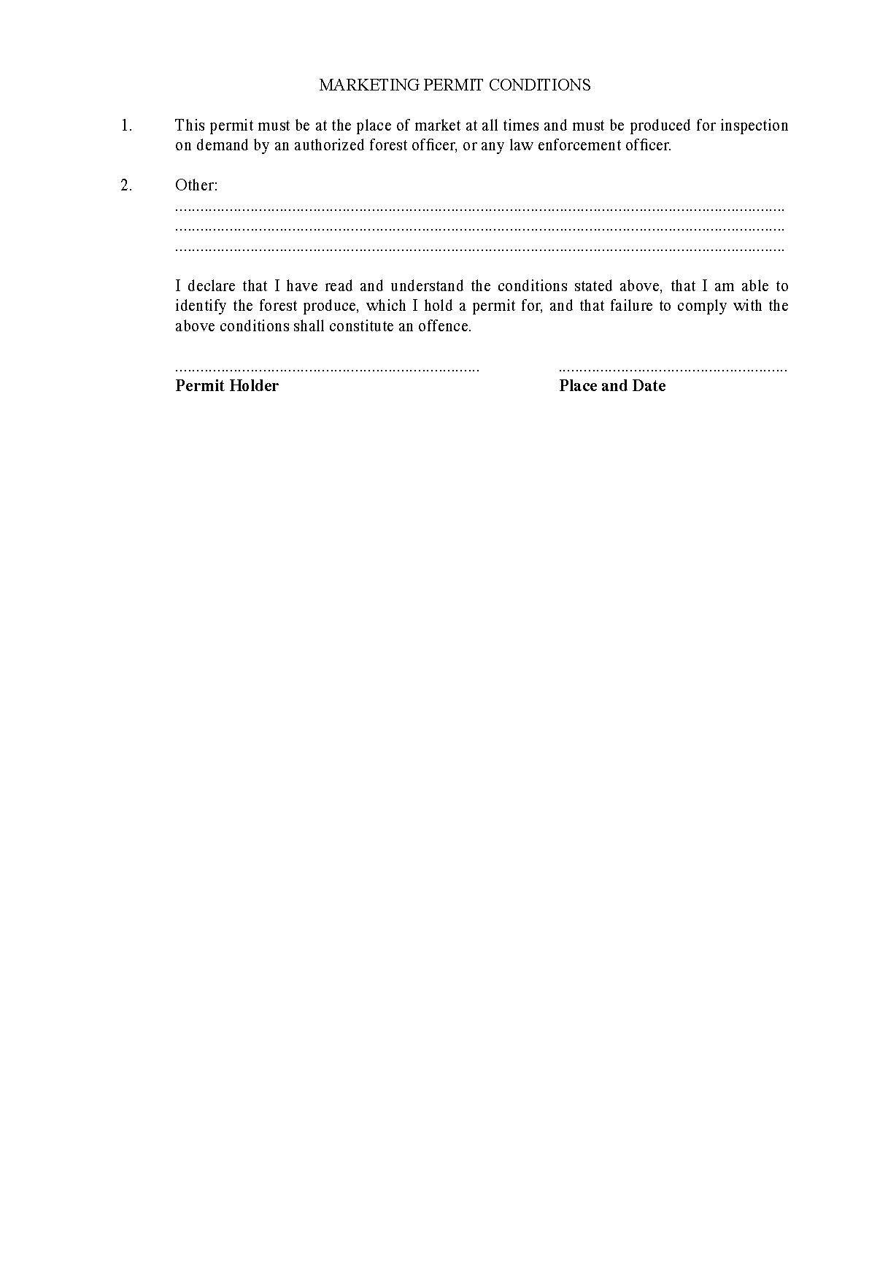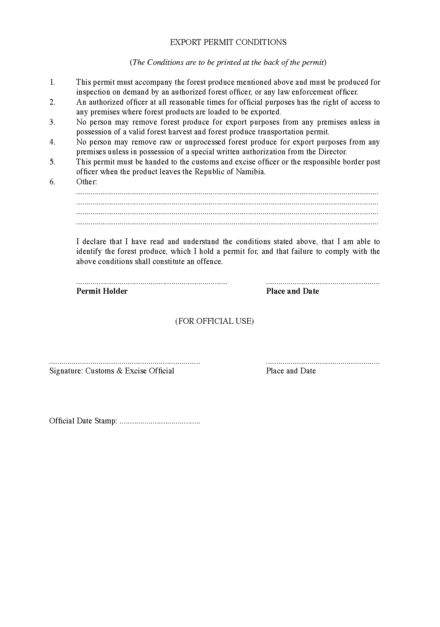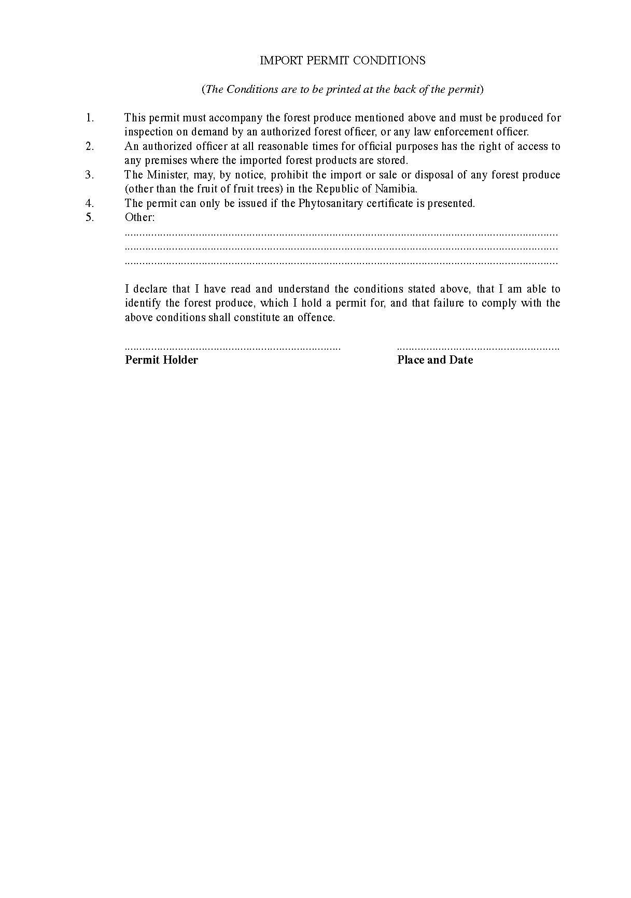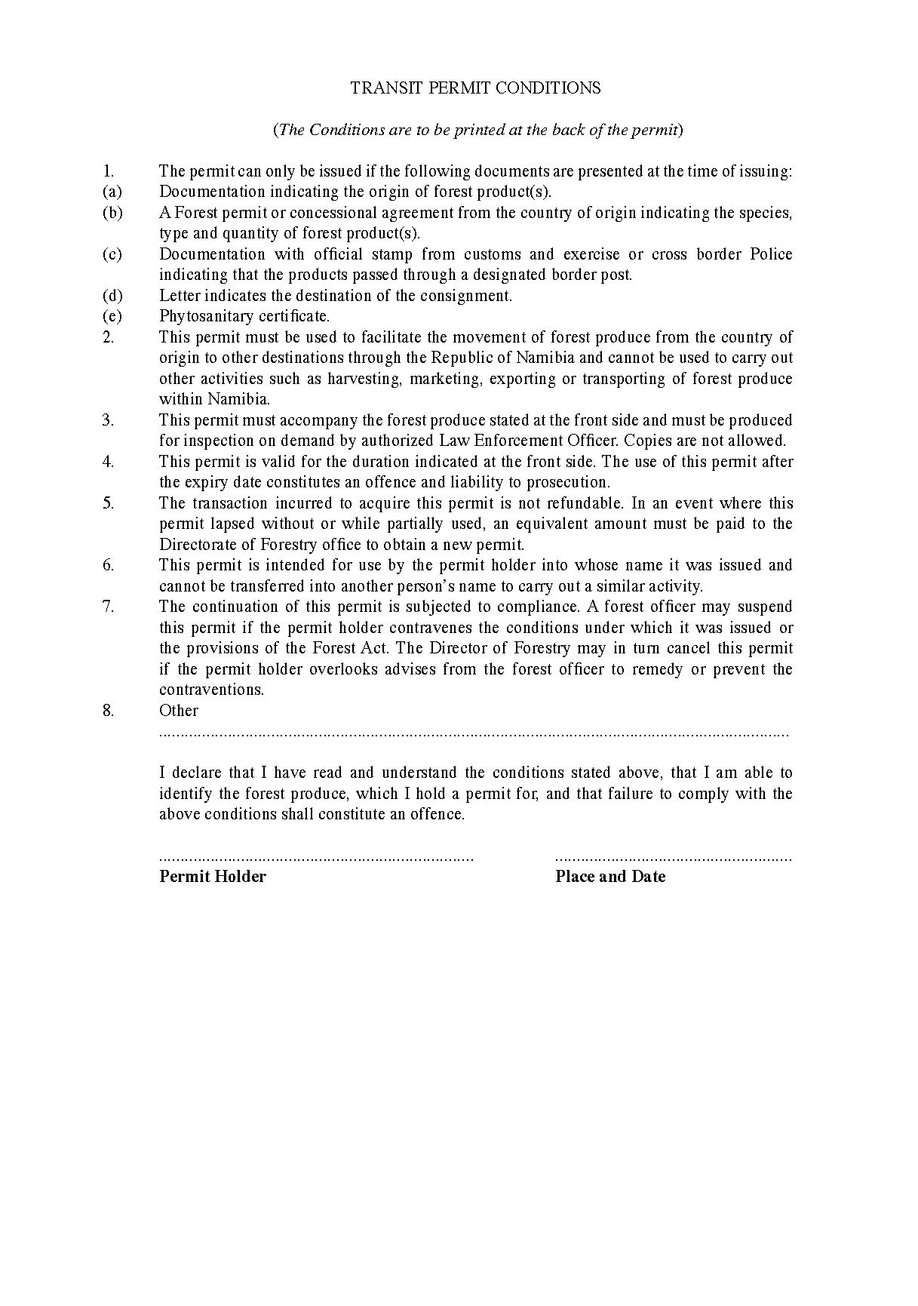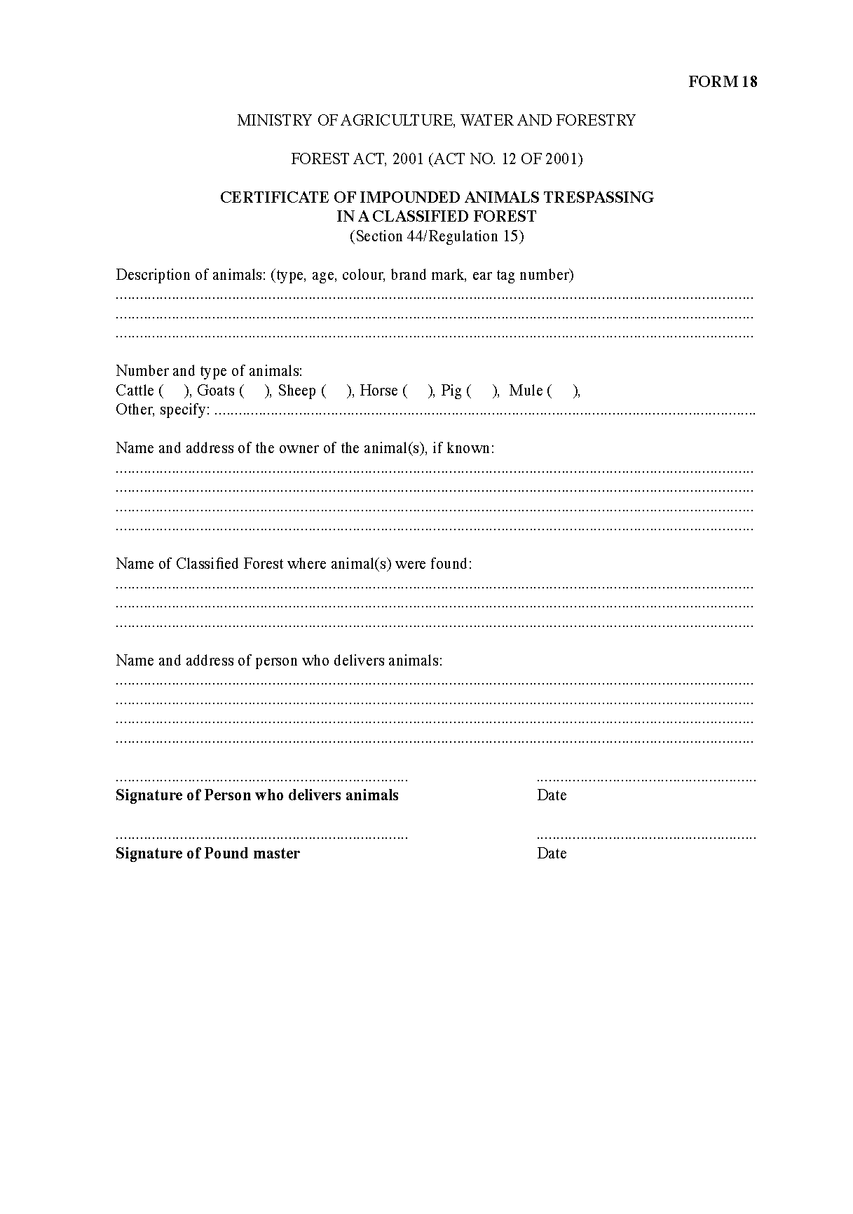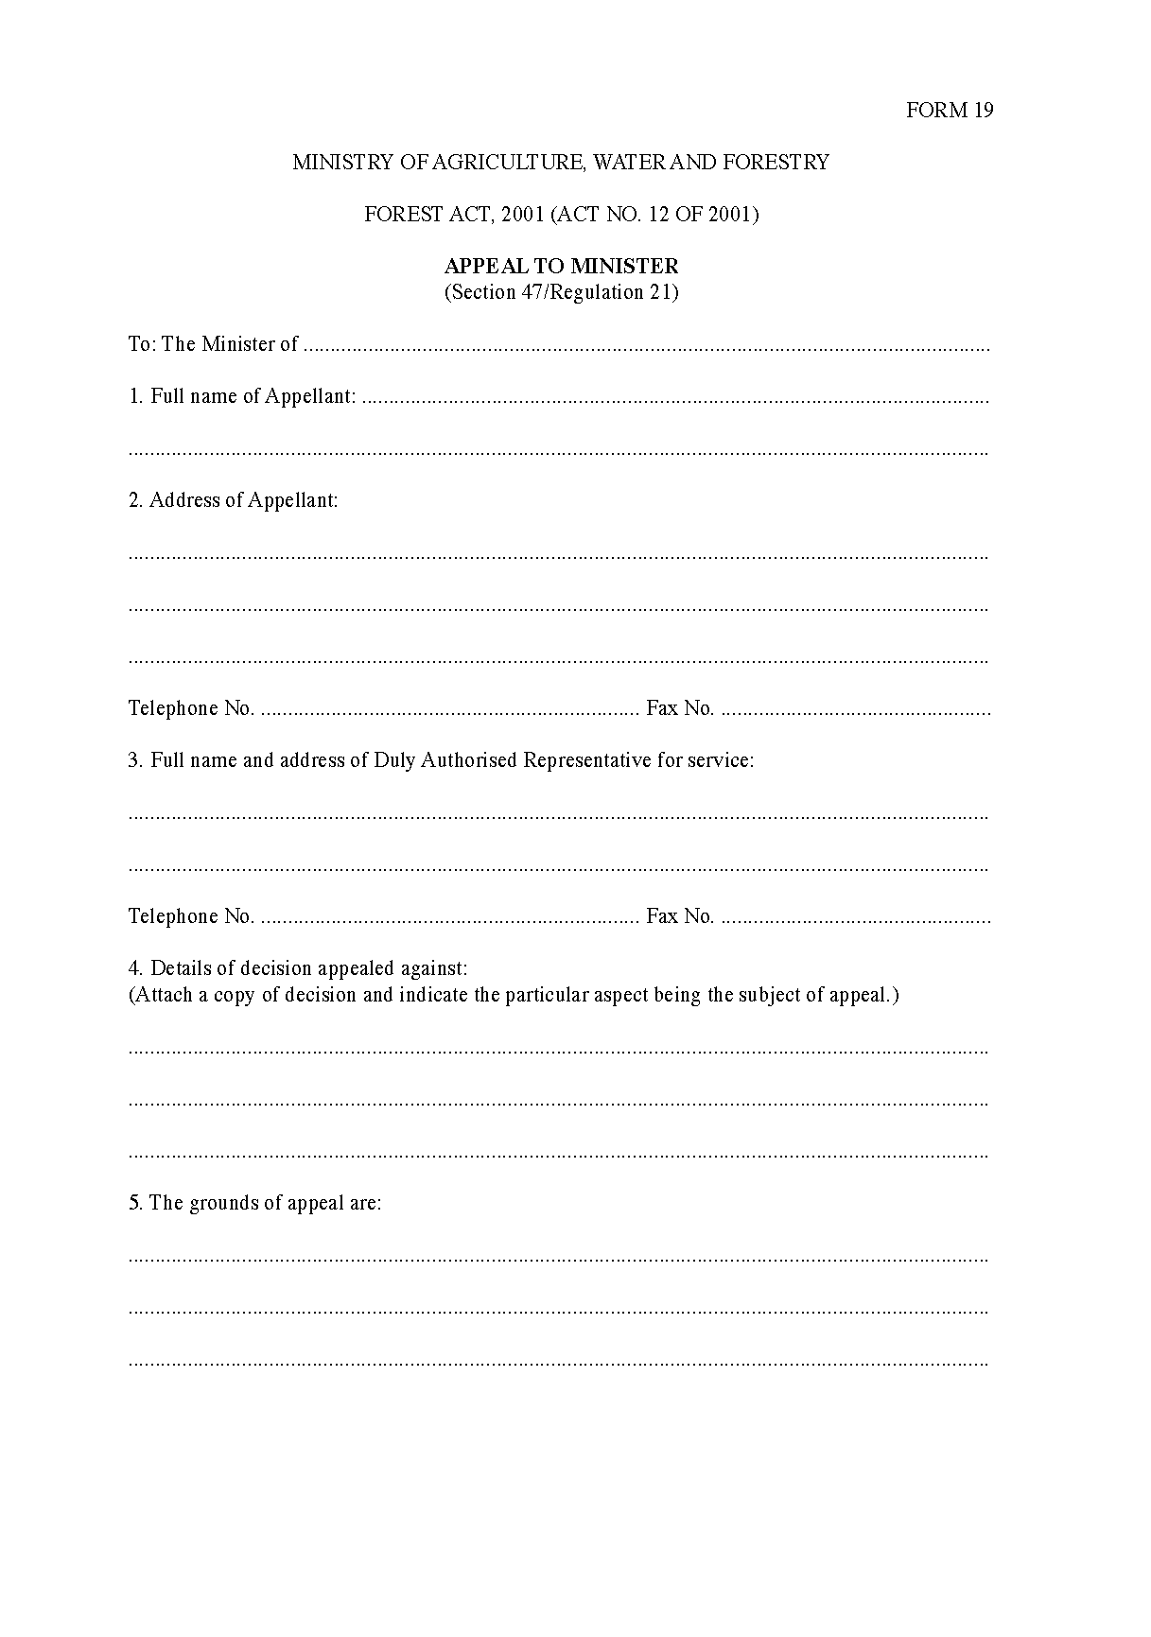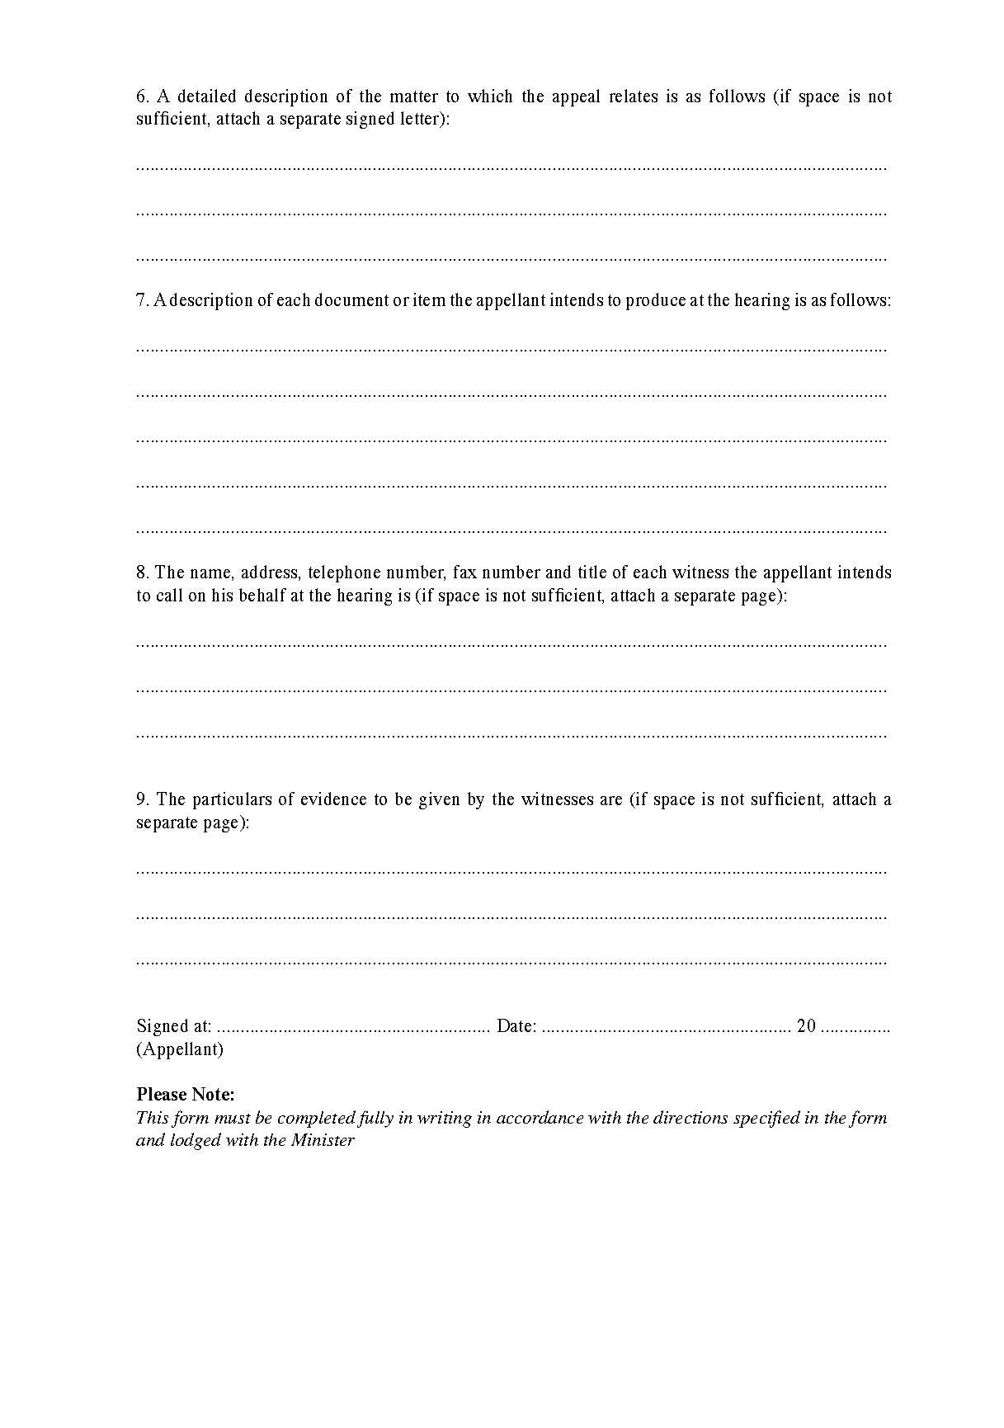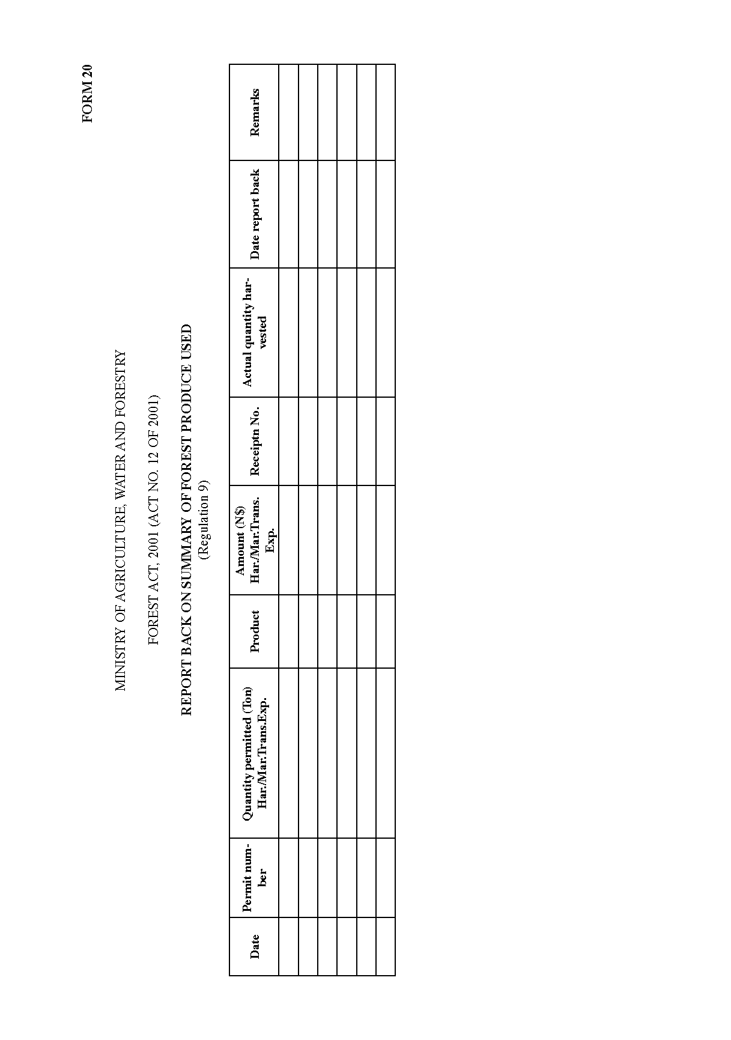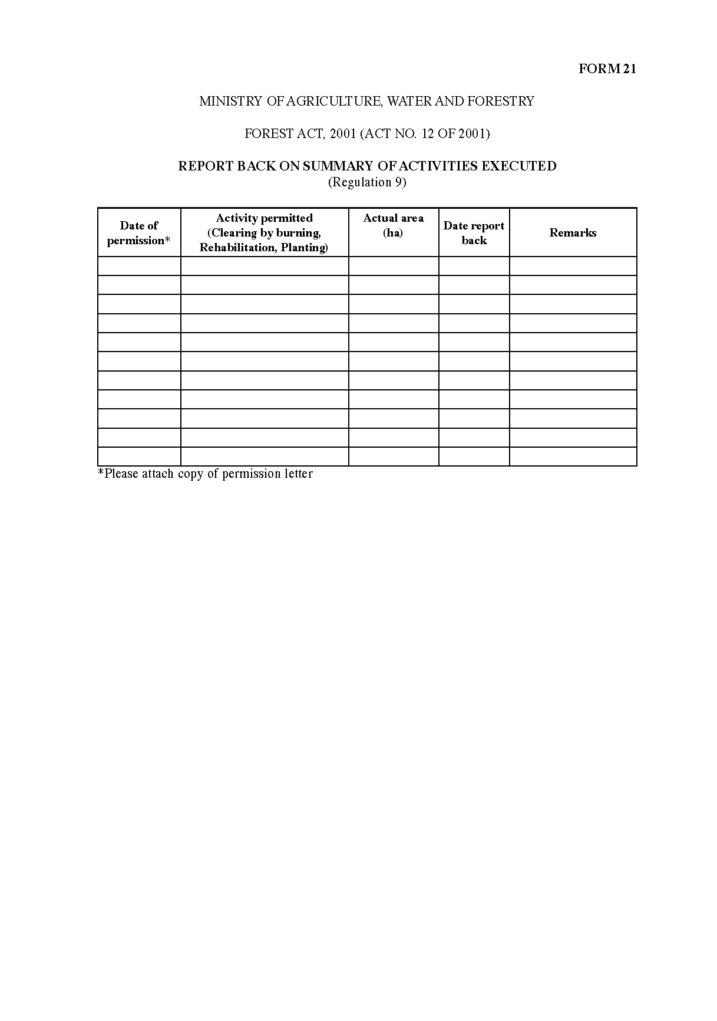

ANNEXURE 2

MINISTRY OF AGRICULTURE, WATER AND FORESTRY

FOREST ACT, 2001 (ACT NO. 12 OF 2001)

PROTECTED PLANT SPECIES
(Sections 22/Regulation 13)

List of protected species:
Species name | Common names (English) | Reasons to be protected
Acacia erioloba E. Mey. | Camel-thorn | EU¹ (Heavily utilized by humans and animals - medicinal, cash crop, unsus- tainable harvesting of fuel wood for ex- port) slow growth rate, cultural value, economic value, ES (keystone species)
Acacia nigrescens Oliv. | Knob-thorn | EU (Used by humans and animals - wood used for construction, utensils, fuel, tanning, browsed by game), ES (retains river banks)
Acanthosicyos horridus Welw. ex Hook.f. | Nara | Cultural and economic value, ES (Dune stabiliser)
Adansonia digitata L. | baobab | ES² (Keystone species) EU (heavily utilised by humans and animals)
Adenia pechuelii (Engl.) Harms | Elephants-foot | EU (unsustainable harvesting for horti- cultural trade), slow growth rate, Slow and/or episodic recruitment
Adenium boehmanium Schinz | Bushman poison | EU (unsustainable harvesting for horti- cultural trade)
Afzelia quanzensis Welw. | Pod mahogany | EU (Extensively used by humans and animals- curios, medicinal, timber, po- tential as ornamental trees, browsed by animals), slow growth rate, Restricted range.
Albizia anthelmintica (A.Rich.) Brongn. | Worm-cure albizia | EU (Utilized by humans and animals  - medicinal, utensils, browsed by live- stock and game)
Aloe dichotoma Masson | Quiver tree | EU (unsustainable harvesting for hor- ticultural trade), Slow growth rate, Cultural value, Slow and/or episodic recruitment
Aloe pillansii L. Guthrie | Giant quiver tree | Slow growth rate, Restricted range, Slow and/or episodic recruitment
Aloe ramosissima Pillans | Maiden’s quiver tree | Slow growth rate, Restricted range, Slow and/or episodic recruitment
Baikiaea plurijuga Harms | Zambezi teak or Rhodesian teak | EU (heavily utilised for timber, imple- ments, utensils, wood carvings)
Berchemia discolour (Klotzsch) Hemsl. | Bird-plum | EU (heavily utilised by humans and animals)
Boscia albitrunca (Burch.) Gilg & Gilg-Ben. | Shepherd’s tree | EU (heavily utilised by humans and animals)
Burkea africana Hook. | Burkea | EU (heavily utilised by humans - tim- ber, firewood, implements)
Caesalpinia merxmeullerana A. Schreib. | Orange-river caesalpinia | Restricted range
Citropsis daweana Swingle & M. Kellerm. |  | EU (Wild crop relative - genetic re- source), Restricted range
Colophospermum mopane (J. Kirk ex Benth.) J. Kirk ex J. Léonard | Mopane | EU (heavily utilised by humans and animals (browse and forage) - charcoal, timber, fuel wood, construction, medi- cine, host to important edible caterpil- lar), slow growth rate, cultural value
Combretum imberbe Wawra | Leadwood | EU (heavily utilised by humans and animals - fuel wood, construction ma- terial, implements, illegally harvested for charcoal, other purposes, browse, shade) Cultural value, Extremely slow growth rate.
Commiphora capensis (Sond.) Engl. | Namaqua corkwood | EU (illegally harvested for horticultural trade), Restricted range
Commiphora cervifolia J.J.A.van der Walt | Antler-leaved corkwood | EU (illegally harvested for horticultural trade), Restricted range
Commiphora dinteri Engl. | Namib corkwood | EU (illegally harvested for horticultural trade)
Commiphora gariepensis Swane- poel | Orange River corkwood | Restricted range
Commiphora giessii J .J. A. van der Walt | Brown-stemmed corkwood | Restricted range
Commiphora gracilifrondosa  Dinter ex J. J. A. van der Walt | Karee corkwood | Restricted range, EU (illegally harvest- ed for horticultural trade), Restricted range
Commiphora kraeuseliana Heine | Feather-leafed corkwood | EU (illegally harvested for horticultural trade), Restricted range
Commiphora namaensis Schinz | Nama corkwood | EU (illegally harvested for horticultural trade)
Commiphora oblanceolata Schinz | Swakopmund corkwood | Very small, widely scattered popula- tions, Restricted range
Commiphora saxicola Engl. | Rock corkwood | EU (illegally harvested for horticultural trade)
Commiphora virgata Engl. | Slender corkwood | Value (cultural - host to edible caterpil- lar)
Commiphora wildii Merxm. | Oak-leaved corkwood | EU (resin for perfume), Value (cultural  - perfume)
Cyphostemma bainesii (Hook. F.) Desc. | Gouty vine | EU (illegally harvested for horticultural trade), Restricted range
Cyphostemma currorii (Hook. F.) Desc. | Kobas | EU (illegally harvested for horticultural trade)
Cyphostemma juttae (Dinter & Gilg) Desc. | Blue kobas | EU (illegally harvested for horticultural trade), Restricted range
Cyphostemma uter (Exell &Men- donça) Desc. | Kaoko kobas | Restricted range
Dialium engleranum Henriq. | Kalahari podberry | EU (Extensively used by humans - fruit an important part of diet of San and Kavango peoples, medicinal, timber, implements)
Diospyros mespiliformis Hochst. Ex A.DC. | Jackal-berry | EU (Heavily utilised by humans and animals - important fruit tree, timber, cash crop, utensils, watos, fuel wood, medicinal, fruit eaten by animals and frugivorous birds), slow growth rate.
Elephantorrhiza rangei Harms | Karas elephant-root | Restricted range and habitat
Entandrophragma spicatum  (C.DC) Sprague | Owambo wooden-banana | Cultural value, slow growth rate, Re- stricted range
Erythrina decora Harms | Namib coral-tree | Small populations scattered over wide area, Cultural value, potential horticul- tural value
Euclea asperrima Friedr.-Holzh. | Mountain guarri | Restricted range
Euclea pseudebenus E. Mey. Ex  A. Dc. | Wild ebony | ES (Keystone species, prevent erosion of water courses), Slow growth rate
Faidherbia albida (Delile) A.Chev. | Ana tree | ES (Important component of riparian fringe, prevents erosion of river beds, Keystone species), EU (heavily utilised by stock and game, important shade tree in arid west).
Ficus burkei (Miq.) Miq. | Strangler fig | EU (fruit for humans and animals), Re- stricted range
Ficus cordata Thunb. | Namaqua rock-fig | EU (fruit for humans and animals)
Ficus sycomorus L. | Sycamore fig | EU (fruit for humans and animals)
Guibourtia coleosperma (Benth.)  J. Léonard | False mopane | EU (Heavily utilised by humans and animals - food, cash crops, very impor- tant shade tree, timber, watos, utensils)
Hyphaene petersiana Klotzsch ex Mart. | Makalani palm | EU (heavily utilised by humans and animals - utensils, basketry, thatching, fuel, ropes, palm wine, food)
Kirkia dewinteri Merxm. & Heine | Kaoko kirkia | Restricted range
Lannea discolor (Sond.) Engl. | Live-long | EU (used by humans and animals), Re- stricted range
Maerua schinzii Pax | Ringwood tree | EU (heavily used by humans and ani- mals), slow growth rate
Moringa ovalifolia Dinter & A.Berger | Phantom tree | EU (heavily used by humans and ani- mals - horticultural value, browse, tour- ism)
Neoluederitzia sericeocarpa  Schinz | Silk-seed bush | Restricted range
Ozoroa concolor (C. Presl. Ex Sond.) De Winter | Green resin-bush | Restricted range, scattered distribution
Ozoroa namaquensis (Sprague) Von Teichman & A. E. vanWyk | Gariep resin-tree | Restricted range
Pachypodium lealii Welw. | Bottle tree | Slow growth rate, EU (unsustainable harvesting for horticulture trade)
Pachypodium namaquanum (Wy- ley ex Harv.) Welw. | Elephant-trunk | Slow growth rate, EU (unsustainable harvesting for horticulture trade), Re- stricted range
Pappea capensis Eckl. & Zeyh. | Jacket-plum | ES (Keystone species, prevents erosion in rivers), EU (utilised by humans and animals - important shade tree, edible fruit, browsed)
Philenoptera violacea (Klotzsch) Schrire | Apple-leaf, rain tree | ES (important component of riparian and floodplain canopy) EU (utilised by humans and animals - fences, watos, medicines, browse, fodder)
Protea gaguedi J. F. Gmel. | African white protea | Restricted range, EU (heavily utilised by humans - medicinal overharvesting of roots)
Pterocarpus angolensis DC. | African teak, kiaat | Value (economic), EU (heavily utilised for timber, implements, utensils, wood carvings)
Salix mucronata subsp. capensis  (Thunb.) Immelman | Small-leaved willow, river willow | ES (stabilisation of river banks, shade), EU (Heavily utilised by humans - over- harvesting for fuel wood, potentially threatened), Restricted range
Schinziophyton rautanenii  (Schinz) Radcl.-Sm. | Manketti | EU (heavily utilised by humans and animals - utensils, curios, musical in- struments, timber, shade, fruit a very important food and cash crop)
Schotia afra (L.) Thunb. var.  angustifolia (E. Mey.) Harv. | Karoo schotia | EU (Utilised by humans for wood), Re- stricted range
Sclerocarya birrea (A. Rich.) Hochst. | Marula | EU (Heavily utilised by humans and animals for fruit, shade, browse, medi- cines, wood).
Searsia lancea (L. F.) F. A. Bar- kley | Karee | ES (Prevent erosion of river banks)
Sesamothamnus benguellensis  Welw. | Kaoko sesame-bush | EU (Illegally harvested for the horti- cultural trade), slow growth rate, Re- stricted range
Sesamothamnus guerichii (Engl.)  E. A. Bruce | Herero sesame-bush | EU (Illegally harvested for the horticul- tural trade), slow growth rate
Sesamothamnus leistneri Giess ex Ihlenf., ined. | Large-leaved sesame-bush | EU (Illegally harvested for the horti- cultural trade), slow growth rate, Re- stricted range
Spirostachys africana Sond. | Tamboti | EU (Heavily utilised by humans - tim- ber)
Sterculia africana (Lour.) Fiori | African star-chestnut | Economic value (tourism and horticul- ture) EU (utilised by humans - medici- nal and food)
Sterculia quinqueloba (Garcke)  K. Schum. | Large-leaved sterculia | Economic value (tourism and horticul- ture), restricted habitat
Strychnos cocculoides Baker | Corky monkey-orange | Economic value (cash crop), EU (heav- ily utilised by humans and animals - fruit)
Strychnos potatorum L. F. | Black bitterberry | ES (Important component of river and flood plain vegetation) EU (utilised by humans (fish poison, shade) and animals (food and shade), Restricted range.
Strychnos pungens Soler. | Spine-leaved monkey-orange | Economic value (cash crop), EU (heav- ily utilised by humans and animals - fruit, medicinal)
Strychnos spinosa Lam. | Spiny monkey-orange | Economic value (cash crop), EU (heav- ily utilised by humans and animals - fruit and furniture), Restricted range
Tamarix usneoides E. Mey. ex Bunge | Wild tamarisk | ES (prevents erosion of river beds and river banks, important component of riparian vegetation), EU (browsed by game)
Tylecodon paniculatus (L. F.) Toelken | Southern botterboom | EU (unsustainable harvesting - horti- cultural trade), Restricted range
Welwitschia mirabilis Hook f. | Welwitschia | Cultural value, scientific value, eco- nomic value (tourism)
Ziziphus mucronata Willd. | Buffalo-thorn | ES (prevents erosion of river beds and river banks, important component of riparian vegetation) EU (Utilized by humans and animals - medicinal, construction, implements, fuel wood, browsed by livestock and game

1: EU = Extend of use
2: ES = Ecosystem Services

ANNEXURE 3

MINISTRY OF AGRICULTURE, WATER AND FORESTRY

FOREST ACT, 2001 (ACT NO. 12 OF 2001)

FEES FOR FOREST PRODUCE

(Regulation 17)

SCHEDULE 1

Timber and Poles

FOREST PRODUCT | TREE SPECIES | PRICE (N$)  (Commercial) | PRICE (N$)  (Own use)
TIMBER (SAWLOGS, >45  cm (dbh) |  | Living tree  Dead tree (dry)
Timber from protected Com-  mercial species | Pterocarpus angolensis  Baikiaea plurijuga  Burkea africana  Guibourtia coleosperma  Colophospermum mopane  Combretum imberbe | N$200 (living)  N$150 (dry)  per tree
Timber from non-protected tree species |  | N$100 (living)  N$80 (dry)  per tree
Timber from exotic tree spe- cies | Eucalyptus species and others | N$100 per tree
POLES
Poles | Colophospermum mopane Terminalia sericea  Acacia erioloba Baikiaea plurijuga Burkea africana | 15-30 cm (dbh)  N$15 each  N$10 each | 40 Poles free  >40 poles  N$5 each
Rafters |  | 2-3 cm in diameter N$5 per bundle of 10 | 100 rafters free  >100 rafters N$1  per bundle of 10
Droppers |  | 3-6 cm in diameter N$2 per dropper | 100 droppers free  >100 droppers N$0.50
Exotic poles (15-30cm)  (treated) | Eucalyptus species and others | 1.6 m N$10 each  1.8 m N$15 each  2.1 m N$20 each  2.4 m N$25 each  2.7 m N$30 each  3.0 m N$35 each  3.5 m N$40 each
Exotic Poles (15-30cm) (un-  treated) | Eucalyptus species and others | 1.6 m N$5 each  1.8 m N$8 each  2.1 m N$10 each  2.4 m N$12 each  2.7 m N$15 each  3.0 m N$20 each  3.5 m N$25 each
REMOVAL OF TREES FOR DEVELOPMENT
Live or dry tree | All tree species except inva- sive bush species | N$200 live tree N$150 dry tree

SCHEDULE 2

Firewood

Definition: Firewood means any wood not serviceable or saleable otherwise than for use as fuel. The price to be charged is for firewood or wood for charcoal production, collected for commercial purposes within communal land, i.e. for sale or if it is more than one tonne for own use.

Quantity | Price (N$)-Commercial | Price (N$)- Own use
Bundle | N$4 each | Free
1 tonne or m3 | N$60 | First tonne free. >1tonne N$30 per tonne
Wood for charcoal  Production (for bush control purposes only) | N$100 per tonne of wood used

Note: Local community members reside in the area referred to in sections 33(1) of the Act are allowed to collect firewood for their own use up to 1 tonne or 1m3 [1m³] free of charge. Everyone transporting firewood outside the local area is required to have a permit. A local area here refers to the traditional authority area from which the letter of consent accompanying the application comes from.

SCHEDULE 3

Nursery Seedlings

[capitalisation replicated as in Government Gazette;
obvious spacing errors corrected]

Type of seedling | Quantity | Price
Indigenous  Ornamental  Fruit tree  Non-fruit tree  Non-fruit tree for Afforestation | 1  1  1  First 100 seedlings  Additional Seedlings in excess of 100 | N$10  N$8  N$10  N$5 each  N$3 each
Protected plant species | 1 | N$10
Grafted plant | 1 | N$20
Exotic  Ornamental  Fruit tree such as Mango, Banana, Citrus, Paw- Paw, Grapes, Guava, etc  Other fruit tree  Non-fruit tree  Non-fruit tree for afforestation | 1  1  1  1  First 100 seedlings  Additional Seedlings in excess of 100 | N$10  N$10  N$8  N$6  N$5  N$4
Grafted fruit tree | 1 | N$25
Mango fruit tree | 1 | N$8
Lemon fruit tree | 1 | N$4
Guava fruit tree | 1 | N$4
Oranges/Naartjies fruit tree | 1 | N$8
Paw-Paw fruit tree | 1 | N$10
Grape fruit tree | 1 | N$10

SCHEDULE 4

Commercial Crafts and Curios

Type of Product [not bold in GG] | Unit | Price
Ornamental dry roots, curios | 1 Tonne | N$200

Note: The charges per unit product should be issued with transport permit. Charges are only applicable to local products. Products on transit are excluded from these charges.

SCHEDULE 5

Fees for Impounded Animals

Type of fee | Stock type | Amount
Detention | Large stock | N$2.50 per animal per day
 | Small stock | N$1 per animal per day
Grazing | Large stock | N$3.75 per animal per day
 | Small stock | N$1.50 per animal/ per day
Feeding | Large stock | N$30 per animal per day
 | Small stock | N$5 per animal per day
Herding | Large stock | N$100 per day
 | Small stock | N$100 per day
Transport (Truck) | Large stock | N$25 per km
 | Small stock | N$25 per km
Transport (Light Delivery Vehicle) | Large stock | N$10 per km
 | Small stock | N$10 per km

SCHEDULE 6

[capitalisation replicated as in Government Gazette]

Service Fee for Permits

Type of Permit | Validity | Service Fee
Harvesting permit (Commercial Area) | 3 months | N$60
Harvesting permit (Communal Area) | 7 days | N$20
Harvesting permit (Own use) | 3 days | N$10
Marketing permit (Commercial Area) | 3 month[s] | N$60
Marketing permit (Communal Area) | 1 month | N$20
Transport permit (Commercial) | 7 days | N$20
Transport permit (own use) | 3 days | N$10
Export permit (Commercial) for value added forest products | 7 days | N$20 per tonne up to 10 tonnes, N$5 for each additional tonne per consignment
Export permit (Commercial) for raw forest products | 7 days | N$50 per tonne up to 10 tonnes, N$20 for each additional tonne per consignment
Export permit (Own use - up to 1 ton) | 7 days | N$20
Import permit | 7 days | N$20
Transit permit | 4 days | N$50

Honey Producing Organisms Permits

Type of Permit | Validity | Service Fee per permit
Farming permit | Up to a maximum of 12 months | N$10 per hive
Harvesting permit | Up to a maximum of 1 month | N$20
Transport/removal of bees permit | 7 days | N$10

NOTE: Payment Conditions
Payment must be presented with the permit application or at the time of permit issuing.

SCHEDULE 7

Other Permits

Type of Permit | Validity | Service Fee per permit
Grazing | 6 months | N$30
Cultivation | 6 months | N$30
Building construction | 6 months | N$30
Roads construction | 6 months | N$30
Mining activity | 6 months | N$50

