

REGULATIONS MADE IN TERMS OF

Financial Intelligence Act 13 of 2012

section 73(2)

Financial Intelligence Regulations

Government Notice 3 of 2015

([GG 5658](https://www.lac.org.na/laws/2015/5658.pdf))

came into force on date of publication: 28 January 2015

The Government Notice which publishes these regulations notes that they were made   
after consulting the Anti-Money Laundering and Combating the Financing of Terrorism   
and Proliferation Advisory Council and the Financial Intelligence Centre. It also repeals   
the regulations made under the previous Financial Intelligence Act 3 of 2007,   
contained in GN 74/2009 ([GG 4253](https://www.lac.org.na/laws/2009/4253.pdf)).

as amended by

**Government Notice 48 of 2021** ([GG 7484](https://www.lac.org.na/laws/2021/7484.pdf))

came into force on date of publication: 16 March 2021;

amendments made after consulting the Anti-Money Laundering and Combating the Financing of   
Terrorism and Proliferation Advisory Council and the Financial Intelligence Centre

**Government Notice 271 of 2023** ([GG 8191](https://www.lac.org.na/laws/2023/8191.pdf))

came into force on date of publication: 31 August 2023;

amendments made after consulting the Anti-Money Laundering and Combating the Financing of   
Terrorism and Proliferation Council and the Financial Intelligence Centre

ARRANGEMENT OF REGULATIONS

1. Definitions

2. Application to Registrar of Companies and Close Corporations

3. Application to Master of High Court

4. Accountable and reporting institution and identity of client

5. Establishing identity

6. Ascertainment of information concerning natural persons

7. Ascertainment of information concerning companies and close corporations

8. Ascertainment of information concerning associations and other entities

9. Ascertainment of information concerning partnerships

10. Ascertainment of information concerning trusts

11. Additional requirements when person acts on authority of another

12. Ascertainment of additional customer due diligence information

13. Verification of information

14. Verification in absence of contact with person

15. Accountable institution to conduct on-going and enhanced customer due diligence

16. Customer acceptance policy

17. Electronic form of documents, records and reports

18. Record keeping

19. Record keeping by third parties

20. Manner of reporting

21. Information to be reported

22. Period for reporting, consultation and intervention by Centre

23. Cash transactions above prescribed limits

24. Risk assessments

25. Registration of accountable and reporting institutions

26. Compliance programmes to be implemented by accountable and reporting institutions

27. Internal rules concerning reporting of suspicious and unusual transactions or activities

28. Internal rules concerning ascertainment and verification of identities

29. Internal rules concerning keeping of records

30. Obligations of and reporting by supervisory bodies

31. Declaration of cross border movement of cash and bearer negotiable instruments

32. Electronic transfers of money to, from and within Namibia

33. Application for exemption

34. Application for granting of monitoring order

35. Powers of examination of records

35A. Manner in which an appeal is to be lodged and payment of fee

35B. The notice of appeal and service

35C. Preparation of appeal board documents

35D. The serving of a notice to oppose and other affidavits

35E. Heads of argument

35F. Filing of documents with Centre

35G. Hearing of Appeal

35H. Withdrawal

35I. Decisions of the appeal board

35J. Record of proceedings

35K. Destruction of documents

35L. Report by Centre on work of appeal board

35M. Tariff of appeal board fees

35N. Translation of documents

35O. Interpretation of oral evidence into official language

35P. Transitional matters

[Regulations 35A-35P are inserted by GN 48/2021.]

36. Offences and penalties

Annexure 1 Suspicious Transaction Report

Annexure 2 Suspicious Activity Report

Annexure 3 Application for granting of Monitoring Order

Annexure 4 Declaration of cross border movement of cash and bearer negotiable instruments

Annexure 5 Acknowledgement of declaration

Annexure 6 Large cash transaction report

Annexure 7 Electronic transfer of money report

Annexure 8 Notice of Appeal

Annexure 9 Return of Service of Process

Annexure 10 Appeal Board Fees: Tariff of Appeal Board Fees

[Annexures 8-10 are inserted by GN 48/2021.]

[Note that these regulations use the spellings “Centre” and “Center” interchangeably.]

**Definitions**

[GN 48/2021 directs “the insertion of” various definitions. These definitions have been inserted here in appropriate alphabetical order even though this is not explicilty specified.]

**1.** (1) In these regulations, unless the context otherwise indicates, a word or expression defined in the Act has that meaning, and -

“appeal board” means the appeal board established by section 57 of the Act;

[The definition of “appeal board” is inserted by GN 48/2021.]

“appellant” means a person or institution who makes an appeal and who lodges an appeal in terms of section 58 of the Act;

[The definition of “appellant” is inserted by GN 48/2021.]

“chairperson” means the chairperson of the appeal board and includes the deputy chairperson who is chosen by the appeal board if the chairperson is absent during a sitting of the appeal board;

[The definition of “chairperson” is inserted by GN 48/2021.]

“close corporation” means a corporation as defined in section 1 of the Close Corporation Act, 1988 (Act No. 26 of 1988);

**[The title of the Act should be “Close Corporations Act, 1988”, with “Corporations” being plural.]**

“company” means a company incorporated under the Companies Act, 2004 (Act No. 28 of 2004);

“customer due diligence” means a process which involves establishing the identity of a client, the identity of the beneficial owners of the client in respect of legal persons and monitoring all transactions of the client against the profile of the client and it includes enhanced due diligence

measures in respect of risk clients;

“days” means all days of the week excluding Saturday, Sunday or a public holiday;

[The definition of “days” is inserted by GN 48/2021.]

“Director” means the Director of the Centre;

“document” means -

(a) the original document or a copy of the original document certified to be a true copy by a commissioner of oaths or public notary in accordance with the provisions of the Justices of the Peace and Commissioners of Oaths Act, 1963 (Act No. 16 of 1963); or

(b) a copy of the original document verified by an authorised person to have viewed the original document and having made a copy thereof; or

(c) a copy of an original foreign document certified to be a true copy of the original by a person in that foreign country holding a corresponding Namibian office set out in the Schedule to Government Notice No. R1872 of 12 September 1980, or any person within that foreign country being in a legal profession equivalent to a legal practitioner, notary or conveyance in Namibia; or

(d) a foreign document authenticated in accordance with the Hague Convention of 5 October 1961 Abolishing the Requirement of Legalisation for Foreign Public Documents;

“file” means to deliver documents to the Centre and to also file it in the manner referred to in regulation 35F;

[The definition of “file” is inserted by GN 48/2021. The pronoun   
“it” should be “them” to accord with the subject “documents”.]

“foreign company” means a company, close corporation or other similar entity incorporated outside Namibia;

“guidance notes” means guidelines issued by the Centre concerning compliance with obligations imposed on accountable institutions, reporting institutions and supervisory bodies under the Act;

“legal practitioner” means a person as defined by section 1 the Legal Practitioners Act, 1995 (Act No. 15 of 1995);

[The definition of “legal practitioner” is inserted by GN 48/2021.]

“monitoring” for purposes of Section 23, 24 and 25 of the Act includes -

[The word “section” should be plural and should not be capitalised.]

(a) the monitoring of transactions and activities carried out by the client to ensure that such transactions and activities are consistent with the knowledge that the accountable institution has of the client, the commercial or personal activities and risk profile of the client;

(b) the enhanced monitoring of transactions and activities of identified high risk clients in order to timeously identify suspicious transactions and activities; and

(c) the screening of the name of a client or potential client, and the names involved in transactions, against the sanctions lists issued by the United Nations Security Council under Chapter VII of the United Nations Charter; for purposes of combating money laundering, the financing of terrorism and the funding of proliferation activities.

“national identity number” means -

(a) the identity number assigned to a person who is a Namibian citizen or the holder of a Namibian permanent residence permit in terms of section 4 of the Identification Act, 1996 (Act No. 21 of 1996);

(b) a unique number assigned to a person other than a person referred to in paragraph (a) under the laws governing citizenship or residency of the country of which that person is a citizen or resident; or

(c) an identification number issued to a person, other than a person referred to in paragraph (b), who is a refugee or a protected person in terms of section 16 of the Namibia Refugee (Recognition and Control) Act, 1999 (Act No. 2 of 1999), or a travel document issued in lieu of a national passport to such refugee as contemplated under the United Nations Convention Relating to the Status of Refugees of 28 July 1951;

“passport” means a travel document of identity issued to a person -

(a) on behalf of the Government of Namibia;

(b) on behalf of the government of any country recognised by the Government of Namibia, to a person who is a citizen of the country concerned but who is not a Namibian citizen;

(a) on behalf of any international organization of which Namibia is a member, to a person who is not a Namibian citizen; or

(b) who is a refugee or protected person, in lieu of a national passport, as provided for in the United Nations Convention Relating to the Status of Refugees of 28 July 1951,

[The last two paragraphs above should be labelled (c) and (d).]

and which contains a personal description of such person, the name of the country in which he or she is born and the date of his or her birth and to which a photograph of such person is attached in which the features of his or her face are depicted or, in the instance of a travel document issued to a refugee or protected person in lieu of a national passport, such particulars and in such form as set out in the Schedule to the United Nations Convention Relating to the Status of Refugees of 28 July 1951;

“person having an interest” means a supervisory body as defined in Schedule II and a regulatory body as defined in Schedule IV of the Act;

[The definition of “person having an interest” is inserted by GN 48/2021.]

“reasonable steps” means appropriate measures which are commensurate with the money laundering or terrorist financing or proliferation funding risks;

“respondent” means the Centre or supervisory body whose decision is appealed against;

[The definition of “person having an interest” is inserted by GN 48/2021.]

“Schedule 1” means Schedule 1 to the Act;

“Schedule 2” means Schedule 2 to the Act;

“serve” means to deliver documents to the parties to the appeal.

[The definition of “serve” is inserted by GN 48/2021.]

“the Act” means the Financial Intelligence Act, 2012 (Act No. 13 of 2012);

“transaction” means -

(a) a transaction concluded between a client and an accountable institution in accordance with the type of business carried on by that institution; or

(b) a transaction concluded between a client and that business in accordance with the type of business carried on by that business when used to indicate a transaction concluded between a client and a business which is not an accountable or reporting institution; and

(c) any attempt to conclude transactions referred to in (a) and (b);

“trust” means the arrangement through which the ownership in property of one person is by virtue of a trust instrument made over -

(a) to another person, the trustee, in whole or in part to be administered or disposed of according to the provisions of the trust instrument for the benefit of the person or class of persons designated in the trust instrument or for the achievement of the object stated in the trust instrument; or

(b) to the beneficiaries designated in the trust instrument, which property is placed under the control of another person, the trustee, to be administered or disposed of according to the provisions of the trust instrument for the benefit of the person or class of persons designated in the trust instrument or for the achievement of the object stated in the trust instrument,

but does not include a trust established by virtue of a court order or a trust established by the trustees of a retirement fund in respect of benefits payable to the beneficiaries of that retirement fund, whether in Namibia or elsewhere.

**Application to Registrar of Companies and Close Corporations**

**2.** (1) The Registrar of Companies and Close Corporations, in the execution of the obligations ascribed in terms of section 4(1)(a) of the Act in respect of all registered companies and close corporations, must annually collect and keep the following information up-to-date in respect of each member, director, shareholder, beneficial owner and each natural person that exercise ultimate effective control over the company or close corporation -

(a) the full name;

(b) previous names, if any;

(c) the nationality;

(d) national identity number or passport number; or

(e) date of birth; and

(f) contact particulars.

(2) The Registrar of Companies and Close Corporations, in the execution of the obligations ascribed in terms of section 4(1)(b) of the Act, must within five working days forward to the Registrar of Deeds all changes to members, directors, shareholders and beneficial owners of companies and close corporations.

(3) The Registrar of Companies and Close Corporation must within five working days of being so requested under section 4(1)(c) of the Act, submit in writing, either electronically or manually or by any other expeditious means the information required in subregulation (1) to the competent authorities.

(4) The Registrar of Companies and Close Corporations must in terms of section 67(1)(h) of the Act, avail identification information as required in subregulation (1) to accountable and reporting institutions within five working days of being so requested for purposes of compliance of those institutions with the Act and these regulations.

**Application to Master of High Court**

**3.** (1) The Master of the High Court, in giving effect to section 5(1)(a) of the Act, must register the following particulars of all testamentary and *inter vivos* trusts in accordance with the format agreed to between the Master and the Centre -

(a) its registered name;

(b) the registration number;

(c) the country where it was set up, if the trust was set up in a country other than Namibia;

(d) the management company of the trust, if any; and

(e) the full name and the identification information, residential addresses and contact particulars of each natural person who is authorised to establish a business relationship or to enter into a transaction on behalf of the trust.

(2) In terms of section 67(1)(h) of the Act, the Master of the High Court, when requested to do so, either electronically or manually or by any other expeditious means, must submit in writing, within five working days or such stipulated shorter period, the information required in terms of subregulation (1) to the Centre or other competent authorities.

(3) The Master of the High Court, in the execution of the obligations ascribed in terms of section 5(1)(b) of the Act in respect of all registered trusts, must collect and keep the following information up-to-date in respect of the founder, each trustee, each income beneficiary, each beneficial owner and each natural person that exercise ultimate effective control over the trust -

(a) the full name;

(b) previous names, if any;

(c) the nationality;

(d) national identity number;

(e) passport number or date of birth; and

(f) marital status.

(4) The Master must avail registration and identification as provided for in subregulation (1) and (3) to accountable and reporting institutions within five working days of being so requested, for purposes of compliance of those institutions.

**Accountable and reporting institutions and identity of its client**

**4.** (1) Subject to subregulation (2), an accountable or reporting institution may not establish or maintain a business relationship or enter into a single transaction above the determined threshold amount with a client where the institution has actual knowledge of the fact that, or reasonably believes that, the client will be conducting such relationship or transaction under a fictitious or false name.

(2) To ensure that a business relationship is not established or maintained or that a transaction is not concluded under a fictitious or false name, an accountable or reporting institution must, in accordance with these regulations regarding ascertainment and verification of identity, establish the identity of every client with whom the accountable or reporting institution -

(a) establishes a business relationship; or

(b) concludes a single transaction.

(3) Despite subregulation (2), an accountable or reporting institution is not required to establish the identity of a person with whom it has no business relationship and who is concluding a single cash transaction of an amount which is less than the amount specified by the Centre under section 21(1) of the Act.

(4) If -

(a) an accountable institution referred to in item 2 (as far as municipalities and local authorities are concerned), 6 and 16 of Schedule 1; or

(b) a reporting institution referred to in item 4 of Schedule 2,

has established a business relationship with a client prior to the commencement of the Act and the accountable or reporting institution has actual knowledge of the fact or reasonably believes that the business relationship continues to exist after the commencement, the accountable or reporting institution must establish the identity of the client within the period determined by the Centre.

**Establishing identity**

**5.** (1) For the purpose of establishing the identity of a client under section 21 or 22 of the Act, an accountable or reporting institution must comply with regulations 6, 7, 8, 9, 11, 12, 13, 14 and 20, relating to ascertainment and verification of identity.

(2) Despite regulation 4 or any other provision contained in these regulations requiring compliance with the establishment of the identity of a client, beneficiary or beneficial owner, an accountable or reporting institution must, where such regulation or other provisions regarding such establishment cannot be complied with due to impossibility or reasonable impracticability -

(a) as far as is reasonably possible, take such steps to ascertain or verify such identity;

(b) without delay give written notice to the Centre of such impracticability or impossibility indicating any alternative measures used to identify or verify such identity;

(c) not open the account, not commence the business relationship or perform the transaction or terminate the business relationship, except if otherwise directed by the Centre; and

(d) consider filing a suspicious transaction or activity report, except if otherwise directed by the Centre.

(3) Despite anything to the contrary in these regulations, an accountable or reporting institution may establish a business relationship or take any preparatory steps to conclude a single transaction above the determined threshold amount before verifying the identity of a client, provided that -

(a) verification in accordance with these regulations is done as soon as practically possible and prior to such client receiving any benefit from such transaction;

(b) the normal conduct of business is not interrupted; and

(c) the money laundering, financing of terrorism or funding of proliferation risks are effectively managed.

(4) Where an accountable or reporting institutions wants to utilise the allowances as provided for in subregulation (3), it must have proper risk management procedures in place concerning the conditions under which a client may conclude a single transaction above the determined threshold amount or utilise the business relationship prior to verification.

[The word “institutions” in the phrase “an accountable or reporting institutions”   
should be singular to be grammatically correct.]

(5) Despite regulation 4 or any other provision in these regulations requiring compliance with the establishment of the identity of a client, beneficiary or beneficial owner, an accountable or reporting institution may not proceed with the identification process if there is reason to believe that the process may tip-off the client and must continue to file a suspicious transaction or suspicious activity report.

(6) In terms of section 67(1)(h) of the Act, the steps to be taken for establishing the identity of a client as contemplated in sections 21 and 22 of the Act, may be completed by an employee of an accountable or reporting institution or by a third party accountable or reporting institution.

(7) Where an accountable or reporting institution relies on an employee of the institution for establishing identity of its clients, the accountable or reporting institution must take reasonable steps to ensure that the person is sufficiently knowledgeable and resourced to ensure compliance with identification procedures.

(8) Where an accountable or reporting institution relies on a third party accountable or reporting institution for establishing identity of its clients, the accountable or reporting institution must take reasonable steps to -

(a) obtain the identification information of the client;

(b) satisfy itself that copies of the identification data and other relevant documentation relating to the client identification requirements will be made available by the third party accountable or reporting institution without delay, upon request; and

(c) satisfy itself that the third party accountable or reporting institution is regulated and supervised or monitored or has measures in place for compliance with client identification and record keeping requirements.

(9) Where an accountable or reporting institution relies on a third party that is part of the same financial group for establishing identity of its clients, the group head office of such accountable or reporting institution must require that the criteria stipulated in subregulation (8) are met in the following circumstances -

(a) where the group applies with customer due diligence and record keeping requirements as well as anti-money laundering, combating the financing of terrorism and the funding of proliferation programmes in line with the Act and international standards and best practices;

(b) where implementation of customer due diligence and record keeping requirements as well as anti-money laundering, combating the financing of terrorism and the funding of proliferation programmes are supervised at group level by the group head office; and

(c) where the anti-money laundering, combating the financing of terrorism and the funding of proliferation policies and procedures of the group adequately mitigate any high country risk.

(10) Despite any allowances that may have been granted in respect of this section or in the general process of establishing the identity of a client, the ultimate responsibility for client identification and verification remains with the accountable or reporting institution that chooses to rely on the client identification and verification of another accountable or reporting institution or a third party accountable or reporting institution.

**Ascertainment of information concerning natural persons**

**6.** (1) For the purpose of compliance with these regulations and the Act, where an accountable or reporting institution seeks to ascertain the identity of a natural person, such accountable or reporting institution must obtain the following in relation to such person -

(a) full name;

(b) previous names, if any;

(c) nationality;

(d) if the person is a citizen or resident of Namibia, one of the following, listed in the order of preference -

(i) national identity number;

(ii) passport number; or

(iii) date of birth, in case of a minor; or

(e) if the person is not a citizen or resident of Namibia, one of the following, listed in the order of preference -

(i) passport number;

(ii) national identity number; or

(iii) date of birth, in case of a minor.

(2) If the person referred to in subregulation (1) does not have the legal capacity to establish a business relationship or conclude a single transaction above the determined threshold amount without the assistance of another person, the accountable or reporting institution must ascertain the particulars referred to in subregulation (1) in relation to that other person.

**Ascertainment of information concerning companies and close corporations**

**7.** (1) For purposes of this regulation “ownership and control structure” means the principal owners of a Namibian or foreign company or close corporations as well as -

(a) the executive manager and chief executive officer of the company or, in the case of a close corporation, the executive manager and each member;

(b) each natural person who purports to be authorised to establish a business relationship or to enter into a transaction with the accountable or reporting institution on behalf of the company or close corporation; and

(c) each beneficial owner of such company or close corporation.

(2) Where an accountable or reporting institution seeks to ascertain the identity of a Namibian or foreign company or close corporation wishing to enter into a business relationship or a single transaction above the determined threshold amount with an accountable or reporting institution, it must ascertain -

(a) its registered name;

(b) the name under which it conducts business in the country in which it is incorporated;

(c) if the company or close corporation is incorporated outside Namibia and conducts business in Namibia using a name other than the name specified under paragraph (a) or (b), the name used in Namibia;

(d) its registration number;

(e) the registered address from which it operates in the country where it is incorporated or if it operates from multiple addresses in that country the address of its principal place of business or registered office;

(f) if the company or close corporation operates within Namibia, the address from which it operates in Namibia or if it operates from multiple addresses within Namibia, the address of the office seeking to establish a business relationship or seeking to enter into a single transaction above the determined threshold amount with the accountable or reporting institution concerned; and

(g) ownership and control structure.

(3) Where an accountable or reporting institution seeks to ascertain the beneficial ownership information of a Namibian or foreign company or close corporation wishing to enter into a business relationship or a single transaction above the determined threshold amount with an accountable or reporting institution, it must ascertain identification information referred to in regulation 6(1)(a), (b) and (c) or (d) of each beneficial owner or person acting or purporting to act on behalf of such beneficial owner.

(4) An accountable or reporting institution referred to in subregulation (3) must ascertain -

(a) in the instance of -

(i) an associations and other entities, the particulars referred to in regulation 8(a), (b), (c) and (e);

[The phrase “an associations” should be “an association”.]

(ii) a partnership, the particulars referred to in regulation 9; or

(iii) a trust, the particulars referred to in regulation 10(1) (a) to (e) and (g),

holding beneficial ownership or acting or purporting to act on behalf of a beneficial owner.

[Subregulation (4) is reproduced as at appears in the *Government Gazette*. Paragraph (a) is the only paragraph in the subregulation, and the closing phrase appears to be misplaced.

This subregulation may have been intended to read as follows:

(4) An accountable or reporting institution referred to in subregulation (3) must ascertain in the instance of -

(a) an association and other entities, the particulars referred to in regulation 8(a), (b), (c) and (e);

(b) a partnership, the particulars referred to in regulation 9; or

(c) a trust holding beneficial ownership or acting or purporting to act on behalf of a beneficial owner, the particulars referred to in regulation 10(1) (a) to (e) and (g).]

**Ascertainment of information concerning associations and other entities**

**8.** An accountable or reporting institution must ascertain in respect of an entity such as an association, a government department, a representative office of a government, a non-governmental organisation, an international organisation, an intergovernmental organisation as well as a legal person other than a Namibian or foreign company or close corporation -

(a) the registered name of the entity, if so registered;

(b) the office or place of business, if any, from which it operates;

(c) the registration number, if any;

(d) its principal activities;

(e) the full name and one of the following, listed in the order of preference:

(i) the national identity number**;**

(ii) the national social security number;

(ii) the passport number; or

[This subparagraph should be numbered (iii).]

(iii) date of birth,

[This subparagraph should be numbered (iv).]

of the natural person purporting to be authorised to establish a business relationship or to enter into a single transaction above the determined threshold amount with the accountable or reporting institution on behalf of the entity and of each beneficial owner; and

(f) the authority of each natural person purporting to be authorised to establish a business relationship or to enter into a single transaction above the determined threshold amount with the accountable or reporting institution on behalf of the entity

**Ascertainment of information concerning partnerships**

**9.** An accountable or reporting institution must ascertain in respect of a partnership -

(a) its name or where applicable its registered name;

(b) its office or place of business, if any, or where applicable, its registered address;

(c) where applicable, its registration number; and

(d) the full name and one of the following, listed in the order of preference:

(i) the national identity number**;**

(ii) the passport number; or

(iii) date of birth,

of each partner, including silent partners and partners *en commandite*, beneficial owner and any other natural person who purports to be authorised to establish a business relationship or to enter into a single transaction above the determined threshold amount with the accountable or reporting institution on behalf of the partnership; and

(e) the authority of each natural person purporting to be authorised to establish a business relationship or to enter into a single transaction above the determined threshold amount with the accountable or reporting institution on behalf of the partnership.

**Ascertainment of information concerning trusts**

**10.** (1) An accountable or reporting institution must ascertain in respect of a trust -

(a) its full name or where applicable its registered name;

(b) the registration number, if any;

(c) the country where it was set up if the trust was set up in a country other than Namibia;

(d) the management company of the trust, if any;

[There is no paragraph (e) in the *Government Gazette*.]

(f) one of the particulars listed in paragraph (g)(i) to (iii), in the order of preference, of each natural person who purports to be authorised to establish a business relationship or to enter into a single transaction above the determined threshold amount with the accountable or reporting institution on behalf of the trust; and

(g) the full name and one of the following, listed in the order of preference -

(i) national identity number**;**

(ii) passport number; or

(iii) date of birth;

of -

(aa) each trustee of the trust;

(bb) each beneficiary of the trust referred to by name in the trust deed or other founding instrument in terms of which the trust is created;

(cc) the founder of the trust;

(dd) each beneficial owner of the trust; and

[There is no subparagraph (ee) in the *Government Gazette*.]

(ff) any class of beneficiaries

(2) If the beneficiaries of the trust are not referred to by name in the trust deed or founding instrument in terms of which the trust is created, the accountable or reporting institution must follow the procedure in regulation 5(2) to ascertain the names of the beneficiaries and document the method of determining such beneficiaries.

(3) If beneficiaries of the trust are designated by characteristics or class, the accountable or reporting institution should obtain sufficient information concerning the beneficiaries to satisfy itself that it will be able to establish the identity of the beneficiaries at the time of a pay-out or at the time when the beneficiaries intend to exercise their vested rights or claim their benefits.

**Additional requirements when person acts on authority of another**

**11.** When a representative or agent acting on behalf of another person seeks to establish a business relationship or conclude a single transaction above the determined threshold amount with an accountable or reporting institution, that institution must -

(a) take reasonable steps to ensure that the representative or agent is authorised to act on behalf of that person; and

(b) establish the identity of the representative or agent as well as the identity of that other person in terms of these regulations.

**Ascertainment of additional customer due diligence information**

**12.** (1) Where an accountable or reporting institution seeks to ascertain the client and risk profile of a natural person, such accountable or reporting institution must take reasonable steps to obtain the following in relation to such person, either before the establishment of the business relationship or conclusion of single transaction above the determined amount or during the course of the business relationship or conclusion of single transaction, depending on the potential risk posed by the person -

(a) Namibian residential address, where the person is a Namibian citizen or resident of Namibia, the residential address in his or her country of domicile and physical address in Namibia, if any, where the natural person is not a Namibian citizen or resident of Namibia;

(b) contact particulars;

(c) occupation or source of income as well as any additional source of income which is not the principal source of income;

(d) nature and purpose of business relationship;

(e) nature and location of business activities, if any; and

(f) the source of funds involved in the transaction.

(2) Where an accountable or reporting institution seeks to ascertain information to establish the client and risk profile of a Namibian or foreign company or close corporation wishing to enter into a business relationship or a single transaction above the determined threshold amount with an accountable or reporting institution, it must take reasonable steps to ascertain, depending on the potential risk posed by such a company or close corporation -

(a) the purpose and nature of the intended business relationship,

(b) the particulars referred to in regulation 6(1)(a), (b) and (c) or (d), whichever is applicable, concerning -

(i) the executive manager and chief executive officer of the company or, in the case of a close corporation, each member and the executive manager; and

(ii) each natural person who purports to be authorised to establish a business relationship or to enter into a transaction with the accountable or reporting institution on behalf of the company or close corporation,

before the establishment of the business relationship or conclusion of such single transaction or during the course of the business relationship or conclusion of such a single transaction.

(3) Where an accountable or reporting institution seeks to ascertain information to establish the client and risk profile of an entity such as an association, a government department, a representative office of a government, a non-governmental organisation, an international organisation, an intergovernmental organisation as well as a legal person other than a Namibian or foreign company or close corporation, it must take reasonable steps to ascertain, depending on the potential risk posed by such an association, government department, representative office of a government, non-governmental organisation, international organisation, intergovernmental organisation or legal person other than a Namibian or foreign company or close corporation -

(a) its principal activities; and

(b) the purpose and nature of the intended business relationship,

before the establishment of the business relationship or conclusion of single transaction above the determined threshold amount or during the course of the business relationship or conclusion of such a single transaction.

(4) Where an accountable or reporting institution seeks to ascertain information to establish the client and risk profile of a trust wishing to enter into a business relationship or a single transaction above the determined threshold amount with an accountable or reporting institution, it must ascertain, depending on the potential risk posed by such a trust -

(a) the residential address and contact particulars of each natural person who purports to be authorised to establish a business relationship or to enter into a transaction with the accountable or reporting institution on behalf of the trust; and

(b) the purpose and nature of the intended business relationship if same cannot be accurately inferred from the product or service offered to the client.

[The full stop after the word “client” should be a comma.]

before the establishment of the business relationship or conclusion of such a single transaction or during the course of the business relationship or conclusion of such a single transaction.

**Verification of identification information**

**13.** Any information or particulars ascertained by an accountable or reporting institution as required by regulation 6, 7, 8, 9, 10 or 11 must, as far as is reasonably practicable in the circumstances, be verified by that accountable or reporting institution by comparing such information obtained with the applicable and corresponding information set out in the following documentation -

(a) trust instrument or deed of trust;

(b) national identification document issued by the country of origin of such person, domicile, citizenship or under the Namibian Refugee Recognition and Control Act, 1999 (Act No. 2 of 1999) or the United Nations Convention Relating to the Status of Refugees of 28 July 1951;

(c) passport;

(d) driving license referred to in Chapter 4 of the Road Traffic and Transport Act, 1999 (Act No. 22 of 1999);

(e) birth certificate where the client or beneficial owner is a minor and not yet eligible for a national identity document;

(f) any document of authorisation to act on behalf of such person, company, close corporation, partnership, trust or other entity;

(g) memorandum and articles of association or the founding statement of a close corporation, certificate of incorporation or partnership agreement, if any, or other similar documentation including notification of situation of registered and business address; or

(h) the constitution or founding document of an entity such as an association, a government department, a representative office of a government, a non-governmental organisation, an international organisation, an intergovernmental organisation as well as a legal person other than a Namibian or foreign company or close corporation;

(i) in the case of entities created by statute the written authority or board resolution providing authority, for the person authorised to act on behalf of such an entity, as well as the particulars required by regulation 6 of such a person.

[The full stop after the word “person” should be a comma.]

or any other reliable document, data or information that reasonably serves to verify any of the information obtained by the accountable or reporting institution in ascertaining the information set out in regulations 6, 7, 8 , 9, 10 or 11.

**Verification in absence of contact with person**

**14.** When an accountable or reporting institution ascertained information in terms of these regulations about a natural or legal person, partnership, trust or other entity without contact with the person, whether with such natural person or with a representative of such natural or legal person, partnership, trust or other entity, the institution must take reasonable steps to ensure the existence of and establish the identity of such natural or legal person, partnership, trust or other entity, taking into account any guidance notes, circulars, notices, determinations or directives concerning the verification of identities that may apply to such institution.

**Accountable institution to conduct on-going and enhanced customer due diligence**

**15.** (1) An accountable institution must monitor transactions carried out by its client throughout the existence of the business relationship to ensure that such transactions are consistent with the knowledge of the accountable institution of the client, the business of the client and risk profile and where necessary, the source of funds of the client.

(2) An accountable institution must take reasonable steps, taking into account any guidance notes, circulars, notices, determinations or directives which may apply to such institution, in respect of an existing business relationship and which compels such accountable institution to maintain correct, up-to-date and relevant information in respect of particulars which are susceptible to change by undertaking continuous reviews of existing records, particularly for higher risk categories of customers.

(3) If it is believed to be reasonably necessary and especially where there is a suspicion of money laundering, financing of terrorism, funding of proliferation or where higher risk situations have been identified, taking into account any guidance notes, circular, notice, determination or directives concerning the verification of identity that may apply to such institution, an accountable institution must, in addition to the verification undertaken in terms of regulation 13, conduct enhanced due diligence and may, amongst others, verify any or all of the particulars as set out in regulations 6, 7, 8, 9, 10, 11 or 12 by comparing such particulars with any applicable and corresponding reliable document, data or information.

(4) In giving effect to section 24(2)(f) of the Act, accountable institutions must obtain and verify sufficient additional information to the extent that it address any doubts about the veracity of previously obtained customer identification data or supports the suspicion of money laundering, financing of terrorism or funding of proliferation and may include, but is not limited to, obtaining and verifying the following information -

(a) in the case of a natural person -

(i) occupation or source of income;

(ii) nature and location of business activities, if any;

(iii) volume of assets;

(iv) reasons for intended or performed transactions; and

(v) the source of funds involved in the transaction; or

(b) in the case of a company or close corporation -

(i) the nature of its business;

(ii) prior to or as soon as reasonably practical after the establishment of the business relationship, the income tax and value added tax registration numbers of the company or close corporation issued by the Receiver of Revenue of Namibia or if incorporated outside of Namibia, such numbers issued by a similar issuing office in the country in which it is incorporated, if such numbers were issued;

(iii) volume of assets;

(iv) reasons for intended or performed transactions; and

(v) the source of funds involved in the transaction.

(5) An accountable institution must also, in the process of monitoring, screen -

(a) names of prospective clients, before acceptance of such a client;

(b) names of existing clients, during the course of the business relationship; and

(c) all the names involved in any transaction,

against the sanctions lists issued by the United Nations Security Council under Chapter VII of the United Nations Charter for purposes of combating the financing of terrorism and the funding of proliferation activities.

**Customer acceptance policy**

**16.** (1) A comprehensive risk based customer acceptance policy must be adopted, developed and implemented and must include clear guidelines and criteria as to the information required and methods to be used in ascertaining and verifying the identity and acceptance of current and prospective clients and in dealing with identified high risk clients, in accordance with these regulations and any guidance notes in respect of customer due diligence applicable to accountable and reporting institutions.

(2) The information required as part of the customer acceptance policy of an accountable or reporting institution may include, but is not limited to -

(a) relevant information pertaining to the background of the client;

(b) the country of origin and residence of the client;

(c) any linked accounts that the client or any other party to the business relationship or single transaction may have at that institution;

(d) the nature and location of the business activities of the client as well as the nature and source of personal income;

(e) the volume or expected volume of transactions in which the client engages or is suspected to engage in;

(f) the business partners of the client; and

(g) any other information that may assist the institution to determine whether the business relationship with the client may be vulnerable to the laundering of the proceeds of crime, the financing of terrorism or the funding of proliferation activities.

**Electronic form of documents, records and reports**

**17.** Unless otherwise indicated in these regulations or determined in writing by the Centre, any document, record or report, as well as copies, required under these regulations may be kept or submitted in electronic form.

**Record keeping**

**18.** (1) The records to be kept in terms of section 26 of the Act may include, but are not limited to, the following information for each transaction -

(a) the identity and address of the beneficiary or the person on whose behalf the transaction is concluded, where applicable;

(b) the identity and address of the person in whose name the transaction is conducted,

[The comma at the end of paragraph (b) should be a semicolon.]

(c) the identity of the accounts affected by the transaction, if any;

(d) the type of transaction involved, such as deposit, withdrawal, exchange of currency, cheque cashing, purchase of cashier cheques, money orders or other payment or transfer by, through or to that accountable or reporting institution;

(e) the identity of the accountable or reporting institution where the transaction occurred;

(f) the date, time and amount of the transaction; and

(g) any other information which the Centre may specify in writing.

(2) An accountable institution must keep a record of all money laundering, financing of terrorist or proliferation activities risk assessments performed in terms of section 20A(1) of the Act.

[Subregulation (2) is substituted by GN 271/2023.]

(3) A person authorised by the Centre to receive a declaration under section 36 of the Act must keep a copy of each declaration so received for at least 5 years from date of receipt of the declaration or longer if specifically so requested by competent authorities.

(4) Records required to be kept in terms of section 26(1)(j) of the Act must be kept in such a manner that it allows any additional information requested under section 40(2) of the Act to be forwarded without delay to such person requesting such additional information.

(5) Every copy, record or document referred to in subregulations (1), (2), (3) and (4) must be kept -

(a) for a period of five years or longer if specifically so requested by competent authorities before the expiration of the five year period from the date of the filing of such report with the Centre; and

(b) in a manner that protects the confidentiality of such copy, record or document; and

(c) in a manner which permit reconstruction of individual transactions so as to provide, if necessary, evidence for prosecution of criminal activity or civil or criminal asset forfeiture procedures.

[The verb “permit” should be “permits” to be grammatically correct.]

**Record keeping by third parties**

**19.** (1) In terms of section 29 of the Act, if an accountable or reporting institution appoints a third party to perform record keeping duties imposed on it by section 26 of the Act, the accountable or reporting institution must within 30 days provide the Centre with the identification and contact particulars of the third party, including the following particulars -

(a) the full name, if the third party is a natural person or registered name, if the third party is a close corporation or company.

(b) the name under which the third party conducts business;

(c) the full name and contact particulars of the individual who exercises control over access to those records;

(d) the physical address where the records are kept;

(e) the address from where the third party exercises control over the records; and

(f) the full name and contact particulars of the individual who liaises with the third party on behalf of the accountable or reporting institution concerning the retention of the records.

**Manner of reporting**

**20.** (1) In terms of section 67(1)(h) of the Act, and subject to subregulation (2), a suspicious transaction or activity report made under section 33 of the Act, as well as any additional information requested in terms of such reports, must be made in accordance with the format specified by the Centre and must be submitted electronically to the Centre by means of the internet-based reporting portal provided by the Centre for this purpose.

(2) If a person or accountable or reporting institution required to make a report referred to in subregulation (1) does not at that time have the technical capability or for another reason acceptable to the Centre is unable to make a report in accordance with that subregulation, such person must make a report substantially in the forms as set out in Annexure 1 or 2 and must provide such completed form to the Centre, including such further information as may be requested by the Centre, by -

(a) sending it by facsimile to the Director at the facsimile number specified in writing by the Centre from time to time for this purpose;

(b) delivering it to the Centre to an address specified in writing by the Centre from time to time; or

(c) sending it by another method determined by the Centre whether as an alternative means or as an exclusive means.

**Information to be reported**

**21.** (1) A person, accountable or reporting institution other than an institution referred to in item 4 of Schedule 1 of the Act required to report a suspicious transaction or activity under section 33 of the Act must electronically complete the applicable parts of the internet-based report form, which form is based on the suspicious transaction or activity report form set out in Annexure 1 or 2 and must send such report as well as any additional information requested in terms of such reports to the Centre in accordance with regulations 20 and 22.

(2) An accountable institution referred to in item 4 of Schedule 1 of the Act which is required to report a suspicious transaction or activity under section 33 of the Act must make such suspicious transaction or activity report electronically using the internet-based reporting portal provided by the Centre for this purpose by completing an electronic form which is based on the suspicious transaction or activity report form set out in Annexure 1, ensuring that the Centre receives such report in Extensible Mark-up Language (XML) format and must send such report as well as any additional information requested in terms of such reports to the Centre in accordance with the provisions of regulations 20 and 22.

**Period for reporting, consultation and intervention by Centre**

**22.** (1) A report made in terms of section 33 of the Act must be sent to the Centre within 15 working days after the suspicion or belief concerning the transaction or activity that gave rise to the requirement to report arose, unless the Centre in writing approves the sending of the report after the expiry of that period.

(2) For the purposes of section 41 and 42 of the Act and in order to facilitate the recognition and handling by accountable or reporting institutions of suspected money laundering, financing of terrorism or funding of proliferation transactions -

(a) if a suspicion or belief arises that is the basis for an accountable or reporting institution making a report under section 33 of the Act regarding a transaction or activity; and

(b) if it is reasonably foreseeable that carrying out that transaction, activity or other related transactions or activities, will jeopardise any significant law enforcement or regulatory interest under Namibian law, including but not limited to, forfeiture of the proceeds of crime under the Prevention of Organised Crime Act, 2004 (Act No. 29 of 2004), where such proceeds will be put beyond the reach of Namibian authorities,

the accountable or reporting institution must, in addition to making such report within the time period specified in subregulation (1), contact as soon as reasonably possible the Director of the Centre or his or her authorised representative, at such contact details as may be specified in writing by the Centre from time to time, for the purposes of consultation and intervention as provided for under section 42 of the Act.

(3) If after the consultation referred to in subregulation (2) the Centre does not consider it necessary to direct the accountable or reporting institution to refrain from the carrying out of that transaction or activity or any other transaction or activity in respect of the funds contemplated in section 42 of the Act, the accountable or reporting institution may continue and carry out any such transaction as provided under section 41 of the Act.

**Cash transactions above prescribed limits**

**23.** (1) In giving effect to its obligations under section 32(1) of the Act, an accountable or reporting institution other than an accountable institution referred to in item 5 of Schedule 1 of the Act, must report to the Centre, within five working days, any transaction concluded by or on behalf of a client which involves cash payments presented to and received by the accountable or reporting institution or cash pay outs made by the accountable or reporting institution in excess of a threshold amount of N$99 999.99.

(2) An accountable institution referred to in item 5 of Schedule 1 of the Act must report to the Centre, within five working days, any transaction concluded by or on behalf of a client which involves cash payments presented to and received by the accountable institution, or cash pay outs made by the accountable institution in excess of a threshold amount of N$24 999.99.

(3) The cash transaction report referred to in subregulation (1) and (2), as well as any additional information requested in terms of such report, must be made in accordance with the format specified by the Centre and must be submitted electronically to the Centre by means of the internet-based reporting portal provided by the Centre for this purpose.

(4) If a person, accountable or reporting institution required to make a report referred to in subregulation (1) and (2) does not at that time have the technical capability acceptable to the Centre or for another reason is unable to make a report in accordance with that subregulation, such person must make a report in the form as set out in Annexure 6 and must provide such completed form to the Centre, including such further information as may be requested by the Centre, by -

(a) sending it by facsimile to the Director at the facsimile number specified in writing by the Centre from time to time for this purpose;

(b) delivering it to the Centre to an address specified in writing by the Centre from time to time; or

(a) sending it by another method determined by the Centre, whether as an alternative means or as an exclusive means.

[The last paragraph in subregulation (4) should be labelled (c) instead of (a).]

(5) A person, accountable or reporting institution other than an institution referred to in item 4 of Schedule 1 of the Act required to report cash transactions as provided for in subregulation (1) or (2) must electronically complete the applicable parts of the internet-based report form which form is based on the cash transaction report form as set out in Annexure 6 and must send such report as well as any additional information that may be requested in terms of such reports to the Centre in accordance with the provisions of subregulation (3).

(6) An accountable institution referred to in item 4 of Schedule 1 of the Act required to report cash transactions as provided for in subregulation (1) or (2) must make such a report electronically, using the internet-based reporting portal, provided by the Centre for this purpose, by completing an electronic form which is based on the cash transaction report form as set out in Annexure 6, ensuring that the Centre receives such report in Extensible Mark-up Language (XML) format and must send such report as well as any additional information that may be requested in terms of such reports to the Centre in accordance with the provisions of subregulation (3).

(7) In situations where it is apparent to the accountable or reporting institution that the person conducting cash transactions is conducting it in a structured manner below the cash threshold amount such accountable or reporting institution must consider -

(a) whether the aggregates of cash amounts that are below the cash threshold exceed the threshold amount when added together; and

(b) whether such transactions are linked,

and if so, the accountable or reporting institution must consider reporting such transactions.

(8) For the purposes of subregulation (7) and for the purposes of determining whether cash transactions are linked, an accountable or reporting institution may, amongst other things, take into account -

(a) whether the transactions were conducted within 24 hours;

(b) whether the transactions involve the same person or account holder, or relates to the same account;

(c) whether the transactions constitute a series of connected transactions; or

(d) whether the transactions are somehow related for any other reason.

(9) Where an accountable or reporting institution is engaged in a cash transaction that involves foreign currency, the accountable or reporting institution must rely on the exchange rate of that day to convert the foreign currency in question into the Namibian dollars.

(10) The source of the exchange rate that is used by the accountable or reporting institution is at the discretion of the accountable or reporting institution conducting the transaction.

**Risk assessments**

**24.** (1) An accountable institution must, when conducting a risk assessment as required in terms of section 20A(1) of the Act, identify the money laundering, terrorism financing or proliferation funding risks that may arise from developing new products and new business processes, including new delivery systems and the use of new or developing technologies in respect of both new and pre-existing products prior to the launch or use of such products, practices and technologies.

[Subregulation (1) is substituted by GN 271/2023.]

(2) A risk assessment as required in terms of section 20A(1) of the Act is conducted on a periodic basis and must be kept up to date.

[Subregulation (2) is substituted by GN 271/2023.]

(3) Senior management must approve and formally document the approach or methodology used for conducting a risk assessment, the findings of the assessment and all other relevant information.

(4) The methodology used for conducting a risk assessment, the findings of the assessment and all other relevant information that is required to formally document a risk assessment in terms of subregulation (2), are made available to the Centre or a Supervisory Body within five working days when so requested;

[The semicolon at the end of subregulation (4) should be a full stop.]

(5) A risk assessment must form the basis of all policies, procedures and controls implemented to mitigate and manage the money laundering, terrorist financing or funding of proliferation risks that have been identified and must be monitored and reviewed as part of the required independent audit function referred to in section 20A(9) of the Act.

[Subregulation (5) is substituted by GN 271/2023.]

(6) In conducting a risk assessment, accountable institutions must take into account any guidance notes, circulars, notices, determinations or directives issued by the Centre in this regard.

**Registration of accountable and reporting institutions**

**25.** (1) Accountable or reporting institutions that are not regulated by a supervisory body must electronically register the following particulars with the Centre -

(a) name and type of entity;

(b) type of accountable or reporting institution;

(c) registration number;

(d) name of holding company, if any;

(e) contact details of the entity;

(f) all relevant contact details of the anti-money laundering and combating the financing of terrorism and proliferation compliance officer as designated in terms of section 20A(7) of the Act; and

[Paragraph (f) is substituted by GN 271/2023.]

(g) any other particulars as the Centre may determine from time to time.

(2) In giving effect to its obligations under section 35(8) of the Act, a supervisory body must electronically register with the Centre all particulars referred to in subregulation (1) of accountable or reporting institutions regulated or supervised by it within 45 working days of being requested to do so.

**Compliance programmes to be implemented by accountable and reporting institutions**

**26.** (1) Subject to regulation 27, 28 and 29 an accountable or reporting institution must develop, adopt and implement, as part of its compliance program, internal rules, which -

(a) confirm the responsibility of the management of the institution in respect of compliance with the Act, these regulations and the internal rules;

(b) provide for the necessary procedures to ensure that clients are identified and the required particulars concerning the identities are verified under the Act and these regulations;

(c) provide for the necessary procedures, including, where applicable, effective ongoing and enhanced monitoring systems to enable staff to recognise potentially suspicious and unusual transactions or activities or series of transactions or activities and to report such suspicious transactions or activities in terms of these regulations;

(d) provide for disciplinary steps against the relevant staff members for non-compliance with the Act, these regulations and the internal rules;

(e) take into account any guidance notes, circulars, notices, determinations or directives concerning those duties and obligations that may apply to that institution; and

(f) where applicable, take into account the risk assessment required by section 20A(1) of the Act, as the underlying basis for the design of these internal rules.

[Paragraph (f) is substituted by GN 271/2023.]

(2) Where an accountable or reporting institution has employees or agents or persons authorised to act on behalf of the accountable or reporting institution, the compliance programme must include, as far as practicable, an on-going compliance training programme for those employees, agents or persons to ensure that they are able to comply with the duties imposed upon them in terms of the Act and these regulations.

(3) An accountable or reporting institution that designates a compliance officer under section 20A(7) of the Act must take reasonable steps to ensure that the person has the training and resources required to effectively and efficiently discharge his or her obligations in terms of these regulations and under the Act.

[Subregulation (3) is substituted by GN 271/2023.]

**Internal rules concerning reporting of suspicious and unusual transactions or activities**

**27.** The internal rules of an accountable or reporting institution concerning the reporting of suspicious and unusual transactions or activities must -

(a) provide for the necessary processes and working methods which will ensure that suspicious and unusual transactions or activities are reported without undue delay;

(b) provide for the necessary processes and working methods to enable staff to recognise potentially suspicious and unusual transactions or activities or series of transactions or activities;

(c) provide for the responsibility of the management of the institution in respect of compliance with the Act, these regulations and the internal rules;

(d) allocate responsibilities and accountability to ensure that staff duties concerning the reporting of suspicious and unusual transactions or activities are complied with;

(e) provide for disciplinary steps against the staff members concerned for noncompliance with the Act, these regulations and the internal rules regarding the reporting of suspicious and unusual transactions or activities ; and

(f) take into account any guidance notes, circulars, notices, determinations or directives concerning the reporting of suspicious or unusual transactions and activities which may apply to that institution.

**Internal rules concerning ascertainment and verification of identities**

**28.** The internal rules of an accountable or reporting institution concerning the ascertainment and verification of identities must -

(a) provide for the necessary processes and working methods to ensure that the required particulars concerning the identities of the parties to a business relationship or single transaction are obtained on each occasion when a business relationship is established or a single transaction above the determined threshold amount is concluded with the institution;

(b) provide for steps to be taken by the relevant staff members aimed at the verification of the required particulars concerning the identities of the parties to a business relationship or single transaction;

(c) provide for the responsibility of the management of the institution in respect of compliance with the Act, these regulations and the internal rules regarding ascertainment and verification of identity;

(d) allocate responsibilities and accountability to ensure that staff members comply with their duties concerning the ascertainment and verification of identities;

(e) provide for disciplinary steps against the staff members concerned for non-compliance with the Act, these regulations and the internal rules regarding ascertainment and verification of identity; and

(f) take into account any guidance notes, circulars, notices, determinations or directives concerning the ascertainment and verification of identities which may apply to that institution.

**Internal rules concerning keeping of records**

**29.** The internal rules of an accountable or reporting institution concerning the keeping of records in terms of sections 26 and 27 of the Act must -

(a) provide for the necessary processes and working methods to ensure that the relevant staff members of the institution obtain the information pertaining to which records must be kept on each occasion when a business relationship is established or a transaction is concluded with the institution;

(b) provide for the responsibility of the management of the institution in respect of compliance with the Act, these regulations and the internal rules regarding the keeping of records;

(c) allocate responsibilities and accountability to ensure that staff members comply with their duties concerning the keeping of records;

(d) provide for disciplinary steps against the staff members concerned for noncompliance with the Act and the internal rules regarding the keeping of records;

(e) provide for the necessary processes and working methods to ensure that the accuracy and the integrity of such records are maintained for the entire period for which they must be kept;

(f) provide for the necessary processes and working methods to ensure that access as may be required or authorised under the Act by the relevant staff members to those records can be obtained without undue hindrance; and

(g) take into account any guidance notes, circulars, notices, determinations or directives concerning the keeping of records which may apply to that institution.

**Obligations of and reporting by supervisory bodies**

**30.** (1) In giving effect to its obligations under section 35(1)(a) of the Act, a supervisory body must complete the applicable parts of Annexure 2 of the Act and must send such report the Centre in the same manner as provided in regulations 20 and 22.

(2) In giving effect to its obligations under section 35(7) and section 52 of the Act a supervisory body must submit a report to the Centre every six months, as from date to be determined by the Centre containing, amongst others, the following information -

(a) all supervisory activities undertaken during the six month period;

(b) the number of off and on-site compliance inspections conducted;

(c) the scope of all on-site compliance inspections conducted;

(d) the significant findings of all supervisory activities, including on-site inspections, with copies of the reports issued to accountable or reporting institutions that were subjected to supervisory activity;

(e) recommendations made by the supervisory body in cases where non-compliance was detected;

(f) actions taken by the supervisory body in respect of detected non-compliance; and

(g) any other information as may be required by the Centre.

(3) In giving effect to its obligations under section 35(17) of the Act, a supervisory body must report in writing, electronically or in hard copy, to the Centre details of the information received from any accountable or reporting institution relating to transactions or activities that could be treated as an offence under the Act, together with any supporting documentation, if available, within five working days of a supervisory body becoming aware of such offence.

(4) The frequency and scope of off-site and on-site compliance inspections must be determined on the basis of -

(a) the money laundering, financing of terrorism and funding of proliferation risks and the policies, internal controls and procedures associated with the accountable or reporting institution, as identified by the assessment of the institutions risk profile by the supervisory body;

(b) the money laundering, financing of terrorism and funding of proliferation risks present in the country; and

(c) the characteristics of the accountable or reporting institutions, in particular the diversity and number of the institutions and the degree of discretion allowed to such institutions under the risk based approach.

(5) A supervisory body required to send a report to the Centre in terms of sections 35(1) and 35(7) of the Act must keep a copy of that report, as well as copies of records and documents supporting that report in a manner that allows any additional information requested under section 40(2) of the Act to be forwarded without delay to the person requesting such additional information.

**Declaration of cross border movement of cash and bearer negotiable instruments**

**31.** (1) A person required to make a declaration under section 36(1), (2) or (3) of the Act must complete the applicable parts of the declaration form as set out in Annexure 4.

(2) A person required to issue an acknowledgement under section 36(5) of the Act must complete the applicable parts of the acknowledgement of declaration form as set out in Annexure 5.

(3) In giving effect to his or her obligations under section 38(1) of the Act, the Commissioner of Customs and Excise and the Post Master must submit all declarations made under section 36(1), (2) or (3) of the Act to the Centre on a weekly basis as from a date to be determined by the Centre in writing.

(4) The Commissioner of Customs and Excise and the Post Master may submit information required under subregulation (3) to the Centre in either electronic form or hard copy, by means of -

(a) an internet-based reporting portal provided by the Centre for this purpose;

(b) direct access by the Centre to the information technology system utilised by the Customs and Excise directorate or by the Namibia Postal Company; or

(c) any other method as agreed upon, whether as an alternative means or as an exclusive means.

(5) All cash or bearer negotiable instruments that is not declared as required by section 36(7) of the Act or that is falsely declared is subject to seizure by the officers of Customs and Excise or the Post Office and must be handed over to the Centre for safekeeping.

(6) The Director of the Centre must sent a letter, with a 15 day return date, to the involved party by where the involved party is invited to make representations, in writing, as to why the whole or part of the cash or bearer negotiable instruments should not be forfeited for the benefit of the State.

(7) The representation must contain a full, frank and verifiable disclosure of all facts pertinent to the matter, supported by all relevant original documentary evidence and confirmatory affidavits.

(8) Once received by the Centre, the representation is scrutinized by verifying the facts or information, as well as the documentary evidence provided, with a view to -

(a) establish the ownership of the cash or bearer negotiable instruments so seized; and

(b) confirm the authenticity of the documentation or information provided.

(9) After a proper analysis of the facts and provided documentation has been conducted, the Director of the Centre will decide as to whether a full or partial forfeiture to the State takes place or whether no forfeiture takes place at all.

(10) The Director of the Centre must cause a notice of forfeiture to the State to be published in the *Gazette* which gives -

(a) notification of any decision to forfeit cash or bearer negotiable instruments to the State;

(b) particulars of the manner in which forfeited cash or bearer negotiable instruments will be disposed of; and

(c) the date, date of the notice, on which the cash or bearer negotiable instruments are so forfeited.

(11) The involved party has 90 days from the date of publication of the notice in the *Gazette* to initiate review proceedings and the Centre may not dispose of any cash or bearer negotiable instruments forfeited to the State before the expiry of the 90 day period as from the date of publication of the notice in the *Gazette* or when final judgment is delivered on proceedings instituted in a court of law.

[Section 26 and section 39(11) of the Namibia Revenue Agency Act 12 of 2017 both provide that a reference in any law to the Commissioner of Customs and Excise must now be construed as a reference to the Commissioner of the Revenue Agency.]

**Electronic transfers of money to, from and within Namibia**

**32.** (1) In giving effect to its obligations under section 34(1) of the Act, an accountable or reporting institution must report to the Centre, within five working days, all electronic transfers of money in or out of Namibia, irrespective of the amount involved together with the following information -

(a) the name of the originator;

(b) the originator account number where such an account is used to process the transaction or in the absence of an account, a unique transaction reference number which permits traceability of the transaction;

(c) the address of the originator, or national identity number, customer identification number or date and place of birth;

(d) the name of the beneficiary; and

(e) the account number of the beneficiary where such an account is used to process the transaction or in the absence of an account, a unique transaction reference number which permits traceability of the transaction.

(2) Where several individual cross-border electronic money transfers from a single originator are bundled in a batch file for transmission to beneficiaries, the batch file should contain required and accurate originator information and full beneficiary information that is traceable in Namibia or the recipient country.

(3) For all cross-border electronic transfers of money, irrespective of the amount involved, a recipient accountable or reporting institution must verify the identity of the beneficiary if the identity has not been previously verified and maintain this information for record keeping purposes as required by sections 26 and 27 of the Act.

(4) In giving effect to its obligations under section 34(1) of the Act, an originator and recipient accountable or reporting institution must report to the Centre, within five working days, all domestic electronic transfers of money in excess of a threshold amount of N$99 999.99 together with the following information -

(a) the name of the originator;

(b) the originator account number where such an account is used to process the transaction or in the absence of an account, a unique transaction reference number which permits traceability of the transaction;

(c) the address of the originator or national identity number, customer identification number or date and place of birth;

(d) the name of the beneficiary; and

(e) the account number of the beneficiary where such an account is used to process the transaction or in the absence of an account, a unique transaction reference number which permits traceability of the transaction.

(5) For domestic electronic transfers of money where it is practically impossible for the originator accountable or reporting institution to ensure that the information accompanying the electronic transfer includes originator information, such originator information can be made available to the recipient accountable or reporting institution and competent authorities by other means.

(6) For purposes of section 34(2) of the Act and subregulation (5), where the information accompanying the domestic electronic transfer can be made available to the recipient accountable or reporting institution and competent authorities by other means, the originator accountable or reporting institution need only include the account number or a unique transaction reference number, provided that this number or identifier permits the transaction to be traced back to the originator or the beneficiary.

(7) The originator accountable or reporting institution must make the information referred to in subregulation (6) available within three working days of receiving the request either from the recipient accountable or reporting institution or from competent authorities.

(8) For all domestic electronic transfers of money above the threshold amount, a recipient accountable or reporting institution must verify the identity of the beneficiary if the identity has not been previously verified and maintain this information for record keeping purposes as required by sections 26 and 27 of the Act.

(9) This regulation does not apply to -

(a) any transfer that flows from a transaction carried out using a credit or debit card for the purchase of goods or services as long as the credit or debit card number accompanies all transfers flowing from the transaction; and

(b) transfers and settlements from financial institution to financial institution where both the originator person and the beneficiary person are financial institutions acting on their own behalf.

(10) The exception provided for under subregulation (9)(a) is not applicable when a credit or debit card is used as a payment system to effect a person-to-person wire transfer.

(11) All electronic transfers of money reports as required in terms of section 34 of the Act, as well as any additional information requested in terms of such reports, are made in accordance with the format specified by the Centre and are submitted electronically to the Centre by means of the internet-based reporting portal provided by the Centre for this purpose.

(12) If a person or accountable or reporting institution required to make a report referred to in subregulation (11) does not at that time have the technical capability acceptable to the Centre or for another reason is unable to make a report in accordance with that subregulation, such person must make a report in the form as set out in Annexure 7 and must provide such completed form to the Centre including such further information as may be requested by the Centre, by -

(a) sending it by facsimile to the Director at the facsimile number specified in writing by the Centre from time to time for this purpose;

(b) delivering it to the Centre to an address specified in writing by the Centre from time to time; or

(c) sending it by another method determined by the Centre whether as an alternative means or as an exclusive means.

(13) A person, accountable or reporting institution other than an institution referred to in item 4 and 13 of Schedule 1 of the Act required to report electronic transfers of money must -

(a) electronically complete the applicable parts of the internet-based report form, which form is based on the electronic transfer of money report form as set out in Annexure 7; and

(b) send such report as well as any additional information that may be requested in terms of such reports to the Centre in accordance with the provisions of subregulation (11).

(14) An accountable institutions referred to in item 4 and 13 of Schedule 1 of the Act required to report electronic transfers of money must -

[The word “institutions” in the phrase “An accountable institutions”   
should be singular to be grammatically correct.]

(a) make such a report electronically using the internet-based reporting portal provided by the Centre for this purpose by completing an electronic form which is based on the electronic transfer of money report form as set out in Annexure 7 ensuring that the Centre receives such report in Extensible Mark-up Language (XML) format; and

(b) send such report as well as any additional information that may be requested in terms of such reports to the Centre in accordance with the provisions of sub regulation (11).

(15) In situations where it is apparent to the accountable or reporting institution that domestic electronic transfers of money are conducted in a structured manner below the cash threshold amount, the accountable or reporting institution must consider -

(a) whether the aggregates of electronic transfer amounts that are below the cash threshold exceed the threshold amount when added together; and

(b) whether such transactions are linked,

and if so, the accountable or reporting institution should consider reporting such transactions.

(16) For the purposes of subregulation (15) and for the purposes of determining whether electronic transfers of money are linked, an accountable or reporting institution may, amongst other things, take into account -

(a) whether the transfers were conducted within 24 hours;

(b) whether the transfers involve the same person or account holder, or relates to the same account;

(c) whether the transfers constitute a series of connected transfers; or

(d) whether the transfers are somehow related for any other reason.

**Application for exemption**

**33.** (1) For purposes of this regulation “exemption” means a relaxation of the rules governing a specific obligation or concessions made in respect of a certain obligation, without nullifying the basic requirement of identifying a client or reporting a suspicious transaction or activity report.

(2) A person or class of persons who wish to be exempted under section 70 of the Act from complying with any or all of the provisions of the Act, in so far as the application for exemption is not inconsistent with the provisions of the Act and its business, products and clients pose limited money laundering, terrorist financing or proliferation funding risks, must apply to be so exempted.

(3) An application referred to in subregulation (2) is addressed to the Minister for the attention of the Director of the Centre and is submitted to the Director together with the grounds upon which the exemption is sought.

(4) An application referred to in subregulation (2) must contain at a minimum, amongst other things -

(a) the reason why an exemption is sought; and

(b) the proven low risk in respect of the business, products or clients for which an exemption is sought.

(4) An application for exemption referred to in subregulation (2) is submitted -

(a) by facsimile for the attention of the Director of the Centre at the number specified by the Centre from time to time for that purpose;

(b) to the Centre to an address specified in writing by the Centre from time to time;

(c) by such other method specified by the Centre for that purpose whether as an alternative means or an exclusive means.

[There are two subregulations numbered as (4) in the *Government Gazette*.]

**Application for granting of monitoring order**

**34.** (1) Where the Centre under section 43 of the Act has reasonable suspicion that -

(a) a person is using an accountable or reporting institution for money laundering, financing of terrorism or funding of proliferation purposes; or

(b) an account or other facility is being used for the purposes of money laundering or financing of terrorism or funding of proliferation,

the Centre may make a written application to the High Court in the form as set out in Annexure 3 for the granting of an order compelling such accountable or reporting institution to report to the Centre, on such terms and in such confidential manner as specified in the order all transactions concluded by such person or all transactions conducted in respect of such account or facility.

(2) An application referred to in subregulation (1) must -

(a) be directed to the High Court;

(b) request a date and time for the application to be heard in closed chambers; and

(c) be signed by the Director or his or her Deputy.

(3) A judge may after hearing the application -

(a) grant the application and issue the order;

(b) dismiss the application and refuse to issue the order;

(c) adjourn the application upon such terms as to the filing of further affidavits by the Director or his or her Deputy, as the judge may consider necessary;

(d) grant leave to the Centre to renew the application on the same papers duly amplified by further affidavits;

(e) make any other order as the judge may consider necessary.

(4) Where an application in terms of subregulation (1) is granted and an order is issued, such order lapses after a period of three months but such order may, subject to section 43(3) of the Act, be extended for further periods not exceeding three months at a time.

(5) The judge who heard the application must direct that the application and the duplicate original of the order issued by him or her be filed in such manner as the judge may determine having due regard to the need for secrecy and confidentiality.

**Powers of examination of records**

**35.** (1) In order to carry out an examination of records as contemplated under section 31 of the Act, the Centre or an authorised representative of the Centre may -

(a) at any time during normal office hours without previous notice enter any premises occupied by an accountable or reporting institution or a supervisory body and require the production to it or to him or her of any or all securities, books, records, accounts or documents of such accountable or reporting institution or supervisory body;

(b) search any premises occupied by an accountable or reporting institution or supervisory body for any moneys, securities, books, records, accounts or documents;

(c) open or cause to be opened any strong room, safe or other container in which it is suspected that any moneys, securities, books, records, accounts or documents of an accountable institution or a supervisory body are kept;

(d) examine and make extracts from and copies of all securities, books, records, accounts and documents of an accountable institution or supervisory body or against a full receipt issued by the Centre or its authorised representative for such securities, books, records, accounts or documents, remove them temporarily from the premises of such accountable or reporting institution or supervisory body for that purpose; and

(e) require an explanation of any entries in the books, records, accounts or documents of such accountable or reporting institution or supervisory body.

(2) In carrying out an examination under section 31 of the Act, the Centre or its authorised representative may cause the examination under oath, in relation to the business of an accountable or reporting institution or supervisory body, of any person who is or formerly was a director, auditor, local auditor, attorney, valuator, agent, employee, member, debtor, creditor, policy holder or shareholder of the accountable or reporting institution or supervisory body and may administer an oath or affirmation to the person being examined provided that the person examined, whether under oath or not, may have his or her legal adviser present at the examination.

(3) A person contemplated in subregulation (2) must, when requested by the Centre or its authorised representative to do so, produce to the Centre or its authorised representative every security, book, record, account or document of such accountable or reporting institution or supervisory body to which such person has access and must, at the request of the Centre or its authorised representative, provide the Centre or such representative any information at disposal of such person relating to the affairs of the institution.

(4) The Centre or its authorised representative, may further inspect the securities, books, records, accounts or documents of any person, partnership or company -

(a) where the Centre or its authorised representative has reason to believe that the accountable or reporting institution or supervisory body, the affairs of which are being inspected, has or had a direct or indirect interest in the business of that person, partnership or company;

(b) where the Centre or its authorised representative has reason to believe that such person, partnership or company has or had a direct or indirect interest in the business of such accountable or reporting institution or supervisory body; or

(c) where the Centre or its authorised representative considers it necessary for a proper inspection of the affairs of such accountable or reporting institution or supervisory body that those securities, books, records, accounts or documents be inspected.

(5) Subregulations (1), (2) and (3) apply with the necessary changes in respect of the inspection referred to in subregulation (4) but for the purpose of subregulation (4)(b), a person who holds shares as a nominee or in trust on behalf of another in an accountable or reporting institution or supervisory body is considered to have an interest in the accountable or reporting institution or supervisory body and must upon request of the Centre or its authorised representative disclose the name of that other person.

(6) An authorised representative of the Centre must on demand produce the certificate furnished to him or her by the Centre authorising him or her as a representative of the Centre to conduct examinations against any accountable or reporting institution or supervisory body in terms of the Act.

**Manner in which an appeal is to be lodged and payment of fee**

**35A**. (1) For the purposes of section 58(2) of the Act, an appeal is lodged within the period referred to in that subsection, if, within that period -

(a) a notice of appeal, together with all the documents which in terms of these regulations must be attached thereto and all these documents must comply with all the requirements of these regulations -

(i) has been delivered by hand to the Centre at the street address provided in Annexure 8;

(ii) has been communicated to the Center in the manner provided for in regulation 35F; and

(iii) if an appeal is lodged against a decision of a supervisory authority, the notice has been served in the manner prescribed in regulation 35B(3) on that authority; and

(b) upon the date of lodging the notice of appeal, pay a fee of five thousand Namibia Dollars:

(i) into the Financial Intelligence Centre income account:

Bank: Bank of Namibia

Branch Code: 980172

Account No: 800605 (Financial Intelligent Centre – Income)

Reference: Details/Reference of the transaction; or

(ii) if the appellant is represented by a legal practitioner, into the trust account of the legal practitioner, with proof of payment made available to the Centre, together with the notice of appeal.

[The wording of paragraph (b) does not fit together with the introductory phrase at the beginning of subregulation (1); to fit, the phrase “…pay a fee of five thousand Namibia Dollars…” at the beginning of paragraph (b) should read “…a fee of five thousand Namibia Dollars is paid…”.]

(2) A notice of appeal as contemplated in subregulation (1) must be accompanied by an affidavit containing in full -

(a) the particulars of the appellant;

(b) the particulars of the respondent;

(c) the decision appealed against, the grounds for the appeal; and

(d) the physical address where the appellant will accept delivery of all documents relevant to the appeal.

(3) The affidavit contemplated in subregulation (2) must be accompanied by all supporting documents referred to in the affidavit.

(4) The appellant must serve and file the notice of appeal together with the affidavit and all supporting documents in terms of regulation 35B.

(5) After receiving a notice of appeal as contemplated in subregulation (1), the Centre must inform the Minister of the lodged notice of appeal as soon as practicable.

(6) The appellant must file, in addition to the notice of appeal and the affidavit contemplated in regulation 35A(2), copies of -

(a) the notice by the respondent informing the appellant of the decision against which the appeal is made; and

(b) any statement of reasons, documents or information, including annexures, that the respondent may have provided to the appellant, which is relevant to the decision against which the appeal is made.

(7) If the appellant fails to lodge the notice of appeal within 30 days from the date when notice of the decision was received or fails to comply with subregulations (2), (3), (4) or (6), the appellant may lodge an application for condonation at the same time as lodging of the appeal, which must be concise and show good cause.

(8) The application for condonation referred to in subregulation (7) may be made on affidavit or in written submissions.

(9) If the application for condonation is opposed by an interested party, the grounds of opposition must also be stated concisely, provided in writing to the Centre within 30 days of the application for condonation.

(10) Depending on the nature of the application, the application for condonation, whether opposed or unopposed, may be decided on the papers or during the hearing by the chairperson presiding over the appeal board.

[Section 35A is inserted by GN 48/2021.]

**The notice of appeal and service**

**35B.** (1) The notice of appeal contemplated in regulation 35A(1) must conform as far as possible with the form set out in Annexure 8.

(2) The notice of appeal and the affidavit contemplated in regulation 35A(2), and all other supporting documents, must be served on all parties and service of a process may be affected in any one of the following ways -

(a) by handing a copy of the process to the person concerned, or to a representative authorised by that person to accept service on behalf of that person;

(b) by handing a copy of the process to a staff member of the authority against whose decision the appellant intends to appeal; or

(c) by delivering a copy to the legal representative of the person or authority concerned.

(3) A party requiring any notice of appeal to be served under these regulations may serve the process itself or cause the process to be served by the deputy sheriff of the High Court or by any person designated in writing by the party.

(4) If no person identified in subregulation (2) is willing to accept service, service may be affected by affixing a copy of the process to -

(a) the main gate or door of the premises or registered office concerned; or

(b) if the premises or office contemplated in paragraph (a) is not accessible, a post-box or other place to which the public has access.

(5) A party must prove that a process was served in terms of these subregulations by providing the appeal board with duly completed Annexure 9, and with, if process was served by hand a copy of a receipt signed by, or on behalf of, the other party clearly indicating the name and designation of the recipient and the place, time and date of service.

(6) If proof of service in accordance with subregulation (5) is provided, it is presumed, until the contrary is proved, that the party on whom it was served, and the Centre, has knowledge of the contents of the process.

[The verb “has” should be “have” to be grammatically correct.]

(7) The appeal board may, on good cause shown, accept proof of service in a manner other than prescribed in these subregulations as sufficient.

(8) Service may be affected at any time between 08h00 and 17h00 on any day, unless the chairperson to the appeal board directs otherwise.

[Section 35B is inserted by GN 48/2021.]

**Preparation of appeal board documents**

**35C.** (1) All typed notices, affidavits and other appeal documents must be in clear and legible type in a font size no smaller than 12 points and no larger than 14 points.

(2) Any document served on the appeal board, other than an exhibit or a facsimile thereof, must be clearly and legibly printed or typewritten in permanent black ink on one side only of paper of good quality and of A4 standard size, weighing at least 60g/m2 and a document is considered to be typewritten if it is reproduced clearly and legibly on suitable paper by duplicating by means of photographic production.

(3) Any notice, affidavit and other appeal documents must be divided into concise paragraphs and the paragraphs must be consecutively numbered.

(4) A notice, affidavit or other appeal document must at the end of that notice, affidavit or other appeal document contain the particulars of the party filing the document and the party on whom it is served.

(5) Any affidavit filed with the Centre to the appeal board by or on behalf of an appellant or a respondent must, if he or she is represented by a legal practitioner or another representative of his or her choice, on the first page thereof bear the name and address of that legal practitioner or the representative of choice.

(6) A matter will not be heard by the appeal board unless all the papers filed of record in that matter are indexed at least 10 days before the hearing.

(7) A legal practitioner or other representative of choice representing the appellant or if the appellant is representing himself or herself, the appellant must ensure that the requirements in subregulation (6) are complied with.

[Section 35C is inserted by GN 48/2021.]

**The serving of a notice to oppose and other affidavits**

**35D.** (1) In the event that a respondent elects to oppose an appeal, it must serve a notice of intention to oppose to the appellant or his or her legal representative within 30 days from the day on which the notice of appeal was received.

(2) The respondent must, within 30 days of serving its notice of intention to oppose, deliver its answering affidavit accompanied by an indexed and paginated record of the documents, as far as reasonably possible with certified copies, which was before it when it made the decision to impose an administrative sanction and any further relevant documents to assist the appeal board in considering the appeal.

(3) The appellant must, within 30 days of receipt of the respondent’s answering affidavit, serve a replying affidavit, if it chooses to do so.

[Section 35D is inserted by GN 48/2021.]

**Heads of argument**

**35E.** (1) The appellant must not less than 30 days before the hearing, and the respondent must not less than 15 days before the hearing, serve and file heads of argument, but the appeal board may direct otherwise or the appeal board may, on good cause shown, accept heads of argument served out of time.

(2) The practice directions of the High Court pertaining to the heads of argument apply in all circumstances where heads of argument are required.

[Section 35E is inserted by GN 48/2021.]

**Filing of documents with Centre**

**35F.** (1) For the appeal board to function effectively, any documents that must be served and filed in terms of the Regulations, must also be served -

(a) by email to [fichelpdesk@fic.na](mailto:fichelpdesk@fic.na); or

(b) through the FIC’s software application GoAML electronic platform, access to which the Centre makes available through the website [www.fic.na](http://www.fic.na).

(2) If documents are sent electronically, they must be both in Adobe Acrobat (.pdf) which conforms with ISO 32000 containing a graphical representation of the signature of the deponent, the stamp and signature of the Commissioner of Oaths and the signature of the appellant or his or her legal representative and in Microsoft Word (.docx) format which conforms with ISO 2145.

[Section 35F is inserted by GN 48/2021.]

**Hearing of Appeal**

**35G.** (1) The date, time and place of the hearing are fixed by the chairperson in consultation with the parties and other appeal board members, through the Centre.

(2) The chairperson may from time to time issue directives relating to the filing of appeal processes and generally with regard to the conduct of the appeal.

(3) The chairperson must send the notice of set down to the Centre for it to serve on the appellant and the respondent if the respondent is an authority other than the Centre.

(4) Matters are set down for as many days as is necessary, depending on the number of appeals to be heard by the appeal board at a time.

(5) The unavailability of a legal representative, or representative of choice, will only in exceptional circumstances be regarded as a reasonable and justifiable ground for postponement of the appeal.

[Section 35G is inserted by GN 48/2021.]

**Withdrawal**

**35H.** (1) An appellant or respondent may -

(a) at any time before the appeal has been set down; or

(b) after the appeal has been set down with consent of the parties or with leave of the appeal board,

withdraw the proceedings or the opposition of the appeal in which event the party concerned must serve a notice of withdrawal on the other party and the Center.

(2) If the appellant has withdrawn his or her appeal, the decision stands as if no appeal has been lodged.

(3) If the respondent has withdrawn its opposition to the appeal, the decision is deemed to have been set aside.

[Section 35H is inserted by GN 48/2021.]

**Decisions of the appeal board**

**35I.** (1) In any appeal, unless the appeal board’s decision is delivered immediately after the hearing, the appeal board must announce or inform the parties in writing of the intended time and date of delivery of its decision and postpone the matter to such date and time.

(2) All appeal board decisions must be published on the website of the respondent, unless the chairperson of the appeal board directs, on application by any party and on good cause shown, that such publication may not reveal the identity of the parties concerned or that no publication may take place.

[Section 35I is inserted by GN 48/2021.]

**Record of proceedings**

**35J.** (1) A party to an appeal and a person having a regulatory or supervisory interest therein, with leave of the Centre on good cause shown may, subject to payment of the required fees listed in Annexure 10, examine any appeal board process, notice or document in that cause or matter at the registered office of the Centre and may against payment of the required fee request from the Centre copies of the appeal process, notice or document in that cause or matter.

(2) The record of the appeal proceedings consists of -

(a) an order or ruling given by the appeal board;

(b) evidence given during the appeal;

(c) affidavits and other supporting documents filed in the appeal;

(d) objections made to any evidence received or tendered;

(e) the proceedings of the appeal hearing, including a record of an inspection or demonstration given by a witness in the appeal; and

(f) any other portion of the proceedings which the appeal board may specifically order to be recorded.

(3) The record referred to in subregulation (2) must be kept by the means as the appeal board considers appropriate and may in particular be taken down in shorthand or be recorded by mechanical means.

(4) The person taking the shorthand notes or making the mechanical record must certify the notes or record as correct and provide them to the Centre.

(5) It is not necessary to transcribe the shorthand notes or mechanical record unless the appeal board so directs.

(6) If the shorthand notes or mechanical record are transcribed, the person transcribing them must certify the transcript of such notes or record as correct and file the transcript, notes and record with the Centre and the transcript of the notes or record certified as correct is deemed to be correct unless the appeal board orders otherwise.

(7) A party to an appeal may apply in writing through the Centre to have the record transcribed, if an order to that effect has not already been made, and that party is entitled to a copy of any transcript ordered to be made on payment of the fees set out in Annexure 10.

(8) A stenographer employed to take down shorthand notes or a person employed to make a mechanical record of any proceedings is considered to be an officer of the appeal board and he or she must, before entering on his or her duties, take the following oath or make the following affirmation:

“I, ___________________, do swear or affirm that I will faithfully, and to the best of my ability, record in shorthand or cause to be recorded by mechanical means, as directed by the appeal board, the proceedings in any case in which I may be employed as an officer of the appeal board and that I will similarly, when required to do so, transcribe same or, as far as I am able, any shorthand notes or mechanical record made by any other stenographer or person employed to make such mechanical record.”

[Section 35J is inserted by GN 48/2021.]

**Destruction of documents**

**35K.** (1) In a matter which has not been adjudicated by the appeal board due to being withdrawn, the Centre may, subject to the provisions of the Archives Act, 1987 (Act No. 4 of 1987), after the lapse of three years from the date of the filing of the last document in the matter, authorise the destruction of the documents filed with the Centre relating to that matter.

(2) Any matter which has been adjudicated on by the appeal board, must be transferred to an archives depot as contemplated in section 5 of the Archives Act, 1987 (Act No. 4 of 1987), after five years after disposal of the case.

[section 35K inserted by GN 48/2021]

**Report by Centre on work of appeal board**

**35L.** (1) The Centre must at the end of every financial year of the Centre, compile and submit to the Council and the Minister, a report containing the following information about the work of the appeal board for the financial year in question -

(a) all cases lodged with the appeal board;

(b) the number of cases completed by the appeal board;

(c) the number of reserved judgments, the length of time during which a judgment remained reserved and the deadline by which the judgment should have been delivered in terms of any directive of the appeal board; and

(d) the status of each appeal case.

(2) After approving the report referred to in subregulation (1), the Council and the Minister must direct the Centre to publish the approved report on the Centre’s webpage.

[Section 35L is inserted by GN 48/2021.]

**Tariff of appeal board fees**

**35M.** The fees payable in respect of the appeal board are contained in Annexure 10.

[Section 35M is inserted by GN 48/2021.]

**Translation of documents**

**35N.** (1) Where a document in a language other than the official language of Namibia is produced in appeal proceedings, it must be accompanied by a translation certified to be correct by a sworn translator.

(2) Unless contrary evidence is adduced, it is assumed that a sworn translation is a correct translation of the document in question.

(3) If no sworn translator is available or if in the opinion of the appeal board it would not be in the interest of justice to require a sworn translation whether because of the expense, inconvenience or delay involved the appeal board may, despite subregulation (1), admit in evidence a translation certified to be correct by any person who it is satisfied is competent to make that translation.

[Section 35N is inserted by GN 48/2021.]

**Interpretation of oral evidence into official language**

**35O.** (1) Where evidence in appeal proceedings is given in a language other than the official language of Namibia, that evidence must be interpreted by a competent interpreter, sworn to interpret faithfully and to the best of his or her ability into the official language.

(2) Before a person is employed as an interpreter the appeal board may, if in its opinion it is expedient to do so or if a party on reasonable grounds so desires, satisfy itself as to the competence and integrity of that person after hearing evidence, if the hearing of evidence is reasonable and practicable.

[Section 35O is inserted by GN 48/2021.]

**Transitional matters**

**35P.** (1) Subject to subregulation (2) and (5), an appeal that has been lodged with the Centre or a supervisory body, prior to the date that these regulations came into force is deemed to have been properly lodged as contemplated in regulation 35A(1) and, subject to any further directives from the chairperson, is deemed to comply with the requirements prescribed for the lodging appeals prescribed by these regulations.

(2) The chairperson may, in writing, direct the appellants to file any additional documents or information, that was not part of the appeal lodged before the date that these regulations came into force, to ensure that those appeals comply with the requirements of the form and manner for lodging an appeal in terms of these regulations.

(3) Without derogating from the generality of subregulation (2), the chairperson may direct an appellant to -

(a) pay the fee for lodging an appeal as required in terms of regulation 35A(1)(b);

(b) file a notice of appeal which conforms as far as possible with the form set out Annexure 8;

(c) file an affidavit as required by regulation 35A(2); and

(d) comply with regulation 35A(6).

(4) An appellant must, within 30 days from the date of any directive by the Chairperson in terms of subregulation (2), file and serve the required documents or information.

(5) The Chairperson must direct the Centre to notify the parties that the lodging of the appeal is complete if in his or her opinion -

(a) the appellant has complied with a directive in terms of subregulation (2); or

(b) an appeal filed and served before the date that these regulations have come into force sufficiently complies with the requirements for the form and manner of lodging an appeal and does not require any directives in terms of subregulation (2).

(6) For the purposes of regulation 35A(1), the date on which a notice of appeal is deemed to have been served is the date on which the notice referred to in subregulation (5) has been communicated -

(a) to the Center, if the appeal is against a decision of the Center; or

(b) to the supervisory body in question if the appeal is against the decision of a supervisory authority.

[Section 35P is inserted by GN 48/2021.]

**Offences and penalties**

**36.** Any person or accountable or reporting institution or supervisory body who contravenes any of these regulations commits an offence and is liable to -

(a) an administrative penalty not exceeding N$10 million; or

(b) a fine not exceeding N$10 million or imprisonment for a period not exceeding 30 years, or to both such fine and such imprisonment.

ANNEXURES

To view content without printing, scroll down.

To print at full scale (A4), double-click the icon below.





[Annexures 8-10 are inserted by GN 48/2021.]

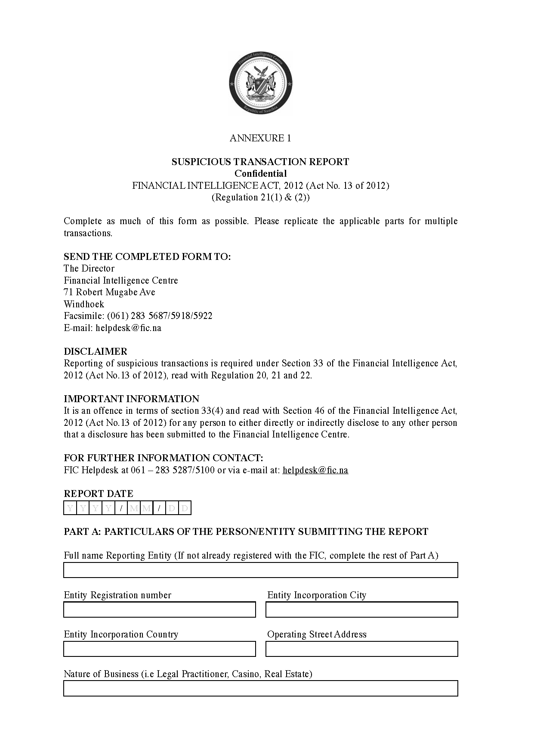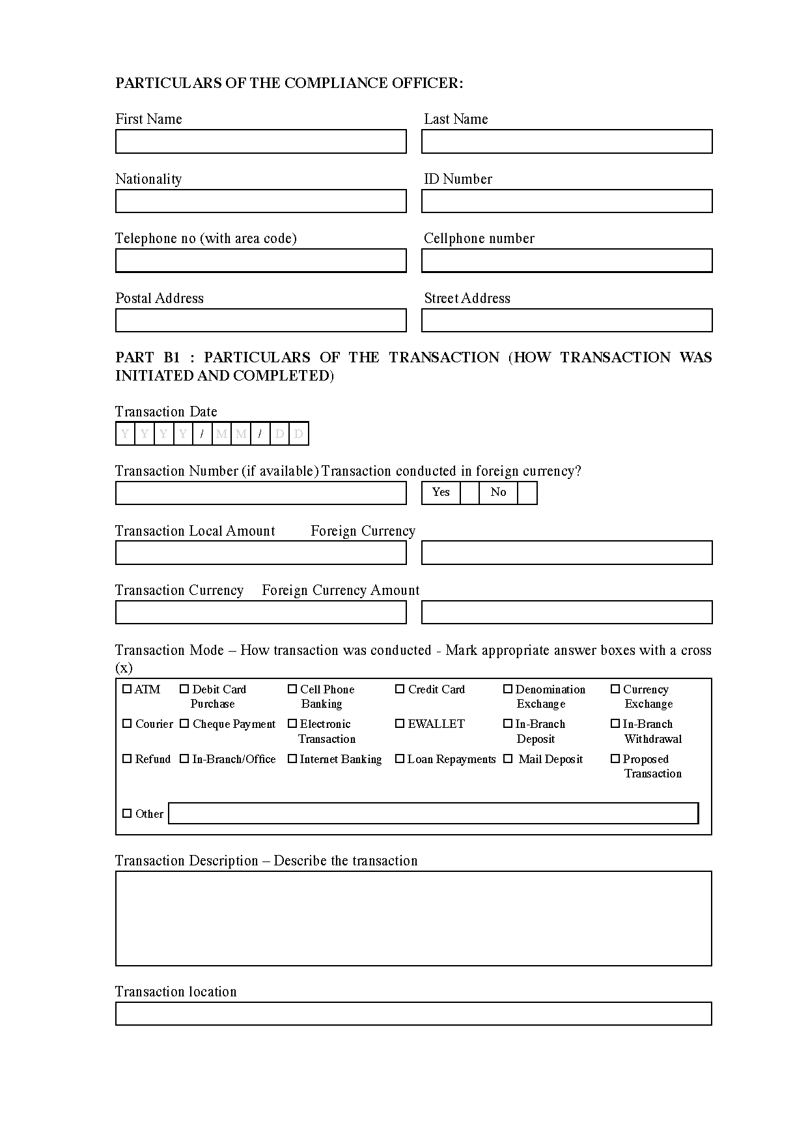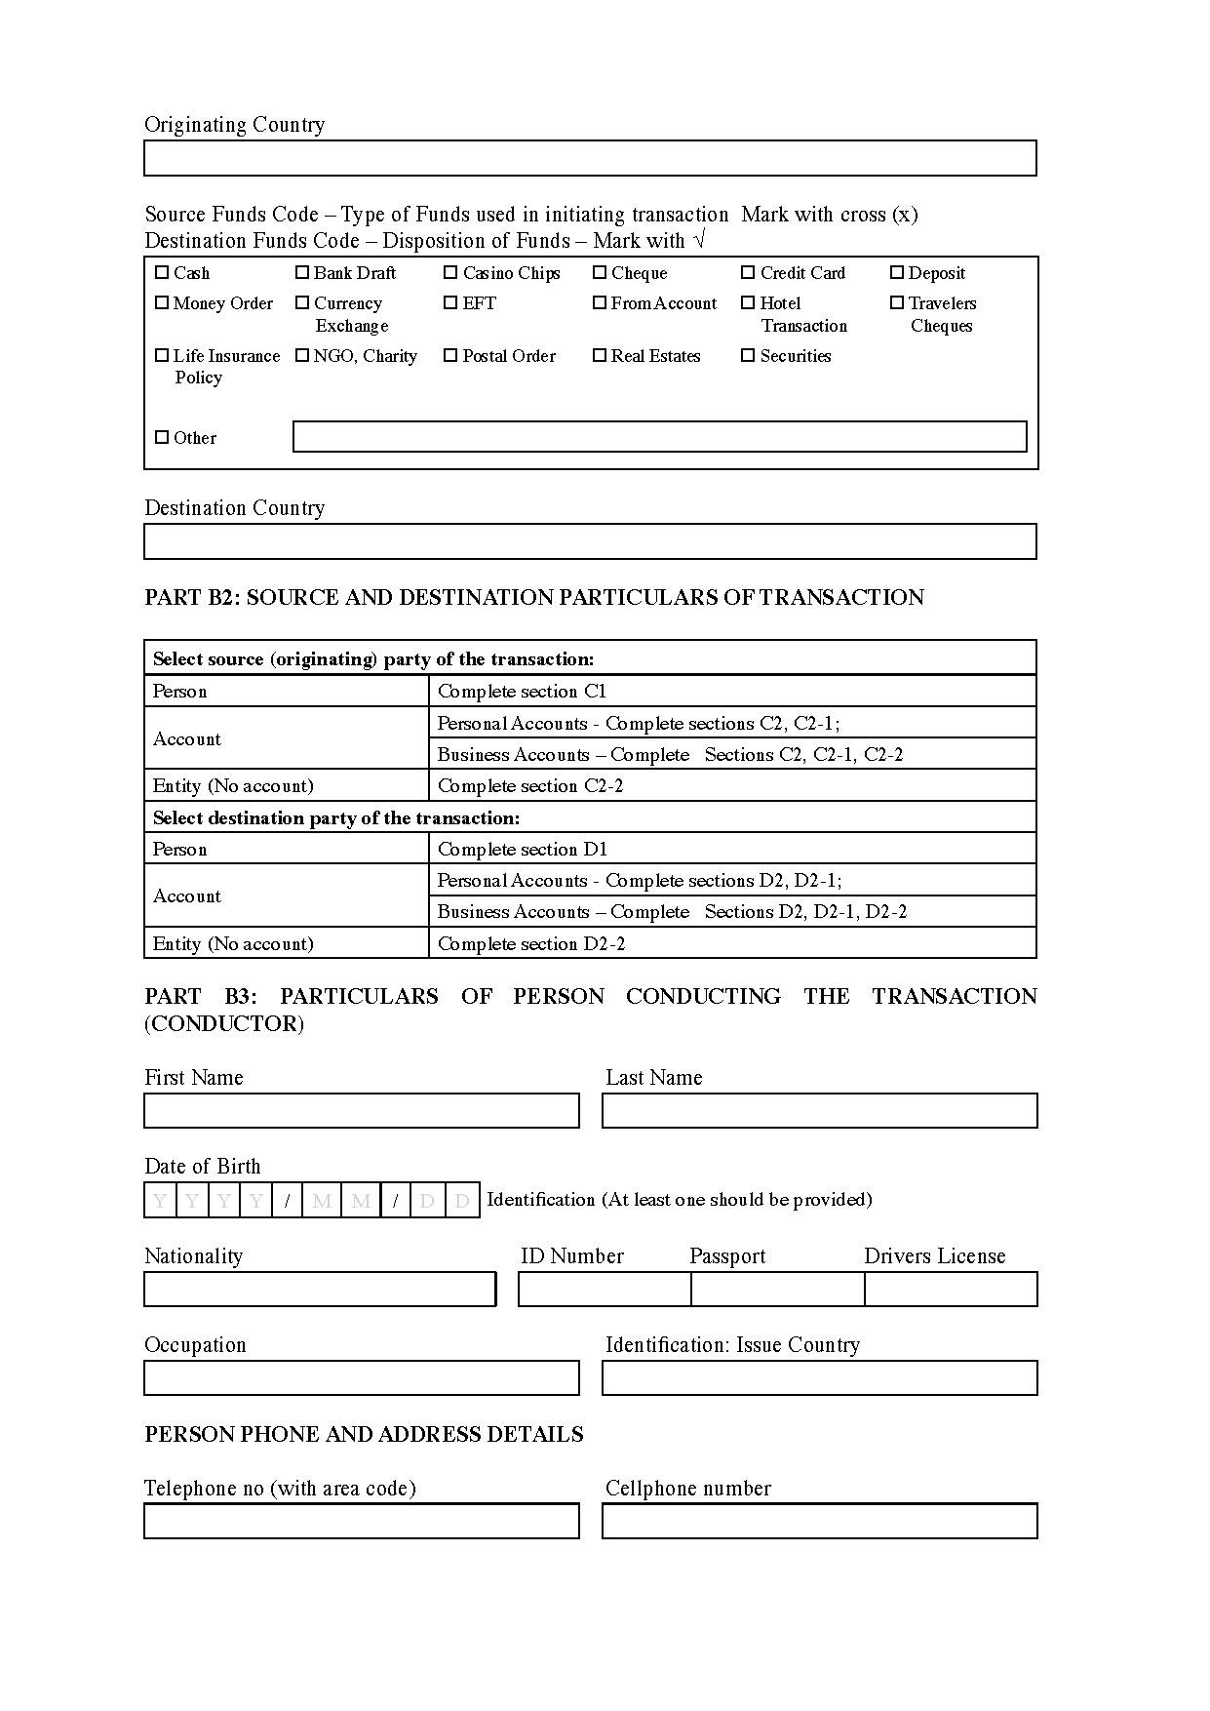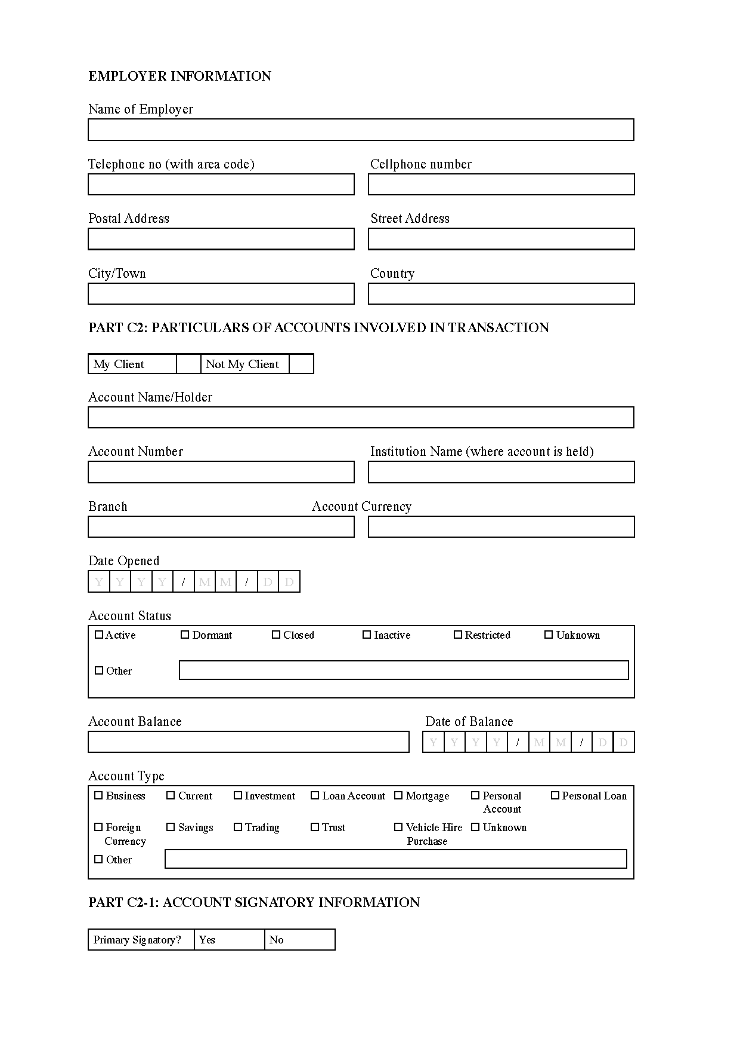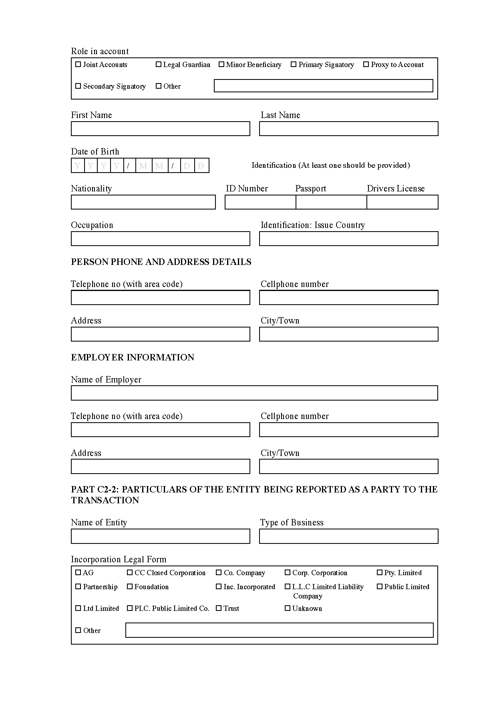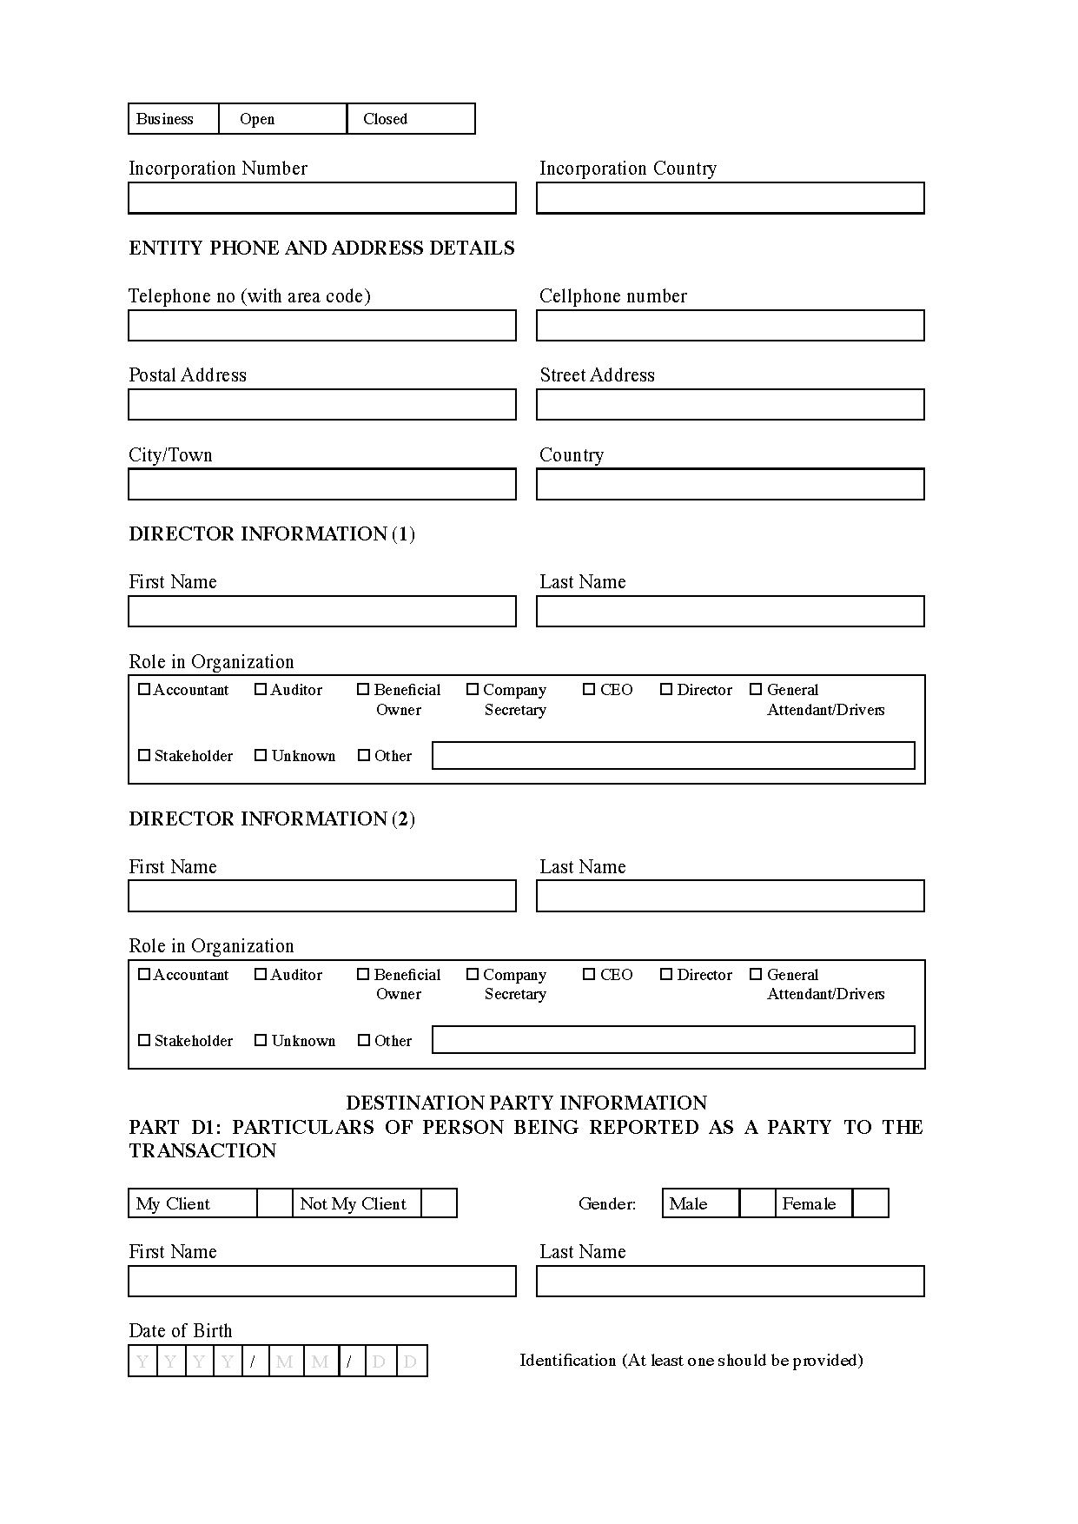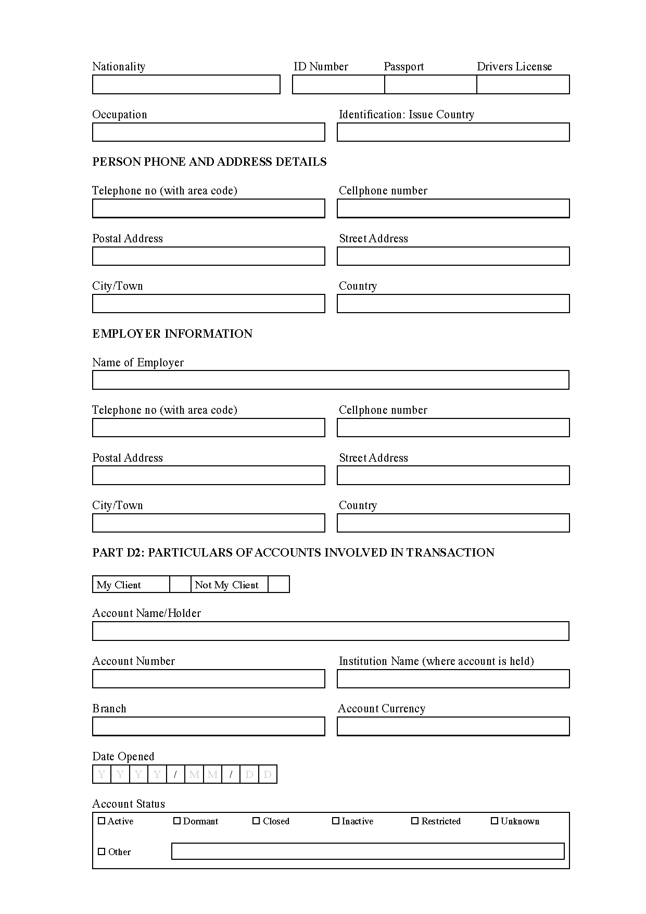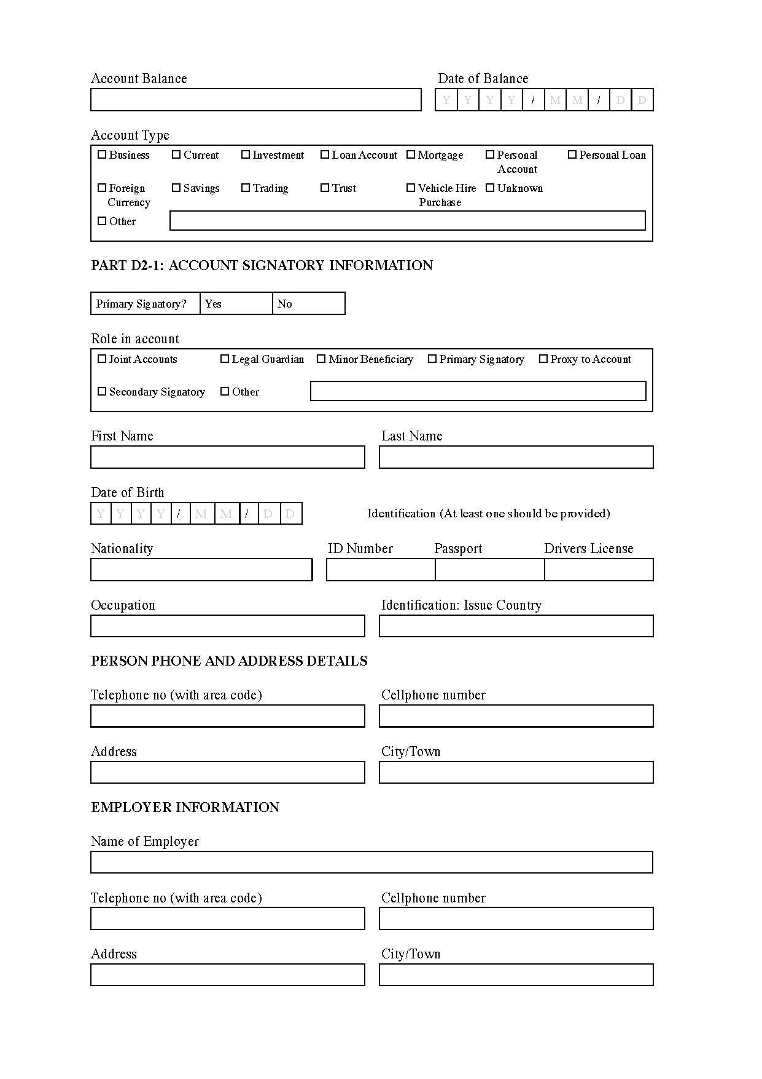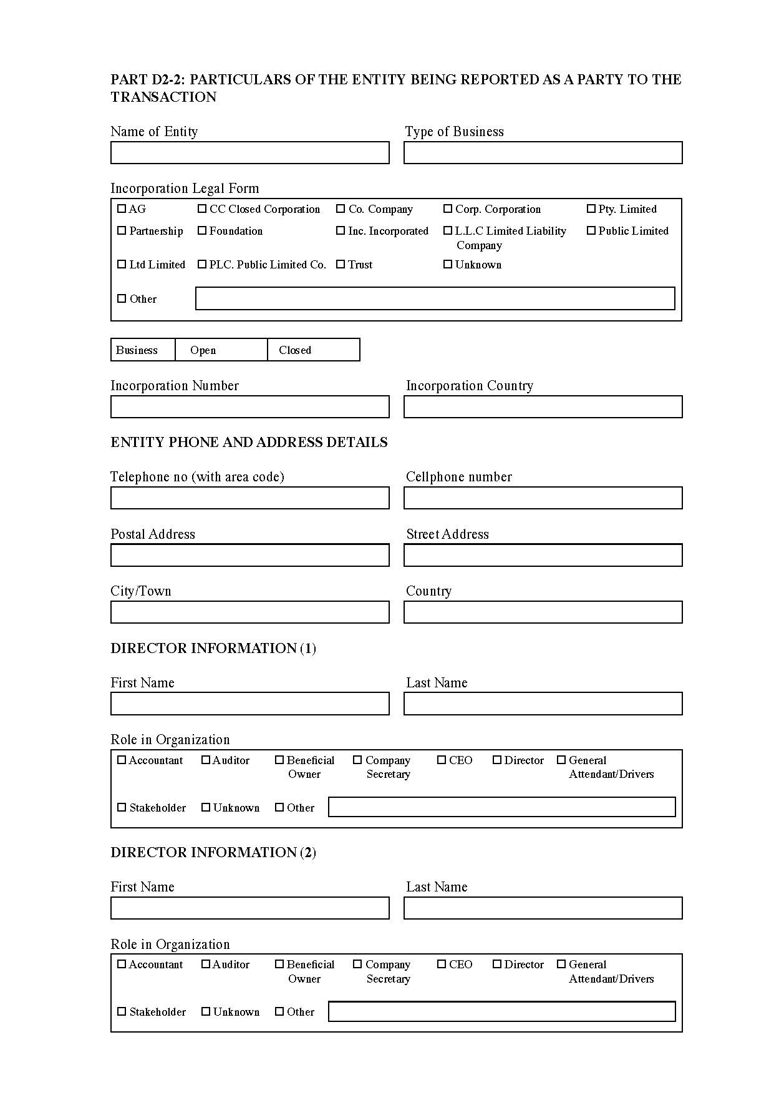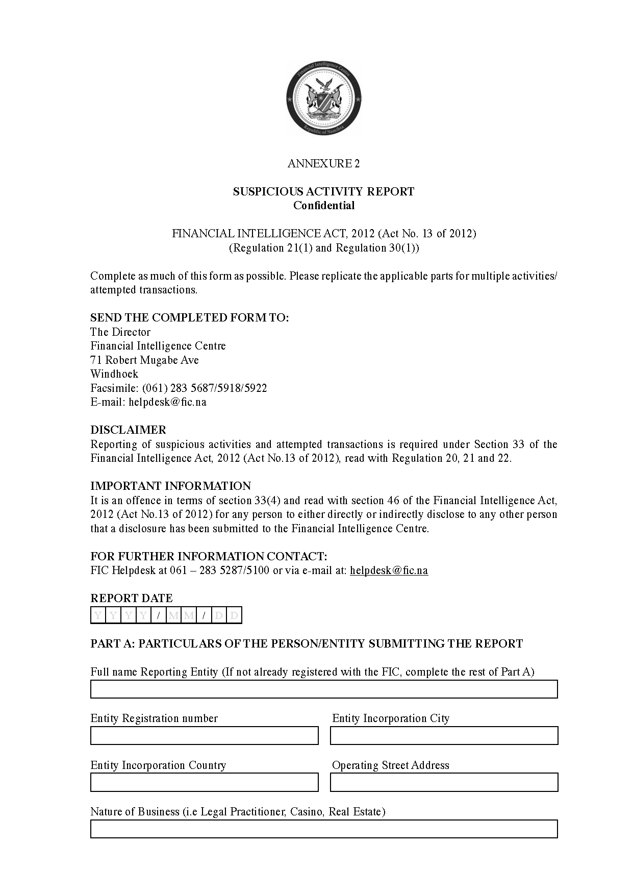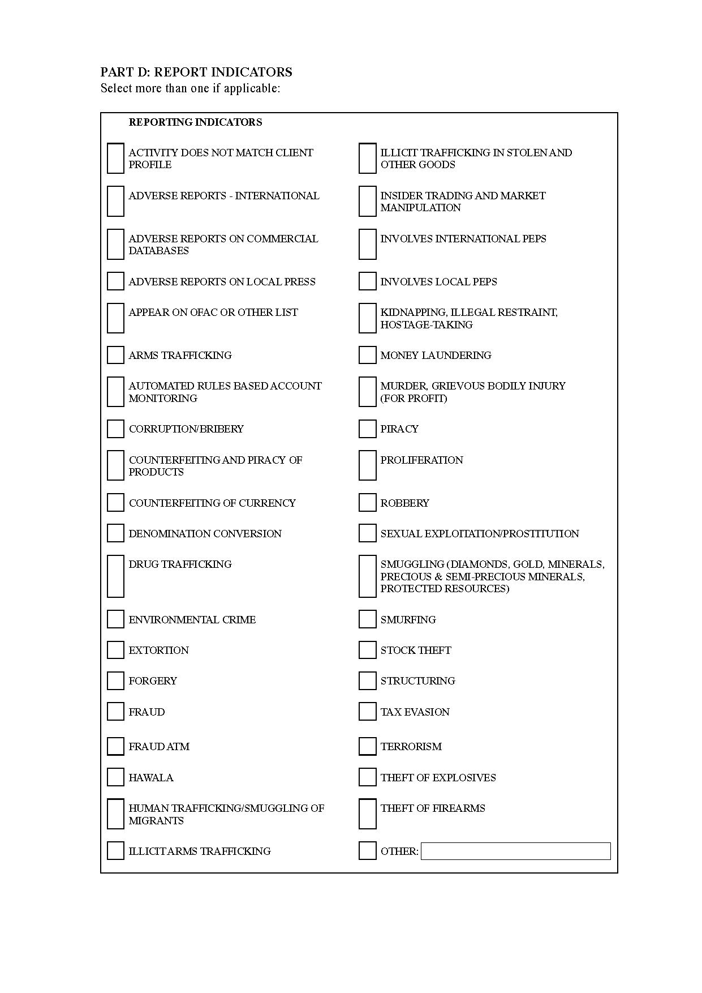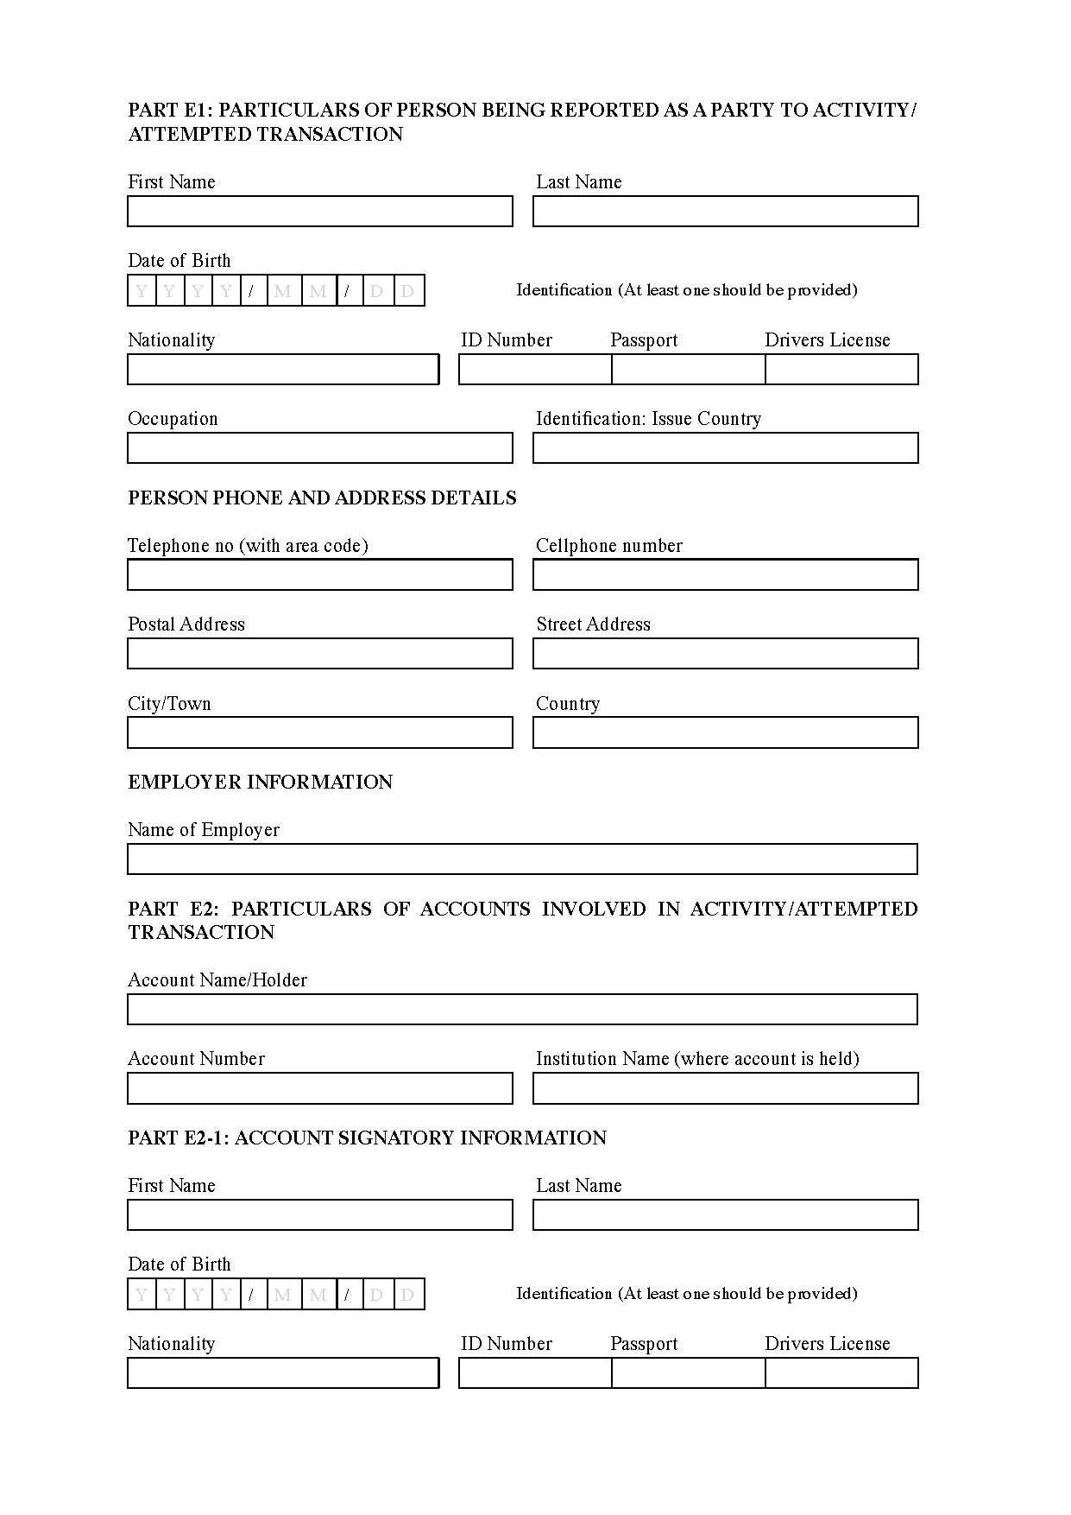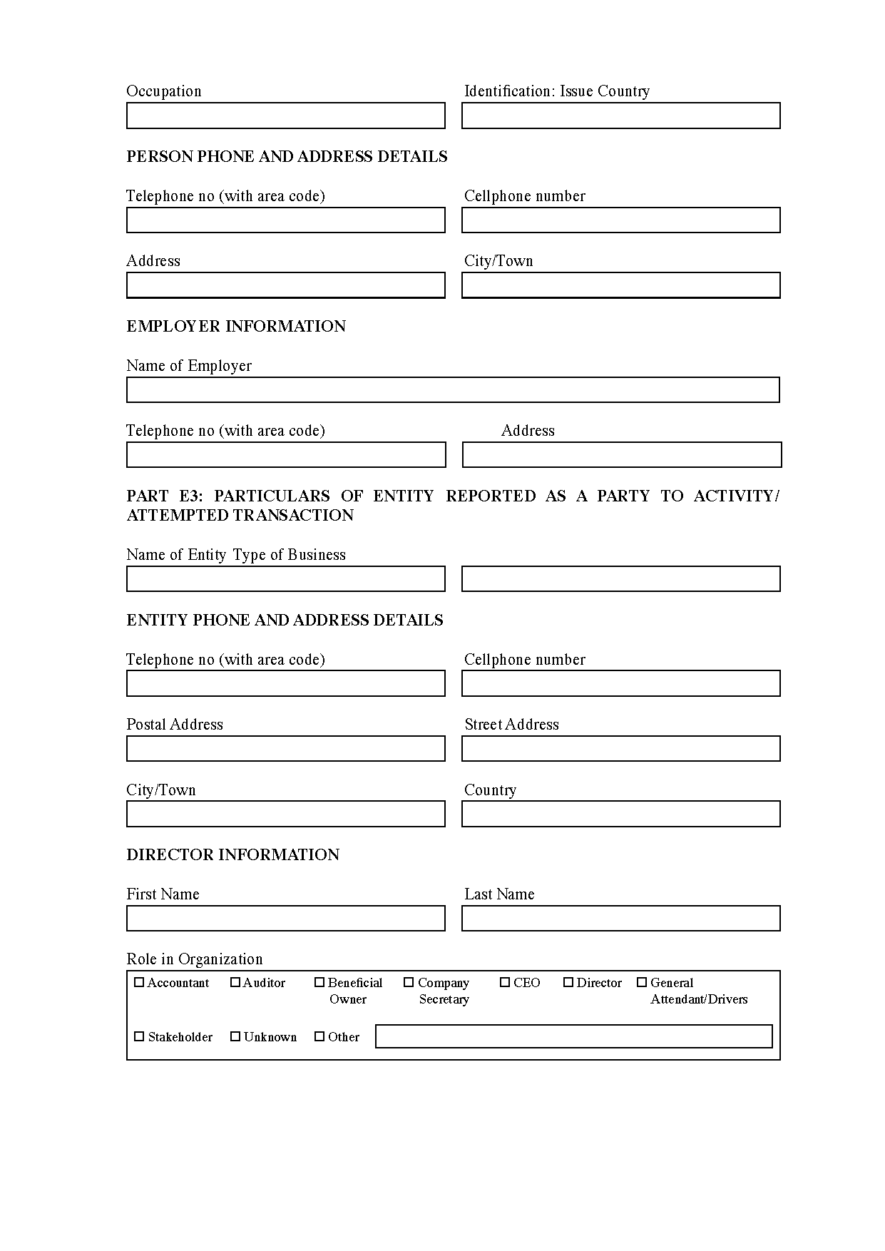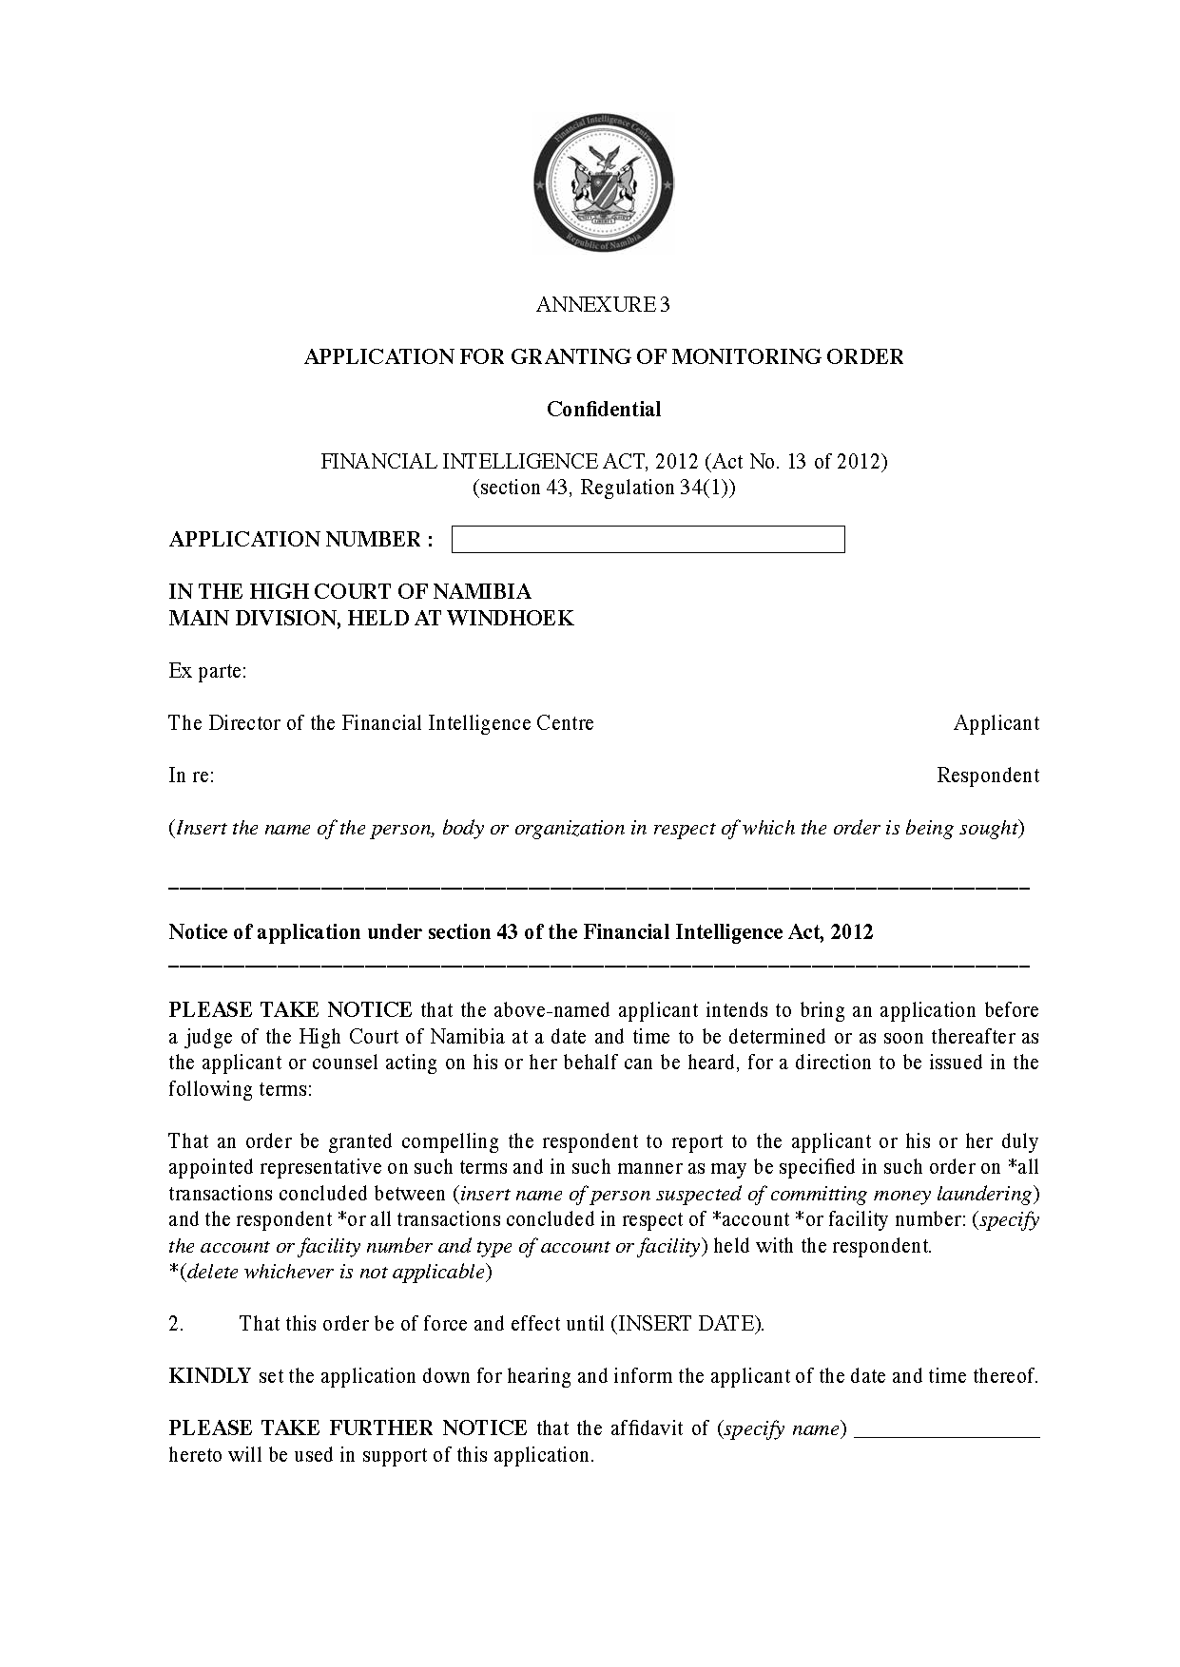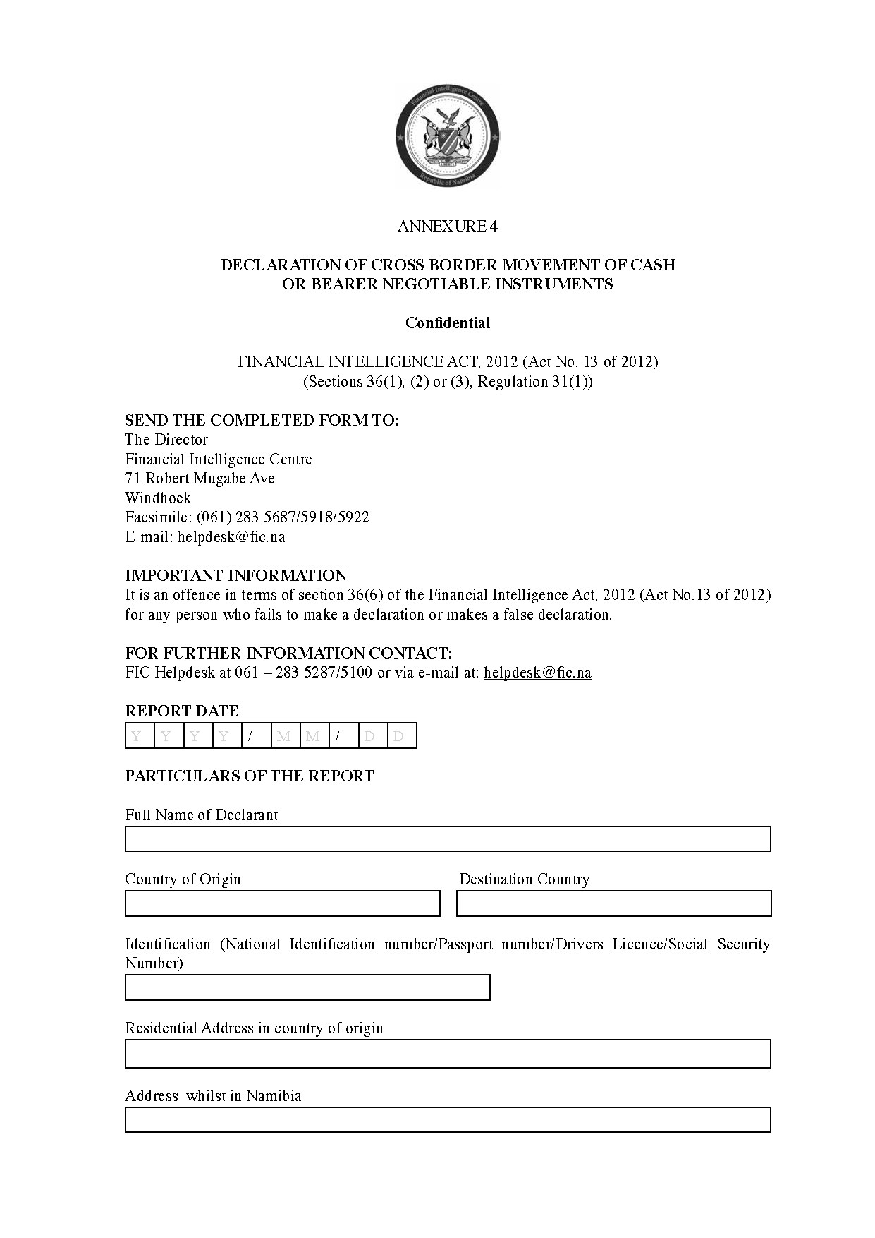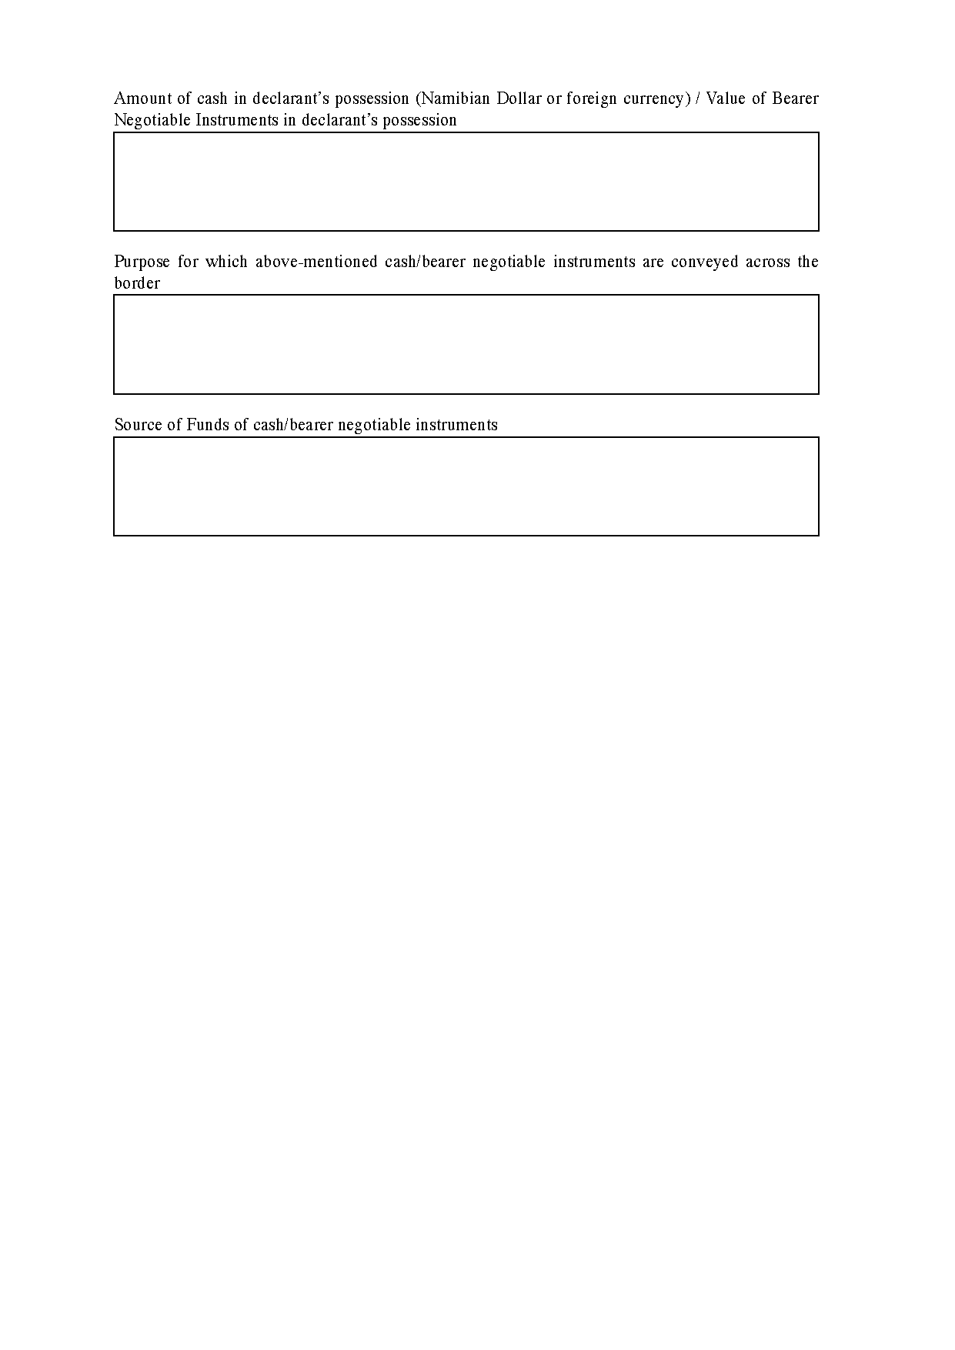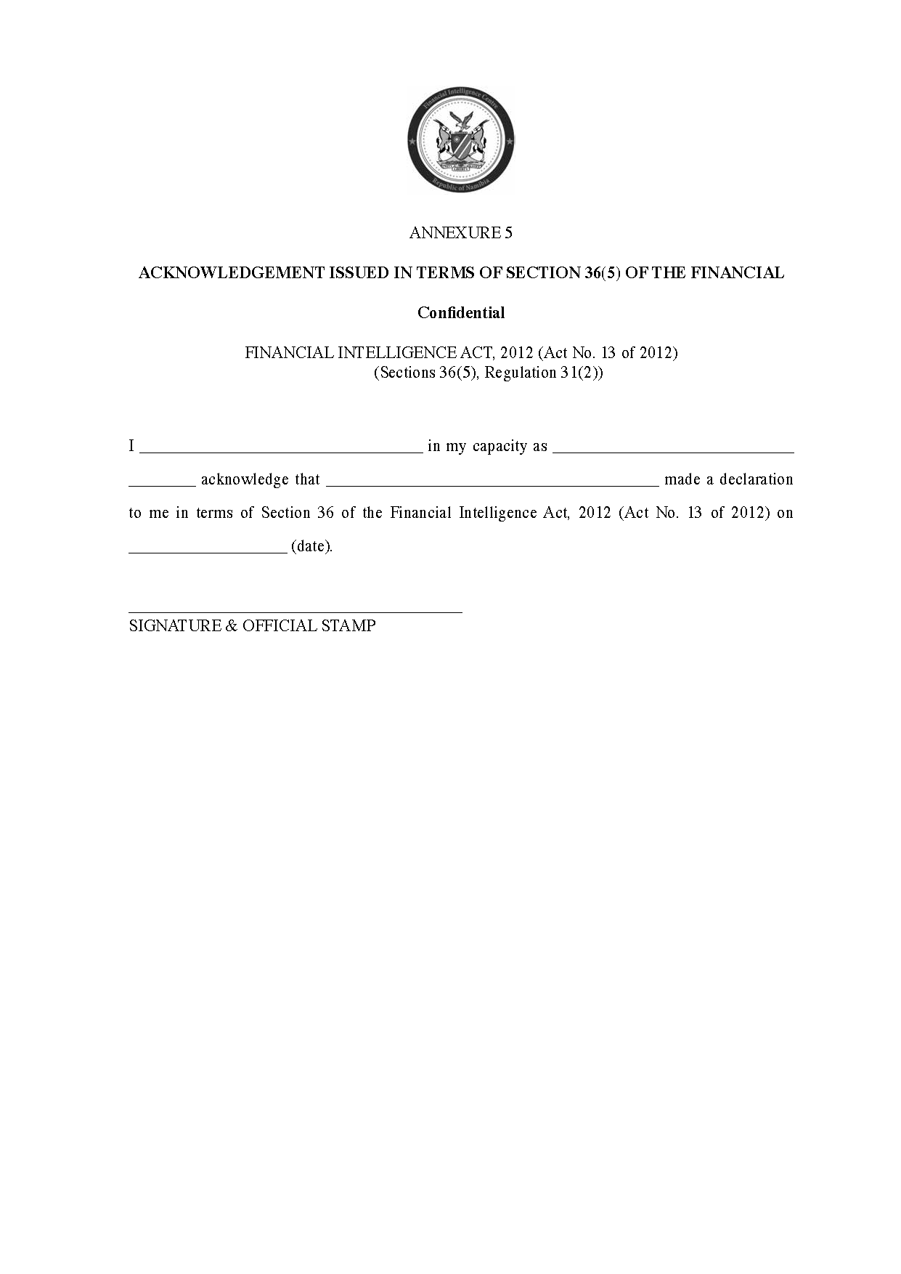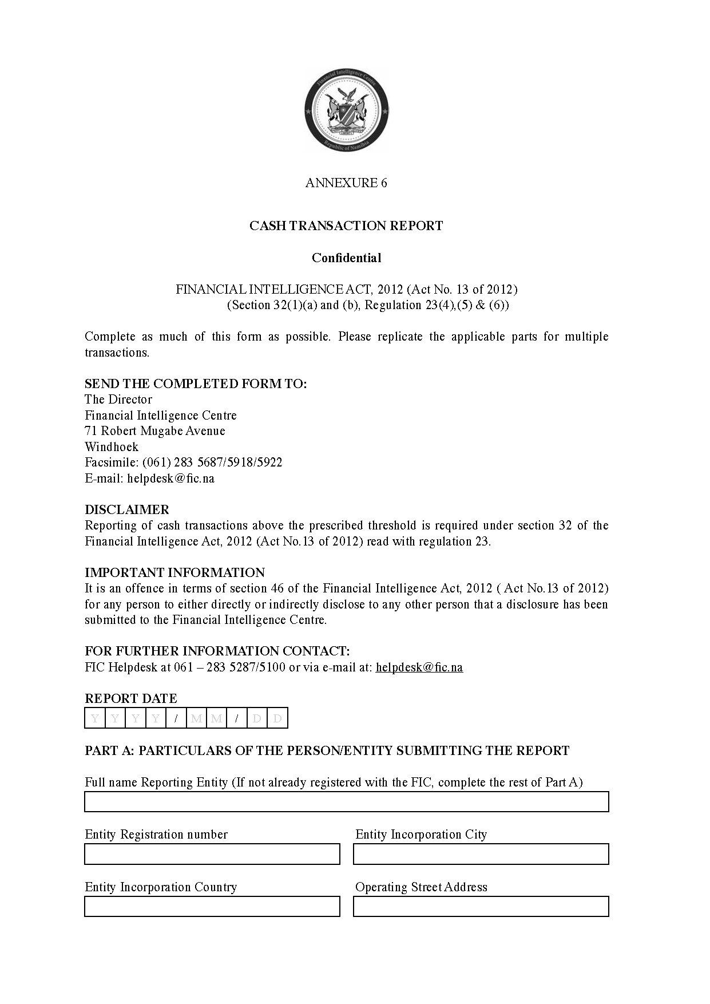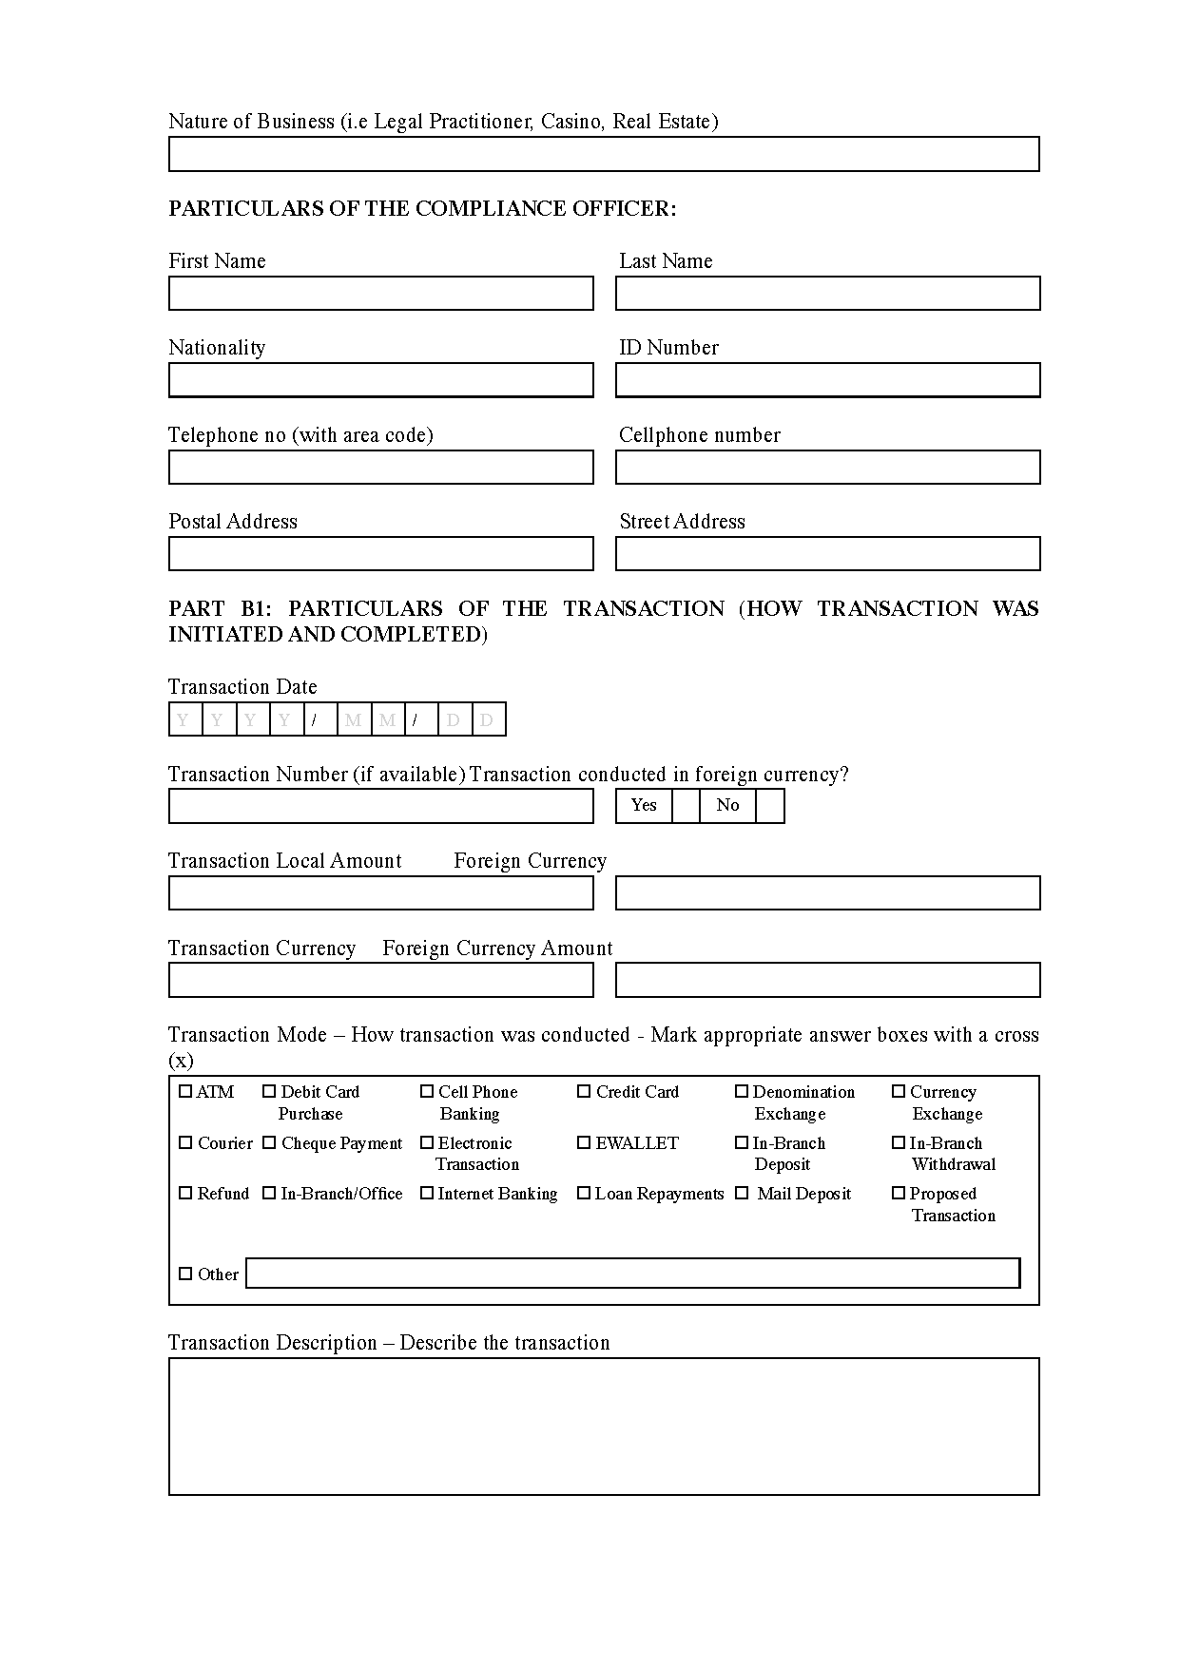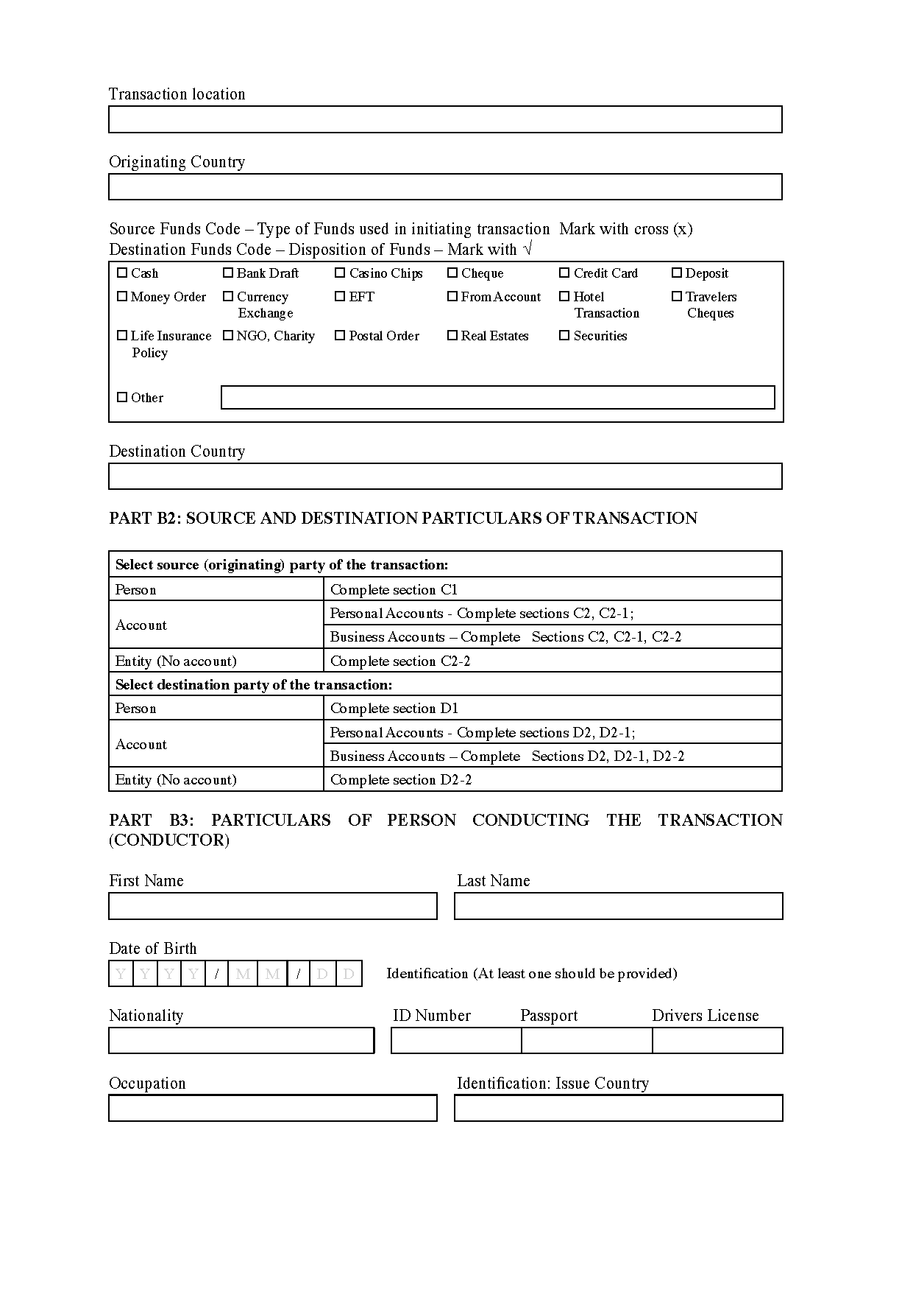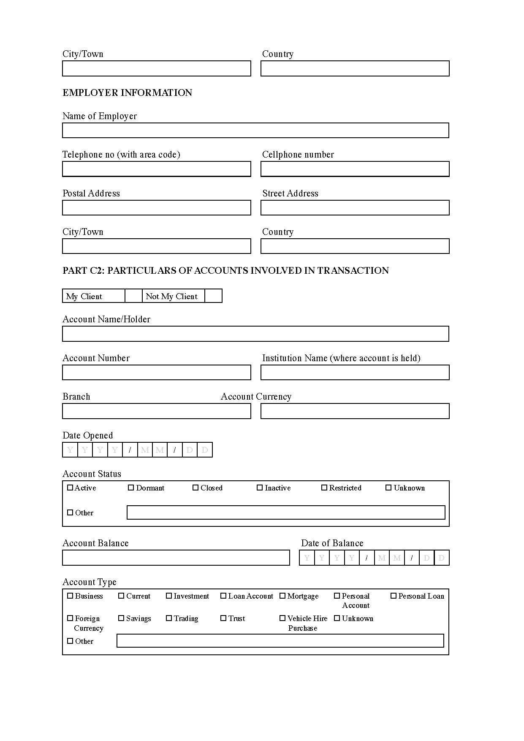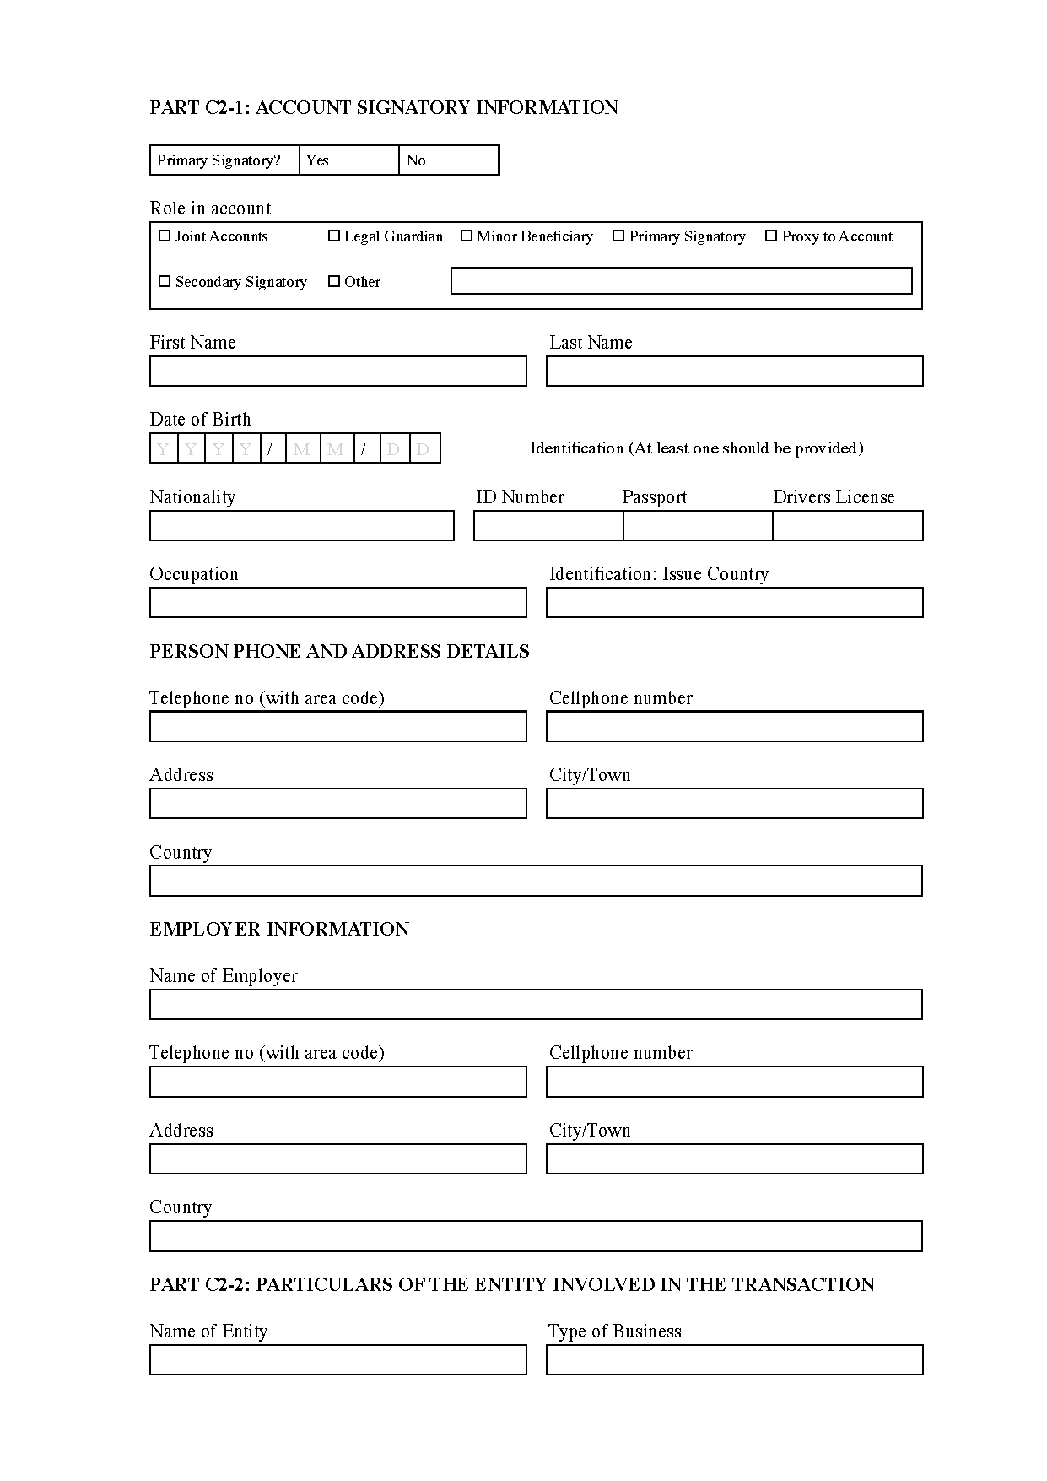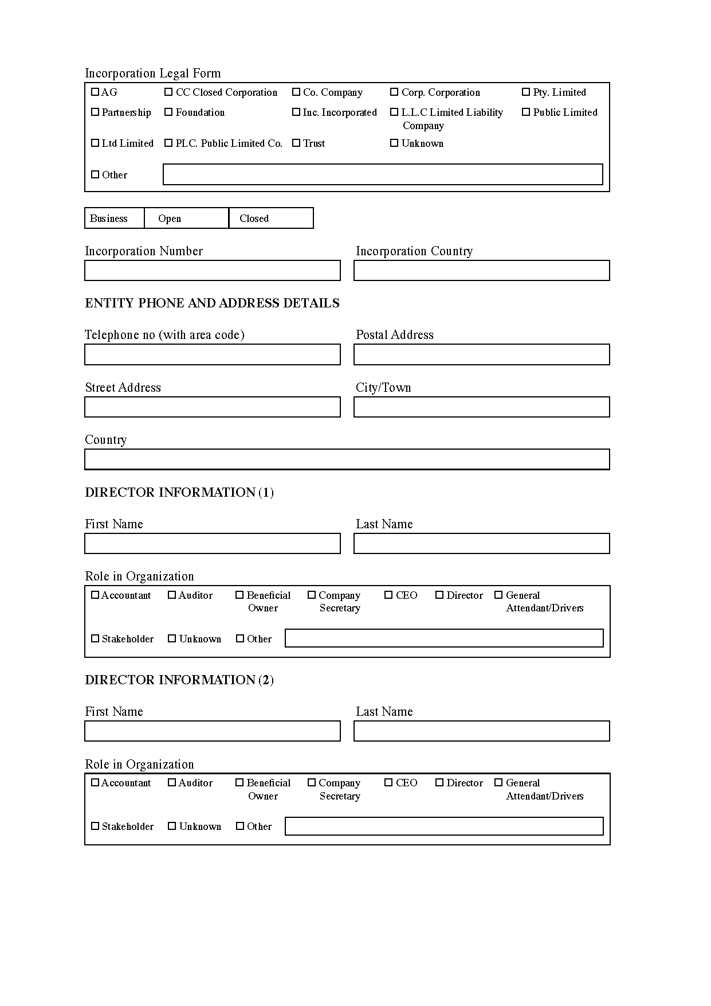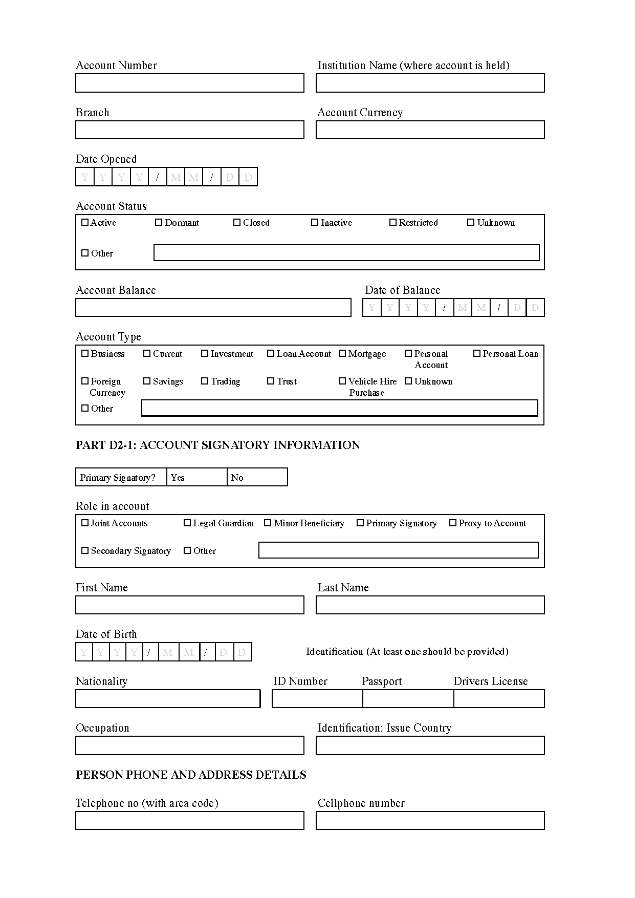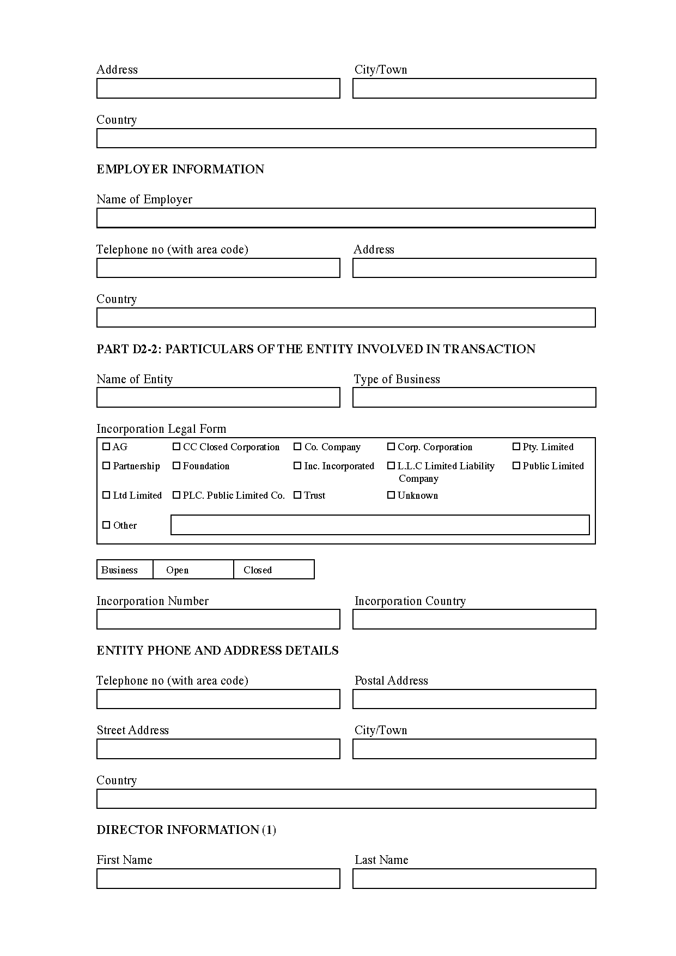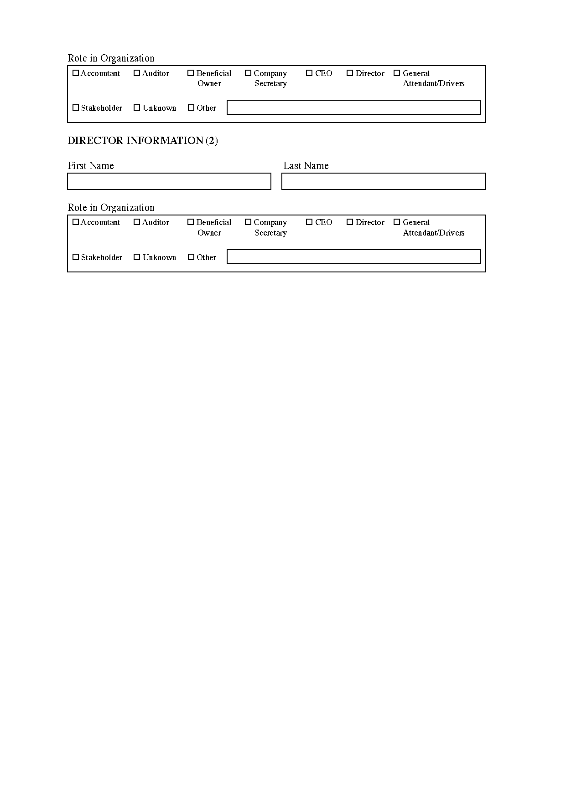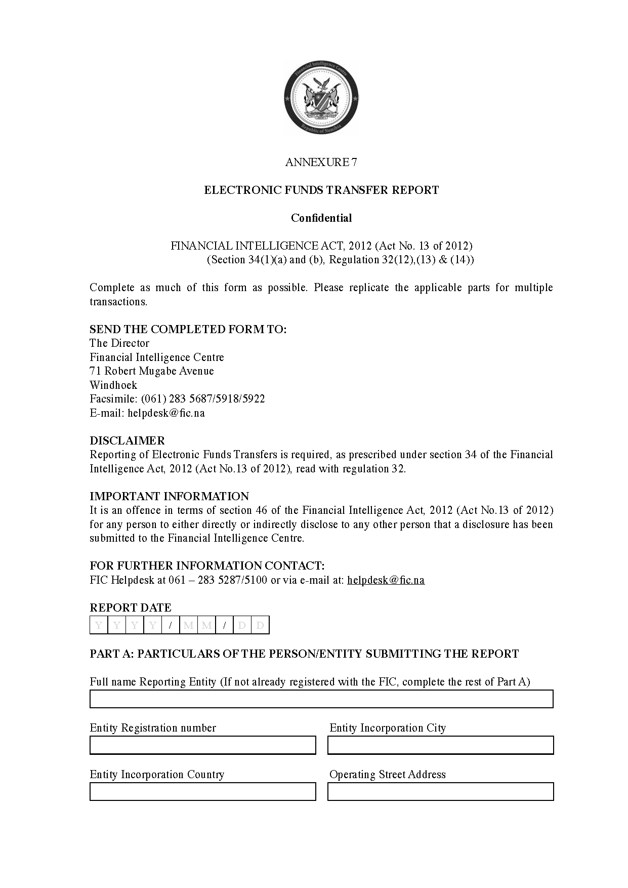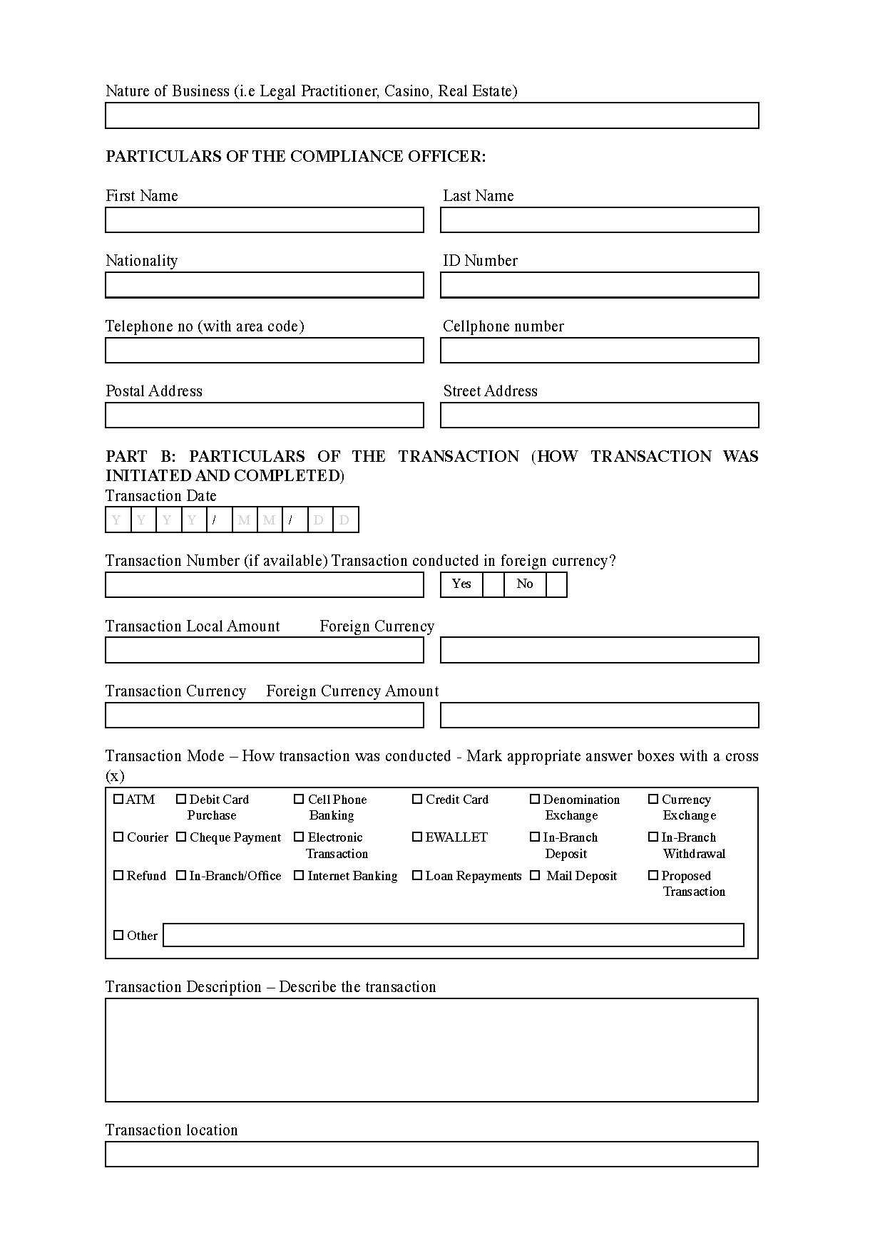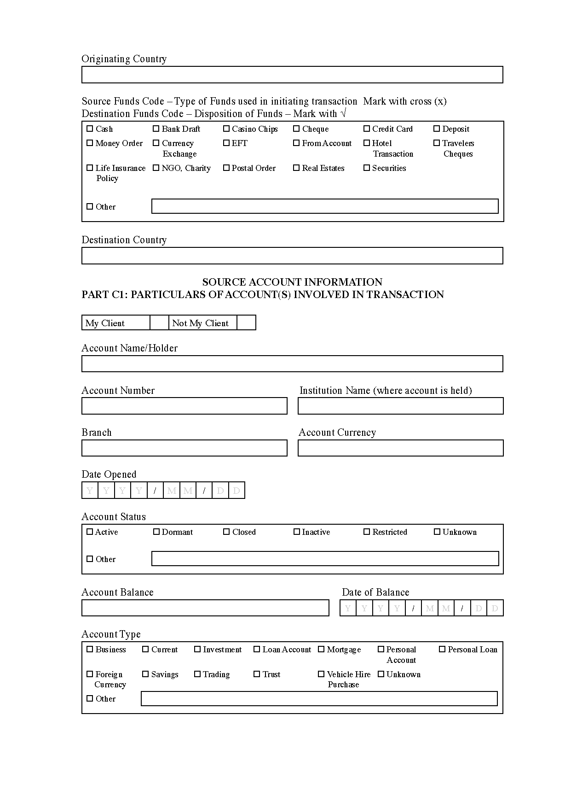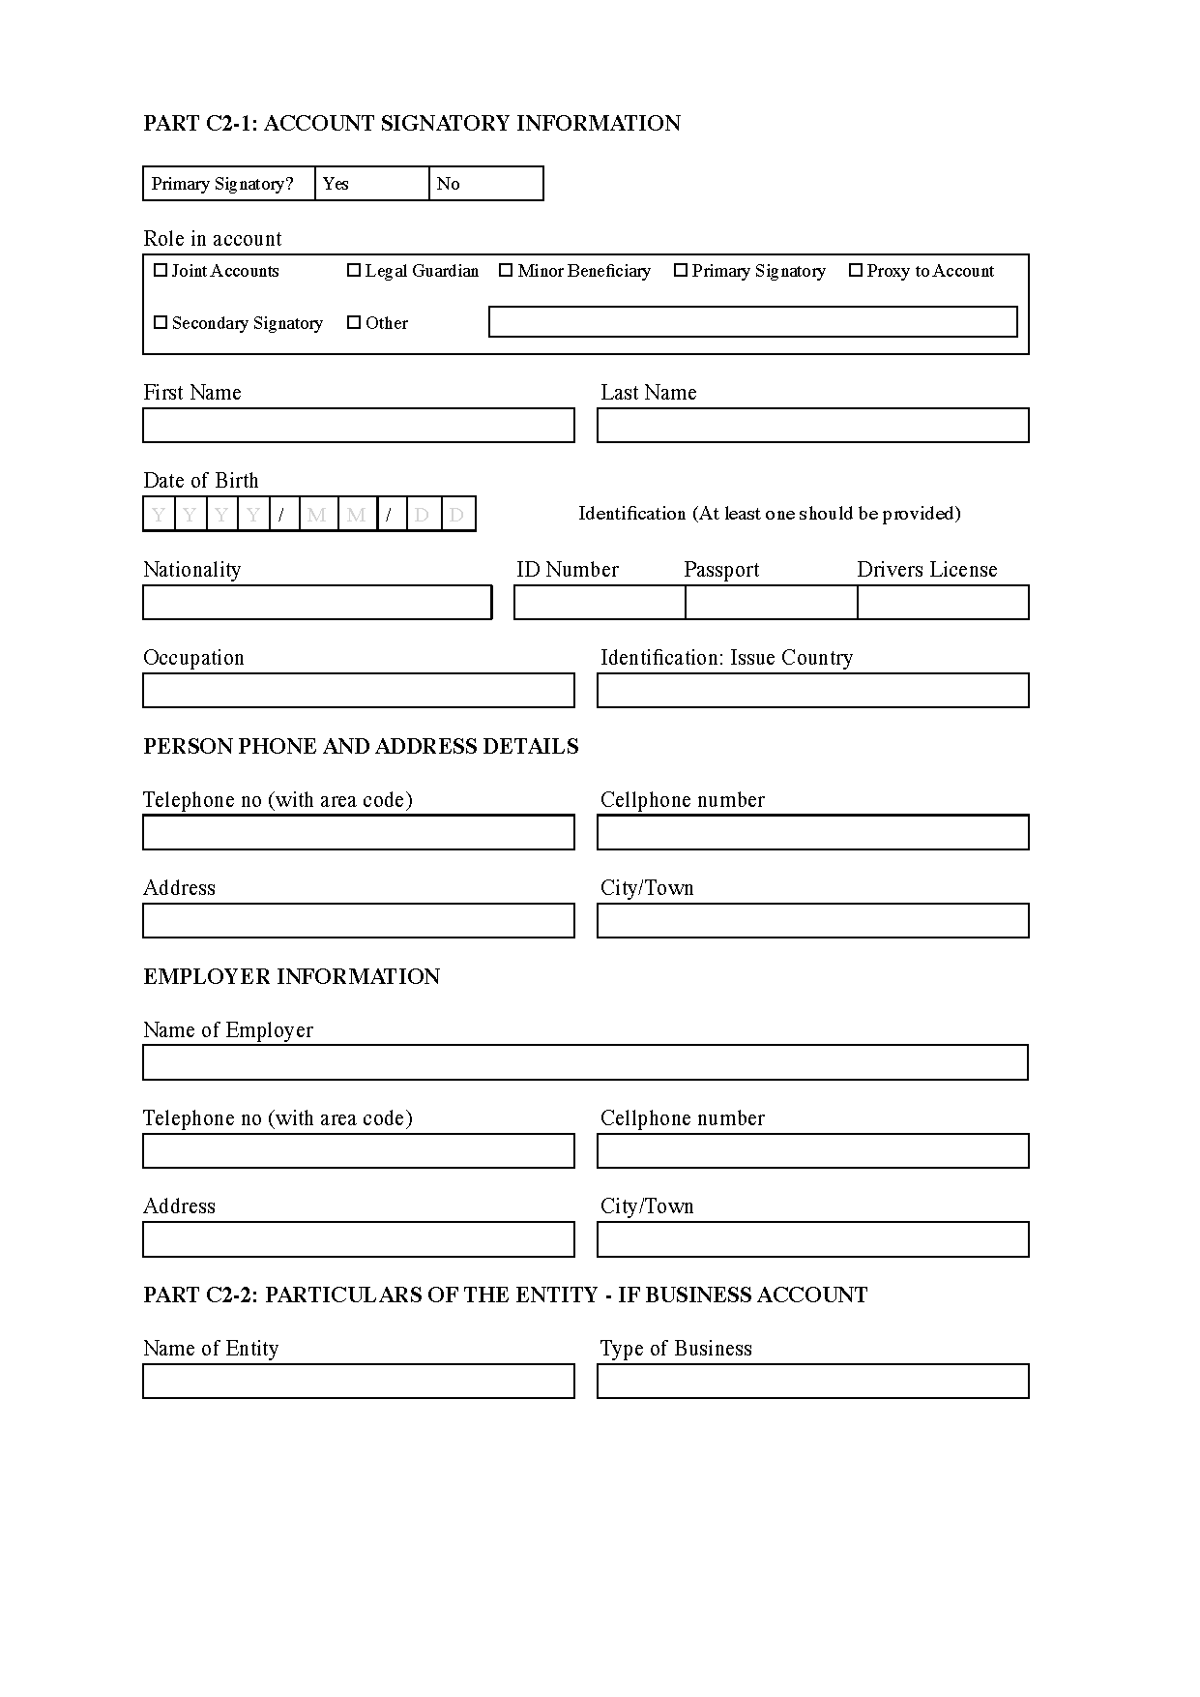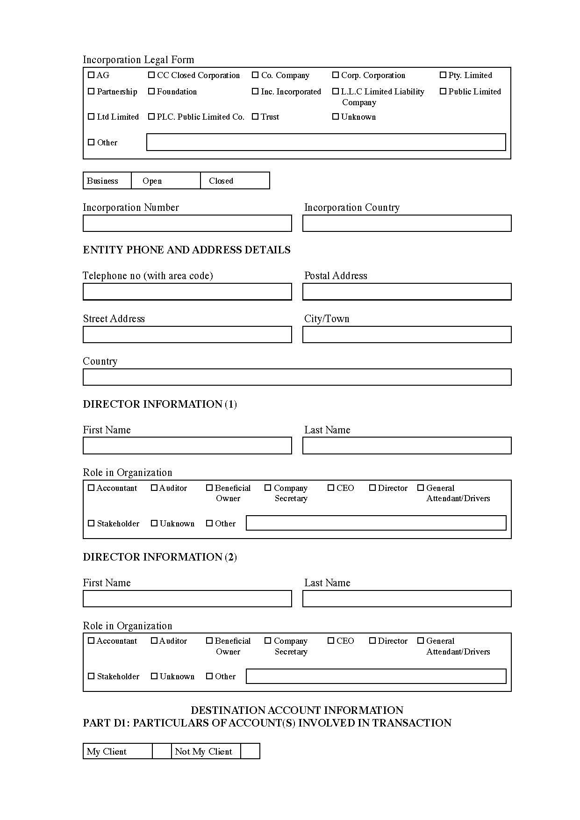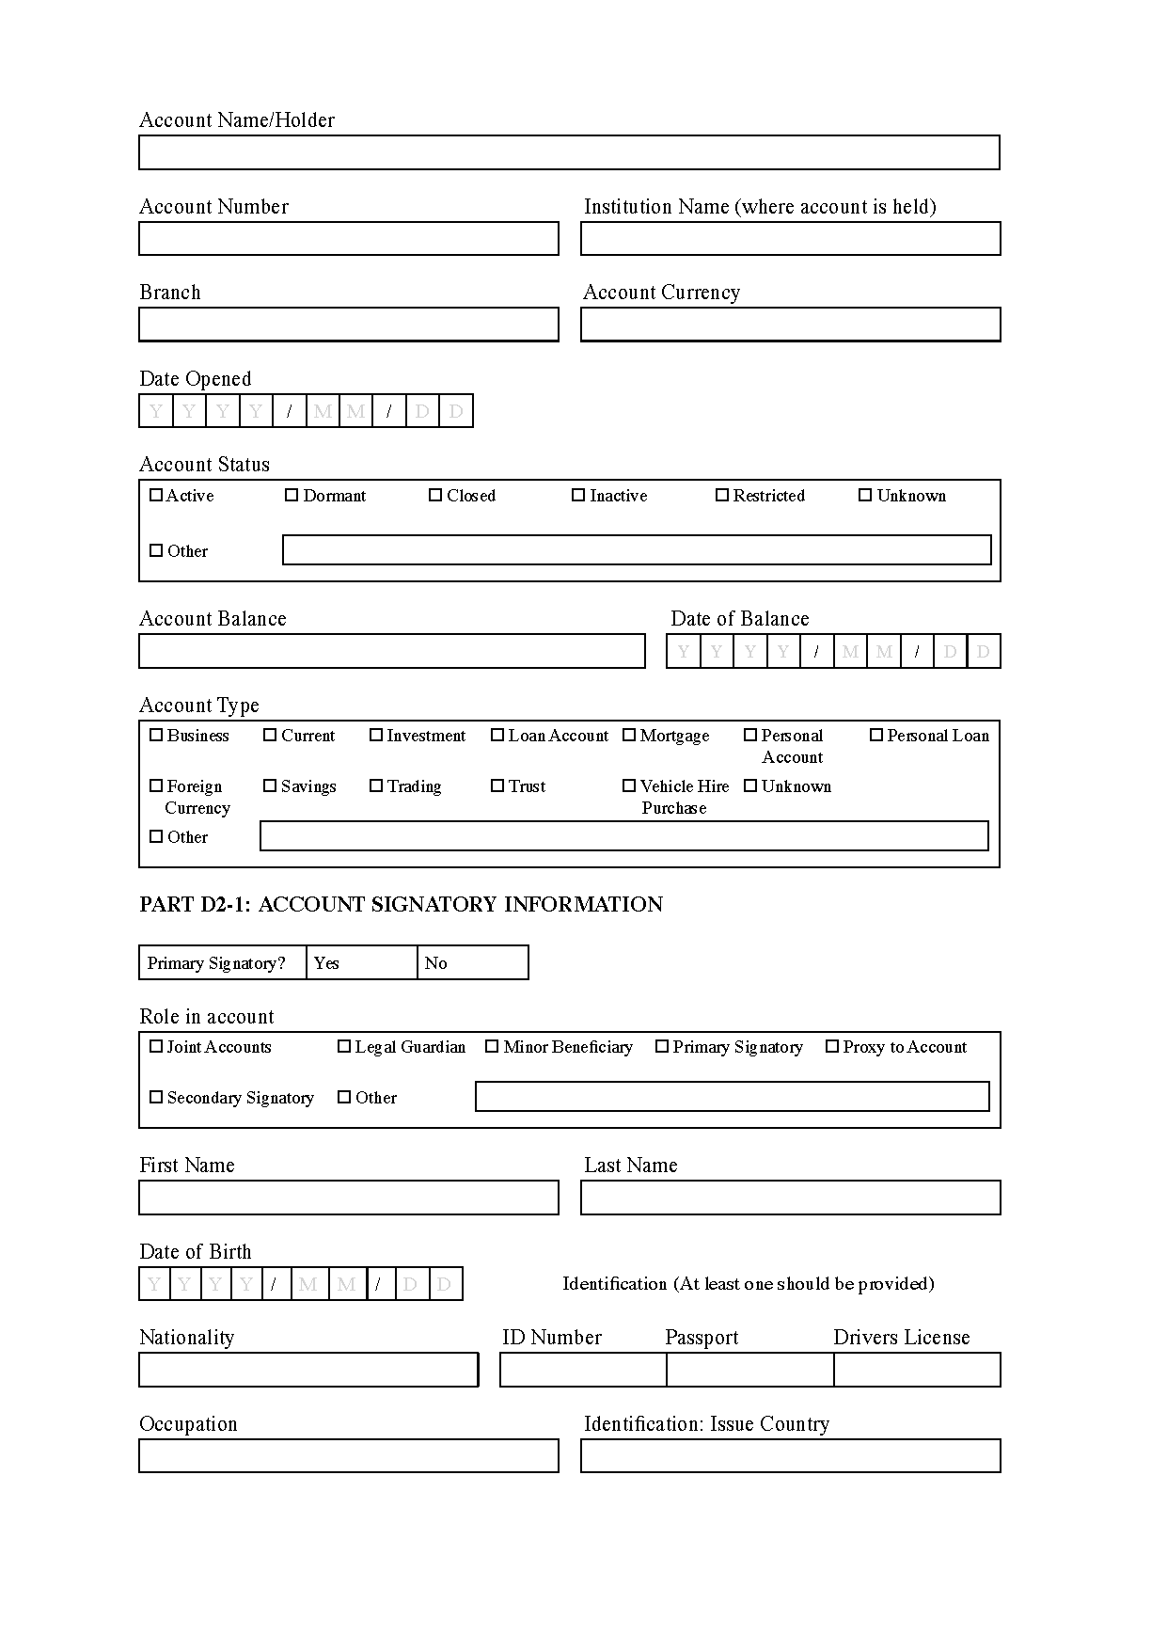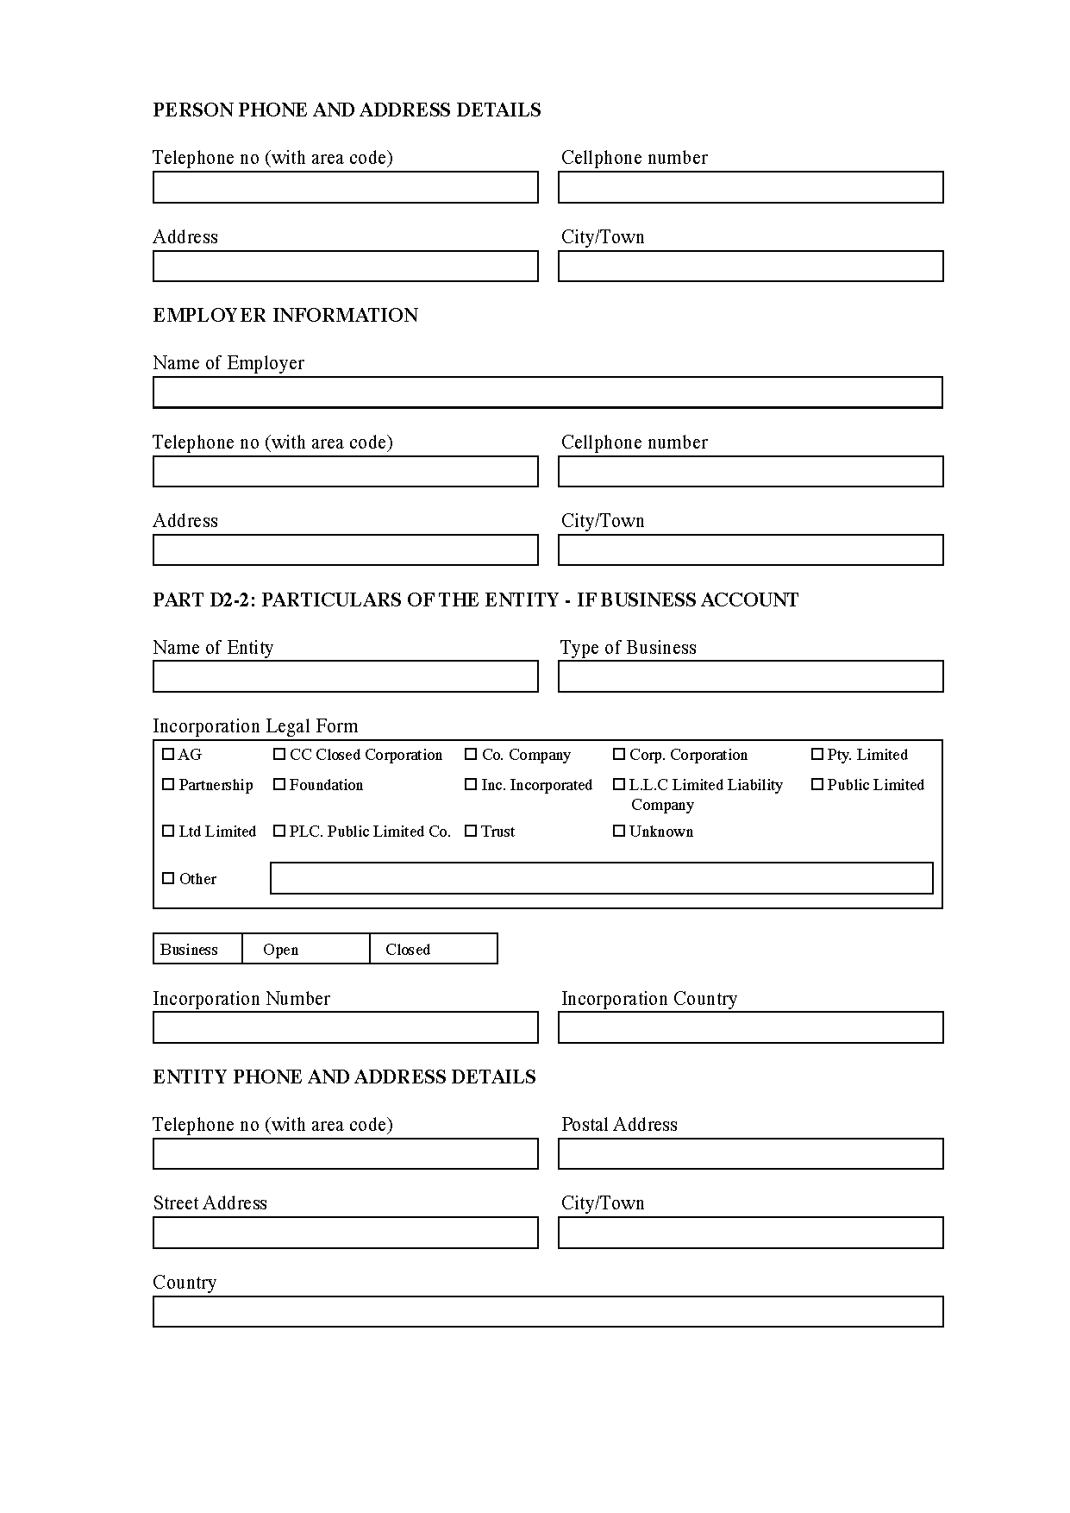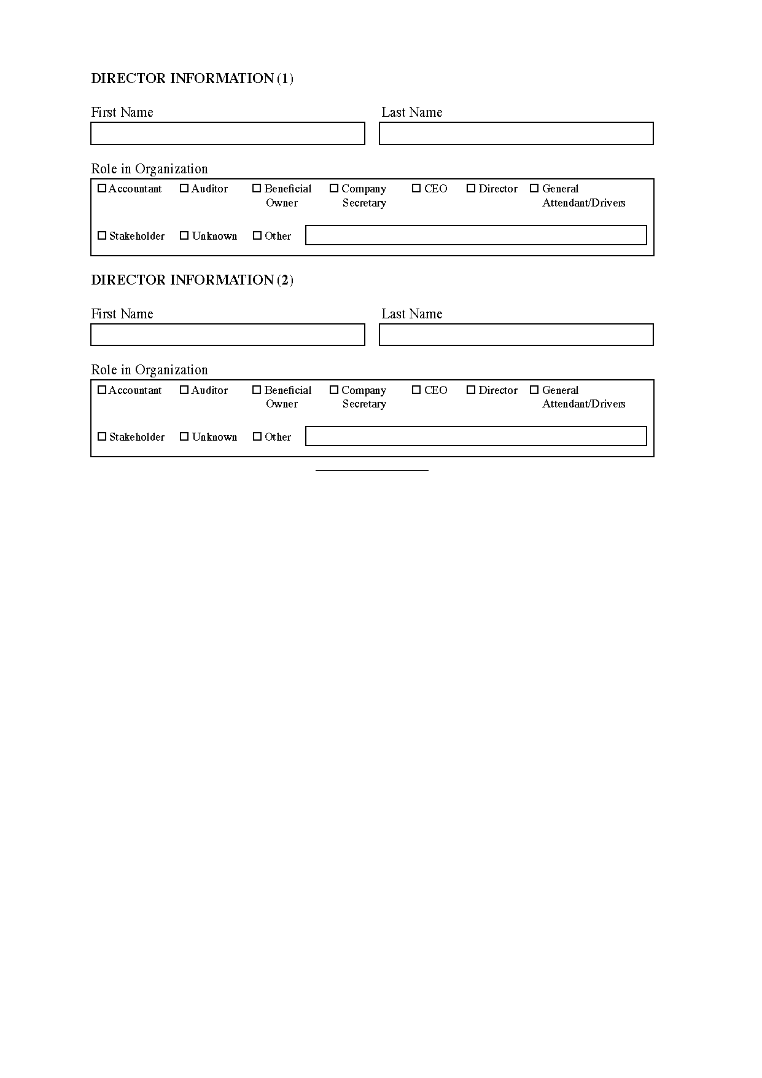

[Annexures 8-10 are inserted by GN 48/2021.]