REGULATIONS MADE IN TERMS OF

Diamond Act 13 of 1999
section 69

Diamond Regulations
Government Notice 84 of 2000
(GG 2300)
came into force on 1 April 2000 (GN 84/2000)

as amended by

Government Notice 104 of 2003 (GG 2984)
came into force on date of publication: 27 May 2003
Note that GN 104/2003 incorrectly indicates that it is amending the regulations in Government Notice 83 of
31 March 2000. GN 83/2000 was published in the same Government Gazette as the regulations, but
was the preceding notice which brought the Diamond Act 13 of 1999 into force.
GN 104/2003 obviously intended to amend the regulations published in GN 84/2000.

ARRANGEMENT OF REGULATIONS

1. Definitions
2. Application for licence
3. Issue of licence
4. Fees for licences
5. Application for permit
6. Issue of permit
6A. Conditions for valuation and release of unpolished diamonds for export
6B. Conditions for import of unpolished diamonds
6C. Power of Minister with regard to unpolished diamond suspected of being exported or imported contrary to law
7. Fees for permits
8. Certificate of approval of premises
9. Application for registration of authorized representative
10. Issue of certificate of registration as authorized representative
11. Registers in respect of unpolished diamonds
12. Notes of receipt or purchase in respect of unpolished diamonds
13. Security check of persons employed or engaged in activities related to unpolished diamonds
14. Records of employees, contractors and sub-contractors
15. Documents required by persons who carry or transport unpolished diamonds
16. Security plan
17. Records to be kept by cutter
18. Registration of diamond prospecting or mining vessels
19. Export of polished diamonds
20. Search of animals

ANNEXURE A
ANNEXURE B

Definitions

1. In these regulations “the Act” means the Diamond Act, 1999 (Act 13 of 1999), and any word or expression to which a meaning has been assigned in the Act shall bear the meaning so assigned to it.

[The definitions below were all “added” to regulation 1 by GN 4/2003. There were no other directions in the amendment about how to incorporate them into regulation 1.]

“consignment” means one or more packets or parcels of unpolished diamonds that are placed in a tamper-resistant container and are exported or imported;

“export” means the taking out of Namibia in any manner;

“import” means the bringing into Namibia in any manner;

“Kimberley Process” means the international forum of diamond producing and trading countries, the diamond industry and civil society wherein representatives have negotiated the international certification scheme for the international trade in unpolished diamonds;

“Kimberley Process Certificate” means a forgery resistant document in a particular format which identifies a consignment of unpolished diamonds as being in compliance with the requirements of the Kimberley Process Certification Scheme, and which -

(a) in relation to a consignment of unpolished diamonds exported from Namibia, is issued and validated by the Namibian Exporting Authority; and

(b) in relation to a consignment of unpolished diamonds imported into Namibia, is issued and validated by a Participant’s Exporting Authority;

“Kimberley Process Certification Scheme” means the International Certification Scheme for the international trade in unpolished diamonds negotiated in the Kimberley Process;

“Namibian Exporting Authority”, means the Minister or a person or body designated by the Minister to issue and validate a Kimberley Process Certificate which is required to accompany a consignment of unpolished diamonds exported from Namibia to a Participant;

“Namibian Importing Authority” means the Minister or a person or body designated by the Minister to verify a Kimberley Process Certificate accompanying a consignment of unpolished diamonds imported into Namibia from the country or territory of a Participant;

“parcel” means one or more unpolished diamonds that are packed together, that are not individualized, and which may contain unpolished diamonds from two or more countries of origin, and has the same meaning as packet;

“Participant” means any state or a regional economic integration organisation enforcing the Kimberley Process Certification Scheme;

“Participant’s Exporting Authority” means the authority or body designated by a Participant as Exporting Authority to issue and validate a Kimberley Process Certificate in respect of unpolished diamonds exported from that country or territory to a Participant;

“Regional Economic Integration Organisation” means an organisation comprised of sovereign states that have transferred competence to that organisation in respect of matters governed by the Kimberley Process Certification Scheme.

Application for licence

2. An application for a licence in terms of section 16 of the Act shall be substantially in the form as set out in Form I of Annexure A.

Issue of licence

3. A licence issued in terms of section 17 of the Act shall be issued substantially in the form as set out in Form 2 of Annexure A.

Fees for licences

4. (1) An application for a licence in terms of section 16 of the Act shall be accompanied by a non-refundable fee as set out in Annexure B.

(2) The fee payable in respect of the issue of a diamond cutting licence, a diamond tool-making licence or a diamond research licence shall be a fee as set out in Annexure B, payable not later than the date of issue thereof, and annually thereafter not later than the anniversary of the date of issue.

(3) The fee payable in respect of the issue of a diamond dealer’s licence shall be a fee as set out in Annexure B, payable not later than the date of issue thereof, and annually thereafter not later than the anniversary of the date of issue.

Application for permit

5. (1) An application in terms of section 28 of the Act for a perm it referred to in section 27(a),(b),(c),(d),(e),(f),(g),(h),(i) or (j) of the Act shall be substantially in the form as set out in Form 3 of Annexure A.

(2) An application in terms of section 28 of the Act for a permit referred to in section 27(k) of the Act shall be substantially in the form as set out in Form 4 of Annexure A.

Issue of permit

6. (1) A permit referred to in section 27(a), (b), (c), (d), (e), (f), (g), (h), (i) or (j) and issued in terms of section 29 of the Act shall be issued substantially in the form as set out in Form 5 of Annexure A.

(2) A permit referred to in section 27(k) and issued in terms of section 29 of the Act shall be issued substantially in the form as set out in Form 6 of Annexure A.

(3) Unless the Minister otherwise determines, a permit referred to in section 27(k) shall automatically expire -

(a) if the holder thereof is convicted of any offence under this Act;

(b) if the holder thereof is convicted of any offence in respect of any high value mineral or any controlled mineral as defined in the Minerals (Prospecting and Mining) Act;

(c) if the holder thereof is in Namibia or elsewhere under any law convicted of theft, fraud, forgery, uttering, robbery, perjury, housebreaking with intent to commit a crime, bribery or an attempt to commit any of these offences, or any other offence involving dishonesty, or any offence relating to the unlawful dealing in or possession of ivory or rhinoceros horns;

(d) if the holder thereof is elsewhere than in Namibia convicted under any law of any offence relating to the unlawful dealing in or possession of diamonds;

(e) at the same time as any work permit or temporary residence permit, as the case may be, issued to the holder thereof under the laws of Namibia expires, unless such permit is simultaneously replaced by another valid work permit or temporary residence permit, or a permanent residence permit, or Namibian citizenship;

(f) if any condition endorsed on such permit in terms of section 29(2) of the · Act is not complied with.

(4) When a permit referred to in section 27(k) of the Act expires for any reason referred to in sub-regulation (3) the holder of such permit shall within a period of seven days or within such longer period as the Minister may determine on good cause shown, leave the restricted area for which it was issued.

Conditions for valuation and release of unpolished diamonds for export

6A. (1) Every unpolished diamond submitted to the Minister for valuation in terms of section 45(1) of the Act for export purposes shall be accompanied by an Export Declaration for Unpolished Diamonds in the form as set out in Form 20 of Annexure A.

(2) A consignment must not be released for export in terms of section 45(4) of the Act unless a Kimberley Process Certificate has been issued and validated by the Namibian Exporting Authority in respect of every diamond contained in the consignment.

(3) For the purposes of the issuing and validation of a Kimberley Process Certificate in terms of subregulation (2) -

(a) the unpolished diamond must be exported to a Participant;

(b) the unpolished diamond must be inspected by the Namibian Exporting Authority to verify conformity with the Export Declaration referred to in subregulation (1); and

(c) the parcel into which the unpolished diamonds must be made up in terms of section 45(4)(a) of the Act before release for export must be a tamper-resistant container sealed in the manner determined by the Minister.

(4) The Namibian Exporting Authority must issue and validate a Kimberley Process Certificate in the form set out in Farm 21 of Annexure A if he or she is satisfied that the provisions of subregulation (3) have been complied with.

(5) A consignment released for export in terms of section 45(4)(a) must be accompanied on export by the original of the Kimberley Process Certificate issued and validated in respect of the diamond contained therein, and the exporter must be furnished with an authenticated copy of that Certificate.

(6) Particulars of every unpolished diamond in a consignment released for export must be recorded forthwith in the appropriate register maintained by the Namibian Exporting Authority for that purpose.

[regulation 6A inserted by GN 104/2003]

Conditions for import of unpolished diamonds

6B. (1) No person shall import an unpolished diamond into Namibia unless -

(a) the person by whom the diamond is imported is the holder of a permit issued in accordance with regulation 6 authorising such import;

(b) the diamond is imported from a Participant;

(c) a valid Kimberley Process Certificate has been issued and validated in respect of the diamond by the Participant’s Exporting Authority;

(d) adequate arrangements have been made for the examination of the consignment by the Namibian Importing Authority.

(2) Upon examination of a consignment containing an unpolished diamond, the Namibian Importing Authority must ensure that -

(a) the parcel in which the diamond is contained on import is accompanied by a valid Kimberley Process Certificate referred to in subregulation (l)(c);

(b) the container in which the diamond is contained has been properly sealed by the Participant’s Exporting Authority and has not been tampered with; and

(c) the content of the container is inspected to ascertain whether the diamond conforms with the details in the accompanying Kimberley Process Certificate.

(3) A consignment must be returned to the Participant’s Exporting Authority if, in the opinion of the Namibian Importing Authority, it has been tampered with.

(4) Upon being satisfied in respect of the matters referred to in subregulations (1) and (2), the Namibian Importing Authority must release the unpolished diamond to the person authorised to import the diamond and furnish that person with an authenticated copy of the Kimberley Process Certificate in respect of the diamond imported.

(5) Particulars of every unpolished diamond released in terms of subregulation (4) must be recorded forthwith in the appropriate register maintained by the Namibian Importing Authority for that purpose.

(6) Details of the consignment must be confirmed by the Namibian Importing Authority with the relevant Participant’s Exporting Authority.

(7) The original of the Kimberley Process Certificate must be kept by the Namibian Importing Authority for a minimum period of 3 years.

[regulation 6B inserted by GN 104/2003]

Power of Minister with regard to unpolished diamond suspected of being exported or imported contrary to law

6C. (1) Should the Minister be of the opinion that the provisions of regulation 6A or 6B have not been complied with or suspect that an unpolished diamond in a consignment has been acquired unlawfully, the Minister may retain such unpolished diamond and -

(a) inform the exporter or importer of its retention; and

(b) request the exporter or importer to provide proof and reasons as to why that diamond should not be retained.

(2) Should the proof and reasons provided in accordance with subregulation (l)(b) be acceptable, the Minister must -

(a) in the case of an exporter, release that diamond for export in terms of section 45(4)(a) of the Act; or

(b) in the case of an importer, release that diamond in accordance with subregulation 6B(4).

(3) If the Minister is not satisfied with the proof and reasons provided in accordance with subregulation 1(b), the Minister must -

(a) inform the person intending to export or import the diamond thereof; and

(b) cause an investigation to be conducted.

(4) Upon completion of the investigation, the Minister may take any appropriate action according to law, which may include -

(a) the return of the unpolished diamond to the rightful owner thereof;

(b) the return of the unpolished diamond to the country of origin; or

(c) referral of the matter to an appropriate law enforcement authority.

[regulation 6C inserted by GN 104/2003]

Fees for permits

7. An application in terms of section 28 of the Act for a permit referred to in section 27(a), (b), (c), (d), (e), (f), (g), (h), (i) or (j) of the Act shall be accompanied by a non-refundable fee as set out in Annexure B.

Certificate of approval of premises

8. (1) A certificate of approval of premises on which unpolished diamonds may be sold or disposed of as referred to in section 38(1)(c) and issued in terms of section 39(4) of the Act shall be issued substantially in the form as set out in Form 7 of Annexure A.

(2) A certificate of approval of premises on which unpolished diamonds may be received or purchased as referred to in section 38(2)(c) and issued in terms of section 39(4) of the Act shall be issued substantially in the form as set out in Form 8 of Annexure A.

(3) A certificate of approval of premises on which unpolished diamonds may be processed, or on which research or tests in connection with unpolished diamonds may be conducted, as referred to in section 40(1)(b) and issued in terms of section 41(2), read with section 39 of the Act, shall be issued substantially in the form as set out in Form 9 of Annexure A.

Application for registration of authorized representative

9. An application for the registration of any person as an authorized representative in terms of section 43(1) of the Act shall be substantially in the form as set out in Form 10 of Annexure A.

Issue of certificate of registration as authorized representative

10. A certificate of registration as an authorized representative issued in terms of section 43(9) of the Act shall be issued substantially in the form as set out in Form 11 of Annexure A.

Registers in respect of unpolished diamonds

(11) The following registers shall be kept in terms of section 46(1) of the Act:

(a) A producer, contractor sub-contractor, holder of an exclusive prospecting licence and holder of a non-exclusive prospecting licence shall keep a register of unpolished diamonds won, recovered, received, transported, sold, disposed of or exported substantially in the form as set out in Form 12 of Annexure A;

(b) a dealer shall keep a register of unpolished diamonds purchased, imported, received or disposed of substantially in the form as set out in Form 13 of Annexure A;

(c) a cutter shall keep a register of unpolished diamonds purchased, imported, received, processed or disposed of substantially in the form as set out in Form 14 of Annexure A;

(d) a tool-maker shall keep a register of unpolished diamonds purchased, received, processed or disposed of substantially in the form as set out in Form 15 of Annexure A;

(e) a researcher shall keep a register of unpolished diamonds purchased, received, processed or disposed of substantially in the form as set out in Form 16 of Annexure A.

(2) A register referred to in subregulation (1) shall be kept in numerical and chronological order and shall with respect to each calender month contain the particulars set out in the relevant form referred to in that subregulation, which particulars shall be recorded in handwritten form.

[The word “calendar” is misspelt in the Government Gazette, as reproduced above.]

(3) Except where otherwise provided for by the relevant security plan approved under section 50 of the Act, a producer, contractor, sub-contractor, holder of an exclusive prospecting licence or licensee shall keep a separate register referred to in sub-regulation (1) at every place specified in terms of regulation 16(1)(g) where diamonds are kept.

(4) A holder of a non-exclusive prospecting licence shall keep a separate register referred to in sub-regulation (1) at every place where unpolished diamonds are kept.

Notes of receipt or purchase in respect of unpolished diamonds

12. The note of receipt or purchase referred to in section 47(1) of the Act shall be completed substantially in the form as set out in Form 17 of Annexure A.

Security check of persons employed or engaged in activities related to unpolished diamonds

13. (1) Whenever any person is required to perform a security check on an employee or a natural person in terms of section 48(l)(a) of the Act, he or she shall -

(a) obtain a certificate of conduct from the Namibian Police Force;

(b) obtain a certified copy of the following documents in respect of that employee or natural person:

(i) passport;

(ii) identity document;

(iii) temporary or permanent residence permit, as the case may be;

(iv) work permit;

(c) if the employee is not a Namibian citizen, or a permanent resident in Namibia, obtain a document, issued by a competent authority of the country of which that employee or natural person is a citizen, stating whether that employee or natural person has been convicted of any offence in that country or any other country and giving particulars of the nature of and the sentence imposed for any offence;

(d) retain all documents obtained for the purposes of a security check for a period of at least three years from the date on which the employee or natural person has ceased to be engaged in the activity or operation for which the security check has been performed, or for a period of at least three years from the date on which the security check is completed, whichever date is the later of the two.

(2) If the documents referred to in sub-regulation (1) indicate that the employee or natural person -

(a) has been convicted of any offence under this Act or the Diamond Industry Protection Proclamation, 1939 (Proclamation No. 17 of 1939);

[The Diamond Industry Protection Proclamation 17 of 1939
was repealed by the Diamond Act 13 of 1999.]

(b) has been convicted of any offence in respect of any high value mineral or any controlled mineral as defined in the Minerals (Prospecting and Mining) Act;

[The “Minerals (Prospecting and Mining) Act” is Act 33 of 1992.]

(c) has in Namibia or elsewhere under any law been convicted of theft, fraud, forgery, uttering, robbery, perjury, housebreaking with intent to commit a crime, bribery or an attempt to commit any of these offences, or any other offence involving dishonesty, or any offence relating to the unlawful dealing in or possession of ivory or rhinoceros horns;

(d) has elsewhere than in Namibia been convicted under any law of any offence relating to the unlawful dealing in or possession of diamonds;

(e) has any charge or investigation relating to any offence mentioned in paragraph (a), (b), (c) or (d) pending against him or her,

that employee or natural person shall not be suitable to be engaged in any activity or operation referred to in section 48(1).

(3) An employee or natural person engaged in any activity or operation referred to in section 48(1) shall immediately inform the relevant producer, holder of an exclusive prospecting licence or licensee of any conviction referred to in sub-regulation 2(a),(b),(c) or (d) or of the fact that any charge or investigation referred to in sub-regulation 2(e) is pending against him or her.

(4) Any employee or natural person who contravenes or fails to comply with a provision of sub-regulation (3) shall be guilty of an offence and liable on conviction to a fine not exceeding N$50 000-00 or to imprisonment for a period not exceeding one year or to both such fine and such imprisonment.

Records of employees, contractors and sub-contractors

14. (1) Every person, being a producer, contractor, sub-contractor, holder of an exclusive or non-exclusive prospecting licence or a licensee shall record in writing -

(a) the names, identity numbers and/or passport numbers of all employees, contractors and sub-contractors employed or engaged or contracted by that person;

(b) particulars of all employees discharged by that person for dishonesty;

(c) particulars of all contractors or sub-contractors engaged or contracted by that person whose approval in terms of section 49 of the Act has been revoked.

(2) The record referred to in sub-regulation (l)(a) shall be kept for a period of at least three years from the date on which any employee, contractor or sub-contractor has ceased to be an employee, contractor or sub- contractor, as the case may be.

(3) The record referred to in sub-regulation (1)(b) and (c) shall be kept for a period of at least three years after the date on which such record was made.

Documents required by persons who carry or transport unpolished diamonds

15. (1) Except where otherwise provided for by the relevant security plan approved under section 50 of the Act, any person who carries or transports any unpolished diamonds outside a restricted area or from any restricted area to another restricted area, as the case may be, shall have in his or her possession -

(a) an original document, issued, signed and dated by the producer, contractor, sub-contractor, holder of an exclusive prospecting licence or a non-exclusive prospecting licence, licensee or permit holder, as the case may be, for or on behalf of whom the unpolished diamonds are carried or transported on his or her own letterhead, stating -

(i) the name and identity or passport number of the person carrying or transporting the unpolished diamonds;

(ii) the origin, destination, number and weight of the unpolished diamonds;

(iii) the date of the intended carriage or transport of the unpolished diamonds;

(iv) the period of time which would probably be required to carry or transport the unpolished diamonds to their destination;

(v) the route by which the unpolished diamonds should be carried or transported, which shall be the shortest possible route which would be reasonable to follow;

(vi) the specific instruction to the carrier or transporter regarding the precise destination of the unpolished diamonds; and

(b) his or her identity document or passport.

(2) Any person who permits the carrying or transport of an unpolished diamond and who fails to provide a document as required in sub-regulation (1) shall be guilty of an offence and liable on conviction to a fine not exceeding N$50 000-00 or to imprisonment not exceeding one year or to both such fine and such imprisonment.

(3) Any person who carries or transports any unpolished diamond without the documents referred to in sub-regulation (1) shall be guilty of an offence and liable on conviction to a fine not exceeding N$50 000-00 or to imprisonment for a period not exceeding one year or to both such fine and such imprisonment.

(4) Any person who without good cause fails to follow the route or instructions referred to in sub-regulation (l)(v) or (vi), shall be guilty of an offence and liable on conviction to a fine not exceeding N$50 000-00 or to imprisonment for a period not exceeding six months or to both such fine and such imprisonment.

(5) A copy of the original document referred to in sub-regulation (1)(a) shall be kept by the person who issued it for a period of at least three years.

(6) Upon delivery of the unpolished diamonds the original document referred to in sub-regulation (1)(a) shall be signed and dated by the person to whom the diamonds are delivered and retained by that person for a period of at least three years.

(7) Any person who contravenes or fails to comply with the provisions of sub-regulations (5) or (6) shall be guilty of an offence and liable on conviction to a fine not exceeding N$25 000-00 or to imprisonment for a period of six months or to both such fine and such imprisonment.

Security plan

16. (1) A security plan referred to in section 50 of the Act shall contain full particulars specifying:

(a) the policy and procedures to be applied and followed with respect to employees involved in offences under the Act or in any way connected to unpolished diamonds;

(b) the systems of surveillance and control of activities on the business premises, other approved premises and in the relevant restricted area or areas covered by such plan;

(c) the systems and procedures to be followed to safeguard any unpolished diamonds;

(d) access of persons to unpolished diamonds and to the premises or area covered by the security plan;

(e) the manner in which and method by which unpolished diamonds, diamondiferous concentrate or sand, soil, clay, gravel, stone or any mineral is or are to be moved on or from the premises or area covered by the security plan to any other place;

(f) systems and procedures regarding the control of movement of employees and other persons on the premises or in the area covered by the security plan;

(g) each location inside or outside the premises or area covered by the security plan where unpolished diamonds shall be kept and the security arrangements at such locations;

(h) the person responsible for the execution and enforcement of the security plan;

(i) in the case of a producer, contractor or sub-contractor, the security arrangements at the place where mining occurs and at every stage of the recovery process until the final intended product is recovered;

(j) the storage of any diamondiferous concentrate, sand, soil, clay, gravel, stone or minerals;

(k) the security arrangements at places where bulk sampling is being carried on;

(l) the systems and procedures to be followed during the transport of any unpolished diamonds, as well as in the case of an exception referred to in regulation 15(1), particulars regarding the documentation that should be kept;

(m) in the case of an exception referred to in regulation 11(3), alternative arrangement with regard to the keeping of registers or records relating to unpolished diamonds;

(n) any other matter which the Minister may require.

(2) Any holder of an exclusive prospecting licence shall be required to submit a security plan within thirty days after the first diamond was won or recovered by such holder or after bulk sampling has commenced.

(3) Whenever any material changes occur regarding the matters which are required to be covered by a security plan, or in the scope of the activities giving rise to such plan, such plan shall be amended accordingly subject to the provisions of section 50(6) of the Act.

Records to be kept by cutter

17. (1) A cutter shall, in respect of each unpolished diamond purchased, received, imported, exported, sold or disposed of, record in writing a description of such diamond, which description shall contain particulars of the weight, value, shape, colour and clarity of such diamond, unless such cutter is, on good cause shown, exempted in writing by the Commissioner from keeping records of any of the prescribed particulars.

(2) A cutter shall, in respect of each diamond processed by that cutter, promptly record in writing a description of such diamond after it has been processed, which description shall contain particulars of the weight, value, cut, colour and clarity of such diamond.

(3) The records referred to in sub-regulations (1) and (2) shall be kept for a period of at least three years, in such a manner that such records are ready and suitable for inspection at the request of a diamond inspector or police official exercising his or her powers under the Act.

(4) Any person who contravenes or fails to comply with the provisions of this regulation shall be guilty of an offence and liable on conviction to a fine not exceeding N$100 000-00 or to imprisonment for a period not exceeding two years or to both such fine and such imprisonment.

Registration of diamond prospecting or mining vessels

18. Every producer, holder of an exclusive prospecting licence, contractor or sub-contractor who is required to register a vessel as a diamond prospecting or mining vessel in terms of section 57(1) of the Act shall complete and submit to the Commissioner a document substantially in the form as set out in Form 18 of Annexure A.

Export of polished diamonds

19. (1) Any person who intends to export from Namibia any polished diamonds of a total weight of 10 carats or more shall notify the Minister, as required by section 64(1) of the Act, of that fact, by completing and delivering a notification substantially in the form as set out in Form 19 of Annexure A within the period required by that section.

(2) For the purposes of this regulation, delivery shall not be regarded to have taken place unless the Minister has acknowledged receipt in writing of the document referred to in sub-regulation (1).

Search of animals

20. Any search in terms of sections 66 or 67 of the Act may include a search of any animal.

ANNEXURE A
Forms

To view content without printing, scroll down.

To print at full scale (A4), double-click the icon below.

[Forms 20 and 21 inserted into Annexure A by GN 104/2003]

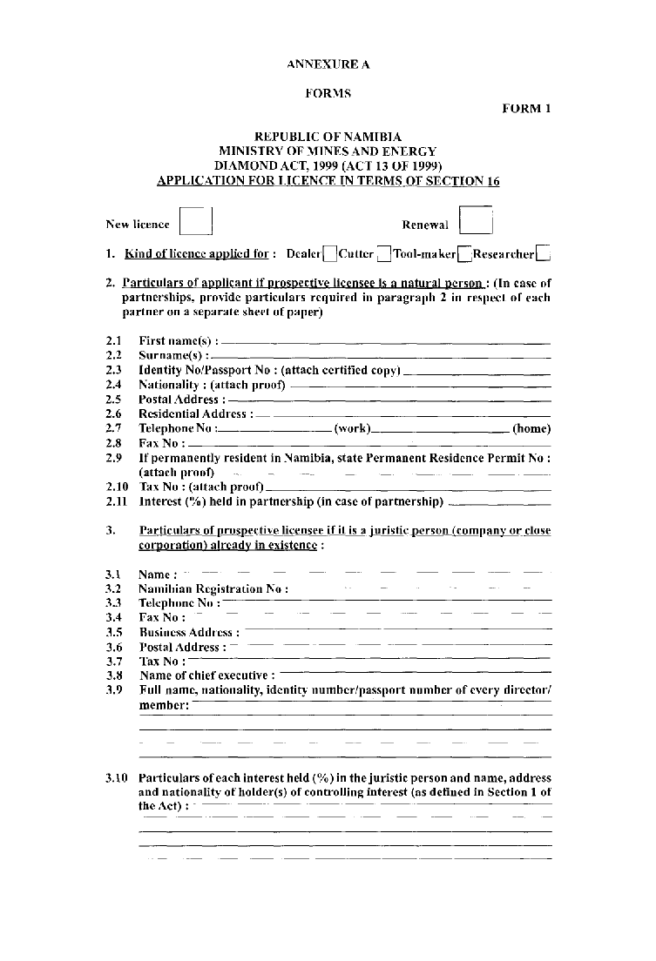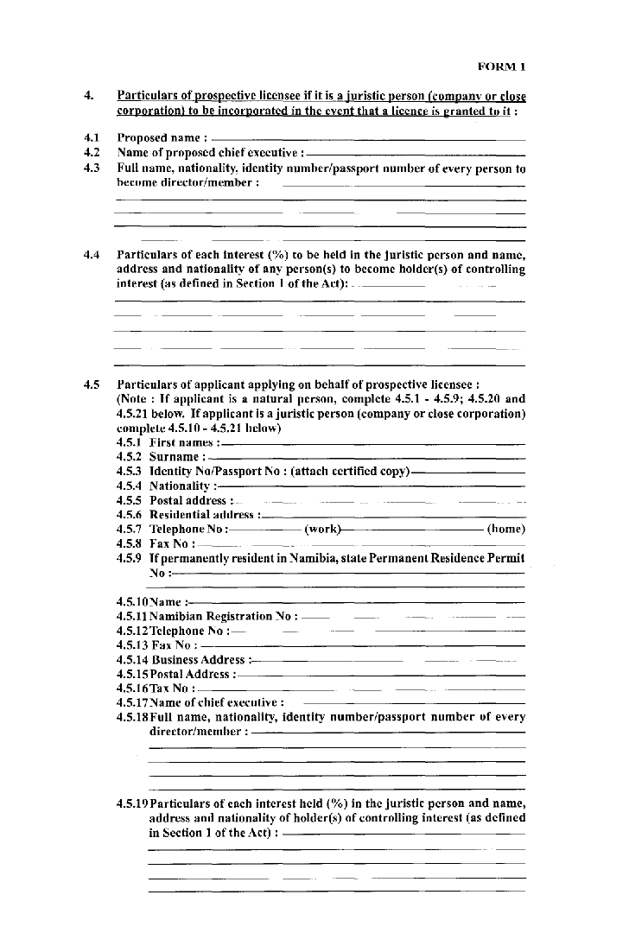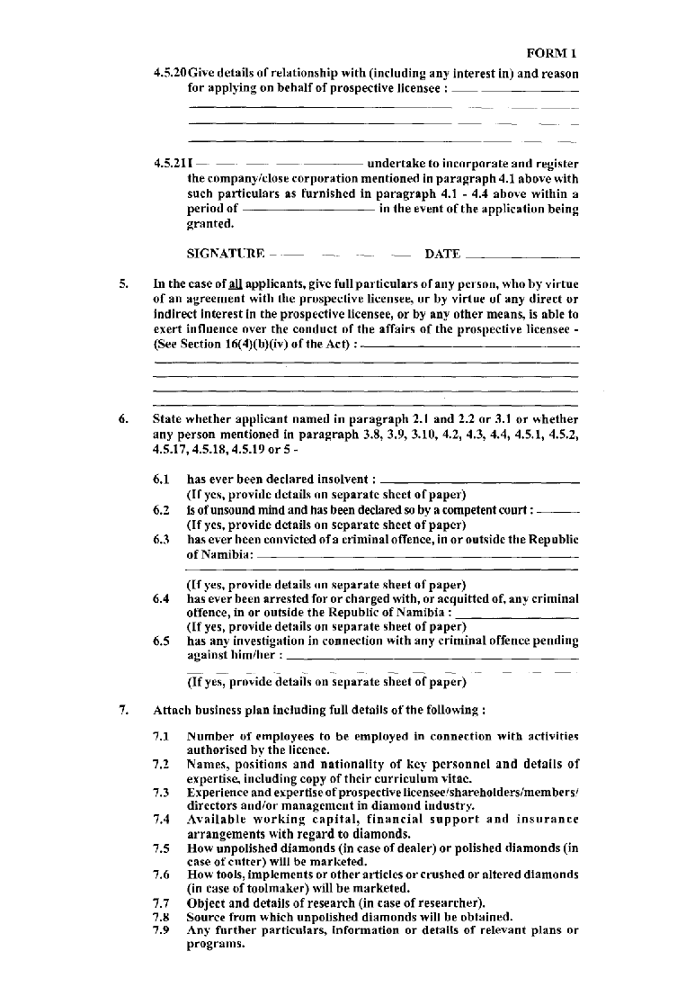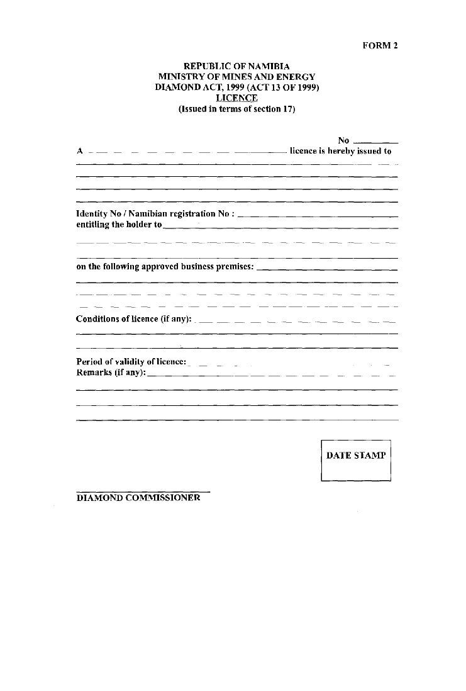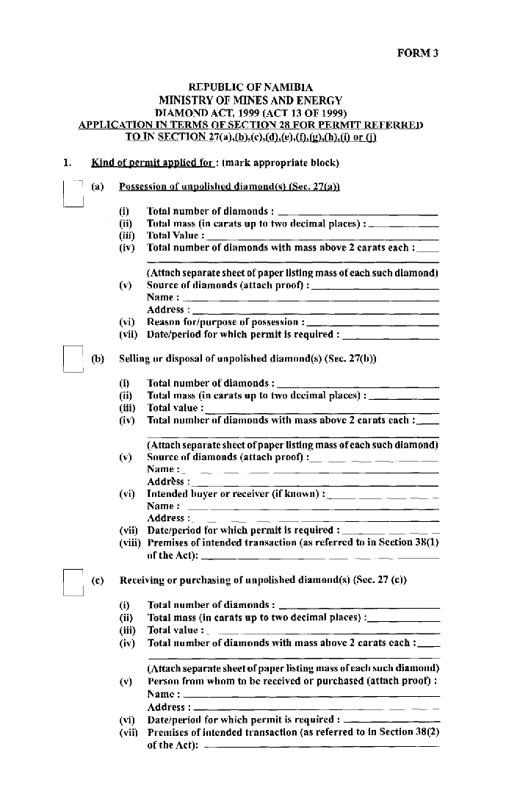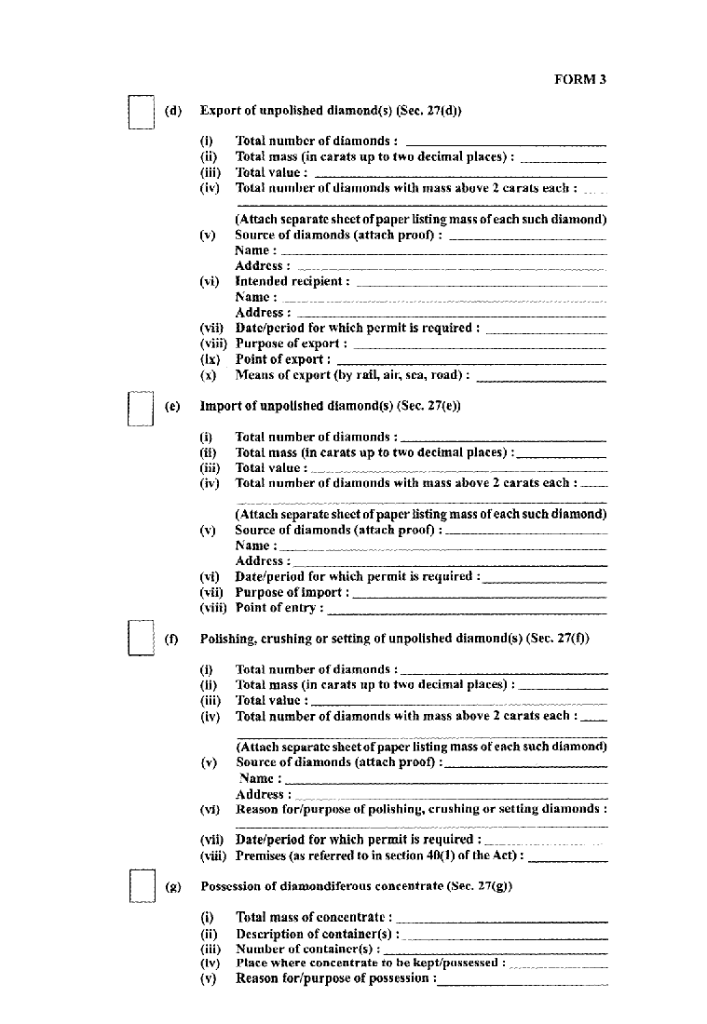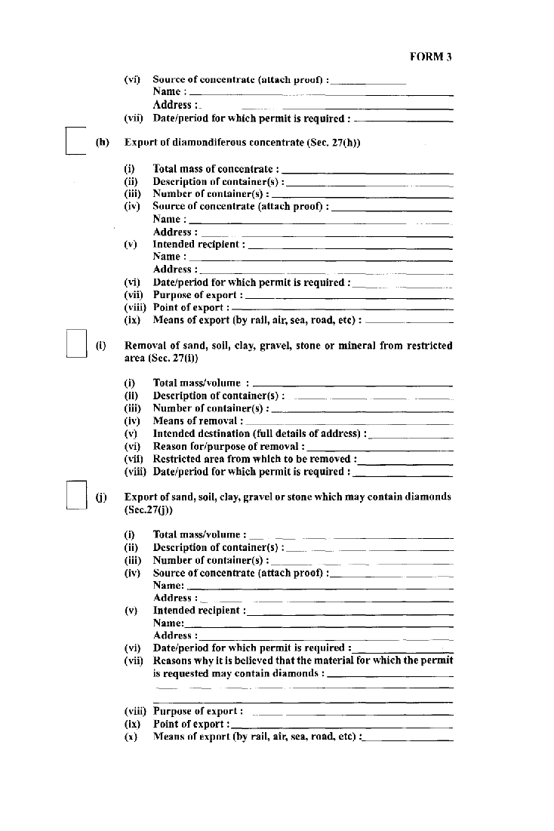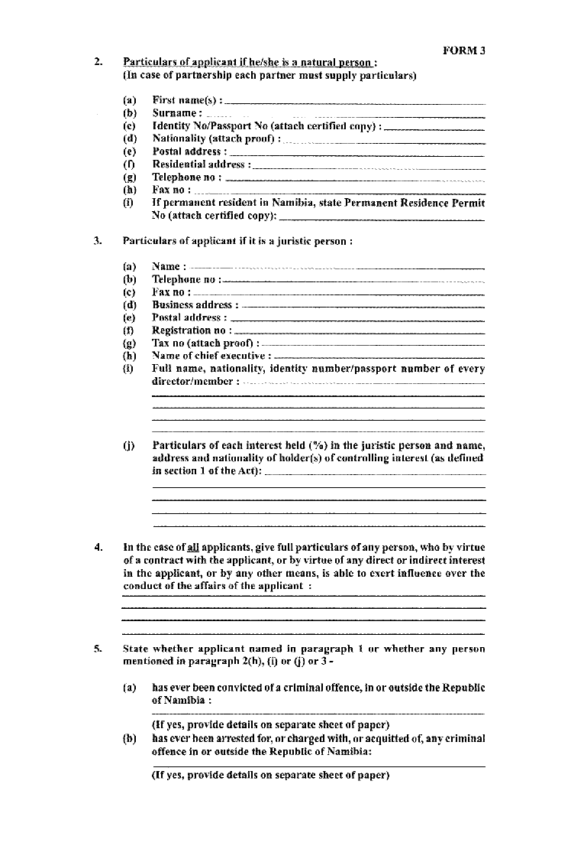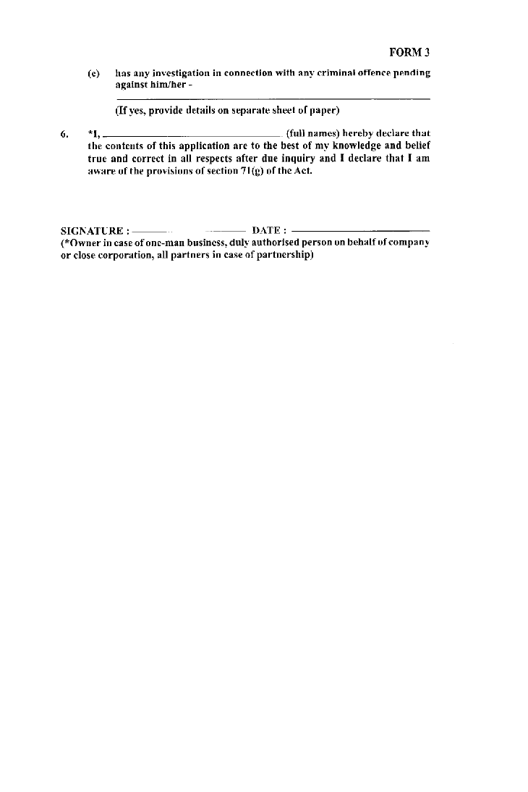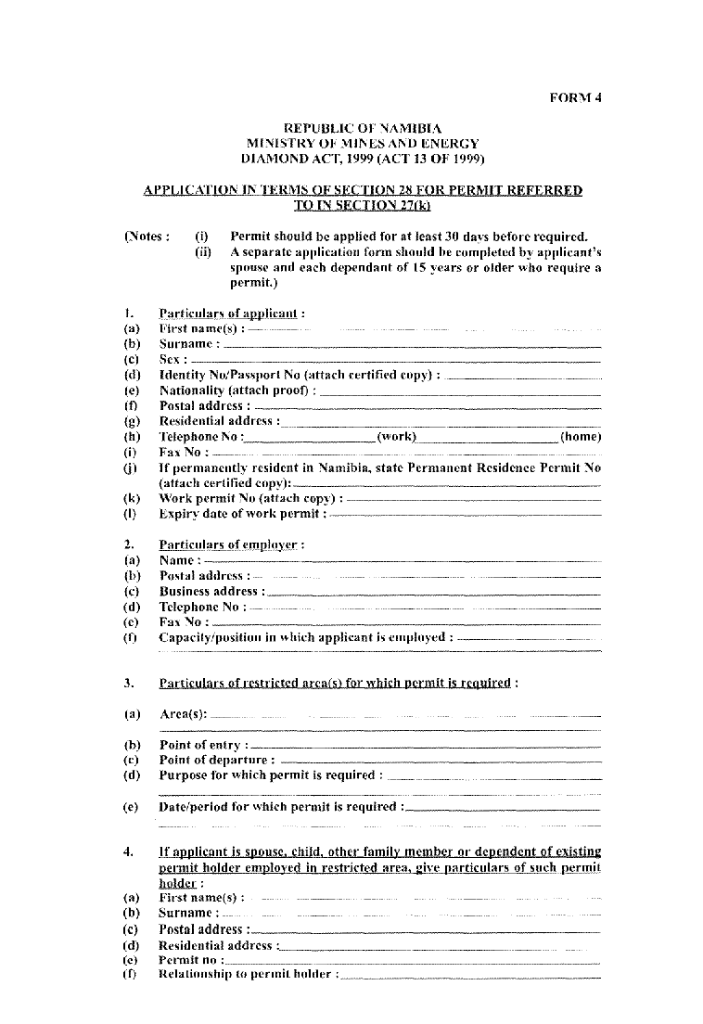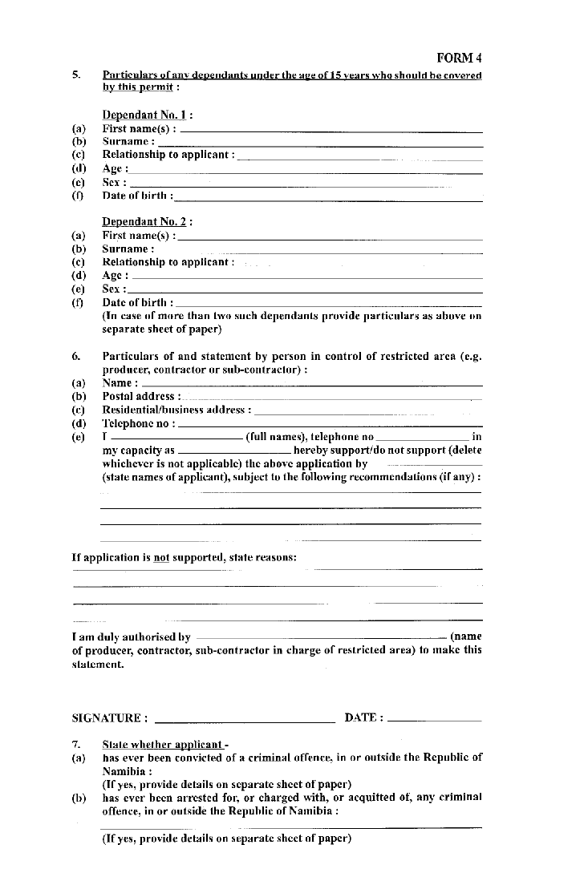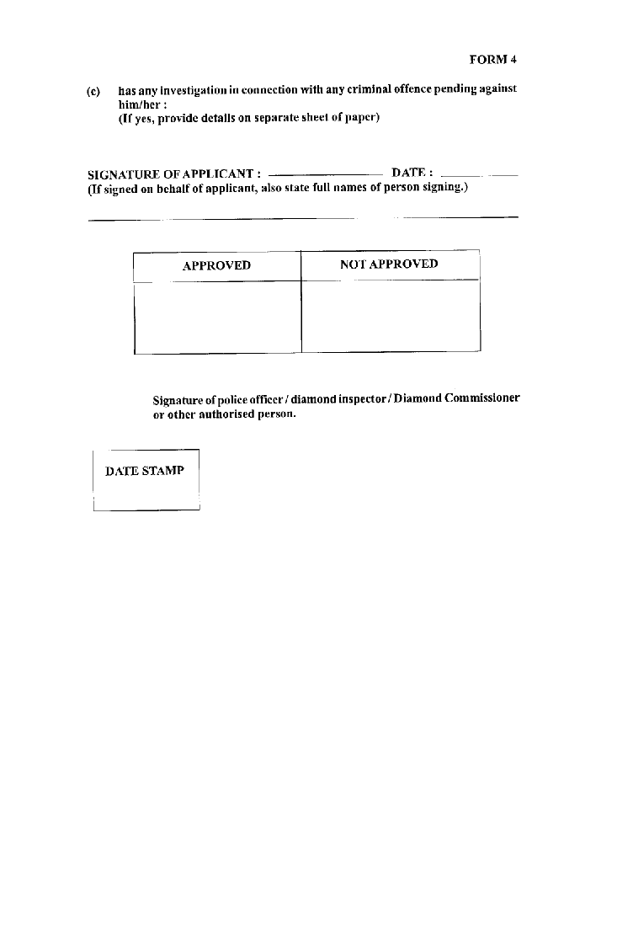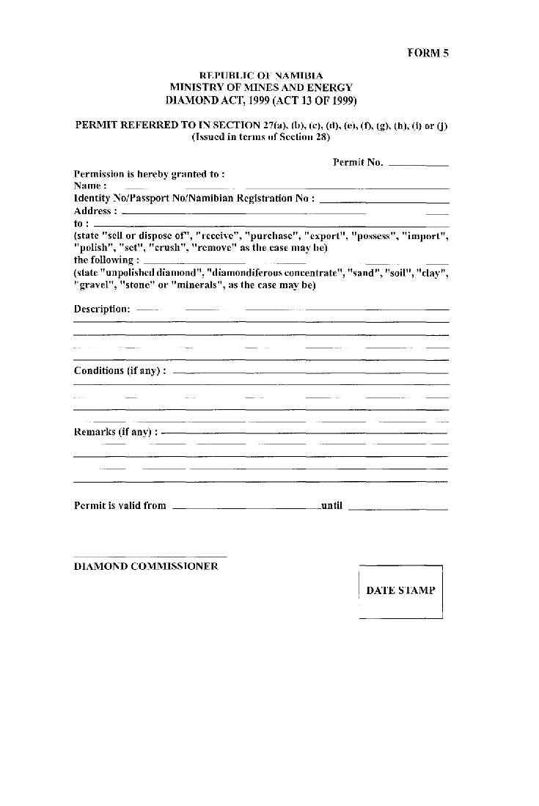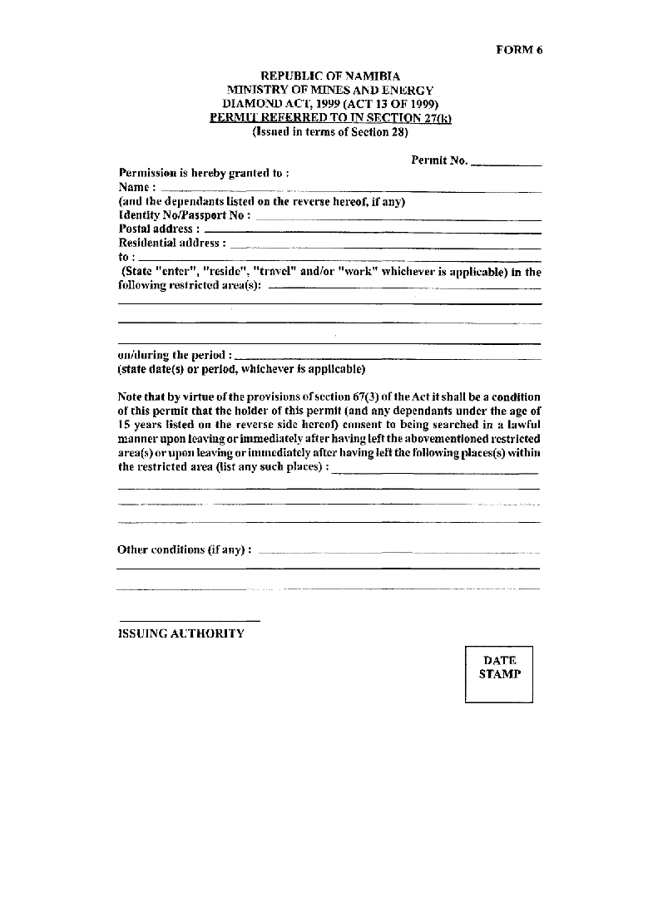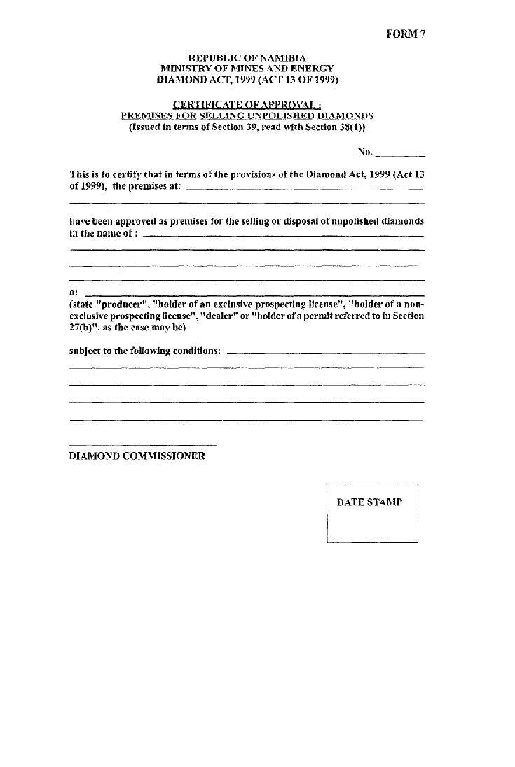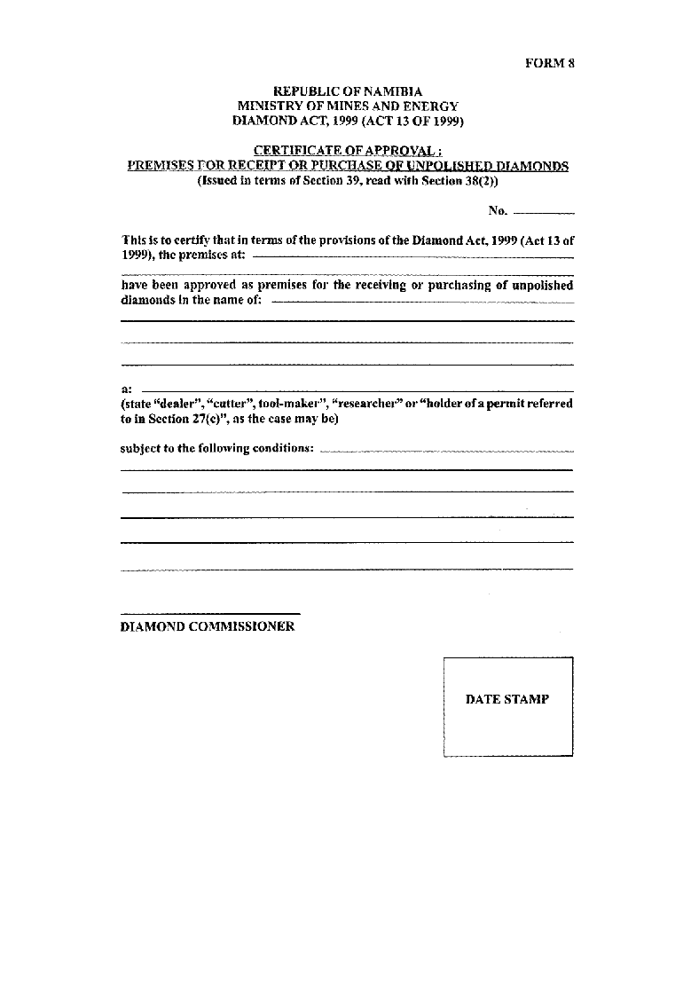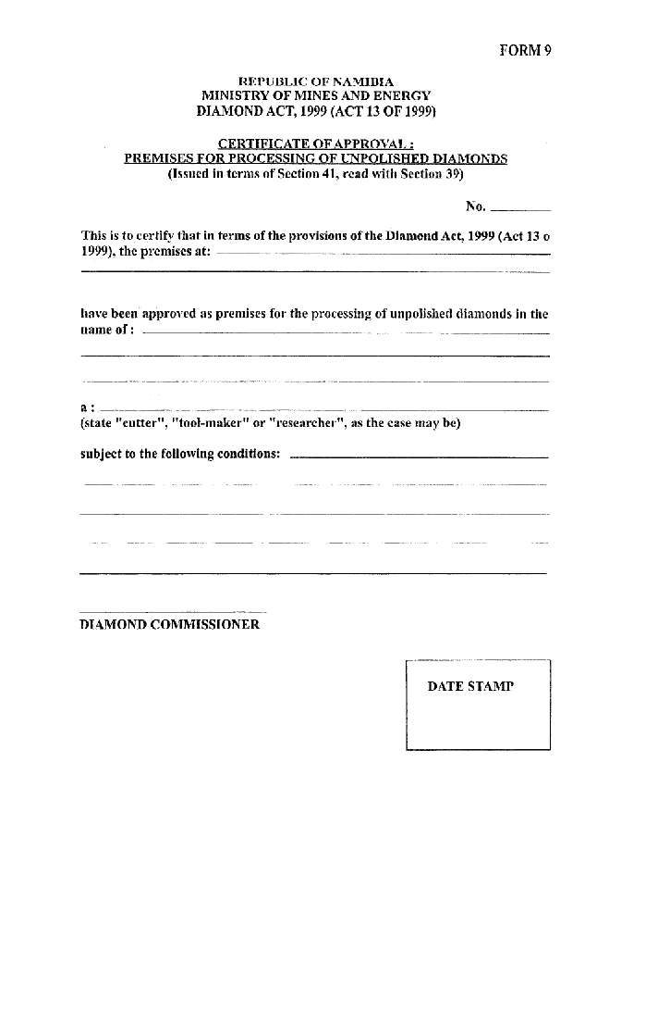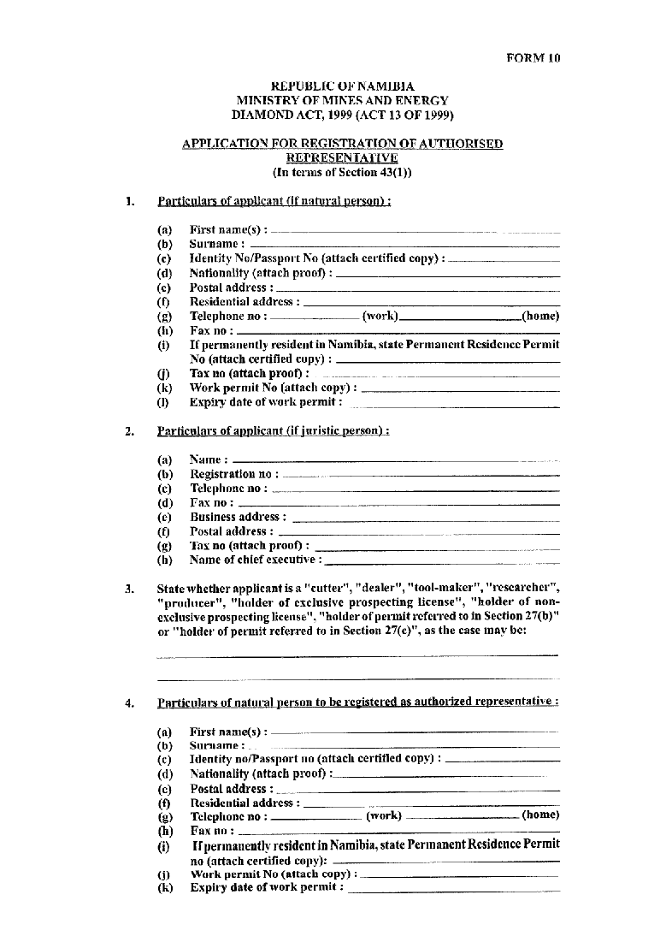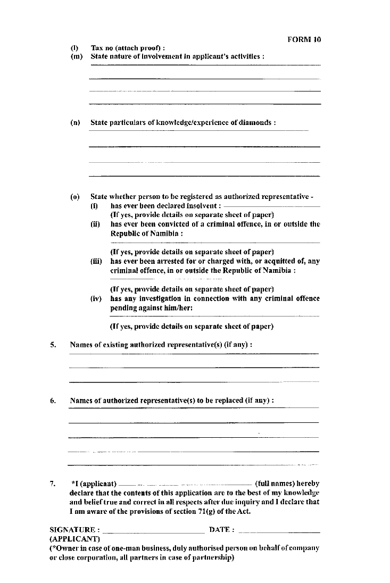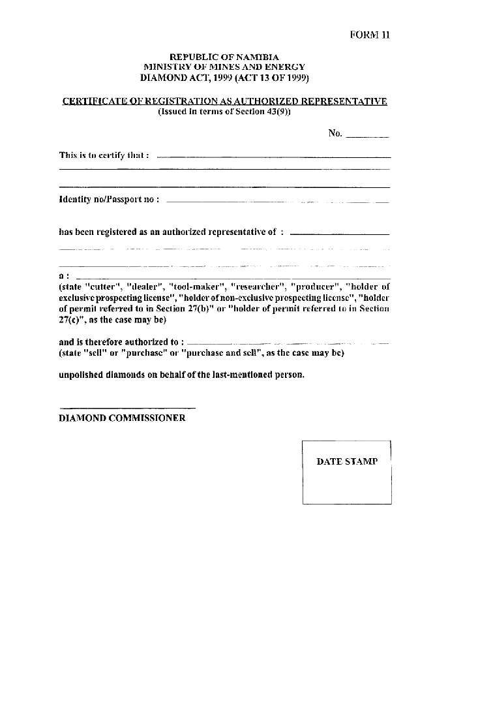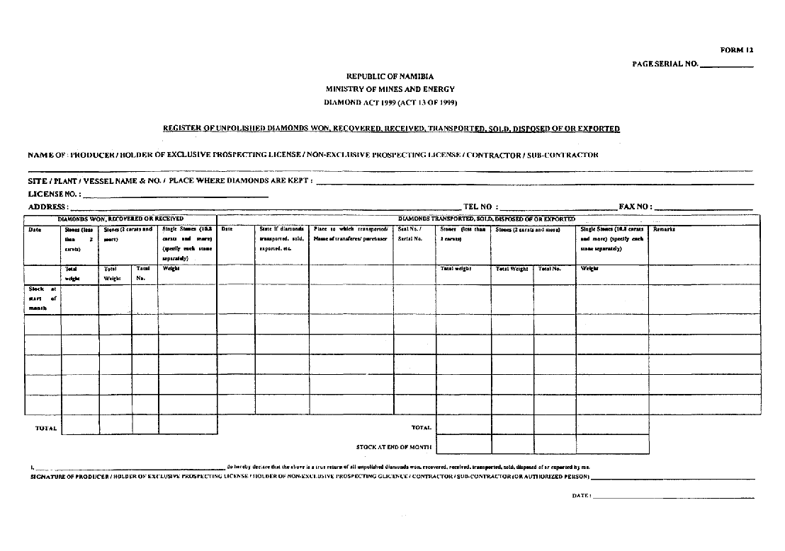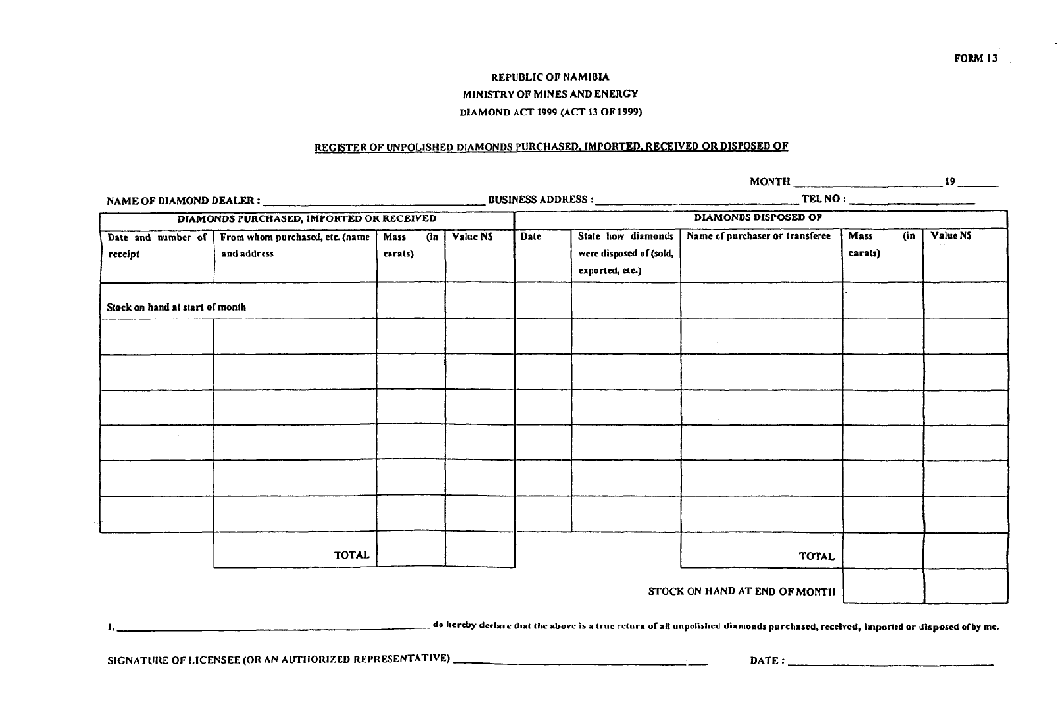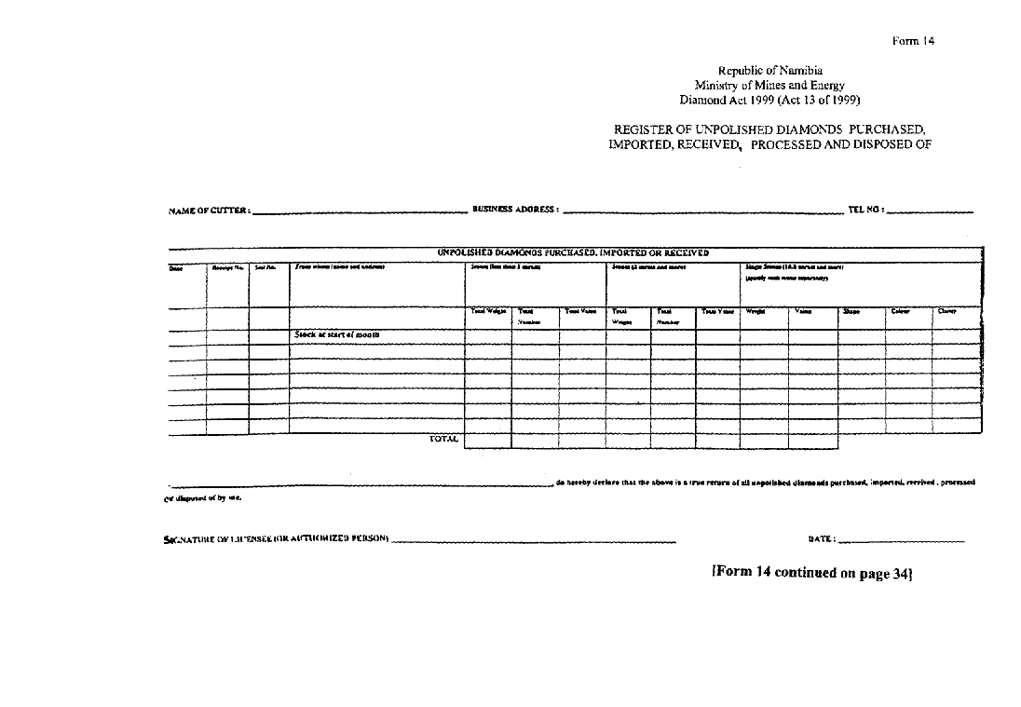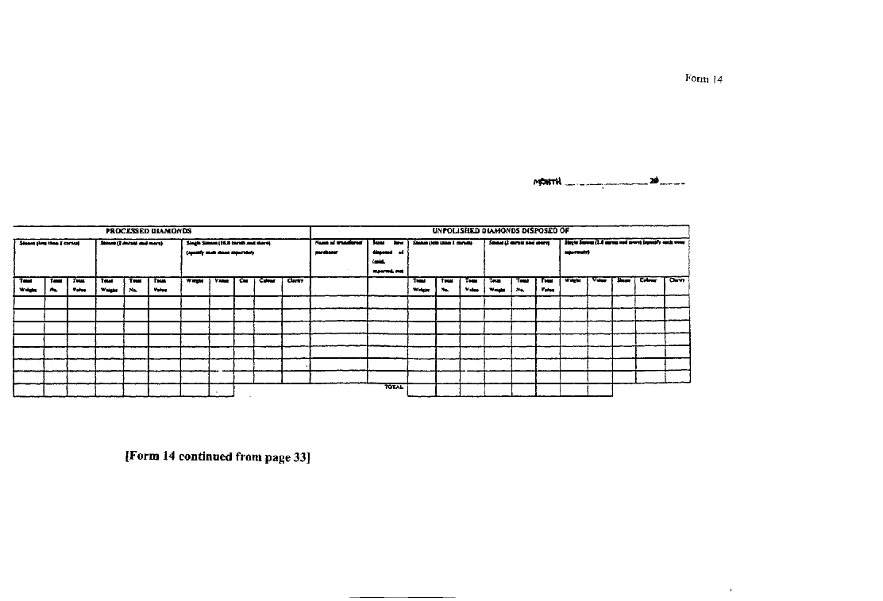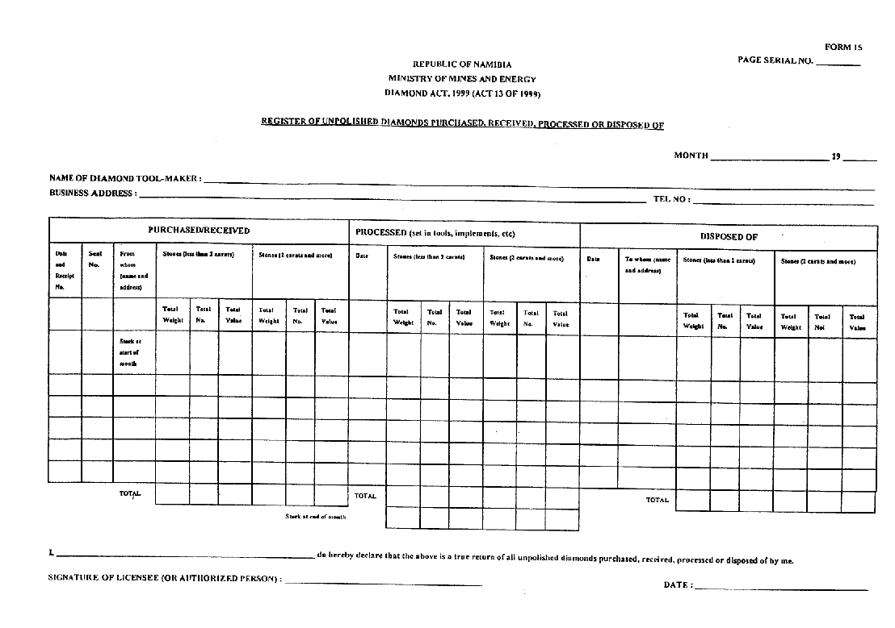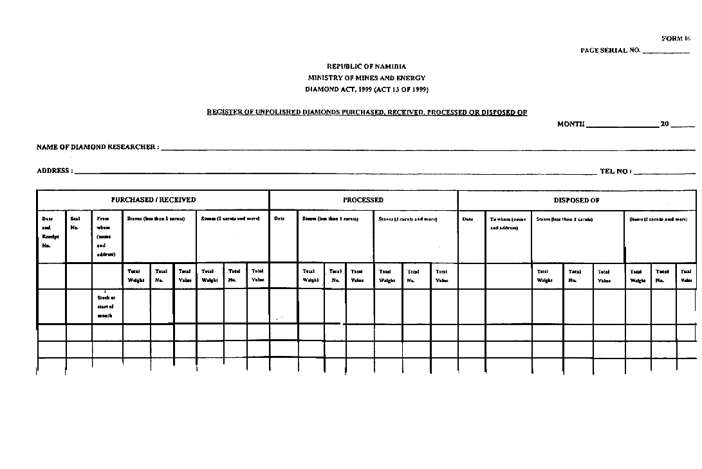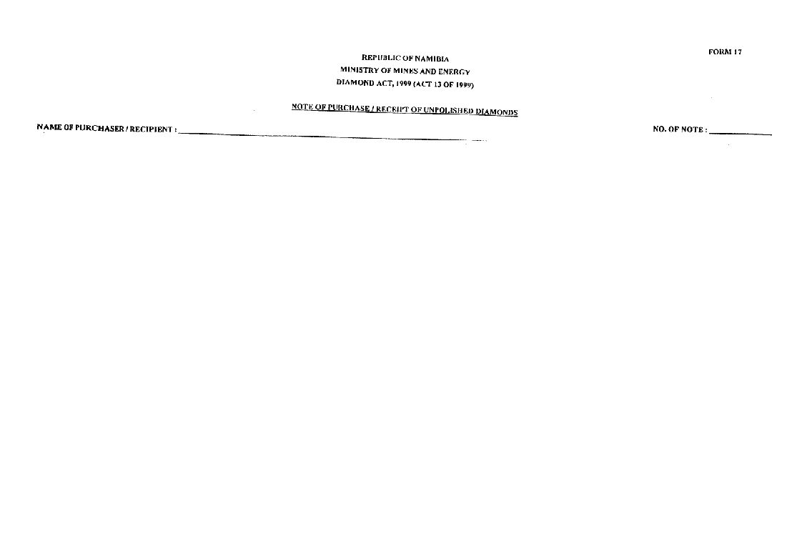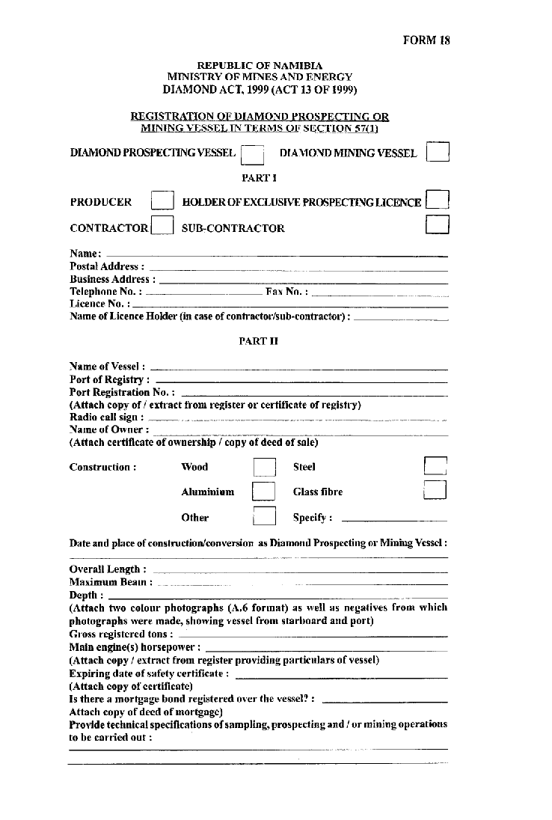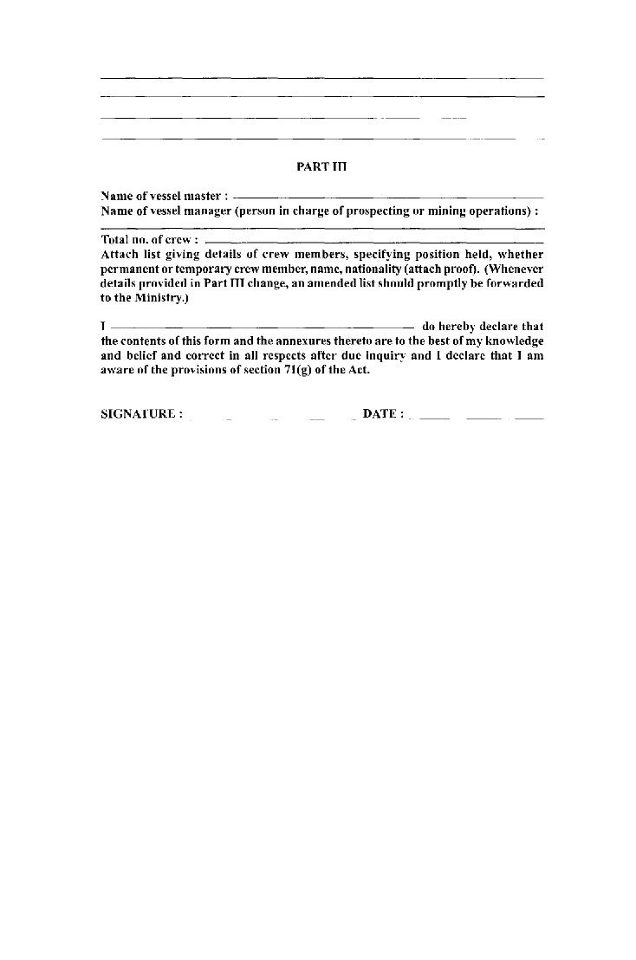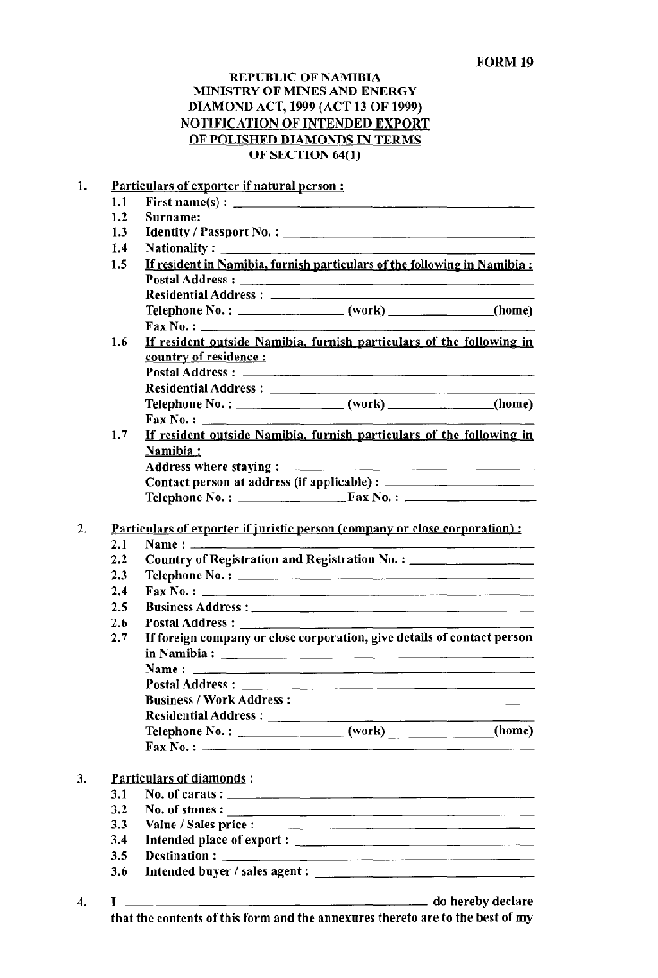

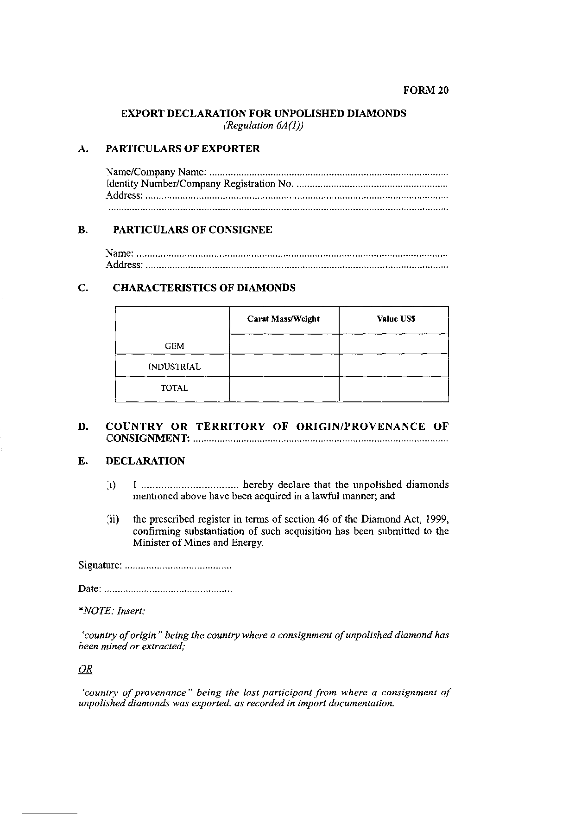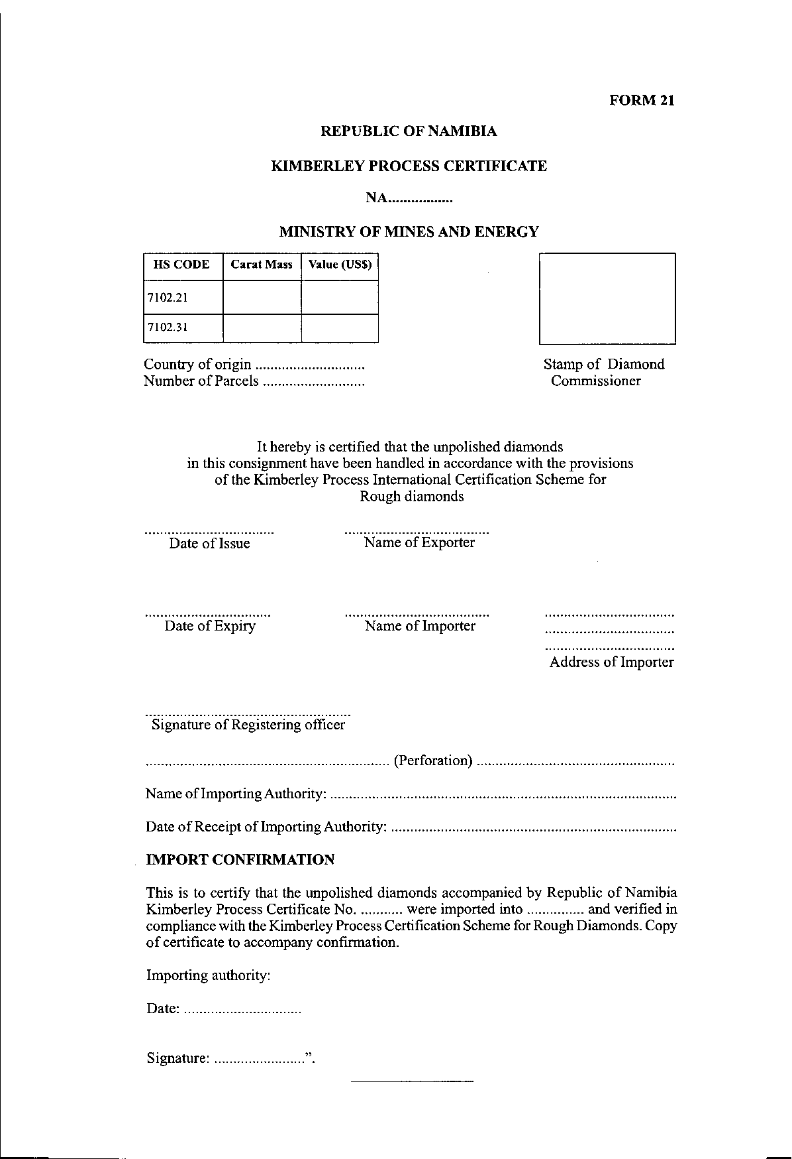

ANNEUXURE B

[The word “Annexure” is misspelt in the Government Gazette, as reproduced above.]

FEES

TYPE OF FEE | FEES PAYABLE  N$
1. Application for licence in terms of section 16 of Act (regulation 4(1)) | 500-00
2. Issue of diamond cutting license, diamond tool-making licence or diamond research license (regulation 4(2)) | 1 500-00
3. Issue of diamond dealer’s license (regulation 4(3)) | 10 000-00
4. Application for permit referred to in section 27(a), (b), (c), (d), (e), (f), (g), (h), (i) or (j) of the Act (regulation 7) | 250-00

