REGULATIONS MADE IN TERMS OF

Deeds Registries Act 14 of 2015
section 93(1)

General Regulations
Government Notice 83 of 2021
(GG 7514)
came into force on the date that the Act came into force: 23 April 2021
(GN 83/2021, read together with GN 81/2021)

The Government Notice which publishes these regulations notes
that they were made on the recommendation of the Regulations Board. It also
repeals the Regulations made under the Registration of Deeds in Rehoboth Act 93 of 1976,
namely GN R.2372/1976 (as amended by AG. GN 28/1978 and GN 75/2007) as well as the regulations made under the Deeds Registries Act 47 of 1937 contained in GN 180/1996 (as amended by GN 36/2004, GN 77/2007 and GN 408/2019).

ARRANGEMENT OF REGULATIONS

1. Definitions
2. Registration divisions and numbering of farm units
3. Numbering of portions
4. Register of conveyancers and notaries public
5. Identity of persons
6. Evidence to establish identity
7. Preparation of deeds and documents and qualification of persons
8. Signatures
9. Space in and numbering of deed
10. Faintness of writing, typing or printing
11. Addition of alias and registration of deeds, powers of attorney and other documents in other language than the official language
[In the body of the regulations, this heading appears as “Addition of alias and registration of deeds, powers of attorney and other documents in any other language than the official language”.]
12. Place and date of execution of deeds and other documents
13. Extending clause
14. Description and numbering of separate properties
[In the body of the regulations, this heading appears as
“Description of and numbering of separate properties”.]
15. Particulars to be furnished in deed
16. Expression of extent of land
17. Use and expression of share
18. Land held by several deeds
19. Transfer of portion of piece of land
20. Separation of piece of land into two or more parts
21. Registration of general plan
22. Transfer or cession of immovable property to or registration of mortgage or notarial bonds in favour of persons who have not attained majority
23. Partnership
24. Procedure in preparation of deeds regarding conditions to which land is or may be subject
25. Transfer to rehabilitated insolvent
26. Consent for registration of transactions
27. Mortgage of land held under special conditions limiting the rights of the owner
28. Consent of legal holder of bond referred to in section 24 of the Act
29. Preparation of deed of grant, deed of transfer, certificate conferring title to immovable property, deed of cession referred to in section 29 of the Act or mortgage bond
30. Certificate by legal practitioner, notary public, conveyancer, owner or empowered person
31. Acceptance of responsibility
32. Lodgement and execution of deeds, mortgage bonds, documents and powers of attorney
33. Lodgement of documents required for registration of transactions contemplated in section 6 of the Act
34. Registration of cession of balance due under bond
35. Collateral bond or surety bond lodged for execution in deeds registry other than that in which principal bond is registered
36. Application under section 41 of the Act
37. Transfer of land in pursuance of will, codicil or other testamentary instrument
38. Dealings with immovable property
39. Registration of undivided share in land in name of deceased person, estate or surviving spouse
40. Acquisition of immovable property by person not married in community of property not registered during lifetime of person
41. Execution of deed of transfer in circumstances referred to in section 7(3)(b) of the Act
42. Execution of transfer in circumstances referred to in section 27(1) of the Act
43. Notice of expropriation
44. Application for consolidated title
45. Servitude over remaining extent
46. Cancellation of registration
47. Endorsement of title deeds in circumstances referred to in section 69 of the Act
48. Reference to deeds, mortgage bonds, powers of attorney or other documents already filed or registered in deeds registry
49. Powers of attorney and certified copies thereof
50. Copies of deeds or other documents
[In the body of the regulations, this heading appears as
“Copies of deeds and other documents for information purposes”.]
51. Copies required for judicial purposes
52. Lost or destroyed deed, mortgage bond, notarial bond, registered lease, sublease or cession thereof
[In the body of the regulations, this heading appears as “Lost or destroyed deeds,
mortgage bonds, notarial bonds, registered lease, sublease or cession thereof”.]
53. Notarial bond registered at two or more deeds registries
54. Certified copy of any document not specified in regulation 52(1)
55. Business with deeds registry
56. Leasing of portion of piece of land which is to be registered
57. Holder of real right referred to in section 61(1) of the Act
58. Registration of any change in name of any person or partnership
59. Act of registration which affects diagram
60. Information to public
61. Disposal of records
62. Certificates of title and registered title or deeds
63. Mortgage bonds
64. Fees of office
65. Conveyancing and Notarial Fees

Annexure 1
Annexure 2
Annexure 3

Definitions

1. In these regulations, unless the context otherwise indicates, any word or expression to which a meaning has been assigned in the Act has that meaning and -

“the Act” means the Deeds Registries Act, 2015 (Act No. 14 of 2015).

Registration divisions and numbering of farm units

2. (1) Subject to subregulation (2), the areas defined as magisterial districts in the Schedule to Government Notice No. 23 of 17 November 1994, continue (despite any later amendment to that Schedule) from the date of commencement of these regulations to constitute registration divisions, each bearing a distinctive letter to be assigned by the Surveyor-General.

[Government Notice 23/1994 appears in Government Gazette 799.]

(2) If the boundary of any registration division referred to in subregulation (1) crosses unsurveyed State land, the boundary of the registration division over the State land is upon subdivision of the State land the nearest cadastral boundary as determined by the Surveyor-General.

(3) If any adjustment in terms of subregulation (2) results in a farm unit falling in more than one registration division, the Surveyor-General must take the necessary steps to have the boundaries of the registration division amended in such a manner that the farm unit falls wholly within one registration division.

(4) Subject to subregulation (5), for the purpose of identifying erven, settlement holdings or lots (hereafter called “allotment units”), the registrar must, with the concurrance of Surveyor-General -

[The word “concurrence” is misspelt in the Government Gazette, as reproduced above.]

(a) determine, if necessary, the limits of an area (hereafter referred to as an allotment area) in which the registration of allotment units must be confined to a single register or set of registers;

(b) assign, if deemed necessary, a distinctive number to each allotment unit situate within an allotment area.

(5) The registrar may consult the local authority council concerned before the limits of allotment areas are determined.

Numbering of portions

3. (1) The portions into which farms or allotment units may be divided must be numbered consecutively, whether directly from the parent piece or indirectly through an intermediate portion, but -

(a) portions already numbered or lettered, and for which title deeds have been registered, need not be renumbered, but portions surveyed for the purpose of registration of title after the commencement of these regulations must follow in numerical progression thereafter, and the diagrams thereof must disclose the parent portion; and

(b) upon subdivision of any piece of land in an allotment area it is permissible to assign a new unit number to the subdivision.

(2) If -

(a) two or more portions of a farm unit or portions of an allotment unit are consolidated into one, the resulting piece of land must receive the next consecutive number as if it were a new portion;

(b) two or more farm units or two or more allotment units are consolidated into one, the resulting piece of land must receive a new number;

(c) a portion of a farm unit and a whole such unit or a portion of an allotment unit and a whole such unit are consolidated into one, the resulting piece of land must receive a new number;

(d) two or more portions of different allotment units or of different farms are consolidated into one, the resulting piece of land must receive the next suitable available number, of the allotment area or registration division, and if no such number is available, the resulting piece of land must receive a new number in the allotment area or registration division.

(3) If deemed necessary to do so, the registrar may authorise, after consultation with the Surveyor-General, a departure from subregulation (2)(a), (b), (c) or (d).

(4) After the numbering of allotment units has been completed within an allotment area as contemplated in regulation 2(1), the registrar must take whatever steps may be necessary to -

(a) compile a register or a set of registers for the allotment area;

(b) identify the allotment units with land held under any title deeds;

(c) endorse the title deeds that the land comprises or corresponds with the respective unit or units and is now registered in the relevant register under its registration number.

Register of conveyancers and notaries public

4. The registrar must keep a register of conveyancers and notaries public.

Identity of persons

5. (1) A person, except any person acting in a representative capacity, must be identified in any deed, power of attorney, application, or other document submitted for registration, attestation or execution and registration, endorsement or preservation -

(a) in the case of a natural person -

(i) by means of his or her full names and the identity number reflected in the identity document issued to him or her by the responsible Government Authority in Namibia; or

(ii) if no such identity document has been issued, by means of his or her full names and date of birth; or

(iii) if his or her date of birth is not known, such other proof as the registrar may require with regard to his or her identity under section 5(1)(a) of the Act; or

(b) in the case of any other person, by means of its name and, if any, its registered number.

(2) Subject to subregulations (3) and (4), the name of a person referred to in subregulation (1), his or her identity number, date of birth or its registered number, as the case may be, obtained under this regulation must be recorded in the relevant registers of the deeds registry concerned.

(3) The fact that no identity document has been issued to a natural person must be established by means of an affidavit or an affirmation signed by the natural person or by means of a certificate signed by a conveyancer or a commissioner of oaths or a Namibian Police Officer based on information obtained from the natural person.

(4) Subregulation (1) does not apply to any consent or application relating to a registered deed granted by a person being a party to that deed if the deed does not disclose his or her identity number, date of birth or registered number, as the case may be.

(5) Upon proof to his or her satisfaction that an error has been made, the registrar may rectify any error made in connection with an entry or note of the identity number, the date of birth or the registered number, as the case may be, of any person appearing in the deeds registry.

Evidence to establish identity

6. The registrar may in connection with any deed or document tendered for execution, registration or record call for evidence to establish the identity or non-identity of any party thereto with any person whose name appears in any register kept in the deeds registry.

Preparation of deeds and documents and qualification of persons

7. (1) Subject to subregulation (2), deeds and other documents submitted for registration, attestation, or execution and registration, endorsement or preservation must be on paper approved by the registrar and must be in clear writing, print or type of good quality.

(2) The registrar may allow that a deed or other document referred to in subregulation (1) may consist of one or more pages which has or have been reproduced by means of print or any other manner of reproduction, whether or not missing particulars have been entered therein by means of print or type.

(3) The upper half of the first page of a deed may not be used for writing, printing, typing or any other purposes, but is reserved for the purpose of deeds registry endorsements and, in the case of deeds or other documents referred to in subregulation (1), a margin of at least four centimetres must be allowed on all pages of a deed for binding purposes.

(4) No carbon or fax copy of any deed or other document may be accepted in a deeds registry for the purposes of preservation.

(5) Black ink of a durable and reproducible quality as the registrar may allow must be used for the purposes of an alteration, an interlineation, a signature or an initial on a deed or other document referred to in subregulation (1).

(6) All alterations to, or interlineations in, a deed or other document referred to in subregulation (1) must be initialled by the person who signed the deed or document.

(7) If any witness other than the original witness attests the initial of the person who signed the document at any alteration or interlineation, the first-mentioned witness must sign his or her name at the initial.

(8) In the case of an attested deed by a notary public all alterations and interlineations must also be initialled by the notary public.

(9) Despite anything to the contrary in this regulation contained, the registrar may accept for preservation any copy of a document filed in any Government office, if the copy has been certified to be a true copy -

(a) by or on behalf of the head of the office, a conveyancer, a notary public, a Namibian Police Officer or another commissioner of oaths;

(b) in the case of a diagram, by the Surveyor-General;

(c) in the case of a will, codicil or other testamentary document, by the Master; and

(d) in the case of a divorce order, by the Registrar of the High Court.

Signatures

8. The registrar must decline any signature to a document for the purpose it was intended if the signature has been -

(a) written across a stamp or with ink other than black in colour and a good quality; or

(b) encroached on the margin of the document.

Space in and numbering of deed

9. Any space in a deed of 3 cm or more which has not been used must be ruled through, and if a deed comprises more than one page, each page must be numbered consecutively.

Faintness of writing, typing or printing

10. If, in the opinion of the registrar, the writing, typing or printing in any deed, power of attorney or other document lodged for attestation, execution or registration or for any other purpose is, owing to the faintness thereof, not calculated to secure durability, the registrar must decline to attest, execute, register or accept it, as the case may be.

Addition of aliases and registration of deeds, powers of attorney and other documents in any other language than the official language

[In the ARRANGEMENT OF REGULATIONS, the word “any” is omitted in this heading.]

11. (1) An addition of an “alias” to the description of any person by or to whom a deed lodged for execution or attestation in the deeds registry is to be passed may not be permitted, and if any such addition has been made in any other deed or power of attorney or other document lodged for registration, the correct name only must be recognised for purposes of the registration.

(2) Deeds, powers of attorney and other documents, if executed outside Namibia and expressed in any other language than the official language of Namibia, may be accepted for registration or record if a translation, duly certified by a person admitted to practice as a sworn translator, is lodged therewith.

Place and date of execution of deeds and other documents

12. Every deed and other document executed in or lodged for registration or record in a deeds registry must disclose the place and date of execution thereof.

Extending clause

13. Every deed of title to land -

(a) for which no form is prescribed; and

(b) for which a form is prescribed wherein provision is made for the inclusion of an extending clause in conformity with these regulations,

must immediately after the description of the property contain -

(i) an extending clause substantially in the form set out in Form A or B, of Annexure 1, as the case may be; and

(ii) the registered number, if any, of the land.

Description of and numbering of separate properties

[In the ARRANGEMENT OF REGULATIONS, this heading appears as “Description
and numbering of separate properties” (without the repetition of the word “of”).]

14. (1) If a deed conferring title to land includes more than one property, each piece of land must be described in a separate paragraph, which must be numbered, and each paragraph must conform to regulation 13.

(2) If required by the registrar, a separate registration clause must be inserted at the end of the deed in respect of each piece of land, which clause must bear a number corresponding to the number of the paragraph in which the land is described.

(3) If two or more pieces of land are shown as separate figures on a single diagram each piece must be described in the relevant deed in a separate paragraph, and may thereafter be transferred independently only upon the production of a further diagram thereof.

(4) Notwithstanding any practice to the contrary in any deeds registry, if separate diagrams of two or more pieces of land are annexed to one and the same deed of transfer and transfer is sought to any of the pieces, a copy of the diagram thereof for the purpose of annexure to the new transfer does not have to be procured from the Surveyor-General.

Particulars to be furnished in deed

15. (1) The following particulars must be furnished in a deed where land is described -

(a) in the case of land situated -

(i) outside a township, the registration division and region in which the land is situated;

(ii) in a township, the registration division and region concerned, the name of the township and the name of the municipality, town, village or settlement area in which the land is situated; and

(b) the registered number, if any, of the land.

(2) In describing land no reference may be made in a deed conferring title to land or any interest therein or in a mortgage bond, to any building or other property, movable or immovable, which may be on or attached to the land.

(3) If the description of the situation of land in an existing deed is defective or insufficient, and the registrar regards it necessary in connection with a further transfer of the land to amend same, the registrar may permit, subject to the production of a certificate by the Surveyor-General if the registrar regards it necessary, the amendment to be made.

(4) The description of the boundaries of land given in a diagram or general plan need not be repeated in the relevant deed, but the deed must contain a reference to the diagram or general plan.

Expression of extent of land

16. In the description of land conveyed in a deed or hypothecated in a bond the extent of the land must be expressed in words and figures.

Use and expression of share

17. In the description of land where an undivided share in a piece of land is being dealt with, the term “share” must be used, and the share must be expressed in one fraction in its lowest terms, the method of arriving at the result also being given in complicated cases.

Land held by several deeds

18. (1) If land to be transferred or mortgaged is held by several deeds, the registrar may require the owner or the conveyancer -

(a) to furnish a statement containing particulars regarding the different fractional shares and describing in complicated cases the method by which the result was arrived at, and

(b) if there are two or more owners, to also indicate in the statement the shares held by each owner.

(2) If the land concerned is one of several pieces described in a deed or mortgage bond the owner or the conveyancer must furnish a reference to the paragraph therein which relates to the land.

(3) In transferring a share in land from two or more titles under which shares are held one or more titles must be exhausted if possible.

Transfer of portion of piece of land

19. Subject to the Act, a portion of any piece of land may only be transferred upon a diagram thereof.

Separation of piece of land into two or more parts

20. If a piece of land has been separated into two or more parts by the deduction of one or more intervening portion or portions thereof, the parts forming the remaining extent may not be regarded as being separate pieces of land for the purposes of sections 37 and 38 of the Act.

Registration of general plan

21. Simultaneously with the opening of a register pertaining to land represented on a general plan, the registrar may register the plan by endorsing the relevant particulars thereof on the title deed.

Transfer or cession of immovable property to or registration of mortgage or notarial bonds in favour of persons who have not attained majority

22. If it is sought to -

(a) transfer or cede immovable property to, or

(b) register mortgage bonds or notarial bonds in favour of,

persons who have not attained majority, the transfers, cessions or bonds must, subject to section 22 of the Act, be made in the name of the minors and not in the name of their guardians, tutors, or curators, as the case may be.

Partnership

23. (1) All deeds or documents executed by, or on behalf or in favour of persons carrying on business as a partnership, and any power of attorney lodged or required in connection with the deeds or documents must contain the full names of the partners constituting the partnership.

(2) If property is registered in the names of persons carrying on business as a partnership it may, so long as the partnership consists of the same partners, be transferred, hypothecated or otherwise dealt with, as the case may be, on a power of attorney or other document bearing the signature of the partnership and of the partner who affixed the signature of the partnership.

(3) If any partner in a partnership wishes to transfer his or her share in any property of the partnership to -

(a) the remaining partners; or

(b) the remaining partners and some other person or persons; or

(c) some other person or persons alone,

to the end that the remaining partners either alone or together with the other person or persons, as the case may be, form a new partnership to hold the property, the transfer may not be passed unless the whole of the property, and not merely the share of the disposing partner, is transferred or ceded to the new partnership.

(4) The deed, power of attorney or other document necessary for the purpose contemplated in subregulation (3) must be signed by each of the partners of the original partnership or by the duly authorised agent of the partner, and, in like manner, if a new partner is admitted into a partnership and the new partnership wishes to transfer or cede property taken over from the old partnership, the transfer or cession may not be passed unless the new partnership has itself received transfer or cession of the property from the old partnership.

(5) If any property of a partnership is not being dealt with on dissolution in the manner described in subregulations (3) and (4), the deed, power of attorney or other document necessary for the transfer or cession to the partners thereof or the other persons to whom the same may have been disposed of, must be signed by each of the individual partners or by the duly authorised agent of the partner.

(6) If, during the continuance of a partnership any partner thereof desires to register any transaction other than an endorsement pursuant to section 42 of the Act, affecting his or her share in any property registered in the name of the partnership, the partner may not be permitted to do so until transfer has been passed to the partner of the share to which he or she is entitled.

(7) If a partner is deceased and the deed of partnership provides that the partnership may not be terminated by reason of the partner’s death, but that his or her share in the partnership must be administered by an administrator, the registrar may endorse the title deed of any immovable property held by the partnership to the effect that the share of the deceased partner in the partnership must be administered in terms of section 40 of the Administration of Estates Act, 1965 (Act No. 66 of 1965).

(8) If land has been sold by or to a partnership the transfer duty receipt issued in respect of the sale must disclose the names of the partners thereof.

Procedure in preparation of deeds regarding conditions to which land is or may be subject

24. (1) The following procedure must be observed in the preparation of deeds conferring title to land with regard to the conditions to which the land is or may be subject -

(a) if it appears from the deed produced to the registrar that the land is subject to special conditions limiting the rights of the owner, the conditions must be repeated in every subsequent deed conferring title to the land and, if necessary, be referred to as mentioned in the deed whereby they were created;

(b) if it appears from a deed produced to the registrar that the land is subject to conditions other than those referred to in paragraph (a), the conditions must be repeated, if the registrar so requires, in a subsequent deed conferring title to the land, otherwise it must be specially referred to as mentioned in the deed and its character be described in general terms;

(c) if the deed produced to the registrar is not a grant from the State and contains a general reference to conditions in a prior title deed by which the land was held, every subsequent deed conferring title to the land must be made subject also to the conditions as are referred to in the deed produced;

(d) if the deed produced to the registrar is a grant or transfer from the State comprising land acquired by purchase or otherwise, and the grant contains a general or specific reference to the conditions contained in the deed by which the land was conveyed to the State, paragraphs (a), (b) and (c) apply;

(e) in any subsequent deed relating to land in connection with which paragraphs (a), (b) and (c), or any of them, have been applied, the deed must follow substantially the preceding deed in its reference to the conditions and omit in the connection any mention of the preceding deed until such time as the land is made subject to further conditions, in which case the further conditions must also be mentioned or specially referred to in the manner prescribed in the paragraphs concerned;

(f) in every deed conferring title to land the rights of the State must be expressly reserved;

(g) the serial number and year (if any) of every deed to which reference is made in connection with conditions must be quoted, but the registrar may waive the application of this paragraph;

(h) if this subregulation is not applicable, the decision of the registrar with regard to the procedure to be followed must be observed.

(2) If it appears from a deed that an owner of land has acquired any right of servitude over any other land, that right must be specially referred to or mentioned and described in every deed conferring title to the first-mentioned land.

(3) If a deed lodged for execution or registration reserves or grants an interest described as a life interest, except if the interest is created by a will, the nature of the life interest must be disclosed in the deed and in the relative power of attorney or other document, if any.

(4) Conditions must be in the official language and must be embodied, subject to subregulation (5), in a title deed immediately after the extending clause contained in the title deed.

(5) Conditions may only in circumstances determined by the registrar as exceptional, be embodied in an Annexure to a title deed.

(6) No conditions may be included in any deed or bond which purports to impose upon the registrar any duty or obligation not sanctioned by law.

Transfer to rehabilitated insolvent

25. If in the circumstances contemplated in section 56(2) of the Act transfer must be passed to a rehabilitated insolvent, the transfer may be passed upon a power of attorney signed by the Master.

Consent for registration of transactions

26. (1) The consent for the registration of the following transactions, namely -

(a) cancellation of a registered mortgage bond or notarial bond;

(b) release of any part of property hypothecated by a registered mortgage bond or notarial bond or, in the case where the debt is further secured by a collateral bond, of all the property, or of any joint debtor or of any surety in respect of any such bond;

(c) part payment of a capital amount due in respect of any registered mortgage bond or notarial bond other than a registered mortgage bond or notarial bond intended to secure future debts;

(d) reduction of cover in respect of a registered mortgage bond or notarial bond intended to secure future debts;

(e) waiver of preference in respect of a registered mortgage bond or notarial bond with regard to the whole or any part of the property hypothecated thereby in favour of any other such bond, whether registered or about to be registered;

(f) cession of a registered mortgage bond or notarial bond;

(g) cancellation of a cession of a registered mortgage bond or notarial bond made as security;

(h) substitution of any other person for a debtor in respect of a registered mortgage bond,

must be granted in every case in accordance with Form C or D of Annexure 1, as the case may be, on separate forms by the holder of the bond or the holder of the bond and the mortgagee or the person to be substituted for the mortgagee, as the case may be, and must be duly signed and attested.

(2) Any agreement referred to in section 4(1)(p) of the Act must be entered into in accordance with Form E of Annexure 1, and must be duly signed and attested.

(3) The application and consent required under section 37(7) of the Act of an owner and a holder of a bond must be made and granted in accordance with Form F of Annexure 1, and must be duly signed and attested.

(4) The -

(a) consent referred to in subregulation (1);

(b) agreement referred to in subregulation (2); and

(c) application and consent referred to in subregulation (3),

must contain, in addition to the particulars required in the Form concerned, also the full names and marital status of the holder of the bond and of any party who thereby grants his or her consent.

(5) The registrar must preserve the application and consent referred to in subregulation (1) and (3) and the agreement referred to in subregulation (2).

(6) Subject to subregulation (7), the -

(a) consent referred to in paragraphs (e) to (h) of subregulation (1);

(b) agreement referred to in subregulation (2); and

(c) application and consent referred to in subregulation (3),

must be prepared in duplicate and the duplicate copy thereof must be annexed to the copy of the bond of the holder of the bond.

(7) If no duplicate copy is available, a copy certified by a notary public, a conveyancer, a Namibian Police Officer or another commissioner of oaths must be annexed to the copy of the bond of the holder of the bond.

(8) An application, consent or agreement referred to in this regulation may not relate to more than one bond.

Mortgage of land held under special conditions limiting the rights of the owner

27. (1) If it is sought to mortgage land held under special conditions limiting the rights of the owner, the registrar may require the limiting conditions to be set out in the bond or a suitable reference made thereto.

(2) Every mortgage bond must contain a full and clear description of the property to be hypothecated, including the extent thereof, and if two or more properties are to be hypothecated, each property must be described in a separate paragraph.

(3) The number (comprising the serial and year number), if any, of the deed by which the property concerned is held must also be quoted in each paragraph, and if more than one property is held by one and the same deed, the number of the deed may be quoted after the description of the last of the properties.

(4) If a bond is lodged for the purpose of noting any part payment or reduction of cover thereon the part payment or reduction of cover need not be noted on the title deed of the property affected.

(5) The deed of cession of a bond must set forth the causa of the cession.

(6) If the cession of a bond has prior to the commencement of these regulations been endorsed upon the bond, the registrar may accept for filing a duplicate of the cession or an acknowledgement of the cession, in terms approved by the registrar, signed by the cedent and duly witnessed, or a notarially certified copy of the cession.

(7) Any waiver of preference in respect of a registered real right in land (including rights referred to in section 63 of the Act which may be contingent) to or in favour of the legal holder under a registered or registrable mortgage bond must be contained -

(a) if the bond has been registered, in a notarial deed; and

(b) if the bond has not been registered, in a notarial deed or in the bond as the owner of the right may elect.

(8) Every waiver registered in terms of this regulation must be duly noted on the owner’s title to the right, and in the case of a registered bond, on the bond.

(9) If a notarial bond which has been registered in more than one deeds registry has been cancelled in any such registry, a copy of the consent lodged for the purposes of the cancellation certified by the registrar thereof may be accepted in any other deeds registry in lieu of an original consent.

Consent of legal holder of bond referred to in section 24 of the Act

28. (1) The consent of the legal holder of any bond referred to in section 24 of the Act must be furnished in duplicate, and if a duplicate has not been furnished, the registrar may accept a copy certified by a conveyancer, a notary public, a Namibian Police Officer or another commissioner of oaths.

(2) The original of the consent referred to in subregulation (1) must be retained by the registrar and the duplicate or copy thereof must be annexed to the bond.

Preparation of deed of grant, deed of transfer, certificate conferring title to immovable property, deed of cession referred to in section 29 of the Act or mortgage bond

29. (1) Every deed of grant, deed of transfer, certificate conferring title to immovable property, deed of cession referred to in section 29 of the Act or mortgage bond must be prepared by a conveyancer or owner or other person empowered thereto by any law, who must make and sign a certificate in the form below in the upper right hand corner of the first page of the document concerned:

“Prepared by me

..............................................................................
CONVEYANCER/OWNER/OTHER EMPOWERED PERSON*
(*Delete whichever is not applicable or amend if necessary)

..............................................................................
(State surname and initials in block letters.)”.

[The term “right hand” should be hyphenated as “right-hand”.]

(2) A conveyancer, an owner or other person empowered thereto by any law who prepares a deed of grant, deed of transfer, certificate, deed of cession or mortgage bond referred to in subregulation (1) must initial personally all alterations or interlineations in the deed of grant, deed of transfer, certificate, deed of cession or mortgage bond, and also every page thereof not requiring his or her signature if the deed of grant, deed of transfer, certificate, deed of cession or mortgage bond is written, typed or printed on separate sheets.

(3) Subject to subregulation (4), no deed of grant, deed of transfer, certificate, deed of cession or mortgage bond referred to in subregulation (2) may be accepted for execution or registration if it does not bear the certificate referred to in subregulation (1) and is not so initialled.

(4) In the case of a deed of transfer or mortgage bond where an alteration or interlineation does not in the opinion of the registrar require initialling by the conveyancer who prepared the deed of transfer or mortgage bond, the conveyancer executing the deed of transfer or mortgage bond must initial the alteration or interlineation.

(5) Subject to the provisions of the Act, any form in Annexure 1 which indicates that it has been drawn up by a conveyancer, must be altered appropriately if the form has been prepared by the owner personally.

(6) Subregulations (1), (2), (3) and (4) and regulation 34 do not apply in respect of the first issue of a deed of transfer or certificate of title of an erf or a farm in terms of section 95 of the Act.

Certificate by legal practitioner, notary public, conveyancer, owner or other empowered person

30. (1) Subject to subregulation (3), any power of attorney, application or consent required for the performance of an act of registration in a deeds registry and any agreement of partition referred to in section 23 of the Act executed and tendered for registration or filing of record in the deeds registry must be prepared by a practicing legal practitioner, notary public, conveyancer, owner or other person empowered thereto by any law, who must make and sign a certificate in the form below in the upper right hand corner of the first page of the document concerned:

“Prepared by me

..............................................................................
LEGAL PRACTITIONER/NOTARY PUBLIC/CONVEYANCER/OWNER/ OTHER EMPOWERED PERSON*
(*Delete whichever is not applicable or amend if necessary)

..............................................................................
(State surname and initials in block letters.)”.

(2) A person who has prepared a document referred to in subregulation (1) must initial any alteration or interlineation in the document.

(3) Subregulation (1) does not prevent a legal practitioner, a notary public, a conveyancer or other person empowered thereto by any law in the employ of the State from preparing in the course of his or her employment, any document mentioned therein.

(4) If a certificate referred to in subregulation (1) is signed by a legal practitioner or notary public the fact that the signatory is a practicing legal practitioner or notary public must be confirmed by a practicing conveyancer, who must countersign the certificate by making and signing the following certificate thereon:

“Countersigned by me.

..............................................................................
CONVEYANCER
..............................................................................
(State surname and initials in block letters.)”.

Acceptance of responsibility

31. (1) The person preparing and signing the documents and certificates referred to in regulations 29(1) and 30(1) accepts, in terms of section 10(1) and (2) of the Act, responsibility for the correctness of the facts stated in the deeds or documents concerned or which are relevant in connection with the registration or filing thereof to the effect -

(a) that all copies of the deeds or documents intended for execution or registration are identical at the date of lodgement;

(b) that, in the case of a deed of grant, deed of transfer or certificate of title of land, all the applicable conditions of title contained in or endorsed upon the owner’s copy of the title deed, together with any conditions imposed in terms of the Townships and Division of Land Ordinance, 1963 (Ordinance No. 11 of 1963), Town Planning Ordinance, 1954 (Ordinance No. 18 of 1954) or imposed in terms of the Urban and Regional Planning Act, 2018 (Act No. 5 of 2018) or any conditions of establishment of a township have been correctly brought forward or created in that deed of grant, deed of transfer or certificate of title of land;

(c) that, in the case of a document referred to in regulation 30(1) signed by a person in his or her capacity as a principal or representative appointed or recognised as such under or in terms of any act or court order including, but not limited to an executor, executrix, administrator, trustee, tutor, curator, liquidator or judicial manager from perusal of the documents evidencing such appointment exhibited to him or her, the person has in fact been appointed in that capacity and is acting therein in accordance with the powers granted to him or her and that any security required has been furnished to the Master;

(d) that, to the best of his or her knowledge and belief and after due enquiry has been made -

(i) the names, identity number or date of birth and marital status of any natural person being a party to a deed of grant, deed or document, and in the case of any other person, its name and registered number (if any), or the name of a trust are correctly reflected in that deed or document;

(ii) in the case of a document referred to in regulation 30(1) or a deed of grant -

(aa) subject to regulation 47, the necessary authority has been obtained for the signing of the document in a representative capacity on behalf of a company, close corporation, church, association, society, trust or other body of persons or an institution whether created by statue or otherwise;

(bb) the transaction as disclosed therein is authorised by and in accordance with the constitution, regulations or founding statement, as the case may be, of any church, association, society, or other body of persons, or any institution other than a company incorporated under the Companies Act, 2004 (Act No. 28 of 2004), or close corporation incorporated under the Close Corporations Act, 1988 (Act No. 26 of 1988), or the deed of a trust being a party to the document or deed of grant;

(cc) a company incorporated under the Companies Act, 2004 (Act No. 28 of 2004) or a close corporation incorporated under the Close Corporations Act, 1988 (Act No. 26 of 1988) being a party to the document or deed of grant, has been incorporated in Namibia;

(dd) a trustee being a party to the such document or deed of grant is acting therein in accordance with the powers set out in the deed of trust concerned and that any security required had been furnished to the Master;

(iii) in the case of a document referred to in regulation 30(1) the necessary authority has been obtained for the signing of the document in a representative capacity on behalf of a company, close corporation, church, association, society, trust or other body of persons or an institution;

(e) that, if the person signs the preparation certificate on a deed of transfer, certificate of title conferring title to immovable property or a mortgage bond, the person accepts responsibility that the particulars in the deed referred to in paragraph (d)(i), have been brought forward correctly from the special power of attorney or application relating thereto.

(2) Despite the provisions of regulation 31, if an owner prepares any deed or document, he or she must submit certified copies of all the documents, statements mentioned herein.

Lodgement and execution of deeds, mortgage bonds, documents and powers of attorney

32. (1) All deeds, mortgage bonds, documents and powers of attorney intended for registration, attestation, execution and registration or preservation, as the case may be, must be lodged for examination by -

(a) a notary public or a conveyancer practicing at the seat of the deeds registry concerned or by a person employed by a notary public or a conveyancer;

(b) any person empowered thereto by law; or

(c) the owner,

in covers with the receiving clerk (who may note thereon the date of lodgement), on working days between the hours determined by the registrar, but -

(i) a notary public practicing at the seat of the deeds registry concerned who is not also a conveyancer or a person employed by the notary public may only lodge notarial deeds;

(ii) any document lodged on behalf of a Government department may be lodged by any person in the employ of the department even though the person is not a notary public or a conveyancer, or if the Government department does not have an office at the seat of the deeds registry concerned, in the manner and by the person approved by the registrar.

(2) Powers of attorney must be lodged singly.

(3) All deeds, mortgage bonds and other documents referred to in subregulation (1) must be lodged in duplicate, but -

(a) if more than one person is a party to a notarial deed affecting immovable property, an additional duplicate original, grosse or certified copy must be lodged in respect of each title deed involved and of each additional person being a party to the notarial deed and who is not the owner of the immovable property concerned, unless the registrar requires less duplicate originals, grosse or certified copies;

(b) the registrar may reduce the number of copies of deeds, mortgage bonds or other documents referred to in subregulation (1) to one.

(4) A notarial deed referred to in subregulation (3) and one copy thereof must be signed, subject to section 4 of the Act, by the registrar and any other additional copies must be endorsed to the effect that it has been issued for information only.

(5) If a procedure has been adopted in a deeds registry of filing of record in the form of a computerised reproduction of any type of deed, mortgage bond or document, a duplicate copy of the deed, mortgage bond or document for filing of record in that deeds registry does not have to be lodged, notwithstanding anything to the contrary in these regulations, and upon registration of the deed, mortgage bond or document it is deemed to be the copy filed of record in that deeds registry until such time as the computerised reproduction of the deed, mortgage bond or document is filed of record in lieu thereof, but the aforesaid procedure may only be applied in a deeds registry if the registrar in Windhoek has instructed the deputy registrar of the registry concerned to do so.

(6) As soon as possible after the expiration of four working days after a deed or a mortgage bond has been lodged and between the hours contemplated in subregulation (1), the deed or mortgage bond intended for attestation or execution and registration, and in respect of which no objection exists, must be attested or executed before or by the registrar, but the registrar may -

(a) allow any deed or mortgage bond to be attested or executed before the time or expiration of the number of working days, and

(b) reject deeds or mortgage bonds not attested or executed within the time or number of working days.

(7) If two or more mortgage bonds are passed on the same day by one and the same mortgagor over the same property and each bond does not disclose the order in which it is to rank, the registrar must note on each the exact time at which he or she affixed his or her signature thereto.

(8) Deeds or mortgage bonds lodged for attestation or execution and registration and in respect of which an objection exists must be rejected, if circumstances permit, not later than four working days after lodgement.

(9) Although a deed or mortgage bond is to be fully examined in the first instance, if a defect of such a nature as to justify rejection is discovered in connection with any deed, mortgage bond or other document lodged for execution or registration, the registrar may -

(a) direct that the further examination of the deed, mortgage bond or other document be postponed until the defect has been cured; and

(b) reject the deed, mortgage bond document or other document in the ordinary course.

Lodgement of documents required for registration of transactions contemplated in section 6 of the Act

33. (1) Any person who lodges documents required for registering the transactions referred to in section 6 of the Act must produce the additional copies required for transmission to the other deeds registries concerned.

(2) The registrar effecting registration must transmit the additional copies to the other deeds registries.

Registration of cession of balance due under bond

34. No -

(a) cession of the balance due under any bond may be registered until the amount paid in reduction thereof has been noted;

(b) bond, other than a bond to secure future debts, of which part of the capital amount has been repaid, may be substituted under sections 42 and 55 of the Act until the part payment has been noted.

Collateral bond or surety bond lodged for execution in deeds registry other than that in which principal bond is registered

35. (1) If a collateral bond or surety bond is lodged for execution in a deeds registry other than that in which the principal bond is registered, a copy of the principal bond, certified by the registrar or the conveyancer lodging the collateral bond or surety bond, must be lodged for filing with the deeds registry duplicate of the collateral bond or surety bond.

(2) If it is required that a collateral bond or surety bond be executed simultaneously with the principal bond, a copy of the principal bond lodged with a registrar must be certified by him or her filing as aforesaid, and that registrar must advise the registrar with whom the collateral bond or surety bond is lodged of the execution of the principal bond.

(3) An advice referred to in subregulation (2) must disclose any material amendments which may have been made in the principal bond since the issue of the copy aforesaid.

(4) In the case of subregulations (2) and (3) a copy need not be lodged for filing if the collateral bond or surety bond is drawn substantially in accordance with Form G or AA of Annexure 1, as the case may be.

Application under section 41 of the Act

36. (1) In the case of an application under section 41 of the Act the following documents must be produced in addition to the title deeds, lease under any law relating to land settlement and bonds -

(a) if transfer duty is payable, a receipt for the duty;

(b) if the property or bond was bequeathed to the survivor, a copy of the will, codicil or other testamentary document accepted and certified as a true copy by the Master;

(c) if the property was purchased from the estate by the survivor, being also the executor in the estate, an Order of Court confirming the sale;

(d) if action is being taken under section 38 or 94 of the Administration of Estates Act, 1965, a certificate or consent from the Master;

[The Administration of Estates Act is Act 66 of 1965.]

(e) in circumstances where no consent or certificate of the Master is required, a certificate from the executor or conveyancer that -

(i) the liquidation account in the estate has lain for inspection;

(ii) no objection thereto has been received; and

(iii) the endorsement is to be made is in terms of the account;

(f) if the survivor is an heir in terms of the Intestate Succession Ordinance, 1946 (Ordinance 12 of 1946) -

(i) proof that the deceased spouse left no valid will; and

(ii) proof of the balance of the estate for distribution by means of a Certificate of the Master or a copy of the liquidation account certified as a true copy by the Master; and

(g) if application is made for the endorsement of a lease under any law relating to land settlement, the consent of the Minister responsible for land affairs

(2) If a title deed is endorsed under section 41 of the Act the registrar must make an appropriate note in the register affected.

Transfer of land in pursuance of will, codicil or other testamentary instrument

37. (1) If land is to be transferred in pursuance of a will, codicil or other testamentary instrument, a copy of the will, codicil or other testamentary instrument, as the case may be, certified and accepted by -

(a) the Master; or

(b) in the case of an estate to which the (repealed) Administration of Estates (Rehoboth Gebiet) Proclamation, 1941 (Proclamation No. 36 of 1941), applies, the magistrate concerned,

must be lodged with the deed.

(2) The registrar may require any executor who seeks to transfer land belonging to the estate under his or her administration, to lodge an accepted and certified copy of the will, codicil or other testamentary instrument, and of the liquidation account in the estate.

(3) If a copy contemplated in subregulation (2) has already been lodged in the deeds registry it is sufficient if a note is made in either case on the deed indicating the number and the date of the deed with which the copy is filed.

(4) If land is sought to be transferred by an executor in pursuance of -

(a) paragraph (b) of section 15 of the Act, there must be lodged with the transfer a certificate by the Master, the executor or a conveyancer that the land has been sold to pay the debts of the joint estate;

(b) paragraph (c) of section 16 of the Act, there must be lodged with the transfer a certificate by the Master or a conveyancer that the surviving spouse has adiated under the will whereby the joint estate is massed or a statement to that effect signed by the surviving spouse and duly witnessed; or

(c) any of the exceptions contemplated in paragraphs (a) to (e) of section 16 of the Act,

the deed of transfer must indicate that the transfer is on behalf of the joint estate and that the joint estate is divested.

Dealings with immovable property

38. (1) Subject to subregulation (2), if it is sought to deal with immovable property, the title deed of the property, or a certified copy thereof, issued to serve as an original, must be produced and be mentioned in the deed dealing with the property, except as provided for in the Act and in subregulations (3) and (4).

(2) Unless the registrar so requires, any deed by which the property was previously held, does not have to be produced, whether the deed be the diagram deed or any intermediate deed, and the registrar is not required to endorse thereon any record of subsequent dealings with the property.

(3) If immovable property is to be transferred or ceded in execution of the judgment of any competent court by the officer appointed by law or by the court, the title deed of the property or a certified copy issued in lieu thereof does not have to be produced if the officer certifies in writing that he or she has been unable to obtain possession of the title deed or copy, but if the duplicate original of the title deed filed of record in a deeds registry has been lost or destroyed, the officer concerned must obtain a certificate or registered title under section 35 of the Act, for which purpose the officer is regarded as the owner of the land.

(4) Despite subregulation (3), if all the property held under a title deed is to be transferred or ceded to the State, regional authority, local authority, body corporate or association of persons and endorsements as contemplated in section 11 of the Act are to be made on the title deed, the title deed of the property or a certified copy in lieu thereof must be produced.

Registration of undivided share in land in name of deceased person, estate or surviving spouse

39. (1) If in the partition of land an undivided share in the land is registered in the name of a deceased person, his or her estate or of his or her surviving spouse, the registrar must require, if the share has been bequeathed, not only the consent of the Master in terms of section 94 of the Administration of Estates Act, 1965 (Act No. 66 of 1965) on behalf of heirs or legatees who may be minors, but also the consents of the major heirs or legatees, if any, unless it can be proved to his or her satisfaction by documentary evidence that the partition was agreed upon during the lifetime of the testator.

(2) If a partition of land is effected in terms of section 23(1) of the Act, the -

(a) agreement to partition or the powers of attorney must set out all the properties to be partitioned and the properties awarded to each partitioner; and

(b) the deeds of partition transfer must be executed simultaneously.

Acquisition of immovable property by person not married in community of property not registered during lifetime of person

40. (1) If immovable property has been acquired by any person not married in community of property and transfer thereof has not been effected during the lifetime of the person, the transfer deed must be made out in favour of the estate of the person.

(2) A certificate of title of land which is registered in the name of a person since deceased must be issued in the name of the registered owner (deceased), and not in favour of his or her estate.

Execution of deed of transfer in circumstances referred to in section 7(3)(b) of the Act

41. If in the circumstances referred to in section 7(3)(b) of the Act, a transfer direct to a purchaser is lodged, the deed of transfer may not be executed unless proof of the value of the immovable property being dealt with is furnished by means of a written valuation by a registered professional valuer.

Execution of transfer in circumstances referred to in section 27(1) of the Act

42. If a transfer is lodged in the circumstances referred to in section 27(1) of the Act the transfer may not be executed, unless proof that the land awarded on partition to the owner of any share subject to a fideicommissum is an equivalent of that share, is furnished by means of the written report of a registered professional valuer or of an impartial person proved by the magistrate of the district in which the property is situate.

Notice of expropriation

43. If a notice of expropriation is to be made in terms of section 28(15)(a) of the Act, the note may only be made if a certificate has been furnished to the registrar by the expropriating authority -

(a) describing the land, giving the name, registered number registration division and region; and

(b) setting out the full names and identity number or registered number of the registered owner and the number and date of the title.

Application for consolidated title

44. Any person who applies to the registrar for a consolidated title must cause, if the diagram of the land in respect of which the application is made does not contain a description of the several pieces of land comprised therein corresponding so far as may be material for purposes of identification with that contained in the existing title deeds, to be lodged with the application a certificate containing the description from the Surveyor-General.

Servitude over remaining extent

45. (1) If it appears from any statement on the diagram of a portion of a piece of land about to be transferred that the transferor -

(a) has granted a servitude in favour of the portion over the remaining extent thereof or over some other land adjoining the land to be transferred and registered in the transferor’s name; or

(b) has imposed a servitude over the portion in favour of the remaining extent or other land,

the servitude must be embodied in the power of attorney given for the purposes of the transfer of the portion and also in the relative deed of transfer, unless the servitude can only be created on the subsequent transfer of the portion.

(2) If a diagram lodged with an application for any certificate of title contains a statement indicating the creation of a new servitude, the registrar must decline to issue the title, unless the servitude is only to be created on eventual transfer of the land affected.

(3) The land affected by a servitude must be sufficiently described and the serial number and year of the deed by which it is held must be quoted, but the registrar may relax the provisions of this subregulation.

Cancellation of registration

46. (1) If cancellation of registration is sought under section 65(5) of the Act, the registrar may accept a unilateral notarial deed of cancellation by the holder of the servitude if the deed does not impose any obligation upon the owner of the land.

(2) The registrar may accept for registration a unilateral notarial deed of -

(a) cancellation of a fideicommissum by the fideicommissary heirs; and

(b) cession of a personal servitude referred to in section 64 of the Act,

by the holder of the right or servitude, if the deed does not impose any obligations upon the owner of the land in a case as contemplated in paragraph (a) or upon a cessionary in a case as contemplated in paragraph (b).

Endorsement of title deeds in circumstances provided for in section 69 of the Act

47. In the circumstances provided for in section 69 of the Act, the title deeds of the land affected must be endorsed as to the nature of the praedial servitude created in a deed of transfer, but if the description of the servitude is of such a lengthy or complicated nature so as to render an affective reference thereto or a transcription thereof impracticable by endorsement, an extract thereof certified by the conveyancer, owner or other empowered person executing the deed of transfer must be lodged for annexure by the registrar to the originals and office duplicates of the deeds affected, and a suitable reference to the extract must be made by the registrar upon the deeds.

Reference to deeds, mortgage bonds, powers of attorney or other documents already filed or registered in deeds registry

48. (1) If, in connection with the execution, registration or filing of record of any deed, mortgage bond, power of attorney or other document, reference is necessary to any deed, mortgage bond, power of attorney or document already filed or registered in the deeds registry, the number and year of that deed or mortgage bond, or of the deed or mortgage bond with which the document is filed, or the number under which it is registered, must be furnished when the deed, mortgage bond, power of attorney or document is lodged for execution or registration or record, but if any deed, mortgage bond power of attorney or document to which reference is necessary is of a lengthy character, the owner or conveyancer or other person concerned must indicate the particular clause thereof which relates to the question to be determined.

(2) All deeds, mortgage bonds, diagrams or documents necessary in connection with the examination, execution or registration of any deed, mortgage bond, power of attorney or other document lodged in the deeds registry, including all receipts or certificates required by law to be produced, must accompany the deed.

(3) The registrar may not execute or attest a deed or mortgage bond unless the title deeds and mortgage bonds thereon for cancellation, release or substitution accompany the deed or mortgage bond lodged for execution, except if the production is specially waived under the Act or these regulations.

(4) If a deed or mortgage bond lodged by any person for execution or registration or any other purpose is intended to be executed or registered, or otherwise dealt with, in conjunction with a deed or mortgage bond lodged by another person, the owner or conveyancer or other person responsible for the lodgement thereof must make a note to that effect on the several deeds or mortgage bonds concerned.

(5) If an owner, conveyancer or other person referred to in subregulation (4) fails to comply therewith, the deed or mortgage bond in respect of which the omission has been made, may be executed, registered, or otherwise dealt with independently of the other deed or mortgage bond if in order.

Powers of attorney and certified copies thereof

49. (1) Any person seeking to pass, cede or cancel a deed or to perform any other act in a deeds registry of behalf of any other person must lodge, except as hereafter provided, for filing with the registrar the original power of attorney under which he or she claims to act.

(2) A power of attorney referred to in subregulation (1) must specify the date, as well as the place of its execution, the latter being described sufficiently to enable the registrar to judge whether or not it is situated within Namibia.

(3) A special power of attorney to transfer, hypothecate or otherwise deal with land or other immovable property must contain -

(a) a clear and sufficient description of the land or property;

(b) the registered number, if any, of the land or property;

(c) the number (consisting of the serial and year number) of the deed whereunder the land or property is held; and

(d) with regard to a power of attorney to transfer land, the date of disposal of the land.

(4) A general power of attorney may not be used for the purpose of dealing with immovable property, unless it contains express authority empowering the agent to do so.

(5) If an original power of attorney is filed of record in any deeds registry the registrar at another deeds registry may accept a copy thereof certified under the hand and seal of the registrar at the first-mentioned deeds registry if the copy bears an endorsement signed by the registrar issuing the same that it has been issued for use in the second-mentioned deeds registry.

(6) A substitution by the mandatory appointed in a power of attorney referred to in subregulation (5) must be registered in the first-mentioned deeds registry only, and the substitution may not be registered unless accompanied by a copy thereof for certification and transmission for use in the second-mentioned deeds registry.

(7) A registrar certifying a copy of a power of attorney for use in a deeds registry in terms of this regulation -

(a) must cause, before issuing the same, to be made on the power of attorney a suitable note indicating -

(i) the issue of the copy;

(ii) the date of the issue; and

(iii) the deeds registry for use in which the copy is issued; and

(b) must further sign or initial the note.

(8) If at any time written notice is received from the mandant by the registrar in charge of a deeds registry in which an original power of attorney has been registered after 21 March 1990, cancelling the same, the registrar must -

(a) forthwith cause a suitable note of the cancellation to be made on the power of attorney;

(b) sign or initial the note; and

(c) if a copy had been issued for use in another deeds registry, forthwith give notice in writing of the cancellation to the registrar in charge of the other deeds registry.

(9) Upon receipt of the notice referred to in subregulation (8)(c) the registrar referred to therein must -

(a) note thereon the time and date of receipt thereof;

(b) acknowledge the same in writing;

(c) cause a suitable note of the cancellation to be made on the copy of the power of attorney; and

(d) sign or initial the note.

(10) A copy of any power of attorney accepted in terms of this regulation serves all the purposes of the original until the notice specified in subregulations (8) and (9) has been received by the registrar in charge of the deeds registry in respect of which the same was issued.

(11) If an original power of attorney is filed of record in the office of a registrar of the High Court or the Master, whether it is already lodged in the deeds registry under his or her charge or is hereafter lodged therein, the registrar may recognise, as and for the purposes of an original, any copy certified under the hand and seal of the registrar or the Master.

(12) Subject to subregulation (13), any copy of a power of attorney certified as contemplated in subregulation (11) and lodged in a deeds registry prior to 21 March 1990 must also be recognised for the purposes of an original.

(13) If it is sought by virtue of any copy of a power of attorney referred to in this subregulation to perform any act before a registrar there must be produced to the registrar concerned a letter or certificate -

(a) signed by the officer in charge of the office or deeds registry as the case may be, from which the copy was issued; and

(b) dated not more than 21 days prior to the date of production thereof,

evidencing that no notification of revocation of the original power of attorney had been received by the officer up to the date of the letter or certificate.

(14) If a letter or certificate, as the case may be, has been produced to and lodged with a registrar by virtue of subregulation (13), the registrar has the power to effect all necessary acts in connection with the registration of any consent, cession or other matter given, made or completed at any time prior to the date of the production and lodgement of the letter or certificate.

(15) A notice of the revocation of any power of attorney filed in a deeds registry will only be recognised if it is signed by the mandant or by some person expressly authorised by the mandant in writing to revoke the same.

(16) If a power of attorney is printed or written on a form of a mortgage bond or deed of transfer, or authorises the passing of a bond or transfer on a form annexed thereto, the form may not be accepted for execution and registration as a bond or transfer.

Copies of deeds and other documents for information purposes

[In the ARRANGEMENT OF REGULATIONS this heading
appears as “Copies of deeds or other documents”.]

50. Copies of deeds conferring title to land or to any interest therein and copies of mortgage or notarial bonds required for information only, may be issued on the application of any person and the words “Issued for information only” must be written or stamped on the face of every copy so issued.

Copies required for judicial purposes

51. Copies of deeds conferring title to land or to any interest therein and copies of mortgage or notarial bonds required for judicial purposes must be issued on a written application signed by the owner, a legal practitioner or any person empowered thereto by law, and the words “Issued for judicial purposes only” must be written or stamped on the face of every copy so issued.

Lost or destroyed deeds, mortgage bonds, notarial bonds, registered lease, sublease or cession thereof

[In the ARRANGEMENT OF REGULATIONS this heading appears as “Lost or destroyed deed, mortgage bond, notarial bond, registered lease, sublease or cession thereof”.]

52. (1) Subject to subregulation (2), if any deed conferring title to land or to any interest therein or any real right, any mortgage or notarial bond, any registered lease, sublease or cession thereof is lost or destroyed and a copy is required for any other purpose than one of those referred to in regulation 50 or 51, the registered holder thereof or his or her duly authorised agent may in writing apply, subject to this regulation, for the copy.

(2) An application referred to in subregulation (1) must be accompanied by an affidavit or an affirmation -

(a) describing the deed, mortgage bond, notarial bond, registered lease, sublease or cession;

(b) stating that it has not been pledged and it is not being detained by any one as security for a debt or otherwise, but that it has been actually lost or destroyed and cannot be found though diligent search has been made therefore; and

(c) setting forth, if possible, the circumstances under which it was lost or destroyed,

and if a registrar is satisfied that any deed, mortgage bond, notarial bond, registered lease, sublease or cession referred to in this subregulation has been inadvertently lost, destroyed, defaced or damaged, the registrar may issue the copy free of charge.

(3) If -

(a) the circumstances of any loss or destruction are not stated; or

(b) the circumstances are stated and the registrar is of the opinion that further evidence is necessary, either from the applicant himself or herself or some other person in whose custody the deed, mortgage or notarial bond, registered lease, sub-lease or cession thereof, may have been before the loss or destruction thereof to establish the loss or destruction, the registrar may call for the circumstances or evidence concerned,

but if it appears from the records of the deeds registry, in the case of -

(i) a deed, that the land or any interest or real right therein has been mortgaged in favour of any person or the owner has conferred a real right therein or any person;

(ii) a registered mortgage bond or notarial bond, that it has been ceded to any person; or

(iii) a registered lease, sublease or cession thereof, that the lessee has mortgaged his or her interest therein in favour of any person,

who may by virtue of the mortgage, conferment or cession be in possession of the deed, mortgage bond, notarial bond, registered lease, sub-lease or cession thereof, the registrar must require that the mortgagee, the person on whom the real right has been conferred, the person in whose favour the lessee has mortgaged his or her interest or the person to whom the registered mortgage bond or notarial bond has been ceded, as the case may be, must state in writing that the deed, mortgage bond, notarial bond, registered lease, sub-lease or cession thereof is not in his or her possession and that he or she consents that the copy be issued.

(4) If a registered holder -

(a) is deceased;

(b) has been declared mentally ill by a competent court; or

(c) is insolvent or has entered into a compromise with his or her creditors or is a company or close corporation under liquidation,

the application and affidavit or affirmation concerned may be made by the legal representative of the estate, the curator of the mentally ill person or the liquidator of the company or close corporation, but if the representative, curator or liquidator is not able to produce evidence definitely establishing the loss or destruction of the deed, the registrar may, upon being satisfied that all necessary steps have been taken to recover the same, issue a copy thereof upon compliance with the other requirements of this regulation.

(5) If the rights held under a deed, mortgage bond, notarial bond, registered lease, sublease or cession referred to in subregulation (1) are attached, the application and affidavit or affirmation concerned may be made by the sheriff concerned.

(6) If the sheriff is unable to definitely establish the cause of the loss or destruction of the deed in the affidavit or affirmation the registrar may nevertheless, upon being satisfied that all the necessary steps have been taken to recover the deed and upon compliance with the other requirements of this regulation, issue a copy of the deed.

(7) The registrar must issue, if he or she is satisfied that no good reason to the contrary exists and upon payment of the applicable fee prescribed in Annexure 2, the certified copy asked for, but no copy may be issued until the registrar has searched the registers and has made suitable endorsements regarding transactions, if any, registered therein in connection with the deed, mortgage bond, notarial bond, registered lease, sublease or cession concerned.

(8) Despite subregulations (7) and (9), if the registrar is satisfied upon evidence presented in terms of this regulation that the deed, mortgage bond, notarial bond, registered lease, sublease or cession concerned has inadvertently been lost, destroyed or damaged, he or she may, free of charge, issue the certified copy referred to in that subregulations.

(9) If a copy issued to serve as an original is itself lost or destroyed the registrar may, subject to the fulfillment with the necessary changes, of the conditions prescribed in this regulation in regard to the loss or destruction of originals, issue a further copy to serve in lieu of the original.

(10) If any deed, mortgage bond, notarial bond, registered lease, sublease or cession thereof referred to in subregulation (1) has for any reason become unserviceable, the registrar may issue a certified copy thereof to serve in place of the original on written application being made to him or her by the owner, the registered holder or the duly authorised agent of the owner or holder, but the original deed, mortgage bond, notarial bond, registered lease, sublease or cession thereof must be lodged with the application.

(11) If any deed, mortgage bond, notarial bond, registered lease, sublease or cession thereof is lodged for any purpose without an application for a certified copy, the registrar may require a certified copy to be obtained if in his or her opinion the deed, mortgage bond, notarial bond, registered lease, sublease or cession thereof is not serviceable for the purpose intended.

(12) If any deed, mortgage bond, notarial bond, registered lease, sublease or cession thereof, in lieu of which a copy has been issued under this regulation, is subsequently found and produced to the registrar, the registrar must endorse thereon that it has become void, except in the case of a deed of transfer affected by section 31(5) of the Act, in which case subregulation (15) will apply.

(13) If the registered holder of a mortgage bond or notarial bond which has been lost or destroyed or his or her duly authorised agent desires to procure cancellation of the bond and has applied in writing, duly witnessed, to the registrar to cancel the bond, and has complied with the necessary changes with subregulations (1), (2), (3) and (4), the registrar must cancel, if he or she is satisfied that no good reason to the contrary exists, the registration duplicate of the bond, and the cancellation is deemed to be a cancellation of the bond notwithstanding that the bond has been submitted for cancellation.

(14) In the circumstances referred to in section 31(5) of the Act this regulation applies with the necessary changes.

(15) If any person has obtained a certificate of registered title under section 31(5) of the Act the registrar must endorse upon the deeds registry duplicate of the lost or destroyed deed the fact that a certificate has been issued in respect of the share of the applicant under that section, and if the lost deed is found and produced to the registrar the registrar must make a similar endorsement thereon.

Notarial bond registered at two or more deeds registries

53. (1) If the original of a notarial bond which has been registered at two or more deeds registries has been lost or destroyed, the registered holder thereof or his or her duly authorised agent may elect to apply for a certified copy thereof under regulation 52(1) to the registrar in charge of any such deeds registry.

(2) Before issuing any copy referred to in subregulation (1) the registrar to whom application has been made must -

(a) require the production of a certificate from the registrar of every other deeds registry in which the bond was registrable -

(i) stating that no objection exists to the issue of the copy to the applicant; and

(ii) containing full particulars of all endorsements of registration and of any cessions or other transactions which may have been registered in respect of the bond in the other deeds registry; and

(b) when issuing any such copy, forthwith notify the fact of such other deeds registry and the fact of the issue to the other registrar.

Certified copy of any document not specified in regulation 52(1)

54. If a certified copy of any document not specified in regulation 52(1) is required by any person the person may obtain the same upon written application and within the period as circumstances permit.

Business with deeds registry

55. No business may be conducted with a deeds registry by means of correspondence in relation to the preparation, lodgement, or registration of any deed or other document.

Leasing of portion of piece of land which is to be registered

56. (1) Subject to subregulation (2), if any portion of any piece of land held under any title is leased and is to be registered, a diagram of the portion must be annexed to each copy of the deed of lease lodged for registration, unless the portion is already registered as a separate entity,

(2) If only a portion of the right referred to in subregulation (1) is subsequently ceded or leased a separate diagram representing the land affected by the parent lease or cession, if not already available, other than the diagram of the affected freehold property, must accompany the diagram of the sublease or cession required in terms of subregulation (3).

(3) A diagram must also be annexed to -

(a) each copy of the relevant deed in respect of leases and sub-leases of land affecting only a portion of the land held under the original leases or cessions;

(b) notarial releases of any part of the property leased; and

(c) deeds creating or defining servitudes and real rights whether created or defined by the parties thereto or by order of the court,

but -

(i) a servitude feature of uniform width, or a servitude feature at a specified distance from, and parallel to, a surveyed line shown on a registered diagram in either instance extending along the entire length of the surveyed line, excluding any servitude relating to widening of a road, may be registered by description without a supporting diagram;

(ii) nothing in this subregulation excludes the registration of a servitude in general terms;

(iii) any other servitude may be registered by the registrar if the Surveyor-General is satisfied that the servitude can be plotted on the diagram of the land affected;

(iv) the diagram need not be annexed to every copy of a deed creating or defining any servitude if the servitude is plotted on any general plan preserved in the deeds registry.

(4) For the purposes of this regulation the registrar may not accept for registration any deed to which there is attached any sketch or plan other than a diagram.

Holder of real right referred to in section 61(1) of the Act

57. The holder of a real right referred to in section 61(1) of the Act may transfer the whole of that right (if transferable), without first obtaining a certificate referred to in that section.

Registration of any change in name of any person or partnership

58. If a registrar effects registration of any change in the name of a person or partnership by virtue of the authority vested in him or her by section 84 of the Act, the registrar must notify, if there is evidence indicating that the name of the applicant appears in any deed, bond, document or power of attorney referred to in the section registered in another deeds registry, notify the registrar in charge thereof of the registration.

[The word “notify” is repeated unnecessarily, appearing both before and after the phrase “if there is evidence indicating that the name of the applicant appears in any deed, bond, document or power of attorney referred to in the section registered in another deeds registry”.]

Act of registration which affects diagram

59. If any act of registration affects a diagram the registrar must notify the Surveyor- General thereof.

Information to public

60. If in any deeds registry access into strong rooms by any member of the public for the purpose of conducting any search is permitted, a registrar may -

(a) regulate during which hours the access may be allowed; and

(b) refuse admission to any member of the public without giving reasons for the refusal.

Disposal of records

61. A deed, bond, lease, sublease, cession or other document or record cancelled in terms of section 4(1) of the Act may be destroyed by the registrar -

(a) in the case of a deed, bond, lease, sublease, cession or other document or record other than a consent for the cancellation of any deed, bond, lease, sublease, cession or other document submitted for registration, attestation or execution and registration or preservation, after expiration of a period of 5 years from the date when it was cancelled;

(b) in the case of a consent for the cancellation of such a deed, bond, lease, sublease, cession or other document, after expiration of a period of 30 years from the date when the cancellation was registered.

Certificates of title and registered title or deeds

62. (1) The certificates -

(a) of title or deeds to be issued by a registrar under the Act and the further deeds or documents prescribed under the Act and which are not specifically referred to in the preceding regulations must be substantially in the form of the relevant forms set out in Annexure 1;

(b) of registered title to be issued by a registrar in terms of sections 14(8)(b)(ii), 19(17)(c) or 52(4)(b) of the Sectional Titles Act, 2009 (Act No. 2 of 2009), must be substantially in the form of the relevant forms set out in Annexure 1.

Mortgage bonds

63. A mortgage bond hypothecating -

(a) immovable property held under a title deed;

(b) a lease or sublease; or

(c) any other real right over immovable property,

must -

(i) be in the form of Form Z in Annexure 1;

(ii) be prepared by a conveyancer authorised by a power of attorney signed by the mortgagor, or his or her duly authorised agent in the presence of a conveyancer or be prepared by the registered owner personally; and

(iii) be in the form suitably adapted when hypothecating land held under a title deed or a registered notarial lease or sublease or other registered real right,

and the conditions to be imposed may be in the form of Form CC in Annexure 1.

Fees of office

64. (1) The fees of office to be charged in respect of any act, matter or thing required or permitted to be done in or in relation to a deeds registry are those specified in the Schedule of fees of office set out in Annexure 2.

(2) Except as otherwise provided in any law, if in the Schedule of fees of office set out in Annexure 2 a fee is prescribed -

(a) for the registration of any deed, bond, power of attorney or other document, the fee includes all acts necessary to give effect to the registration, including any consequential endorsement;

(b) in respect of any note, entry, endorsement or other act not otherwise expressly provided for in the Schedule of fees of office, set out in Annexure 2 the fee is levied, in the case of a deed, bond, power of attorney or other document, in respect of each deed, bond, power of attorney or other document concerned without reference to the number of notes, entries, endorsements or other acts necessary to be made or done in connection with the deed, bond, power of attorney or other document.

Conveyancing and Notarial Fees

65. (1) Subject to subregulation (2), the fees and charges of conveyancers and notaries public contemplated in section 93(1)(c) of the Act are those specified in the Tariff of Conveyancing and Notarial Fees set out in Annexure 3.

(2) The registrar may tax a bill for wasted costs and the fees allowed in connection with the wasted costs are in the discretion of the registrar.

(3) Any bill of costs presented for taxation must refer to the relevant Part and paragraph thereof of the Tariff referred to in subregulation (1) under which the payment of any fee or charge is claimed.

ANNEXURE 1
(Forms A-Z and AA-CC)

To view content without printing, scroll down.

To print at full scale (A4), double-click the icon below.

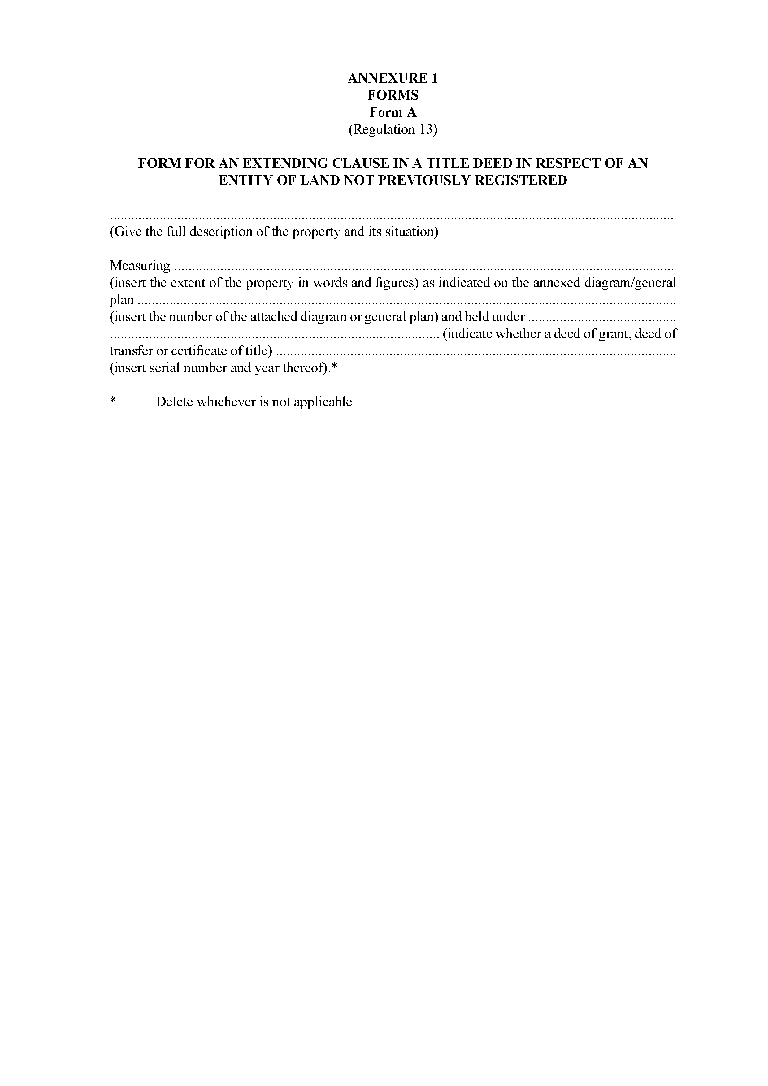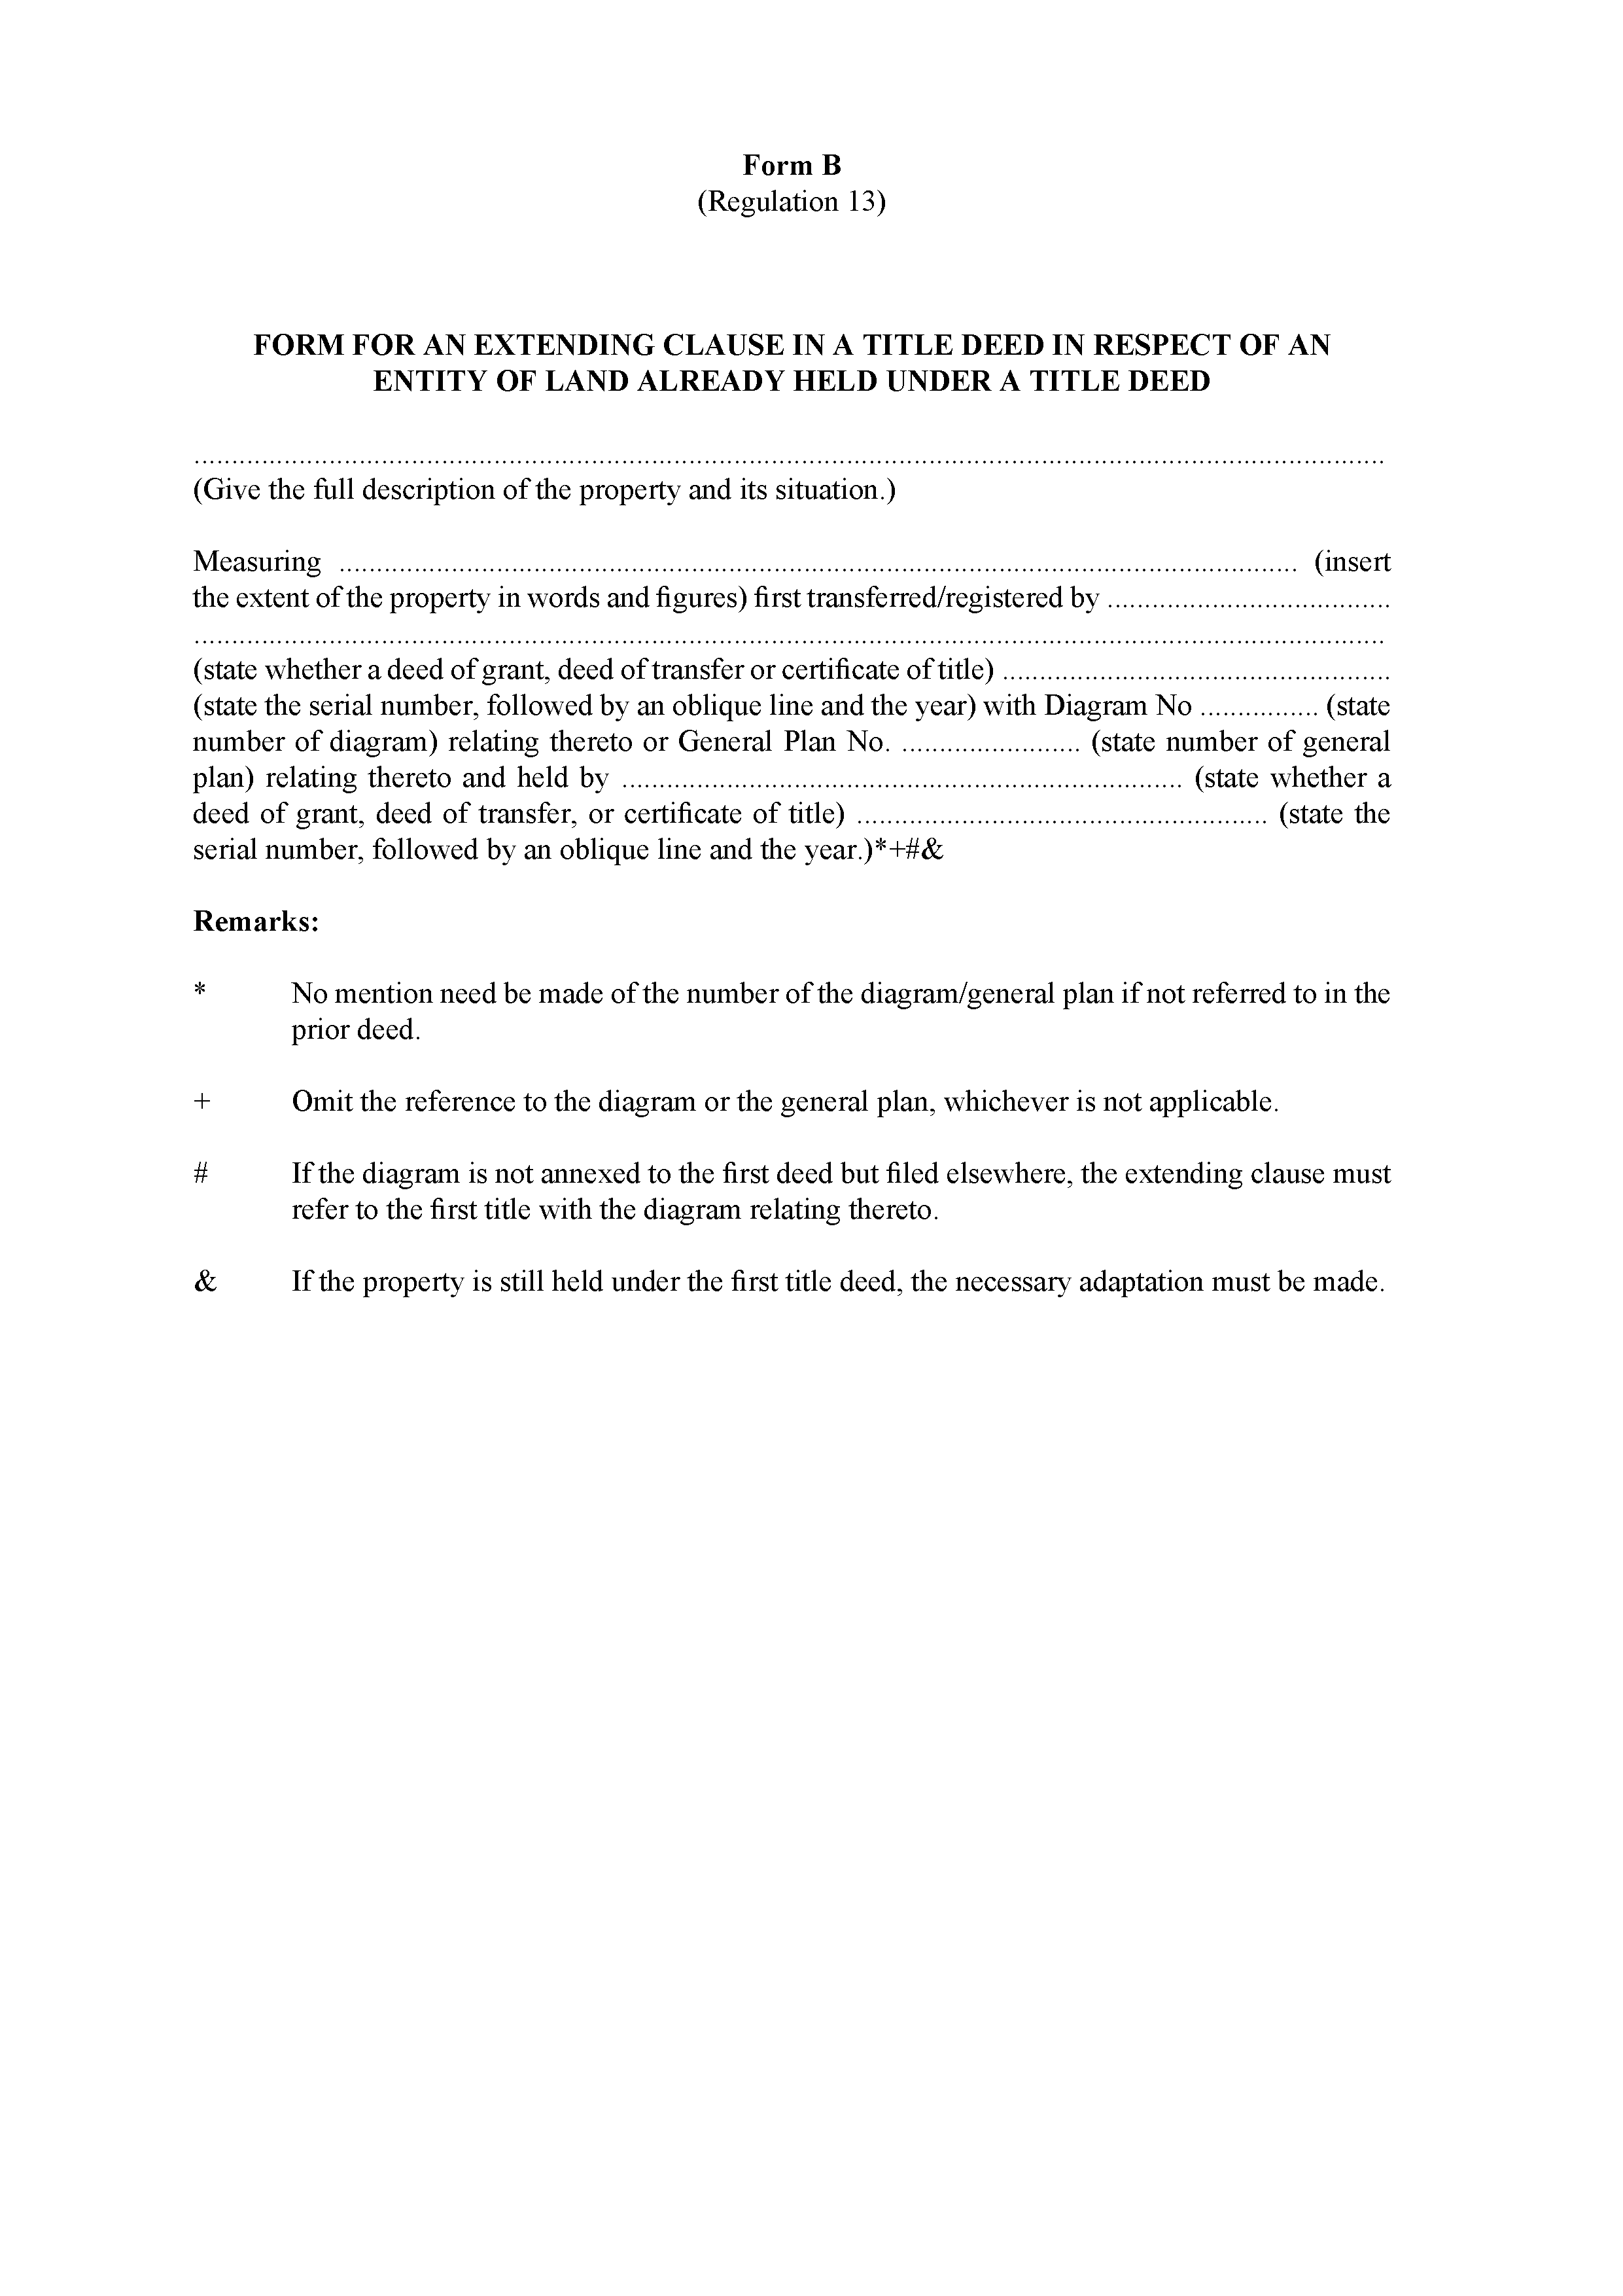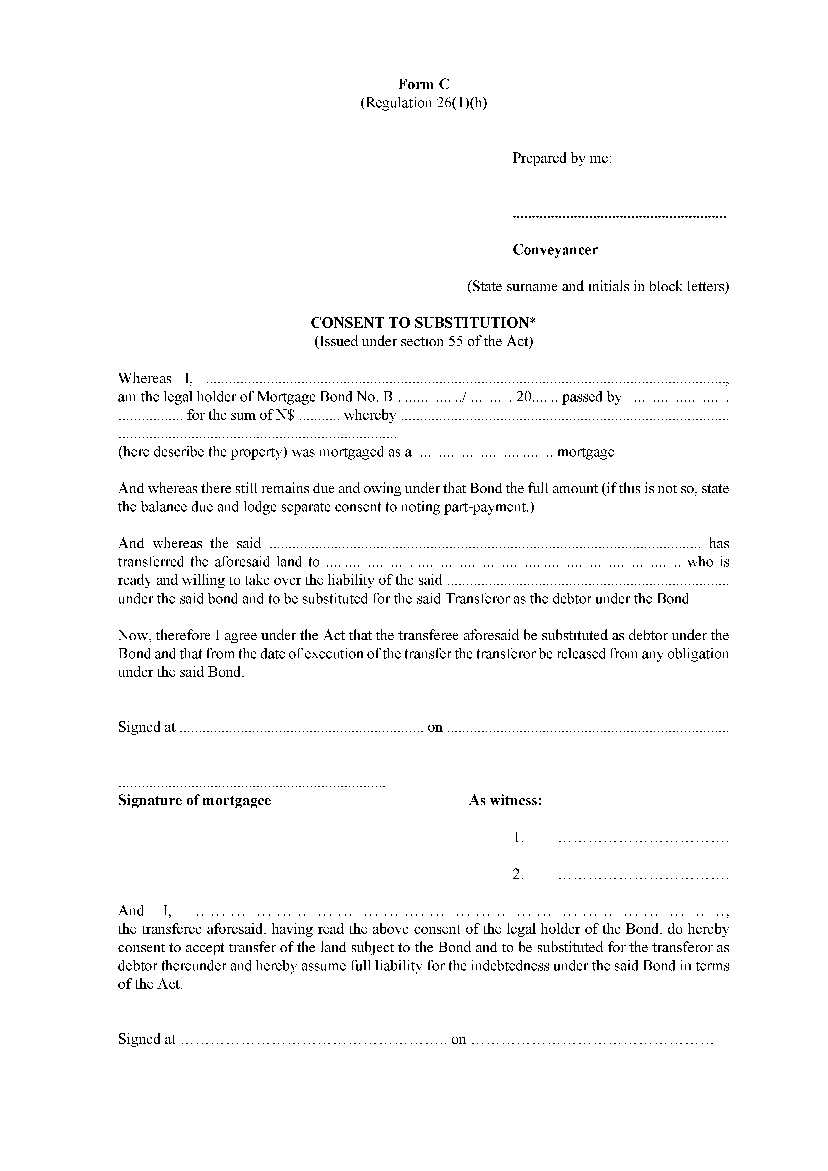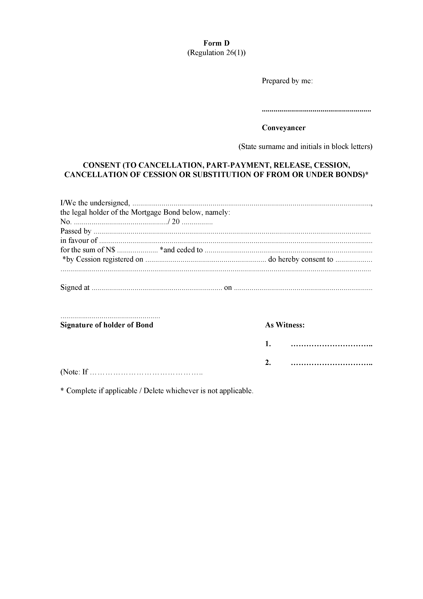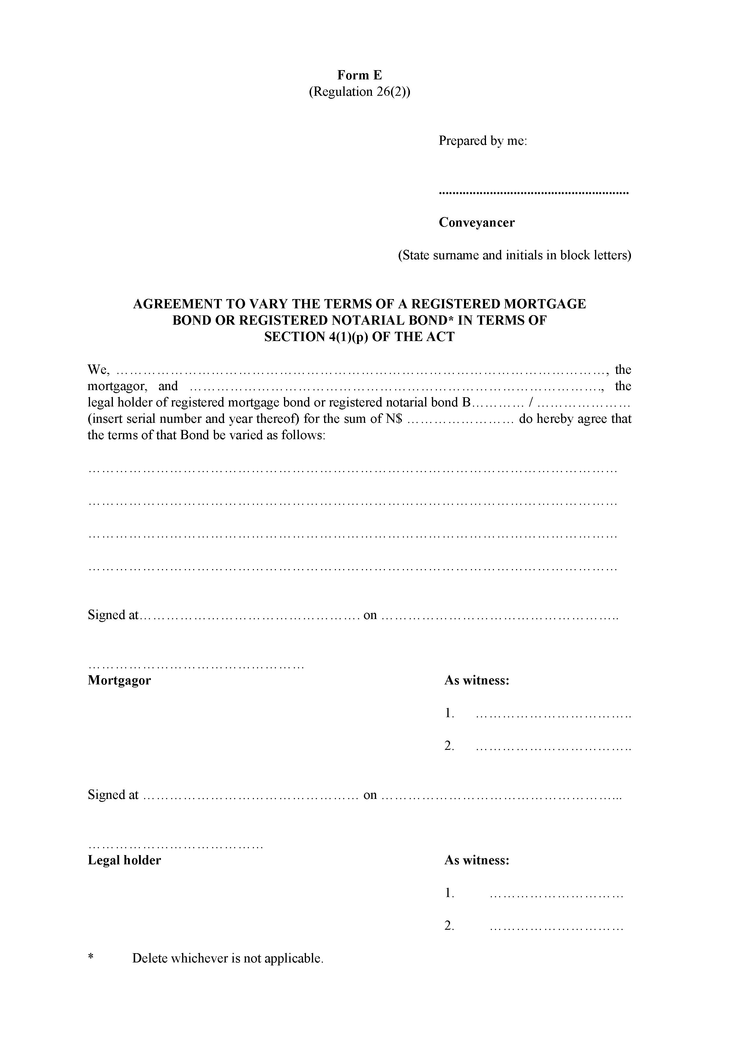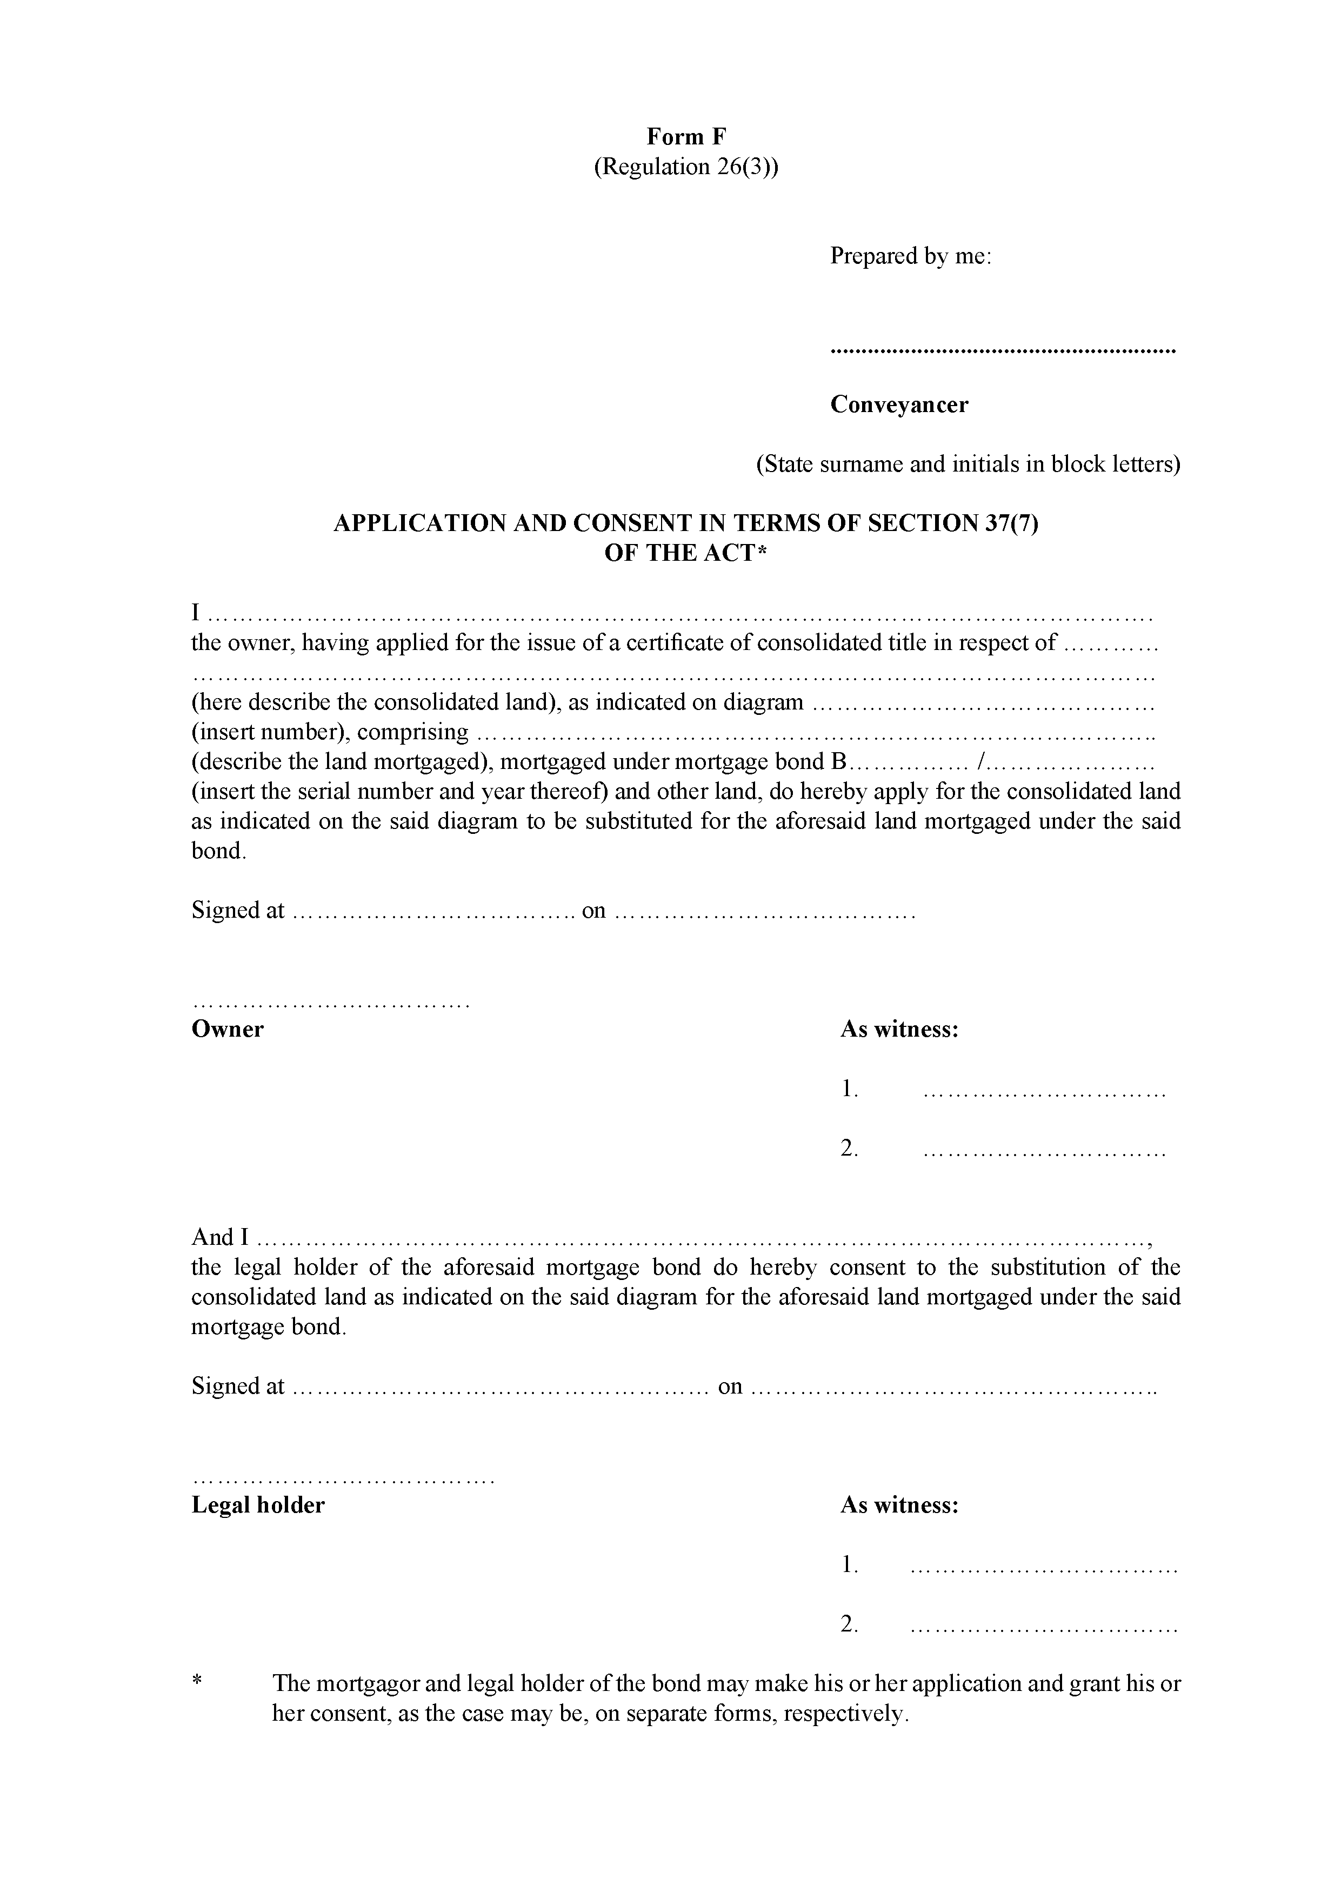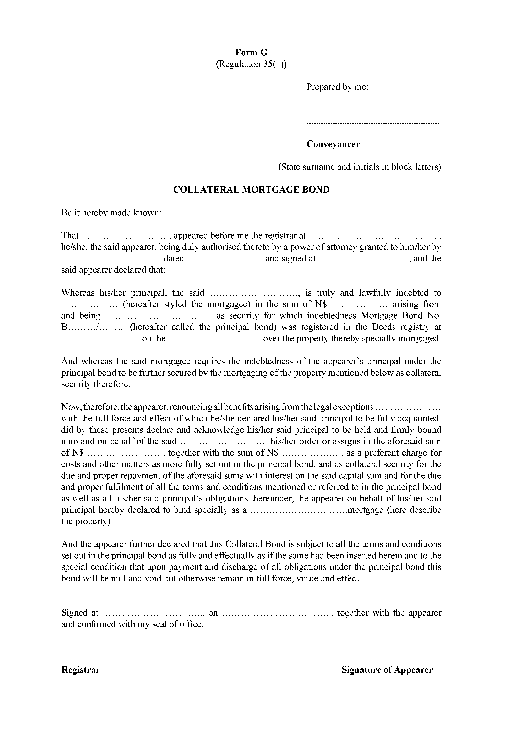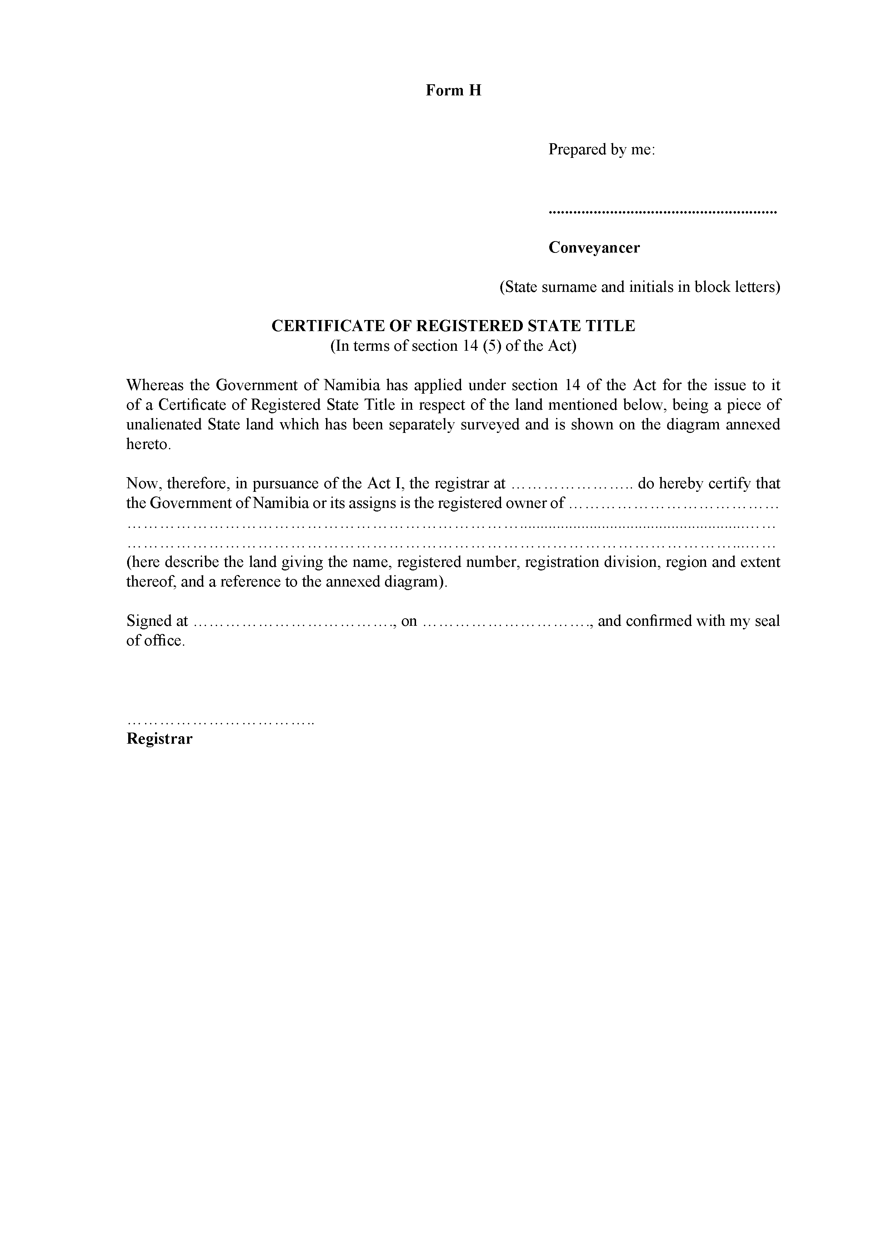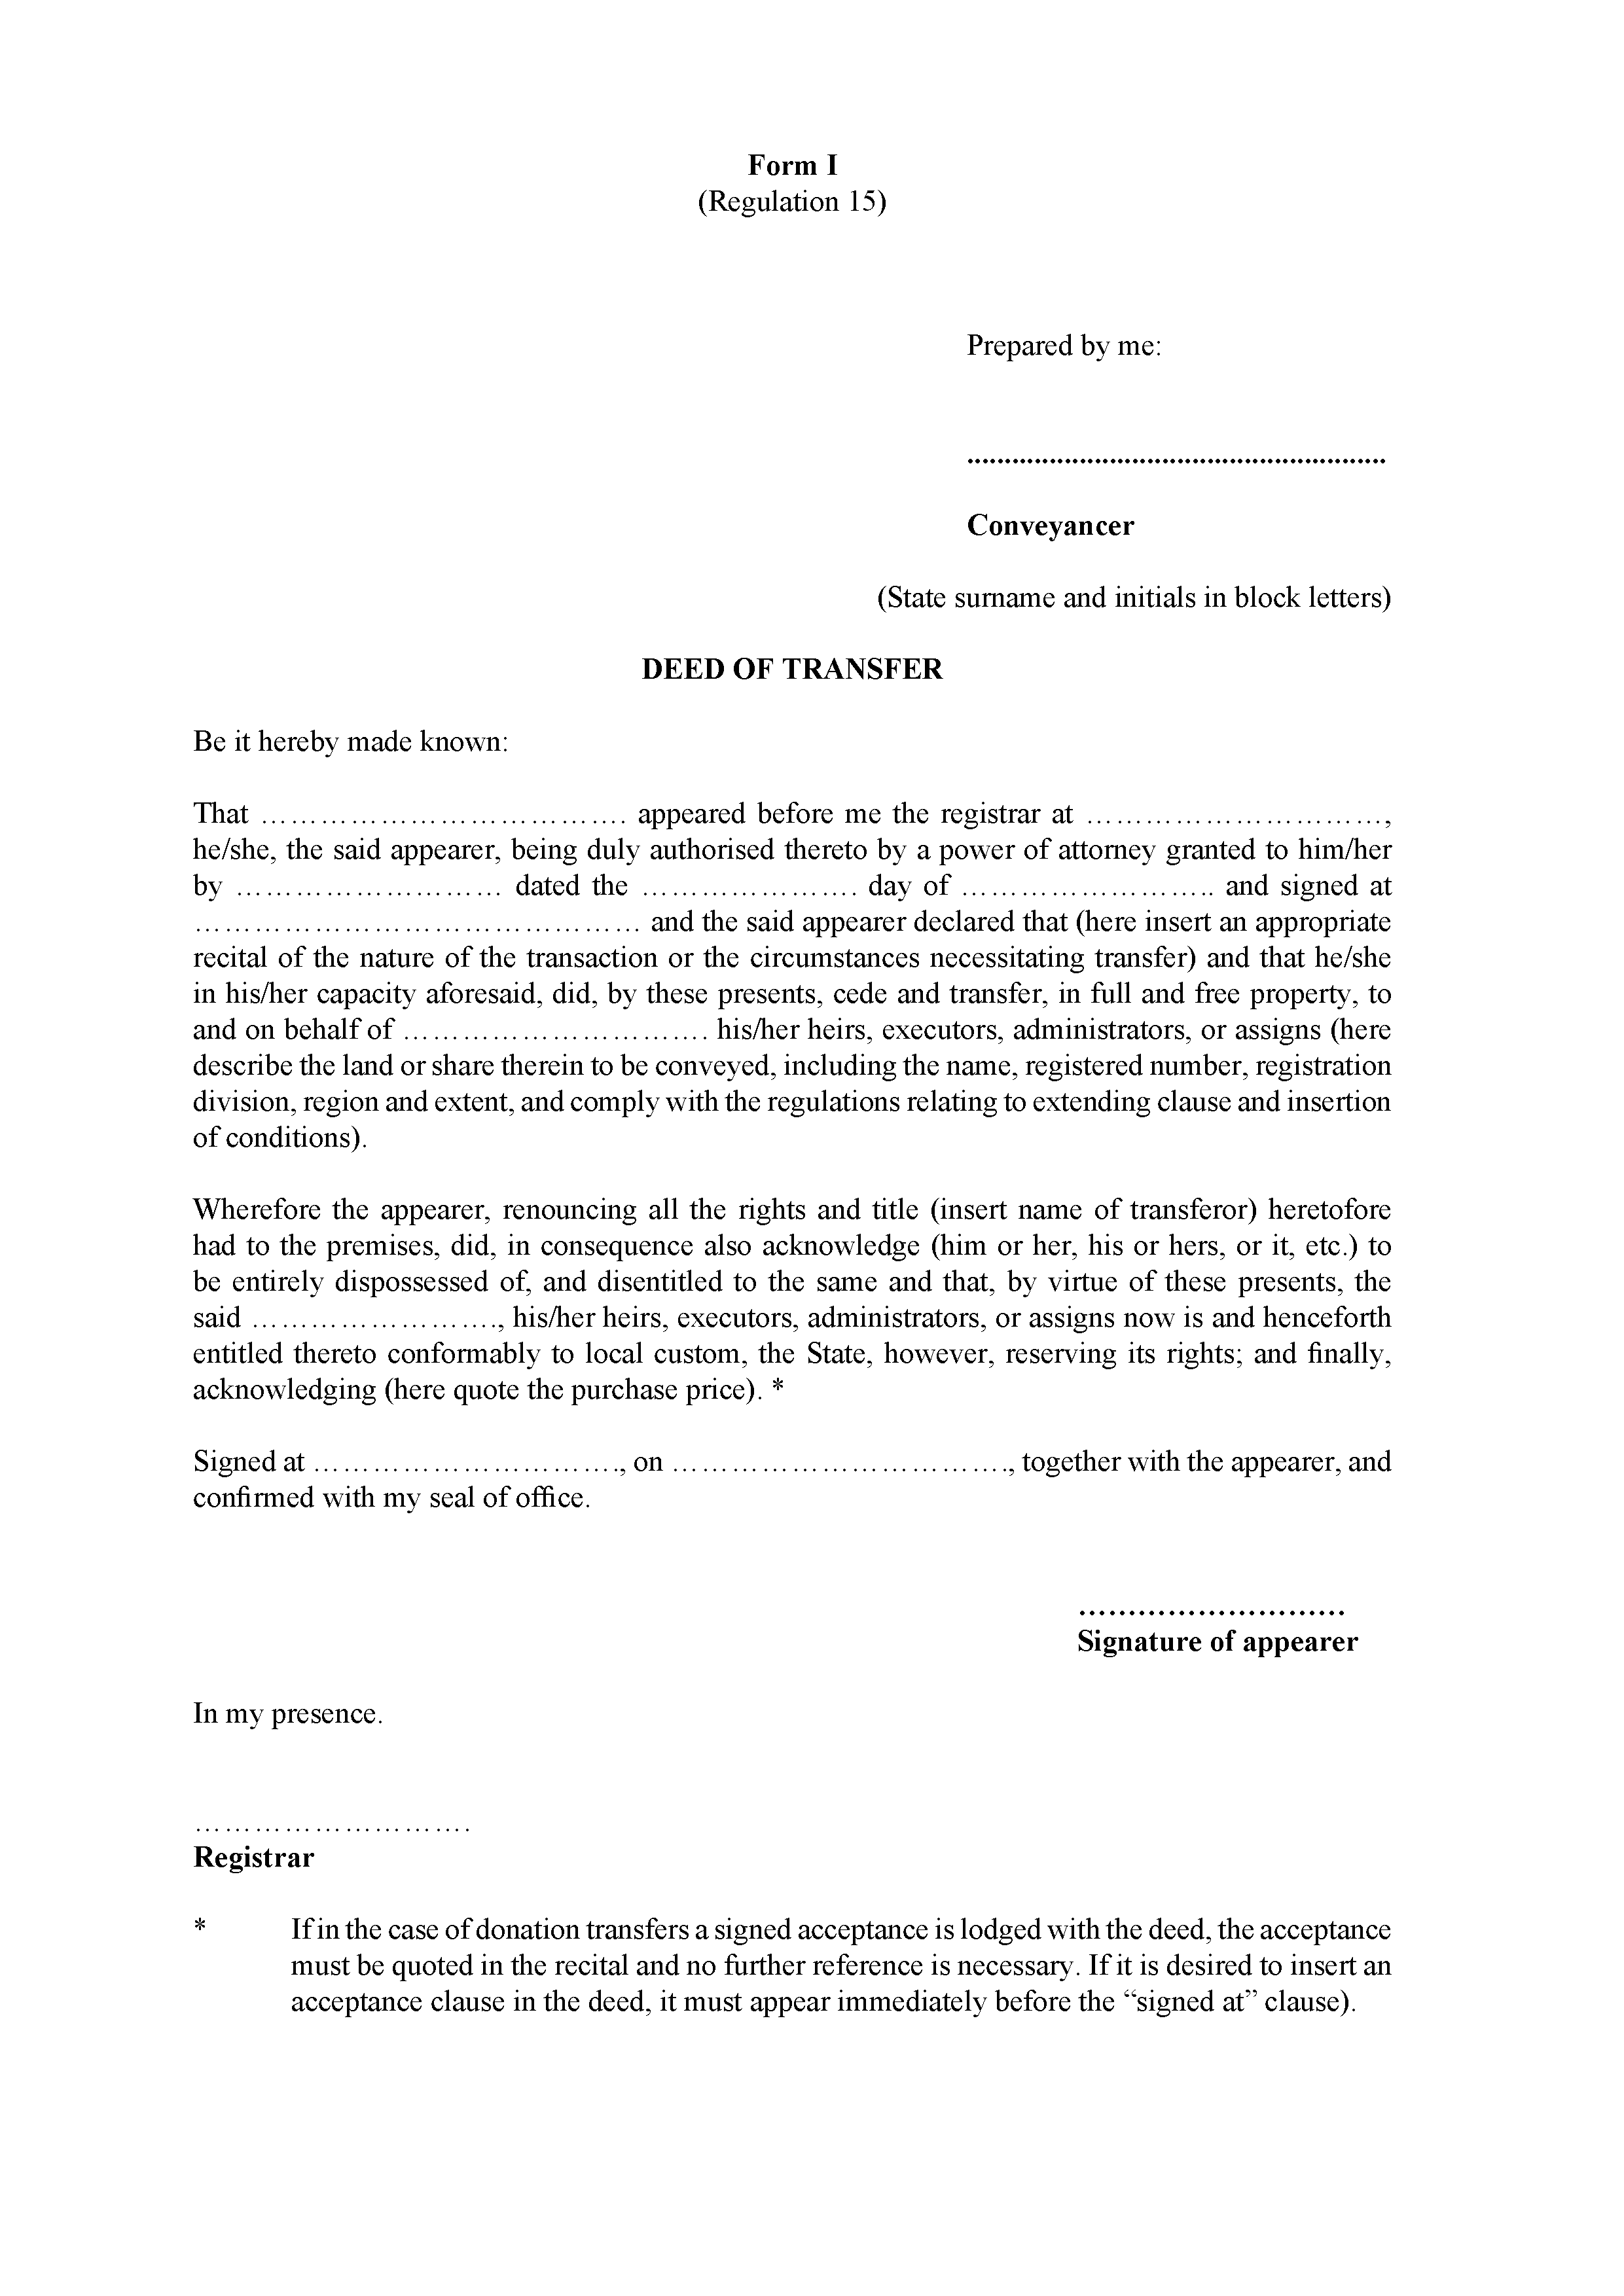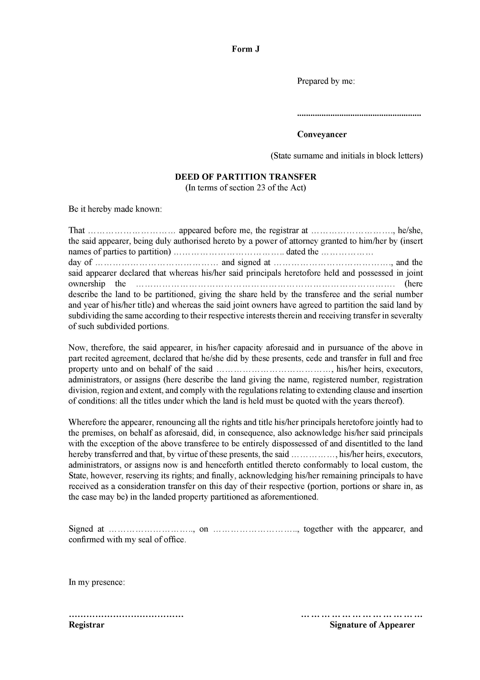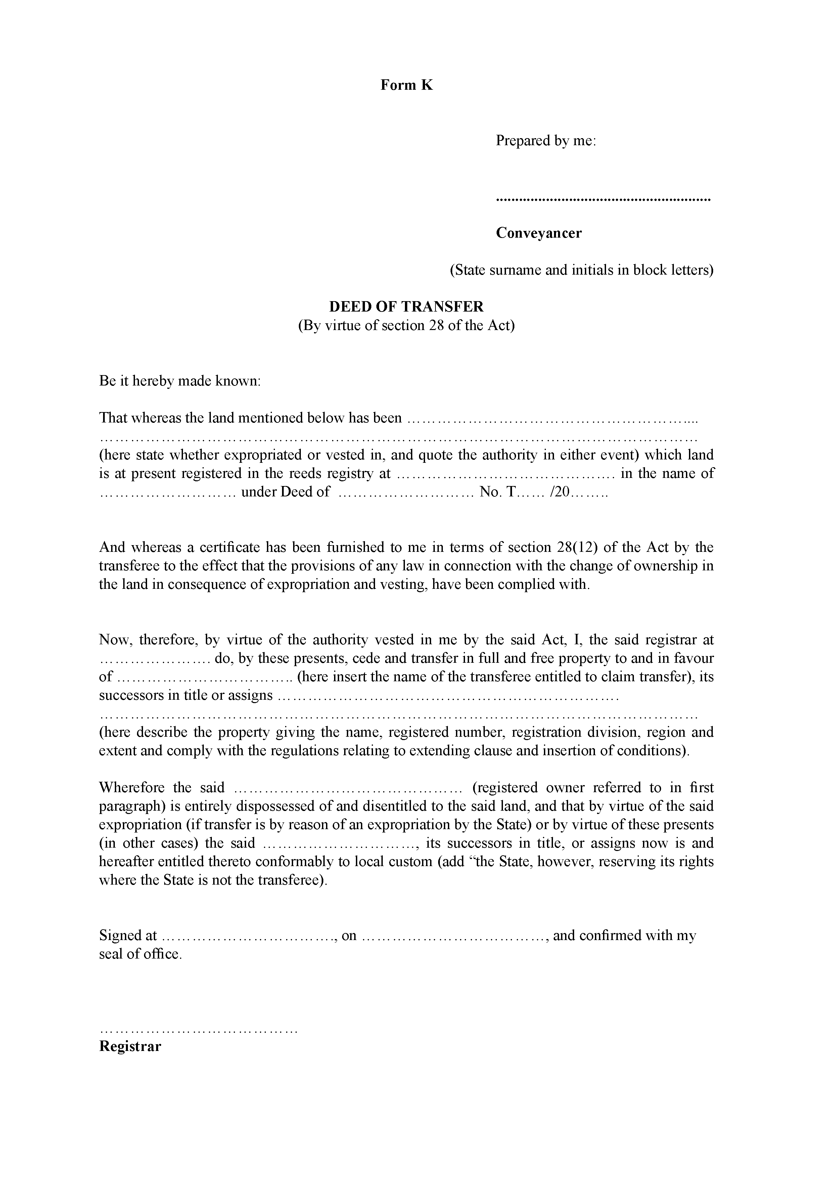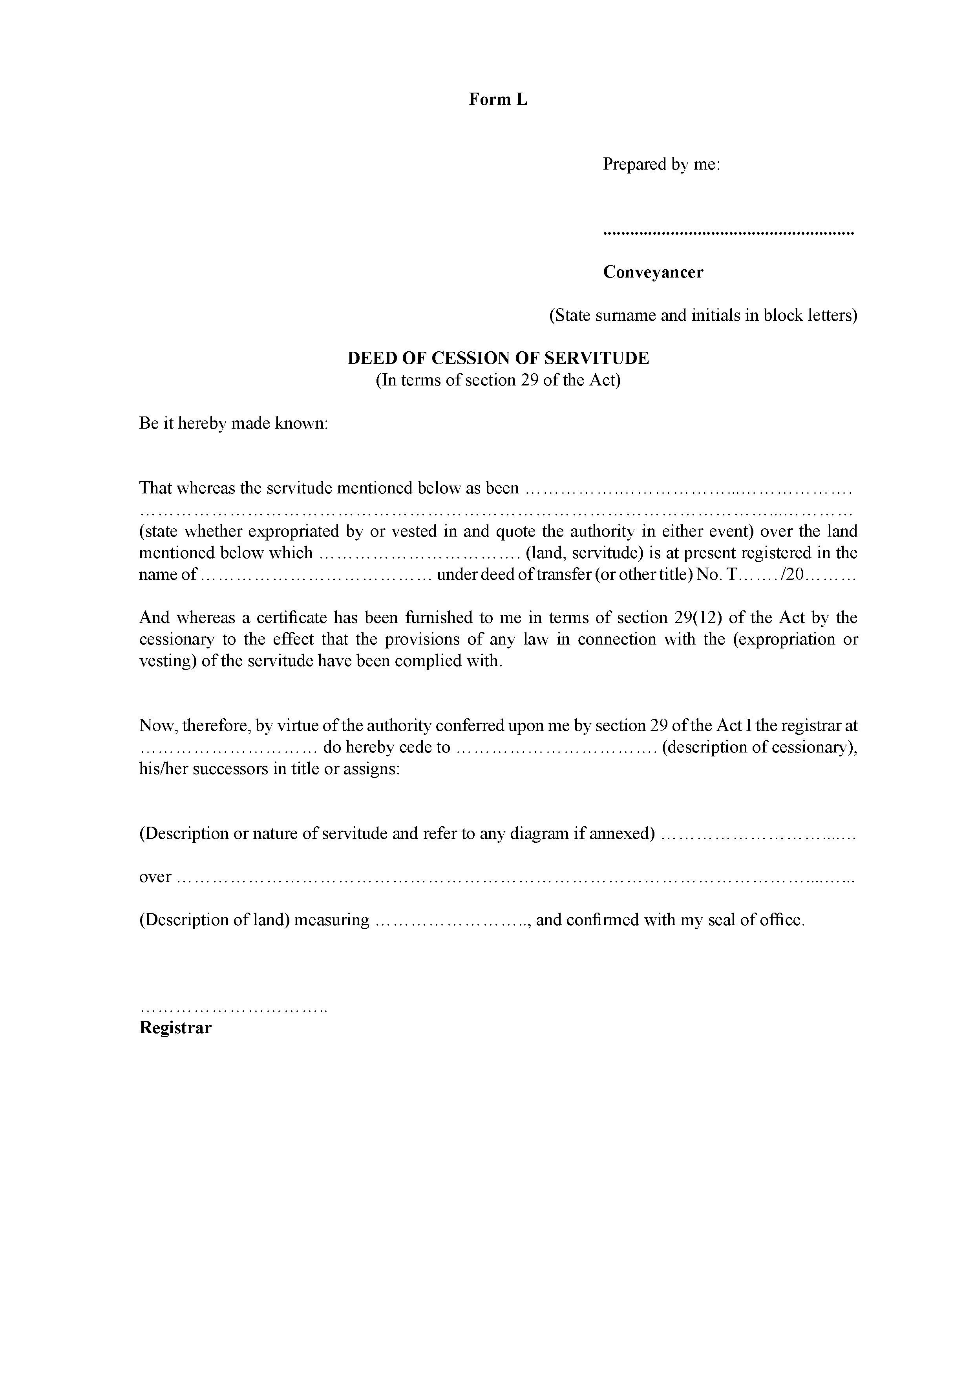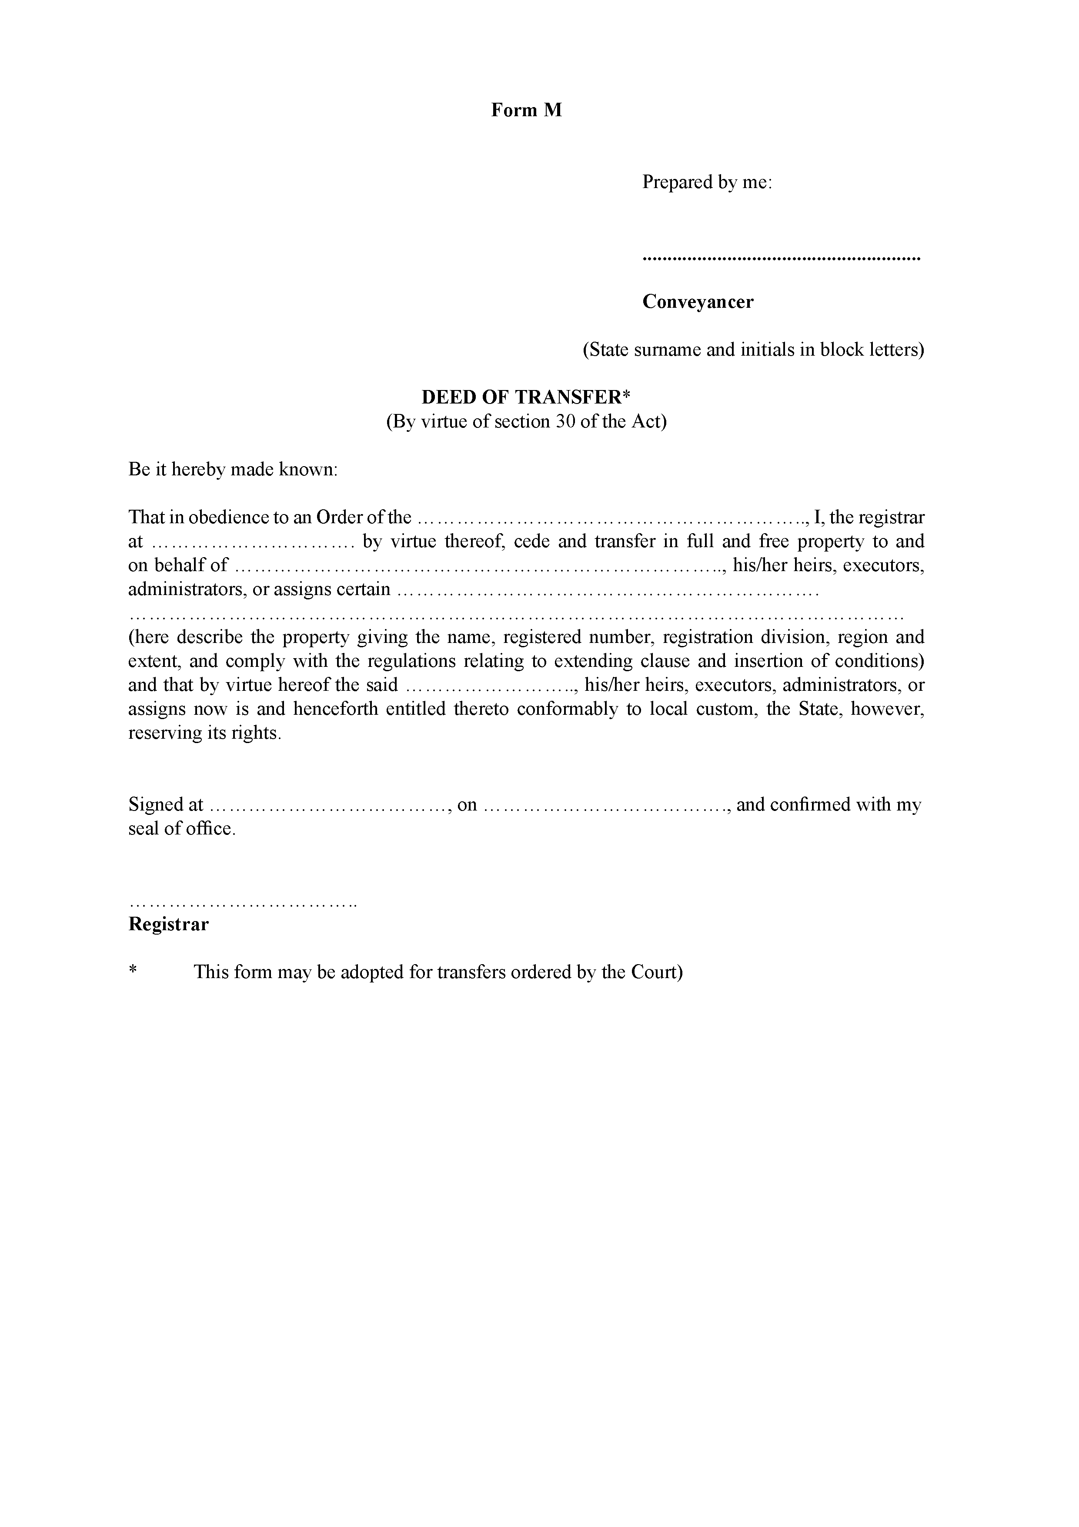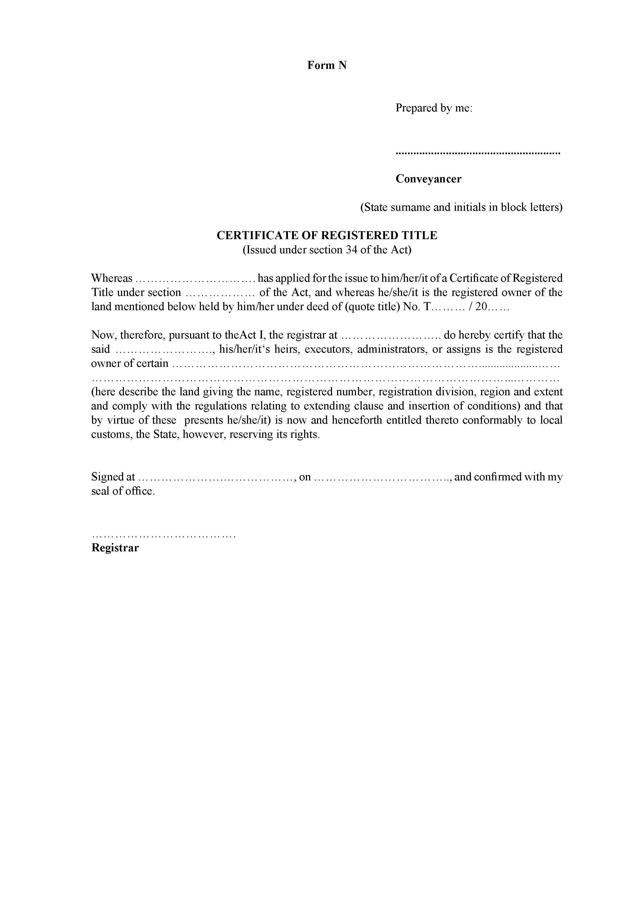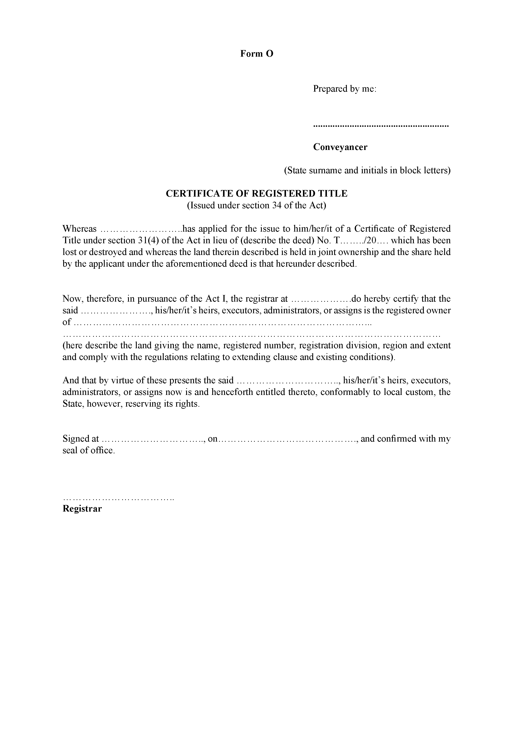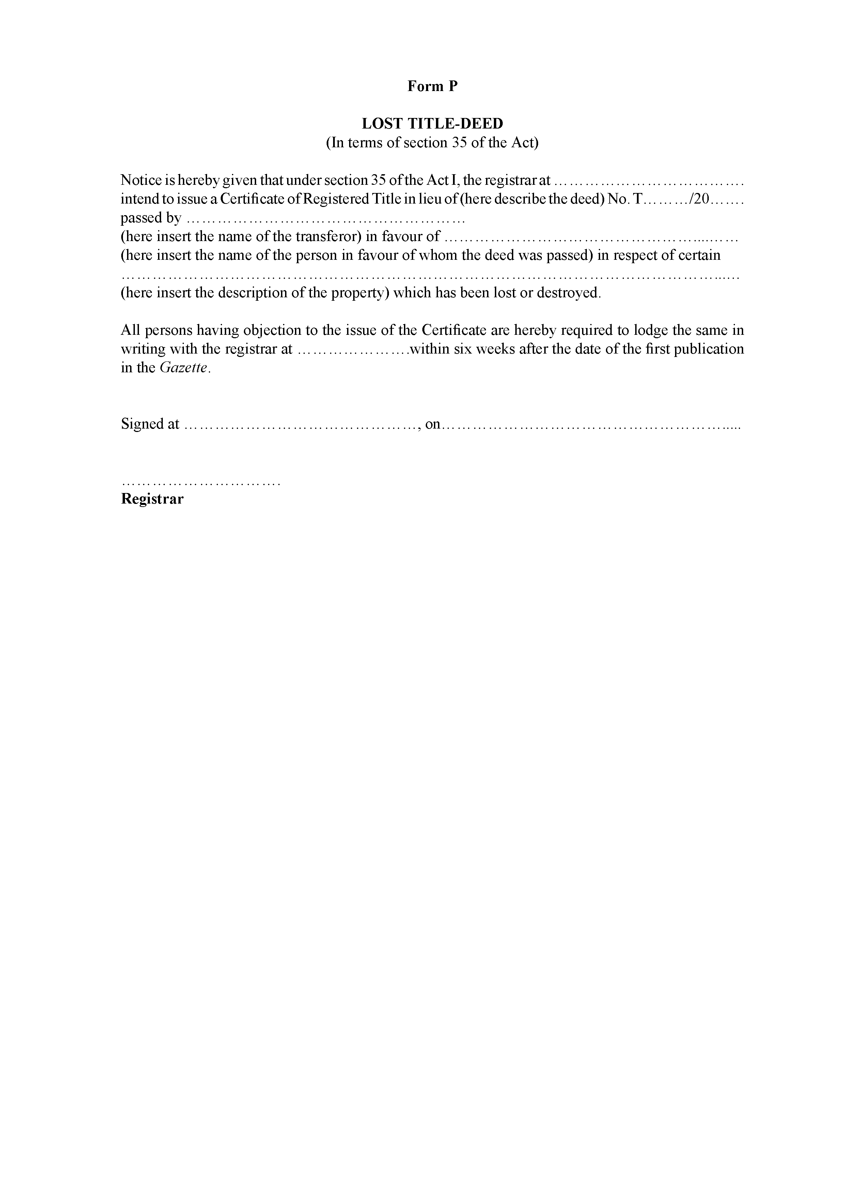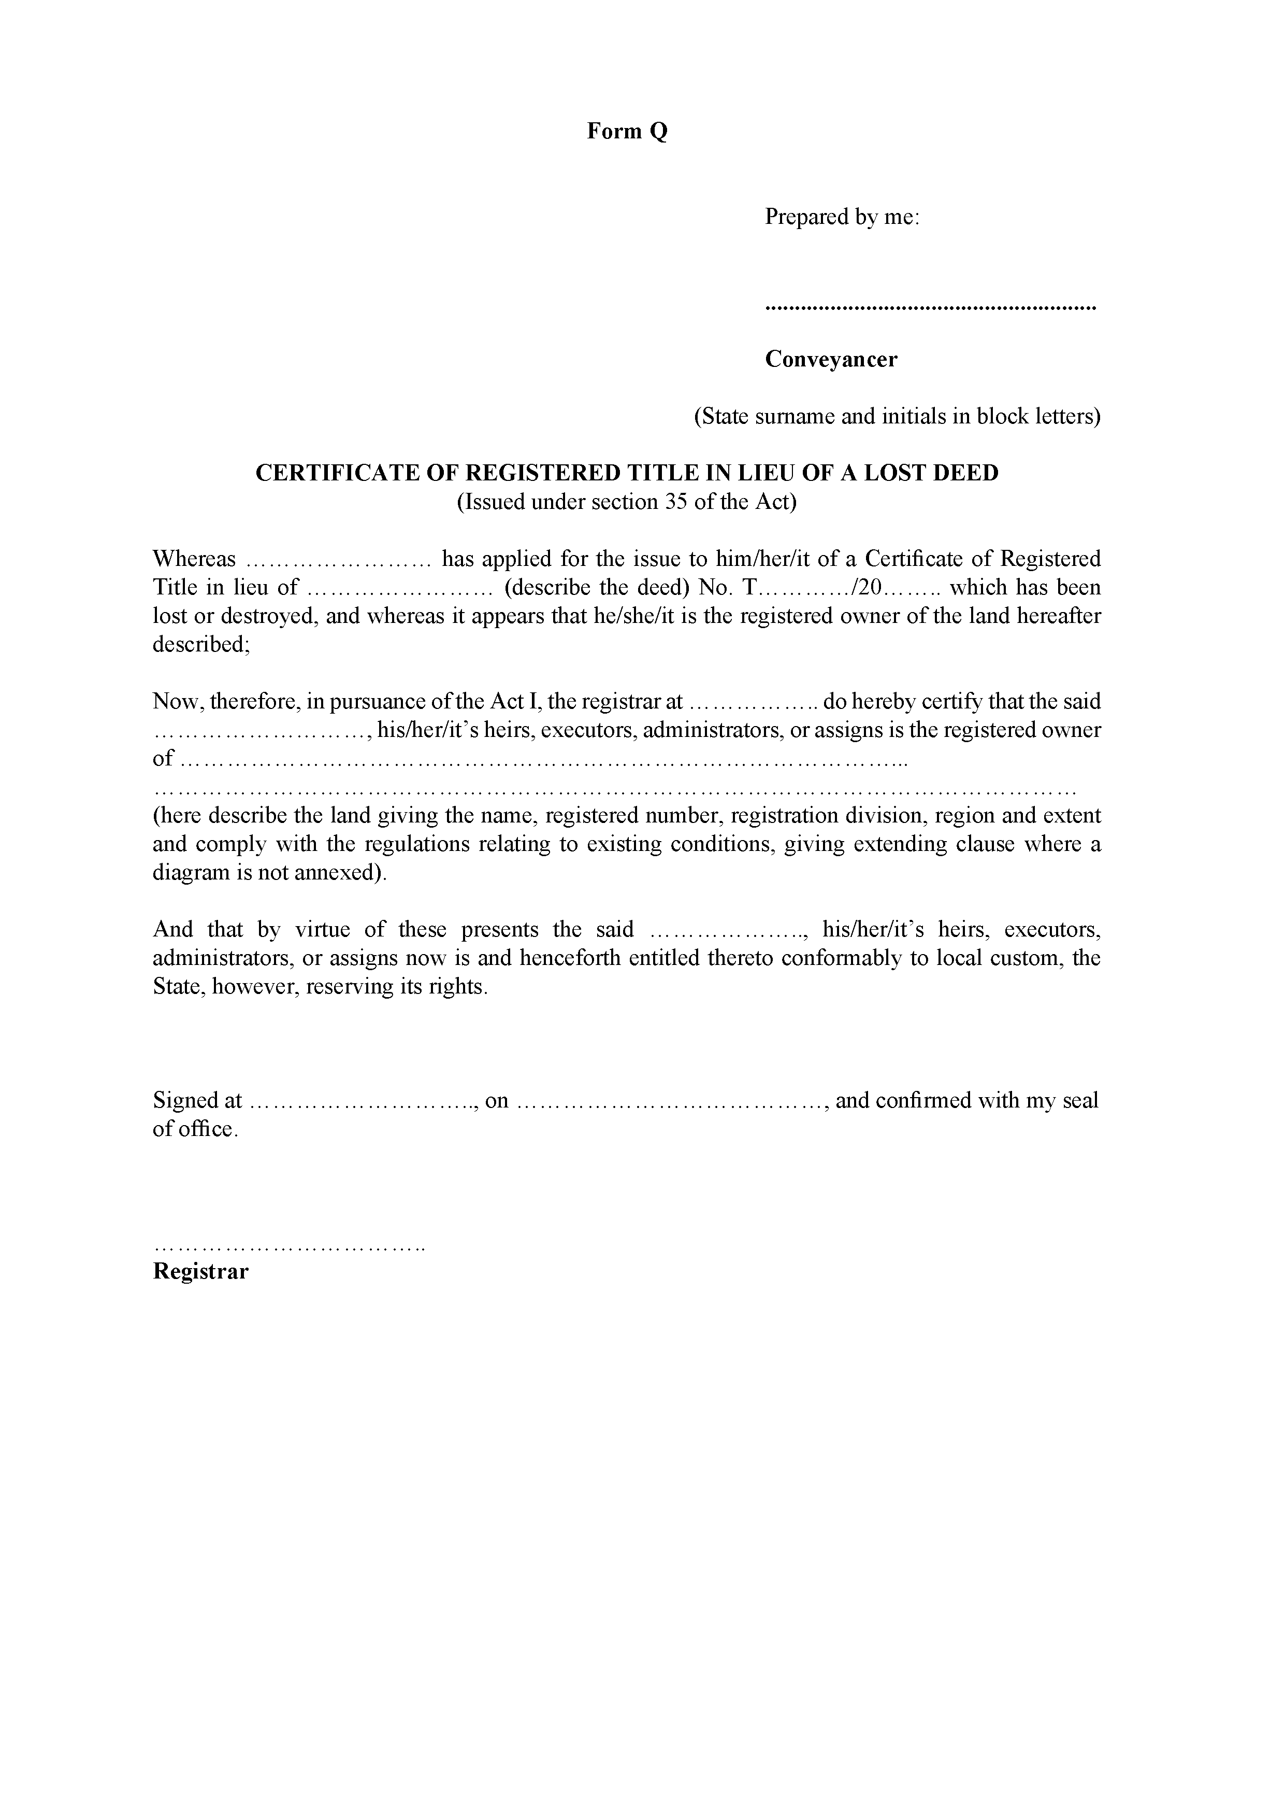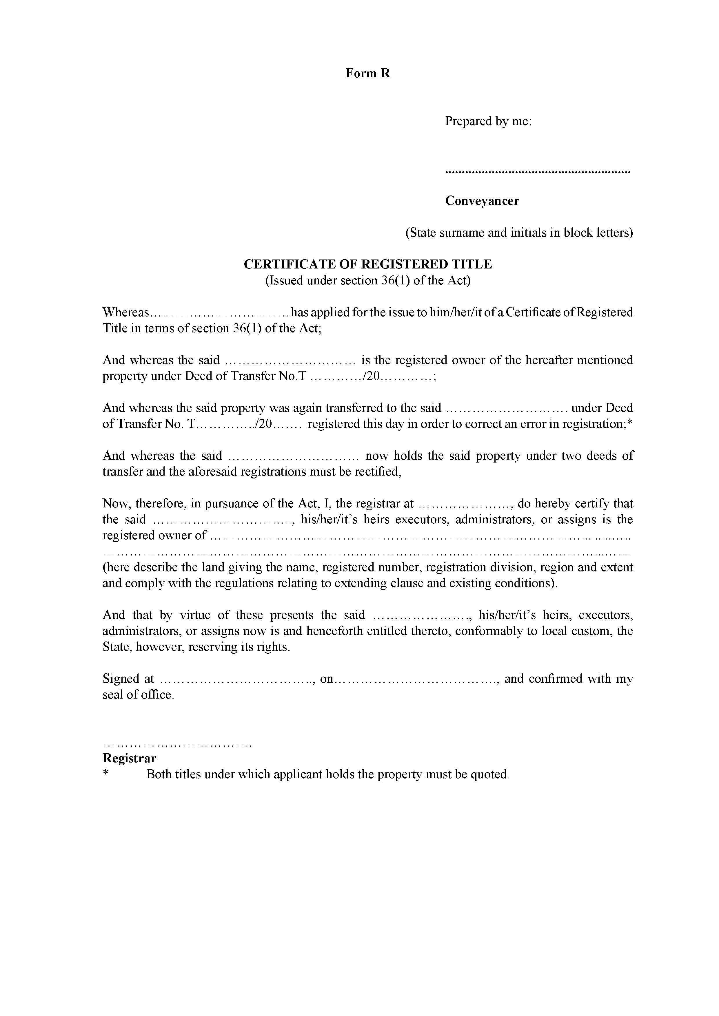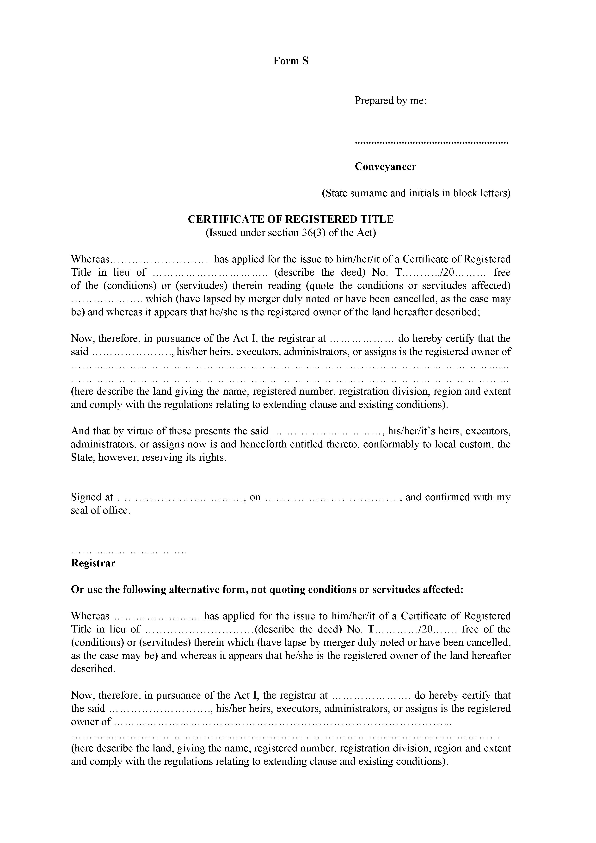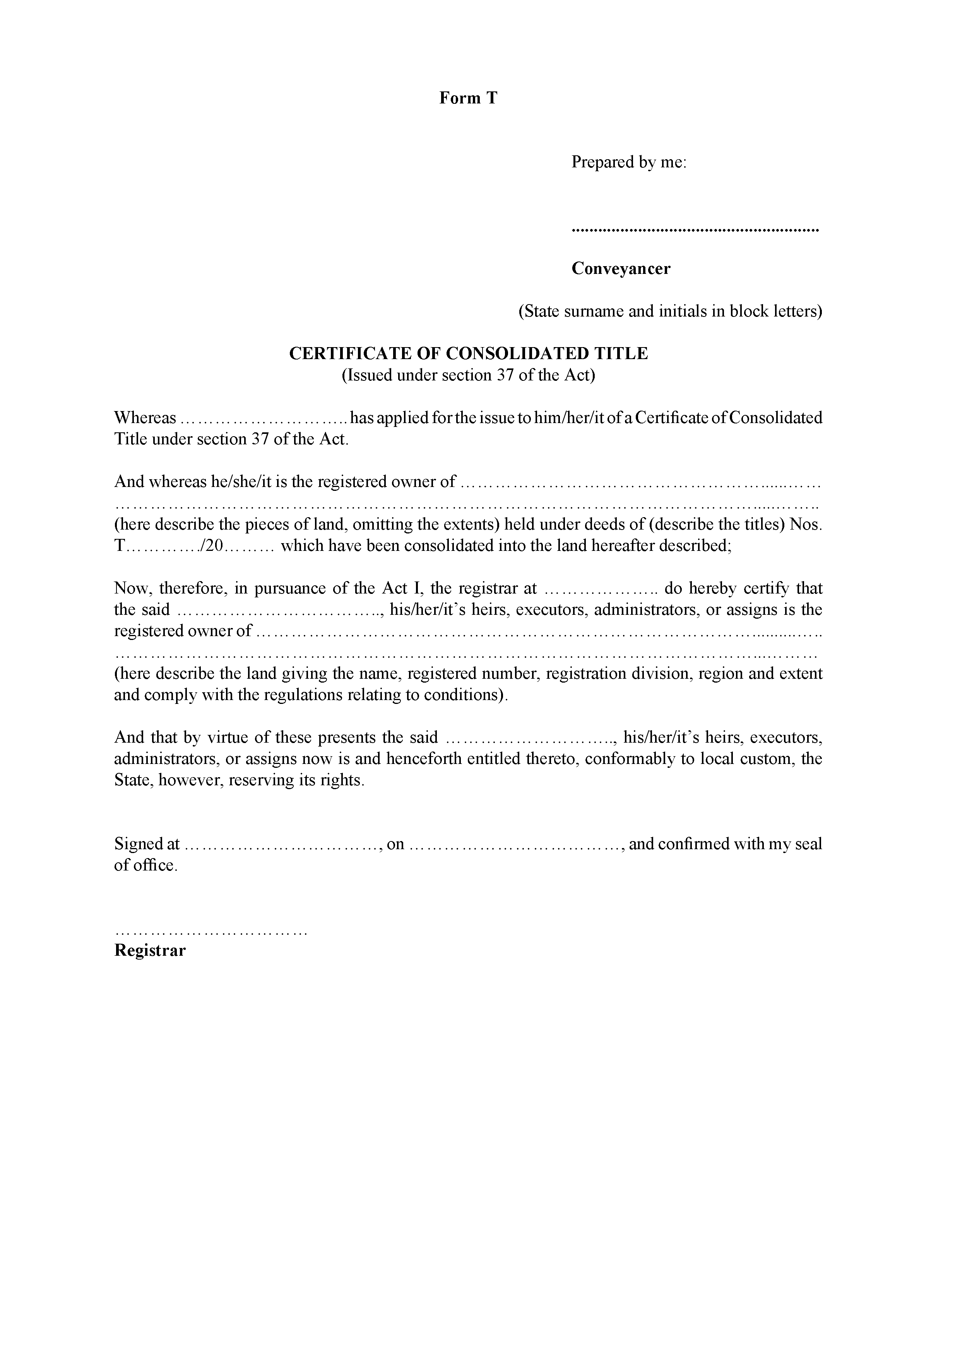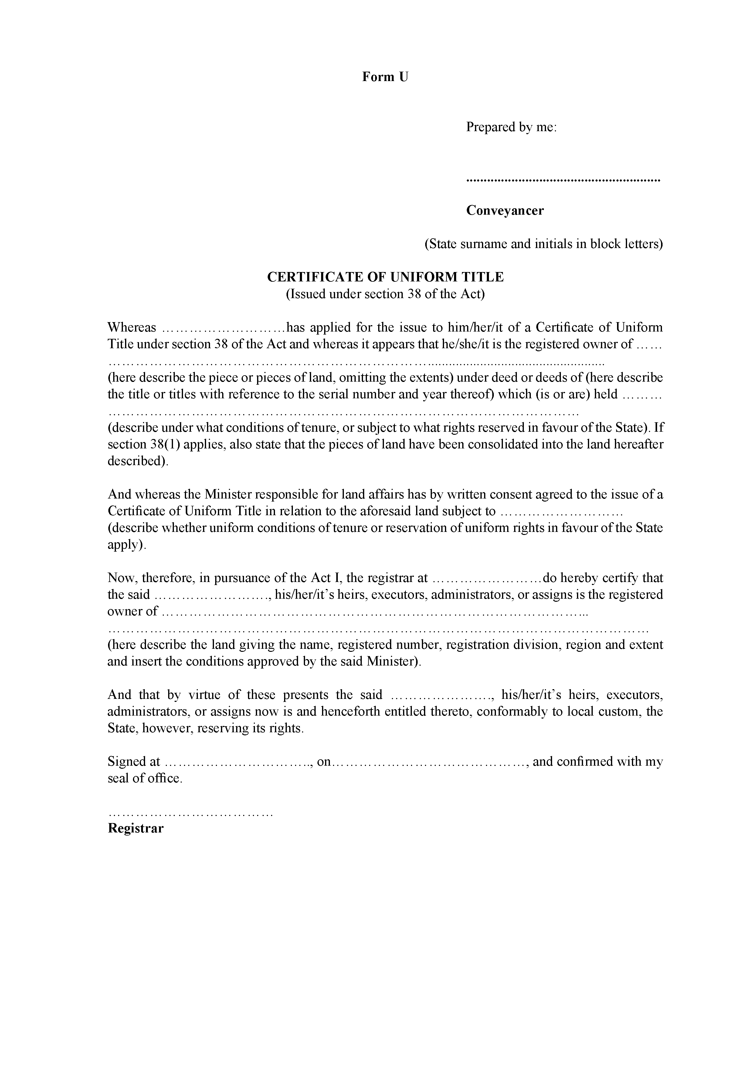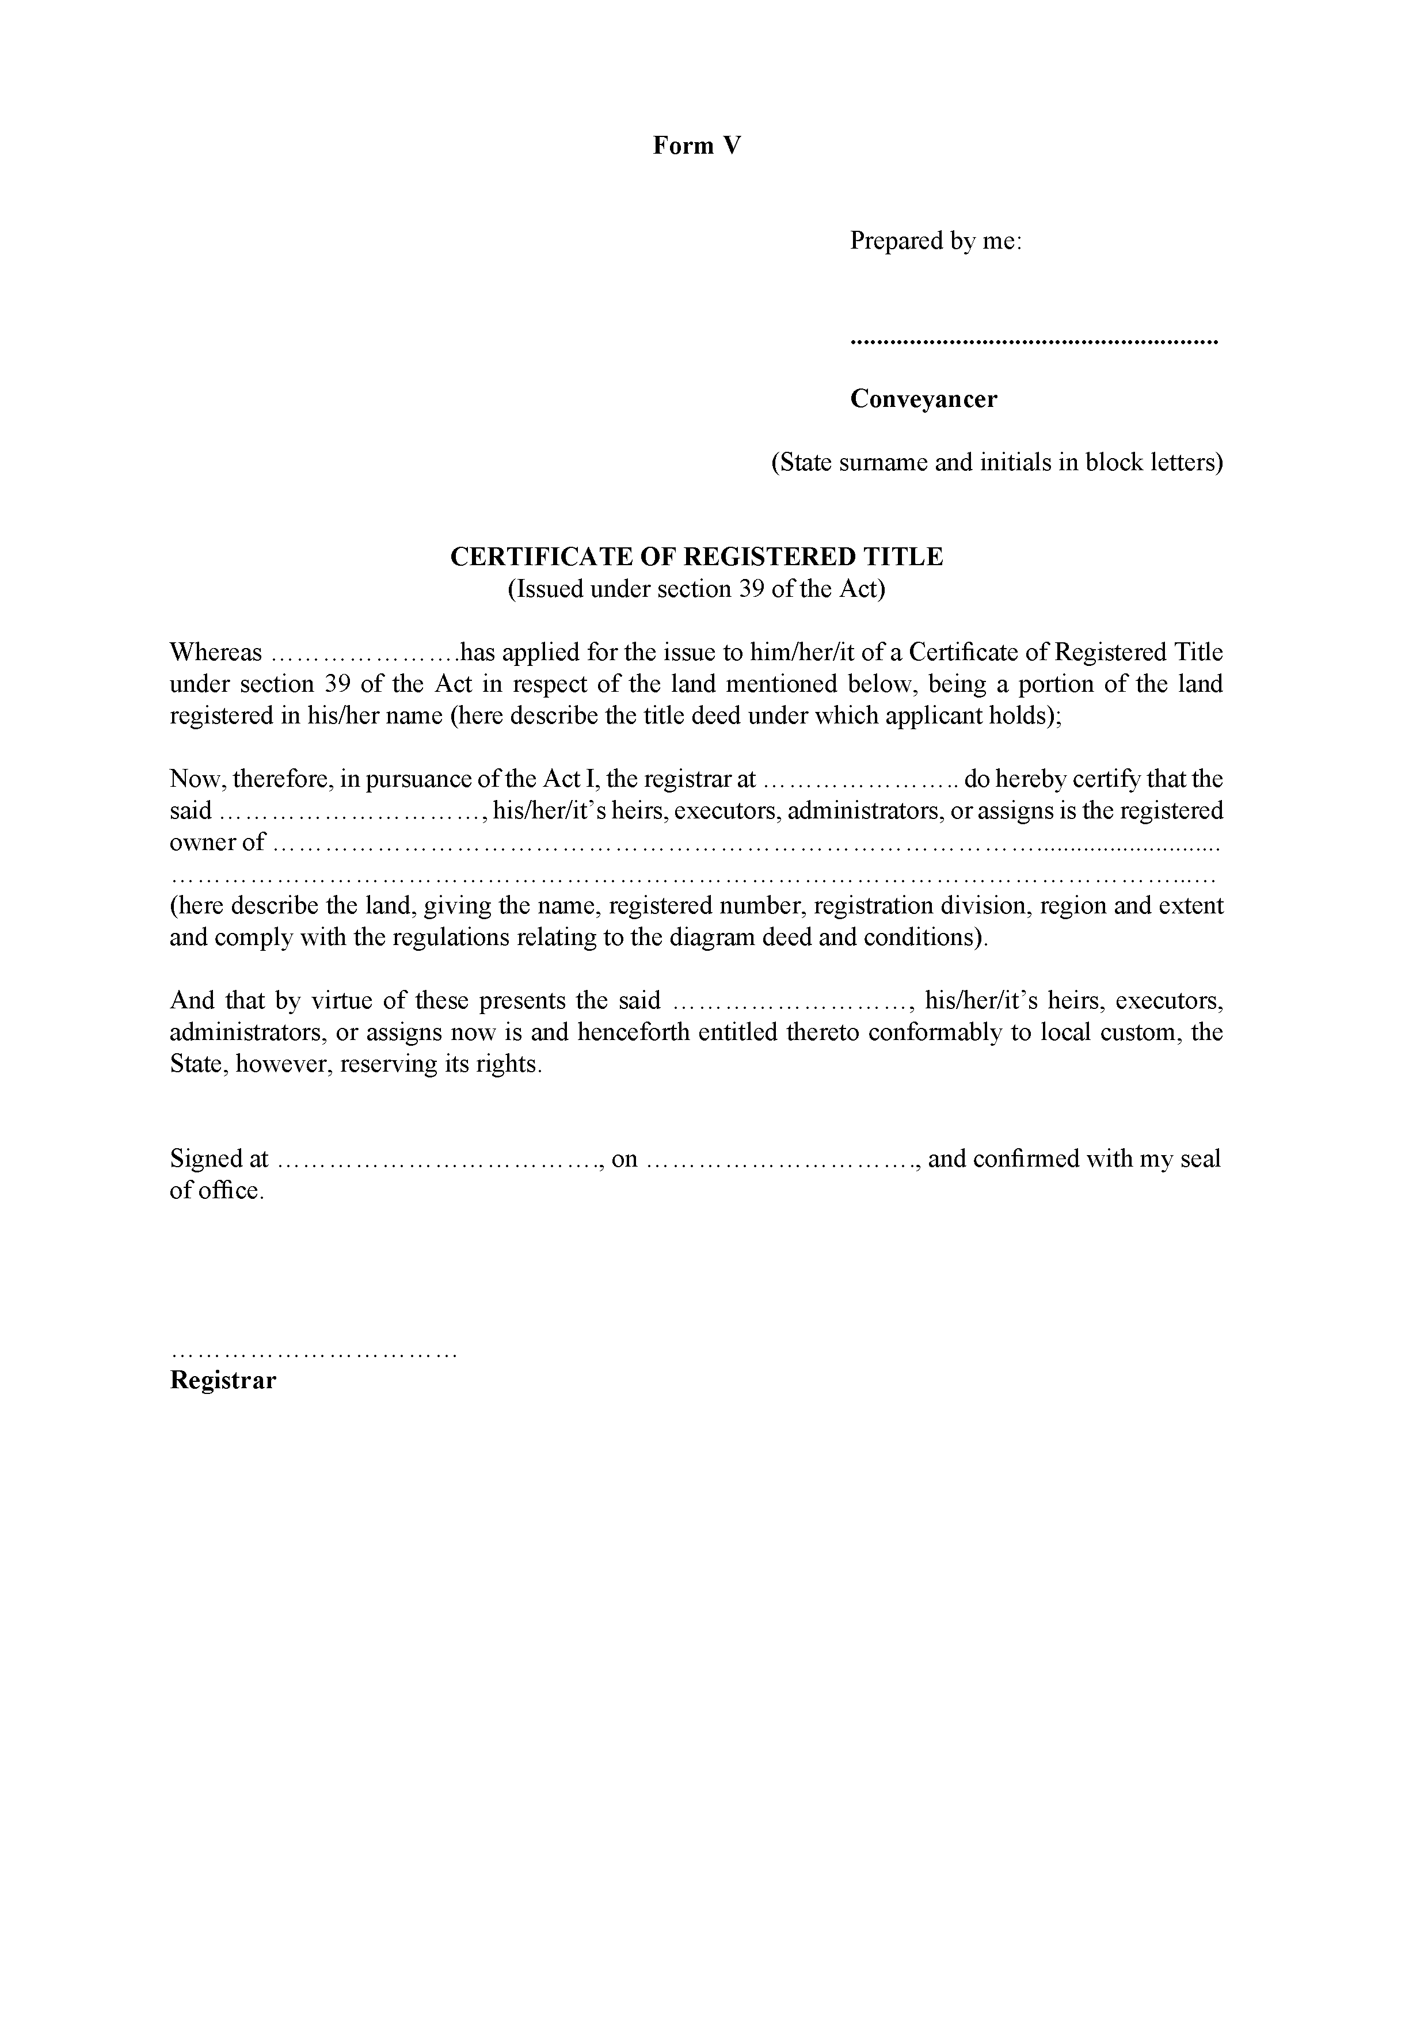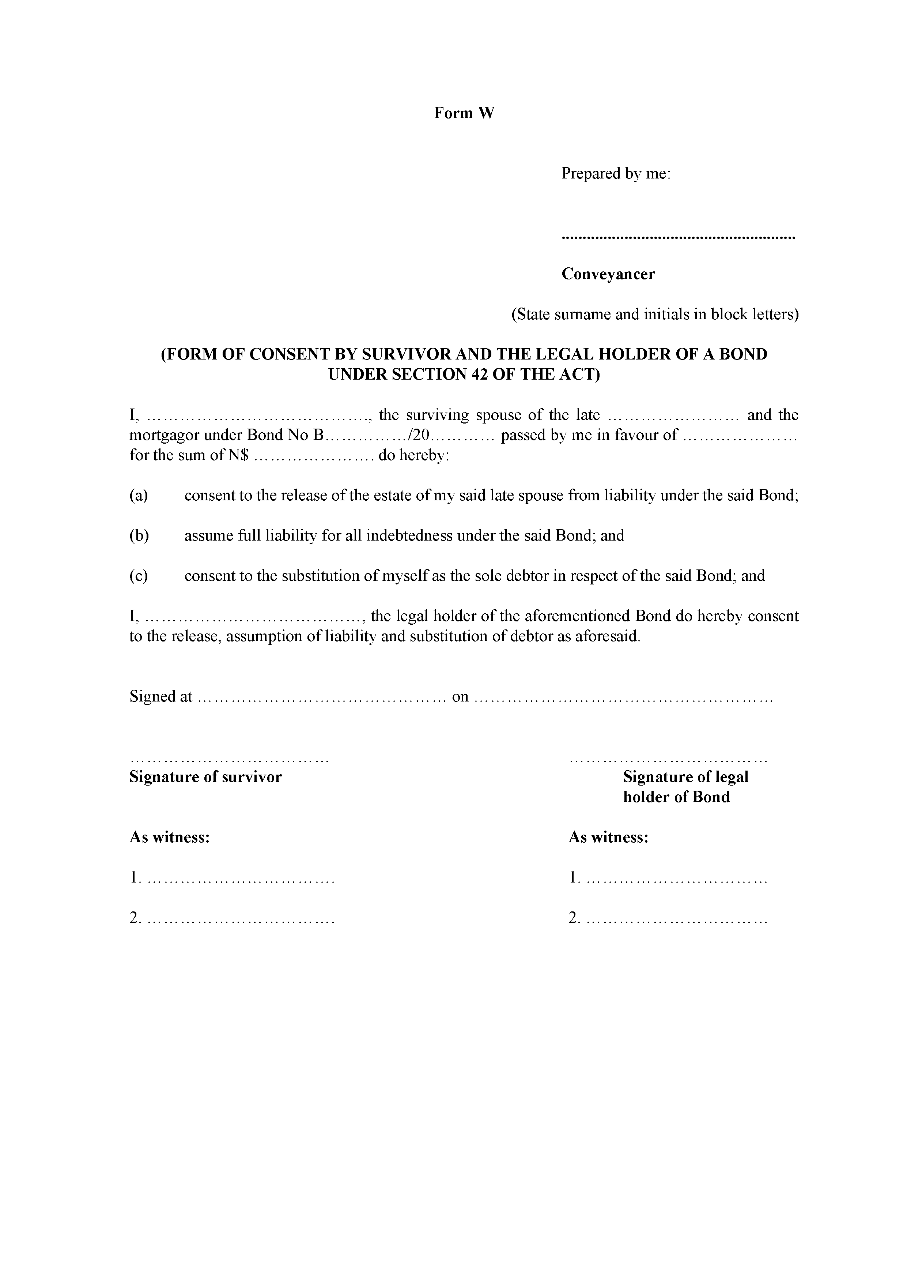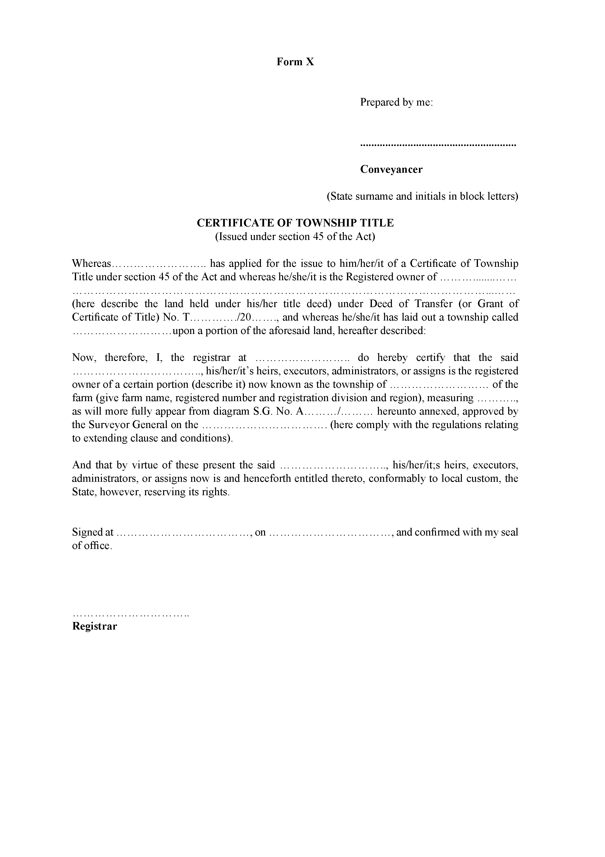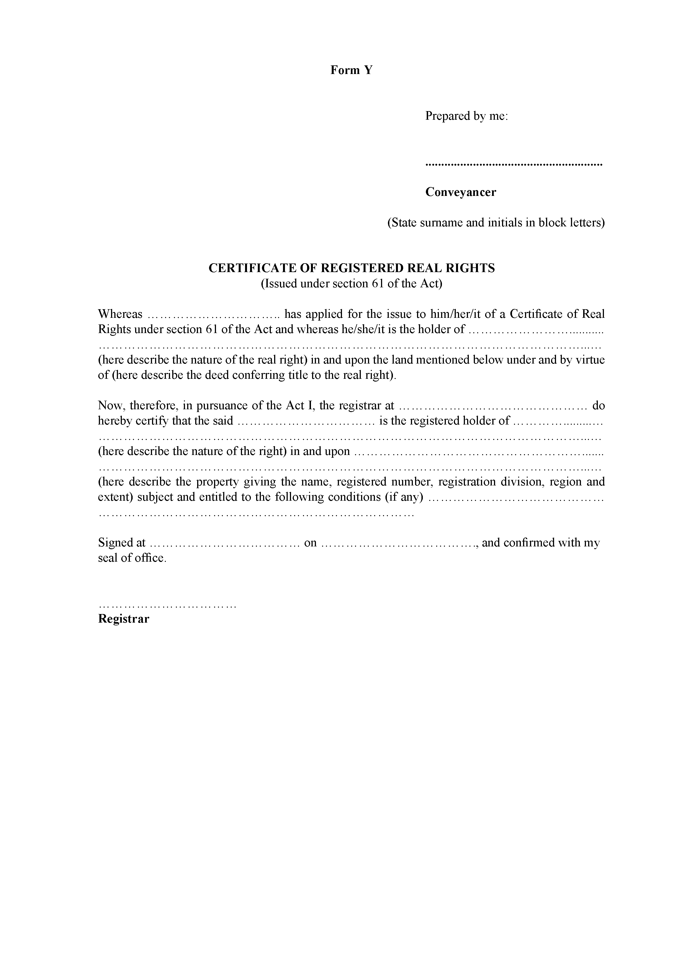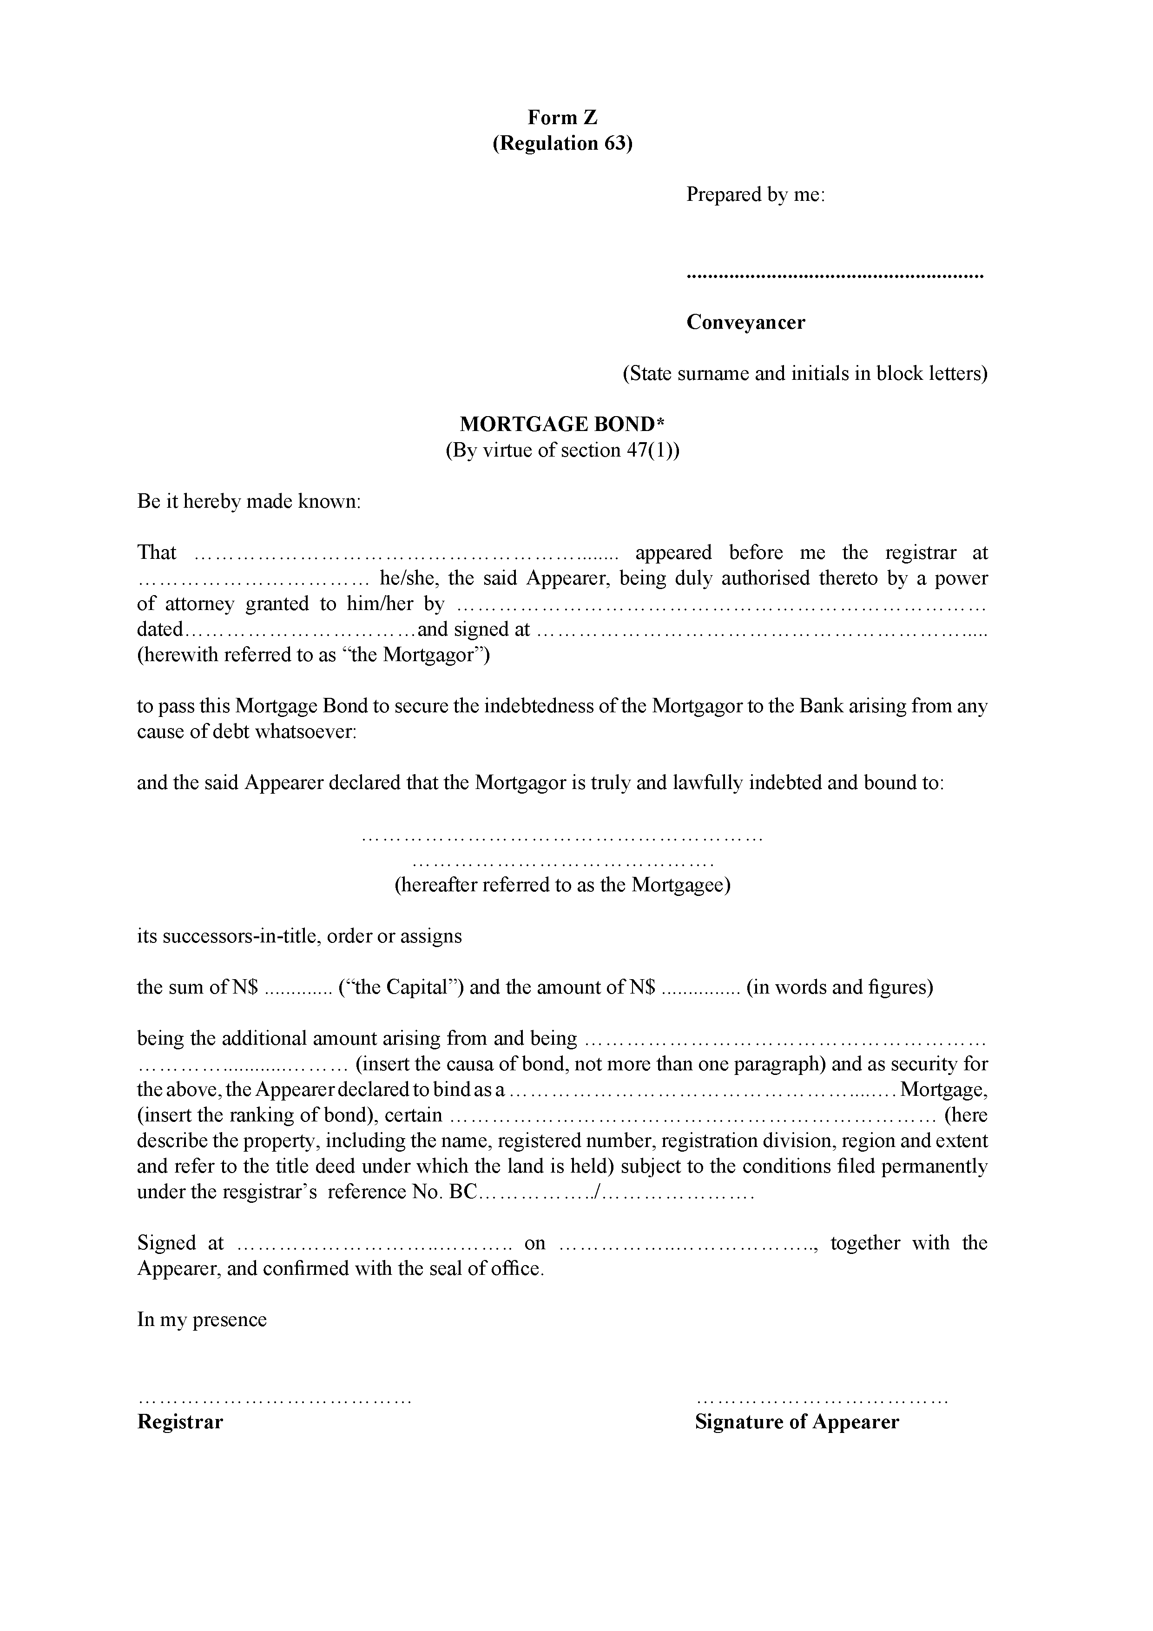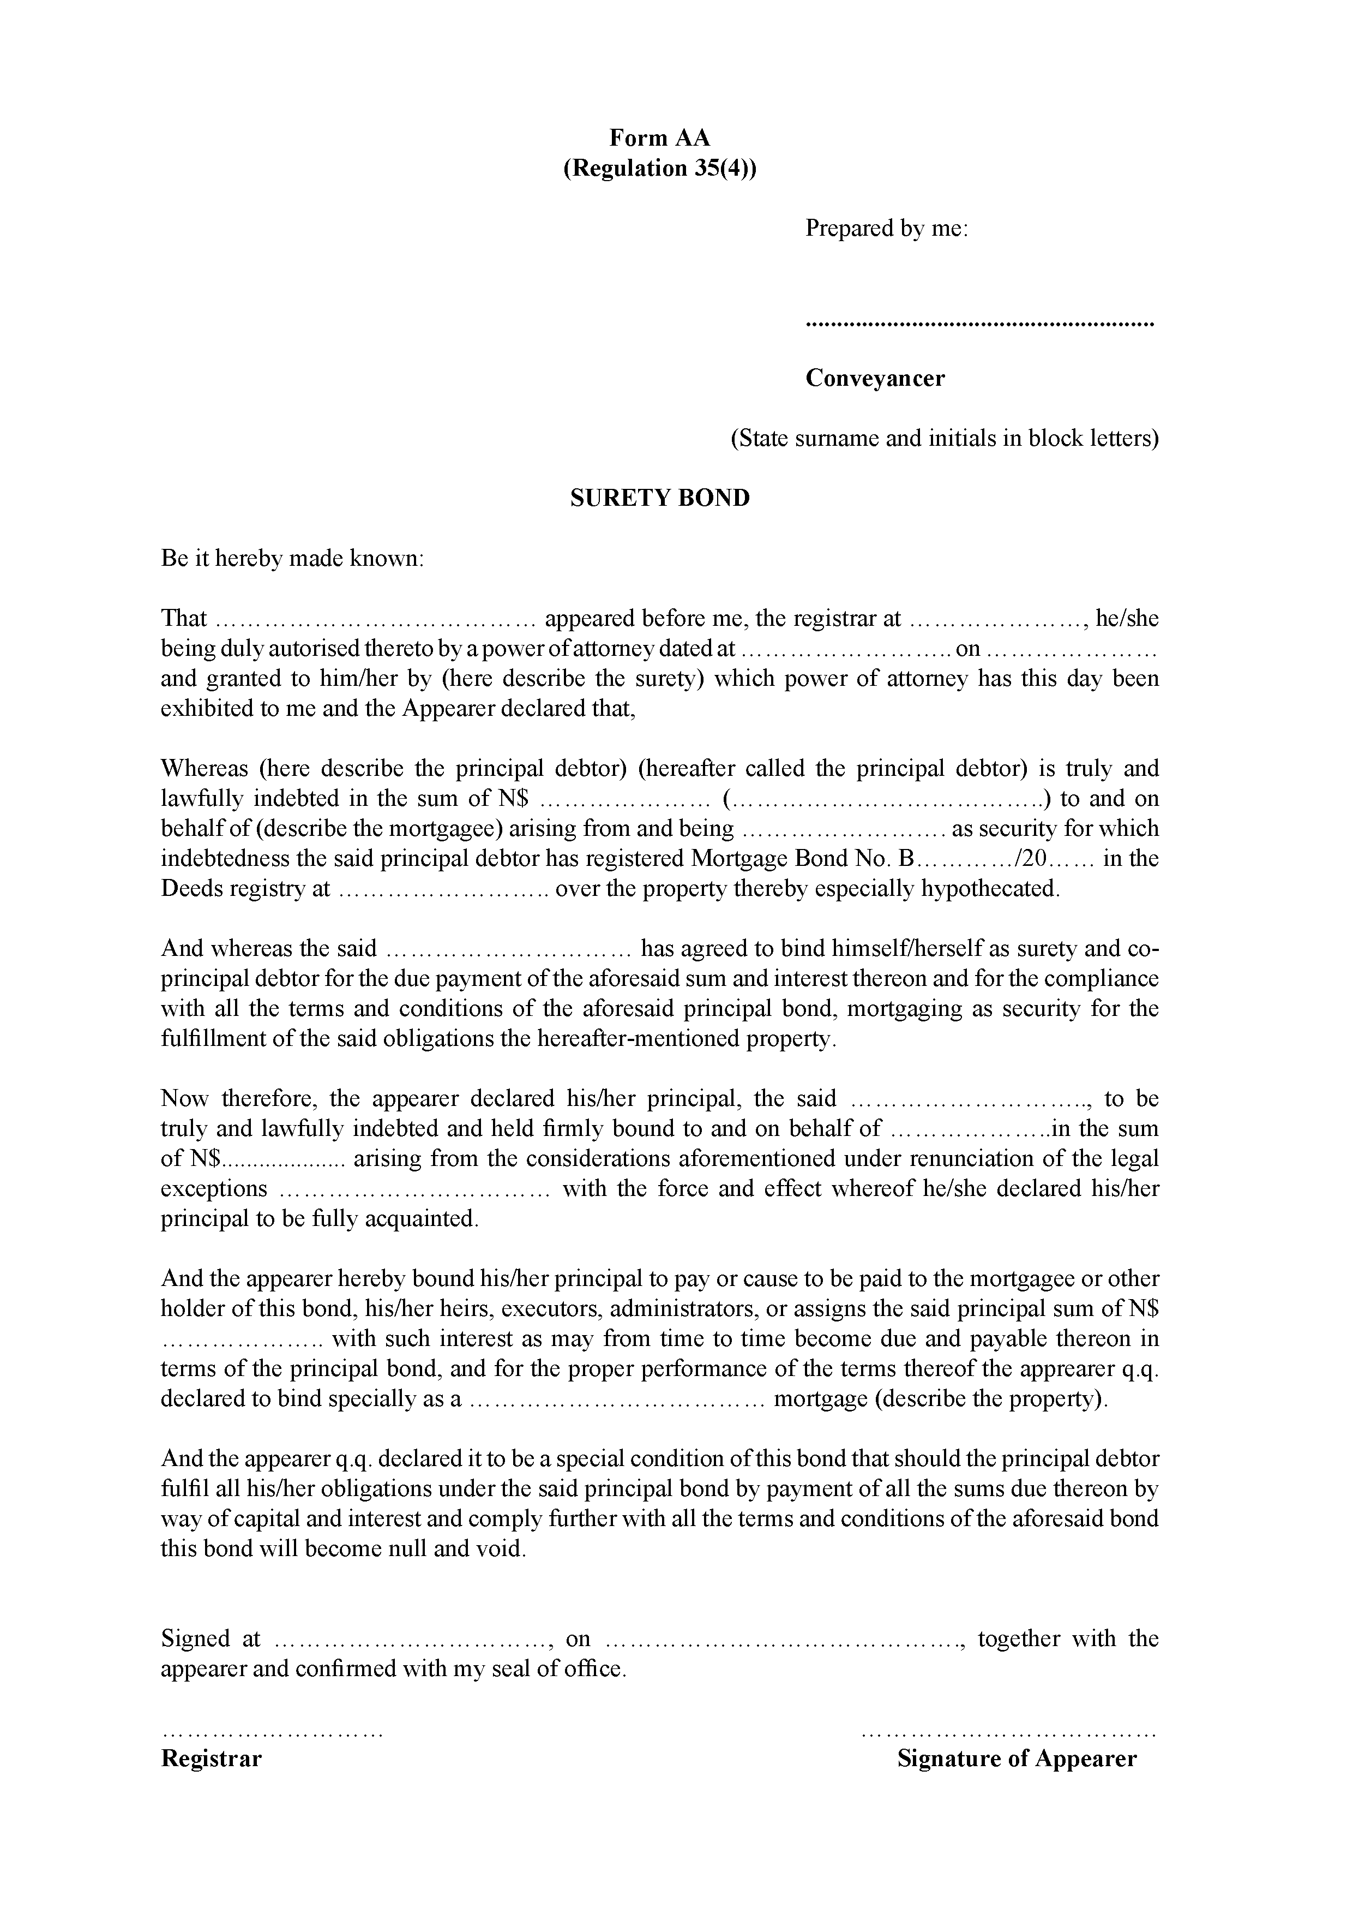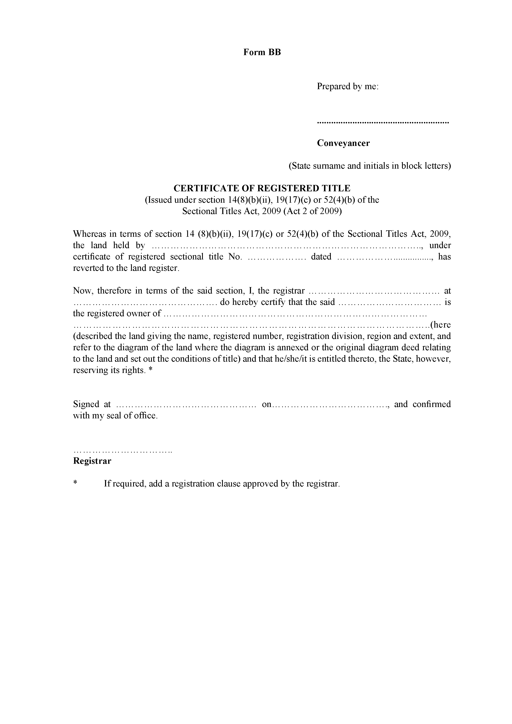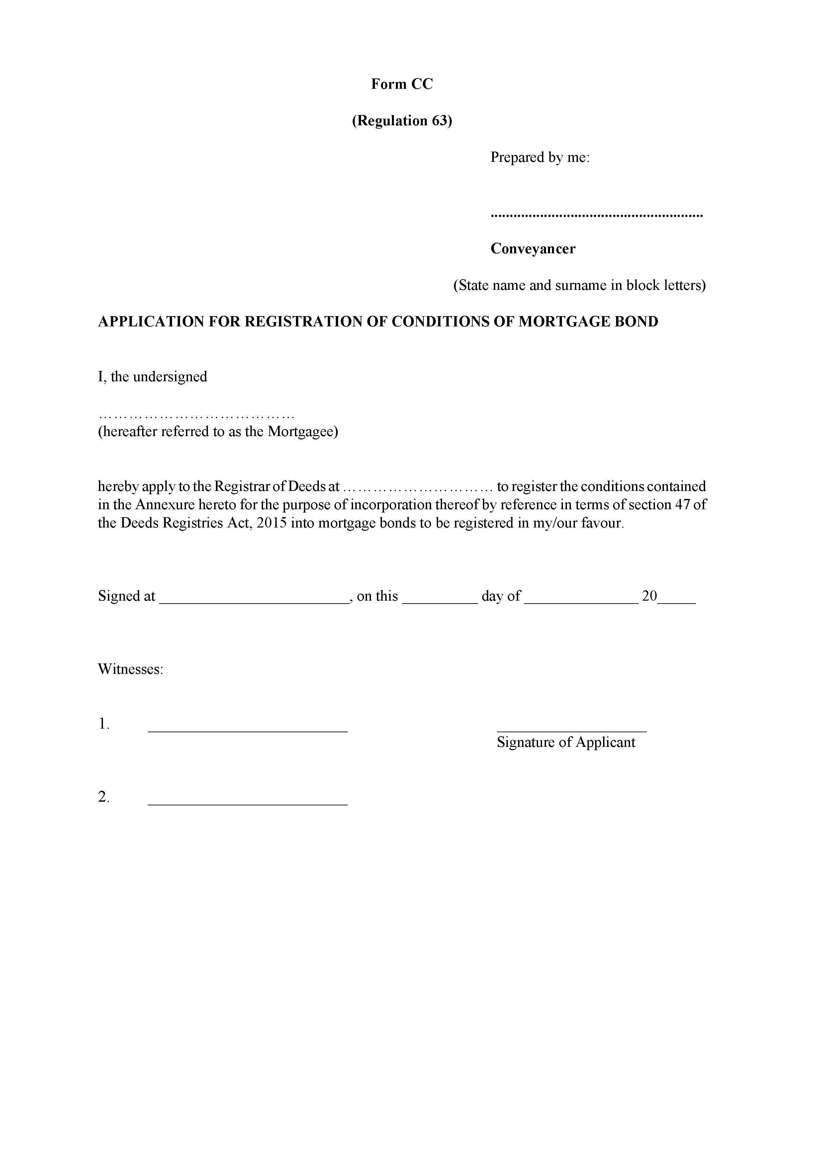

ANNEXURE 2

FEES OF OFFICE
(Regulation 64)

Service  1. For the issue of a certificate compiled by the registrar on request from information contained in the registers or records preserved in the deeds registry, per certificate  2. For the preparation and submission of a report to the court under section 97 of the Act, per report ......................................................................................................  3. For a certified copy of -  (a) a deed, bond or document registered or preserved in the deeds registry and issued in terms of regulation 50 or 51, per deed, bond or document  (b) a deed registered or preserved in the deeds registry and issued in terms of regulation 52, per deed .....................................................................  (c) a document registered or preserved in the deeds registry and issued in terms of regulation 54, per page ......................................................................  4. (a) For the search of an index to any register, for an enquiry relating to a person, property or deed ...............................................................................  (b) For transmission by facsimile of copies or for a photocopy or computer printout of the relevant information requested in respect of a person, property or deed, per page ..............................................................................  (c) For the inspection of any one deed or document or page of a register relating to any particular property preserved in the deeds registry, per deed, document or page of a register  (d) For any other enquiry, continuous search or inspection pertaining to information preserved in the deeds registry, per hour or part thereof ..................  5. (a) For the registration of a deed of transfer ..........................................  (b) For the registration of a bond securing immovable property ............  (c) For the registration of -  (i) a certificate of registered title or consolidated title;  (ii) a deed of cession referred to in section 29 of the Act;  (iii) a lease, sublease or cession of a lease;  (iv) a general power of attorney;  (v) general plans of erven or subdivisions of land and opening of registers, as referred to in section 45(2) of the Act  per any such registration .................................................................  (d) For the registration of -  (i) a notarial deed, including antenuptial contracts;  (ii) a notarial bond;  (iii) a cession of a bond .................................................................  (e) For work related to a transfer by endorsement, except such a transfer in terms of section 11(3) of the Act ................................................................ | Fee
 | N$ | 9
 | N$ | 287
 | N$ | 34
 | N$ | 259
 | N$ | 5
 | N$ | 7
 | N$ | 7
 | N$ | 7
 | N$ | 23
 | N$ | 345
 | N$ | 345
 | N$ | 345
 | N$ | 345
 | N$ | 345
6. For the registration of the following transactions, namely -
(i) the cancellation of a registered mortgage bond or notarial bond;
(ii) cancellation of a cession of a registered mortgage bond or notarial bond;
(iii) release of any part of property hypothecated by a registered mortgage bond or notarial bond or, in the case where the debt is further secured by such a collateral bond, of all the property, or of any joint debtor or of any surety in respect of such a bond;
(iv) part payment of a capital amount due in respect of any registered mortgage bond or notarial bond other than a registered mortgage bond or notarial bond intended to secure future debts;  (v) reduction of cover in respect of a registered mortgage bond or notarial bond intended to secure future debts;  (vi) an agreement varying the terms of a registered mortgage bond or notarial bond;  (vii) waiver of preference in respect of a registered mortgage bond or notarial bond with regard to the whole or any part of the property hypothecated thereby in favour of any other such mortgage bond whether registered or about to be registered; and  (viii) waiver of preference in respect of a registered real right in favour of a registered mortgage bond or notarial bond if such waiver is contained in the mortgage bond ..................................................................................................  7. For the cancellation of the registration of a lease or servitude under section 81 of the Act, for every cancellation ...........................................................................  8. For every endorsement, note or registration of a transaction not provided for in this list (excluding the revocation of a power of attorney) .................................  9. For furnishing to a local authority council or a regional council a return containing particulars of properties transferred, per property contained in such return  10. For taxation of fees or charges of conveyancers, notaries public or of other legal practitioners: 5% of fees or charges allowed, excluding transfer duties, stamp duties and fees of office charged in relation to any act, matter or thing done in the deeds registry. | N$  N$  N$  N$ | 57  57  57  7

ANNEXURE 3
TARIFF OF CONVEYANCING AND NOTARIAL FEES,
(Regulation 65)

PART I
GENERAL PROVISIONS

1. The fees specified in this Tariff include fees in respect of the following functions performed by a conveyancer, notary public or other legal practitioner: The taking and giving of instructions; the exchange of correspondence; the perusal of completed deeds of sale, trust instruments and memoranda and articles of association; the preparation or obtaining of the necessary powers of attorney, declarations, affidavits, resolutions, company certificates, exchange control certificates or other preliminary and ancillary documents and the procurement of the required signatures on any such document; the payment of the transfer duty and rates levied by the relevant authorities; the obtaining of the necessary clearance and other certificates from the relevant authorities; the obtaining (except where otherwise provided in this Tariff) of copies of, or endorsements on, documents from the office of the Master or from any other relevant public office; the making of the necessary financial arrangements, inclusive of attending to guarantees and the payment thereof; the preparation of the necessary documents for execution or registration at the deeds registry and, where necessary, the arrangement with other conveyancers for simultaneous lodgement and registration; the furnishing of references required by the deeds registry for examination purposes; and all attendances at the deeds registry, but does not include –

(a) any attendance in connection with the preparation and execution of deeds of sale, deeds of donation, deeds of exchange, preliminary partition agreements, deeds of suretyship, acknowledgements of debts, or documents of a similar nature;

(b) any separate act of registration of any other document which may be necessary or in connection with such act of registration;

(c) any attendance in connection with the resolution of a dispute between the transferror and the transferee arising from a deed of sale or any of the other documents referred to in paragraph (a) or from whatever cause;

[The word “transferor” is misspelt in the Government Gazette, as reproduced above.]

(d) any attendance arising from negotiations between the parties resulting in a further agreement or an addendum or other amendment to an existing agreement;

(e) any consultation for the purpose of preparing an antenuptial contract;

(f) any attendance in connection with the opening of a township register in terms of section 45 of the Act; or

(g) any attendance in connection with the preparation and obtaining of documents relating to collateral security required by a mortgagee.

2. Where the work necessary to perform any act under the Act or these regulations is partly performed by one legal practitioner, conveyancer, or notary public (hereinafter called the instructed legal practitioner) on the instructions received from another legal practitioner, conveyancer, or notary public (hereinafter called the instructing legal practitioner), both the instructed legal practitioner and instructing legal practitioner are entitled to a fee, apportioned as set out in the relevant part in this Tariff.

3. Where this Tariff provides for a specific or proportionate fee for lodgement, such fee means the fee payable by the instructing legal practitioner to the instructed legal practitioner for all attendances and correspondence in connection with the lodgement and, where necessary, the registration of any document, and for the furnishing of the necessary references in connection with such lodgement and registration, and is payable out of the total fee.

4. For the purposes of this Tariff -

(a) “folio” means 100 printed or written words or figures or part thereof, and four figures is considered to be one word;

(b) “final work” means the preparation of a document for execution or registration at the deeds registry and, where relevant, the obtaining of the registration of such document; the arrangement for simultaneous lodgement with another conveyancer or conveyancers, where necessary; the furnishing to the deeds registry of all the references required for examination purposes; and all attendances at the deeds registry and all correspondence that are related to the registration of a document, but does not include any separate act of registration of any other document which may be necessary before or in connection with the first mentioned act of registration or for which special provision is made in this Tariff;

(c) “preliminary work” means the taking and giving of instructions; the preparation or obtaining of the necessary powers of attorney; declarations, affidavits, resolutions or other preliminary and ancillary documents such as extracts from a company’s memorandum or articles of association, and the procurement of the required signatures on any such document; the payment of the transfer duty and rates levied by relevant authorities; the obtaining of the necessary clearance and other certificates from the relevant authorities; the obtaining (except where otherwise provided in this Tariff) of copies of, or endorsements on, documents from the office of the Master or from any other public office; the making of all financial arrangements, inclusive of attending to guarantees and the payment thereof and to all relevant correspondence, but does not include any attendances in connection with the preparation and execution of general powers of attorney, deeds of sale, deeds of exchange, preliminary partition agreements, preliminary agreements with regard to any lease, servitude, or donation and documents of a similar nature and documents for which a special fee is provided for in this Tariff;

(d) “value of property” -

(i) where transfer duty is payable, means the purchase price of the property or the amount on which transfer duty is payable, whichever amount is the higher;

(ii) where no transfer duty is payable in terms of section 9(2) of the Transfer Duty Act, 1993 (Act No. 14 of 1993), means the purchase price of the property or the declared value as determined under that Act, whichever amount is the higher;

(iii) where no transfer duty is payable in terms of any provision of section 9 of the Transfer Duty Act, 1993, other than subsection (2) thereof, but an official valuation from a regional, village, town or municipal council or from the Master is available, means such valuation or the consideration paid for such property, whichever amount is the higher: Provided that where no official valuation is available, it is deemed to be the fair value of the property as defined in section 1 of the Transfer Duty Act, 1993; or

(iv) where no consideration is payable and no regional, village, town or municipal council or other official valuation is available, is deemed to be no less than N$200 000.

PART II
CONVEYANCING AND NOTARIAL FEES

[In the Government Gazette, the heading “Conveyance of ownership of immovable property (other than partition, rectification or exchange transfers)” appears at the top of each page of the table, under the terms “SERVICE” AND “FEES”. This appears to be in error. The extra appearances
of this heading have been omitted here.]

Service | Fees
Conveyance of ownership of immovable property (other than partition, rectification or exchange transfers)
(a) For work in connection with the obtaining of conveyance of ownership of immovable property in any manner not specifically mentioned elsewhere in this Tariff, the fee shall be as set out in Schedule 1 to this Annexure: Provided that in the case of conveyance in terms of section 11(3) or in terms of section 28, 42 or 43 (bonds excluded) of the Act, and in the case of property transactions where the value of the property is N$100 000 or less, and in respect of which a certificate is issued by the appropriate governmental or other institution to the effect that the property in question is of a low cost housing nature, the fee shall be 60% of the amount set out in Schedule 1 to this Annexure.  (b) For more than one property included in the same instrument of conveyance and in respect of which the same title conditions apply, for each additional property an additional fee of 15% of the amount set out in Schedule 1 to this Annexure.  Provided that in cases where the title conditions differ a further additional fee of N$300 per folio of the conditions shall be payable.  (c) Apportionment of the fees set out in paragraphs (a) and (b):  (i) For conveyance by means of a deed of transfer the following percentage of the applicable fee shall be payable -  (aa) 66,67% on completion of the preliminary work ..........................  (bb) 33.33% on completion of the final work ......................................  (ii) For conveyance in terms of section 11(3) or in terms of section 28, 42 or 43 of the Act, 20% of the applicable fee shall be payable on lodgement, but not less than a fee of .......................................................................... | N$ 248
Endorsement of title deeds or bonds in terms of section 21 (2) or 22(3) of the Act
or in terms of the Administration of Estates Act, 1965 (Act No. 66 of 1965)
(a) For work in connection with the obtaining of an endorsement on a title deed or bond in terms of section 21 (2) or 22(3) of the Act or in terms of the Administration of Estates Act, 1965 (Act No. 66 of 1965), inclusive of the preparation of the necessary documents, the obtaining of the necessary ancillary documents, consents and certificates from the Master and the registrar and of relevant attendances and correspondence ...........................................................  (b) For more than one property or bond included in the same application for endorsement, for each additional property or bond an additional fee of ............  (c) Apportionment of the fees set out in paragraphs (a) and (b): The following amount of the applicable fee shall be payable on lodgement ............................. | N$ 1 500  N$ 230  N$ 300
Partition, rectification and exchange transfers
(a) For preparing a deed of partition, rectification or exchange transfer and obtaining registration thereof, inclusive of all preliminary and other work in connection therewith, but excluding any attendance in connection with the framing of any provisional agreement:
(i) Where the value can be determined, the fee shall be as set out in Schedule 1 to this Annexure;
(ii) where the value cannot be determined, a fee of ......................................  (b) For each additional property or subdivision transferred in any one deed, an additional fee of ..................................................................................................  (c) Apportionment of the fees set out in paragraphs (a) and (b): The following percentage of the applicable fee shall be payable on-  (i) 50% on completion of the preliminary work ..........................................  (ii) 50% on completion of the final work ...................................................... | N$ 4 000  N$ 400
Certificates of title or substituted title
(a) (i) For work in connection with the obtaining of a certificate of title under section 14, 31, 32, 33, 35, 36, 39, 46 or 61 of the Act or a certificate of substituted title under the provisions of the Deeds Proclamation, 1920 (Proclamation No. 8 of 1920) ..................................................................  Provided that in cases where the registration of any of the said certificates results in the subdivision of a property, the fee shall be .........................  (ii) For all matters falling under this paragraph, for each additional property an additional fee of ..................................................................................  (b) (i) For work in connection with the obtaining of a certificate of consolidated title under section 37 or certificate of uniform title under section 38 of the Act ...........................................................................................................  (ii) For every additional constituent property after the first two properties, an additional fee of .......................................................................................  (c) Apportionment of the fees set out in paragraphs (a) and (b): The following percentage of the applicable fee shall be payable-  (i) 33,33% on completion of the preliminary work ......................................  (ii) 66,67% of the final work ......................................................................... | N$ 2 900  N$ 2 500  N$ 230  N$ 2 900  N$ 230
Mortgage and collateral bonds
(a) For mortgage bonds, including surety mortgage bonds, the fee shall be as set out in Schedule 2 to this Annexure: Provided that for all bonds where the amount is N$500 000 or less and a certificate is issued by the appropriate governmental or other institution to the effect that the property in question is of a low cost Housing nature, the fee shall be 60% of the amount set out in Schedule 2 to this Annexure.  Note:  For purposes of determining the fee to be charged under this paragraph, the amount of the bond on which stamp duty is being levied shall be used, and in the event of a bond exempted from stamp duty, the amount on which stamp duty would have been levied had the bond in question not been exempted shall be used.  (b) For collateral bonds, being mortgage bonds passed as additional security for another Bond, the fee shall be 75% of the fee as set out in Schedule 2 to this Annexure.  (c) For any waiver in terms of regulation 30(6) when included in a bond, an additional fee of ..................................................................................................  (d) For more than one property included in any bond referred to in paragraph (a) or (b), for each additional property an additional fee of ..............................................................................................................................  (e) Apportionment of the fees set out in paragraphs (a) to (d): The following percentage of the applicable fee shall be payable -  (i) 66,67% on completion of the preliminary work .....................................  (ii) 33.33% on completion of the final work ................................................ | N$1 000  N$ 230
Notarial bonds
(a) For notarial bonds, inclusive of surety notarial bonds, securing -  (i) an amount up to and including N$500 000, a basic fee of .....................  (ii) an amount over N$500 000, a basic fee of ..............................................  plus the relevant amount as set out in Schedule 2 to this Annexure. | N$1 600  N$1 800
Note:  For purposes of determining the fee to be charged under paragraph (a), the amount of the bond on which stamp duty is being levied shall be used, and, in the event of a bond exempted from stamp duty, the amount on which stamp duty would have been levied had the bond in question not been exempted shall be used.  (b) The fee for collateral notarial bonds passed as additional security for a mortgage bond or another notarial bond between the same parties, shall be 50% of the fee set out in Schedule 2 to this Annexure.  (c) Apportionment of the fees set out in paragraphs (a) and (b): The following percentage or amount of the applicable fee shall be payable -  (i) 50% on completion of the preliminary work ...........................................  (ii) 50% on completion of the final work ......................................................  (iii) where the instructing notary public prepares and attests the deed, on lodgement ................................................................................................ | N$1 800  N$ 360
Antenuptial contracts
(a) For preparing an antenuptial contract and the necessary copies in respect thereof and attending to relevant correspondence and to the execution, notarial attestation and registration of the contract ..........................................................  Note:  This fee does not include any consultations for the purpose of the drafting of the antenuptial contract.  (b) Apportionment of the fees set out in paragraph (a): The following percentage or amount of the applicable fee shall be payable -  (i) 50% on completion of the preliminary work ..........................................  (ii) 50% on completion of the final work .....................................................  (iii) where instructing notary public prepares and executes the contract, on lodgement ................................................................................................ | N$1 800  N$ 360
Other notarial deeds
(a) For preparing any notarial waiver of preference by mortgagee, usufructuary, or other holder of a limited interest, or other notarial consent required under the Act or these regulations and obtaining registration thereof ......................................  (b) For preparing any notarial lease, servitude, donation, or other notarial deed (other than those elsewhere provided for in this Tariff) and obtaining registration thereof, a fee assessed according to the length and complexity thereof .............  (c) Apportionment of the fees set out in paragraphs (a) and (b): The following percentage or amount of the applicable fee shall be payable -  (i) 50% on completion of the preliminary work ...........................................  (ii) 50% on completion of the final work ......................................................  (iii) where the instructing notary prepares and executes the deed, on lodgement ................................................................................................ | N$2 300  N$2 300  N$ 360

Cancellation, cession or variation of bonds, release of persons or property from bonds and waiver of preference in regard to ranking of bonds
(a) (i) For preparing a consent to the cancellation of a bond, a consent to the cancellation of a cession of a bond, a release of a property or a person from a bond, a consent to reduction of cover, a consent to a part payment of capital, a waiver of preference in regard to the ranking of a bond, a waiver of preference in respect of real rights in land, or a consent of a mortgagee, usufructuary, lessee, or holder of other limited interest required by the Act or these regulations and not otherwise provided for in this Tariff (not notarial), inclusive of attending to relevant instructions and correspondence, and of attendances at the office of the Master, and of any attendance at the deeds registry to obtain registration of the relevant document ................................................................................................. | N$1 800
Provided that in any such cases where there are no financial arrangements to be made by the conveyancer, the fee shall be .....................................  (ii) For attending to all matters referred to in subparagraph (i) in respect of any second or subsequent bond or bonds when the document or documents has or have been prepared by the same conveyancer who prepared the corresponding documents in connection with the first bond between the same parties over the same property, and the documents are or can be lodged simultaneously as a set, per bond ................................................  (iii) For more than two properties included in any release referred to in subparagraph (i) or (ii), for each additional property over and above the first two properties, an additional fee of ..................................................  (b) For preparing a cession of a bond or an application for the endorsement of a bond in terms of sections 42 or 43 of the Act, inclusive of attending to relevant instructions and correspondence, and to the preparation, where necessary, of a consent by the mortgagor and the procurement of the signatures of the mortgagor and mortgagee on the cession or on the endorsement application, and of any attendance at the deeds registry to obtain registration of the cession or to obtain an endorsement and all other relevant attendances, except attendances at the office of the Master .............................................................................................  Provided that in cases where there are no financial arrangements to be made by the conveyancer the fee shall be .........................................................................  (c) For preparing an agreement varying the terms of a bond, inclusive of attending to relevant instructions and correspondence and to the procurement of the signatures of the mortgagor and mortgagee on the agreement, and of any attendance at the deeds registry to obtain registration of the agreement and all other relevant attendances, a fee assessed according to the length and complexity of the transaction, with a minimum fee of N$1000 and a maximum fee of N$2000.  (d) (i) For preparing a consent to substitution required in terms of section 21(3), 42(2)(b) or 43(2) of the Act, inclusive of attending to relevant instructions and correspondence and to the procurement of the necessary signatures of the mortgagee and the new debtor on the consent to substitution, and of attendances at the office of the Master ................................................  Provided that in cases where there are no financial arrangements to be made by the conveyancer, the fee shall be .............................................. | N$1 200  N$ 360  N$ 470  N$1 800  N$ 900  N$1 800  N$1 200
(ii) For preparing a consent to substitution required in terms of section 57 of the Act, inclusive of attending to relevant instructions and correspondence and to the procurement of the necessary signatures of the mortgagee and the new debtor on the consent to substitution, and of any attendance at the deeds registry to obtain registration of the consent to substitution and all other relevant attendances, except attendances at the office of the Master the fee shall be 60% of the fees for bonds as set out in Schedule 2 to this Annexure.  (iii) For preparing the application and consent required under section 40(5)(a) of the Act, inclusive of attending to relevant instructions and correspondence and to the procurement of the signatures of the mortgagor and mortgagee on the consent, and of any attendance at the deeds registry to obtain registration of the consent and all other relevant attendances ..  (e) If any of the documents referred to in these paragraphs are required to be signed by more than one mortgagee, mortgagor, usufructuary, lessee or holder of any other limited interest, for each such additional person after the first, an additional fee of ...................................................................................................................  (f) Where attendances at the office of the Master is necessary in connection with any matter referred to in paragraph (a)(i), (b) or (d), the following additional fees shall be allowed: | N$1 800  N$ 240
(i) for obtaining any certificate from the Master, per estate for any number of certificates which are or can be applied for simultaneously ...............  (ii) for obtaining copies of all the necessary documents which are or can be included in one application, per estate ....................................................  (g) Apportionment of the fees set out in paragraphs (a) to (f): The following amount of the applicable fee referred to in -  (i) paragraphs (a)(i), (b), (c) and (d) shall be payable on lodgement ...........  (ii) paragraph(a)(ii) shall be payable on lodgement ......................................  (iii) paragraph (f)(i) shall be payable to the instructed conveyancer ..............  (iv) paragraph (f)(ii) shall be payable to the instructed conveyancer ............. | N$ 470  N$ 470  N$ 360  N$ 180  N$ 520  N$ 280
Miscellaneous
(a) For attending on behalf of the transferor or transferee, the mortgagor or mortgagee, or any other person to the supervision of the registration of the transfer or bond, or to the supervision of a bond, when the documents are being prepared and lodged by another conveyancer, inclusive of attending to instructions and correspondence relevant to any such supervision -  (i) where the value of the property or amount of the bond does not exceed N$100 000 ...............................................................................................  (ii) where the value of the property or amount of the bond exceeds N$100 000 ...............................................................................................  (b) For obtaining an endorsement of any amendment of title in terms of section 41 of the Act, inclusive of attending to relevant instructions and of any attendance in connection with the obtaining of such endorsement ......................................  (c) For any attendance at the deeds registry for any certification or any act of registration required ............................................................................................  (d) For preparing an application for an endorsement in terms of section 45 of the Act and for attendances in connection with the lodging of the title deed for endorsement ........................................................................................................ | N$ 460  N$ 920  N$ 240  N$ 240  N$ 2 900
(e) (i) For obtaining an endorsement in terms of section 84 of the Act reflecting a change of name -  (aa) where no advertisement is required .............................................  plus  for every deed after the first deed ................................................  (bb) where advertisement is required ...................................................  plus  for every deed after the first deed ................................................  (ii) For obtaining an amendment of a deed in terms of section 5(1)(b) of the Act ...........................................................................................................  plus  for every deed after the first deed ............................................................  (iii) For preparing and lodging the consent of any interested party, including that of any bondholder that has an interest in any endorsement or amendment in terms of this paragraph ....................................................  Note:  The fees prescribed in this paragraph include fees for attending to instructions, correspondence and to the preparation of the necessary applications and for all relevant attendances and, where advertising is necessary, for preparing and placing the necessary advertisements.  (f) For any attendance to obtain an endorsement on any deed reflecting the conversion of a company to a close corporation and vice versa ........................  plus  for every deed after the first ................................................................................ | N$ 780  N$ 150  N$ 2 000  N$ 150  N$ 1 000  N$ 360  N$1 000  N$ 450  N$ 150
(g) (i) For any attendance and search at the deeds registry to obtain the information required, other than information required for the preparation or registration of a deed, and for attending to the relevant instructions, and correspondence, per quarter hour or part thereof .............................  (ii) Reporting per folio ..................................................................................  (h) For preparing and submitting an application for a certified copy of a deed, registered lease, mortgage bond or notarial bond for a purpose referred to in regulation 52(1), inclusive of attending to relevant instructions, correspondence and filing of documents, and of attendances in connection with any such application ..........................................................................................................  (i) For any attendance at the deeds registry to obtain a certified copy of any deed or document from the deeds registry for any purpose other than a purpose referred to in regulation 54 and for attending to the relevant instructions, correspondence, and filing of documents ......................................................................................  plus  for every deed after the first for which may be applied for in the same application ...................................................................................................................  (j) For any attendance at the office of a local authority, the Urban and Regional Board or any other authority to obtain -  (i) the necessary approval required by law in respect of diagrams of sub- division and to obtain the necessary certificates or other documents .....  (ii) an endorsement on a power of attorney or diagram ................................. | N$ 260  N$ 180  N$ 1 000  N$ 360  N$ 240  N$1 500  N$ 700
(k) (i) For preparing an affidavit or application in connection with any separate act of registration or endorsement not specifically mentioned in this Tariff and attending to the relevant instructions and correspondence, and for any attendance in relation to such affidavit or application, or for the creation of township conditions against the remainder of the property, or for the lapsing of any condition of title or personal servitude (excluding a usufruct, usus or habitatio) ...................................................................  plus  for the preparation of each extra folio of an affidavit or application where such document exceeds one folio in length .............................................  (ii) For any attendance at the office of the Master to obtain the necessary endorsements in connection with any matter referred to in this paragraph, per estate ..................................................................................................  (iii) For preparing a general power of attorney and for attendances in connection therewith ...............................................................................  (iv) For preparing a certificate in terms of section 42(1) of the Administration of Estates Act, 1965 (Act No. 66 of 1965), and for any attendance at the office of the Master to obtain his or her signature on such certificate, per estate for any number of certificates ...................................................  (v) For preparing an application for the registration of a lapse of usufruct, habitatio, or usus (not notarial) ...............................................................  (l) (i) For preparing a cession of servitude in the form prescribed in ?Form HH to these regulations and for attending to the relevant instructions, correspondence and registration ..............................................................  (ii) For more than one property included in the same cession, for each additional property an additional fee of ..................................................  (m) For any attendance in connection with taxation, inclusive of correspondence: a fee equal to 5% of the fees allowed on taxation shall be chargeable by the conveyancer submitting the bill of costs, and a fee equal to 5% of the total fees originally reflected in that bill of costs shall be chargeable by the conveyancer opposing taxation, subject to a minimum fee of N$1000 in respect of each conveyancer. | N$1 000  N$ 250  N$ 360  N$ 900  N$ 380  N$ 700  N$1 800  N$ 150
(n) Apportionment of the fees set out in paragraphs (a) to (m): The following percentage or amount of the fee referred to in -  (i) paragraphs (a) and (b) shall be payable on -  (aa) 33,33% on completion of the preliminary work ..........................  (bb) 66,67% on completion of the final work ......................................  (ii) paragraph (c) shall be payable on lodgement ..........................................  (iii) paragraphs (d), (e)(i)(aa) and (bb), (e)(ii), (e)(iii), (g), (i), (j)(i) and (ii), (k)(i) and (iii) and (l)(i) and (ii),shall be payable-  (aa) 50% to the instructing legal practitioner ......................................  (bb) 50% to the instructed legal practitioner .......................................  (iv) paragraph (h) shall be payable on lodgement ..........................................  (v) paragraph (k)(ii) shall be payable to the instructed legal practitioner ....  (vi) paragraph (k)(iv) shall be payable to the instructed legal practitioner ....  Note:  Fees and percentages specified in this Tariff shall be nett and shall not be subject to any allowance, the customary one-third allowance having been taken into account in the apportionments.  Where the instructing legal practitioner merely takes instructions from his or her client and thereafter sends his or her whole file to the instructed legal practitioner who then does all the work, the former shall, as a general rule, be entitled to 20% and the latter to 80% of the fee where the fee is divided on a percentage basis.  Where the instructing legal practitioner merely takes instructions from his or her client and thereafter sends his or her whole file to the instructed legal practitioner who then does all the work, the former shall, as a general rule, be entitled to 20% and the latter to 80% of the fee where the fee is divided on a percentage basis. | N$ 150  N$ 450  N$ 450  N$ 450

PART III
APPORTIONMENT OF FEES FOR PRELIMINARY WORK

Where a legal practitioner who attends to the preliminary work in connection with any conveyancing matter requests another legal practitioner to do part of that preliminary work, the former must from his or her share of the fees pay to the latter (subject to any provision to the contrary in these fees) the amount agreed between them.

PART IV
APPORTIONMENT OF FEES WHERE MANDATE IS TERMINATED

The following is a guideline for the apportionment of fees where a mandate is terminated at any stage before execution or registration:

Task | Total percentage
(a) For attending to the taking of instructions and the planning of the transaction, 20% of the prescribed fee ................................................................................... | 20%
(b) For preparing the preliminary documents, an additional 20% of the prescribed fee ....................................................................................................................... | 40%
(c) For attending to or procuring the signing of the preliminary documents, an additional 10% of prescribed fee ........................................................................ | 50%
(d) For attending to all the necessary financial arrangements before lodgment, an additional 20% of prescribed fee ........................................................................ | 70%
Task | Total percentage
(a) For attending to the taking of instructions and the planning of the transaction, 20% of the prescribed fee ................................................................................... | 20%
(b) For preparing the preliminary documents, an additional 20% of the prescribed fee ....................................................................................................................... | 40%
(c) For attending to or procuring the signing of the preliminary documents, an additional 10% of prescribed fee ........................................................................ | 50%
(e) For preparing a deed or other document for execution or registration, an additional 10% of the prescribed fee .................................................................. | 80%
(f) For lodgement, an additional 10% of the prescribed fee .................................... | 90%
Task | Total percentage
(a) For attending to the taking of instructions and the planning of the transaction, 20% of the prescribed fee ................................................................................... | 20%
(b) For preparing the preliminary documents, an additional 20% of the prescribed fee ....................................................................................................................... | 40%
(c) For attending to or procuring the signing of the preliminary documents, an additional 10% of prescribed fee ........................................................................ | 50%
(d) For attending to all the necessary financial arrangements before lodgment, an additional 20% of prescribed fee ........................................................................ | 70%
(e) For preparing a deed or other document for execution or registration, an additional 10% of the prescribed fee .................................................................. | 80%
(f) For lodgement, an additional 10% of the prescribed fee .................................... | 90%
Task | Total percentage
(a) For attending to the taking of instructions and the planning of the transaction, 20% of the prescribed fee ................................................................................... | 20%
(b) For preparing the preliminary documents, an additional 20% of the prescribed fee ....................................................................................................................... | 40%
(c) For attending to or procuring the signing of the preliminary documents, an additional 10% of prescribed fee ........................................................................ | 50%
(d) For attending to all the necessary financial arrangements before lodgment, an additional 20% of prescribed fee ........................................................................ | 70%
(e) For preparing a deed or other document for execution or registration, an additional 10% of the prescribed fee .................................................................. | 80%
(f) For lodgement, an additional 10% of the prescribed fee .................................... | 90%
Task | Total percentage
(a) For attending to the taking of instructions and the planning of the transaction, 20% of the prescribed fee ................................................................................... | 20%
(b) For preparing the preliminary documents, an additional 20% of the prescribed fee ....................................................................................................................... | 40%
(c) For attending to or procuring the signing of the preliminary documents, an additional 10% of prescribed fee ........................................................................ | 50%
(d) For attending to all the necessary financial arrangements before lodgment, an additional 20% of prescribed fee ........................................................................ | 70%
(e) For preparing a deed or other document for execution or registration, an additional 10% of the prescribed fee .................................................................. | 80%
(f) For lodgement, an additional 10% of the prescribed fee .................................... | 90%

PART V
APPLICATION OF TARIFF

This Tariff applies only in relation to any act -

(a) in respect of which the fees referred to in regulation 65 of these regulations are payable; and

(b) which is performed by a legal practitioner, a notary public or a conveyancer in connection with any transaction in respect of which he or she received an instruction on or after the commencement of these regulations.

Schedule 1

The fees for the registration of immovable property are -

(a) where the value of the property is less than N$100 000, the fee is N$3 000;

(b) where the value of the property is N$100 000 or more, but less than N$300 000, the fee is N$4 500;

(c) where the value of the property is N$300 000 or more, but less than N$500 000, the fee is N$6 000;

(d) where the value of the property is N$500 000 or more, but less than N$600 000, the fee is N$6 800;

(e) where the value of the property is N$600 000 or more, but less than N$1 000 000, the fee is N$10 260 plus N$1 200 per N$100 000 or part thereof above N$600 000;

(f) where the value of the property is N$1 000 000 or more, but less than N$5 000 000, the fee is N$16 260 plus N$1 200 per N$200 000 or part thereof above N$1 000 000;

(g) where the value of the property is N$5 000 000 or more, the fee is N$40 260 plus N$1 600 per N$500 000 or part thereof above N$5 000 000.

Schedule 2

The fees for the registration of a bond are-

(a) where the amount of the bond is less than N$100 000, the fee is N$2 500;

(b) where the amount of the bond is N$100 000 or more, but less than N$300 000, the fee is N$3 500;

(c) where the amount of the bond is N$300 000 or more, but less than N$500 000, the fee is N$5 000;

(d) where the amount of the bond is N$500 000 or more, but less than N$600 000, the fee is N$6 000;

(e) where the amount of the bond is N$600 000 or more, but less than N$1 000 000, the fee is N$10 000 plus N$1 000 per N$100 000 or part thereof above N$600 000;

(f) where the amount of the bond is N$1 000 000 or more, but less than N$5 000 000, the fee is N$15 000 plus N$1 000 per N$200 000 or part thereof above N$1 000 000;

(g) where the amount of the bond is N$5 000 000 or more, the fee is N$35 000 plus N$1 400 per N$500 000 or part thereof above N$5 000 000.

