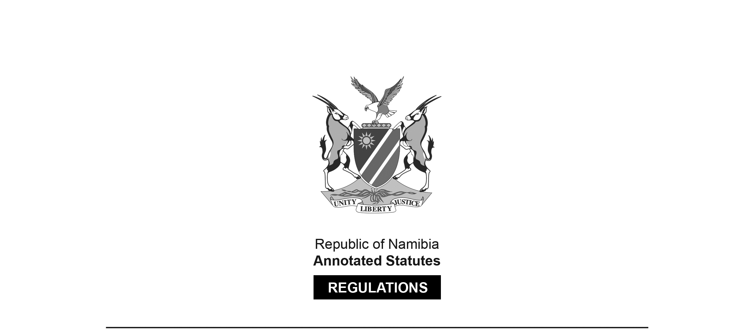

REGULATIONS MADE IN TERMS OF

Dairy Industry Act 30 of 1961

section 29

Regulations relating to the Manufacture, Composition,   
Packing and Marking of Margarine

RSA Government Notice R.1716 of 1977

([RSA GG 5725](http://www.lac.org.na/laws/GGsa/rsagg5725.pdf))

came into force on date of publication: 2 September 1977

The *Dairy Industry Act 30 of 1961 (SA)* was applied to South West Africa only in so far as it relates to margarine, as a result of amendments made to the Act by the *Dairy Industry Amendment Act 7 of 1976* ([RSA GG 5015](http://www.lac.org.na/laws/GGsa/rsagg5015.pdf)), brought into force on 1 July 1976 by RSA Proc. R.103/1976 ([RSA GG 5161](http://www.lac.org.na/laws/GGsa/rsagg5161.pdf)). Section 1 as amended defines “Republic” as including the territory “in relation to margarine”, and the “territory” is defined as “the territory of South West Africa, including the Eastern Caprivi Zipfel”. Section 35A, inserted by *Act 7 of 1976*, states “This Act, and any amendment thereof which may be made from time to time, in so far as it relates to margarine or to a margarine factory,   
shall apply also in the territory.”

These regulations are obviously relevant to margarine.

CONTENTS

*Regulations*

Definitions 1

PART I

Compositional requirements 2

PART II

Packing requirements 3

PART III

Marking requirements 4

PART IV

Proviso 5

*Definitions*

**1.** In these regulations, unless inconsistent with the context, a word or expression to which a meaning has been assigned in the Act, shall have a corresponding meaning and -

“additives” means foreign matter permitted in quantities as prescribed in terms of the Foodstuffs, Cosmetics and Disinfectants Act, 1972 (No. 54 of 1972);

[In South West Africa, the analogous law was the Food, Drugs and Disinfectants Ordinance 36 of 1952, which was replaced by the Foodstuffs, Cosmetics and Disinfectants Ordinance 18 of 1979.]

“Department” means the Department of Agricultural Economics and Marketing;

“large container” means a container into which more than two margarine units are packed or bulk-packed margarine in a 12,5 kg or 25 kg unit;

“milk fat” or “butterfat” means the fat of milk;

“registration number” means the number allocated to a margarine factory which is registered in terms of the Act;

“solids non-fat” means the dry matter of milk other than the milkfat; and

[The term “milk fat” appears elsewhere in the regulations as two words.]

“the Act” means the Dairy Industry Act, 1961 (No. 30 of 1961).

**PART I**

**2.** *Compositional requirements*.—(1) The composition of margarine shall be as follows:

|  |  |  |
| --- | --- | --- |
|  | *Yellow margarine* | *White margarine* |
| (a) *Constituents* (except vitamins): | % m/m | % m/m |
| Milk fat (max)  Plants fats (max)  Animal fats (other than milk fat) (max)  Marine fats (max)  Total fat  Salt (max)  Water  Starch (min)  Solids non-fat (max)  Sugar (max)  Additives—  (a) colourants  (b) flavourants  (c) emulsifiers (max)  (d) preservatives (bensoic or sorbic acid or sodium or potasium salts of bensoic and sorbic acids or calsium salts of sorbic acid) (max) | 1  85  None  None  80-86  2  10-16  0,025  2  1  *  *  1  0,1 | 1  85  85  85  80-86  2  10-16  0,025  2  1  *  *  1  0,1 |
| (b) *Vitamins:*  Vitamine [Vitamin] A  Vitamine [Vitamin] D (min) | /g  20-40 I.U.  1 I.U. | /g  20-40 I.U.  1 I.U. |

min = minimum.

max = maximum.

* Denotes no specification.

I.U. Denotes international unit.

(2) In the case of margarine where it is directly or by implication purported that the contents is a poly-unsaturated fat or contain poly-unsaturated fatty acid the fatty acid contents of the fat phase shall be such that the sum of palmitic acid and stearic acid does not exceed 20 per cent by mass of the total fatty acids shall not be less than 40 per cent by mass of the total acid content.

(3) Margarine shall be clean, of pleasant flavour, reasonably soft to the palate and be capable of being easily spread at normal temperatures.

(4) The slip point of the separated fat phase shall be below 38 °C.

**PART III**

*Marking requirements*

**4.** (1) Containers or wrappers into which margarine are packed shall be clearly and legibly marked with -

[The verb “is” should be “are” to be grammatically correct.]

(a) the words “White margarine” or “Wit margarien” if such unit consists of white margarine or “Margarine” or “Margarien” if such unit consists of yellow margarine in letters at least 10 mm in height: Provided that the words said -

(i) appear on at least three sides of the package in the case of margarine wrapped in a wrapper and on at least two opposite sides and on the lid in the case of margarine packed in any other type of container; and

(ii) be in a contrasting colour with the background;

(b) the net mass of the contents;

(c) the registration number referred to in section 7 of the Act preceded by the expression “Reg. No.” or the registration number shall be framed;

(d) the name or trade name and address of the manufacturer or the person on whose behalf such margarine is manufactured;

(e) a description of the preservative being used preceded by the words “Preserved with” or “Gepreserveer met”, if treated with a preservative; and

(f) the words “Contains poly-unsaturates” or “Bevat poli-onversadigde vetsure” in the case of margarine sold or advertised to contain poly unsaturated fatty acids.

[The hyphen is missing in the term “poly-unsaturated” in paragraph (f) in the *Government Gazette*.]

(2) All large containers shall be marked clearly and legibly in letters at least 25 mm in height, with -

(a) the words “White margarine” or “Wit margarien” if such container contains white margarine or “Margarine” or “Margarien” if such container contains yellow margarine;

(b) the registration number referred to in section 7 of the Act preceded by the expression “Reg. No.” or the registration number only shall be framed;

(c) the name or trade name and address of the manufacturer or the person on whose behalf such margarine is manufactured; and

(d) the total net mass, viz the number of units multiplied by the mass of each unit;

[The semicolon at the end of paragraph (d) should be a full stop;   
there are no additional provisions in the *Government Gazette*.]

**PART IV**

*Proviso*

**5.** (1) No wording, mark or illustration which directly or by implication -

(a) creates a misleading or false impression of the true nature of the contents; or

(b) refers to or is suggestive of butter or of any other product or substance connected with the dairy industry;

shall appear on a container containing margarine.

(2) No wording which directly or by implication purports that the contents is a poly-unsaturated fat or contains poly-unsaturated fatty acids, shall appear on a container containing margarine unless such margarine conforms to the requirements prescribed in regulation 2(2) and shall not be purporting to contain any nutritive or health advantages.