

REGULATIONS SURVIVING IN TERMS OF

Customs and Excise Act 20 of 1998
section 131(2)

Customs and Excise Act 91 of 1964 - Regulations
RSA Government Notice R.1770 of 1973
(RSA GG 4040, reprinted in OG 3354)
came into force on date of publication: 5 October 1973

These regulations were made in terms of section 120 of the Customs and Excise Act 91 of 1964 which was repealed by the Customs and Excise Act 20 of 1998. Pursuant to section 131(2) of the Customs and Excise Act 20 of 1998, these regulations are deemed to have been made under that Act. The Government Notice which publishes these Regulations notes that they are made
in substitution of the regulations published in RSA Government Notice R.555/1966.

as amended by

RSA Government Notice R.2051 of 1973 (RSA GG 4067, republished in OG 3359)

came into force on date of publication: 2 November 1973

RSA Government Notice R.1918 of 1974 (RSA GG 4460, republished in OG 3430)
came into force on date of publication: 25 October 1974

RSA Government Notice R.1988 of 1974 (RSA GG 4478, republished in OG 3433)
came into force on date of publication: 1 November 1974

RSA Government Notice R.2046 of 1974 (RSA GG 4491, republished in OG 3433)
came into force on date of publication: 8 November 1974

RSA Government Notice R.2099 of 1974 (RSA GG 4495, republished in OG 3437)
came into force on 1 January 1975 (RSA GN R.2099/1974)

RSA Government Notice R.279 of 1975 (RSA GG 4586, republished in OG 3452)
came into force on date of publication: 14 February 1975

RSA Government Notice R.366 of 1975 (RSA GG 4598, republished in OG 3435)
came into force on date of publication: 28 February 1975

RSA Government Notice R.469 of 1975 (RSA GG 4614, republished in OG 3457)
came into force on date of publication: 14 March 1975

RSA Government Notice R.815 of 1975 (RSA GG 4682, republished in OG 3465)
came into force on date of publication: 25 April 1975

RSA Government Notice R.968 of 1975 (RSA GG 4710, republished in OG 3467)
came into force on date of publication: 16 May 1975
RSA Government Notice R.1088 of 1975 (RSA GG 4733, republished in OG 3468)

came into force on date of publication: 6 June 1975
RSA Government Notice R.1148 of 1975 (RSA GG 4741, republished in OG 3741)
came into force on date of publication: 14 June 1975

RSA Government Notice R.1560 of 1975 (RSA GG 4816, republished in OG 3484)

came into force on date of publication: 15 August 1975

RSA Government Notice R.621 of 1976 (RSA GG 5081, republished in OG 3535)
came into force on date of publication: 9 April 1976

RSA Government Notice R.861 of 1976 (RSA GG 5135, republished in OG 3541)
came into force on date of publication: 21 May 1976

RSA Government Notice R.903 of 1976 (RSA GG 5141, republished in OG 3542)
came into force on date of publication: 28 May 1976

RSA Government Notice R.1218 of 1976 (RSA GG 5215, republished in OG 3551)
came into force on date of publication: 16 July 1976
RSA Government Notice R.2567 of 1976 (RSA GG 5368, republished in OG 3590)
came into force on date of publication: 31 December 1976

RSA Government Notice R.2568 of 1976 (RSA GG 5368, republished in OG 3590)
came into force on date of publication: 31 December 1976

RSA Government Notice R.129 of 1977 (RSA GG 5395, republished in OG 3594)
came into force on date of publication: 4 February 1977

RSA Government Notice R.693 of 1977 (RSA GG 5530, republished in OG 3621)
came into force on date of publication: 29 April 1977

RSA Government Notice R.905 of 1977 (RSA GG 5565, republished in OG 3632)
came into force on date of publication: 27 May 1977

RSA Government Notice R.2310 of 1977 (RSA GG 5800, republished in OG 3671)
came into force on date of publication: 11 November 1977

RSA Government Notice R.2630 of 1977 (RSA GG 5846, republished in OG 3688)
came into force on date of publication: 30 December 1977

RSA Government Notice R.146 of 1978 (RSA GG 5863)

came into force on date of publication: 20 January 1978
RSA Government Notice R.146/1978 reproduces
the amendments in RSA Government Notice R.2630/1977.

RSA Government Notice R.307 of 1978 (RSA GG 5888, republished in OG 3716)
came into force on date of publication: 24 February 1978

RSA Government Notice R.923 of 1978 (RSA GG 6003, republished in OG 3748)
came into force on date of publication: 5 May 1978

RSA Government Notice R.1362 of 1978 (RSA GG 6106, republished in OG 3788)
came into force on date of publication: 3 July 1978

RSA Government Notice R.1409 of 1978 (RSA GG 6110, republished in OG 3789)
came into force on date of publication: 7 July 1978

RSA Government Notice R.766 of 1979 (RSA GG 6405)
came into force on date of publication: 12 April 1979

RSA Government Notice R.2293 of 1979 (RSA GG 6699)
came into force on date of publication: 12 October 1979

RSA Government Notice R.2294 of 1979 (RSA GG 6699)
came into force on date of publication: 12 October 1979

RSA Government Notice R.2461 of 1979 (RSA GG 6716)
came into force on date of publication: 2 November 1979

RSA Government Notice R.2683 of 1979 (RSA GG 6753)
came into force on 1 January 1980 (RSA GN R.2683/1979)

RSA Government Notice R.2684 of 1979 (RSA GG 6753)
came into force on 1 January 1980 (RSA GN R.2684/1979)

RSA Government Notice R.2889 of 1979 (RSA GG 6794)
came into force on date of publication: 28 December 1979

RSA Government Notice R.112 of 1980 (RSA GG 6815)
came into force on date of publication: 18 January 1980

RSA Government Notice R.417 of 1980 (RSA GG 6874)
came into force on date of publication: 7 March 1980

RSA Government Notice R.2253 of 1980 (RSA GG 7275)
came into force on 1 November 1980 (RSA GN R.2253/1980)

RSA Government Notice R.186 of 1981 (RSA GG 7393)
brought into force on 1 January 1981 (RSA GN R.186/1981)

RSA Government Notice R.579 of 1981 (RSA GG 7494)
came into force on date of publication: 20 March 1981

RSA Government Notice R.889 of 1981 (RSA GG 7558)
came into force on date of publication: 24 April 1981

RSA Government Notice R.2635 of 1981 (RSA GG 7947)
came into force on date of publication: 4 December 1981

RSA Government Notice R.2770 of 1982 (RSA GG 8489)
came into force on date of publication: 24 December 1982

RSA Government Notice R.1202 of 1983 (RSA GG 8748)
brought into force on 1 July 1983 (RSA GN R.1202/1983)

RSA Government Notice R.1356 of 1983 (RSA GG 8783)
came into force on date of publication: 1 July 1983

RSA Government Notice R.1525 of 1983 (RSA GG 8800)
came into force on date of publication: 8 July 1983

RSA Government Notice R.2167 of 1983 (RSA GG 8919)
came into force on date of publication: 7 October 1983

RSA Government Notice R.2168 of 1983 (RSA GG 8919)
came into force on date of publication: 7 October 1983

RSA Government Notice R.629 of 1984 (RSA GG 9142)
came into force on date of publication: 30 March 1984

RSA Government Notice R.768 of 1984 (RSA GG 9188)
came into force on date of publication: 19 April 1984

RSA Government Notice R.929 of 1984 (RSA GG 9219)
brought into force retrospectively from 14 May 1980 (RSA GN R.929/1984)

RSA Government Notice R.1242 of 1984 (RSA GG 9269)
came into force on date of publication: 22 June 1984

RSA Government Notice R.1665 of 1984 (RSA GG 9367)
came into force on date of publication: 10 August 1984

RSA Government Notice R.1958 of 1984 (RSA GG 9413)
came into force on date of publication: 7 September 1984

RSA Government Notice R.2131 of 1984 (RSA GG 9437)
came into force on date of publication: 28 September 1984

RSA Government Notice R.2264 of 1984 (RSA GG 9463)
came into force on date of publication: 19 October 1984

RSA Government Notice R.58 of 1985 (RSA GG 9548)
came into force on date of publication: 11 January 1985

RSA Government Notice R.494 of 1985 (RSA GG 9615)
brought into force retrospectively from 30 March 1984 (RSA GN R.494/1985)

RSA Government Notice R.1012 of 1985 (RSA GG 9738)
came into force on date of publication: 10 May 1985

RSA Government Notice R.2442 of 1985 (RSA GG 9986)
came into force on date of publication: 1 November 1985

RSA Government Notice R.1795 of 1986 (RSA GG 10403)
came into force on date of publication: 29 August 1986

RSA Government Notice R.2518 of 1986 (RSA GG 10537)
came into force on date of publication: 5 December 1986

RSA Government Notice R.2519 of 1986 (RSA GG 10537)

came into force on date of publication: 5 December 1986

RSA Government Notice R.2094 of 1987 (RSA GG 10931)
came into force on date of publication: 25 September 1987

RSA Government Notice R.184 of 1987 (RSA GG 11690)
came into force on date of publication: 10 February 1989
Afrikaans version corrected by RSA GN R.402/1989 (RSA GG 11729)

RSA Government Notice R.1410 of 1989 (RSA GG 11992)
came into force on date of publication: 7 July 1989

RSA Government Notice R.1692 of 1989 (RSA GG 12044)
came into force on date of publication: 11 August 1989

RSA Government Notice R.1774 of 1989 (RSA GG 12054)
came into force on date of publication: 18 August 1989

RSA Government Notice R.2339 of 1989 (RSA GG 12163)
came into force on date of publication: 3 November 1989

RSA Government Notice R.2826 of 1989 (RSA GG 12225)
brought into force retrospectively from 1 June 1989 (RSA GN R.2826/1989)

ARRANGEMENT OF REGULATIONS

[Most of the regulations do not have individual headings.]

CHAPTER I
GENERAL PROVISIONS

1.01-1.05

CHAPTER II
ADMINISTRATION, GENERAL DUTIES AND POWERS OF COMMISSIONER AND OFFICERS, AND APPLICATION OF ACT

2.01-2.03

CHAPTER III
IMPORTATION, EXPORTATION AND TRANSIT AND COASTWISE CARRIAGE OF GOODS

3.01 Calling of ships or landing of aircraft at places not appointed for that purpose
3.02 Report of arrival or departure of ships or aircraft
3.03 General or special transpires for fishing, sealing or whaling ships and ships engaged in the collection or transporting of guano or the recovery of rough diamonds
3.04 Boarding and searching of ships and aircraft
3.05 Ships’ or aircraft stores
3.06 Landing of goods from ships or aircraft; deposit of goods on wharves or in transit sheds
3.07 Delivery of goods from wharves, transit sheds or airports
3.08 Exportation of goods
3.09 Importation or exportation of goods from and to African territories
3.10 Importation or exportation of goods from, to or through Mozambique
3.11 Coastwise traffic and coasting ships
3.12 Persons entering or leaving the Republic ad their baggage
3.13 Removal of goods in bond

CHAPTER IV
CUSTOMS AND EXCISE WAREHOUSES: STORAGE AND MANUFACTURE OF GOODS IN CUSTOMS AND EXCISE WAREHOUSES

4.01 Approval of customs and excise warehouses
4.02 Goods deposited or to be deposited in a customs and excise warehouse
4.03 General regulations regarding manufacture of goods in customs and excise warehouses
4.04 General provisions regarding clearance and removal of goods from customs and excise warehouses and payment of duty
4.05 Clearance and removal of goods from customs and excise warehouses for home consumption
4.06 Clearance and removal of goods from customs and excise warehouses for export (including supply as stores to foreign-going ships or aircraft)
4.07 Clearance of goods from customs and excise warehouses for removal in bond
4.08 Ascertaining the strength and quantity of spirits for duty purposes
4.09 Control of the use of spirits for certain purposes
4.10 Requirements in respect of stills
4.11 Additional provisions regarding spirits manufactured in agricultural distillers
4.12 Additional regulations regarding the manufacture of spirits in customs and excise manufacturing warehouses
4.13 Additional regulations regarding manufacture of spirituous beverages in any customs and excise storage warehouse and clearance of such beverages
4.14 Additional regulations regarding the manufacture of wine
4.15 Additional provisions regarding the manufacture of beer
4.16 Additional regulations regarding the manufacture of vinegar substitutes and acetic acid (including pyroligneous acid)
4.17 Additional regulations regarding the manufacture of tobacco
4.18 Additional regulations regarding the manufacture of mineral oils
4.19 Additional regulations regarding the manufacture of motor vehicles
4.20 Additional regulations regarding the manufacture of sales duty goods

CHAPTER V
CLEARANCE AND ORIGIN OF GOODS: LIABILITY FOR AND PAYMENT OF DUTIES

5.01 Entry of goods and time of entry
5.02 Requirements regarding invoices
5.03 Origin of goods
5.04 Regulations in respect of the importation of cigarettes

CHAPTER VI
ANTI-DUMPING DUTIES

6.01.01 Onus of proof
6.02.01 Currency conversion

CHAPTER VII
AMENDMENT OF DUTIES

CHAPTER VIII
LICENSING

8.01 Issuing and renewal of licences
8.02 Licensing of special customs and excise warehouses
8.03 Allocation of numbers to customs and excise warehouses
8.04 Issuing and renewal of licences to agricultural distillers
8.05 Special provisions regarding stills and still makers

CHAPTER IX
VALUE

9.01 Currency conversion
9.02 Declaration
9.03. Related persons
9.04. Valuation code on bill of entry
9.05 Furnishing of information
9.06 Value determinations
9.07 Additions to price

CHAPTER X
REBATES, REFUNDS AND DRAWBACKS OF DUTY

10.01 General provisions
10.02 Registered premises

10.03 Rebate stores
10.04 Security

10.05 Liability for duty
10.06 Transfer of goods

10.07 Stock records and working cards

CHAPTER XI
PENAL PROVISIONS

CHAPTER XII
GENERAL

12.01 Removal of excisable goods between the Republic and South West Africa

12.02 Examination of goods
12.03Wreck

12.04 Goods unshipped, landed or brought or washed ashore from wrecked or distressed ships or aircraft
12.05 Hours of general attendance

12.06 Charge for extra and special attendance
12.07 Business in customs and excise offices
12.08 Surety bonds
12.09 Licence to search or to search for wreck
12.10 Agents and carriers subject to the provisions of section 99

FIRST SCHEDULE

Regulation 3.05.03
Regulation 3.05.05
Regulation 4.08.01
Regulation 4.15.06(d)
Regulation 5.02.06
Regulation 5.02.07
Regulation 5.02.08
Regulation 12.05.01

SECOND SCHEDULE
PRESCRIBED FORMS

Third SCHEDULE
INDUSTRIAL REBATES OF CUSTOMS DUTIES

FOURTH SCHEDULE
GENERAL REBATES OF CUSTOMS DUTIES

FIFTH SCHEDULE
SPECIFIC DRAWBACKS AND REFUNDS OF CUSTOMS DUTIES

SIXTH SCHEDULE
SPECIFIC REBATES AND REFUNDS OF EXCISE DUTIES

SEVENTH SCHEDULE
REBATES AND REFUNDS OF SALES DUTY

[RSA GN R.2770/1982 directs that the following substitutions
be made throughout the regulations:
* “Commissioner” is substituted for “Secretary”
* ”Office” is substituted for “department”.]

CHAPTER I

GENERAL PROVISIONS

1.01 In these regulations “the Act” means the Customs and Excise Act, 1964, and any definition in that Act shall, unless inconsistent with the context, apply to these regulations.

1.02 Any reference in these regulations to any section, to Schedule No. 1, 2, 3, 4, 5, 6, 7 or 8 and to any tariff heading, tariff item or item shall be deemed to be a reference to such section of, Schedule to, or heading or item in the Customs and Excise Act, 1964.

[The Customs and Excise Act 91 of 1964
has been replaced by the Customs and Excise Act 20 of 1998.]

1.03 Any person who conducts any business with the Office shall at his own expense provide all the relative forms prescribed in the Second Schedule hereto as well as any other form prescribed from time to time and any reference in these regulations to a form and the number or lettering thereof shall unless otherwise indicated, be deemed to be a reference to such forms.

1.04 Any person carrying on any business in the Republic shall keep within the Republic in one of the official languages reasonable and proper books, accounts and documents relating to his transactions comprising at least the following -

(a) in the case of imported goods: a copy of the relative bill of entry and documents produced therewith in terms of section 39 of the Act;

(b) in the case of sales duty goods manufactured in the Republic: an order book, journal/ledger and invoices (also in respect of cash sales) on which a serial number, the manufacturer’s warehouse number and a description of the goods are reflected: and

(c) in the case of excisable goods: books, accounts and documents to the satisfaction of the Commissioner.

Such person shall in all instances keep available such books, accounts and documents for a period of at least two years from date of importation, exportation, manufacturing, purchase or sale of any goods for inspection by an officer: Provided that in the case of goods stored in a customs and excise warehouse the period shall be extended until all the relevant goods have been duly cleared in terms of section 20(4) of the Act and have in accordance with such entry been delivered or exported and in the case of goods stored in a rebate store, as prescribed in regulation 10.07.04.

1.05 Any person who conducts any business with the Office shall, if required by the Commissioner, apply for a code number and such code number shall be reflected on all prescribed forms or any other document specified by the Commissioner.

[Regulation 1.05 is inserted by RSA GN R.2630/1977 and substituted by RSA GN R.1362/1978.]

CHAPTER II

ADMINISTRATION, GENERAL DUTIES AND POWERS OF COMMISSIONER AND OFFICERS, AND APPLICATION OF ACT

2.01 Any officer may at any time be called upon to perform temporarily duties other than those ordinarily appertaining to his class or grade. Officers in the general division may be called upon at any time to perform, in addition to their normal duties, such clerical work as the Commissioner may decide.

2.02 No officer shall have the right to refuse to undertake extra attendance but the Controller may exempt an officer from such attendance in general or in any particular case.

2.03 Any customs and excise inspector whose normal duty it is to conduct inspections under the provisions of the Act shall, on arrival at the premises of any importer, manufacturer or any other person on routine inspection duties declare his official capacity and purpose and produce the authority issued to him by the Commissioner to conduct such inspection, but the provisions of this regulation shall not apply in circumstances which the Controller or such inspector considers exceptional.

CHAPTER III

IMPORTATION, EXPORTATION AND TRANSIT AND COASTWISE CARRIAGE OF GOODS

Calling of ships or landing of aircraft at places not appointed for that purpose

3.01.01 The master of a foreign-going ship or the pilot of a foreign-going aircraft who is forced by stress of weather, accident or other circumstances beyond his control to call or land at a place in the Republic not appointed as a place of entry or a customs and excises airport (whether or not such ship or aircraft has already called at any place in the Republic), shall forthwith report the arrival of his ship or aircraft in terms of section 7 and the circumstances of such arrival to the Controller at that place.

3.01.02 If no Controller is stationed at the place mentioned in regulation 3.01.01 such master or pilot shall forthwith report the circumstances of his arrival to the magistrate or a member of the police force at or nearest to that place and such master or pilot shall also as early as possible make a report in terms of section 7 to the Controller at the place at which such ship or aircraft was next due to call or land or to the Controller nearest to the place where he has called or landed.

3.01.03 Such master or pilot shall forthwith take steps to prevent the landing, loss, damage, removal or pilferage of any cargo or other goods on such ship or aircraft or, if any cargo or other goods are landed from such ship or aircraft when in distress, to prevent the loss, damage, removal or pilferage of any cargo or other goods so landed. He shall also report available particulars of all cargo or other goods landed from such ship or aircraft to the Controller, magistrate or a member of the police force.

3.01.04 The master or pilot of such ship or aircraft shall also prevent the passengers and crew of such ship or aircraft from leaving the immediate vicinity thereof unless the permission of the Controller, magistrate or a member of the police force has been obtained or the circumstances demand otherwise.

3.01.05 Any magistrate or a member of the police force to whom a report is made by a master or pilot of such ship or aircraft, shall report the circumstances to the nearest Controller by the most expeditious means available and shall render all possible assistance to such master or pilot to comply with the requirements of regulations 3.01.03 and 3.01.04.

Report of arrival or departure of ships or aircraft

3.02.01 The report referred to in section 7(1)(a) shall, in the case of a ship, state the information required in form DA 1 prescribed in these regulations and, in the case of an aircraft, the information required in form DA 2, so prescribed.

3.02.02 The master of any foreign-going ship and the pilot of any foreign-going aircraft shall, before its departure from any place in the Republic, deliver to the Controller one certificate of clearance (form DA 3) or general declaration (form DA 2) in respect of all such destinations together and a separate Transire – For a Destination in the Republic (form DA 4) in respect of each such destination.

3.02.03 A manifest, in a form approved by the Commissioner, of all goods shipped as stores ex customs and excise warehouse and of all excisable and sales duty goods shipped as stores on such foreign-going ship or aircraft (or alternatively copies of all bills of entry for shipment of such goods), shall be sealed by the Controller to such certificate of clearance or general declaration.

3.02.04 A manifest, in a form approved by the Commissioner, of all goods ex customs and excise warehouse or goods on which a drawback of customs or excise duty is due on export or imported goods on which duty has not been paid or excisable or sales duty goods, exported or removed in bond on such foreign-going ship or aircraft to a place outside the Republic (or alternatively copies of all bills of entry for shipment of such goods), shall be sealed to such certificate of clearance or general declaration.

3.02.05 Copies of the manifest of all goods shipped at that place on such foreign-going ship or aircraft for a destination outside the Republic (including again the goods mentioned in regulation 3.02.04), shall -

(a) together with a copy of the report outwards (form DA 1) in the case of a ship, be sealed to such certificate of clearance; and

(b) in the case of an aircraft, be sealed to such general declaration (from DA 2).

[Regulation 3.02.05 is substituted by RSA GN R.629/1984.]

3.02.06 The master or pilot of such foreign-going ship or aircraft shall submit, at the time of reporting inwards of such ship or aircraft, to the Controller at every place in the Republic at which such ship or aircraft calls, the certificate of clearance or general declaration issued to him at every place in the Republic at which such ship or aircraft has previously called and such certificate or declaration may be retained by the Controller until the time of departure of such ship or aircraft.

3.02.07 To the transire submitted in term of section 7(6) by the master or pilot of a foreign-going ship or aircraft in respect of each place in the Republic at which it is due to call the Controller shall seal a manifest, in a form approved by the Commissioner, of goods removed in bond or, alternatively, copies of all bills of entry for the removal of goods in bond to that place (or if no goods for removal in bond have been shipped for that place, the relative transire must bear a statement to that effect) and such transire shall contain a statement whether or not goods of the nature referred to in regulation 3.02.03 or 3.02.04 have been shipped at any place in the Republic. Such transire shall also contain a manifest of goods carried coastwise and shall be handed to the Controller at the time of reporting inwards of such ship or aircraft at the place of destination and shall be retained by the Controller at that place.

3.02.08 The master of a ship which is not a foreign-going ship shall, subject to the provisions of section 7(10), comply with the provisions of regulations 3.02.02 and 3.02.07 in so far as they relate to transires.

3.02.09 The Controller may refuse clearance for the departure of any ship or aircraft from any place unless evidence to his satisfaction has been produced that the master or pilot of such ship or aircraft has complied with the provisions of all laws of the Republic with which it was his duty to comply.

3.02.10 The master or pilot of any ship or aircraft arriving at or departing from any place in the Republic shall submit to the Controller the number of copies of such documents as are referred to in regulations 3.02.01 to 3.02.09 as the Controller requires.

General or special transpires for fishing, sealing or whaling ships and ships engaged in the collection or transporting of guano or the recovery of rough diamonds

3.03.01 No ship [except a ship which is required to be licensed in terms of section 68 of the Merchant Shipping Act, 1951 (Act No. 57 of 1951)] registered in the Republic and engaged in fishing, sealing, whaling or the collection and transporting of guano or the recovery of rough diamonds on or off the coast of the Republic, the home port of which is either permanently or temporarily a place in the Republic, shall leave such place without a valid transire in terms of regulation 3.02.08 unless the master of such ship is in possession of a special transire issued by the Controller at that place or by the nearest Controller.

[The square brackets appear in the Government Gazette, as reproduced above.]

3.03.02 The special transire shall be granted for such periods (not longer than three months) and for such voyages as the said Controller may decide and shall contain the name and tonnage of the ship, the name of its home port and the name of the master. There shall be sealed to such transire a list giving full particulars of the fuel shipped under rebate of duty for the use of the ship and any additions made to such fuel from time to time shall be added to the list. The transire shall specifically stipulate that the ship shall not visit any port or place outside the Republic.

3.03.03 The master shall, unless exempted by the Commissioner, keep a logbook in which he shall record the following -

(a) the movements or position of his ship from day to day;

(b) the name of any bay, inlet, port or other place touched at in the Republic or of any island visited within or without the territorial waters of the Republic, whether any landing was effected or not, and the particulars of any goods landed or shipped;

(c) particulars relating to any ship which was passed, spoken to, or boarded at sea, or any ship seen in any port (other than a port appointed as a place of entry), bay, or inlet, or which arrived in any such port, bay or inlet during his stay there.

3.03.04 When such ship visits any place (except its home port) where there is a Controller or other person acting as such, the master shall as soon as possible after the arrival of the ship submit the special transire and his logbook to the said Controller, who shall sign the logbook immediately below the last entry therein and return it to the master. The said Controller shall, however, retain the special transire until the master is ready to proceed to sea, when it must then be handed to him on application, endorsed with the time and date of arrival of the ship and of its intended departure and with particulars of any goods that were landed or shipped. The master shall not proceed to sea with such ship unless he is in possession of the said transire so endorsed.

Boarding and searching of ships and aircraft

3.04.01 All sealable goods which have not been declared by the master or pilot or any member of the crew of a ship or aircraft at any place in the Republic in terms of section 9 and any other goods (not being the personal baggage or possessions of the master, pilot, crew or passengers) which the master is unable to prove to the satisfaction of the Controller to be manifested for discharge at any other place shall be treated as illicit goods and shall be liable to forfeiture.

3.04.02 The Controller may prohibit any person who has no official business relating to any ship or aircraft on such ship or aircraft from boarding such ship or aircraft until such formalities on arrival of a ship or aircraft relating to customs and excise requirements as he may decide have been completed.

Ships’ or aircraft stores

3.05.01 The declaration required in terms of section 9(1) shall be made on form DA 5 and shall be handed to the Controller on demand immediately upon arrival of any ship or aircraft at any place in the Republic and if not demanded before the time of reporting of such ship or aircraft, the said form shall be submitted to the Controller at the time of reporting of such ship or aircraft.

3.05.02 The declarations required to be made in terms of section 9(1) shall be made individually on the same form by the master or pilot and every member of the crew of any ship or aircraft.

3.05.03 The master or pilot and every member of the crew shall each be allowed to retain for his own consumption such goods and such quantities as are enumerated in paragraphs 101.01 to 101.03 of the First Schedule hereto. This regulation shall not entitle the master or pilot or any member of the crew to land such goods without the payment of duty except with the permission of the Controller. If required to do so by the Controller, the master or pilot or any member of the crew shall produce all sealable goods in his possession.

3.05.04 The Controller shall place under seal all quantities in excess of those enumerated in paragraphs 101.01 to 101.03 of the First Schedule hereto, as well as any other goods mentioned in section 9 and rule 3.05 (and the master or pilot shall provide every facility for such sealing) but the Controller may permit the pilot of an aircraft or any member of the crew of an aircraft to leave any sealable stores in his possession on arrival of such aircraft in the Republic in the custody of the Controller until re-exported under official supervision by such pilot or member of the crew.

3.05.05 In cases where the master or pilot and crew remain on board for more than 4 days at any place, the Controller may, at the request of the master, pilot or any member of the crew, issue from under seal further quantities as enumerated in paragraphs 102.01 to 102.03 of the First Schedule hereto.

Landing of goods from ships or aircraft; deposit of goods on wharves or in transit sheds

3.06.01. The master, pilot, agent or the representative of such master, pilot or agent, or any other person (including the South African Transport Services) landing goods before due entry thereof, shall remove such goods only into a duly appointed transit shed (or other place previously approved by the Controller) and shall stack such goods in such manner as will readily enable a complete check of all packages to be made. Goods shall not be removed from one transit shed to another without the specific permission of the Controller.

[The phrase “South African Transport Services” is substituted for the phrase
“South African Railways” in this regulation by RSA GN R.2770/1982.]

3.06.02. Goods in transit, or goods marked for another place, shall, on being landed, be kept entirely separate from other goods, and packages which are damaged or from which the whole or part of the contents is missing, shall not be placed on board any ship or vehicle for removal to another place until they have been examined in the presence of the Controller and their contents ascertained. The packages shall then be repaired to the satisfaction of the Controller and be sealed by him.

3.06.03. Goods shall, on being landed, not be stacked in the open except with the special permission of the Controller.

3.06.04 In all cases where landed goods are deposited in the open, the conditions relating to stacking, as stipulated in regulations 3.06.01 and 3.06.02, shall apply.

3.06.05 Goods which have been duly entered before landing may be landed direct from a ship into vehicles for immediate conveyance to their destination on condition that the goods are stowed in the vehicles in such a manner that they can readily be checked, but goods may be so landed direct from an aircraft into vehicles only with the permission of the Controller.

3.06.06 The Commissioner may permit goods of any class or kind which have not been entered before landing to be landed direct from a ship or aircraft into vehicles on such conditions as he may impose in each case.

3.06.07 (a) If any package landed from a ship is leaking or if the whole or part of its contents is missing or if the package is in a damaged condition or the mass of any package differs from the invoiced or manifested mass thereof, the contents of such package (hereinafter referred to as a discrepant package), ascertained by examination as stated below, shall subject to the provisions of section 44(1), be accepted as being all the goods imported in such package, provided -

(i) such package is examined as early as possible after landing but not later than expiry of the time referred to in section 38(1), or removal of such package from the transit shed where it was deposited on landing, whichever is the earlier, or, if not so deposited, before removal from the wharf or other place where it was landed;

(ii) such package is examined, in the case of examination of the package after due entry thereof, by the importer and in the case of examination of the package before due entry thereof, by the master of the ship from which it was landed, in the presence of and in conjunction with a representative of the South African Transport Services;

(iii) and account of the contents of the package (or missing goods), on the South African Transport Services’ form T. 896 is furnished to the Commissioner by the importer or the master, as the case may be;

(iv) the account on the said form T. 896 is legible, identifies the missing goods to the satisfaction of the Commissioner, is signed and dated by the representative of the South African Transport Services and the importer or master, as the case may be, conducted the examination;

(v) the account on form T. 896 specifies the identifying marks, numbers and other particulars of each package examined and specifies the actual contents (or the missing goods) of each package separately; and

(vi) there is no evidence that the missing goods (or any portion thereof) entered into consumption in the Republic.

(b) The provisions of paragraph (a) of this regulation shall mutatis mutandis apply in respect of any discrepant package landed from an aircraft and for that purpose any reference in the said paragraph to the South African Transport Services, to the master of the ship and to an account on form T. 896 shall be deemed to be a reference to the Controller, to the pilot of the aircraft and to the account taken by the Controller of the contents of such package, respectively: Provided that the contents of such discrepant package shall be accepted as being all the goods imported in that package even when the duty on the goods missing therefrom does not exceed R25.

(c) The provisions of paragraph (a) of this regulation shall mutatis mutandis apply in respect of any discrepant package landed from a railway train in which such package was imported and for that purpose any reference to the master of the ship shall be deemed to be a reference to the carrier of the package.

(d) The provisions of paragraph (a) of this regulation shall mutatis mutandis apply in respect of any discrepant package imported by road and for that purpose any reference in the said paragraph to the South African Transport Services, to the master of the ship, to the time of examination and to any account on form T.896 shall be deemed to be a reference to the Controller at the place where the conveying vehicle entered the Republic, to the; carrier of the package. to the time while such vehicle is under the control of the Controller at such place and to the account taken by the Controller of the contents of such package, respectively.

(e) The provisions of paragraph (a) of this regulation shall mutatis mutandis apply in respect of any discrepant package imported by post and for that purpose any reference in the said paragraph to the South African Transport Services, to the time of the examination and to any account on form T.895 shall be deemed to be a reference to any postal official in whose custody the package is prior to delivery, to the time while such package is int e custody of such official and to an account of the missing goods endorsed by such official on the relative postal manifest respectively: Provided that the contents of such discrepant package shall be accepted as being all the goods imported in that package even when the duty on the goods missing therefrom does not exceed R25.

(f) The provisions of paragraph (a) to (d) of this regulation shall mutatis mutandis apply in respect of any examination conducted in terms of the provisions of regulation 3.06.02 and for that purpose any reference to the South African Transport Services and to an account on form T.896 shall be deemed to be a reference to the Controller and to the account taken by him of the contents of such package, respectively.

(g) The provisions of paragraph (a) of this regulation shall only apply to a discrepant package at the first place of landing thereof in the Republic and shall not apply to any discrepant package after removal thereof in bond.

[The phrase “South African Transport Services” is substituted for the phrase
“South African Railways” in this regulation by RSA GN R.2770/1982.]

3.06.08 Examination, mass-measuring, repairing or removal of any package in terms of regulation 3.06.07 shall, in the discretion of the Controller, be subject to supervision by him and he may at any time demand re-examination of the package concerned.

Delivery of goods from wharves, transit sheds or airports

3.07.01 No person shall deliver goods landed from a ship or aircraft from any transit shed. wharf or other approved place until he has submitted to the authority in control of such shed, wharf or other approved place a release copy of a bill of entry or any other document approved by the Commissioner, relating to such goods and authorising delivery to the importer of such goods.

[Regulation 3.07.01 substituted by RSA GN R.1362/1978.]

3.07.02 If any goods have been delivered before release has been granted by the Controller in respect of such goods for the delivery or forwarding thereof to the importer, such goods shall, if the Controller so requires, be returned at the expense of the master or pilot, to the place from which such goods were so delivered, or be brought to such other place as the Controller may decide.

[Regulation 3.07.02 is substituted by RSA GN R.1362/1978.]

3.07.03 The Commissioner may enter into such other arrangements with the South African Transport Services, airline operators and container depot or container terminal operators as he may deem necessary in respect of the handling of goods in terms of this Chapter.

[Regulation 3.07.03 is substituted by RSA GN R.1362/1978. The phrase
“South African Transport Services” is substituted for the phrase
“South African Railways” in this regulation by RSA GN R.2770/1982.]

3.07.04 The delivery of goods from any transit shed, wharf or other approved place before discharge of the ship or aircraft has been completed, will be permitted. provided a release copy of the till of entry or other approved document, as the case may be, proving that the goods have been duly entered has been received by the authority in control of such transit shed, wharf or other approved place and the goods are not required to be detained for the purposes of the Office.

[Regulation 3.07.is 04 substituted by RSA GN R.1362/1978.]

3.07.05 (a) No landing, delivery and forwarding order or customs and excise delivery order shall be valid and shall be acted upon unless such form is signed and date-stamped by the Controller and bears the number and date of the bill of entry on which the goods to which such order relates were entered in terms of the Act.

(b) The Controller may by endorsement on any release copy of the bill of entry or any other approved release document or in any other manner. order the detention or the delivery to a place indicated by him of the whole or any part of the goods to which such document relates and such goods shall not be delivered or removed except as ordered by the Controller.

[Regulation 3.07.05 is substituted by RSA GN R.1362/1978, and then amended by
RSA GN R.2770/1982, which inserts paragraph (b) and accordingly marks
the previous text as paragraph (a).]

3.07.06 Goods carried coastwise under cover of form T.983 (Coastal Cargo Transit Bill) or form T.1424 (Coastal Transit Bill Containers), as the case may be, may be delivered by the authority in control of such shed, wharf or other approved place without the authority of the Controller.

[Regulation 3.07.06 is substituted by RSA GN R.1362/1978 and by RSA GN R.2770/1982.]

3.07.07 Every agent, railway official or other person landing and delivering goods at any place shall, within a period of 14 days from the date on which such landing commences, or within such further period as the Controller may allow, furnish to the Controller a statement with particulars or the packages reported for landing at that place in terms of section 7 but not landed at that place, and of the packages landed at that place but not so reported, and shall before the expiration of the said period of 14 days or such further period as has been allowed by the Controller, deliver all goods landed but not reported (unless the said statement reflects particulars of due entry and delivery of such goods), as well as all goods in respect of which due entry has not been made, to the State warehouse or such other place as may be approved by the Controller.

Exportation of goods

3.08.01 Any person entering goods for exportation shall, if required to do so by the Controller, produce all documents relating to the goods together with the shipping and collecting order (in a form approved by the Commissioner), air way-bill or consignment note.

3.08.02 Subject to the provisions of regulation 3.08.04 no person shall cause any goods for export to be loaded into a ship or aircraft or any other vehicle unless such person has received a copy of the shipping and collecting order, air way-bill or consignment note relating to such goods, signed and date-stamped by the Controller, authorising the export of such goods in that ship, aircraft or any other vehicle: Provided that in respect of air freight cleared at the office of any Controller such clearance shall be valid for export of the goods through any customs and excise airport.

[Regulation 3.08.02 is substituted by RSA GN R.366/1975.]

3.08.03. The master or pilot of any ship or aircraft into which any goods referred to in regulation 3.02.03 or 3.02.04 have been loaded for export shal1, before departure from the last place-of call in the Republic, on demand by the Controller indicate to him all such goods for the purpose of checking or account to him for such goods. No such goods shall be landed at any place in the Republic without the express permission of the Controller and if landed, such goods shall be treated as imported goods landed without reporting in terms of section 7.

3.08.04 In the case of goods being exported from a place in the Republic where there is no customs and excise office, the Commissioner may, in respect of such goods as he considers necessary and under such conditions as he may impose, permit the exporter to present a bill of entry for export of -

(a) goods not ex warehouse (form DA 23 or 24), together with the relative documents, to the railway or air transport official at that place; and

(b) sales duty goods manufactured in the Republic and exported ex warehouse (form DA 25) by rail by the licensed manufacturer, together with the relative invoice to the railway official at that place.

Such official shall ensure that the requirements of the Act are complied with before authorizing the exportation of the goods in question and shall forward the original of the bill of entry concerned to the Commissioner.

Importation or exportation of goods from and to African territories

3.09.01 The importation of any goods from or the exportation of any goods to any African territory with the government of which any agreement has been concluded under any provisions of the Act shall be subjected to the provisions of such agreement.

Importation or exportation of goods from, to or through Mozambique

3.10.01 Goods imported from or through the Province of Mozambique may be duly entered for South African customs purposes at Maputo. The forms prescribed by these regulations for due entry of goods in South Africa shall be used, and, in all cases where due entry has been made before the Controller of Customs at Maputo, the carrier, if a person other than the South Africa Transport Services, shall not deliver the goods concerned to the consignee in South Africa unless the said carrier has received a numbered and date-stamped copy of the relative bill of entry from that Consul in respect of such goods and where such goods are imported by road, such copy shall be produced to the Controller at Komatipoort or other appointed place of entry for the Republic or Swaziland.

[The following substitutions are made in this regulation by RSA GN R.2770/1982:
* The phrase “Controller of Customs” is substituted
for the phrase “South African Consul (Customs)".
* The word “Maputo” is substituted for the phrase “Lourenco Marques”.
* The phrase “South African Transport Services” is substituted
for the phrase “South African Railways”.]

3.10.02 In all cases where due entry for South African customs purposes has not been made before the Controller of Customs at Maputo, goods imported from or through the Province of Mozambique may be forwarded only to the places appointed as places of entry, and the South African Transport Services or other carrier shall, if so required, deliver any goods which have not been duly entered for South African customs purposes at Maputo, but which have been accepted for conveyance to a place other than a place appointed as a place of entry, to the Controller under whose jurisdiction such other place falls.

[The following substitutions are made in this regulation by RSA GN R.2770/1982:
* The phrase “Controller of Customs” is substituted
for the phrase “South African Consul (Customs)".
* The word “Maputo” is substituted for the phrase “Lourenco Marques”.
* The phrase “South African Transport Services” is substituted
for the phrase “South African Railways”.]

3.10.03 If due entry of goods brought from or through the Province of Mozambique into South Africa has not been made before the Controller of Customs at Maputo, the consignee shall within 7 days of the arrival of the goods, or within such further period as the Controller at the place of destination may allow, enter such goods for customs purposes on the prescribed forms. If not, the South African Transport Services or other carrier shall deliver the goods to the State warehouse or any other place approved by the Controller at the place of destination.

[The following substitutions are made in this regulation by RSA GN R.2770/1982:
* The phrase “Controller of Customs” is substituted
for the phrase “South African Consul (Customs)".
* The word “Maputo” is substituted for the phrase “Lourenco Marques”.
* The phrase “South African Transport Services” is substituted
for the phrase “South African Railways”.]

3.10.04 When goods of a class or kind referred to in regulation 3.11.02 are loaded at any place in the Republic for removal via Maputo to another place in the Republic, the person who causes such goods to be so loaded shall comply with such procedure and conditions as the Commissioner may decide in each case and if such procedure and conditions are not complied with, the goods shall on their re-entry into the Republic be regarded as being imported goods liable to duty.

[The word “Maputo” is substituted for the phrase
“Lourenco Marques” in this regulation by RSA GN R.2770/1982.]

Coastwise traffic and coasting ships

3.11.01 (a) In the case of goods laded for carriage coastwise the shipper shall deliver to the Controller, before the goods are so loaded, a bill of entry for coastwise removal or removal through contiguous territories of released goods (form DA 31) and the master of the ship concerned shall deliver to the Controller before departure of the ship the place where the goods were so loaded, a manifest in a form approved by the Commissioner and containing particulars of such goods. The shipper shall forward a copy of such bill of entry (numbered and date-stamped by the Controller) to the consignee of the goods to which it relates.

(b) Instead of form DA 31 the shipper may utilise form T.983 or form T.1424, as the case may be, for coastwise removal of goods. The shipper need not deliver such form to the Controller or forward a copy thereof to the consignee of the goods to which it relates and the master of the ship concerned need not deliver to the Controller a manifest in respect of such goods loaded for carriage coastwise.

[RSA GN R.2770/1982 inserts paragraph (b) and accordingly marks
the previous text as paragraph (a).]

3.11.02 (a) A bill of entry for coastwise removal may only be presented to the Office and shall only be valid in respect of imported, excisable or sales duty goods on which the duty due has been paid or in respect of goods grown, produced or manufactured in the Republic and not liable to excise duty, sales duty or such other goods as the Commissioner may decide from time to time, for transport by ship from any place in the Republic to any other place in the Republic or to any place outside the Republic which has been appointed a place of entry in terms of section 6 or in such other circumstances as the Commissioner deems fit. A separate bill of entry for such removal shall be presented to the Controller in respect of each separate carrying vessel and each separate consignee.

(b) Form T.983 or T.1424 shall not be valid in respect of transhipment cargo/containers, imported goods in respect of which due entry has not been made and goods entered for removal in bond on form DA 14.

[RSA GN R.2770/1982 inserts paragraph (b) and accordingly marks
the previous text as paragraph (a).]

3.11.03 (a) No goods shall be loaded on any ship for carriage coastwise until a shipping and collecting order in respect of such goods has been signed and date-stamped by the Controller authorizing the loading of such goods in that ship.

(b) In respect of goods loaded on any ship for carriage coastwise under cover of form T.983 or T.1424, a shipping and collecting order is not required.

[RSA GN R.2770/1982 inserts paragraph (b) and accordingly marks
the previous text as paragraph (a).]

3.11.04 (a) The consignee of goods carried coastwise shall submit to the Controller at the place where such goods are landed a copy of the bill of entry for coastwise removal or removal through contiguous territories of released goods (form DA 31) in respect of such goods, numbered and date-stamped by the Controller at the place where such goods were loaded, together with a copy of the bill of lading for those goods and any other evidence the Controller may require that no duty is payable on such goods or that no obligation under the Act is to be complied with in respect of such goods. No such goods shall be removed or delivered by the landing authority until the Controller has authorized delivery on a landing, delivery and forwarding order and a copy of such order, signed and date-stamped by the Controller, is in the possession of the landing authority.

(b) Form T.983 or T.1424 take the place of the form DA 31, the bill of lading and the landing, delivery and forwarding order. Goods carried coastwise under cover of form T.983 or T.1424 may at the place of destination be removed or delivered by the landing authority without the sanction of the Controller.

[RSA GN R.2770/1982 inserts paragraph (b) and accordingly marks
the previous text as paragraph (a).]

3.11.05 Regulation 3.07.02 shall apply to goods carried coastwise.

3.11.06 Goods carried coastwise. except goods removed under cover of form T.983 or T.1424, shall be kept entirely separate from other goods after landing at the place of destination.

[Regulation 3.11.06 is substituted by RSA GN R.2770/1982.]

3.11.07 The provisions of regulation 3.02.08 shall apply in respect of coasting ships but the Commissioner may authorize the issue of general or special transires to coasting ships in such circumstances as he considers necessary. Any general or special transire issued in terms of this regulation shall be subject to the provisions of regulations 3.03.01 to 3.03.04.

Persons entering or leaving the Republic and their baggage

3.12.01 A person entering the Republic shall not remove his baggage, nor any other goods accompanying him, from customs and excise control, or cause such baggage or goods to be so removed until they have been released by the Controller and no person (not even the master or pilot, his agents or officials of the South African Transport Services), shall deliver any such baggage or goods left with or handed to him for delivery until such release has been granted.

[The phrase “South African Transport Services” is substituted for the phrase “South African Railways” in this regulation by RSA GN R.2770/1982.]

3.12.02 (a) Every person entering or leaving the Republic shall declare unreservedly to the Controller what goods he has in his possession, taking particular care in the case of entry to mention articles such as the following -

tobacco, cigars, cigarettes, spirits (including perfumed or toilet spirits, commonly called perfumery), on which the duty is not rebated in terms of item 407.02(1); firearms; dangerous weapons; watches; jewellery; fur clothing; live animals; vegetable matter; dependence-producing substances and presents for or parcels carried on behalf of other persons.

Every person entering or leaving the Republic shall also produce and deliver to the Controller any goods the importation or exportation of which is prohibited or restricted.

(b) Goods entered on a bill of entry for removal in bond (form DA 14) shall not be carried coastwise under cover of form T.983 or T.1424.

[RSA GN R.2770/1982 inserts paragraph (b) and accordingly marks
the previous text as paragraph (a).]

3.12.03 The Controller may in his discretion demand a written declaration in lieu of a verbal declaration made to him.

3.12.04 Any goods brought into the Republic and intended for sale shall be specially declared as cargo end shall be entered as such for customs and excise purposes on the prescribed forms.

3.12.05 Any goods not being cargo reported in terms of section 7 which have been imported or exported or removed from customs and excise control or in respect of which an attempt at importing, exporting or removal has been made without a valid declaration shall be treated as goods imported, exported or removed without due entry thereof.

Removal of goods in bond

3.13.01 All goods removed in bond under the provisions of section l8(1) shall be entered for removal on a bill of entry for removal in bond (form DA 14, DA 600 or DA 610), but the Commissioner may, in respect of such class or kind of goods as he may decide, accept such other form of entry as he may approve on such conditions as he may impose.

[Regulation 3.13.01 is substituted by RSA GN R.1362/1978.]

3.13.02 Subject to the provisions of regulations 3.13.06 and 3.13.07 no goods shall be removed in bond until the remover has been authorised by the Controller on a release copy of a bill of entry or other approved document to remove such goods.

[Regulation 3.13.02 is substituted by RSA GN R.1362/1978.]

3.13.03 Goods may be removed in bond within the Republic only to a place appointed as a place of entry or, in circumstances which the Commissioner considers to be exceptional to any railway station or siding, or any premises or warehouse within the area of control of the Controller at that place or, in the case of excisable goods, to a licensed customs and excise warehouse if such goods are intended or warehousing in such customs and excise warehouse: Provided that sales duty goods manufactured in the Republic may be removed in bond only to a place appointed as a place of entry and only for rewarehousing at that place.

3.13.04 Except where otherwise provided in these regulations, the consignee of goods removed in bond to a place in the Republic shall not take delivery of such goods or cause them to be warehoused or exported at the place of destination until he has duly entered the goods at the customs and excise office at that place, for consumption, warehousing or export, and has obtained the written authority of the Controller for such delivery, warehousing or export. The said consignee shall also submit to the Controller all such invoices and documents relating to the goods as he may require as well as a numbered and date-stamped copy of the relative bill of entry for removal in bond. If entry of the goods at the place of destination is not made within 7 days of the arrival of the goods at that place, or within such further period as the Controller may allow, the remover or the South African Transport Services or other person having custody of the goods shall forthwith deliver them to the State warehouse or other place approved by the Controller.

[The phrase “South African Transport Services” is substituted for the phrase
“South African Railways” in this regulation by RSA GN R.2770/1982.]

3.13.05 Any person removing goods in bond to a place in the Republic shall consign the goods to the care of the Controller of Customs and Excise at that place and shall conspicuously mark the consignment note with the words “in bond”. The South African Transport Services or other carrier shall advise its officials or agents at the place of destination that the goods are in bond and shall not deliver the goods without the written authority of the Controller.

[The phrase “South African Transport Services” is substituted for the phrase
“South African Railways” in this regulation by RSA GN R.2770/1982.]

3.13.06 Subject to the provisions of regulation 3.13.07, the Commissioner may, in the case of goods in transit through the Republic from any other territory in Africa by air or rail to any destination outside the Republic, allow the goods in question to be entered for removal, in the case of goods removed by air, at the place where the goods are first landed in the Republic, or in the case of goods removed by rail, at the place where the goods are exported from the Republic provided the duty on any deficiency is paid forthwith. No person shall allow such goods to be carried forward or exported from such airport or place until such goods have been duly entered for removal in bond and the Controller at the place in question has granted written authority for such carriage or export.

3.13.07 Goods in transit overland through the Republic from any other territory in Africa other than by air or rail shall be entered for removal in bond at the place where they enter the Republic, but if such goods are removed from Maputo such entry shall be made at the office of the Controller of Customs, Maputo, or if removed by road, such entry may be made at the office of the Controller at Komatipoort.

[The following substitutions are made in this regulation by RSA GN R.2770/1982:
* The phrase “Controller of Customs” is substituted
for the phrase “South African Consul (Customs)".
* The word “Maputo” is substituted for the phrase “Lourenco Marques”.]

3.13.08 Except with the permission of the Commissioner, goods in transit through the Republic to a destination outside the Republic shall be exported immediately and if export cannot take place immediately such goods shall be warehoused in a licensed customs and excise warehouse after entry for warehousing.

3.13.09 Beef or other meat and such other goods as the Commissioner may decide, in transit by rail through the Republic to a destination outside the Republic shall be carried in sealed trucks direct from the sending station to the place of export in the Republic and such seals shall not be broken except with the permission of the Controller at that place. Such goods carried by any other means shall be subject to such conditions as the Commissioner may impose.

3.13.10 When goods are removed in bond from a place in the Republic to another place in the Republic via Maputo the remover shall enter such goods on a bill of entry fur removal in bond (form DA 14, DA 600 or DA 610), and shall in the case of goods re-entering the Republic at a coastal port, produce a copy of such bill of entry to the Controller at that port. In the case of goods re-entering the Republic overland via Maputo, the copy of such bill of entry shall be forwarded to the Controller of Customs at Maputo.

[Regulation 3.13.10 is substituted by RSA GN R.1362/1978.]

3.13.11 Goods removed in bond to a customs and excise warehouse for manufacturing purposes or for storage in such warehouse shall be entered on a bill of entry for warehousing or rewarehousing (form DA 500, DA 600 or DA 610) but goods removed in bond to a place of entry for any other purpose may be duly entered for such purpose even if removed to such place from a customs and excise warehouse in terms of section 20(4)(c).

[Regulation 3.13.11 is substituted by RSA GN R.1362/1978.]

3.13.12 The following particulars shall be reflected on a bill of entry for direct removal in bond (form DA 14) -

(a) in the case of goods removed in bond to a place outside the Republic, full particulars as required in accordance with the bill of entry form;

(b) in the case of goods which have been landed from a ship, aircraft or other vehicle at a place to which they were not consigned and are removed in bond by the master, pilot or other carrier to the place to which they were consigned in the first place, full particulars as required in accordance with manifest requirements in form DA 1 or 2 referred to in regulation 3.02.01 and such additional particulars as are available to such master, pilot or other carrier in respect of such goods; and

(c) in other cases, full particulars as required in accordance with the bill of entry form, but the particulars relating to tariff heading/item need not be furnished unless required to be furnished by the Commissioner.

[Paragraph (c) is amended by RSA GN R.2630/1977 by the deletion of the phrase "and domestic value" in the phrase "but the particulars relating to tariff heading/item
and domestic value need not be furnished unless…".]

3.13.13 Suppliers’ invoices in respect of goods entered for removal in bond in the circumstances stated in regulation 3.13.12(a) shall be produced to the Controller at the time of entry for removal, and suppliers’ invoices, documents of title and such other documents as may be required by the Controller shall be produced to the Controller at the time of due entry at the place of destination in respect of goods removed in the circumstances referred to in regulation 3.13.12(b) or (c).

3.13.14 If goods which have been entered for warehousing at the place of importation are required for immediate removal in bond from that place before they have been deposited in the warehouse, they may be treated and entered for removal as if they had been so deposited.

3.13.15 If the final destination of any goods is a place other than the place of entry to which such goods have been removed in bond, no person shall remove such goods or cause such goods to be removed from such place of entry until such goods have been duly entered and the Controller has granted written authority for delivery thereof and if forwarded to the final destination without such written authority, such goods shall, if the Controller so requires, be returned at the expense of the carrier or other person who brought the goods into the Republic or who removed the goods without such written authority, to such place of entry or to such other place as the Controller may decide.

CHAPTER IV

CUSTOMS AND EXCISE WAREHOUSES: STORAGE AND MANUFACTURE OF GOODS IN CUSTOMS AND EXCISE WAREHOUSES

Approval of customs and excise warehouses

4.01.01 Customs and excise warehouses (excluding special customs and excise manufacturing warehouses) shall be licensed only at places appointed by the Commissioner in terms of section 6 and on application on a form approved by him.

4.01.02 The application form shall be completed in all details and shall be accompanied by such plans, description of the warehouse or other particulars as the Commissioner may require.

4.01.03 A licence for a customs and excise warehouse may be issued in respect of any premises, store, fixed vessel, fixed tank, yard or other place which complies with such conditions as the Commissioner may impose in each case in regard to construction, situation, access, security or any other condition he considers necessary.

4.01.04 Different premises, stores, vessels, tanks, yards or other places on a single site, or on more than one site approved by the Commissioner, may be licensed as a single customs and excise storage warehouse, a single customs and excise manufacturing warehouse or a single special customs and excise warehouse for the purpose of sales duty in the name of one licensee.

4.01.05 Separate customs and excise warehouses on the same site may be licensed in the names of different persons subject to the conditions referred to in regulation 4.01.03.

4.0l.06 The Commissioner may license a customs and excise warehouse for the storage or manufacture of any particular commodity or article or any class or kind of commodity or article and such warehouse shall not be used for any other purpose, except with the written permission of the Commissioner.

4.01.07 If the security for the duty is at any time in the opinion of the Controller not sufficient in regard to any customs and excise warehouse in which goods are deposited, he may at the risk and expense of the licensee of such warehouse and the owner of such goods cause them to be immediately removed and deposited in another customs and excise warehouse or other place approved by him. Alternatively, the said licensee or owner may forthwith pay the duty on the goods.

4.01.08 The licensee of a customs and excise warehouse shall keep at the warehouse, in a place accessible to the Controller, a record in a form approved by the Commissioner of all receipts into and deliveries or removals from the warehouse of goods not exempted from entry in terms of section 20(3), with such particulars as will make it possible for all such receipts and deliveries or removals to be readily identified with the goods warehoused, and with clear references to the relative bills of entry passed in connection therewith.

4.01.09 The licensee of a customs and excise warehouse shall display in a prominent position in the warehouse an extract of the relative regulations in Chapter IV hereof.

4.01.10 No goods entered for storage or manufactured in a customs and excise warehouse (except spirits or wine in the process of maturation or maceration in a customs and excise manufacturing warehouse) shall be retained in customs and excise warehouses for a total period of more than 5 years from when the goods were first entered for warehousing but the Commissioner may, in exceptional circumstances and on such conditions as he may impose in each case, allow such goods intended for trade purposes to be so retained for a further period not exceeding 1 year and such other goods as he may decide to be retained for such further period as he may specify.

4.01.11 Any fixed vessel, tank, receiver, vat or other container licensed as a customs and excise warehouse or used in a customs and excise warehouse for the storage or manufacture of any goods in terms of Chapter IV of the Act shall be gauged in a manner approved by the Commissioner and any fitting, meter, gauge or indicator necessary for ascertaining the quantity of any goods contained in such vessel, tank, receiver, vat or other container shall be supplied and fitted by the licensee at his expense.

4.01.12 The licensee of a customs and excise warehouse shall notify the Controller immediately of, or prior to, any change, or contemplated change, no matter of what nature, in his legal identity, name or address of his business or goods manufactured by him.

Goods deposited or to be deposited in a customs and excise warehouse

4.02.01 Subject to the provisions of regulation 4.02.02, goods which have been entered for warehousing in a customs and excise warehouse shall be conveyed to the warehouse immediately after such entry and there deposited. All goods entered for warehousing shall be conveyed to the warehouse only by the South African Transport Services or by a person who has given such security as the Commissioner may require in terms of section 99.

[The phrase “South African Transport Services” is substituted for the phrase
“South African Railways” in this regulation by RSA GN R.2770/1982.]

4.02.02 Imported packages which have been entered for warehousing in a customs and excise warehouse but which are leaking, or of which the whole or part of the contents is missing, or which are in an otherwise damaged condition, shall not be removed to the warehouse unless examined in terms of regulation 3.06.07. If such package is however removed to the warehouse without such examination the full invoiced contents of such package shall be deemed to have been imported and shall be accounted for under the provisions of the Act.

4.02.03 The licensee of any customs and excise warehouse shall notify the owner of any imported goods entered for warehousing in such warehouse of the non-receipt of any such goods, or any part thereof, and the owner of such goods shall take immediate steps to account to the Controller for such goods or to pay the duty due thereon.

4.02.04 The licensee of any customs and excise warehouse into which goods are received shall ensure that such goods have been duly entered for warehousing in such warehouse and, unless proof that such goods have been so entered is in his possession at the time of receipt of such goods, he shall keep such goods separated from other goods in such warehouse and make a report to the Controller forthwith.

4.02.05 The licensee of a customs and excise warehouse shall not allow any goods of a dangerous or inconvenient nature to be stored in such warehouse unless it has been approved for the storage of such goods, and the licensee of a customs and excise warehouse which has been approved for a particular class of goods shall not allow any other goods to be deposited therein.

4.02.06 All goods in a customs and excise warehouse shall be so arranged and marked that it will be easily identifiable and accessible for inspection and that each consignment and the particulars thereof can readily be ascertained and checked.

[The pronoun “it” should be “they” to accord with the antecedent “goods”.]

4.02.07 Goods deposited in a customs and excise warehouse may at any time be examined by the Controller and the licensee of such warehouse, or his representative, shall be present during such examination and assist the Controller in the execution of such examination.

4.02.08 Goods deposited in a customs and excise warehouse in closed trade containers shall not be examined, nor the packages opened or altered in any way, except with the permission of the Controller and in the presence of an officer if he so requires, unless immediate action for the safety of the goods is necessary, in which case the licensee shall immediately notify the nearest available officer and the Controller.

4.02.09 No unpacked goods in liquid form shall be stored in ungauged containers in a customs and excise warehouse without the written permission of the Controller.

General regulations regarding manufacture of goods in customs and excise warehouses

4.03.01 The Commissioner may, on such conditions as he may impose, in each case, allow the manufacture by a licensee in a customs and excise manufacturing warehouse of goods which shall not be subject to the provisions of Chapter IV of the Act.

4.03.02 Subject to the provisions of regulation 4.01.02, any application for the licensing of a customs and excise manufacturing warehouse shall state the nature of materials and the processes to be used in the manufacture of every excisable or other product, the expected annual quantities of such materials to be so used and the expected annual production of every excisable product: Provided that the nature and quantity of materials to be used in the manufacture of sales duty goods need not be stated.

4.03.03 The plans referred to in section 27(5) shall be submitted to the Controller with as many copies as the Commissioner may require distinguishing marks or numbers to the satisfaction of the Controller shall be indicated on every room, vessel, still, utensil or other plant and such mark or number shall be shown on schedules submitted with such plans.

4.03.04 Vessels, stills and other plant in a customs and excise manufacturing warehouse shall be placed, fixed and connected to the satisfaction of the Controller and the licensee shall not alter the shape, position or capacity of any plant or install any additional or new plant or remove any plant without the permission of the Controller after submission to him of an application for alteration of such plant.

4.03.05 No manufacturing shall commence in a customs and excise manufacturing warehouse without the permission of the Controller.

4.03.06 All rooms, places, distilling apparatus, spirits receivers and other fixed vessels or containers and such other plant as the Commissioner may specify, in a customs and excise manufacturing warehouse shall be locked or otherwise secured in accordance with the instructions and in the discretion of the Controller and the licensee shall at his own expense and to the satisfaction of the Controller, provide, apply, repair and renew whatever is required to enable an officer to affix locks to such rooms, places, distilling apparatus, spirits receivers and other fixed vessels or containers and other plant specified by the Commissioner, or to secure them in any other manner.

4.03.07 Every pipe in a customs and excise manufacturing warehouse shall except with the permission of the Commissioner or unless used exclusively for the discharge of water and spent wash, be so fixed and placed as to be capable of being examined for the whole of its length. Pipes for the conveyance of different materials or products shall if required by the Commissioner, be painted in such colour for every material or product as he may require. The licensee shall paint such pipes at his own expense and shall repaint such pipes whenever required by the Controller. Every cock and valve used in such warehouse shall be of a type approved by the Commissioner. The licensee shall keep such cocks and valves in proper repair at all times.

4.03.08 No person other than a licensee of a customs and excise manufacturing warehouse licensed for the manufacture of excisable goods shall own, use or control a machine for cutting tobacco or a machine, appliance or apparatus which is in the opinion of the Commissioner of a type specially designed for any process in the manufacture of an excisable product except with the permission of the Commissioner and no person to whom permission to own, use or control such machine, appliance or apparatus has been so granted, shall sell or dispose of such machine, appliance or apparatus or allow any other person to use it without the permission of the Commissioner. The Commissioner may require that any class or kind of such machine, appliance or apparatus shall be registered with him and shall bear such registration numbers in such manner as he may decide.

4.03.09 When a manufacturing operation has been completed in a customs and excise manufacturing warehouse, the licensee shall give the Controller all the necessary assistance in ascertaining the quantity and strength or other particulars of the goods manufactured and record such particulars and render such returns as the Commissioner may require. A licensee shall stop any operation or the working of any still when required to do so by the Controller for the purpose of testing the output.

4.03.10 Every licensee who is required to do so by the Commissioner shall furnish a diagram to scale of any still, utensil or other plant in his customs and excise manufacturing warehouse together with explanatory notes relating to the working of such still, utensil or other plant.

4.03.11 Except with the permission of the Controller no excisable goods manufactured in a customs and excise manufacturing warehouse shall be removed from a receiver, vessel or other container in which they were collected until account thereof has been taken by the Controller.

4.03.12 The Commissioner may allow the quantity of any excisable goods in a customs and excise manufacturing warehouse to be ascertained by means of any massmeter, meter, gauge or other instrument or appliance of a type approved by him. The licensee shall supply and fit such massmeter, meter, gauge or other instrument or appliance to the satisfaction of the Commissioner and keep it in proper repair at his expense and shall have it assized regularly and, in addition, at any time required by the Controller.

4.03.13 Every licensee of a customs and excise manufacturing warehouse shall, unless exempted by the Commissioner, keep a stock record, in a form approved by the Commissioner, in which such licensee shall record daily such particulars of receipts of materials, nature and quantities of excisable goods manufactured, nature and quantities of by-products or other goods manufactured and disposal of goods manufactured and such other particulars as the Commissioner may require in each case. Such stock record shall, when not in use, be kept in a fire-proof safe.

4.03.14 Every licensee of a customs and excise manufacturing warehouse shall furnish to the Controller such returns showing such particulars and at such times and under such conditions as the Commissioner may decide.

4.03.15 The provisions of regulations 4.03.03 to 4.03.07, 4.03.09 and 4.03.13 shall not apply in respect of special customs and excise warehouses for purposes of sales duty.

General provisions regarding clearance and removal of goods from customs and excise warehouses and payment of duty

4.04.01 The licensee of a customs and excise warehouse shall not cause or permit any goods to be delivered or removed from such warehouse until he is in possession of a relative ex warehouse bill of entry, in the prescribed form, numbered and date-stamped by the Controller, and any person entering any goods for delivery or removal from a customs and excise warehouse shall do so on the forms prescribed herein.

4.04.02 Notwithstanding the provisions of regulation 4.04.01 and subject to the provisions of the Sixth Schedule hereto the Commissioner may permit the licensee of any customs and excise warehouse to remove from such warehouse goods which are liable to excise duty and/or sales duty only or such other goods as the Commissioner may specify from time to time, provided -

(a) a certificate for removal of excisable/specified goods ex warehouse (form DA 32), duly completed by the licensee of such warehouse, is deposited by such licensee in the entry box referred to in regulation 4.04.03;

(b) in the case of sales duty goods manufactured in the Republic an invoice prescribed in terms of regulations 4.01.11 and 4.15.07 is completed or complies with the provisions of regulation 3.08.04; and

(c) he complies with the provisions of regulations 4.04.04, 4.04.05, 4.04.07 and 4.04.09.

4.04.03 Except with the permission of the Commissioner subject to such conditions as he may impose, every licensee of a customs and excise warehouse who has been granted permission in terms of regulation 4.04.02 shall provide and fix to any convenient and permanent structure in an accessible place in such warehouse a box (to be known as an entry box) of a construction and design approved by the Commissioner, for safe depositing of documents. The box in question shall be provided with fittings and shall be designed to enable the Controller to lock it with a State padlock so that documents deposited therein cannot be withdrawn and also so that at any time considered necessary by the Commissioner documents can be neither deposited nor withdrawn.

4.04.04 In the case of excisable goods to be removed from any customs and excise warehouse for home consumption under Schedule No. 6 or for home consumption as State stores, the licensee of such warehouse shall, notwithstanding the provisions of regulation 4.04.02, not remove or permit such goods to be removed from such warehouse unless a declaration regarding restricted removal of excisable/specified goods ex warehouse (form DA 33) has been completed and signed by the manufacturer under Schedule No. 6 or an official of the State body in question, as the case may be, and a copy of such declaration has been attached to each copy of the certificate for removal of excisable/specified goods ex warehouse (form DA 32). In the case of goods to be so removed for consumption under Schedule No. 6 the Commissioner may require that the said declaration shall be approved by the Controller in the area where the manufacturer’s premises are situated before such goods are removed.

4.04.05 Joint excise and sales duty accounts together with the bills of entry as referred to in regulation 4.04.01 shall be presented to the Controller by the licensee of each customs and excise warehouse in respect of all motor vehicles which are subject to excise and sales duty and removed from such warehouse during the previous period of three months for the purposes mentioned in section 20(4), on or before the 14th day of the month following the period of three months to which the account relates. All other bills of entry as referred to in regulation 4.04.01 shall be presented to the Controller by the licensee of each customs and excise warehouse in respect of all excisable/specified goods removed from such warehouse during the previous calendar month for the purposes mentioned in section 20(4) within 14 days after stock-taking or the closing of accounts for duty purposes. Copies of all certificates (including certificates and invoices in respect of motor vehicles) deposited in the entry box for each such purpose or for each class or kind of bill of entry prescribed in these regulations, as the Commissioner may require, shall be attached to the original of the respective bills of entry or shall be specified on a schedule attached to such bill of entry, such certificates being submitted to the Controller separately in accordance with conditions which the Commissioner may impose. Any duty due in respect of goods to which such bills of entry relate shall be paid by such licensee.

4.04.06 Notwithstanding the provisions of regulation 4.04.01 the Commissioner may also permit the licensee of a customs and excise warehouse, subject to compliance with the requirements of regulation 4.04.03, to remove from such warehouse imported oil classified under tariff headings 27.07.50, .60, .70, or .80 and 27.10.20, .30, .40 or .50 and such other imported goods as the Commissioner may permit from time to time, for consumption in terms of item 401.00 under the provisions of regulations 4.04.02 to 4.04.05 and in that event the provisions of the said regulations 4.04.02 to 4.04.05 shall mutatis mutandis apply and for the purpose of such application any reference in such regulations to excisable goods and excise duty shall be deemed to be a reference to the abovementioned goods and to customs duty or customs duty as well as excise duty, respectively.

4.04.07 Certificates may be deposited in the entry box in his customs and excise warehouse by a licensee at any time during the hours when goods are permitted to be delivered or removed from such warehouse, but the Commissioner may require in writing that certificates relating to deliveries or removals from such warehouse for any date or any period stated by the Commissioner shall be deposited in the entry box before a time indicated by him on that date or on each day during that period. The licensee shall number certificates consecutively in the space provided in respect of removals from each customs and excise warehouse.

4.04.08 When the Controller has authorized the delivery or removal of any goods from a customs and excise warehouse or the licensee has deposited a certificate in terms of regulation 4.04.02 in the entry box for delivery or removal of any such goods, the licensee of the warehouse shall cause such goods to be so delivered or removed immediately, unless the special permission of the Controller has been obtained for their retention, but for any retention exceeding a period of 7 days the permission of the Commissioner shall be obtained. The Commissioner may grant general permission for retention in respect of such class or kind of goods and for such periods as he considers necessary.

4.04.09 The duty on any goods removed from a customs and excise warehouse shall be payable before such goods are so removed, but in respect of goods removed under the provisions of regulation 4.04.02 by any licensee, the Commissioner may, subject to such security as he may require and to such conditions as he may impose in each case, permit the removal of such goods without prior payment of any duty due, under cover of a certificate for removal of excisable/specified goods ex warehouse (form DA 32) and permit the payment of duty due in respect of such removals to be effected by such licensee monthly or three monthly, as determined by the Commissioner, at the office of the Controller, provided stocktaking or the closing of duty accounts shall take place, by arrangement with the Controller, between the 25th day and the last day of the month or period of three months following the month or period of three months during which this regulation is published or the month or period of three months when goods are first removed in terms of regulation 4.04.02 by any licensee. The date so decided shall apply permanently in every month or period of three months except when such date falls on a Saturday, Sunday or public holiday in which case the Controller shall determine the said date, but the date of payment of duty as provided for hereafter shall not be affected thereby. The duty on goods removed without prior payment of duty in terms of this regulation between the date of stocktaking or closing of duty accounts in one month or period of three months and the said date in the next month or period of three months shall be paid within 30 days of the date of such stocktaking or closing of duty accounts but not later than the penultimate official working day of the month following the month or period of three months during which the date determined for stocktaking or closing of duty accounts occurs: Provided that 75% of the duty due in terms of tariff item 117.00 (excluding duty payable in terms of tariff items 117.01.20 and 117.01.30) in respect of any period of three months shall be paid in three equal parts in the three subsequent periods of three months. The Commissioner may, however, in circumstances which he deems exceptional and subject to such conditions as he may impose, determine any date for stocktaking or the closing of duty accounts. The Commissioner may further also, in respect of any imported or excisable products, subject to such security as he may require and to such conditions as he may impose, permit the removal of such products with payment of duty due thereon at such intervals as he may decide provided at least 2 payments are made per annum.

[Regulation 4.04.09 is substituted by RSA GN R.2630/1977 and by RSA GN R.2826/1989.]

4.04.10 Notwithstanding the provisions of regulation 4.04.09 every manufacturer of sales duty goods or excisable goods of section B of Part 2 of Schedule No. 1, every owner of sales duty goods, or such excisable goods, manufactured for him partly or wholly from materials owned by such owner, and every manufacturer of and dealer in pearls, precious and semi-precious stones, precious metals or articles containing or manufactured of such pearls, precious and semi-precious stones or precious metals, shall present quarterly an account. in accordance with the directions of the Commissioner in respect of any goods removed from their premises which have been licensed as special customs and excise warehouses for the purposes of sales duty or such excise duty. The said account shall be presented to the Controller and the duty due paid to him on or before the 25th day of the month following the quarter to which the account relates: Provided that, in the case of motor vehicles, accounts be presented and the duty paid at the times prescribed in regulations 4.04.05 and 4.04.09, respectively.

[Regulation 4.04.10 is substituted by RSA GN R.112/1980.]

4.04.11 The provisions of regulation 4.15.07 shall mutatis mutandis apply in respect of any removal of sales duty goods ex warehouse and for that purpose any reference to beer shall be deemed to be a reference to any sales duty goods.

4.04.12 On any duty paid after the dates mentioned in regulations 4.04.09 and 4.04.10 interest shall be paid at the rate of 10 per cent per annum for every full month the amount is in arrear and a portion of a month is calculated as a full month: Provided that the Commissioner may in his discretion remit such interest if he is of the opinion that circumstances exist on account of which such arrear payment was unavoidable.

[Regulation 4.04.12 is inserted by RSA GN R.112/1980.]

Clearance and removal of goods from customs and excise warehouses for home consumption

4.05.01 Excisable goods shall not be removed from any customs and excise warehouse for payment of duty in terms of regulation 4.04.01 or 4.04.02 except in such minimum quantities as the Commissioner may determine in respect of each excisable product or spirituous beverage.

4.05.02 Subject to the provisions of regulation 4.04.06 imported goods liable to customs duty and/or sales duty shall not be removed from a customs and excise warehouse for home consumption until such gods have been entered in terms of section 20(4) with payment of any duty due and the licensee of such warehouse is in possession of a copy of such entry numbered and date-stamped by the Controller.

Clearance and removal of goods from customs and excise warehouses for export (including supply as stores to foreign-going ships or aircraft)

4.06.01 The clearance and removal of goods from any customs and excise warehouse for export or supply as stores to any foreign-going ship or aircraft shall be subject to the provisions of regulations 4.04.01 to 4.04.09.

4.06.02 The Controller may require any goods entered for export or supply as stores from any customs and excise warehouse to be delivered to any examination shed or other place indicated by him or may require such goods to be retained in such warehouse for the purpose of examination prior to such export or supply and such goods shall not be removed, exported or supplied without the permission of the Controller.

4.06.03 The goods in question shall be kept separate from any other goods conveyed on the same vehicle and shall be accompanied by a copy· of the relative bill of entry. certificate or invoice mentioned in regulation 4.04.02. Unless the stores are conveyed by the actual remover or owner or licensee of the customs and excise warehouse in question or his employee, such stores shall. except with the permission of the Commissioner be carried only by the South African Transport Services or a person who has given security in terms of section 99 of the Act. Such goods for export or supply as stores shall be taken to the Baggage Warehouse or such other place as the Controller may decide. for verification and immediately thereafter conveyed by the shortest route direct to the ship, aircraft or rail by means of which they will be exported. No carrier or other person shall divert such goods to any other destination or substitute any other goods for such goods intended for export or supply as stores or tamper with such goods in any manner.

[Regulation 4.06.03 is substituted by RSA GN R.968/1975. The phrase “South African Transport Services” is substituted for the phrase “South African Railways”
in this regulation by RSA GN R.2770/1982.]

4.06.04 The licensee of a customs and excise warehouse from which goods for supply to a foreign-going ship or aircraft as stores are removed, shall obtain on a copy of the bill of entry, certificate or invoice relating to such goods a receipt signed by an officer of the ship or aircraft to the effect that the stores have been received on board, and such receipted copy shall be handed to the Controller before the departure of the ship or aircraft.

4.06.05 The licensee shall produce proof to the satisfaction of the Commissioner that goods entered for export or supply as stores to a foreign-going ship or aircraft have been exported and such proof shall be submitted within such period as the Commissioner may require.

4.06.06. If any goods removed from a customs and excise warehouse for export or supply as ships’ or aircraft stores, or any portion of such goods, are not shipped or despatched, the licensee of the said warehouse shall immediately report the facts to the Controller, and he shall forthwith pay the duty on such goods or came them to be removed to the Stale warehouse or take such other action as the Controller may decide.

4.06.07 The master of a ship or the pilot of an aircraft, shall produce any stores on board his ship or aircraft (irrespective of where such stores were taken on board) whenever and wherever he is required to do so by a Controller, and shall provide facilities for such stores to be placed under seal. He shall also forthwith pay the duty on any stores which were shipped outside the Republic or which were shipped at any place in the Republic ex a customs and excise warehouse and which have been consumed, sold or disposed of on such ship in any port in the Republic or on such aircraft at any place in the Republic when the aircraft is not airborne or on such aircraft on a flight between any places in the Republic (except such stores which have been so consumed for the operation of the ship or aircraft itself or which have been so consumed by the master or pilot or any member of the crew or any passenger as part of the service included in the service contract of such master, pilot or crew member or fare of such passenger without extra payment therefor).

4.06.08 For the purposes of regulation 4.06.01 goods which may be supplied to a ship or aircraft as stores shall include all consumable goods normally used on such ship or aircraft for propulsion, catering or maintenance but shall not include normal durable equipment or replacements of normal durable equipment of such ship or aircraft.

4.06.09 Normal durable equipment or replacements thereof shipped at any place in the Republic on any ship or aircraft shall, except if elsewhere provided for, be treated as an export of such goods and shall be subject to the provisions of the Act and these regulations in so far as they relate to the exportation of goods.

[Regulation 4.06.09 is substituted by RSA GN R.629/1984.]

4.06.10 Goods may be removed from a customs and excise warehouse as stores for any foreign-going ship under the provisions of section 20(4) (d) only if -

(a) such ship is not a coasting ship (permanently or temporarily) in terms of the provisions of section 14; or

(b) such ship, in respect of which the provisions of section 14 do not apply, is not registered in the Republic and does not operate for gain for or on behalf of or under any charter or other contract to any person in the Republic

4.06.11 The master of a ship entering the coasting trade of the Republic and becoming a coasting ship, temporarily or permanently, shall pay all duties leviable on any unconsumed stores on board the ship at the time it so enters the coasting trade or shall warehouse such stores in a customs and excise warehouse. A clearance for the ship shall not be issued to such master until he has paid such duties or warehoused such stores: Provided that where tankers temporarily enter the coasting trade and their voyage starts and ends at a specific port the Controller may take a count of the stocks on board on first arrival as well as on return and shall collect the duty on the stores used during the coastal voyage.

Clearance of goods from customs and excise warehouses from removal in bond

4.07.01 The provisions of regulations 3.13.01 to 3.13.15 shall mutatis mutandis
apply to goods removed in bond from any customs and excise warehouse.

4.07.02 The removal in bond of goods from a customs and excise warehouse shall also be subject to the provisions of regulations 4.04.01 to 4.04.09.

4.07.03 In the case of goods liable to excise duty only and removed in bond from one customs and excise warehouse to another any copy of a certificate for the removal of excisable/specified goods ex warehouse (form DA 32) relating to the removal of such goods shall on being deposited in the entry box in such warehouse to which such goods were so removed be deemed to be a bill of entry for rewarehousing in respect of such goods in that warehouse.

4.07.04 In the case of sales duty goods manufactured in the Republic, the owner may only remove such goods under cover of a form DA 32 for removal in bond and for rewarehousing only. Particulars of such removals shall be indicated on a form DA 75.22.

4.07.05 The consignee of any goods removed in bond shall notify the remover immediately of the non-receipt of such goods, or any part thereof, and such remover shall take immediate steps to account to the Controller for such missing goods or to pay the duty due thereon.

Ascertaining the strength and quantity of spirits for duty purposes

4.08.01 The strength of any spirits or spirituous preparation imported into or manufactured in the Republic shall be taken to be that shown on test by Sikes’ hydrometer in accordance with the appropriate tables prescribed by the Commissioner.

4.08.02 In any entry, certificate, return, invoice, statement or other document submitted to the Office in accordance with the provisions of the Act in respect of imported spirits or spirituous preparations or spirits or spirituous preparations manufactured in the Republic, the strength of such spirits or spirituous preparations shall be declared as percentage alcohol by volume at 20 º Celsius.

4.08.03 The quantity of spirits in any container shall, if calculated by mass-measuring be ascertained in the manner specified by the Commissioner and in accordance with the tables prescribed by him.

[Regulation 4.08.01, including the heading, is substituted
by regulations 4.08.01 to 4.08.03 by RSA GN R.2099/1974.]

Control of the use of spirits for certain purposes

4.09.01 Samples for submission to the Government Brandy Board in terms of section 30(1) of the Act, or for approval in terms of section 9 of the Wine and Spirits Control Act (Act No: 47 of 1970), shall, wherever possible, be taken by, or under the supervision of the Controller, and shall be despatched in a manner determined by the Commissioner. The licensee concerned shall furnish such declaration and in such form as the Commissioner may require. The Government Brandy Board shall set forth in a certificate its decision concerning the certification or approval of any sample submitted.

[Regulation 4.09.01 is substituted by RSA GN R.58/1985.
The Wine and Spirits Control Act 47 of 1970 was never in force in Namibia.]

4.09.02 No person shall without authority of the Controller tamper with, substitute or alter any sample or a label thereon after such sample has been taken for certification or approval.

4.09.03 A licensee who intends using for blending brandy in terms of section 30(2) any wine spirits, grape spirits and pot still brandy under rebate of duty in terms of rebate item 609.04.35, shall notify the Controller at least twenty-four hours before commencement of such blending operation and comply with the conditions which the Controller deems necessary in the absence of supervision of the blending operation. Where the Controller directs that an officer should be present at the blending operation, the blending must take place under the supervision of the officer.

[Regulation 4.09.03 is substituted by RSA GN R.58/1985.]

Requirements in respect of stills

4.10.01 Subject to the provisions of regulation 4.10.02 no person, other than a museum or agricultural distiller, shall use a pot still with a capacity of less than 680 litres or a continuous still which is not capable of distilling 910 litres or more of wine or wash per hour.

[Regulation 4.10.01 is substituted by RSA GN R.186/1981.]

4.10.02 The provisions of regulation 4.10.01 shall not apply to any still lawfully in use at the time of the commencement of the Act, or to any still which the Commissioner may, in his discretion, authorize to be used for the distilling or manufacture of essences or such other preparations as he may determine, or for experimental purposes.

4.10.03 No approved museum or agricultural distiller shall use a still with a capacity of less than 90 litres for distilling spirits: Provided that this requirement shall not apply in respect of a still which is lawfully in the possession of an agricultural distiller immediately prior to the commencement of the Act.

[Regulation 4.10.03 is substituted by RSA GN R.186/1981.]

4.10.04 No person shall use a still for distilling spirits, and no licence to distil spirits therein shall be issued, unless such still is made wholly of copper, tin, stainless steel or aluminium: The said stills shall only be repaired with one or more of the aforementioned metals (not coatings thereof) unless otherwise approved by the Commissioner.

4.10.05 When an agricultural distiller ceases to operate as an agricultural distiller or ceases to be an agricultural distiller in terms of the provisions of the Act, he shall, in addition to any notification under any provision of the regulations regarding any spirits manufactured by him, forthwith notify the Controller of the disposal or intended disposal of any still in his possession.

Additional provisions regarding spirits manufactured in agricultural distillers

4.11.01 No agricultural distiller in the Province of the Transvaal or the Orange Free State shall distil spirits from any fruit other than fresh apricots, apples, grapes, cherries, pears, peaches, plums, citrus or figs.

[Regulation 4.11.01 is substituted by RSA GN R.768/1984.]

4.11.02 An agricultural distiller shall not use a still which is not erected on a foundation of brick, stone or cement and is not securely built-in to the satisfaction of the Controller and in a position approved by him on the farm in question.

4.11.03 Every agricultural distiller shall submit on forms approved by the Commissioner -

(a) to the Controller within 30 days after the first day of January in each year, a return of spirits in his possession on the first day of January;

(b) to the Controller within 14 days after completion of each new distillation or redistillation of spirits by him, a return of the quantity and strength of the spirits so distilled or redistilled; and

(c) on demand by an officer, a return, declared by him to be correct, of the strength and quantity of spirits in his possession on the date of such demand.

4.11.04 The return required in terms of regulation 4.11.03 (a) shall also be rendered by a person who has ceased to be an agricultural distiller, but who was an agricultural distiller during the preceding calendar year.

4.11.05 When an agricultural distiller ceases to operate as an agricultural distiller or ceases to be an agricultural distiller in terms of the provisions of the Act he shall notify the Controller forthwith and furnish at the same time a return of the nature referred to in regulation 4.11.03 (c) on the date on which he ceases to operate as or to be an agricultural distiller. He shall also pay the duty forthwith on any spirits stated in such return to be in his possession on such date unless such spirits are consumed on such farm in accordance with the provisions of the Act and shall surrender to the Controller the counterfoils of any certificates issued in respect of any spirits, as well as any unused certificates in his possession.

4.11.06 The provisions of regulations 4.03.01 to 4.03.13, 4.04.01 to 4.04.09 and 4.12.01 to 4.12.03 shall mutatis mutandis apply to any agricultural distiller and to any spirits manufactured by him, and for the purpose of such application any reference to a customs and excise manufacturing warehouse shall be deemed to be a reference to the farm owned or occupied by such agricultural distiller or on which such spirits are manufactured, but the Commissioner may exempt any class of agricultural distillers from the application of the provisions of all such regulations or any such regulation on such conditions as he may impose in each case.

Additional regulations regarding the manufacture of spirits in customs and excise manufacturing warehouses

4.12.01 All wash shall be fermented in the entered fermenting vessels and all wash and wine shall, before being conducted to a still for distillation, be placed in the entered chargers and conducted thence through the pump and head tank by means of closed metal pipes or other pipes of a kind approved by the Commissioner direct to the still.

4.12.02 No person shall feed any wine, spirits or spirits mixed with wine or wash into any still from a charger unless the Controller has taken account of the quantity and strength thereof. Thereupon the Controller shall lock or seal the charger which shall be kept so locked or sealed throughout the distilling operation, but the Commissioner may, in respect of such class or kind of charge and on such conditions as he may decide, dispense with the requirement of locking or sealing any charger or of taking account of any charge.

4.12.03 Every licensee shall keep, to the satisfaction of the Commissioner, proper warehouse registers of all spirits in his customs and excise manufacturing warehouse, and he shall keep a true record in a transfer book in such form as the Commissioner may require of all transfers of such spirits from one vessel or container to another. Such transfers shall not be effected without the permission of the Controller and shall be recorded in the transfer book immediately on completion of each such transfer.

4.12.04 In every case where any person is required to show in an) entry, certificate, return, invoice, declaration or other document the strength of spirits manufactured in the Republic he shall state the true alcoholic strength, i.e. the strength as would be indicated by Sikes’ hydrometer after the removal of any obscuration in such spirits.

4.12.05 For the purposes of these regulations “pot still brandy” means brandy as defined in section 9 of the Wine and Spirit Control Act, 1970 (Act No. 47 of 1970).

[The Wine and Spirits Control Act 47 of 1970 was never in force in Namibia.]

4.12.06 Unfortified wine approved for distillation of pot still brandy may, with a view to preservation be topped or fortified with pot still brandy certified by the Government Brandy Board and wine so topped or fortified shall not be regarded as fortified wine on distillation.

4.12.07 No distilling operations shall be commenced unless the whole distilling system has been secured by means of customs and excise locks or seals to the satisfaction of the Controller. Distillation of wine in the manufacture of pot still brandy shall be fractional and non-continuous.

4.12.08 The pipes used by a distiller in connection with the distillation of pot still brandy shall be of copper or other material approved by the Commissioner and shall be closed throughout their entire length. The discharge ends of pipes shall be secured in the receivers in a manner approved by the Controller.

4.12.09 All receivers for pot still brandy shall be constructed of a material approved by the Commissioner.

4.12.10 A representative sample of the distilled pot still brandy shall be taken direct from the receiver and submitted to the Government Brandy Board for certification. Only the middle run of any distillation shall be accepted for certification.

4.12.11 Feints (first runnings and after runnings) of pot still brandy distilling or re-distilling operations may be added to approved wine for distillation or to low wines for redistillation of pot still brandy and the former operation may be treated as a mixed distillation.

4.12.12 Any customs and excise manufacturing warehouse or any portion thereof for the storage of pot still brandy for maturation shall be specially approved by the Controller for such purpose and such approved warehouse or portion thereof shall not be used for any other purpose without the written consent of the Controller.

4.12.13 All casks for the storage of pot still brandy for maturation shall be sound and clean. They shall not be painted in any manner, except that the heads may be painted with water paint. They shall not have undergone any internal treatment, shall be free from mustiness or greenness, and shall not exceed 340 litres in capacity: Provided that certified pot still brandy matured in casks not exceeding 340 litres in capacity for a period of not less than three years may, with the written permission of the Controller, thereafter be transferred under official supervision to casks not exceeding 545litres incapacity, for further maturation.

[Regulations 4.12.05 to 4.12.13 are inserted by RSA GN R.58/1985.]

4.12.14 All casks containing spirits for maturation shall be plainly marked to the satisfaction of the Controller, on one of the outside ends, with a distinguishing number, the year of removal to a customs and excise manufacturing warehouse for maturation and such other information as the Commissioner may require from time to time.

4.12.15 The stacking of casks containing spirits for maturation in a customs and excise manufacturing warehouse shall be in a manner approved by the Controller. No spirits shall be removed from any cask during the period of maturation, except under the supervision of the Controller.

4.12.16 The stacking of packages or vessels containing spirits in a customs and excise manufacturing warehouse shall be in a manner approved by the Controller.

4.12.17 Such particulars as the Commissioner may require shall be marked to the satisfaction of the Controller on one of the outside ends of all packages or vessels (except fixed vessels) containing spirits in a customs and excise manufacturing warehouse. All such particulars shall be legibly painted and kept so painted thereon in letters or figures of such size as the Controller requires.

[Original regulations 4.12.05 to 4.12.08 are renumbered as regulations 4.12.14 to 4.12.17
by RSA GN R.58/1985, due to the insertions of new regulations numbered
as regulations 4.12.05 to 4.12.13 by RSA GN R.58/1985.]

Additional regulations regarding manufacture of spirituous beverages in any customs and excise storage warehouse and clearance of such beverages

4.13.01 Any bill of entry for removal in bond or rewarehousing (form DA 600 or DA 610) or a certificate for removal of excisable/specified goods ex warehouse (form DA 32), for transfer of any spirits from any customs and excise manufacturing warehouse to any customs and excise storage warehouse shall be for the actual quantity so removed and shall be reduced by the licensee of the said customs and excise storage warehouse by the percentage relating to spirits specified in section 75(18) and such reduced quantity shall be deemed to have been received in such storage warehouse: Provided that, for the purposes of the allowance of the said percentage, the Commissioner may regard any customs and excise storage warehouse as a customs and excise manufacturing warehouse provided the said percentage is thereby not allowed more than once in respect of the same spirits.

[Regulation 4.13.01 is substituted by RSA GN R.1362/1979.]

4.13.02 When any spirits so rewarehoused in a customs and excise storage warehouse are required for the blending of brandy or the manufacture of any other spirituous beverage, such spirits shall first be entered on a provisional bill of entry for payment of duty ex warehouse or a relative certificate for removal of excisable/specified goods ex warehouse (form DA 32) but payment of duty in respect of such spirits shall be subject to the provisions of regulation 4.13.05.

4.13.03 Any spirits or any spirits contained in spirituous beverages removed from any customs and excise storage warehouse for removal in bond, rewarehousing or supply under the provisions of Schedule No. 6, shall be subject to the provisions of regulations 4.04.01 to 4.04.09 and the actual quantity so removed shall in each case be entered on the relative bill of entry or certificate.

4.13.04 Stock shall be taken not later than on the last working day of every month or at such other times as the Commissioner may decide, by the Controller and the licensee of every customs and excise storage warehouse, of all spirits and spirits contained in spirituous beverages in such warehouse.

4.13.05 The amount of duty payable in respect of any spirits removed from any customs and excise storage warehouse shall, in addition to any duty payable under the provisions of regulation 4.13.03, be calculated at the appropriate rates of duty on the difference between the total quantities deemed to have been received into such warehouse in terms of the provisions of regulation 4.13.01 during the month in question and the total quantities of spirits and spirits contained in spirituous beverages removed under the provisions of regulation 4.13.03 during that month plus the total quantities of spirits and spirits contained in spirituous beverages found to be in stock in accordance with the provisions of regulation 4.13.04 and payment of such duty shall be subject to the provisions of regulations 4.04.05 and 4.04.09. Any quantity mentioned in this regulation shall be such quantity expressed in litres alcohol by volume.

4.13.06 Brandy blended in terms of the provisions of section 30(2), shall not be used in any other blend under the provisions of the said section without the permission of the Controller.

[Regulation 4.13.06 is substituted by RSA GN R.58/1985.]

4.13.07 The Commissioner may require that the blending or other formula in respect of the manufacture of any spirituous beverage in terms of section 30 shall be registered with him and such formula shall not be altered without the knowledge and permission of the Commissioner.

4.13.08 The Commissioner may, in respect of any blended brandy or other spirituous beverage manufactured under the provisions of section 30, require that any code mark approved by him in respect of any formula mentioned in regulation 4.13.07 and registered with him be indicated on any retail or wholesale container or any fixed vessel, tank or other container in a customs and excise storage warehouse containing any such brandy or beverage.

4.13.09 Any bill of entry or certificate for rewarehousing or removal in bond of any spirituous beverage in a customs and excise storage warehouse shall reflect sufficient particulars so that the duty payable in respect of the goods so entered can be readily calculated.

Additional regulations regarding the manufacture of wine

4.14.01 Regulations 4.01.01 to 4.01.11 shall mutatis mutandis apply to the approval and conduct of any special customs and excise warehouse for the manufacture of wine.

4.14.02 Regulations 4.03.01 to 4.03.13 and 4.04.01 to 4.04.09 shall mutatis mutandis apply to the manufacture of wine in any special customs and excise warehouse, but the Commissioner may exempt any class of manufacturer of wine from the application of the provisions of such regulations or any such regulation on such conditions as he may impose in each case.

4.14.03 Invoices in such form and reflecting such particulars as the Commissioner may require shall, prior to removal of any wine, be completed in respect of all wine removed from a special customs and excise warehouse or a customs and excise manufacturing warehouse, subject to such conditions or exemptions as the Commissioner may impose or grant. The duplicates of such invoices shall at all times be available to the Controller for inspection. Consignment notes, shipping documents and any other documents relating to such wine shall also be made available to the Controller on demand.

4.14.04 In the case of any removal of wine ex warehouse for payment of duty, the relative invoice referred to in regulation 4.14.03 shall be deemed to be a certificate for removal of excisable/specified goods but copies of such invoices shall not be deposited in the entry box unless required in writing by the Commissioner on the date or for the period mentioned in regulation 4.04.07. The quantities of wine removed for payment of duty under the provisions of this regulation may, at the time of declaration on a bill of entry in terms of the provisions of regulation 4.04.05, be reduced by the percentage specified in section 75(18) in respect of wine and duty shall be calculated on such reduced quantities.

4.14.05 In the case of any removal of wine ex warehouse for a purpose other than payment of duty, the relative invoice referred to in regulation 4.14.03 shall not be accepted as a certificate for removal of excisable/specified goods and such removal shall be subject in all respects to the provisions of regulations 4.04.01 to 4.04.09.

4.14.06 When a wine-grower discontinues his operations as a wine-grower, he shall surrender to the Controller all the counterfoils of certificates which have been issued in respect of any wine and also all unused certificate forms in his possession

Additional provisions regarding the manufacture of beer

4.15.01 At least 24 hours before any brew is begun, the manufacturer shall record the day and hour of brewing together with the date of making the entry, and at least 2 hours before commencing to mash he shall record the quantity and kind of materials to be used. The manufacturer shall also record the quantity of worts collected and the relative density of the worts before fermentation, the numbers and description of the vessels in which the worts were collected, and the time when the entry is made. Such entry shall be made not later than 1 hour after the collecting has been completed. The manufacturer shall record the aforementioned particulars in a brewing book, in a form approved by the Commissioner, within 48 hours after the brew has been collected.

[Regulation 4.15.01 is substituted by RSA GN R.2293/1979.]

4.15.02 If worts of different brews are mixed at any stage of manufacture, the manufacturer shall record in the brewing book (within 1 hour of such mixing), the relative quantities, relative density before fermentation and such other particulars as the Commissioner may require in respect of the different quantities so mixed and also the quantity and relative density before fermentation of the mixed worts.

4.15.03 The manufacturer shall keep the said brewing book in his customs and excise manufacturing warehouse where it shall at all times be accessible to the Controller and ready for his inspection. The manufacturer shall not, except with the permission of the Controller, obliterate or alter any entry in such book.

4.15.04 Sugar solutions shall not exceed 1 150 degrees relative density. Pure caramel used for colouring purposes and sugar solutions shall be prepared, recorded and used in a manner approved by the Commissioner.

4.15.05 In the manufacture or preparation of beer for sale, a manufacturer shall not use or add any saccharin, sucramine or sugarol, or any of the compounds of saccharin, sucramine or sugarol respectively, or any other substance (except sugar) that shows a positive reaction to the chemical tests for saccharin.

4.15.06 If at any time after fermentation has commenced in any worts so that the original relative density cannot be ascertained by the prescribed saccharometer, the original relative density thereof is required to be ascertained, such relative density shall be ascertained in the following manner -

(a) from a sample taken from any part of such worts, a definite quantity at 15,6 degrees Celsius shall be distilled;

(b) the distillate and residue shall each be made up with distilled water to the total quantity before distillation and the relative density of each shall be ascertained;

(c) the number of degrees by which the relative density of the distillate is less than the relative density of distilled water shall be deemed the spirit indication of the distillate; and

(d) the degrees of original relative density standing opposite to such indication in the table in paragraph 104.00 of the First Schedule to these regulations added to the relative density of the residue shall be deemed to be the original relative density of such worts.

4.15.07 Invoices in a form approved by the Commissioner and reflecting such particulars as he may require, shall be completed by every manufacturer to cover all beer removed from any customs and excise manufacturing warehouse, and copies of such invoices shall at all times be accessible for inspection by the Controller. Consignment notes, shipping documents and such other documents and returns as the Controller may require, shall also be made available to him on demand.

4.15.08 In the case of any removal of beer ex warehouse for payment of duty, the relative invoice referred to in regulation 4.1 5.07 shall, for the purpose of regulation 4.04.02, be deemed to be a certificate for removal of excisable/specified goods, but copies of such invoices shall not be deposited in the entry box unless required in writing by the Commissioner on the date or for the period mentioned in regulation 4.04.07. The quantities of beer so removed shall, however, be declared on a bill of entry monthly in terms of the provisions of regulation 4.04.05.

4.15.09 In the case of any removal of beer ex warehouse for any purpose other than payment of duty, the relative invoice referred to in regulation 4.15.07 shall not be accepted as a certificate for removal of excisable/specified goods and such removal shall be subject in all respects to the provisions of regulations 4.04.01 to 4.04.09.

Additional regulations regarding the manufacture of vinegar substitutes and acetic acid (including pyroligneous acid)

4.16.01 The provisions of regulations 4.15.07 to 4.15.09 shall mutatis mutandis apply in respect of any removal of vinegar substitutes or acetic acid ex warehouse and for that purpose any reference to beer shall be deemed to be a reference to vinegar substitutes or acetic acid.

Additional regulations regarding the manufacture of tobacco

4.17.01 The net mass per 1 000 cigarettes of each class of each brand of cigarettes manufactured in a customs and excise manufacturing warehouse shall be ascertained in such manner and at such times as the Commissioner may require.

4.17.02 The Commissioner may permit an average mass, ascertained from time to time in the manner determined by him, of each class of each brand of cigarettes or cigars manufactured in any customs and excise manufacturing warehouse to be used in that warehouse for purposes of calculating the duty on such class of cigarettes or cigars for such time as he may permit.

4.17.03 Subject to the proviso to section 35A(2) no manufacturer shall remove any cigarettes or cigarette tobacco or permit any cigarettes or cigarette tobacco to be removed from his licensed customs and excise manufacturing warehouse for consumption in the Republic unless -

(a) in the case of cigarettes they are properly packed in an unbroken and unopened container which contains 10, 20 or 30 cigarettes and a stamp impression as determined by the Commissioner has been made thereon; and

(b) in the case of cigarette tobacco it is properly packed m an unbroken and unopened container containing a nett mass of 50 grammes or multiples thereof with a maximum of 200 grammes.

[Regulation 4.17.03 is substituted by RSA GN R.2630/1977.]

4.17.04 The dies for making the stamp impressions referred to in regulation 4.17.03, shall be made available by the Commissioner to manufacturers on payment of an amount to be decided upon from time to time by him. Manufacturers shall keep proper record of all such dies under their control and damaged and worn out dies shall be returned to the Commissioner within seven days from the date of replacement of such dies.

[Regulation 4.17.04 is inserted by RSA GN R.2630/1977.]

4.17.05 The name and address of the licensee of the customs and excise manufacturing warehouse In which any cigarettes or cigarette tobacco are manufactured or any identification mark or number. in lieu of such name and address approved. by the Commissioner shall be permanently applied to the immediate container of such cigarettes or cigarette tobacco in a manner approved by the Commissioner.

[Regulation 4.17.05 is inserted by RSA GN R.2630/1977.]

4.17.06 Notwithstanding the provisions of regulation 4.17.03 unpacked tobacco may be removed in bond from one customs and excise manufacturing warehouse to another such warehouse subject to the provisions of these regulations and subject to such conditions as the Commissioner may impose in each case.

[Regulation 4.17.06 is inserted by RSA GN R.2630/1977.]

4.17.07 The provisions of regulations 4.15.07 to 4.15.09 shall mutatis mutandis apply in respect of any removal of manufactured tobacco ex warehouse and for that purpose any reference to beer shall be deemed to be a reference to manufactured tobacco.

[Regulation 4.17.07 is inserted by RSA GN R.2630/1977.]

Additional regulations regarding the manufacture of mineral oils

4.18.01 The provisions of regulations 4.15.07 to 4.15.09 shall mutatis mutandis apply in respect of any removal of mineral oils ex warehouse and for that purpose any reference to beer shall be deemed to be a reference to mineral oils.

Additional regulations regarding the manufacture of motor vehicles

[The heading of regulation 4/19/01 is substituted by RSA GN R.2683/1979.]

4.19.01 The manufacturer of any motor vehicle liable to excise duty under tariff items 117.05, 117.10 and 117.15 shall be subject to the provisions of regulations 10.01.01 to 10.07.04 but the Commissioner may exempt any person who manufactures a vehicle for his personal use from any such regulation or all such regulations.

[Regulation 4.19.01 is substituted by RSA GN R.693/1977 and by RSA GN R.2683/1979.]

4.19.02 A manufacturer who intends manufacturing any excisable vehicle shall, before he commences such manufacture, notify the Controller of the type and model of such vehicle and shall furnish the Controller with such particulars as he may require.

4.19.03 A manufacturer of any excisable vehicle shall notify the Controller in advance of the intended manufacture of any new model of such vehicle or the discontinuation of manufacture of any excisable vehicle or of any additions or alterations affecting the mass of any such vehicle.

4.19.04 Except with the permission of the Controller, no manufacturer shall remove any excisable vehicle manufactured by him from his customs and excise manufacturing warehouse until the mass of such vehicle has been determined in terms of Note 1(f) to item 117.00 of Part 2 of Schedule No. 1.

[Regulation 4.19.04 is substituted by RSA GN R.693/1977 and by RSA GN R.2683/1979.]

4.19.05 For the purposes of item 609.17, the Commissioner may in respect of rubber pneumatic tyres and tubes determine an average mass for each size.

[Regulation 4.19.05 is substituted by RSA GN R.693/1977.]

4.19.06 Invoices reflecting particulars as the Commissioner may require, shall be completed by every manufacturer to cover all excisable vehicles removed from any customs and excise manufacturing warehouse and copies of such invoices shall at all times be available for inspection by the Controller. Consignment notes, shipping documents and any other documents and returns as the Controller may require shall be made available on demand.

[Regulation 4.19.06 is substituted by RSA GN R.693/1977.]

4.19.07 In the case of any removal of an excisable vehicle ex warehouse for payment of duty, the invoice referred to in regulation 4.19.06 shall, for the purposes of regulation 4.04.02 be deemed to be a certificate for removal of excisable/specified goods (form DA 32), but copies of such invoices shall not be deposited in the entry box unless required in writing by the Commissioner on the date or for the period mentioned in regulation 4.04.07. The number of vehicles so removed shall, however, be declared quarterly in terms of the provisions of regulation 4.04.05.

[Regulation 4.19.07 is substituted by RSA GN R.693/1977.]

4.19.08 In the case of removal of an excisable vehicle ex warehouse for a purpose other than payment of duty, the invoice referred to in regulation 4.19.06 shall not be accepted as a certificate for removal of excisable/specified goods and such removal shall be subject in all respects to the provisions of regulations 4.04.01 to 4.04.09.

[Regulation 4.19.08 is substituted by RSA GN R.693/1977.]

Additional regulations regarding the manufacture of sales duty goods

4.20.01 The Commissioner may exempt manufacturers of sales duty goods from licensing and payment of sales duty if the value for sales duty purposes of such goods during the preceding calendar year -

(a) did not exceed R250 in the case of motor vehicle number plates; and

(b) did not exceed R2 000 in the case of all other goods.

CHAPTER V

CLEARANCE AND ORIGIN OF GOODS: LIABILITY FOR AND PAYMENT OF DUTIES

Entry of goods and time of entry

5.01.01 Only the forms prescribed in these regulations shall be used for the entry of goods in terms of the provisions of the Act.

5.01.02 Except as otherwise provided, full particulars as indicated on such prescribed forms shall be furnished by the person entering such goods and he shall produce to the Controller such evidence as the Controller may require in each case to substantiate any particulars shown on such entry.

5.01.03 All bills of entry and duplicates thereof shall be completed in a clearly legible manner, and the Controller may refuse to accept any bill of entry if he considers that any part of it is illegible or that it has not been properly completed.

5.01.04 Any person entering any goods for any purpose in terms of the provisions of the Act shall also furnish in addition to such particulars as are necessary for the calculation of the duty on such goods the following -

(a) such particulars of such goods as the Commissioner may require from time to time for the compilation of trade returns in terms of section 117;

(b) in addition to the transaction value as defined in section 66 the actual price charged in respect of such goods by the exporter plus all the costs and charges incidental to the sale in question and to placing such goods on board ship or on any vehicle ready for exportation and any agent’s commission (calculated on such price, costs and charges) in respect of such goods; and

[Paragraph (b) is substituted by RSA GN R.1012/1989.

(c) the C.I.F. and C. (cost, insurance, freight and commission) price. Such price shall be calculated by the addition of insurance, freight (from the port of exportation to the port of importation in the Republic) and commission where applicable to the price as calculated in terms of subparagraph (b) above.

[Regulation 5.01.04 is substituted by RSA GN R.2630/1977.]

5.01.05 In the case of goods not ex warehouse exported from the Republic, such statistical code number relating to such goods as the Commissioner may from time to time notify in the Gazette, shall be furnished in the column relating to statistical code on the relative entry in addition to any particulars required in terms of the provisions of regulation 5.01.04.

5.01.06 Any duty payable or not rebated in terms of any tariff heading, tariff item or item of any Schedule to the Act shall be entered in the appropriate duty column on the same line on the relative bill of entry as the said heading or item to which it relates and the nature of any other payment in respect of any goods declared on any bill of entry shall be stated in the column relating to tariff heading or item on the same line as the amount of such payment.

5.01.07 Any person who has entered any goods under the provisions of the Act or any subsequent owner of such goods or any licensee of any customs and excise warehouse in which such goods are warehoused or any person acquiring such goods under the provisions of Schedule No. 3, 4, 5, 6, or 7 or any other person dealing with or in or consuming such goods shall, if he becomes aware at any time that such goods were incorrectly entered, advise the Controller forthwith and produce to the Controller any documents or any other evidence in his possession.

5.01.08 If any goods are entered before such goods have actually been loaded on a ship or vehicle for despatch to the Republic, such entry shall, notwithstanding any proof of such loading submitted to or accepted by the Controller in terms of the provisions of section 38(1)(b), not be treated as due entry of such goods for the purposes of the Act.

Requirements regarding invoices

5.02.01 Any person entering any goods imported or to be imported shall produce to the Controller at the time of presenting the bill of entry in question an invoice from the supplier of the goods showing all particulars required in terms of these regulations.

[Regulation 5.02.01 is substituted by RSA GN R.2630/1977.]

5.02.02 (a) Invoices issued in respect of the sale, disposal, supply or transfer of excisable goods shall be in such form for each class or kind of such goods as the Commissioner may require from time to time.

(b) It is a requirement that all invoices, in respect of sales duty goods intended for export or for incorporation in an unused condition in other sales duty goods, show the sales duty paid to the Office separately.

(c) If invoices in respect of the sale, disposal, or supply of sales duty goods show the sales duty separately the said sales duty shall represent the exact amount paid to the Office.

5.02.03 Any person entering any goods for exportation shall, on demand by the Controller, produce to the Controller at the time of presentation of the bill of entry in question, an invoice in such form as the Commissioner may require.

5.02.04 The provisions of regulations 5.02.01 and 5.02.03 shall mutatis mutandis apply in respect of goods imported or exported by post but the Commissioner may, in respect of any class or kind of goods or any class or kind of postal package which he may specify and provided entry at a customs and excise office under the provisions of section 13 is not a requirement, dispense with production of an invoice on such conditions as he may impose in each case.

[Regulation 5.02.04 is substituted by RSA GN R.2630/1977.]

5.02.05 An invoice required in terms of the provisions of regulation 5.02.01 shall not be accepted as satisfying the requirements of that regulation if it does not contain, in addition to any proprietary or trade name of such goods, a full description of the nature and characteristics of such goods together with such particulars thereof as are required to assess the duty due and to compile trade statistics.

[Regulation 5.02.05 is substituted by RSA GN R.2630/1977.]

5.02.06 In addition to the information required in terms of regulation 5.02.05, prescribed invoices in respect of any imported goods of any class or kind enumerated in paragraph 105.00 of the First Schedule hereto shall contain the particulars specified in such paragraph in respect of such goods.

[Regulation 5.02.06 is amended by RSA GN R.146/1978 by the deletion of the word “prescribed” in the phrase “prescribed invoices in respect of any imported goods”.]

5.02.07

[Regulation 5.02.07 is deleted by RSA GN R.2630/1977.]

5.02.08

[Regulation 5.02.08 is deleted by RSA GN R.2310/1977.]

5.02.09

[Regulation 5.02.09 is deleted by RSA GN R.2310/1977.]

Origin of goods

5.03.01 In the calculation, for the purposes of section 46, of the cost of materials produced and labour performed in respect of the manufacture of any goods in any territory, only the following items may be included -

(a) the cost to the manufacturer of materials wholly produced or manufactured in the territory in question and used directly in the manufacture of such goods; and

(b) the cost of labour directly employed in the manufacture of such goods.

5.03.02 In the calculation, for the purposes of section 46, of the production cost of any goods in any territory, only the following items expended in the manufacture of such goods may be included -

(a) the cost to the manufacturer of all materials;

(b) manufacturing wages and salaries;

(c) direct manufacturing expenses;

(d) overhead factory expenses;

(e) cost of inside containers;

(f) other expenses incidental to the manufacturing operations, in the discretion of the Commissioner.

5.03.03 The following charges, which are charges incurred subsequent to the completion of the manufactured goods, may not be included in the production cost -

(a) outside packages (including zinc linings, tarred paper, etc., in which the goods are ordinarily exported from the territory) and expenses in connection with the packing of goods therein;

(b) manufacturer’s or exporter’s profit, or the profit or remuneration of any trader, broker or other person dealing with the article in its finished condition;

(c) royalties;

(d) carriage, insurance, etc., from the place of production or manufacture in the territory to the port of shipment or other place of final despatch; and

(e) any other charges incurred subsequent to the completion of the manufacture of the goods.

5.03.04 Any person entering any goods imported or to be imported shall produce to the Controller at the time of presenting the bill of entry in question in the following circumstances a declaration of origin in the prescribed form (form DA 59) from the supplier of such goods, completed in all respects as indicated in the said form and in accordance with the requirements indicated therein -

(a) where the rate of duty is determined by the country of origin and such rate of duty in respect of such goods is lower than the general rate; and

(b) in such circumstances as the Commissioner may deem expedient.

[Regulation 5.03.04 is inserted by RSA GN R.2630/1977.]

5.03.05 (a) Subject to the provisions of regulations 5.03.01, 5.03.02 and 5.03.03, the prescribed percentage in respect of goods of Turkish origin and entered for home consumption in terms of rebate item 412.24 of Schedule No.4 shall be -

(i) at least thirty-five per cent in the case of goods of subheading No. 8471.20 of Schedule No.1; and

(ii) at least fifty per cent in the case of all other goods.

(b) Any person entering any goods in terms of rebate item 412.24 of Schedule No.4, shall produce to the Controller at the time of entry, the certificate of origin required in terms of that rebate item.

(c) Notwithstanding the provisions of paragraphs (a) and (b), any permit issued by the Director-General: Trade and Industry, prior to 30 June 1989 in terms of item 412.24 of Schedule No.4, shall be valid in respect of goods entered for home consumption on or before 30 September 1989.

[Regulation 5.03.05 (containing paragraphs (a)-(c))
is inserted by RSA GN R.1692/1989.]

5.03.06 (a) For the purposes of section 46(1) and subject to the provisions of regulations 5.03.01, 5.03.02 and 5.03.03, the prescribed percentage in respect of goods of Mozambican origin and entered in terms of rebate item 412.25 of Schedule 4 shall be at least thirty five per cent.

(b) Any person entering any goods in terms of rebate item 412.25 of Schedule 4 shall produce to the Controller at the time of entry, the export certificate required in terms of that rebate item.

[Regulation 5.03.06 (containing paragraphs (a)-(b))
is inserted by RSA GN R.1410/1989.]

Regulations in respect of the importation of cigarettes

[This heading is substituted by RSA RSA GN R.2630/1977.]

5.04.01 Subject to the proviso to section 54(2) no importer shall import any cigarettes into the Republic unless they are properly packed in an unbroken and unopened container which contains 10, 20 or 30 cigarettes and bears a stamp impression as determined by the Commissioner.

[Regulation 5.04.01 is substituted by RSA GN R.2630/1977.]

5.04.02 The dies for making the stamp impressions referred to in regulation 5.04.01 shall be made available by the South African Diplomatic Representatives in foreign countries to suppliers of cigarettes in such countries on payment of an amount to be decided upon from time to time by the Commissioner. Damaged and worn out dies shall be returned to the Diplomatic Representative within seven days from the date of replacement of such dies.

[Regulation 5.04.02 is substituted by RSA GN R.2630/1977.]

5.04.03

[Regulation 5.04.03 is deleted by RSA GN R.2630/1977.]

5.04.04

[Regulation 5.04.04 is deleted by RSA GN R.2630/1977.]

5.04.05

[Regulation 5.04.05 is deleted by RSA GN R.2630/1977.]

5.04.06

[Regulation 5.04.06 is deleted by RSA GN R.2630/1977.]

5.04.07

[Regulation 5.04.07 is deleted by RSA GN R.2630/1977.]

5.04.08

[Regulation 5.04.08 is deleted by RSA GN R.2630/1977.]

CHAPTER VI

ANTI-DUMPING DUTIES

Onus of proof

6.01.01 Any person who claims that the importation of any goods causes or threatens material injury to an established industry or retards the establishment of an industry in the Republic or causes or threatens material injury to an established industry in another territory which is the territory of origin of any identical or comparable goods imported into the Republic, shall furnish the Board of Trade and Industries with such information as it may require in an investigation.

Currency conversion

6.02.01 The provisions of regulations 9.01.01 to 9.01.03 shall mutatis mutandis apply in respect of the conversion of foreign currency for the purpose of sections 55, 56, 57 and 57A of the Act.

[Regulation 6.01 is inserted by RSA GN R.2630/1977.]

CHAPTER VII

AMENDMENT OF DUTIES

7.01.01 For the purposes of section 58(2) the reference to importer in the said section shall not include a retail dealer who imports goods for sale or disposal solely in retail quantities through his retail business.

7.01.02 For the purposes of section 58(3) goods which are in transit to an importer, manufacturer or dealer but which have not been entered for home consumption at the time of the taxation proposal referred to in the said section shall not be regarded as forming part of the stock of such importer, manufacturer or dealer.

7.01.03 Any importer, manufacturer or dealer referred to in section 58(4) shall, after he has rendered a sworn statement in terms of the provisions of paragraph (b) of the said section, immediately advise the Controller of particulars of any inaccuracy in or omissions from such statement of which he becomes aware.

CHAPTER VIII

LICENSING

Issuing and renewal of licences

8.01.01 No licence prescribed in Schedule No. 8 shall be issued except on application to the Controller on a form approved by the Commissioner with as many copies as the Controller may require.

8.01.02 The application form shall be completed in all respects and if false or incomplete information is furnished on such form the Commissioner may treat any licence issued in terms of such form containing false or incomplete information as invalid.

8.01.03 The Commissioner may, subject to such conditions as he may in each case impose, exempt certain applicants or groups of applicants from any provision or from all the provisions of regulations 8.01.01 and 8.01.02.

8.01.04 Licences issued under the provisions of the Act shall expire on the 31st day of December of every year and applications for new licences shall be submitted to the Controller before expiry of the period of validity.

Licensing of special customs and excise warehouses

8.02.01 A licence for a special customs and excise warehouse shall be issued either for the storage of dutiable goods or for the manufacture of dutiable goods and such warehouse shall be subject to the provisions of the Act and regulations relating to customs and excise storage warehouses and customs and excise manufacturing warehouses respectively in all other respects except in such respects as the Commissioner considers reasonable in exceptional circumstances.

Allocation of numbers to customs and excise warehouses

8.03.01 No licence issued to any customs and excise warehouse under the provisions of the Act shall be valid unless the number allocated to such warehouse is reflected on such licence.

8.03.02 The number allocated to any customs and excise warehouse shall comprise -

(a) the name of the warehousing place appointed under the provisions of section 6;

(b) the letters VM for any such manufacturing warehouse, OS for any such storage warehouse, the letters SVM for any such special warehouse licensed as a manufacturing warehouse, SOS for any such special warehouse licensed as a storage warehouse, VS for such special customs and excise warehouse licensed as a manufacturing warehouse for sales duty goods and VSJ for such special customs and excise warehouse licensed for the manufacturing or storage of the following sales duty goods: Pearls, precious and semi-precious stones worked but loose and unmounted; and other articles of precious metal (excluding rolled precious metal) specified in item 144.00 whether or not mounted with pearls, precious or semi-precious stones and articles consisting entirely of natural or cultured pearls; and

(c) a number allocated consecutively in respect of each of the six types of warehouses mentioned in (b) above at each appointed warehousing place;

and such number shall be reflected on all bills of entry, certificates or invoices which require entry of that number.

Issuing and renewal of licences to agricultural distillers

8.04.01 Application by an agricultural distiller for a licence to keep a still or to distil, shall be made to the Controller on forms approved by the Commissioner.

Special provisions regarding stills and still makers

8.05.01 Every still maker shall immediately on importation or manufacture by him of any still obtain from the Commissioner a registration number which he shall imprint or emboss legibly, together with his name and address and the capacity of the still, on the column or columns of every such still if it is a patent continuous still, and on both the shoulder and helm in the case of a pot still.

8.05.02 The Commissioner may, subject to such conditions and safeguards as he may deem necessary, authorize the keeping of any still without a licence if it is proved to his satisfaction that such still will be used solely for distilling water or any other purpose for which, in his opinion, a licence is not necessary.

8.05.03 No person (not even a still maker) may sell, remove or otherwise dispose of a still unless the approval of the Controller has been obtained.

8.05.04 Whenever any still which has not been marked in accordance with regulation 8.05.01 is received by a still maker for the purpose of repair or otherwise, he shall immediately advise the Controller.

8.05.05 No person shall obliterate or alter the prescribed markings on any still without the authority of the Controller or have in his possession or under his control any still without such markings.

8.05.06 The provisions of regulations 4.03.13 and 4.03.14 shall mutatis mutandis apply to stills manufactured by a still maker and for that purpose any reference to a licensee of a customs and excise manufacturing warehouse and to excisable goods shall be deemed to be a reference to a still maker and stills respectively.

CHAPTER IX

VALUE

Currency conversion

[This heading is substituted by RSA GN R.2630/1977.]

9.01.01 When the value of or the price paid or payable for any imported goods is expressed in a foreign currency, it shall, for the purpose of calculating the customs value thereof, be converted into the currency of the Republic at the selling rate determined by the Commissioner, in consultation with the South African Reserve Bank and based on the rates quoted by authorised dealers in exchange in the Republic, at the date of shipment of the goods or if no such rate is determined for the date of shipment, the latest rate determined before that date shall be used.

[Regulation 9.01.01 is substituted by RSA GN R.2630/1977,
RSA GN R.1525/1983 and RSA GN R.1665/1984.]

9.01.02 If no selling rate for a particular currency is quoted in the Republic, the Commissioner may. after consultation with the South African Reserve Bank determine such rate.

[Regulation 9.01.02 is substituted by RSA GN R.2630/1977 and by RSA GN R.1525/1983.]

9.01.03 For the purpose of regulations 9.01.01 and 9.01.02 the date of shipment of -

(a) non-containerised goods shall be the date of the bill of lading, air waybill, consignment note or such other document as the Commissioner may require;

(b) containerised goods shall be the date on which the container is taken on board ship as endorsed on the bill of lading or arrival notification or, if imported otherwise than by sea, the date of the air waybill, consignment note or such other document as the Commissioner may require.

[Regulation 9.01.03 is inserted by RSA GN R.2630/1977 and substituted by RSA GN R.1525/1983.]

Declaration

[This heading is substituted by RSA GN R.2630/1977.]

9.02.01 The following classes or kinds of goods are exempted from the requirements of section 66(2)(c) -

(a) Goods imported by an importer from a single supplier and which do not exceed Rl 000 in value per consignment

[Paragraph (a) is substituted by RSA GN R.2518/1986;
the capitalisation is reproduced as in the Government Gazette.]

(b) goods which are not liable to an ad valorem duty, or to an ad valorem duty in addition to, or as an alternative to any other duty;

(c) goods cleared under the provisions of paragraphs (i) to (iv) of the proviso to section 38(1)(a);

(d) goods entered under rebate of duty provided for in items 401.00 to 404.02, 404.03/30.02, 405.01, 405.02, 405.03/37.05 to 405.03/90.10, 405.04/00.00/02.00 to 405.04/92.12, 405.05/92.00, 405.05/92.12, 405.05(11), 405.06 to 405.10, 405.20 to 408.01, 408.02/94.00 to 408.03, 410.01 to 410.02/12.01, 410.03/03.01 to 411.00/85.01(3), 411.00/89.01, 411.00/89.02, 412.02 to 412.04, 412.06, 412.08 to 412.16, 412.20 to 460.06/29.02(2), 460.06/29.04 to 460.06/29.16(1), 460.06/29.31, 460.06/29.35, 460.06/30.03(2) to 460.16/85.21,460.17/87.01(2),460.24 and all items of Part 3 of Schedule No.4; and

(e) goods which the Commissioner may from time to time exempt from the obligation to make the prescribed declaration.

[Regulation 9.02.01 is substituted by RSA GN R.2630/1977, amended by RSA GN R.1409/1978
and substituted by RSA GN R.1525/1983.]

Related persons

9.03.01 The tests provided for in section 66(3)(b) shall be used on request of the importer and for comparative purposes only.

[Regulation 9.03.01 is inserted by RSA GN R.1525/1983.]

Valuation Code on Bill of Entry

9.04.01 For the purpose of section 66(2)(c) any importer who is -

(a) related to the supplier of the goods shall so indicate, in the field “Valuation Code” on the bill of entry, by inserting the letter “R”,

(b) not related to the supplier of the goods shall so indicate, in the field “Valuation Code” on the bill of entry, by inserting the letter “N”.

9.04.02 Every importer of goods exempted in terms of regulation 9.02.01 shall indicate such exemption by inserting the letter “E” in the field “Valuation Code” on the bill of entry.

9.04.03 The valuation methods prescribed in sections 66(1), 66(4), 66(5), 66(7), 66(8) and 66(9) of the Act, shall be known as Valuation Methods 1 to 6, respectively, and every importer shall indicate the Valuation Method which is applicable to his goods by inserting in the field “Valuation Code” on the bill of entry after the letter “R” or “N”, as required by regulation 9.04.01, the appropriate method number: Provided that importers of the classes or kinds of goods enumerated in regulation 9.02.01 are exempted from this requirement.

[Regulation 9.04 is inserted by RSA GN R.1525/1983.]

Furnishing of Information

9.05.01 The Commissioner may whenever he deems it expedient for purposes of determining a customs value, request the importer to furnish such information as he may require on a form DA 55 or in any other manner, and the importer shall furnish the Commissioner with such information not later than thirty days from the date of such request.

[Regulation 9.05.01 is inserted by RSA GN R.1525/1983.]

Value Determinations

9.06.01 The Commissioner shall allocate a number to any determination in respect of a customs value issued by him and shall notify the importer in writing of such determination and its number. The importer shall, in respect of future consignments from the same supplier, insert such value determination number in the field “Additional Information” on the bill of entry.

9.06.02 The Commissioner shall, on request, advise the importer in writing of the method used in determining the customs value of his goods, provided such request is received within thirty days from the date of such determination.

[Regulation 9.06 is inserted by RSA GN R.1525/1983.]

Additions to Price

9.07.01 The Commissioner shall, in determining the value for duty purposes of any imported goods, make no additions, except those additions specified in section 67(1), to the price actually paid or payable for such goods.

[Regulation 9.07.01 is inserted by RSA GN R.1525/1983.]

CHAPTER X

REBATES, REFUNDS AND DRAWBACKS OF DUTY

General provisions

10.01.01 Any person desirous of obtaining any goods under the provisions of any item of Schedule No. 3 or of such items of Schedule No. 4, 6 or 7 as may be indicated in the regulations in the Fourth, Sixth or Seventh Schedule hereto, shall apply to the Commissioner through the Controller, on a form approved by the Commissioner, for registration to obtain such goods and for registration of the premises where such goods will be used or stored.

10.01.02 The Commissioner may refuse to register any person in terms of the provisions of regulation 10.01.01 if, in his opinion, such person should not be permitted to use materials obtained under the provisions of section 75 or the premises on which such materials are to be used are so situated or such materials are to be used in such circumstances that such arrangements as the Commissioner considers necessary to provide for official supervision or for adequate control are not practicable or if the number of operatives employed or the number of machines used or the quantity of such materials used or the quantity of goods produced from such materials by such person is less than such minimum number or quantity of operatives, machines, materials or goods as the Commissioner may, subject to the provisions of section 75(2)(c) in each case decide.

10.01.03 An applicant shall only be registered to obtain goods specified in such stated items of Schedule No. 3, 4, 6 or 7 as the Commissioner may approve and upon registration the registrant in question shall be permitted to obtain and use such goods, subject to the provisions of the Act and these regulations, for the purposes specified in the said items of Schedule No. 3, 4, 6 or 7 in which such goods are specified.

10.01.04 Any registrant shall on entry of any goods referred to in regulation 10.01.01 declare on the relative bill or entry that he is registered to obtain such goods under the items stated in such entry and that such goods will be used by him solely in accordance with the provisions of such items. If such goods are not acquired as a result of an unconditional sale and are not the property of such registrant, the owner shall declare on the relative bill of entry that the said goods are for transfer to the said registrant who shall also furnish the declaration referred to in this regulation. Any goods declared on a bill of entry in respect of which any registrant is required to declare that such goods will be used by him under rebate of duty shall, for the purposes of the Act and these regulations, be deemed to have been entered by such registrant, and acceptance of such bill of entry is subject to the conditions determined by the Commissioner in each case.

10.01.05 Goods which have been entered under any item referred to in regulation 10.01.01 or which have been transferred in terms of the provisions of regulation 10.06.01 shall, except with the permission of the Commissioner in circumstances which he considers exceptional and on such conditions as he may impose in each case, be conveyed directly to the appropriate approved store, vessel, tank, yard or other place for the storage of such goods on the registered premises of the registrant in question and shall be stored only in such store, vessel, tank, yard or other place which shall be kept locked or secured in a manner approved by the Controller at all times when not actually in use for depositing or removing any goods.

10.01.06 The books, documents, stocks and premises of every registrant shall at all reasonable times be open for inspection by a duly authorized officer.

10.01.07 Any registrant shall, when required to do so by the Controller, carry out under the supervision of an officer, at such times as the Controller may deem necessary, any manufacturing operation in which materials specified in and entered under any item referred to in regulation 10.01.01 are being used, and charges at the prescribed rates for the special or extra attendance of such officer shall be paid by such registrant.

10.01.08 A registrant shall notify the Controller immediately, or in advance, of any change, or contemplated change, no matter of what nature, in his legal identity, the name under which he trades, the address of his registered premises, the nature of the materials obtained by him under the provisions of Schedule No. 3, 4, 6 or 7, the nature of the goods manufactured from such materials and the position, size or other particulars of his rebate store mentioned in regulation 10.03.01.

10.0109 An extract of all relative regulations shall be prominently displayed in the approved rebate store on the registered premises of every registrant.

10.01.10 In addition to the provisions of this Chapter (excluding regulation 10.08.01) the regulations in the Third, Fourth, Sixth and Seventh Schedules hereto, relating to goods specified in Schedules Nos. 3,4,6 and 7 respectively, shall be applicable to such goods.

Registered premises

10.02.01 The Commissioner may, in his discretion, refuse to register any premises or may cancel the registration of any premises if -

(a) any business other than manufacturing is or will be conducted on such premises;

(b) more than one of the industries referred to in Schedule No. 3, 4, 6 or 7 are or will be conducted on such premises;

(c) the premises are occupied by more than one person or business;

(d) registration of the premises has been made subject to compliance with special conditions and such special conditions have not been complied with;

or any premises which he considers unsuitable on any other grounds for the manufacture of goods with material obtained under rebate of duty or for the storage of such material.

10.02.02 No registrant shall, without the written permission of the Controller and subject to such conditions as the Commissioner may impose in each case, perform or permit or arrange to be performed any process or operation or any portion of the manufacture of any goods in which goods referred to in regulation 10.01.03 are used on any premises other than his registered premises.

10.02.03 The Commissioner may require any registrant to provide separate stores, vessels, tanks, yards or other places for storage in respect of goods provided for in different items of Schedule No. 3, 4, 6 or 7 or to perform the manufacturing operations in which such goods are used in separate sections of his registered premises and he may impose such conditions and requirements in regard to such separation of stores or sections as he considers necessary.

Rebate stores

10.03.01 Every applicant for registration shall provide, on the premises to be registered in terms of the provisions of these regulations. a store, vessel, tank, yard or other place (to be known as a rebate store) which, in the opinion of the Commissioner, is secure and adequate and complies with such requirements as the Commissioner may impose in each case, for the storage of materials obtained under the provisions of section 75 and such applicant shall provide at his own expense such separate fastening as will permit of such rebate store being locked by an officer but the Commissioner may exempt any applicant from the requirements of this regulation on such conditions as he may impose in each case.

10.03.02 All goods in a rebate store shall be so arranged and marked that they will be easily identifiable and accessible for inspection and that each consignment and the particulars thereof can readily be ascertained and checked.

10.03.03 Except with the permission of the Controller, only goods which have been entered under rebate of duty under the provisions of Schedule No. 3, 4, 6 or 7 may be stored in a rebate store.

Security

10.04.01 An applicant, before being registered, shall furnish a bond in a form approved by the Commissioner and in an amount required by the Commissioner. The surety to such bond shall be a recognised banking or insurance institution and the Commissioner may at any time require that the form, nature or amount of such bond shall be altered or renewed in such manner as he may determine.

Liability for duty

10.05.01 In addition to any liability for duty incurred by an importer or manufacturer in terms of the provisions of section 44, any registrant who has entered any goods or has completed a declaration in terms of the provisions of regulation 10.01.04 on any bill of entry in respect of any goods referred to in regulation 10.01.01 under rebate of duty shall be liable for the duty on such goods, subject to the provisions of section 75(5)(a), and such liability shall continue until the registrant in question has proved to the satisfaction of the Commissioner that all such goods have been used in accordance with the provisions of the said section 75 and of the item under which they were so entered, but the Commissioner may regard normal manufacturing losses and waste to be goods used in accordance with the said provisions

Transfer of goods

10.06.01 A registrant may transfer any goods entered under any item referred to in regulation 10.01.01 to any other registrant who is registered under the same item or to the same or any other registrant who is registered under any other item in which the same goods are specified if the extent of the rebate under such items at the time of such transfer is the same, provided such goods were acquired as a result of an unconditional sale and are owned by the first-mentioned registrant at the time of such transfer and an application on form DA 62 for such transfer is submitted to and except with the permission of the Commissioner, approved by the Controller prior to such transfer. If the extent of the rebate under such items is not the same the Commissioner may require the application on form DA 62 to be accompanied by a statement of the circumstances in which the transferor desires to transfer the goods in question. If such application is granted any difference in duty payable as a result of such transfer shall be paid to the Controller by the transferor before such transfer but no person shall be entitled to a refund of duty arising out of any such transfer.

10.06.02 Notwithstanding the provisions of regulation 10.06.01, the Commissioner may, in circumstances which he considers to be exceptional (for example, insolvency of manufacturer, ceasing of operations), permit a registrant to transfer goods which are not owned by him under the provisions of the said regulation.

10.06.03 The transferor of any goods transferred in terms of the provisions of regulation 10.06.01 shall remain liable for the duty on such goods until they have been delivered to the transferee, whereupon the provisions of regulation 10.05.01 shall mutatis mutandis apply to such transferee as if he had entered such goods.

Stock records and working cards

10.07.01 Every registrant shall keep a stock record which shall be in a form approved by the Commissioner and which shall show full particulars of all goods entered by him or in respect of which he has completed a declaration in terms of the provisions of regulation 10.01.04 or which he received from another registrant in terms of the provisions of regulation 10.06.01 as well as of the use or disposal of such goods

[There is no full stop at the end of this sentence in the Government Gazette;
there are no additional words.]

The stock record shall be kept in such a manner that the said goods can readily be accounted for to the satisfaction of the Controller. The said stock record (which shall be known as a rebate stock record) shall contain at least the following particulars which shall be entered daily in such record:

RECEIPTS:

Registrant’s shipment or reference number.
Number and date of bill of entry or transfer form.
Name of ship or name and address of transferor/manufacturer.
Date received.
Tariff heading and rebate item.
Description, quantity and value of goods.

ISSUES:

Date issued to factory.
Quantity issued.
Nature and quantity of goods produced.
Reference.
Balance of stock on hand.

10.07.02 Any registrant shall, if required to do so by the Commissioner, also keep a “working” book or “working” cards and shall show therein or thereon all receipts at factory ex rebate store, as well as the nature and quantities of the materials used and of the finished articles manufactured therefrom, in such a manner as the Commissioner may decide. A registrant shall also keep such samples of materials obtained under rebate of duty as the Commissioner may require and in such manner as he may decide.

10.07.03 The Commissioner may, in respect of any goods referred to in regulation 10.01.01 or in respect of any industry or any class of registrant using such goods, require that a special stock record or special working cards, in a form approved by him and reflecting such particulars as he may decide, be kept in respect of such goods or for such industry or by such registrant in addition to or in lieu of the stock record or working cards referred to regulation 10.07.01 or 10.07.02.

10.07.04 A registrant shall retain in his records a copy of any bill of entry or transfer form in respect of goods obtained by him under rebate of duty, together with any clearance documents in his possession in respect of such goods, until all stocks of the goods to which such bill of entry, transfer form or clearance documents relate have been exhausted and such bill of entry, transfer form or clearance documents shall be made available to the Controller on demand.

10.07.05 A registrant who obtains goods for use under rebate of duty shall, unless he is in possession of a valid bill of entry or transfer form, store such goods separately from other goods in his rebate store and shall not use such goods until the permission of the controller has been obtained.

10.07.06 A registrant shall keep his rebate stock record, when not in use, in a fire-proof safe.

General refunds in respect of imported, excisable or sales duty goods

10.08.01. Any application for a refund or payment from any applicant who contends that he has paid any duty or other charge for which he was not Gable or that he is entitled to any payment under the Act, shall be submitted to the Controller in the prescribed form (form DA 66) together with all the documents relating to such application and there shall be no obligation on the Commissioner to consider any application which has not been completed in all the relative details indicated in the form.

CHAPTER XI

PENAL PROVISIONS

11.01.01 Any person who contravenes any provision of these regulations or who fails to comply with any such provision with which it is his duty to comply, shall, even where such contravention or failure is not elsewhere declared an offence, be guilty of an offence.

11.01.02 Any person guilty of an offence under these regulations shall, where no punishment is expressly provided for such offence, be liable on conviction to a fine not exceeding four hundred rand or treble the value of the goods in respect of which such offence was committed, whichever is the greater, or to imprisonment for a period not exceeding six months or to both such fine and such imprisonment

CHAPTER XII

GENERAL

Removal of excisable goods between the Republic and South West Africa

12.01.01 Excisable goods (including spirits contained in spirituous beverages) manufactured in the Republic shall not be removed for consumption in South West Africa, and excisable goods (including spirits contained in spirituous beverages) manufactured in South West Africa shall not be removed for consumption in the Republic, unless the excise duty has been paid thereon or such goods are removed in bond to a place appointed as a place of entry under the Act. Any person who removes excisable goods between the said territories, shall endorse the relative invoices and bill of entry or certificates with the words “South West Africa” in the case of goods removed to South West Africa and with the words “Republic of South Africa” in the case of goods removed to the Republic. In addition, in the case of liquor removed to South West Africa, the invoice, bill of entry or certificate and the consignment note or other equivalent document shall be endorsed with the number and date of the permit allowing importation into that territory.

Examination of goods

12.02.01 Every importer, exporter, manufacturer or owner of any goods shall whenever required to do so by the Controller, convey without delay any package selected for examination to any place approved or indicated by the Controller for such examination and shall ensure that such package is opened and unpacked at any time indicated by the Controller. The provisions of section 42 shall mutatis mutandis apply in respect of any goods examined under the provisions of this regulation.

Wreck

12.03.01 In the case of ships or aircraft which are wrecked, stranded or in distress at any place in the Republic or within the territorial waters or fishing zone of the Republic, the Commissioner may station such officers as he considers necessary at the wreck in question.

12.03.02 If no of the ship or aircraft or of its cargo is landed, removed, sold or disposed of within a period of 7 days, the State shall bear all costs and expenses (including subsistence allowances) in connection with the stationing of such officers at such wreck.

12.03.03 On expiration of the period mentioned in regulation 12.03.02 or if the conditions mentioned in the said regulation do not apply, the master, pilot, underwriter, purchaser or other owner for the time being of such wreck shall be liable for all costs and expenses (including subsistence allowances) in connection with the stationing of such officers at such wreck while he is the owner or in possession or control of such wreck.

12.03.04 The number of officers and the period during which they are stationed at any wreck shall be in the discretion of the Commissioner.

Goods unshipped, landed or brought or washed ashore from wrecked or distressed ships or aircraft

12.04.01 The person in control of goods recovered from wrecked or distressed ships or aircraft shall compile a list, in duplicate, of such goods. The list shall contain such particulars thereof as the Controller may require, and the said person shall declare in writing that the contents of such list are true and correct. If the goods are not immediately cleared by entry and payment of the duties after examination, the said person shall remove them to a warehouse, shed or other place approved by the Controller. The said person shall also furnish a bond in a form approved by the Commissioner, and for a sum to the satisfaction of the Commissioner or such other security as he may require, to cover the duty on such goods and to ensure compliance with the customs and excise requirements in respect of the goods. If the importation of any such goods is prohibited, they shall be liable to forfeiture unless they are immediately warehoused for exportation or have been dealt with in some other manner as directed by the Commissioner.

12.04.02 The lists compiled in terms of regulation 12.04.01 shall be handled by the person who compiles them to the nearest officer who shall retain one copy and transmit the other to the Controller together with a statement regarding the manner of disposal of the goods concerned and such other particulars as the Commissioner may decide.

Hours of general attendance

12.05.01 The hours of officers shall, except on Sundays and public holidays, or where otherwise stated, be as enumerated in paragraph 108.00 of the First Schedule hereto.

Charges for extra and special attendance

12.06.01 Where the attendance of an officer is required on Sundays or public holidays, or at any time not covered by the hours mentioned in regulation 12.05.01 or within those hours for any special purpose determined by the Commissioner, the person requiring such attendance shall apply to the Controller on form DA 73 and he shall guarantee the payment of the charges approved in the regulations hereunder and shall pay the said charges immediately on demand. The Controller may, in his discretion, prior to allowing such attendance, demand payment of an amount sufficient to cover the charges that will be incurred.

12.06.02 Any person requiring any extra or special attendance shall provide the necessary transport for the officer rendering such attendance or such person may be required to pay to the Controller such travelling and other expenses incurred by such officer in connection with such attendance as the Controller considers reasonable.

12.06.03 For extra attendance in connection with the examination of post office parcels, the sealing of ships’ or aircraft stores and the rummaging of ships and aircraft, no attendance charge will be made. Such attendance charge is also not to be made in respect of extra attendance in connection with the reporting of the arrival or departure of ships or aircraft at places specified by the Commissioner.

12.06.04 No charge in connection with the supervision of the receipt of wine or the fortification of wine with spirits entered under rebate of duty shall be payable by the manufacturer of such wine or the supplier of such spirits and such manufacturer or supplier shall not be liable for any transport or other expenses.

12.06.05 Where the special attendance of an officer is required for the purpose of making a copy of a document or making and certifying a copy of a document or certifying only a copy of a document, the fee for such attendance shall be fifty cents per copy

12.06.06 The charges for special or extra attendance, except when such attendance is given in respect of any service mentioned in regulation 12.06.05 shall be four rand per officer per hour or part thereof and in addition thereto an amount of five rand if the prescribed notice of the time and date of the arrival or departure of aircraft is not given by the pilots. These charges shall be payable by means of revenue stamps.

[Regulation 12.06.06 is substituted by RSA GN R.2567/1976.]

Business in customs and excise offices

12.07.01 The representative of any importer, exporter, manufacturer or other principal who attends at any customs and excise office in connection with the clearance of goods or any other official business shall be conversant with the requirements of the Office in respect of such business and shall be able to reply to such questions or to furnish such information as the Controller may put to him or require of him, but the Controller may demand the personal attendance of any person or any principal in connection with any official matter.

12.07.02 The conduct of any business in any customs and excise office shall be in accordance with such instructions as the Commissioner or the Controller may issue and any person attending at such customs and excise office shall be subject to such instructions.

Surety bonds

12.08.01 No surety bond shall be accepted by the Commissioner for any purpose unless such bond is given by a banking or insurance institution acceptable to the Commissioner.

12.08.02 Any person who has given a surety bond which has been accepted by the Commissioner may give the Commissioner or Controller thirty days notice of withdrawal of such bond and after the expiry of this period his obligations under the bond will terminate in respect of transactions entered into thereafter. The surety, however, remains responsible in respect of transactions entered into prior to the expiry of the period of notice until the Controller has satisfied himself that all obligations under such bond have been fulfilled and he cancels it.

Licence to search or to search for wreck

12.09.01 Any licence to search or to search for wreck shall be granted by the Commissioner subject to such security as he may require and such conditions as he may impose.

12.09.02 Any licence so issued shall not be transferable and shall expire on the 31st day of December of every year unless it is renewed on or before the said date.

Agents and carriers subject to the provisions of sections 99

12.10.01 Any carrier who for his own account brings into or takes out goods from the Republic by road or transports goods overland through the Republic by road is subject to the provisions of section 99.

Removal of goods to territories in Africa

12.11.01 Any person who removes goods from the Republic to a territory in Africa with whom the Republic has concluded an agreement in terms of section 51 of the Act, shall declare the description, quantity and value of such goods -

(a) in the case of such removal by post, by air, by rail or by South African Transport Services (Road Transport) on the relative dispatch form; or

[The phrase “South African Transport Services” is substituted for the phrase
“South African Railways” in this regulation by RSA GN R.2770/1982.]

(b) in the case of such removal by other official or private road transport, including transport contractors, on a form as determined by the Commissioner from time to time.

[Regulation 12.11.01 is inserted by RSA GN R.307/1978.]

FIRST SCHEDULE

Regulation 3.05.03
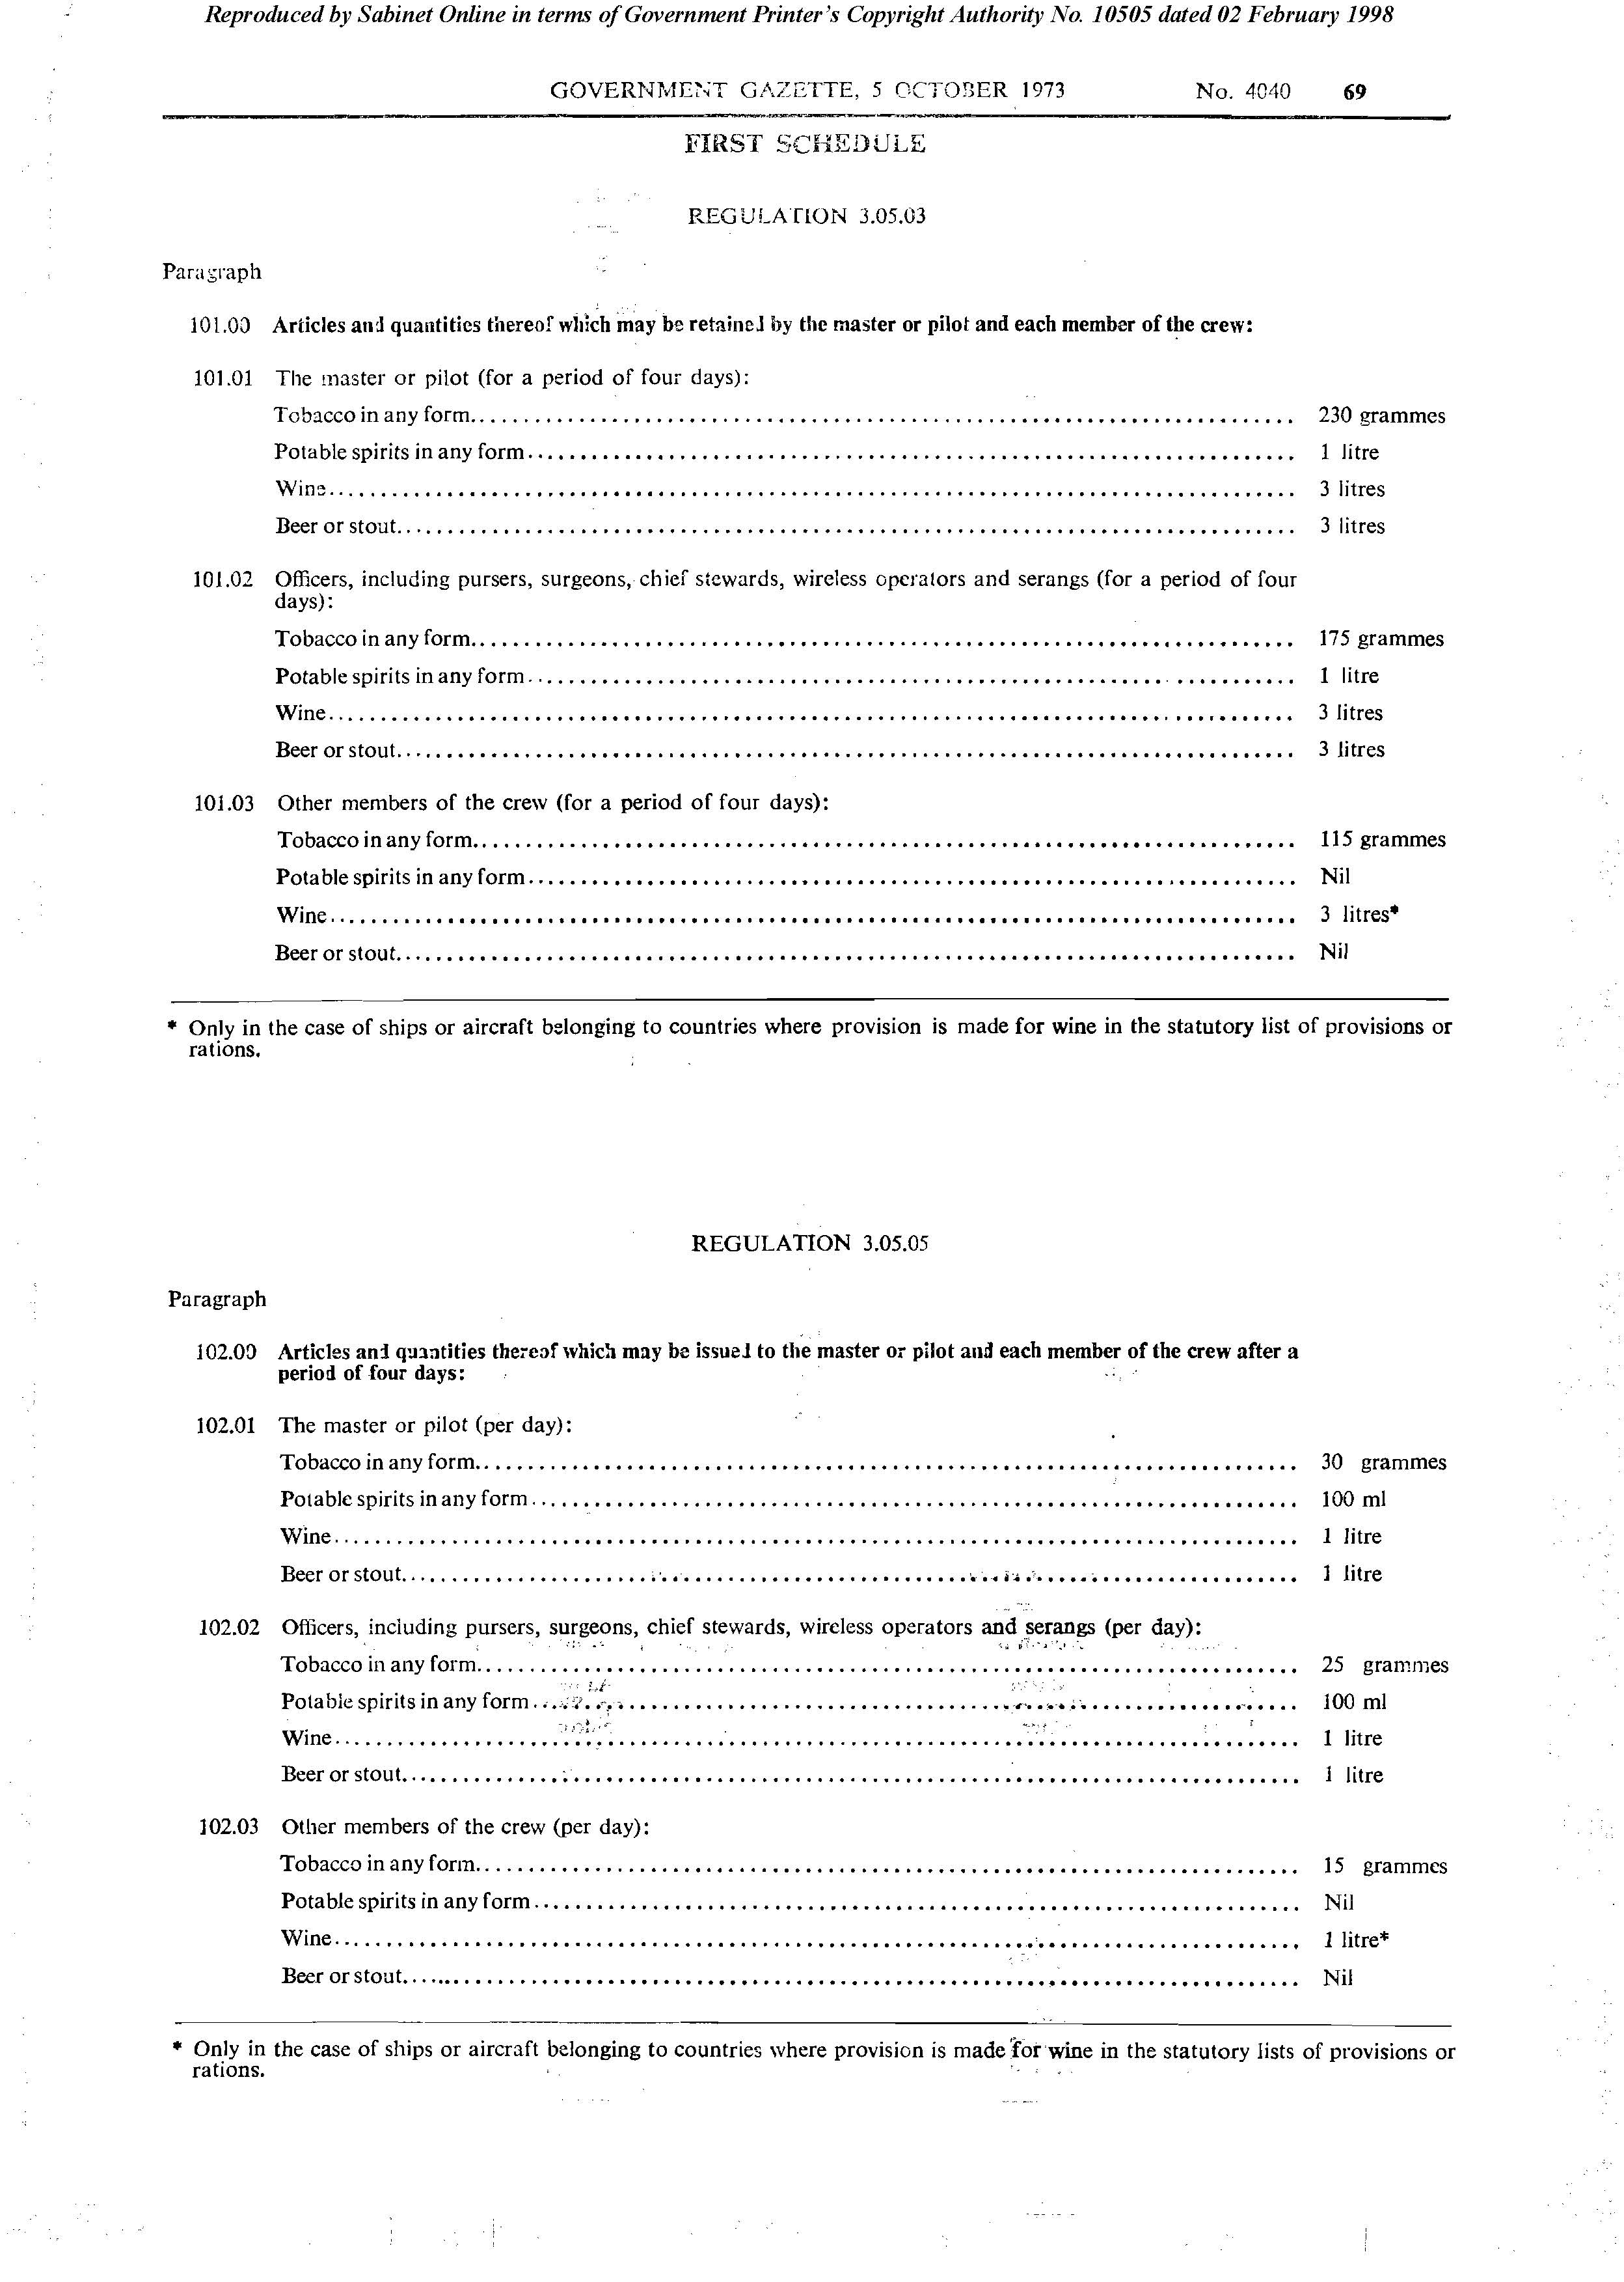

Regulation 3.05.05

Regulation 4.08.01

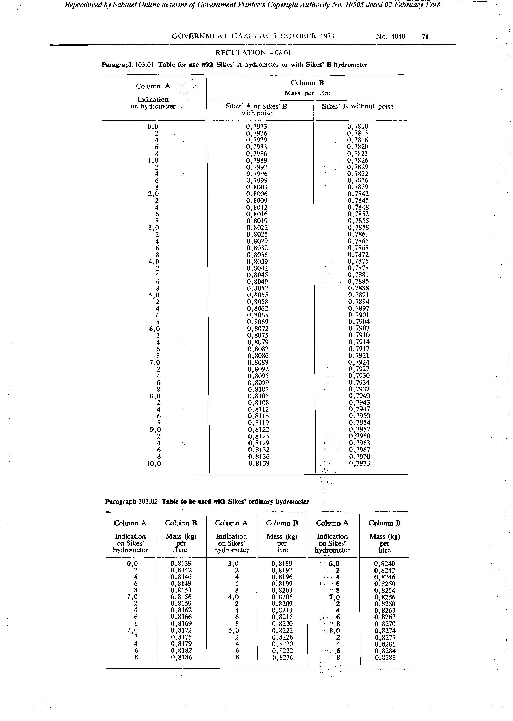

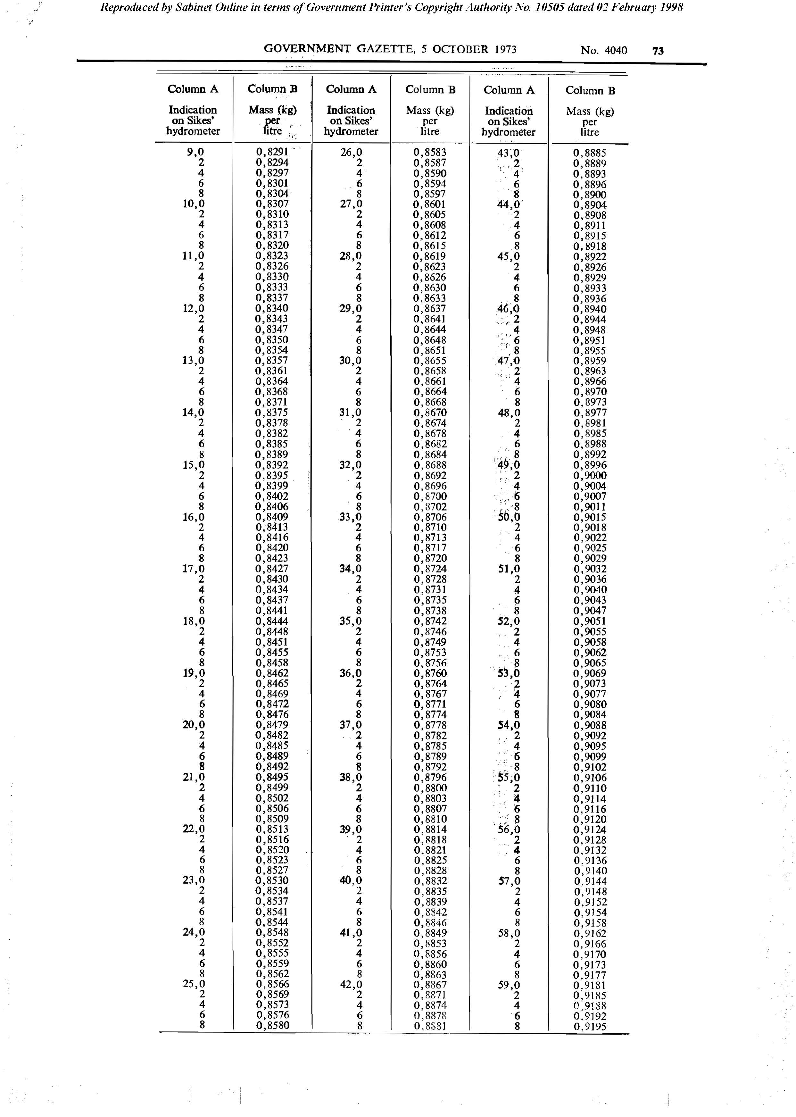

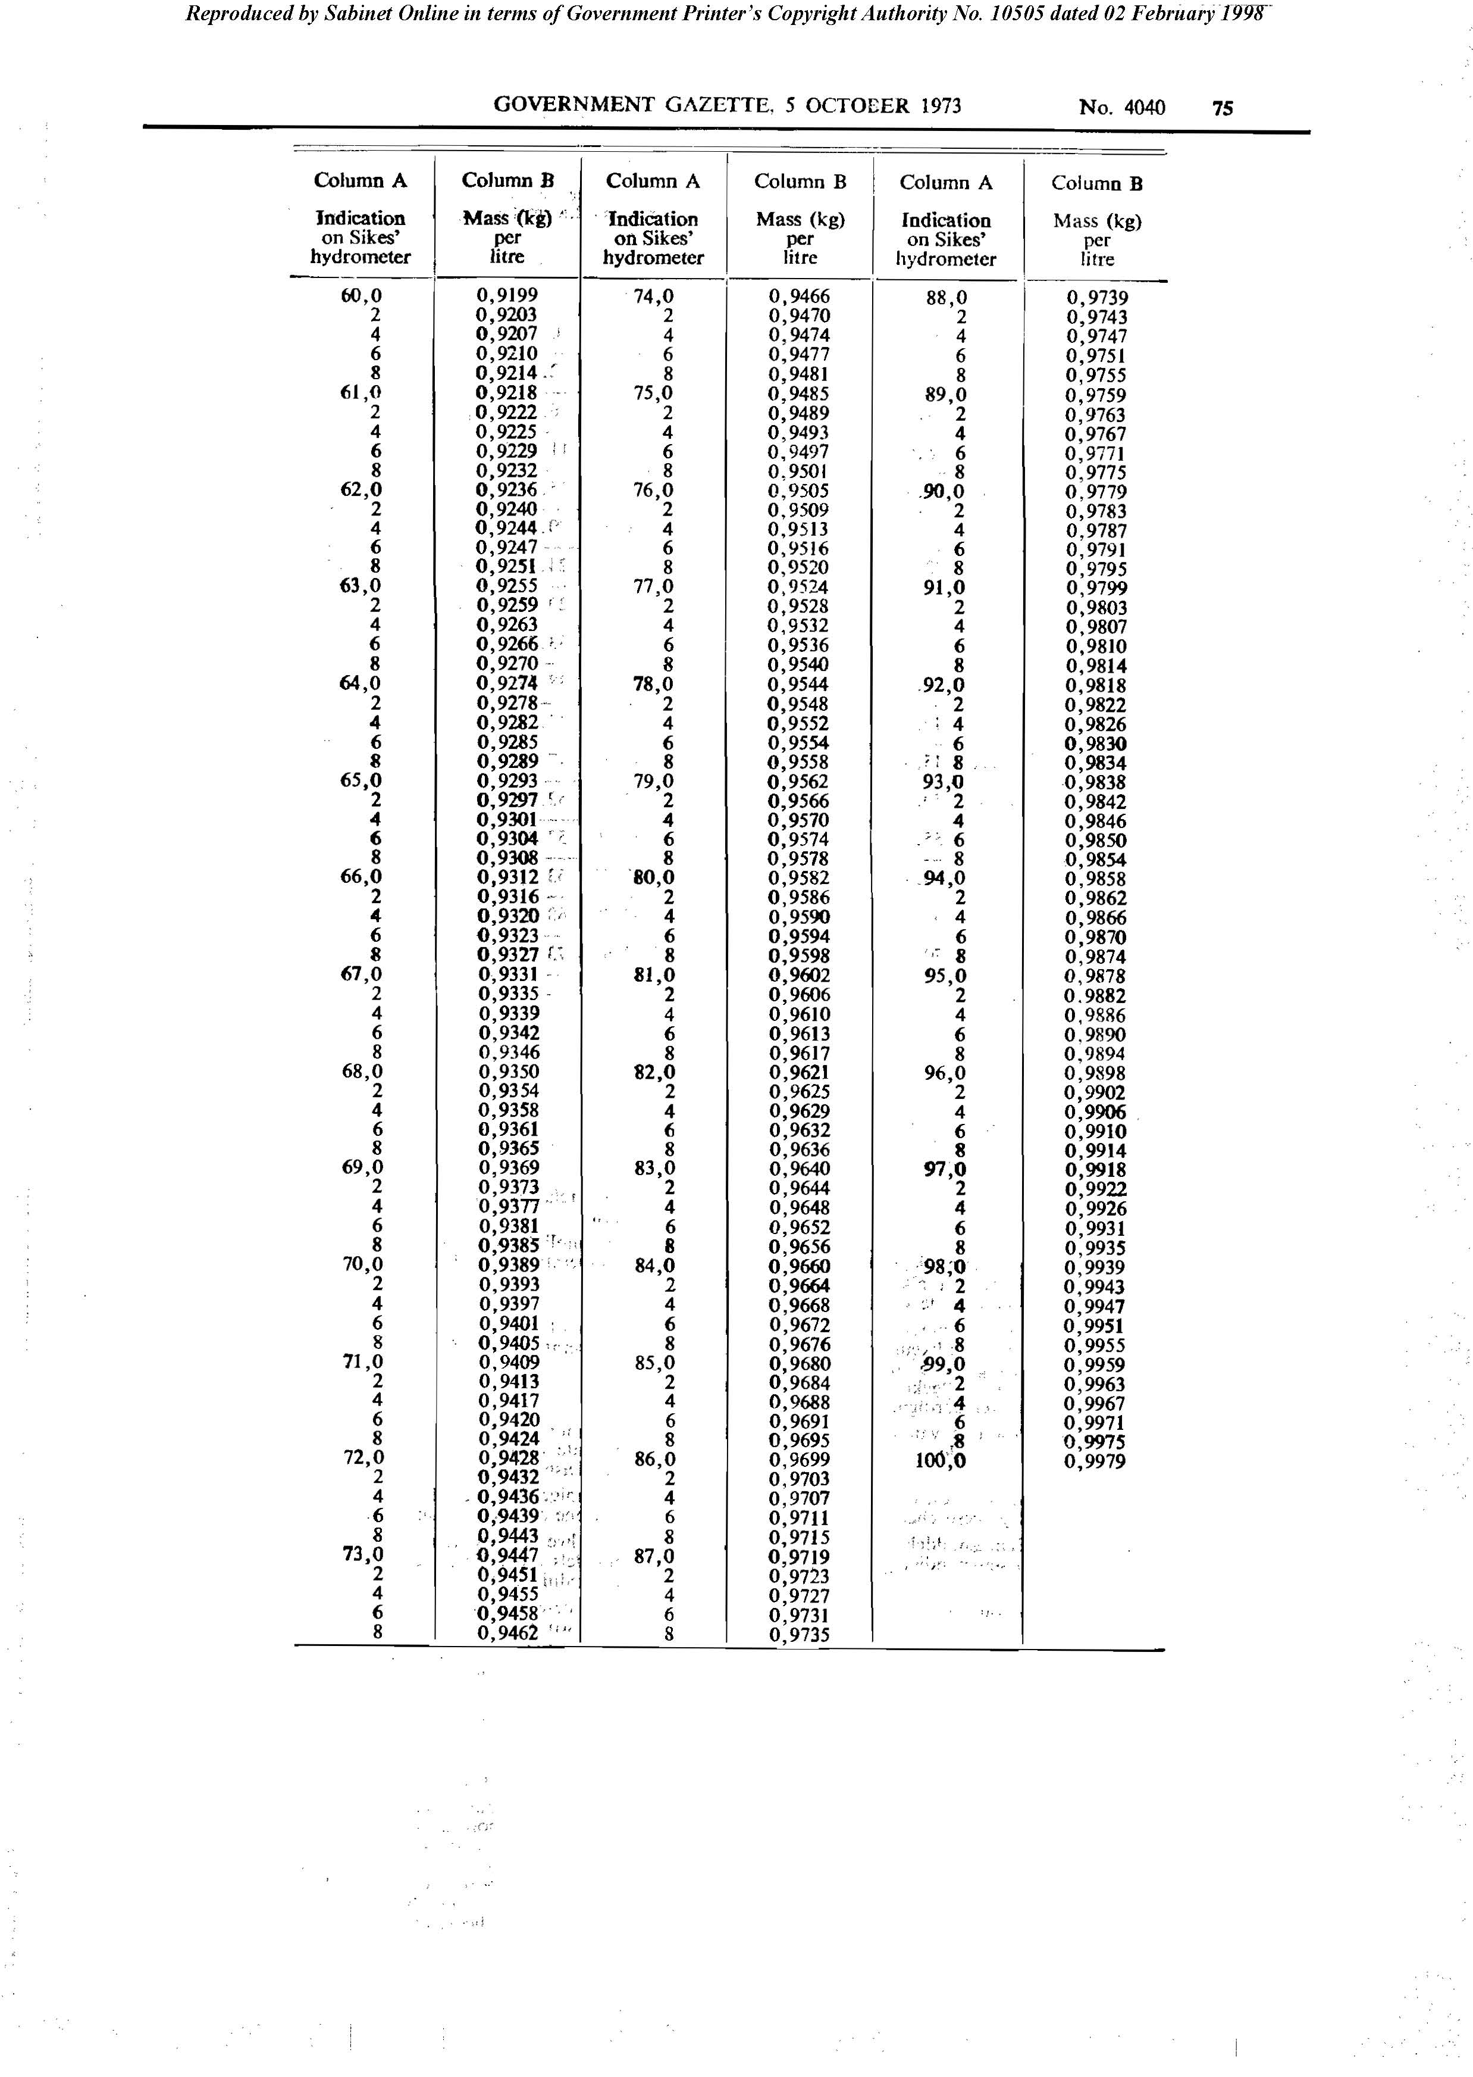

Regulation 4.15.06(d)

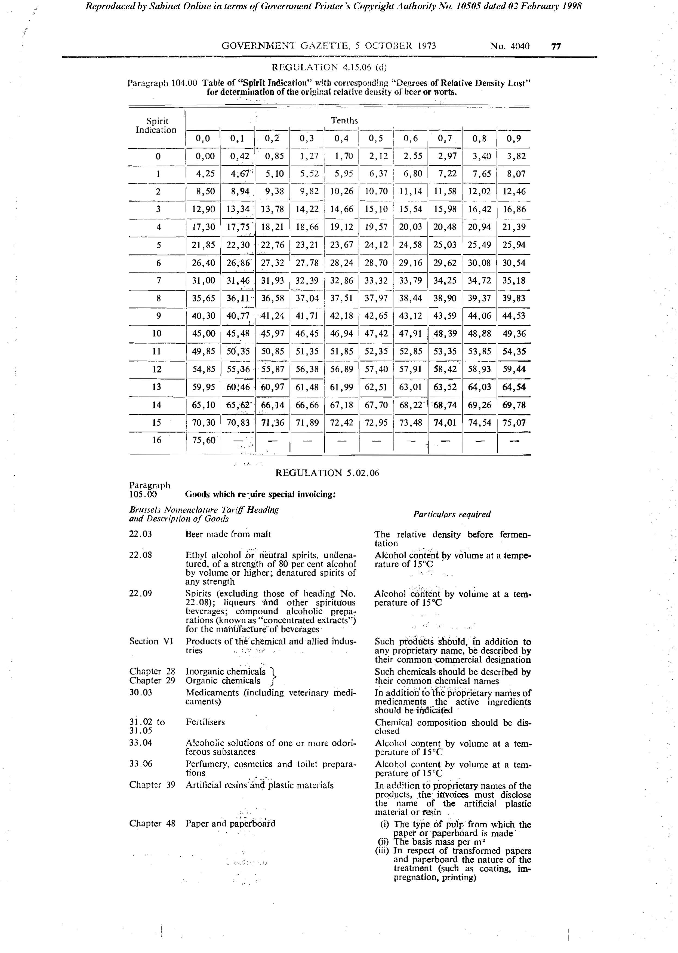

Regulation 5.02.06

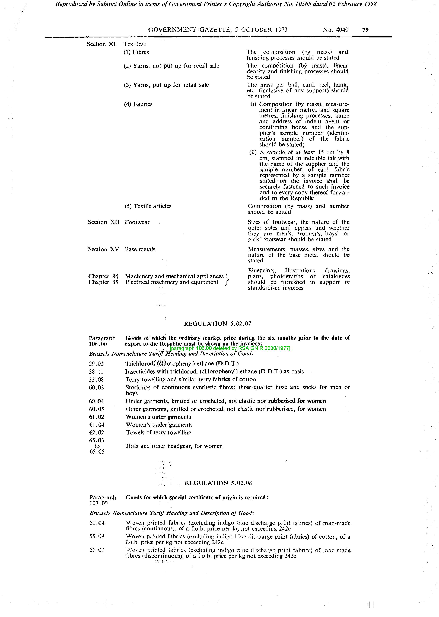

Regulation 5.02.7



Regulation 5.02.08

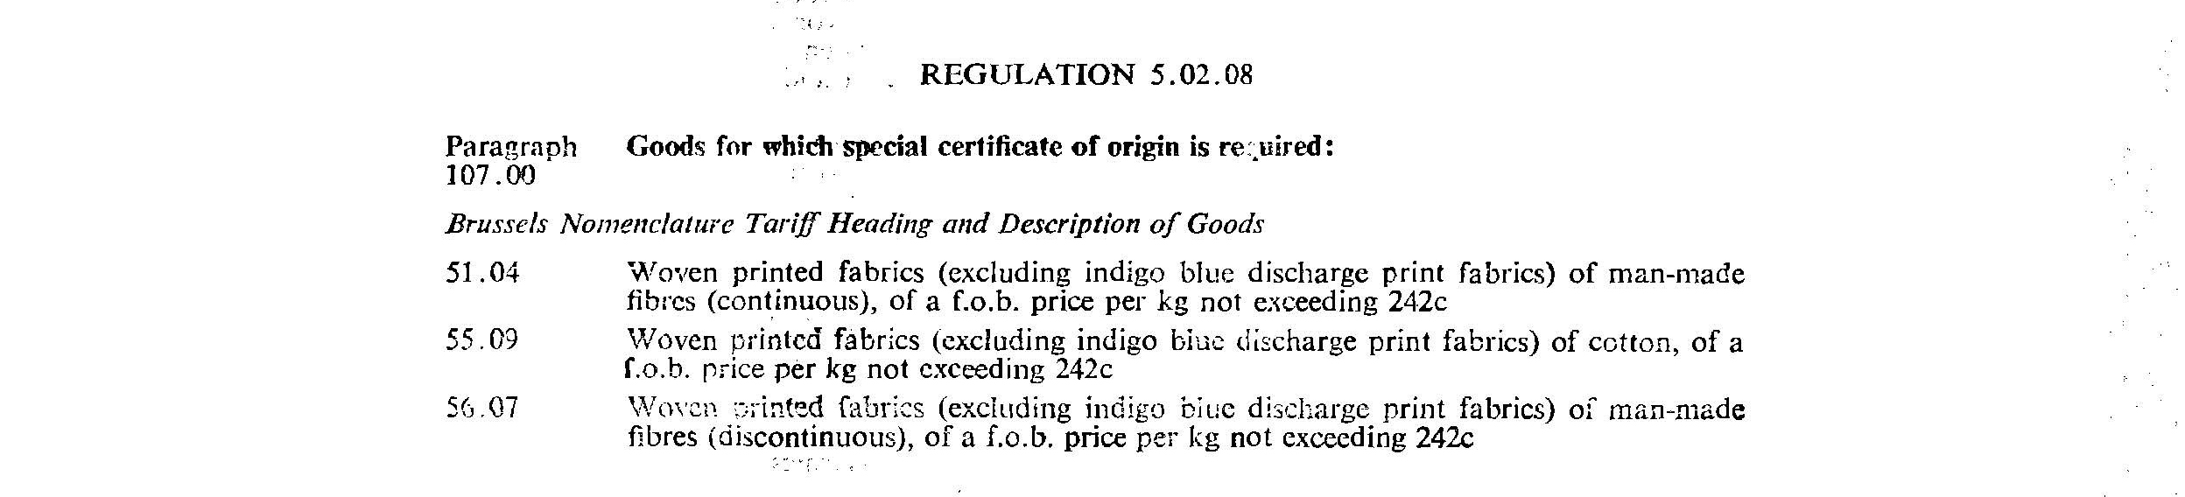

Regulation 12.05.01

[The text below is amended by RSA GN R.279/1975, RSA GN R.815/1975, RSA GN R.1560/1975, RSA GN R.2568/1976, RSA GN R.129/1977, RSA GN R.2630/1977, RSA GN R.1362/1978, RSA GN R.2253/1980, RSA GN R.579/1981 (Afrikaans version) and RSA GN R.2770/1982. However, since this regulation concerns only South African customs offices and seems to have no relevance in independent Namibia, the amendments to the original regulation have not been processed.]

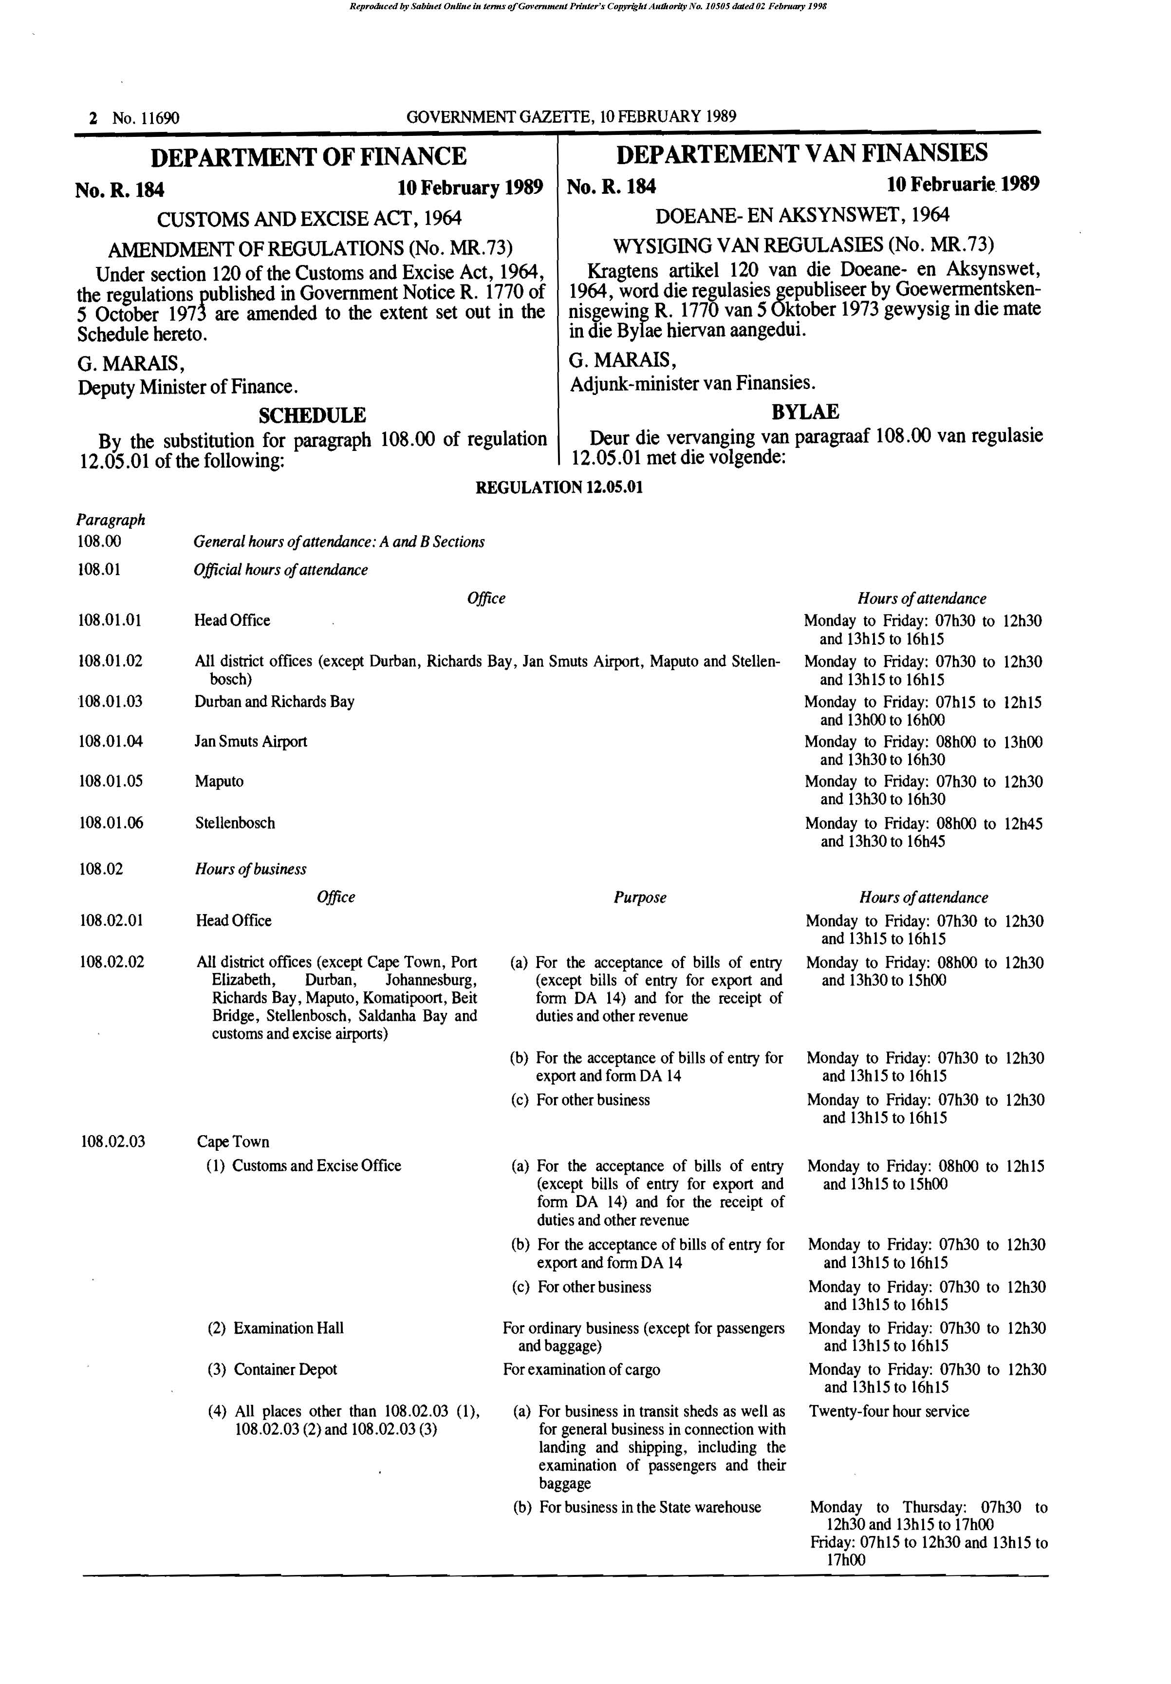

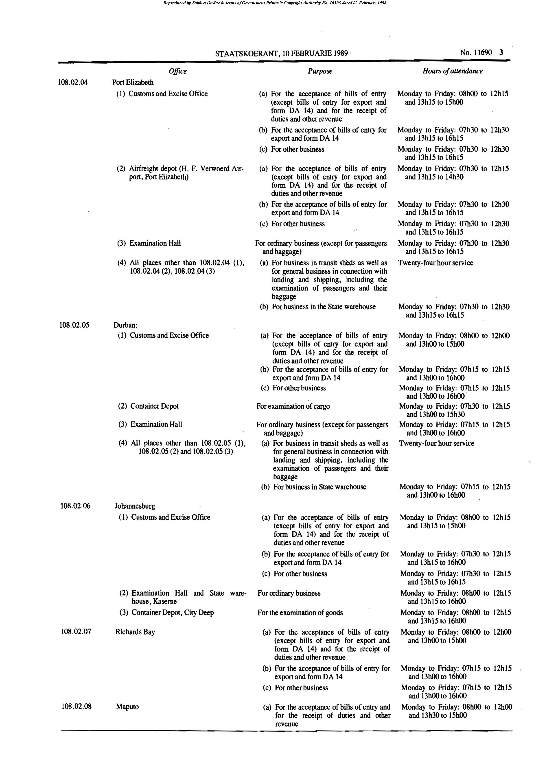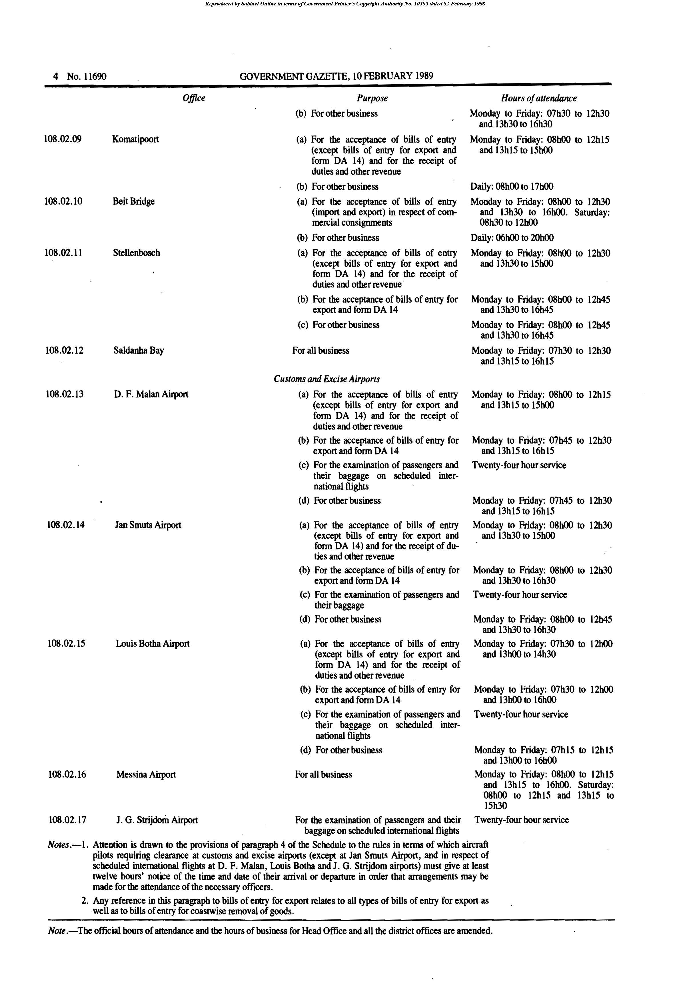

SECOND SCHEDULE

PRESCRIBED FORMS

200.01 The prescribed forms required for customs and excise purposes shall be set out as shown in this Schedule and -

1. in respect of forms DA 500, DA 501, DA 510, DA 600, DA 601, DA 610 and DA 611, must -

(a) be printed lengthwise,

(b) have dimensions of 210 mm x 297 mm,

(c) be printed in black ink; and

(d) be printed on paper of a colour as indicated in the purpose code table below;

2. in respect of forms DA 504, DA 514, DA 604 and DA 614, must -

(a) be printed lengthwise,

(b) have dimensions of 210 mm x 297 mm.

(c) be printed in black ink; and

(d) be printed on yellow paper;

3. in respect of all other forms, each form reflects -

(a) whether printing is to be lengthwise or upright,

(b) the dimensions,

(c) the colour of the ink; and

(d) the colour ofthe paper; and

4. the printing shall be so arranged as to allow the maximum space for the particulars to be entered.
PURPOSE CODE TABLE (IMPORTS)

BILL OF ENTRY (DIRECT) FORMS DA 500 AND DA 501

Printed on white paper.

Purpose of entry | Purpose code
Payment of duty or fee | DP
Warehousing | WH
Warehousing for export only | WE
Industrial rebates of customs duties (Schedule 3 to the Act) (excluding State Stores) | IR
General rebates of customs duties (Schedule 4 to the Act) (excluding State Stores) | GR
State Stores | SS

BILL OF ENTRY (DIRECT) TRANSFER OF LIABILITY FORM DA 510

Printed on white paper.

Purpose of entry | Purpose code
Industrial rebates of customs duties (Schedule 3 to the Act) where the importer of goods is not the registered rebate manufacturer | TIR
General rebates of customs duties (Schedule 4 to the Act) where the importer desires to deliver goods (excluding State Stores) directly to a person or firm authorised to receive the goods under rebate of duty | TGR
Where the importer desires to deliver goods directly as State Stores | TSS

BILLS OF ENTRY (EX WAREHOUSE) IMPORTED GOODS
FORMS DA 600 AND D 601

Printed on pink paper.

Purpose of entry | Purpose code
Payment of duty | XDP
Rewarehousing | XRW
Removal in bond | XIB
Industrial rebates of customs duties (Schedule 3 to the Act) | XIR
General rebates of customs duties (Schedule 4 to the Act) (excluding State Stores) | XGR
State Stores | XSS

BILLS OF ENTRY (EX WAREHOUSE) SOUTH AFRICAN PRODUCTS
FORMS DA 610 AND D 611

Printed on green paper.

Purpose of entry | Purpose code
Payment of duty | ZDP
Rewarehousing | ZRW
Removal in bond | ZIB
Specific rebates of excise duties (Schedule 6 to the Act) (excluding State Stores) | ZGR
State Stores | ZSS

PURPOSE CODE TABLE (EXPORTS)

BILL OF ENTRY (NOT EX WAREHOUSE) EXPORT

FORM DA 550

Purpose of entry | Purpose code
Export of local goods | ELG
Export of imported goods | EIG
Export as Ships’/Aircraft Stores (imported or local goods) | EAS

[Item 200.01 is substituted by RSA GN R.1362/1978 and by RSA GN R.2094/1987.]

200.02 Any space marked “No.” or “Bill of Entry Number” in the lower right-hand corner of any prescribed form (except forms DA 62, DA 63, DA 68, DA 69 and DA 70) shall be of a minimum dimension of 35 mm by 45 mm, any such space for a revenue stamp shall be of a minimum dimension of 25 mm by 35 mm and any space reserved for official use shall be of a minimum dimension of 35 mm by 50 mm.

[Item 200.02 is substituted by RSA GN R.1362/1978.]

200.03 In respect of all prescribed forms a binding margin of 20 mm wide shall be left at the top of each form printed lengthwise and each prescribed form printed upright shall have a similar binding margin on the left-hand side. In respect of form DA 550, the ‘Line reference’ field shall be regarded as being part of the binding margin.

[Item 200.03 is substituted by RSA GN R.1362/1978 and by RSA GN R.2094/1987.]

200.04 The revenue stamp shall be affixed to the original of any prescribed form in respect of which it is required.

[Item 200.04 is substituted by RSA GN R.1362/1978.]

200.05 The original of any prescribed form and so many copies as the Controller may require in each case shall be presented to him when such form is used for any purpose under the provisions of the Act and these regulations.

[Item 200.05 is substituted by RSA GN R.1362/1978.]

200.06 In respect of the prescribed bill of entry forms DA 14, DA 22, DA 28, DA 29, DA 30 and DA 31, there shall be a further prescribed form with the words “Voucher of Correction” added to the name of the form and the letter “A” added in the number of the form. The declaration(s) shall be omitted if such vouchers are printed separately and the blank portion for entry of the particulars of the goods shall be divided into equal portions with two parallel horizontal lines and the words ‘Originally entered on B/E No. ...............of...................as’ between the two lines. In respect of any form with a column relating to the amount of duty, the words “Difference in duty” shall be substituted for the word “Totals” on such form. Such vouchers may be printed separately or the normal prescribed forms may be used and the above-stated adjustments made thereto. Provision should in all cases be made for the signature of the person presenting such voucher to the Controller.

[Item 200.06 is substituted by RSA GN R.1362/1978 and by RSA GN R.2094/1987.]

200.07 Forms DA 23, DA 24 and DA 27 may not be used for the clearance of the goods after 31 December 1987.

[Item 200.07 is substituted by RSA GN R.1362/1978 and by RSA GN R.2094/1987.]

[Note that the forms are not all numbered consecutively.]

Form DA 1

[Form DA 1 is substituted by RSA GN R.629/1984.]

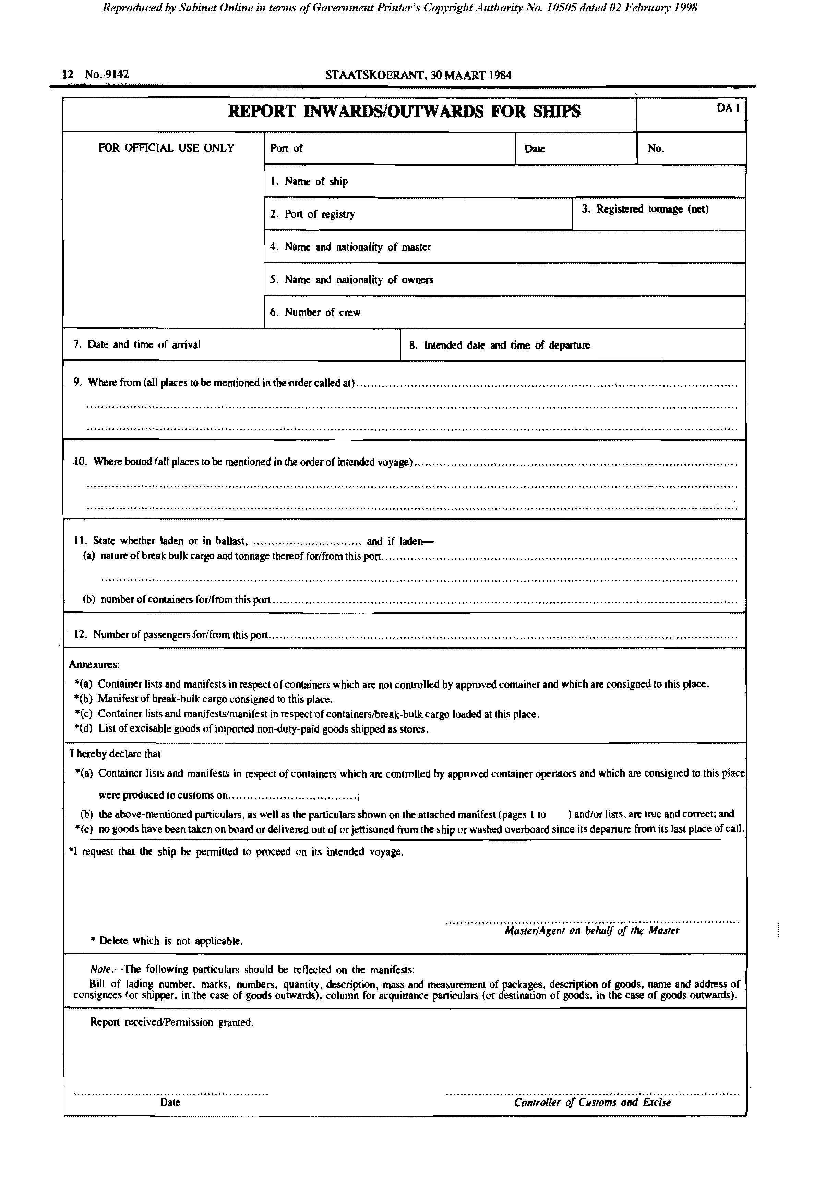

Form DA 2
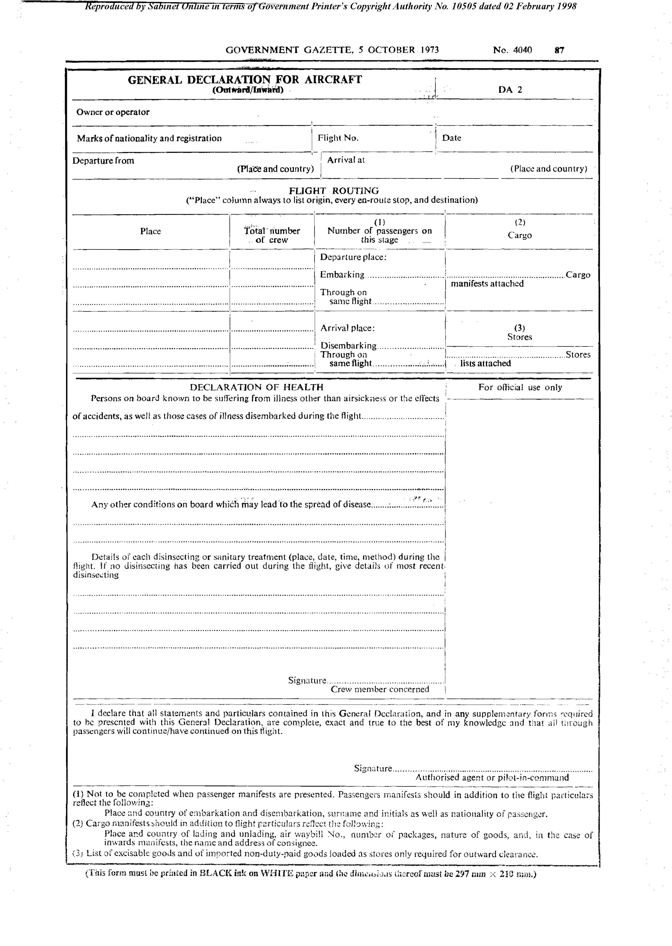

Form DA 3

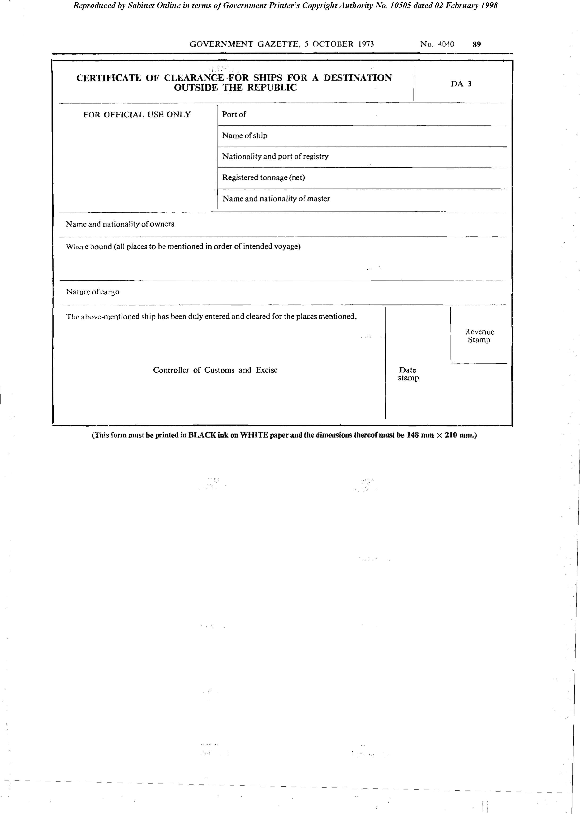

Form DA 4
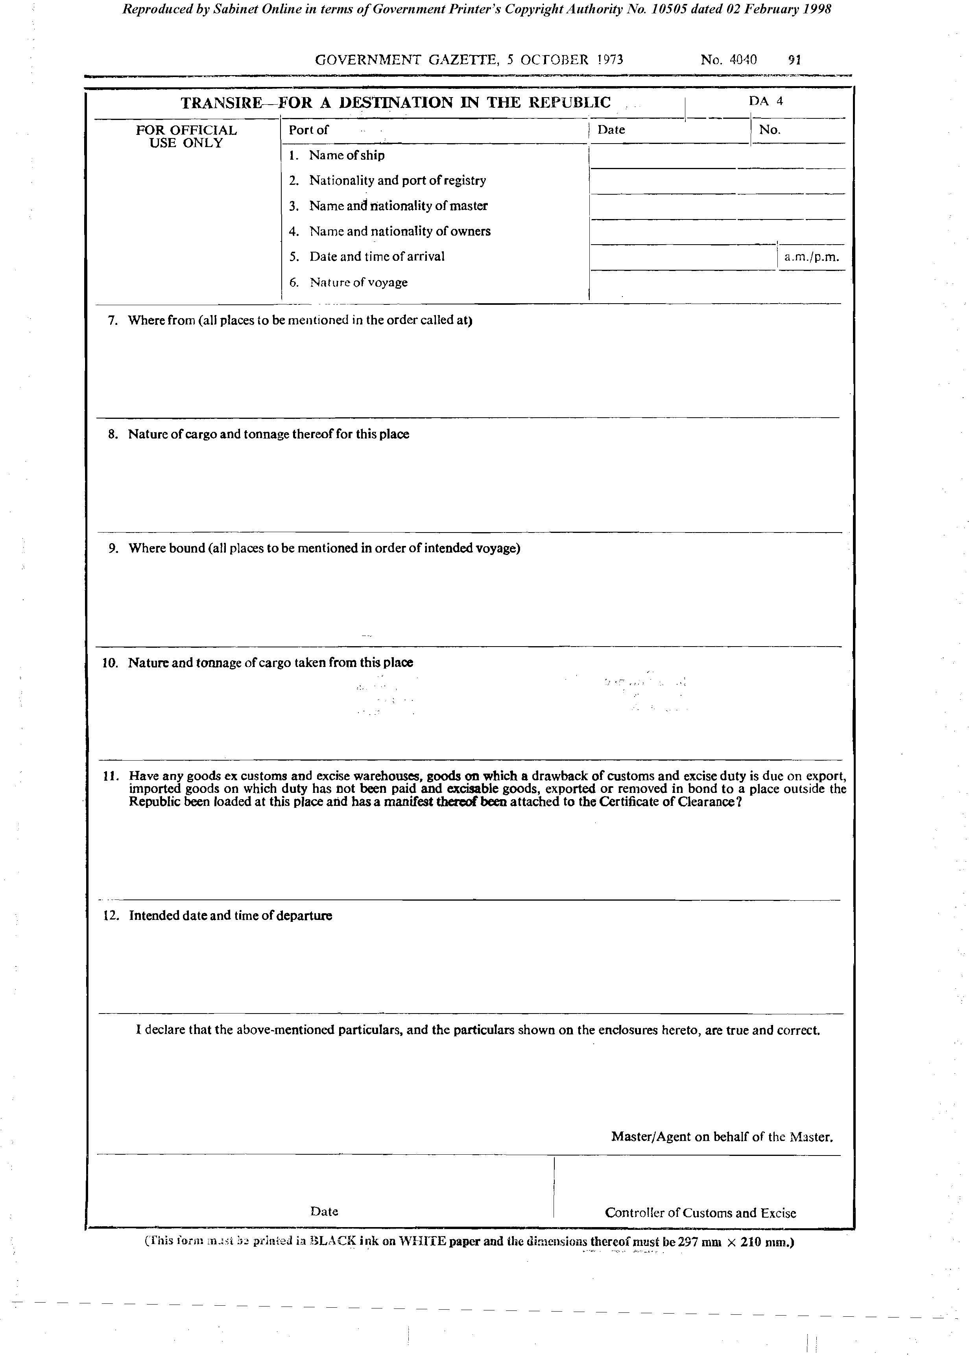

Form DA 5

[Form DA 5 is substituted by RSA GN R.2051/1973.]
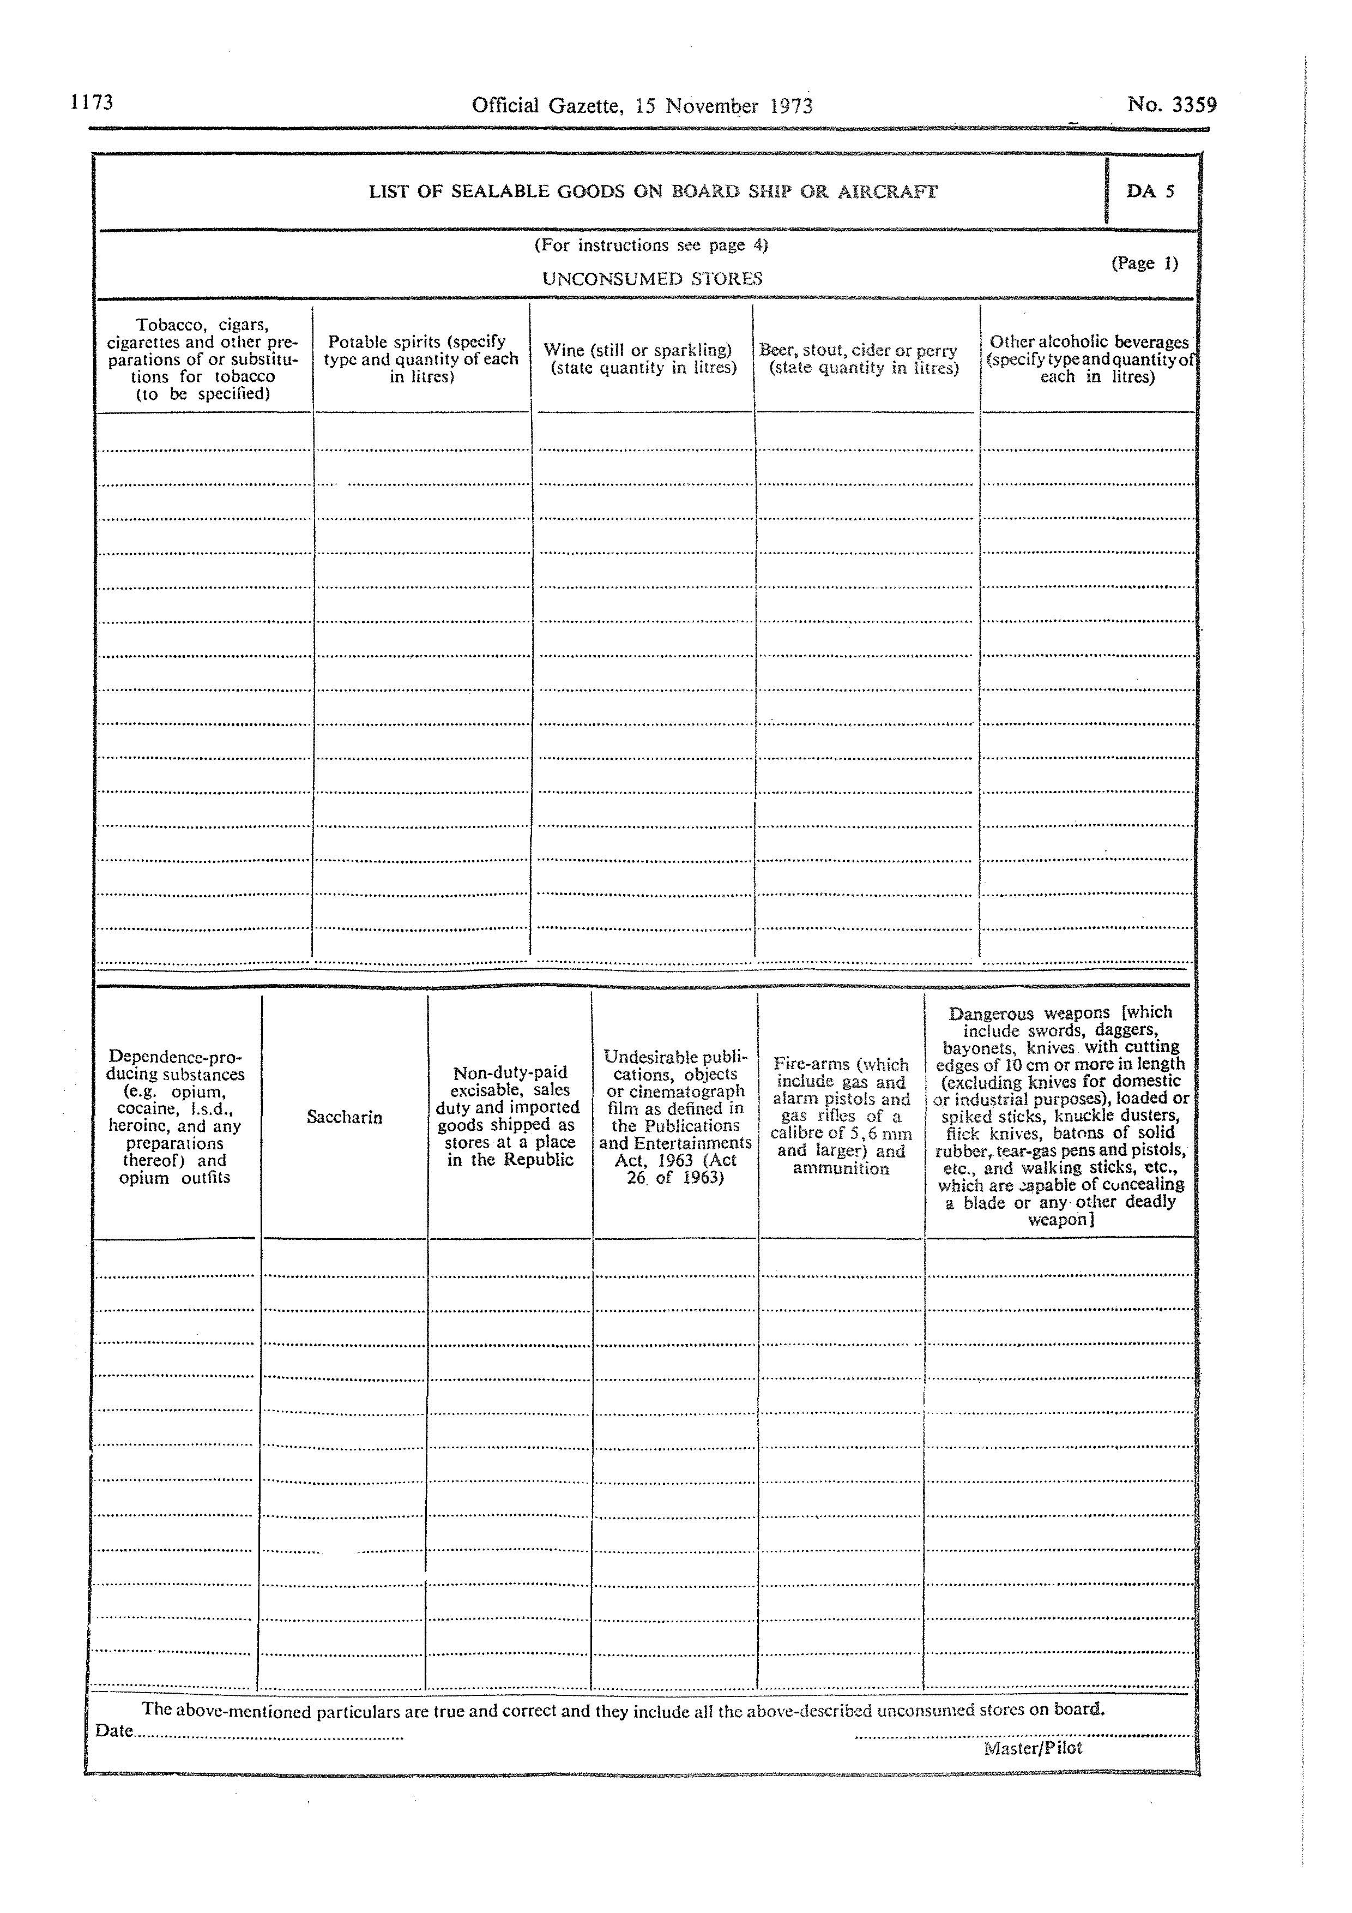

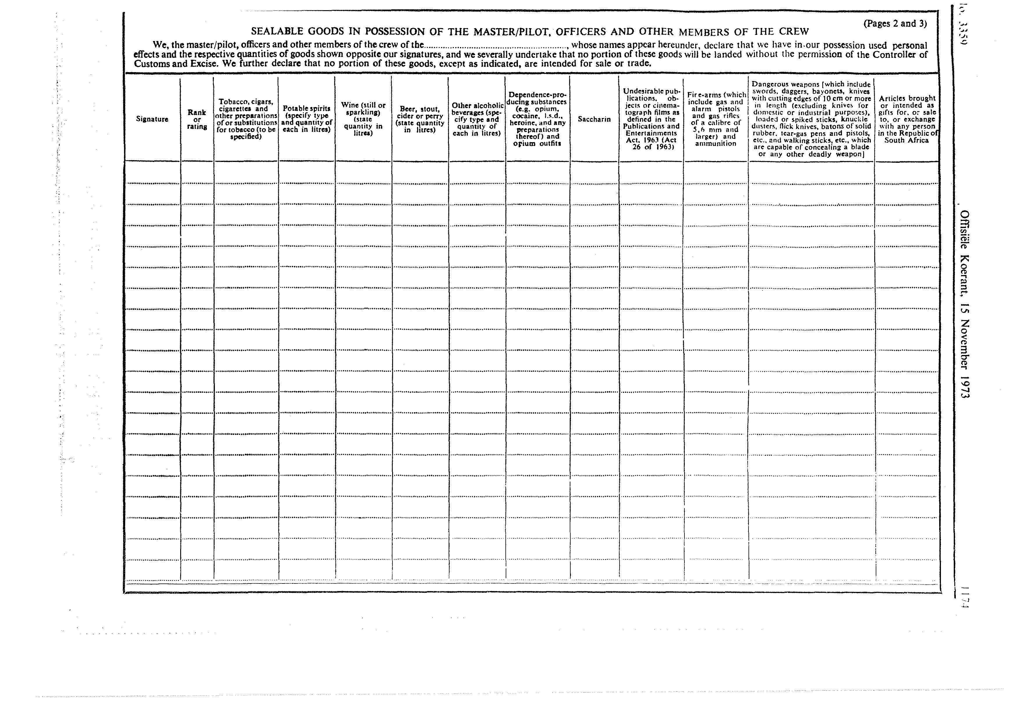

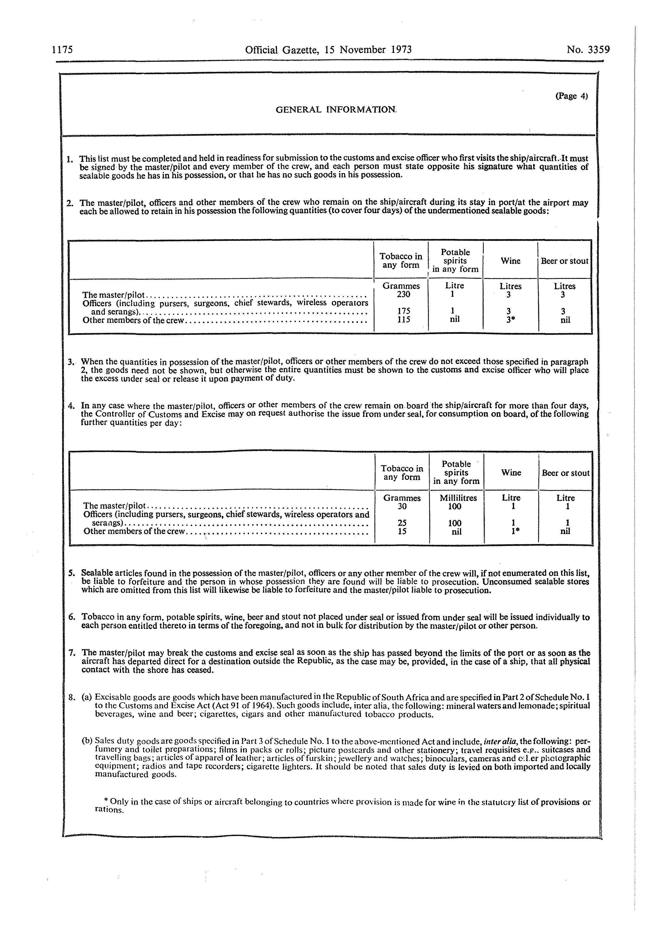

Form DA 10

Form DA 11

Form DA 12

Form DA 13

Form DA 14

Form DA 15

Form DA 16

Form DA 17

Form DA 18

Form DA 19

Form DA 20

Form DA 21

[A new Form DA 500 is substituted for Forms DA 10, DA 12, DA 16, DA 18 and DA 20 by RSA GN R.1362/1978. New forms DA 570, DA 571 and DA 574 are substituted for Form DA 14 by RSA GN R.1774/1989. A new Form DA 600 is substituted for Forms DA 11, DA 13, DA 15, DA 17, DA 19 and DA 21 by RSA GN R.1362/1978. New forms DA 500, DA 570, DA 571, DA 574 and DA 600 are
placed below in numerical order.]
Form DA 22

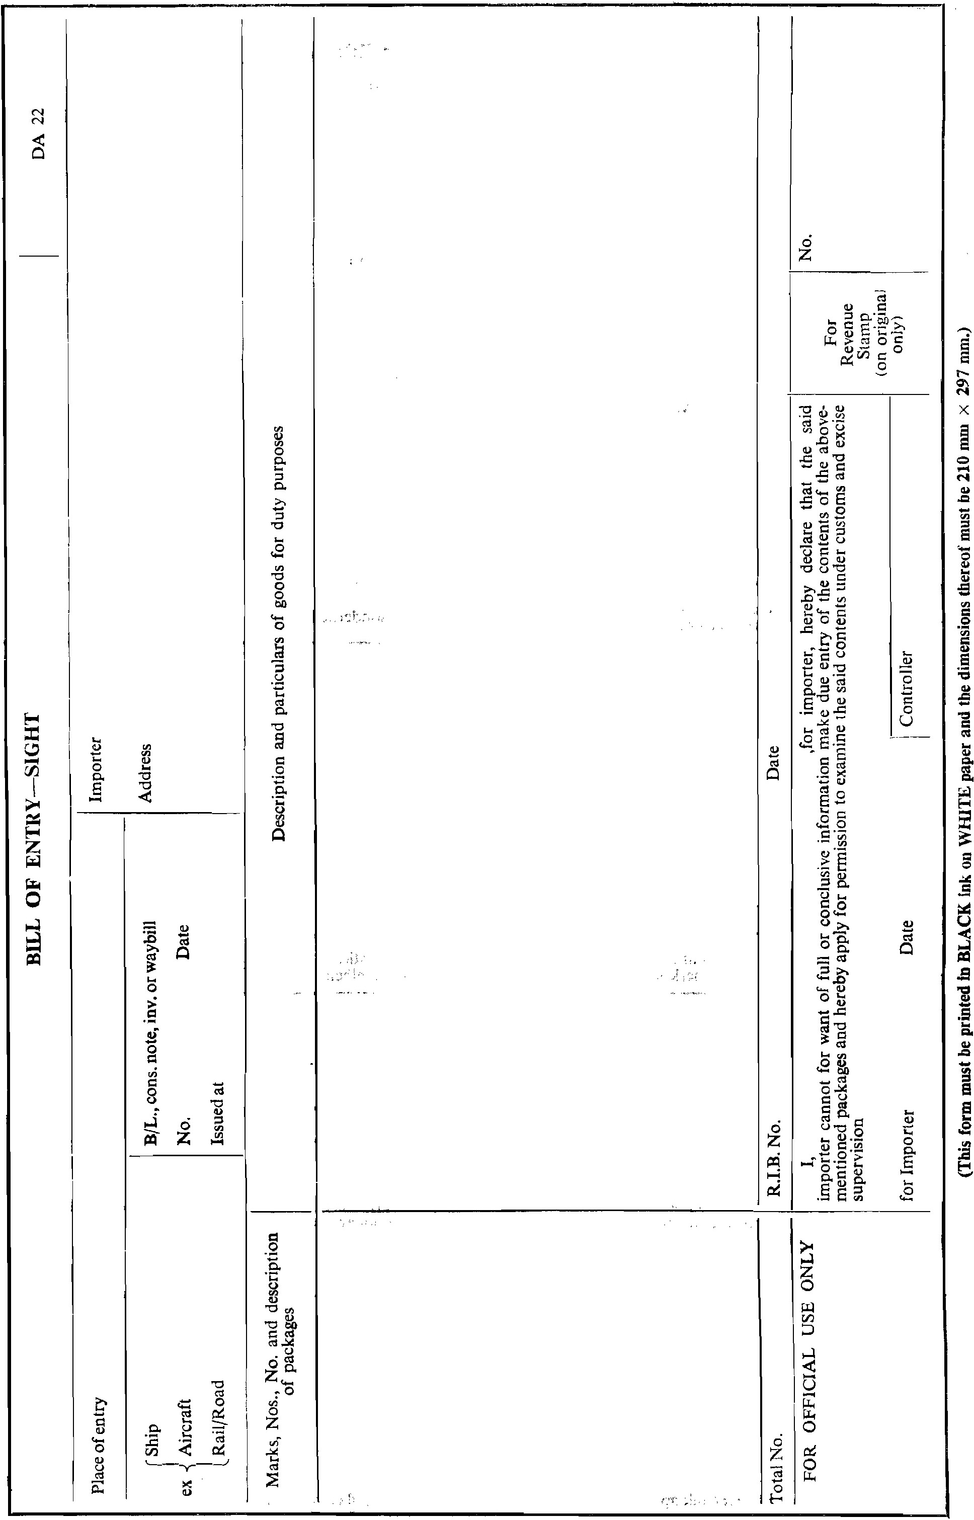

Form DA 23

[Form DA 23 is substituted by RSA GN R.469/1975 and
replaced with a new Form DA 550 by RSA GN R.2519/1986.
Form 550 is reproduced above.]

Form DA 23A

[Form DA 23A (which despite its numbering appears in the original regulations)
is substituted by RSA GN R.469/1975.]

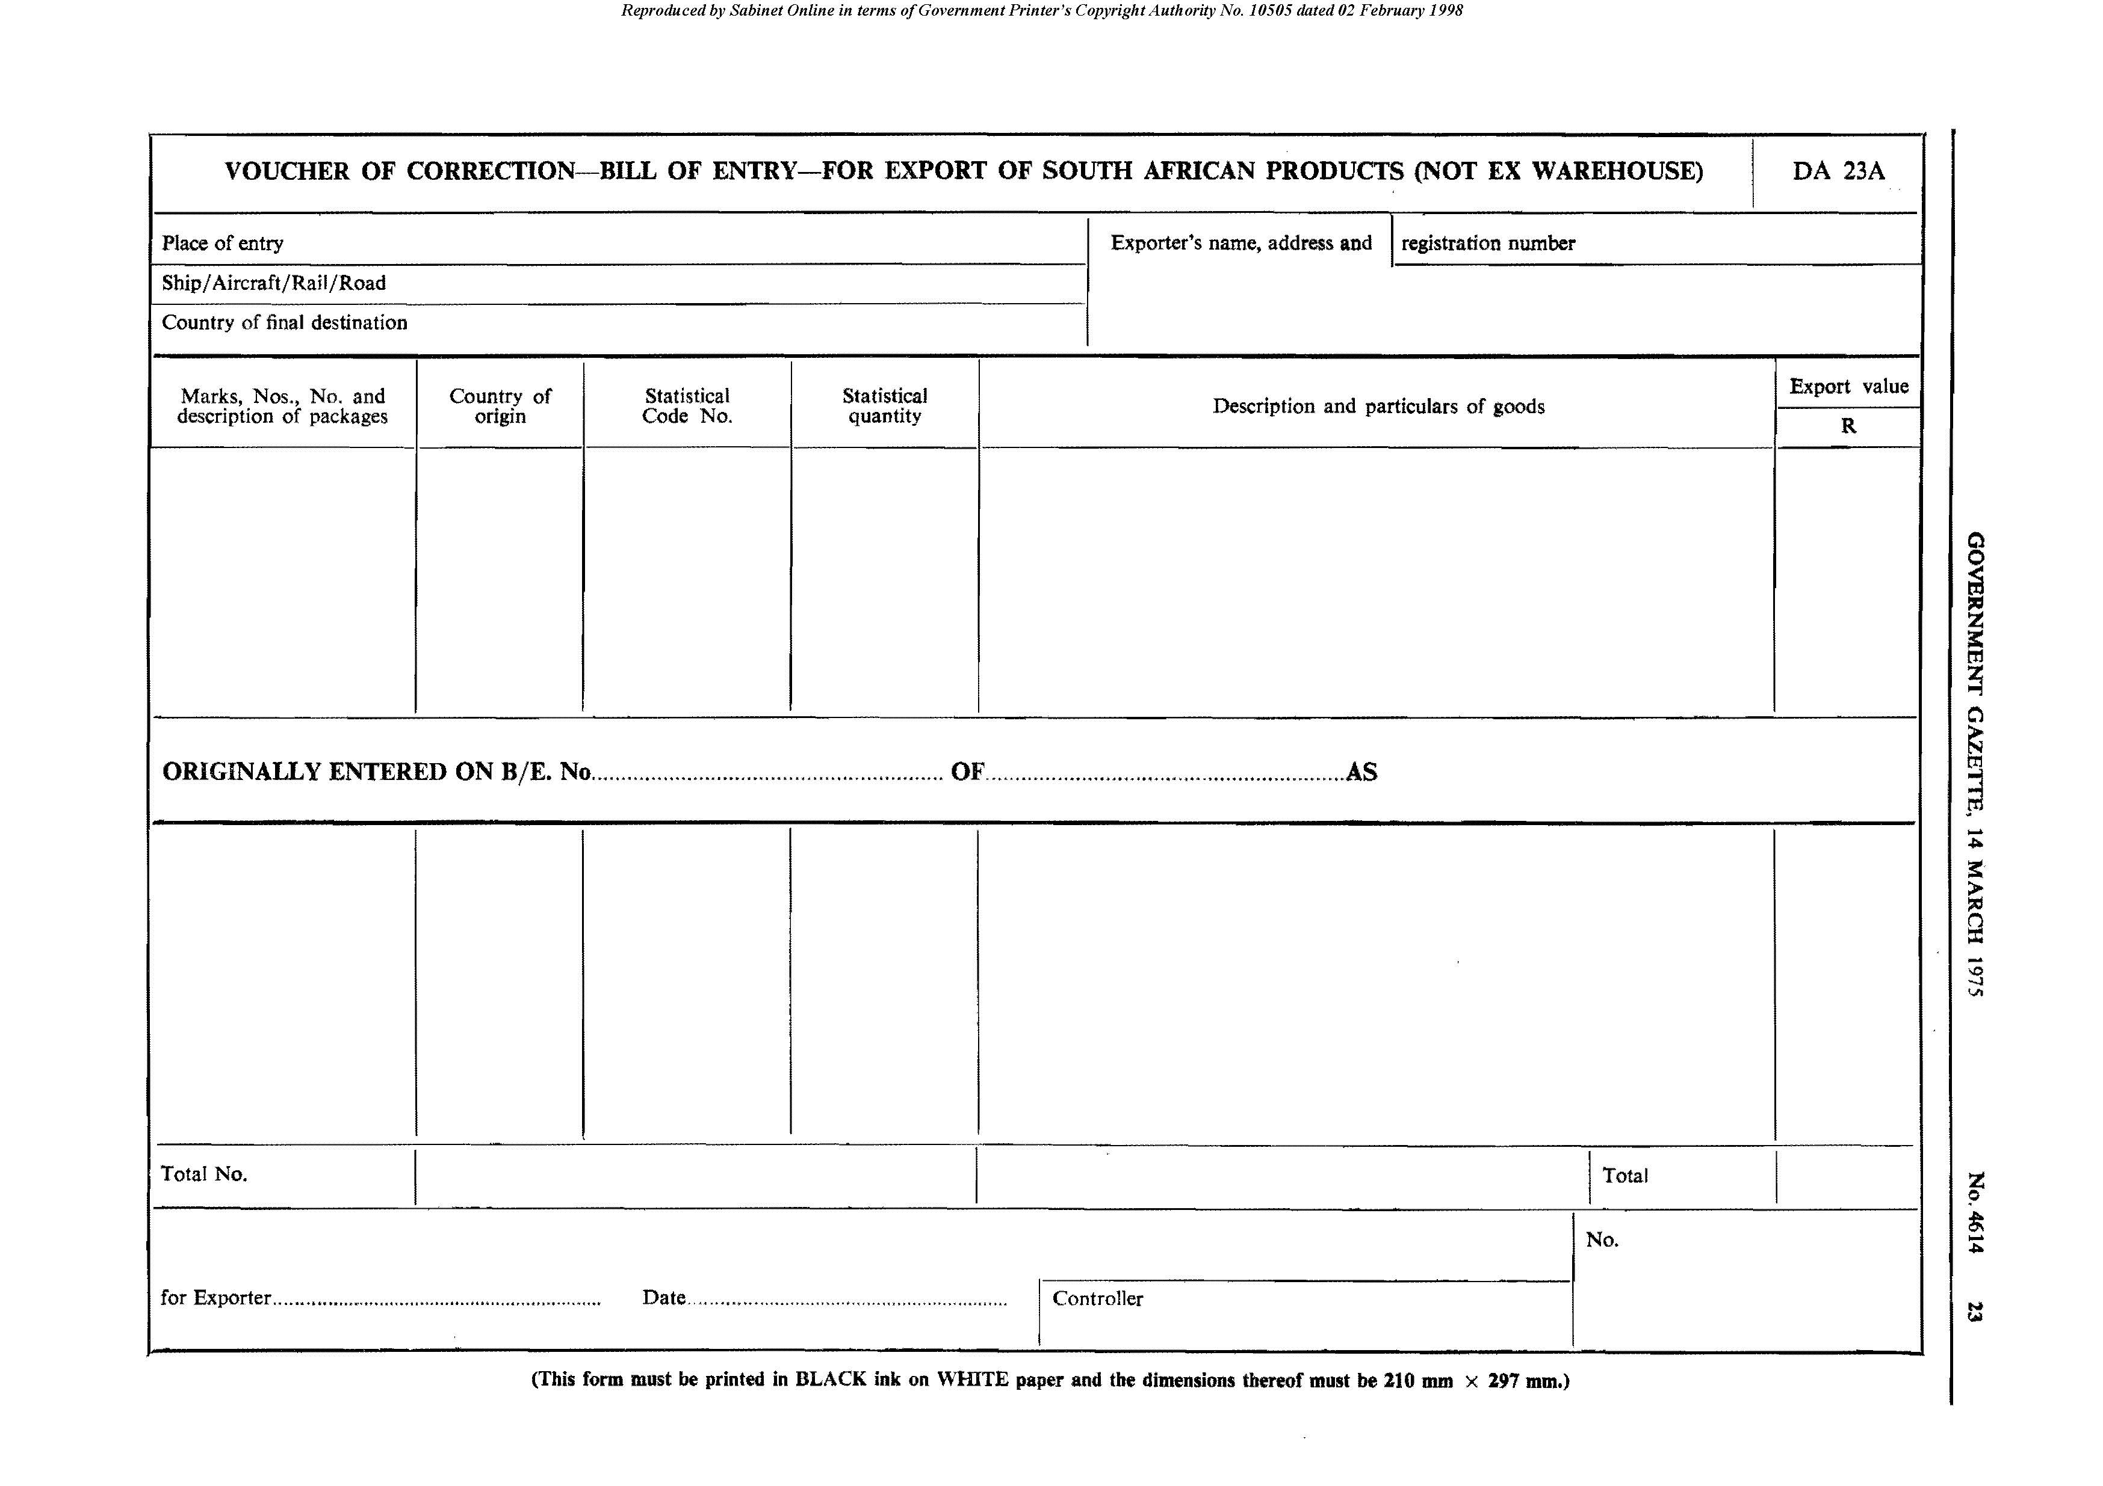

Form DA 24

[Form DA 24 is replaced with a new Form DA 550 by RSA GN R.2519/1986.
Form DA 550 is reproduced below in numerical order.]

Form DA 24A

[Form DA 24A, despite its numbering, appears in the original regulations.]

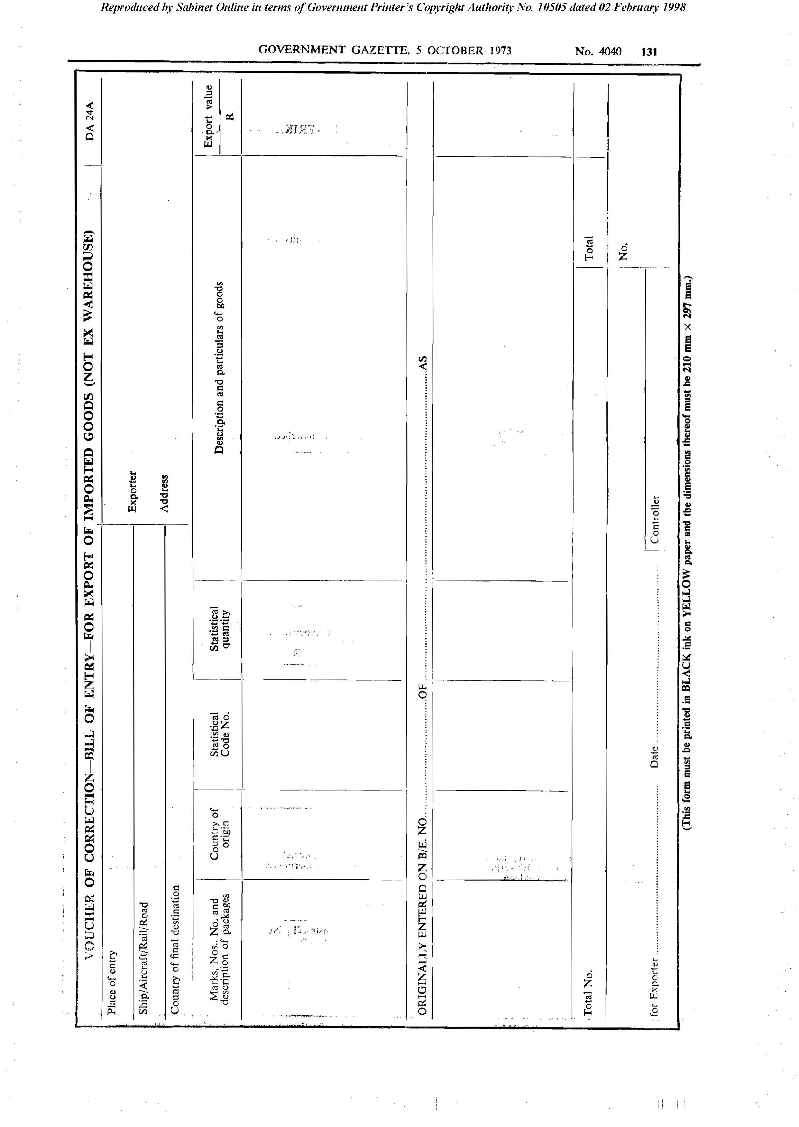

Form DA 25

[Form DA 25 is substituted by RSA GN R.469/1975.]

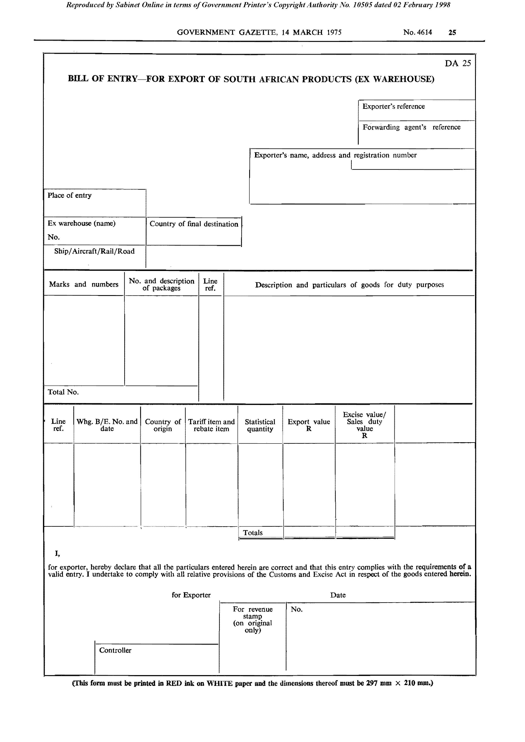

Form DA 25A

[Form DA 25A (which despite its numbering appears in the original regulations)
is substituted by RSA GN R.469/1975 and by RSA GN R.629/1984.]

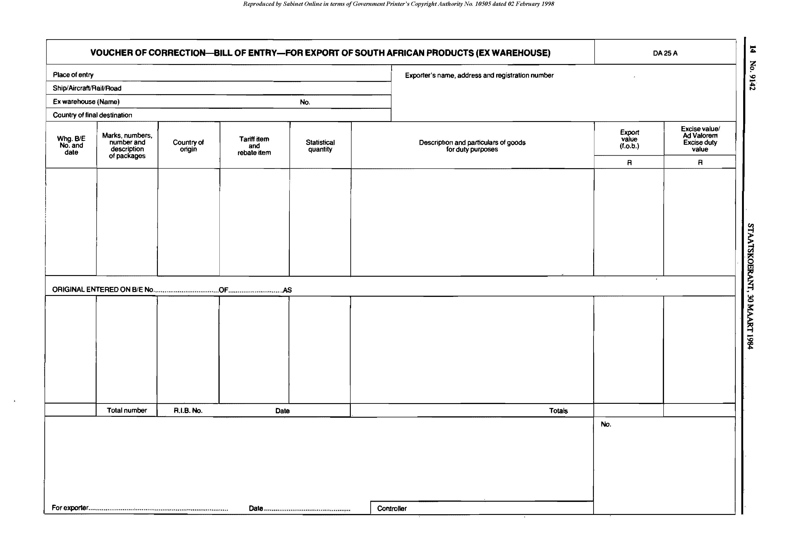

Form DA 26

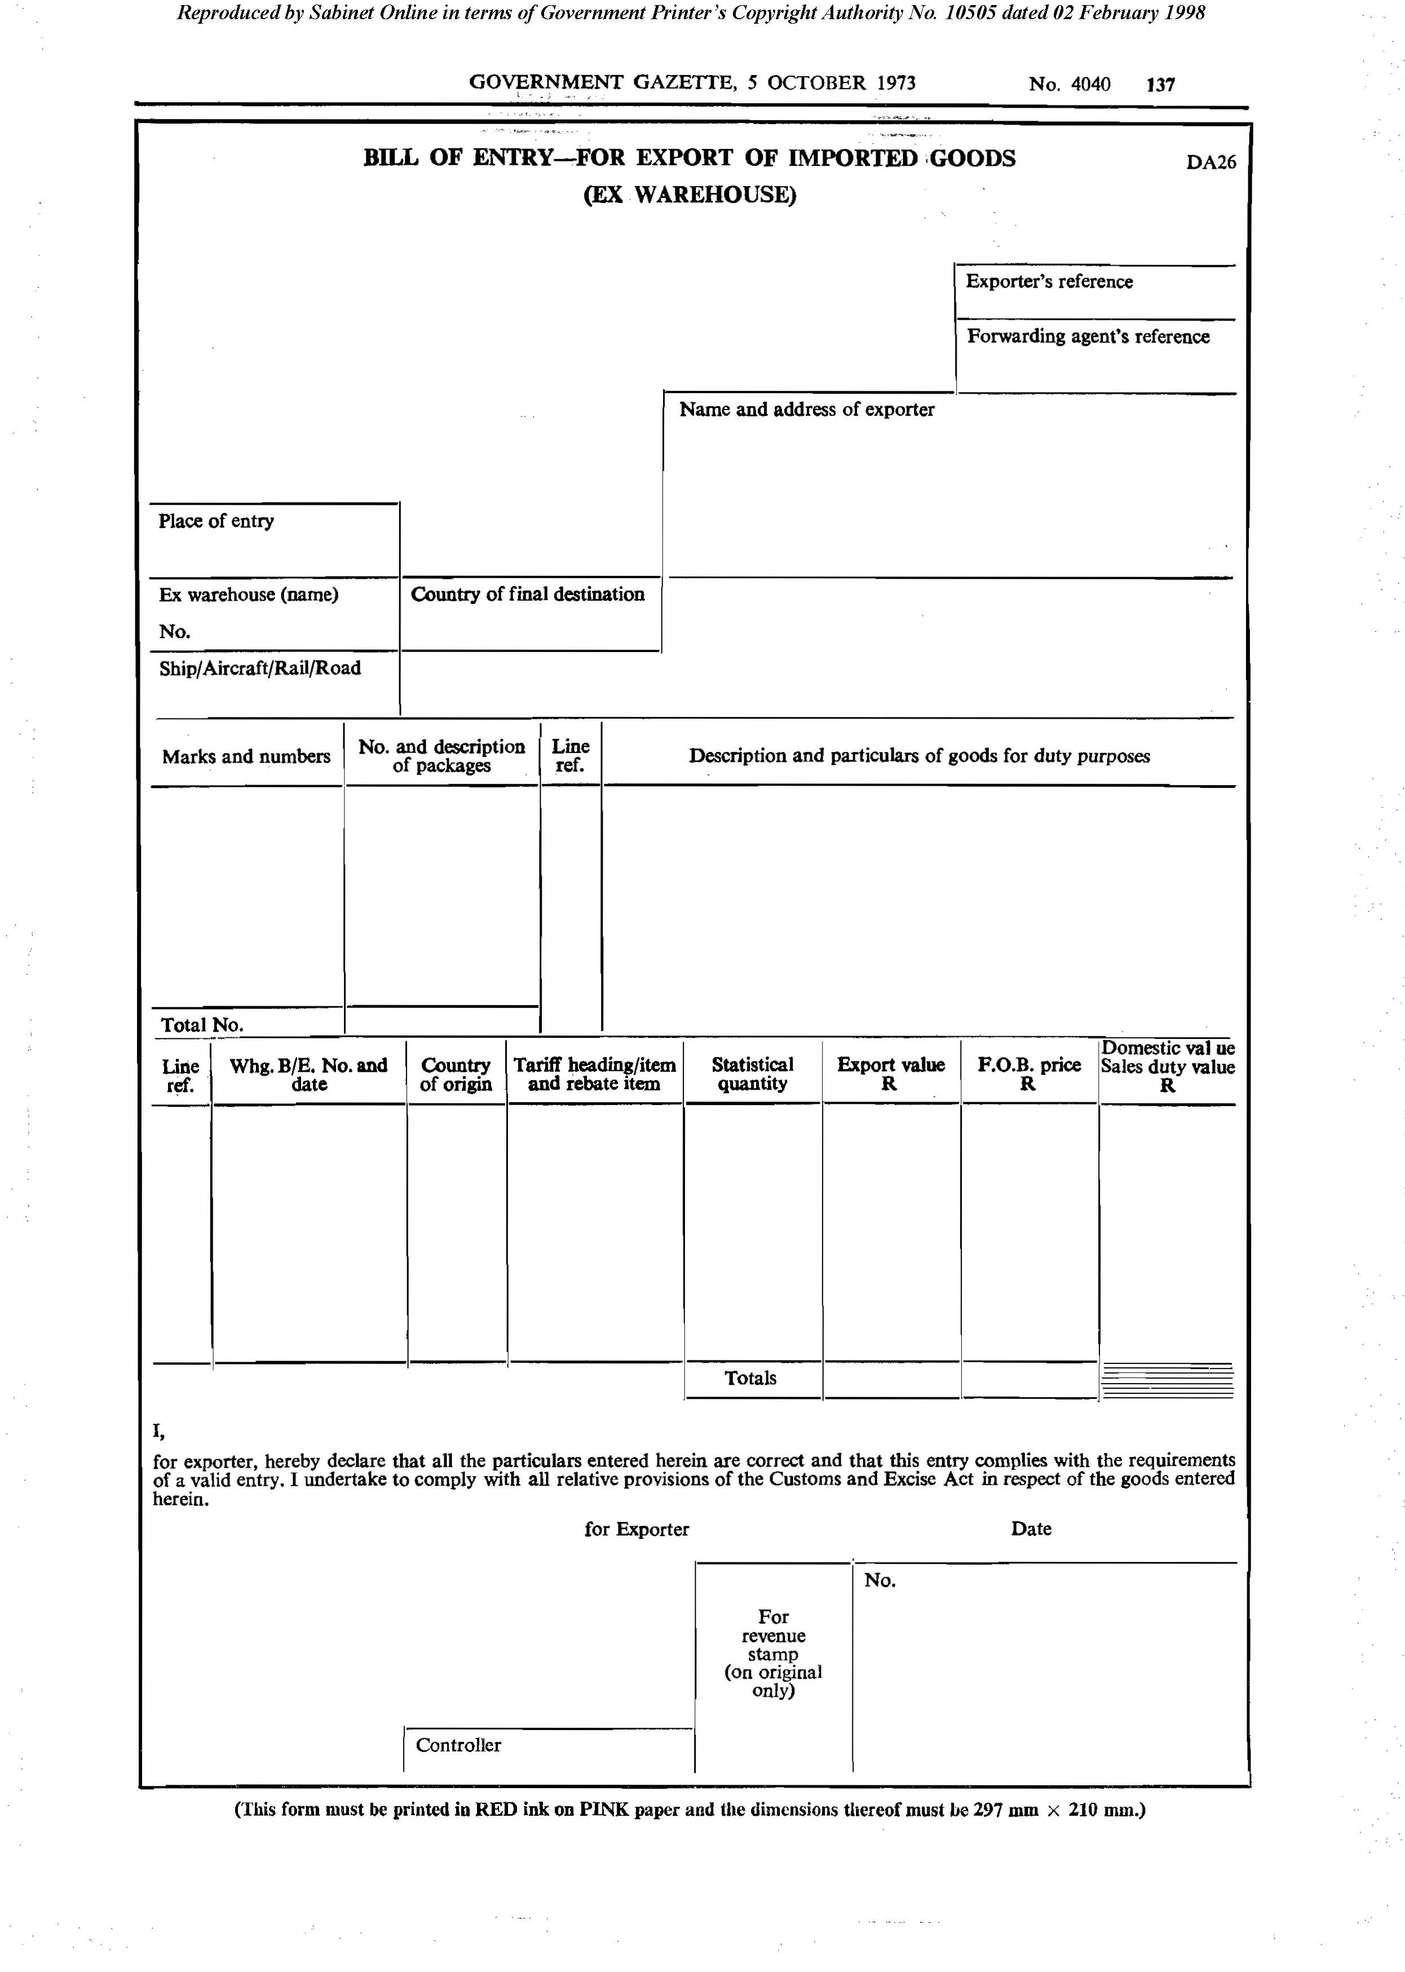

Form DA 26A

[Form DA 25A, despite its numbering, appears in the original regulations.]

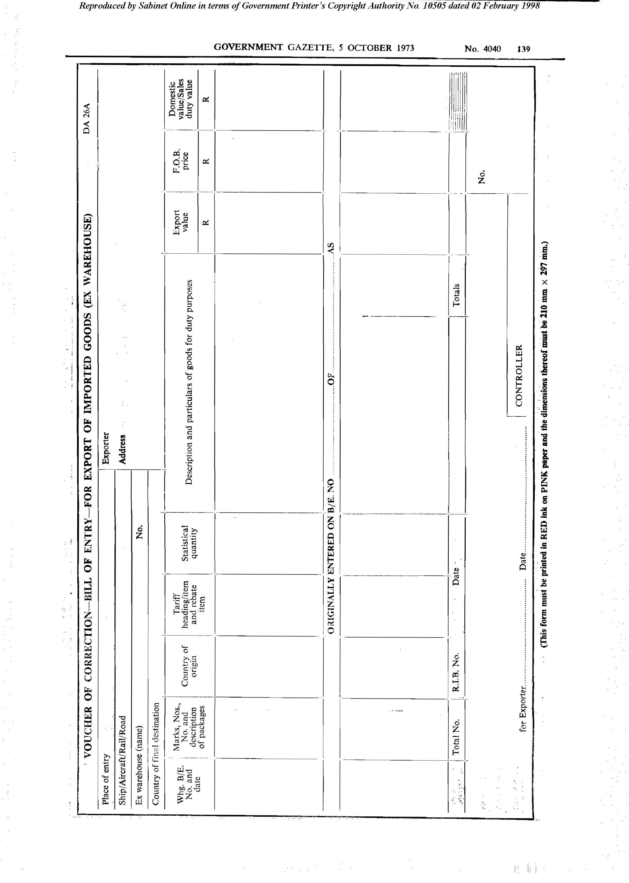

Form DA 27
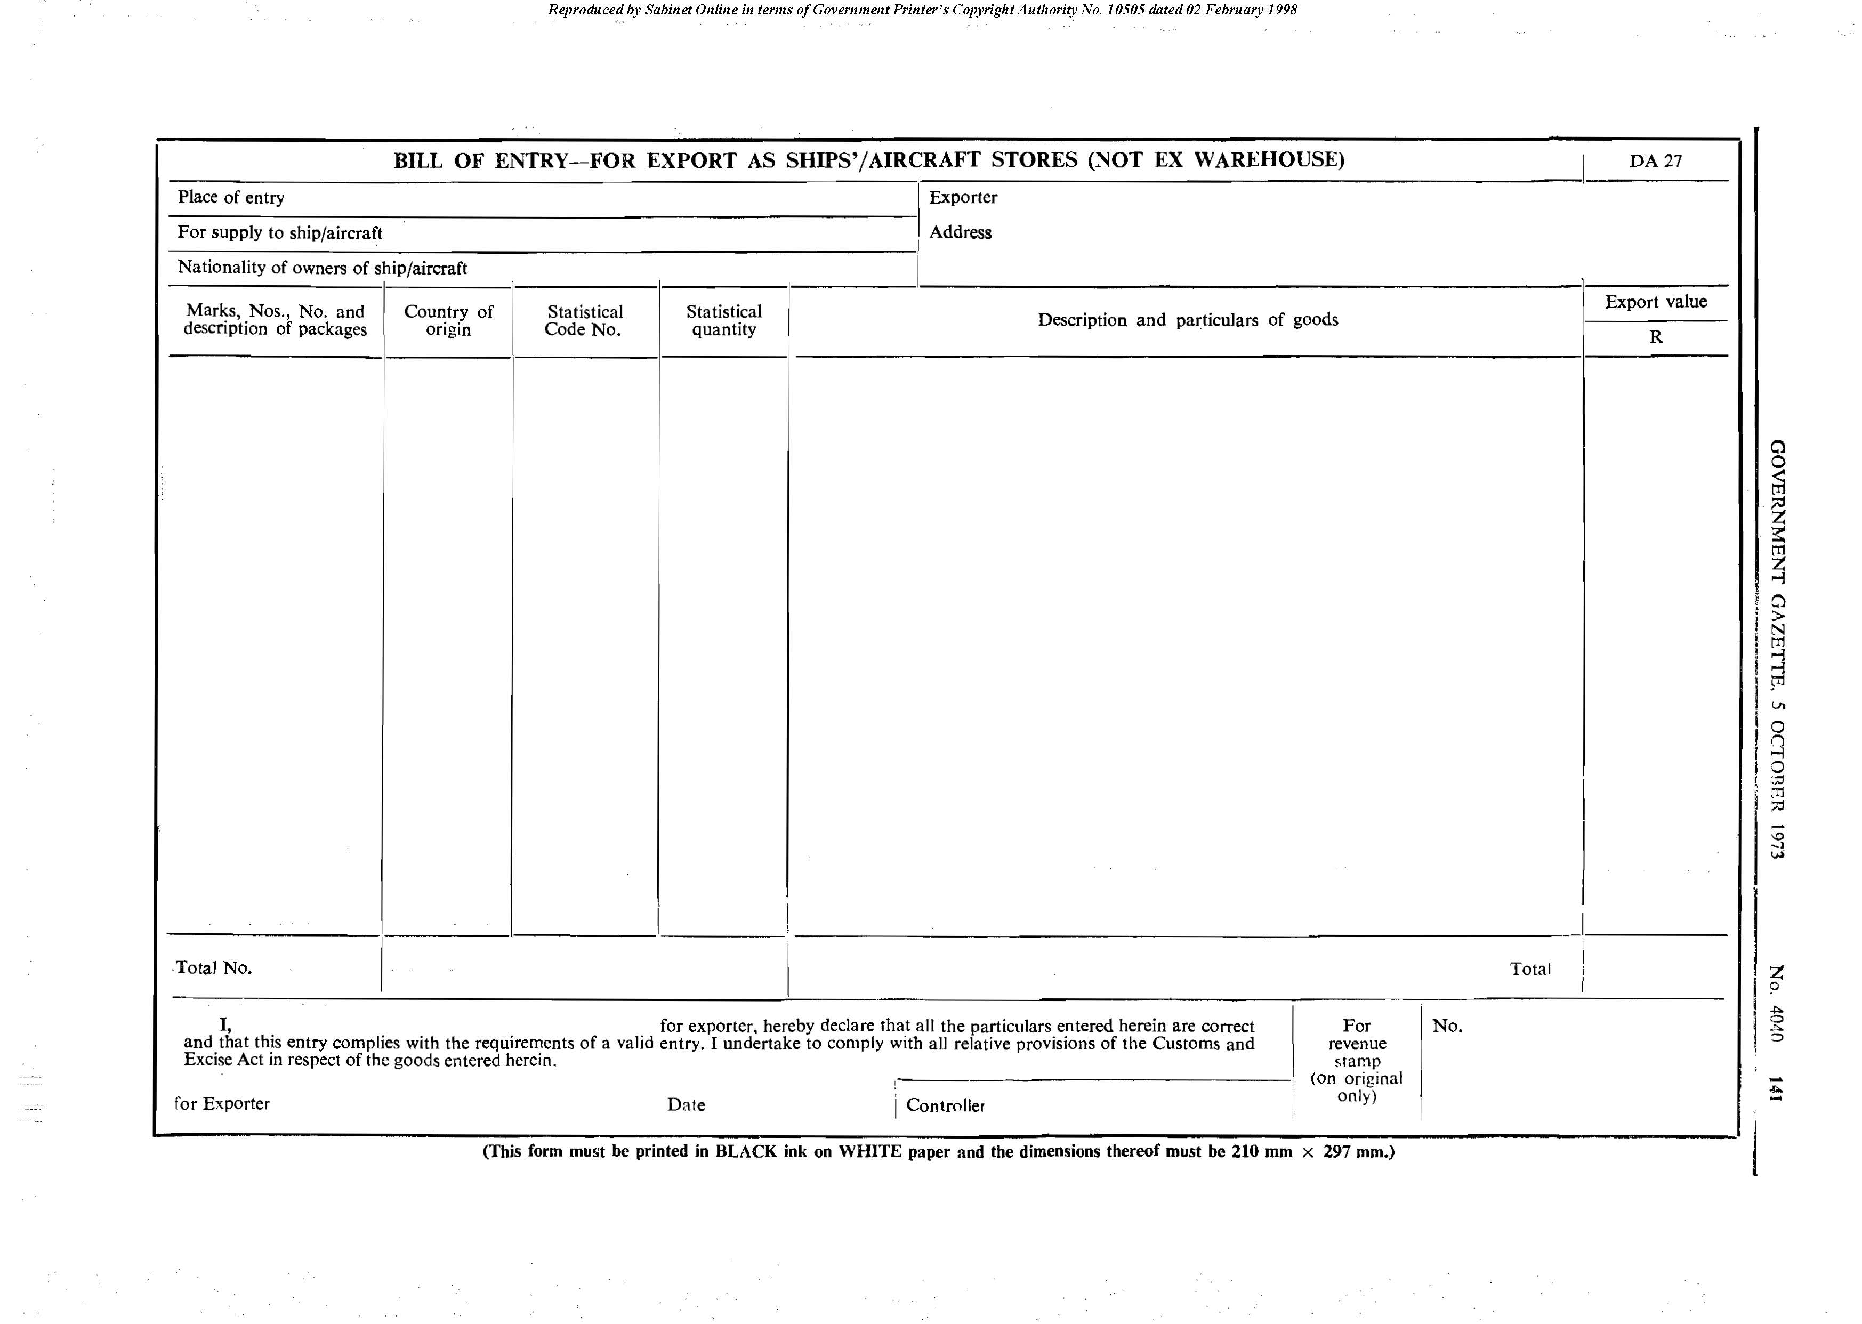

Form DA 28

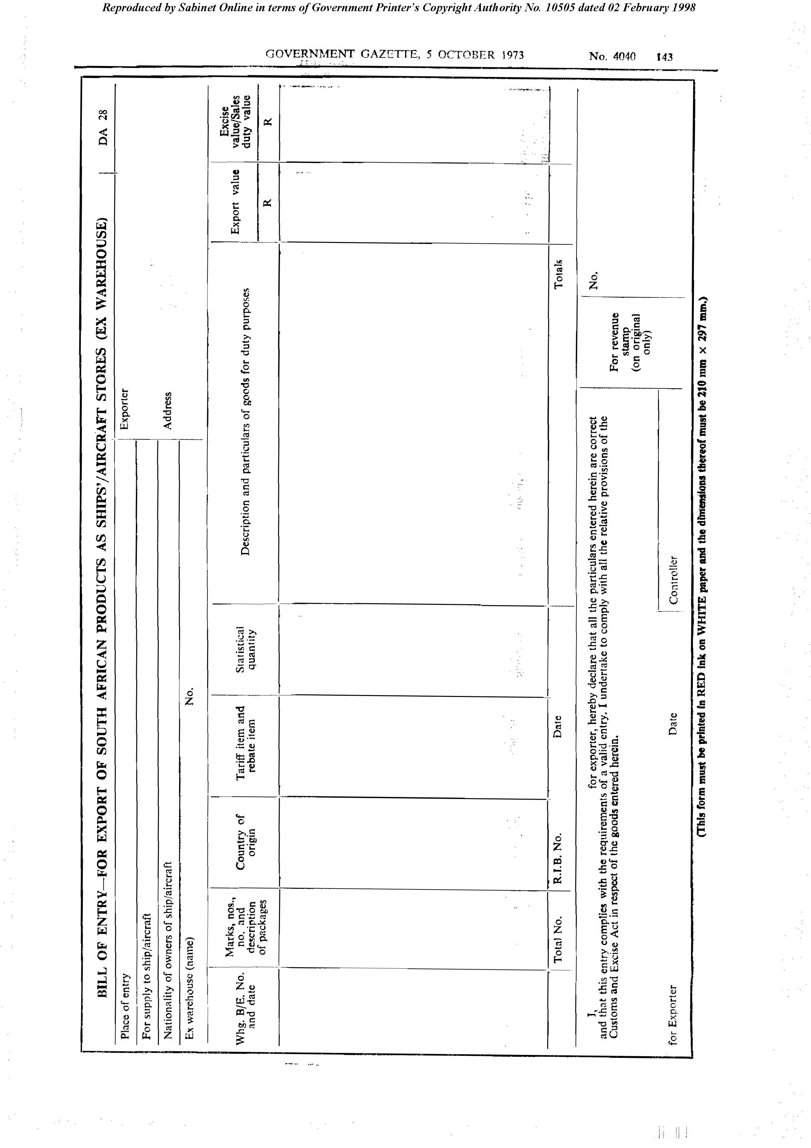

Form DA 29

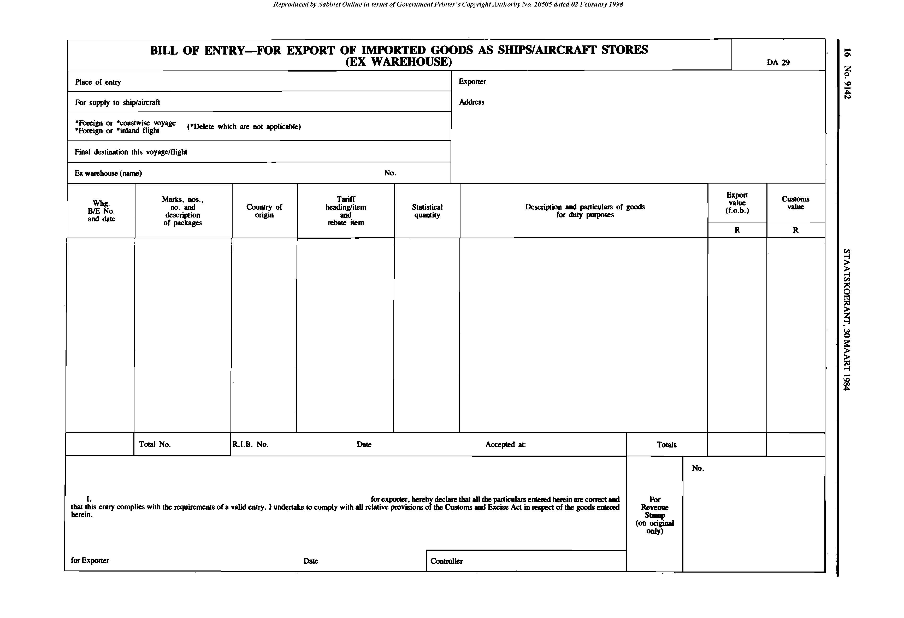
[Form DA 29 is substituted by RSA GN R.629/1984.]

Form DA 30

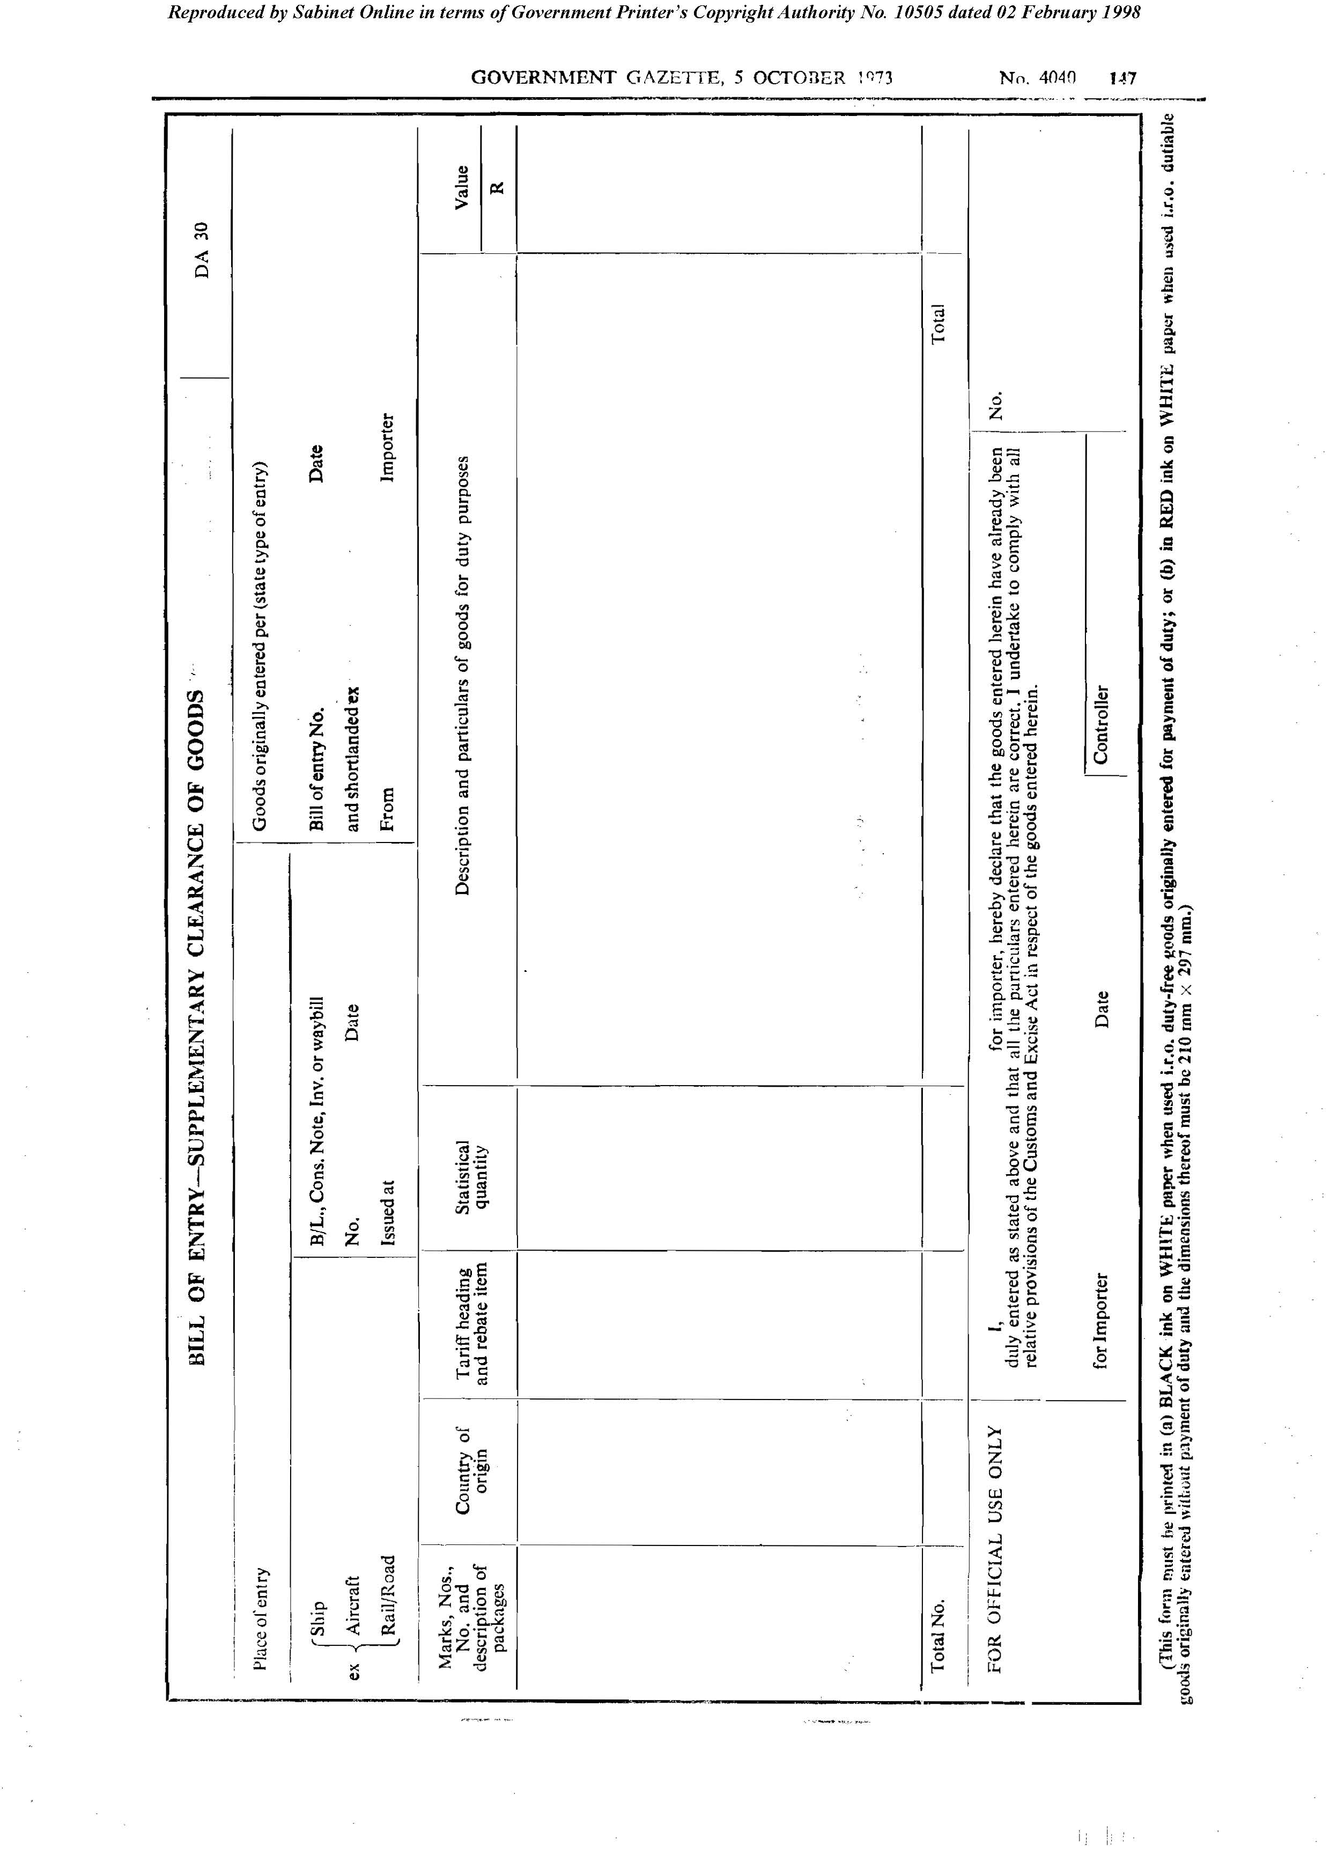

Form DA 31

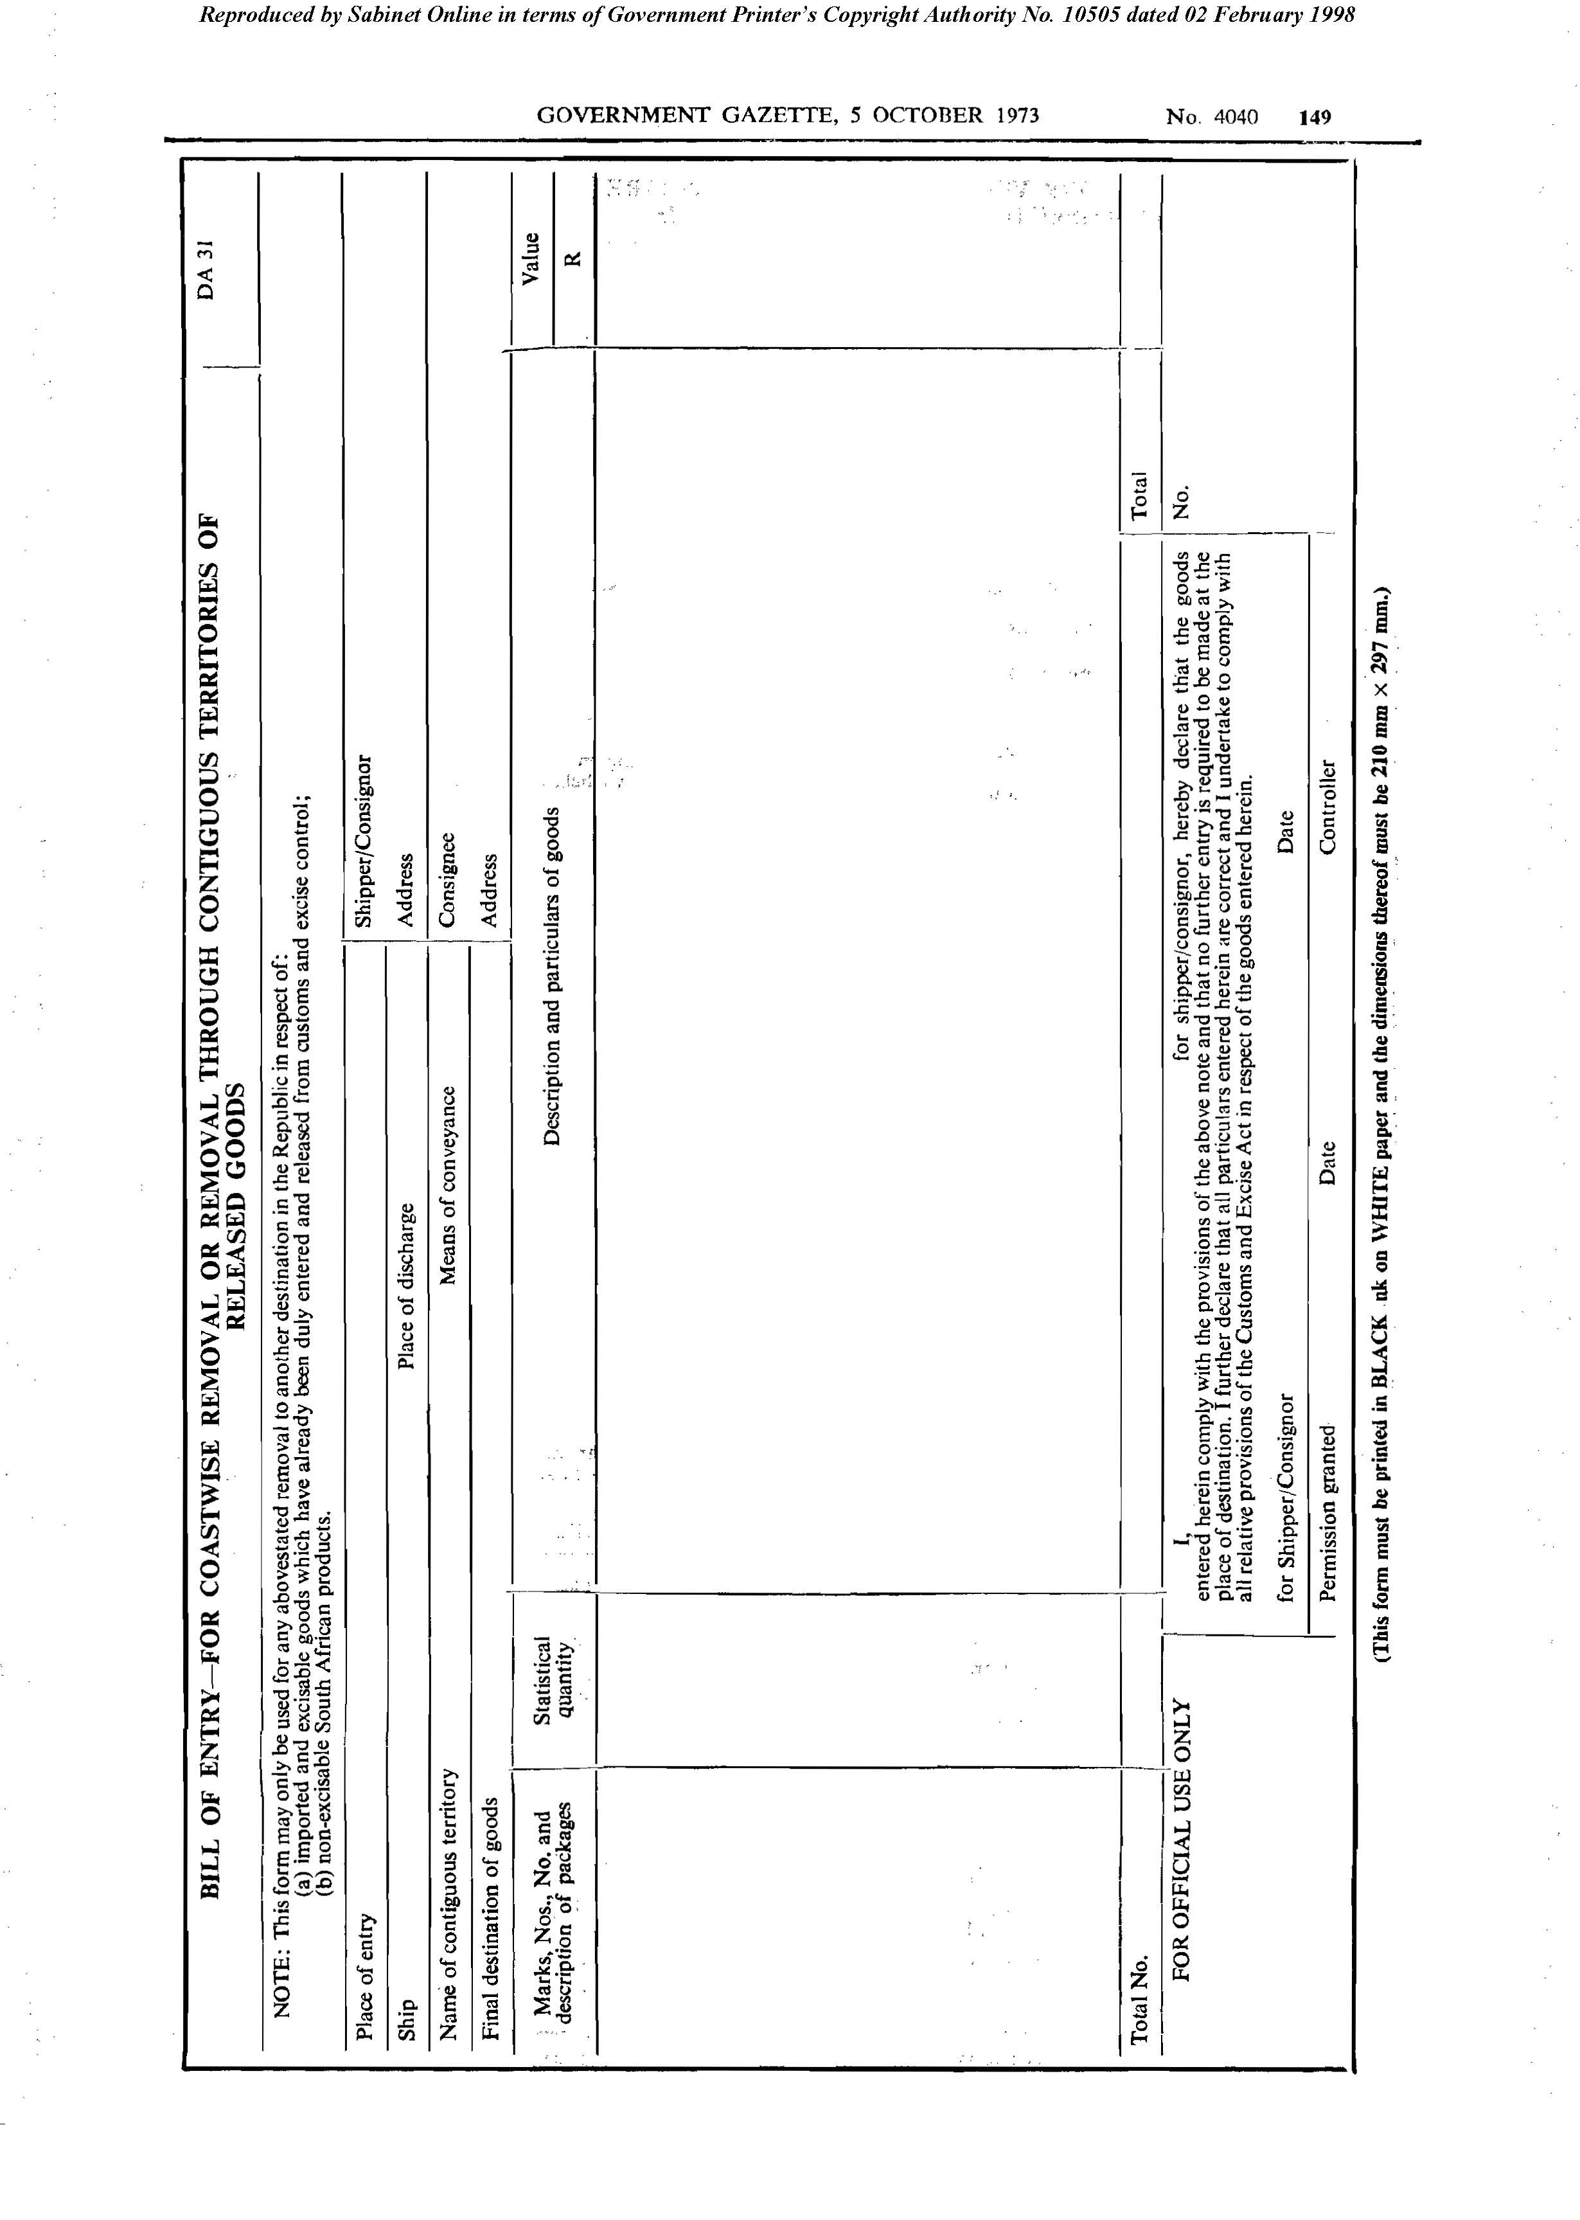

Form DA 32
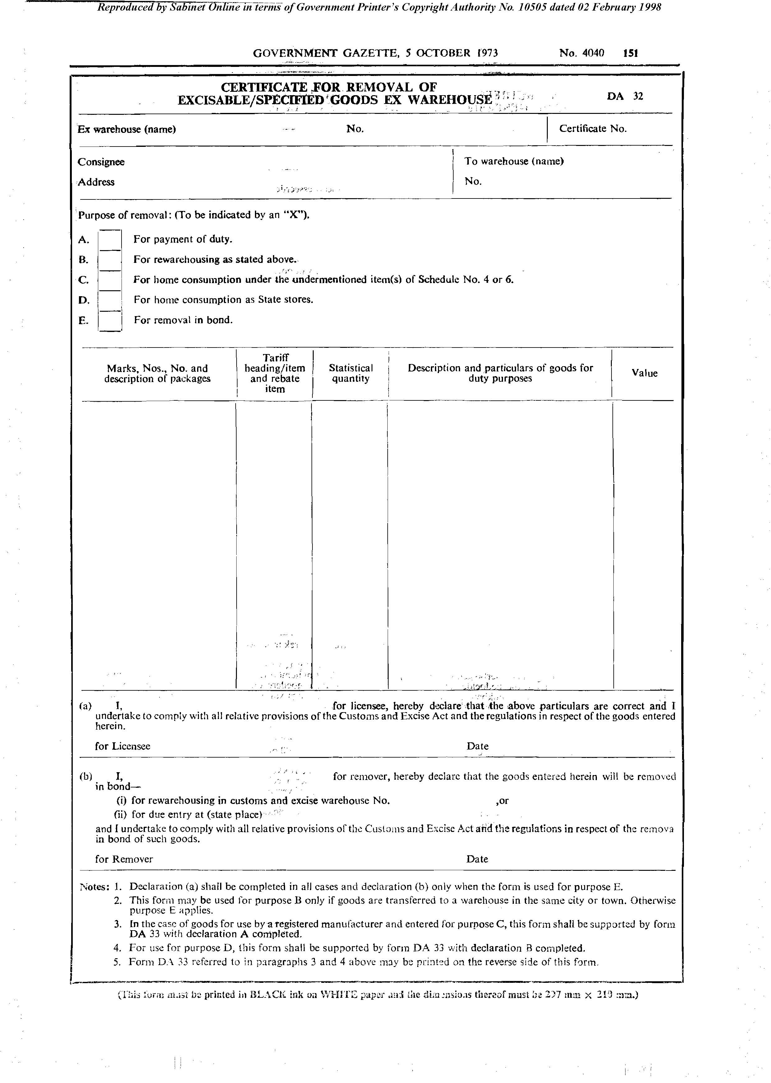

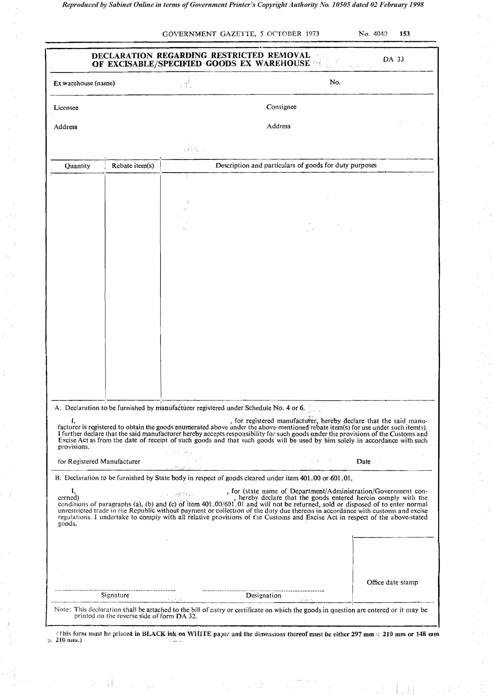
Form DA 33

[Forms DA 50, DA 51, DA 52 are inserted by RSA GN R.2630/1977
and deleted by RSA GN R.1525/1983.]

Form DA 59

[Form DA 59 is inserted by RSA GN R.2630/1977/]

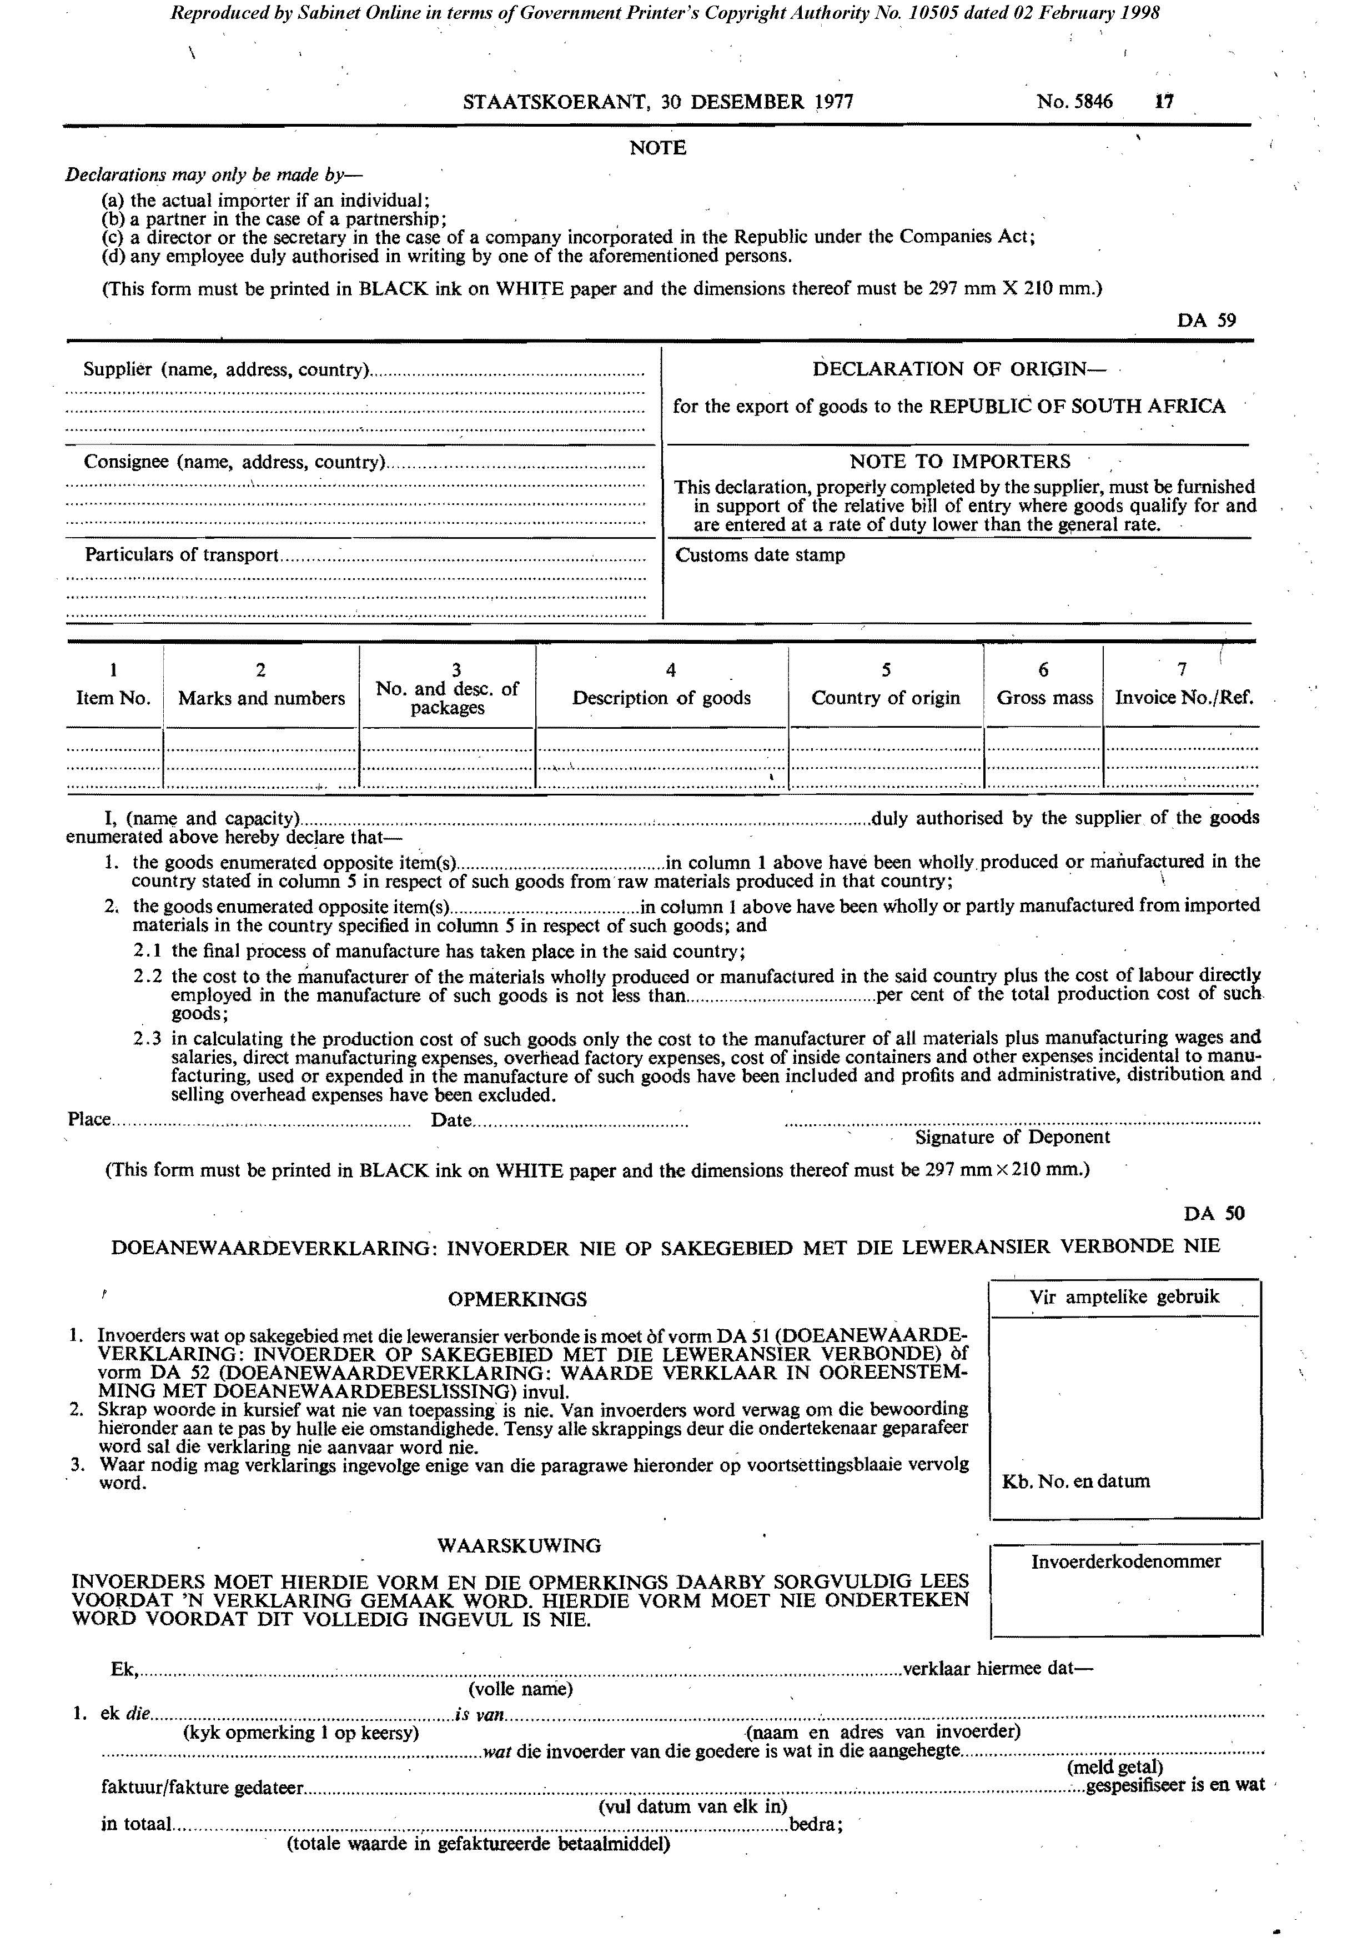

Form DA 60

[Form DA 60 is withdrawn by RSA GN R.2630/1977.]

Form DA 60A

[Form DA 60A, despite its numbering, appears in the original regulations.]
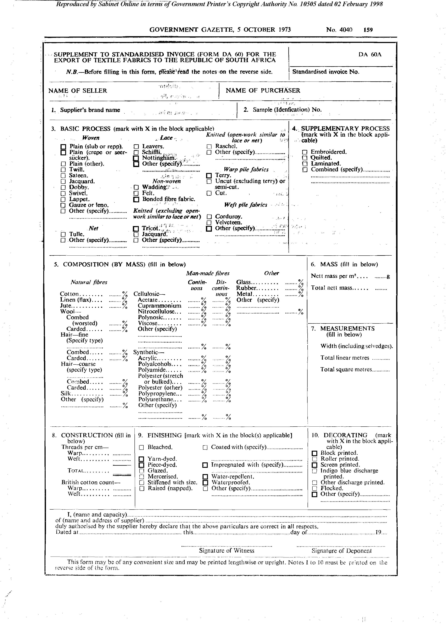

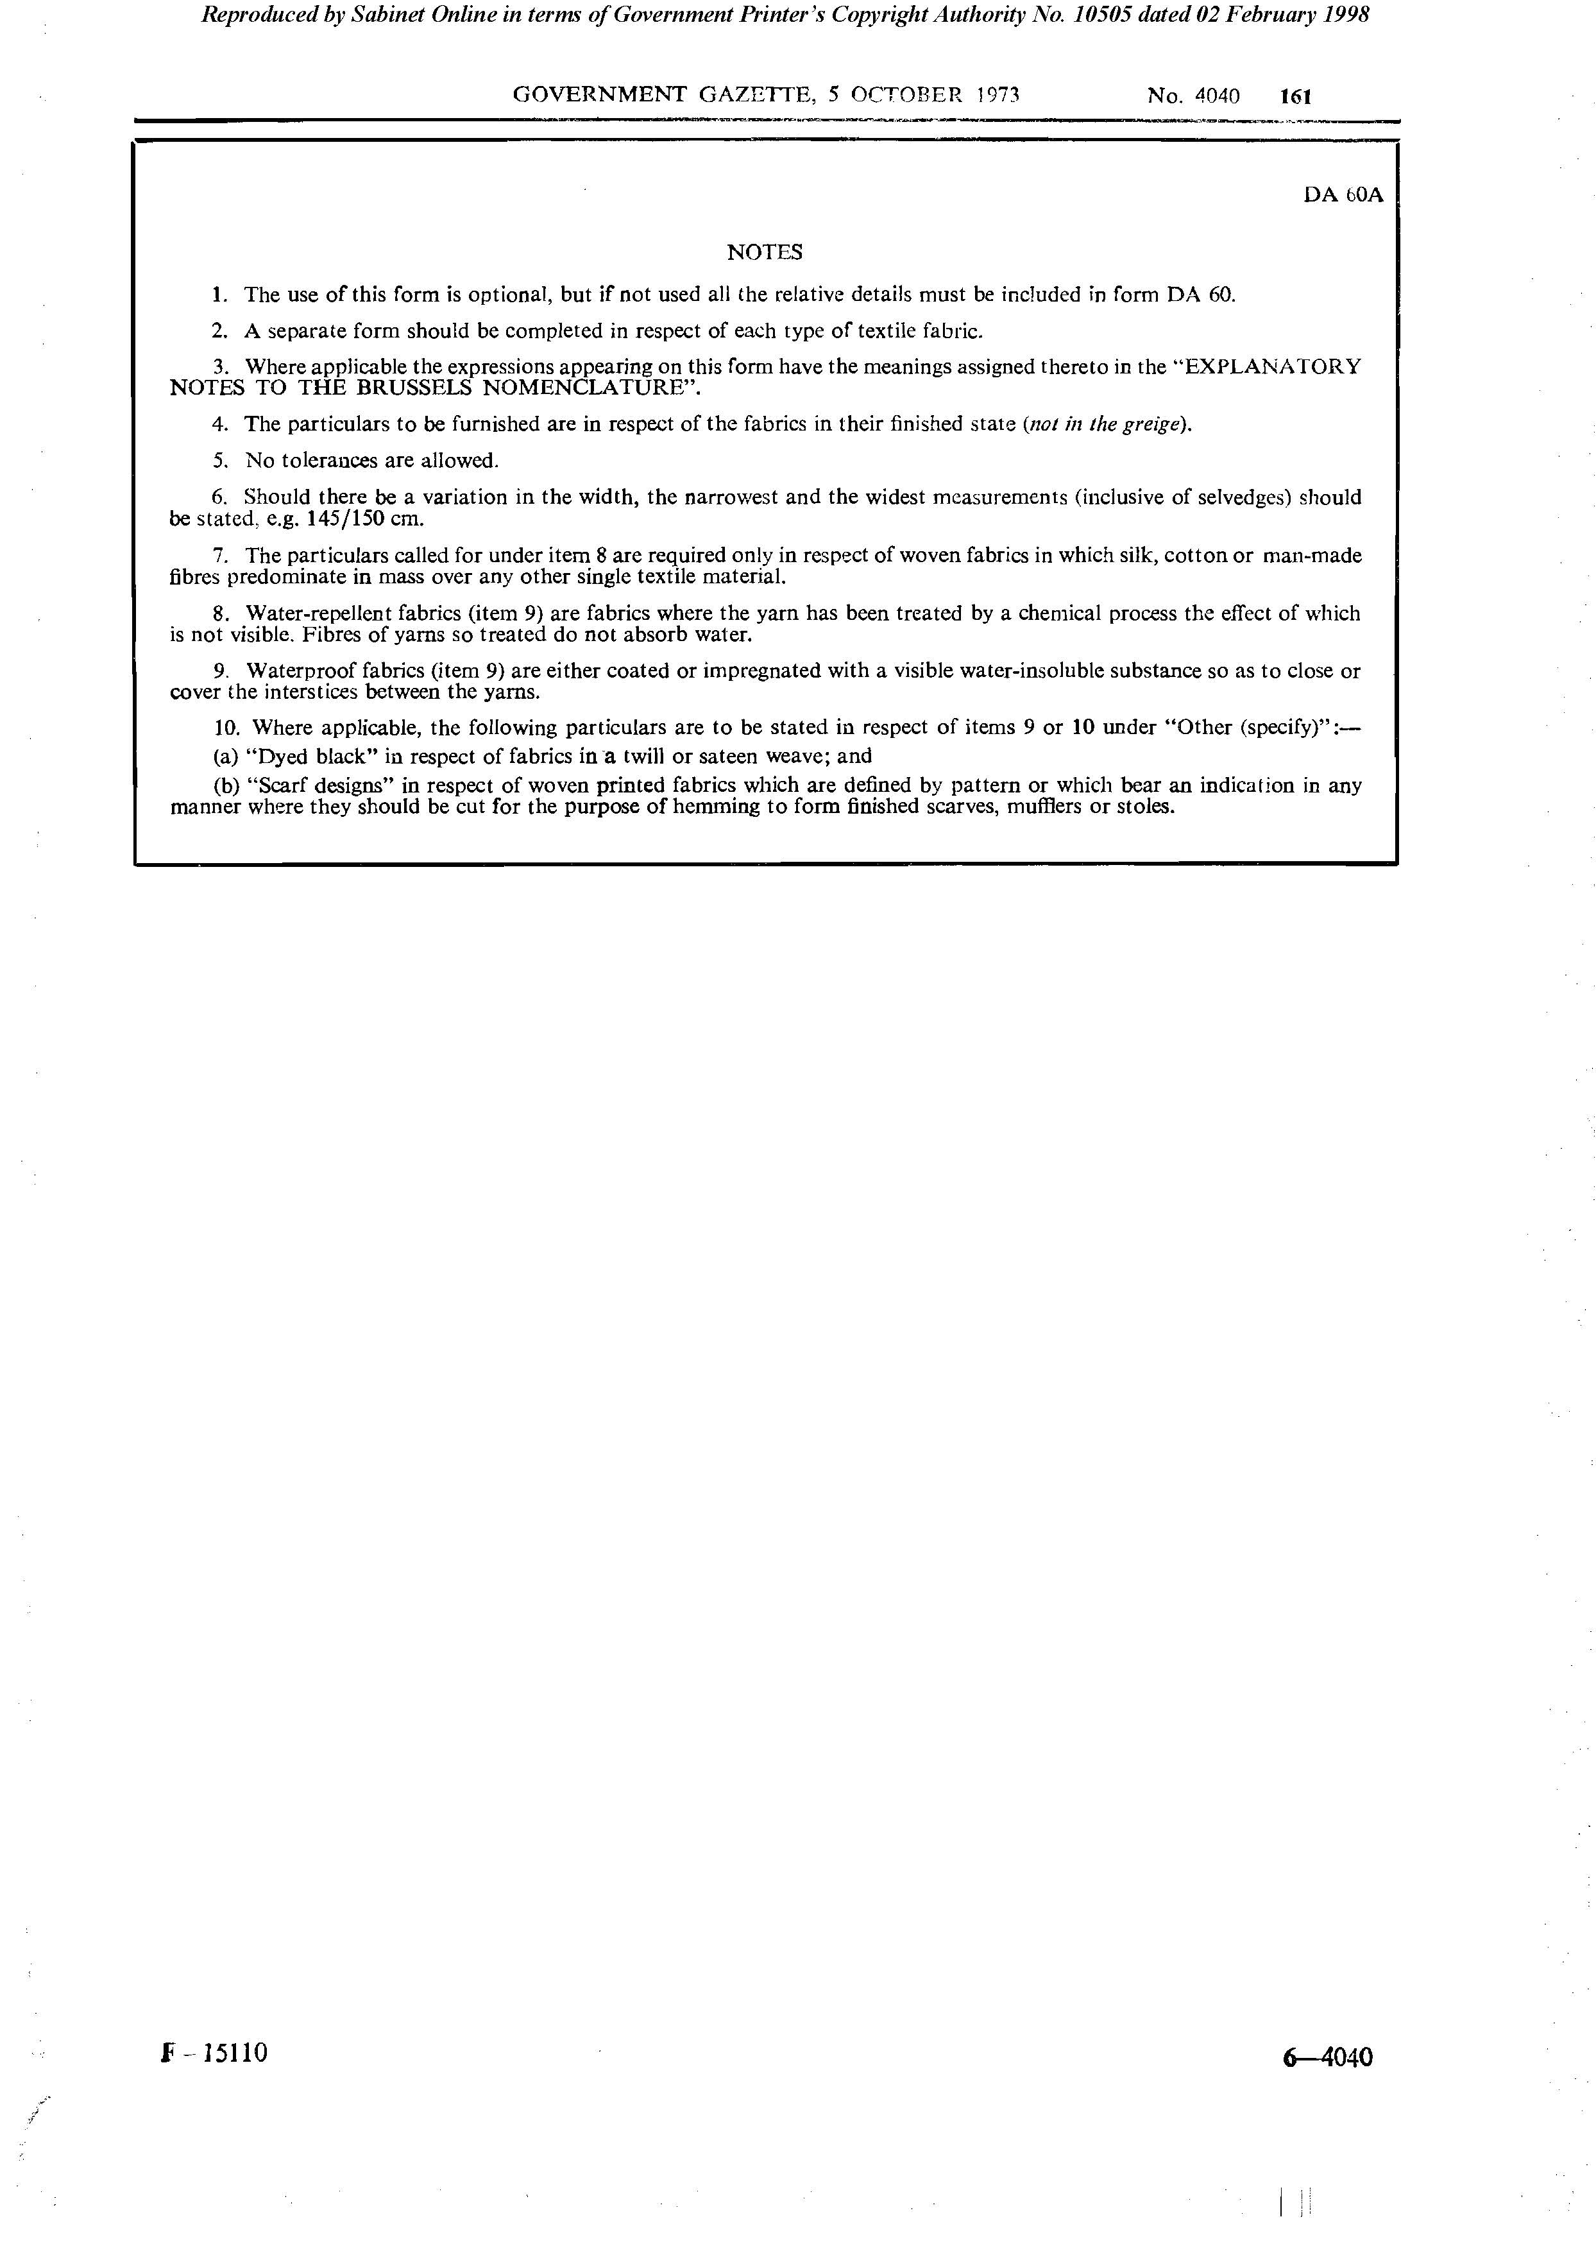

Form DA 61
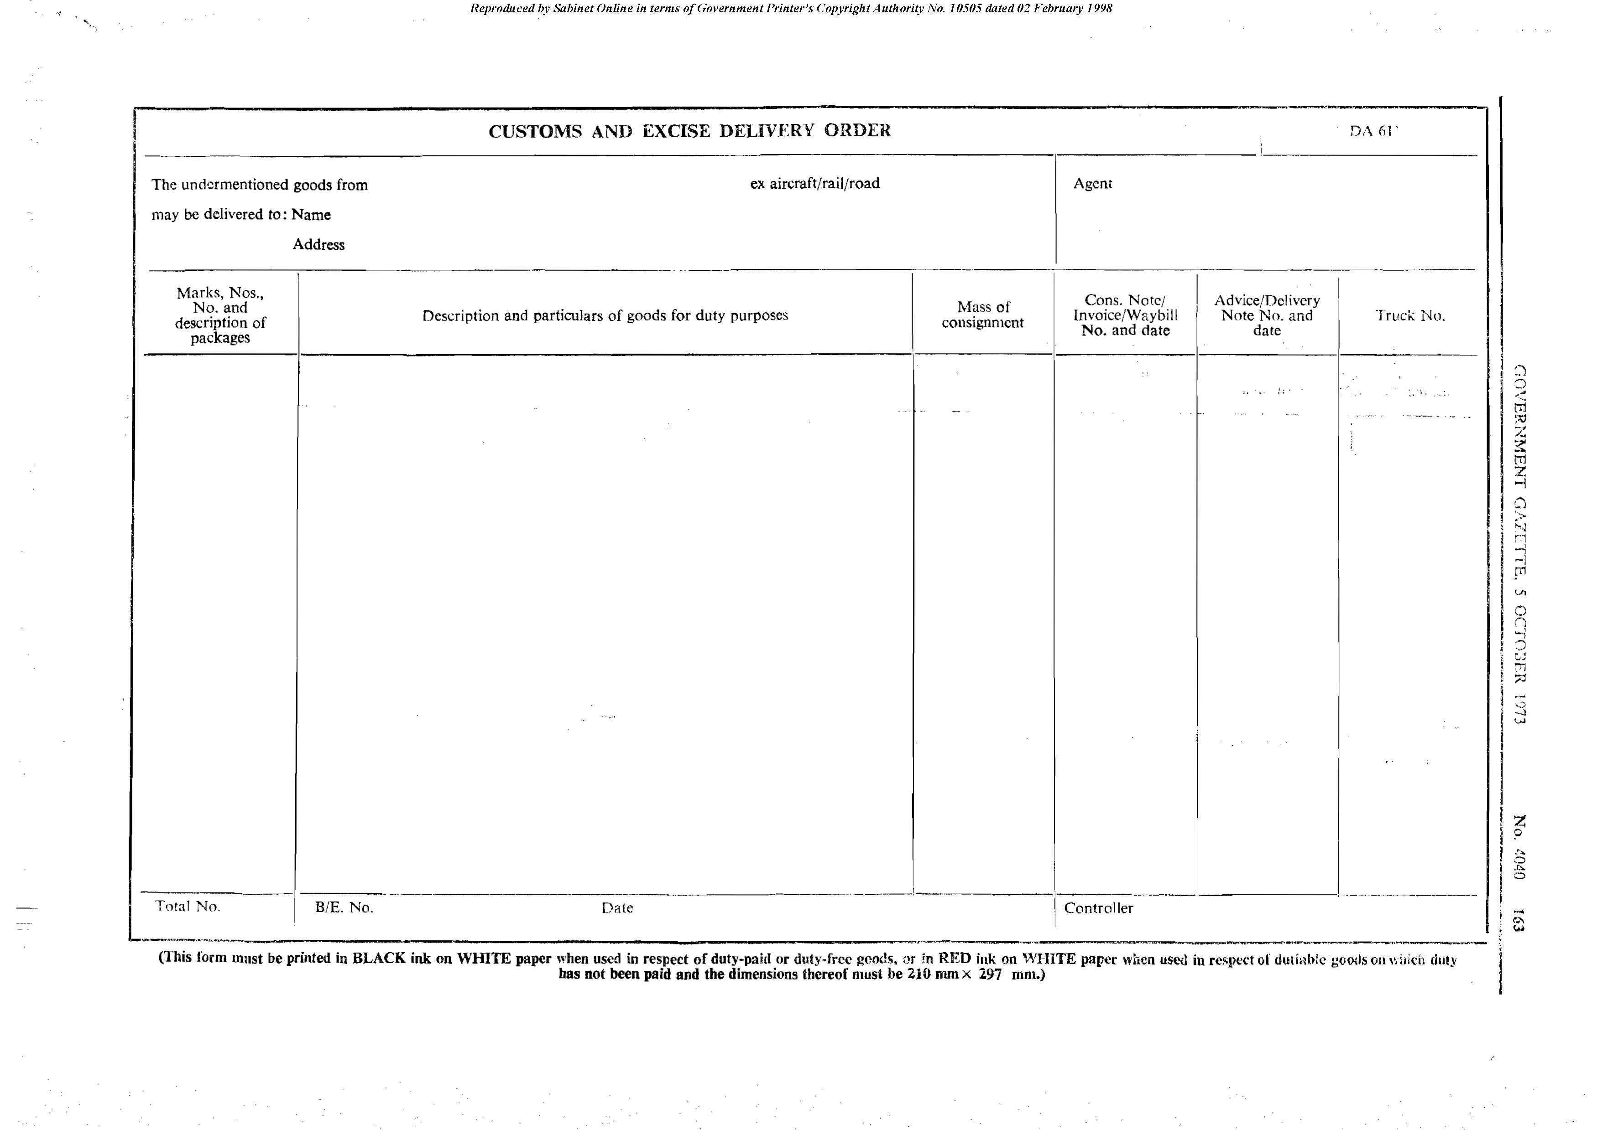

Form DA 62

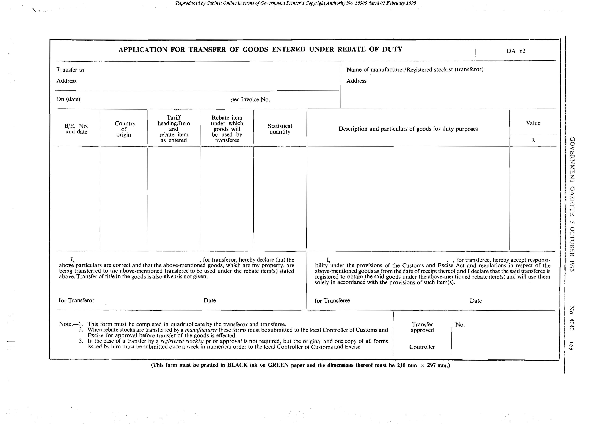

*

Form DA 63

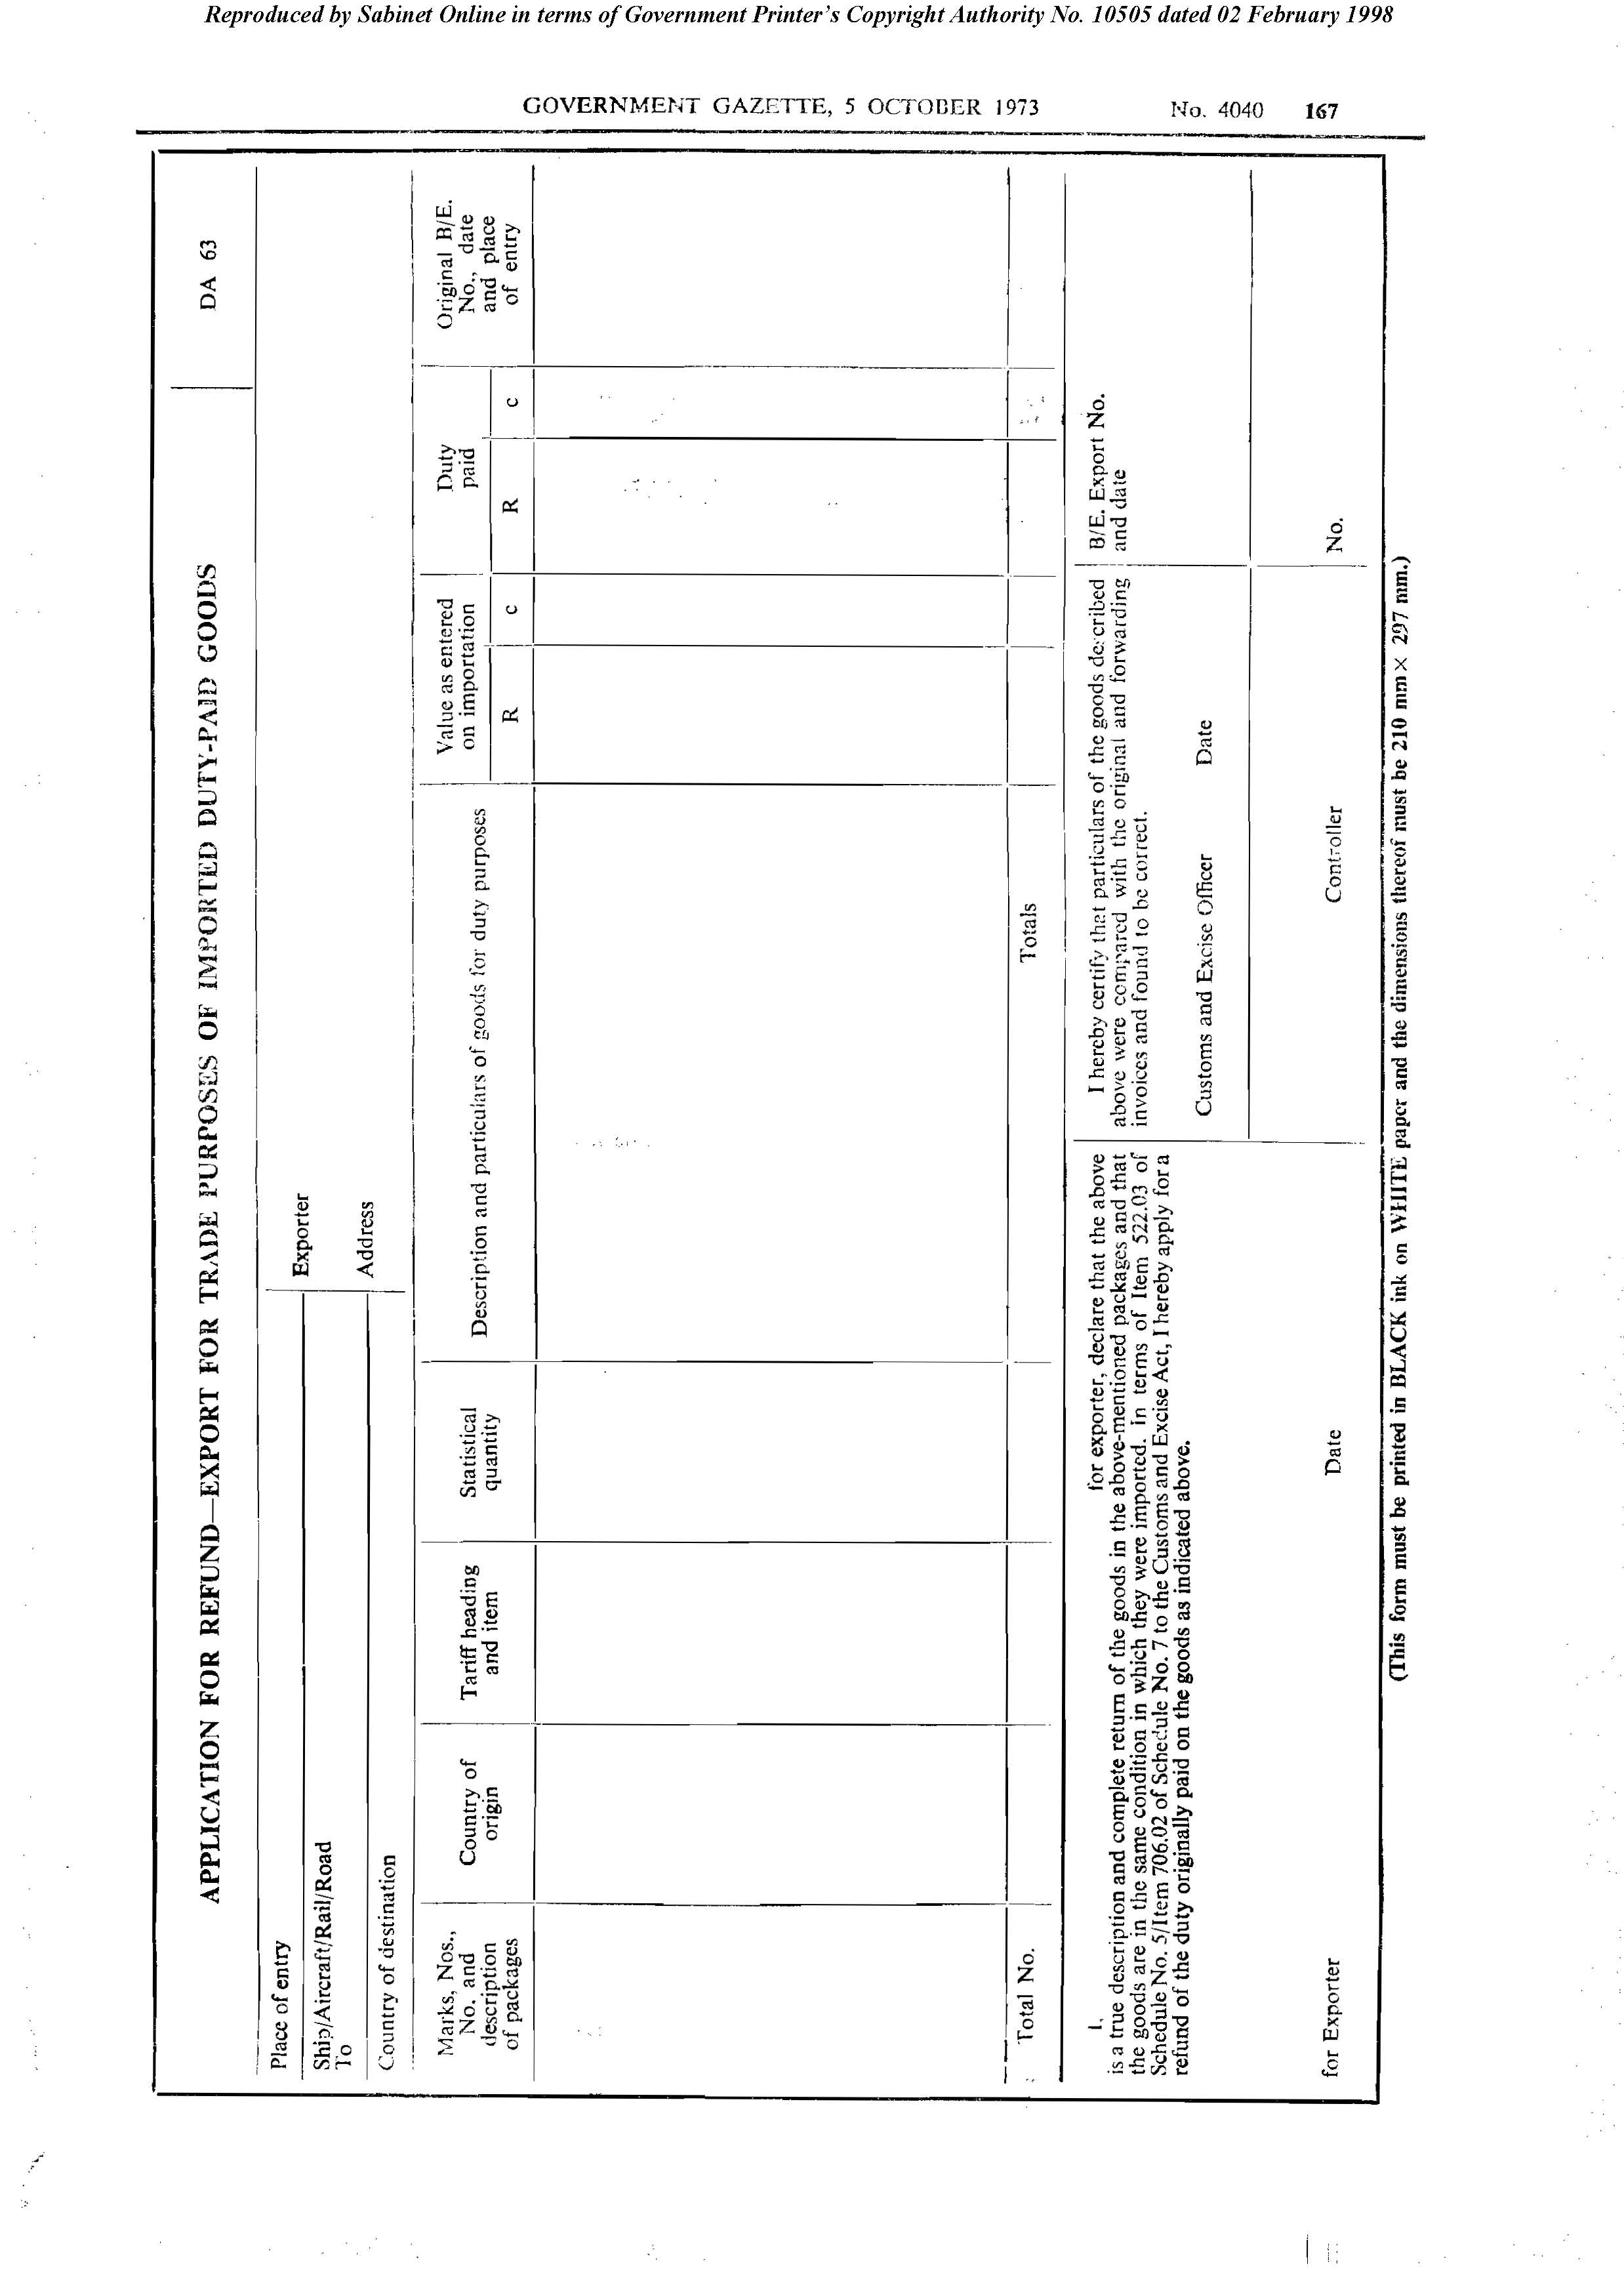

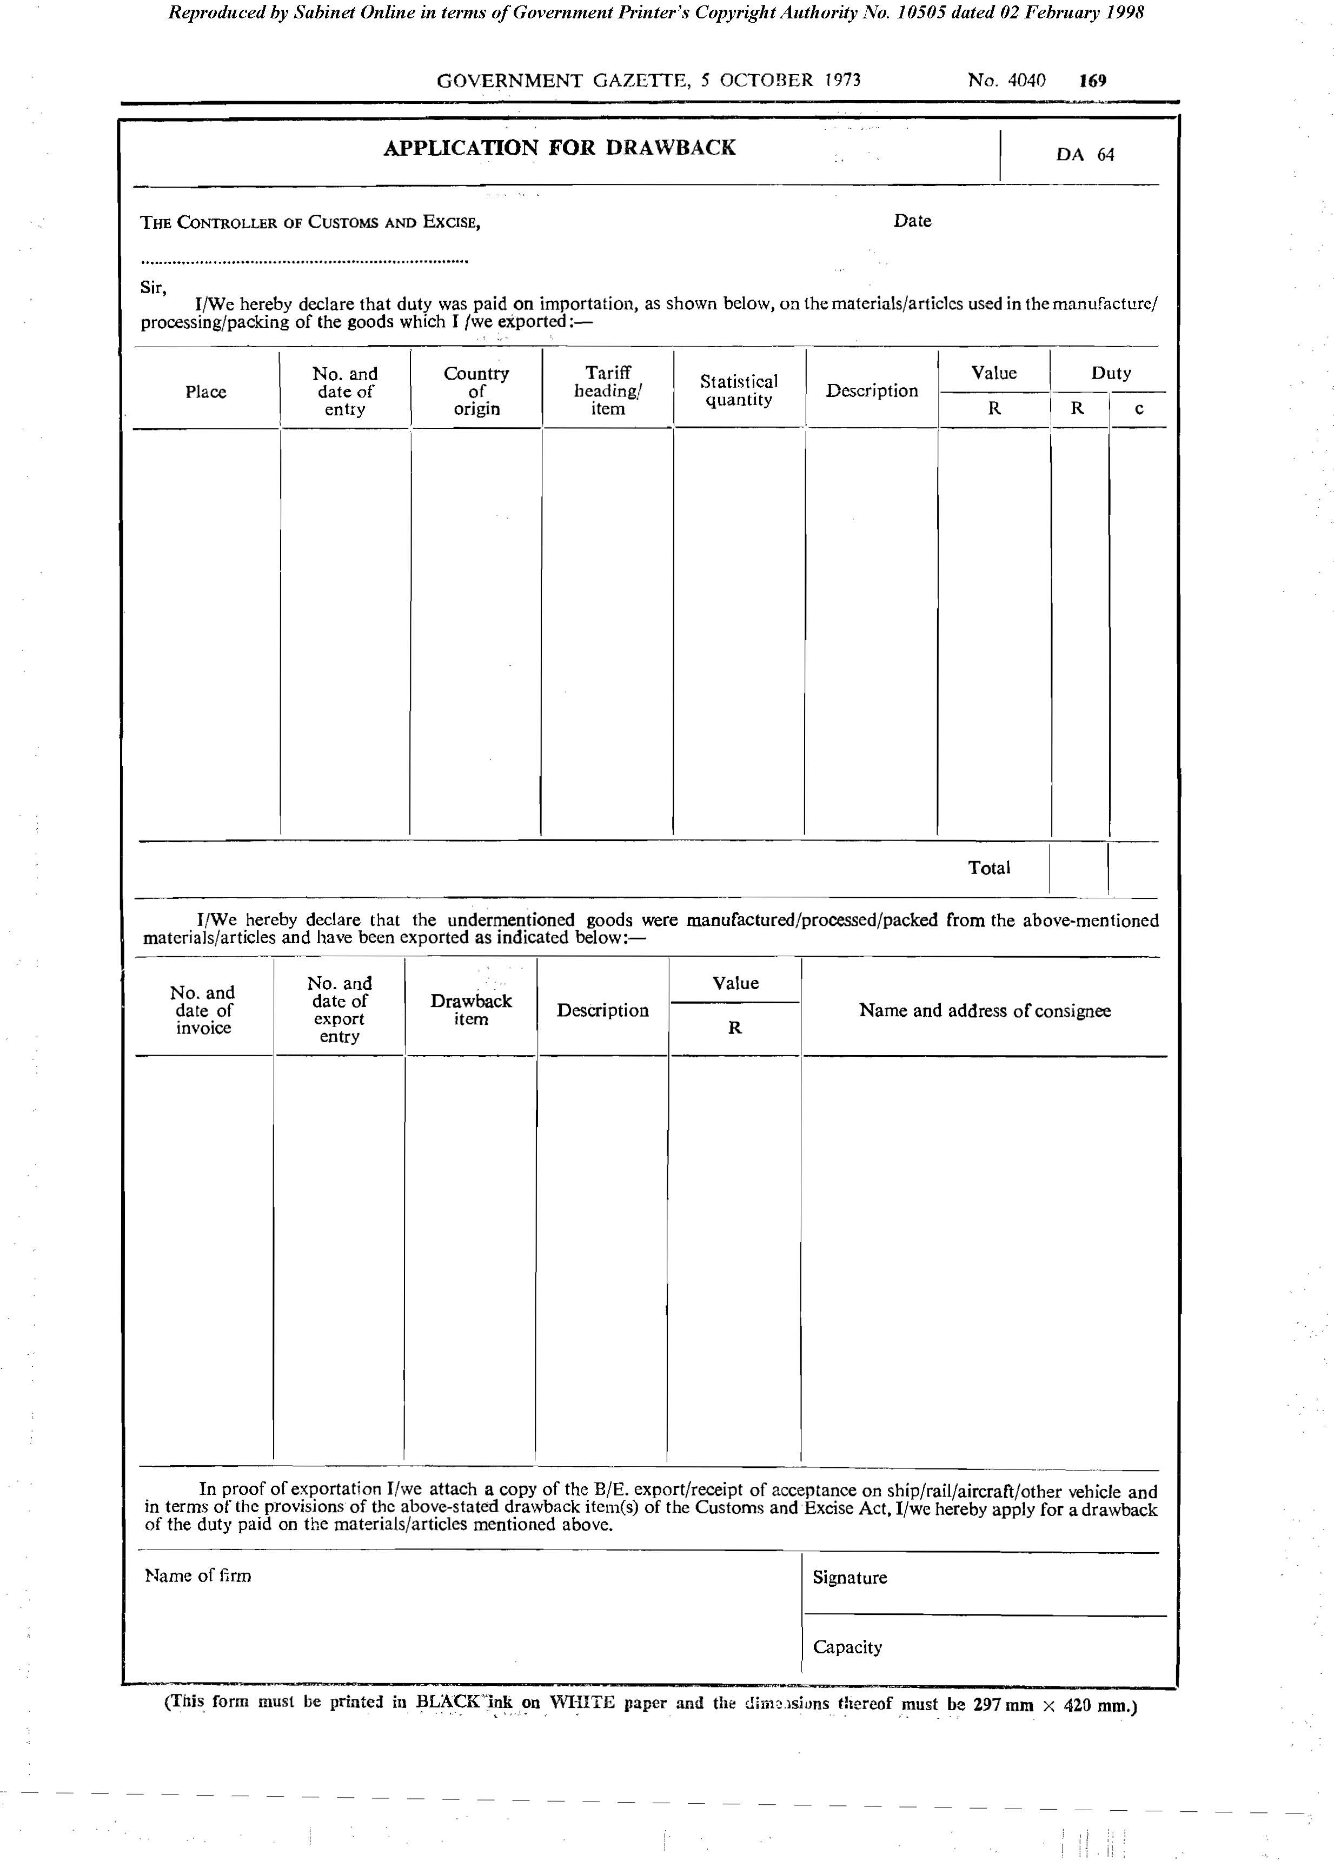
Form DA 64

Form DA 65

[Form DA 65 is substituted by RSA GN R.2635/1981.]

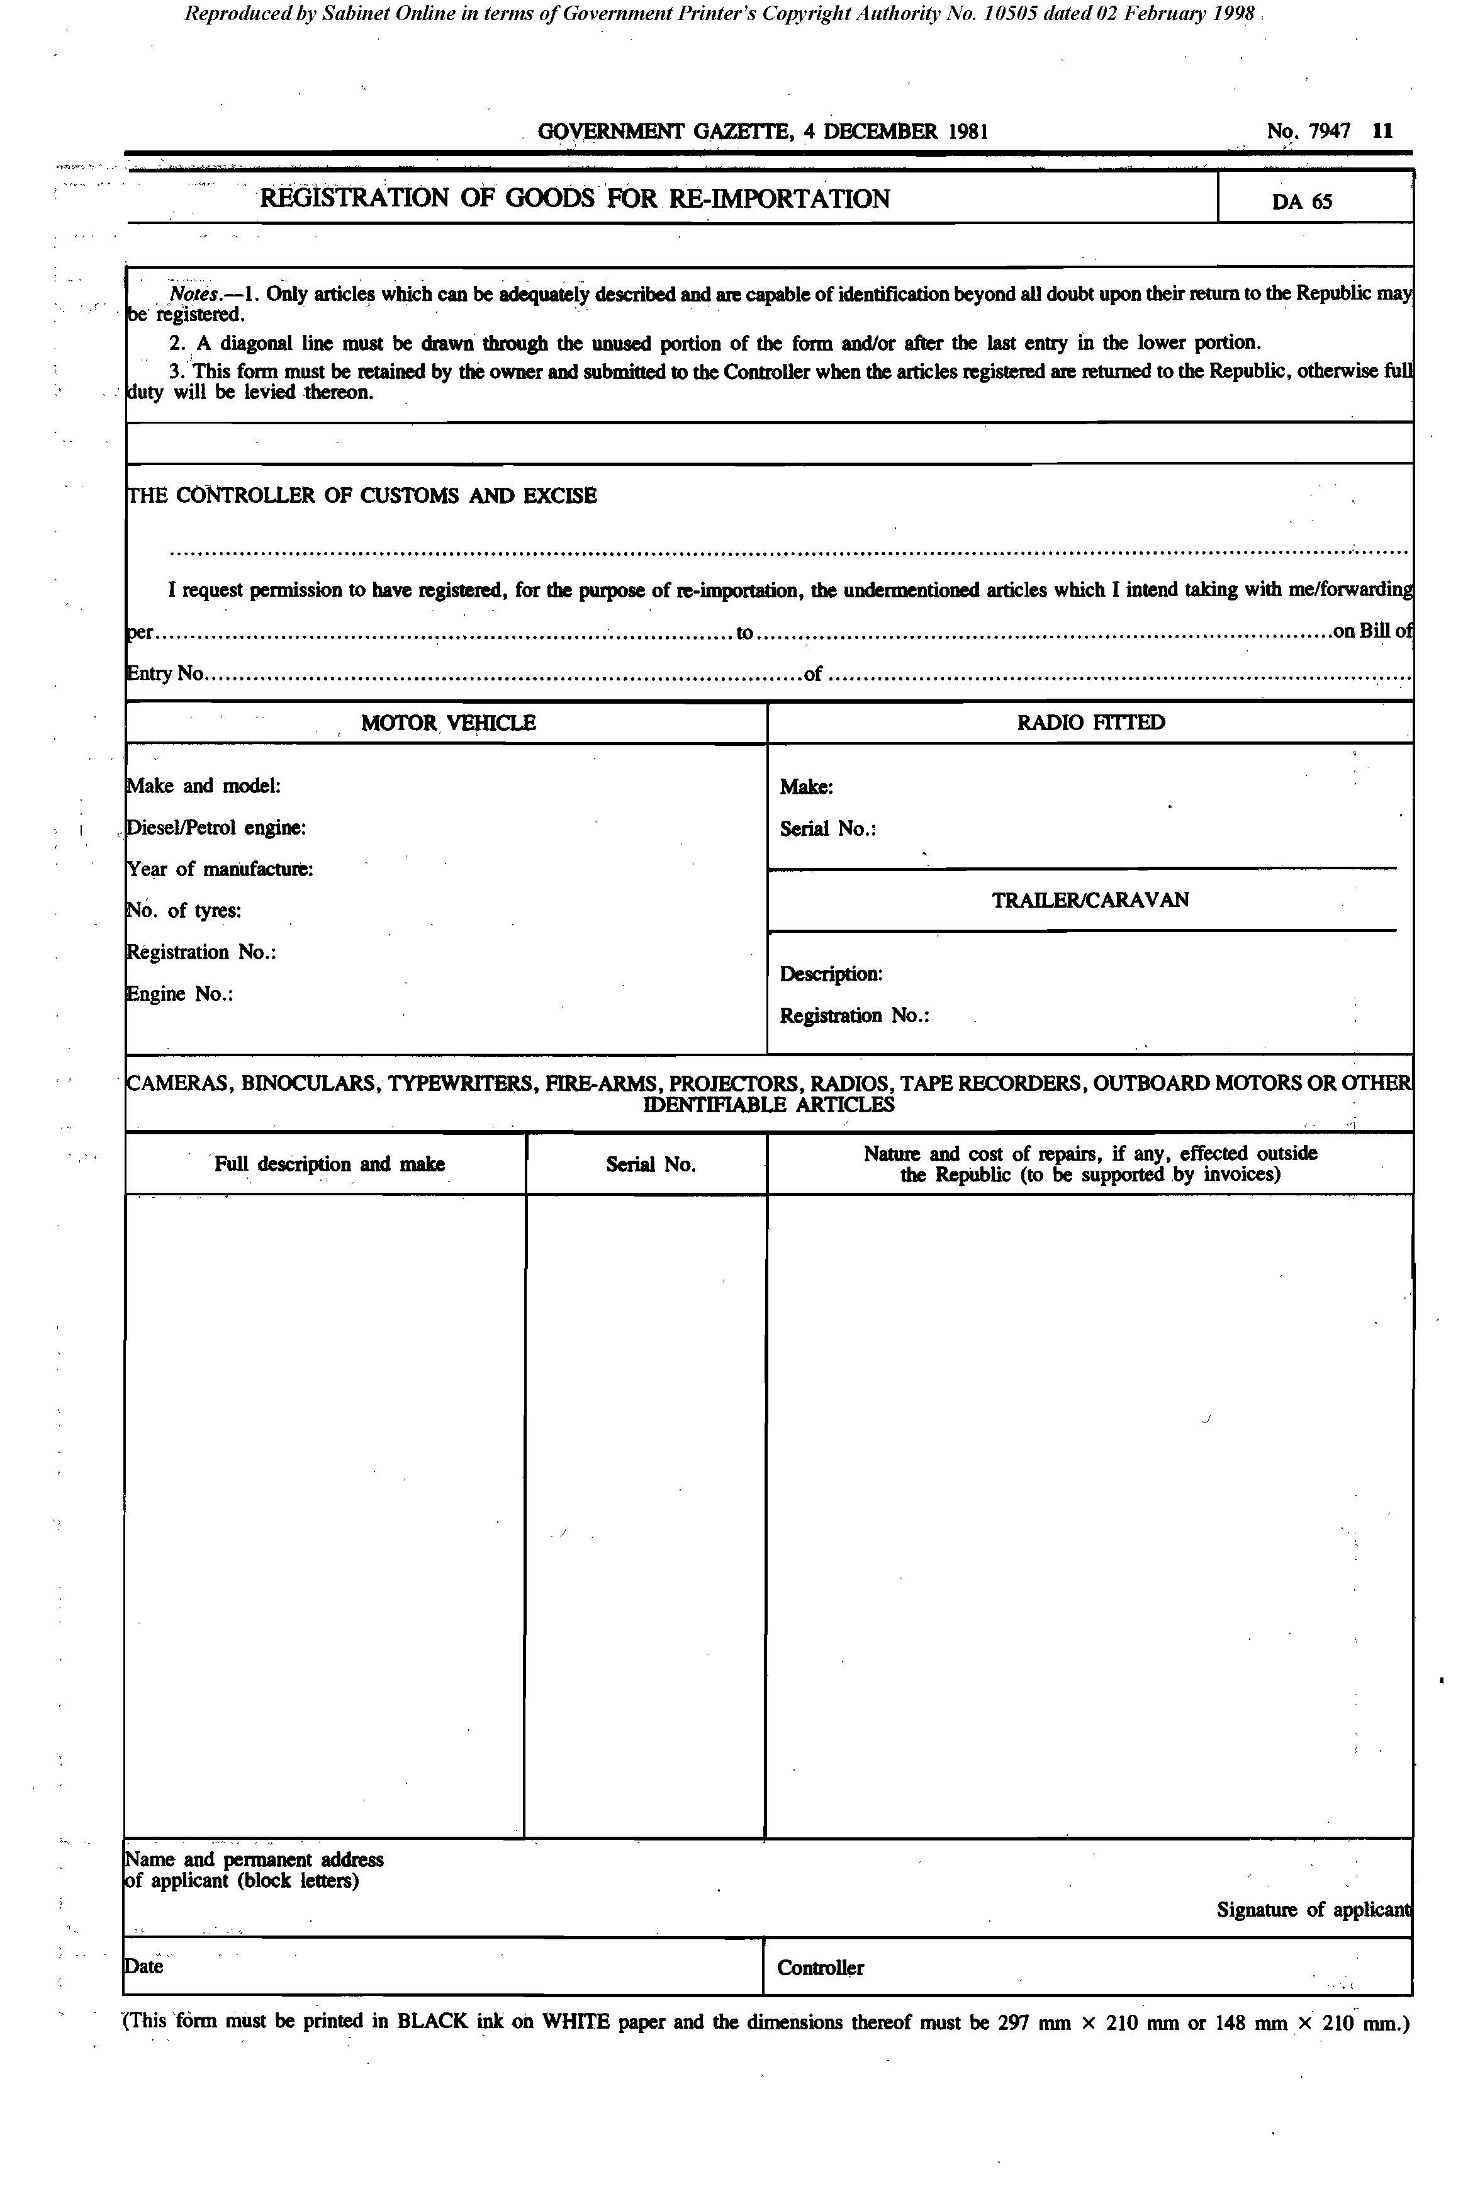

Form DA 66

[Form DA 66 is amended by RSA GN R.2630/1977and substituted by RSA GN R.889/1981.]
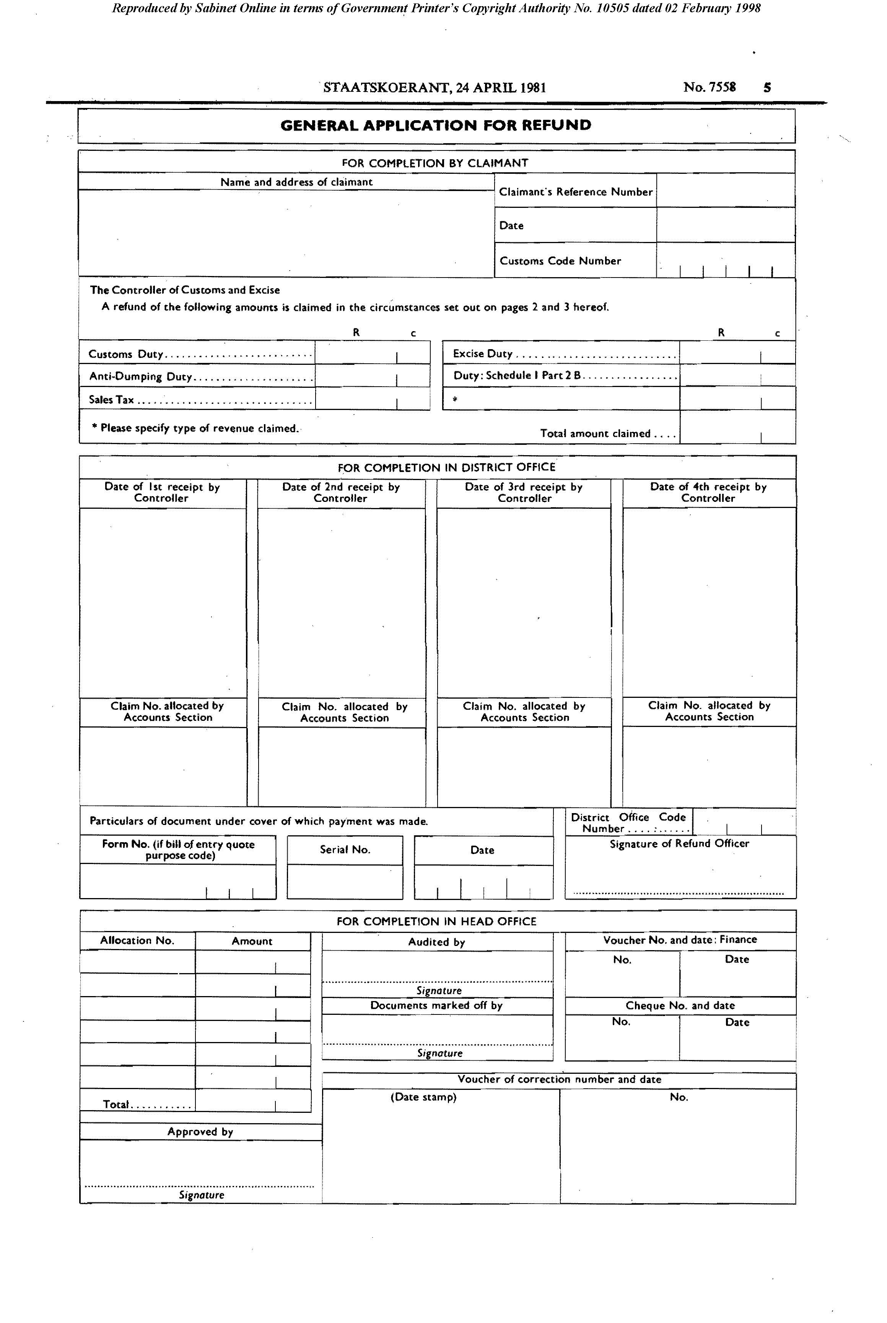
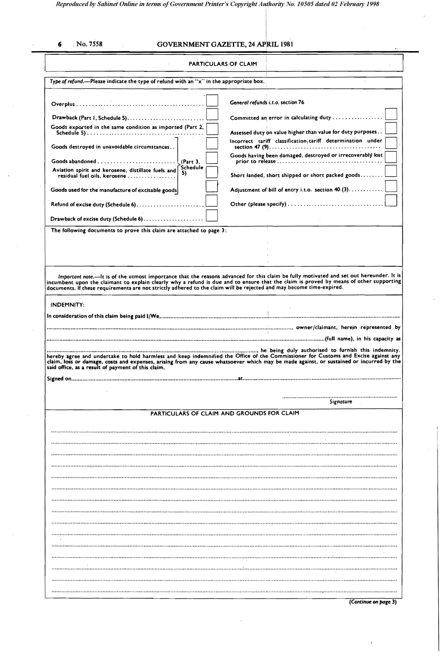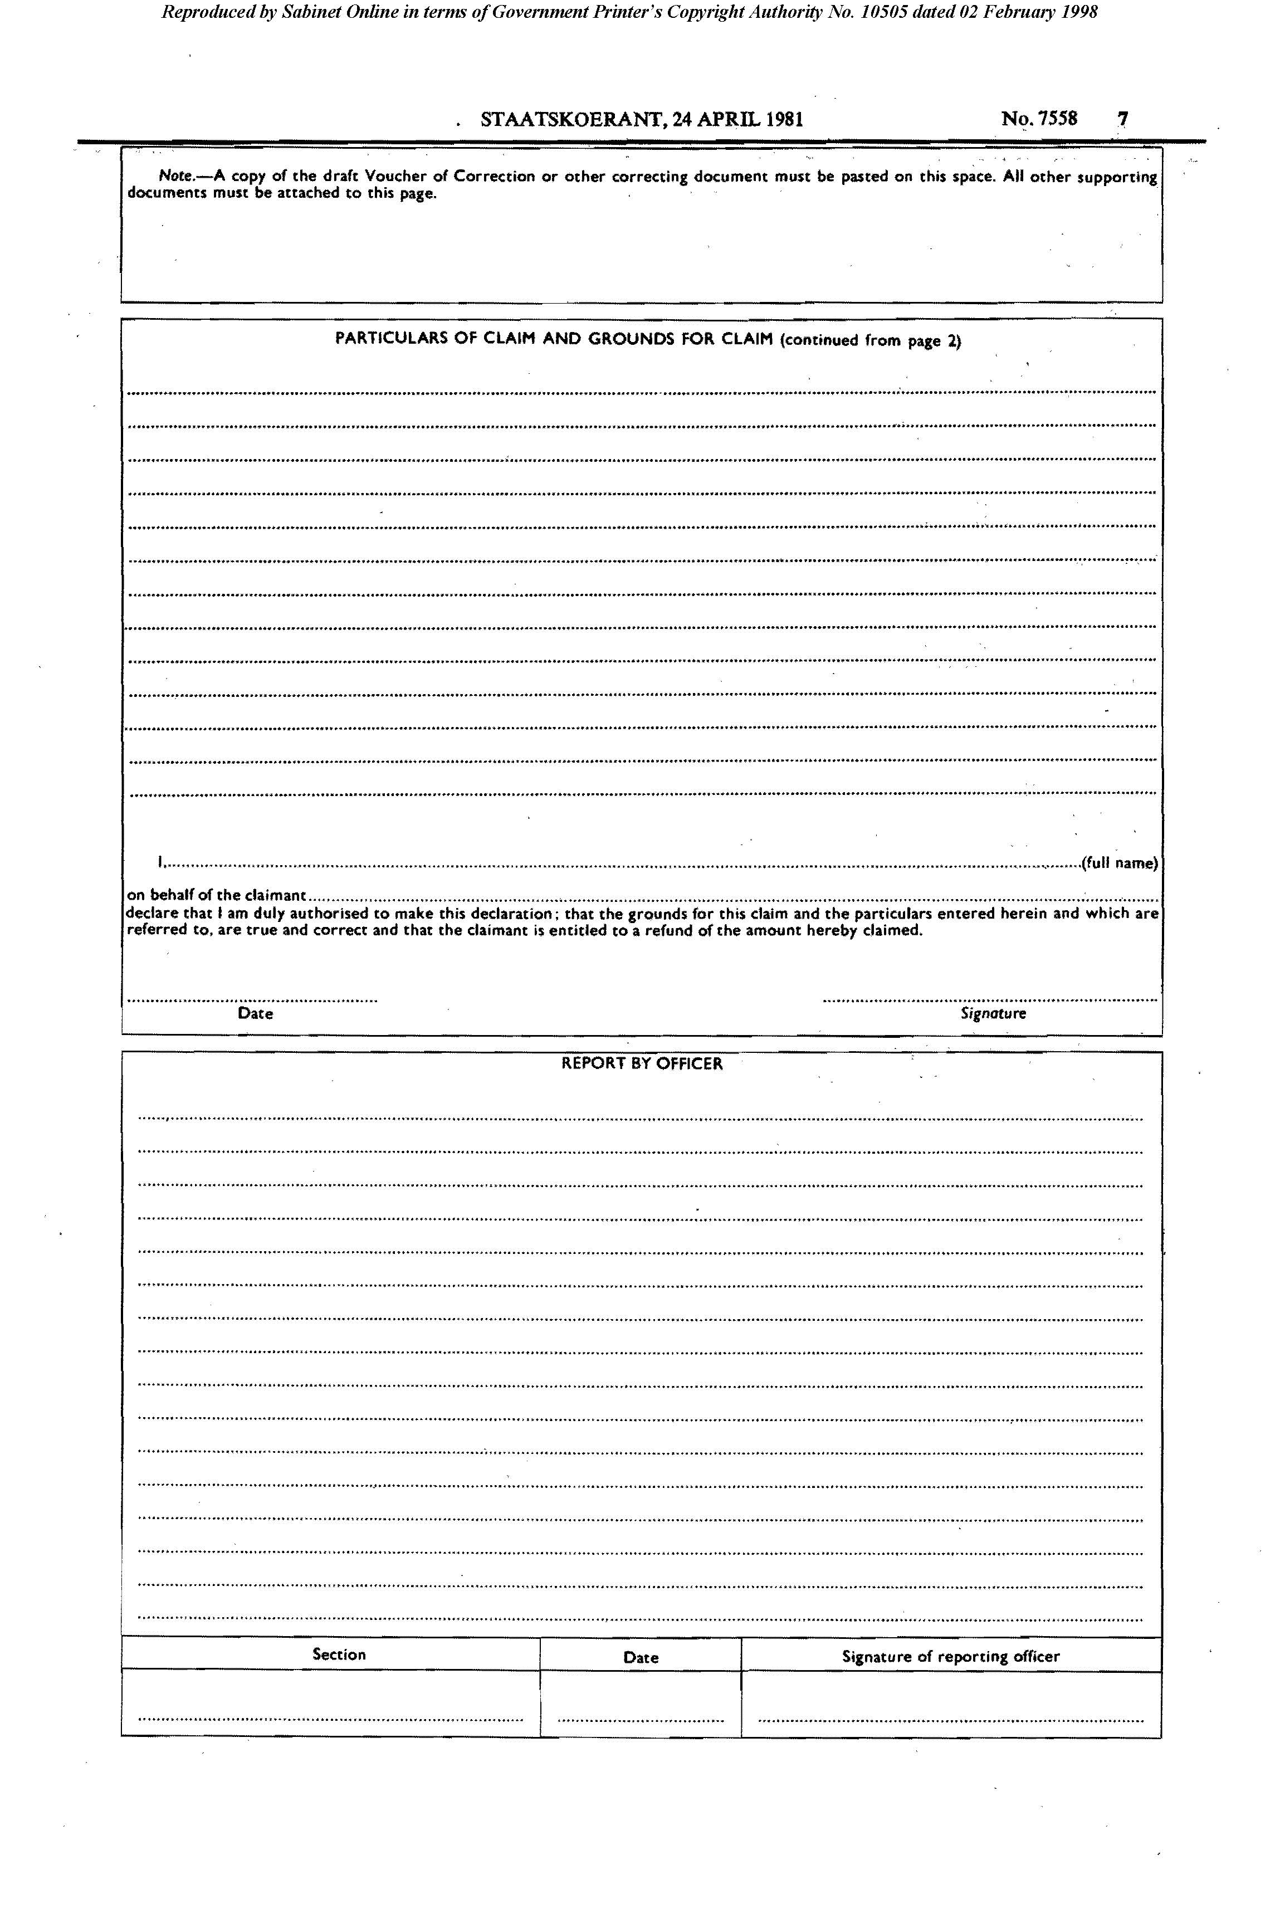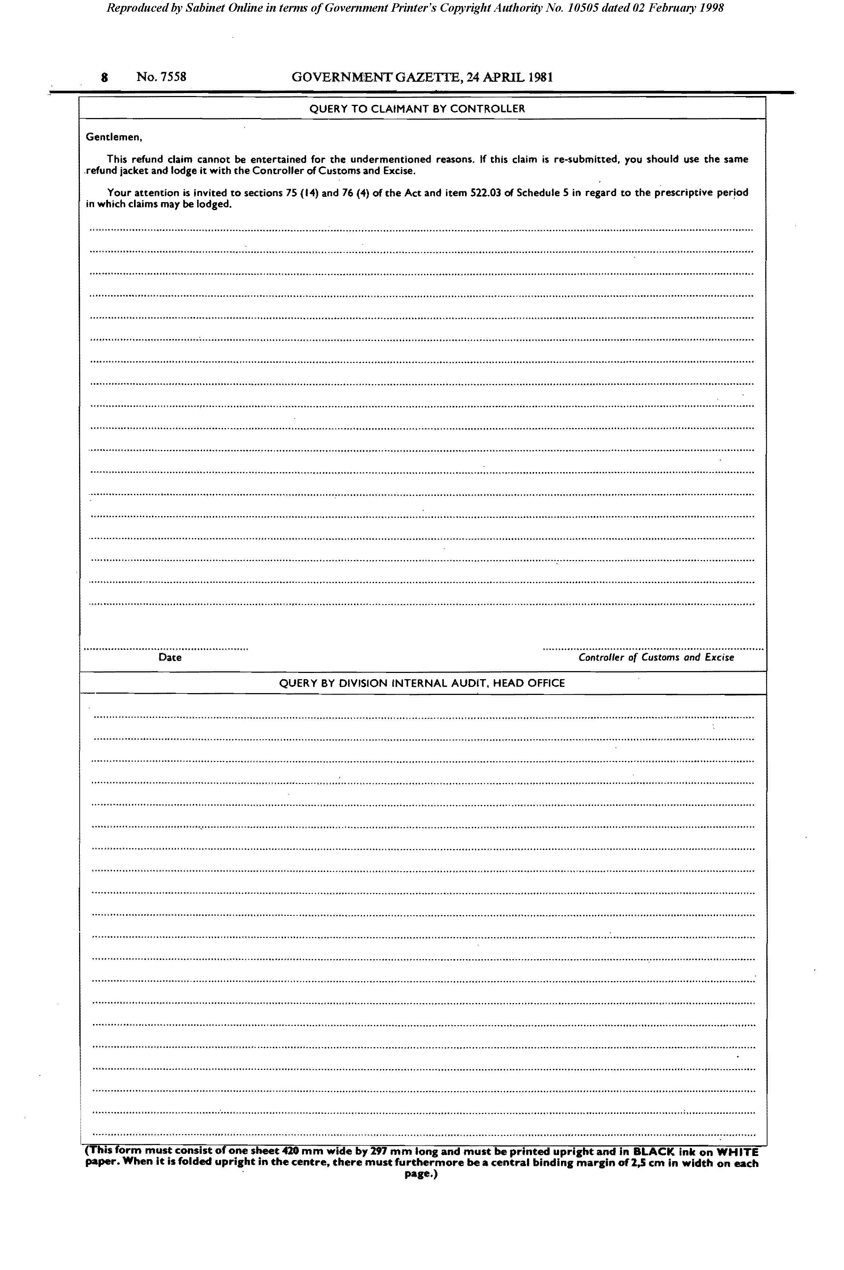

Form DA 67

[Form DA 67 is substituted by RSA GN R.2442/1985.]

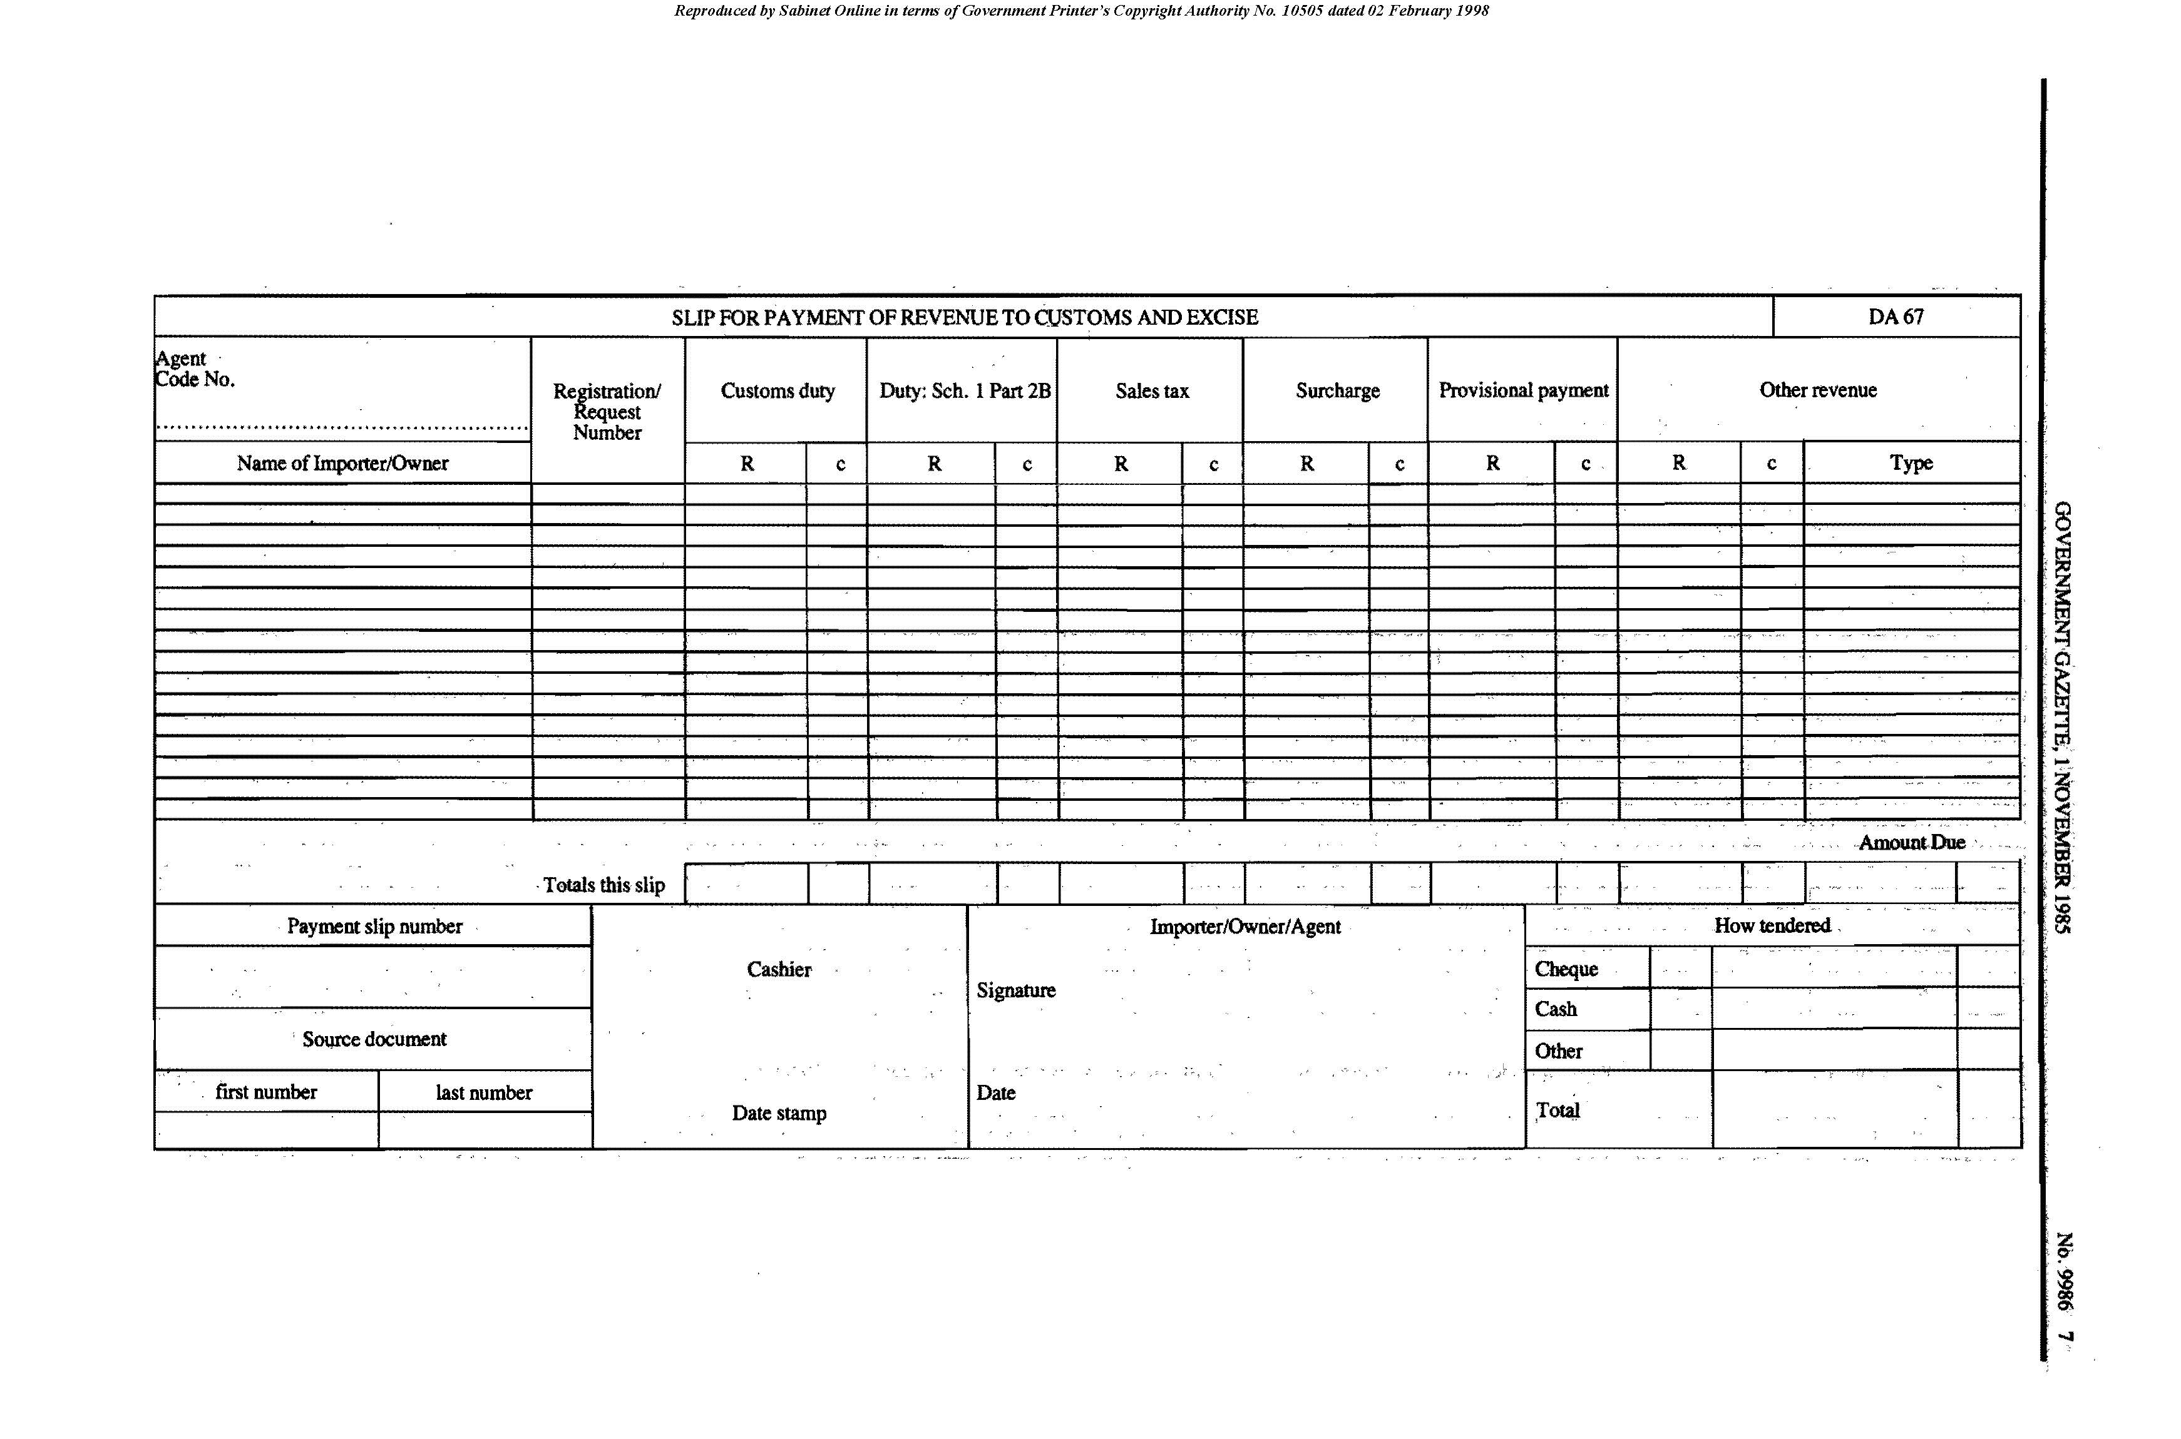

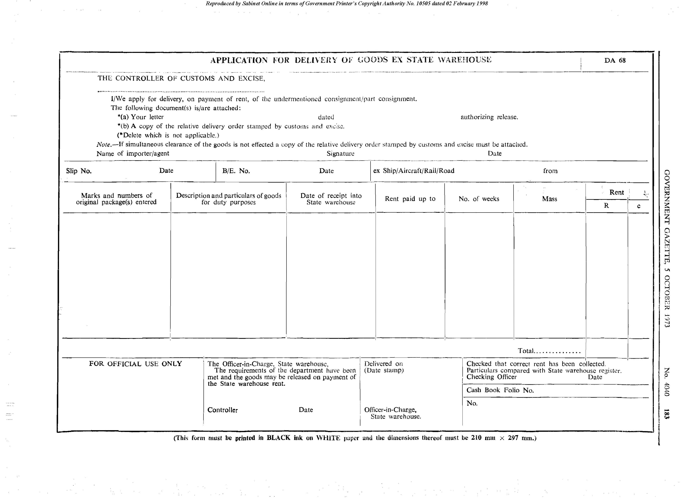
Form DA 68

Form DA 69
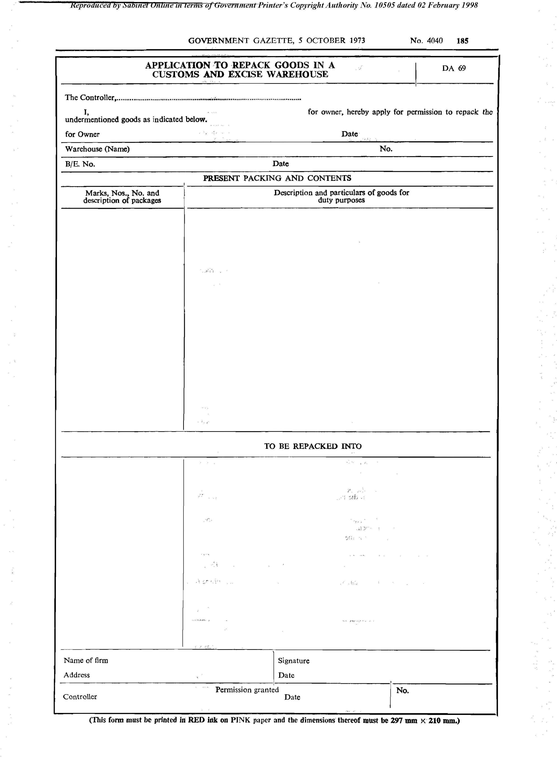

Form DA 70
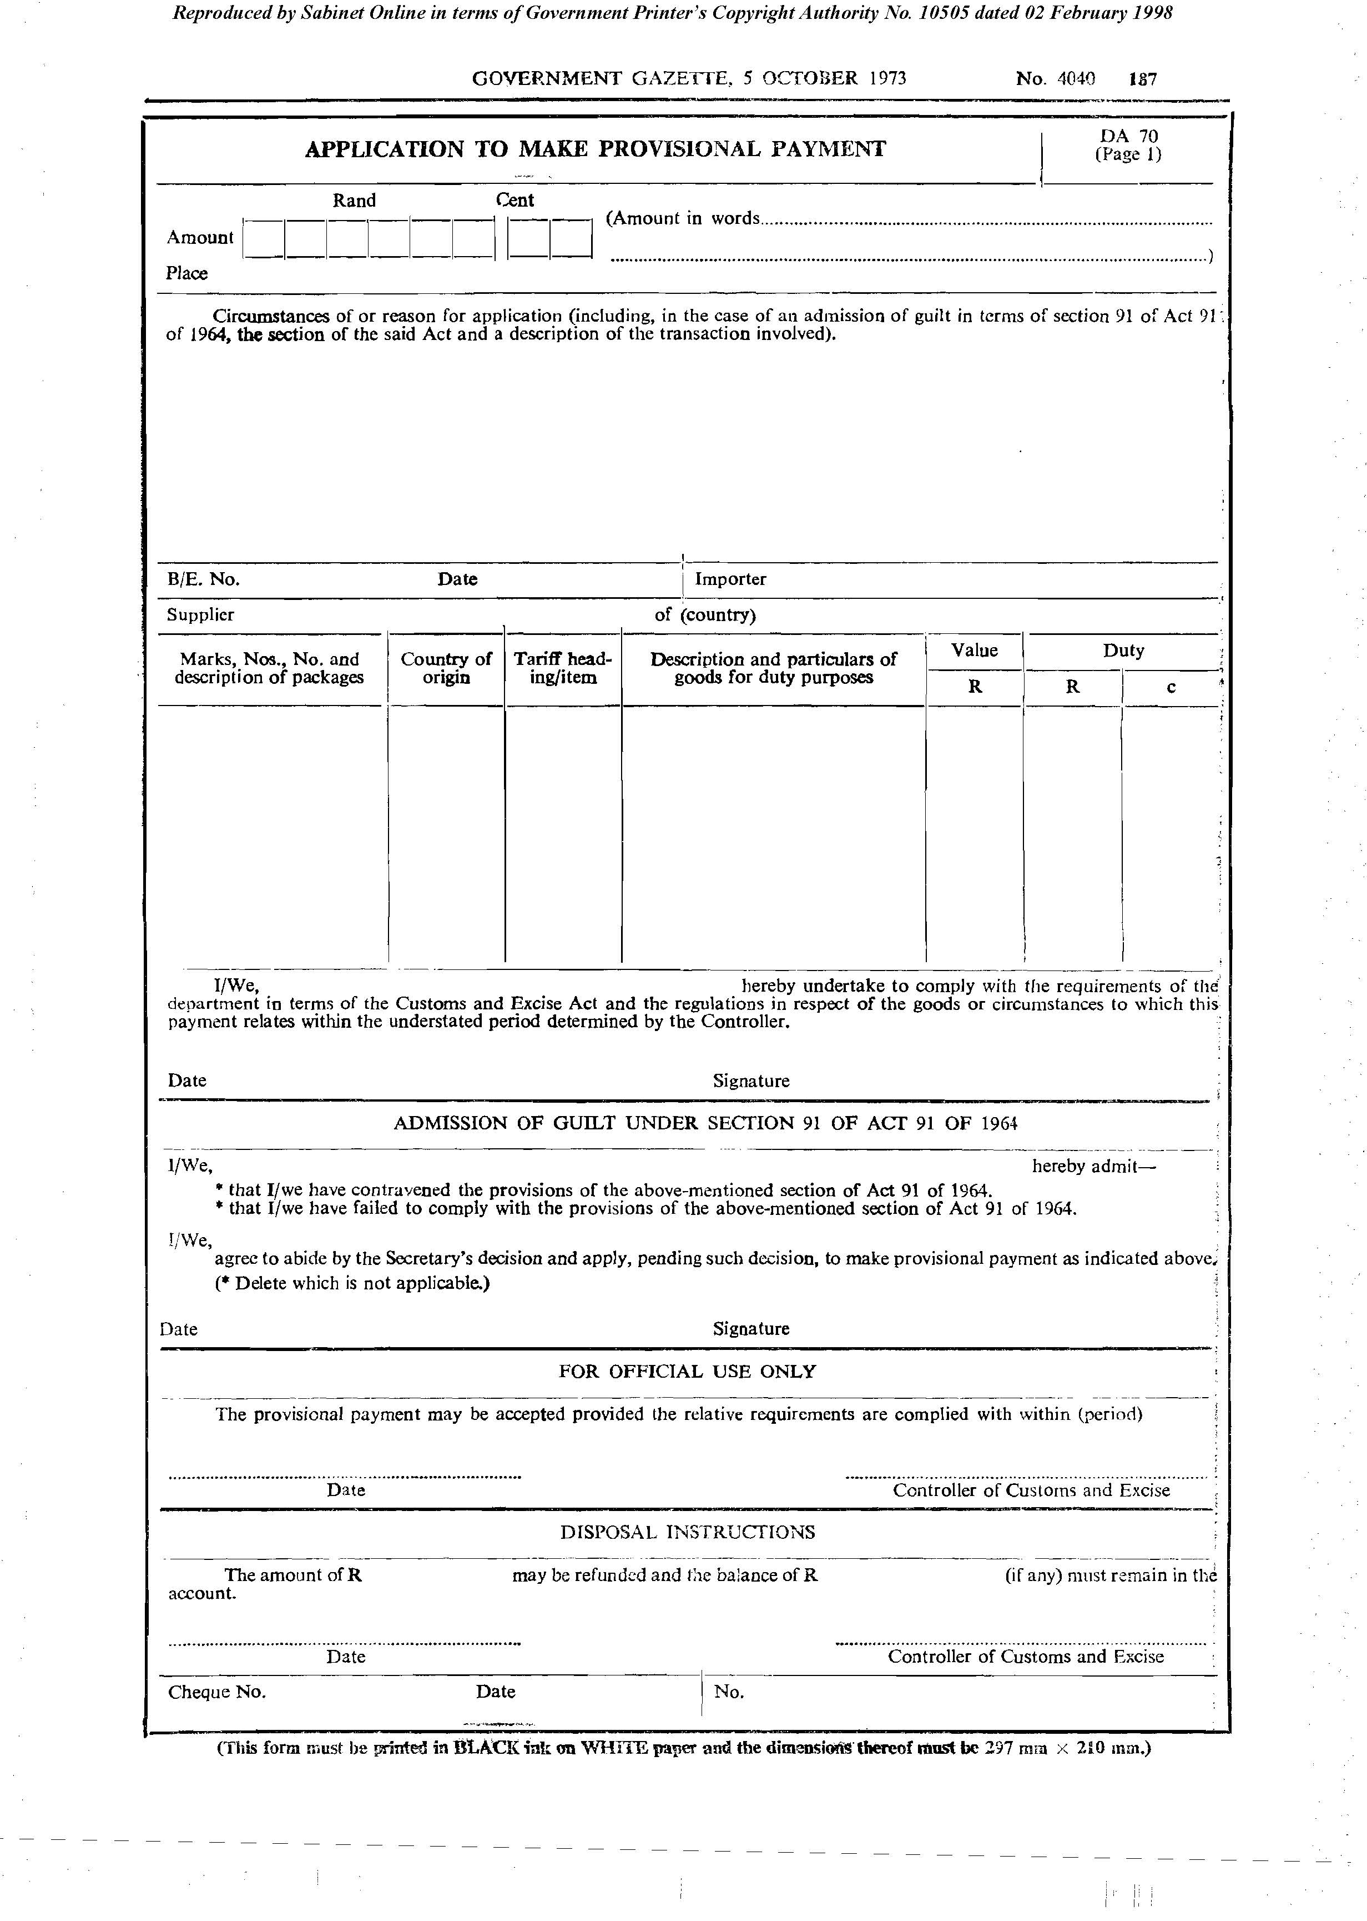

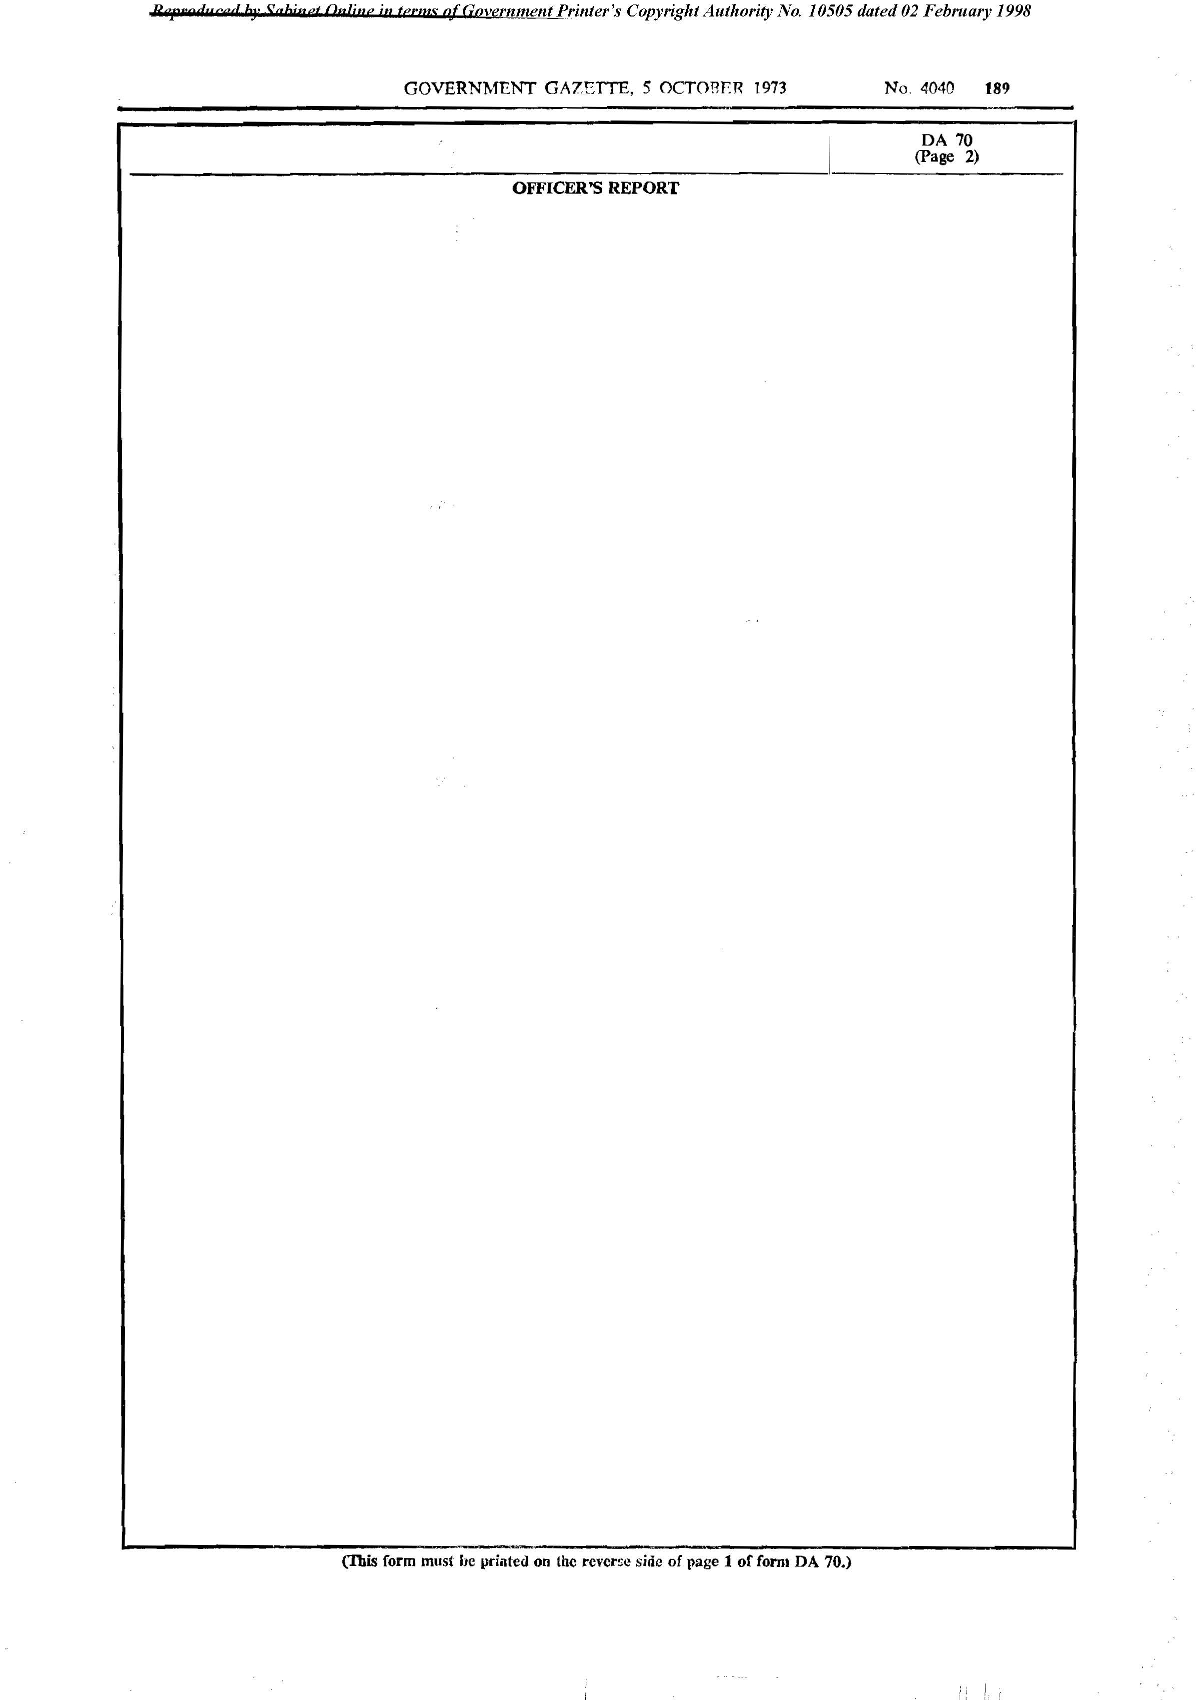

Form DA 71
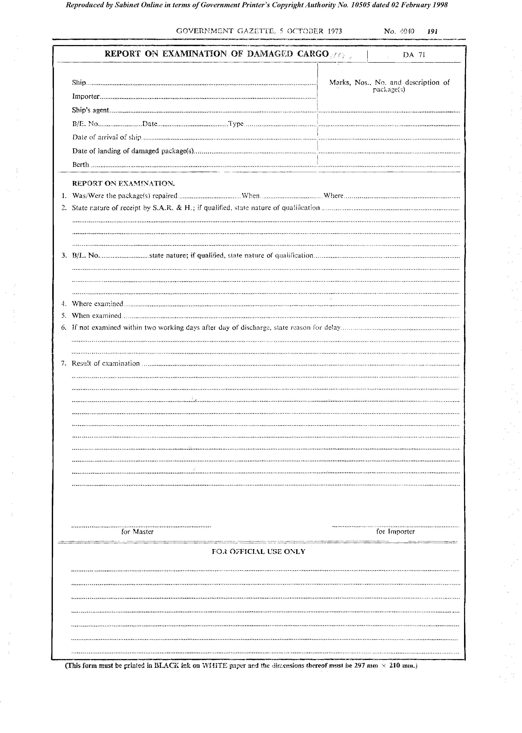

[There is no Form DA 72 in the original regulations.]

Form DA 73

[Form DA 73 is substituted by RSA GN R.2770/1982.]
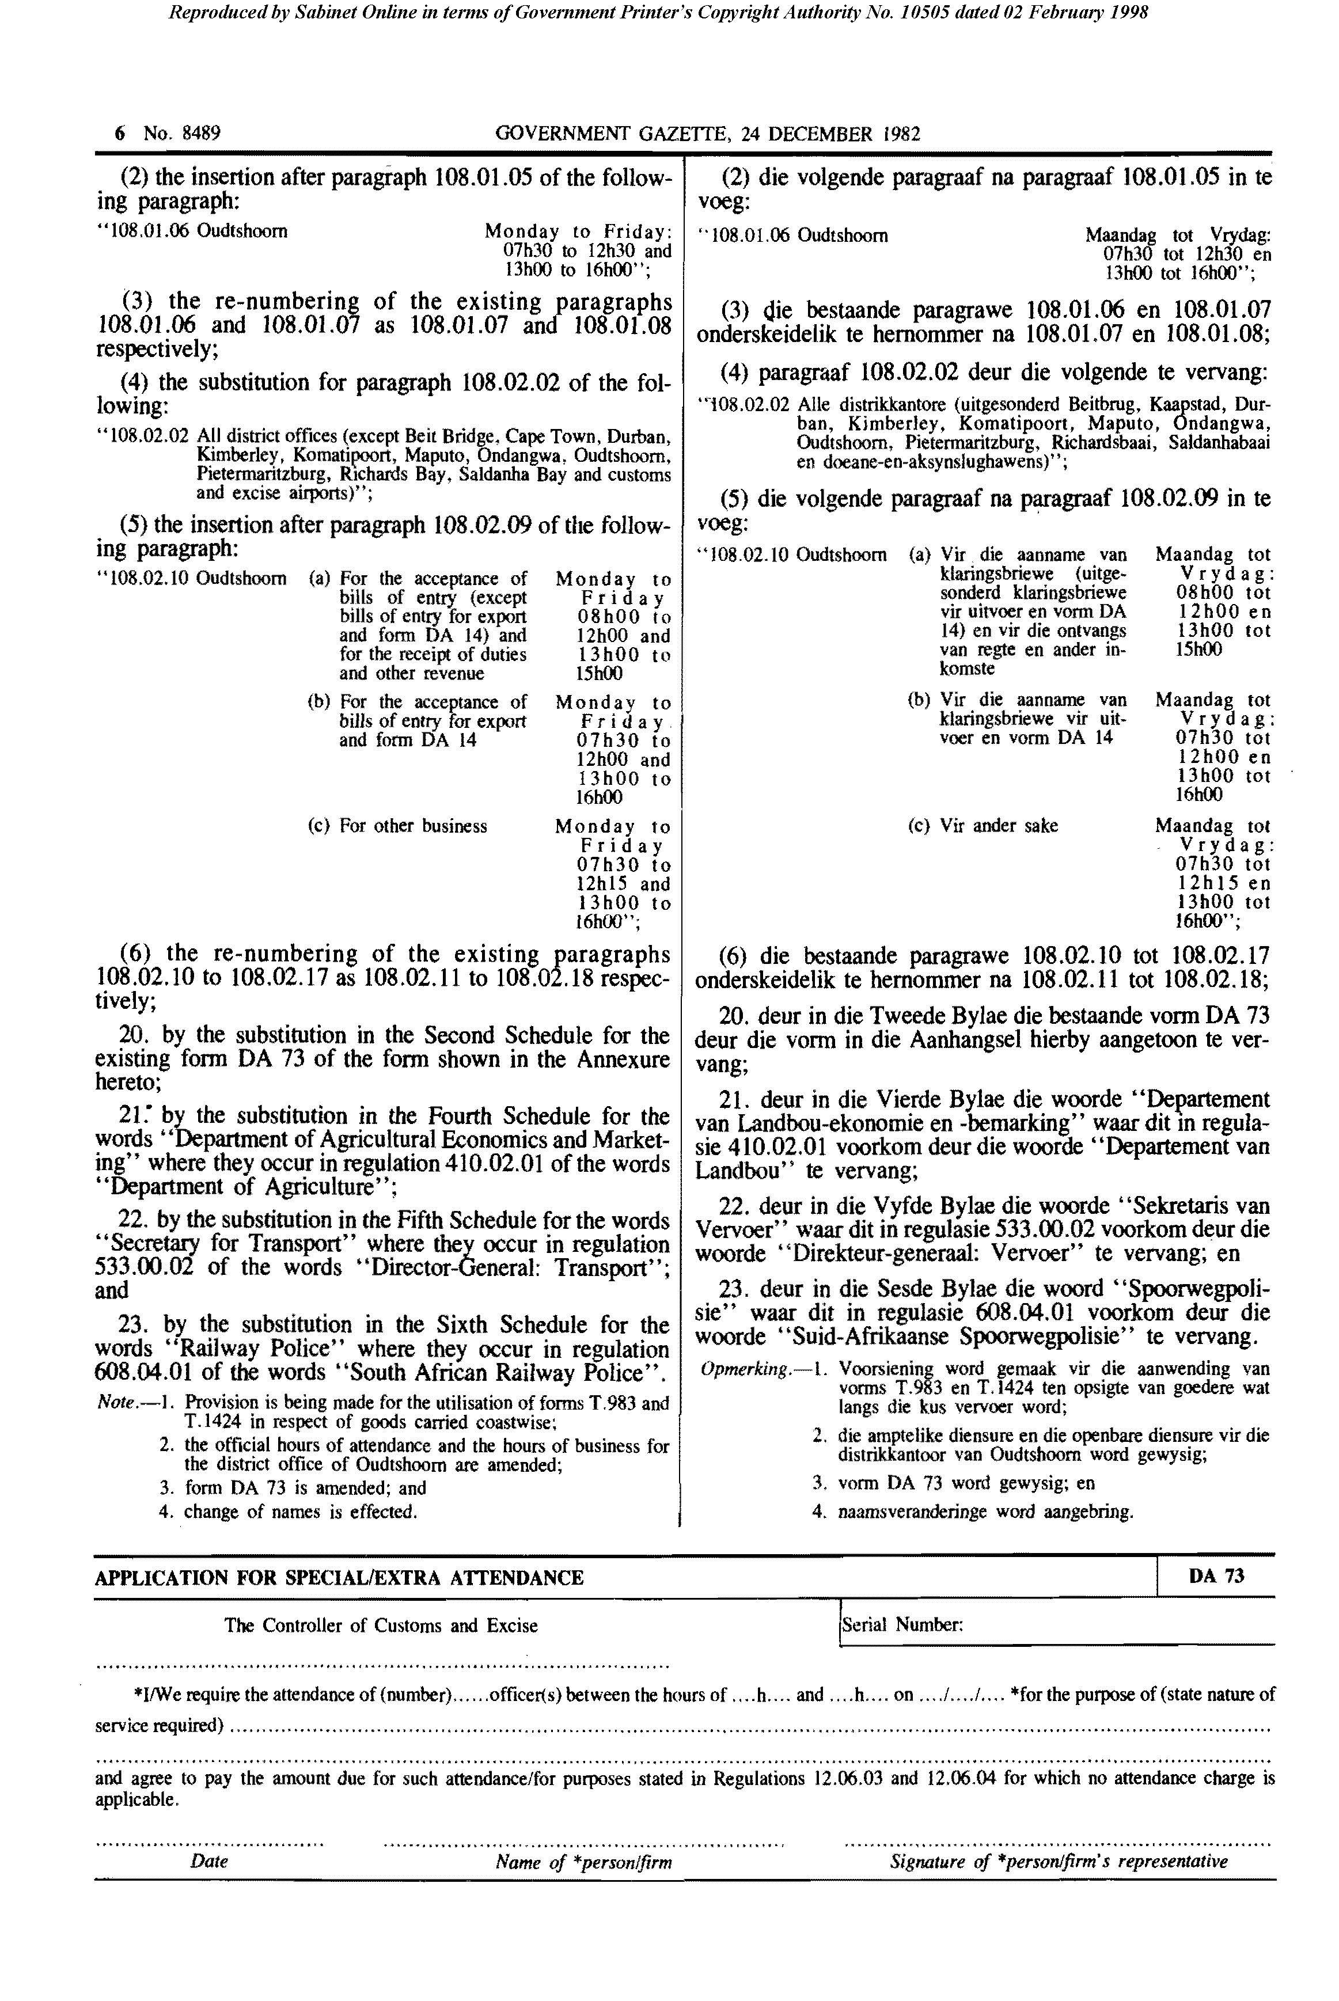

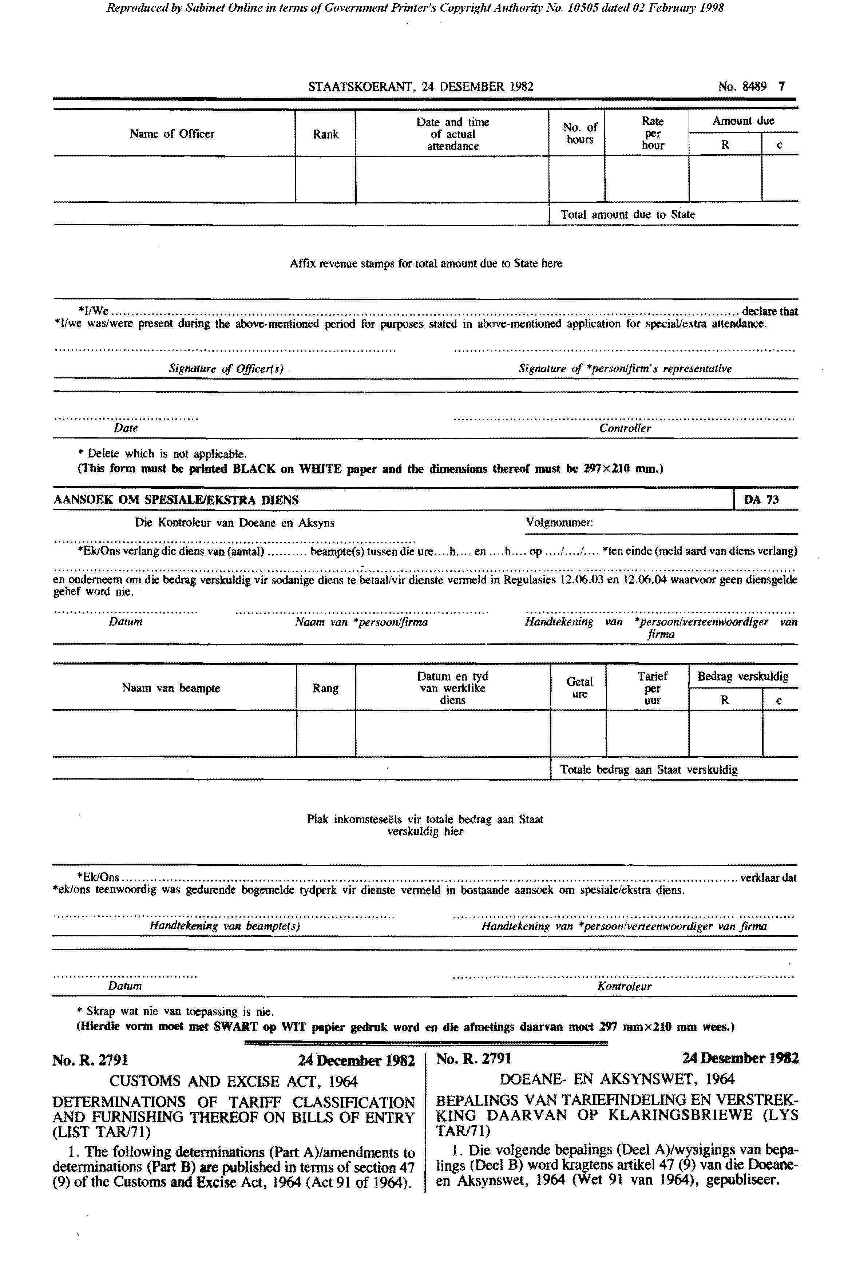

Form DA 74

[Form DA 74 is substituted by RSA GN R.629/1984.]

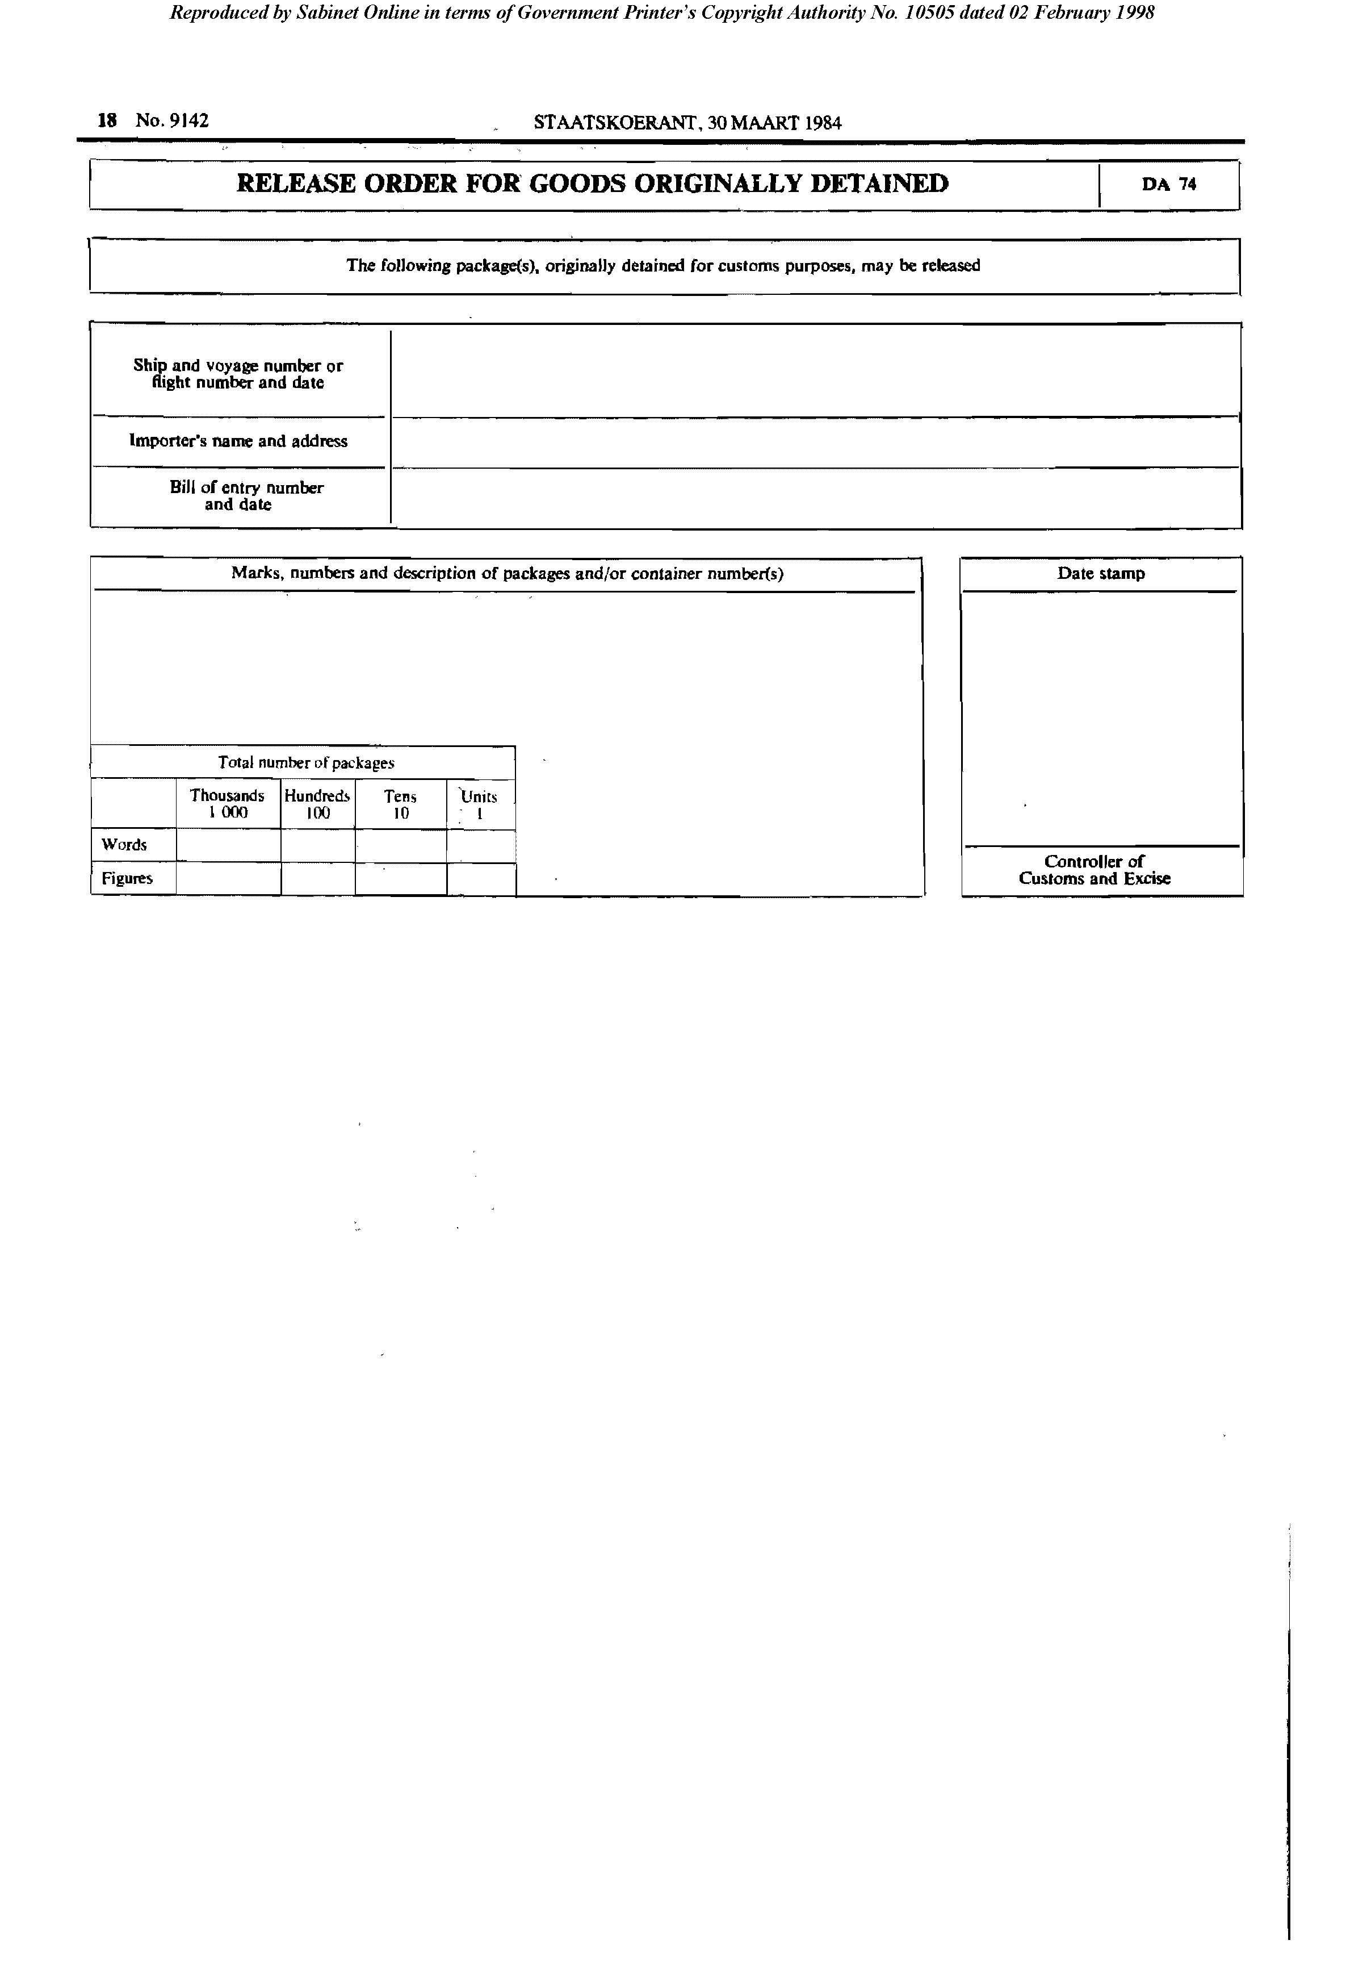

Form DA 137

[Form DA 137 is inserted by RSA GN R.1356/1983.]

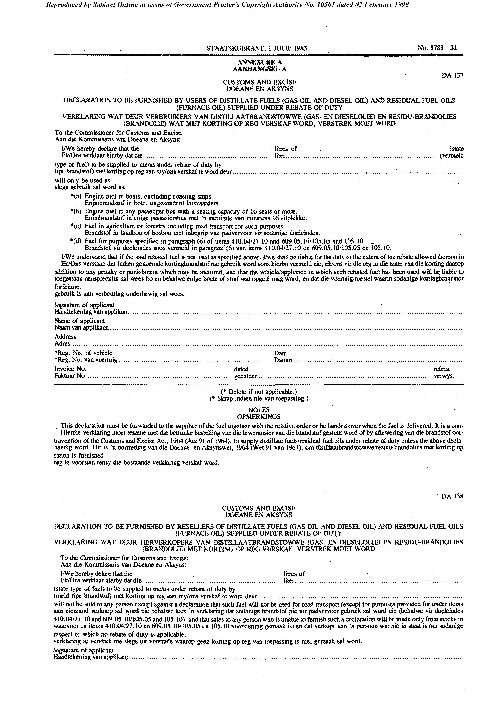

Form DA 138

[Form DA 138 is inserted by RSA GN R.1356/1983.]

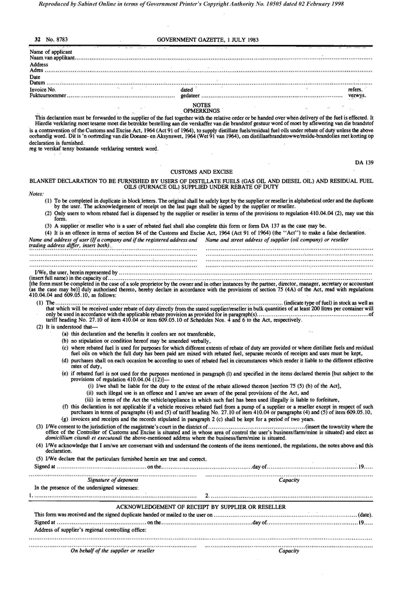

Form DA 139

[Form DA 139 is inserted by RSA GN R.1356/1983.]

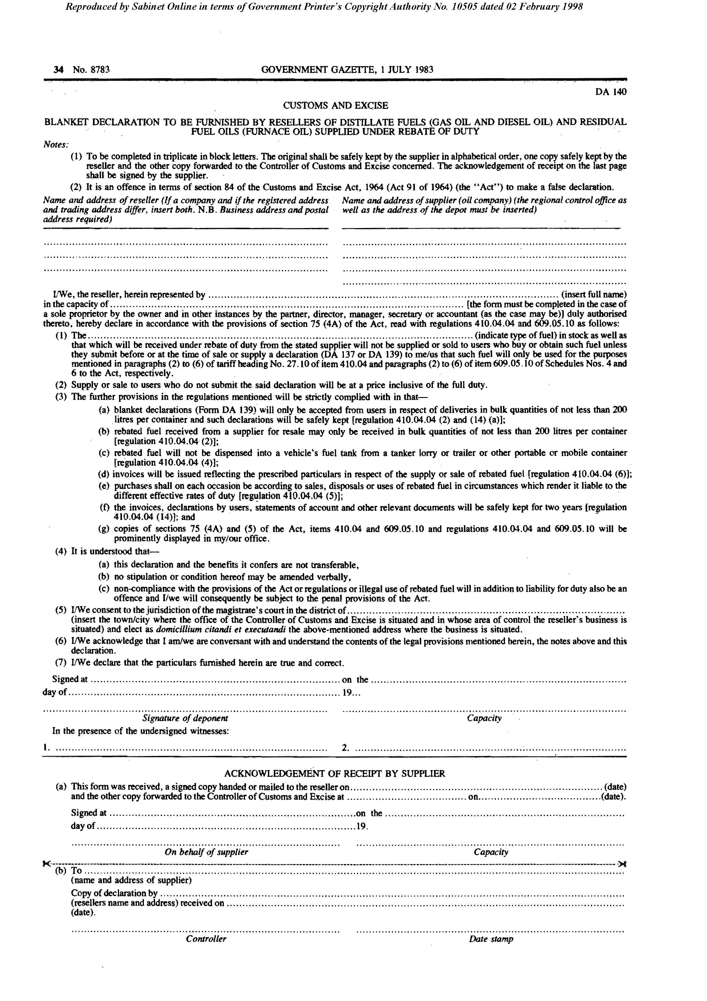

Form DA 140

[Form DA 140 is inserted by RSA GN R.1356/1983.]

Form DA 500

[Form DA 500 is substituted for Forms DA 10, DA 12, DA 16, DA 18 and DA 20
by RSA GN R.1362/1978. Form DA 500 is then substituted by
RSA GN R.1202/83 and by RSA GN R.629/1984.]

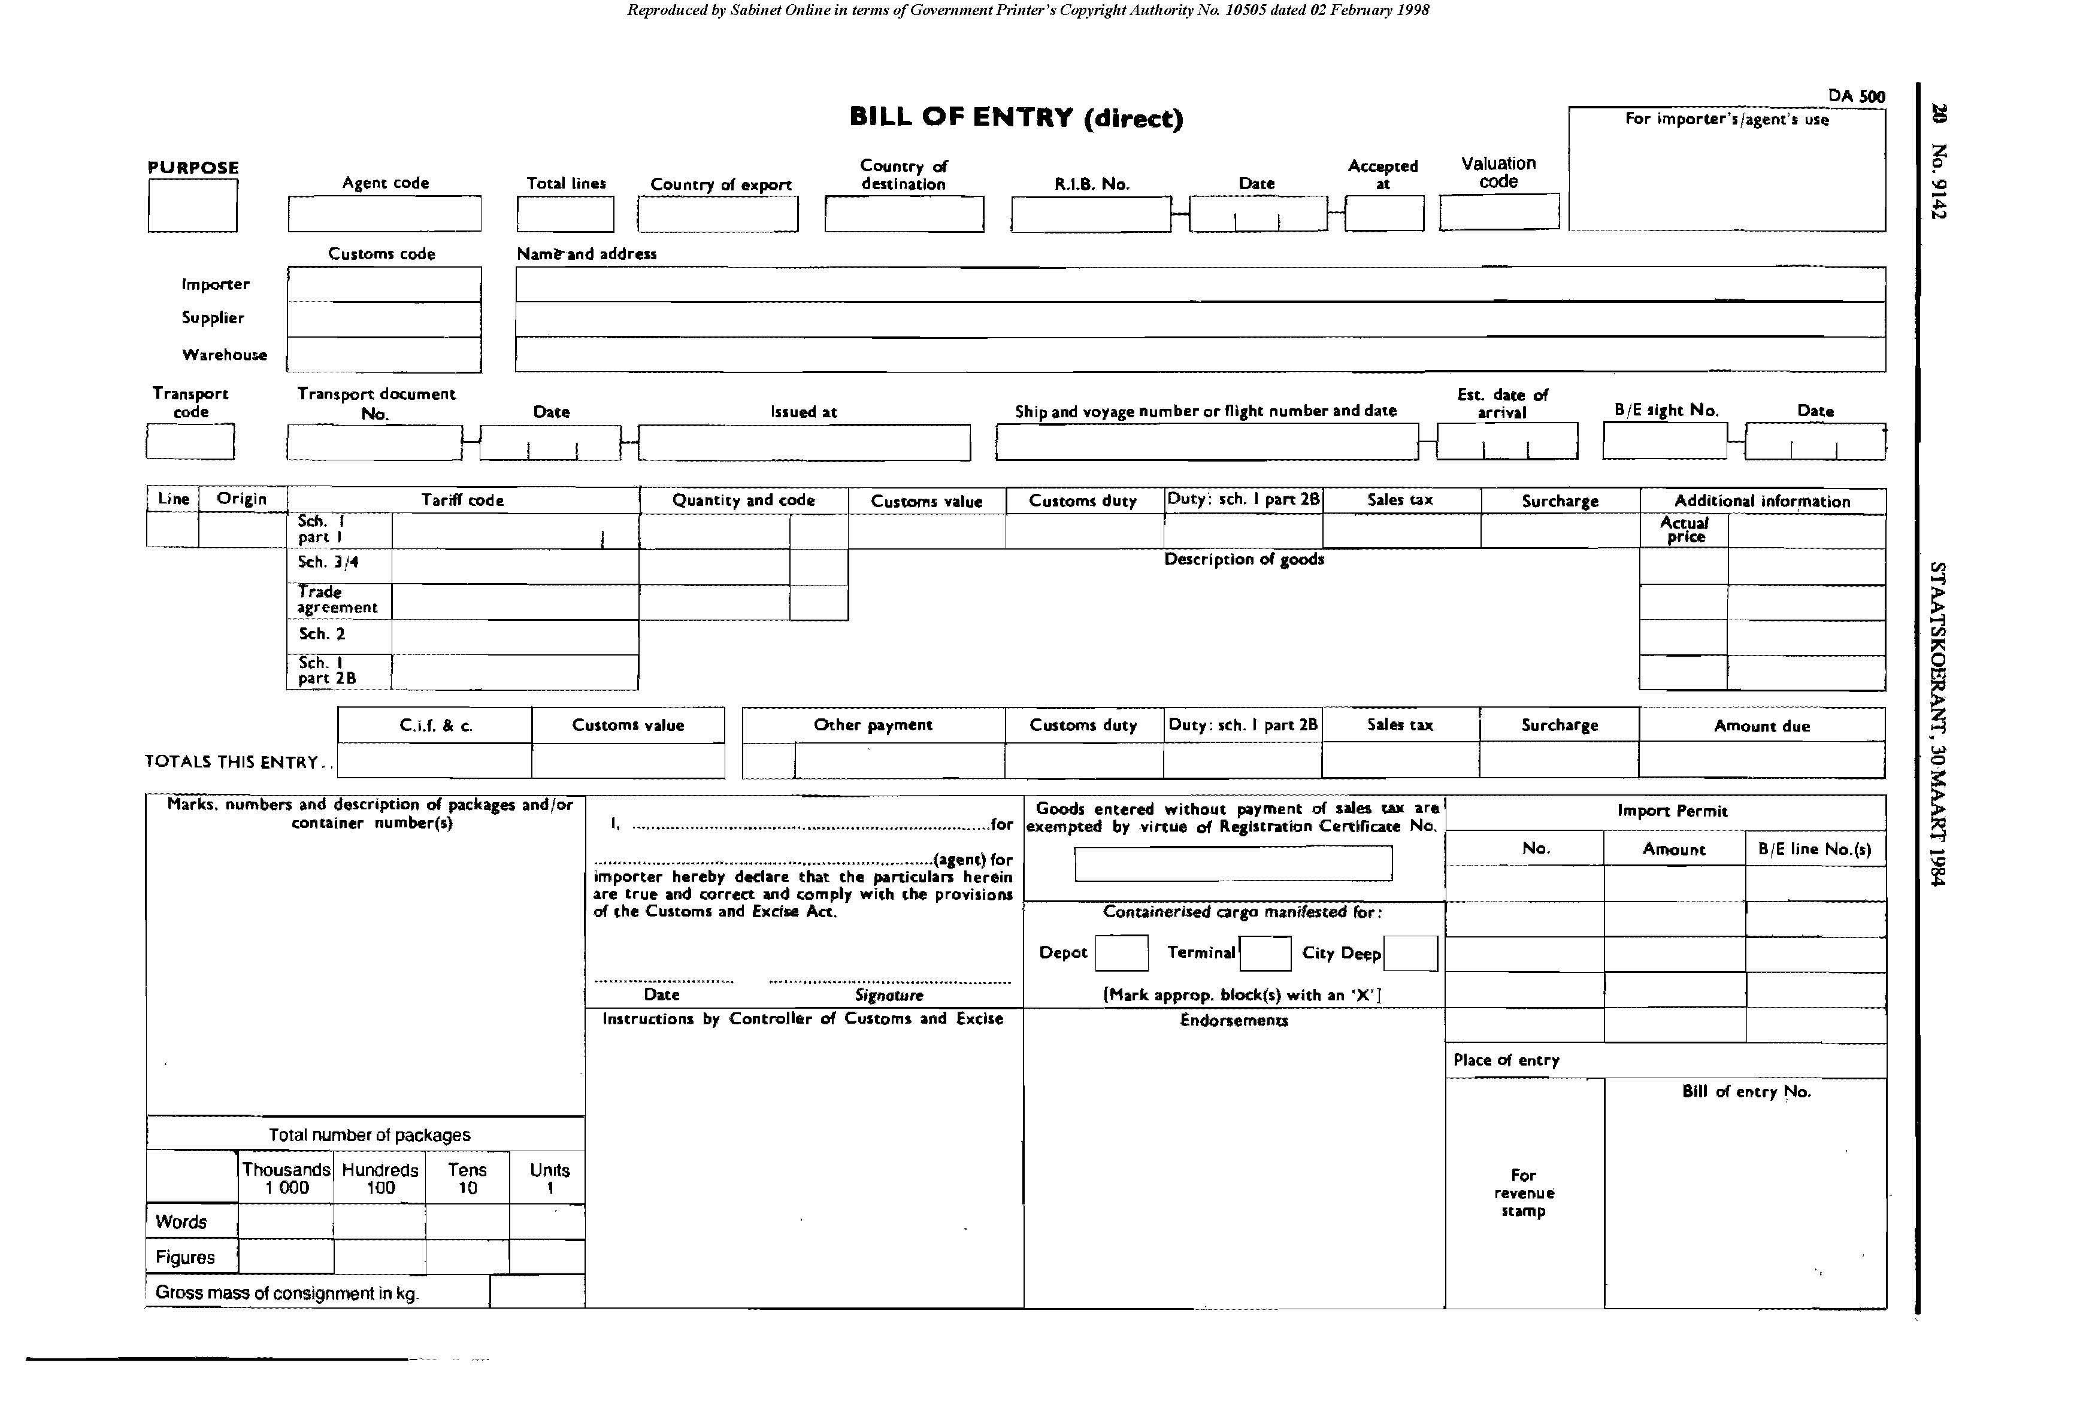

Form DA 501

[Form DA 501 is inserted by RSA GN R. R.1362/1978.]
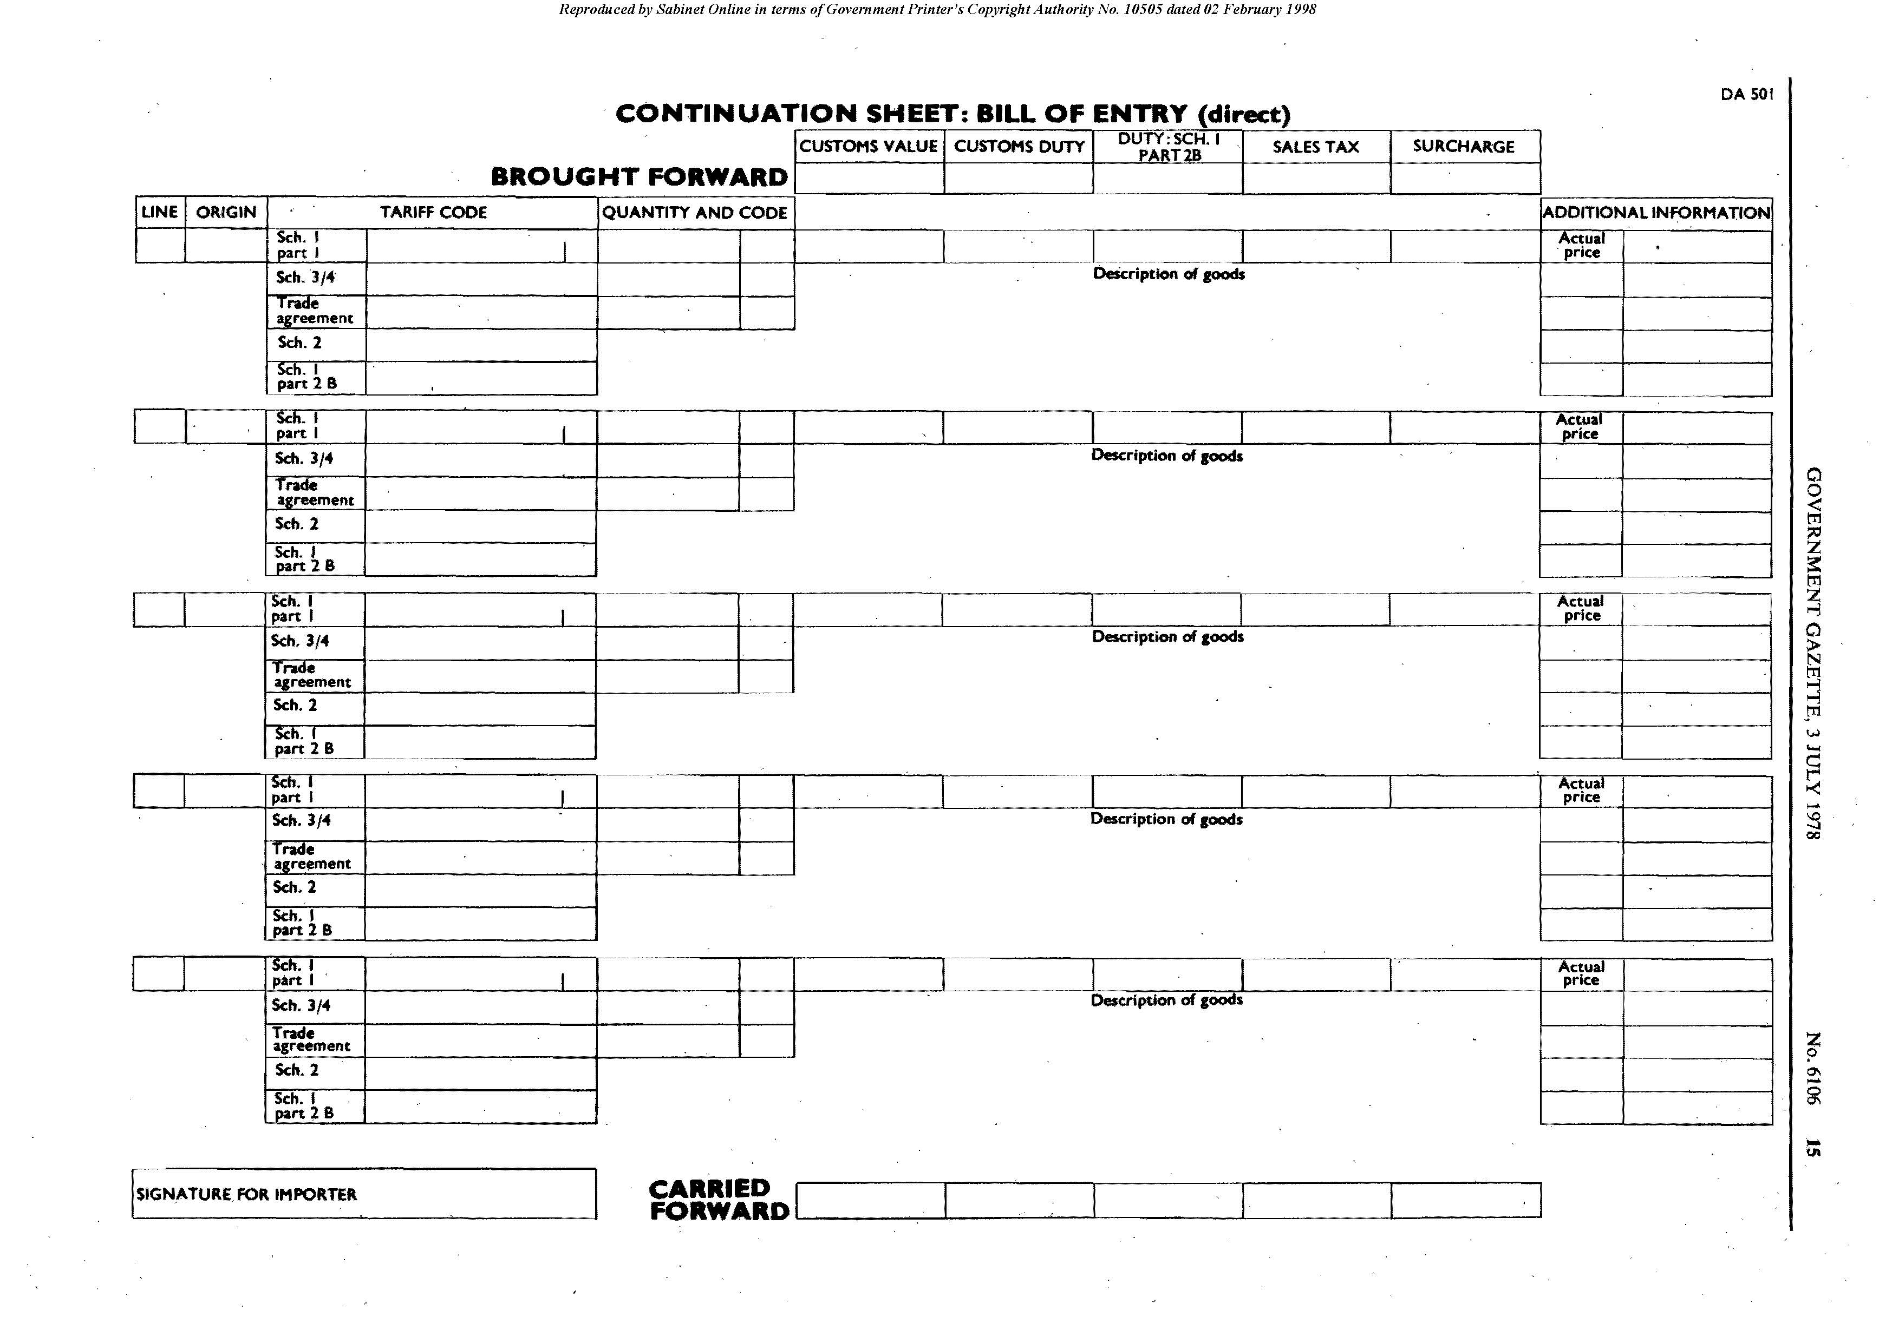

Form DA 504

[Form DA 504 is inserted by RSA GN R. R.1362/1978 and substituted
by RSA GN R.1202/83 and by RSA GN R.629/1984.]

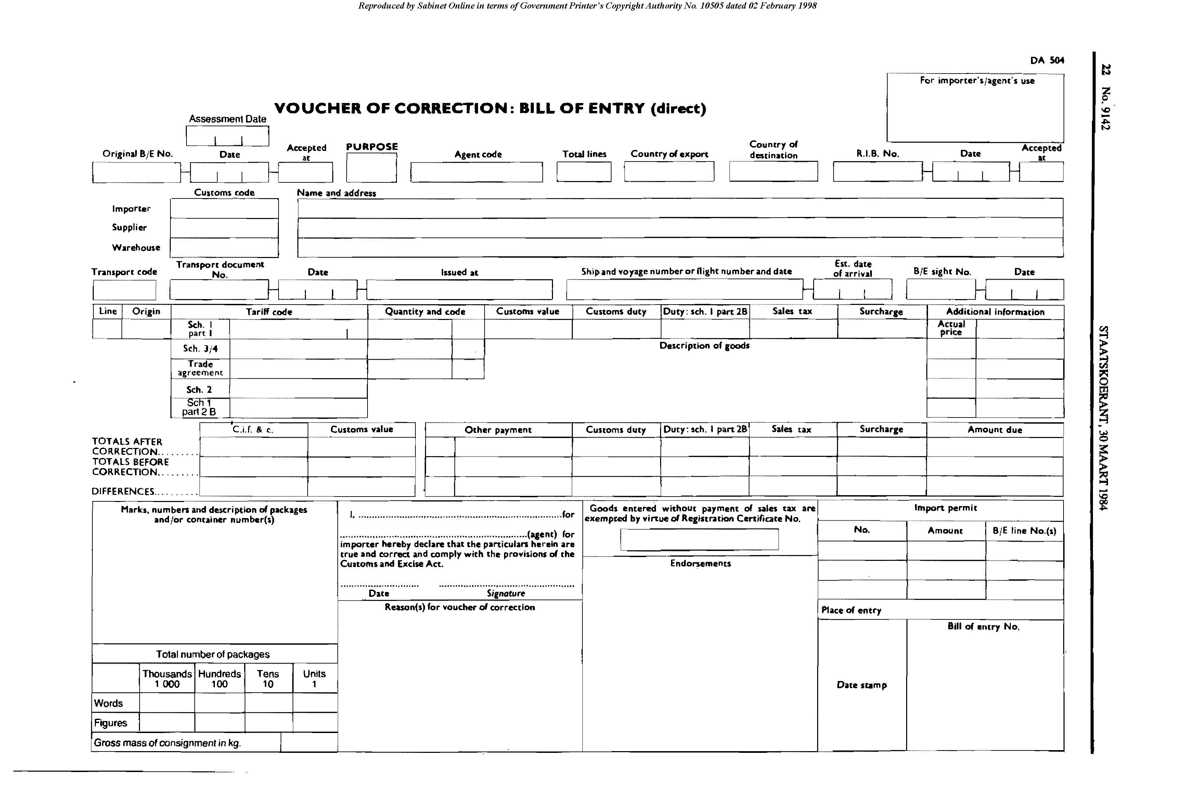

Form DA 510

[Form DA 510 is inserted by RSA GN R. R.1362/1978 and
substituted by RSA GN R.1202/83 and by RSA GN R.629/1984.]
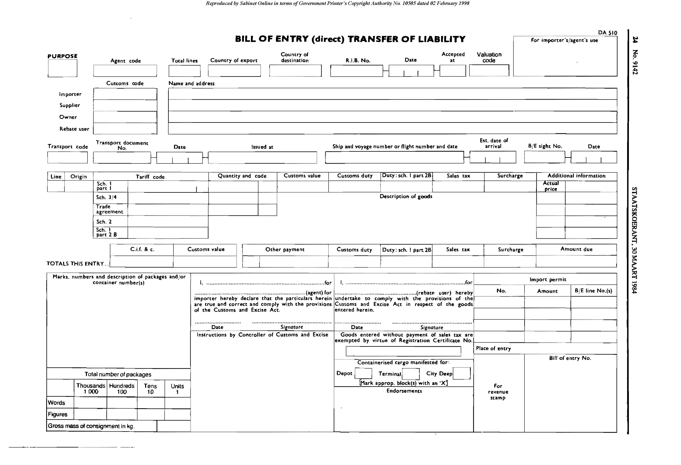

Form DA 514

[Form DA 514 is inserted by RSA GN R. R.1362/1978 and substituted
by RSA GN R.1202/83 and by RSA GN R.629/1984.]

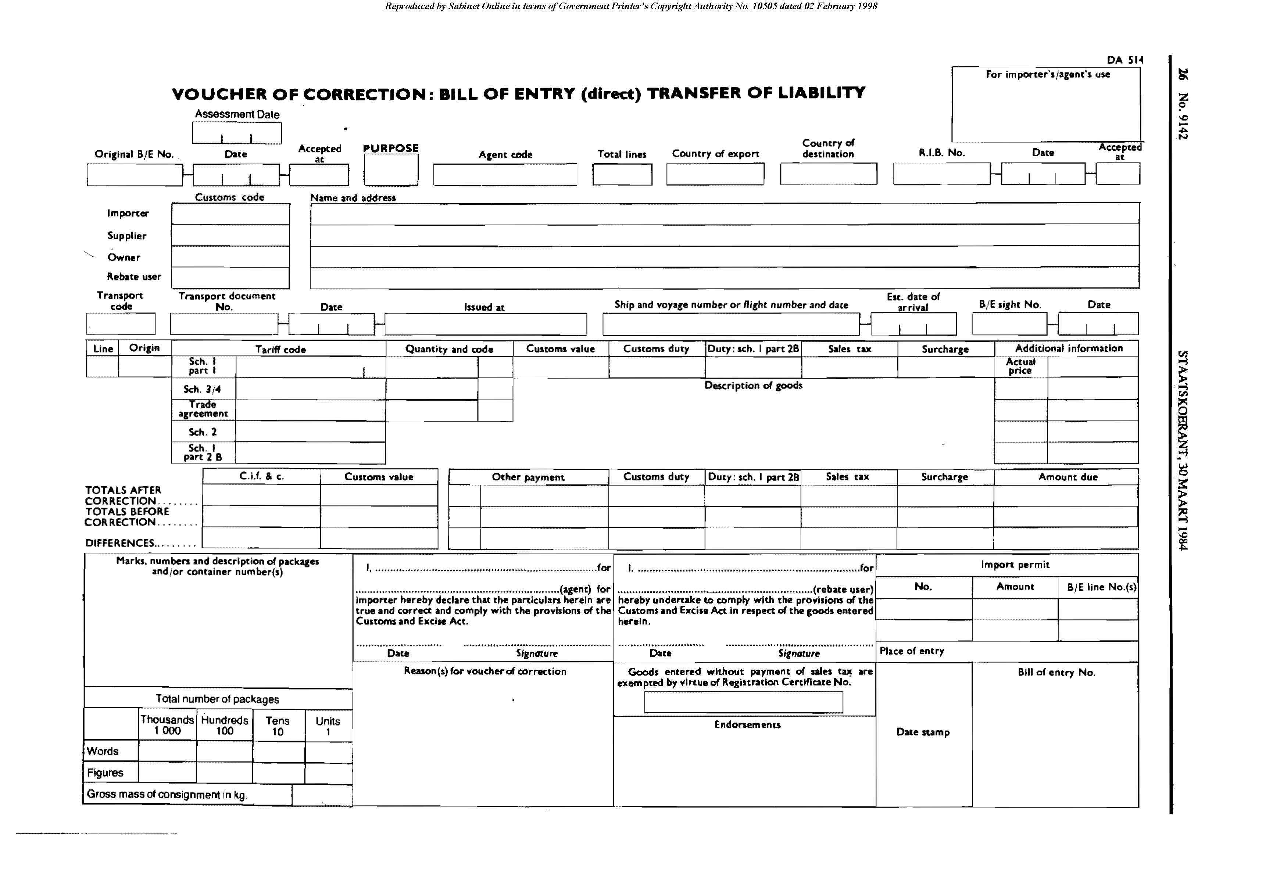

Form DA 550

[Form DA 550 is substituted for Forms DA 23 and DA 24 by RSA GN R.2519/1986.
Form 550 is then substituted by RSA GN R.2094/1987.]

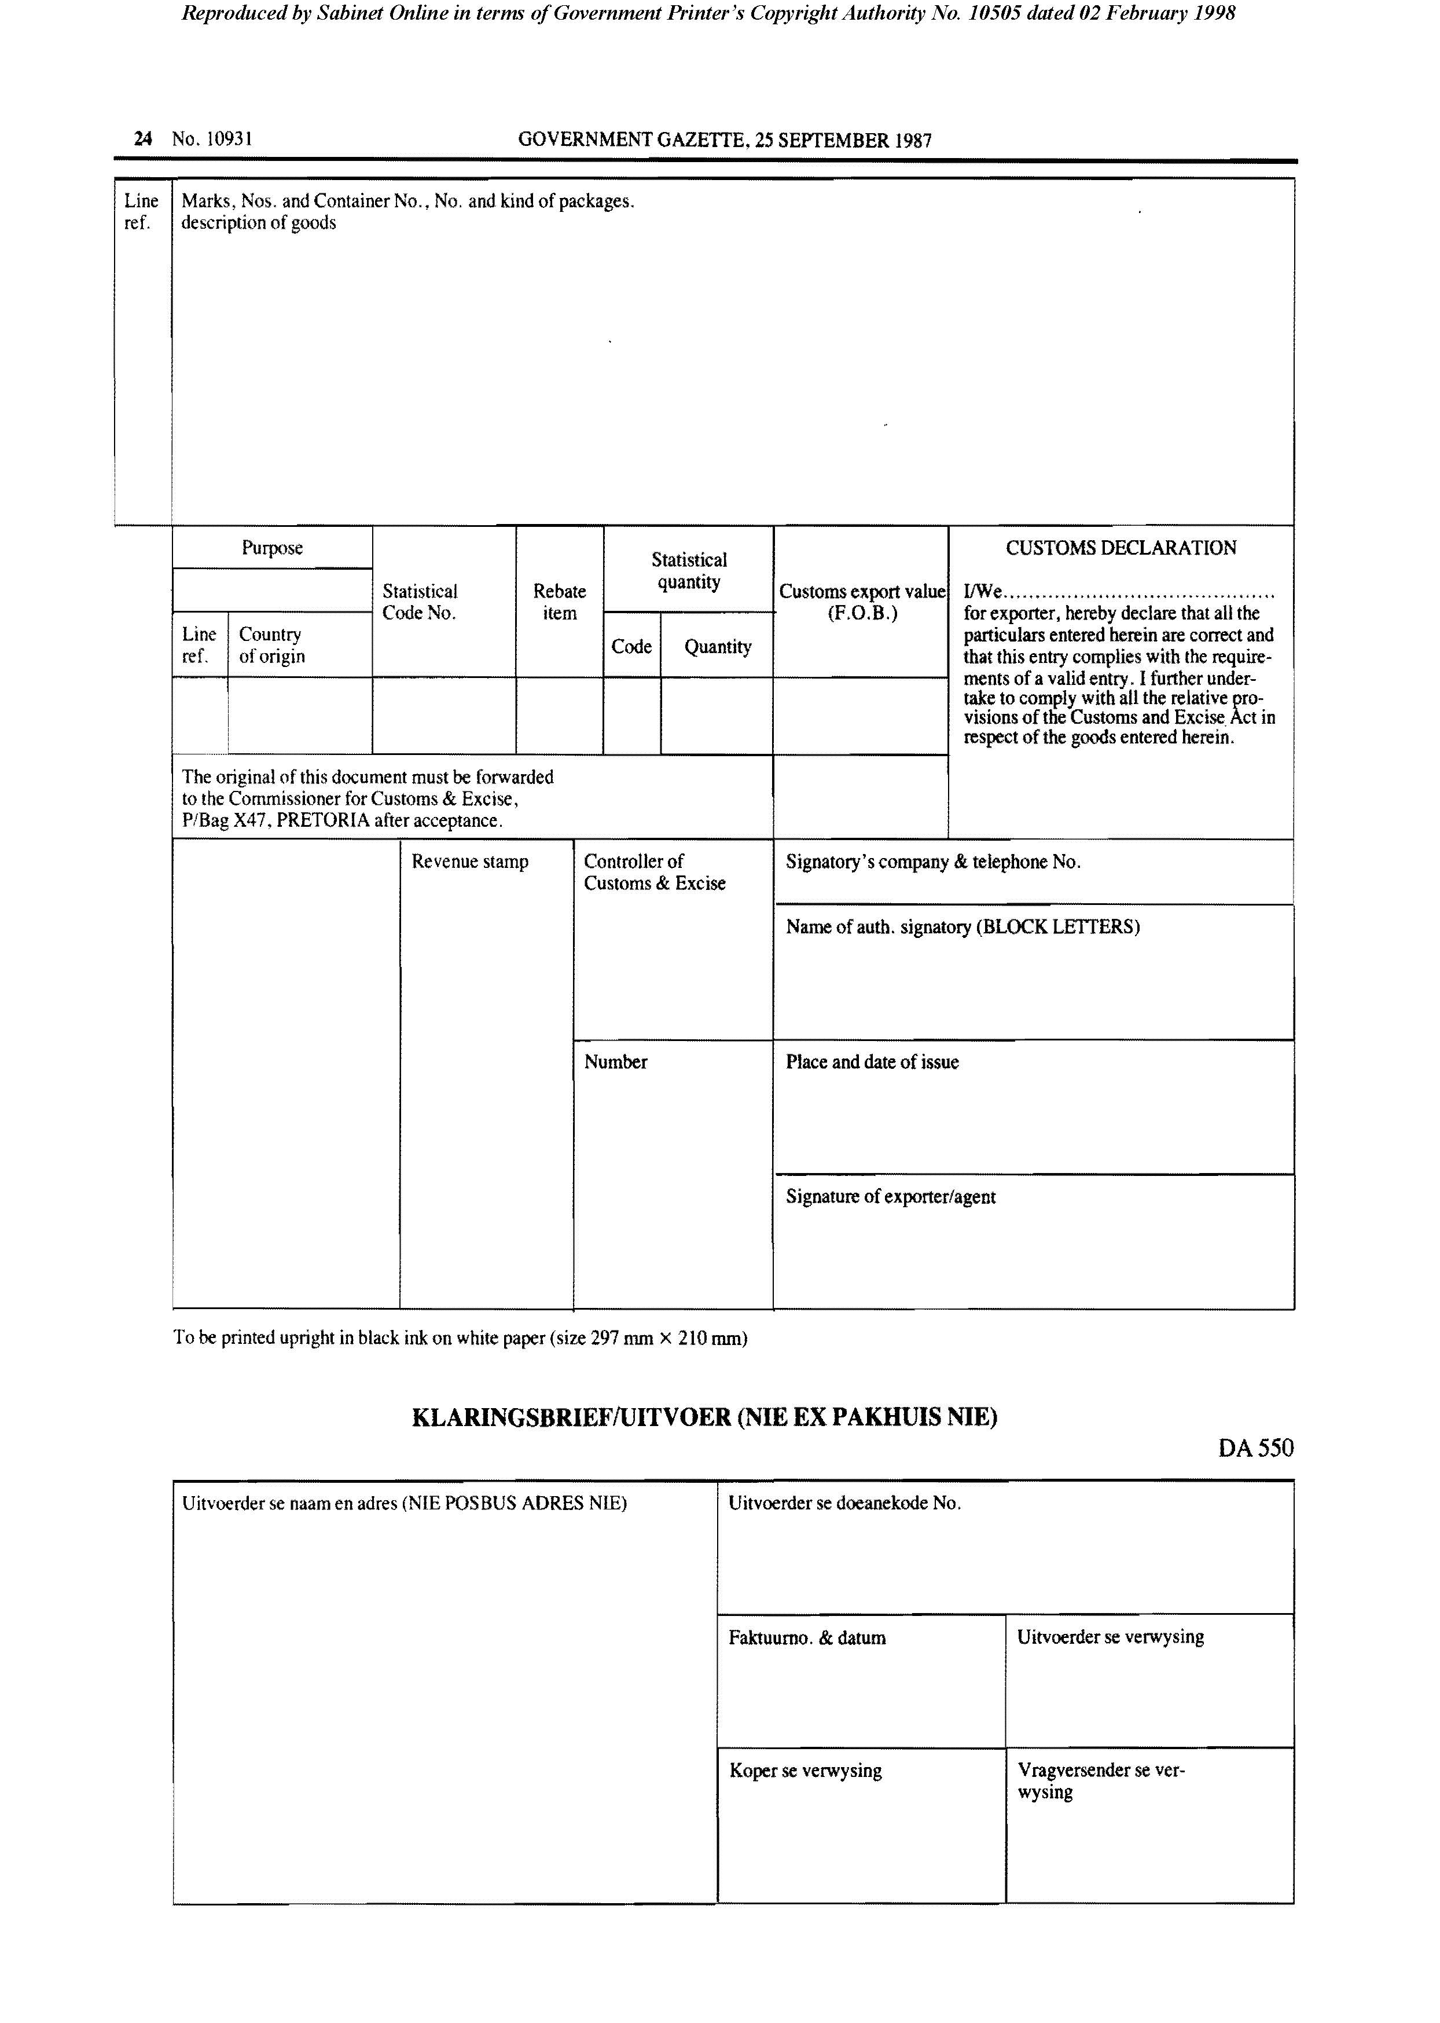
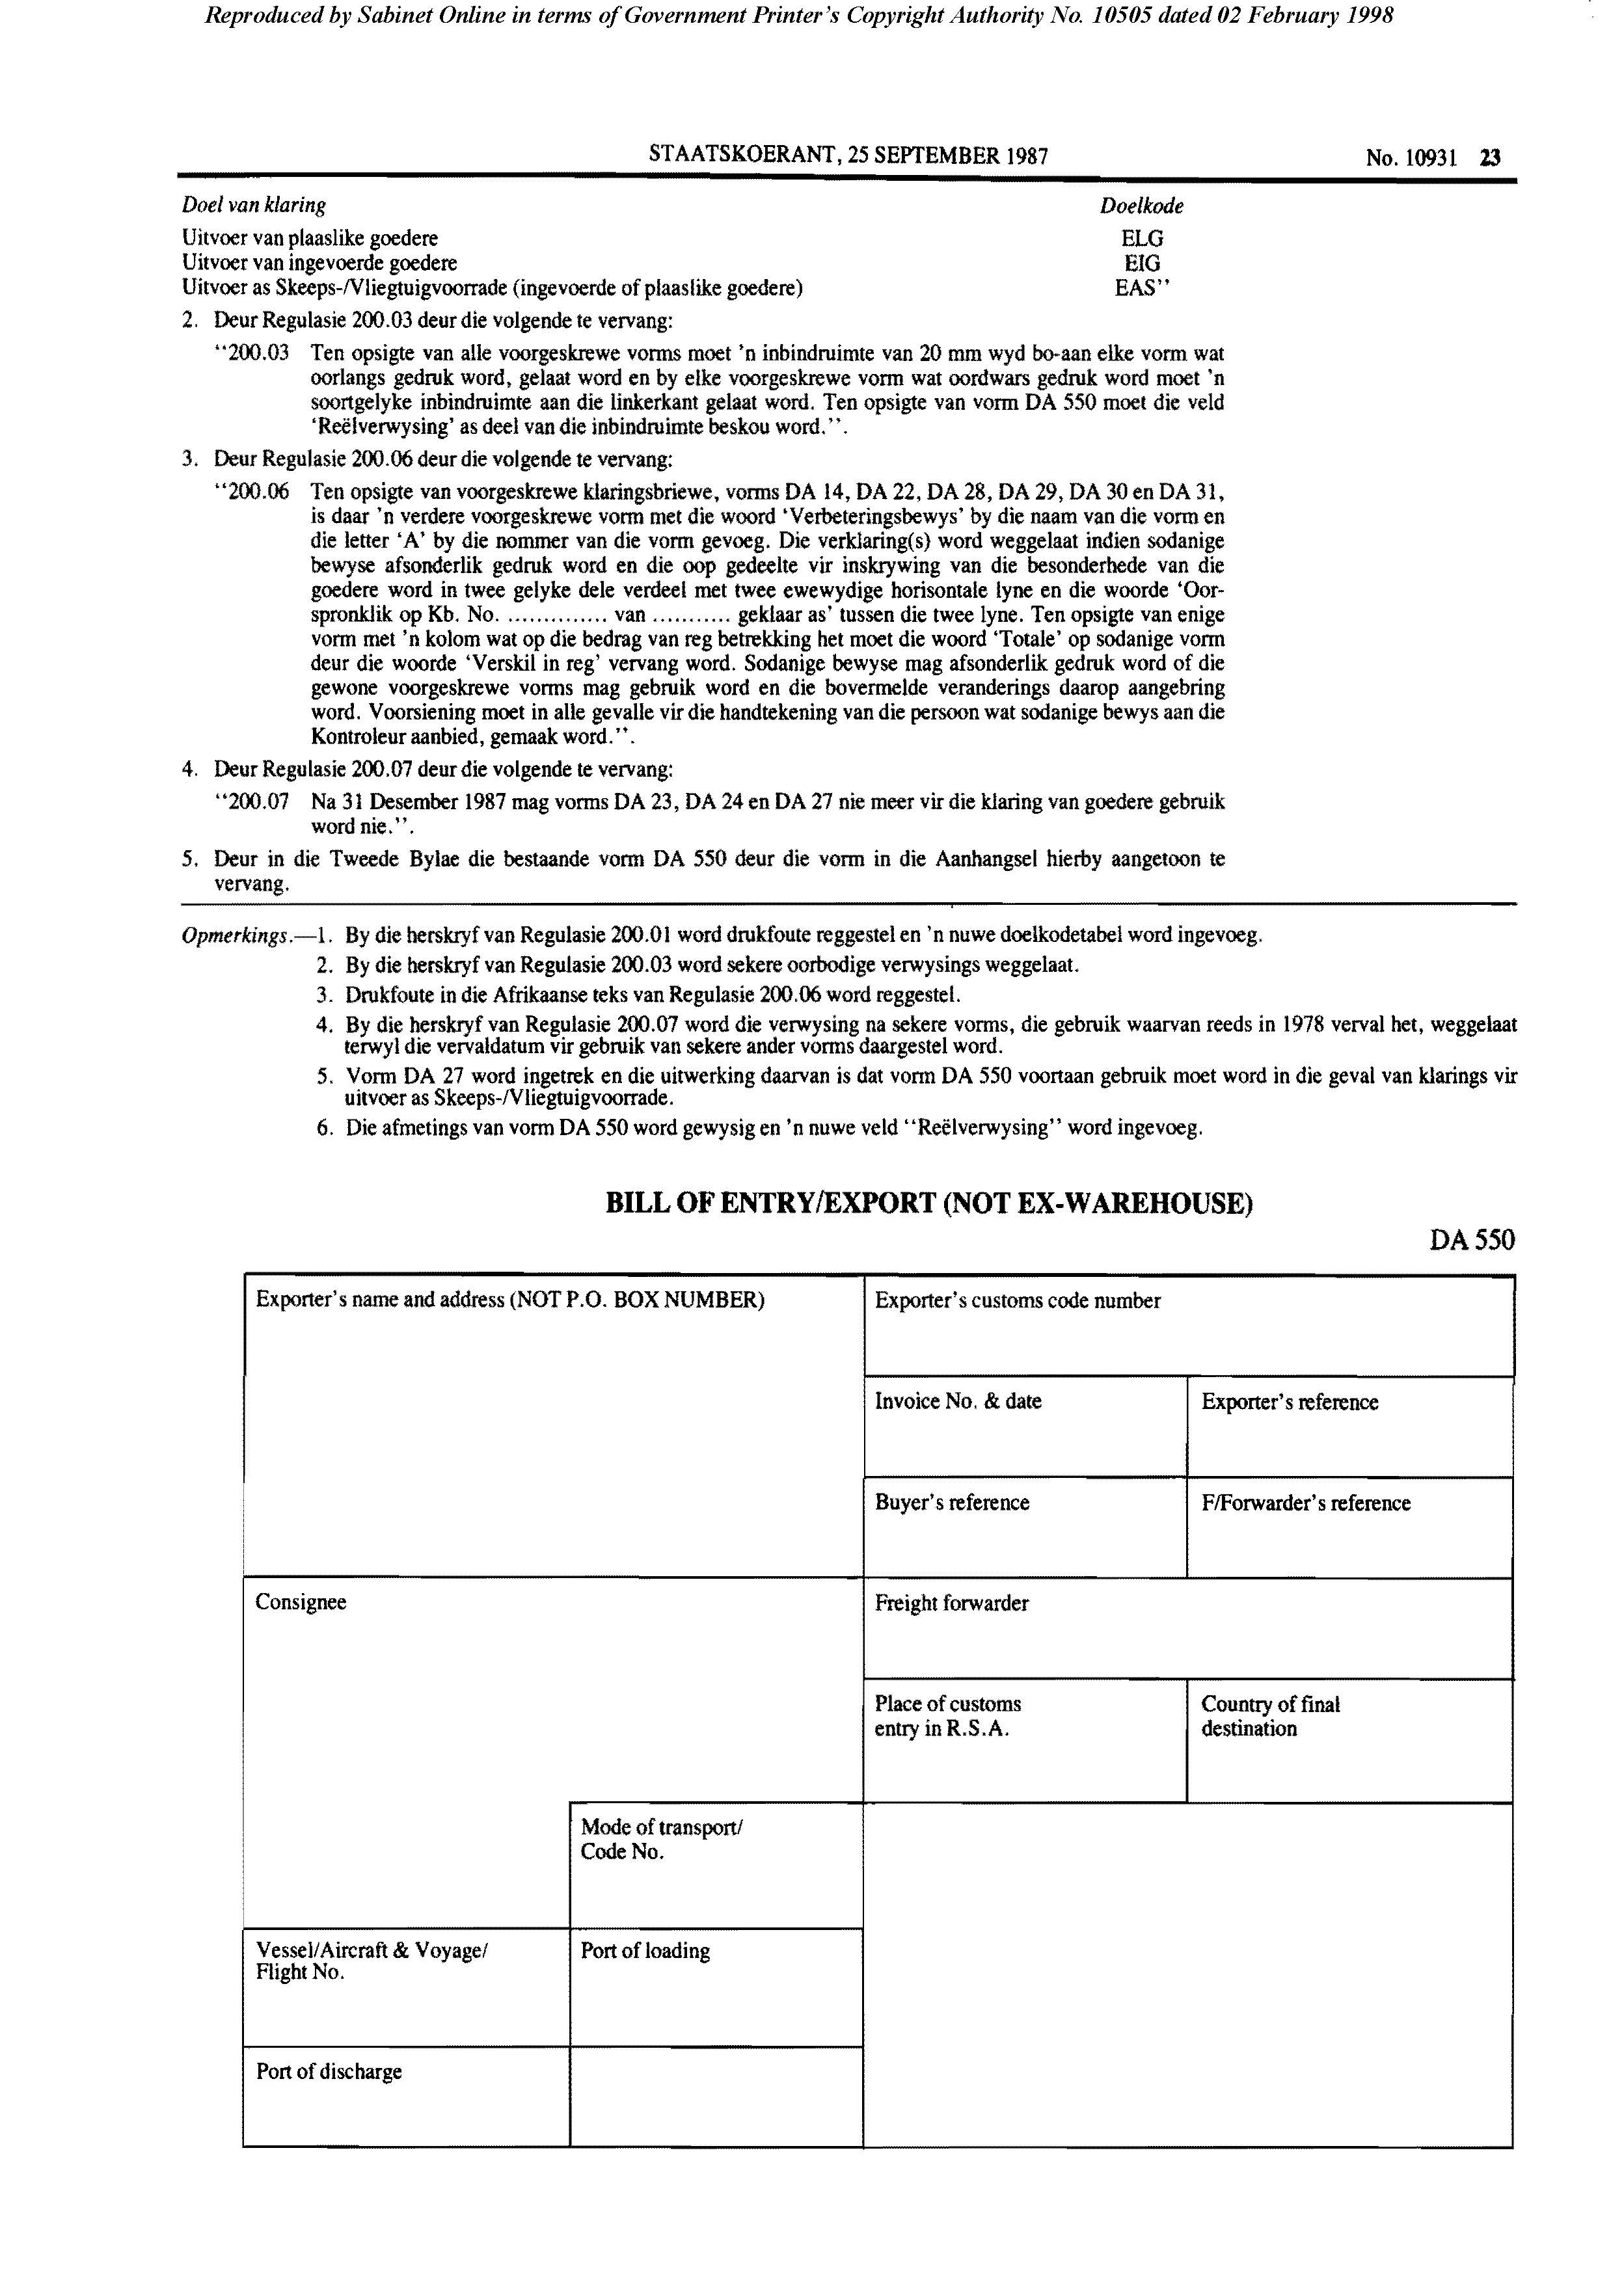

[Forms DA 570, DA 571 and DA 574 are substituted for Form DA 14 by RSA GN R.1774/1989.]

Form DA 570

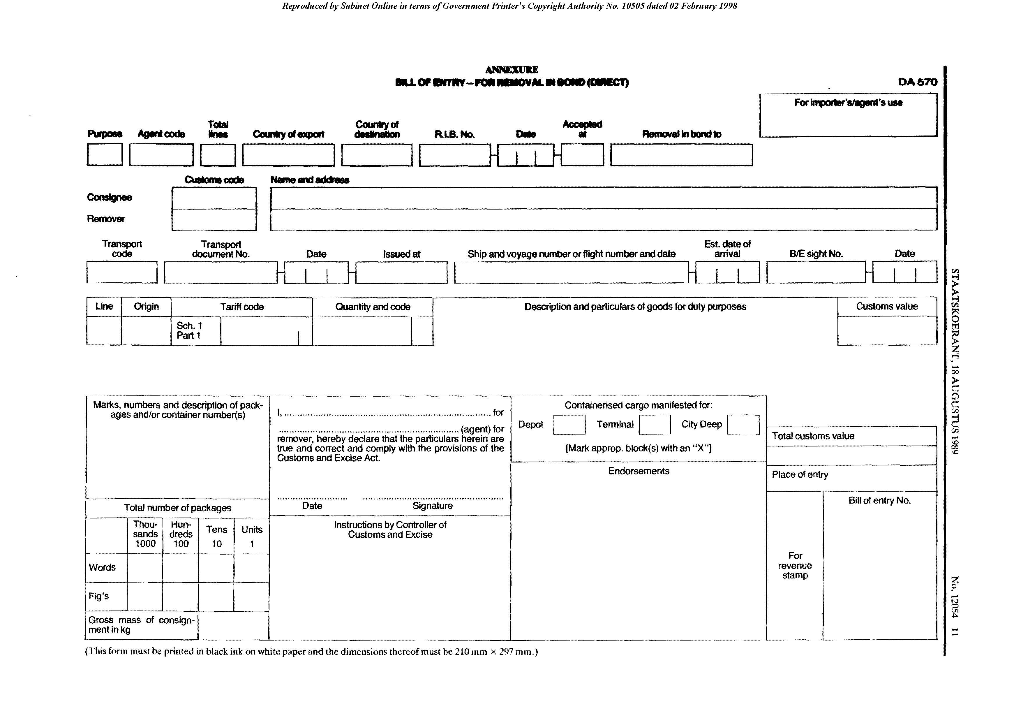

Form DA 571

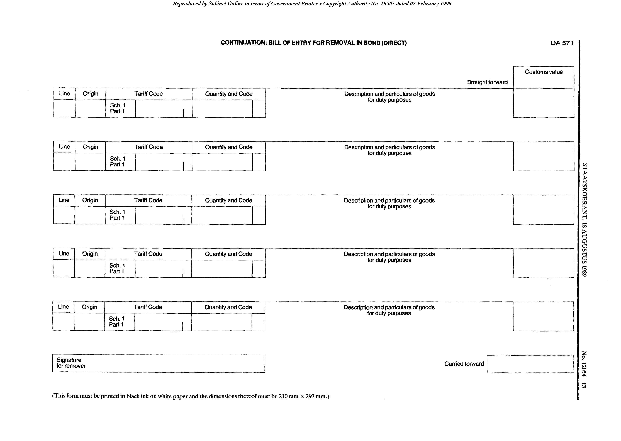

Form DA 574

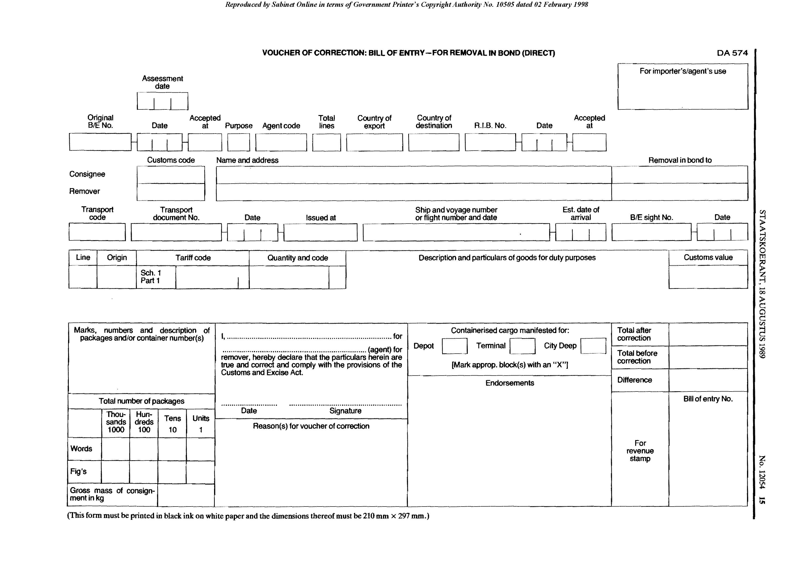

Form DA 600

[Form DA 600 is substituted for Forms DA 11, DA 13, DA 15, DA 17,
DA 19 and DA 21 by RSA GN R.1362/1978.]
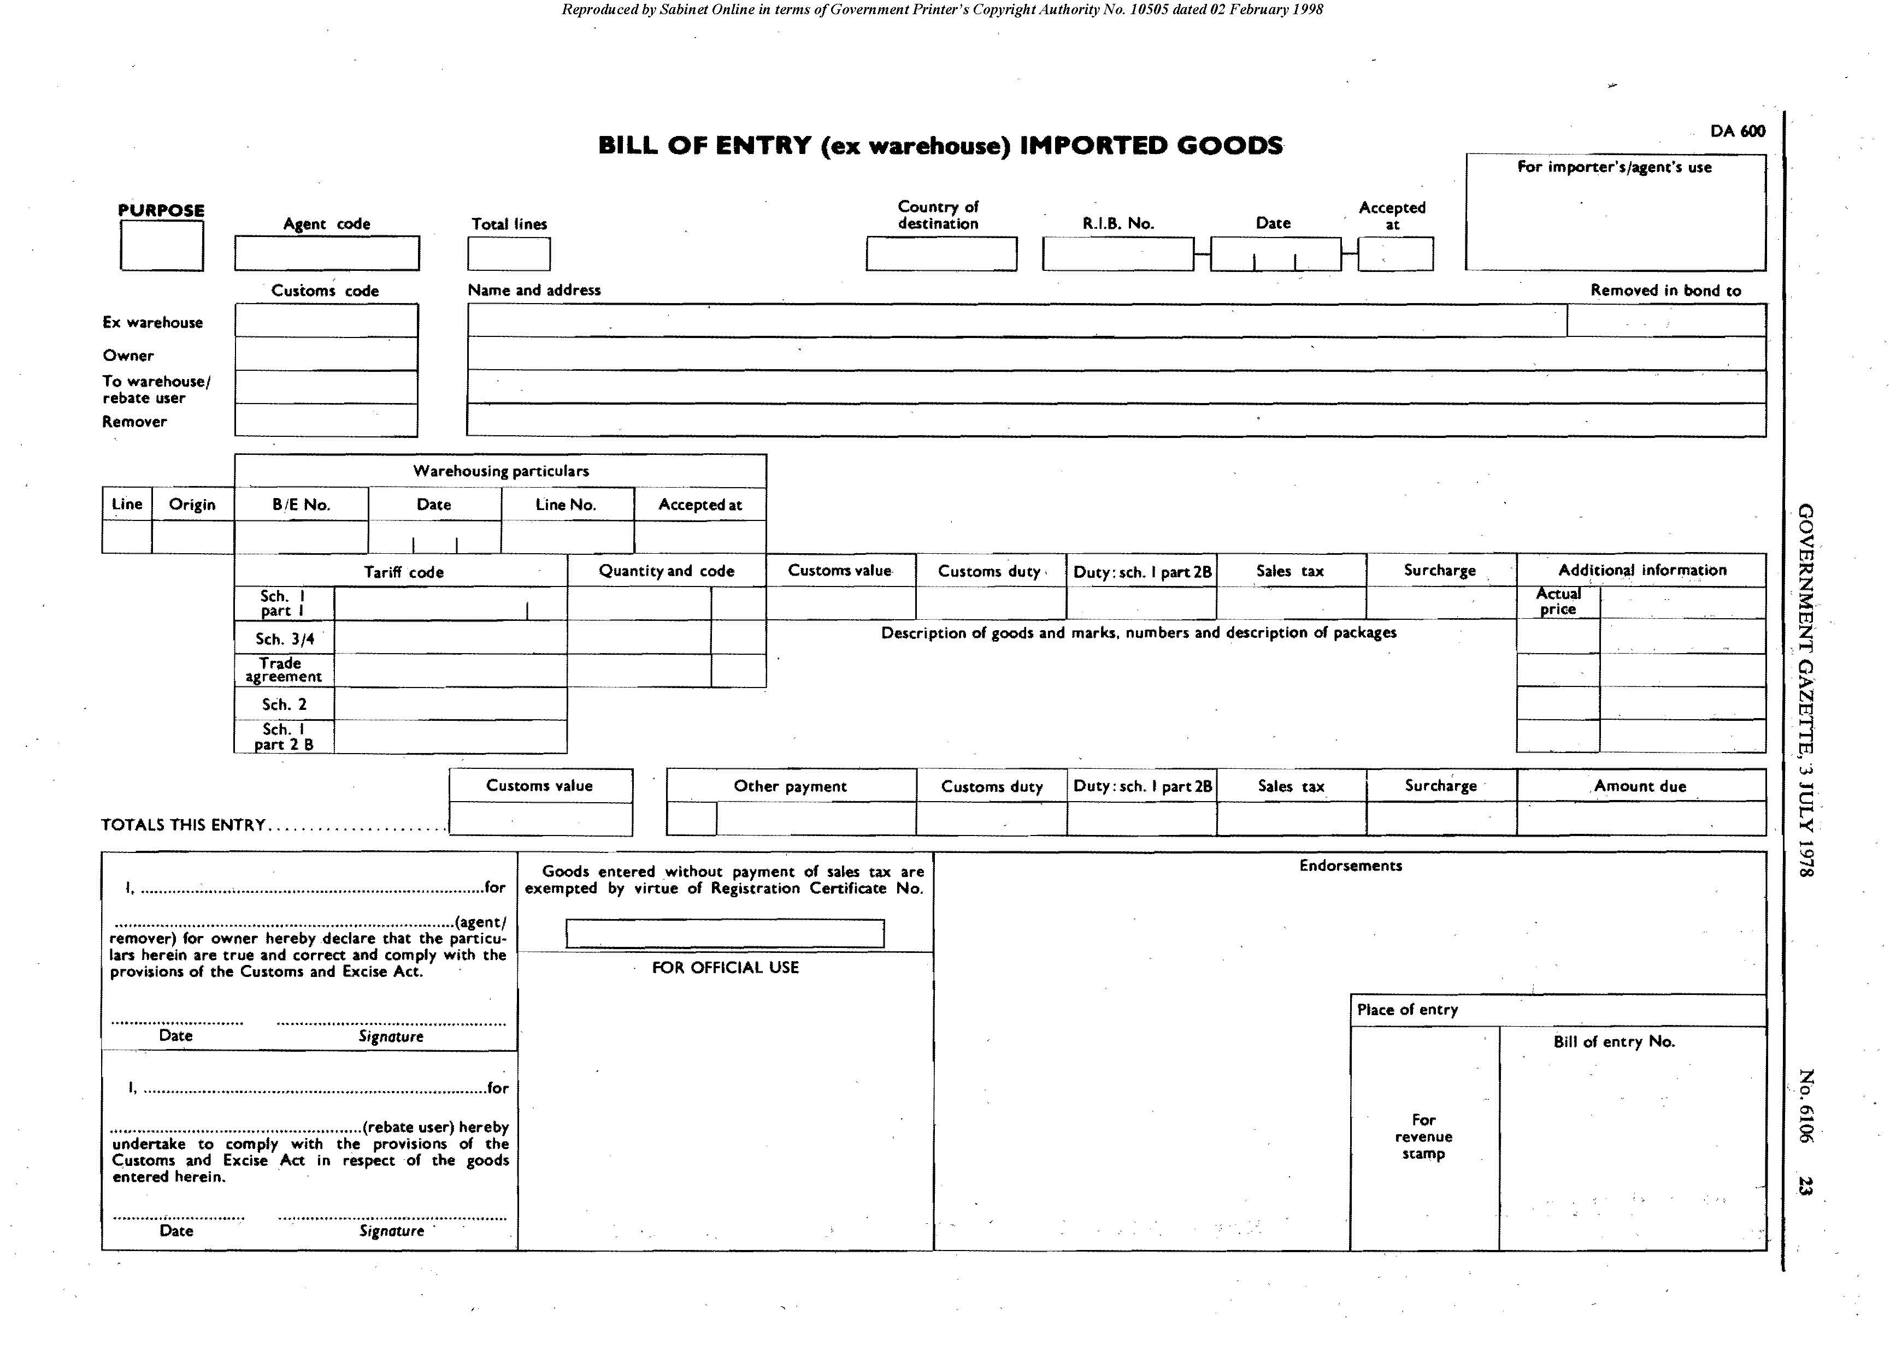

Form DA 601

[Form DA 601 is inserted by RSA GN R.1362/1978.]

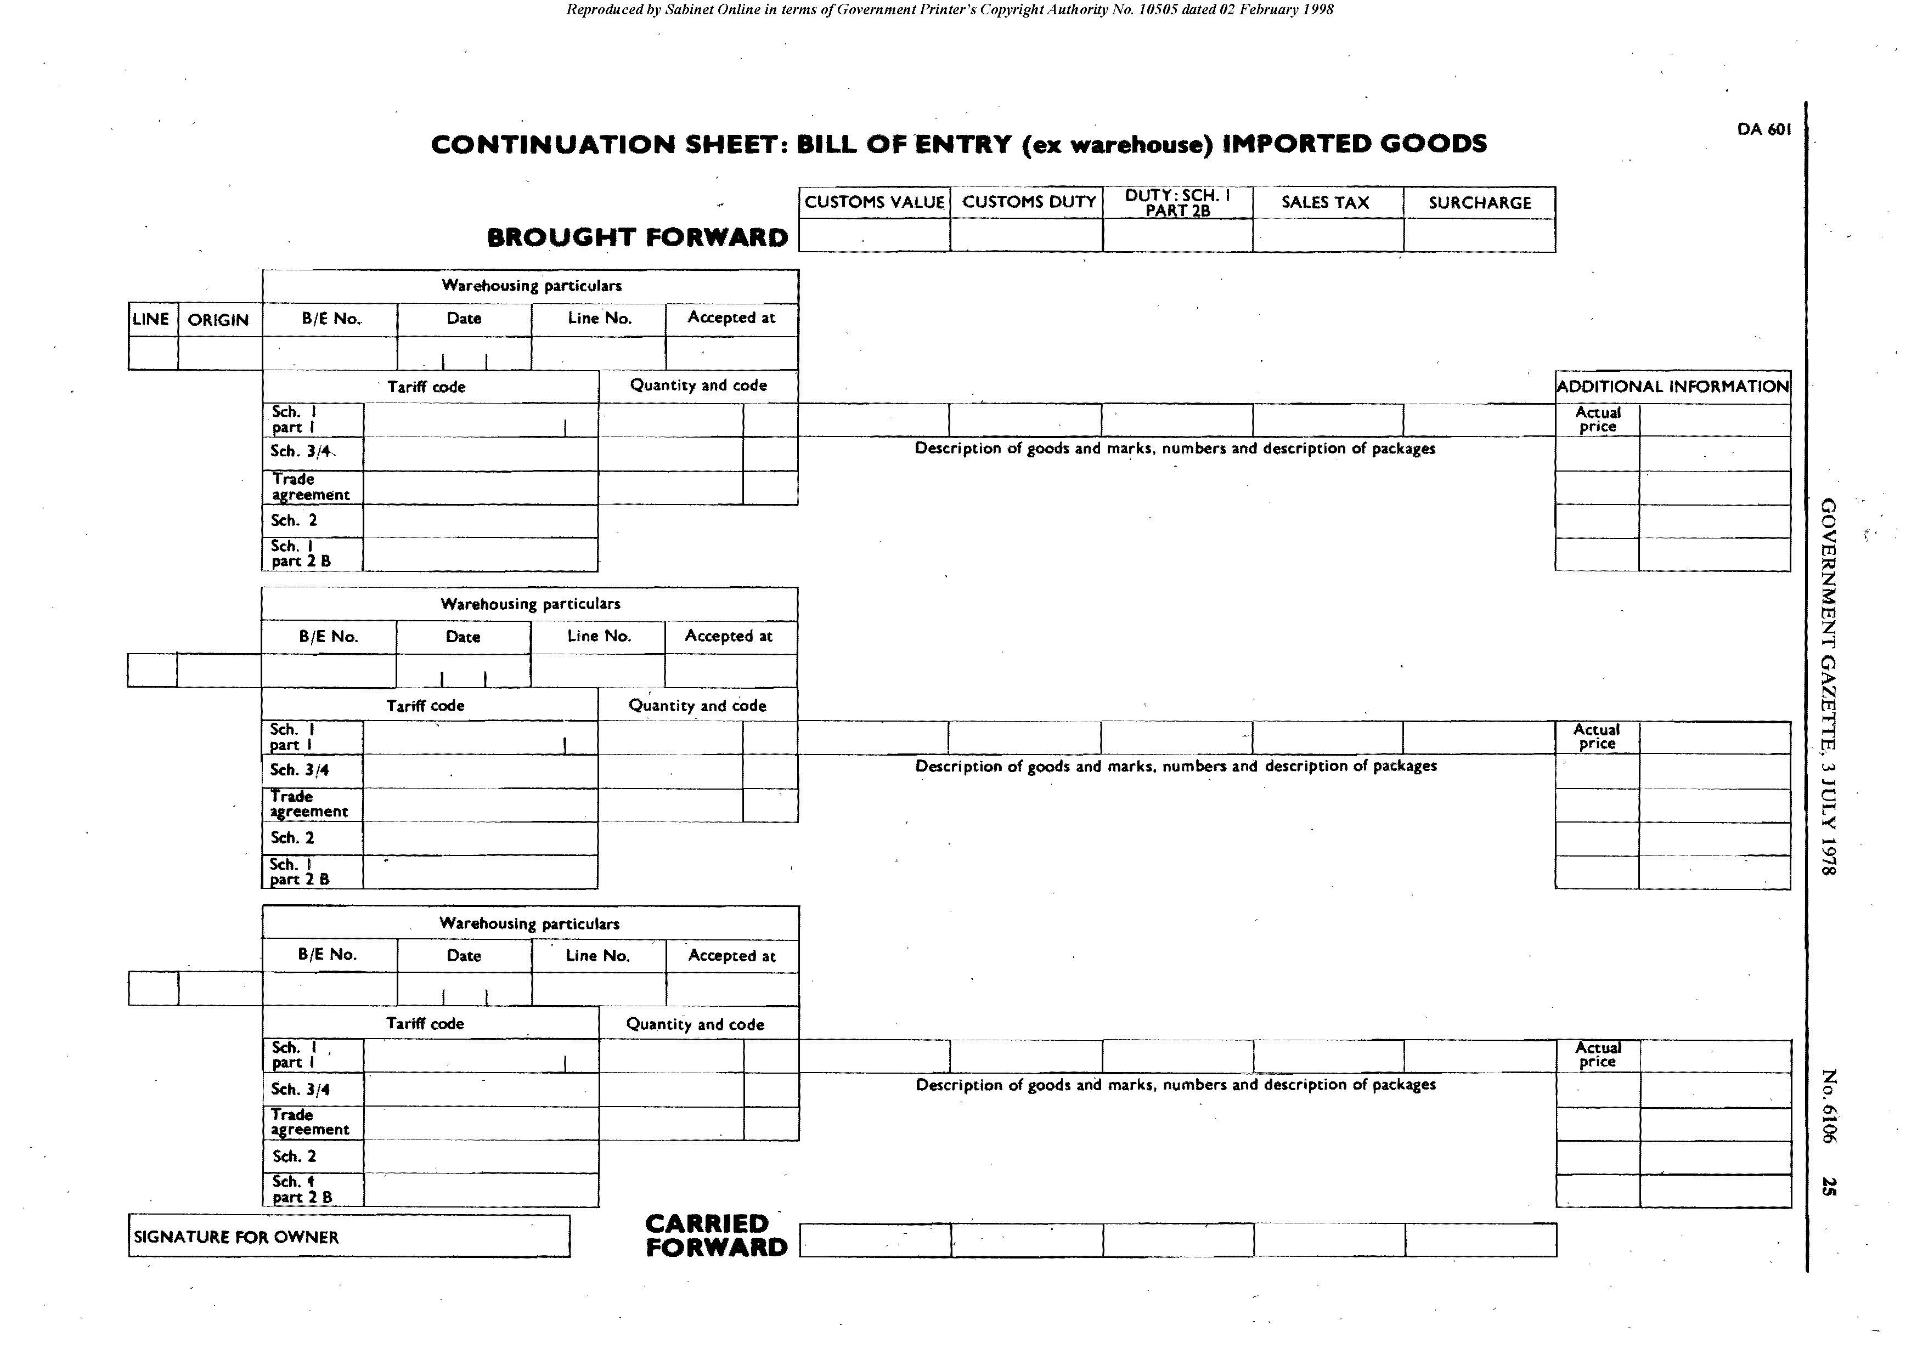

Form DA 604

[Form DA 604 is inserted by RSA GN R.1362/1978 and
substituted by RSA GN R.1202/83 and by RSA GN R.629/1984.]
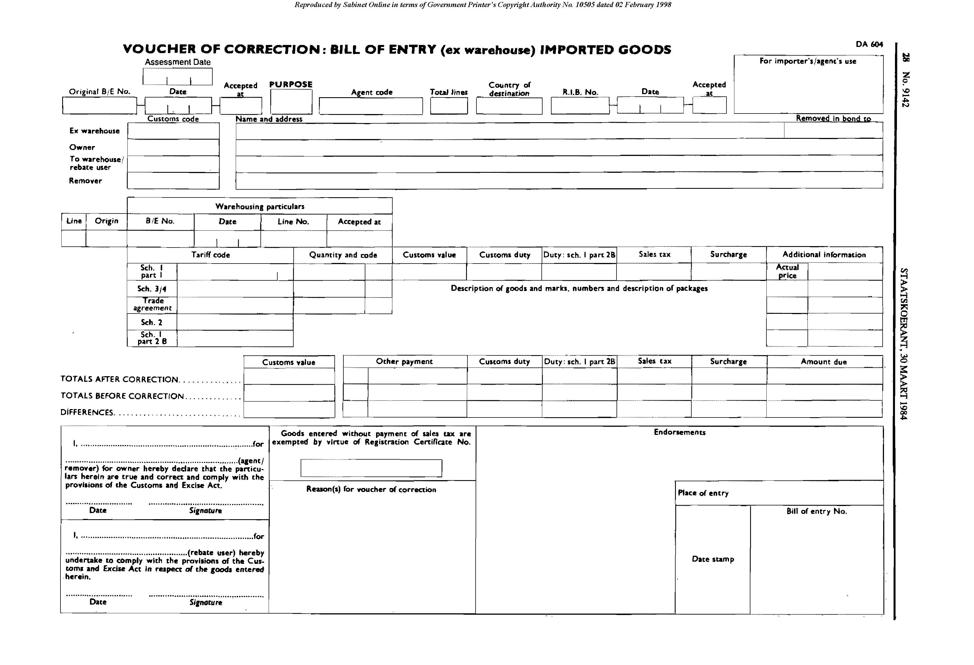

Form DA 610

[Form DA 610 is inserted by RSA GN R.1362/1978.]

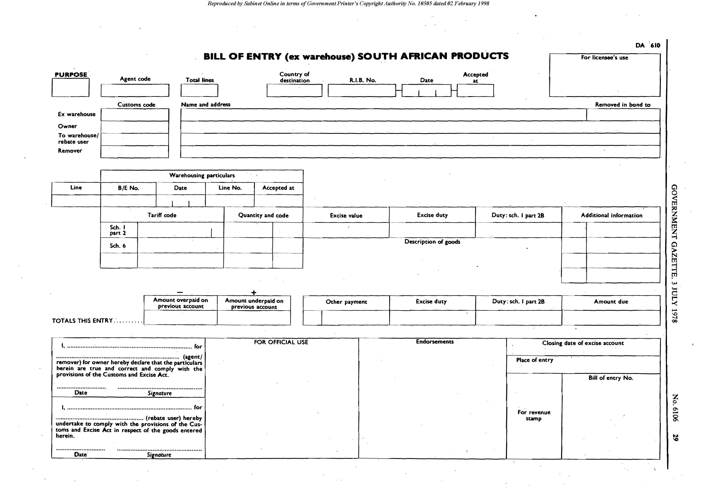

Form DA 611

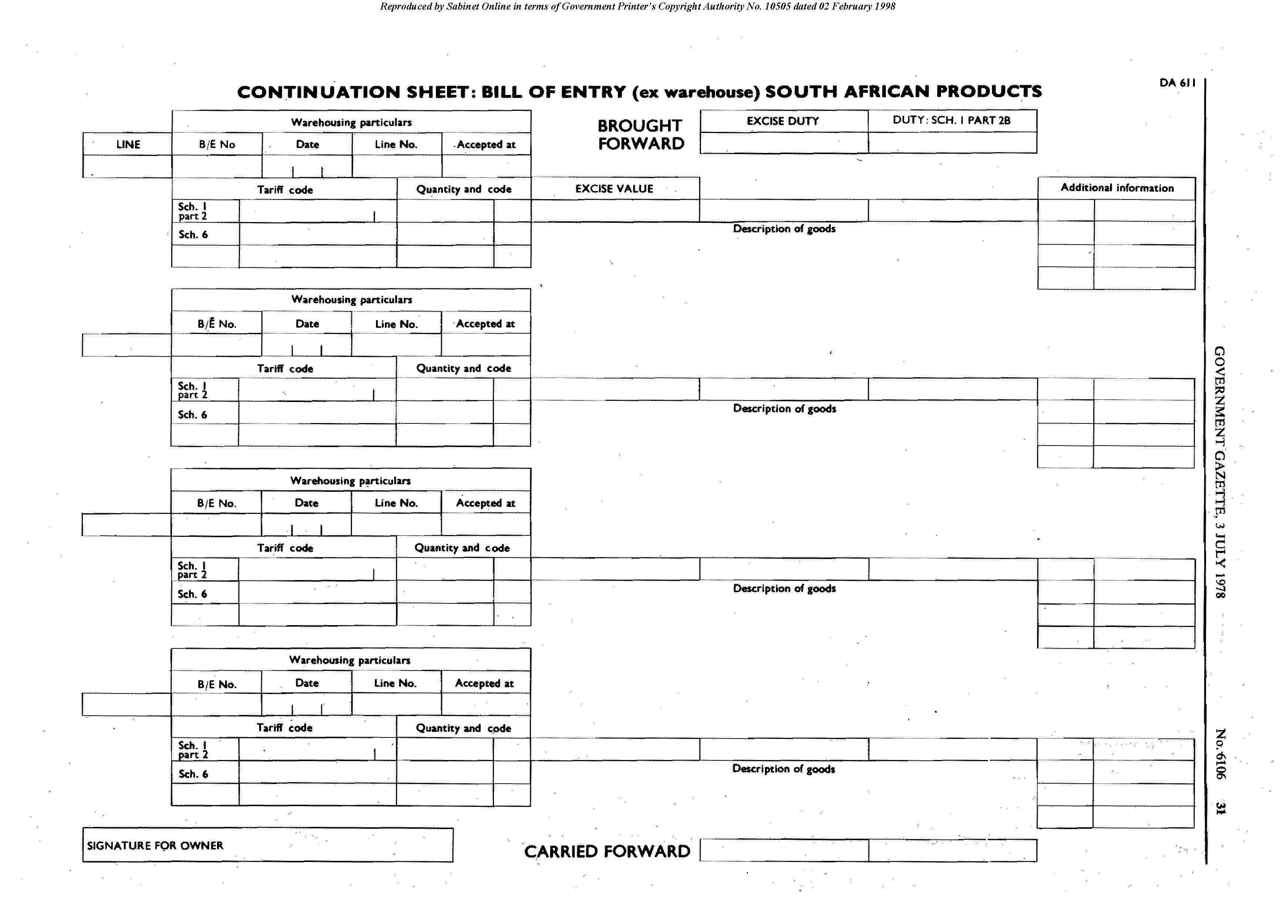
[Form DA 611 is inserted by RSA GN R.1362/1978.]

Form DA 614

[Form DA 614 is inserted by RSA GN R.1362/1978 and substituted
by RSA GN R.1202/83 with effect from 1 July 1983.]

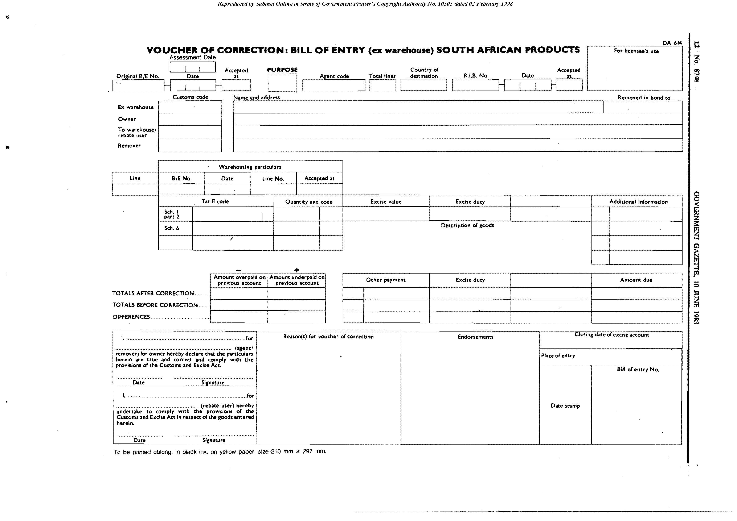

Third SCHEDULE

INDUSTRIAL REBATES OF CUSTOMS DUTIES
(Schedule No. 3 to the Act)

General regulations regarding Schedule No. 3 to the Act

300.01.01 The Secretary may, on such conditions as he may impose in each case, in respect of any goods specified in such item of Schedule No. 3 to the Act as he may decide, register a licensee of a customs and excise storage warehouse as a stockist of such goods and may permit such stockist to enter such goods under the said item and retain them unpacked in such warehouse in such a manner as the Controller requires, for supply in small quantities to persons registered to obtain such goods under such item.

300.01.02 The provisions of regulations 10.04.01 and 10.06.01 to 10.06.03 shall mutatis mutandis apply in respect of any goods referred to in regulation 300.01.01 and supplied by a stockist to any other registrant, but the Secretary may, on such conditions as he may impose, exempt stockists from the requirement of prior approval of transfer applications.

300.01.03 Any customs and excise storage warehouse approved for the purpose stated in regulation 300.01.01 shall be approved and used only for the purpose stated in the said regulation
and such warehouse and the licensee thereof shall otherwise be subject to the provisions of chapter IV of these regulations.

300.01.04 The Secretary may, on such conditions as he may impose in each case, permit a registered stockist to supply any goods referred to in regulation 300.01.01 to a person other than a registered manufacturer provided the duty on such goods is paid by such stockist at such times and in such manner as the Secretary may determine.

300.01.05 If any person registered in terms of these regulations to use any goods specified in Schedule No. 3 is reported to the Minister by the Board of Trade and Industries, because he is maintaining unsatisfactory labour conditions, and, if not less than six weeks and not more than six months after such person has been notified of such report, he is again reported to the Minister by the said Board because he has taken no adequate steps to maintain satisfactory labour conditions, his registration may be cancelled by the Minister, and in the event of such cancellation he shall thereafter not be permitted to import or receive under rebate of duty any of the goods specified in the said Schedule.

300.01.06 In addition to any other relative regulation, the undermentioned regulations shall apply in respect of the goods specified in the items of Schedule No. 3 mentioned in such regulations.

Item 301.02.

301.02.01

[Item 301.02.01 is deleted by RSA GN R.1665/1984.]

Item 304.06.

304.06.01 A manufacturer of jams from pulp entered in terms of this item shall, on demand by the Controller, either produce such jams for inspection by the Controller or furnish proof to his satisfaction that the said jams have been duly exported for consumption outside the Republic.

Item 305.02.

305.02.01 The provisions of regulation 606.04.20(1) in the Sixth Schedule hereto, shall mutatis mutandis apply in respect of petrol entered in terms of this item for mixing with locally manufactured ethyl alcohol.

Item 311.19.

311.19.01 Manufacturers registered in terms of this item shall maintain the following -

(a) records giving details of the process of conversion of the raw materials into manufactured articles (clothing, shirts, etc.) in such a manner that the use to which each consignment of goods entered under rebate of duty has been put can readily be established; and

(b) cutting orders, sales invoices and sample books which shall be available at all reasonable times for inspection by duly authorised officers, the said cutting orders, (which shall have a sample snippet of the material affixed thereto) to reflect inter alia the number and date of the bill of entry, the total number of metres entered, the rating (i.e. the number of metres required in the manufacture of each garment or unit) and the number of garments intended to be manufactured and the number actually manufactured.

Item 311.20.

311.20.01 The provisions of regulation 311.19.01 shall apply to registrants under this item.

Item 311.21.

311.21.01 The provisions of regulation 311.19.01 shall apply to registrants under this item.

Item 311.22.

311.22.01 The provisions of regulation 311.19.01 shall apply to registrants under this item.

Item 361.25.

311.25.01 The provisions of regulation 311.19.01 shall apply to registrants under this item.

FOURTH SCHEDULE

GENERAL REBATES OF CUSTOMS DUTIES
(Schedule No. 4 to the Act)

[Note that the regulations are not all numbered consecutively.]

PART 1

400.01.01 In addition to any other relative regulation, the undermentioned regulations shall apply in respect of the goods specified in the following items of Schedule No. 4.

Item 401.00.

401.00.01 Goods entered under the provisions of this item shall not be returned by the State body concerned to the supplier of such goods in the Republic without the permission of the Commissioner or payment of the duty thereon to the Controller and the supplier of such goods shall not accept any goods so returned to him until such permission has been obtained or such duty paid or otherwise until he obtains such permission or pays such duty.

401.00.02 Goods entered under the provisions of item 401.00 may be sold or disposed of in a new or unused condition by the State body concerned so as to come into the possession of or use by any person not legally entitled to obtain the same under rebate of duty without collection of the duty on such goods from the purchaser. Such duty may be retained by the department, administration, government or corporation mentioned in items 401.05 to 401.40 of Schedule No. 4.

[Regulation 401.00.02 is substituted by RSA GN R.1665/1984.]

401.00.03 Goods entered under the provisions of item 401.00 may be sold or disposed of in a used condition by the State body concerned and the selling price shall be regarded as including the duty on such goods and such duty shall be retained by such body.

[Regulation 401.00.03 is substituted by RSA GN R.1665/1984.]

401.00.04 For the purposes of regulation 401.00.03 the duty included .in the selling price shall be deemed to be as follows -

(a) goods which are free of duty - no duty included in selling price;

(b) goods (not being motor cars) liable to an ad valorem rate of duty - duty at the appropriate rate;

(c) goods (not being motor cars) liable to a specified rate of duty - one-tenth of the selling price;

(d) goods (not being motor cars) liable to an ad valorem and a specific rate of duty or to an ad valorem or a specific rate of duty - duty at the appropriate rate or one-tenth of the selling price, whichever amount of duty is greater; and

(e) motor cars classified under Tariff Heading No. 87.02.10 - one-tenth of the selling price or the full duty rebated on first entry less 10 per cent of such duty for each completed period of use of 6 months, whichever amount of duty is the greater, with a maximum, in the case of any such motor car which is sold or disposed of in terms of a subsidised scheme, of an amount calculated according to the formula -

A x (B - C)
B where -

“A” represents the full duty rebated on first entry;

“B” represents the official life kilometres determined by the State body concerned in respect of such motor car;

“C” represents the kilometres covered up to and including the date of sale or disposal.

401.00.05 The provisions of regulation 401.00.02 shall not apply in respect of medicaments and drugs entered under the provisions of this item and supplied by the State body concerned to patients directly or indirectly through any body not being a commercial concern.

401.00.06 The provisions of item 401.00 shall not be construed to debar from entry thereunder any goods which are to be supplied to any other person by the State body concerned, for further processing or incorporation into any article manufactured for such State body by such person in terms of a contract which provides that such goods so entered shall be supplied at its own expense by such State body, provided the goods so entered remain the property of such State body at all times.

401.00.07 The Commissioner may permit entry under this item of any machine or other equipment which is intended for supply to or installation in the premises of any State body mentioned in this item for use by such body on a rental basis, but on return of such machine or equipment to the supplier or on removal thereof from the premises of such body, duty thereon shall be calculated on a basis decided by the Commissioner and shall be paid forthwith to the Controller.

401.00.08 Entry of any goods under the provisions of item 401.00 shall be subject to such declaration in writing being furnished by the State body concerned on or attached to the bill of entry as is required on the relative form prescribed in these regulations.

Item 402.00.

402.00.01

[Regulation 402.00.01 is substituted by RSA GN R.923/1978
and deleted by RSA GN R.1665/1984.]

402.00.02

[Regulation 402.00.02 is deleted by RSA GN R.1665/1984.]

402.00.03

[Regulation 402.00.03 is deleted by RSA GN R.1665/1984.]

402.00.04

[Regulation 402.00.04 is deleted by RSA GN R.1665/1984.]

Item 404.00.

404.00.01 For the purposes of this item any reference to any approved public hospital shall be deemed to be a reference to any hospital with bed facilities for the general public and any reference to any approved educational institution shall be deemed to be a reference to any institution the main purpose of which is education and which is approved by the Commissioner.

404.00.02 Subject to the provisions of regulation 404.00.03 below, the provisions of regulations 401.00.01, 401.00.02, 401.00.06 and 401.00.07 in so far as they relate to the supply, return, sale or disposal of goods in a new or unused condition, shall mutatis mutandis apply to any goods [except goods referred to in paragraph (III) of item 404.01] entered under this item but any duty payable or to be collected in respect of such goods in terms of the provisions of the said regulations shall in each case be paid to the Controller.

404.00.03 The provisions of regulations 405.01.01 to 405.01.04 shall mutatis mutandis apply in respect of any goods entered under paragraph (III) of item 404.02.

Item 405.00.

405.01.01 In respect of goods entered in terms of item 405.01 the relative bill of entry shall be accompanied by or contain a declaration, signed by the Commissioner or the officer in charge of the specified association to the effect that the fabrics are intended solely for the manufacture of uniforms for the use of members of such association, or that the appointments and insignia are intended solely for the use of such members and a written undertaking shall be furnished by such Commissioner or officer that, if any of the said fabrics, appointments or insignia are sold or otherwise used or disposed of the duty due thereon will forthwith be paid to the Controller.

405.01.02 The Commissioner of officer referred to in regulation 405.01.01 shall keep a register, in a form approved by the Controller, showing receipts and disposals of fabrics, appointments and insignia on which duty has been rebated. Such register shall be open to inspection by the Controller at all reasonable times.

405.01.03 In the case of fabrics the register shall also show the quantities received, the number of uniforms made therefrom and the manner of disposal of such uniforms.

405.01.04 If fabrics entered under this item are sold or disposed of, before being made up into uniforms, by the association which so entered them, the duty thereon shall be paid to the Controller.

405.02.01 The provisions of regulations 401.00.01 and 401.00.02 insofar as they relate to the return, sale or disposal of goods in a new or unused condition, shall mutatis mutandis apply to any goods entered under item 405.02 but any duty payable or to be collected in respect of such goods in terms of the provisions of the said regulations shall in each case be paid to the Controller.

405.02.02 Any body or person entering any goods under the said item shall produce to the Controller, at the time of entry, such evidence of the licence mentioned in the said item as the Controller may require and the relative bill of entry shall contain or be accompanied by a declaration that the goods in question will be used solely for such public radio or television service and an undertaking that the duty due will be paid to the Controller on return, sale or disposal of such goods in a new or unused condition in terms of the regulations.

405.03.01 The Commissioner may permit slides (including film slides) entered for educational purposes and slides (including film slides) approved by him for instruction in industry to be entered under item 405.03 on such conditions as he may impose.

405.03.02 The Secretary may permit slides. including film slides, photographs, loudspeakers and amplifiers for use with projectors, cinematographic projectors, image projectors, portable screens for projectors and magnetic tape sound recorders and reproducers to be entered under item 405.03 by or on behalf of any member of the National Film Library or any body or person, approved by the Secretary, whose main purpose is educational (including adult or religious education) provided, that any person entering such goods on behalf of any such member, body or person, shall, at the time of entry, be in possession of a firm order by such member, body or person and that such conditions as the Secretary may impose shall be complied with.

[Regulation 405.03.02 is substituted by RSA GN R.2889/1979.]

405.03.03 The provisions of regulations 401.00.01 to 401.00.04 shall mutatis mutandis apply in respect of any goods entered under item 405.03 which are returned to the supplier thereof in the Republic or within two years of the date on which such entry was made are sold or disposed of by the member, body or other person entitled to the rebate in question arid any duty payable under the provisions of tile said regulations shall be paid to the Controller.

405.04.01 Admission under rebate of duty of any goods specified in paragraph (II) of item 405.04 shall be subject to -

(a) a certificate by the secretary or other person in charge of the body concerned, on or attached to the bill of entry in question, that such goods are intended solely for use by the blind for the manufacture of goods for sale;

(b) a written undertaking by the said secretary or other person, on or attached to the relative bill of entry, that if such goods are used for any purpose other than that specified in paragraph (a) above, or are sold or otherwise disposed of, the rebated duty will forthwith be paid to the Controller; and

(c) the keeping of a stock book by the said secretary or other person showing receipts and disposals of all goods entered under rebate of duty. The stock book and all machines, implements and unused materials entered under rebate of duty, shall at all reasonable times be available for inspection by the Controller.

[Regulation 405.04.01 is substituted by RSA GN R.1918/1974.]

405.04.02

[Regulation 405.04.02 is deleted by RSA GN R.1918/1974.]

405.05.01 Goods entered under the provisions of item 405.05 (II) shall not be returned to the supplier thereof in the Republic or transferred to any other person or sold or disposed of without the permission of the Controller. If any such goods are returned to the supplier in the Republic or transferred to any other person or sold or disposed of with the permission of the Controller in a new or unused condition, the full duty shall be paid to the Controller and if such goods are sold in a used condition duty thereon calculated on the basis of regulation 401.00.04, shall be paid to the Controller.

[Regulation 405.05.01 is substituted by RSA GN R.1665/1984.]

405.09.01 The provisions of regulation 405.05.01 shall mutatis mutandis apply in respect of goods entered under item 405.09.

[Regulation 405.09.01 is substituted by RSA GN R.1665/1984.]

Item 406.00.

406.00.01 Admission of any goods under the provisions of this item shall be subject to such written declarations as the Commissioner may require to be furnished by the representative who claims the rebate or by the Head of the Mission to which he is attached and to such other conditions as the Commissioner may impose.

406.00.02 Return to the supplier in the Republic or sale or disposal of any goods (excluding motor cars) obtained under rebate of duty by any person under this item, shall be subject to payment to the Controller in each case of duty on such goods calculated on the basis of regulations 401.00.01 to 401.00.04 if such goods are so returned, sold or disposed of within two years of the date of entry under this item.

406.00.03 Duty calculated as follows shall be payable to the Controller, after the permission of the Commissioner has been obtained, in respect of any motor vehicle which has been obtained under rebate of duty under item 406.00 and is sold or disposed of within two years of the date of entry under rebate of duty, by the person who obtained such motor vehicle under rebate of duty:

(a) | In use for less than 1 month | The full duty rebated.
(b) | In use for 1 month or more, but less than 6 months | 87½ per cent of the full duty rebated.
(c) | In use for 6 months or more, but less than 12 months | 75 per cent of the full duty rebated.
(d) | In use for 12 months or more, but not more than 24 months | 70 per cent of the full duty rebated.
(e) | In use for more than 24 months | No duty payable.

[Regulation 406.00.03 is amended by RSA GN R.1218/1976.]

Item 407.00.

407.01.01 In order to qualify for the rebate of duty in terms of item 407.01 the goods shall ­

(a) be in quantities which the Controller deems reasonable; and

(b) at the time of importation, be the personal property of the passenger and be intended for his own use and not for sale, gift or exchange.

407.03.01

[Regulation 407.03.01 is deleted by RSA GN R.861/1976.]

407.03.02

[Regulation 407.03.02 is deleted by RSA GN R.861/1976.]

407.04.01 In respect of any motor vehicle entered under item 407.04 the importer shall at the time of entry furnish the Controller with the following -

(a) such documentary evidence as the Controller may require to prove that the importer has permanently changed his residence to the Republic; and

(b) a declaration in a form approved by the Commissioner setting forth the circumstances and particulars in connection with the importation of such vehicle and incorporatin8 and undertaking in respect of the disposal of the vehicle as required by the item.

[Regulation 407.04.01 is substituted by RSA GN R.903/1976.]

407.04.02 The provisions of regulation 406.00.03 shall mutatis mutandis apply in respect of any motor vehicle entered under item 407.04.

[Regulation 407.04.02 is inserted by RSA GN R.1218/1976.]

407.05.01 The provisions of regulation 406.00.03 shall mutatis mutandis apply in respect of any motor vehicle entered under item 407.05.

[Regulation 407.05.01 is substituted by RSA GN R.903/1976 and by RSA GN R.1218/1976.]

407.06.01 In respect of any goods entered under item 407.06 the rebate of duty shall be subject to the following conditions -

(a) a declaration in a form approved by the Commissioner, signed by the head of the family, together with an inventory of all the goods being imported shall be furnished to the Controller at the time of entry;

(b) in the case of used household furniture, other household effects and other removable articles, such goods shall have been owned and used by the importer or members of his family prior to despatch;

(c) in the case of new household furniture, other household effects and other removable articles, such goods shall have been owned by the importer or members of his family prior to despatch; and

(d) the household furniture, other household effects and other removable articles will continue to be owned and used by the importer or the members of his family for a period of at least 6 months as from the date of entry thereof.

[Regulation 407.06.01 is substituted by RSA GN R.903/1976.]

Item 408.00.

408.02.01 The granting of any rebate under the provisions of item 408.02 shall be subject to the discretion of the Commissioner and to such conditions as he may impose in each case.

408.02.02 Admission of motor vehicles and motor cycles with or without side-cars, under rebate of duty in terms of item 408.02 is, in each case, subject to the production of a certificate issued by the National Council for the Care of Cripples in South Africa to the effect that -

(a) in respect of a permanently physically disabled person, whose application concerns an adapted vehicle to be driven by himself, a qualified driver’s licence has been issued to the relevant person and that the person is disabled to such an extent that he is physically incapable of personally driving an ordinary unadapted motor vehicle or motor cycle; or

(b) in respect of a quadriplegic, the relevant person is disabled to such an extent that he is by no means physically capable of personally driving any motor vehicle or motor cycle.

[Regulation 408.02.02 is substituted by RSA GN R.929/1984 and by RSA GN R.1958/1984,]

408.02.03 Written application supported by full particulars of the adaptations to the motor vehicle or motor cycle shall be submitted to the Commissioner for approval.

[Regulation 408.02.03 is substituted by RSA GN R.929/1984.]

408.02.04 The provisions of regulation 406.00.03 shall mutatis mutandis apply in respect of any motor vehicle or motor cycle entered under item 408.02.

[Regulation 408.02.04 is substituted by RSA GN R.929/1984.]

408.02.05 Admission of furniture under rebate of duty in terms of item 408.02 is, in each case, subject to acceptable evidence that such furniture has been specially manufactured or adapted for use by a permanently physically disabled person.

[Regulation 408.02.05 is inserted by RSA GN R.905/1977.]

Item 409.00.

409.01.01 In respect of goods entered in terms of item 409.01 the importer shall at the time of entry of the goods upon re-importation attach to the relative bill of entry a statement indicating -

(a) the reasons why the goods are being returned;

(b) whether any change in the ownership of the goods has taken place;

(c) whether the goods have been subjected to any process of manufacture or manipulation since their exportation from the Republic and if so, to what extent;

(d) whether the goods were manufactured in a customs and excise warehouse and exported in bond ex such warehouse;

(e) whether at the time of export, or at any other time, any refund, rebate, drawback or remission of customs or excise duty was granted in respect of such goods or any materials from which such goods were manufactured;

(f) the number and date of the bill of entry relating to the export of such goods and the place where such entry was made; and

(g) the place where duty was paid on the goods upon their first importation into the Republic, and of the number and date of the bill of entry. on which such duty was brought to account, but in the case of goods which are personal and private property and not merchandise, or which have been exported and returned by post, the Controller may accept any other evidence to his satisfaction that the goods were previously imported and that duty was paid thereon.

409.01.02 The importer or person claiming the rebate shall, if required to do so by the Controller, submit to him all documents and correspondence relating to the export and subsequent return of the goods.

409.01.03 The Commissioner may exempt any class or kind of goods not being merchandise for trade purposes from the requirement of entry upon re-importation provided the Controller is satisfied that such goods satisfy the requirements of entry under item 409.01, and he may permit the registration of any goods with the Controller, prior to export of such goods, for the purpose of subsequent re-importation thereof under the provisions of item 409.01.

409.01.04 The Commissioner may refuse to accept entry under the provisions of item 409 01 if, in his opinion, such re-importation will constitute an attempt at evasion of duty or he may accept such entry on such conditions as he may impose and payment of the difference in duty on such goods at the time of exportation and at the time of re-importation.

409.02.01 The provisions of regulations 409.01.01 to 409.01.04 shall mutatis mutandis apply to any goods entered under item 409.02.

409.03.01 A statement of the particulars of original importation into or manufacture in the Republic and payment of any duty due at that time and of the export of any goods, entered under the provisions of item 409.03 shall be attached to any entry under the said item.

409.04.01 The provisions of regulations 409.01.01 to 409.01.04 shall mutatis mutandis apply to any goods entered under item 409.04.

Item 410.00.

410.02.01 The admission of seed potatoes under the provisions of item 410.02 shall be subject to a certificate, issued by an officer of the Department of Agricultural duly appointed for the purpose, that such seed potatoes satisfy the conditions and purpose of the permit mentioned in item 410.02 in relation to seed potatoes.

[Regulation 410.02.01 is amended by RSA GN R.2770/1982.]

410.02.02 The admission under rebate of duty of any goods specified against any tariff heading under item 410.02 shall be subject to a declaration by the importer/owner on or attached to any bill of entry in respect of such goods that it will not be used or disposed of for any purpose not specified in the said item in relation to such goods without the permission of the Commissioner.

410.03.01

[Regulation 410.03.01 is deleted by RSA GN R.1665/1984.]

410.03.02 Admission under rebate of duty of any goods specified against tariff headings 34.02 and 38.06 under item 410.03 shall be subject to a declaration by the importer/owner on or attached to the bill of entry in question that such goods will not be used or disposed of for any purpose not specified against the said tariff headings without the permission of the Commissioner.

410.03.03

[Regulation 410.03.03 is deleted by RSA GN R.1665/1984.]

410.03.04 Admission under rebate of duty of any goods specified in paragraph (I) of item 410.03 shall be subject ·to the provisions of regulations 10.01.01 to 10.07.04.410.04.01

410.04.01

[Regulation 410.04.01 is substituted by RSA GN R.1088/1975 and
by RSA GN R.417/1980 and deleted by RSA GN R.2131/1984.]

410.04.02

[Regulation 410.04.02 is substituted by RSA GN R.1088/1975 and deleted by RSA GN R.2131/1984.]

410.04.03 (a) Any distillate fuels and residual fuel oils shall be entered under the provisions of paragraph (1) of tariff heading N.O. 27.10 in item 410.04 on a bill of entry for home consumption under Schedule No. 4 or 6 (ex warehouse) whether or not supplied directly ex warehouse to coasting ships, whalers, trawlers and other ocean-going fishing boats registered in the Republic (excluding such vessels used for pleasure). Where such oils so entered are not supplied directly ex warehouse to the vessels mentioned, record thereof shall be kept in such a manner that the said oils can readily be accounted for to the satisfaction of the Controller.

(b) No person shall, without the written permission of the Controller and subject to such conditions as he may impose, land at any place in the Republic any oil shipped under the said provisions.

(c) The supplier of any oil under the provisions of this regulation shall obtain from the master or owner of the ship on which such oil is shipped an acknowledgement of receipt and undertaking in a form approved by the Commissioner.

[Regulation 410.04.03 is substituted by RSA GN R.2131/1984.]

410.04.04 (1) For the purpose of this regulation -

(a) “supplier” means any of the following companies -

BP Southern Africa (Ply) Limited;
BP South West Limited;
Caltex Oil (S.A.) (Ply) Limited;
Caltex Oil (S.W.A.) (Ply) Limited;
Esso Standard South Africa (Ply) Limited;
Mobil Oil Southern Africa (Ply) Limited;
Mobil Oil South West Africa (Ply) Limited;
Sasol Marketing Company Limited;
Shell South Africa (Ply) Limited;
Shell South West Africa Limited;
Sonarep (South Africa) (Ply) Limited;
Total South Africa (Ply) Limited;
Total South West Africa (Ply) Limited;
Trek Petroleum (Ply) Limited;

(b) “reseller” means any person who deals in rebated fuel as defined in subparagraph (c) in the course of or as part of the activities of a business carried on by him, but excluding any person who supplies such fuel to any other person in terms of a contract of letting or hiring of work or services;

(c) “rebated fuel” means distillate fuels or residual fuel oils entered under rebate of duty in terms of section 75(4A) for the purposes or uses mentioned in paragraphs (2) to (6) of tariff heading No. 27.10 of item 410.04;

(d) “user” means any person who obtains rebated fuel for the purposes mentioned in paragraphs (2) to (6) of tariff heading No. 27.10 of item 410.04 and includes any person who supplies such fuel to any other person in terms of a contract of letting or hiring of work or services.

(2) No person shall be entitled to be supplied with rebated fuel, unless, at the time of purchase or delivery thereof he furnishes the supplier or reseller with a declaration form DA 137 or DA 138, as the case may be, and no supplier or reseller shall supply or sell rebated fuel unless the person to whom it is supplied or sold, has complied with the provisions of this paragraph: Provided that the Commissioner may allow in lieu of a separate declaration, the furnishing of a blanket declaration form DA 139 or DA 140, as the case may be, for purchases or deliveries in bulk quantities of not less than 200 litres per container other than pump deliveries into vehicle fuel tanks: Provided further that a supplier or a reseller may deliver rebated fuel purchased in terms of the provisions of paragraphs (4) and (5) of tariff heading No. 27.10 of item 410.04 in any quantities and in any manner, except as provided for in regulation 410.04.04(4), provided a blanket declaration has been furnished to such supplier or reseller.

(3) The blanket declaration provided for in paragraph (2) or the benefits it confers shall not be transferable.

(4) No supplier or reseller shall dispense rebated fuel into a vehicle fuel tank from a tanker lorry or trailer or other portable or mobile container.

(5) Any reseller of rebated fuel may -

(a) purchase it at a price which includes any of the effective rates of duty;

(b) sell it at a price which includes any duty equal to or in excess of the 365c per 1 000 litres duty paid by the supplier on entering such fuel for home consumption;

(c) use it in the ordinary course of his business or dispose thereof in circumstances which render it liable to duty equal to or in excess of 365c per 1 000 litres; or

(d) mix it in his fixed vessel with distillate fuel or residual fuel oil on which the full duty has been paid,

provided he alternates his purchases on each occasion at prices which include the different effective rates of duty to the extent that such purchases are duly reconciled with sales, disposals or uses of such fuel in circumstances which render it liable to different effective rates of duty.

(6) No supplier or reseller shall supply, sell, otherwise dispose of or use rebated fuel unless a numbered and dated invoice is issued indicating the quantity, price, buyer’s name and business address and the registration letters and numbers of the vehicle when it is supplied as fuel into the tank of such vehicle.

(7) A supplier or reseller shall keep declarations (excluding blanket declarations) with the copies of the relative invoices issued by him.

(8) The supply or sale of rebated fuel under cover of invoices or declarations which are not completed in all respects shall be regarded as being in conflict with the manner and conditions mentioned in this regulation and such supplier or reseller shall be liable for the duty thereon as provided for in section 75(4A): Provided that a supplier or reseller shall be allowed a period of 60 days from the date of receipt of a blanket declaration which is not complete in all respects to have such declaration completed.

(9) Any supplier of rebated fuel shall keep a monthly reconciliation of opening stock, receipts, total supplied, sold or used and closing stock of such fuel and shall render to the Controller in addition to the return specified in paragraph (13) such returns in the form and at the times as the Commissioner may determine.

(10) (a) Any reseller of rebated fuel shall be registered with the Commissioner to obtain such fuel.

(b) Any reseller of rebated fuel shall keep a bound register in which at least the following particulars shall be entered on a daily basis:

(i) Total purchases and total quantity supplied, sold or used in respect of each of the rebated fuels subject to the different extents of rebate of duty;

(ii) total quantity of rebated fuel supplied or sold at a price which includes the full duty or used or disposed of in any circumstances which render it liable to such full duty;

(iii) purchases and sales of distillate fuels or residual fuel oils at a price which includes the full duty.

(c) The register shall be balanced on a three monthly basis and opening and closing stocks as well as any deficiency or surplus must be reflected therein.

(d) The register shall contain a declaration certifying to the correctness of all entries made therein. Such declaration shall be entered in the register at the end of each three monthly period and shall, in the case of a sole proprietorship be given by the owner, in the case of a partnership by a partner and in the case of a company by a director, manager, secretary or accountant.

(e) The books, documents and stocks of a registrant shall at all reasonable times be open for inspection by the Controller.

(f) A registrant shall notify the Controller immediately, or in advance, of any change, no matter of what nature, in his legal identity, the name under which he trades and the address of his premises.

(g) The Commissioner may, at any time, call upon the registrant to submit a statement of account in a form approved by him.

(h) Any reseller who supplies. sells, disposes of or uses rebated fuel without the declaration mentioned in paragraph (2) having been obtained or in any manner whatsoever in circumstances where the full duty is due in terms of section 75(4A) and these regulations, shall purchase distillate fuel or residual fuel oil from the supplier at a price inclusive of the full duty in substitution of rebated fuel for the purpose of the reconciliation referred to in paragraph (5).

(11) (a) Any supplier who uses or who supplies or sells rebated fuel to resellers, users or any other person -

(i) at a price which includes any duty in excess of the 365c per 1 000 litres duty paid on entering such fuel for home consumption; or

(ii) for a purpose which renders it liable to duty in excess of 365c per 1 000 litres; or

(iii) without the declaration mentioned in paragraph (2) having been furnished or obtained; or

(iv) in any manner whatsoever in circumstances where duty is due in terms of section 75 (4A) and these regulations,

shall pay the duty due, in excess of the 365c per 1 000 litres paid on entering such fuel for home consumption, within 30 days after the date of closing of his accounts for the month in which such supply, sale, disposal or use took place.

(b) The payment of duty mentioned in subparagraph (a) shall be made in a single amount to the Controller in whose area of control such supplier is situated or to such other Controller as the Commissioner may determine.

(12) (a) Any user of rebated fuel subject to different extents of rebate of duty may receive and mix it with distillate fuel or residual fuel oil on which the full duty has been paid in his fixed vessel provided such user, other than a supplier who uses such rebated fuel in the ordinary course of his business, alternates his purchases on each occasion at prices which include the different effective rates to the extent that such purchases are duly reconciled with uses of rebated fuel in circumstances which render it liable to a different effective rate of duty.

(b) Failure to balance purchases with uses as provided for in paragraph (a) shall be deemed to be application of rebated fuel contrary to the provisions of the rebate item under which it was acquired and shall render such act and such fuel subject to the provisions of section 75(5)(b).

(13) (a) A supplier of rebated fuel shall furnish to the Controller in the form approved by the Commissioner and at the times required by him, a return for any period of three months as indicated by him, which shall include -

(i) depot number;

(ii) name, address and account number of purchaser;

(iii) invoice number and date;

(iv) quantity supplied at each effective rate of duty;

(v) names and addresses of resellers purchasing rebated fuel at a price which includes any of the effective rates of duty;

(vi) a progressive total of rebated fuel supplied to each purchaser at each effective rate of duty during any accounting year of the supplier.

(b) A supplier shall maintain a record at his head office reflecting separate quantities of rebated fuel supplied or sold at prices which include in each case a rate of duty in excess of 365c per 1 000 litres.

(14) (a) Any supplier or reseller shall keep safely copies of the required invoices of purchases, supply or sales, disposals or uses, declarations (including blanket declarations which shall be kept in alphabetical order), the returns and such other books and documents relating to such purchases, supply or sales, disposals or uses, as the Commissioner may require, for a period of two years from the date of such purchases, supply or sales, disposals or uses and have them available at all reasonable times for inspection by the Controller.

(b) Any user who -

(i) obtains rebated fuel; or

(ii) obtains rebated fuel as well as distillate fuel or residual fuel oil on which the full duty bas been paid, shall keep safely all invoices and receipts, a record of use in the form approved by the Commissioner and such other books and documents as the Commissioner may require, for a period of two years from the date of use and have them available at all reasonable times for inspection by the Controller.

(15) Copies of sections 75(4A) and (5), the relevant rebate items and these regulations shall be kept in a safe place in the office of the supplier or reseller of rebated fuel.

[Paragraph (15) is substituted by RSA GN R.2131/1984.]

[Regulation 410.01.04 is substituted by RSA GN R.1356/1983.]

Item 411.00.

411.00.01 (a) Admission under rebate of duty of any goods provided for in item 41l.00 shall, where applicable, be ·subject to a written declaration being furnished by the importer on or attached to the bill of entry in respect of such goods that it will be used only for the purposes specified and will not be used or disposed of for any other purpose without the permission of the Commissioner.

(b) Admission of any goods as aforesaid shall further be subject to such conditions as the Commissioner may impose including compliance with any regulation in Chapter IV thereof.

Item 412.00.

412.01.01 In respect of goods entered in terms of item 412.01 the relative bill of entry shall contain a declaration or be accompanied by a declaration, signed by the head of a Government department that -

(a) the goods in question are imported solely for experimental purposes;

(b) the importer has been authorised to conduct such experiments, which shall be specified;

(c) such experiments are in the public interest and will be carried out under the control or supervision of the aforesaid department; and

the relative bill of entry shall also contain a declaration, or be accompanied by a declaration by the importer that the goods so admitted under rebate will be used solely for experimental purposes, as well as an undertaking in writing by him that, if the goods or any portion thereof are sold, used or disposed of for any other purpose, the duty due thereon will be paid forthwith to the Commissioner.

412.03.01 Admission of any goods under the provisions of item 412.03 shall be subject to a written statement of the circumstances and particulars of the bequest and that the goods are for the importer’s own use and not for sale being furnished by the importer on or attached to the relative bill of entry and to production to the Controller of such evidence relating to such bequests as the Controller may require.

412.04.01 The provisions of regulation 412.03.01 shall mutatis mutandis apply in respect of any goods entered under the provisions of item 412.04.

412.07.01 Any offer to abandon any goods to the Office or application to destroy any goods under the provisions of item 412.07 shall be subject to the following conditions -

(a) it shall be made in writing by or on behalf of the owner of the goods and shall indemnify the Office against any claim by any other person;

(b) it shall be unconditional;

(c) it shall state the full identifying particulars and description of the goods in question;

(d) it shall state the reason for abandonment or the reason why destruction and not abandonment is requested;

(e) it shall furnish full particulars of the place of entry and the number and date of the warehousing or other bill of entry in respect of the goods in question;

(f) it shall be accompanied by the invoices and other documents relating to the importation of such goods;

(g) the owner shall be responsible for the cost of storage in and removal to the State warehouse or any place of security indicated by the Commissioner as well as for any other expenses including the cost of destruction, if any: Provided that removal need not be insisted upon; and

(h) it shall be destroyed under the supervision of an officer if destruction is authorised by the Commissioner.

412.07.02 For the purposes of item 412.07 goods in respect of which security of the duty due has been furnished to the Office are to be taken to be still under the control of the Office.

412.08.01 Any loss in respect of which a rebate of duty is claimed under the provisions of item 412.08 shall be proved to the satisfaction of the Commissioner.

412.08.02 Any application for a rebate or duty under the provisions of item 412.08 shall be submitted to the Controller on a form approved by the Commissioner and shall be accompanied by such documents as the Commissioner may specify.

412.15.01 Admission under rebate of duty of any goods specified in and entered under item 412.15 shall be subject to a declaration, on or attached to the relative bill of entry, signed by the Chief of the South African Defence Force or a person designated by him, certifying that such goods are for sale to and consumption by members of the South African Defence or Police Force at places approved by the Secretary, while such members are serving on the borders of the Republic.

[Regulation 412.15.01 is substituted by RSA GN R.2046/1974.]

412.15.02 Proper records reflecting the nature and quantity of all goods ordered for clearance under item 412.15, those actually received, those supplied to frontier posts and those on hand, shall be kept and such shall be available for inspection by the Commissioner.

412.15.03 A monthly return, in a form approved by the Commissioner, reflecting the particulars prescribed by regulation 412.15.02, shall be submitted to the Commissioner within seven days after the end of the end of the month in respect of which the return is rendered.

412.15.04 A quarterly certificate, in a form approved by the Commissioner and signed by the Chief of the S.A. Army or a person designated by him, to the effect that the goods received at the frontier posts from the central supply depot were sold in reasonable quantities to approved members of the forces only or are still in stock, shall be submitted to the Commissioner within seven days from the end of the quarter in respect of which the certificate is rendered.

PART 2

TEMPORARY REBATES OF CUSTOMS DUTIES

460.23.01 Goods cleared in terms of the provisions of this item may not without the permission of the Commissioner and payment of the full duty thereon to the Controller be returned to the supplier of such goods in the Republic and the supplier of such goods in the Republic shall not accept any such goods so returned to him before such permission has been obtained and such duty has been paid or otherwise before such permission is obtained and such duty is paid by him.

460.23.02 Goods cleared in terms of the provisions of this item, shall not be used or retained for use by the person for whom they were so cleared, in a new or unused condition for any purpose other than as provided for in the item and shall not be transferred or sold or disposed of by him to any other person without the permission of the Commissioner and before the full duty due thereon has been paid to the Controller.

460.23.03 Goods cleared in terms of the provisions of this item which, with the permission of the Commissioner, are used or retained for use by the person for whom they were so cleared for any purpose other .than as provided for in the item or transferred or sold or disposed of by him to any other person after a period of use in terms of the provisions of the item by the person for whom they were so cleared, are subject to payment of duty to the Controller by the person for whom they were so cleared on the undermentioned basis and such duty shall, for purposes of calculation thereof, be deemed to be included in any selling price -

(a) | goods which are free of duty - | no duty included in selling price;
(b) | goods (not being motor cars) liable to an ad valorem rate of duty - | duty at the appropriate rate;
(c) | goods (not being motor cars) liable to a specific rate of duty - | one-tenth of the selling price;
(d) | goods (not being motor cars) liable to an ad valorem and a specific rate of duty or to an ad valorem or a specific rate of duty - | duty at the appropriate rate or one-tenth of the selling price, whichever amount of duty is greater; and
(e) | motor cars classified under tariff heading 87.02.10 - | one-tenth of the selling price or the full duty rebated on the first entry under rebate less 10 per cent of such duty for each completed period of six months, whichever amount of duty is greater.

PART 3

[Part 3 is substituted by RSA GN R.861/1976.]

TEMPORARY ADMISSION OF GOODS UNDER REBATE OF CUSTOMS DUTIES

Item 470.00

470.00.01 The temporary admission of any goods under the provisions of item 470.00 shall be subject in each case to -

(a) such procedure;

(b) examination at time of importation and exportation;

(c) marking for the purpose of subsequent identification;

(d) method of entry on importation and exportation;

(e) provision of security in the form of a cash deposit or bond furnished by a recognised bank or insurance institution in an amount not exceeding the duty involved: Provided that in respect of persons who regularly use the temporary admission procedure, general security may be accepted or where payment of any duty due can be secured by other means, the requirement for security may be waived; and

(f) such other conditions;

as the Commissioner may impose.

470.00.02 Temporary admission of any goods under item 470.00 shall be subject to the provisions of regulations 10.01.01 to 10.07.04, to the extent that the Commissioner may require.

470.00.03 Goods admitted under the provisions of item 470.00 shall on importation/exportation be entered in terms of section 38 of the Act. Such entries shall be coded separately for statistical purposes.

[Regulation 470.00.03 is substituted by RSA GN R.2442/1985.]

470.00.04 The importer shall, if required by the Controller, produce a copy of the contract entered into with the owner in terms of which the imported goods are to be processed, repaired, cleaned or reconditioned for export.

470.00.05 The Commissioner shall require the importer to register with him a rate of yield of the processed goods that will be obtained per unit of the imported goods. The rate of yield may be verified by the Controller by reference to the manufacturing process.

470.00.06 Goods admitted under the provisions of item 470.00 shall be exported within six months from the date of entry thereof or within such further period as the Commissioner may, in exceptional circumstances, allow.

470.00.07 Liability for the duty on any goods admitted under item 470.00 shall cease on production of proof of export of such goods.

470.03.01

[Regulation 470.03.01 is inserted by RSA GN R.2461/1979
and deleted by RSA GN R.2442/1985.]

470.03.02 Goods admitted in terms of the provisions of item 470.03 must be used in the processing or manufacture of goods for export and such processed or manufactured goods must notwithstanding the provisions of regulation 470.00.06 be exported within 12 months form the date of entry of the imported goods or within such further period as the Commissioner, in exceptional circumstances, allows. Application for such extension must be made in writing and must reach the Commissioner prior to expiry of the 12 months period.

[Regulation 470.03.02 is inserted by RSA GN R.2461/1979
and substituted by RSA GN R.2442/1985.]

470.03.03 Goods entered in terms of the provisions of item 470.03 or goods processed or manufactured from such goods may not be diverted for consumption in the Republic unless the prior permission of the Secretary is obtained.

[Regulation 470.03.03 is inserted by RSA GN R.2461/1979.]

470.03.04

[Regulation 470.03.04 is inserted by RSA GN R.2461/1979
and deleted by RSA GN R.2339/1989.]

470.03.05 Liability for the duty on any goods admitted in terms of item 470.03 shall cease on presentation of a certificate that such goods have been processed or used in the manufacture of goods intended for export only together with documentary proof that such processed or manufactured goods have been exported, or that due entry thereof has been made in terms of regulation 470.03.04.

[Regulation 470.03.05 is inserted by RSA GN R.2461/1979.]

Item 480.00.

480.00.01 The provisions of regulation 470.00.01 shall mutatis mutandis apply in respect of any goods specified in and entered under item 480.00.

480.00.02 Notwithstanding the provisions of any other regulation under item 480.00, carnets for the temporary admission of goods issued under the provisions of section 38 of the Act shall be accepted in lieu of import and export documents and as the security for any duty in respect of the following -

Item | Goods
480.10 | Goods for display or use at exhibitions, fairs, meetings or similar events.
480.15 | Professional equipment (including ancillary apparatus and accessories) owned by persons resident abroad, for use solely by or under the supervision of a visiting person.
480.35 | Commercial samples owned abroad and imported for the purposes of being shown or demonstrated in the Republic for the soliciting of orders for goods to be supplied from abroad.

480.00.03 Goods temporarily admitted under item 480.00 shall on importation be entered on form DA 18 and on exportation on form DA 24. Such entries shall be coded separately for statistical purposes.

480.00.04 Where articles cannot satisfactorily be identified by foreign seals, by marks, by numbers or other identification permanently affixed to them, by description, by photographs or by sampling, customs and excise marks or seals shall be affixed to them.

480.00.05 The maximum time limit for the re-exportation of goods admitted under item 480.00 shall, in the ease of goods admitted under a carnet, not exceed the period of validity of that carnet and, in respect of other goods it shall be six months from the date of entry thereof of within such further period as the Secretary may, in exceptional circumstances, allow.

480.00.06 Goods temporarily admitted may be exported through any competent customs and excise office and may be made in more than one consignment.

480.00.07 On the exportation of goods temporarily admitted under item 480.00 the documents produced at the time of entry shall be produced to the Controller, if so required.

480.00.08 The liability of the importer for duty in respect of goods temporarily admitted shall cease on exportation of the goods provided exportation takes place under official supervision if so required by the Controller, or on production of proof of export of the goods.

480.00.09 On request by the importer, and subject to the permission of the Controller, temporary admission under item 480.00 may be terminated by entering the goods for home consumption, by storing the goods in a customs and excise storage warehouse with a view to their exportation, by abandonment of the goods to the Department or on their destruction under official supervision, without expense to the State.

480.00.10

[Regulation 480.00.10 is deleted by RSA GN R.2339/1989.]

480.20.01 For the purposes of item 480.20 welfare material landed from a ship for temporary use ashore by the crew for a period not exceeding the ship’s stay in port shall not be subject to formal entry for customs and excise purposes.

480.35.01 The following importers are eligible to import commercial samples under item 480.35 -

(a) commercial travellers and other representatives of firms abroad who visit the Republic temporarily with their samples for the purpose of securing orders;

(b) persons or firms established in the Republic, including agents for foreign firms, to whom samples may be sent by firms abroad, free of charge, for the same purpose; or

(c) a prospective customer in the Republic to whom a sample is sent on free loan for inspection and demonstration with a view to obtaining an order for similar goods provided the sample is returned abroad whether or not an order is obtained.

480.35.02 Except in exceptional circumstances only one sample of each description, range, type or colour of an article will be allowed temporary admission. Identical articles imported by the same importer in such quantities that, taken as a whole, they do not constitute samples as understood in ordinary commercial usage will not be granted temporary admission.

480.35.03 Bach sample must be an article representative of a particular category of goods already produced or to be produced abroad, imported solely for the purpose of being shown or demonstrated free of charge to prospective customers.

Item 490.00.

490.00.01 The provisions of regulation 470.00.01 shall mutatis mutandis apply in respect of any goods specified in and entered under item 490.00.

490.00.02 Temporary admission of any goods under item 490.00 shall, except as may be provided for in any other regulation under item 490.00, be subject to the provisions of regulations 480.00.03 to 480.00.10.

490.35.01 Pallets temporarily imported by a pallet operator either laden or for loading with cargo for export, shall on application by the o.perator, be admitted without production of customs and excise documents either at importation or at re-exportation and without the furnishing of security.

490.35.02 The pallet operator shall keep records of pallets temporarily admitted and shall supply, on request, detailed information regarding the movement of each pallet granted temporary admission, including the dates and places of entry into and exit from the Republic.

490.35.03 Non-returnable pallets of insubstantial value shall be regarded as packaging for the imported goods in terms of General Note VI to Schedule No. 1.

FIFTH SCHEDULE

SPECIFIC DRAWBACKS AND REFUNDS OF CUSTOMS DUTIES
(Schedule No. 5 to the Act)

[Note that the regulations are not all numbered consecutively.]

PART 1

SPECIFIC DRAWBACKS OF CUSTOMS DUTIES

500.00.01 Any person desirous of claiming a drawback of duty under the provisions of any item of Part I of Schedule No. 5 in respect of any goods specified in such item, shall make application to the Commissioner through the Controller, on a form approved by the Commissioner, for registration to entitle him to such drawback and for registration of the premises where such goods will be µsed.

500.00.02 The provisions of regulations 10.01.02, 10.01.03, 10 .01.06, 10.01.07, 10.02.01, 10.02.02 and 10.02.03 shall mutatis mutandis apply in respect of any drawback claimed under the provisions of any item in Part 1 of Schedule No. 5 and for that purpose any reference to Schedule No. 3, 4 or 6 shall be deemed to include a reference to Part 1 of Schedule No. 5 and any reference to a rebate of duty shall be deemed to be a reference to a drawback of duty.

500.00.03 The Commissioner may require any applicant for registration under the provisions of· regulation 500.00.01 to provide for a separate store, vessel, tank, yard or other place in respect of which the provisions of regulations 10.03.01 and 10.03.02 shall mutatis mutandis apply, for the storage of goods specified in any item of Part 1 of Schedule No. 5 in respect of which registration is sought under regulation 500.00.01.

500.00.04 Every registrant shall keep a stock record which shall be in a form approved by the Commissioner and shall show such particulars as the Commissioner may require in each case. Such particulars shall be entered daily.

500.00.05 The Commissioner may require any registrant to keep such working records as he may decide in the case of the conversion of the goods specified in any item of Part 1 of Schedule No. 5 into the goods which are to be exported and such other particulars as he may decide or to keep such samples, invoices or other documents as he may decide.

500.00.06 Every applicant shall submit to the Controller with his application for registration in terms of the provisions of regulation 500.00.01, a statement indicating the methods he proposes to follow for the purposes of proving that any imported materials specified in any item of Part 1 of Schedule No. 5 in respect of which registration is sought have been used in the manufacture of the products specified in such item and that he is entitled to a drawback in respect of the duty on such materials.

500.00.07 Every registrant shall notify the Controller immediately, or in advance, of any change or contemplated change in the registered name under which he trades, the address of his registered premises, the nature of the materials obtained by him under the provisions of Part 1 of Schedule No. 5 and the nature of the goods manufactured therefrom or the method by which it is his intention to prove his claim to a drawback in respect of such materials.

500.00.08 The Commissioner may require that the formula to be used by any registrant under such items of Part 1 of Schedule No. 5 as he may decide shall be registered with him and no registrant under such item shall depart from such formula except with the permission of the Commissioner.

500.00.09 Any application for a drawback of duty under the provisions of any item of Part 1 of Schedule No. 5 shall be submitted to the Controller on the prescribed form (form DA 66) together with an application for drawback on form DA 64·and such supporting evidence as the Controller may require.

500.00.10 Every registrant shall establish and prove to the Commissioner the quantity of each class or kind of imported goods specified in the item of Part 1 of Schedule No. 5 actually incorporated or used in any exported product specified in the said item and also the quantity of waste of such imported goods incurred in the manufacture of such exported product. If in the opinion of the Commissioner such waste is normal for the product in question, he may accept a claim for a drawback of the duty on such imported goods actually incorporated or used in such exported product and the normal waste incurred in the manufacture of such exported product.

500.00.11 No drawback of duty in excess of the duty actually paid on· importation of any goods specified in any item of Part 1 of Schedule No. 5 shall be paid in terms of the said Part and the onus of proving the amount of duty so paid on importation of such goods to the satisfaction of the Commissioner shall rest upon the registrant claiming a drawback in respect of such goods. If such goods were imported or cleared for payment of duty by a person other than the claimant in question, such claimant shall obtain and submit an authenticated copy of the relative bill of entry from such person or arrange for such copy to be submitted to the Controller by such person.

500.00.12 Any claim for a drawback of duty in terms of Part 1 of Schedule No. 5 shall be based on the consignments of the imported goods in question which have been in the possession of the claimant for the longest period.

500.00.13 The Commissioner may accept a claim for a drawback of duty on any goods specified in Part 1 of Schedule No. 5 from a person other than the manufacturer of the exported product and he may authorise a drawback of duty to an exporter who is not the importer or a person who paid the duty on entry for home consumption provided the rights of the last-mentioned are not prejudiced. No claim for drawback in terms of this regulation shall be accepted by the Commissioner unless the said manufacturer is registered in terms of and has complied with the provisions of regulations 500.00.01 to 500.00.08 and the Commissioner may require that any product manufactured from any such imported goods shall be given such identifying mark or number as he may decide and that any declaration by such manufacturer as mentioned in this regulation shall refer to such mark or number.

500.00.14 In respect of any goods referred to in the proviso to section 75(7), the following conditions shall apply -

(a) the quality, type and description of any locally manufactured goods of the same class or kind as the specified imported goods used in the manufacture of any exported product specified in the item relating to such imported goods shall be approximately the same as the quality, type and description of such imported goods to which any claim for drawback of duty relates;

(b) such specified imported goods shall be used only in accordance with the provisions of the item of Part 1 of Schedule No. 5 in which they are specified and shall not be used, sold or disposed of for any other purpose;

(c) any claim for drawback of duty shall be based on the duty paid on the consignments of the specified imported goods in the order in which they were acquired by the registrant or if the Commissioner is satisfied that this method is not practicable and different values or different rates of duty applied in respect of different consignments of such imported goods, he may determine an amount of duty and such amount shall be deemed to be the amount of duty paid in respect of such imported goods;

(d) for the purpose of this regulation the Commissioner may determine the quantity of exported goods which shall be deemed to have been manufactured from any given quantity of specified imported goods or the quantity of specified imported goods which shall be deemed to have been used in the manufacture of any given quantity of exported products manufactured therefrom.

500.00.15 The Commissioner may accept a claim for a drawback of duty on any goods specified in any item of Part 1 of Schedule No. 5 and incorporated or used in any goods exported on or after the date on which the claimant in question was registered in terms of regulation 500.00.01 provided· the Commissioner is satisfied that the provisions of the said item and the relative regulations have been materially complied with in respect of such goods.

PART 2

REGULATIONS REGARDING THE REFUNDS OF CUSTOMS DUTIES ON GOODS EXPORTED IN THE SAME CONDITION AS IMPORTED
(Part 2 of Schedule No. 5)

522.00.01 The granting of a refund of duty on any goods specified in and exported in terms of the provisions of item 522.00 shall be subject to the following conditions -

(a) a copy of the bill of entry relating to the importation of such goods or such other or additional evidence of the payment of duty on and the identity of such goods shall be submitted by the person claiming the refund;

(b) the identity of such goods shall be established to the satisfaction of the Controller and for that purpose any documents produced to the Controller at the time of importation of such goods shall again be produced and such goods may in the discretion of the Controller, be examined;

[Paragraph (b) is substituted by RSA GN R.629/1984 and by RSA GN R.494/1985/]

(c) such evidence of exportation as the Commissioner may require shall be produced; and

[Paragraph (c) is substituted by RSA GN R.2889/1979.]

(d) item 522.00 shall not apply to goods which have already gone into use in the Republic. except where there has been limited use in cases where such use is indispensable to reveal any inherent defect or to establish that the goods do not conform to the conditions of the contract. The period of limited use may be determined by the Commissioner.

[Paragraph (d) is substituted by RSA GN R.2889/1979.]

522.00.02 Any application for a refund of duty in terms of the provisions of item 522.00 shall be submitted on the prescribed form which shall be completed in detail and shall be supported by evidence of compliance with the conditions stated in regulation 522.00.01 and by the evidence required in terms of the provisions of the said regulation.

522.00.03 Where the Controller considers it necessary that any goods to be exported under the provisions of item 522.00 shall be examined or that such goods or their containers shall be sealed by an officer, the exporter shall pay at the prescribed rates for the attendance of such officer.

522.00.04 In addition to the provisions of regulations 522.00.01 to 522 00.03 the undermentioned regulations shall apply in respect of the items in Part 2 of Schedule No. 5 enumerated below.

522.02.01 The provisions of regulation 412.07.01 shall mutatis mutandis apply in respect of any refund of duty claimed under the provisions of item 522.02 as the result of the abandonment of the goods.

[Regulation 522.02.01 is inserted by RSA GN R.766/1979.]

522.03.01 A refund of duty as intended by section 75(1)(c) and item 522.03 of Schedule No. 5 -

(a) shall only be granted to a person -

(i) if the bill of entry for export is at the time of the submission thereof accompanied by an application for refund in the prescribed form (form DA 63): Provided that where such bill of entry at the time of the submission thereof is not accompanied by such application for refund, such refund may be considered provided proof of the identity of the goods is produced to the satisfaction of the Commissioner; and

(ii) who, subject to the provisions of section 75 (14), submits a general application for refund (form DA 66) together with an application for refund (form DA 63) and any other documents which the Commissioner may require in respect of the intended refund;

[Paragraph (a) is substituted by RSA GN R.494/1985.]

(b) may be granted to a person -

(i) who has submitted, on or after 1 January 1982 but before promulgation of this amendment, a bill of entry for the export of the goods in question which. was not accompanied by an application for refund (form DA 63) but has submitted such application within six months from the date of submission of such bill of entry; and

(ii) who, within six months from such promulgation, submits the forms mentioned in paragraph (a) in respect of the intended refund.

[Regulation 522.03.01 is substituted by RSA GN R.629/1984.]

522.03.02 In the case of goods to be exported by parcel post or from a place where there is no customs and excise office, the exporter shall, prior to the export of the goods, deliver the said application for refund (form DA 63) to the Controller at the customs and excise office nearest the place from where the goods are to be exported, and the said goods shall not be exported until permission to export has been granted by the Controller

[Regulation 522.03.2 is inserted by RSA GN R.629/1984.]

522.04.01 No person shall be granted the refund of duty for which provision has been made in item 522.04 unless such person has complied with the conditions of the said item and -

(a) return of the goods to the sender has taken place under the supervision of a customs and excise officer or post office official and proof of payment of duty on importation has been furnished to the satisfaction of that officer or official;

(b) the application for refund is in a form approved by the Commissioner and is supported by a certificate signed by the customs and excise officer or post office official concerned to the effect that the requirements of paragraph (a) have been met.

PART 3

REGULATIONS REGARDING THE MISCELLANEOUS
REFUNDS OF CUSTOMS DUTIES
(Part 3 or Schedule No. 5)

530.00.01 The payment of any refund of duty or of an amount determined by the Minister in lien of such refund in terms of the provisions of item 530.00 shall be subject to submission to the Secretary at such time as he may require of such particulars and documents or other evidence of the purchases in question as he may consider necessary to calculate the amount of such refund or payment.

531.00.01 Any refund of duty under the provisions of item 53l.00 shall be subject to the following conditions -

(a) the importer shall report the circumstances in which any goods are destroyed to the Controller immediately and shall immediately take steps to prevent further loss;

(b) the importer shall arrange with the Controller for an examination under official supervision of the consignment involved in such loss to establish the nature and quantity of the goods destroyed and such loss shall be certified by the Controller;

(c) an application for refund of duty shall be made in writing to the Controller by the importer of the goods, on a form approved by the Commissioner, stating the circumstances in which the goods in question were destroyed; and

(d) such application form shall be supported by the record of the examination mentioned in paragraph (b), certified by the Controller, and the supplier’s invoices and other documents relating to such goods.

532.00.01 The provisions of regulations 412.07.01 and 412.07.02 shall mutatis mutandis apply in respect of any refund of duty claimed under the provisions of item 532.00.

533.00.01 Any person who has purchased distillate fuels (for example, gas oil or diesel oil) or residual fuel oil (furnace oil) at a price inclusive of the full duty and has used such oil in terms of the provisions of item 410.04, may apply for a refund of the duty to the extent specified in item 533.00, subject to the conditions that such application is made on the prescribed form (form DA 66) and is received by the Controller within six months of the date of purchase of the said oil (provided that the Commissioner may, in such circumstances as he may consider exceptional, consider any such application after expiration of such period) and is supported by the receipted account or cash sale invoice. as. the case may be, and by a declaration in the following form -,

I........................................................ hereby declare that the total quantity of.............. litres of oil shown on the attached invoice has been used by me for the purpose of .....................................

Date ........................ Signature .................................

[Regulation 533.00.01 is substituted by RSA GN R.2131/1984.]

533.00.02 Any scheduled air service operator licensed to undertake scheduled flights and who is a member of the Association of Scheduled Air Service Operators of South Africa, who has purchased aviation fuel (aviation kerosene and aviation spirit) at a price inclusive of the full duty and has used such aviation fuel for the purpose of undertaking scheduled flights, may apply for a refund of the duty to the extent specified in item 533.00, subject to the conditions that such application is made on the prescribed form (form DA 66) and is received by the department within one month of the date of purchase of the said aviation fuel (provided that the Director-General: Transport may, in such circumstances as he may consider exceptional, consider any such application after expiration of such period) and is supported by the receipted account or cash sale invoice, as the case may be, as well as the aviation fuel delivery receipt and by a declaration in the following form -

I............................................................ hereby declare that the total quantity of.............. litres (R.....................) aviation kerosene/aviation spirit shown on the attached invoice has been used by ..................................................................................................................................... for the purpose of undertaking scheduled flights. I further declare that ...................................................................is licensed to undertake scheduled flights and is a member of the Association of Scheduled Air Service Operators of South Africa.

Date ........................ Signature .................................

[Regulation 533.00.02 is amended by RSA GN R.2770/1982.]

SIXTH SCHEDULE

SPECIFIC REBATES AND REFUNDS OF EXCISE DUTIES
(Schedule No. 6 to the Act)

[Note that the regulations are not all numbered consecutively.]

600.01.01 In addition to any other relative regulations, the regulations in this Schedule shall apply in respect of the goods specified in the items of Schedule No. 6 mentioned in such regulations.

Item 601.00.

601.01.01 The provisions of regulations 401.00.01 to 401.00.08 shall mutatis mutandis apply in respect of any goods specified in and entered under item 601.01 but for that purpose any reference in regulation 401.00.04(e) to full duty shall be deemed to be a reference to the full excise duty rebated in terms of the provisions of item 601.01 to the State body concerned (excluding any duty rebated in terms of item 609.17.).

[Regulation 601.01.01 is amended by RSA GN R.2684/1979.]

601.02.01 In respect of goods entered in terms of item 601.02 the relative bill of entry shall be accompanied by or contain a declaration, signed by the secretary of the local authority in question and countersigned by the chairman thereof [but in respect of the Divisional Council of the Cape, any official to whom such authority is delegated namely: the Deputy Secretary I or the Deputy Secretary II or the Principal Administrative Officer or the Senior Administrative Officer (Legal)], to the effect that such goods are to be used solely for the purposes specified in the said item, and a written undertaking shall be furnished by such secretary [but in respect of the Divisional Council of the Cape, any official to whom such authority is delegated namely: the Deputy Secretary I or the Deputy Secretary II or the Principal Administrative Officer or the Senior Administrative Officer (Legal)] that, if any such goods are used for any other purpose or are sold or otherwise disposed of by such local authority so as to come into the possession of or to be used by any person not legally entitled to obtain the same under rebate of duty, the Controller will be advised in writing of such use, sale or disposal, and that the duty due will immediately be paid to the Controller by the local authority concerned.

[Regulation 601.02.01 is substituted by RSA GN R.1665/1984.
The bracketed text is in the Government Gazette.]

601.02.02 The secretary or accounting officer of any local authority to which the foregoing provisions of this regulation apply, shall keep a stock book showing separately the quantities of all goods received under rebate of duty, the place at which such goods were entered under rebate and the quantities issued for road construction or maintenance or for any other purpose, together with the separate dates of receipt and issue. Such book shall at all reasonable times be open to inspection by the Controller.

[Regulation 601.02.02 is inserted by RSA GN R.1665/1984.]

601.02.03 The said secretary or accounting officer shall at the end of each financial year render to the Controller at each place where the goods were entered under rebate of duty by or on behalf of the local authority concerned a certificate in a form approved by the Controller.

[Regulation 601.02.03 is inserted by RSA GN R.1665/1984.]

601.02.04 If goods entered under this item are sold or disposed of in a new or unused condition by the local authority which so entered them, the full duty thereon shall be paid to the Controller and if such goods are sold in a used condition duty thereon calculated on the basis of regulation 401.00.04, shall be paid to the Controller

[Regulation 601.02.04 is inserted by RSA GN R.1665/1984.]

601.03.01 The relative provisions of regulations 404.00.01 404.00.02 and 412.01.01 shall mutatis mutandis apply in respect of any goods specified in and entered under item 601.03.

601.03.02 Any goods entered under the provisions of item 601.03 shall be kept under lock and key until required for use and the hospital or institution concerned shall exercise adequate control to prevent the use or disposal of any such goods for any purpose other than the official purposes of such hospital or institution or the purposes specified in the said item. Entry of such goods shall further be subject to such conditions as the Commissioner may impose in each case and the duty due thereon shall forthwith be paid to the Commissioner on any such goods not used for official or specified purposes, as the case may be.

601.05.01 Goods entered under the provisions of item 601.05 shall not be returned to the supplier thereof in the Republic or transferred to any other person or sold or disposed of without the permission of the Controller. The provisions of regulation 601.02.04 shall mutatis mutandis apply in respect of any such goods returned to the supplier in the Republic or transferred to any other person or sold or disposed of with the permission of the Controller.

[Regulation 601.05.01 is substituted by RSA GN R.1665/1984.]

601.06.01 The provisions of regulations 412.15.0l to 412.15.04 shall mutatis mutandis apply in respect of any goods specified in and entered under item 601.06.

Item 602.00.

602.01.01 The provisions of regulations 406.00.01 to 406.00.03 shall mutatis mutandis apply in respect of any goods specified in and entered under item 602.01 but for that purpose any reference in regulation 406.00.03 to full duty shall be deemed to be a reference to the full excise duty rebated in terms of the provisions of item 602.01 to the representative in question (excluding any duty rebated in terms of item 609.17).

[Regulation 602.01.01 is amended by RSA GN R.2684/1979.]

Item 603.00.

603.01.01 The provisions of regulations 4.06.01 to 4.06.11 shall mutatis mutandis apply in respect of any goods specified in and entered under item 603.01 or any such goods in respect of which a refund of duty is claimed under the provisions of item 603.01.

603.01.02 Any refund of duty in terms of the provisions of item 603.01 in respect of any goods exported shall be limited to the duty actually paid in respect of such goods.

603.01.03 Any person claiming any refund of duty in terms of the provisions of item 603.01 in respect of any goods exported, shall produce evidence to the satisfaction of the Commissioner of the duty actually paid on such goods and if no such evidence can be produced, the Commissioner may determine the amount of duty to be refunded in respect of such goods.

603.01.04 The Commissioner may exempt any goods liable to an excise stamp duty under the provisions of Part 2 of Schedule No. 1 from the requirement of being stamped if such goods are intended for export (including supply as stores for foreign-going ships or aircraft) subject to such conditions as he may impose. Such goods shall not be permitted to enter home consumption without being stamped and on export of such unstamped goods any reference to a rebate or refund of duty in item 603.01 in respect of such goods shall be construed to exclude any reference to any stamp duty thereon.

Item 604.00.

604.01.01 Any person entitled to a rebate of duty under the provisions of this item shall furnish to the Controller on demand, full particulars of the receipt, nature and use of any goods obtained under the provisions of the said item.

604.01.02 Use or supply of any goods specified in item 604.00 by or to any person under rebate of duty shall be subject to such conditions, declarations, undertakings or returns as the Secretary may decide.

604.01.03 The Commissioner may permit any wine-growers co-operative agricultural society to remove from the customs and excise warehouse (including any special warehouse) of such society, on one bill of entry, such quantities of the goods specified in item 604.03 and 604.04 as he may decide, to any room or place approved by him for supply to persons entitled to rebate of duty under the provisions of the said items 011 such conditions as he may decide.

604.01.04 No wine-growers’ co-operative agricultural society or holder of a wine farmers’ licence or producer of any goods specified in item 604.00 shall supply such goods to any person not entitled to obtain such goods under rebate of duty or in excess of the quantity specified in the said item unless the duty thereon has been paid and no person shall accept any such goods to which he is not entitled from any such society, holder or producer, unless the duty thereon has been paid with the permission of the Controller.

604.01.05 No person who is entitled to obtain or use any goods under rebate of duty under the provisions of item 604.00 shall sell or dispose of any such goods to any other person whether or not the latter person is entitled to a rebate of duty under the said item and no person shall accept any such goods so obtained under rebate of duty if he is not entitled thereto under the provisions of the Act and these regulations.

Item 605.00.

605.00.01 The provisions of the regulations in the Fifth Schedule hereto shall mutatis mutandis apply to any refund of duty under the provisions of item 605.00 and for that purpose any reference to Schedule No. 5 shall be deemed to be a reference to item 605.00.

Item 606.00.

606.00.01 No excisable goods specified in item 606.00 for use in the manufacture of other excisable goods shall be used in such manufacture except under the provisions of sections 27, 35 and 64 and the relative regulations.

606.00.02 Except as specified herein, no excisable goods specified in item 606.00 for use in the manufacture of other excisable goods so specified shall be removed under the provisions of the said item from the customs and excise warehouse where such goods were manufactured or used for the purpose of manufacture of such other excisable goods, without the permission of the Controller.

606.00.03 The use of any goods specified in item 606.00 in the manufacture of any other excisable goods so specified shall be subject to such conditions as the Commissioner may impose in each case and to the keeping by the licensee in question of such records of any manufacturing operation as the Commissioner may decide.

606.00.04 In addition to any other relative regulation, the regulations under this item shall apply in respect of the excisable goods specified in the items mentioned in such regulations

606.04.05

[Regulation 606.04.05(1) is deleted by RSA GN R.2167/1983, which renumbers regulation 606.04.05(3) as regulation 606.04.05. This renumbered regulation 606.04.05 is deleted by
RSA GN R.58/1985. There is no regulation 606.04.05(2).]

606.04.10(2)

[Regulation 606.04.10(2) is deleted by RSA GN R.2264/1984.
There is no regulation 606.04.10(1).]

606.04.10(2) Fortified still wine entered for use in the manufacture of spirits.

(a) Fortified still wine entered for distillation in the manufacture of spirits may, with the permission of the Controller, be diluted with water·

[Regulation 606.04.10(3) is renumbered as regulation 606.04.10(2) by RSA GN R.2264/1984.]

606.04.15(1) Sparkling wine entered for use in the manufacture of spirits.

(a) Sparkling wine entered for distillation in the manufacture of spirits may, with the permission of the Controller, be diluted with water.

606.04.20 Plain spirits (excluding that of tariff item 104.20.27) for mixing with duty paid petrol.

(a) The provisions of regulations 10.01.01 to 10.07.04 (excluding regulations 10.06.01 to 10.06.03) shall mutatis mutandis apply in respect of any spirits entered under item 606.04.20.

[Regulation 606.04.20(1) is substituted by RSA GN R.2264/1984,
which renumbers it as regulation 606.04.20.]

606.04.20(2)

[Regulation 606.04.20(2) is deleted by RSA GN R.2264/1984.]

606.04.20(3)

[Regulation 606.04.20(3) is deleted by RSA GN R.2264/1984.]

606.04.25 Wine spirits entered for use in the manufacture of fortified still wine.

(a) The strength of wine spirits used for fortification or preservation purposes shall not be lower than 60 per cent alcohol by volume.

(b) The minimum quantity of unfortified wine which may be fortified in anyone operation, and in any particular vessel, shall be 1 140 litres, but the Controller may permit a smaller quantity to be so fortified in circumstances which he considers exceptional.

(c) The Controller may, subject to such conditions as he may impose, permit the removal of spirits from any customs and excise warehouse for the purpose of fortification of wine in another such warehouse provided such removal of such spirits is covered by a certificate for the removal of excisable/specified goods ex warehouse (form DA 32) which shall be deposited in the entry box in such warehouse in terms of the provisions of regulation 4.04.02 prior to such removal.

(d) No spirits forwarded under a certificate of removal to a winegrower for fortification or preservation purposes may be kept unused in the winegrower’s customs and excise warehouse for a period longer than 30 days without the special permission, in writing, of the Controller.

(e) Except with the permission of the Controller no fortification of unfortified wine in the manufacture of fortified wine shall take place without official supervision and such notice and particulars of any intended fortification operation as the Controller may require shall be given to him by the manufacturer of the fortified wine in question.

(f) Such returns as the Commissioner considers necessary and in such form as he may decide shall be rendered to the Controller by the manufacturer of the fortified wine in question immediately after completion of every fortification operation.

[Regulation 606.04.25(1) is substituted by RSA GN R.2167/1983 and
renumbered as regulation 606.04.25 by RSA GN R.2264/1984.]

606.04.25(2)

[Regulation 606.04.25(2) is deleted by RSA GN R.2167/1983.]

606.04.30 The clearance of cigarette tobacco or pipe tobacco under rebate of duty under the provisions of item 606.04.30 shall be subject to such conditions as the Commissioner may impose in each case.

606.05.10

[Regulation 606.05.10 is deleted by RSA GN R.2131/1984.]

606.05.10(1)

[Regulation 606.05.10(1) is deleted by RSA GN R.2264/1984.]

606.05.20

[Regulation 606.05.20 is deleted by RSA GN R.2131/1984.]
606.05.20(1)

[Regulation 606.05.20(1) is deleted by RSA GN R.2264/1984.]

606.05.30 Residual fuel oils entered for use in the manufacture of base oils for prepared lubricating oils.

(a) The clearance of residual fuel oils under rebate of duty under this provision shall be subject to such conditions as the Commissioner may impose in each case.

606.22.10 Excisable goods, in a customs and excise warehouse, entered for use in the manufacture, by reprocessing, of excisable goods of the same or another class or kind.

(a) The clearance of any goods under rebate of duty under this provision shall be subject to such conditions as the Secretary may impose in each case.

Item 607.00.

607.04.05(1) (a) The provisions of regulations 10.01.01 to 10.07.04 (excluding regulations 10.06.01 and 10.06.02) shall mutatis mutandis apply in respect of any goods specified in and entered under item 607.04.05

(b) Except with the special permission of the Controller a quantity of fortified or unfortified still wine of less than 1 140 litres for any single conversion into vinegar by a process of acetic fermentation shall not be entered under rebate of duty under item 607.04.05(1). Any wine entered under the provisions of the said item shall, except with the special permission of the Controller, be denatured under official supervision on the registered premises of the registrant by the addition of vinegar to such extent that the acidity of the mixture shall be equivalent to at least 1 per cent by mass of acetic acid. The registrant shall inform the Controller of the date and time when any manufacturing operation involving the wine in question is to take place.

607.04.05(2) Fortified still wine entered for use in the preservation or sweetening of unfortified still wine.

(a) The provisions of regulation 10.01.01 to 10.07.04 (excluding regulations 10.06.01. to 10.06.03) shall mutatis mutandis apply in respect of any goods specified in and entered under item 607.04.05(2).

(b) Except with the permission of the Controller, all preservation or sweetening operations in terms of the provisions of item 607.04.05(2) shall take place under official supervision and such notice as the Controller may require shall be given to him by the licensee of the preservation or sweetening of unfortified still wine.

(c) Fortified still wine entered under rebate of duty under this provision shall not be used in the preservation or sweetening of unfortified wine if the alcoholic strength of such unfortified still wine is thereby increased by more than 0,6 per cent of alcohol by volume at 15°C per annum and of so used such fortified wine shall be dutiable separately at the appropriate rate of duty applicable to such fortified wine and the total quantity of such blended wine shall be dutiable in accordance with the provisions of Note 5 to Chapter 22 of Part I of Schedule No. 1.

(d) Immediately upon completion of the preservation or sweetening of unfortified still wine, the registrant shall render to the Controller a return on a form approved by the Commissioner.

[Regulation 607.04.05(2) is inserted by RSA GN R.2167/1983.]

607.04.07 Fortified still fermented apple, pear and orange beverages entered for use in the preservation or sweetening of unfortified still fermented apple, pear and orange beverages.

(a) The provisions of regulation 601.04.05 (2) shall mutatis mutandis apply in respect of any fortified still fermented apple, pear and orange beverages used in terms of the provisions of item 601.04.01.

[Regulation 607.04.07(1) is inserted by RSA GN R.2167/1983,
and renumbered as Regulation 607.04.07 by RSA GN R.2264/1984.]

607.04.10(1) (a) No spirits entered under the provisions of item 607.04.10(1) shall be methylated except by the licensee of a customs and excise manufacturing warehouse approved for the manufacture of spirits and in accordance with the provisions of Chapter IV of the Act and the relative regulations.

(b) The methylation of spirits shall take place only in a room or place which has been specially set aside in such manufacturing warehouse for that purpose only and which has been approved by the Controller for such purpose.

(c) A licensee who intends to methylate any spirits under item 601.04.10(1) shall give the Controller such notice and particulars of such intended methylation as he may require

[Paragraph (c) is substituted by RSA GN R.2168/1983.]

(d) Only the following (and no other spirits) may be used for methylation: Unsweetened and unflavoured spirits of such strength as will ensure that the methylated spirits shall be of a strength of not less than 91,4 per cent alcohol by volume.

(e) The-quantity of spirits entered or used for methylation at any one time shall not, except with the permission of the Commissioner, be less· than 1 140 litres.

(f) The methylation of spirits shall be restricted to the following -

(i) non-coloured methylated spirits, which shall mean spirits methylated in accordance with paragraph (g) below;

(ii) mineralised methylated spirits which shall mean non-coloured methylated spirits to which has been added not less than 0,15 grammes of powdered quiline dye (methyl violet) and 1 gram benzyl diethyl [(2, 6-xylyl carbamoyl) methyl] ammonium benzoate of every 100 litres of non-coloured methylated spirits and not less than 0,375 per cent by .volume mineral naphtha of a relative density of not less than 0, 796 at 20° Celsius.

[The bracketed text is in the Government Gazette.]

(g) The Commissioner may authorise methylated spirits to be prepared according to any of the following formulae:

(i) | Spirits | Litres
 | Crude methyl alcohol or methanol | 95,0
 | Pyridine bases | 3,5
 |  | 1,5
 |  | 100,0
 |  | Litres
(ii) | Spirits | 97,5
 | Simonstem oil | 1,0
 | Pyridine bases | 1,5
 |  | 100,0
 |  | Litres
(iii) | Spirits | 95,0
 | Crude butyl alcohol | 4,0
 | Pyridine bases | 1,0
 |  | 100,0
 |  | Litres
(iv) | Spirits | 95,0
 | Petrol (excluding petrol manufactured in terms of item 606.00 of Schedule No.6 | 3,5
 |  | 1,5
 |  | 100,0
 |  | Litres
(v) | Spirits | 95,0
 | Crude butyl alcohol | 3,5
 | Benzine | 1,5
 |  | 100,00

Notwithstanding the above, in the case of non-coloured methylated spirits manufactured in accordance with formula (i) or (iii) and required for hospital or laboratory purposes, the pyridine bases may, with the special permission of the Commissioner, be dispensed with. In such cases the quantity of crude methyl alcohol, methanol or crude butyl alcohol shall be increased to 6,0 per cent.

(h) Any crude methyl alcohol or methanol referred to in paragraph (g) above shall be of a strength of not less than 91,4 per cent alcohol by volume, and all the other substances referred to in the said regulation shall conform to such specifications, as the Commissioner may determine.

(ij) Before a licensee carries out any process of methylation, he shall submit samples of such substances prescribed in paragraph (g) above for use in the methylation of spirits as may be specified by the Commissioner to any government chemical laboratory, and, unless a certificate is received from such laboratory to the effect that the substances are of the standards approved by the Commissioner, they shall not be permitted to be used for the purpose aforesaid. Such denaturants shall be kept in vessels secured to the satisfaction of the Controller.

[Paragraph (ij) is substituted by RSA GN R.2168/1983.
The lettering “(ij)” is reproduced from RSA GN R.1770/1973.]

(k) Every vessel in which a licensee stores, keeps or supplies non-coloured methylated spirits or mineralised methylated spirits shall be labelled in such a manner as to show that the methylated spirits are non-coloured or mineralised, as the case may be.

(l) A licensee shall keep stock accounts in a form approved by the Secretary in which he shall enter daily, separately, the particulars of non-coloured and mineralised methylated spirits manufactured by him and removed from stock, and such stock accounts shall at all times be accessible to the Controller and ready for his inspection.

(m) Invoices, consecutively numbered and in duplicates, shall be completed by every licensee in respect of all disposals of methylated spirits, and the duplicates of such invoices shall be made available to the Controller on demand.

(n) In the Republic a licensee may supply mineralised methylated spirits only to an authorised dealer or a person registered with the Commissioner or an agent or master of a ship if the methylated spirits is intended for export and non-coloured methylated spirits only to a person registered with the Commissioner

[Paragraph (n) is substituted by RSA GN R.2618/1983.]

(o) The Commissioner may, on application, authorise and register any person to obtain non-coloured methylated spirits from a licensee or from a specially registered person for use by the State or other bodies mentioned in items 601.03.10 (l) and (2) or in the manufacture of articles not elsewhere prohibited, or for any other purpose approved by the Commissioner. The authority shall not be granted until the applicant has made a declaration on the application form as prescribed by the Commissioner, that he will use such non-coloured methylated spirits solely for the purpose authorised.

(p) No licensee or person registered in terms of paragraph (o) mentioned above shall, apart from propellants approved by the Commissioner, add to or mix with methylated spirits any essential oil, flavouring matter or any other substance: Provided that the Commissioner may allow a licensee to add a quantity of resin, not being less than 85 grammes per 4.5 litres. to non-coloured methylated spirits for supply to furniture-makers for polishing furniture and such furniture-maker shall be exempted from the requirements of paragraph (o).

[Paragraph (p) is substituted by RSA GN R.2630/1977.]

607.04.10(2) (a) The provisions of regulations 10.01.01 to 10.07.04 (excluding regulations 10.06.01 to 10.06.02) shall mutatis mutandis apply in respect of any goods specified in and entered under item 607.04.10(2).

(b) Full particulars regarding any process of manufacture (including the formula, in quadruplicate) of any preparation to be manufactured shall be submitted to the Commissioner through the Controller, for approval before permission to manufacture under rebate of duty can be granted. Should any manufacturer so desire, such particulars may be confidentially communicated directly to the Commissioner. Where the applicant proposes to use mixtures of oils and ingredients the composition of which is unknown to him, the formula shall be accompanied by an analytical report signed by a competent analyst.

(c) No approval will be given to manufacture medicinal preparations unless such manufacture takes place under the personal supervision of a registered chemist and druggist, and on the premises of a duly licensed chemist and druggist.
.
,

(d) Except with the permission of the Commissioner the registrant shall apply to the Controller for permission on a form approved by the Commissioner for the removal to him of spirits, and such form shall be attached to any bill of entry or certificate referred to in regulation 4.04.01 or 4.04.02 and any duty not rebated shall, subject to the provisions of regulation 4.04.09, be payable at the time of clearance of such spirits from a customs and excise warehouse.

(e) Except (with the special approval of the Commissioner no permission mentioned in paragraph (d) above shall be granted for a quantity of spirits less than 110 litres of alcohol by volume at 15° C, and, should the quantity of any particular preparation made be less than 4, 5 litres, or should the quantity of spirits used during any one operation be Jess than 110 litres of alcohol by volume at 15° C, no rebate will be allowed, except with the special permission of the Commissioner.

(f) The registrant shall inform the Controller of the date and time when any manufacturing operation involving the spirits in question is to take place, and shall furnish him with a list showing the description and quantity of each preparation to be manufactured, as well as the quantity and strength of the spirits to be used.

(g) No spirits may be kept unused by the registrant for a period longer than 120 days without the special permission, in writing, of the Controller.

[Paragraph (g) is substituted by RSA GN R.2294/1979.]

(h) Except with the special permission of the Controller all manufacturing operations shall take place under official supervision.

(ij) (i) immediately upon completion of the manufacturing operation, the registrant shall render to the Controller a return on a form approved by the Secretary, showing, in addition to the particulars of the spirits used, the quantity and description of each preparation manufactured, the quantity and strength of the spirits used for each preparation, and such other information as the Commissioner may require from time to time, and shall declare that such return is correct, and that the preparations were made strictly in accordance with the formulae and methods approved by the Commissioner.

(ii) In the case of medicinal preparations an additional declaration similarly made, shall be furnished on the said form by the supervising chemist and druggist to the effect that the preparations were made under his immediate supervision and strictly in accordance with the formulae approved by the Commissioner.

(iii) The use of plain spirits denatured according to a formula approved by the Commissioner, in the manufacture of approved preparations under the provisions of item 607.04.10(2), shall be subject to such conditions as the Commissioner may impose in each case.

[The lettering “(ij)” is reproduced from the Government Gazette.]

(k) Every registrant shall record in the stock record mentioned in regulation 10,07.01 such additional particulars relating to the manufacturing operation as the Commissioner may prescribe.

(l) The presence of an officer during the manufacturing operations does not relieve the manufacturer of responsibility for the proper carrying out of his obligations under the relative regulations, and should completed preparations manufactured with spirits under rebate of duty not conform to the registered formula, the manufacturer shall be liable for the duty due on spirits used therein.

(m) In the event of any preparation being made in a considerable quantity and being deemed by the Commissioner or Controller to be capable of being converted into an alcoholic beverage, the manufacturer shall furnish full particulars regarding the disposal of such preparation.

(n) When the operations of any manufacturer who uses spirits in large quantities are continuous the Commissioner may, notwithstanding anything to the contrary contained in these regulations, make such special arrangements as may be required by the particular nature of the operations.

(o) The Commissioner shall have the right at any time to cancel any formula previously approved by him for manufacture under rebate of duty.

607.04.10(3) to 607.04.10(15) The provisions of regulation 607.04.10(2) shall mutatis mutandis apply in respect of any spirits used 607.04.10(15) under the provisions of item 607.04.10(3) to 607.04.10(15).

[Regulation 607.04.10(3) is substituted by RSA GN R.2264/1984.]
607.04.10(4)

[Regulation 06.04.10(4) is deleted by RSA GN R.2264/1984.]

607.04.10(5)

[Regulation 06.04.10(5) is deleted by RSA GN R.2264/1984.]

607.04.10(6)

[Regulation 06.04.10(6) is deleted by RSA GN R.2264/1984.]

607.04.10(7)

[Regulation 06.04.10(7) is deleted by RSA GN R.2264/1984.]

607.04.10(8)

[Regulation 06.04.10(8) is deleted by RSA GN R.2264/1984.]

607.04.12 The use of any spirits under rebate of duty under this provision shall be subject to such conditions as the Secretary may impose in each case.

[Regulation 601.04.15(1) is renumbered as regulation 601.04.12 by RSA GN R.2167/1983.]

607.04.15 Wine spirits entered for use in the topping or preservation of unfortified still wine.

(a) In respect of wine spirits entered in terms of the provisions of item 607.04.15 for use in the topping or preservation of unfortified still wine, the provision of regulation 607.04.05(2) shall apply.

[Regulation 607.04.15 is inserted by RSA GN R.2167/1983.]

607.04.18 Spirits obtained by the distillation of any apple, pear and orange product and entered for use in the topping or preservation of unfortified still fermented apple, pear and orange beverages.

(a) The provisions of regulation 601.04.05 (2) shall mutatis mutandis apply in respect of any spirits used in terms of the provisions of item 601.04.18

[Regulation 607.04.18 is inserted by RSA GN R.2167/1983.]

607.04.20(1) The provisions of regulation 607.04.10 (2) shall mutatis mutandis apply in respect of any goods specified in and entered under the provisions of item 607.04.20(l).

607.04.25(1) (a) The use of manufactured tobacco under rebate of duty under this provision shall be subject to such conditions as the Commissioner may impose in each case.

(b) Such manufactured tobacco shall be thoroughly mixed to the satisfaction of the Controller with not less than 2 per cent flowers of sulphur or any other substance approved by the Commissioner.

607.05.10 The provisions of regulation 607.04.10 (2) shall mutatis mutandis apply in respect of any goods specified in and entered under the provisions of item 607.05.10.

[Regulation 607.05.10 is substituted by RSA GN R.2131/1984.]

607.05.20 The provisions of regulation 607.04.10(2) shall mutatis mutandis apply in respect of base oils specified in and entered under the provisions of item 607.05.20.

607.05.30 The provisions of regulation 607.04.10(2) shall mutatis mutandis apply in respect of residual fuel oil specified in and entered under the provisions of item 607.05.30.

Item 608.00.

608.01.01 The granting of a rebate or refund of duty in terms of the provisions of item 608.01 shall be subject to submission to the Controller, on a form approved by the Commissioner and incorporating such declaration as he may require, of an application by the licensee of the customs and excise manufacturing warehouse in question and the granting of such rebate or refund shall be indicated by the Controller on such form.

608.01.02 No licensee shall be entitled to a rebate or refund of duty under the provisions of item 608.01 unless -

(a) any loss through evaporation and other natural causes to which an application for such rebate or refund relates is proved to the satisfaction of the Commissioner;

(b) any loss through leakage to which an application for rebate or refund relates is proved to the satisfaction of the Commissioner and satisfactory evidence is submitted with such application that such leakage was reported to the Controller immediately and that steps to repair the container in question or to prevent further losses were taken immediately;

(c) any deficiency resulting from natural drying out or other cause, of tobacco or such other excisable goods as the Commissioner may specify from time to time is established and recorded in the licensee’s stock book in a manner indicated by the Commissioner;

(d) any individual loss or deficiency of any particular type does not exceed such per­ centage of the goods in which such loss or deficiency. Occurred as the Commissioner may determine in respect of such excisable goods and in such circumstances as he may decide.

608.01.03 The removal of any excisable goods which are in the process of manufacture, from one customs and excise manufacturing warehouse to another such warehouse for the purpose of further manufacturing thereof shall for the purpose of the provisions of item 608.01, be deemed to be in the customs and excise manufacturing warehouse to which such goods are in transit, provided such goods are removed in a manner and in containers approved by the Commissioner.

608.02.01 The granting of any rebate or refund under the provisions of item 608.02 shall be subject to the discretion of the Commissioner and to such conditions as he may impose in each case.

608.02.02 Any offer to abandon or application to destroy any goods under the provisions of item 608.02 shall comply with the relative conditions stated in regulation 412.07.01 but the Commissioner may exempt any offer of abandonment in respect of such goods of any class or kind or any goods to which such circumstances apply as he may specify from any of said conditions.

608.02.03 No application to destroy any goods in a customs and excise warehouse under the provisions of item 608.02 shall be considered by the Commissioner unless such goods have no commercial value or unless he is satisfied that the disposal of such goods will be detrimental to the applicant or the industry in question.

608.02.04 The provisions of regulation 412.07.02 shall mutatis mutandis apply in respect of any offer to abandon or application to destroy any goods under the provisions of item 608.02.

608.03.01 The provisions of regulations 412.08.01 and 412.08.02 shall mutatis mutandis apply in respect of any rebate of duty claimed under the provisions of item 608.03.

608.04.01 No licensee shall be entitled to a rebate of duty under the provisions of item 608.04 unless such loss to which an application for rebate relates is proved to the satisfaction of the Secretary and satisfactory evidence is submitted with such application that -

(a) all possible steps were taken to ensure that the containers and equipment including those for the conveyance of goods in bond are in a good condition;

(b) any loss in transit by road was immediately reported to the nearest Controller and the South African Police or a traffic officer and that steps to repair the containers in question or to prevent further loss were taken immediately;

(c) any loss in transit by rail was immediately reported to the nearest Controller and South African Railway Police; and

(d) any loss in a licensed warehouse was immediately reported to the Controller and if the Controller is not available such loss was reported without delay to the South African Police and that steps to prevent further loss were immediately taken.

[Regulation 608.04.01 is amended by RSA GN R.2770/1982.]

Item 609.00.

609.04.05 The granting of any rebate under the provisions of item 609.04.05 shall be subject to such conditions as the Commissioner may impose in each case.

609.04.10

[Regulation 609.04.10 is deleted by RSA GN R.693/1977.]

609.04.20 Any rebate granted under the provisions of item 609.04.20 shall be subject to a declaration by a responsible official of the church in question that the wine supplied will be used in such church solely for religious purposes being attached to the bill of entry or certificate by which clearance of such wine is effected and to acknowledgement of receipt of such wine by such official within one month or within the further period allowed by the Commissioner of the date of such entry or certificate.

609.04.30

[Regulation 609.04.30 is deleted by RSA GN R58/1985.]

609.04.40 Any person who intends manufacturing gin under the provisions of item 609.04.40 shall furnish the Commissioner with such particulars, documents and declarations as he may require.

609.05.07

[Regulation 609.05.07 is deleted by RSA GN R.2131/1984.]

609.05.10 The provisions of regulation 410.04.03, 410.04.04 or 533.00.01, as the case may be, shall mutatis mutandis apply in respect of any goods specified in and supplied under the provisions of item 609.05.10.

[Regulation 609.05.10 is substituted by RSA GN R.2131/1984.]

609.05.20

[Regulation 609.05.20 is deleted by RSA GN R.2131/1984.]

609.17.00 (a) The provisions of regulations 4.19.01 and 4.19.02 shall mutatis mutandis apply in respect of any motor vehicle specified in and entered under the provisions of item 609.17/ 117.00.

(b) A rebate of duty shall only be allowed under the provisions of item 609.17. if any excisable motor vehicles specified therein were manufactured in a customs and excise manufacturing warehouse under the provisions of Chapter IV of the Act and in terms of the regulations;

[Paragraph (b) is substituted by RSA GN R.2131/1984.]

(c) A manufacturer of any excisable motor vehicle qualifying for a rebate of duty under the provisions of items 609.17/117.05. 609.17/117.10, 609.l7/117.15 and 609.17/117.17 shall establish the mass of any locally manufactured parts and materials incorporated or used in such motor vehicle, to the satisfaction of the Controller.

[Paragraph (c) is substituted by RSA GN R.2131/1984.]

(d) Any part or material shall only qualify as net local content if it is supported by a valid certificate of origin on form DA 190 or on both forms DA 190 and DA 190.01 whichever is applicable.

(e) In respect of any excisable motor vehicle qualifying for a rebate of excise duty under the provisions of items 609.17/117.05, 609.17/117.10, 609.17/117.15 and 609.17/117.17 the manufacturer shall furnish a record thereof to the Controller on form DA 193 detailing parts and materials which qualify as net local content in terms of Note 1(d) to item 117.00 of Part 2 of Schedule No. 1;

[Paragraph (e) is substituted by RSA GN R.2131/1984.]

(f) A manufacturer shall notify the Controller in advance of the replacement of any component manufactured in the Republic by an imported component

(g) A manufacturer of any excisable motor vehicle qualifying for a rebate of excise duty shall keep working records. which shall reflect the date of incorporation of any locally manufactured component. or of an imported component. replacing a locally manufactured component. in such motor vehicle and shall keep stock records showing the dates of receipt and of issue of parts and materials manufactured in the Republic for incorporation in such motor vehicle. Likewise the manufacturer shall maintain a record of any component deleted from a motor vehicle as well as the effective date of such deletion.

(h) For the purpose of Note 1(h) to tariff item 117.00 of Part 2 of Schedule No. 1 the following changes in a motor vehicle shall constitute the manufacture of a new or additional model -

(i) (a) Body style (relating to motor cars) for example, two-door, four-door and station-wagon.

(b) Body style (relating to other motor vehicles) for example, minibuses, panel vans and short wheelbase, long wheelbase, double cab or four-wheel drive light goods vehicles.

[Subparagraph (b) is substituted by RSA GN R.2131/1984.]

(ii) Engines for example. compression ignition. spark ignition or rotary, cubic displacement and number of cylinders.

(iii) Steering, power-assisted or manual.

(iv) Transmission, automatic or manual.

(v) Braking equipment, power-assisted or manual

(i) For the purpose of Note 2 to item 609.17 of Schedule No. 6 the following components are regarded as -

(i) variations to standard equipment -

Rubber pneumatic tyres and tubes;
paint;
tinted windshield;
steering-wheel;
steering-wheel cover;
interior body trim (for example, seats, carpets, door panels);
road wheels;
interior rear-view mirror;
rear axle; and
interior instruments and controls (for example, revolution counter, speed control);

(ii) additional to standard equipment -

Cigar lighters;
heating or air conditioning equipment;
plastic roof covering;
exterior rear-view mirrors;
fog lamps;
radio and other sound receiving and reproduction apparatus;
exterior body trim (for example, additional chrome);
wheel trims;
roof rack;
mud flaps; and
sunroofs.

[Regulation 609.17.00 is inserted by RSA GN R.2684/1979.]

609.17.10

[Regulation 609.17.10 is deleted by RSA GN R.2684/1979.]

609.17.20

[Regulation 609.17.20 is deleted by RSA GN R.2684/1979.]

609.17.30

[Regulation 609.17.30 is deleted by RSA GN R.2684/1979.]

609.17.40

[Regulation 609.17.40 is deleted by RSA GN R.2684/1979.]

609.22.10 (a) No refund of duty shall be paid under the provisions of item 609.22.10 except to the manufacturer of such goods.

(b) A manufacturer who desires to avail himself of the concession provided for in item 609.22.10 shall advise the Controller in advance of detailed particulars of the class or kind of goods it is intended to withdraw from the market and of the steps he intends taking to .keep such goods intact and entirely separate from any other goods or materials in his customs and excise manufacturing warehouse which steps shall be approved by the Controller before such goods are returned.

(c) Any goods returned under the provisions of item 609.22.10 shall be kept ·int act and entirely separate from any other goods or materials until they have been examined and identified by the Controller. Such goods shall be unpacked and transferred to and mixed with stocks of materials for processing, under official supervision.

(d) If any goods returned under the provisions of item 609.22.10 bear any stamp labels in terms of the provisions of any item of Part 2 of Schedule No. 1, such manufacturer shall destroy such stamp labels to the satisfaction of the Controller under official supervision.

(e) The onus shall be on the manufacturer of any goods returned under the provisions of item 609.22.10 to produce evidence to the satisfaction of the Commissioner of the duty paid on the goods so returned and if such evidence cannot be produced the Commissioner may determine an amount which shall be deemed to be· the duty paid on such goods for the purposes of the said item.

(f) Charges at the prescribed rate shall be paid by the manufacturer in question for the special attendance of the Controller in terms of the provisions of paragraphs (c) and (d) above.

609.22.20 The provisions of regulations 406.00.03, 408,02.01, 408.02.02 and 408.02.03 shall mutatis mutandis apply in respect of any goods specified in and entered under the provisions of item 609.22.25.

[Regulation 609.22.20 is substituted by RSA GN R.1958/1984.]

Item 610.00

610.11.01 The provisions of regulations 401.00.Q1 and 401.00.02 shall mutatis mutandis apply in respect of any videotapes entered under item 610.11 but any duty payable or to be collected in respect of such videotapes in terms of the provisions of the said regulations shall in each case be paid to the Controller.

610.11.02 Videotapes entered in terms of the provisions of item 610.11 shall oo1y be screened to members of the Defence Force who do not have ready access to public leisure time amenities.

[Item 610.00 is inserted by RSA GN R.1242/1984.]

SEVENTH SCHEDULE

REBATES AND REFUNDS OF SALES DUTY

(Schedule No. 7 to the Act)

700.01.01 In addition to any other relative regulations the regulations in this Schedule shall apply in respect of the goods specified in the items of Schedule No. 7 mentioned in such regulations.

Item 701.00.

701.01.01 The provisions of regulations 401.00.01 to 401.00.07 shall mutatis mutandis apply in respect of any goods specified in and entered under item 701.01 but for that purpose any reference in the said regulations to duty shall be deemed to include sales duty rebated in terms of the provisions of item 701.01 to the State body concerned.

701.01.02 The provisions of regulation 401.00.08 shall mutatis mutandis apply in respect of imported sales duty goods entered under item 701.01.

701.01.03 Clearance of sales duty goods manufactured in the Republic under the provisions of item 701.01 is -subject to the submission by the State body concerned of the written declarations which the Secretary desires and any other conditions imposed by the Commissioner

701.02.01 For the purposes of item 701.02 any reference to a public hospital shall be deemed to be a reference to any hospital which provides bed facilities for and admits members of the general public.

701.02.02 The provisions of regulations 401.00.01 and 401.00.02 shall mutatis mutandis apply in respect of any goods entered under item 701.02 but any duty payable or to be collected in respect of such goods in terms of the provisions of the said regulations shall in each case be paid to the Controller.

701.03.01 The provisions of regulations 401.00.01 and 401.00.02 shall mutatis mutandis apply in respect of any goods entered under item 701.03 but any duty payable or to be collected in respect of such goods in terms of the provisions of the said regulations shall in each case be paid to the Controller.

701.05.01 The provisions of regulations 401.00.01 and 401.00.02 shall mutatis mutandis apply in respect of any goods (excluding motor vehicles) entered under item 701.05 but any duty payable or to be collected in respect of such goods in terms of the provisions of the said regulations shall in each case be paid to the Controller.

701.05.02 The provisions of regulation 601,05.01 shall mutatis mutandis apply in respect of motor vehicles entered under item 701.05.

[Regulation 701.05.02 is substituted by RSA GN R.1665/1984.]

Item 702.00.

702.00.01 The provisions of regulations 406 .00.01 to 406 .00.03 shall mutatis mutandis apply in respect of any goods specified in and entered under item 702.00 but for that purpose any reference in regulation 406.00.03 to full duty shall be deemed to be a reference to the full sales duty rebated in terms of the provisions of item 702.00 to the person in question.

[Regulation 702.00.01 is substituted by RSA GN R.1148/1975.]

Item 703.00.

[Item 703.00 is deleted by RSA GN R.861/1976.]

Item 704.00.

704.00.01 The provisions of regulations 470.00.01 to 490.00.02 shall mutatis mutandis apply in respect of goods entered under item 704.00.

[Item 704.00 is substituted by RSA GN R.861/1976.]

Item 705.00.

705.02.01 No sales duty goods for use in the manufacture of other .sales duty goods shall be entered under item 705.02 and used for such manufacture except, under the provisions of sections 27, 36A and 37(8) and the relative regulations.

705.03.01 The provisions of regulations 10.01.01 to 10.07.04 shall mutatis mutandis apply in respect of goods entered under item 705.03: Provided that the Commissioner may in his discretion not insist on security in terms of the provisions of regulation 10.04.01.

Item 706.00.

706.01.01 The clearance and removal of sales duty goods from any customs and excise warehouse for export or supply as stores to any foreign-going ship or aircraft shall be subject to the provisions of regulations 4.04.01, 4.04.02, 4.04.05, 4.04.10 and 4.04.11.

706.01.02 For the purpose of regulation 706.01.01 goods which may be supplied to a ship or aircraft as stores shall include all consumable goods normally used ort such ship or aircraft for propulsion, catering or maintenance but shall not include normal durable equipment or replacements of normal durable equipment of such ship or aircraft.

706.01.03 The provisions of regulations 4.06.02 to 4.06.07 and 4.06,09 to 4.06.10 shall mutatis mutandis apply in respect of any goods entered under item 706.01 or any goods in respect of which a refund of sales duty is claimed under the provisions of item 706.01.

706.01.04 Any refund of duty in .terms of the provisions of item 706.01 in respect of any goods exported, shall be limited to the duty actually paid in respect of such goods.

706.01.05 Any person claiming any refund of duty in terms of the provisions of item 706.01 in respect of any goods exported, shall produce evidence to the satisfaction of the Secretary of the duty actually paid on such goods and if no such evidence can be produced, the Commissioner may determine the amount of duty to be refunded in respect of such goods.

Item 707.00.

707.01.01 The granting of any rebate or refund under the provisions of item 707.01 shall be subject to the discretion of the Commissioner and to such conditions as he may impose in each case.

707.01.02 Any offer to abandon or application to destroy any goods under the provisions of item 707.01 shall comply with the relative conditions stated in regulation 412.07.01 but the Commissioner may exempt any offer of abandonment in respect of such goods of any class or kind or any goods to which such circumstances apply as he may specify from any of the said conditions.

707.01.03 No application to destroy any goods in a customs and excise warehouse under the provisions of item 707.01 shall be considered by the Commissioner unles·s such goods have no commercial value or unless he is satisfied that the disposal of such goods will be detrimental to the applicant or the industry concerned.

707.02.01 Any loss in respect of which a rebate or refund of sales duty is claimed in terms of the provisions of item 707.02 shall be proved to the satisfaction of the Commissioner.

707.03.01 The provisions of regulation 608.04.01 shall mutatis mutandis apply in respect of any sales duty goods entered under item 707.03.

Item 708.00.

708.00.01 The provisions of regulations 409.01.01 to 409.01.04 shall mutatis mutandis apply in respect of any goods entered under item 708.00.

Item 709.00.

709.01.01 All holders of licences with a VSJ warehouse number in terms of regulation 8.03.02(b) shall keep stock records, which shall be in a form approved by the Commissioner in respect of the goods mentioned in item 709.01, in which shall be indicated particulars of all goods received under rebate of sales duty as well as the disposal of such goods (including cash sales). The stock record shall be kept in such a manner that the said goods can readily be accounted for to the satisfaction of the Controller. The said stock record shall contain at least the following particulars which shall be entered daily in such record -

Receipts:

Licensee’s customs and excise warehouse number (VSJ number).
Number and date of the bill of entry in the case of imported goods and VSJ number and serial number as well as the date of the invoice in the case of all other goods.
Name of ship in respect of imported goods. Sales duty and rebate items.
Description. and quantity of goods.

Sales:

VSJ number and serial number as well as the date of the invoice.
Description and quantity of goods in respect of each separate invoice (including cash sales).

709.01.02 A licensee shall retain with his records a copy of any bill pf entry or invoice in respect of goods obtained by him under rebate of duty together with any clearance documents in his possession in respect of such goods as prescribed in regulation 1.04.

709.03.01 The provisions of regulation 412.04.01 shall mutatis mutandis apply in respect of goods entered under item 709.03.

