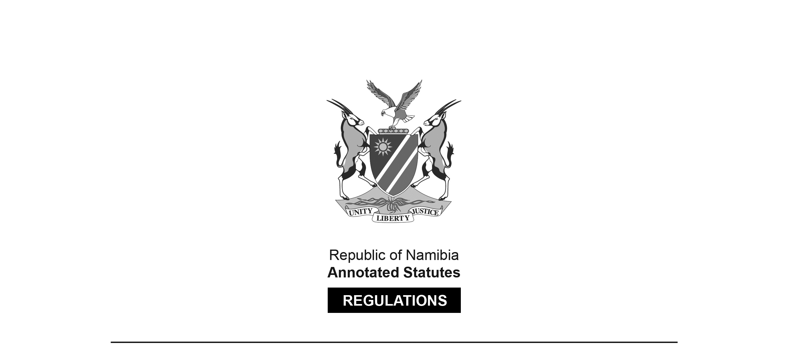

REGULATIONS MADE IN TERMS OF

Controlled Wildlife Products and Trade   
Act 9 of 2008

section 9

Regulations relating to Controlled Wildlife Products and Trade

Government Notice 144 of 2011

(GG 4773)

came into force on date of publication: 15 August 2011

ARRANGEMENT OF REGULATIONS

1. Definitions

2. Application for a permit

3. Conditions of CITES permits

4. Packaging of live animals

5. Procedures to be followed when CITES specimen are imported, exported or introduced from the sea

6. Application for manufacturer or dealer’s licence

7. Terms and conditions of controlled wildlife products dealer and manufacturer licence

8. Validity period

9. Display of dealer or manufacturer licence

10. Cancellation

11. Registers, returns and accounts of controlled wildlife products

12. Cessation of business by holder of controlled wildlife products manufacturer licence or dealer licence

13. Change of address of holder of controlled wildlife products manufacturer’s licence or dealer’s licence

14. Possession of controlled wildlife products

15. Marking of controlled wildlife products

ANNEXURE A

Application to Import/Export CITES Listed Species   
or their Parts, Derivatives and Products

ANNEXURE B

Application for a Licence to Deal in or Manufacture

Controlled Wildlife Products

ANNEXURE C

Register for Controlled Wildlife Products   
Dealer and Manufacturer

ANNEXURE D

Application to Possess Controlled Wildlife Products

**Definitions**

**1.** In these regulations a word or expressions defined in the Act has that meaning and, unless the context otherwise indicates -

“the Act” means the Controlled Wildlife Products and Trade Act, 2008 (Act No. 9 of 2008).

**Application for a permit**

**2.** (1) A person who wants to import, export, re-export or re-introduce from the sea any species listed in the Appendices of the Convention, including live specimens as well as parts and derivatives must apply to the CITES Office, by fully completing the application form provided by the Ministry set out in the Annexure A.

(2) An application for any CITES permit must be submitted to the CITES Office of the Ministry five working days prior to the import, export, re-export or introduction from the sea of any wildlife specimen.

**Conditions of CITES permits**

**3.** (1) A CITES permit is valid for a single consignment only.

(2) Each permit or certificate issued in terms of these regulations in respect of the import, export, re-export or introduction from the sea of any wildlife specimen referred to in CITES Appendix I and II must bear -

(a) the title of the Convention;

(b) the title and identifying stamp of the Minister; and

(c) a number assigned to the permit or certificate by the Minister.

(3) A permit or certificate issued by the Minister for the import, export, re-export or introduction from the sea of any wildlife specimen referred to in CITES Appendix I and II, in addition to the matters specified in subregulation (2), must contain the following information -

(a) the full name and address of the person or company to whom the permit or certificate, whichever is applicable, is issued;

(b) the name “Namibia”, as being the country of export;

(c) the name of the country to which and the name and address of the person to whom, the wildlife specimen concerned is being consigned; and

(d) in relation to any wildlife specimen which is being exported -

(i) the scientific and common names of the species concerned;

(ii) in the case of living specimens for wild life, the number of specimens, their sex, size and details of any identifying marks;

(iii) in the case of parts or derivatives of wildlife, their quantity, type and any identifying marks;

(iv) the Appendix to the Convention in which the species concerned is listed; and

(v) where known, whether or not the wildlife concerned was bred in captivity, ranched or cultivated in Namibia.

(4) Any copy of a permit or certificate issued must be clearly marked as such, and may be used in place of the original only to the extent specified therein.

(5) Any alteration, addition or deletion made to the permit or certificate issued in terms of subsection (1) or (2) is only valid, if such alteration, addition or deletion is authenticated by the stamp and signature of the Minister.

(6) A permit issued by the Minister for re-export, import and re-introduction from the sea of any wildlife specimen ceases to be valid after the period specified therein lapses, unless it has been earlier revoked in terms of subregulation 8.

(7) A permit or certificate is not transferable, and any purported transfer of a permit or certificate is void, provided that nothing in this section prevents the holder of a permit or certificate from appointing any other person as her or his agent for the purposes of importing or exporting the wildlife specimen concerned.

(8) The Minister may, at any time amend or revoke any permit or certificate issued by her or him in accordance with this Act.

**Packaging of live animals**

**4.** (1) A person transporting a live animal listed in the CITES Appendix I and II must transport it in such a way that -

(a) it cannot escape from the vehicle in or on which it is transported;

(b) it is not subjected to maltreatment;

(c) it cannot injure any other game or wild animal which is transported together with it; and

(d) it can get sufficient rest during the journey.

(2) The transport of live animals by air is subject to International Air Transport Association (IATA) regulations.

**Procedures to be followed when CITES specimen are imported, exported or introduced from the sea**

**5.** (1) Any person authorised to import, re-export or re-introduce from the sea any wildlife specimen must report back to the CITES Office, within 14 days after such import, re-export and re-introduction from the sea of any wildlife specimen.

(2) The Minister may, by notice in writing, require any person who has been issued with a permit to import, re-export or re-introduction from the sea any CITES listed animal in terms of these regulations, to keep records or registers and to report to the Minister any information relating to the management or care of any wildlife specimens to which the permit or certificate relates.

**Application for manufacturer or dealer’s licence**

**6.** (1) A person who intends to obtain a controlled wildlife products manufacturer’s licence or a dealer’s licence may apply to the CITES Office for such licence, by filling in an application set out in Annexure B.

(2) An application referred to in subregulation (1) must -

(a) for an application for a dealer’s licence, be accompanied by a certified copy of his or her general dealer’s licence;

(b) for an application for a manufacturer licence, be accompanied by -

(i) a certified copy of the municipality certificate that allows for the storage and manufacturing of controlled wildlife products on the premises concerned;

(ii) documentation to prove that the applicant has experience in manufacturing of articles from controlled wildlife products; and

(iii) a list of the kind of articles to be manufactured.

**Terms and conditions of controlled wildlife products dealer and manufacturer licence**

**7.** (1) Subject to the provisions of this regulation, a controlled wildlife products dealer’s licence authorises the holder of such licence -

(a) to purchase items manufactured out of specified controlled wildlife products from any person who has a certificate or permit issued in terms of this regulations to sell such items; and

(b) within the premises to which the licence relates, to sell such items purchased in terms of paragraph (a).

(2) Subject to the provision of this regulation, a controlled wildlife products manufacturer’s licence authorises the holder of such licence -

(a) to purchase specified controlled wildlife products from any person, who has a certificate or permit from the Minister to sell such items;

(b) within the premises to which the licence relates, to carve, embellish or otherwise manufacture specified controlled wildlife products purchased by him or her in terms of paragraph (a) or purchased on his or her behalf by some other holder of a controlled wildlife products manufacturer licence; and

(c) within the premises to which the licence relates, to sell controlled wildlife products which he or she has processed, carved, embellished or otherwise manufactured in terms of paragraph (b).

**Validity period**

**8.** A controlled wildlife products manufacturer or dealer licence is valid for a period of one year.

**Display of dealer or manufacturer licence**

**9.** A licensee must, when the licensed premises is open for business, prominently display in any part of the licensed premises, which is open to the public, the original licence in respect of the premises and, where applicable, a current and valid certificate of renewal in respect of such licence.

**Cancellation**

**10.** (1) If a holder of a controlled wildlife products manufacturer or dealer licence fails to comply with any of the provisions of the Act or with the terms and condition of his or her licence, the Minister may, in addition to any other penalty which may be imposed upon such a holder -

(a) amend the terms and conditions of that licence; or

(b) suspend or cancel that licence.

**Registers, returns and accounts of controlled wildlife products**

**11.** (1) Every controlled wildlife products manufacturer and dealer must -

(a) keep a register in which he or she must enter all transactions or arrangements by which he or she acquires or comes into possession or control of controlled wildlife products items for manufacture or resale, within three days of such items entering his or her possession or control as set out in Annexure C;

(b) keep adequate records and books of account relating to the manufacture and sale of controlled wildlife products items by him or her; and

(c) make the records and books referred to in paragraph (b) available for inspection in terms of section 7 of the Act.

(2) Each controlled wildlife products manufacturer must, within seven days after the end of each month, submit to the Minister -

(a) copies of all transactions and arrangements whereby he or she acquired or came into possession or control, of controlled wildlife products; or

(b) a statement that no transactions or arrangements referred to in paragraph (a) occurred.

(3) If a dealer who is required by these regulations to keep proper records of controlled wildlife products or items possesses the said items in excess of the amount shown on his or her certificate, he or she is deemed to be in illegal possession of such excess products or items.

**Cessation of business by holder of controlled wildlife products manufacturer licence or dealer licence**

**12.** A holder of a controlled wildlife products manufacturer’s licence or dealer licence who ceases to carry on business as a manufacturer or dealer must within seven days after so ceasing:

(a) give written notice of that fact to the Minister; and

(b) return his or her licence to the Minister.

**Change of address of holder of controlled wildlife products manufacturer’s licence or dealer’s licence**

**13.** A holder of a controlled wildlife products manufacturer licence or dealer licence must, within seven days after changing his or her business or physical address to which such licence or permit relates, notify the Minister in writing of such change.

**Possession of controlled wildlife products**

**14.** (1) A person who wants to possess controlled wildlife products must apply to the Minister for a possession permit, by completing the application form intended for that purpose, set out in Annexure D.

(2) Any transfer of controlled wildlife products must be reported to the Minister within seven days.

(3) A possession permit is not transferable.

(4) A holder of a possession permit must within seven days after changing his or her address, to which that permit relates, notify the Minister in writing of such change.

(5) A possession permit is valid until it is cancelled or revoked by the Minister.

**Marking of controlled wildlife products**

**15.** (1) A holder of a controlled wildlife products manufacturer licence must engrave upon the item an identifying code registered in his or her name in terms of subsection (3).

(2) No person may alter, deface or remove any engraving referred to in subsection (1) without the written permission of the Minister.

(3) A holder of a controlled wildlife products manufacturer licence must apply to the Minister for the registration of his or her identifying code which must be a combination of two letters and two numbers.

(4) Every controlled wildlife products manufacturer and dealer licence holder must ensures that all his or her items are certified by the Ministry before they are displayed for sale.

(5) All ivories, manufactured or raw, and rhino horns in private possession must be marked with a possession permit number in permanent ink.

(6) A person may not alter, deface or remove any marking without the written permission of the Minister.

ANNEXURES

To view content without printing, scroll down.

To print at full scale (A4), double-click the icon below.



