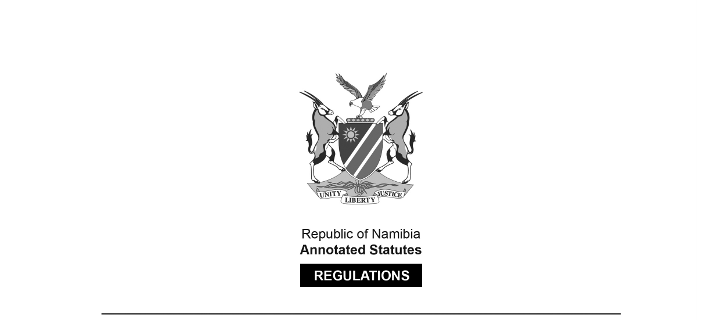
REGULATIONS MADE IN TERMS OF

Communications Act 8 of 2009
section 100(1) and (6)

The Frequency Band Plan of Namibia
General Notice 295 of 2025
(GG 8643)
came into force on date of publication: 8 May 2025

These regulations were made by the
Communications Regulatory Authority of Namibia.

General Notice 295/2025 (GG 8643) repeals the Frequency Band Plan of Namibia in
General Notice 448/2021 (GG 7617), which replaced the Frequency Band Plan of Namibia in
General Notice 424/2016 (GG 6160), which in turn replaced the Frequency Band Plan
in General Notice 191/2013 (GG 5214).

Note that a Frequency Band Plan of Namibia was issued in General Notice 163/2025 (GG 8612),
but this notice was withdrawn by General Notice 294/2025 (GG 8643).

ARRANGEMENT OF REGULATIONS

1. Definitions
2. Purpose
3. Applicability
4. Table of Frequency Allocation

ANNEXURE: NAMIBIA TABLE OF FREQUENCY ALLOCATIONS

Definitions

1. In this plan, any word or expression to which a meaning is assigned in the Act, shall have the same meaning and -

ITU means International Telecommunications Union;

the Act means the Communications Act, 2009 (Act No. 8 of 2009); and

WRC-23 means World Radio Conference held from 20 November 2023 to 15 December 2023 in Dubai, United Arab Emirates.

[There are no quotation marks around the defined terms in the Government Gazette.]

Purpose

2. The frequency band plan of Namibia is set out in terms of section 100 of the Act and the Final Acts of ITU WRC-23.

Applicability

3. This Frequency Band Plan is applicable in the assignment of spectrum licences issued in terms of section 101 of the Act and Regulations prescribing Procedures regarding the Application for and Amendment, Renewal, Transfer and Cancellation of Spectrum Licences as published in Government Gazette No. 6888, General Notice No. 104 on 29 April 2019, as may be amended from time to time.

Table of Frequency Allocation

4. (1) The table of frequency allocation in the Annexure lists all the planned allocations for the radio frequency spectrum in the Republic of Namibia for spectrum band from 8.3 kHz to 3000 GHz.

(2) The table is similar to the table set out by the ITU in its Radio Regulations based on the outcomes of WRC-23 and the 2024 SADC Frequency Allocation Plan.

(3) Column 4 of the table provides the spectrum allocations applicable in the Republic of Namibia.

(4) The ITU philosophy for reflecting radiocommunication services in terms of primary and secondary, placing of footnotes and using French alphabetical order therefore also applies, and of particular importance is to note the following:

(a) all primary services are printed in capitals;

(b) all secondary services are printed in lower case;

(c) the order of listing in each frequency band category does not establish priority withing each category (listed alphabetically according to the French langue);

[The words “within” and “language” are misspelt
in the Government Gazette, as reproduced above.]

(d) where a footnote is printed next to a service that footnote applies only to that service; and

(e) where a footnote is printed at the bottom of a frequency band that footnote applies to more than one service, or all services allocated to the particular frequency band.

ANNEXURE

NAMIBIA TABLE OF FREQUENCY ALLOCATIONS

To view content without printing, scroll down.

To print at full scale (A4), double-click the icon below.

