REGULATIONS MADE IN TERMS OF

Communications Act 8 of 2009
section 129 read with sections 69, 74(2) and 132

Regulations regarding Procedures for
the Adjudication of Disputes
General Notice 468 of 2017
(GG 6466)
came into force on date of publication: 9 November 2017

as amended by

General Notice 105 of 2019 (GG 6889)
came into force on date of publication: 30 April 2019
General Notice 159 of 2020 (GG 7197)
came into force on date of publication: 29 April 2020
General Notice 24 of 2021 (GG 7445)
came into force on date of publication: 1 February 2021

These regulations and amendments were made by the Communications Regulatory Authority of Namibia. Note that they repeal the Regulations Regarding Consumer Complaints in General Notice 128/2011 (GG 4714) and the Regulations Regarding Licensee Disputes in
General Notice 148/2013 (GG 5194) (regulation 23).

ARRANGEMENT OF REGULATIONS

1. Definitions
2. [deleted]
3. Application and purpose
4. Delivery of complaints and requests for adjudication
5. Particulars required in respect of complaints
6. Complainants requiring assistance
7. Joint complaints
8. Internal complaints resolution procedures of service providers
9. Particulars required in respect of requests for adjudication
10. Procedures prior to adjudication by Authority
11. Decision by Authority upon conclusion of documentary exchange
12. Written submissions and oral hearings
13. Determination by the Authority
14. Extension of proceedings by Authority
15. Referral of dispute for mediation
16. Obligations of parties where dispute is referred for mediation
17. Confidential information
18. Condonation
19. Communications regarding dispute
20. Record of proceedings
21. Publication of determinations
22. Reconsideration
23. Repeal of Laws

Forms A, B and D
[Form C deleted by General Notice 24/2021]

Definitions

1. In these Regulations, any word or expression to which a meaning is assigned in the Act has that meaning, and -

“Act” means the Communications Act, 2009 (Act No. 8 of 2009);

“complainant” means any person, who is a customer of a service provider, who submits a complaint;

[definition of “complainant” substituted by General Notice 105/2019]

“complaint” means a written complaint submitted by complainant to service provider or to the Authority as the case may be -

(i) in accordance with section 131 of the Act relating to quality of service rendered by a service provider; or

(ii) arising from the Broadcasting Code, as contemplated in section 90(1) of the Act, published by the Authority from time to time in the Gazette in accordance with the Act;

[The definition of “complaint” is substituted by General Notice 105/2019. There should be an article such as “a” before the term “service provider” in the introductory phrase.]

“customer” means any person who makes use of the services of a service provider and includes a potential customer of a service provider;

“day” excludes a Saturday, Sunday and public holiday;

“determination” means any order or decision made by the Authority to finally dispose of a dispute;

“dispute” means a dispute which is the subject of a request for adjudication referred to the Authority for determination in terms of sections 50, 69, 74, 90(1) or 132 of the Act;

[definition of “dispute” substituted by General Notice 105/2019]

“mediation” means a form of alternative dispute resolution which is a voluntary, impartial, confidential and flexible process aimed at resolving -

(a) a complaint; or

(b) a request for adjudication;

“respondent” means a party in respect of whom a dispute is referred or is intended to be referred to the Authority;

“request for adjudication” means a written request by a service provider or, for purposes of paragraph (f), an interception centre requiring the Authority to make a determination -

(a) of reasonable terms in accordance with section 48(8) of the Act relating to the duties referred to in that section;

(b) of terms of interconnection in accordance with section 49(7) of the Act, if service providers fail to agree on such terms within a reasonable period;

(c) of the appropriate prices, terms or conditions in accordance with section 50(10) of the Act, for any agreement in terms of that section where the service providers concerned are unable to negotiate a reasonable price, or terms or conditions for such agreement;

(d) of a discounted rate for resale in accordance with section 51(3) of the Act, where the service providers concerned are unable to negotiate such discounted rate for resale;

(e) in accordance with section 69(1) of the Act regarding the exercise of the rights conferred upon a service provider in Part 5 of Chapter V of that Act;

(f) in accordance with section 74(2) of the Act regarding any dispute that may arise between a service provider and an interception centre, if such a dispute relates to any duty imposed by Part 6 of Chapter V of that Act or a Regulation made in terms of any provision of that Part;

“service provider” means a licensee as contemplated by Chapters V, VI and VII of the Act;

[definition of “service provider” substituted by General Notice 105/2019]

“submitting party” means a complainant, service provider or interception centre who intends to refer or who referred a dispute to the Authority;

“quality of service”, in relation to the services rendered by a service provider means the minimum quality of service standards set out in Appendix A to the Regulations Prescribing Quality of Service Standards Applicable to Service Licensees No. 152 of 21 April 2015.

[There should either be a comma after the phrase “in relation to the services
rendered by a service provider”, or else no comma before it.]

***

2.

[Regulation 2 is deleted by General Notice 24/2021. Note that this General Notice refers to subregulation (2), but the intention seems to have been to delete regulation 2.]

Application and purpose

3. (1) These Regulations apply to -

(a) complainants;

(b) service providers;

(c) interception centres, where applicable; and

(d) all complaints arising from the Broadcasting Code, published by the Authority from time to time in the Gazette.

(2) The purpose of these Regulations is to regulate the procedures for the resolution of complaints and requests for adjudication received by the Authority.

Delivery of complaints and requests for adjudication

4. (1) A complainant that wishes to submit a complaint must do so by delivering a completed Complaint Form (Form A hereto) to the Authority.

(2) A service provider or interception centre, as the case may be, that wishes to submit a request for adjudication must do so by delivering a completed Request for Adjudication Form (Form B hereto) to the Authority.

(3) A submitting party may only deliver a Complaint Form or Request for Adjudication Form to the Authority -

(a) if the submitting party has first presented to the respondent the complaint or the subject-matter of the request for adjudication, as the case may be; and

(b) if the complaint or the subject-matter of the request for adjudication, as the case may be, has not been resolved or adequately resolved by the respondent within a period of 14 days after receiving such complaint or subject-matter of the request for adjudication; or

(c) upon showing good cause why the complaint or the subject-matter of the request for adjudication has not been submitted first to the respondent.

Particulars required in respect of complaints

5. A complaint must contain -

(a) the name and complete contact details of the complainant and the name and contact details of the person delivering the Complaint Form, if different;

(b) the name of the respondent, or if the name of the respondent is unknown, as many identifying details as are available in order to assist the Authority in identifying the respondent;

(c) an accurate and concise statement of the facts that gave rise to the complaint and the basis on which it is alleged that the respondent acted wrongly;

(d) a clear and concise statement of the specific relief or remedy sought; and

(e) any other information deemed relevant by the complainant or requested by the Authority.

Complainants requiring assistance

6. (1) If a complainant has a disability or is disadvantaged due to a lack of language or writing skills, the complainant may seek assistance from the Authority’s legal department.

(2) Where the complainant is blind, his or her complaint must be orally recorded and transcribed by the Authority.

Joint complaints

7. More than one complainant may jointly deliver a complaint to the Authority, in which event the joint complainants must -

(a) ensure that one complainant signs the hard copy of the complaint on behalf of the other complainants; and

(b) designate one of the complainants or a single representative to receive correspondence relating to the complaint on their behalf;

(c) attach a letter of authorization or a power of attorney verifying the authority of the persons contemplated in paragraphs (a) and (b).

Internal complaints resolution procedures of service providers

8. (1) Service providers must establish clear and easily-understood internal complaints resolution procedures to resolve complaints submitted directly to them by customers, which must include provisions to -

(a) ensure the resolution of a complaint within 14 days of receipt thereof; and

(b) notify customers of their right to submit a complaint to the Authority in terms of these Regulations if the matter has not been resolved within the aforesaid 14 days.

(2) Service providers must maintain records of all complaints submitted to them by customers and complaints submitted to the Authority in terms of these regulations.

(3) A service provider must submit reports to the Authority in accordance with the Regulations on Reporting Obligations for Licensees, published under General Notice No. 24 of 1 February 2021.

[subregulation (3) amended by General Notice 105/2019 and substituted by General Notice 24/2021]

Particulars required in respect of requests for adjudication

9. A request for adjudication must contain -

(a) the name and contact details of the service providers that have a direct or substantial interest in the request for adjudication and the name and contact details of the person delivering the Request for Adjudication Form;

(b) the contact details of the head of the interception centre, if applicable;

(c) the name and contact details of the respondent;

(d) an accurate and concise statement of the facts that gave rise to the request for adjudication and the basis, if any on which it is alleged that the respondent acted wrongly;

[There should be a comma after the phrase “if any”.]

(e) a clear and concise statement of the specific relief or remedy sought; and

(f) any other information deemed relevant by the service provider in question or requested by the Authority.

Procedures prior to adjudication by Authority

10. (1) Upon receiving a complaint or request for adjudication, the Authority must within three days issue an acknowledgement of receipt and a reference number to the submitting party.

(2) Unless the complaint or request for adjudication is frivolous or vexatious, the Authority must deliver a copy of such complaint or request for adjudication to the respondent and to any other party who may have a direct or substantial interest therein.

(3) The respondent must deliver to the Authority and the submitting party a written response to the complaint or request for adjudication within seven days from date of receipt thereof.

(4) (a) If the respondent fails without good cause to deliver a written response within the period referred to in subregulation (3), the Authority must request the respondent to deliver its response within a further period stipulated by the Authority, which period must not be more than three days.

(b) Should the Authority not receive the response within the period stipulated by it, the Authority must adjudicate the complaint or the request for adjudication, as the case may be, without such response.

(5) (a) The submitting party must within seven days of receipt of the respondent’s response deliver to the Authority and simultaneously to the respondent a written reply to such response.

(b) If the submitting party fails without good cause to deliver a written reply within the period referred to in paragraph (a), the Authority must request the submitting party to deliver its response within a further period stipulated by the Authority, which period must not be more than three days.

(c) Should the Authority not receive the submitting party’s written reply within the period stipulated by it, the Authority shall regard the matter as having been finalized and will forthwith close the matter, provided that the Authority is not precluded from contacting the submitting party for an explanation before closing the matter.

(6) All written submissions contemplated in this Regulation must be clear and concise and conform to any further requirements determined by the Authority from time to time.

(7) The Authority may request additional information or documentation from a submitting party or the respondent relating to a dispute, and may stipulate the time periods and the manner in which such information or documentation must be submitted.

Decision by Authority upon conclusion of documentary exchange

11. (1) Upon the conclusion of the process contemplated in regulation 10 the Authority may -

(a) initiate an investigation in terms of sections 122 to 127 of the Act;

(b) call for written submissions or conduct an oral hearing;

(c) appoint a suitably qualified person to conduct mediation proceedings in order to obtain a settlement of the dispute;

(d) dismiss the dispute, wholly or in part, subject thereto that the Authority must provide written reasons for such dismissal;

(e) grant the relief sought in the complaint or request for adjudication, wholly or in part, but only if the respondent agrees to the granting of such relief;

(f) take any other action or decision, as may be appropriate in the circumstances, or refuse to take any action or decision, as may be appropriate in the circumstances.

(2) The Authority must inform the submitting party of the progress of the dispute when -

(a) all documentation has been exchanged in terms of regulation 10; and

(b) the Authority has made a decision in accordance with subregulation (1).

Written submissions and oral hearings

12. (1) If in accordance with regulation 11(1)(b) the Authority decides to call for written submissions or to conduct an oral hearing to determine a dispute, the procedures set out in the Regulations Regarding Hearings No. 310 of 13 September 2012 must be followed to determine the dispute.

(2) In addition to the procedures set out in subregulation (1), the Authority must -

(a) conduct an oral hearing in a manner that the Authority considers appropriate in order to determine a dispute fairly and quickly; and

(b) deal with the substantial merits of the dispute with the minimum of legal formalities and without strictly applying the rules of the law of evidence.

(3) The Authority may -

(a) administer an oath or accept an affirmation from any individual called to give evidence at an oral hearing; and

(b) question any individual about any matter relevant to the dispute.

(4) No person may, without lawful excuse, refuse to answer a question put to that person by the Authority in terms of subregulation (3)(b).

[subregulation (4) substituted by General Notice 159/2020]

(5) Subject to the discretion of the Authority or the agreement of the parties as to the appropriate form of proceedings, a party to a dispute may give evidence, call witnesses, question witnesses of any other party, and address concluding oral submissions to the Authority.

(6) If the parties to the dispute so request, the Authority may suspend the proceedings to enable the parties to resolve the dispute through negotiation.

(7) Subject to subregulation (8), in any oral hearing a party to a dispute must -

(a) appear in person, if the party is an individual; or

(b) be represented by an office bearer or official if that party is a service provider or interception centre;

[There should be a full stop at the end of paragraph (b)
instead of a semicolon; there is no additional text.]

(8) Subject to subregulation (9), the Authority may permit -

(a) a legal practitioner; or

(b) any other individual,

to represent a party to a dispute.

(9) If a party to a dispute intends to be represented at an oral hearing by a person contemplated in subregulation (8)(a) or (b) such party must send a letter of authorization or power of attorney to the Authority and to the opposing party no later than one week before the hearing as notification of that party’s intention to be so represented.

(10) The Authority must consider the letter of authorization or power of attorney and exercise its discretion to allow a party to be represented at the hearing by the person indicated in such letter of authorization or power of attorney, which decision must be conveyed to both parties no later than three days before the hearing.

(11) After hearing the evidence of the parties to the dispute the Authority must afford the parties an opportunity to make oral concluding submissions regarding the manner in which the dispute must be determined.

(12) The oral concluding submissions must -

(a) include a statement of the name and contact details of the person making the such submissions and the name and contact details of the person for whom those submissions is made, if different;

[The word “the” in the phrase “making the such submissions” is superfluous.
The verb “is” should be “are” to be grammatically correct.]

(b) be clear and concise; and

(c) conform to any further requirements stipulated by the Authority.

(13) The Authority may require -

(a) that in lieu of oral concluding submissions the parties should provide written concluding submissions to the Authority;

(b) further information or clarification from the person making oral concluding submissions;

(c) that documentation or further written submissions must be provided to the Authority at the time and in the manner directed by the Authority.

(14) The Authority must keep a record of -

(a) any evidence given in an oral hearing;

(b) any sworn testimony given in any proceedings before the Authority; and

(c) any determination or ruling made by the Authority.

(15) The record may be kept by legible hand-written notes or by means of an electronic recording.

(16) A party may request a copy of the transcript of a record or a portion of a record kept in terms of subrule (15), on payment of the costs of the transcription.

[The reference to “subrule (15)” should be a reference to “subregulation (15)”.]

Determination by the Authority

13. (1) The Authority must render a determination within 60 days after the conclusion of oral hearing or the submission of all written submissions in respect of a dispute.

[An article such as “an” or “the” should appear before the phrase “oral hearing”.]

(2) The Authority’s determination must be in writing and must contain -

(a) concise findings of fact and conclusions of law together with reasons for the order, sanction, relief or remedy; and

(b) the appropriate order, sanction, relief, or remedy or the denial of the requested order, sanction, relief or remedy.

[There should be a semicolon followed by the word “and” at the end of paragraph (b)
instead of a full stop, as there is an additional paragraph (c).]

(c) reasons for the order, sanction, relief or remedy imposed or the denial of the requested order, sanction, relief or remedy.

Extension of proceedings by Authority

14. (1) The Authority may in exceptional circumstances extend any portion of the proceedings to resolve a dispute, inclusive of the date to render a determination, where it deems it necessary to do so.

(2) Notwithstanding subregulation (1), if the Authority is unable to render a determination within 60 days of the last written or oral submissions of the parties to a dispute, the Authority must inform the parties of its inability and what measures are being taken to address the matter urgently, which determination must then be rendered within a further maximum period of 30 days after the lapse of the aforesaid 60 days, unless the Authority has identified extraordinary circumstances beyond the Authority’s reasonable control that make it impossible to render such determination within that further period of 30 days.

Referral of dispute for mediation

15. (1) The Authority may at any time refer a dispute to mediation and towards that end the Authority must, after hearing the parties -

(a) give directions concerning terms of reference, where and how, and if not agreed by the parties, by whom such mediation is to be conducted; and

(b) stipulate the time when it is to be conducted, as well as the time when or within which a report by the mediator concerned is to be submitted to the Authority.

(2) The costs of any mediation proceedings referred to in subregulation (1) must be borne by the Authority.

(3) No further proceedings relating to the dispute must take place until the mediation proceedings are concluded.

(4) If the mediation proceedings fail to produce a settlement the report referred to in subregulation (1)(b) must only state the fact that the settlement discussions have failed, without stating the reason for such failure.

Obligations of parties where dispute is referred for mediation

16. (1) Where a matter has been referred for mediation in terms of regulation 15 the parties must exchange letters in writing as follows -

(a) the letter of the submitting party or of that party’s legal practitioner, if represented, must set out the following information -

(i) a brief summary of the facts and legal principles, if any that the submitting party relies on to establish the complaint or request for adjudication;

[There should be a comma after the phrase “if any”.]

(ii) a brief explanation of why, in the opinion of the submitting party, the relief claimed in the dispute should be granted;

(iii) an itemisation of the relief the submitting party believes can be established during a formal hearing by the Authority and a brief summary of the facts and legal principles supporting the relief; and

(iv) a concise settlement proposal; and

(b) the letter of the respondent or of the respondent’s legal practitioner, if represented, in response to the submitting party’s letter must set out the following information -

(i) any points in the submitting party’s letter with which the respondent agrees;

(ii) any points in the submitting party’s letter with which the respondent disagrees; and

(iii) a concise settlement offer.

(2) Copies of the letters referred to in subregulation (1) must not under any circumstances be brought to the attention of the Authority.

(3) The parties or the legal practitioners of the parties, if represented, must within seven days after the exchange of letters referred to in subregulation (1) determine a date for holding a settlement conference before the mediator.

(4) The legal practitioners of the parties, if represented must provide their respective clients with the opposing party’s letter referred to in subregulation (1) before the holding of a settlement conference.

[There should be a comma after the phrase “if represented”.]

(5) Only a person with full settlement authority must attend a settlement conference convened before the mediator within a time limit as directed by the Authority.

(6) For the purposes of discussing and reaching settlement of a dispute in terms of subregulation (5), a party that is -

(a) a natural person, must be represented by that natural person or if that natural person is under a disability by his or her legal representative;

(b) a juristic person, must be represented by a person duly authorised in writing by that juristic person, other than the legal practitioner of record;

[There should be a full stop at the end of paragraph (b)
instead of a semicolon; there is no additional text.]

(7) A person referred to in subregulation (5) must, without reference to any other person not present at the settlement conference, have the necessary authority to make a final and binding settlement regarding any offer or demand.

(8) The letters referred to in subregulation (1) and anything discussed during a settlement conference are without prejudice and may not be used by any party in the proceedings to which the letters and the conference relate or in any other proceedings.

(9) Any settlement reached between the parties during mediation proceedings will be final and binding on the parties.

(10) If the mediation failed to resolve the dispute, the mediator must refer the dispute back to the Authority to dispose thereof in terms of these Regulations.

Confidential information

17. (1) If a party to a dispute has designated information or documentation submitted to the Authority as confidential, the provisions of section 28 of the Act apply.

(2) A party to a dispute may request the Authority that an oral hearing or any part thereof be closed to the public on the grounds that information or evidence tendered during such hearing or part thereof is confidential

(3) If an oral hearing is closed to the public by the Authority such hearing must be regarded as a confidential meeting in terms of section 29 of the Act, and the notice of the closed meeting required by section 29(4) of that Act must be maintained on the relevant file pertaining to the dispute.

Condonation

18. (1) If a party to a dispute is unable to comply with any time limit stipulated in these Regulations, that party may, prior to the lapse of the stipulated time period request an extension of time from the Authority not exceeding a period of seven days or a further period agreed by the Authority upon good cause shown.

[There should be a comma after the phrase
“prior to the lapse of the stipulated time period”.]

(2) The Authority must respond to the request for condonation as soon as practicable, and may in its sole discretion, taking into account factors such as the nature of the proceeding and the reasons for non-compliance with any stipulated time period, grant or deny such request.

(3) Subject to the sole discretion of the Authority, requests for the extension of any time period submitted to the Authority outside any stipulated time period referred to in subregulation (1) may only be considered if valid reasons are provided for the late request.

(4) Notwithstanding subregulation (1), if the Authority grants the request for condonation, the extension of time may not exceed a maximum period of 14 days calculated from the original stipulated time period.

Communications regarding dispute

19. No person may communicate with the members of the Board, the Authority’s Chief Executive Officer or staff members or consultants of the Authority to discuss the subject matter of any dispute, except as provided for herein.

Record of proceedings

20. (1) The Authority must in the most appropriate format maintain all documents to a dispute that the Authority considers relevant.

(2) Except for information regarded as confidential by the Authority in terms of section 28 of the Act, any person may at the head offices of the Authority during normal business hours examine the contents of a file relating to a dispute and may make copies upon payment of a fee determined by the Authority.

(3) If considered practical the Authority may keep electronic copies of the contents of a file relating to a dispute on its official website for free download.

(4) Information regarded as confidential by the Authority in terms of section 28 of the Act may not be made available to any person except to a person who has a legal entitlement thereto and to staff members of the Authority entitled by virtue of their employment to access such information.

Publication of determinations

21. (1) After finalising a dispute, the Authority must inform the submitting party and the respondent of its decision and deliver a copy of the determination to them.

(2) The Authority must at its head office and if practicable, on its website maintain a public register of all its determinations relating to disputes and keep copies of all such determinations.

(3) Any person may during normal business hours examine the public register and determinations referred to in subregulation (2) at the head office of the Authority and may request copies of any determination upon payment of a fee determined by the Authority, or, if such determination is available on the Authority’s website copies thereof may download it free of charge.

There is a grammatical problem in the last part of subregulation (9).
It may have been intended to read as follows:
“…if such determination is available on the Authority’s website,
copies thereof may be downloaded free of charge”, or alternatively:
“…if such determination is available on the Authority’s website, may download it free of charge”.]

Reconsideration

22. (1) The Authority may in terms of section 31 of the Act reconsider any decision or order made in terms of these Regulations, within 90 calendar days from the date of making that decision or issuing that order.

(2) Any person (hereinafter “the requesting party”) may within 15 days of receiving any decision or order made by the Authority request the Authority in writing to reconsider decision or order subject to the following:

(a) The requesting party must comprehensively complete the Reconsideration Form (Form D hereto) and submit that form to the Authority within 30 days from date of receipt of the Authority’s decision or order.

(b) The Authority must within three days of receipt of the Reconsideration Form determine whether there are grounds for reconsideration.

(c) Where there are no valid grounds for reconsideration, the Authority must forthwith notify the requesting party of its decision and close the file pertaining to the dispute.

(d) Where the Authority considers that the request for reconsideration should be heard, the Authority must provide a copy of the Reconsideration Form to any party with a direct or substantial interest in the matter and simultaneously notify the requesting party of its decision within 7 days from the lapse of the period referred to in paragraph (b).

(e) A party with a direct or substantial interest referred to in paragraph (d) must deliver a response in writing to the request for reconsideration within a period of 14 days of receipt of the Reconsideration Form.

(f) Upon receipt of the response referred to in paragraph (e), the Authority must deliver that response to the requesting party and afford that party 14 days from receipt of the response to reply thereto.

(g) The Authority must thereafter, subject to subregulation (3), make a determination on whether or not to reconsider its decision or order.

(3) The Authority may publish its determination on reconsideration without further submissions having been received, or it may provide an opportunity to the public to provide further written or oral submissions, prior to making a determination contemplated in subregulation (2)(g), in a manner stated by the Authority.

Repeal of Laws

23. (1) The Regulations Regarding Consumer Complaints (published in Government Gazette No. 4714, General Notice No. 128, dated 18 May 2011) are hereby repealed.

(2) Regulations Regarding Licensee Disputes (published in the Government Gazette No. 5194, General Notice No. 148, dated 17 March 2013 are hereby repealed.

FORMS A, B AND D

[Form C is deleted by General Notice 24/2021.]

To view content without printing, scroll down.

To print at full scale (A4), double-click the icon below.

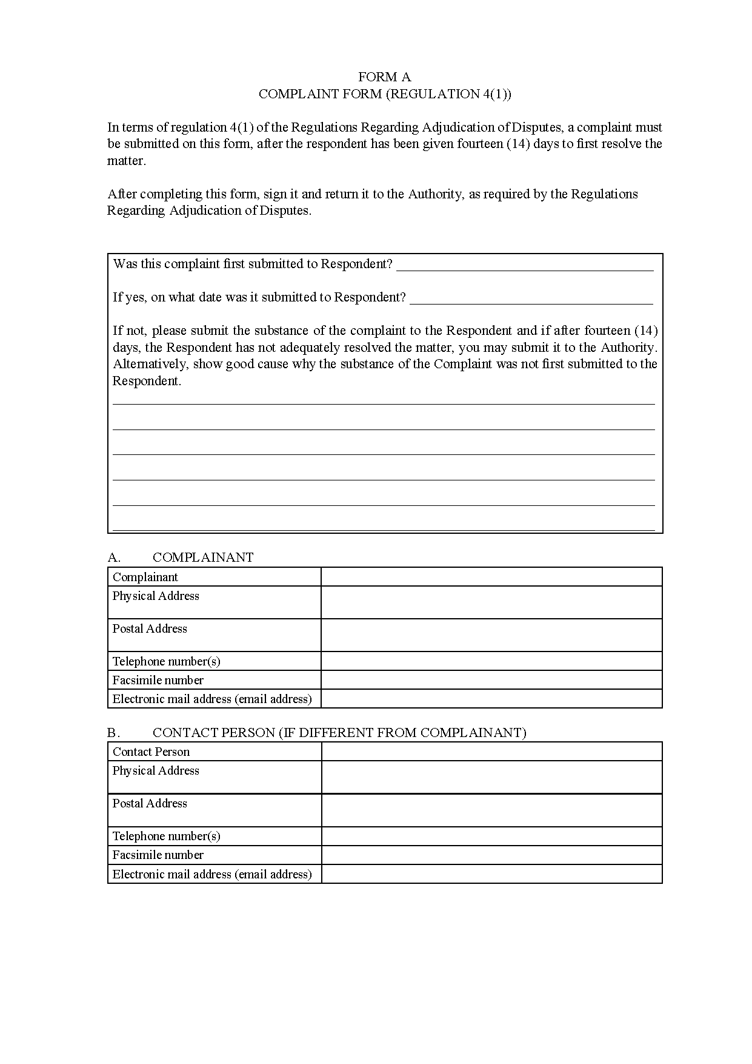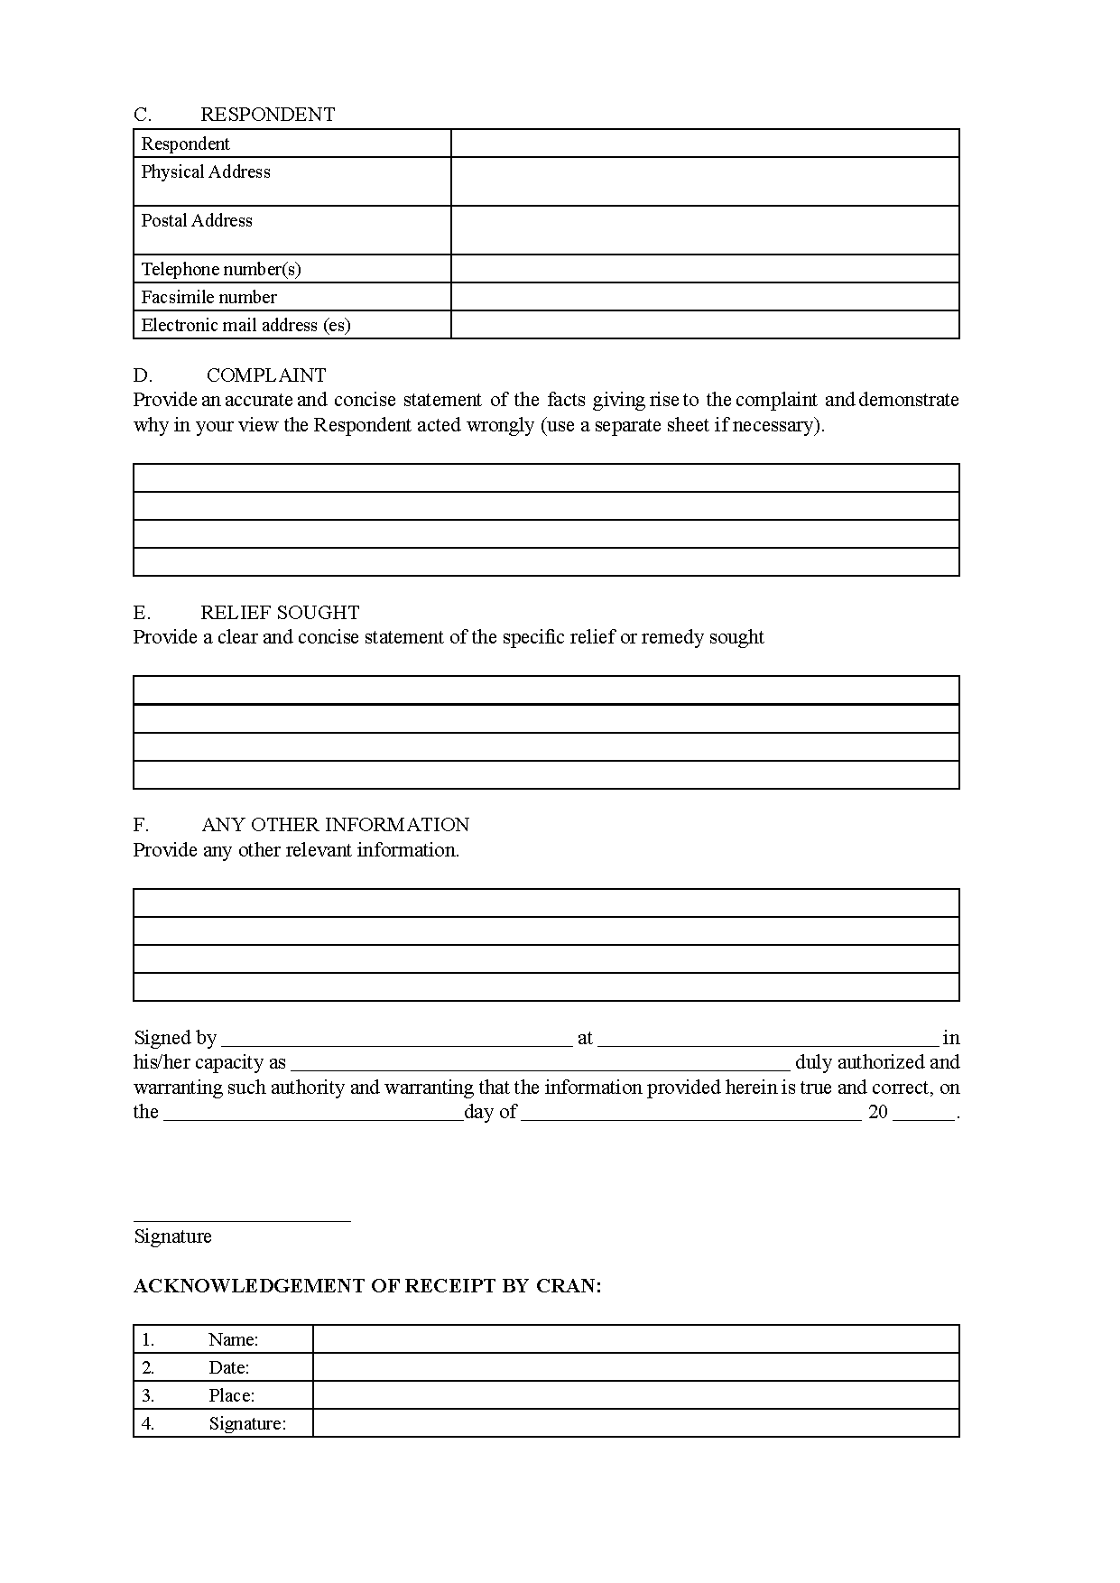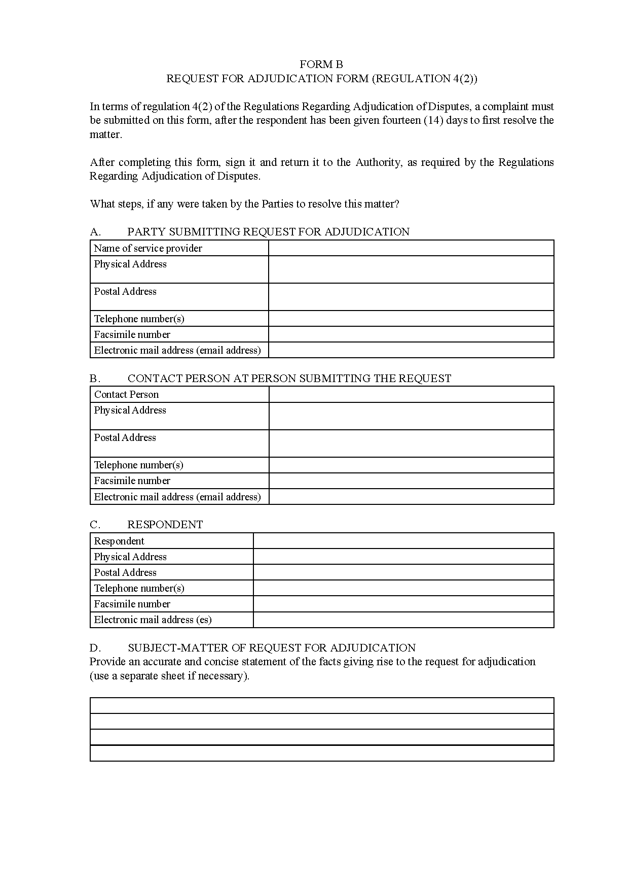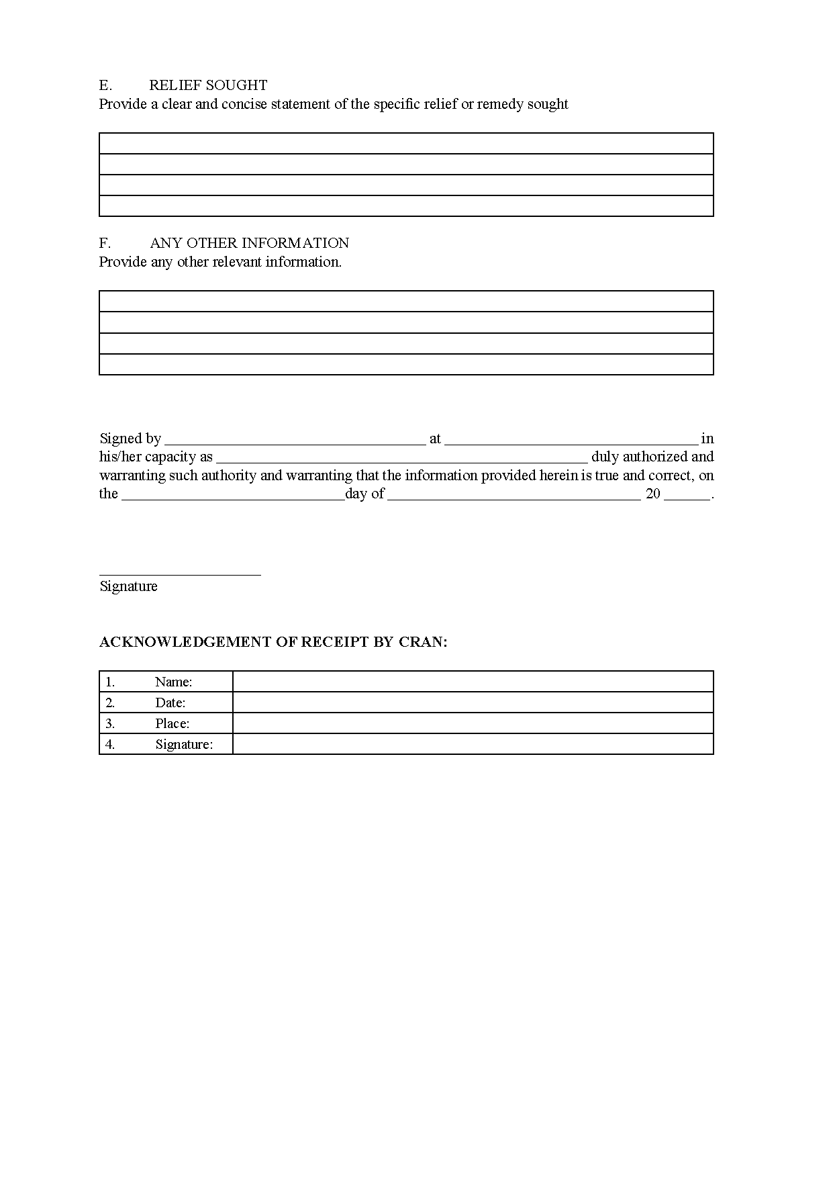
[Form C is deleted by General Notice 24/2021.]