

REGULATIONS MADE IN TERMS OF

Communications Act 8 of 2009

section 81 and regulation 4(3) of the Regulations regarding Rule-Making Procedure published in General Notice 334/2010

Regulations prescribing the National Numbering Plan for Use   
in the Provision of Telecommunications Services in the Republic of Namibia, Numbering Licence Fees and   
Procedures for Number Licences

General Notice 97 of 2016

([GG 5983](http://www.lac.org.na/laws/2016/5983.pdf))

came into force on date of publication: 1 April 2016

as amended by

**General Notice 500 of 2018** ([GG 6692](http://www.lac.org.na/laws/2018/6692.pdf))

came into force on date of publication: 30 August 2018

Note that another *Government Gazette* incorrectly numbered as GG 6692 was issued and   
subsequently withdrawn. Note also that the *Government Gazette* containingGeneral Notice 500/2018   
was originally issued as GG 6693, but this incorrectly-numbered version was withdrawn   
and replaced with one numbered as GG 6692.

General Notice 150 of 2020 ([GG 7196](http://www.lac.org.na/laws/2020/7196.pdf))

came into force on date of publication: 29 April 2020

General Notice 159 of 2020 **(**[GG 7197](http://www.lac.org.na/laws/2020/7196.pdf)**)**

came into force on date of publication: 29 April 2020

General Notice 445 of 2021 **(**[GG 7613](http://www.lac.org.na/laws/2021/7613.pdf)**)**

came into force on date of publication: 30 August 2021

Note that the General Notice which publishes this amendment incorrectly indicates that  
the original regulations were published in General Notice 18 of 1 April 2021.

General Notice 675 of 2022 **(**[GG 7961](http://www.lac.org.na/laws/2022/7961.pdf)**)**

came into force on date of publication: 22 November 2022

Note that the General Notice which publishes this amendment incorrectly indicates that  
the original regulations were published in General Notice 445 of 30 August 2021.

General Notice 668 of 2024 **(**[GG 8491](http://www.lac.org.na/laws/2024/8491.pdf)**)**

came into force on date of publication: 1 November 2024

These regulations and their amendments were made by the   
Communications Regulatory Authority of Namibia.

ARRANGEMENT OF REGULATIONS

CHAPTER I

INTRODUCTORY PROVISIONS

Regulation

1. Definitions and Interpretation

2. Purpose of the Regulations

3. Submission of Documents to the Authority

4. Applicability

5. Authorisation

6. Exclusions

6A. Number portability requirement

[Regulation 6A is inserted by General Notice 500/2018.]

CHAPTER II

STRUCTURE OF THE NATIONAL NUMBERING PLAN

7. Structure of the National Numbering Plan

8. Short Codes Categories

9. Use of Short Codes

10. Signalling Point Codes (SPCs)

11. Network Codes

12. International Carrier Codes

13. Unstructured Supplementary Service Data (USSD) Codes

14. Transitional Arrangements

CHAPTER III

MANAGEMENT OF THE NUMBERING RESOURCES

15. Responsibilities of the Authority

16. Licensees’ Responsibilities and Obligations

17. Eligibility to Apply for Numbering Resource

18. Applications for Allocation of Numbering Resources

19. Criteria for the Assessment of Applications for an Allocation of Numbering Resources

20. Transfer of licences and transfer of control of licences

21. Withdrawal of Number Licences

22. Application Procedures

23. Confidentiality of Licensee’s information

24. Reservation of Numbering Resources

25. Notification of Number Activation or De-Activation

26. Duration of Number Licences

27. Applications for ITU-T Numbering Resources

28. ENUM

CHAPTER IV

PROCEDURAL MATTERS

29. Oral Hearings

30. Condonation

31. Record of Proceedings

32. Publication of licensing decisions and licenses

33. Reconsideration

CHAPTER V

AUDIT OF THE USE OF NUMBERING RESOURCES

34. Objective of Audit

35. Audit Methods

36. Frequency of Audit

37. Content of the Annual Audit Return

CHAPTER VI

FEES

38. Timetable for the Payment of Fees

39. Calculation of Fees

CHAPTER VII

INTEREST AND PENALTIES

40. Penalties for non-compliance

CHAPTER VIII

REVIEW AND REVISION OF THE REGULATIONS

41. Review and Revision of the Regulations

annexure 1A - Number Portability

[Annexure 1A is inserted by General Notice 500/2018.]

**ANNEXURE A** - Form CRAN12 - Application Form: Number Licence

**ANNEXURE B** - Form CRAN13 - Application Form: Transfer of Licenses and Transfer of Control of Licences-Number Licence

**ANNEXURE C** - Form CRAN14 - Application Form: Withdrawal of Number Licence

**ANNEXURE D** - Chargeable Fee

[Annexure D is inserted by General Notice 445/2021 and   
substituted by General Notice 675/2022 and by General Notice 668/2024.]

**ANNEXURE E** - Discussion Paper on Numbering Fees for CRAN

[Annexure E is inserted by General Notice 445/2021 and substituted by General Notice 675/2022.]

[These regulations are presented in an unusual format in the original *Government Gazette*,   
while the amendments follow the usual regulation style. All of the regulations are presented   
here in the usual regulation style insofar as possible, for consistency. Capitalisation is reproduced throughout as it appears in the *Government Gazettes*. ]

CHAPTER I

INTRODUCTORY PROVISIONS

**Definitions and Interpretation**

**1.** In these Regulations, any word or expression to which a meaning is assigned in the Act, Licence Regulations, and ITU-T Recommendation E.164, has the same meaning, unless the context indicates otherwise -

[The punctuation throughout this regulation is reproduced as it appears in the *Government Gazette*. Some definitions have no punctuation at the end, and some have full stops.

There should be a semicolon after each definition.]

“Act” means the Communications Act, 2009 (Act No. 8 of 2009).

“Area Code” is synonymous with the ITU-T’s use of the term “Network Destination Code” as they apply it in their Recommendations relating to numbering matters.

“Call” where the context requires the term, it shall include SMS texts and other services.

“CDMA” means Code Division Multiple Access

“Chargeable fee” means the reference value multiplied by the chargeable quantity of numbers.

“Chargeable quantity of numbers” means the total amount of numbers of a specific number length allocated to and in use by a licensee multiplied by weighted value of numbers in terms of regulation 38.

[The word “the” appears to have been omitted before the phrase “weighted value”.]

“Commercial Services” means short codes that are to be used for services for which a charge is made for the call that exceeds the licensee’s standard cost of call or SMS text message.

“Customer” means any person who concluded a contract with the provider of telecommunications services for the provision of such services

“Day(s)” means calendar days

“Dialled” where the context requires, the term shall include any method a customer uses to initiate a call.

“DID” means Direct Inward Dialling

“E.164” means the ITU-T Recommendation E.164: The International Public Telecommunication Numbering Plan, 2010.

“ECS” means Electronic Communications Service.

“ECNS” means Electronic Communications Network Service.

“ENUM” means the translation of an E.164 number to one or more IP addresses in accordance with the RIPE specification RFC 3761: The E.164 to Uniform Resource Identifiers (URI) Dynamic Delegation Discovery System (DDDS) Application (ENUM)

“Emergency and Public Services” means short codes to be dialled by any customers to access emergency or public services from any network

“FreeFone” means a call that is free from charges to the calling customer, also referred to as “Toll Free” calls.

“Higher Rate” means a call charge that exceeds a licensee’s standard charge for an off-net call or SMS text and the call charge may include payment for the service accessed by the call.

“ISPC” means International Signalling Point Code

“ITU-T” means the International Telecommunications Union - Telecommunications.

“ITU/TSB” means the International Telecommunications Union - Telecommunications Standards Bureau.

“Licence Regulations” means the Regulations Setting Out Broadcasting and Telecommunications Service Licence Categories published in *Government Gazette* 4714, Notice No. 124 dated 18 May 2011, as amended from time to time.

“Licensee Services” means non-commercial services provided by a licensee to its customers to support the provision of telecommunications services e.g. Customer Care or fault reporting by dialling a “on-net” short code.

[The article “a” before “on-net” should be “an”.]

“Machine-to-Machine (M2M)” means a call or data session that is initiated by a device, rather than the customer, to another device or automated answering service.

“National Numbering Plan” means the National Numbering Plan for the use in the provision of telecommunications services in the Republic of Namibia

“Network Access” means a short code used as a prefix by the customer at the start of the dialling sequence or added by the licensee’s network to ensure correct routing of a call.

“NSPC” means National Signalling Point Code

“Number Portability” means the ability of users of telecommunications services to retain, at the same location, existing telecommunications numbers without impairment of quality, reliability or convenience when switching from one carrier to another.

“Numbering Resources” means the prefixes, codes, short codes, numbers and numbering ranges specified in these regulations.

“Off-net” means calls that can originate and terminate or could originate and terminate on different networks. All numbers in these regulations are off-net unless explicitly stated to be on-net.

“On-net” means calls that originate and terminate on the same network.

“Premium Rate” means a call to service where the charge to the calling customer includes payment for the service accessed, normally in addition to standard call or SMS charges.

“Reference Value” means the fee per number equal to the monetary value set by the Authority to offset the cost incurred in respect of management of numbering resources as mandated by section 81 of the Act.

“SANC” means Signalling Area/Network Code

“Short Codes” means numbers with significantly fewer digits than customer numbers. They may be used as numbers in their own right or as prefixes to other numbers for some special purpose, normally call routing purposes.

“Specially Tariffed Numbers” means numbers where the calling customer pays a tariff that is different from the licensee’s standard call tariff

“Third party service providers” means service providers that may not be ECS or ENCS providers that offer value added services to telecommunications customers through the use of E.164 numbers

“TIA” means the Telecommunications Industry Association “USSD” means Unstructured Supplementary Service Data “VSAT” means Very Small Aperture Terminal

“Virtual Telephone” means services that are additional to and enhance a standard Voice or SMS service.

**Purposes of the Regulations**

**2.** The purposes of these regulations are:

(1) to prescribe a national numbering plan for use in the provision of telecommunications services;

(2) to provide a long term framework for the national numbering plan which is capable of adaption according to developments in the telecommunications industry for the benefit of all users of telecommunication services in Namibia;

(3) to put in place the procedures for the allocation to licensees of adequate prefixes, numbers and numbering ranges without unreasonable delay, in a non-discriminatory, proportionate and transparent manner, in return for the payment of a fee that is no greater than necessary to compensate for the costs of managing the numbering plan, controlling its use, and its implementation;

(4) to allocate numbers in a manner that does not confer any competitive advantage to any particular licensee;

(5) to provide for number portability.

**Submissions of documents to the Authority**

**3.** In these regulations “submit in writing to the Authority” means either physically or electronically:

(1) by hand to the head offices of the Authority, namely, Communications House, 56 Robert Mugabe Avenue, Windhoek or any other address set out by the Authority from time to time;

(2) by post to the head offices of the Authority, namely, Private Bag 13309, Windhoek, 9000 or any other address set out by the Authority from time to time;

(3) by electronic mail to the following address: [operations@cran.na](mailto:operations@cran.na) or at any other address set out by the Authority from time to time;

(4) by facsimile to number +264 61 222 790 or to any other number set out by the Authority from time to time; or

(5) in any other manner or at alternative addresses set out by the Authority from time to time.

**Applicability**

**4.** (1) These regulations apply to the application for and use of Namibian numbering resources by telecommunications services licensees.

(2) Providers of private ECS/ECNS telecommunications services or whom engage in the resale of ECS/ECNS telecommunications services who are licence exempt may not use numbering resources assigned to them by telecommunications services licensees in any manner that contravenes or compromises the use of numbering resources as specified in these regulations.

[There is a grammatical error here. The opening phrase may have been intended to be   
“Providers of private ECS/ECNS telecommunications services who engage in the resale   
of ECS/ECNS telecommunications services…”.]

(3) Licensees may assign individual or groups of numbers to customers and providers of ECS and ECNS services who are licence exempt according to these regulations.

**Authorisation**

**5.** (1)Licensees may not trade in the rights to use numbering resources.

(2) Licensees may not transfer the rights to use numbering resources other than:

(a) the transfer of individual numbers at the request of a customer who intends to change the licensee providing the service of the customer;

(b) the provisioning of numbering resources to providers of ECS/ECNS and the resellers of ECS/ECNS who are licence exempt;

(c) the transfer or takeover of the licensee’s assets by another licensee with prior written permission of the Authority.

**Exclusions**

**6.** (1) Internet names and addresses such as IP addresses and URIs are not part of the national numbering plan and are not governed by these regulations.

(2) Numbering resources for satellite, maritime and other global services that use a country code allocated by the ITU-T for these purposes do not form part of the national numbering plan. The ITU-T has recognised an appropriate recognised operating agency to administer the number resources for each of these country codes.

**Number portability requirement**

**6A.** (1) A holder of a service technology neutral telecommunications services licence, as defined in Annexure 1A, must implement number portability within the timeframe and in accordance with the requirements contained in Annexure 1A.

(2) Unless specifically stated otherwise in Annexure 1A, the obligations as contained that Annexure and imposed on a holder of a service technology neutral telecommunications services licence in relation to number portability apply on and after the implementation date specified in that Annexure.

[Regulation 6A is inserted by General Notice 500/2018. The word “in” appears   
to have been omitted in subregulation (2) in the phrase “as contained in that Annexure”.]

CHAPTER II

STRUCTURE OF THE NATIONAL NUMBERING PLAN

**Structure of the National Numbering Plan**

**7.** (1) The numbering resources based on the initial leading digit is structured as follows:

|  |  |  |  |
| --- | --- | --- | --- |
| **Access Prefix** | **Use** | **Total Number length (N[s]N)** | **Notes** |
| + | International Access prefix |  |  |
| 0 | 0 – National Access prefix  00 – International Access prefix 01-09 Reserved for future number plan expansion | - |  |
| **Leading Digit** | **Use** | **Total Number length (N[s]N)** | **Notes** |
| 1 | Short Codes | 3 to 5 digits |  |
| 2 |  |  | Reserved |
| 3 |  |  | Reserved |
| 4 |  |  | Reserved |
| 5 |  |  | Reserved |
| 6 | 60 - CDMA | 9 digits | No further allocation to be made. The existing allocation will be withdrawn once the service ceases and the range will become reserved |
|  | 612, 613, 614, 625, 632, 642, 644, 645, 652, 662, 672 and 673 Existing DID Services only | 9 digits | Allocations to be made for existing customers only. All new customer services to be assigned 86 numbers |
|  | All other ranges |  | Reserved |
| 7 |  |  | Reserved |
| 8 | 80 – FreeFone | 9 digits |  |
| 81 – Electronic Communications | 9 digits |  |
| 82 – Electronic Communications | 9 digits |  |
| 83 – Electronic Communications | 9 digits |  |
| 84 – Electronic Communications | 9 digits |  |
| 85 – Electronic Communications | 9 digits |  |
| 86 – Electronic Communications | 9 digits | Fixed line, VSAT to be migrated to this number range |
| 87 – Higher Rate | 9 digits |  |
| 88 – Virtual Telephone | 9 digits |  |
| 89 – M2M | 12 digits | Includes ENUM services |
| 9 | Short Codes | 3 to 5 digits |  |

(2) Customers should dial the national escape prefix “0” first when dialling calls, unless the call is to a short code.

(3) Customers should dial the international escape prefix “00” first when dialling international outgoing calls.

(4) Mobile customers may replace the “00” with the symbol “+” when dialling the international escape prefix in accordance with ITU-T REC E.164.

**Short code categories**

**8.** (1) Short codes for voice services shall form part of the National Numbering Plan used for voice and related services and form part of the E.164 numbers but are not part of the International Numbering Plan.

(2) Short codes used for SMS text messaging and related services do not form part of the E.164 numbers, except as prescribed in Regulation 9 of these regulations.

(3) Short codes are categorised as follows:

(a) emergency and public services;

(b) licensee services;

(c) network access; and

(d) commercial services.

(4) All licensees are required to route emergency and public service short codes dialled from numbers assigned to their customers to the correct terminating point without charge to the customer. Where the call is routed via a second or subsequent network, no interconnection charges will be payable between licensees.

(5) Network access codes may only be used for inter-network routing purposes and the use of the codes does not change any interconnection payment arrangements.

(6) The commercial services short codes assigned by a licensee to a third party provider, may be subject to commercial agreement between the licensee and the third party provider. Where the call is routed via a second or subsequent network, charges will be in accordance with the interconnection tariffs set by the Authority.

**Use of short codes**

**9.** (1) Short codes starting with the digit 1 may be used for commercial, emergency and public services, licensee services and network access. They may consist of three to five digits.

(2) Short codes starting with the digit 9 may be used for emergency and public services and commercial services. They may consist of three to five digits.

(3) Short codes starting with other leading digits shall not be used.

(4) Licensees must correctly route calls making use of short codes designated for emergency services. These short codes designated for emergency services will be found on the website of the Authority.

(5) In the event that licensees offer to provide the same or similar voice and/or SMS services, they should use the same short code for both services.

(6) Where a licensee introduces a voice and/or SMS licensee service or commercial service that is the same or similar to another licensee’s voice and/or licensee service or commercial services, they shall use the short code already in use by the latter licensee.

(7) Licensees may enter into commercial agreements with other licensees to provide a licensee service on their behalf. Such agreements will be deemed to be ‘on-net’ and the calls may be routed to the second licensee’s network. The costs and payments associated with the routing and termination of calls are subject to interconnection tariffs.

**Signalling point codes**

**10.** (1) The Authority shall manage the international signalling point codes (ISPCS) utilising the signalling area/network codes (SANCs) allocated to Namibia by the Telecommunication Standardization Bureau of the International Communications Union (TSB/ITU) in accordance with ITU-T recommendations. The Authority will adopt the procedures specified by the TSB/ITU from time to time in recommendation Q.708 or its successor recommendation(s).

(2) A signalling point code must have a code from each signalling network to which it is connected. An international gateway will have both an ISPC and a NSPC.

(3) No signalling point shall have more than one signalling point code from the signalling network to which it is a member. Only one ISPC and/or one NSPC per signalling point shall be allowed.

(4) A 14-bit code shall be used for the identification of signalling points in conformance with the ITU-T recommendations.

(5) The format of the 14-bit binary code used for the identification of international signalling points shall be:

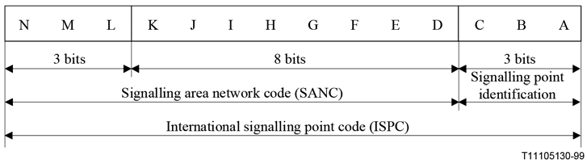

The binary code is represented by three (3) decimal numbers indicated as follows:

a) The first indicating the three (3) most significant bits (NML), with a value of 0 to 7;

b) The second indicating the following eight (8) bits (K-D), with a value of 0 to 255; and

c) The third consisting of the three (3) least significant bits (CBA), with a value of 0 to 7.

The combination of the fields containing bits NML and bits K-D is regarded as the Signalling Area/Network Code (SANC). The three (3) bits (CBA) identify a specific signalling point which when combined with the SANC forms the 14-bit ISPC (e.g. 2-0681).

(6) ITU/TSB has allocated 2-SANC to Namibia. This is 6-098-X. No other SANC shall be used by Licensees unless the Authority has applied for it to the ITU/TSB and Namibia has been allocated SANCs from the ITU/TSB.

(7) ISPCs will be assigned to licensees using the next available code using the CBA bits, on a ‘first-come first-served’ basis.

(8) The format of the 14-bit binary code used for the identification of national signalling points shall be:

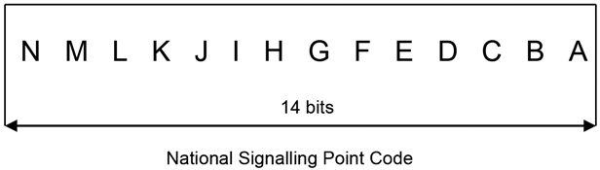

A single decimal number represents the binary code, which always consists of 4- digits, 1000 to 9999.

(9) NSPCs will be assigned to licensees using the next available code on a ‘first-come first-served’ basis.

**Network codes**

**11.** (1) A licensee may use any scheme of network codes within its individual networks in accordance with ITU-T Recommendations provided such codes are used internally and are not used for public use or used for inter-network purposes, including identifying a signalling point between networks.

(2) These network codes shall include mobile network codes (recommendation E.212), data identification codes (recommendation X.121) and system identification codes (various TIA wireless standards including IS-2000 ‘cdma 2000’).

(3) When the ownership of a network changes and the new owner has an existing network code for the type of network in respect of which ownership has changed, the licensee shall inform the Authority and relinquish one of the codes.

(4) Licensees may use the mobile country code 649 and the data country code 649 allocated to Namibia by the ITU-T.

**International carrier codes**

**12.** Licensees shall obtain and use an ITU Carrier Code (ICCs) in accordance with ITU-T Recommendation M.1400.

**Unstructured Supplementary Service Data (USSD) Codes**

**13.** (1) Licensees shall use USSD codes in accordance with the standards GSM 02.90 Unstructured Supplementary Service Data - Stage 1 (customer initiated USSD) and GSM 03.90 Unstructured Supplementary Service Data - Stage 2 (network initiated USSD).

(2) Licensees shall co-ordinate their use of USSD codes and use the same code for the same or similar service for the convenience of customers of the service.

**Transitional arrangements**

**14.** (1) Every licensee and third party service provider shall enable the introduction of the following changes to be effected in accordance with these regulations:

(a) immediately on the date on which these regulations become operative, the revocation of numbering resources allocated to licensees, but not in use by customers;

(b) within six (6) months of the date on which these regulations become operative, the revocation of the allocation of numbers and short codes that are in use by customers, but which the Authority has determined shall be withdrawn as contemplated in these regulations;

(c) within six (6) months of the date on which these regulations become operative, the replacement of the numbers and short codes to be withdrawn as contemplated in regulation 14(1)(b) of these regulations with new short codes and special tariffed numbers to be agreed upon between the Authority, the licensees and the third party providers (if any), and in the absence of such agreement within five months of the date on which these regulations become operative, to be determined by the Authority within fifteen (15) days of the expiry of such five (5) months;

(d) within six (6) months of the date on which these regulations become operative, the implementation of harmonised USSD codes in accordance with regulation 13 of these regulations. to be agreed upon between the Authority, licensees and third party service providers (if any), and in the absence of such agreement within five months of the date on which these regulations become operative, to be determined by the Authority within fifteen (15) days after the expiry of such five (5) months;

(e) within twelve (12) months of the date on which these regulations become operative, the migration of short codes, M2M services and numbers used for fixed line, VSAT services and any other numbers to the number ranges specified in these regulations.

(2) Each licensee shall be responsible for their own implementation of the changes to their networks, support systems and customer communications arising from the changes contemplated in regulation 14(1) of these regulations.

(3) Each licensee shall bear their own cost in relation to the changes contemplated in regulation 14(1) of these regulations.

(4) The Authority shall award numbering licences for numbering resources that are already in use by customers, provided their use is in accordance with the permitted use in terms of these regulations.

(5) The Authority shall determine those numbering resources (including prefixes and short codes) that are to be withdrawn or migrated due to these numbering resources being used for services other than those specified in these regulations or because they are not in use by customers.

(6) The Authority shall not allocate new numbering resources to existing licensees during the transitional period of six (6) months of the date on which these regulations become operative.

(7) Any M2M numbers in use by customers on the date on which these regulations become operative will be migrated to the M2M number range.

(8) The Authority shall confirm and allocate NSPCs that are in use within a licensee’s network regardless of the codes’ conformance with the code scheme contained in these regulations.

CHAPTER III

MANAGEMENT OF THE NUMBERING RESOURCES

**Responsibilities of the Authority**

**15.** The Authority shall:

(1) Allocate numbering resources as blocks of numbers that balance the need for efficient use of the available numbering resources with operational efficiency of the licensees and administrative efficiency. To achieve this the numbering resources will be allocated in the following block sizes:

|  |  |  |
| --- | --- | --- |
| **1st Digit** | **Use** | **Proposed Block Size** |
| + | International Access prefix |  |
| 0 | National and International Escape digits |  |
| 1 | Short Codes | Single Number |
| 2 |  | N/A[1] |
| 3 |  | N/A |
| 4 |  | N/A |
| 5 |  | N/A |
| 6 | Fixed-Line DID existing services only | 10,000 |
| 7 |  | N/A |
| 8 | FreeFone | Single numbers |
| Electronic Communications (81,82,83,84,85) | 100,000 |
| M2M | 100,000 |
| Electronic Communications (86) | 10,000 |
| Higher Rate Services | Single numbers |
| Virtual Telephone | 100 |
| 9 | Short Codes | Single numbers |
| Signalling, Network and Carrier Codes | Single codes |

(2) ensure that the available numbering resources are used efficiently by licensees. This will be achieved by audits to be carried out by the Authority of the licensees, and by the use of clear criteria when the Authority considers an application for the allocation of numbering resources;

(3) when new services are introduced that require a review of the national numbering plan designations, make appropriate allocations of numbering resources to permit the service launch pending the review of the national numbering plan. Such temporary allocation shall be without prejudice of the review;

(4) make available to licensees relevant information on the status of the blocks of numbering resources. All blocks will be designated a status as described below:

(a) designated by the name of the licensee (which may be more than one in the case of short codes);

(b) designated by time limit specified and the name of the licensee (which may be more than one in the case of short codes);

(c) designated by application under consideration (in which case the applicant’s name will be confidential to the Authority);

(d) designated by availability for allocation;

(e) designated as reserved (in the case of which the reasons for the reservation may be confidential to the Authority);

(5) have the exclusive right, power, duty and authority to liaise with the ITU-T on behalf of the Namibian telecommunications industry on all matters which are regulated by these regulations.

**Licensees’ responsibilities and obligations**

**16.** (1) Licensees shall:

(a) register with the Authority, and maintain with the Authority current and correct details of the primary person, and up to two authorised agents, responsible within their organisation for all matters regulated by these regulations;

(b) accept that the allocation of numbering resources by the Authority to licensees only grants the right to use the allocated numbers according to and subject to the applicable legislation, and that no proprietary rights are granted thereby;

(c) only assign to their customers, and sub-allocate to third party service providers which are licence exempt, numbers from the national numbering plan which the Authority has allocated to them, and only in accordance with these regulations and terms and conditions attached to the allocation by the Authority;

(d) only use numbering resources allocated to them for the purposes specified in their application for such allocation;

(e) not use allocation of numbering resources (in general or specific allocations) to gain a competitive advantage;

(f) accept that were temporary allocations have been made for any reason, the numbers will be withdrawn at the end of the temporary period, and that for the service to continue the customers may need to undertake a number change;

(g) activate in their networks numbering resources allocated to another licensee within three (3) months of the licensee informing them of the allocation;

(h) route all calls dialled with a valid allocated number to the correct termination, including transferring ‘off-net’ calls to other networks when appropriate or necessary for the correct termination of the call. Where the routing occurs before the conclusion of an interconnection or commercial agreement, the terms and conditions of that agreement shall be applied retroactively once the agreement is concluded;

(i) route calls on the number of dialled digits defined in these regulations and suppress any additional digits dialled before the call is routed to the dialled number or other network;

(j) ensure that such end-users are able to call the emergency and public services free of charge using any and all of the designated short codes in these regulations and published on the website of the Authority;

(k) as soon as technically and economically practicable, make caller location information available to authorities and agencies receiving the emergency calls dialled using the short codes designated in these regulations;

(l) activate the numbering resources in their networks within six (6) months of the date on which the Authority allocated such resources to them, upon failure of which the licensees concerned shall immediately give written notice to the Authority of the un-activated numbers, whereupon the Authority shall immediately withdraw their allocation provisionally. The licensees concerned shall have the right to show good cause, if any, in writing to the Authority within fifteen (15) days of such provisional withdrawal (which fifteen (15) days may be extended in the discretion of the Authority on good cause shown) why the provisional withdrawal should not become final. Should the Authority decide that no such good cause has been shown, the provisional withdrawal shall become final;

(m) place a number in quarantine for a period of six (6) months when a number that has been in use is cancelled by a customer, or is recovered or replaced by the licensee, and during this period the number shall not be re-assigned to any customer other than the customer who had the right to use it immediately prior to the commencement of the quarantine period;

(n) maintain an accurate record of their assignment to customers, and sub-allocation to third party providers which are licence exempt, of the numbering resources which the Authority allocated to them, and express such numbers assigned and sub-allocated as a percentage of the total numbers allocated to them by the Authority, which total shall include those numbers in ‘quarantine’, ported to other licensees (if applicable), and numbers reserved for identified customers;

(o) submit to the Authority in writing on the last day of January of each year the information required by the Authority for its annual audit;

(p) submit to the Authority in writing the information requested by the Authority in writing for an ad hoc audit within fourteen (14) days of the date of such request;

(q) not use network - specific numbers or codes or private network telephone numbers that may cause interference with the national numbering plan in terms of these regulations or prevent or hinder the development of the national numbering plan in any way;

(r) ensure that the measures which have been agreed upon between all the licensees and the Authority (and in the absence of such agreement imposed by the Authority) to inform and support customers during and after the implementation of the changes to the national numbering plan contemplated in terms of these regulations;

(s) ensure that the terms and conditions of their agreements with their customers include a provision or provisions to the effect that the Authority may after a fair hearing withdraw the numbers assigned by the licensees to their customers;

(t) recognise that the Authority may, amend, add to or repeal any of the above regulations where the needs of the national or telecommunications industry or the users of telecommunications services require same.

[The comma after the word “may” is superfluous.]

(2)

[Subregulation (2) is deleted by General Notice 159/2020.]

(3) Where the Authority finds that a licensee has failed to comply with a responsibility, an obligation or a term or condition subject to which numbering resources were allocated to such licensee, the Authority may -

(a) impose an appropriate penalty on such licensee in accordance with regulations made under section 129(2) of the Act; and

(b) in addition to paragraph (a), withdraw one or more of such licensee’s rights to use numbering resources allocated to that licensee and regulation 21(5) applies to such withdrawal with the necessary changes.

[Subregulation (3) is substituted by General Notice 159/2020.]

**Eligibility to apply for numbering resources**

**17.** Only duly licenced providers of telecommunications services may apply for and be allocated numbering resources.

**Applications for allocation of numbering resources**

**18.** (1) A licensee intending to offer services requiring a number or a number range as stipulated in the national numbering plan must submit to the Authority in writing an application, in accordance with the prescribed form annexure “A” hereto made available by the Authority, for the allocation of a number or a block of numbers.

(2) The applicant must:

(a) set out the full official name of the licensee intending to utilise a number or a block of numbers;

(b) set out the name of the contact person (if different form the applicant) and the following contact details of the applicant:

[The word “form” should be “from”.]

(i) physical address;

(ii) postal address;

(iii) telephone number or numbers;

(iv) facsimile number or numbers; and

(v) electronic mail address or addresses;

(c) identify the category of the number or numbers as contemplated in the national numbering plan the allocation of which is applied for;

(d) set out a concise, but complete and accurate, statement of the services intended to be provided by utilising the number or block of numbers the allocation of which is applied for, and in the case of a short code, the category that the applicant believes applies to the proposed service;

(e) in respect of applicants that have been offering the proposed service for the continuous period of longer than the twelve (12) months immediately preceding the date on which the application is submitted to the Authority the percentage utilisation achieved with the existing allocated numbers;

(f) the anticipated percentage utilisation of the existing allocated numbers and the allocation of numbers applied for twelve (12) months after the date of submission of the application to the Authority;

(g) a declaration of intention to comply with the responsibilities, obligations, and terms and conditions of the utilisation of the numbering resources applied for as prescribed by these regulations, and any terms and conditions subject to which the Authority may allocate the numbering resources applied for;

(h) any other information the applicant believes might be relevant to the consideration by the Authority of the application.

(3) The application must be accompanied by the relevant application fee as determined by the Authority from time to time.

(4) The Authority may request in writing additional information in respect of any application it may receive in terms of these regulations. An application will be deemed to be withdrawn by the applicant, if the additional information so requested is not received by the Authority within fourteen (14) days of the date of the request, which fourteen (14) days may be extended by the Authority on good cause shown.

(5) The Authority shall process all applications on a first come first served basis.

(6) Successful applicants shall be allocated the next free number or block of numbers from the appropriate level of the national numbering plan.

**Criteria for the assessment of applications for an allocation of numbering resources**

**19.** (1) The Authority shall in assessing applications for the allocation of numbering resources take the following into consideration:

(a) whether the proposed utilisation of the numbers conform with these regulations;

[The verb “conform” should be “conforms” to be grammatically correct.]

(b) whether the proposed use of the numbers conform with national and international regulations, recommendations and standards;

(c) whether there are numbering resources available for the proposed use of the numbers or should additional sources be made available;

(d) whether the applicant complied with the minimum utilisation of numbering resources already allocated to the applicant for the same of similar purposes, which minimum utilisation is as follows:

[The word “of” in the phrase “same of similar purposes” should be “or”.]

|  |  |  |
| --- | --- | --- |
| **1st Digit** | **Use** | **Required Utilisation** |
| + | International Access prefix |  |
| 0 | National and International Escape digits |  |
| 1 | Short Codes | 100% |
| 2 |  | N/A |
| 3 |  | N/A |
| 4 |  | N/A |
| 5 |  | N/A |
| 6 | Fixed-Line DID for existing services only | 70% |
| 7 |  | N/A |
| 8 | FreeFone | 100% |
|  | Electronic Communications (81,82, 83,84, 85, 86) | 70% |
|  | M2M | 70% |
|  | Higher Rate Services | 100% |
|  | Virtual Telephone | 100% |
| 9 | Short Codes | 100% |
|  | Signalling, Network and Carrier Codes | 100% |

(e) whether the licensee’s utilisation of pervious allocations to the licensee of numbering resources complied with:

(i) the general terms and/or conditions of use of numbering resources in terms of these regulations;

(ii) any specific terms and/or conditions imposed by the Authority to previous allocations of numbering resources to the licensee.

(2) Where the Authority finds that one or more of these criteria is not achieved by the licensee, the Authority may request further information regarding the licensee’s achievement of these criteria. In the absence of information confirming compliance with these criteria, the application shall be rejected.

(3) Should the Authority find that the application does not accord with the designations of numbers in the national numbering plan, the Authority may consult with the applicant to identify the appropriate numbering level, or for a new service, or more widely on a new designation required in the national numbering plan.

(4) Where the Authority consults with an applicant on the designations of numbers in the national numbering plan, it may offer to the applicant a temporary allocation of numbering resources for a period not exceeding six (6) months to permit the new service to the launched. It shall be a provision of such temporary allocation that all the numbers in use at the end of such period must be changed to accord with any revised designation of numbers in the national numbering plan.

(5) Such consultations shall be treated as requests for further information by the Authority regarding the achievement of these criteria by the applicant.

**Transfer of licences and transfer of control of licences**

**20.** (1) A licensee may apply in writing to the Authority in accordance with the prescribed form, annexure “B” hereto, to transfer numbering resources allocated to the licensee or control thereover.

(2) The application must:

(a) set out the details of the number or the block of numbers which are the subject of the application, together with a copy of the number licence certificate in respect thereof;

(b) set out the full detail and official name of the licensee involved in the proposed transfer;

(c) set out the name of the contact person (if different from the applicant) and the following contact details:

(i) physical address;

(ii) postal address;

(iii) telephone number or numbers;

(iv) facsimile number or numbers; and

(v) electronic mail address or addresses;

(d) in respect of the number or the block of numbers which are the subject matter of the application, set out the information in respect of the proposed new licensee contemplated in regulations 18(2)(c) to (g) of these regulations with the necessary changes required by the context;

(e) set out a concise, but complete and accurate, statement of the reasons for the proposed transfer;

(f) include any other information which the applicant believes may be relevant the Applicant’s consideration of the application.

[The word “to” has been omitted between “relevant” and “the”.]

(3) The transfer application must be accompanied by the applicable fee determined by the Authority from time to time.

(4) The Authority may request further information or documentation from the applicant, which must be provided to the Authority in the time and the manner set out by the Authority.

**Withdrawal of number licences**

**21.** (1) A licensee which intends to discontinue permanently providing the service in accordance with its licence and the numbering resources allocated to it pursuant thereto, must submit to the Authority a written application to withdraw the numbering resources allocated to it in accordance with the attached prescribed form, annexure “C” hereto.

(2) The application must:

(a) set out the details of the number or the block of numbers which are the subject of the application, together with a copy of the number licence in respect thereof;

(b) set out the full and official name of the licensee intending to withdraw a number or a block of numbers;

(c) set out the name of the contact person (if different from the applicant) and the following contact details:

(i) physical address;

(ii) postal address;

(iii) telephone number or numbers;

(iv) facsimile number or numbers; and

(v) electronic mail address or addresses;

(d) set out a concise, but complete and accurate, statement of the reasons for the proposed withdrawal;

(e) set out the date the licensee intends to discontinue permanently the utilisation of the number or block of numbers, which must be at least sixty days of the date on which the application is submitted to the Authority;

(f) indicate whether the licensee has paid all fees payable to the Authority in relation to the number or block of numbers to be withdraw; and

[The word “withdraw” should be “withdrawn”.]

(g) include any other information which the licensee believes might be relevant to the Authority considering the application.

(3) The Authority may request further information or documentation in relation to the application for the withdrawal of the allocation of numbering resources, which must be provided to the Authority in the time and manner set out by the Authority in writing.

(4) To manage the national numbering plan effectively, the Authority has the power to withdraw number licences, which power may be exercised only in one or more of the following circumstances:

(a) all numbers of an allocated range having been withdraw from customer service;

[The word “withdraw” should be “withdrawn”.]

(b) the need for additional numbering capacity elsewhere demands such withdrawal;

(c) international harmonisation requires such withdrawal;

(d) such withdrawal is necessary in order to implement a change to the national numbering plan;

(e) a serious or repeated failure by a licensee to meet one or more of the terms and conditions subject to which the Authority granted the use of the numbering resources to the licensee and/or to comply with these regulations;

(f) the licensee fails to pay the fees due in respect of the utilisation of numbering resources within thirty days after the Authority notified the licensee in writing of the amount due;

(g) insufficient or inappropriate utilisation by the licensee of one or more of the numbers allocated to it;

(h) if the Authority considers such withdrawal to be in the overall national interest.

(5) In the event of the Authority considering the withdrawal of numbering resources, it shall (before deciding to so withdraw) give the affected licensee in writing a reasonable opportunity to show good cause by written submissions to the Authority why it should not decide to so withdraw the numbering resources. Thereafter, the Authority may exercise its discretion whether to so withdraw the allocated numbering resources under consideration or not.

(6) When the Authority agrees with a licensee’s request to withdraw numbering resources allocated to the licensee, the Authority shall give three (3) months written notice of the proposed withdrawal to all other affected licensees stating the reasons for the withdrawal.

(7) During the notice period mentioned in regulation 21(6) above, the Authority may discuss with the relevant affected licensees any procedures relating to the implementation of the proposed withdrawal and the manner in which the customers should be notified thereof.

**Application procedures**

**22.** (1) The Authority must give notice in the Government *Gazette* of any application made in terms of these regulations, inviting the public to submit written comments regarding the application to the Authority within a time stated in the notice which shall not be less than fourteen days of the date of such publication thereof.

(2) The public may submit in writing to the Authority comments on the application within the time stated in the notice mentioned in regulation 22(1) above.

(3) Should the Authority receive any comments from the public, the Authority shall within seven days of the expiry of the time stated in the notice mentioned in regulation 22(1) above, give written notice to the applicant of such comments, and give the applicant the opportunity to respond thereto within the time stated by the Authority in such notice which shall not be less than fourteen days.

(4) The times for the submission of public comments and applicant responses thereto are to be determined by the Authority taking into account the nature of the application.

(5) The Authority may consider written submissions not filed timeously, if in its opinion it is practicable to do so.

(6) In addition to the above, the Authority may request further written submissions, from the applicant or a person who has filed a written submission, for example, further information or clarification, which must be provided to the Authority in the time and manner set out by the Authority.

(7) All written submissions filed with the Authority must:

(a) contain the name and contact details of the person making the submission, and the name and contact details of the person on whose behalf the submission is made, if different;

(b) be clear and concise;

(c) conform to any further requirements as determined by the Authority from time to time.

(8) After considering any application made in terms of these regulations and any written or oral submissions relating thereto, the Authority shall either refuse or grant the application, in whole or in part, and:

(a) award a number licence for the appropriate number or block of numbers;

(b) award a number licence for the appropriate number or block of numbers to the transferee in respect of number transfer applications.

(9) No application shall be considered by the Authority should the payment of any fees to the Authority be outstanding by the applicant, transferor or transferee, as the case may be.

(10) If the Authority is unable to render a decision on any application within sixty days of the last written or oral submission to it in regard thereto, the Authority shall inform the licensee of its inability to do so, the reasons therefore, and the measures being taken to render the decision urgently. The Authority shall then render its decision within a further maximum period of sixty days, unless the Authority has identified extraordinary circumstances beyond its control that makes it impossible to render its decision within the further maximum period of sixty days.

(11) The Authority may modify and/or amend a number licence allocating numbering resources and the national numbering plan, if the Authority considers it in the interest of the administration of the Act and/or these regulations to do so.

**Confidentiality of licensee’s information**

**23.** (1) Any licensee providing information or documentation to the Authority may designate information therein as confidential, provided however that, if the Authority is of the opinion that the information is not confidential, it must inform the licensee that it may withdraw the information, or agree that it will not be treated as confidential, or request a hearing on the issue of confidentiality to be conducted in terms of section 28 of the Act.

(2) Any licensee making oral submissions to the Authority may request a closed hearing on the grounds that the submissions are confidential. Closed hearings shall be treated as confidential meetings in terms of the Act, and the notice of the closed meeting required by section 29(4) of the Act must be maintained in the relevant application file of the Authority.

(3) Confidential information submitted to the Authority shall be dealt with in terms of the regulations regarding confidential information and confidential communication with the Authority as published in Government *Gazette* No 5037, Notice No 307 dated 13 September 2012.

**Reservation of numbering resources**

**24.** The Authority may, at its sole discretion, reserve one or more numbers or blocks of numbers for any reason, including but not limited to anticipation of future application(s) of licensee(s).

**Notification of number activation or de-activation**

**25.** (1) The Authority shall in writing notify the licensee making an application of its decision regarding any application for the allocation or withdrawal of numbering resources. A brief summary of the reasons shall be provided with the notification.

(2) It is the responsibility of the licensee receiving notice of an allocation or withdrawal of numbering resources to notify within thirty days of the date of such notification all other Namibian licensees thereof and the proposed date on which the numbers will be assigned to customers or be withdraw from use by customers.

[The word “withdraw” should be “withdrawn”.]

(3) Other licensees notified by the licensee receiving notice of the allocation or withdrawal of numbering resources must activate or de-activate, as the case may be, the numbers concerned in their networks(s) between the licensees by no later than thirty days of the date of receipt of such notification.

(4) To facilitate this process and on written request, the Authority shall provide licensee(s) with the name and contact details of the primary person and their authorised agents responsible for numbering matters of other licensees in possession of the Authority.

**Duration of number licences**

**26.** (1) Unless otherwise specified in the Authority’s decision on a number licence application, all allocations shall last until the end of the licence period of the licensee, and shall be automatically extended, if the licence is renewed or extended, until the end of the renewal or extended period of the licence, subject to regulations 15, 16 and 38 of these regulations.

(2) If the Authority is satisfied that a licensee has:

(a) failed to commence providing the services in respect of which the licensee is licensed within six months of the date on which the licence was issued to the licensee; or

(b) failed to pay licence fees payable in respect of the licence; or

(c) ceased to provide the services in respect of which the licensee is licensed;

the Authority may by written notice to the licensee notify such licensee that it intends to cancel such licensee’s number licence and state in such notice the grounds for such intended action.

(3) A licensee may within thirty (30) days of the date on which the licensee received the notice mentioned in the preceding sub-regulation make written representations to the Authority in connection with the matter.

(4) After consideration of the representation referred to in the preceding sub-regulation, or, if no such representation has been made, upon the expiry of the period mentioned in the preceding sub-regulation, the Authority may:

(a) if it is satisfied that it is just and equitable to do so in the particular case, by written notice to the licensee withdraw the notice mentioned in regulation 26(2) above; or

(b) if it is not satisfied that it is just and equitable to withdraw the notice mentioned in regulation 26(2) above in the particular case, by written notice to the licensee and by notice in the Government *Gazette* prohibit such licensee with effect from a date specified in those notices from providing services in respect of which such licence is granted.

**Applications for ITU-T numbering resources**

**27.** (1) ITU-T numbering resources include:

(a) signalling area network codes;

(b) international carrier codes;

(c) mobile network country codes; and

(d) data network country codes.

(2) Licensees applying for numbering resources managed by the ITU-T or the Authority for and on behalf of the ITU-T must follow the procedures in the relevant ITU-T recommendations.

(3) Applications must be submitted to the Authority in writing on the forms prescribed by the ITU-T which are available on the website of the ITU-T.

(4) If the Authority is duly empowered and authorised by the ITU-T to do so, the Authority shall decide the application itself in accordance with the criteria in the recommendations of the ITU-T; and if not so empowered and authorised the Authority, shall submit the application to the ITU-T for the latter to decide.

**ENUM**

**28.** (1) The Authority shall be the only Namibian organisation permitted to apply to the ITU-T and/or AFRINIC for the delegation of the 264.arpa domain.

(2) Telecommunications service licensees and telecommunications service providers who are licence exempt may use the ENUM technology and protocols using the 264.arpa or any other publicly available domain for internal network routing translation.

(3) No licensed or unlicensed telecommunications service provider or any other person may use the 264.arpa registry without the agreement of the Authority.

(4) Numbering resources used in a 264.arpa registry must be applied for in accordance with these regulations.

CHAPTER IV

PROCEDURAL MATTERS

**Oral hearings**

**29.** If the Authority considers it necessary or appropriate, it shall in addition hear oral submissions in respect of any application, which hearing shall be conducted in accordance with the regulations regarding hearings published in Government *Gazette* No 5037, Notice No 310 dated 13 September 2012.

**Condonation**

**30.** (1) The Authority may on written application to it, on good cause shown extend any time limit in terms of these regulations or set by the Authority itself in accordance with these regulations, provided the application is submitted to the Authority seven days prior to the expiry of the time limit claimed to be extended.

(2) Notwithstanding anything to the contrary contained in these regulations, the Authority shall dispose of applications for the extension of time mentioned in the preceding sub-regulation in accordance with a just, fair, expeditious, efficient and cost-effective procedure as the Authority in its sole discretion deem appropriate in the circumstances of the application.

**Record of proceedings**

**31.** (1) All documents deemed relevant by the Authority to the application proceedings contemplated in these regulations, including information and documentation provided in terms of these regulations and decisions made by the Authority, must be maintained by the Authority separately for each application in files located at the head office of the Authority and, if practicable, on the website of the Authority.

(2) Except for confidential information, any person may examine the application proceedings files, either at the head offices of the Authority during normal business hours and may make copies thereof and the documents therein against payment of the fee determined by the Authority from time to time, or, if available, on the website of the Authority and download it free of charge.

**Publication of licensing decisions and licences**

**32.** (1) All decisions in terms of these regulations will be communicated in writing to the applicants and other relevant parties together with reasons, and may be published in the Government *Gazette* if the Authority so determines.

(2) The Authority must keep and maintain at its head offices a correct and up to date register of all number licences, and if practicable, on the website of the Authority.

(3) Any person may examine the register of the Authority of number licences at the head offices of the Authority during normal business hours and may make copies thereof against payment of a fee determined by the Authority from time to time, and if available, on the website of the Authority and download it free of charge.

**Reconsideration**

**33.** (1) The Authority may of its own motion reconsider any decision made by it in terms of these regulations within the time limit set out in section 31 of the Act.

(2) Any licensee may submit to the Authority in writing a request to reconsider any decision made by the Authority in terms of these regulations within thirty days of receiving notice of the decision, and the Authority shall reconsider such decision within the time set out in section 31 of the Act.

(3) The Authority may publish its decision on reconsideration without receiving further submissions, or it may provide for the opportunity to make further submissions in a manner to be determined by the Authority.

CHAPTER V

AUDIT OF THE USE OF NUMBERING RESOURCES

**Objective of audit**

**34.** (1) The Authority will conduct audits of the utilisation by licensees of numbering resources:

(a) to confirm that licensees utilise the numbering resources allocated to them efficiently;

(b) to confirm that licensees utilise the numbering resources allocated to them for the purposes specified in these regulations;

(c) to confirm that only numbering resources allocated to licensees are in use;

(d) to confirm the accuracy of the respective records of the licensees and the Authority;

(e) to facilitate planning of the utilisation of numbering resources;

(f) to perform the obligations of the Authority owing to the ITU-T of monitoring the utilisation of international numbering resources; and

(g) to attend to any other matter relating to the utilisation and management of numbering resources.

**Audit methods**

**35.** (1) The Authority shall for each audit select and use one or more of the following methods depending on the objectives of the specific audit:

(a) a desk based audit that requires licensees to complete and submit a written return to the Authority responding to specific questions asked by the Authority;

(b) a ‘walk through’ of the procedures of the licensee that requires the licensee to explain In person to the Authority the internal procedures that the licensee is using to ensure compliance with these regulations, and by which the licensee shall provide the authority with supporting documentary evidence of such procedures and their use as determined by the Authority;

(c) a visit to the premises of the licensee by the duly authorised inspectors of the Authority in terms of sections 123 and 125 of the Act to examine on a representative sampling basis the numbering resources of the licensee;

(d) the Authority making calls to numbers on a representative sampling basis to ascertain whether they are in service, and if they are in service, the purpose for which they are being used;

(e) any other method the Authority believes is appropriate to achieve the objective of a specific audit.

**Frequency of audit**

**36.** (1) The Authority shall undertake in September of each year a general desk based audit with the objectives of assessing utilisation by licensees of numbering resources allocated to them in and during the year which ended the end of March of that year, and estimating the likely future demand for numbering resources.

(2) The Authority may conduct an ad hoc audit at any time upon prior written notice to a licensee when:

(a) the Authority has concerns about the utilisation by a licensee of the numbering resources allocated to the licensee;

(b) the Authority must supply Information to the ITU-T; or

(c) the Authority identifies a need to inform itself on any aspect of the utilisation of numbering resources.

**Content of annual audit return**

**37.** Unless the Authority notifies licensees before the end of August of any year of alternative information requirements, licensees must provide the Authority before the end of October of each year with the following information as at 30 September of that year:

(1) the numbers and number blocks allocated by the Authority to the licensee, and configured in the network(s) of the licensee;

(2) the numbers and number blocks allocated by the Authority to the licensee, but not yet configured in the network(s) of the licensee;

(3) the numbers and number blocks allocated to the licensee which are assigned to customers and are being used by customers, which use includes but is not limited to the use of roaming services by business and tourist visitors to Namibia and numbers in a state of quarantine;

(4) the proportion of each block of numbers allocated to the licensee which are programmed into SIMs and still in the retail chain;

(5) the proportion of each block of numbers allocated to the licensee which are used by the licensee for internal use, for example, as service numbers or test numbers;

(6) if relevant, the total quantity of numbers ported-out in respect of each block of numbers allocated to the licensee;

(7) if relevant, the total quantity of numbers ported-in in respect of each number designation, for example, mobile or fixed-line;

(8) the growth (or reduction) in the use of numbers expected by the licensee in the year ahead in respect of each number designation, for example, mobile or fixed-line;

(9) a five year forward forecast of additional numbering resources required by the licensee form the Authority; and

(10) information on any new services the licensee may introduce during the next two years and possible quantity of additional numbering resources to be required by the licensee from the Authority for the proposed new service.

CHAPTER VI

FEES

**Timetable for payment of fees**

**38.** (1) By the end of December each year the Authority shall notify each licensee of the chargeable fee that they must pay to the Authority for the use of the numbering resources allocated to them as at the end of September of that year.

(2) The licensee shall pay to the Authority the fees for utilising the numbering resources allocated by the Authority to the licensee within thirty days of the date on which the Authority notifies the licensee in writing of the amount due.

**Calculation of fees**

**39.** (1) The Authority shall calculate the fees payable for the use of numbering resources that compensate for the management costs of the numbering plan and the control of its use.

(a) based on its own records and the analysis of the annual audit returns, the Authority shall calculate the total quantity of numbers with a given number of digits assigned to each Licensee, including assigned numbers that are to be withdrawn but remain allocated on the date the Authority undertakes the calculation. These totals shall be aggregated to give the total quantity of assigned numbers for each number length.

[The word “Based” at the beginning of paragraph (a) should be capitalised.]

(b) The Authority shall calculate the chargeable fee per number based on the ‘chargeable quantity of numbers by applying the reference value to a weight,[2] to reflect the value of shorter numbers.

|  |  |
| --- | --- |
| **Number** | **Weight** |
| 3 Digit Numbers | = 1,000,000 |
| 4 Digit Numbers | = 100,000 |
| 5 Digit Numbers | = 10,000 |
| 6 Digit Numbers | = 1, 000 |
| 7 Digit Numbers | = 100 |
| 8 Digit Numbers | = 10 |
| 9 Digit Numbers | = 1 |

[Paragraph (b) is substituted by General Notice 445/2021, where is it mis-labelled as paragraph (a). There should be a closing quotation mark at the end of the phrase ‘chargeable quantity of numbers’. The footnote in paragraph (b) appears in the *Government Gazette*. ]

(c) The chargeable fee for short codes with a number length of three (3) to five (5) digits will be divided by the number of licensees that have implemented the same short code.

(d) The Authority will not impose a chargeable fee on a short code designated as an emergency number by the Authority at its sole discretion and as published on the Authority’s website

(e) The reference value is determined by the Authority as set out in Annexure **D** and may be reviewed on annual basis.

[Paragraph (e) is substituted by General Notice 445/2021. The letter “D” is bolded in the *Government Gazette*. General Notice 675/2022 indicates that it amends paragraph (e),   
but it actually substitutes Annexure D, which is referred to in paragraph (e).]

(f)

[Paragraph (f) is deleted by General Notice 445/2021.]

CHAPTER VII

INTEREST AND PENALTIES

**Penalties for non-compliance**

**40.** (1) Any licensee who fails to comply with the requirements and obligations contained in these regulations or fails to submit documents and/or information as required to be submitted by these regulations shall be guilty of contravening these regulations.

(2)

(3)

(4)

(5)

(6)

[Subregulations (2)-(6) are deleted by General Notice 159/2020.]

CHAPTER VII

REVIEW AND REVISION OF THE REGULATIONS

**Review and revision of regulations**

**41.** (1) The Authority shall review these regulations at least every three years.

(2) Where the Authority determines that these regulations are constraining development of the telecommunications industry or are overly burdensome to administer, the Authority may undertake an interim review of these regulations.

(3) A licensee may submit a written request to the Authority to undertake an interim review of these regulations clearly stating the reasons for the request. The decision of the Authority to accede to or refuse the request shall be final.

(4) Any review shall be undertaken in accordance with the regulations regarding rule making procedures of the Authority.

[In the *Government Gazette*, this regulation is erroneously numbered as “40”   
instead of “41”. The number has been changed here to prevent confusion.]

**ANNEXURE 1A**

[Annexure 1A is inserted by General Notice 500/2018.]

**NUMBER PORTABILITY**

**PART 1**

**PRELIMINARY**

**Interpretation**

**1.** In this Annexure any word or expression to which a meaning is assigned in the Act or in regulation 1 has the same meaning and unless the context indicates otherwise -

“clearing house” means a central service co-ordinating the steps of porting a number between two or more licensees and managing the porting messages flowing between them;

“donor licensee” means the licensee who is losing or ‘exporting’ the number to another licensee in terms of number portability;

“fixed service” means a radio communications service between two specified fixed points;

[The definition of “fixed service” is inserted by General Notice 150/2020.]

“licensee” means the holder of a service technology neutral telecommunications services licence as anticipated in item 3 of this Annexure;

“mobile service” means a radio communication service between mobile and land stations or between mobile stations;

“MSISDN” means Mobile Station International Subscriber Directory Number;

“Number Portability Steering Group’ means the committee established in terms of item 7(1) of this Annexure;

“recipient licensee” means the licensee gaining or ‘importing’ the number from another licensee in terms of number portability;

“reference database” means a database with information which contains a record of, at least, all

ported numbers and the current licensees who have the rights to use such numbers;

[The semicolon at the end of the definition of “reference database”   
should be a full stop; there are no more definitions.]

**Objectives of this Annexure**

**2.** The objectives of this Annexure are:

(a) To set out the scope of number portability required to be implemented;

(b) to determine the date on which the number portability requirement becomes obligatory and enforceable; and

(c) irrespective of the date anticipated in paragraph (b), to set out the process for the implementation of number portability.

**Scope**

**3.** The provisions of this Annexure apply to all holders of service technology neutral telecommunications services licences having a number range and having allocated numbers and which licensees have been awarded one or more number licences for the provision of telecommunication services.

**PART II**

**NUMBER PORTABILITY ARRANGEMENTS**

**Number portability rights and obligations**

**4.** (1) Within the timeframe specified in item 5 of this Annexure -

(a) customers having ECS (including any or all of the following services: DID services, fixed services and mobile services) may retain their number or numbers when they change the licensee providing their service and when they change their service type;

[Paragraph (a) is substituted by General Notice 150/2020.]

(b) third party service providers using M2M numbers, Specially Tariffed Numbers, virtual telephone numbers and Short Codes may retain their number or numbers when they change the licensee providing their service only when the recipient licensee provides the customer with a service similar to that of the donor licensee without impairment to quality, reliability or convenience;

(c) where a customer has a service with the donor licensee which utilises more than one number, the customer has the right to move some or all of the customer’s numbers in a single porting transaction.

(2) A licensee providing services referred to in subitem (1) must ensure that a customer or third party service provider is able to exercise such customer’s or third party service provider’s rights in relation to number portability in accordance with this Annexure.

**Timeframe for the implementation of number portability**

**5.** All licensees must ensure that number portability is available to their customers and third party service providers when customers or third party service providers change the licensee providing their service within 12 months from the date of publication of this Annexure.

[Item 5 is substituted by General Notice 150/2020. However,   
the substituted provision is identical to item 5 as it stood previously.]

**Rights and obligations of licensees with regard to number portability**

**6.** (1) Within the timeframe specified in item 5, a licensee must complete its own internal number portability preparation and implementation tasks not only out of own accord but also in accordance with the decisions of, and within the time periods specified by, the Authority.

(2) The customer porting process shall be a recipient licensee led one-stop process whereby the customer does not communicate with the donor licensee during the porting process and the recipient licensee acts as the customer’s agent to the donor licensee in all matters relating to the porting of the number.

(3) Verification of the customer requesting the port is the sole responsibility of the recipient licensee and the verification data used is limited to:

(a) MSISDN to be ported;

(b) SIM card number belonging to the subscription (where applicable) or telephone account number; and

(c) ID-number or passport number (for a residential or non-residential customer who is a Namibian citizen and a natural person), passport number (for a residential or non-residential customer who is a natural person but not a Namibian citizen) or close corporation or company registration number (for a corporate business customer).

(4) Where a mobile service is required by the customer, the number portability process must be completed within 24 hours from the time on which the recipient licensee accepts the customer’s request to port their number.

(5) A recipient licensee may charge the customer for porting the number, subject to the internal business processes of the licensee and provided that such charging does not result in non-compliance with subitem (4).

(6) A donor licensee may only charge the porting customer the value of any unexpired term of the contract with the customer and for calls and services used by the customer up to the time that the number is ported.

(7) A donor licensee may refuse a port request because a customer has an outstanding negative balance or debt or an existing contract.

(8) Subject to the Authority’s interconnection tariff -

(a) the donor licensee may only charge the recipient licensee the direct per port costs associated with the individual port; and

(b) such recoverable per port costs are limited to the incremental costs incurred by the donor licensee for the port activation activities only and exclude costs which the donor licensee would normally incur when a customer terminates the customer’s service.

(9) A licensees shall bear its own cost of preparing for and implementing the capability to port numbers.

[The plural word “licensees” should be the singular word “licensee”.]

(10) The provisions of subitems (2) to (7) of this item apply in the same manner, but with the necessary changes, to third party service providers.

**Number portability implementation processes**

**7.** (1) The Authority must establish and chair a committee to be called the Number Portability Steering Group whose responsibility it is to manage and coordinate the implementation of number portability and to perform such other functions as the Authority may allocate to it.

(2) Specific functions of the Number Portability Steering Group include:

(a) Making recommendations to the Authority on the implementation of number portability;

(b) managing industry issues and concerns regarding the number portability implementation;

(c) co-ordinating licensee specific issues regarding the implementation the number portability.

(3) Every licensee and the Authority -

(a) must participate in the Number Portability Steering Group;

(b) may nominate up to three representatives to serve on the Number Portability Steering Group subject thereto that it is within the discretion of the Authority as to how many representatives it wants to nominate;

(c) must instruct and authorise its representatives to act in good faith with the aim to reach agreement with other representatives and the Authority in order to achieve the implementation and availability of number portability for customers and third party service providers in accordance with this Annexure.

(4) The Number Portability Steering Group must develop, as and when necessary, the procedures for meetings of the Group, the procedures for performance of functions by representatives serving on the Group and any other relevant procedures.

(5) The responsibility of the Number Portability Steering Group covers all aspects of the implementation of number portability, including but not limited to:

(a) Establishing customer processes for requesting number portability, inter-licensee number portability processes and a Licensee Code of Practice or Business Rules common to and applicable to all licensees;

(b) establishing and managing of the industry wide number portability implementation plan;

(c) establishing the corporate governance and institutional arrangements for the clearing house and reference database;

(d) supporting and assisting the Authority in the tender, selection and other procurement processes for the clearing house and reference database;

(e) developing and co-ordinating industry wide customer awareness programmes and publicity for number portability and the service to which it relates, subject thereto that these may be supplemented by individual licensees’ additional awareness creation and publicity activities.

(6) The Number Portability Steering Group may, as and when necessary, establish working groups to consider particular aspects of the implementation and must determine the terms of reference, membership and procedures of the working groups and their degree of delegated authority (if any).

(7) The Number Portability Steering Group must make every effort to achieve decision making by unanimous consent, subject thereto that if this cannot be achieved, the Authority’s decision on the relevant matter shall prevail.

**\*\*\***

**8.**

[item 8 is deleted by General Notice 159/2020.]

ANNEXURES A-C

To view content without printing, scroll down.

To print at full scale (A4), double-click the icon below.



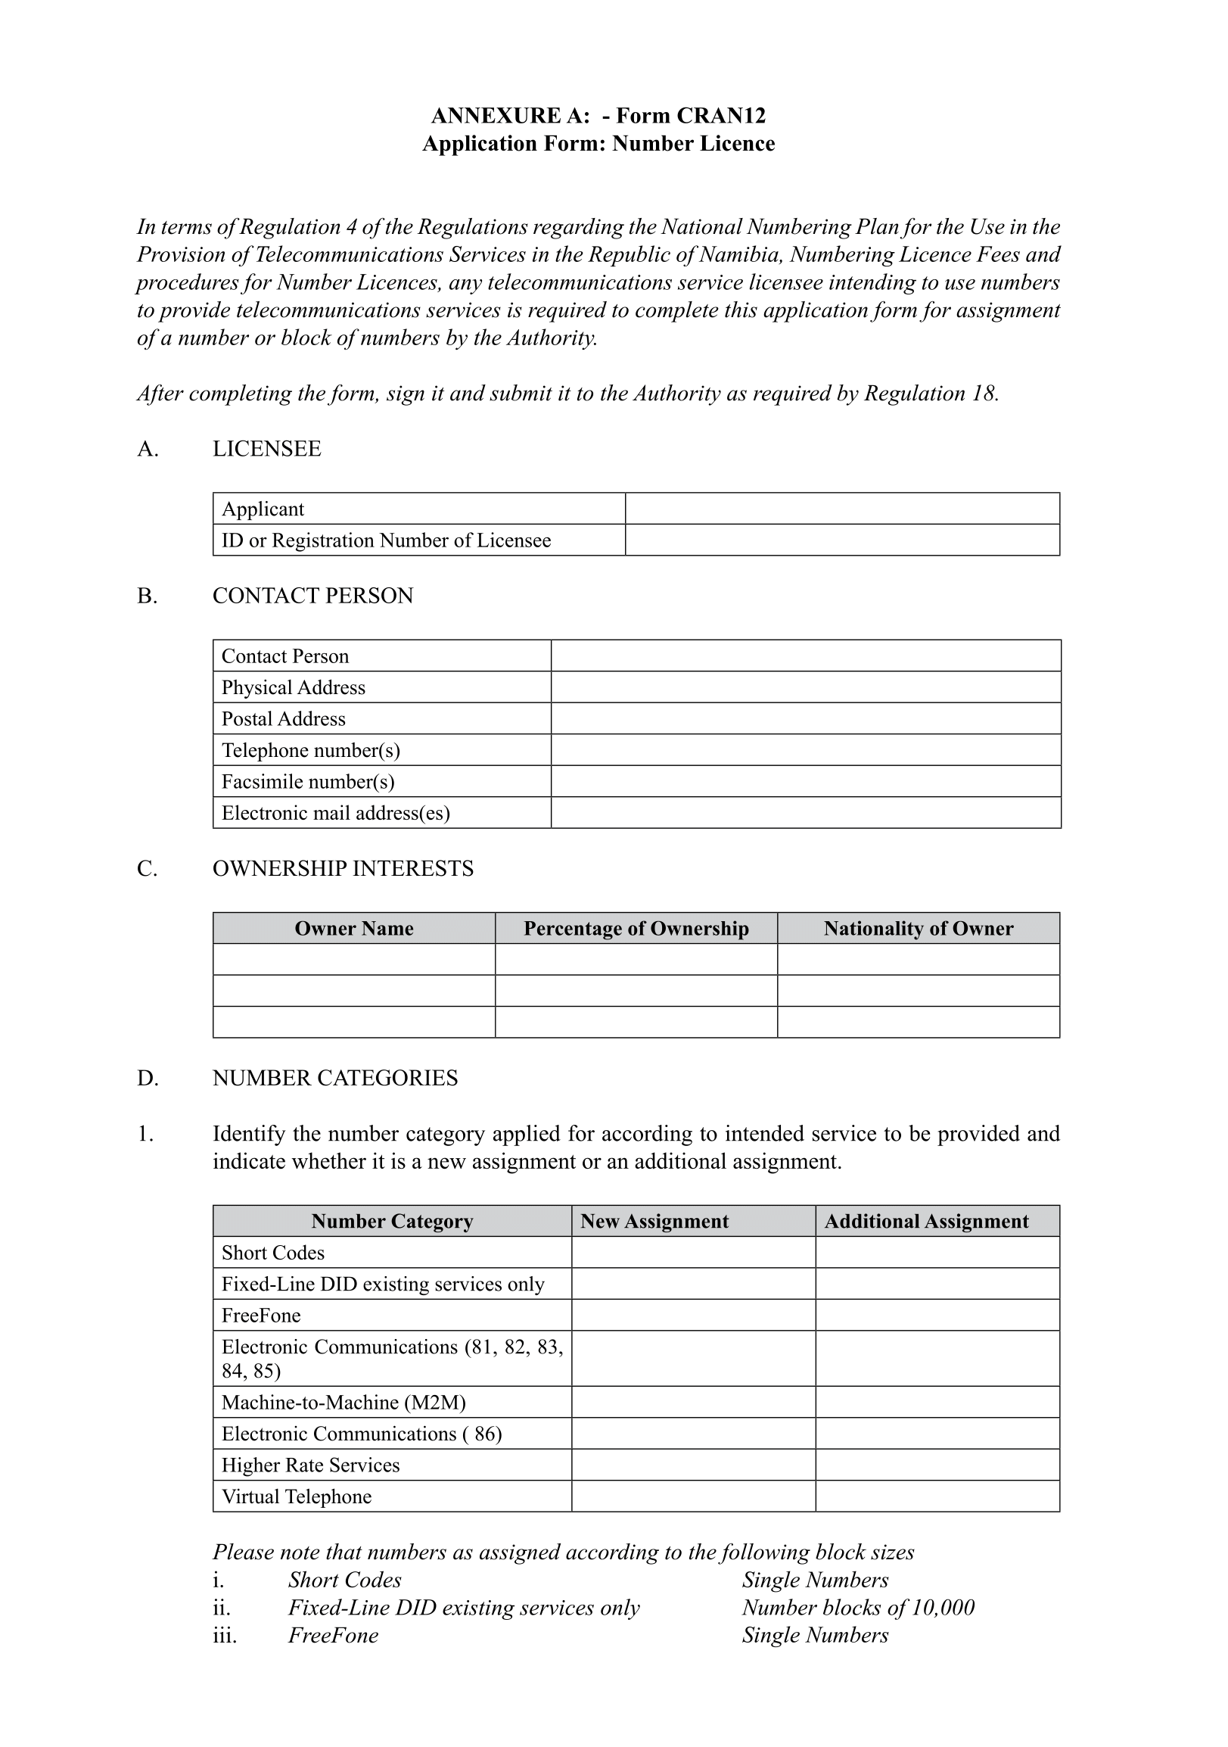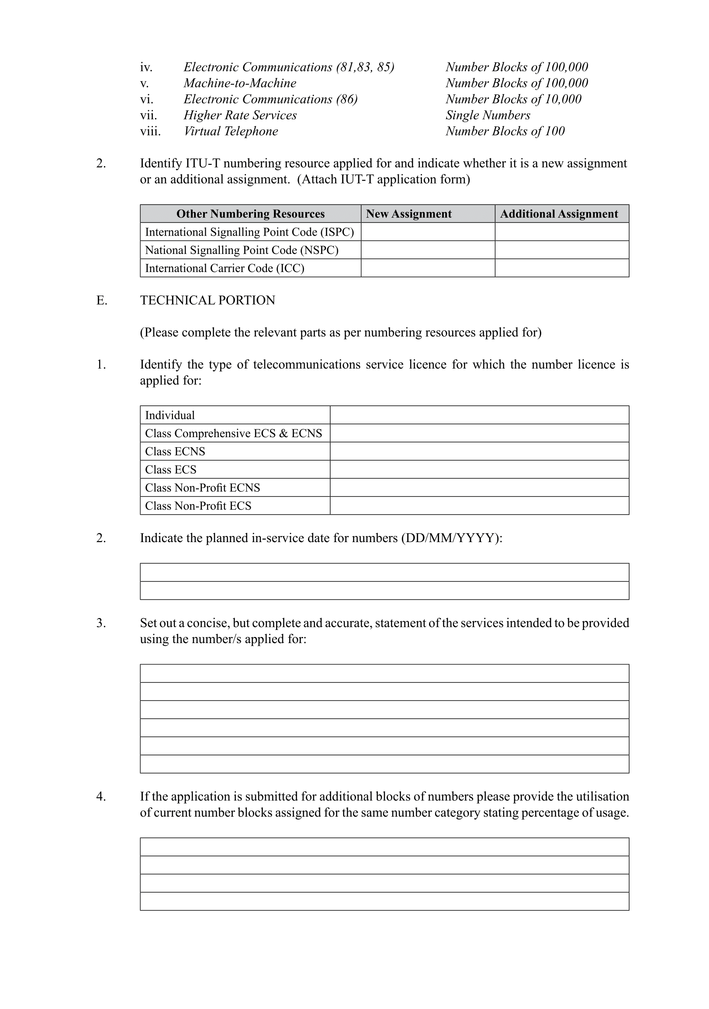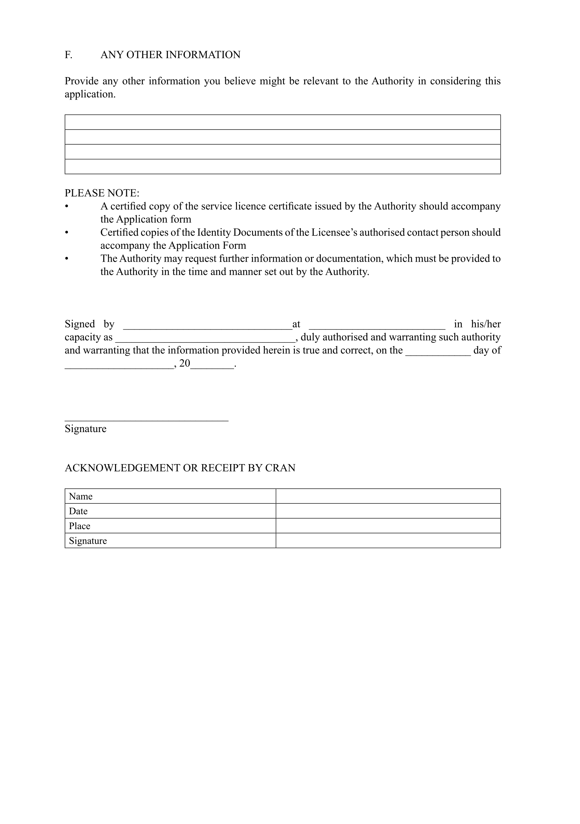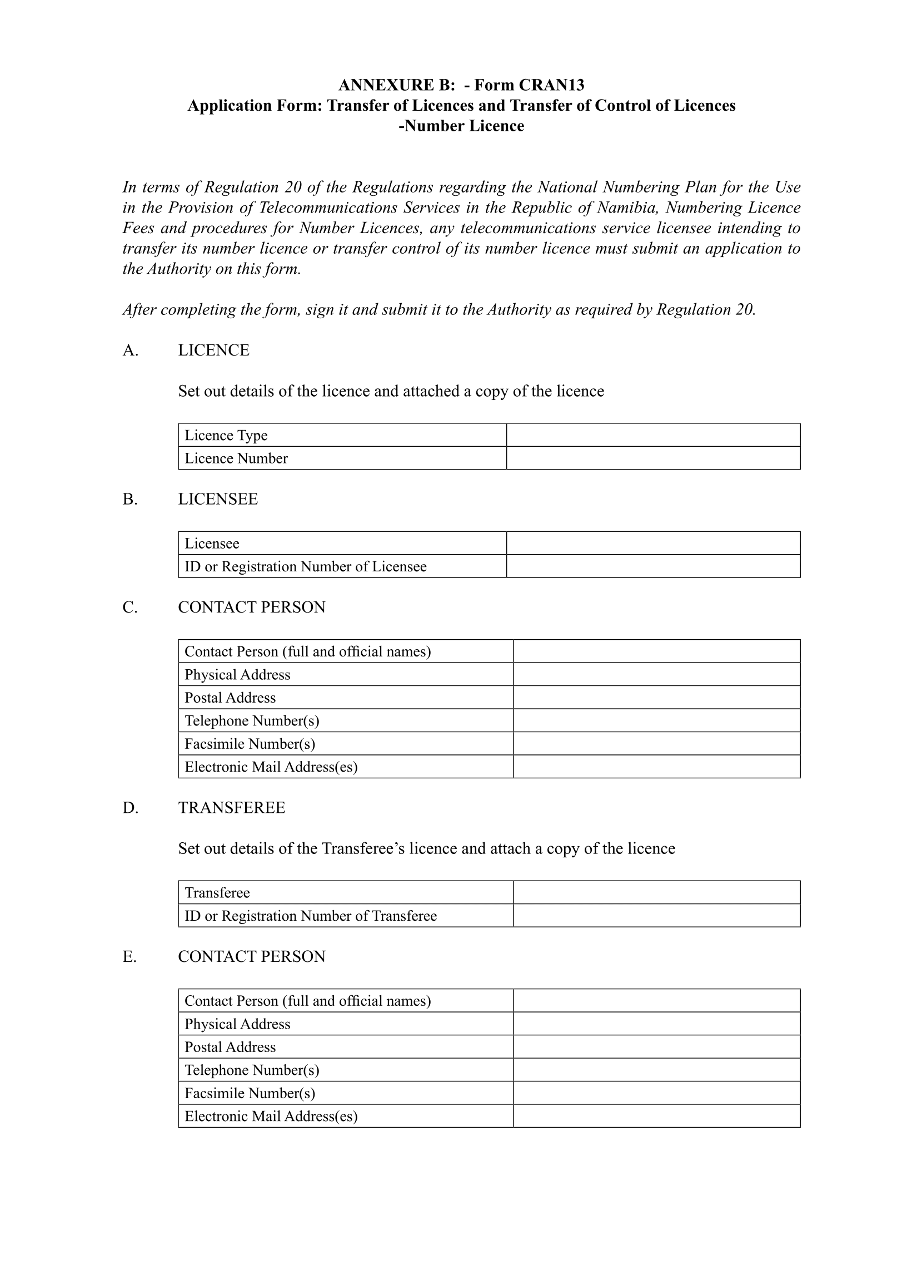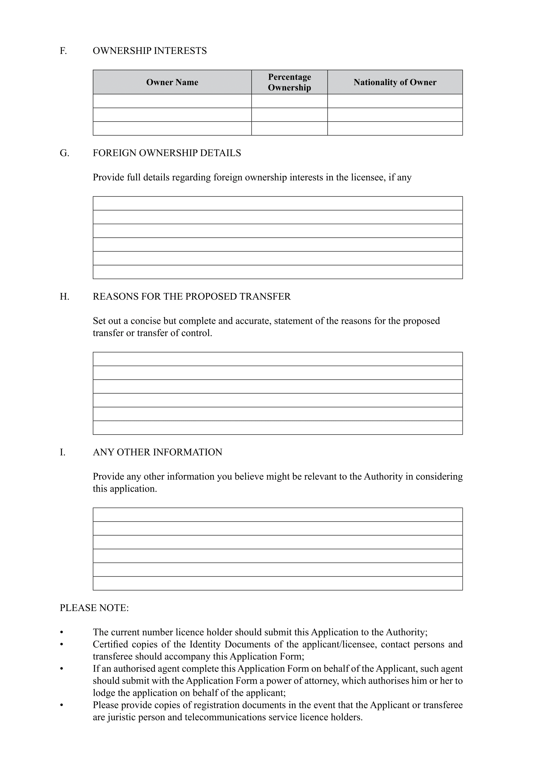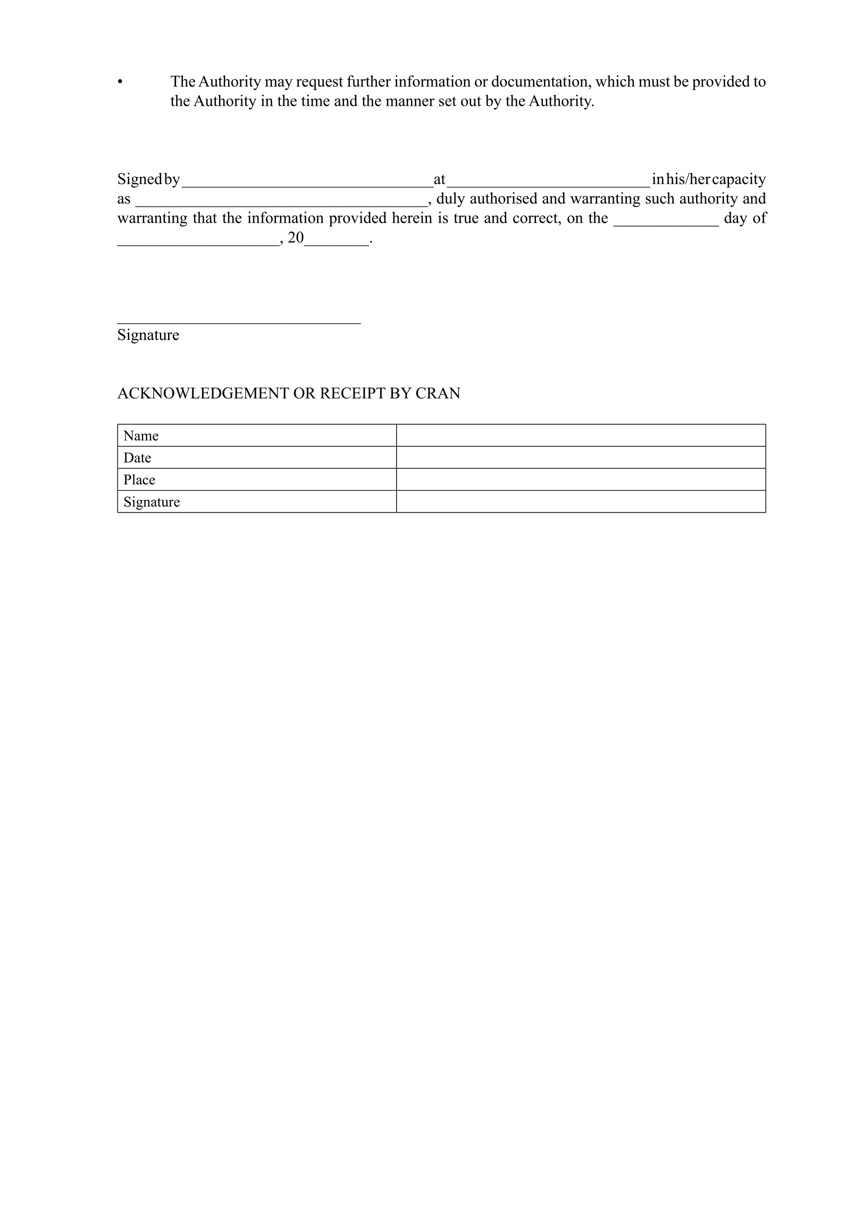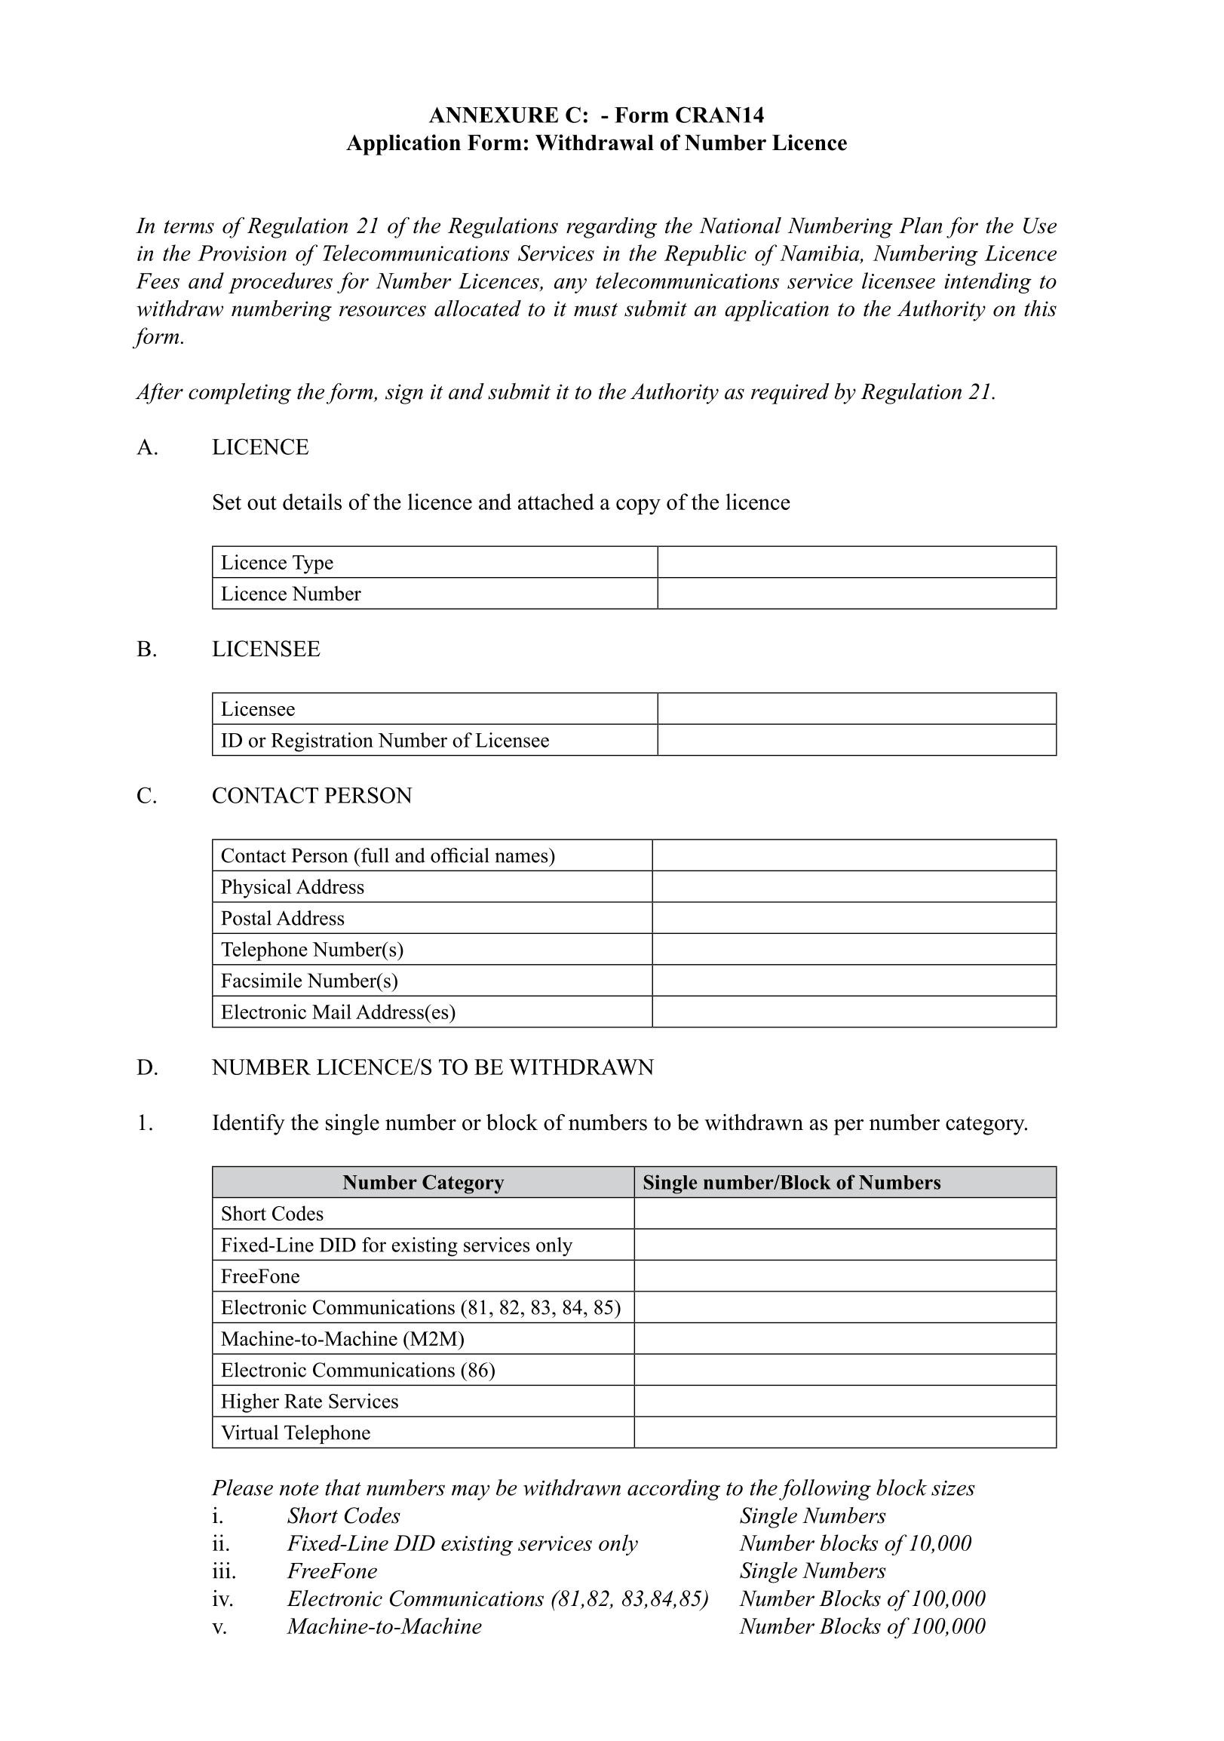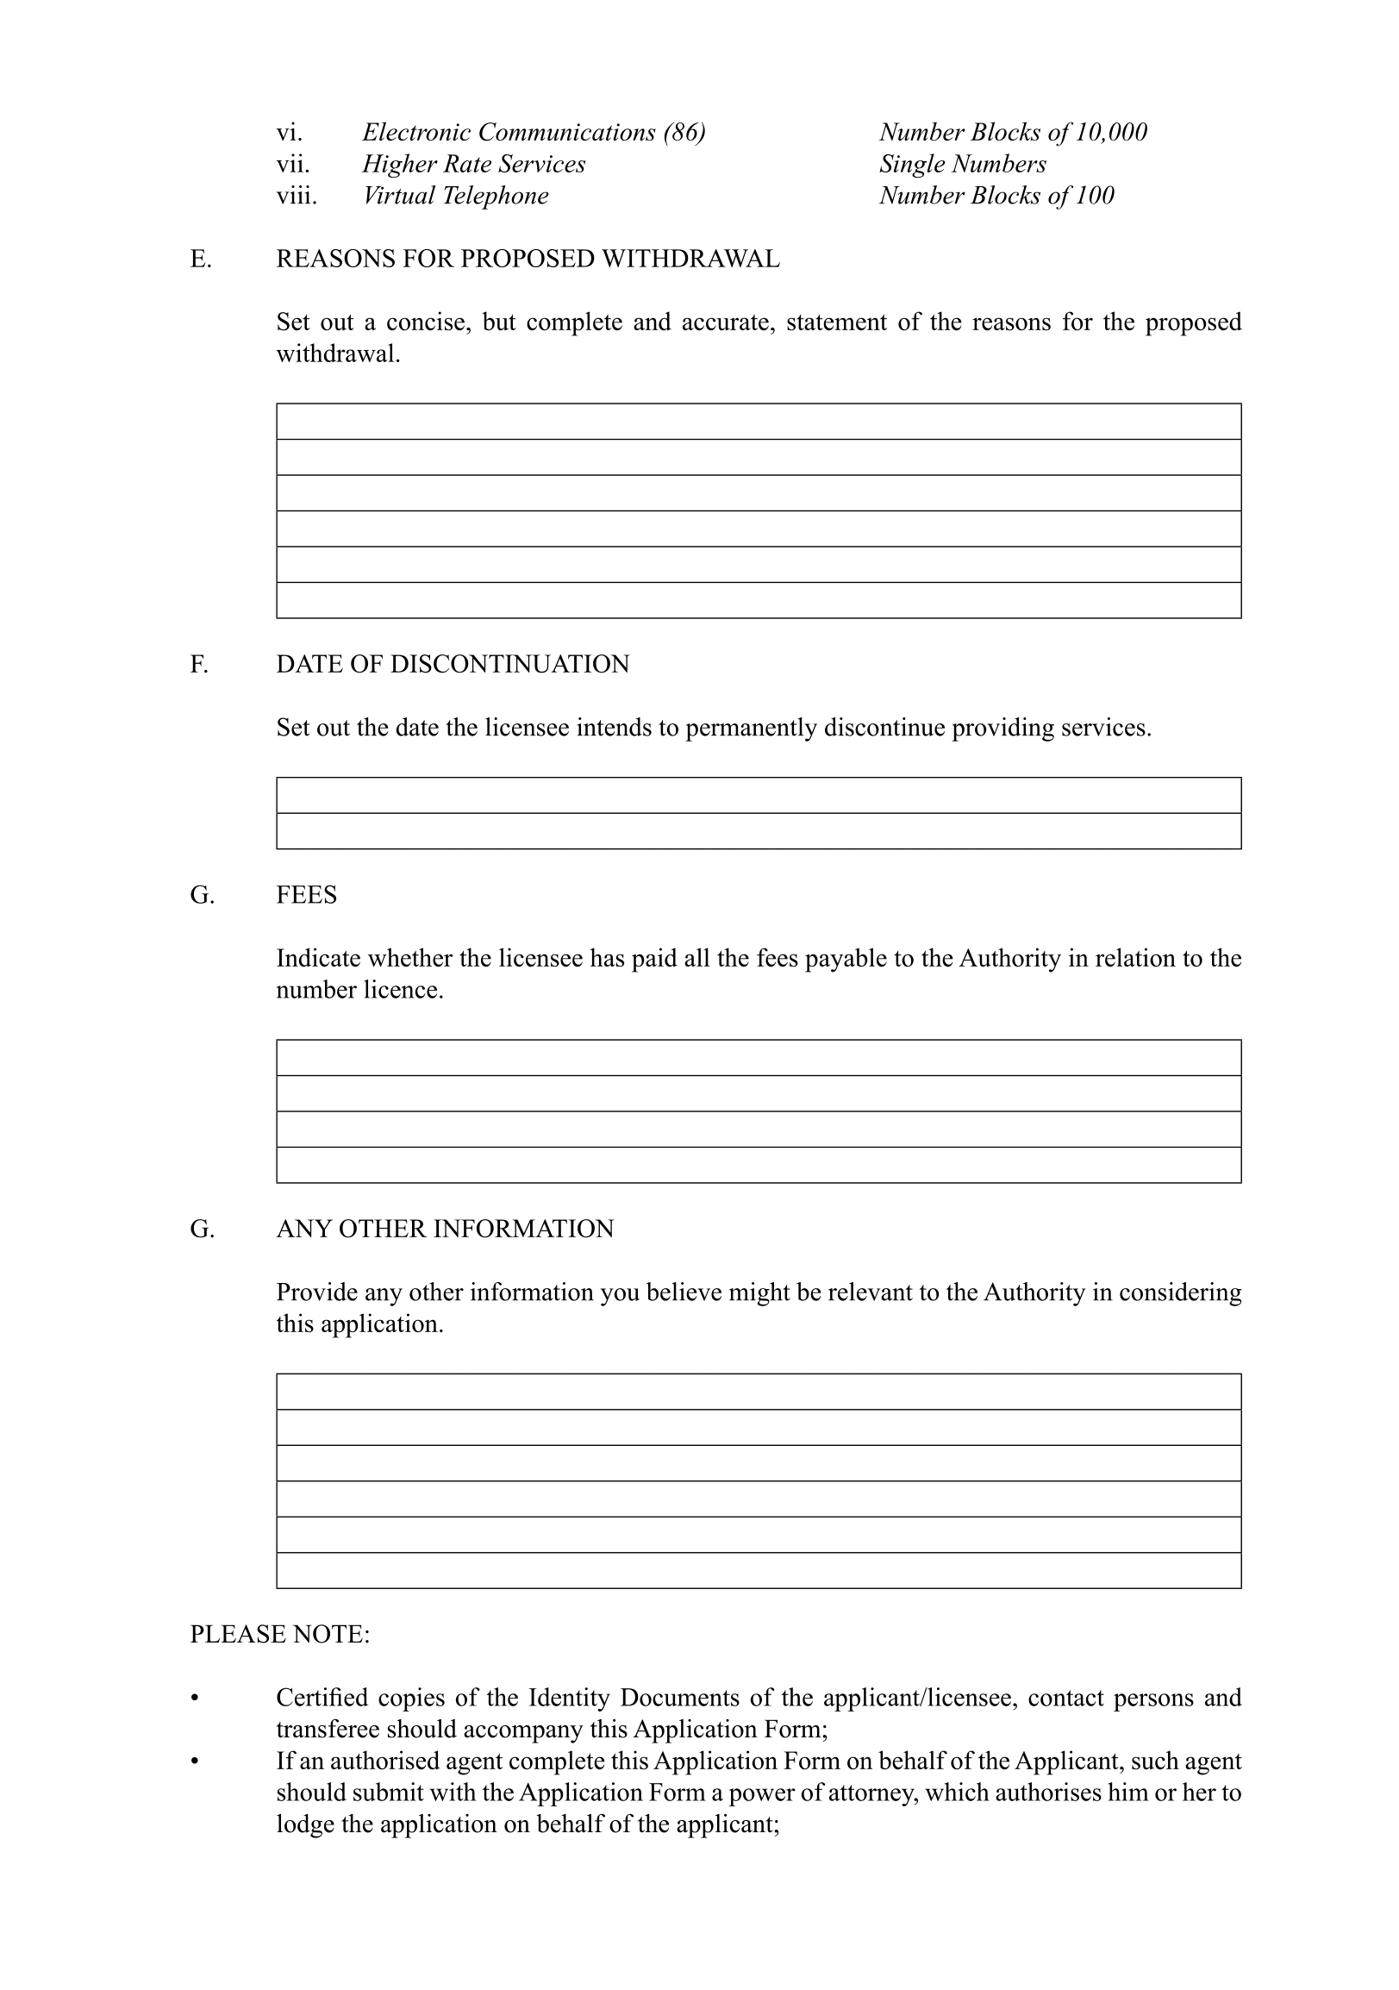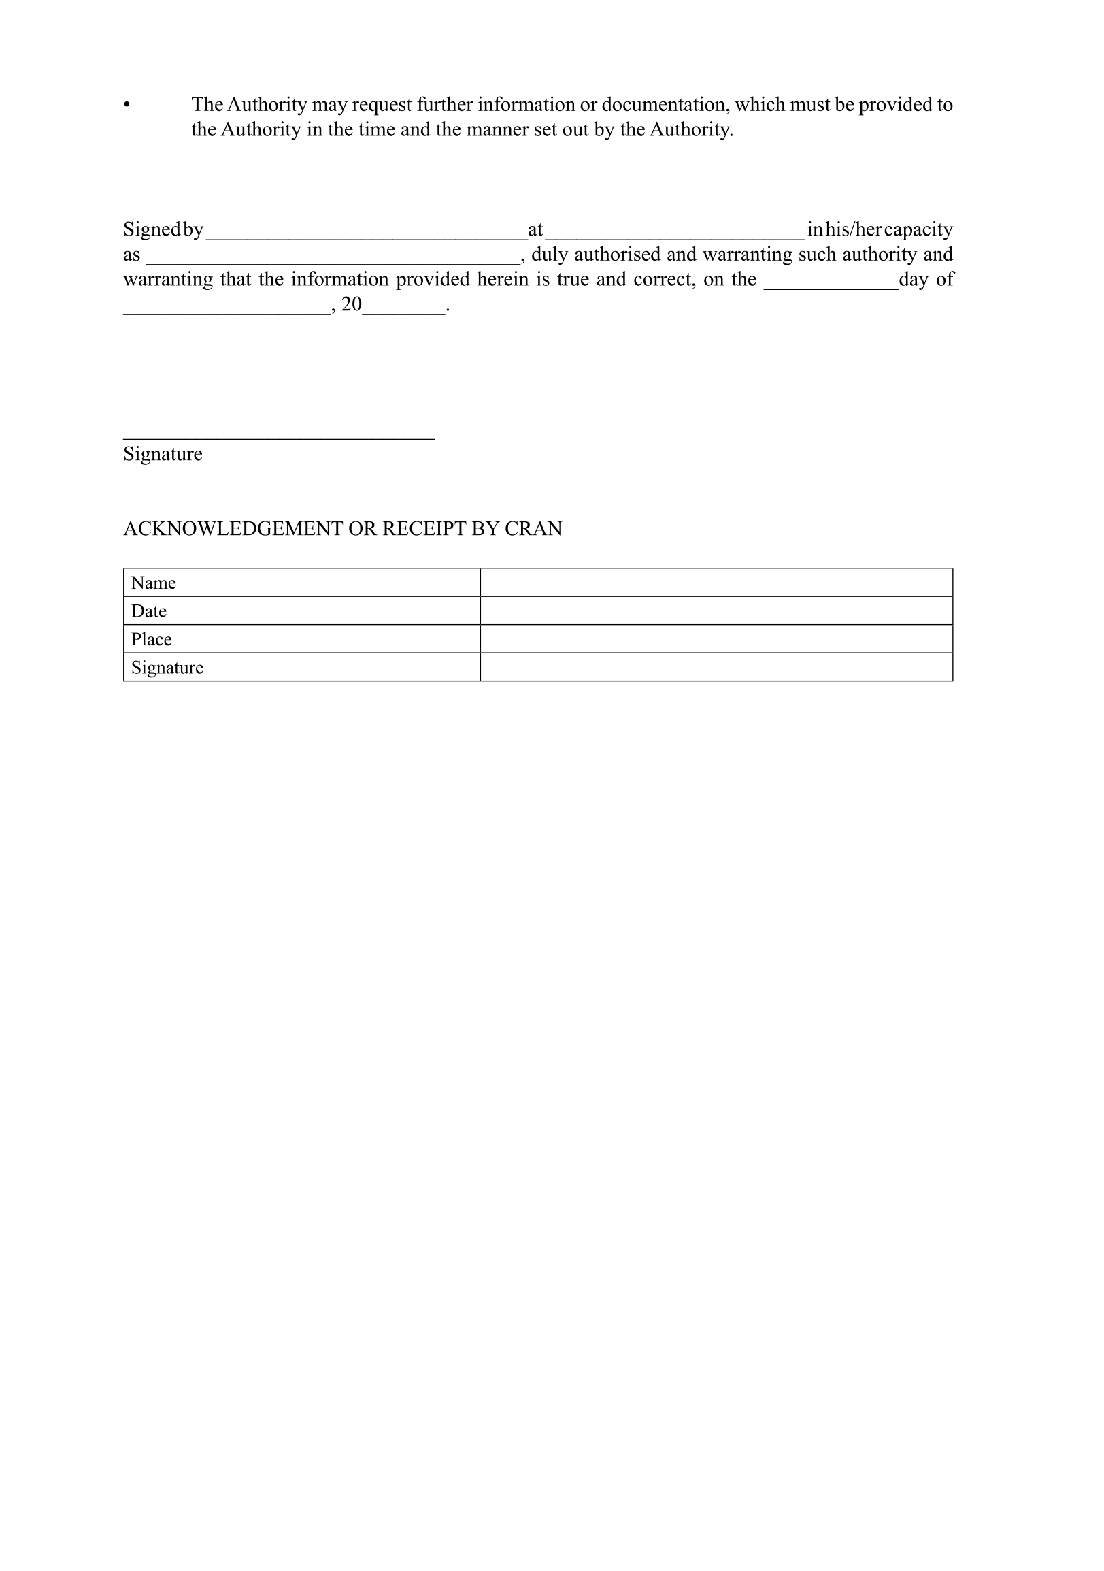

**ANNEXURE D**

**Regulation 39(1)(e)**

[Annexure D is inserted by General Notice 445/2021 and   
substituted by General Notice 675/2022 and by General Notice 668/2024.]

chargEable

*In terms of regulation 39(1)(e) the Authority hereby determine the reference value.*

[The verb “determine” should be “determines” to be grammatically correct.]

*The reference value is set at One Namibian Dollars and Sixty-Eight Four Two (****N$ 1.6842****).*

|  |  |  |
| --- | --- | --- |
| **Number** | **Weight** | **N$ (fees payable)** |
| 3 Digit Numbers | = 1,000,000 | = 1,684,200.00 |
| 4 Digit Numbers | = 100,000 | = 168,420.00 |
| 5 Digit Numbers | = 10,000 | = 16,842.00 |
| 6 Digit Numbers | = 1,000 | = 1.684.42  [perhaps intended to be 1.684.20] |
| 7 Digit Numbers | = 100 | = 168.42 |
| 8 Digit Numbers | = 10 | = 16.842 |
| 9 Digit Numbers | = 1 | = 1.6842 |

*Annual Number Fee = number x weight x reference value*

**ANNEXURE E**

DISCUSSION PAPER ON NUMBERING FEES FOR CRAN

To view content without printing, scroll down.

To print at full scale (A4), double-click the icon below.



[Annexure E is inserted by General Notice 445/2021 and apparently substituted by   
General Notice 675/2022 (although this is not clearly stated).]

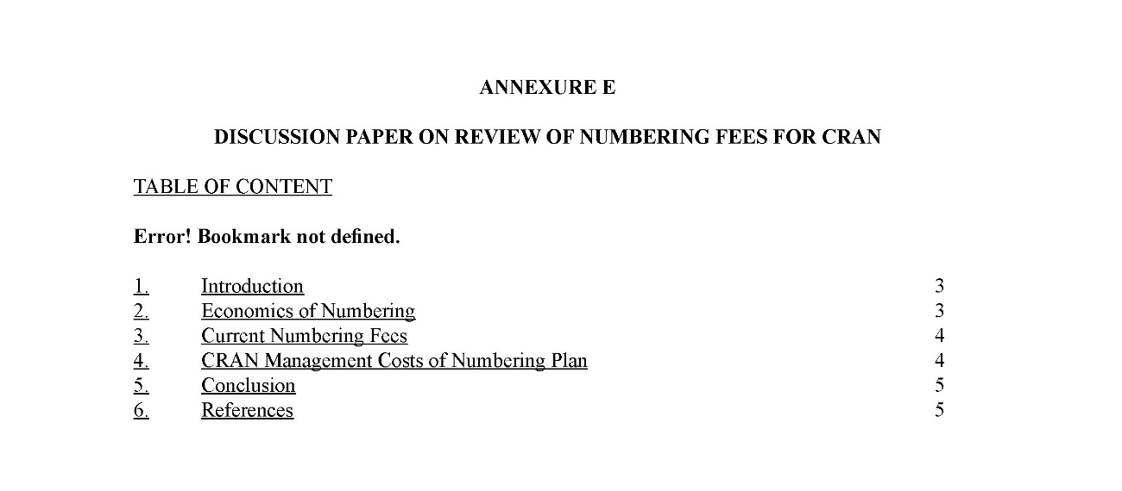

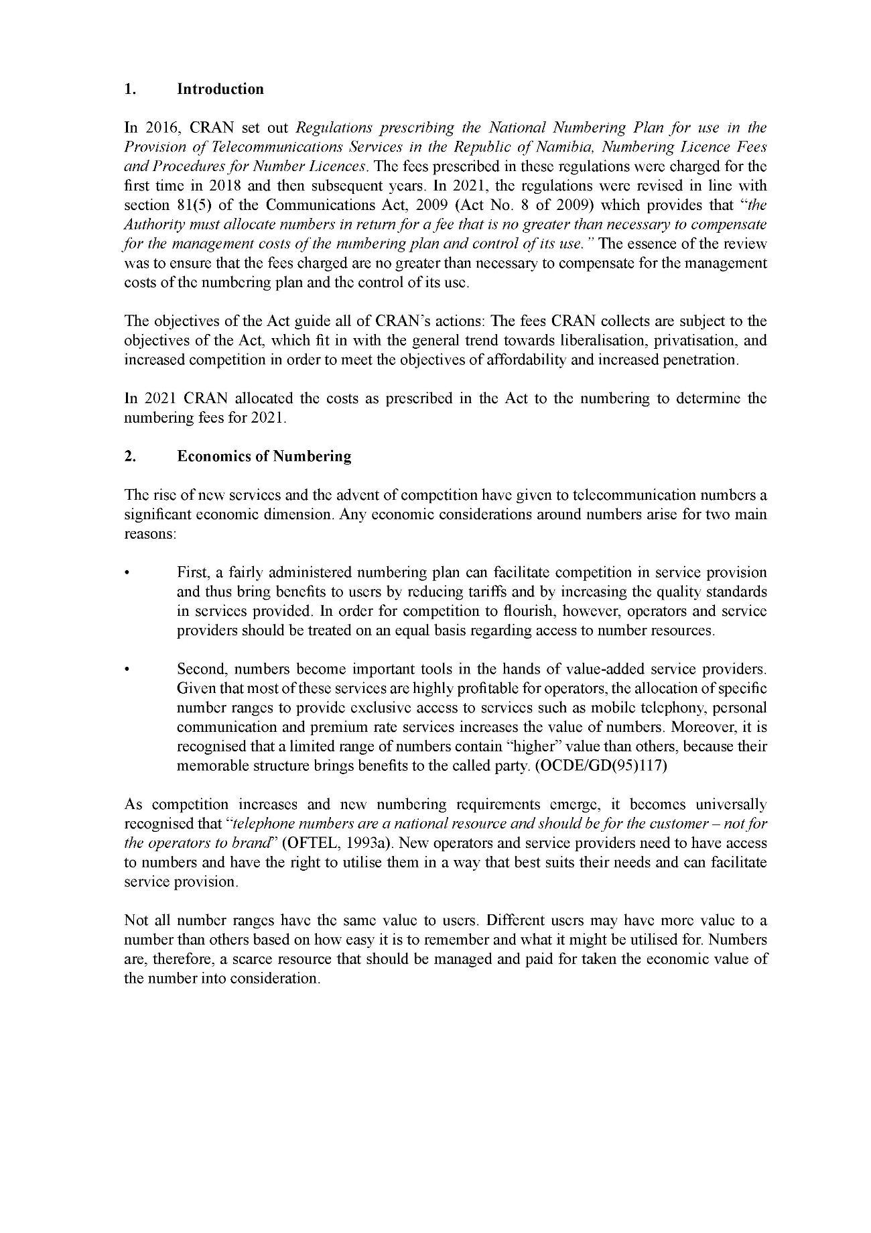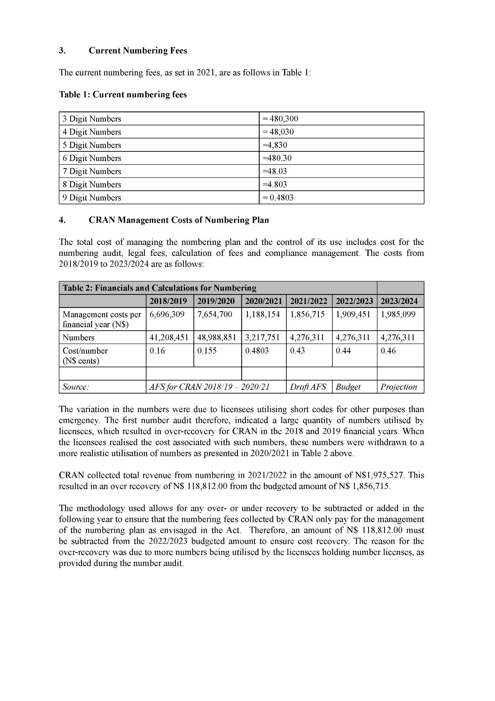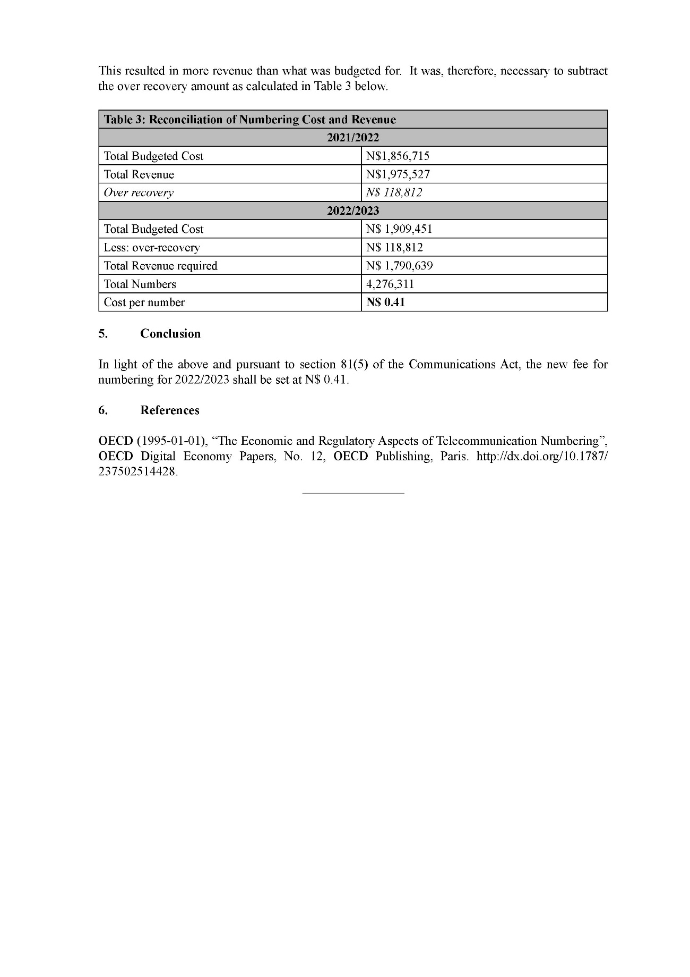

1. N/A = Not Applicable at this time. When the number range is made available for allocation the block size and utilisation will be established
2. Weighting refers to the total numbers not available for use if a certain number with lesser digits is allocated for use to a licensee.