REGULATIONS MADE IN TERMS OF

Communications Act 8 of 2009
section 129

Regulations Prescribing Quality of Service Standards
Applicable to Service Licencees
General Notice 152 of 2015
(GG 5713)
came into force on date of publication: 21 April 2015

as amended by

General Notice 159 of 2020 (GG 7197)
came into force on date of publication: 29 April 2020
General Notice 24 of 2021 (GG 7445)
came into force on date of publication: 1 February 2021

These regulations and amendments were made by the
Communications Regulatory Authority of Namibia.

The General Notice containing the regulations includes a Schedule which
set out a motivation for the regulations, based on the proposed regulations
which were published in advance of the final regulations:

“PURPOSE OF THE PROPOSED REGULATIONS
REGARDING MINIMUM QUALITY OF SERVICE STANDARDS APPLICABLE TO
SERVICE LICENCES: COMMUNICATIONS ACT, 2009

The proposed regulations set out the quality of service standards that are applicable to Individual (Comprehensive telecommunications service licence (ECNS and ECS), Class ECS, ECNS and Class Comprehensive telecommunications (ECNS and ECS).), Class Comprehensive Multiplex and Signal Distribution, Multiplex and Signal Distribution Licenses. Commercial Broadcasting service licence, Community Broadcasting service licence and Public Broadcasting service licence.

The regulations also set out reporting requirements applicable to licensees and mandate a specific reporting format and the consequences for failure to comply with the quality of service standards and reporting requirements.”

ARRANGEMENT OF REGULATIONS

1. Definitions
2. Submission of documents to the Authority
3. Applicability
4. Minimum Quality of Service Standards
5. Reporting Requirements
6. Condonation
7. Submission of information
8. Contraventions and failures

APPENDIX A: MINIMUM QUALITY OF SERVICE STANDARDS

[Appendix B deleted by General Notice 24/2021]

[The layout of these regulations has been adjusted to be consistent with that of other regulations,
but the numbering and lettering remain as they appear in the Government Gazette.]

1. Definitions

In these regulations, any word or expression to which a meaning is assigned in the Act, shall have the same meaning and -

“Act” means the Communications Act, 2009 (Act No. 8 of 2009);

“Authority” means the Communications Regulatory Authority of Namibia;

“Busy time” means a set of the same three (3) hours in each of the same days in the reporting period, during which the highest average traffic for a service is measured or expected;

“Elapsed day” means a twenty-four (24) hour time period;

“Electronic communications” means any emission, transmission or reception of sound, pictures, text or any other information by wire, radio waves, optical media, electromagnetic systems or any other means of a like nature;

“Fault” means the failure of a service to the extent that the service or some aspects of the service is unavailable;

“Licensees” means licensees issued with licences in terms of regulation 5(1)(a) & (b)(i)(ii)(iii) of the Regulations Setting Out Broadcasting and Telecommunications Service Licence Categories, as published in Government Gazette No. 4714, Notice No. 124, dated 18 May 2011, as amended in Government Gazette 5148, General Notice No. 74, dated 13 March 2013;

“Log-in” means multi-step process including, both authentication and authorization, as well as other system start-up tasks in order to provide a user with access to services and/or resources

“Packet loss” means the failure of one or more transmitted packets to reach their final destination;

“Reporting period” means the period of one (1) month starting from the 1st day of every applicable calendar month to the last day of the month for measurements to be submitted by the licensee or a specified time period as determined by the Authority to conduct quality of service measurements;

“Reporting area” means the geographical area as determined by the Authority from time to time within which quality of service standards are measured;

“Service coverage” means the state of indoor and outdoor radio access within the network coverage area of the licensee;

“SMS” means Short Message Service;

“Telecommunications services” means services whose provision consists wholly or partly in the transmission or routing of information on telecommunications networks by means of telecommunications processes but does not include broadcast services; and

“Quality of Service data” means all data accumulated by the Authority pertaining to the measurement of quality of service standards.

2. Submission of documents to the Authority

(1) In these regulations, when persons are permitted or called upon to submit information to the Authority in writing, they may do so either physically or electronically -

[There are no subregulations additional to subregulation (1) in the Government Gazette.]

i) by hand to the head offices of the Authority, namely Communication House, 56 Robert Mugabe Avenue, Windhoek;

ii) by post to the head offices of the Authority, namely Private Bag 13309, Windhoek 9000;

iii) by electronic mail to the following address: operations@cran.na

[There should be a semicolon at the end of paragraph (iii).]

iv) by facsimile to the following facsimile number: +264 61 222790; or

v) in any other manner or at alternative addresses set out by the Authority from time to time.

3. Applicability

(1) These regulations are applicable to the following service licence categories set out in the Regulations Setting Out Broadcasting and Telecommunications Service Licence Categories, published as General Notice No. 124 in Government Gazette No. 4714 dated 18 May 2011 as amended in General Notice No. 74 in Government Gazette No. 5148 dated 13 March 2013 -

[There are no subregulations additional to subregulation (1) in the Government Gazette.]

i) Individual (Comprehensive telecommunications service licence ECNS and ECS); and

ii) Class

a. ECS;
b. ECNS; and
c. Comprehensive telecommunications service licence (ECNS and ECS);
d. Class Comprehensive Multiplex and Signal Distribution service licence;
e. Commercial Broadcasting service licence;
f. Community Broadcasting service licence;
g. Multiplex service licence;
h. Public Broadcasting service licence; and
i. Signal Distribution service licence.

4. Minimum Quality of Service Standards

(1) Licensees must maintain the minimum quality of service standards in accordance with the requirements contained in Appendix A to these regulations.

[There are no subregulations additional to subregulation (1) in the Government Gazette.]

5. Reporting Requirements

(1) A licensee must submit reports to the Authority in accordance with the Regulations on Reporting Obligations for Licensees, published under General Notice No. 24 of 1 February 2021.

[subregulation (1) substituted by General Notice 24/2021]

(2) The licensee shall take the measurements according to the standards stipulated in Appendixes A and B to these regulations.

(3) The Authority may publish quality of service performance indicators in any form or format that it deems reasonably appropriate.

(4) If the Authority publishes the quality of service performance indicators as indicated in subsection 5(3), the Authority may request comments from licensees on quality of service performance indicators prior to publication.

[The term “subsection” should be “subregulation”.]

(5) The Authority may conduct surveys or other studies to assess customer satisfaction with the quality of service provided by licensees.

(6) The Authority may audit some or all of the quality of service data submitted by a licensee.

(7) The Authority may investigate the quality of service measurement, reporting and record keeping procedures of the licensee.

(8) Licensees shall submit any additional information requested by the Authority to verify or clarify quality of service measurements including time periods and geographical areas within thirty (30 days) from receiving the request from the Authority.

(9)

[subregulation (9) deleted by General Notice 24/2021]

(10) The Authority shall determine the geographical area and time period for drive testing conducted on behalf of the Authority to measure quality of service standards.

(11) The Authority shall measure and ensure compliance to quality of service standards using any or all of the following methods: -

(a) Drive testing by the Authority, and/or an independent party appointed by the Authority; and/or

(b) Data collection and statistical reports from licensees; and/or

(c) Any other reasonable means.

6. Condonation

(1) In the event a licensee is unable to comply with any time set out in these regulations, it may request from the Authority an extension of time at least seven (7) days prior to the time set out or within such other time period agreed by the Authority upon good cause shown.

(2) The Authority will respond to the request for condonation as soon as practicable, and may either grant or deny the request, in its sole discretion, based on, among other things, the nature of the information and the reasons for non-compliance with the time set out.

7. Submission of information

A licensee must submit information and reports in the manner and format as set out in these regulations.

[regulation 7 substituted by General Notice 159/2020]

8. Contraventions and failures

Each failure to comply with, or contravention of, a quality of service standard set out in items 1 to 3 of Annexure A, and each such repeated failure or contravention, constitutes a separate failure or contravention with regard to which a penalty may be imposed.

[regulation 8 substituted by General Notice 159/2020]

APPENDIX A

[Appendix B deleted by General Notice 24/2021]

To view content without printing, scroll down.

To print at full scale (A4), double-click the icon below.

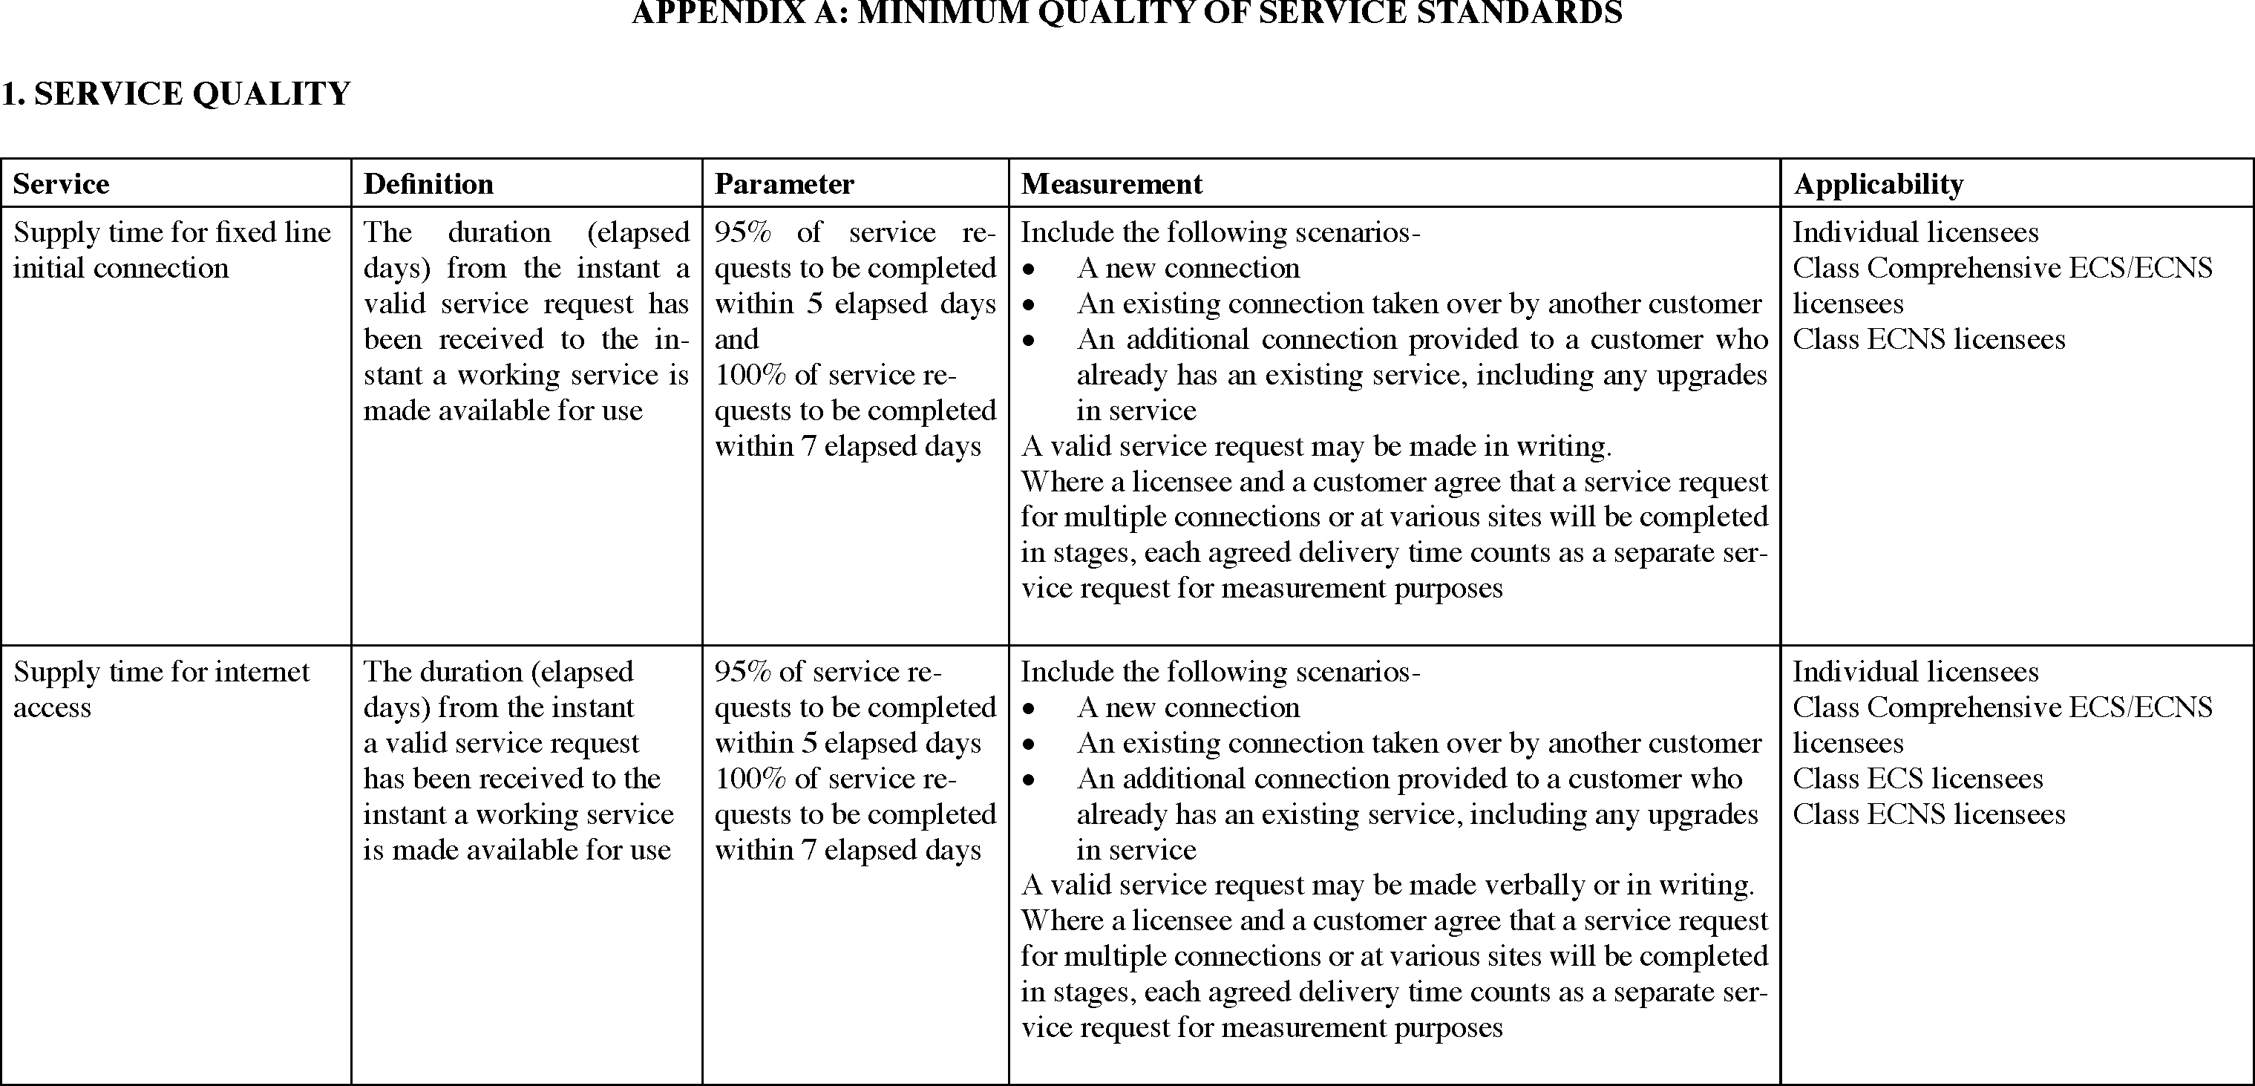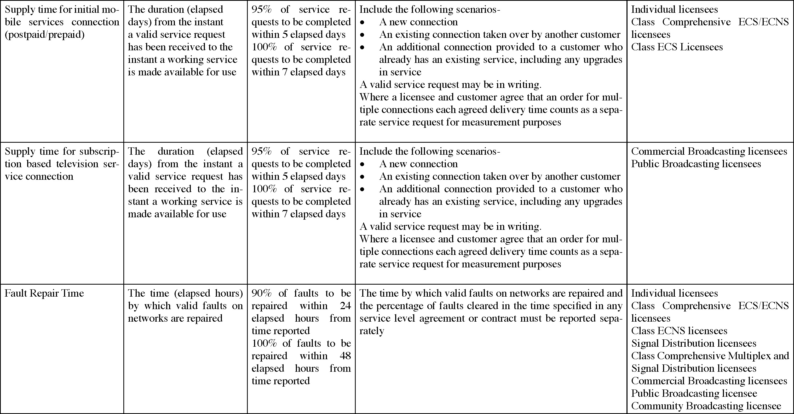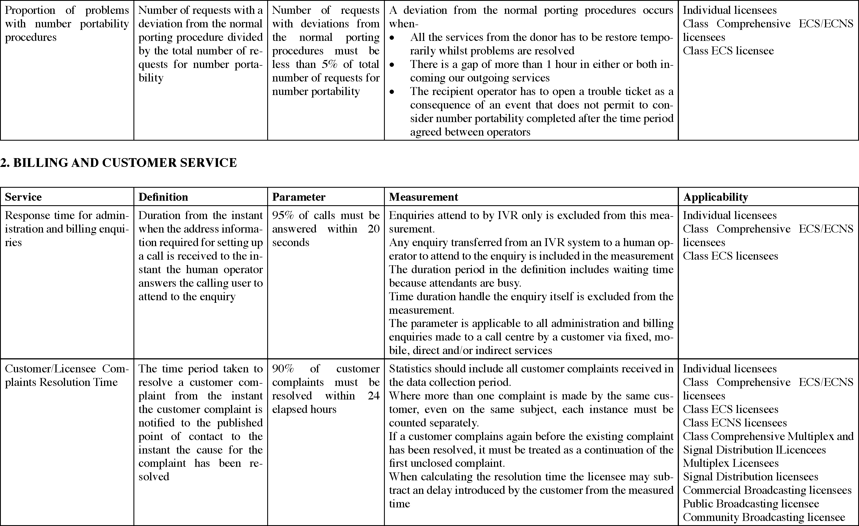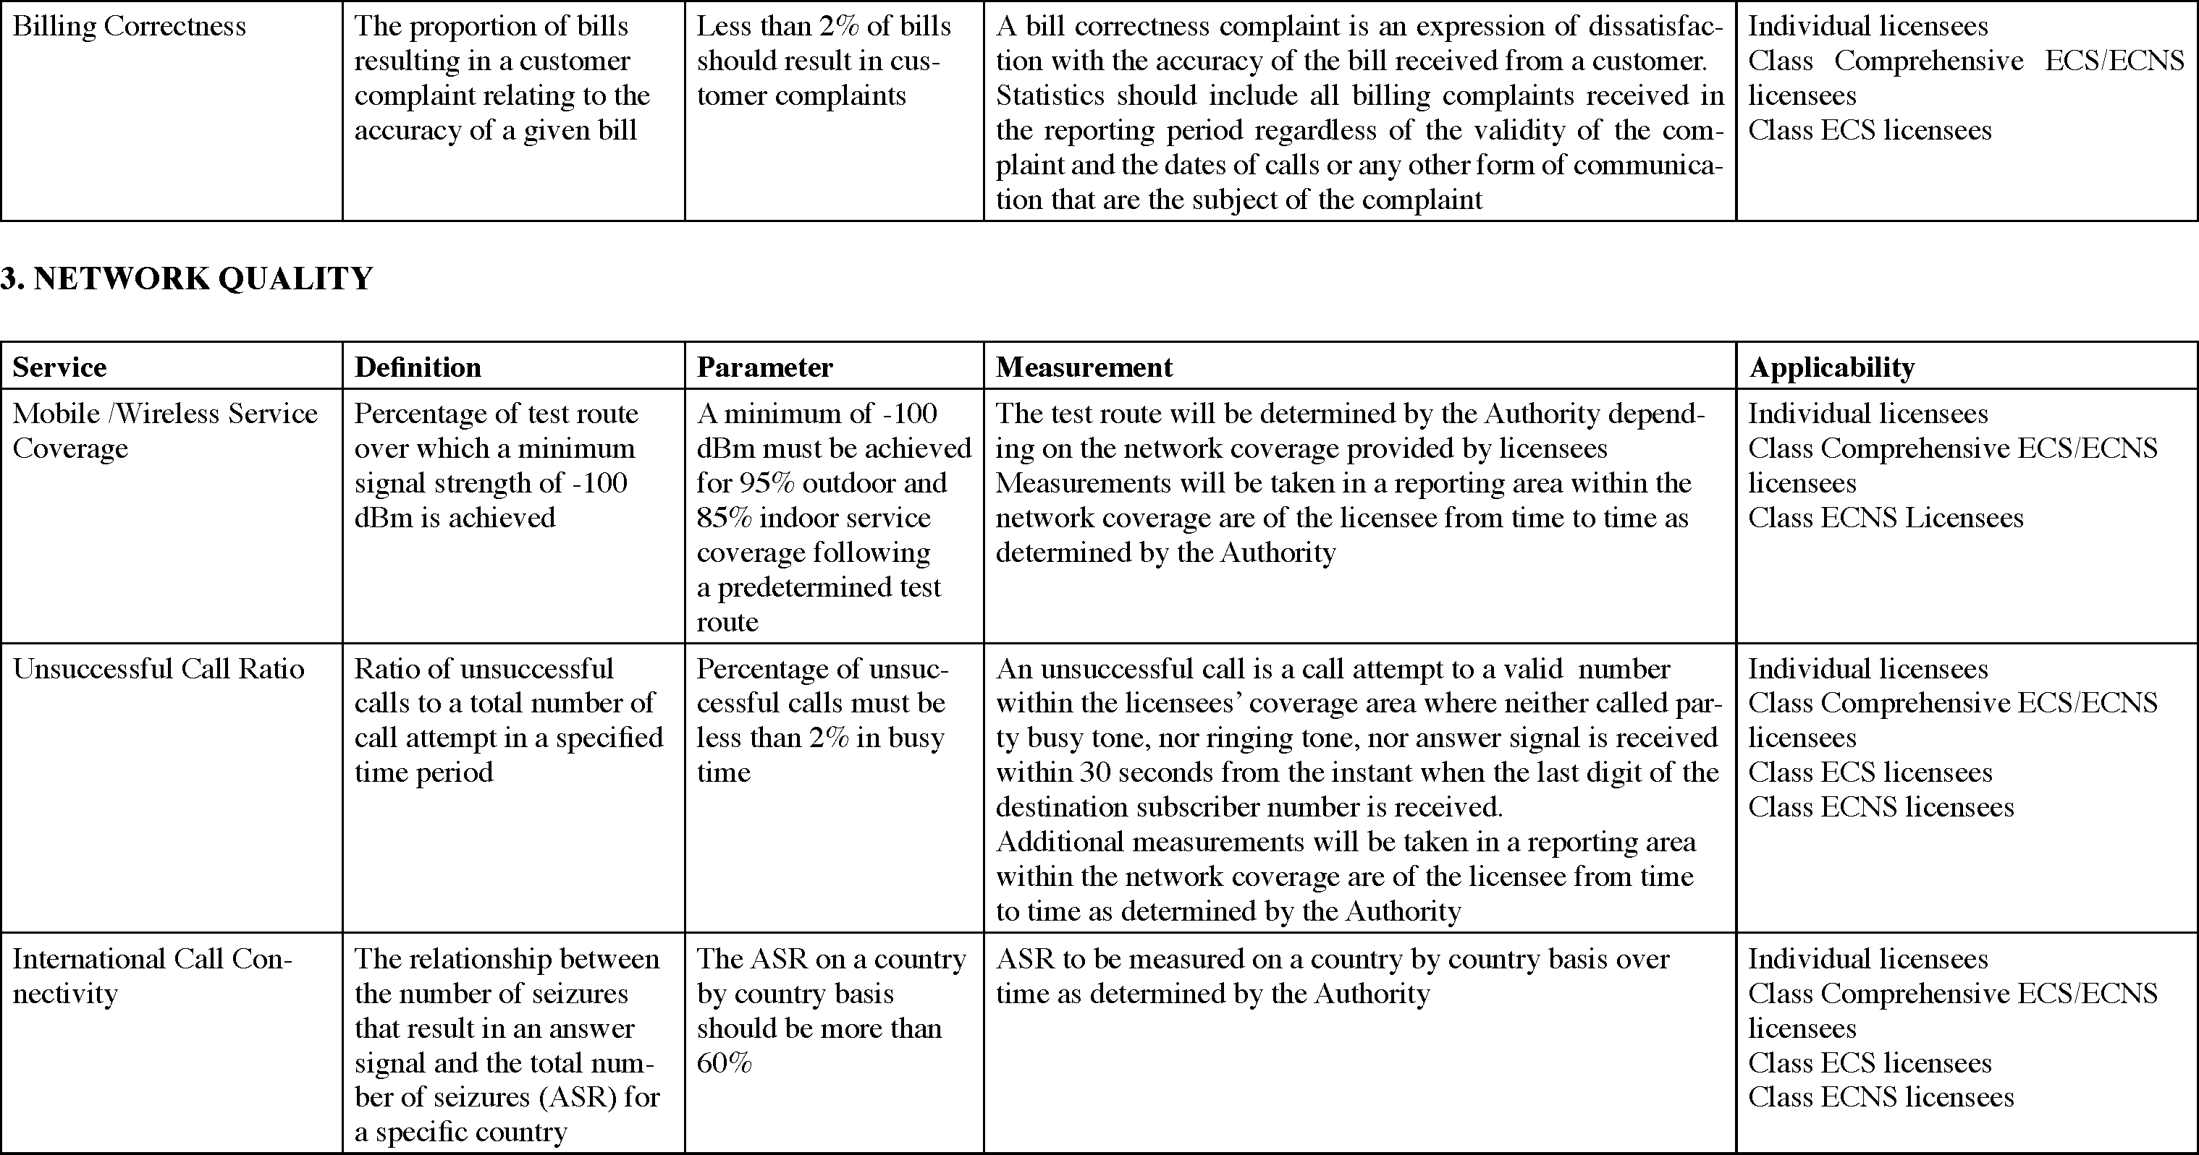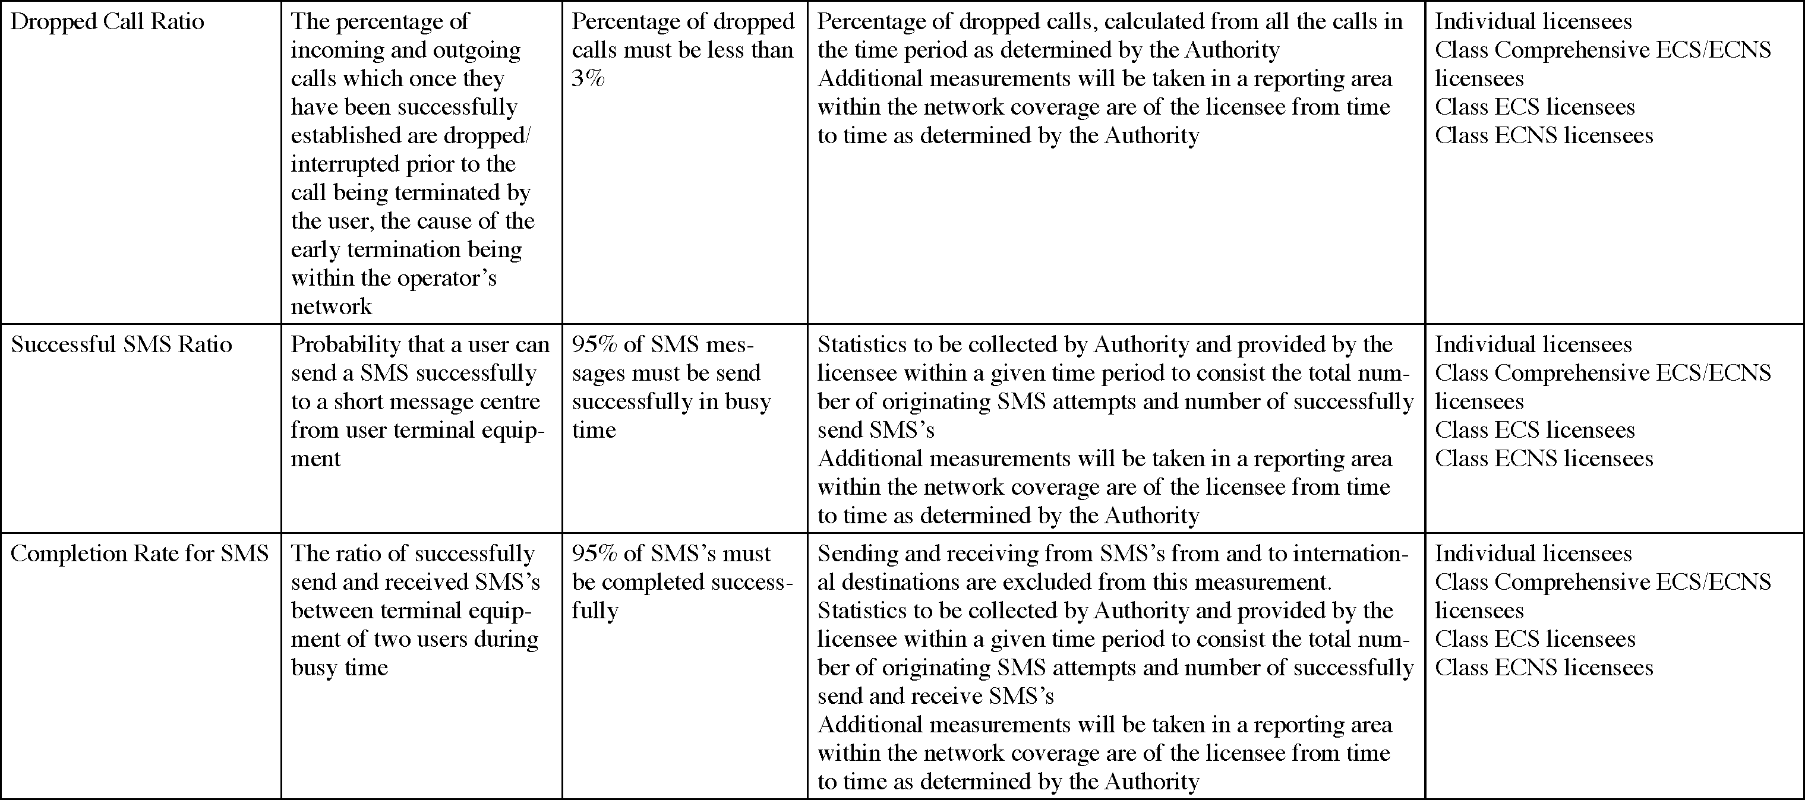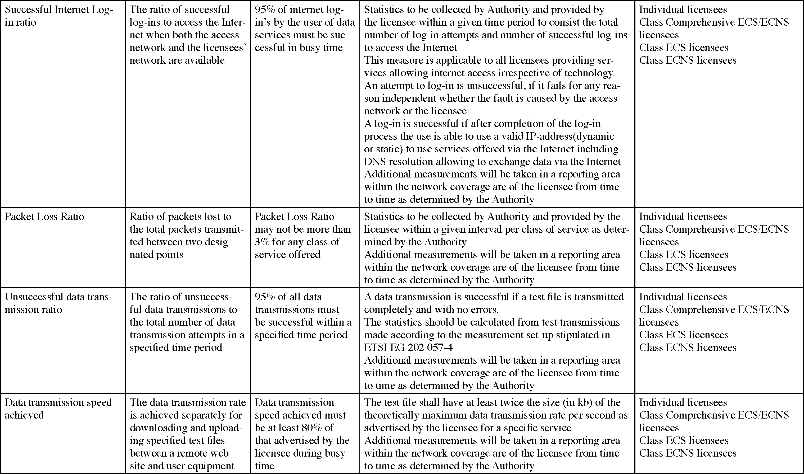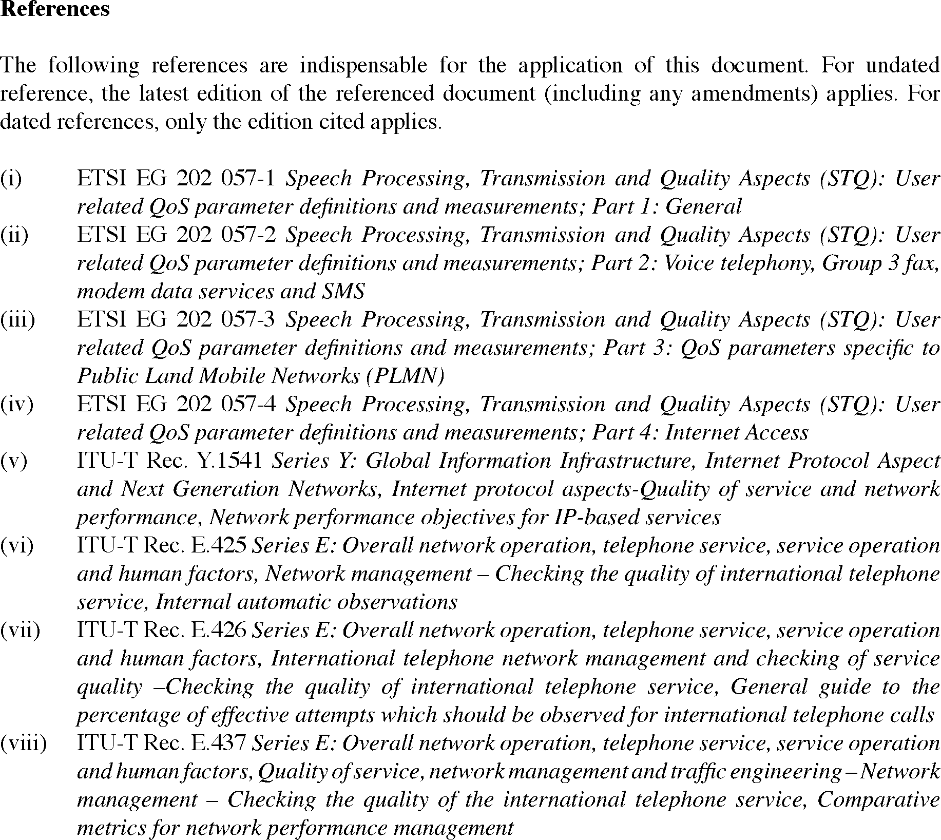

[Appendix B deleted by General Notice 24/2021]

