REGULATIONS MADE IN TERMS OF

Communal Land Reform Act 5 of 2002
section 45

General Regulations
Government Notice 37 of 2003
(GG 2926)
came into force on date of publication: 1 March 2003

as amended by

Government Notice 120 of 2003 (GG 2994)
came into force on date of publication: 16 June 2003
Government Notice 15 of 2014 (GG 5412)
came into force on date of publication: 21 February 2014
Government Notice 100 of 2015 (GG 5760)
came into force on date of publication: 15 June 2015
Government Notice 159 of 2016 (GG 6069)
came into force on date of publication: 12 July 2016

Joseph and Others v Joseph 2020 (3) NR 689 (SC) declares regulation 35 to be ultra vires
the provisions of the Act and thus invalid and of no force and effect.

ARRANGEMENT OF REGULATIONS

PRELIMINARY

1. Definitions

PART l
CUSTOMARY LAND RIGHTS

2. Application for customary land right
3. Maximum size of land that may be held under customary land right
4. Particulars pertaining to allocation of customary land right
5. Register of customary land rights and certificate of registration of customary land right
6. Cancellation of customary land right
7. Application for recognition and registration of right referred to in section 28(1) of the Act
8. Register of recognition of right referred to in section 28(1) of the Act and certificate of registration of that right
9. Hearing regarding application for recognition and registration of right referred to in section 28(1) of the Act
10. Conditions regarding grazing of stock of lawful residents on commonage

PART II
RIGHTS OF LEASEHOLD

11. Application for right of leasehold
12. Application for right of leasehold for agricultural purposes outside designated area
13. Maximum size of land that may be granted under a right of leasehold
14. Determination of amount payable in respect of right of leasehold and improvements
15. Conditions applicable to right of leasehold
16. Register of right of leasehold and certificate of leasehold
17. Application for recognition of right referred to in section 35(1) of the Act and for the grant of a right of leasehold under the Act
18. Hearing regarding application for recognition of right referred to in section 35(1) of the Act
19. Deed of leasehold

PART III
PRELIMINARY INVESTIGATION OF CLAIM TO EXISTING RIGHTS

20. Form of notice regarding holding of preliminary investigation and form of summons
21. Service of notice and summons regarding holding of investigating committee
22. Conducting of preliminary investigation
23. Service of notice by board regarding report of investigating committee

Part IIIA
CRITERIA FOR IDENTIFYING BENEFICIARY FOR INFRASTRACTURE
DEVELOPMENT IN DESIGNATED AREAS

[Part IIIA, comprising regulations 23A-23D, is inserted by GN 159/2016.
Capitalisation is reproduced as in the Government Gazette. The word “INFRASTRUCTURE”
is misspelt in the Government Gazette, as reproduced above.
Other similar Part headings appear in bold.]

23A. Notification of intention to develop farm infrastructure in area designated for agricultural purposes
23B. Minimum eligibility criteria for infrastructure development support
23C. Point scoring system for selection of applicants
23D. General condition
[regulations 23A-23D inserted by GN 159/2016]

Part IIIB
CRITERIA FOR ALLOCATING FARMING UNITS IN DESIGNATED AREAS

[Part IIIB, comprising regulations 23E-23G, is inserted by GN 159/2016.
Capitalisation is reproduced as in the Government Gazette.
Other smilar Part headings appear in bold.]

23E. Notice for allocation of farming unit

23F. Minimum eligibility criteria for allocation of farming unit
23G. Point scoring system for allocation purposes
[regulations 23E-23G inserted by GN 159/2016]

PART IV
GENERAL

[GN 120/2003 substitutes PART IV of the ARRANGEMENT OF REGULATIONS;
the original PART IV did not correspond to the regulations in the text.]

24. Application for transfer of customary land right or right of leasehold
25. Appeal against decision of Chief, Traditional Authority or board
26. Exemptions regarding retention of fences on communal land
27. Procedure for application for authorisation for erection of a fence on communal land and circumstances in which such authorisation is not required
28. Procedure for investigation to be conducted by board for purpose of considering an application, including the summoning of witnesses
29. Procedure for referral of a matter to an arbitrator
30. Conditions under which prospecting or mining operations may be carried out on communal land
31. Combating and prevention of soil erosion
32. Protection of pastoral resources
33. Matters relating to roads, watercourses, woods and the use of water, wood, clay and stone on communal land
34. Functions of secretary of a board
35. Eviction of persons occupying communal land
[declared invalid by Joseph and Others v Joseph 2020 (3) NR 689 (SC)]
36. Offences and penalties
37. Fees payable
38. Repeal of regulations
Annexure 1
Annexure 2

PRELIMINARY

Definitions

1. In these regulations, unless the context otherwise indicates, any word or expression to which a meaning has been assigned in the Act bears that meaning, and -

“Act” means the Communal Land Reform Act, 2002 (Act No. 5 of 2002);

“agricultural land” means agricultural land as defined in section 1 of the Agricultural (Commercial) Land Reform Act, 1995 (Act No. 6 of 1995);

“applicant” means a person who is a lawful resident and identified for investments to be made on his or her leased land inside an area designated for agricultural purposes;

[definition of “applicant” inserted by GN 159/2016]

“chief” includes the head of a traditional community as defined in section 1 of the Traditional Authorities Act, 2000 (Act No. 25 of 2000);

“investment plan” means a prioritised and costed infrastructure development plan emanating through a participatory planning process;

[definition of “investment plan” inserted by GN 159/2016]

“large livestock” means any adult cattle, horse, ass or mule;

“Ministry” means the Ministry responsible for land;

[definition of “Ministry” inserted by GN 159/2016]

“organising committee” means the committee appointed through the participatory planning process for the identification of beneficiaries for infrastructure development and to develop the investment plan;

[definition of “organising committee” inserted by GN 159/2016]

“small livestock” means any adult sheep, goat or pig; and

[definition of “writing” deleted by GN 120/2003]

PART I
CUSTOMARY LAND RIGHTS

Application for customary land right

2. (1) Every application in terms of section 22(1) of the Act for the allocation of a customary land right must be made in the form of Form A set out in Annexure 1 and must be submitted in triplicate to the Chief.

[subregulation (1) amended by GN 15/2014]

(2) All the information required in Form A must be furnished fully therein.

[subregulation (2) amended by GN 15/2014]

(3) Before the allocation of any customary land right a Chief or a Traditional Authority must display for a period of at least seven days on a notice board at the offices of the Traditional Authority a notice -

(a) stating -

(i) the name of the applicant;

(ii) the approximate size of the land applied for;

(iii) the geographical location of the land applied for; and

(iv) the type of customary land right applied for, and

(b) inviting interested parties to lodge with the Chief or Traditional Authority within a period of seven days any objections regarding the application.

(4) A Chief or a Traditional Authority may cause the information contained in the notice referred to in subregulation (3) to be published in any newspaper circulating in its communal area or to be broadcasted on any radio station broadcasting in its communal area.

Maximum size of land that may be held under customary land right

3. (1) Subject to section 23(1) of the Act and subregulation (2), the size of land which may be allocated under a customary land right may not exceed 50 hectares.

[subregulation (1) substituted by GN 100/2015]

(2) If an applicant applies for a size of land that exceeds the size referred to in subregulation (1), the Chief or Traditional Authority must refer the matter, together with adequate reasons and motivations by the applicant and the Chief or Traditional Authority, to the Minister for his or her written approval as contemplated in section 23(1) of the Act.

Particulars pertaining to allocation of customary land right

4. A Chief or Traditional Authority who has allocated a customary land right under section 22 of the Act must, within a period of 30 days after allocating the customary land right, furnish to the board a copy of the application form, as well as the following particulars pertaining to the allocation of the right -

(a) the type of customary land right allocated;

(b) the geographical location of the portion of land allocated;

(c) the size in square metres or hectares of the portion of land allocated; and

(d) whether the applicant has the beneficial use of any other land, whether communal land or otherwise, and the size, location and purpose of use by the applicant of such land.

Register of customary land rights and certificate of registration of customary land right

5. (1) A board must keep a register in respect of allocated customary land rights which are ratified by the board and enter the following particulars in respect of each customary land right into the register -

(a) the name, sex, nationality and date of birth of the person to whom the customary land right has been allocated;

(b) the names of the spouse and other dependants of the person referred to in paragraph (a);

(c) the type of customary land right allocated;

(d) the geographical location of the portion of land allocated;

(e) the size in square metres or hectares of the portion of land allocated; and

(f) the name of the communal area and the region in which the land is situated.

(2) A certificate of registration of a customary land right referred to in section 25(1)(b) of the Act must be issued to the holder of the right in the form determined by the Minister.

[subregulation (2) substituted by GN 15/2014]

Cancellation of customary land right

6. (1) In addition to the grounds mentioned in section 27(1)(a) and (b) of the Act a Chief or Traditional Authority may cancel a customary land right, including a right referred to in section 28(1) of the Act, -

(a) if the land is being used for a purpose other than the purpose for which it has been allocated;

(b) if the land has been kept dormant for three consecutive years;

(c) if the customary land right has been obtained through fraud or not in accordance with the Act; and

(d) if a customary land right in respect of the land has previously been allocated to another person under this Act and such right has not terminated in accordance with any provision of the Act.

(2) A Chief or Traditional Authority who has cancelled a customary land right must furnish to the board the following particulars pertaining to such cancellation -

(a) the name, sex, nationality and date of birth of the person whose right has been cancelled;

(b) the names of the spouse and any other dependants of the person referred to in paragraph (a);

(c) the type of customary land right cancelled;

(d) the geographical location of the portion of land held under such cancelled right;

(e) the size in square metres or hectares of such portion of land;

(f) the name of the communal area and the region in which the land is situated;

(g) the date on which the customary land right has been cancelled; and

(h) the reason for the cancellation of the right.

(3) The board must enter the cancellation of a customary land right in the register referred to in regulation 5(1).

Application for recognition and registration of right referred to in section 28(1) of the Act

7. (1) Every application in terms of section 28(2) of the Act for the recognition and registration of an existing customary land right referred to in section 28(1) of the Act and, where applicable, for authorisation for the retention of any fence on the land concerned, must be made in the form of Form A set out in Annexure 1 and must be submitted in triplicate.

[subregulation (1) amended by GN 15/2014]

(2) All the information required in Form A must be furnished fully therein or be attached thereto.

[subregulation 2 amended by GN 15/2014]

(3) The letter of the Chief or Traditional authority referred to in section 28(5) of the Act must contain information relating to -

(a) whether or not the application is supported by the Chief or Traditional Authority; and

(b) any other information which the Chief or Traditional Authority may wish to bring to the attention of the board.

(4) Before the recognition and registration of a right referred to in subregulation (1) the board must display for a period of at least seven days on a notice board at its offices a notice -

(a) stating -

(i) the name of the applicant;

(ii) the approximate size of the land in respect of which the recognition of the right is applied for;

(iii) the geographical location of the land in respect of which the recognition of the right is applied for; and

(iv) the type of customary land right applied for to be recognised, and

(b) inviting interested parties to lodge with the board within a period of seven days any objections regarding the application.

(5) A board may cause the information contained in the notice referred to in subregulation (3) to be published in any newspaper circulating in its region or to be broadcasted on any radio station broadcasting in its region.

Register of recognition of right referred to in section 28(1) of the Act and certificate of registration of that right

8. (1) The register in which a board must enter the recognition of a customary land right referred to in section 28(1) of the Act as contemplated in section 28(7) thereof, must contain the following particulars -

(a) the name, sex, nationality and date of birth of the person whose right has been recognised;

(b) the names of the spouse and any other dependants of the person referred to in paragraph (a);

(c) the type of customary land right recognised;

(d) the geographical location of the portion of land in respect of which the right has been recognised;

(e) the size in square metres or hectares of the portion of land in respect of which the right has been recognised; and

(f) if the retention of any fence on the land has been authorised, the nature of such fence and its dimensions or the area of land enclosed by the fence.

(2) A certificate of registration of an existing customary land right referred to in section 28 of the Act must be issued to the holder of the right in the form determined by the Minister.

[subregulation (2) substituted by GN 14/2014]

Hearing regarding application for recognition and registration of existing customary land right referred to in section 28(1) of the Act

9. (1) If the board in terms of section 28(9) of the Act determines that a hearing referred to in that section must be held, the secretary of the board must in writing inform the applicant -

(a) the reason for the holding of the hearing;

(b) the date, time and place where the hearing will be held;

(c) to produce at the hearing any documentary evidence or to lead any verbal evidence in support of his or her claim;

(d) to ensure that any witness he or she intends to call in support of his or her claim, will be present at the hearing.

(2) At the hearing the chairperson of the Board -

(a) must give particulars of any conflicting claims in relation to the land or the reason why the validity of the applicant's claim is doubted, and

(b) may produce documentary evidence or call witnesses to testify on any matter relevant to the subject matter of the hearing.

(3) The applicant concerned -

(a) may interrogate any person who has given verbal evidence or who has submitted documentary evidence as referred to in subregulation (2)(b); and

(b) may give and lead evidence, including documentary evidence, in support of his or her claim or in rebuttal of any document or evidence referred to in paragraph (a).

(4) The chairperson of the Board may administer an oath or affirmation to any witness appearing before the board.

(5) The chairperson and other members of the board with his or her permission, may put questions to any person giving evidence.

(6) After all evidence has been given, the applicant must be afforded the opportunity to address the board on the evidence and whether or not the application must be granted.

(7) Upon conclusion of the hearing, the Board must make a decision in accordance with section 28(10) of the Act, which must be -

(a) reduced to writing;

(b) signed by the chairperson of the board; and

(c) made known at the hearing.

(8) The board may at any time adjourn the hearing to be resumed at such date, time and place as the board may determine or as the secretary of the board may by registered post communicate to all parties concerned.

Conditions regarding grazing of stock of lawful residents on commonage

10. (1) Subject to subregulation (2), a lawful resident referred to in section 29(1) of the Act may not allow more than 300 large livestock or more than 1800 small livestock to graze at any given time on the commonage of a communal area.

(2) A lawful resident referred to in subregulation (1) who is the owner of or hires any agricultural land may not allow any livestock to graze on the commonage of a communal area concerned.

(3) No person, other than a lawful resident referred to in subregulation (1), or a person representing such a resident, may bring or cause to be brought any livestock onto the commonage of a communal area, unless such person has been granted grazing rights by the Chief or Traditional Authority in terms of section 29(3).

(4) Any person who contravenes subregulations (1), and (2) and (3) is guilty of an offence.

[punctuation and wording of subregulation (4) reproduced
as it appears in the Government Gazette]

PART II
RIGHTS OF LEASEHOLD

Application for right of leasehold

11. (1) Every application in terms of section 31(1) of the Act for a right of leasehold must be made in the form of Form B set out in Annexure 1 and must be submitted in triplicate.

[subregulation (1) amended by GN 15/2014]

(2) All the information required in Form B must be furnished fully therein or be attached thereto.

[subregulation (2) amended by GN 15/2014]

(3) Before the granting of any right of leasehold the board must display for a period of at least seven days on a notice board at its offices a notice -

(a) stating -

(i) the name of the applicant;

(ii) the approximate size of the land applied for;

(iii) the geographical location of the land applied for; and

(iv) the type of right of leasehold applied for, and

(b) inviting interested parties to lodge with the Chief or Traditional Authority within a period of seven days any objections regarding the application.

(4) A board may cause the information contained in the notice referred to in subregulation (3) to be published in any newspaper circulating in its region or to be broadcasted on any radio station broadcasting in its region.

Application for right of leasehold for agricultural purposes outside designated area

12. (1) Every application referred to in section 30(3) of the Act for approval for a right of leasehold for agricultural purposes outside a designated area must be made in the form of Form B set out in Annexure 1 and must be submitted in triplicate.

[subregulation (1) amended by GN 15/2014]

(2) All the information required in Form B must be furnished fully therein or be attached thereto.

[subregulation (2) amended by GN 15/2014]

Maximum size of land that may be granted under a right of leasehold

13. (1) Subject to section 31(3) of the Act and subregulation (2), the size of land in respect of which a right of leasehold may be granted may not exceed 100 hectares.

[subregulation (1) substituted by GN 100/2015]

(2) If an applicant applies for a size of land that exceeds the size referred to in subregulation (1), the Board must refer the matter to the Minister for his or her written approval as contemplated in section 31(3) of the Act.

Determination of amount payable in respect of right of leasehold and improvements

14. (1) An amount payable in respect of a right of leasehold and improvements, if any, on a portion of land as contemplated in section 32(2) of the Act, must be determined by the Board with regard to -

(a) the particular use or purpose for which the right is required;

(b) the value of the improvements, if any, on the portion of the land;

(c) the size of the portion of land in respect of which the right has been granted; and

(d) the period for which the right of leasehold has been granted.

(2) A board may in the determination of the amount referred to in subregulation (1) use the services of valuators.

(3) For purposes of this regulation “valuator” means -

(a) any estate agent registered as such under the Estate Agents Act, 1976 (Act No. 112 of 1976);

(b) any quantity surveyor or architect, as the case may be, registered respectively as such under the Quantity Surveyors” and Architects' Act, 1979 (Act No. 13 of 1979); or

(c) any other person appointed by the Minister in writing for such purpose.

Conditions applicable to right of leasehold

15. (1) The following conditions apply to a right of leasehold -

(a) the holder of a right of leasehold or any person in his or her employment may not use the land for any purpose -

(i) other than that for which its occupation is authorised, without the prior written approval of the Board;

(ii) in contravention of the Liquor Act, 1998 (Act No. 6 of 1998) or any regulations made in terms thereof;

(iii) in contravention of any law relating to the cultivation, possession, disposal of or dealing in dependence-producing drugs;

(b) the Minister or any person duly authorised by him or her in writing may at any reasonable time enter upon and inspect the land and any buildings thereon for the purpose of ensuring compliance by the holder with any regulation or condition, or to determine or re-determine the boundaries of the land;

(c) the holder of a right of leasehold must preserve and maintain the beacons by which the land is demarcated and is liable for the cost of repairing or rebuilding any such beacon which has become dilapidated or damaged, and for replacing any such beacon which has been demolished, lost or misplaced, in such position as the Chief or Traditional Authority, as the case may be, directs;

(d) no roads or thoroughfares which exists on or over the land may be closed or otherwise obstructed to prevent free passage of persons, animals or traffic, unless such closure or obstruction is authorised by a competent authority;

(e) the Board may cancel any right of leasehold if -

(i) the right was granted in error;

(ii) the right of leasehold was obtained by fraud or misrepresentation;

(iii) the holder of that right -

(aa) fails to comply with any of the conditions subject to which that right was granted; or

(bb) fails to pay two consecutive instalments referred to in section 32(l)(c) of the Act in respect of the land;

(cc) defaults in paying an amount in respect of the periodical rental payable in terms of the deed of leasehold, within 30 days after having been given a written demand for such payment by the Board;

(iv) upon proof to the satisfaction of the Board-

(aa) that the land is no longer used for the purpose for which it has been granted; or

[There is only one sub-subparagraph under subparagraph (iv).]

(v) if the holder of a right of leasehold has been convicted of an offence of treason or sedition;

(f) the Minister may cancel a right of leasehold granted in respect of land for agricultural purposes outside a designated area in accordance with section 30(3);

(g) any business for the purpose of which a right of leasehold is granted must be personally conducted by the holder of a right of leasehold, or in the case of a company or a close corporation, by a director or a member thereof, unless the Board or the Minister has in writing approved that any other person may so conduct the business;

(h) when requested to do so by a Chief, a Traditional Authority or a board, the holder of a right of leasehold must in respect of any building on the land -

(i) before occupying any such building, insure that building against fire for such sum as the Minister may notify in writing and cede the insurance policy to the Government;

(ii) pay the initial premium on such policy and promptly on due date pay any renewal premium thereon and furnish proof of compliance with this condition to the Minister;

(iii) maintain any such building to the satisfaction of the Minister;

(i) the holder of a right of leasehold or any person in his or her employment may not demolish or effect any alteration or addition to any building or other property of the Government without the prior written approval of the Minister.

(2) If a board has determined that the portion of land in respect of which a right of leasehold has been granted, must be surveyed, that board may determine the manner of survey that should be done in the particular case.

Register of right of leasehold and certificate of leasehold

16. (1) A board must keep a register, referred to in section 33(l)(a) of the Act, in respect of allocated rights of leasehold which are ratified by the Board and enter the following particulars in respect of each such right of leasehold -

(a) the name, sex, nationality and date of birth of the person to whom the right has been granted;

(b) the names of the spouse and other dependants of the person referred to in paragraph (a);

(c) the type of right of leasehold granted;

(d) the geographical location of the portion of land in respect of which the right of leasehold has been granted;

(e) the size in square metres or hectares of the portion of land in respect of which the right of leasehold has been granted;

(f) the period for which the right of leasehold has been granted;

(g) the name of the communal area and the region in which the land is situated; and

(h) the particulars of every mortgage bond, servitude or similar right registered over the land in terms of the Deeds Registries Act, 1937 (Act No. 47 of 1937), or any other law;

[Paragraph (h) ends with a semicolon instead of a full stop; there are no additional words in
the Government Gazette. The Deeds Registries Act 47 of 1937 has been replaced by the
Deeds Registries Act 14 of 2015.]

(2) A -

(a) certificate of leasehold for any purpose other than agricultural purposes outside a designated area must be in the form determined by the Minister; and

(b) certificate of leasehold for a purpose other than agricultural purposes outside a designated area must be in the form determined by the Minister,

and the original certificate must be issued to the holder at the time of the registration of the right of leasehold.

[subregulation (2) substituted by GN 15/2014]

Application for recognition of right referred to in section 35(1) of the Act and for the grant of a right of leasehold under the Act

17. (1) Every application in terms of section 35(2) of the Act for the recognition of a right referred to in section 35(1) of the Act and for the grant of a right of leasehold under the Act and, where applicable, for authorisation for the retention of any fence on the land, must be made in the form of Form B set out in Annexure 1 and must be submitted in triplicate.

[subregulation (1) amended by GN 15/2014]

(2) All the information required in Form 8 must be furnished fully therein or be attached thereto.

(3) The letter of the Chief or Traditional authority referred to in section 35(5) of the Act should contain information relating to -

(a) whether or not the application is supported by the Chief or Traditional Authority; and

(b) any other information which the Chief or Traditional Authority wish to bring to the attention of the board.

(4) Before the recognition and granting of right of leasehold referred to in subregulation (1) the board must display for a period of at least seven days on a notice board at its offices a notice -

(a) stating-

(i) the name of the applicant;

(ii) the approximate size of the land in respect of which the recognition of the right is applied for;

(iii) the geographical location of the land in respect of which the recognition of the right is applied for; and

(iv) the type of right of leasehold to be recognised and granted, and

(b) inviting interested parties to lodge with the board within a period of seven days any objections regarding the application.

(5) A board may cause the information contained in the notice referred to in subregulation (3) to be published in any newspaper circulating in its region or to be broadcasted on any radio station broadcasting in its region.

(6) If an application referred to in subregulation (1) has been granted, the secretary of the board must issue to the applicant a certificate of leasehold in the form determined by the Minister and enter into the register referred to in regulation 16(1) the particulars referred to in regulation 16(1).

[subregulation (6) substituted by GN 15/2014]

Hearing regarding application for recognition of right referred to in section 35(1) of the Act

18. (1) If the Board in terms of section 35(10) of the Act determines that a hearing referred to in that section must be held, the secretary of the Board must in writing inform the applicant -

(a) the reason for the holding of the hearing;

(b) of the date, time and place of the hearing;

(c) to produce at the hearing any documentary evidence or to lead any verbal evidence in support of his or her claim; and

(d) to ensure that any witness he or she intends to call in support of his or her claim, will be present at the hearing.

(2) At the hearing the chairperson of the Board -

(a) must give particulars of any conflicting claims in relation to the land or the reason why the applicant's claim is doubted, as the case may be, and

(b) may produce documentary evidence or call witnesses to testify on any matter relevant to the subject matter of the hearing.

(3) The applicant -

(a) may interrogate any person who has given verbal evidence or who has submitted documentary evidence as referred to in subregulation (2)(b); and

(b) may give and lead evidence, including documentary evidence, in support of his or her claim or in rebuttal of any document or evidence referred to in paragraph (a).

(4) The chairperson of the Board may administer an oath or affirmation to any witness appearing before the board.

(5) The chairperson and other members of the board may put questions to any person giving evidence.

(6) After all evidence has been given, the applicant must be afforded the opportunity to address the board on the evidence and whether or not the application must be granted.

(7) Upon conclusion of the hearing, the Board must make a decision in accordance with section 35(11) of the Act, which must be -

(a) reduced to writing;

(b) signed by the chairperson of the board; and

(c) made known at the hearing.

(8) The Board may at any time adjourn any hearing to be resumed at such date, time and place as the board may determine or as the secretary of the board may by registered post communicate to all parties.

Deed of leasehold

19. If -

(a) a right of leasehold, except a right of leasehold for agricultural purposes outside the designated area, has been granted to an applicant, that applicant must in respect of that right enter into a deed of leasehold with the board in the form determined by the Minister; or

(b) a right of leasehold for agricultural purposes outside a designated area has been granted to an applicant, that applicant must in respect of that right enter into a deed of leasehold with the Minister in the form determined by the Minister.

[Regulation 19 is substituted by GN 15/2014. The amending Government Notice says “Regulation 19 of the Regulations is amended by the substitution for subregulation 6 of the following subregulation”. However, this direction appears to be in error as there are no subregulations in regulation 19.
The intention appears to have been to substitute regulation 19 in its entirety.]

PART III
PRELIMINARY INVESTIGATION OF CLAIM TO EXISTING RIGHTS

Form of notice regarding holding of preliminary investigation and form of summons

20. (1) A notice referred to in section 37(3) of the Act must be given in the form determined by the Minister.

[subregulation (1) substituted by GN 15/2014]

(2) A summons referred to in section 37(4) of the Act must be issued in the form determined by the Minister.

[subregulation (2) substituted by GN 15/2014]

Service of notice and summons regarding holding of investigating committee

21. (1) A notice referred to in section 37(3) of the Act and a summons referred to in section 37(4) of the Act must be served by the chairperson of the investigating committee -

(a) by delivering it to the person named therein; or

(b) if he or she cannot be found, by delivering it at his or her residence or place of employment or business to a person apparently over the age of 16 years and apparently residing or employed there.

(2) A return by the person who served the notice or summons referred to in subregulation (1) that the service thereof has been effected may, upon the failure of the person so served to attend the preliminary investigation, be handed in at the investigation and will be prima facie proof of such service.

(3) A notice or a summons referred to in subregulation (1) must be served on the person concerned so that he or she is in possession thereof at least 30 days before the date determined for the preliminary investigation.

Conducting of preliminary investigation

22. (1) At the preliminary investigation, the chairperson of the investigating committee -

(a) must read out to the person in respect of whom the investigation is held or to the person who has been summoned as contemplated section 37(4) of the Act, as the case may be, any evidence, including documentary evidence, which the investigating committee may have regarding -

(i) the occupation, use or control of the land by the person in respect of whom the investigation is held;

(ii) the existence of any fence on the land concerned; or

(iii) any other matter contemplated in section 37(2)(c) of the Act, as the case may be, and may lead verbal evidence in this regard;

(b) must at the preliminary investigation put the questions of the investigating committee to the person; and

(c) must request the person, if applicable, to produce to the investigating committee the book or document which that person was informed or summoned to produce.

(2) After the applicant has answered any questions put to him or her or has produced any book or document, as the case may be, that applicant -

(a) may interrogate any person who has given verbal evidence or who has submitted documentary evidence; and

(b) may give and lead evidence, including documentary evidence, in support of his or her claim or in rebuttal of any document or evidence referred to in subregulation (l)(a)(i) to (iii).

(3) The chairperson and other members of the investigating committee may put questions to any person giving evidence.

(4) After all evidence has been given, the applicant must be afforded the opportunity to address the investigating committee on the evidence regarding his or her claim to the land in question or to his or her entitlement to the fence on the land.

(5) Upon conclusion of the investigation, the investigating committee must make a decision, which must be -

(a) reduced to writing;

(b) signed by the chairperson of the investigating committee; and

(c) made known at the investigation.

(6) After deliberating in committee the investigating committee may at any time adjourn any investigation to be resumed at such date, time and place as the investigating committee may determine or as the chairperson thereof may by registered post communicate to all parties concerned.

Service of notice by board regarding report of investigating committee

23. A notice referred to in section 37(9) of the Act -

(a) must be given in the form determined by the Minister; and

[paragraph (a) substituted by GN 15/2014]

(b) must be served by the secretary of the Board or a person authorized in writing by the secretary -

(i) by delivering it to the person named therein; or

(ii) if he or she cannot be found, by delivering it at his or her residence or place of employment or business to a person apparently over the age of 16 years and apparently residing or employed there.

Part IIIA
CRITERIA FOR IDENTIFYING BENEFICIARY FOR INFRASTRACTURE
DEVELOPMENT IN DESIGNATED AREAS

[Part IIIA, comprising regulations 23A-23D, is inserted by GN 159/2016.
Capitalisation is reproduced as in the Government Gazette. The word “INFRASTRUCTURE”
is misspelt in the Government Gazette, as reproduced above.
Other similar Part headings appear in bold.]

Notification of intention to develop farm infrastructure in area designated for agricultural purposes

23A. (1) For the purpose of developing infrastructure in an area designated for agricultural purposes, the Ministry must establish participatory planning methodologies, processes or any other means, to be used to make available information regarding the intention, procedures and available budget to develop infrastructure in the designated area.

(2) The Ministry must develop and approve participatory procedures and make the participatory procedures available to the public.

(3) The participatory procedures contemplated in subregulation (2) must -

(a) ensure full stakeholder involvement in pursuit of the international standard known as free prior informed consent;

(b) involve all relevant stakeholders from the regional authority, local authority and community; and

(c) consider the participation by women and persons from vulnerable groups as crucial.

(4) Any decision made at a stakeholders meeting must be made through consent or majority voting by the stakeholders at the meeting.

(5) The stakeholders at the stakeholders meeting contemplated in subregulation (4) may elect from themselves an organising committee to investigate, plan and create proposals to be presented to the stakeholders meeting for final discussion and ratification.

(6) A meeting, inclusive of a stakeholders meeting or a meeting of the organising committee, must be in the public domain and the minutes of the meeting must be made available to the public.

(7) Any key decision and forward action from the meeting contemplated in subregulation (6) must be recorded and signed for by -

(a) the stakeholders at a stakeholder meeting; or

(b) the organising committee at a meeting of the organising committee.

(8) The decisions taken at meetings held under subregulation (6) must be validated -

(a) during consecutive meetings; and

(b) where considered necessary, through separate stakeholder meetings with local communities, traditional authorities or regional councils.

(9) Local people and local or regional institutions may participate in the participatory planning process contemplated in subregulation (1).

(10) A leaseholder over communal land who is interested in infrastructure development for the land must make the interest known to the organising committee or any other body facilitating the process, either in writing or at a meeting announced through radio or newspaper.

(11) The participatory planning process contemplated in subregulation (1) includes the assessment of the legitimacy of land claims in accordance with the Act where the land claims are not yet registered, but are deemed to be according to the Act.

(12) The participatory planning process contemplated in subregulation (1) is supported by the mapping of all land parcels, formal and informal land use zones, productive assets, including infrastructure and other relevant information as well as through a basic socio-economic survey of the land users in the area.

[regulation 23A inserted by GN 159/2016]

Minimum eligibility criteria for infrastructure development support

23B. (1) The minimum eligibility criteria for a person to qualify for infrastructure development support in areas designated for agricultural purposes are as follows:

(a) the person must be -

(i) a Namibian citizen;

(ii) a previously disadvantaged Namibian in terms of the Constitution; and

(iii) at least 18 years of age;

[There is no paragraph (b) in the Government Gazette.]

(c) the person must not have other land rights for grazing in commercial or communal areas, other than residential customary land rights;

(d) subject to paragraph (c), the person must hold a land right certificate issued by the Board in respect of the designated area;

(e) where leasehold rights have not been issued in respect of a designated area the Board, Traditional Authority and other key stakeholders must give consent letters for the implementation of the proposed farming business or models before the investment plan is submitted to the Ministry for approval and implementation; and

(f) existing land rights over the designated areas must be free of any disputes as Traditional Authorities and Communal Land Boards must address and resolve the disputes, if any, during the planning process before the finalisation of the beneficiary selection.

(2) The investments plan contemplated in paragraph (c) of subregulation (1) actively seeks to maximise the number of beneficiaries through sharing of benefits.

(3) The Ministry, through consultation during the planning process, may agree upon stratified envelopes for infrastructure support to cater for the specific socio-economic conditions in any given area designated for agricultural production.

[regulation 23B inserted by GN 159/2016]

Point scoring system for selection of applicants

23C. (1) A point scoring system is used to select applicants from the list of those meeting minimum eligibility criteria where -

(a) farmers meeting the minimum eligibility criteria for infrastructure development are more than the number of applicants which can be supported; or

(b) the planning process is proven to have failed to reach a consensus investment plan.

(2) A point scoring system is used for the evaluation of applicants interested in infrastructure development by the organising committee.

(3) An applicant with the highest score is considered for infrastructure development support after all points are added to give a total score.

(4) The following are the factors considered during the evaluation with the point scoring system for infrastructure development support:

(a) (i) full time farmers score five points; and

(ii) part time farmers score two points;

(b) farmers who occupied the area before the project was known in the area score five points while farmers who occupied the area after the project was known score two points and this is to ensure that people who moved into the area for the purpose of benefiting from the project are not targeted;

(c) people already farming economically in the identified area or with a proven ability to generate marketable surplus score five points while those who are not engaged in serious farming score two points;

(d) farmers with higher level of development efforts on the land score three points; and

(e) members of recognised marginalised groups such as San, Zemba, Ovahimba including people with disabilities, score two points.

(5) Where scores are equal for two or more applicants the organising committee in consultation with the Board and traditional authorities must consider other factors to determine eligibility.

[regulation 23C inserted by GN 159/2016]

General condition

23D. The organising committee may consider any provisions contained in any relevant Act pertaining to the development of farm infrastructure that apply to persons identified for farm infrastructure development.

[regulation 23D inserted by GN 159/2016]

Part IIIB
CRITERIA FOR ALLOCATING FARMING UNITS IN DESIGNATED AREAS

[Part IIIB, comprising regulations 23E-23G, is inserted by GN 159/2016.
Capitalisation is reproduced as in the Government Gazette.
Other similar Part headings appear in bold.]

Notice for allocation of farming unit

23E. (1) For the purpose of granting a person a right of leasehold for agricultural purpose on a portion of surveyed communal land as contemplated in section 30 (1) of the Act, the Board in consultation with the respective Traditional Authority, must give notice of the information regarding the available farming unit in the Gazette, national radio and in at least one national newspaper and in any other manner the Board and Traditional Authority where the land is situated considers expedient.

(2) The notice contemplated in subregulation (1) must invite applicants for the allotment of a farming unit available and must state -

(a) the location of the farming unit;

(b) the size of the farming unit;

(c) the land use of the farming unit;

(d) the place where the farming unit diagram may be inspected;

(e) any special condition upon which the farming unit is offered; and

(f) the closing date for applications.

(3) Applications for a farming unit must be submitted to the Board through the Secretary of the Board within the region where the particular farming unit is situated.

(4) The Secretary of the Board must -

(a) register, conduct an administrative compliance check and refer all applications received to the respective Traditional Authority for evaluation and recommendations to the Board for allocation; and

(b) on request by the Traditional Authority, support the evaluation process.

[regulation 23E inserted by GN 159/2016]

Minimum eligibility criteria for allocation of farming unit

23F. (1) The minimum eligibility criteria for the allocation of a farming unit to a person is as follows:

(a) the person must be -

(i) a Namibian citizen;

(ii) a previously disadvantaged Namibian in terms of the Constitution; and

(iii) at least 18 years of age; and

(b) the person must not have other exclusive land rights for grazing in commercial or communal areas, other than customary land rights, except in special cases like group holdings or occupation of uneconomical farming unit.

(2) Where more than five farming units are available in an area the available land may be divided amongst the three following groups as follows:

(a) 10% for the applicants with 20 to 50 large livestock units or equivalent small livestock units or proof of guaranteed access to finance to procure equivalent number of livestock;

(b) 40% for the applicants with 51 to 100 large livestock units or equivalent small livestock units or proof of guaranteed access to finance to procure equivalent number of livestock; and

(c) 50% for the applicants with 101 or more large livestock units or equivalent small livestock units or proof of guaranteed access to finance to procure equivalent number of livestock.

[regulation 23F inserted by GN 159/2016]

Point scoring system for allocation purposes

23G. (1) On receipt of applications from the Secretary of the Board pursuant to regulation 23E(4)(a), the Traditional Authority must -

(a) apply the eligibility criteria contemplated in regulation 23F; and

(b) use the point scoring system set out in subregulations (3), (9) and (10) to evaluate applicants for the purpose of recommending the applicants for allocation by the Board.

(2) The Traditional Authority may request the assistance of the Secretary of the Board when the Traditional Authority applies the selection criteria or evaluates applicants as contemplated in subregulation (1).

(3) The Traditional Authority must use the following factors and associated point scoring system when evaluating, and recommending applications -

(a) experience in relevant agricultural activities are applied as follows:

(i) two points for applicants with one to five years experience;

(ii) three points for six to 10 years experience;

(iii) four points for 11 to 14 years experience; and

(iv) five points for 15 years and above experience;

(b) age category is applied as follows:

(i) one point for 18 – 25 years;

(ii) five points for 26 – 72 years; and

(ii) two points for 73 years and above;

(c) lawful local residents of the traditional authority area in which the advertised farming unit is located get points as follows:

(i) five points for the lawful local residents; and

(ii) two points for all other Namibian citizens;

(d) all applicants engaged in formal agricultural farming activities in communal areas score five points; and

(e) members of recognised marginalised groups such as San, Zemba, Ovahimba including people with disabilities score two points.

(4) The Traditional Authority must determine for each application the points given and these points are added together to give a total score.

(5) Despite subregulation (4), applicants must take note that scoring the highest total score may not automatically translate into allocation of a farming unit.

(6) The Traditional Authority concerned must submit their recommendations together with all applications and a written report to the Secretary of the Board.

(7) The Board -

(a) must verify the recommendations submitted under subregulation (6) to ensure that the Traditional Authority has applied the selection criteria correctly; and

(b) may consult the Traditional Authority for clarity on any matter relating to the recommendations contemplated in subregulation (6).

(8) If the Board is satisfied that the Traditional Authority has applied the selection criteria correctly the Board may allocate the farming unit to the successful applicant in accordance with the Act.

(9) The Traditional Authority or Board may use other factors at their discretion where the scores are equal for two or more applicants.

(10) The Traditional Authority or Board must exercise its discretion contemplated in subregulation (9) within the confines of the law.

[regulation 23G inserted by GN 159/2016]

PART IV
GENERAL

Application for transfer of customary land right or right of leasehold

24. (1) Every application for -

(a) the transfer of a customary land right must be made in the form of Form C set out in the Annexure;

[paragraph (a) amended by GN 15/2014]

(b) the transfer of a right of leasehold must be made in the form of Form C set out in the Annexure,

[paragraph (b) amended by GN 15/2014]

and must be submitted in triplicate.

(2) All the information required in Form C must be furnished fully therein or be attached thereto.

[Subregulation (2) is amended by GN 120/2003 and by GN 15/2014. The amendment directions in GN 15/2014 are inaccurate. GN 15/2014 directs the replacement of “the words ‘Forms 13’ and
‘Form 14’ in subregulation (2)” with “the words ‘Form C’”. However, the previous version of subregulation (2) contained the phrase “Forms 13 and 14” rather than the two indicated phrases. The intention clearly seems to have been to replace the words “Forms 13 and 14”
with the words “Form C”, and GN 15/2014 has been applied in this way.]

(3) The holder of a customary land right or a right of leasehold who wants to transfer that right, must attach the original certificate of his or her right to the application.

(4) If a customary land right has been transferred as contemplated in subregulation (1)(a), the board -

(a) must enter the particulars referred to in regulation 5(1) in respect of the transferee in the register referred to therein, and

(b) must issue, at the time of the transfer, to the transferee a certificate of registration of a customary land right in the form determined by the Minister.

[paragraph (b) amended by GN 15/2014]

(5) If a right of leasehold has been transferred as contemplated in subregulation (1)(b), the board -

(a) must enter the particulars referred to in regulation 16(1) in respect of the transferee in the register referred to therein, and

(b) must issue, at the time of the transfer, to the transferee a certificate of leasehold in the form determined by the Minister.

[paragraph (b) amended by GN 15/2014]

Appeal against decision of Chief, Traditional Authority or board

25. (1) Any person who wishes to appeal against a decision of a Chief, a Traditional Authority or a board, as the case may be, must lodge the appeal with the Permanent Secretary within 30 days after the decision has been made known or otherwise brought to his or her notice.

(2) The Permanent Secretary must as soon as is practicable -

(a) after he or she has received an appeal in terms of subregulation (1), notify the Minister thereof for the purposes of the appointment of an appeal tribunal by the Minister as contemplated in section 39(1) of the Act;

(b) after the Minister has appointed an appeal tribunal, submit the appeal to the appeal tribunal.

(3) An appeal referred to in subregulation (1) must be in writing and must set out -

(a) particulars of the decision appealed against;

(b) the grounds for the appeal; and

(c) any representations the appellant wishes to be taken into account in the hearing of the appeal.

(4) The fee set out in Annexure 2 in respect of an appeal must accompany the appeal.

(5) An appeal tribunal must hear an appeal within 30 days after the date from which it has received the appeal.

(6) Any decision of an appeal tribunal in terms of section 39(6) of the Act is conclusive and binding on the parties.

Exemptions regarding retention of fences on communal land

26. Any fence which at the commencement of the Act exists on communal land and which is used to fence in homesteads, cattle pens, water troughs or crop fields may be retained on the portion of land concerned.

Procedure for application for authorisation for erection of a fence on communal land and circumstances in which such authorisation is not required

27. (1) Every application for the erection of a fence on communal land must be made in the form of Form D set out in Annexure 1 and must be made in triplicate.

[subregulation (1) amended by GN 15/2014]

(2) All the information required in Form D must be furnished fully therein or be attached thereto.

[subregulation (2) amended by GN 15/2014]

(3) No authorisation for the erection of a fence is required if the holder of a customary land right or a right of leasehold wants to fence in homesteads, cattle pens, water troughs or crop fields.

(4) If any fence is found on communal land in contravention of section 44(I) of the Act, the Chief, Traditional Authority or board, as the case may be, may in writing notify the holder of the customary land right or right of leasehold -

(a) to remove such fence or to cause it to be removed, within a period, not exceeding 30 days, as the Chief, Traditional Authority or board, as the case may be, may determine, and such period must be specified in the notification;

(b) that, if the fence is not removed within the period referred to in paragraph (a), that the Chief, Traditional Authority or board will remove the fence or cause the fence to be removed, and that any costs relating thereto may be recovered from the holder.

(5) If a holder referred to in subregulation (4) fails to remove the fence or to cause it to be removed within the period referred to in that subregulation, the Chief, Traditional Authority or board itself may remove the fence or cause it to be removed.

(6) A Chief, Traditional Authority or board that has removed or caused to be removed a fence as contemplated in subregulation (5), may sell the material used for the erection of the fence in order to cover any costs incurred by the Chief, Traditional Authority or board.

(7) The holder of a customary land right or a right of leasehold who has applied for authorisation for the erection of a fence as contemplated in subregulation (1) must attach a copy of the certificate of his or her right to the application.

Procedure for investigation to be conducted by board for purpose of considering an application, including the summoning of witnesses

28. (1) A board may, when considering any application under the Act, consult with, and seek advice from, any person who in the opinion of the Board may have any information or any book or document which may be relevant to the application.

(2) A board may, in order to obtain -

(a) the presence of any person referred to in subregulation (1); or

(b) any book or document referred to in subregulation (1) which may be relevant to the application,

summon, in the form determined by the Minister, any person to appear before the Board to be questioned or to produce the book or document.

[subregulation (2) amended by GN 15/2014]

Procedure for referral of a matter to an arbitrator

29. A board referred to in section 30(5) of the Act who wishes to submit a matter to an arbitrator, must submit the matter in the form determined by the Minister and must attach a copy of the application to that form.

[regulation 29 substituted by GN 15/2014]

Conditions under which prospecting or mining operations may be carried out on communal land

30. (1) Subject to the Minerals (Prospecting and Mining) Act, 1992 (Act No. 33 of 1992), every person who wants to carry out any prospecting or mining operations as contemplated in that Act on communal land must notify, prior to the making of any application in terms of that Act, the Chief or Traditional Authority of the traditional community and the board, of his or her intention to apply as aforementioned.

(2) The Chief or Traditional Authority and the board referred to in subregulation (1) must provide its recommendation regarding the application to the person referred to in that subregulation, and that person must attach that recommendation to the application.

(3) If the Chief, Traditional Authority or board referred to in subregulation (1) recommends that an application referred to in subregulation (1) not be granted, the Minister of Mines and Energy or the Mining Commissioner, as the case may be, may disregard, if he or she is of the opinion that the application ought to be granted, the recommendation of the Chief, Traditional Authority or the board that the application not be granted.

Combating and prevention of soil erosion

31. (1) Subject to the Soil Conservation Act, 1969 (Act No. 76 of 1969), the holder of any customary land right or right of leasehold must use and manage the land so as to prevent -

(a) erosion of the soil; or

(b) any other disturbance of the soil which creates or may create conditions which cause or may cause any form of erosion or pollution of water by silt or drift-sand,

and must in this regard at all times comply with any requirements of the Department of Agriculture and any provision of law with regard to the combating and prevention of soil erosion on land.

(2) Subject to subregulation (3), if any land referred to in subregulation (1) or any portion thereof is being so used or cultivated as to cause or is likely to cause erosion of the soil, the Chief, Traditional Authority or the board, as the case may be, may suspend or cancel in writing, addressed to the holder, any or all of the rights of the holder in or to such land.

(3) Any suspension or cancellation referred to in subregulation (2) may only be done after the Chief, Traditional Authority or board, as the case may be, -

(a) has afforded the holder the opportunity to be heard regarding the suspension or cancellation; and

(b) has consulted with the Minister responsible for agriculture.

Protection of pastoral resources

32. Subject to the Soil Conservation Act, 1969, the holder of any customary land right or right of leasehold must use and manage the land concerned in accordance with accepted farming practises in the area concerned and must at all times comply with any requirements of the Department of Agriculture and any provision of law with regard to the utilisation, resting and burning of pasturage.

Matters relating to roads, watercourses, woods and the use of water, wood, clay and stone on communal land

33. (1) No road or thoroughfare which at the commencement of these regulations, or which after that commencement is lawfully made, passes over communal land may be altered or closed, except by competent authority.

(2) No person may in any manner obstruct the approaches to any public watering place within any communal area, or prevent or attempt to prevent any person from drawing water from or watering stock at such watering place, or foul or defile the water at or in such watering place or interfere with the operation of any windmill, water-pump, water­ pipe, dam or water storage tank or other appurtenance installed or constructed and maintained in such communal area for domestic or other water supplies.

(3) The lawful residents of any communal area may without the payment of compensation -

(a) take out water from any watercourse on the communal area; and

(b) use wood, sand, stone or clay on the communal area,

for household purposes.

(4) Any lawful resident of any communal area who wants to take out water from any watercourse on communal land or use wood, sand, stone or clay on communal land for any purpose other than for household purposes, must obtain the consent of the Chief or Traditional Authority therefor.

Functions of secretary of a board

34. In addition to any function imposed upon the secretary of a board by or under the Act or these regulations, the secretary of a Board must -

(a) act as accounting officer of the board;

(b) provide secretarial services to the board and keep records of meetings of the board;

(c) execute decisions of the board; and

(d) supervise the staff members performing the administrative work of the board.

Eviction of persons occupying communal land

35. Any person other than a Chief, a Traditional Authority or a board who evicts any person occupying communal land from communal land which he or she legally occupies, is guilty of an offence.

[Joseph and Others v Joseph 2020 (3) NR 689 (SC) declares regulation 35 to be ultra vires
the provisions of the Act and thus invalid and of no force and effect.]

Offences and penalties

36. (1) Any person who has been convicted of an offence in terms of these regulations is liable to a fine not exceeding N$4 000 or to imprisonment for a period not exceeding one year or to both such fine and such imprisonment.

[The subregulation number “(1)” is omitted in the Government Gazette.]

(2) Any person who has been convicted of an offence in terms of these regulations and who after such conviction continues with the conduct in respect of which he or she has so been convicted, is guilty of a continuing offence and on conviction liable to a fine not exceeding N$50 in respect of each day on which he or she so continues the conduct concerned or allows that it be continued.

Fees payable

37. The fees set out in Annexure 2 are payable in respect of the act, matter or thing mentioned therein.

Repeal of regulations

38. The regulations promulgated by Proclamation No. R.188 of 11 July 1969 are repealed.

[These previous regulations, contained in RSA GG 2486, were issued in terms of section 25(1) of the SA Bantu Administration Act 38 of 1927, read with section 21 (1) and 48 (1) of the SA Bantu Trust and Land Act 18 of 1936. Act 18 of 1936 was repealed by the Communal Land Reform Act 5 of 2002, which contained no savings clause on regulations made under repealed legislation.]

ANNEXURE 1

To view content without printing, scroll down.

To print at full scale (A4), double-click the icon below.

[Form A is substituted for Forms 1 and 3 by GN 15/2014.

Forms 2 and 4 are deleted by GN 15/2014.

Form B is substituted for Forms 5, 6 and 8 by GN 15/2014.

Form 7 (Part A and Part B), Form 9 (Part A and Part B), Form 10,
Form 11 and Form 12 are deleted by GN 15/2014.

Form C is substituted for Form 13 and 14 by GN 15/2014.

Form D is substituted for Form 15 by GN 15/2014.

Form 16 is deleted by GN 15/2014.

The result is that the only remaining forms in Annexure 1 are
Form A, Form B, Form C and Form D, all of which are contained in GN 15/2014.]

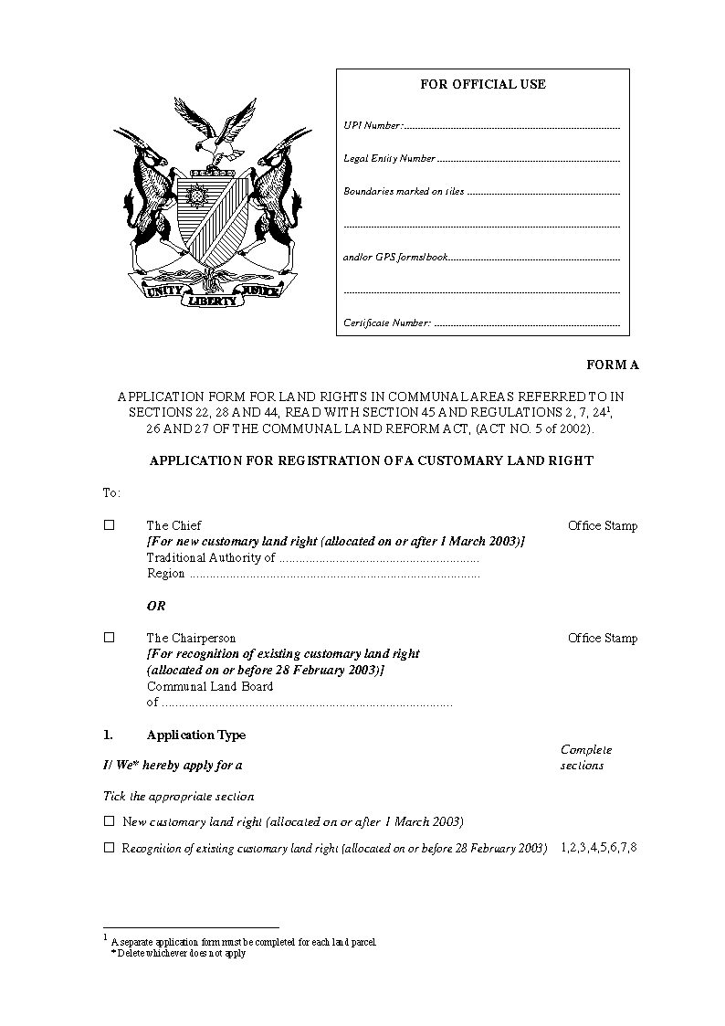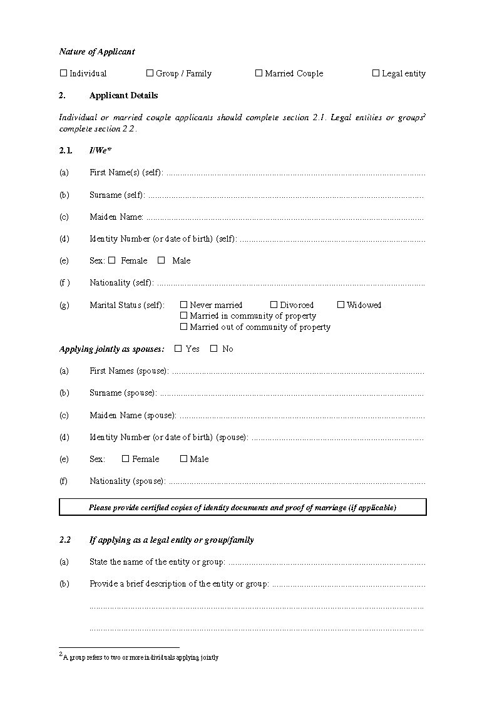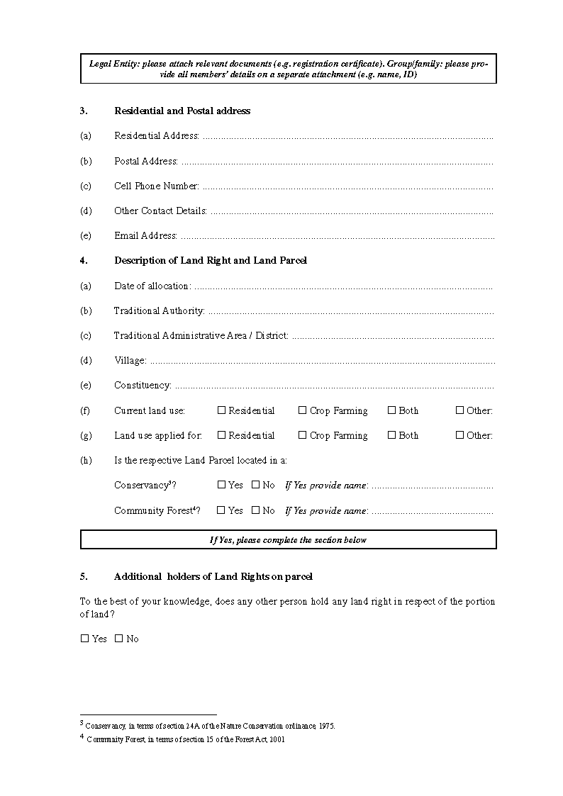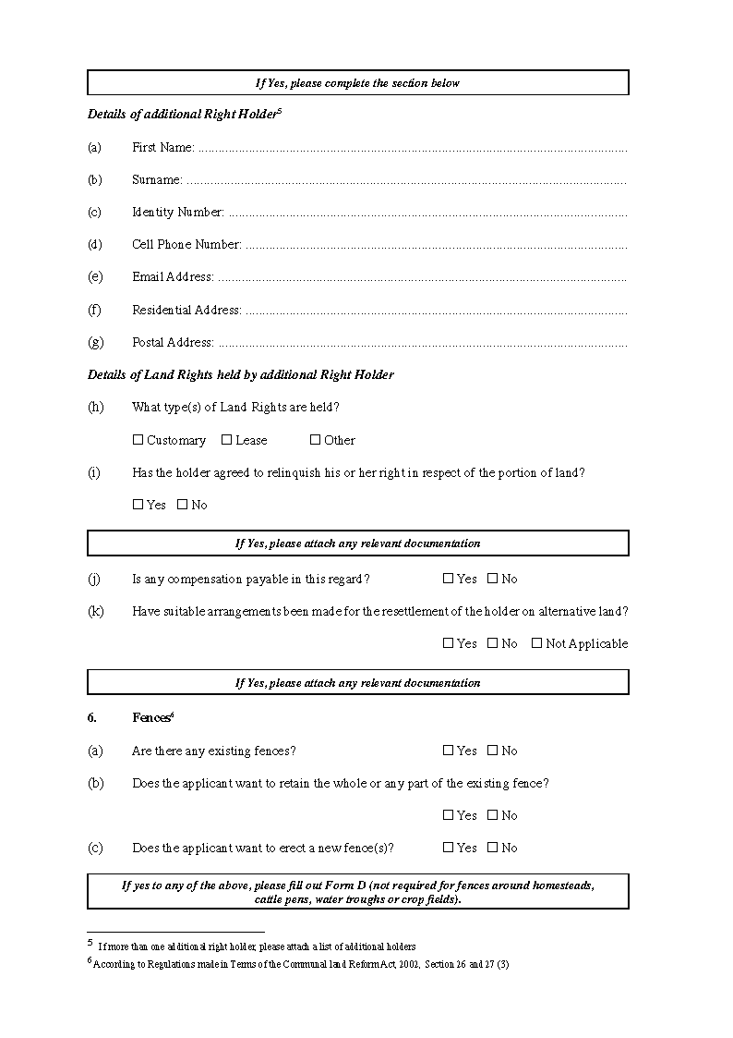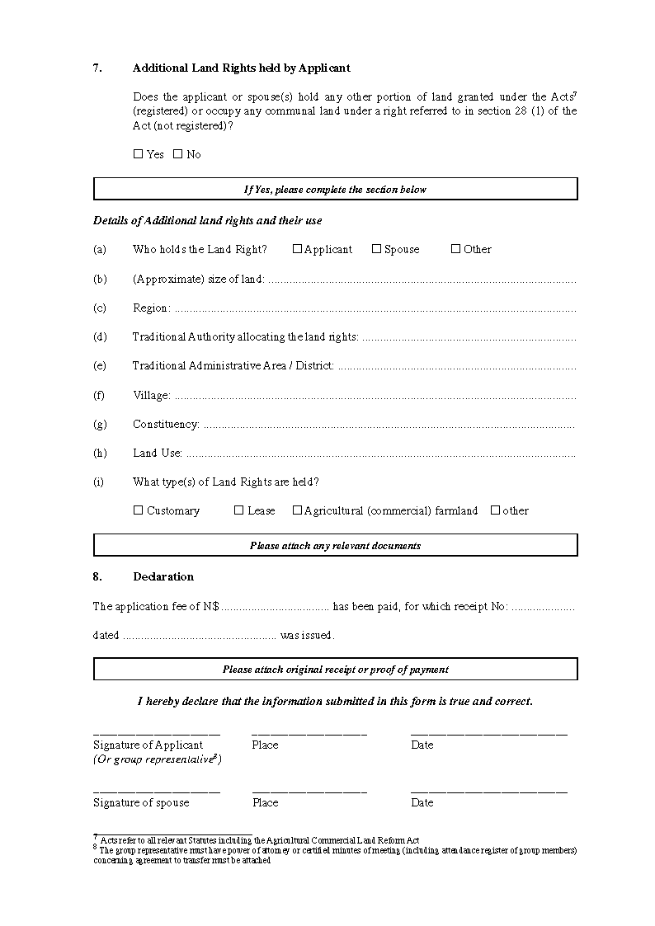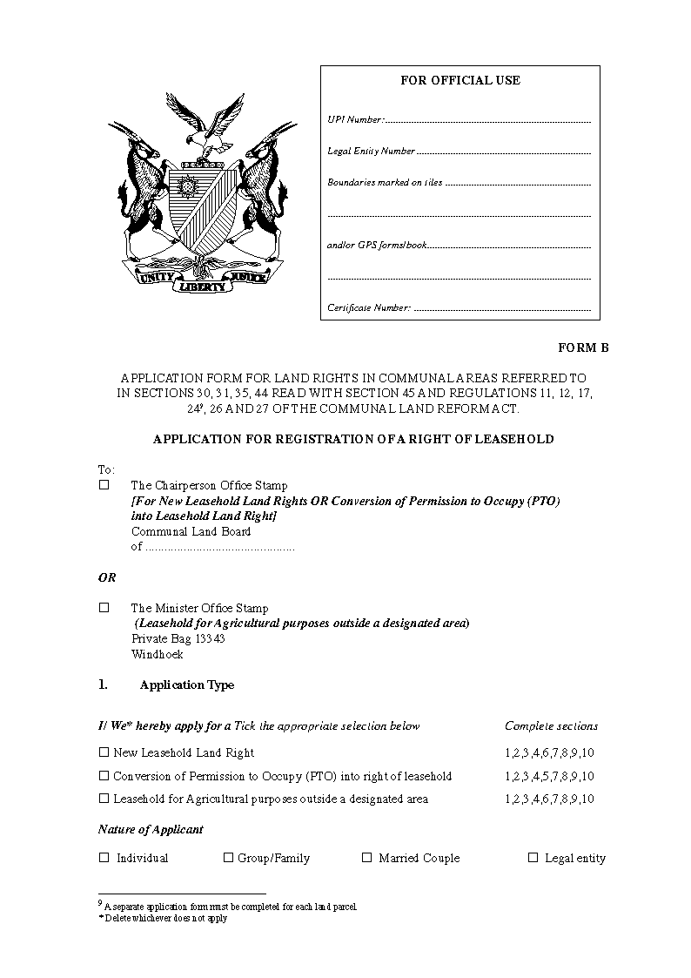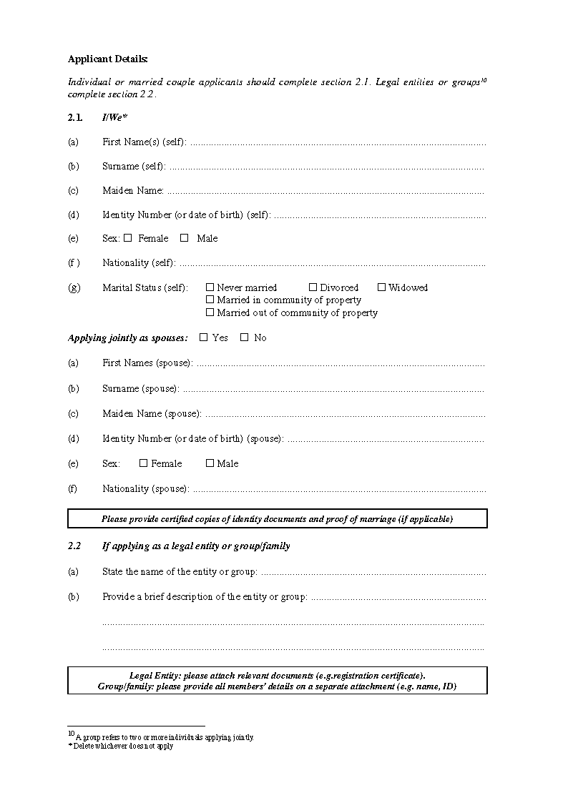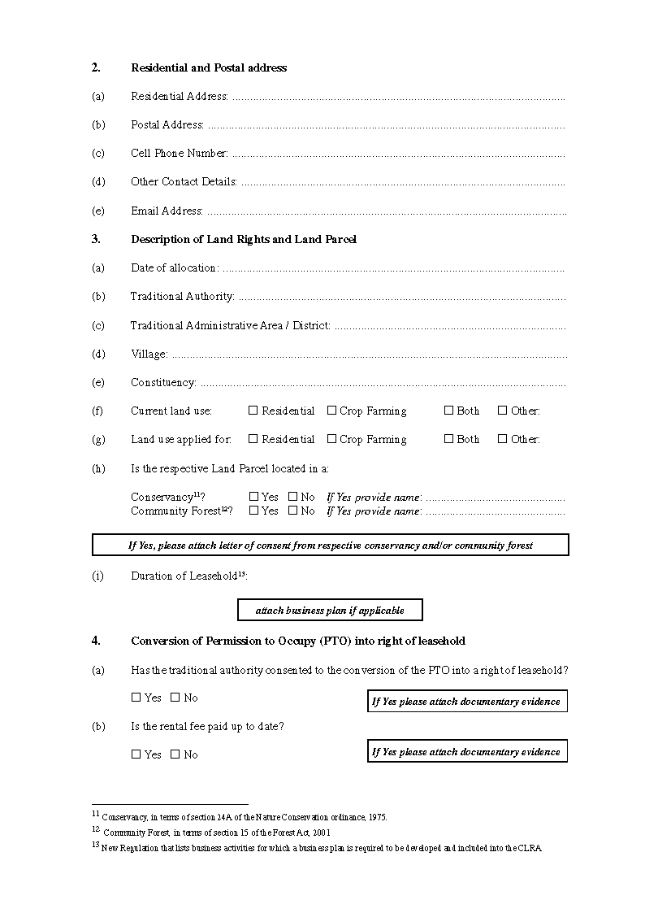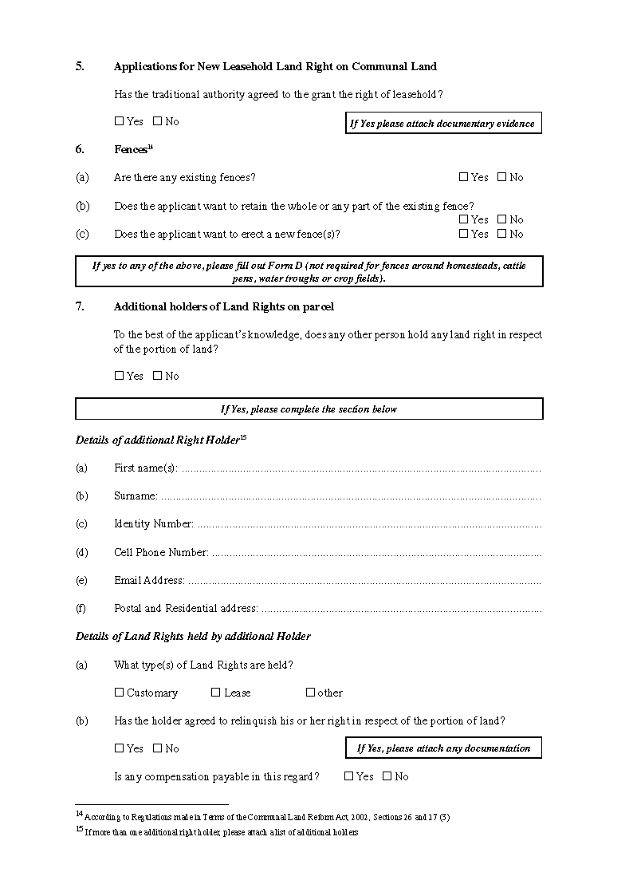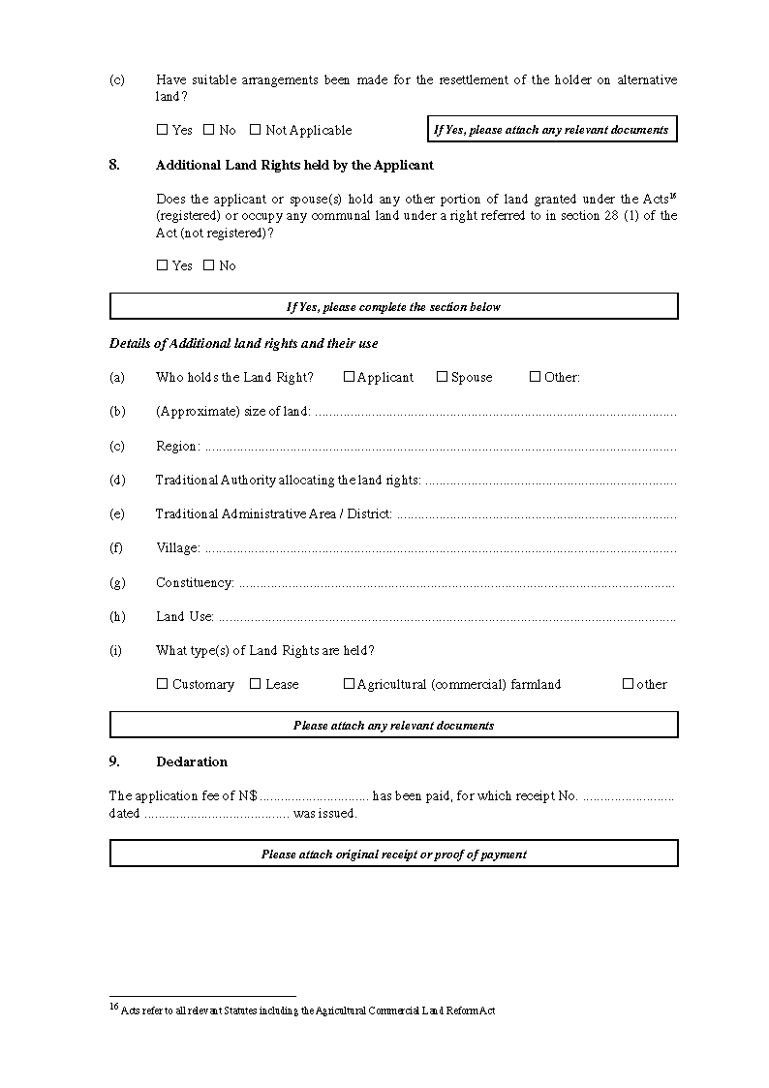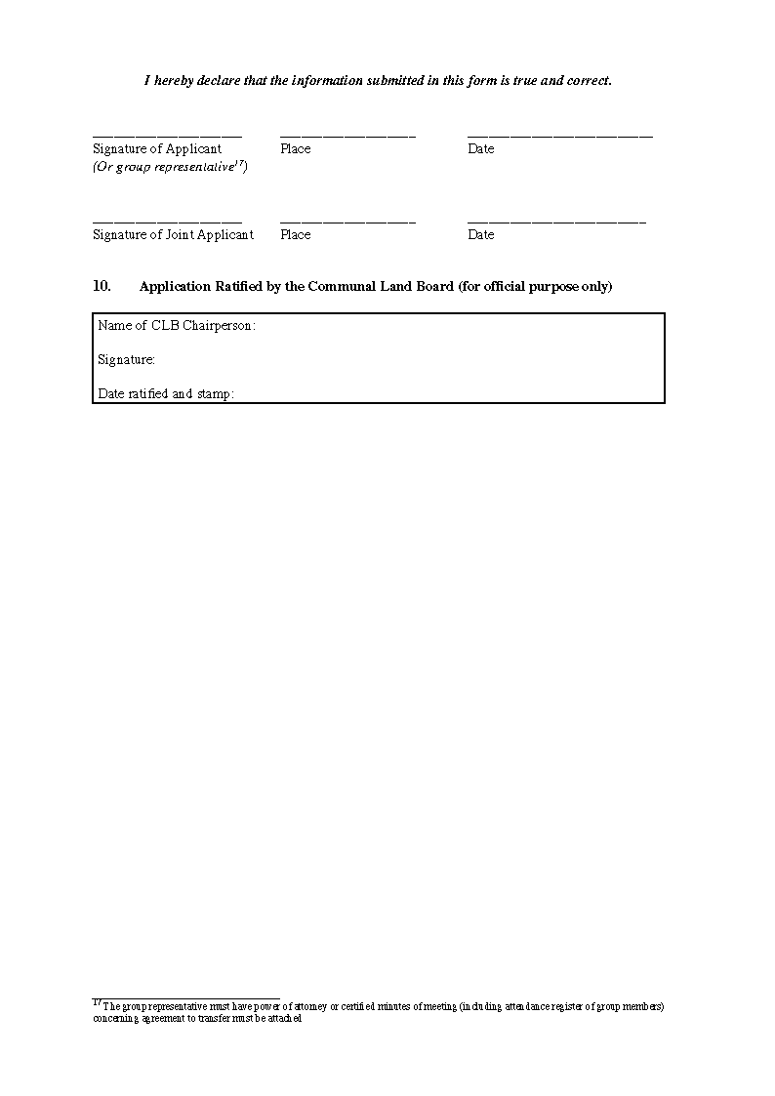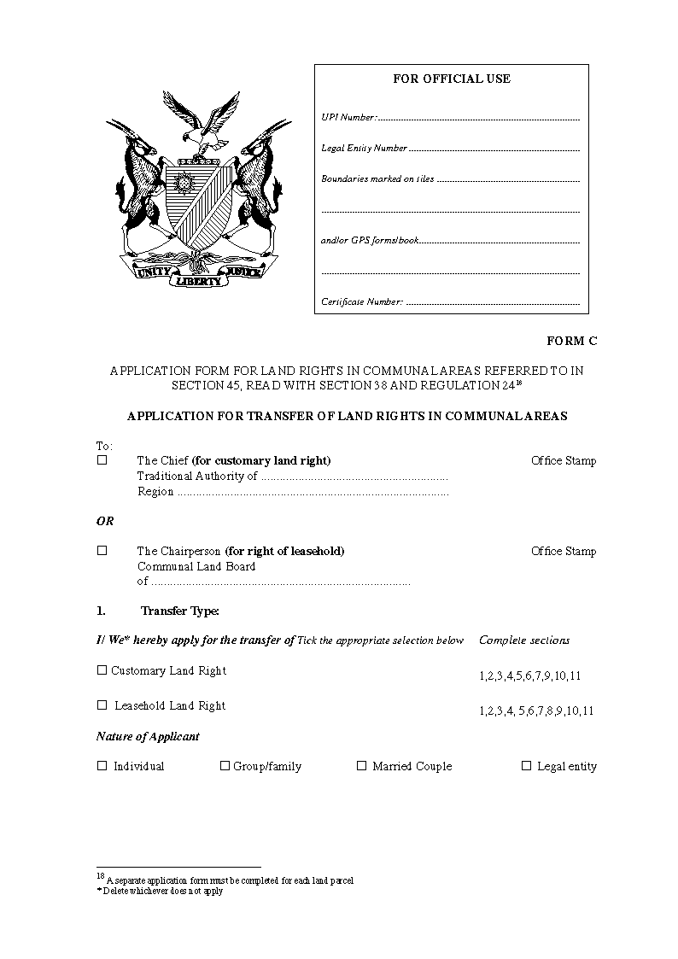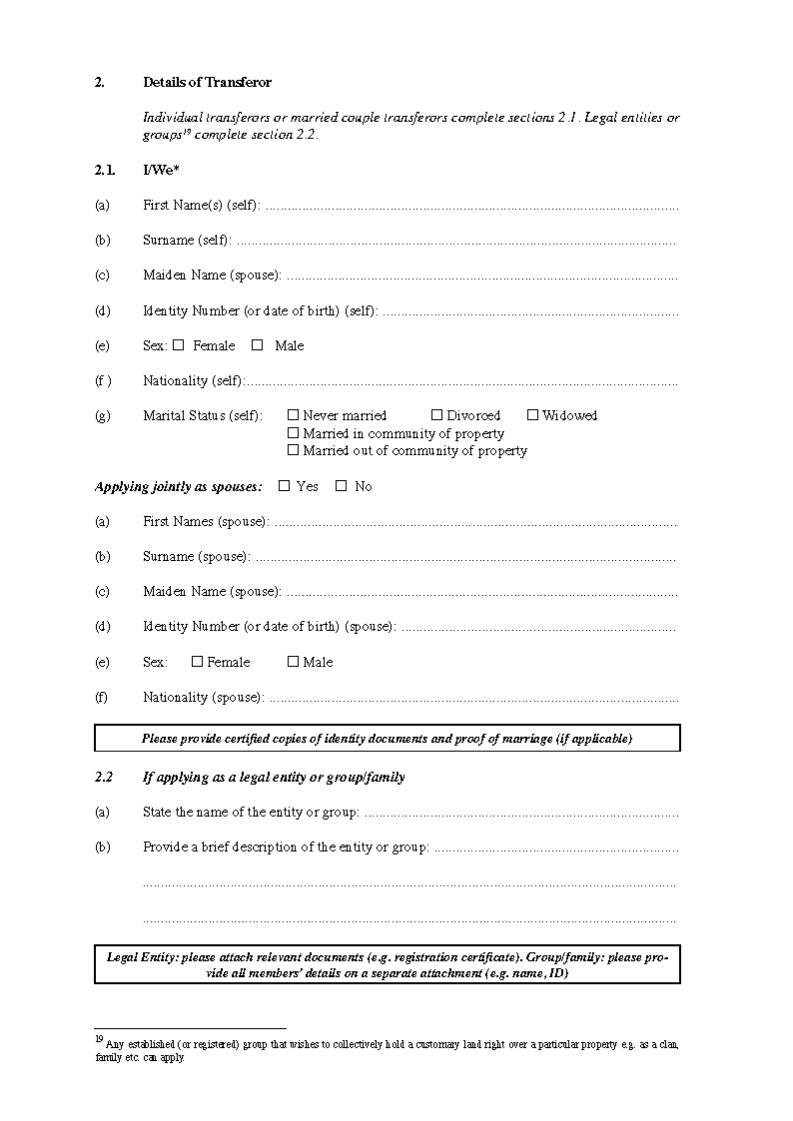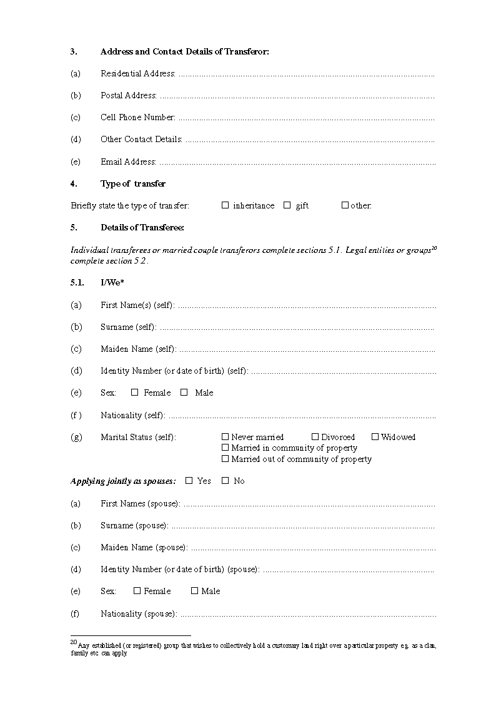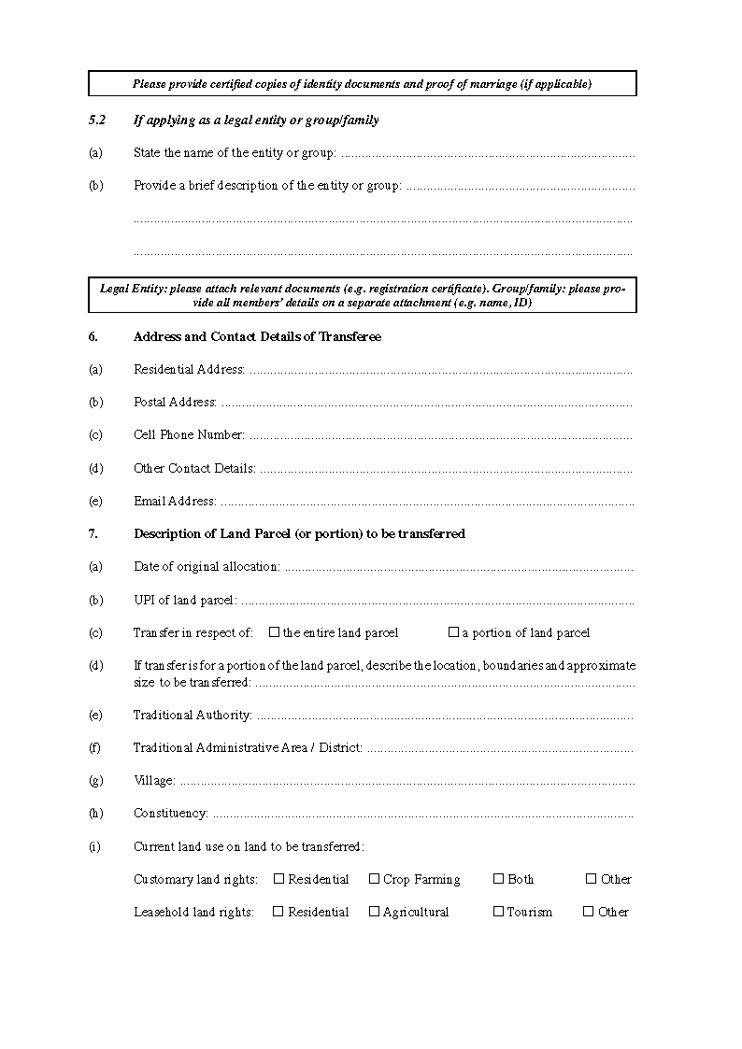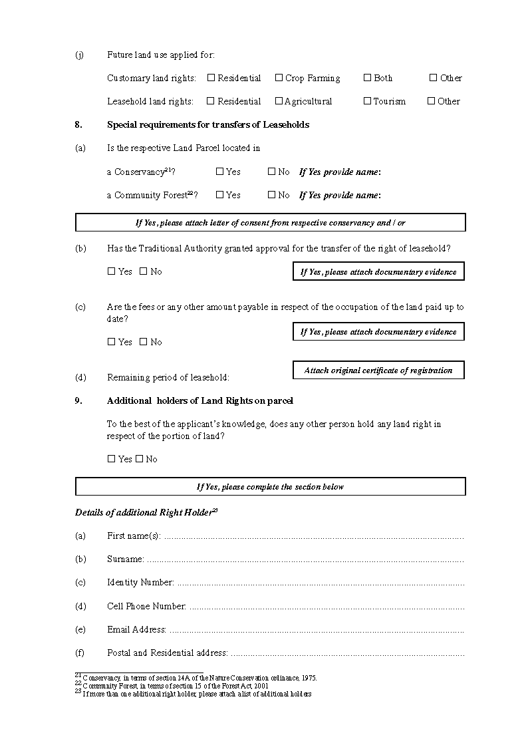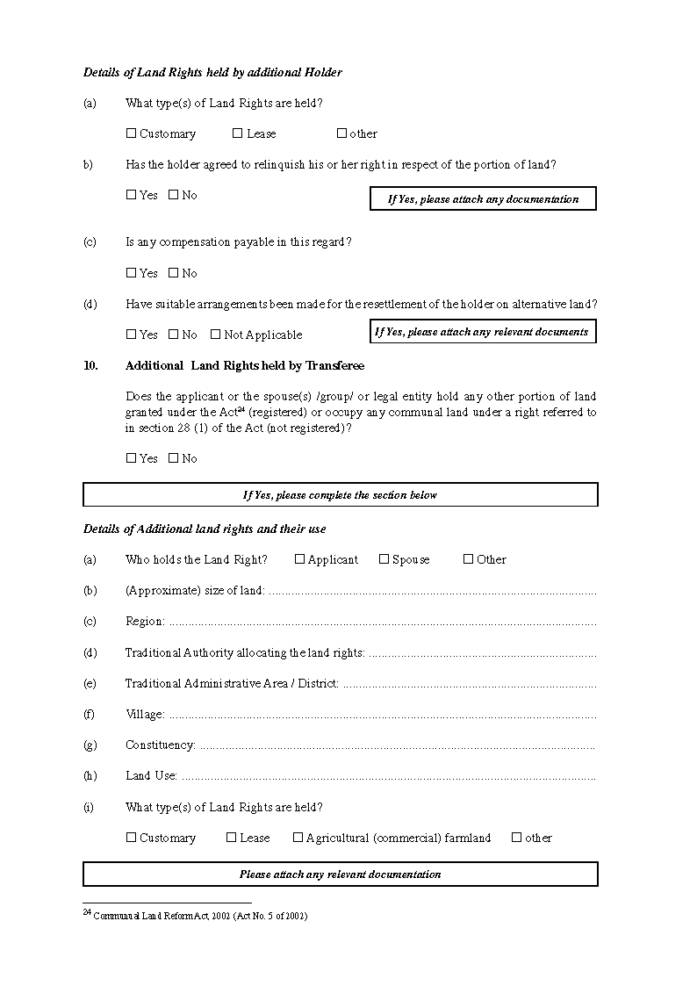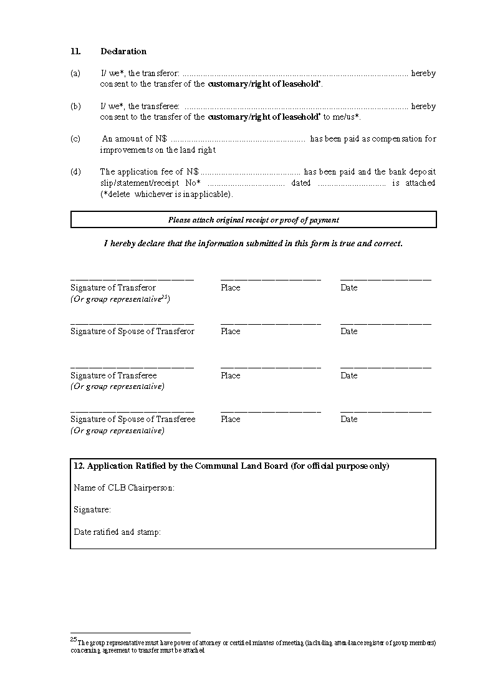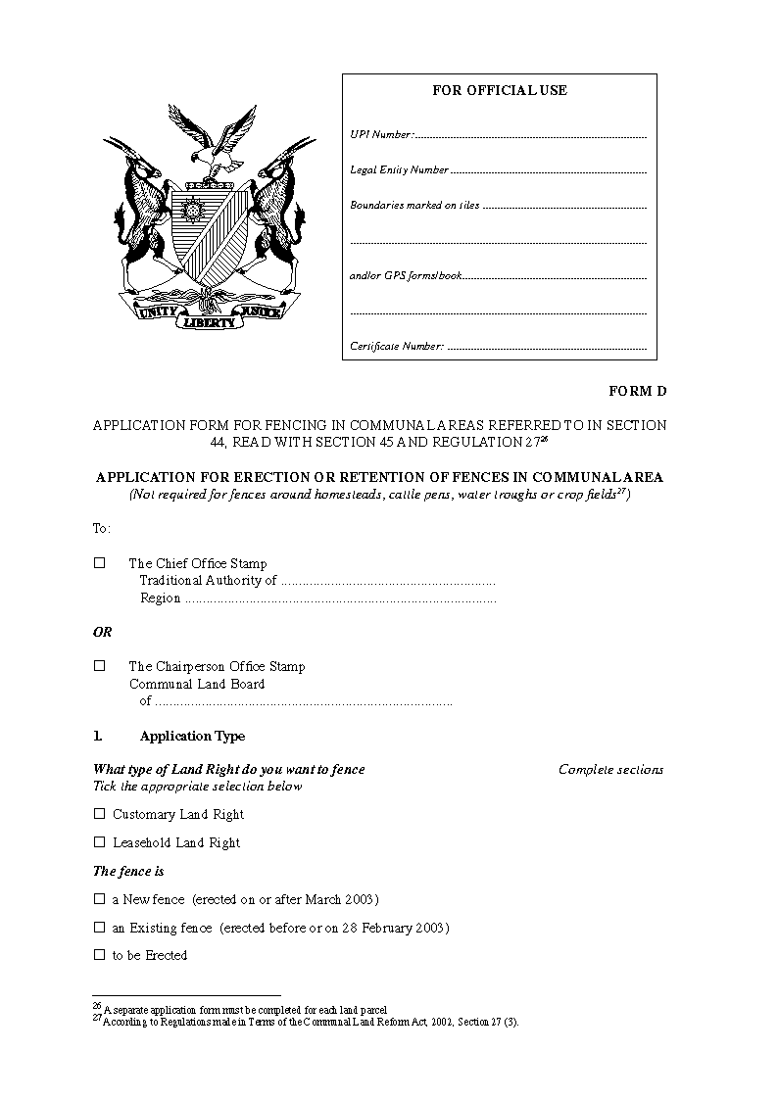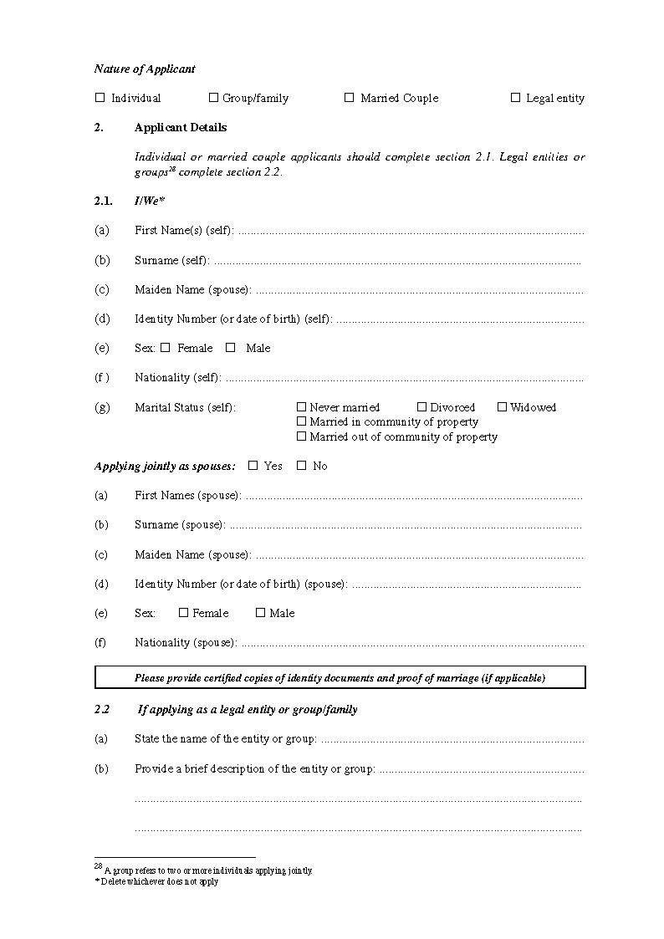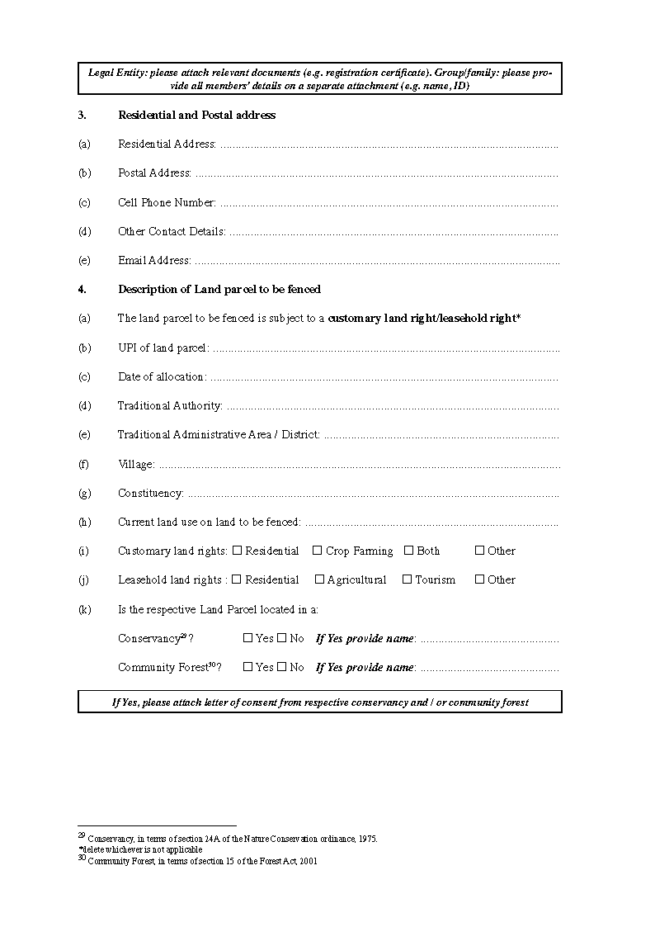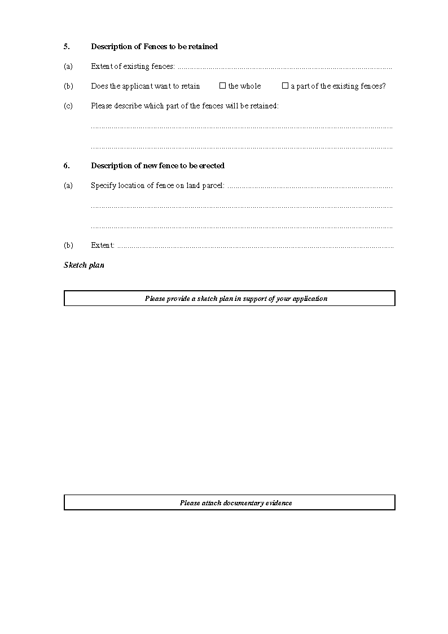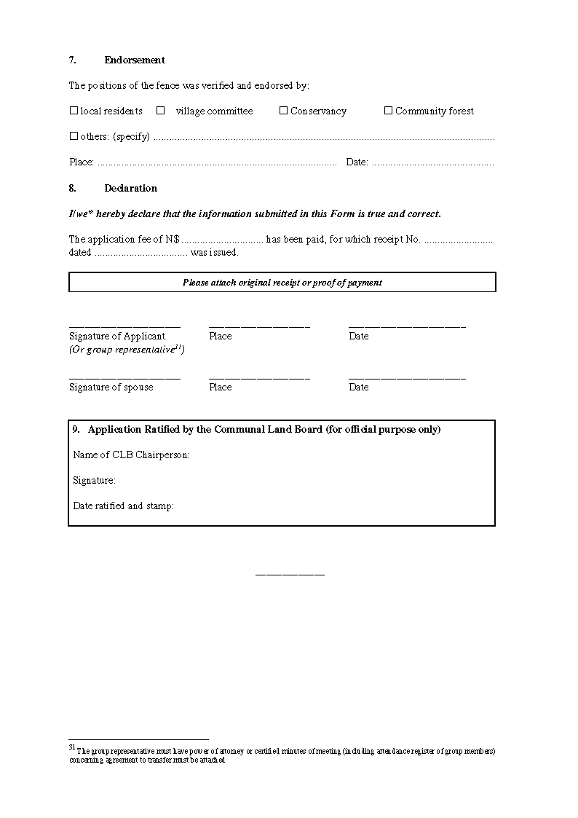

ANNEXURE 2

MINISTRY OF LANDS, RESETTLEMENT AND REHABILITATION

FEES
(Section 45 and regulation 37)

[The bracketed phrase is substituted by GN 120/2003.]

1. Fee payable for any application in terms of this Act: N$25-00.

2. Fee payable for the issue of any certificate or other
document in terms of this Act: N$50-00.

3. Fee payable for an appeal in terms of the Act: N$25-00.

