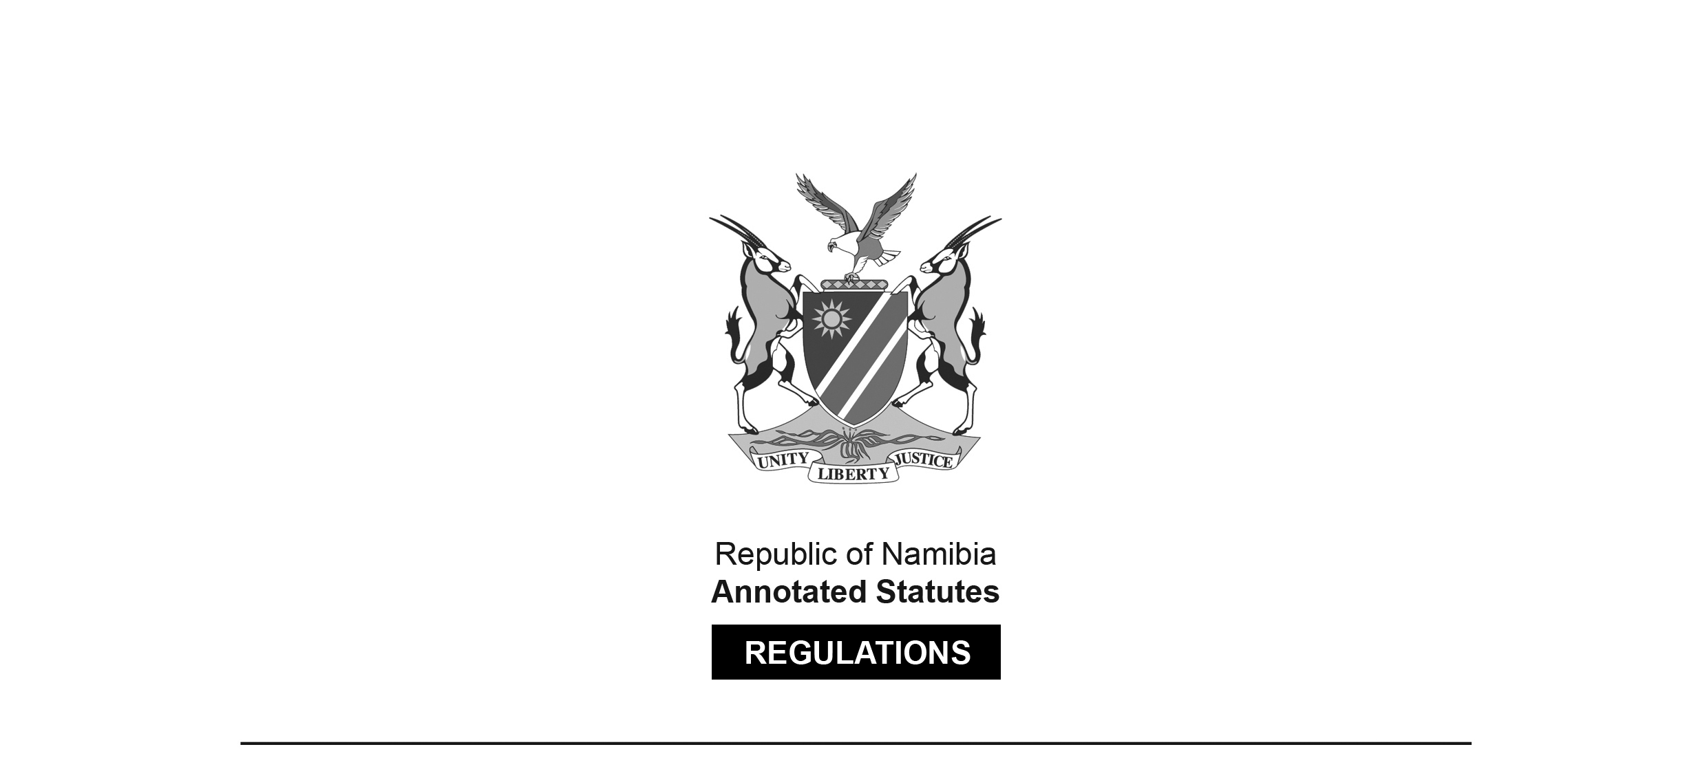
REGULATIONS MADE IN TERMS OF

Casinos and Gambling Houses Act 32 of 1994
section 54

General Regulations
Government Notice 231 of 1994
(GG 984)
came into force on date of publication: 2 December 1994

as amended by

Government Notice 84 of 1995 (GG 1084)
came into force on date of publication: 15 May 1994
Government Notice 136 of 1995 (GG 1124)
came into force on date of publication: 11 August 1995
Government Notice 121 of 1996 (GG 1317)
came into force on date of publication: 27 May 1996
Government Notice 76 of 2010 (GG 4460)
came into force on date of publication: 15 April 2010
Government Notice 95 of 2017 (GG 6295)
came into force on date of publication: 27 April 2017
Government Notice 255 of 2020 (GG 7361)
came into force on date of publication: 15 October 2020

INDEX

Regulation

1. Interpretation

CHAPTER I
APPLICATIONS FOR LICENCES, TRANSFER AND REMOVAL
OF LICENCES, AUTHORITY TO SHARE IN PROFITS
AND CERTIFICATES OF APPROVAL

2. Application for a casino licence
3. Application for a gambling house licence
3A. Application for increase of number of gambling machines
[regulation 3A inserted by GN 136/1995]
4. Application for the transfer of a casino licence
5. Application for the transfer of a gambling house licence
6. Application for the removal of a casino licence
7. Application for the removal of a gambling house licence
8. Application for authority to control a business, become a partner therein or share in the profits thereof
9. Application for certificate of approval
10.
[regulation 10 deleted by GN 84/1995]

CHAPTER II
OBJECTIONS AND REPLIES

11. Objection to application
12. Reply to objection

CHAPTER III
LICENCES, CERTIFICATES AND AUTHORITY

13. Licences and certificates of transfer or removal
14. Authority to control a business, become a partner therein or share in the profits thereof
15. Certificate of approval

CHAPTER IV
FEES, ANNUAL LEVY AND PENALTIES FOR LATE
PAYMENTS

16. Application fees
17. Annual licence fees
18. Issue of licence, transfer and removal fees
[heading of regulation substituted by GN 95/2017]
19. Fee for certificate of approval
20.
[heading of regulation 20 substituted by GN 84/1995;
regulation 20 then deleted by GN 255/2020]
21. Penalties for late payment of annual licence fee
[heading of regulation substituted by GN 84/1995 and by GN 255/2020]

CHAPTER V
TERMS AND CONDITIONS APPLICABLE TO LICENCES
AND FURNISHING OF GUARANTEES

22. Terms and conditions applicable to casino licences
23. Terms and conditions applicable to gambling house licences
23A. Restriction on number of gambling machines for which gambling house licence may be granted
[regulation 23A inserted by GN 136/1995]
23B. Restriction on profit-sharing with respect to gambling machines
[regulation 23B inserted by GN 136/1995]
24. Furnishing of guarantees
25. Prohibition against jackpot prize linked to scheme outside Namibia
[regulation 25 inserted by GN 84/1995]
Annexure A – Forms
Annexure B – Fees

[These regulations use both “percent” (one word) and “per cent” (two words).]

Interpretation

1. (1) In these regulations and in the forms in Annexure A, unless the context otherwise indicates, any word or expression to which a meaning has been assigned in the Casino and Gambling Houses Act, 1994(Act 32 of 1994) shall have the same meaning, and -

“gambling area” means that part or parts of a casino or gambling house where gambling machines or other gambling devices are placed and where gambling activities are conducted.

[The definition of “gambling area” is inserted by GN 121/1996.
The full stop at the end should be a semicolon.]

“secretary” means the secretary of the board designated in terms of section 4(4) of the Act;

“the Act” means the Casino and Gambling Houses Act, 1994 (Act 32 of 1994).

(2) The form of any form required to be used by these regulations shall be as set out in Annexure A.

CHAPTER I
APPLICATIONS FOR LICENCES, TRANSFER AND
REMOVAL OF LICENCES, AUTHORITY TO SHARE
IN PROFITS AND CERTIFICATES OF APPROVAL

Application for a casino licence

2. (1) An application for a casino licence shall be made in the form of Form 1, and shall be submitted in eightfold to the secretary.

(2) Every such application shall be accompanied by -

(a) a detailed description of the premises of the accommodation establishment in respect of which application is being made;

(b) a plan drawn to scale of such premises, clearly indicating -

(i) the dimensions and arrangement of the internal structure, including all doors, windows and other means of internal and external communication;

(ii) the location of the casino;

(iii) if gambling machines will be provided on the premises, the area or areas where such gambling machines will be kept; and

(iv) every area where liquor or other refreshments will be served;

(c) a power of attorney if the application is signed by a person acting on behalf of the applicant;

(d) any written representations in support of the application.

Application for a gambling house licence

3. (1) An application for a gambling house licence shall be made in the form of Form 2, and shall be submitted in eightfold to the secretary.

(2) Every such application shall be accompanied by -

(a) a detailed description of the premises of the accommodation establishment, retail liquor business or bookmaking business in respect of which the application is made;

[paragraph (a) substituted by GN 136/1995]

(b) a plan drawn to scale of such premises, clearly indicating -

(i) the dimensions and arrangement of the internal structure, including all doors, windows and other means of internal and external communication;

(ii) the area or areas comprising the gambling area; and

[subparagraph (ii) substituted by GN 121/1996]

(iii) except in the case of a retail liquor business which is not licensed to sell or supply liquor for consumption on the premises, every area where liquor and other refreshments will be served;

(c) if application is made in respect of a retail liquor business, a certified copy of the liquor licence held by the applicant in respect of that business;

(d) a power of attorney if the application is signed by a person acting on behalf of the applicant;

(e) any written representations in support of the application.

Application for increase of number of gambling machines

3A. (1) The holder of a gambling house licence who, in terms of such licence, is authorized to keep a number of gambling machines being less than the maximum number prescribed by regulation 23A in respect of the type of accommodation establishment or business conducted by such holder, may apply to the Board for authorization to increase the number of gambling machines to be kept by him or her, but subject to the maximum number so prescribed.

(2) An application in terms of subregulation (1) shall be made in the form of Form 9 and shall be submitted in eightfold to the secretary.

(3) Every such application shall be accompanied by -

(a) in the event where alterations are intended to be made to the licensed premises to accommodate the additional gambling machines, a plan drawn to scale clearly indicating such alterations;

(b) a power of attorney if the application is signed by a person acting on behalf of the applicant;

(c) any written representations in support of the application;

(d) the fee prescribed for an application for the grant of a licence as set out in Part 1 of Annexure B.

(4) Upon receipt of an application in terms of subregulation (1) the secretary shall, at the cost of the applicant, forthwith cause a notice of such application to be published in the Gazette and in a newspaper circulating in the area in which the premises in question are situated.

(5) The secretary shall refer every application to an inspector who shall report in writing to the Board whether the licensed premises to which the application relates -

(a) are in good repair and in all respects suitable for the proper conducting of the gambling house with the increased number of gambling machines; or

(b) will, where alterations are intended to be made to the licensed premises, on completion of such alterations in accordance with the plan submitted be suitable for the proper conducting of the gambling house with the increased number of gambling machines.

(6) Any person who wishes to object to an application in terms of subregulation (1), shall not later than 21 days after the date of publication of the notice in the Gazette lodge such objection with the secretary in the manner as required by regulation 11.

(7) The secretary shall provide the applicant with a copy of every objection lodged in terms of subregulation (6), and the applicant may, within 14 days from the date on which an objection is provided to him or her, and in the manner required by regulation 12, lodge with the secretary any reply which he or she may wish to make to an objection.

(8) An application in terms of subregulation (1) shall be considered by the Board at a meeting of the Board for the purpose of making its recommendation to the Minister.

(9) The applicant and any person who has lodged an objection to the application may appear before the Board and be heard, either personally or through his or her legal representative.

(10) After the consideration of the application by the board, the secretary of the board shall submit to the Minister -

(a) the application together with all documents and information which accompanied the application;

(b) the report of an inspector referred to in subregulation (5);

(c) a copy of the minutes of the proceedings at the meeting of the board; and

(d) the recommendation of the board.

(11) The Minister shall decide on every application made in terms of this regulation and may, after consideration of the application and all documents submitted to him or her in terms of subregulation (10), refuse the application or grant it, subject to the provisions of regulation 23A.

(12) If the Minister grants the application, the secretary shall, upon payment to him or her of the prescribed annual licence fees in respect of the additional gambling machines, endorse the licence of the applicant to show the increased number of gambling machines authorized.

[regulation 3A inserted by GN 136/1995]

Application for the transfer of a casino licence

4. (1) An application for the transfer of a casino licence shall be made jointly by the holder of the licence and the proposed transferee in the form of Form 3, and shall be submitted in eightfold to the secretary.

(2) Every such application shall be accompanied by -

(a) a certified copy of the deed of sale or other document in terms of which the accommodation establishment or the retail liquor business, as the case may be, is disposed of to the proposed transferee;

(b) a power of attorney if the application is signed by a person acting on behalf of any of the applicants;

(c) a certified copy of the casino licence proposed to be transferred;

(d) any written representations in support of the application.

Application for the transfer of a gambling house licence

5. (1) An application for the transfer of a gambling house licence shall be made jointly by the holder of the licence and the proposed transferee, and shall be submitted to the secretary in eightfold in the form of Form 4.

(2) Every such application shall be accompanied by -

(a) a certified copy of the deed of sale or other document in terms of which the accommodation establishment, retail liquor business or bookmaking business in respect of which the licence is held is disposed of to the proposed transferee;

[paragraph (a) substituted by GN 136/1995]

(b) in the case of an application relating to a retail liquor business, proof that application for the transfer of the liquor licence in question to the proposed transferee has been made to the competent authority;

(c) a power of attorney if the application is signed by a person on behalf of any of the applicants;

(d) a certified copy of the gambling house licence proposed to be transferred;

(e) any written representations in support of the application.

Application for the removal of a casino licence

6. (1) An application for the temporary or permanent removal of a casino licence to any other premises (hereinafter referred to as the new premises) shall be made in the form of Form 5, and shall be submitted in eightfold to the secretary.

(2) Every such application shall be accompanied by -

(a) a detailed description of the new premises of the accommodation establishment;

(b) a plan drawn to scale of such new premises, clearly indicating -

(i) the dimensions and arrangement of the internal structure, including all doors, windows and other means of internal and external communication;

(ii) the location of the casino;

(iii) if gambling machines will be provided on the new premises, the area or areas where such gambling machines will be kept; and

(iv) every area where liquor or other refreshments will be served;

(c) a power of attorney if the application is signed by a person acting on behalf of the applicant;

(d) a certified copy of the casino licence held by the applicant;

(e) any written representations in support of the application.

Application for the removal of a gambling house licence

7. (1) An application for the temporary or permanent removal of a gambling house licence to any other premises (hereinafter referred to as the new premises) shall be made in the form of Form 6, and shall be submitted in eightfold to the secretary.

(2) Every such application shall be accompanied by -

(a) a detailed description of the new premises of the accommodation establishment, retail liquor business or bookmaking business, as the case may be;

[paragraph (a) substituted by GN 136/1995]

(b) a plan drawn to scale of such new premises, clearly indicating -

(i) the dimensions and arrangement of the internal structure, including all doors, windows and other means of internal and external communication;

(ii) the area or areas comprising the gambling area; and

[subparagraph (ii) substituted by GN 121/1996]

(iii) except in the case of a retail liquor business which is not licensed to sell or supply liquor for consumption on the premises, every area where liquor and other refreshments will be served;

(c) a power of attorney if the application is signed by a person acting on behalf of the applicant;

(d) a certified copy of the gambling house licence held by the applicant;

(e) in the case of an application relating to a retail liquor business, proof that application for the temporary or permanent removal of the liquor licence in question has been made to the competent authority;

(f) any written representations in support of the application.

Application for authority to control a business, become a partner therein or share in the profits thereof

8. (1) Any application in terms of section 38 of the Act for authority to allow any other person (hereinafter referred to as the proposed person) in effect to control any casino or gambling house or to become a partner therein or to share in the profits thereof, shall be made jointly by the holder of the licence and the proposed person in the form of Form 7, and shall be submitted in eightfold to the secretary.

(2) Every such application shall be accompanied by a certified copy of the licence of the licence holder concerned.

Application for certificate of approval

9. (1) An application for a certificate of approval in terms of section 26 of the Act shall be made in the form of Form 8, and shall be submitted in triplicate to the secretary.

(2) In addition to the requirements of section 26(1), every such application shall be accompanied by two recent passport photographs of the applicant.

(3) For the purposes of section 26(1)(a) of the Act, the fingerprints of any applicant shall be taken by a member of the Namibian Police Force in order to investigate and report to the secretary whether or not the applicant has any previous convictions and the nature of such convictions, if any.

***

10.

[regulation 10 deleted by GN 84/1995]

CHAPTER II
OBJECTIONS AND REPLIES

Objection to application

11. (1) An objection in terms of section 19 of the Act to any application made in terms of section 16 thereof shall be in writing and shall be lodged in eightfold with the secretary.

(2) Every such objection shall -

(a) state the full name and address of the objector;

(b) clearly identify the application to which the objection relates; and

(c) in detail set out the grounds on which the objection is made.

Reply to objection

12. (1) Any reply by an applicant to any objection contemplated in regulation 11 shall be in writing and shall be lodged in eightfold with the secretary.

(2) Every such reply shall clearly identify the objection replied to.

CHAPTER III
LICENCES, CERTIFICATES AND AUTHORITY

Licences and certificates of transfer or removal

13. (1) For the purposes of section 22 of the Act -

(a) a casino licence shall be issued in the form of Form 10;

(b) a gambling house licence shall be issued in the form of Form II;

(c) a certificate of transfer of a licence shall be issued in the form of Form 12;

(d) a certificate of removal of a licence shall be issued in the form of Form 13.

(2) Any certificate issued by the secretary in accordance with paragraph (c) or (d) of subregulation (1) shall be attached to the licence in question.

(3) The secretary shall forward a duplicate copy of every licence or certificate issued in accordance with the provisions of subregulation (1) to the Permanent Secretary: Home Affairs

Authority to control a business, become a partner therein or share in the profits

14. (1) Any authority granted under section 38 whereby any person is allowed in effect to control a casino or a gambling house or to become a partner therein or to share in the profits thereof, shall be issued in the form of Form 14.

(2) Any authority issued in accordance with subregulation (I) shall be attached to the licence in question.

Certificate of approval

15. (1) A certificate of approval issued in terms of section 29 of the Act shall be in the form of Form 15.

(2) The secretary shall forward a duplicate copy of every certificate of approval issued in accordance with subregulation (1) to the Permanent Secretary: Home Affairs

CHAPTER IV
FEES, ANNUAL LEVY AND PENALTIES
FOR LATE PAYMENTS

Application fees

16. (1) Upon the submission of an application in terms of section 16, 26 or 38 of the Act the applicant shall pay to the secretary the appropriate fee set out in Part I of Annexure B.

[subregulation (1) substituted by GN 84/1995]

(2) No amount paid in terms of subregulation (1), or any part there­ of shall be refunded to the applicant.

Annual licence fees

17. (1) The secretary shall not in terms of section 22 of the Act issue any licence unless the appropriate annual licence fee set out in Part II of Annexure B is paid to the secretary.

[subregulation (1) amended by GN 84/1995]

(2) After a licence has been issued in terms of section 22 of the Act, the annual licence fee referred to in subregulation (l) shall be paid by the holder of the licence to the secretary annually not later than the last day of the particular month in which the licence was issued to such holder or, where the licence was obtained through a transfer, to the original holder of such licence.

[subregulation (2) amended by GN 84/1995]

(3) No amount paid in respect of the annual fee shall be refundable in the event of the surrender, withdrawal or suspension of the licence in question.

(4) Every holder of a gambling house licence who conducts a retail liquor business shall, simultaneously with the payment referred to in subregulation (2), submit to the secretary a certified copy of the current liquor licence held by such holder in respect of such business or furnish to the secretary such other proof, as the secretary may require, that the annual fee in respect of such liquor licence has been paid in respect of the year in question.

[subregulation (4) inserted by GN 121/1996]

Issue of licence, transfer and removal fees

18. The secretary shall not in terms of section 22 of the Act issue any licence or any certificate of transfer or removal of a licence, unless the appropriate fee set out in Part III of Annexure B has been paid by the applicant to the secretary.

[regulation 18 amended by GN 84/1995 and substituted by GN 95/2017]

Fee for certificate of approval

19. The secretary shall not in terms of section 29 of the Act issue a certificate of approval unless the fee prescribed for such certificate in Part IV of Annexure B is paid to the secretary.

[regulation 19 amended by GN 84/1995]

***

20.

[regulation 20 substituted by GN 84/1995,
amended by GN 95/2017 and deleted by GN 255/2020]

Penalties for late payment of annual licence fee

21. Without prejudice to the provisions of section 24 of the Act, if the amount payable in terms of these regulations in respect of the annual licence fee is not paid in full to the Receiver of Revenue before the expiry of the period allowed by these regulations for the payment of such fee, the licence holder shall pay a penalty equal to 10 per cent of the outstanding amount for each month or part of a month that such amount remains outstanding.

[regulation 21 substituted by GN 84/1995 and by GN 255/2020]

CHAPTER V
TERMS AND CONDITIONS APPLICABLE TO LICENCES
AND FURNISHING OF GUARANTEES

Terms and conditions applicable to casino licences

22. (1) The area or areas comprising the casino in licensed premises shall be as indicated on the plan contemplated in regulation 2(2)(b) and no alteration to the premises, structural or otherwise, affecting the number, size or location of such areas shall be carried out unless a plan showing the proposed alteration has been submitted to the secretary and the Minister, on the recommendation of the board, has approved that plan.

[subregulation (1) substituted by GN 95/2017]

(2) The holder of a casino licence shall not -

(a) conduct or allow to be conducted any games, or keep or allow to be kept any gambling machines for the purposes of gambling, in or at any place other than that part of the licensed premises which comprises the casino;

(b) in the casino in respect of which such licence is held -

(i) conduct or allow to be conducted any games other than games specified in subregulation (3);

(ii) keep for the purposes of gambling any gambling machine which does not conform to the requirements of subregulation (4).

(3) Subject to subregulation (5), the games which may be conducted in a casino are -

(a) American roulette;
(b) French roulette;
(c) Black Jack;
(d) Punto Banco;
(e) Chemin de Fer;
(f) Poker;
(g) Crap;
(h) Boule;
(i) Big wheel.

(4) Subject to subregulation (5), no gambling machine, other than a machine or device used for the playing of any game referred to in subregulation (3), shall be kept in any casino, unless -

(a) it operates by means of electrical power;

(b) it is played by means of the insertion of coins or playing chips in a slot in the machine provided for the purpose; and

(c) it is capable of keeping accurate record of the amounts played and the amounts paid out as prizes.

(4A) If a gambling machine or device used for gambling is fitted with two or more panels of control which -

(a) work independently of each other; and

(b) allow for a separate game of gambling to be played independently from the others,

each panel of control constitutes a separate gambling machine for purposes of determining the number of gambling machines permitted by the casino licence.

[subregulation (4A) inserted by GN 95/2017]

(5) The holder of a casino licence shall not in the casino use or allow to be used any gambling table or other device intended for the playing of games or any gambling machine, unless -

(a) it is marked with a permanent and ineffaceable serial number; and

(b) it has been registered with the secretary.

(6) The playing of any game in a casino, other than by means of a gambling machine, shall be conducted or controlled by at least one person in the employ of the licence holder, but no person shall be so engaged unless he or she is the holder of a certificate of approval issued in terms of section 29 of the Act or has been granted permission by the Minister under section 33 of the Act.

(7) The holder of a casino licence shall not -

(a) allow any person to enter the casino, unless he or she -

(i) is properly dressed; and

(ii) except if he or she is a lodger in the accommodation establishment concerned, is charged and pays an entrance fee of at least N$5 before entering the casino;

(b) permit any person to remain in the casino if he or she is notably under the influence of alcohol or a drug having a narcotic effect or, through the use of foul language or disorderly behaviour, causes a nuisance to other persons in the casino.

(8) The holder of a casino licence shall keep such books of account and records relating to the operation of the casino as are necessary to reflect in respect of each day the amount of money derived from gambling operations and the amount of money paid out in respect of prizes.

(9) Every holder of a casino licence shall in respect of each period of six months ending on 31 March and 30 September of each year prepare a statement showing the gross takings of the casino and the amount paid out as prizes during such period and shall1odge such statement with the secretary not later than 14 days after the expiry of any such period.

(10) The holder of a casino licence may carry on gambling operations on the licensed premises between 10:00 on any day and 04:00 on the following day.

Terms and conditions applicable to gambling house licences

23. (1) No gambling machines provided for the purpose of gambling on premises licensed as a gambling house shall be kept at any place other than the area or areas as indicated on the plan of the premises submitted in terms of regulation 3(2)(b).

(2) If an area referred to in subregulation (1) is not a separate room, such area shall at all times be screened off from the remainder of the premises in such a manner that it will not be possible to observe from outside the area the gambling activities carried on therein, and every such room or screened off area shall be provided with a door that can be closed in order to control the entrance of persons thereto: Provided that where gambling machines are kept in a bar conducted on the premises under an on-consumption licence issued under the Liquor Ordinance, 1969 (Ordinance 2 of 1969) or in a bookmaking business, it shall not be required that the area concerned be so screened off if the gambling machines are so placed inside such bar or the premises of such bookmaking business that it will not be possible to observe from outside the bar or such bookmaking business, as the case may be, the activities carried on therein.

[subregulation (2) substituted by GN 136/1995]

(3) No change to the number of areas comprising the gambling house in the licensed premises or to the location of any such area on such premises or any other structural alterations to such premises affecting the number of those areas or the location of any such area on such premises shall be effected, unless plans indicating the proposed changes or alterations have been submitted to the Minister and the Minister, acting on a recommendation of the board, has approved such plans.

(4) The holder of a gambling house licence shall not offer any prize in excess of N$10 000 to be won by way of gambling in the gambling house, whether by means of the operation of a single gambling machine or two or more gambling machines linked for the purpose of gambling.

[subregulation (4) substituted by GN 136/1995]

(5) Subject to subregulation (6), no gambling machine shall be kept in any gambling house unless -

(a) it operates by means of electrical power;

(b) it is played by means of the insertion of coins or playing chips in a slot in the machine provided for the purpose; and

(c) it is capable of keeping accurate record of the amounts played and the amounts paid out as prizes.

(5A) If a gambling machine or device used for gambling is fitted with two or more panels of control which -

(a) work independently of each other; and

(b) allow for a separate game of gambling to be played independently from the others,

each panel of control constitutes a separate gambling machine for purposes of determining the number of gambling machines permitted by the gambling house licence.

[subregulation (5A) inserted by GN 95/2017]

(6) The holder of a gambling house licence shall not in the gambling house use or allow to be used any gambling machine unless -

(a) it is marked with a permanent and ineffeceable serial number; and

[The word “ineffaceable” is misspelt in the Government Gazette, as reproduced above.]

(b) it has been registered with the secretary.

(7) The holder of a gambling house licence shall not -

(a) allow any person to enter the gambling house, unless he or she is properly dressed;

(b) permit any person to remain in the gambling house if he or she is notably under the influence of alcohol or a drug having a narcotic effect or, through the use of foul language or disorderly behaviour, causes a nuisance to other persons in the gambling house.

(8) The holder of a gambling house licence shall keep such books of account and records relating to the operation of the gambling house as are necessary to reflect in respect of each gambling machine the total daily amount played and the total daily amount paid out.

(9) Every holder of a gambling house licence shall in respect of each period of six months ending on 31 March and 30 September of each year prepare a statement showing the gross takings of the gambling house and the amount paid out as prizes during such period and lodge such statement with the secretary not later than 14 days after the expiry of such period.

(10) The holder of a gambling house licence shall not keep the gambling house open for gambling or allow any person to be present therein for the purpose of gambling at any time, if -

(a) in the case of a retail liquor business or an accommodation establishment, the sale or supply of liquor is not permitted by the liquor licence held in respect of that business or accommodation establishment; or

(b) in the case of a bookmaker business, the business is not open to the public for betting.

[regulation 23 substituted by GN 84/1995 and by GN 95/2017]

Restriction on number of gambling machines for which gambling house licence may be granted

23A. A gambling house licence shall not be granted -

(a) in the case of an application relating to an accommodation establishment with a grading of three stars, for more than 25 gambling machines;

(b) in the case of an application relating to an accommodation establishment with a grading of two stars, for more than 20 gambling machines;

(c) in the case of an application relating to an accommodation establishment with a grading of one star, for more than 15 gambling machines; or

(d) in the case of an application relating to a retail liquor business or bookmaking business, for more than 10 gambling machines but in the case of an application relating to the retail liquor business by a holder of a shebeen liquor licence issued under the Liquor Act, 1998 (Act No. 6 of 1998), for more than five gambling machines; and

[paragraph (d) substituted by GN 95/2017]

(e) to a holder of the following liquor licence -

(i) a temporary liquor licence;

(ii) a parks liquor licence;

(iii) a vineyard liquor licence; or

(iv) a grocery liquor licence,

issued under the Liquor Act, 1998 (Act No. 6 of 1998).

[paragraph (3) inserted by GN 95/2017]

[regulation 23A inserted by GN 136/1995]

Restriction on profit-sharing with respect to gambling machines

23B. (1) Where the Minister has granted authority under section 38 of the Act allowing a person to share in the profits derived from any gambling house operations under a licence, it shall be a condition of such authority that no person to whom the authority relates, other than the holder of the licence, shall share in the profits so derived by more than 50 percent of those profits, but without prejudice to any agreement between the parties for a lesser ratio of distribution of such profits in favour of such other person.

[subregulation (1) substituted by GN 76/2010]

(2) An authority granted under section 38 by the Minister -

(a) in respect of a gambling house shall be valid for a period of two years, but may from time to time, upon application made under that section by the parties concerned, be renewed by the Minister on recommendation from the Board, but not for a period of more than two years at any one time; and

(b) in respect of a casino shall be valid for a period of fifteen years, but may from time to time, upon application made under that section by the parties concerned, be renewed by the Minister on recommendation from the Board, but not for a period of more than fifteen years at any one time.

[subregulation (2) substituted by GN 76/2010]

(3) The Minister may at any time by written notice given to the holder of a licence or any other party to whom an authority referred to in subregulation (1) relates, require from such holder or other party -

(a) to submit to the Minister or any other person designated by the Minister for such purpose, any records relating to the distribution of profits under such authority;

(b) to furnish particulars or proof of any income or expenditure taken into account in the calculation of profits shared or to be shared by the parties involved,

and any person to whom such a notice is directed, shall comply with the requirements thereof within 14 days after the notice has been given.

(4) Without prejudice to any other steps which may be taken in terms of the Act, the Minister may, subject to subregulations (5), (6) and (7), withdraw an authority referred to in subregulation (1) on the ground of a contravention of the condition imposed by that subregulation or non-compliance with any requirement made under subregulation (3).

(5) If the Minister proposes to withdraw an authority referred to in subregulation (1), the Minister shall give to the holder of the licence and every other party in relation to whom the authority was granted notice in writing of the proposed withdrawal and the reasons therefor.

(6) A notice in terms of subregulation (5) shall state that the holder of the licence or any other party referred to in that subregulation may, within 14 days after such notice is given, make representations in writing to the Minister in connection with the matter

[There is no full stop at the end of subregulation (6).]

(7) Upon expiry of the period referred to in subregulation (6), the Minister shall determine the matter and inform all parties concerned of his or her decision.

[regulation 23B inserted by GN 136/1995]

Furnishing of guarantees

24. (1) Where it is indicated in an application for the grant or removal of a casino licence or the transfer of a casino licence that the applicant, if the application is granted, intends to offer in the casino concerned a prize that can be won through the playing of a single gambling machine or two or more gambling machines linked for that purpose, the amount or value of which will exceed N$10 000, the Minister, acting on a recommendation of the board and with due regard to the maximum value of the prize that will be offered to be won, may, when granting the application, require from the applicant to furnish to the secretary a guarantee for the due and punctual payment of such prize to any person who may become entitled thereto and may, after consultation with the applicant, determine the amount for which and the manner and form in which, the guarantee is to be furnished.

[subregulation (1) substituted by GN 84/1995]

(2) Where, in accordance with subregulation (1), the Minister has required that a guarantee be furnished by any applicant, the secretary shall not in terms of section 22 of the Act issue to the applicant the licence or the certificate of transfer of the licence, as the case may be, unless there is submitted to the secretary a guarantee conforming to the requirements as determined by the Minister.

(3) If at any time after the grant or transfer of a casino licence the holder of such licence intends to introduce a scheme whereby a prize as contemplated in subregulation (1) is offered, such licence holder shall not introduce such scheme unless he or she has in writing notified the Minister accordingly and, where so required by the Minister on the recommendation of the board, has furnished to the secretary a guarantee as contemplated in subregulation (1).

[subregulation (3) inserted by GN 84/1995]

Prohibition against jackpot prize linked to scheme outside Namibia

25. No holder of a casino licence or gambling house licence shall, for the purpose of offering a cumulative jackpot prize, participate in any scheme whereby any gambling machine provided by such holder is linked to any gambling machine or machines outside Namibia.

[regulation 25 inserted by GN 84/1995]

ANNEXURE A

[Annexure A is substituted by GN 136/1995.
The index to the forms has been amended accordingly.]

INDEX TO FORMS

Form No. Description Regulation No.
1. Application for a casino licence. 2(1)
2. Application for a gambling house licence. 3(1)
3. Application for the transfer of a casino licence. 4(1)
4. Application for the transfer of a gambling house licence. 5(1)
5. Application for the removal of a casino licence. 6(1)
6. Application for the removal of a gambling house licence. 7(1)
7. Application for authority to control a business, become
a partner therein or share in the profits thereof. 8(1)
8. Application for a certificate of approval. 9(1)
9. Application to increase the number of gambling machines
granted on a gambling house licence. 3A
10. Casino licence. 13(1)(a)
11. Gambling house licence. 13(1)(b)
12. Certificate for transfer of licence. 13(1)(c)
13. Certificate for removal of licence. 13(1)(d)
14. Authority to control a business, become a partner therein
or share in the profiles thereof. 14(1)
15. Certificate of approval. 15(1)

ANNEXURE A

To view content without printing, scroll down.

To print at full scale (A4), double-click the icon below.

[Annexure A is substituted by GN 136/1995.]

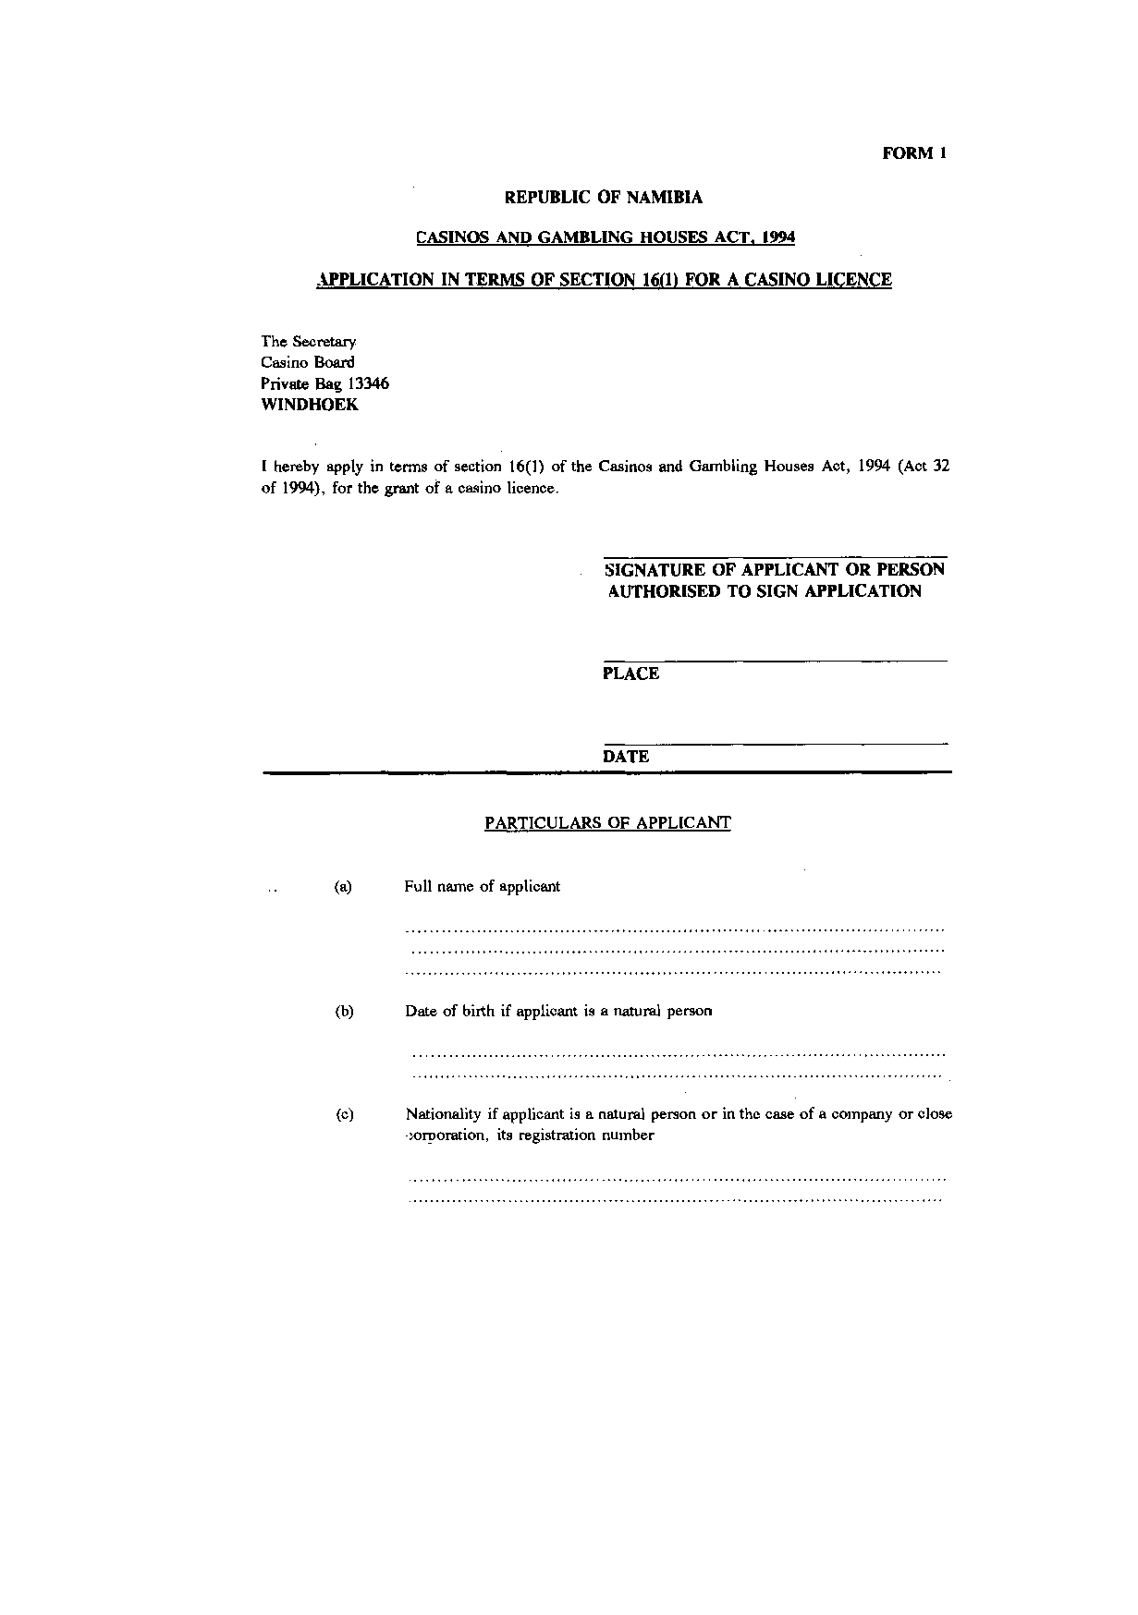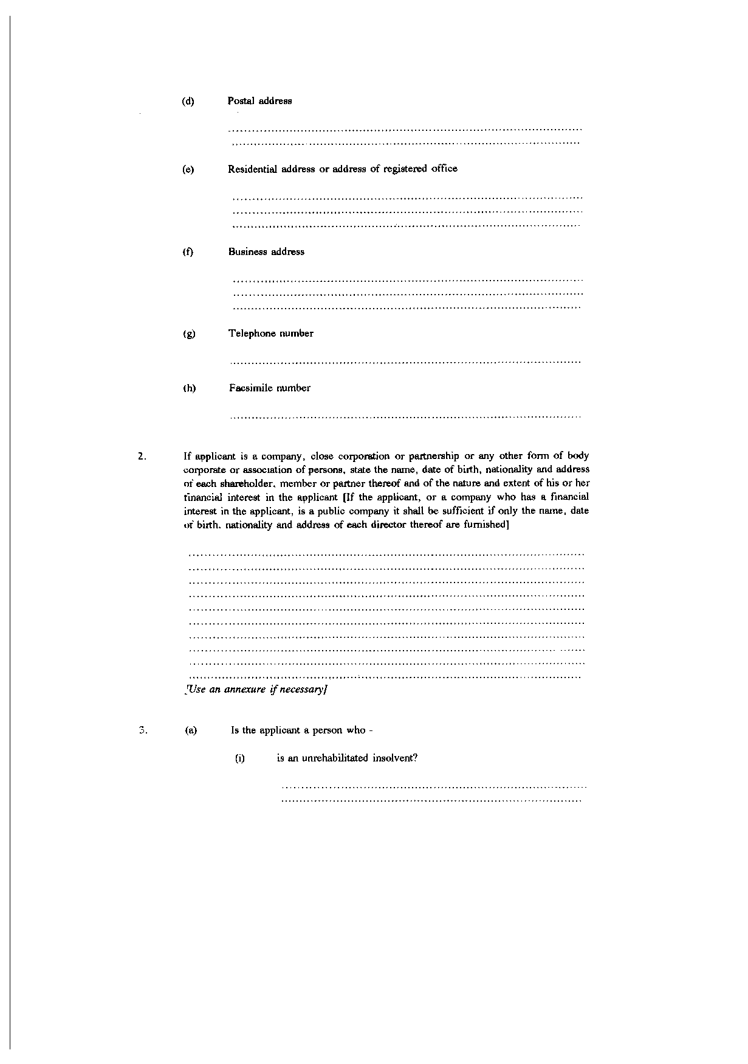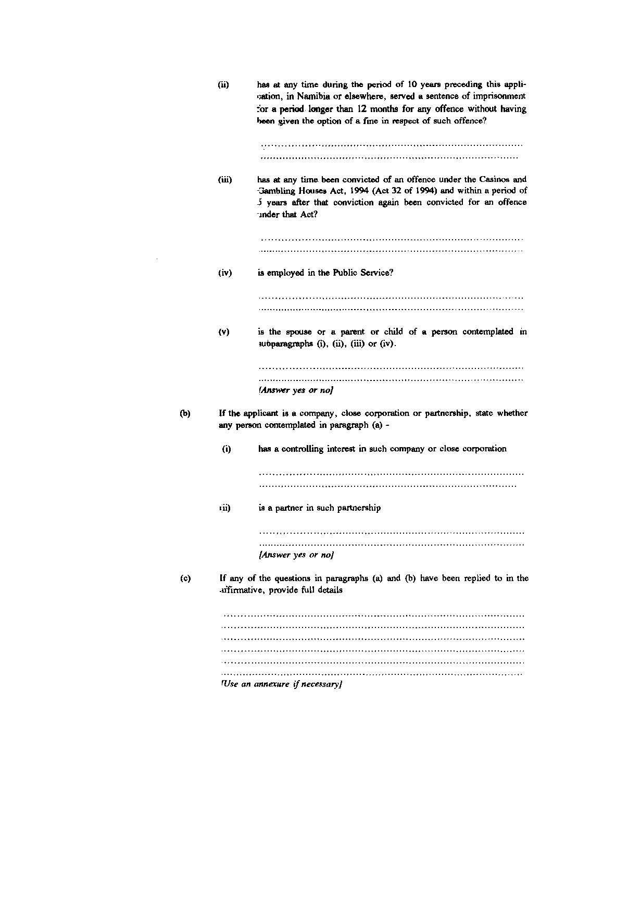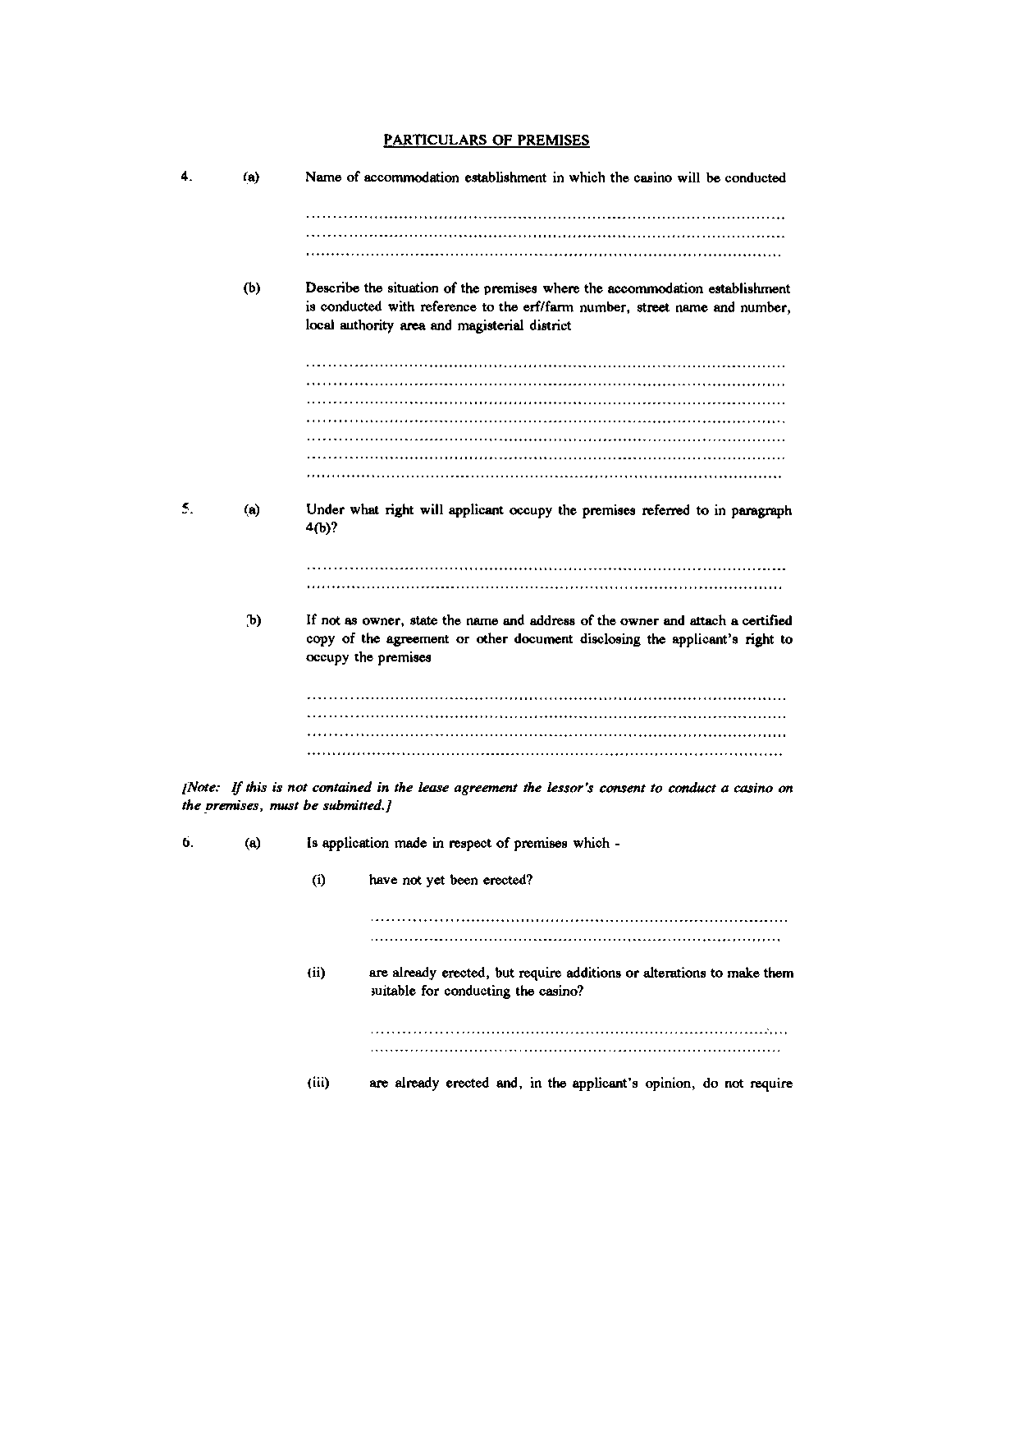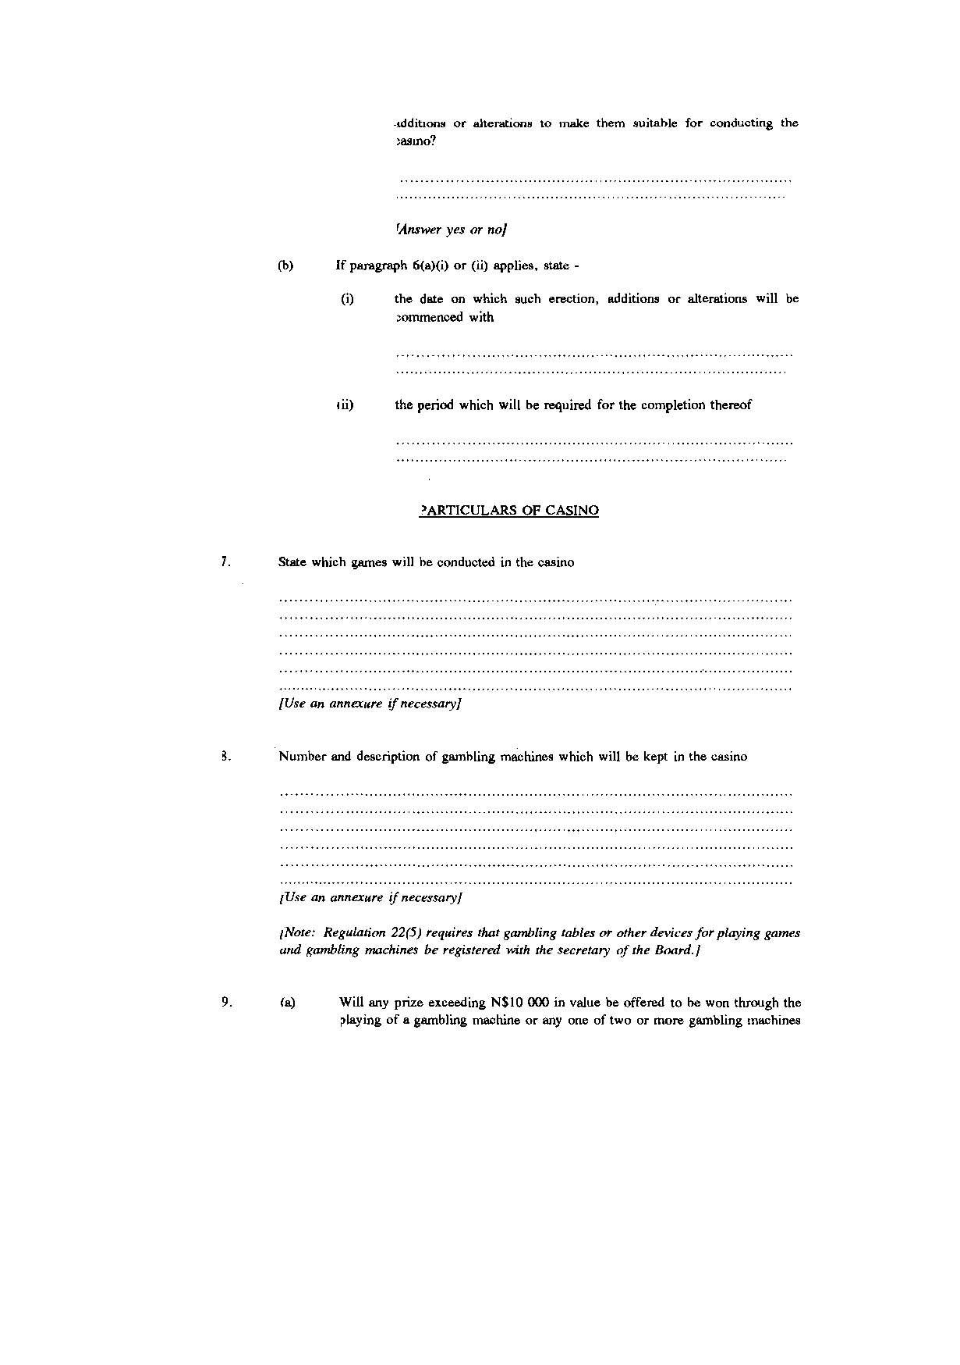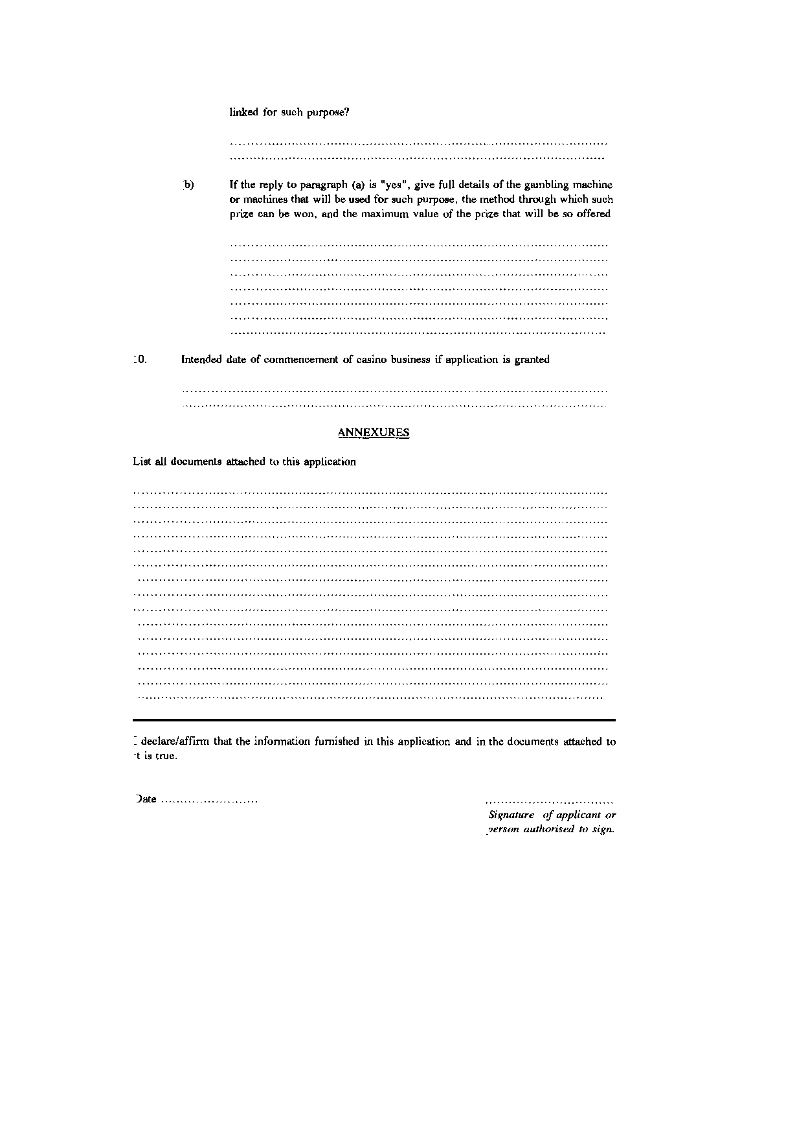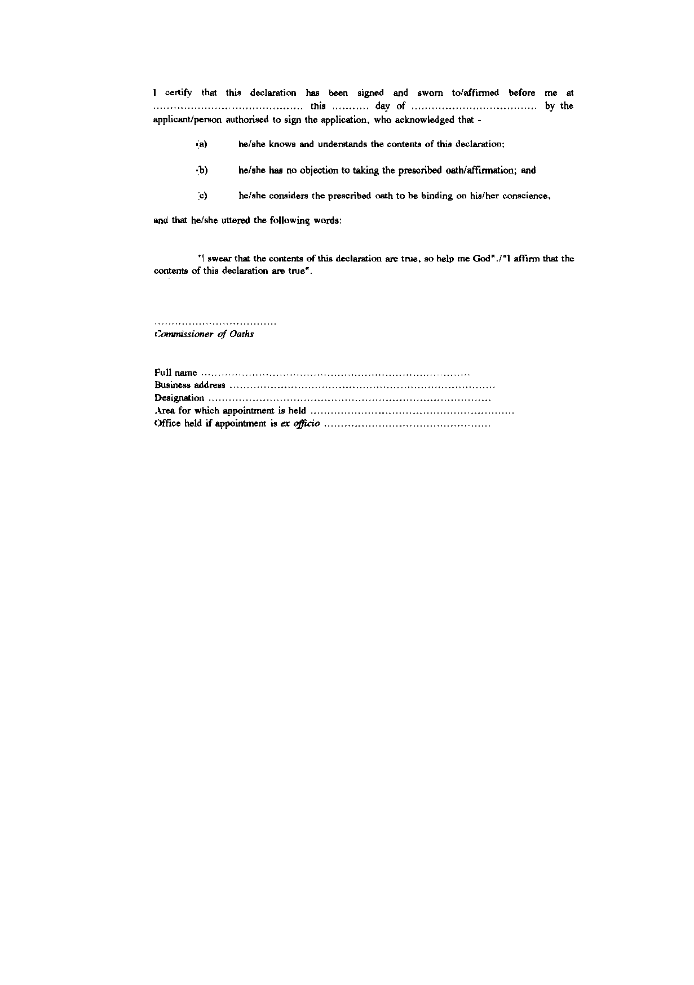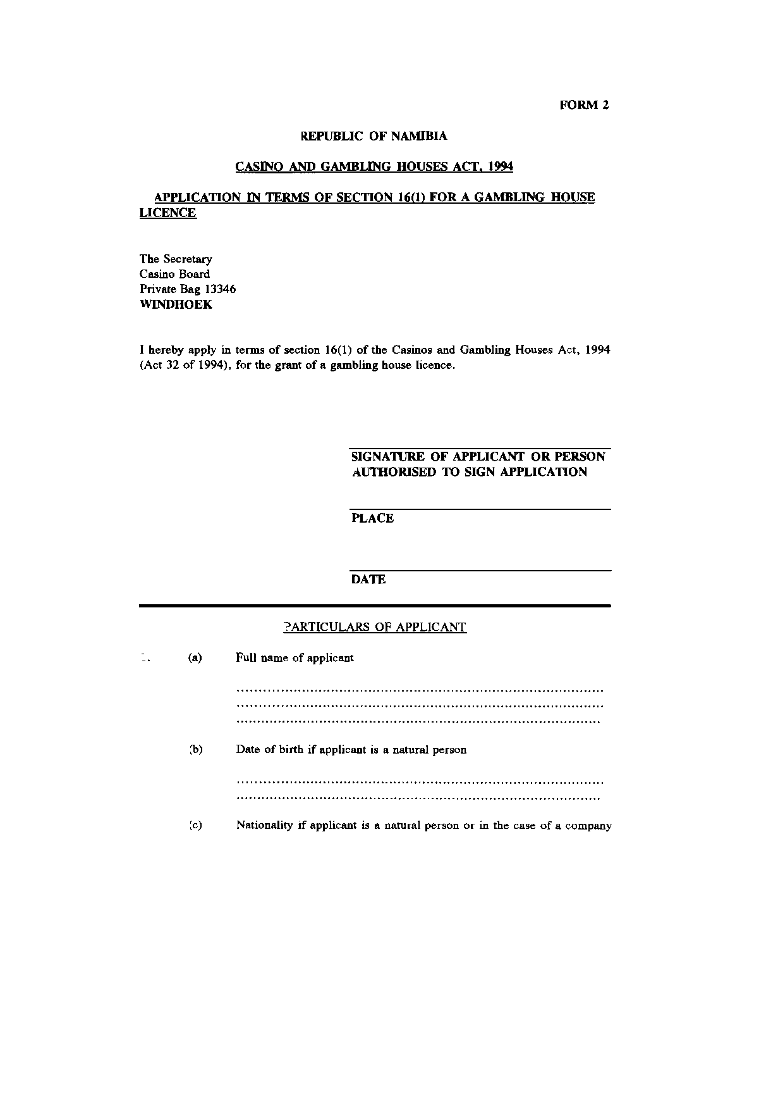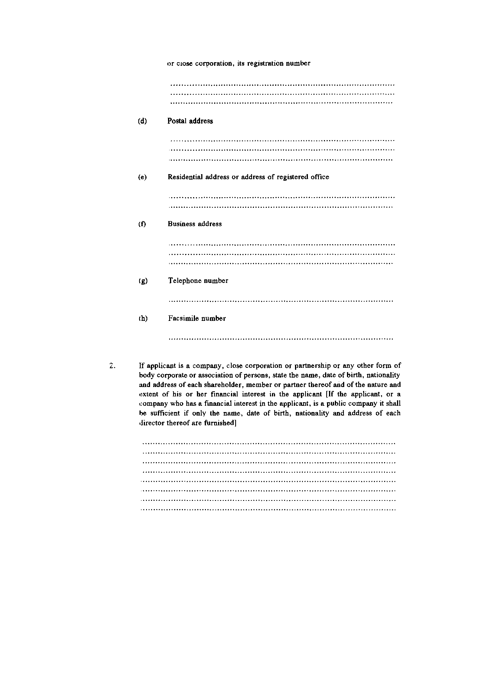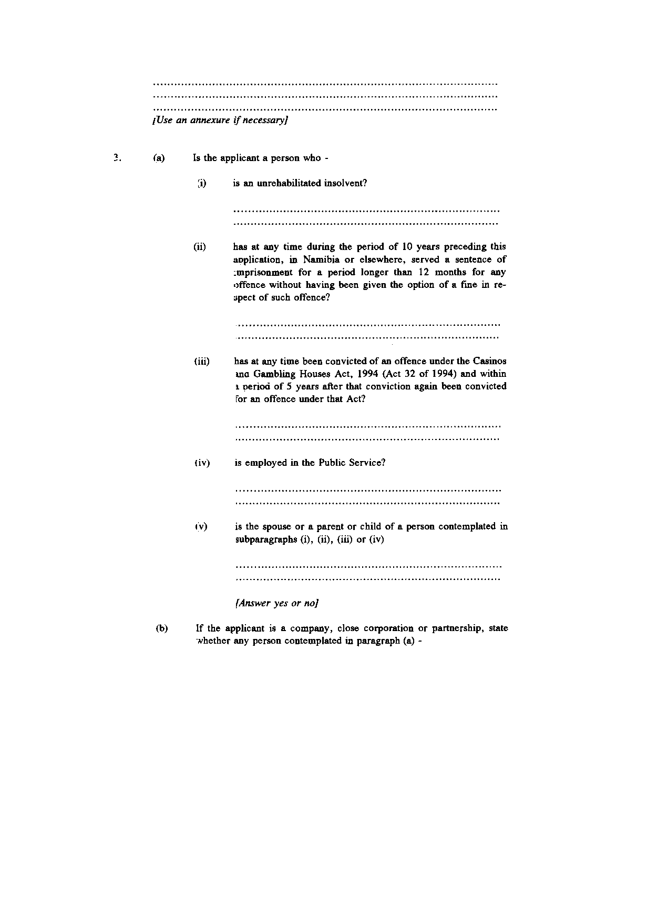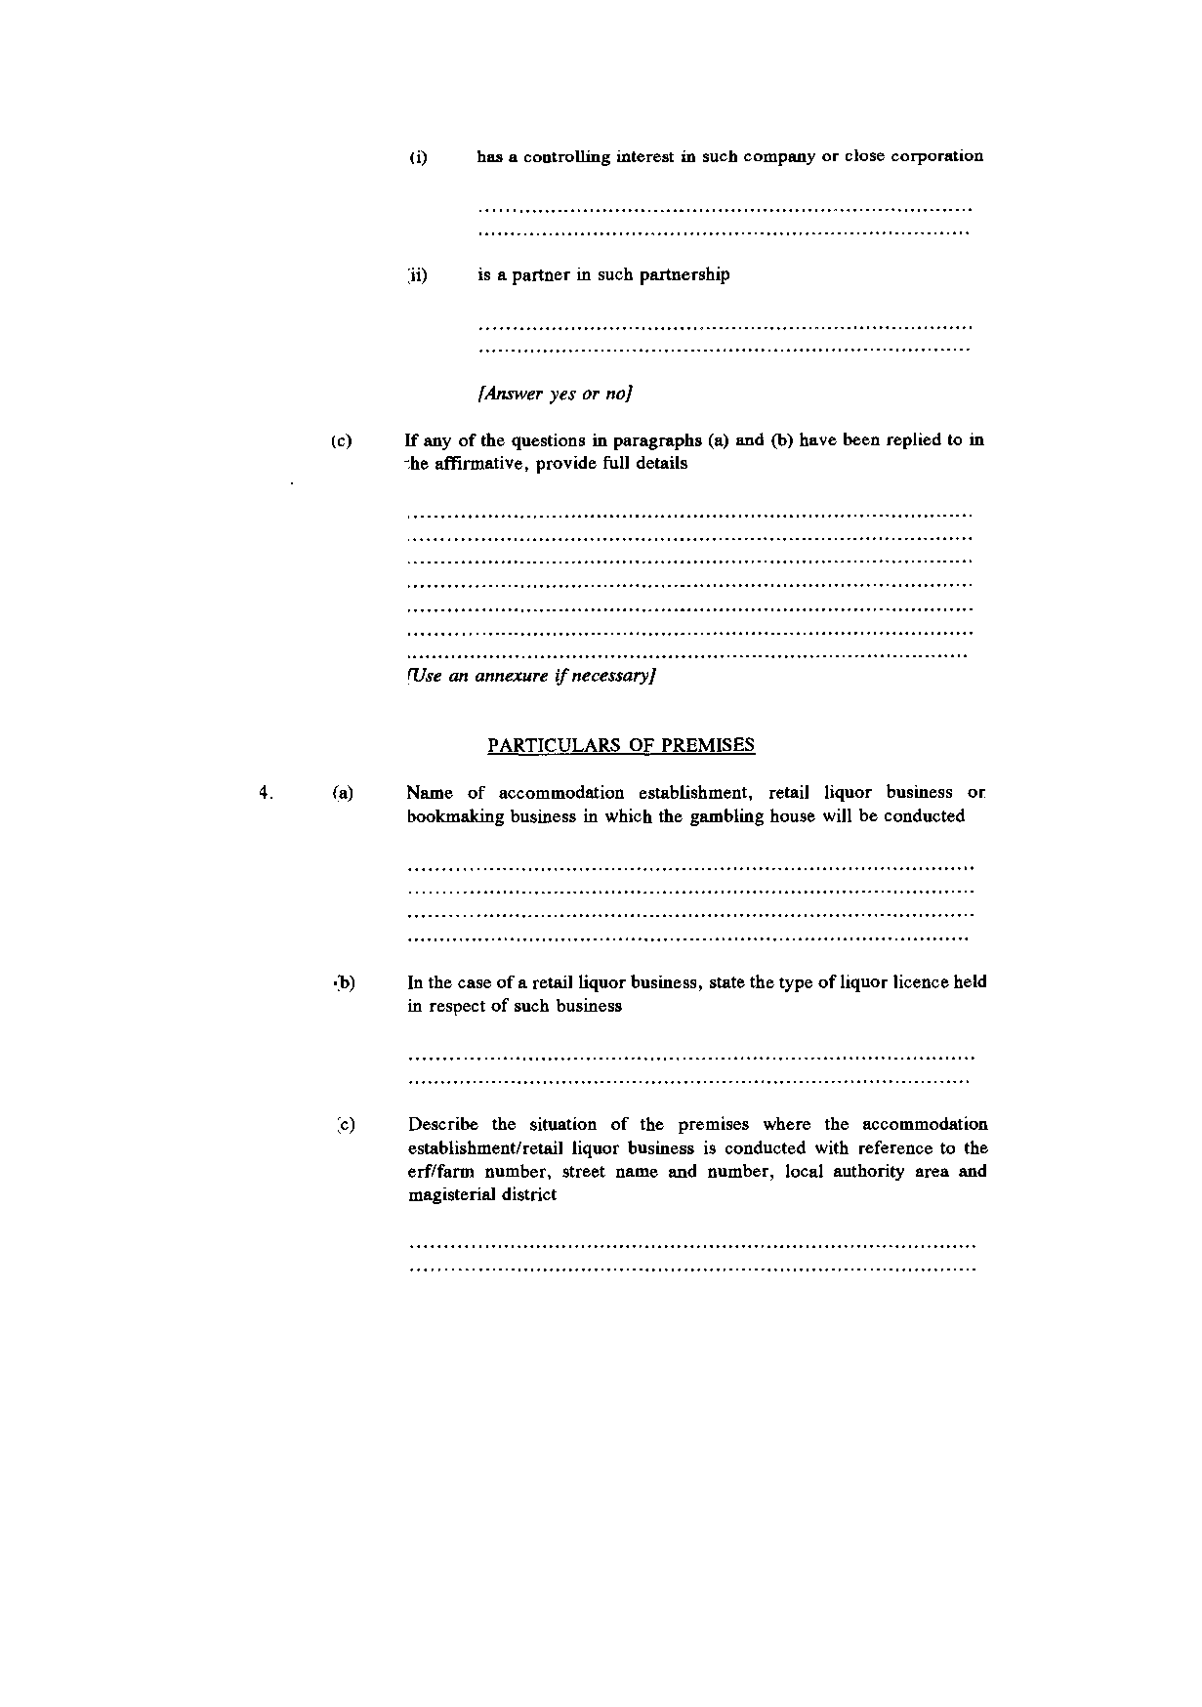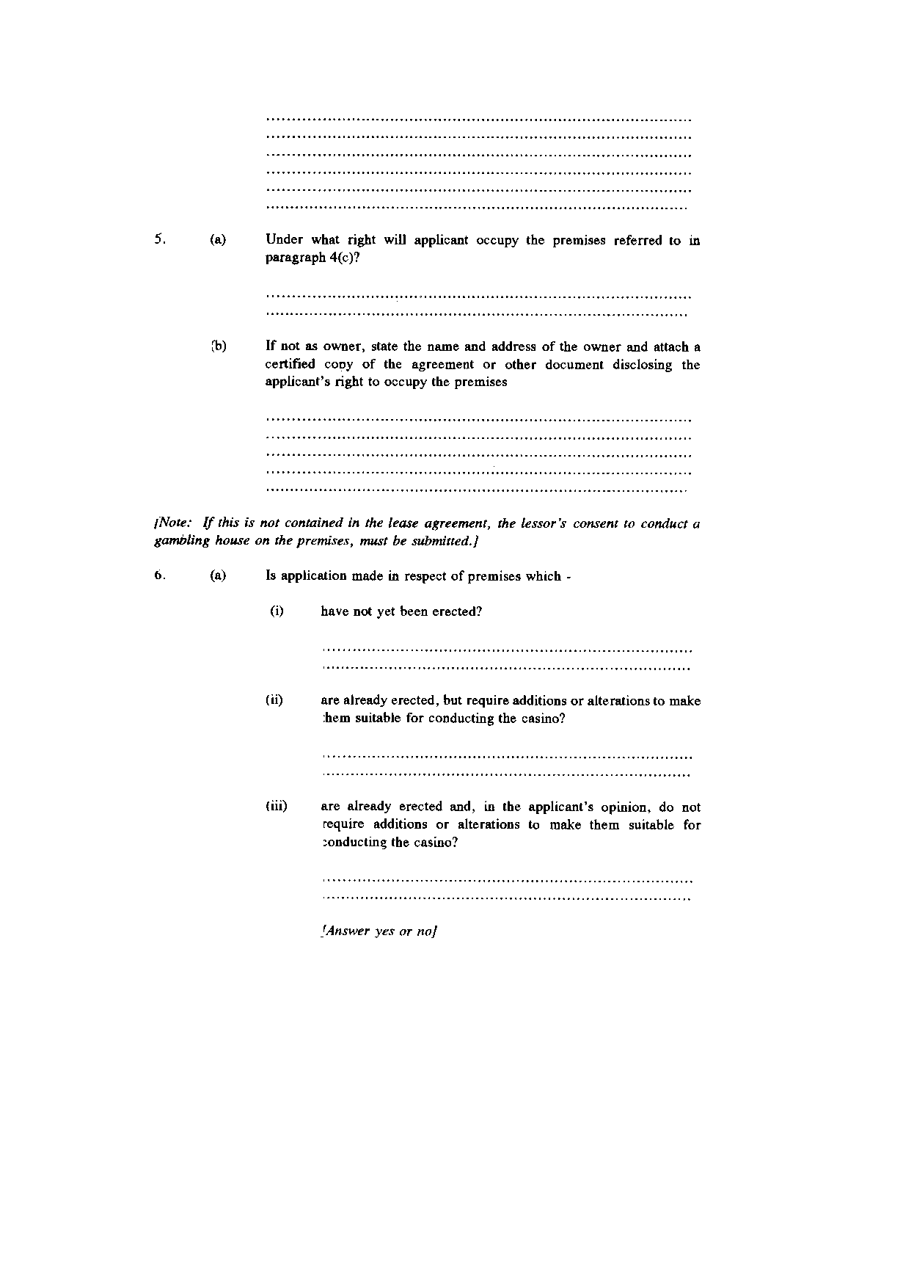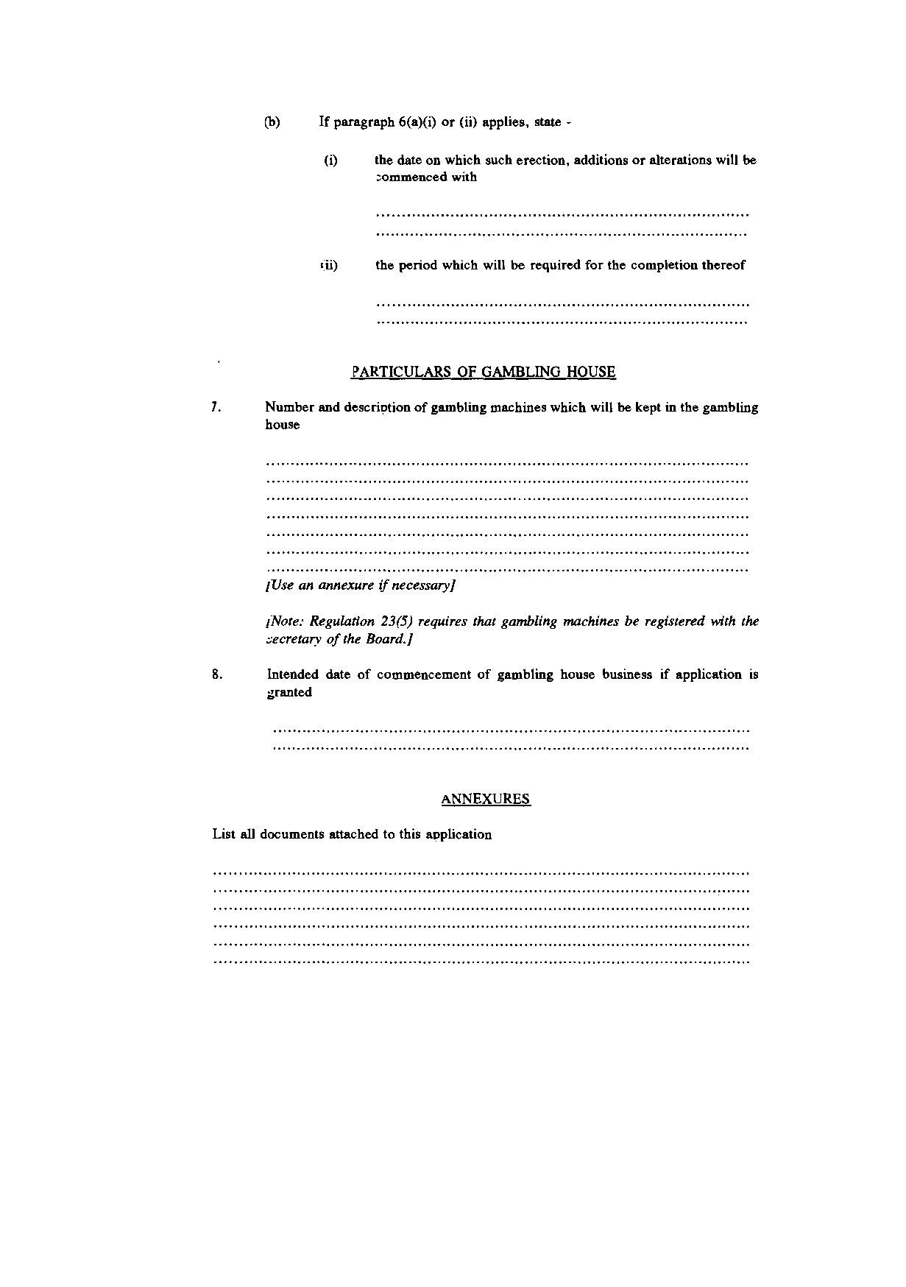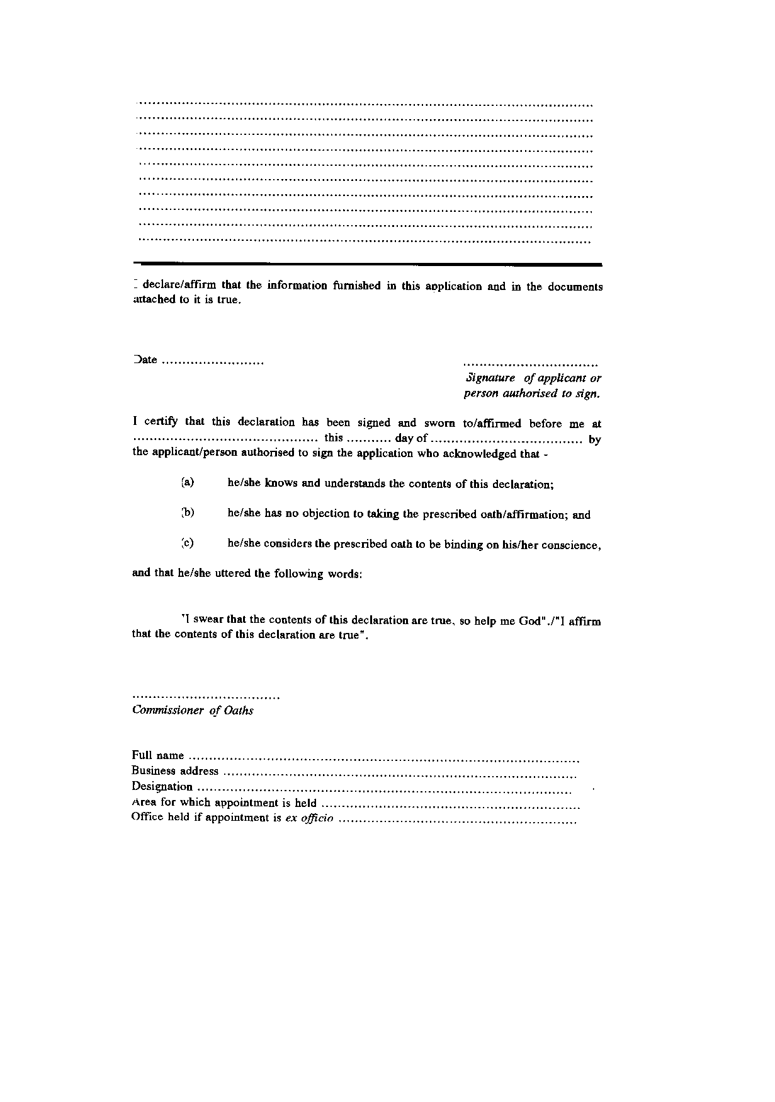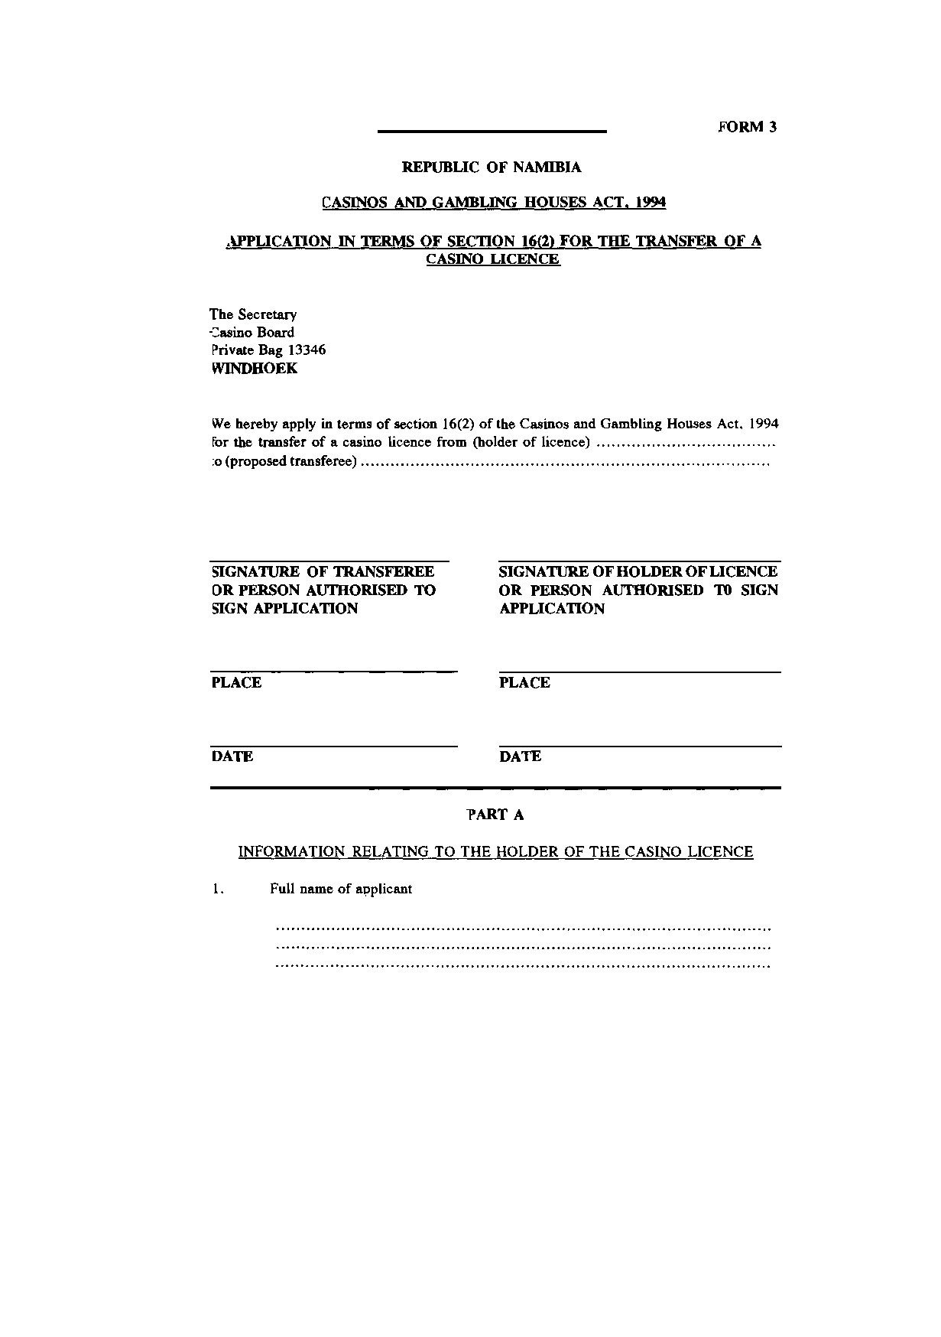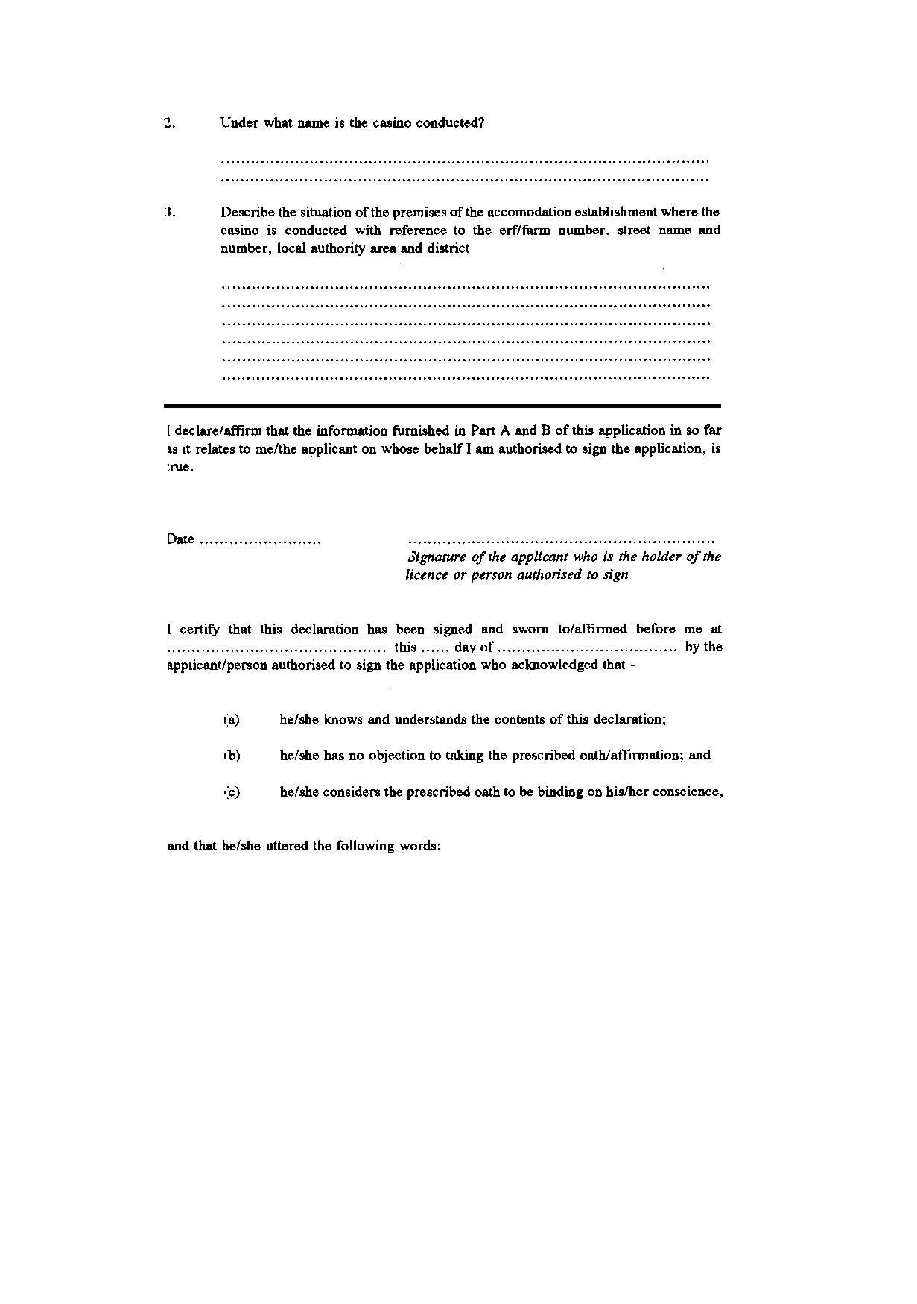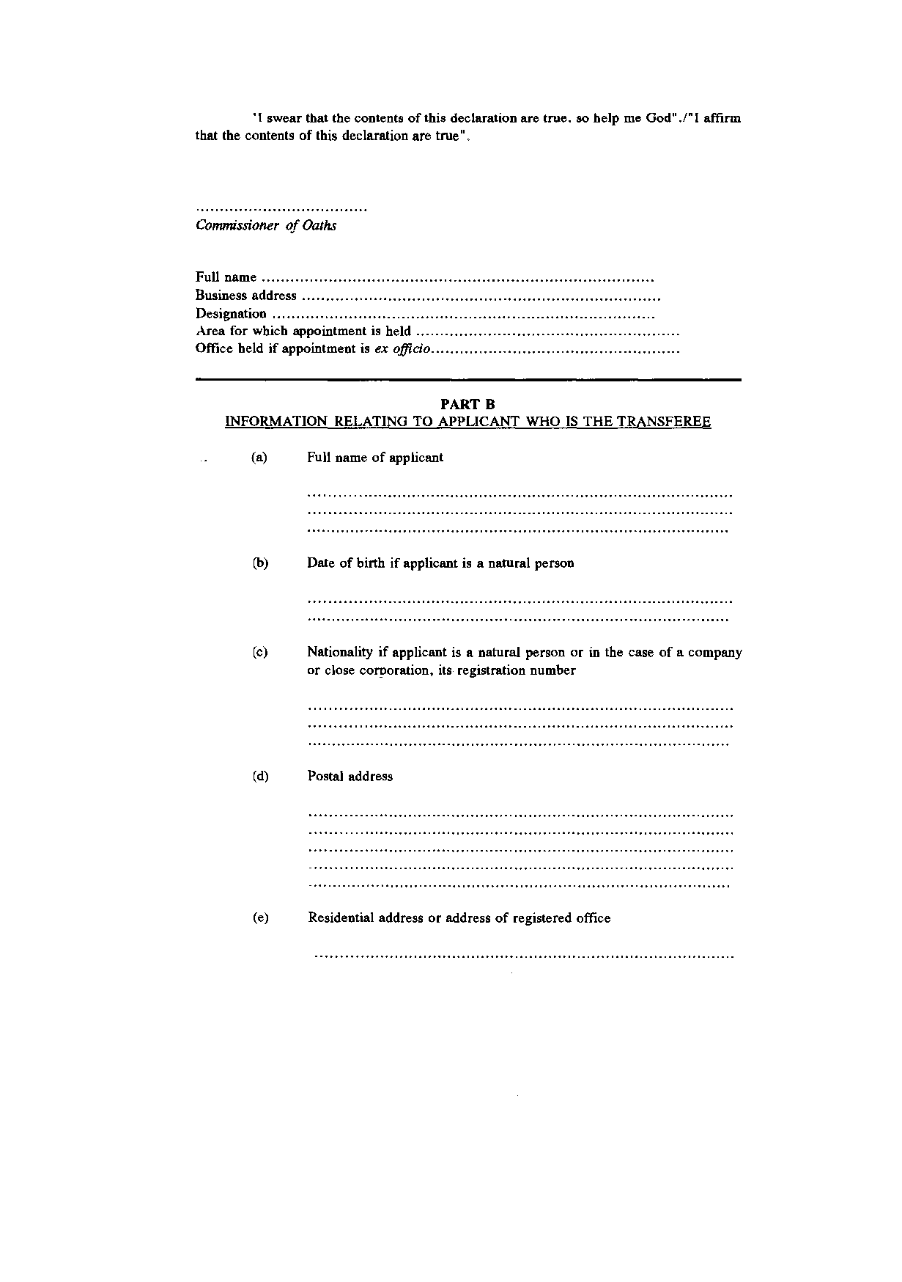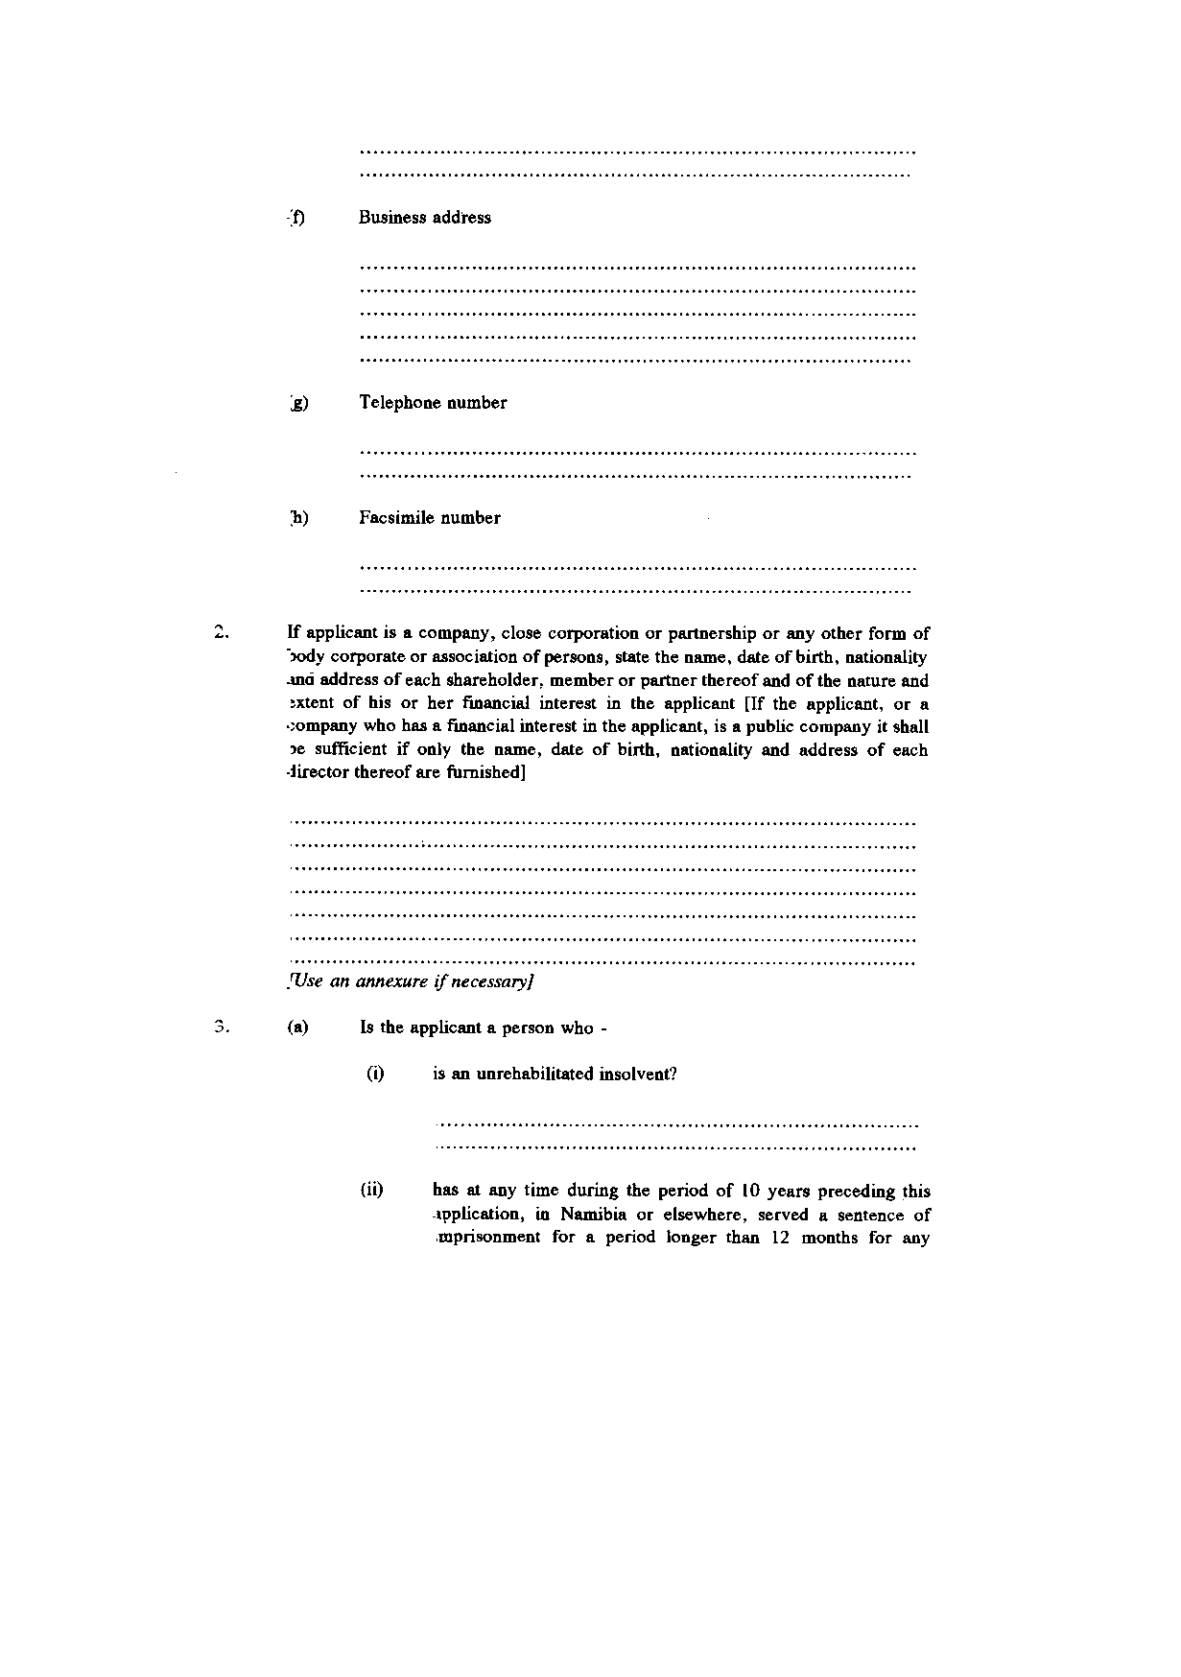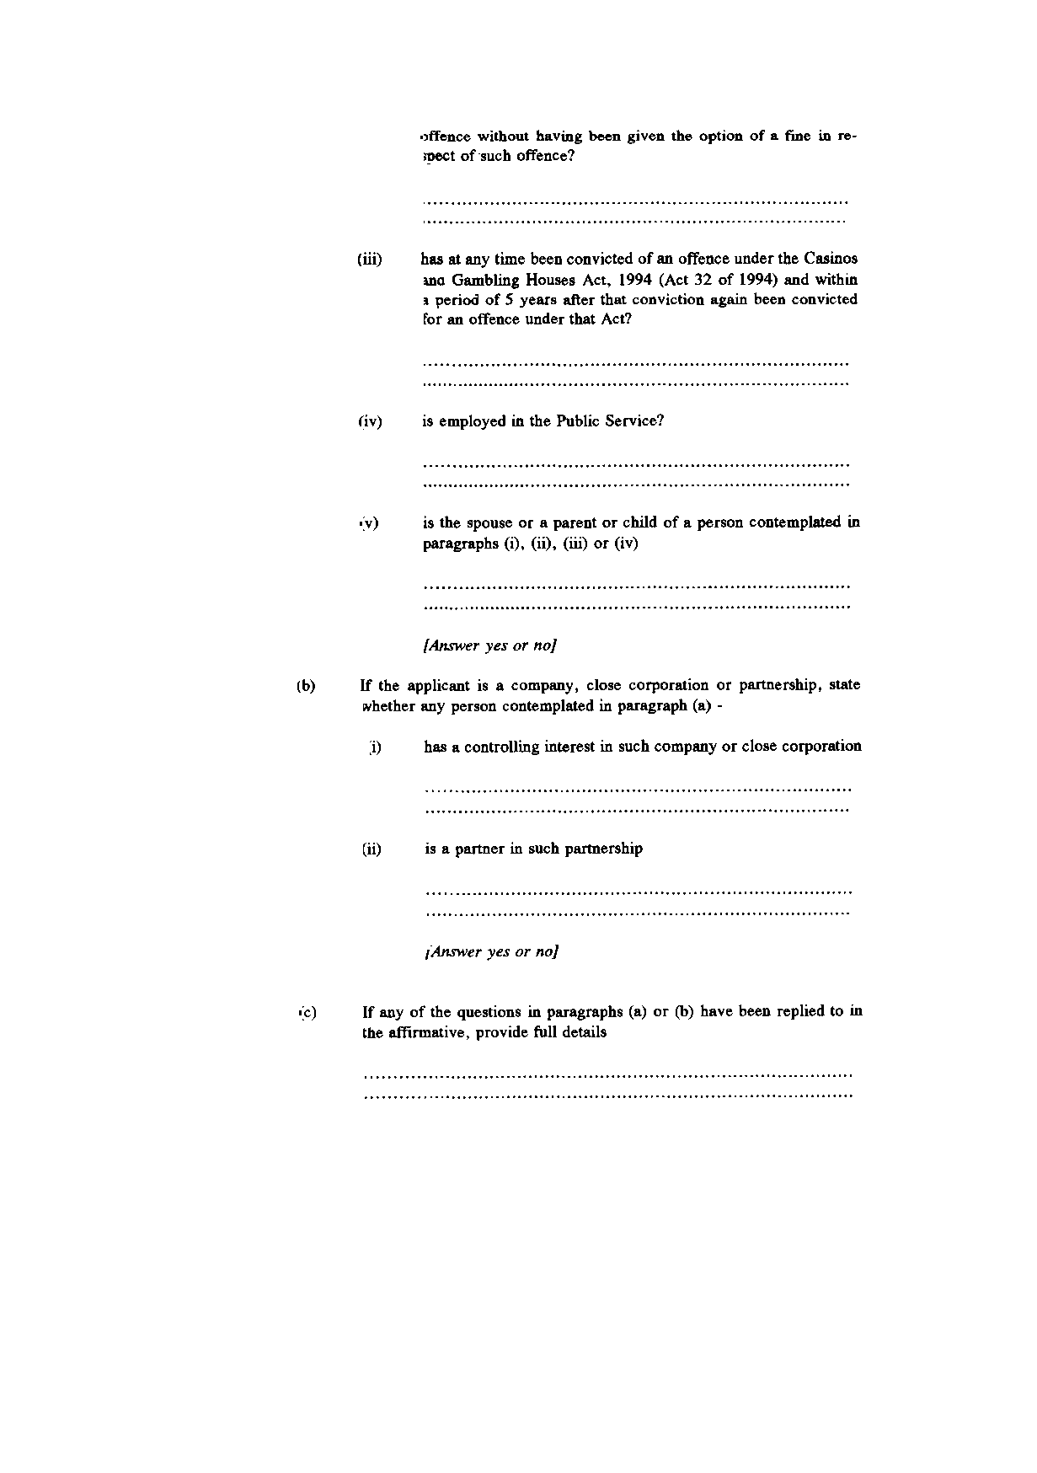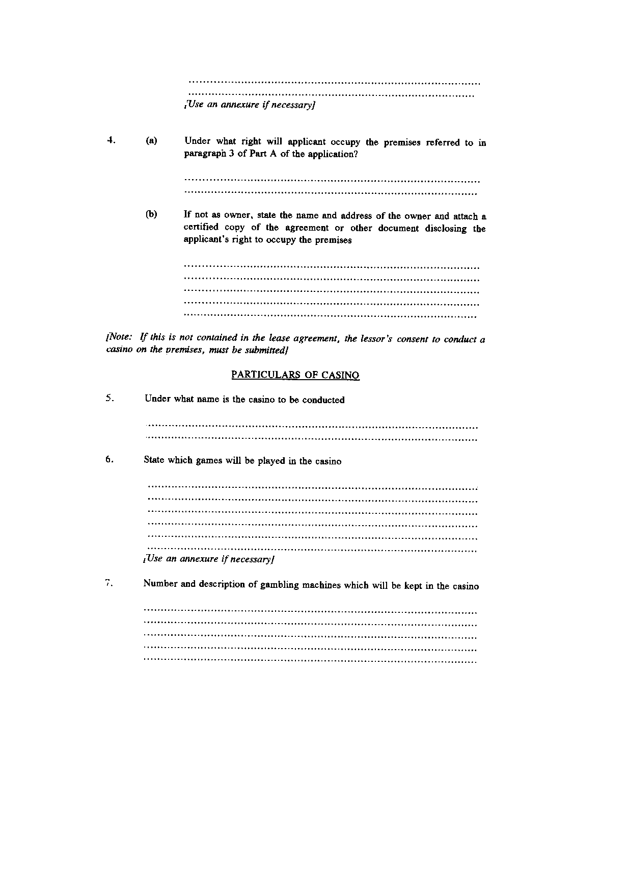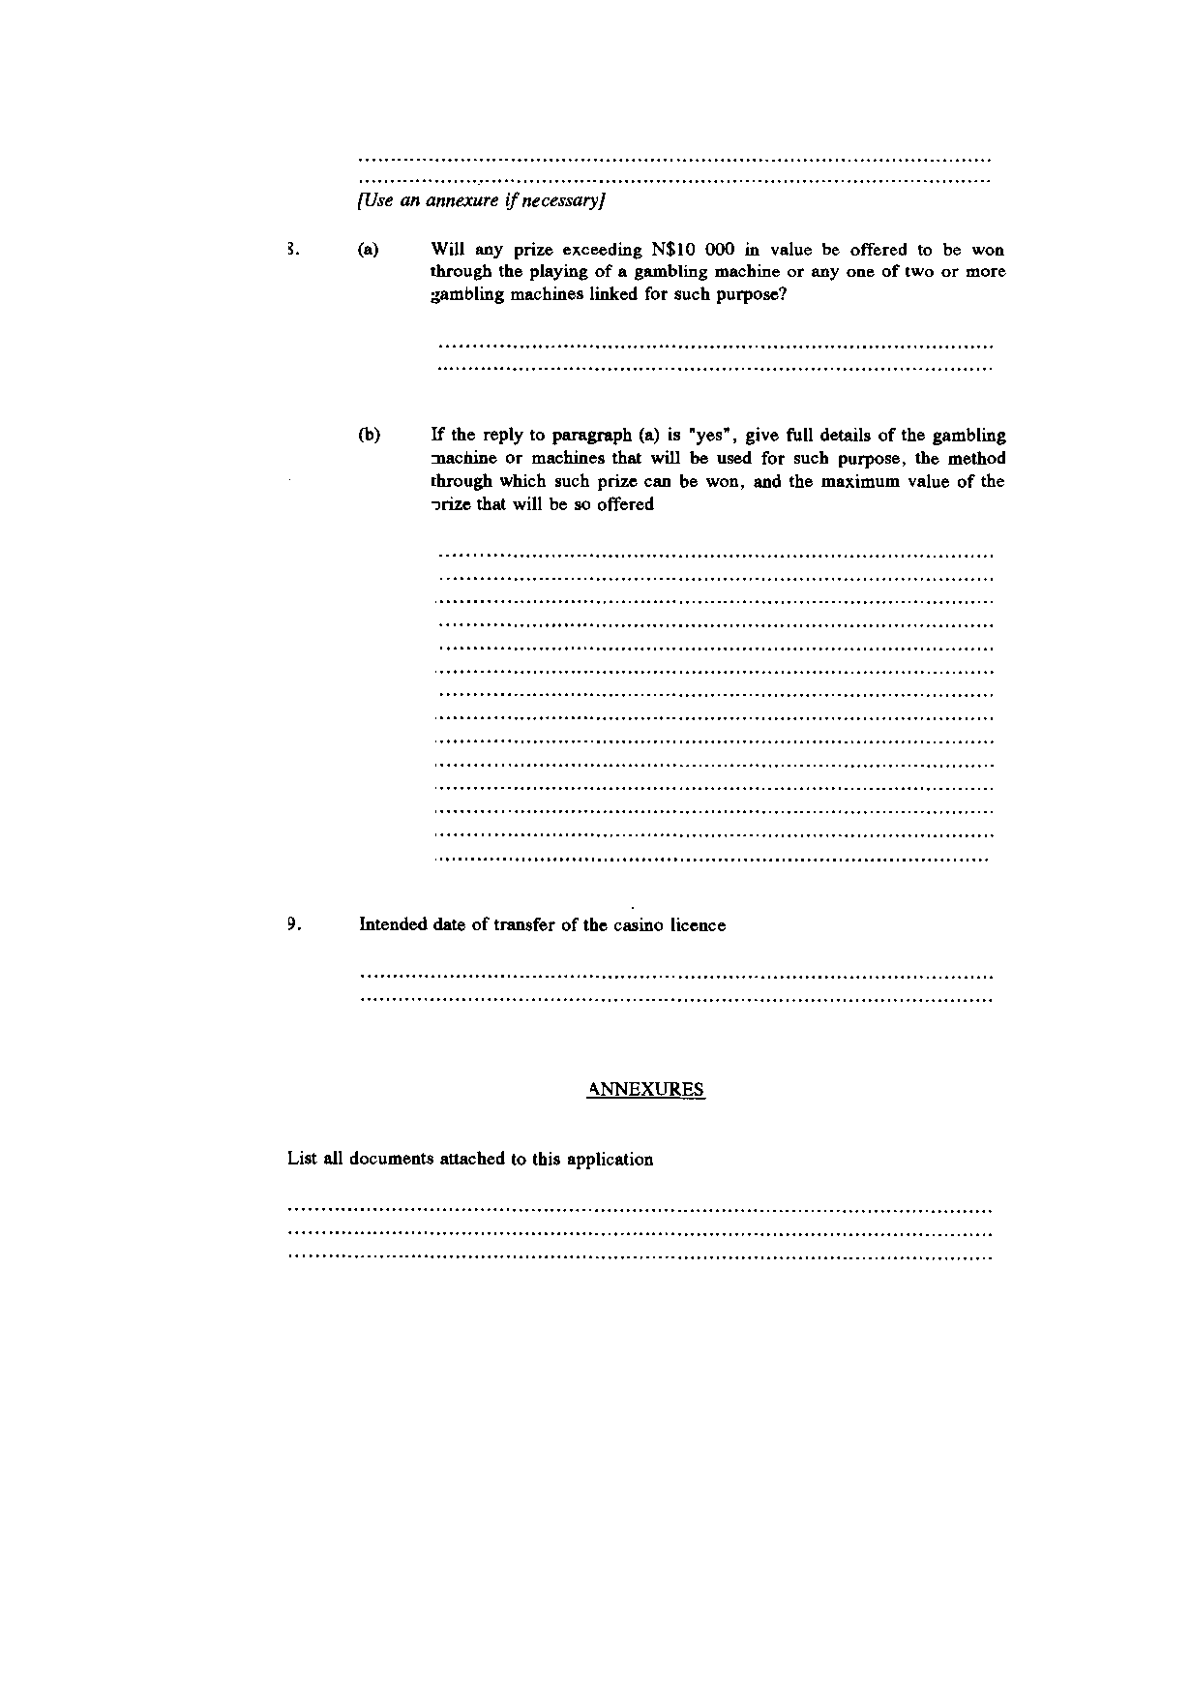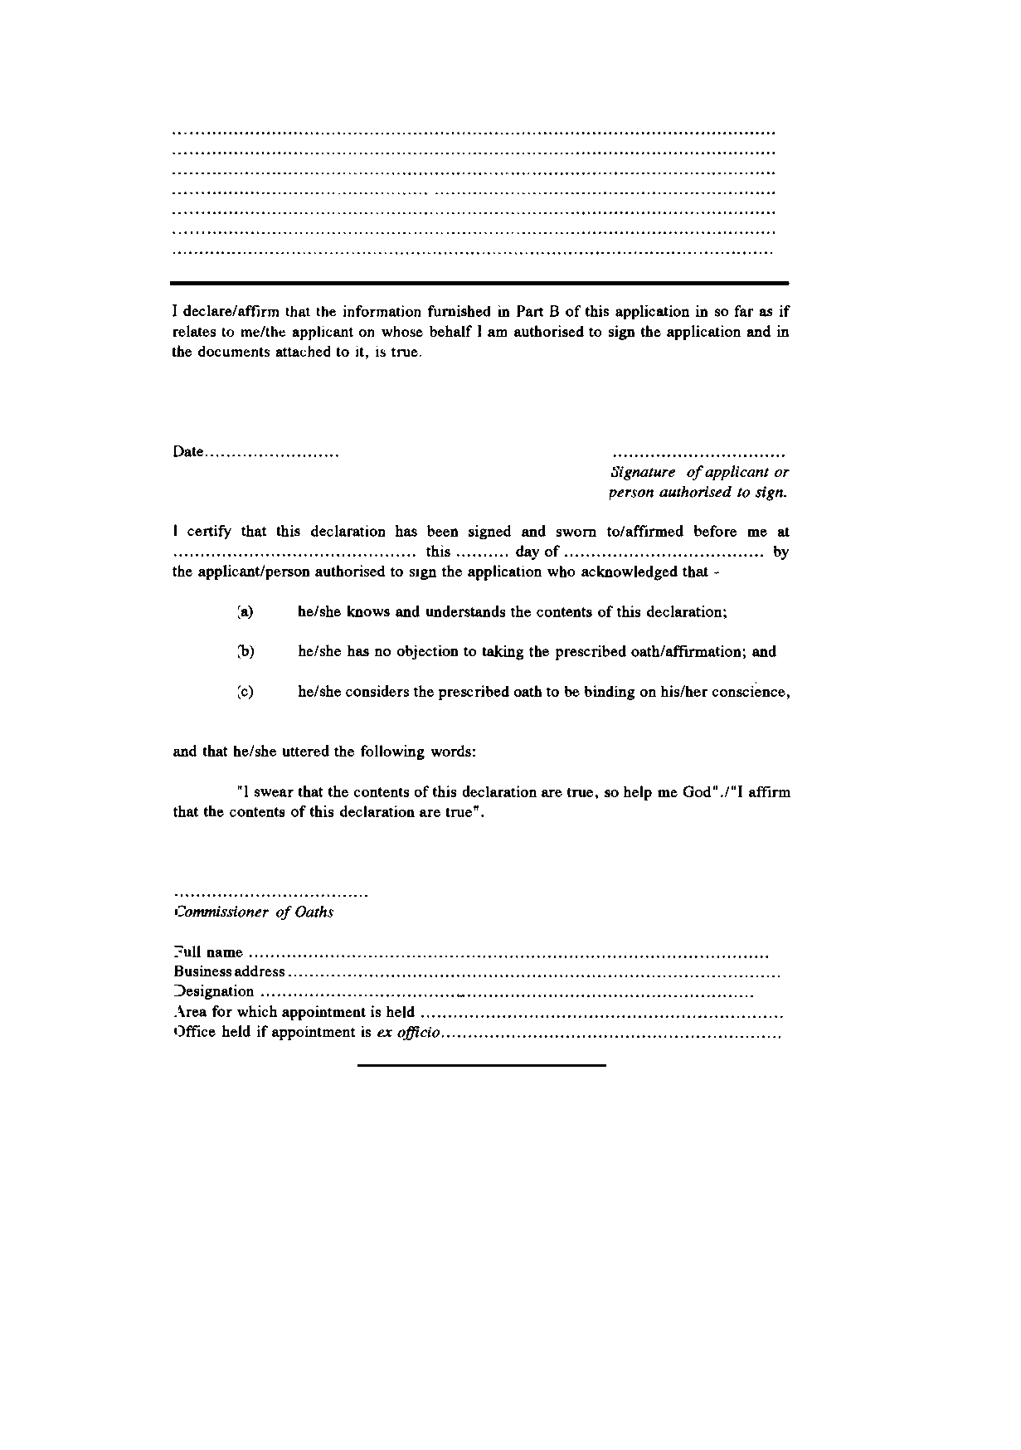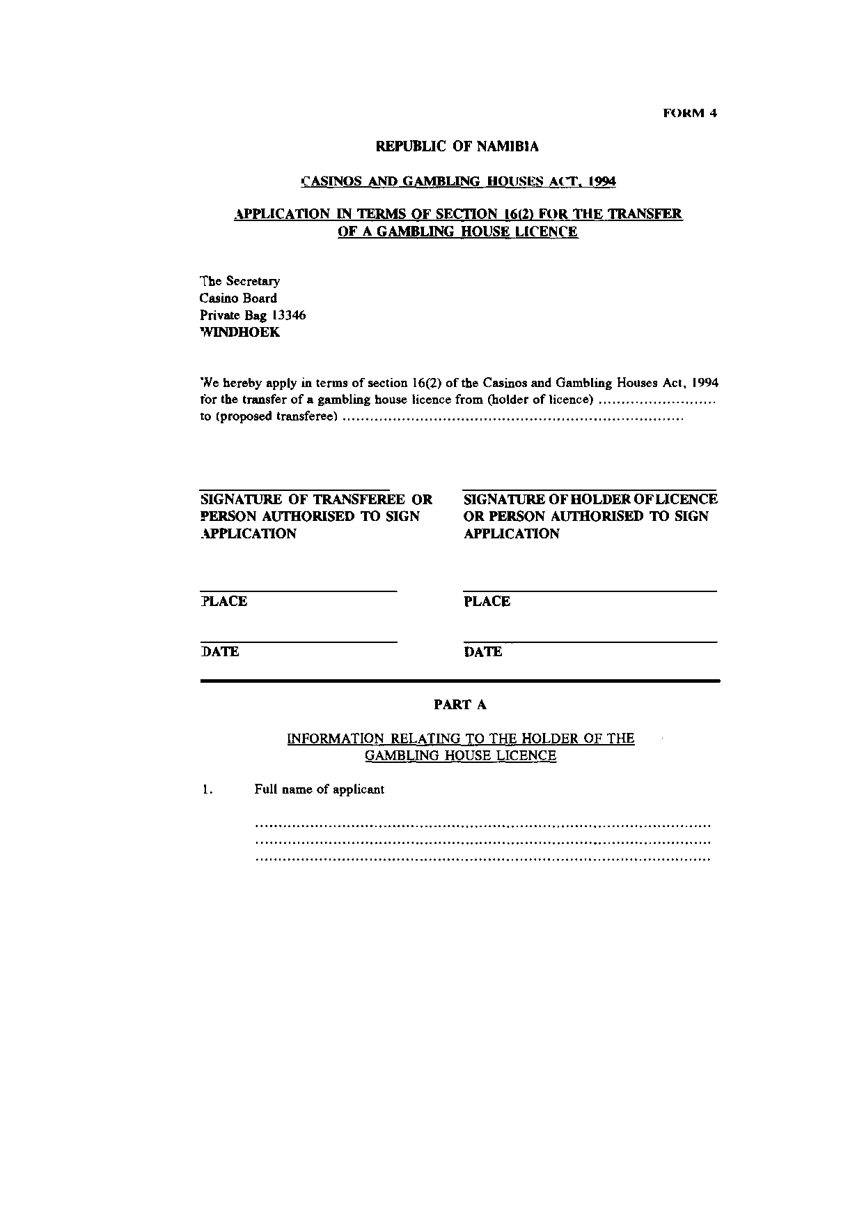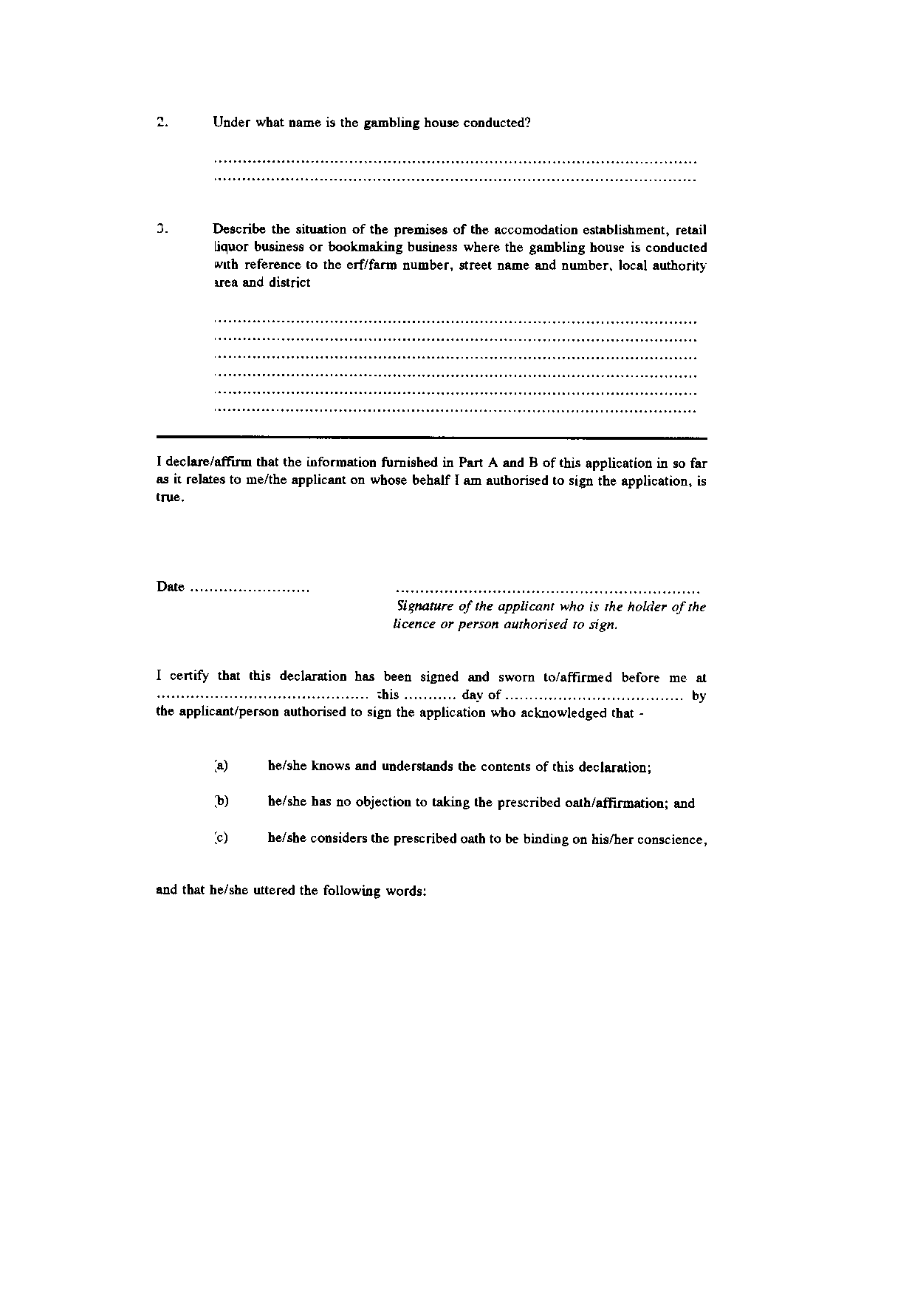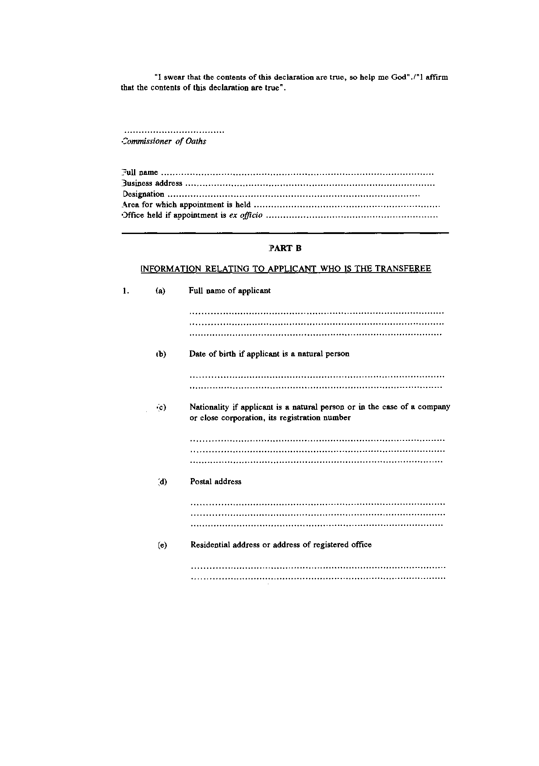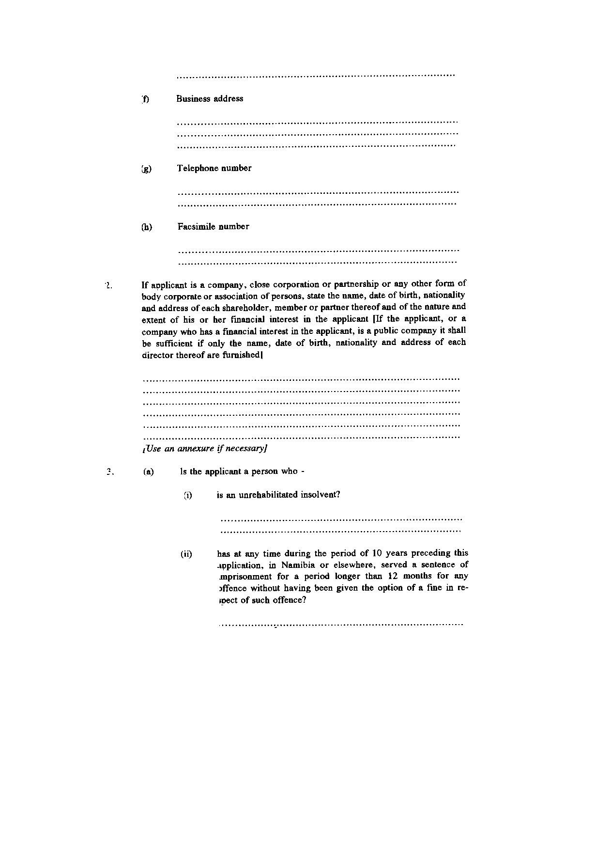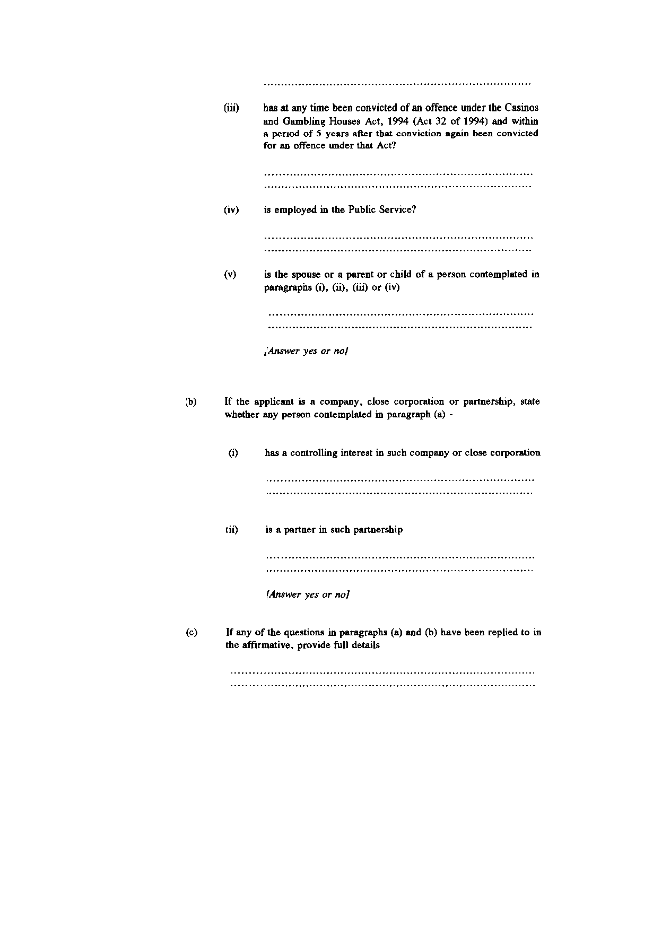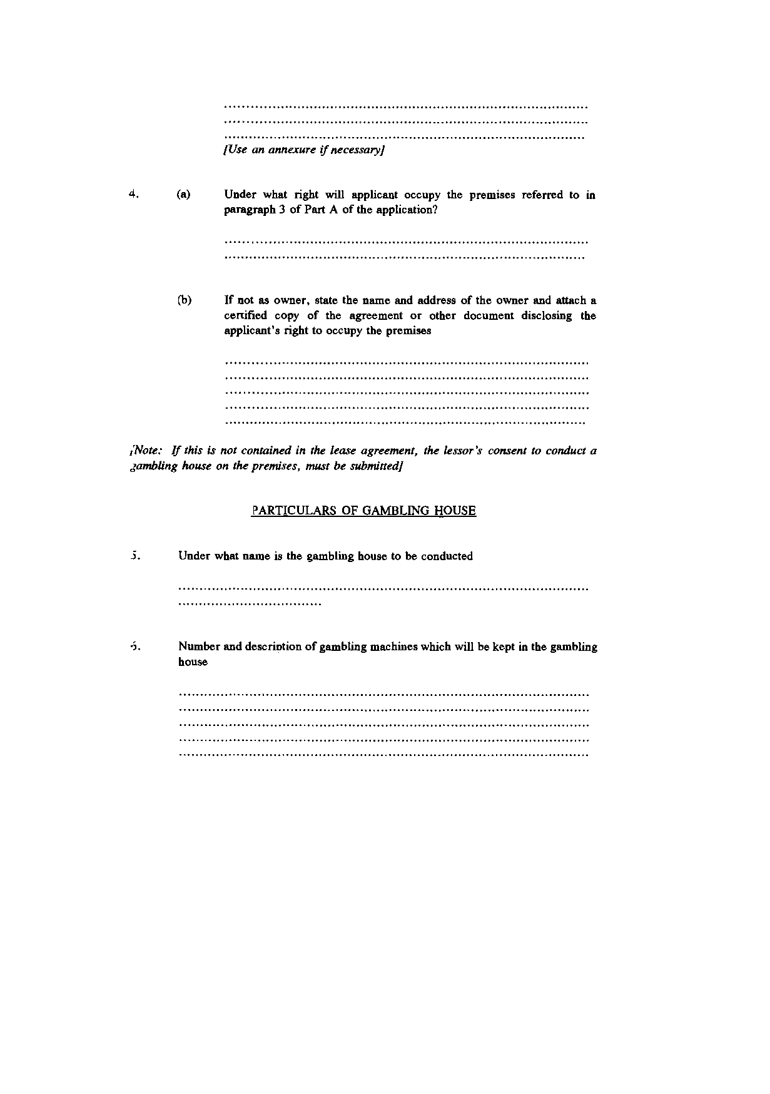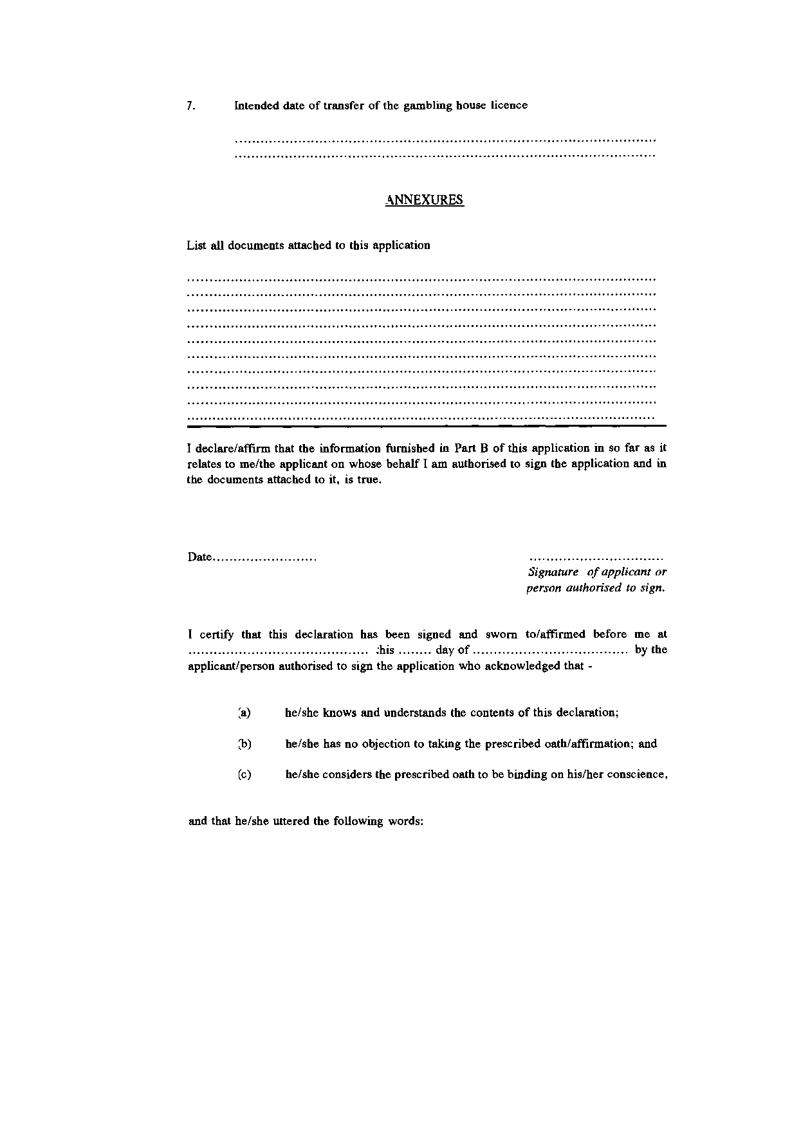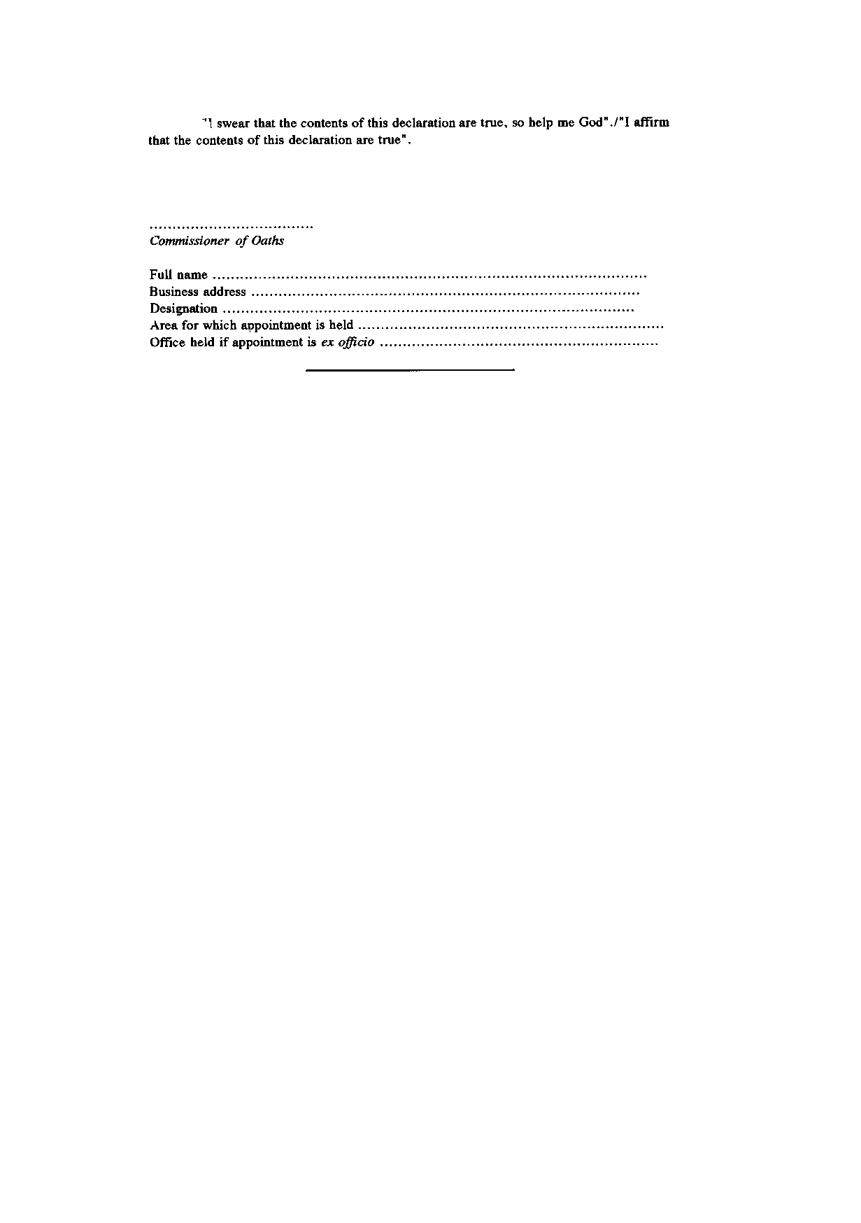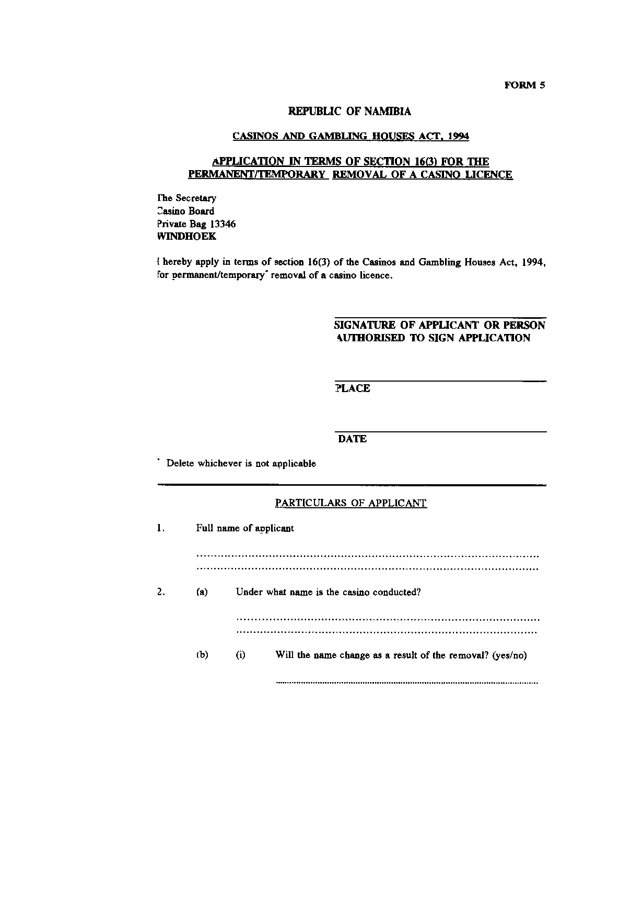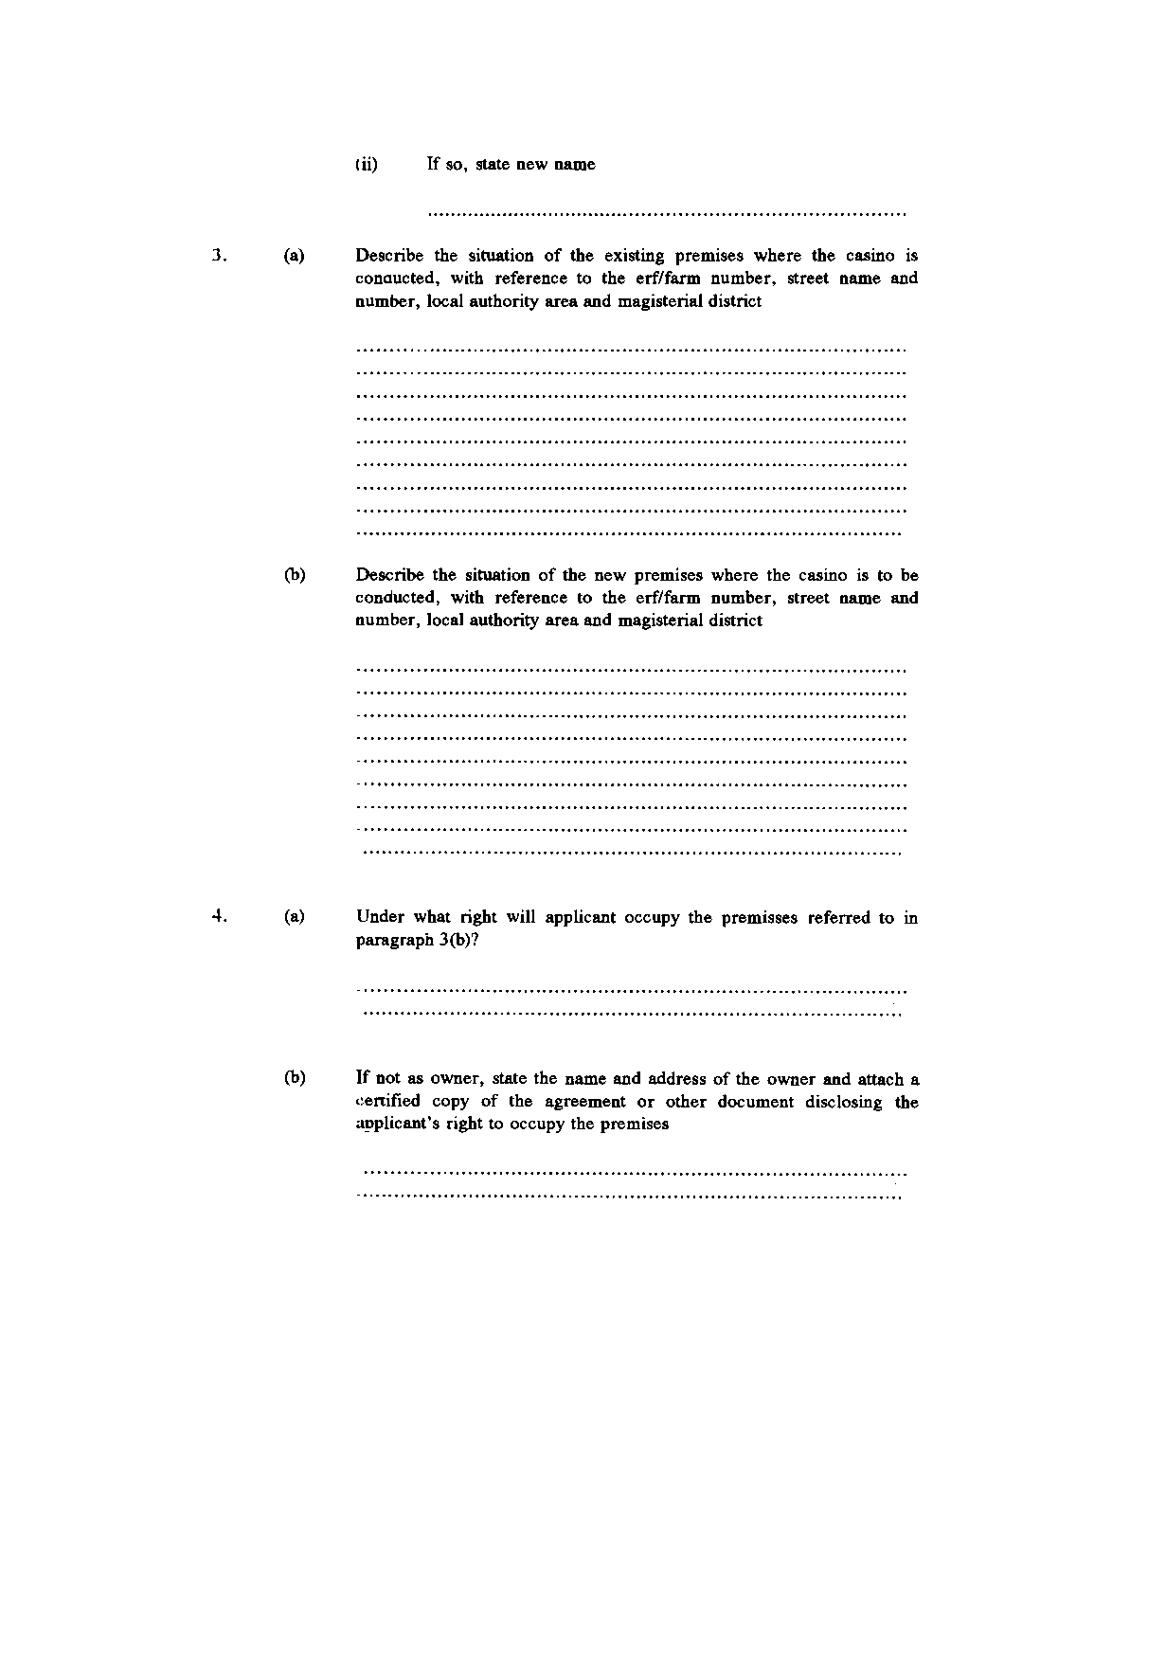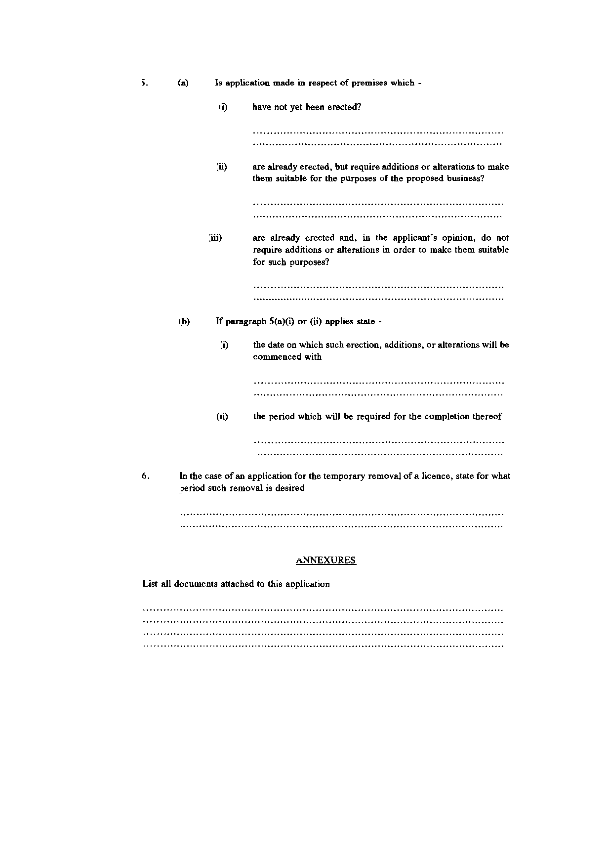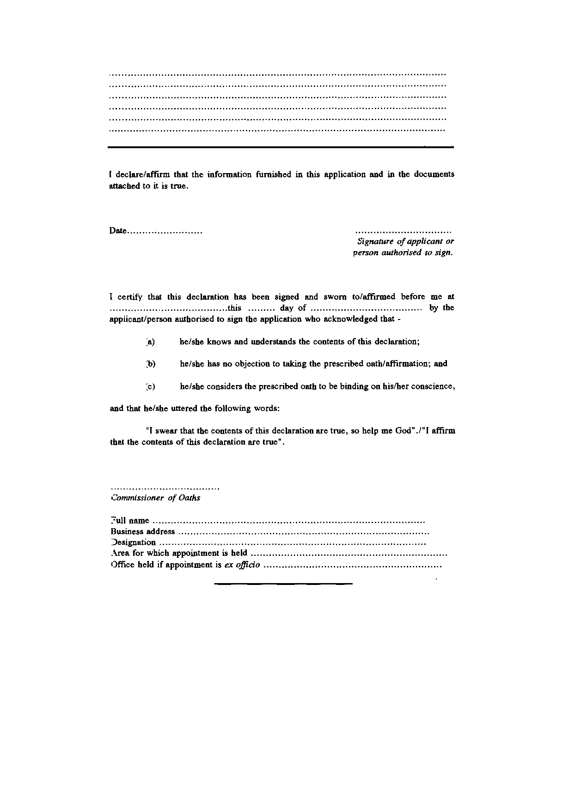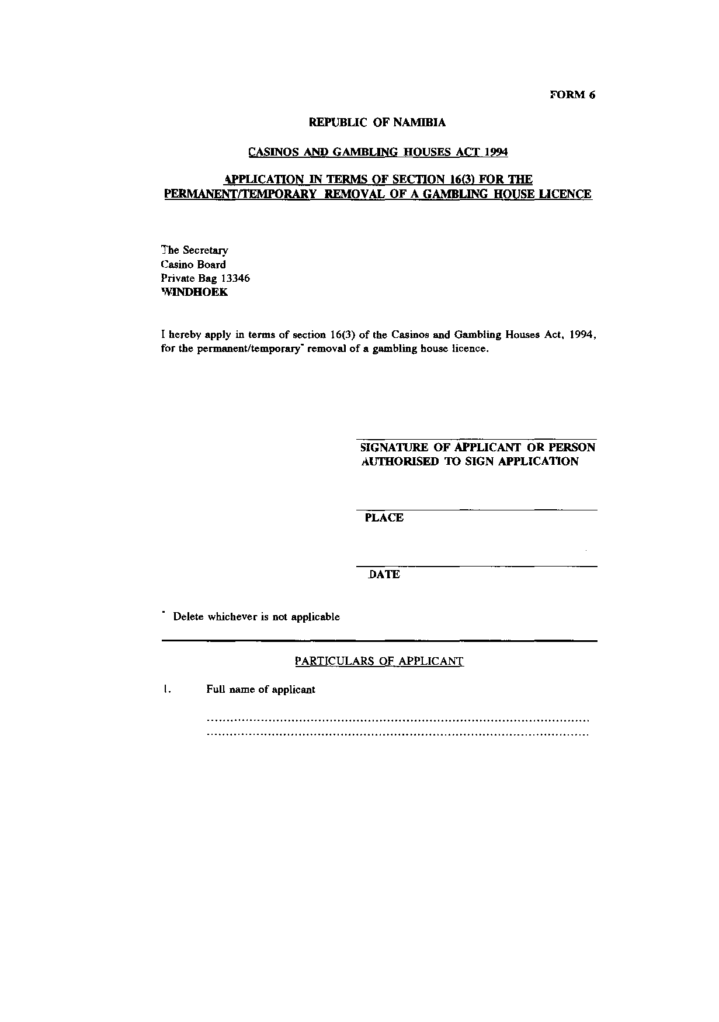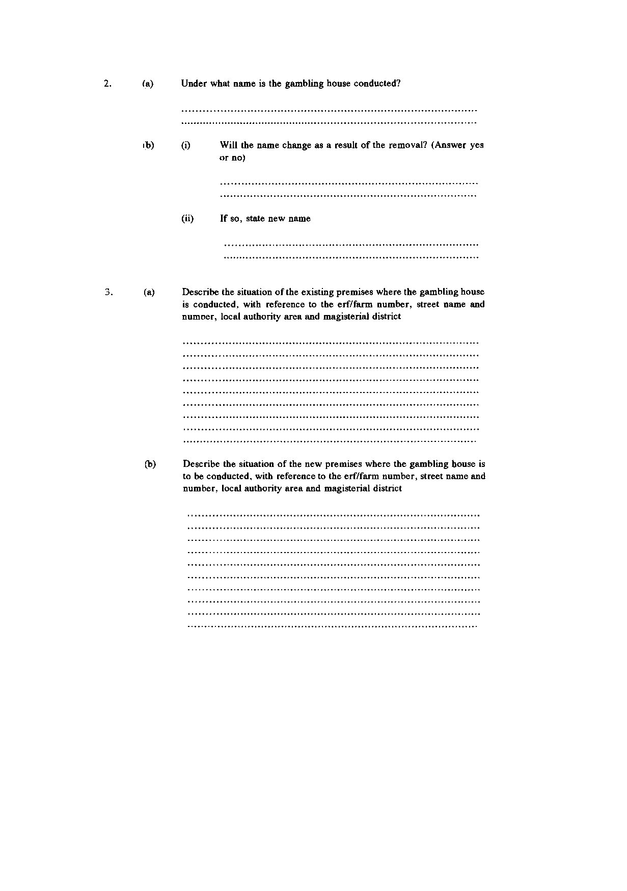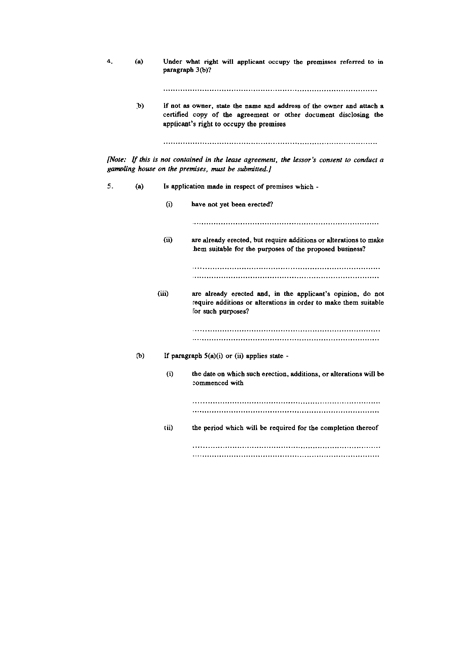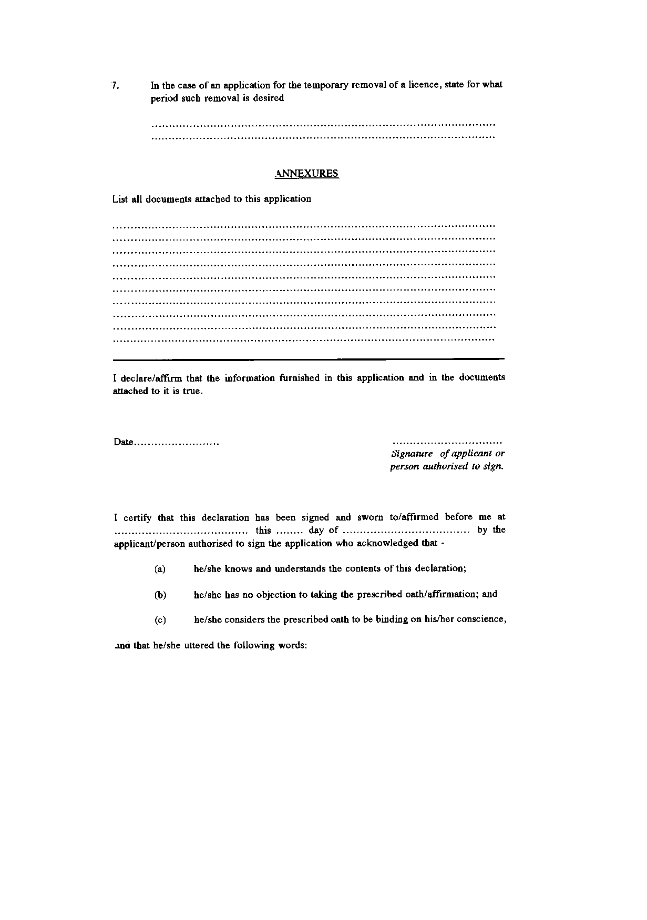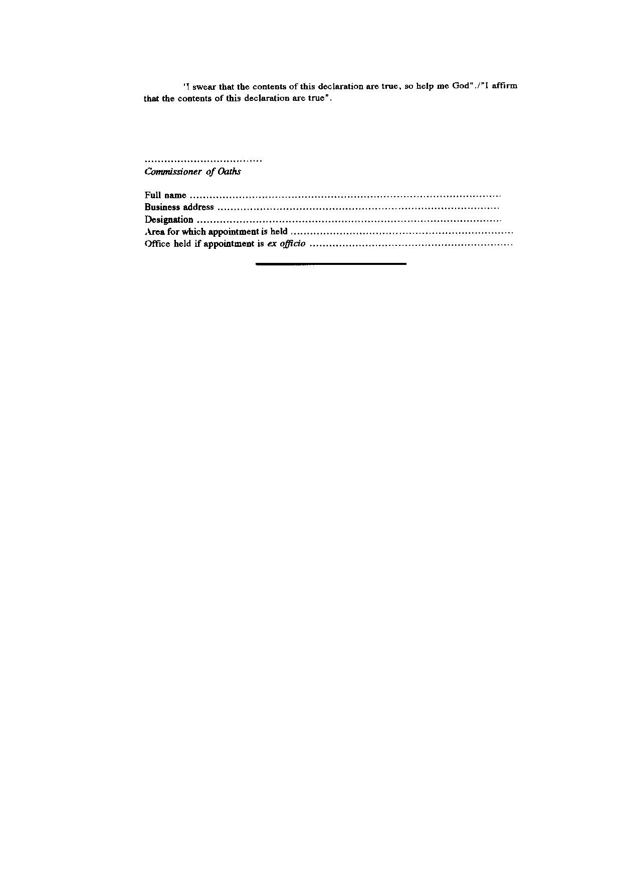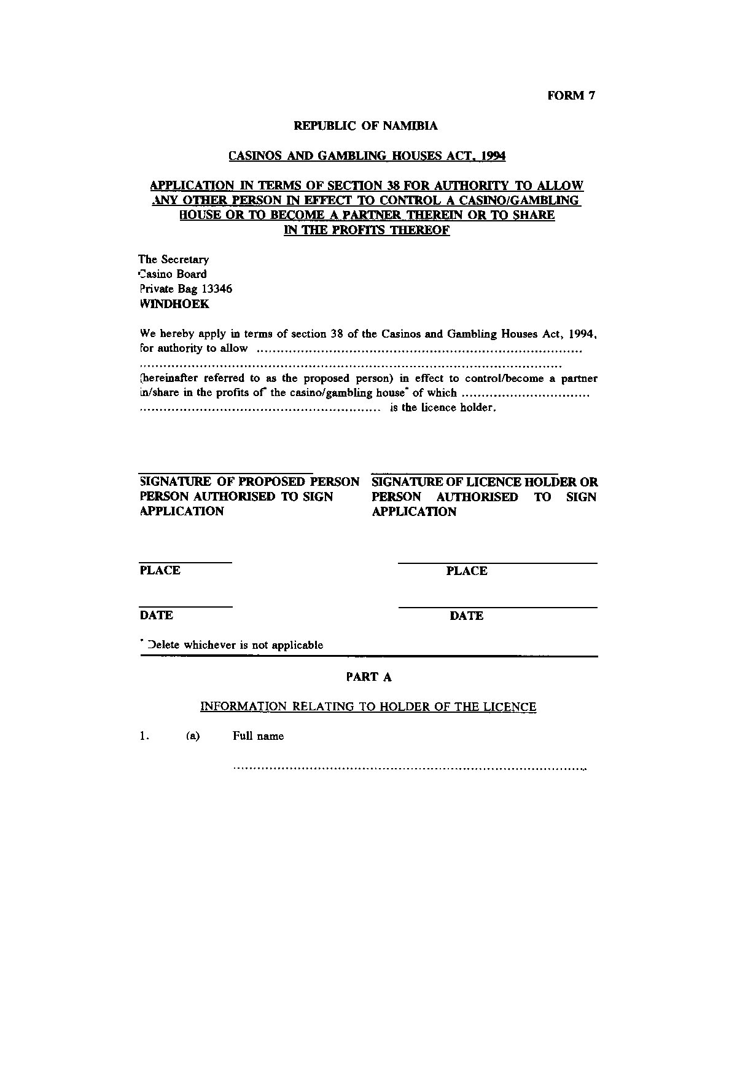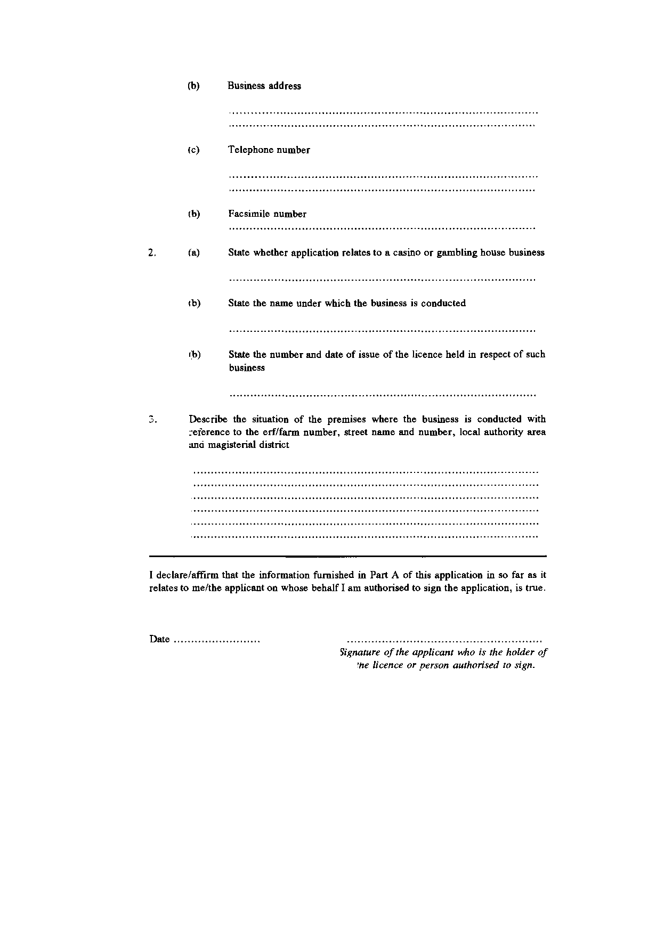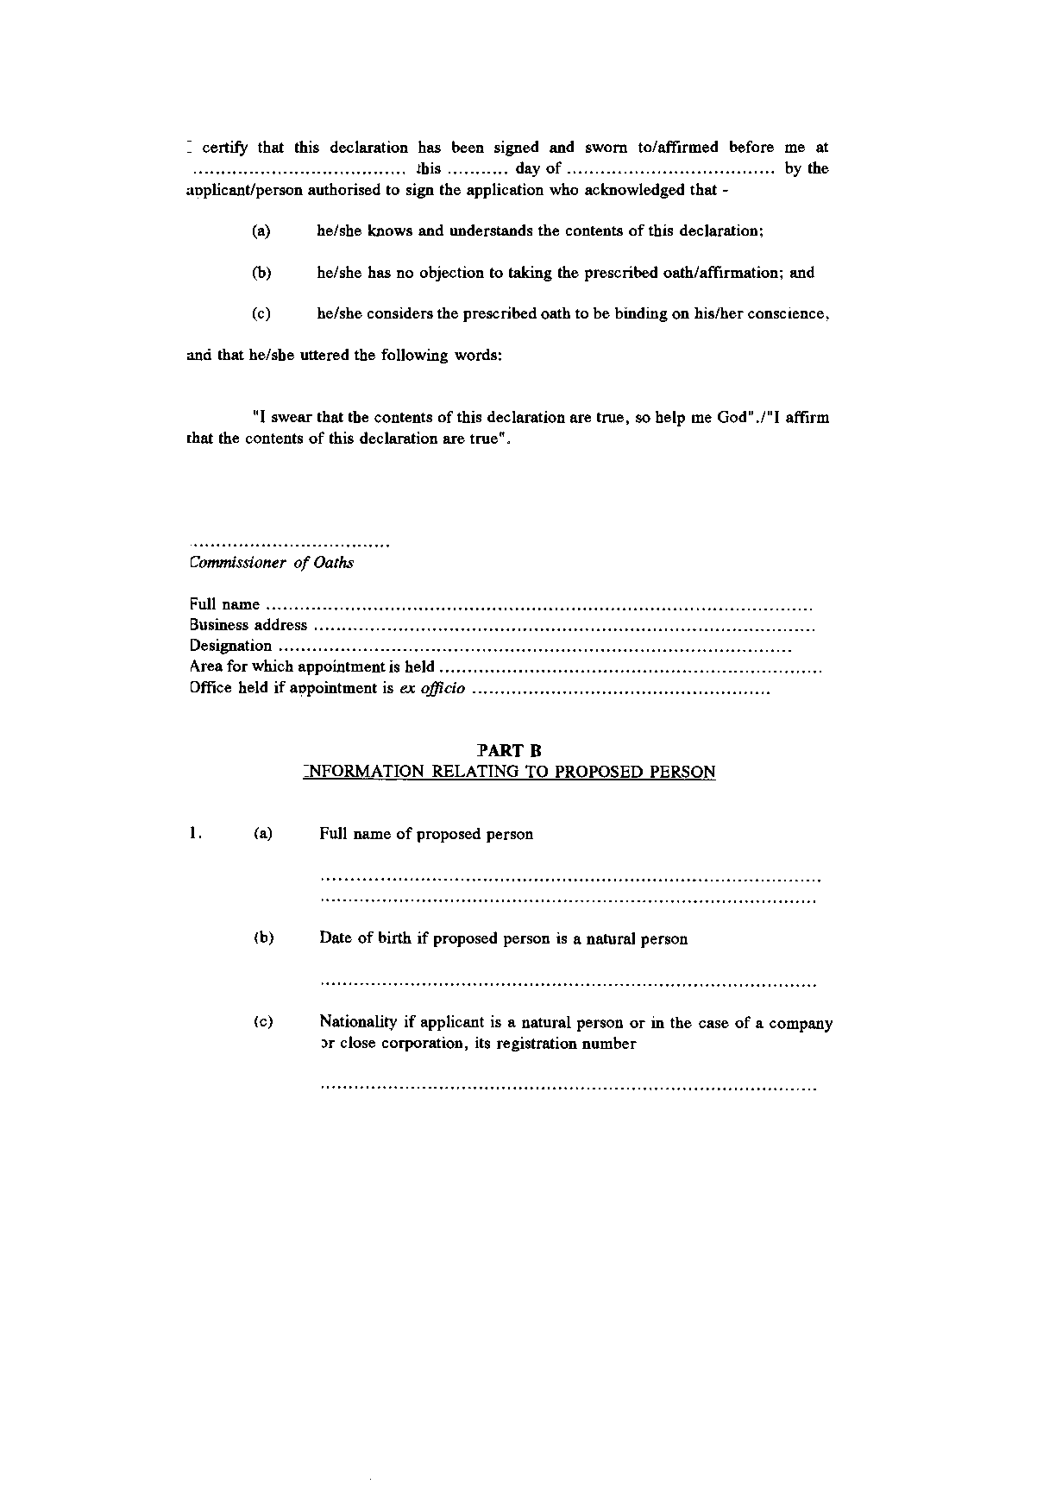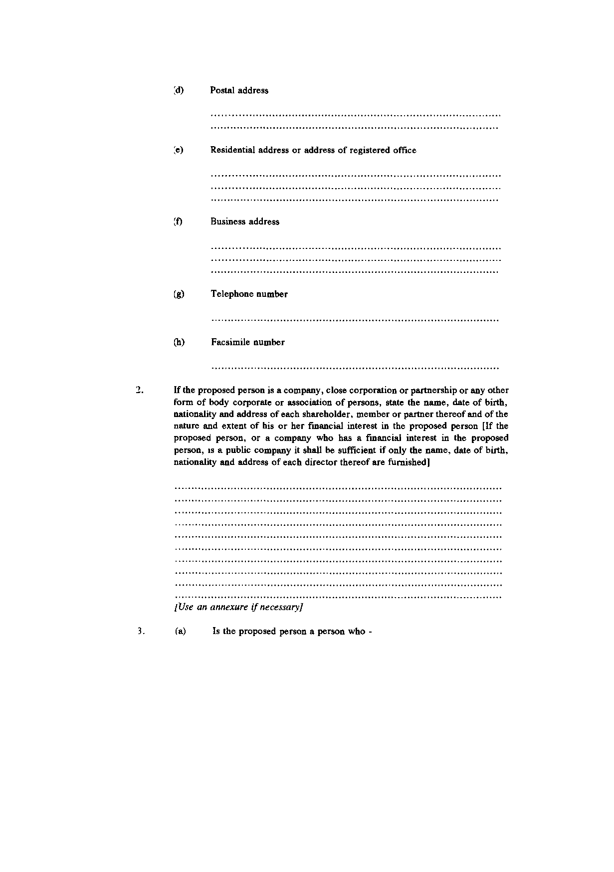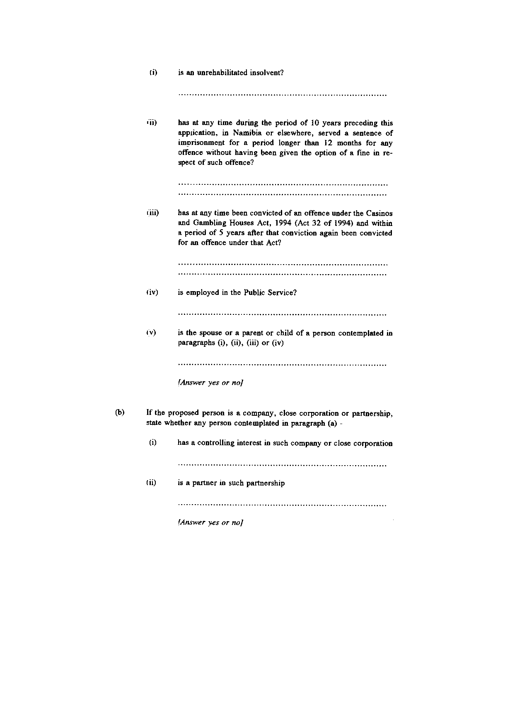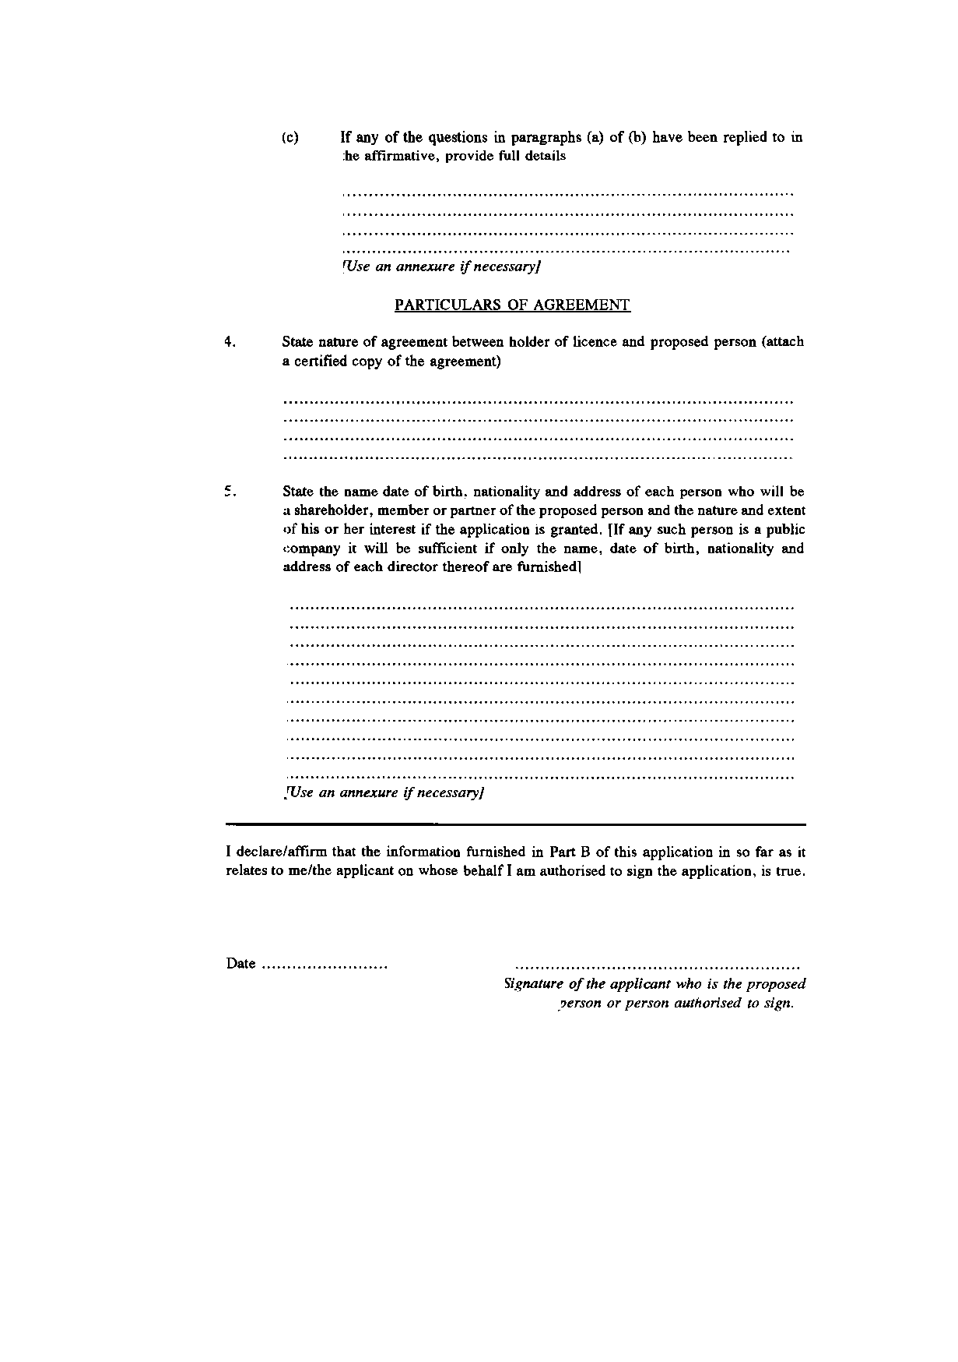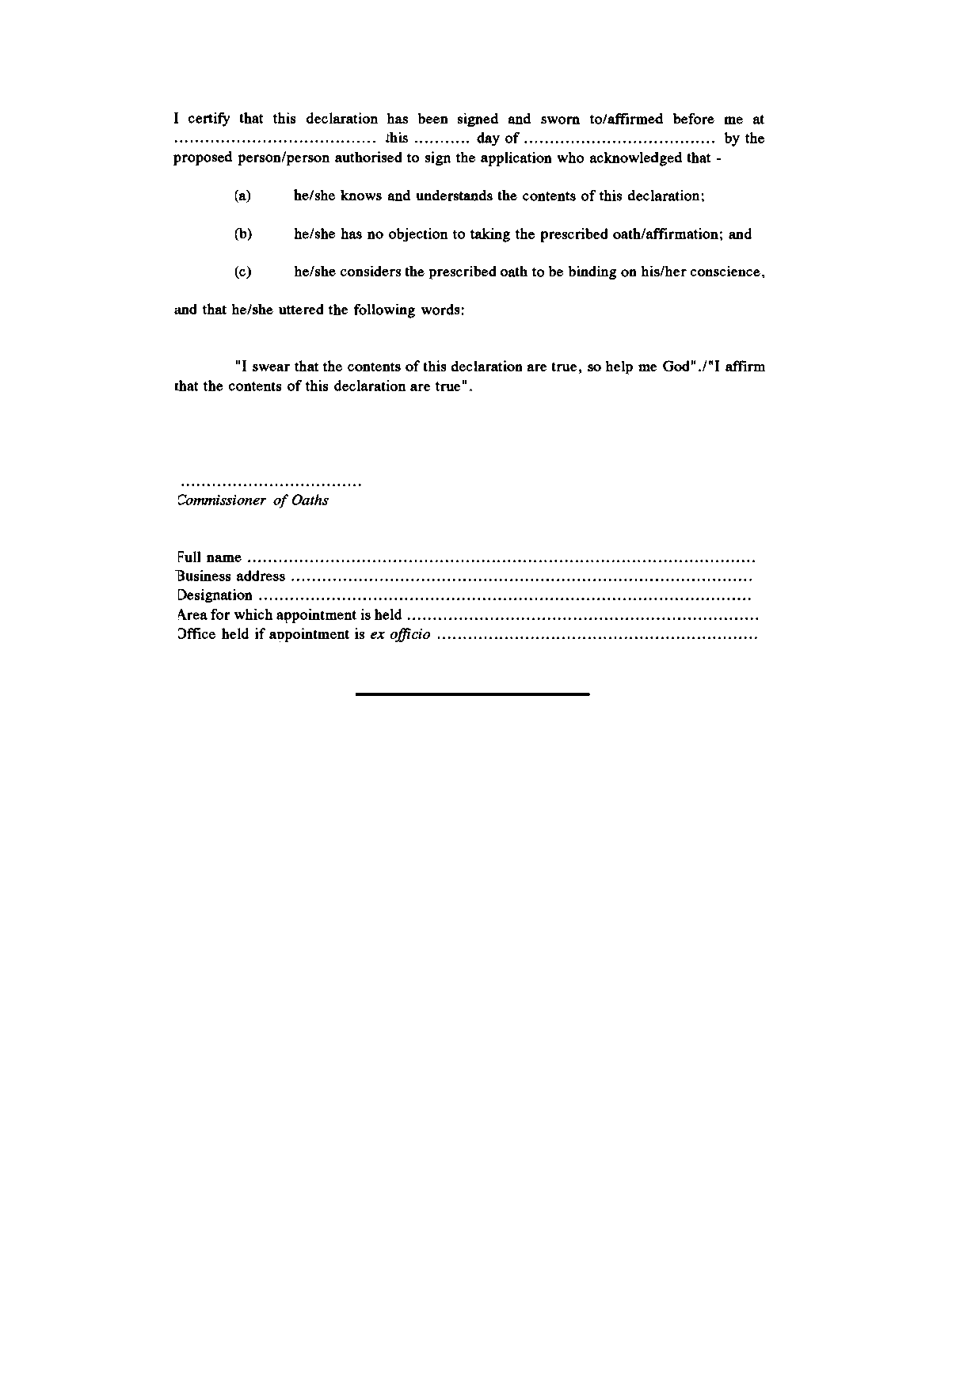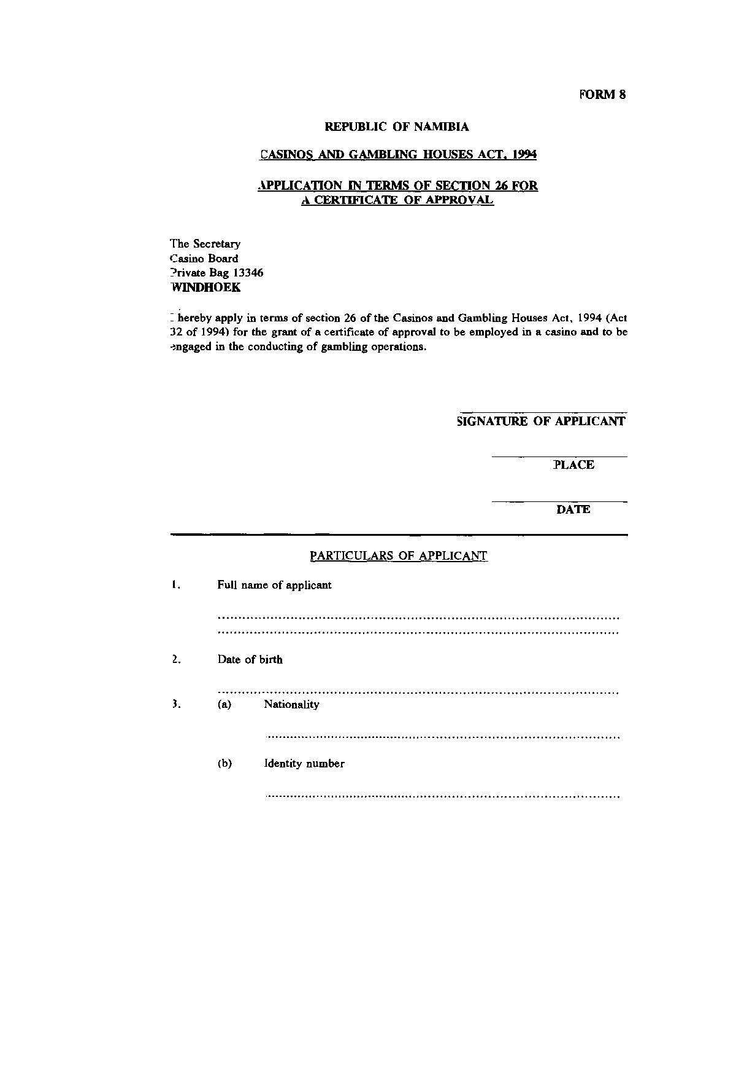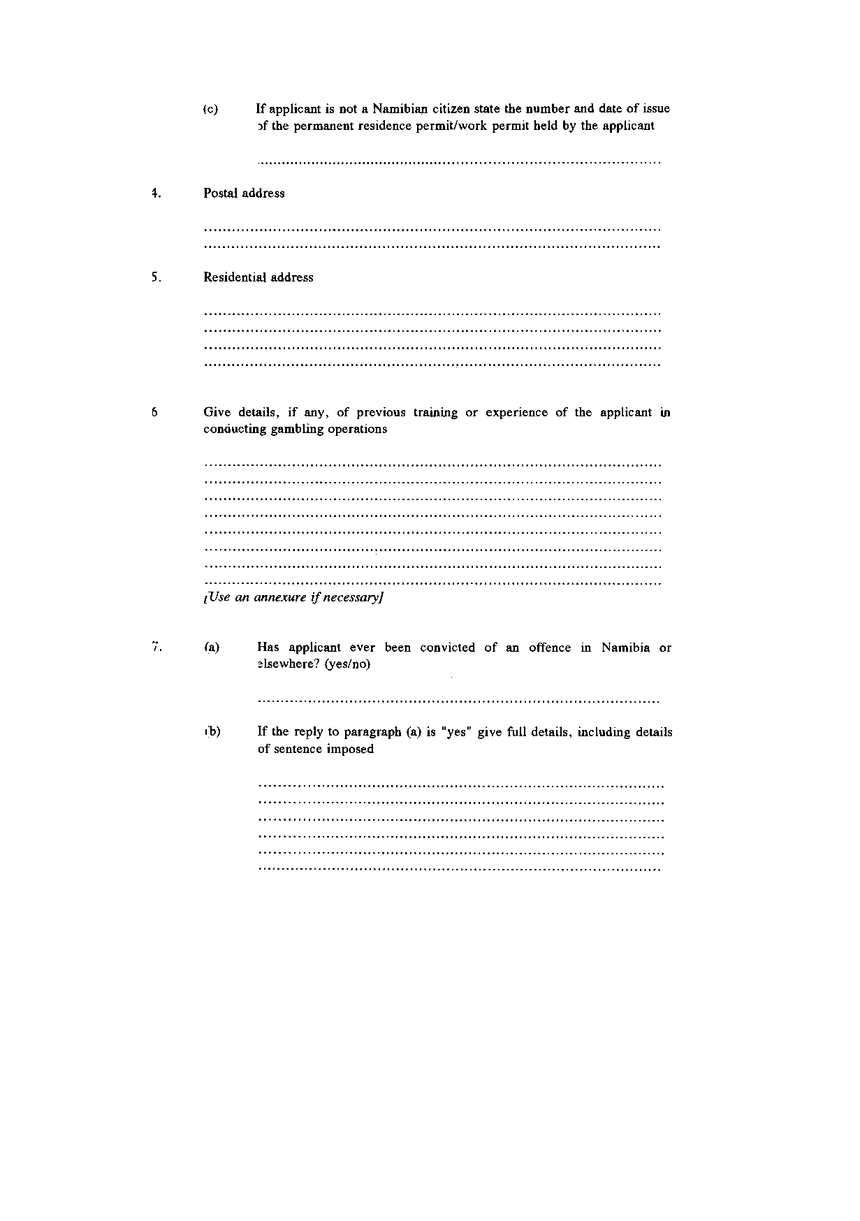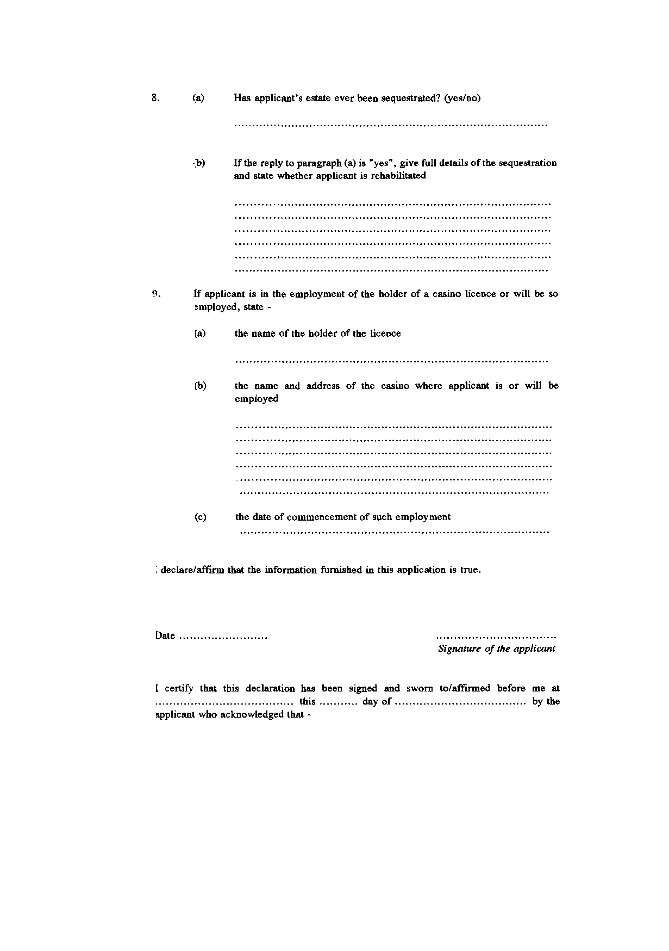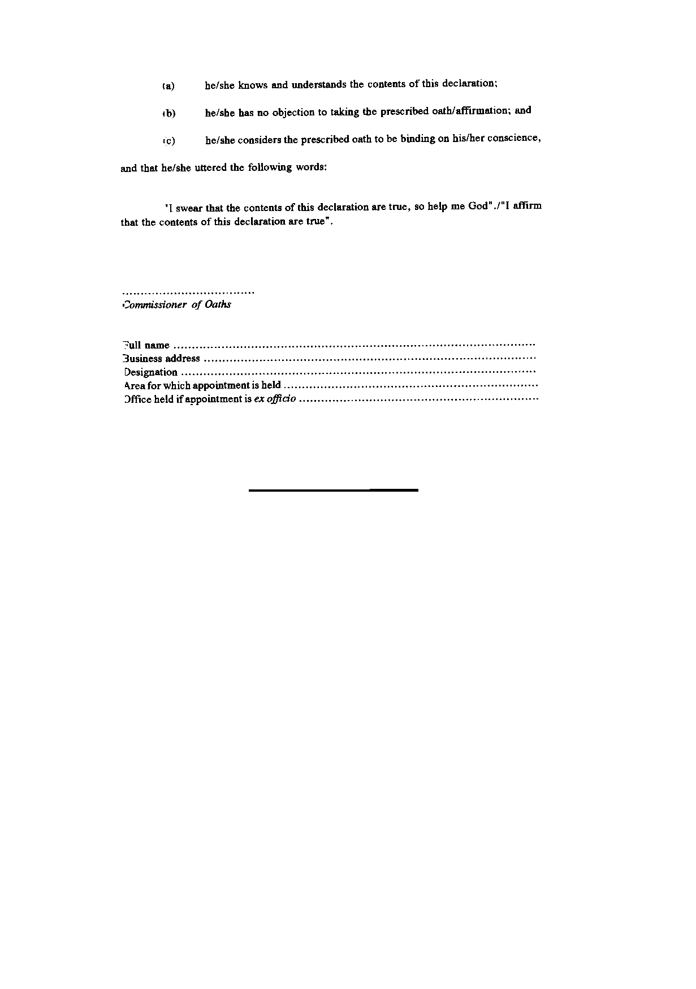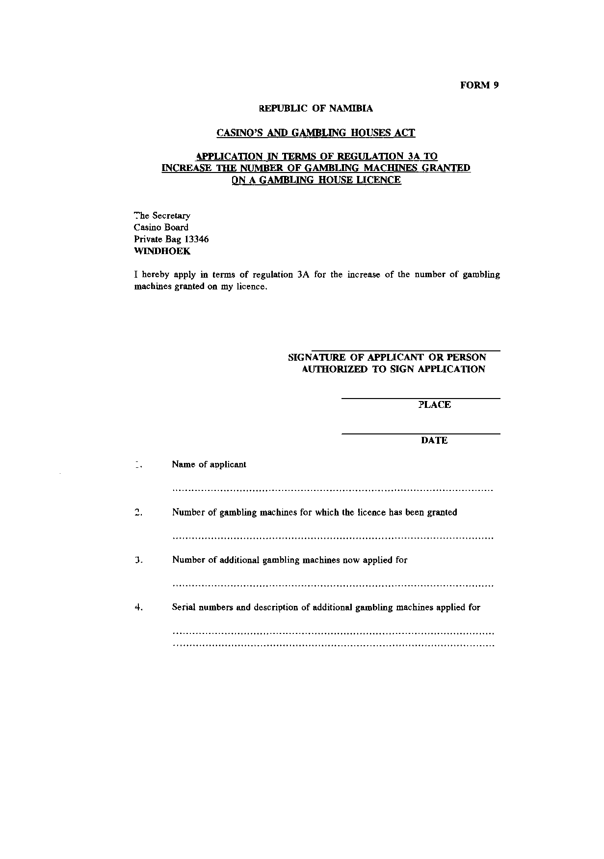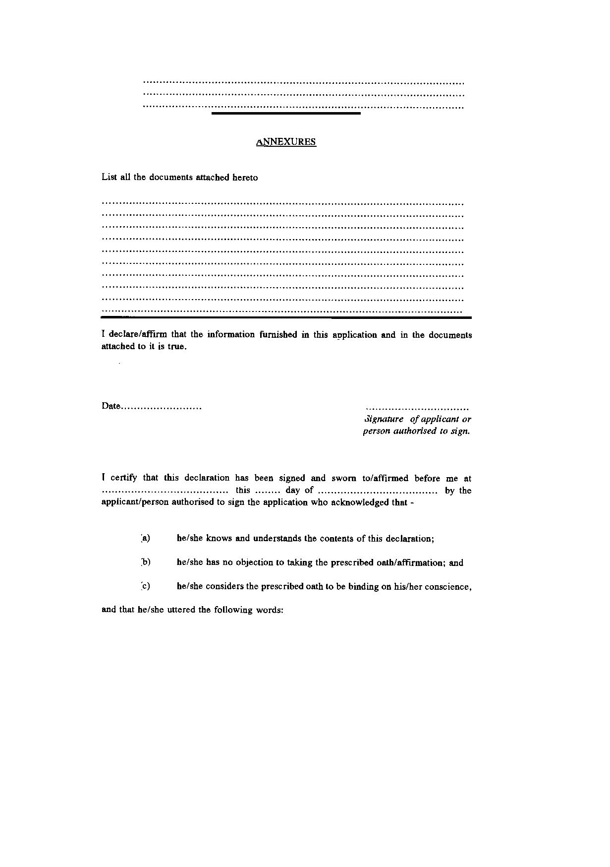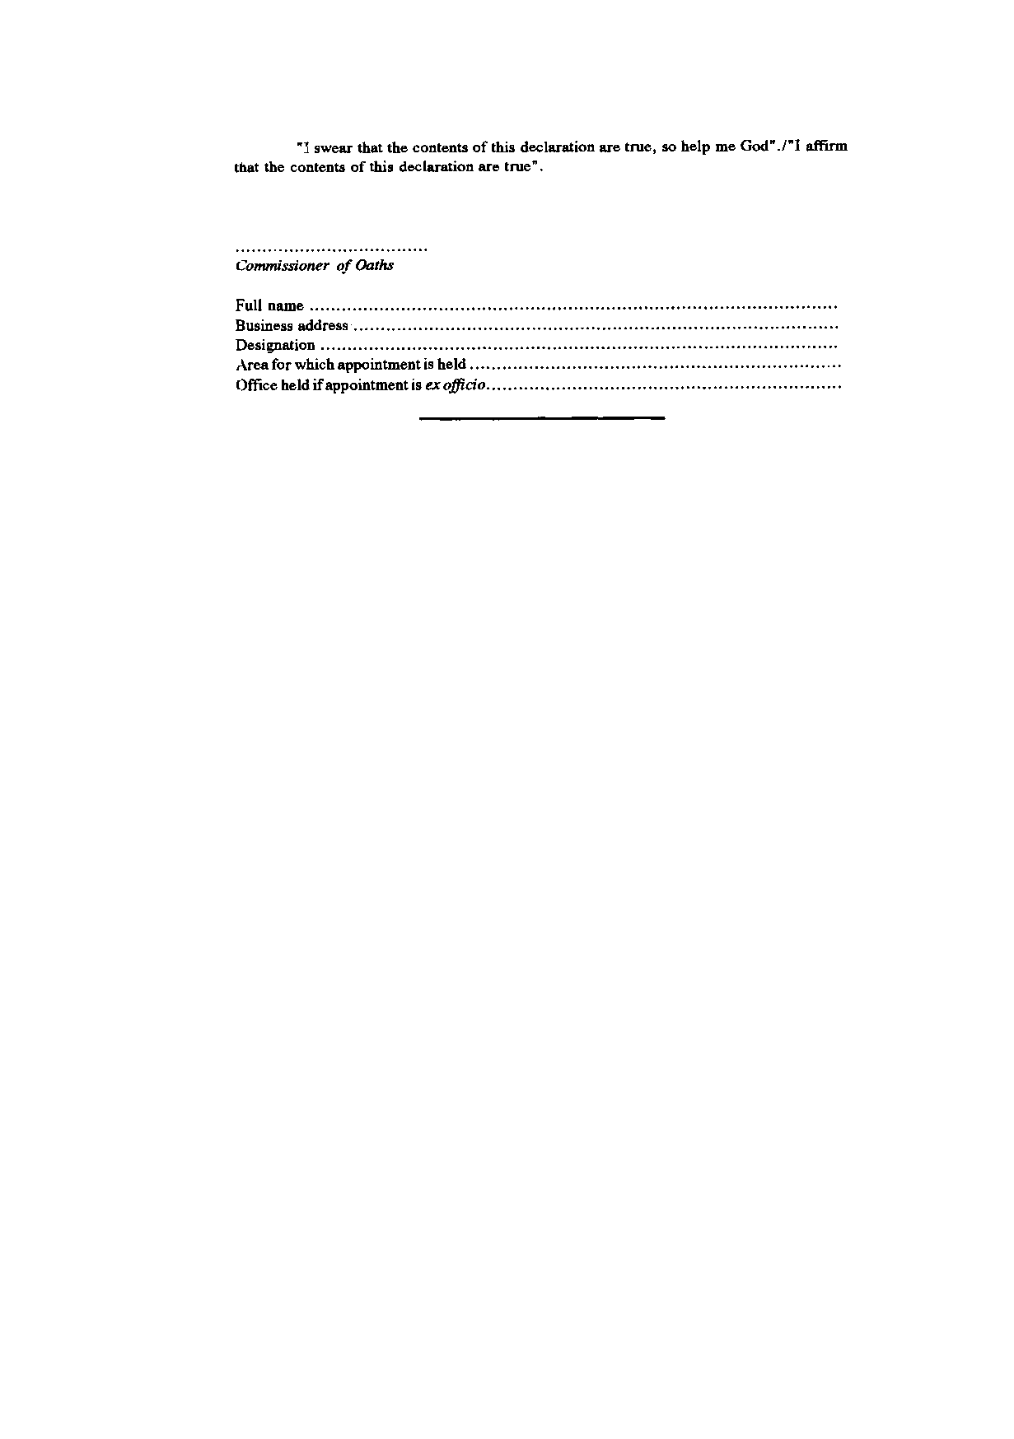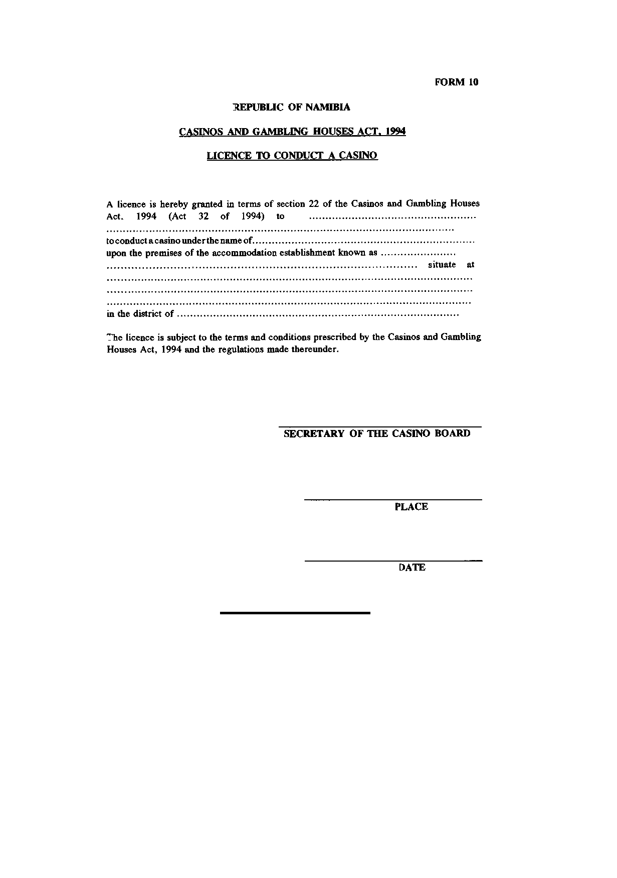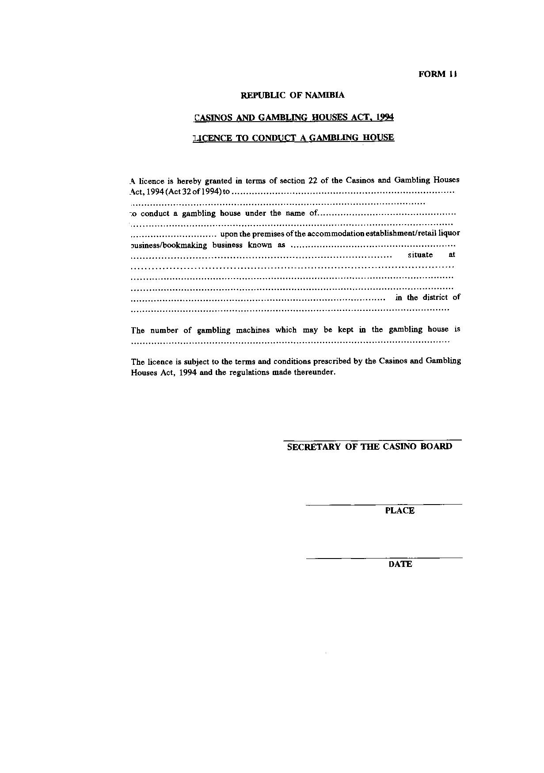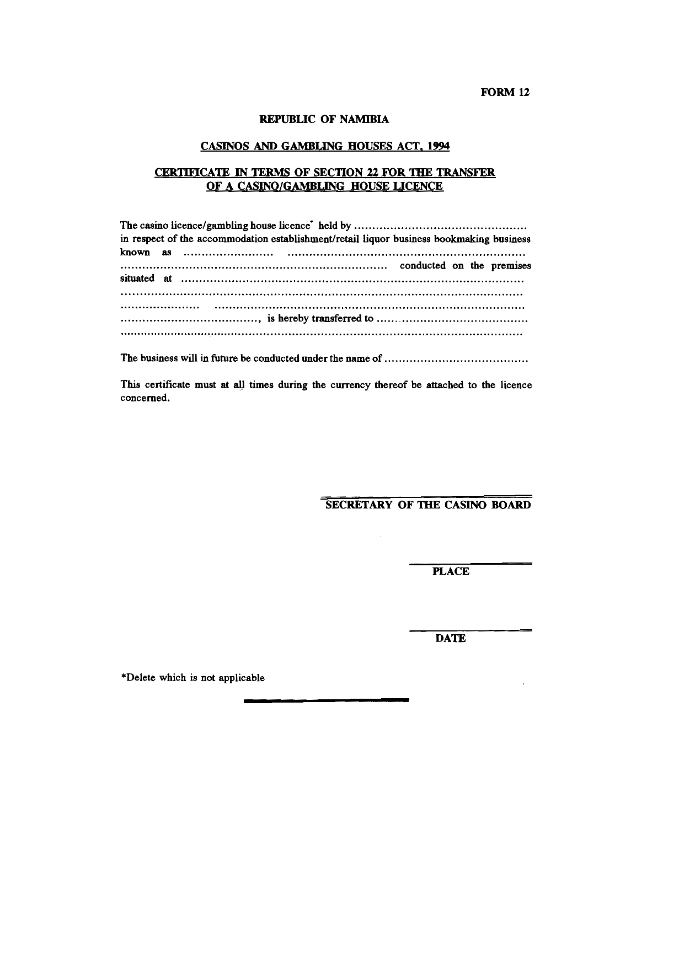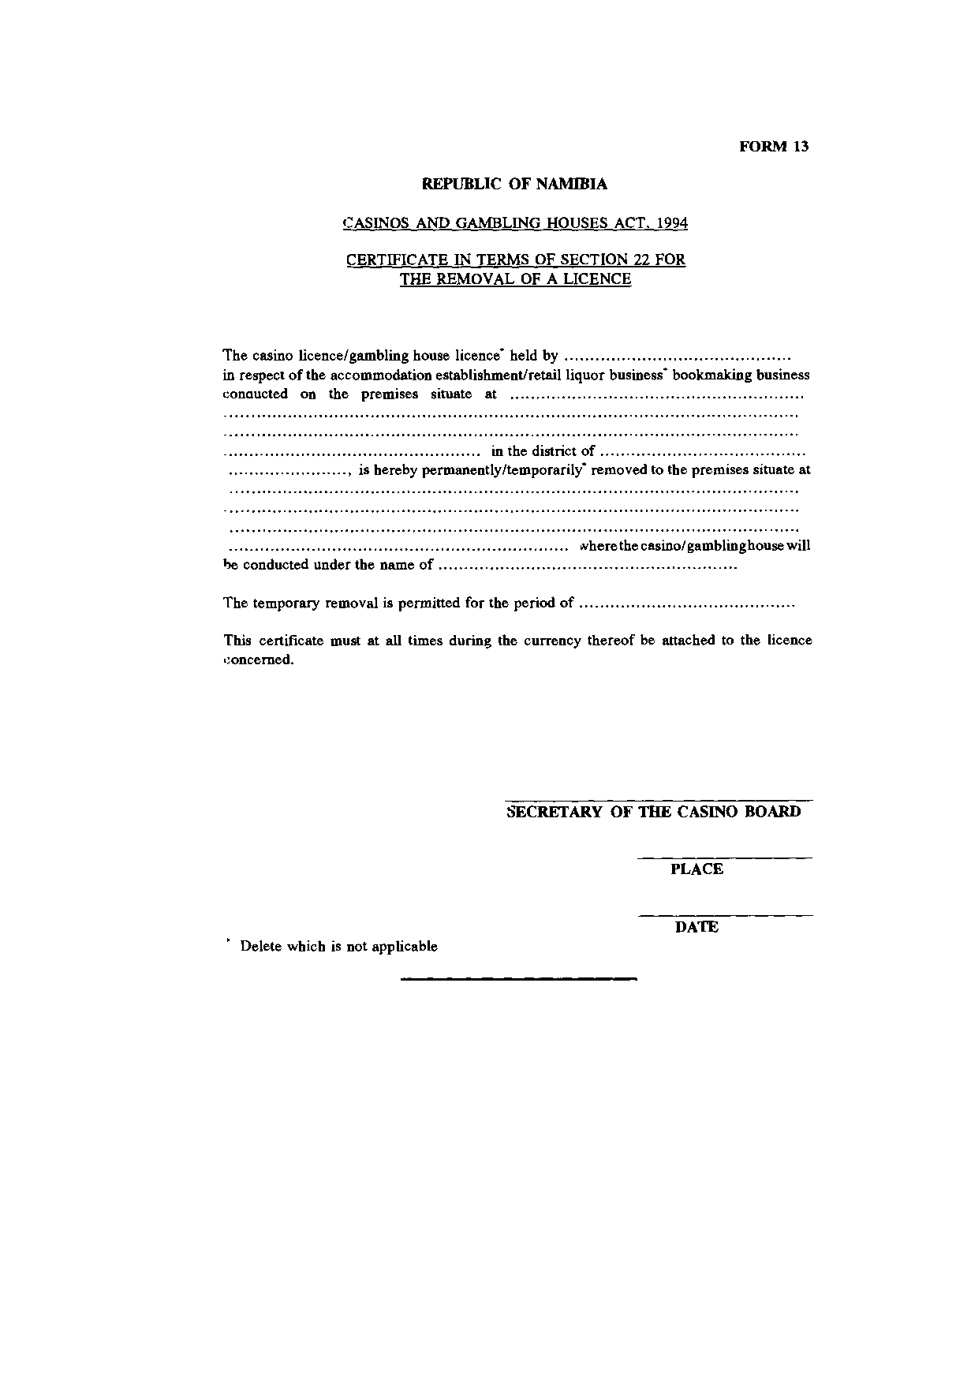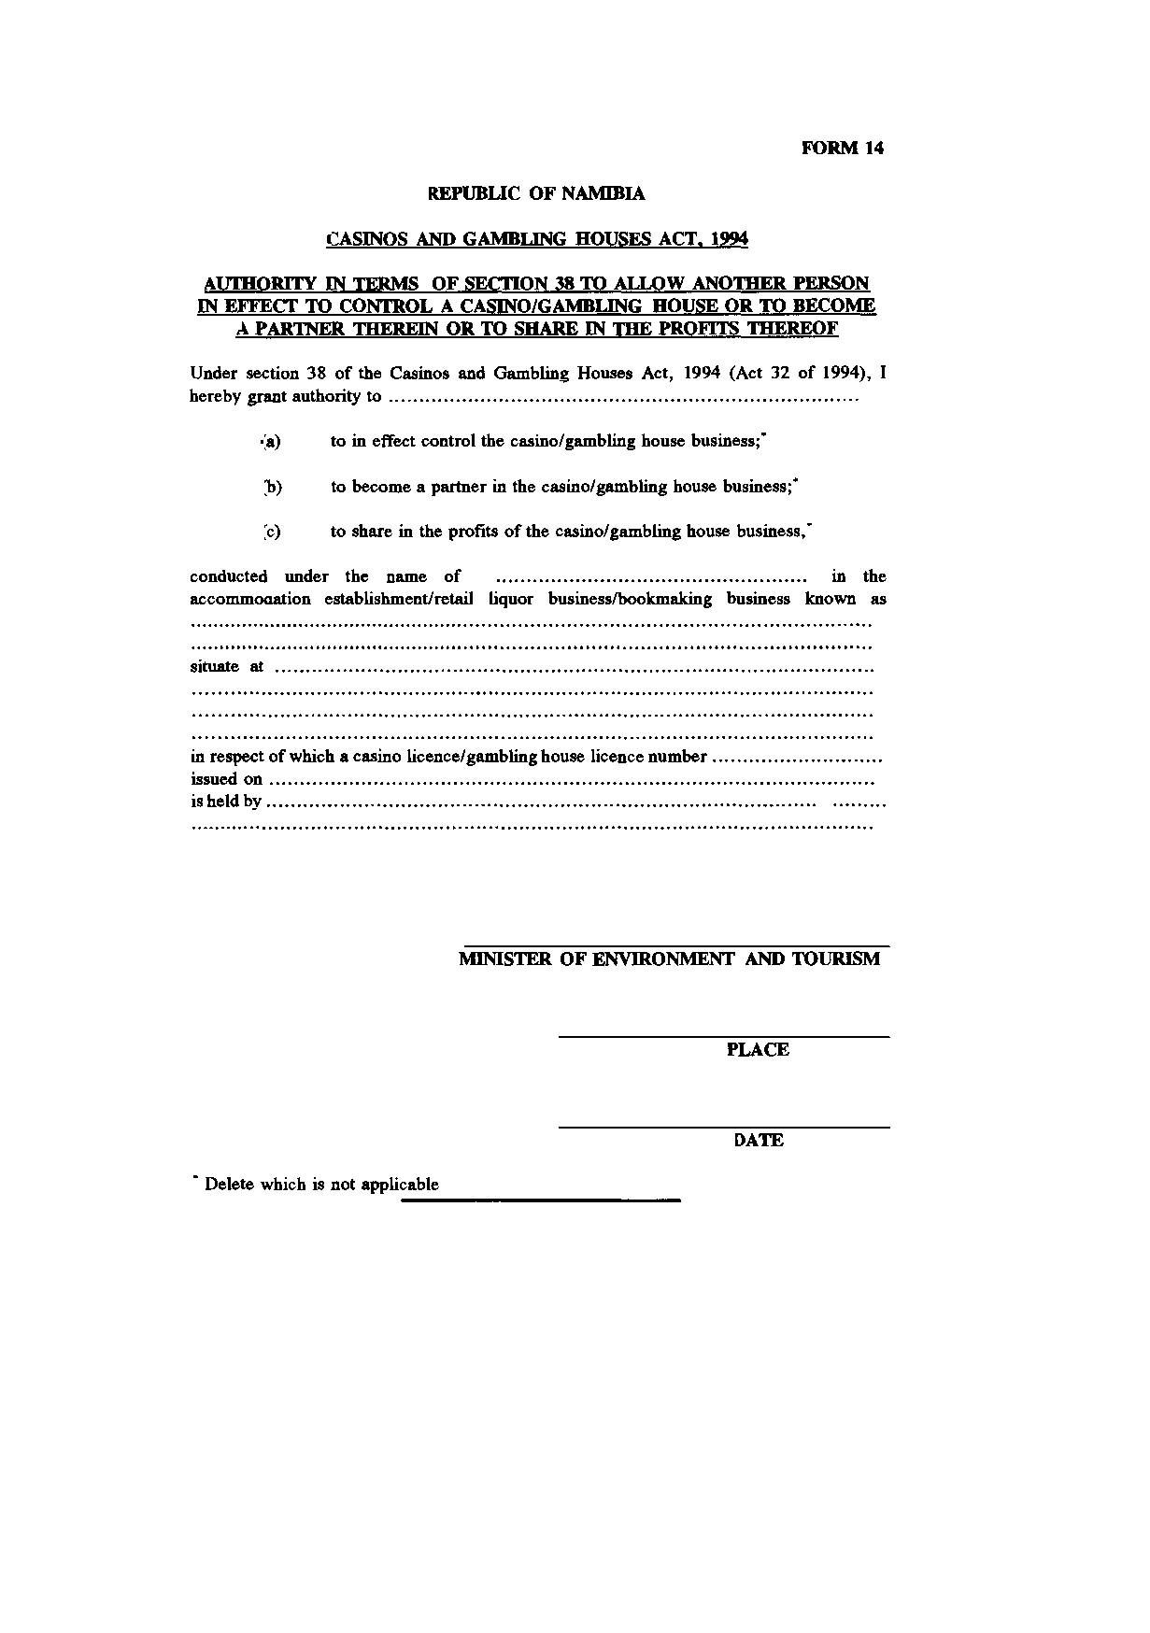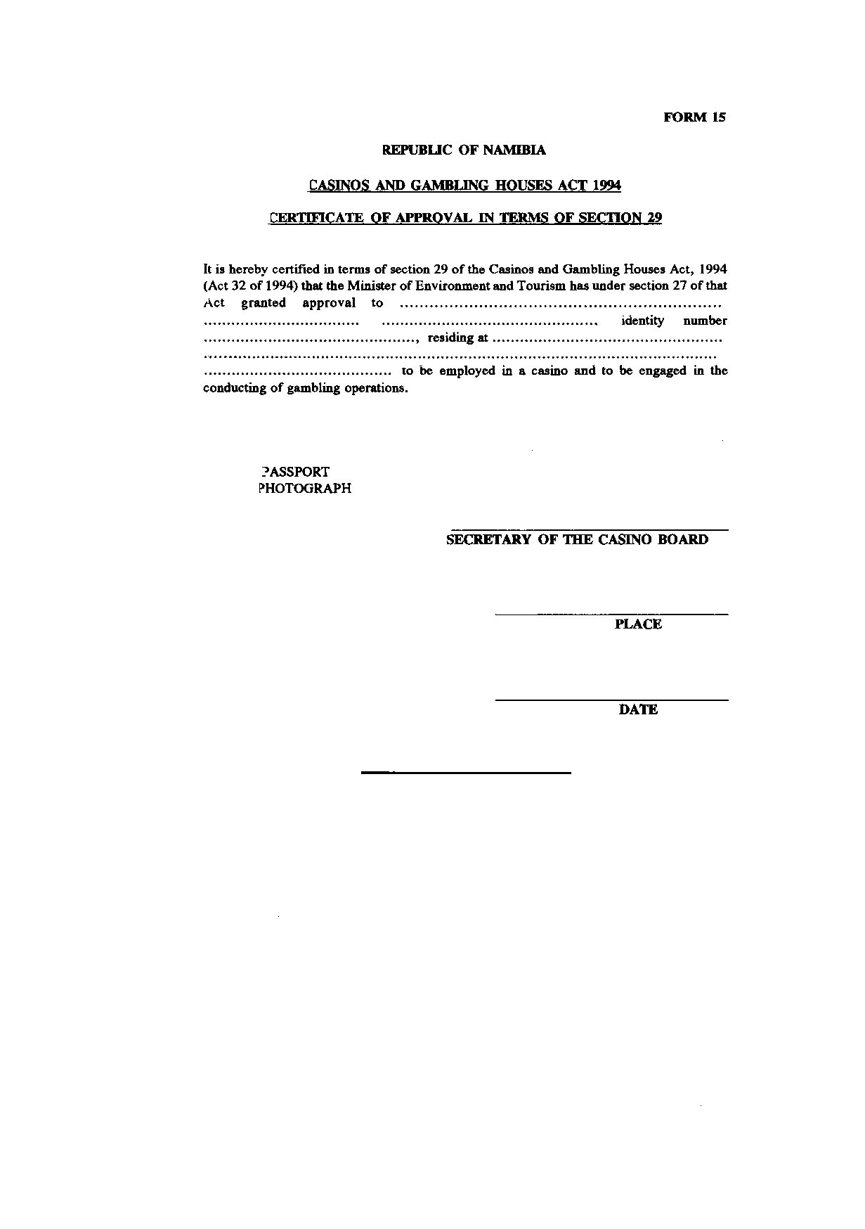

ANNEXURE B

[Annexure B is substituted by GN 121/1996 and by GN 95/2017.]

PART I
APPLICATION FEES
(regulation 16)

Nature of Application | Fees payable  N$
Application for casino licence | 80 000
Application for gambling house licence | 10 000
Application for transfer of casino licence | 10 000
Application for transfer of gambling house licence | 2 500
Application for removal of casino licence | 15 000
Application for removal of gambling house licence | 2 500
Application for authority to allow another person in effect to control a Casino or gambling house, or to become a partner therein or to share in profits thereof  [Note that the reference to a gambling house appears to overlap with the item below.  The word “Casinos” should not be capitalised.] | 50 000
Application for authority to allow another person in effect to control a gambling house, or to become a partner therein or to share in profits thereof  [Note that the reference to a gambling house appears to overlap with the item above.] | 10 000
Application for a certificate of approval | 2 000

PART II
ANNUAL LICENCE FEES
(regulation 17)

Casino Licence | 100 000
Gambling house Licence | 10 000
For each gambling machine or device | 1 000

[Capitalisation reproduced as in Government Gazette]

PART III
ISSUES OF LICENCE, TRANSFER AND REMOVAL FEES
(regulation 18)

Issue of licence fees | 5 000
Transfer fees | 5 000
Removal fees | 5 000

PART IV
FEE FOR CERTIFICATE OF APPROVAL
(regulation 19)

Fee for certificate of approval | 500

