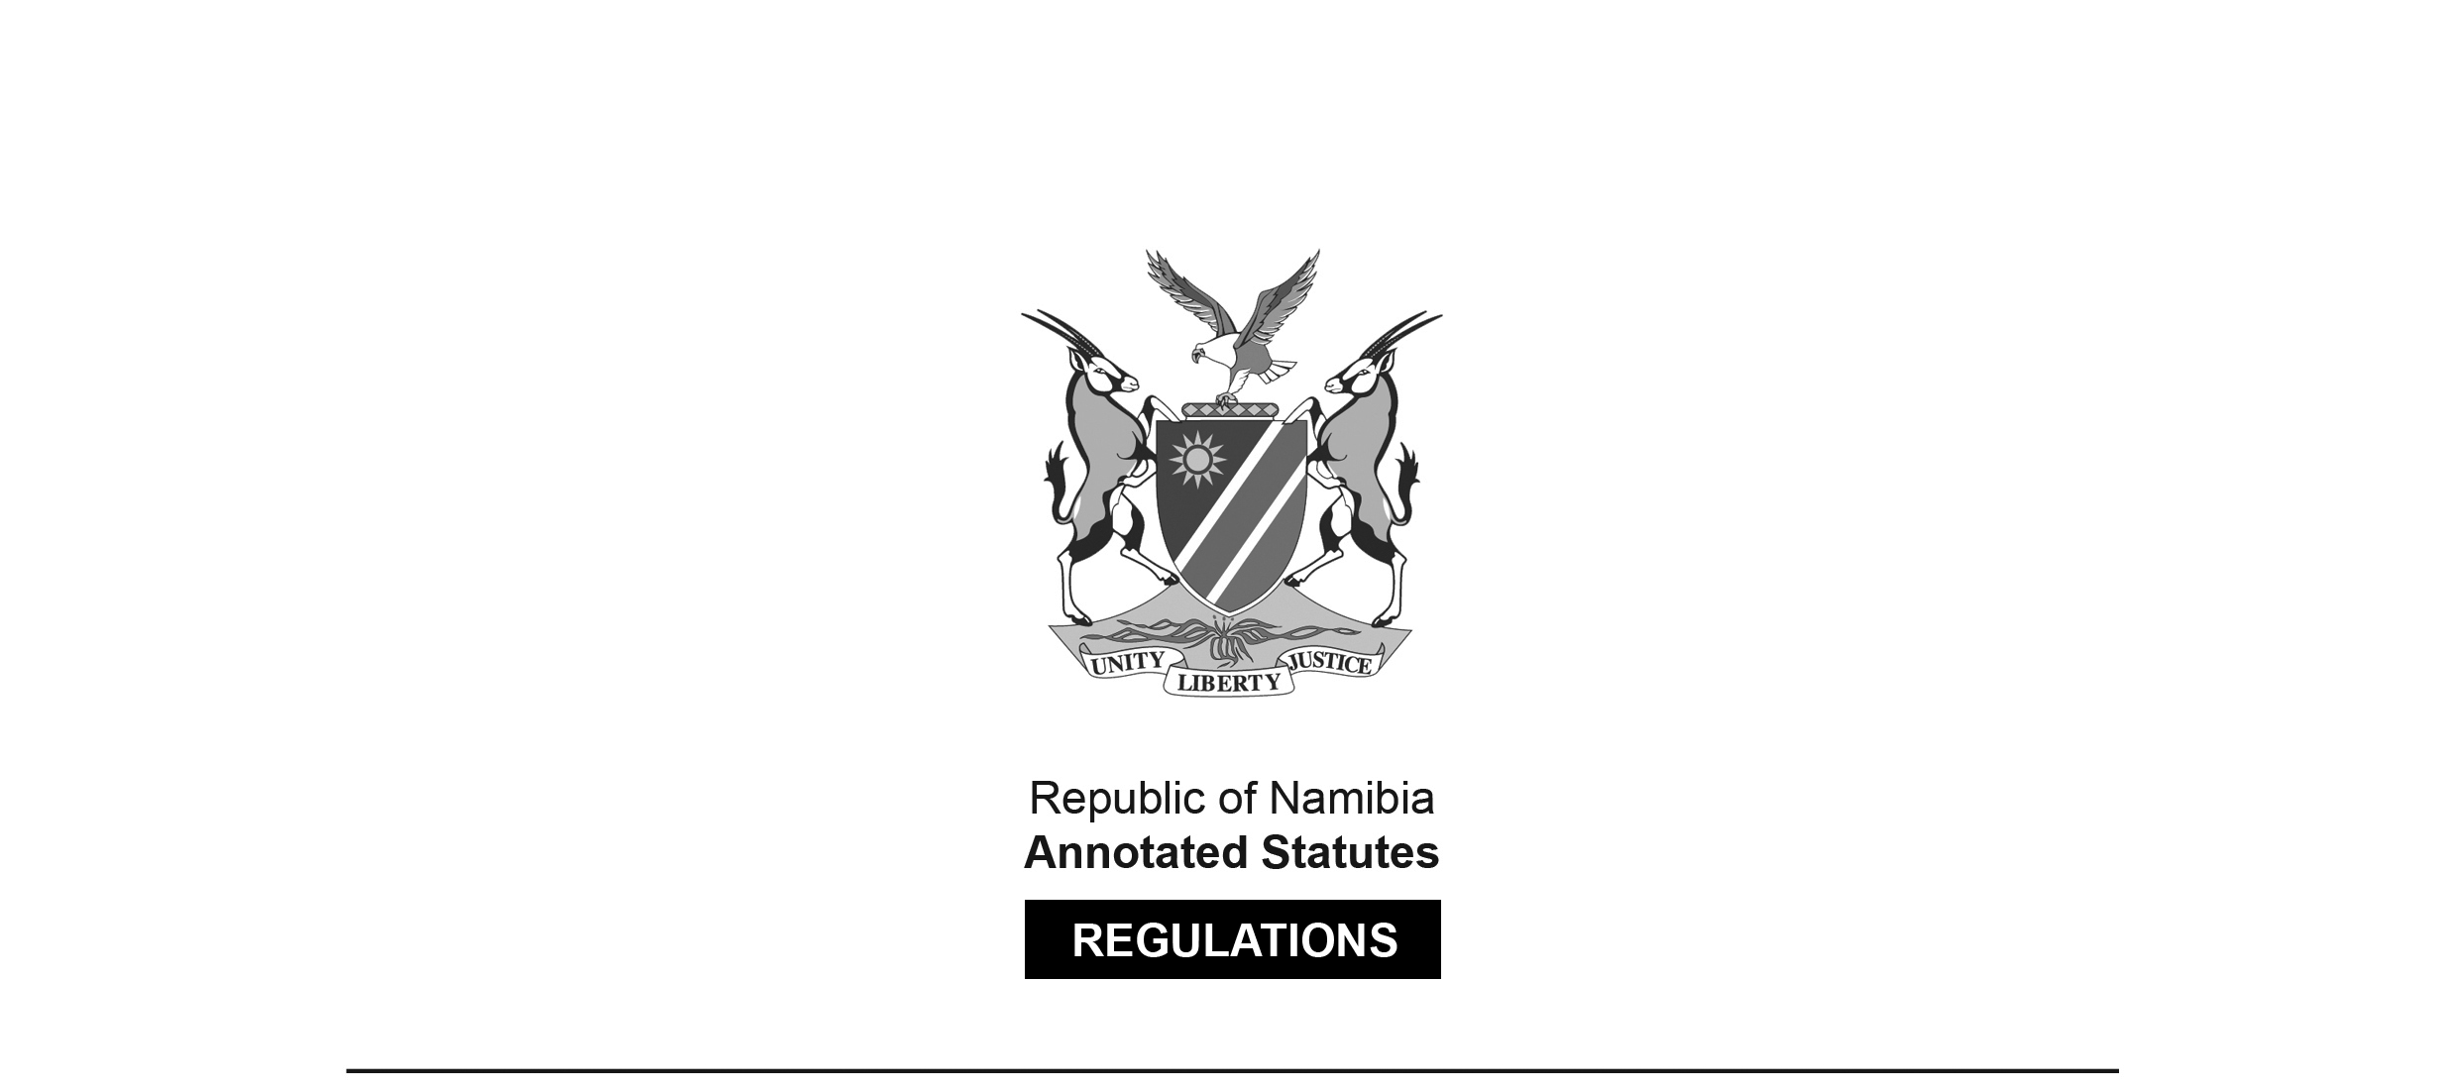
REGULATIONS MADE IN TERMS OF

Aquaculture Act 18 of 2002
section 43

Regulations relating to Import and Export of Aquatic Organisms and Aquaculture Products
Government Notice 70 of 2010
(GG 4453)
came into force on date of publication: 9 April 2010

ARRANGEMENT OF REGULATIONS

PART I
DEFINITIONS

1. Definitions

PART II
IMPORT OF AQUATIC ORGANISMS

2. Requirements for import of aquatic organisms
3. Application for registration as importer
4. Decision on application for registration as importer
5. Application for import permit
6. Risk assessment
7. Decision on application for import permit
8. Conditions relating to import of certain aquatic organisms
9. Additional requirements

PART III
INSPECTION

10. Documents to accompany shipment
11. Inspection and transfer of shipment
12. Costs

PART IV
QUARANTINE FACILITIES

13. Application for licence to operate quarantine facility
14. Decision on application to operate quarantine facility

PART V
EXPORT OF AQUATIC ORGANISMS OR AQUACULTURE PRODUCTS

15. Requirements for export of aquatic organisms or aquaculture products
16. Application for registration as exporter
17. Decision on application for registration as exporter
18. Application for export permit
19. Decision on application for export permit
20. Additional requirements

PART VI
GENERAL REQUIREMENTS

21. Import and export at approved ports
22. Cancellation or suspension of authorisation
23. Keeping of lists

ANNEXURES

Annexure A Application for registration as importer of aquatic organisms
Annexure B Registration as importer of aquatic organisms
Annexure C Application for a permit to import aquatic organisms
Annexure D Permit to import aquatic organisms
Annexure E Application for a licence to operate a quarantine facility for aquatic organisms listed it annexure
Annexure F Licence to operate a quarantine facility for aquatic organisms listed in annexure I
Annexure G Standards of construction, security and operation for quarantine facilities for aquatic organisms and aquaculture products listed in annexure I
Annexure H Standards of construction, security and operation for quarantine facilities for introduction or transfer of aquatic organisms and aquaculture products
Annexure I List of freshwater and marine ornamental aquatic organisms approved for importation.
Annexure J List of aquatic organisms whose importation is restricted or prohibited
Annexure K Application for registration as an exporter of aquatic organisms or aquaculture products
Annexure L Registration as exporter of aquatic organisms or aquaculture products
Annexure M Application for a permit to export aquatic organisms or aquaculture products
Annexure N Permit to export aquatic organisms or aquaculture products
Annexure O List of aquatic organisms and aquaculture products whose exportation is prohibited
Annexure P Approved ports

PART I
DEFINITIONS

Definitions

1. In these regulations a word or expression to which a meaning has been assigned in the Act has that meaning, and unless the context indicates otherwise -

“approved” means approved by the Minister;

“aquatic organisms” or “aquaculture products” includes genetically modified “aquatic organisms” or “aquaculture products”;

“Aquaculture (Licensing) Regulations” means the Aquaculture (Licensing) Regulations published under Government Notice No. 246 of 03 December 2003;

“audit” means an evaluation to determine the degree of compliance of quarantine facilities with the standards set out in Annexure G or H;

“biosecurity clearance” means a letter signed by the competent authority releasing aquatic organisms from quarantine detention, and in the case of aquatic organisms released from an introductions and transfers quarantine facility, specifying risk management measures to be complied with;

“competent authority” means -

(a) in the case of Namibia, the Minister; and

(b) in the case of any other country, the authority responsible for the control and supervision of the implementation of health measures relating to aquatic organisms;

“exporter” means a person registered as an exporter of aquatic organisms or aquaculture products in terms of regulation 17;

“exporting country” means a country from which a shipment is send to a destination in another country;

“export permit” means a permit issued in terms of regulation 19;

“health certificate” means a certificate issued by a competent authority confirming the health status of a aquatic organisms or aquaculture product;

[The phrase “a aquatic organisms” is grammatically incorrect;
it should probably be “an aquatic organism”.]

“importer” means a person registered as an importer of aquatic organisms in terms of regulation 4;

“importing country” means a country that is the final destination to which a shipment is sent;

“import permit” means a permit issued in terms of regulation 7;

“introduction” means the human assisted movement of aquatic organisms and aquaculture products to an area outside their natural range;

“laboratory” means a laboratory approved by a competent authority for conducting tests on aquatic organisms and aquaculture products;

“operator” means a person who, in terms of regulation 14, is approved or holds a licence to operate a quarantine facility;

“quarantine” means the holding or rearing of aquatic organisms and aquaculture products under conditions that prevent their escape, and the escape of any pathogens the aquatic organisms and aquaculture products may be carrying, into the surrounding environment;

“quarantine officer” means -

(a) in the case of Namibia, a person designated by the Minister as a quarantine officer; and

(b) in the case of any other country, a person designated by the competent authority to regulate the operation of a quarantine facility;

“risk assessment” means the process of identifying and estimating the risks associated with the importation of aquatic organisms and aquaculture products and evaluating the consequences of risks;

“risk management measures” means measures developed as a result of risk assessment to prevent the transfer of infectious agents as a result of movement of aquatic organisms and aquaculture products;

“shipment” means a shipment of aquatic organisms or aquaculture products; “the Act” means the Aquaculture Act, 2002 (Act No. 18 of 2002);

“transfer” means the movement of aquatic organisms or aquaculture products to an area within the established or historical range of the species.

PART II
IMPORT OF AQUATIC ORGANISMS

Requirements for import of aquatic organisms

2. A person intending to import aquatic organisms must register as an importer and apply for an import permit in terms of these regulations.

Application for registration as importer

3. An application for registration as an importer must be made to the Minister in the form substantially corresponding with Annexure A.

Decision on application for registration as importer

4. The Minister must consider an application made in terms of regulation 3, and may -

(a) approve the application and issue to the applicant registration as an importer in the form substantially corresponding with Annexure B; or

(b) refuse the application.

Application for import permit

5. (1) An application for an import permit must be made to the Minister in the form substantially corresponding with Annexure C.

(2) A person intending to import aquatic organisms for the purpose of introduction or transfer must apply, in terms of regulation 21 of the Aquaculture (Licensing) Regulations, for a permit to introduce or transfer aquatic organisms.

Risk assessment

6. (1) Before making a decision on an application for an import permit, the Minister may require an applicant to carry out a risk assessment in respect of the aquatic organisms to be imported.

(2) An assessment referred to in subregulation (1), must be carried out in accordance with the law or policy relating to environmental assessment.

Decision on application for import permit

7. The Minister must consider an application for an import permit, taking into account findings of a risk assessment carried out in terms of regulation 6, and may -

(a) approve the application and issue to the applicant an import permit in the form substantially corresponding with Annexure D;

(b) approve the application, subject to condition that the applicant complies with further risk management measures, which may include -

(i) the quarantine, in the exporting country, of the aquatic organisms to be imported;

(ii) diagnostic testing of the aquatic organisms to be imported to ensure that the organisms are free from diseases; or

(iii) the issuing of a health certificate by the competent authority of the exporting country; or

(c) refuse the application.

Conditions relating to import of certain aquatic organisms

8. The Minister may only approve an application for an import permit -

(a) relating to the import of aquatic organisms listed in Annexures I or J; or

(b) relating to the import of aquatic organisms approved for introduction or transfer,

if the applicant is an operator of an quarantine facility or has contractual access to a quarantine facility.

[The phrase “an quarantine facility” is grammatically incorrect. The word “an” should be “a”. ]

Additional requirements

9. An importer must comply with additional importing requirements that are required by law.

PART III
INSPECTION

Documents to accompany shipment

10. An imported shipment must be accompanied by -

(a) a copy of the bill of lading;

(b) the import permit; and

(c) a copy of the health certificate, if required under regulation 7(b).

Inspection and transfer of shipment

11. (1) At the port of entry, an inspector or any other person authorised by law must carry out an inspection of an imported shipment, in order to -

(a) determine the place of origin of the shipment;

(b) determine the nature and quantity of the shipment; and

(c) identify the presence of any mortalities or clinical signs of diseases.

(2) An inspector or the person referred to in subregulation (1) may, if he or she considers it necessary and in the exercise of his or her powers, collect samples of a life aquatic organism for laboratory analysis or to confirm the identity of the organism.

(3) An inspector or the person referred to in subregulation (1) must, after carrying out an inspection in terms of subregulation (1) or (2), re-seal the shipment with an approved seal and transfer the shipment to the custody of an operator who must secure the transportation of the shipment under quarantine conditions to the required quarantine facility.

Costs

12. The importer is responsible for the costs, if any, of an inspection, quarantine diagnostics tests, treatment, destruction or disposal of an infected aquatic organism.

PART IV
QUARANTINE FACILITIES

Application for licence to operate quarantine facility

13. (1) A person may not operate a quarantine facility, except in accordance with a licence issued or an approval granted in terms of regulation 14.

(2) A person intending to operate a quarantine facility for -

(a) aquatic organisms listed in Annexure I, must apply to the Minister for a licence in the form substantially corresponding with Annexure E.

(b) purposes of introduction or transfer, must apply in writing to the Minister for approval to operate such a facility.

(3) A quarantine facility for -

(a) aquatic organisms listed in Annexure I; and

(b) introduction or transfer,

must comply with the standards set out in Annexures G and H, respectively.

Decision on application to operate quarantine facility

14. The Minister must consider an application made in terms of regulation 13, taking into account the standards set out in Annexure G and H, and may -

(a) in the case of an application for a licence referred to in regulation 13 2(a) approve the application and issue a licence to the applicant in the form substantially corresponding with Annexure F;

(b) in the case of a request for approval referred to in regulation 13 2(b) grant the request and issue to the applicant an approval of request;

(c) approve the application or request, on condition that the applicant complies with additional conditions the Minister may consider necessary to impose; or

(d) refuse the application.

PART V
EXPORT OF AQUATIC ORGANISMS OR AQUACULTURE PRODUCTS

Requirements for export of aquatic organisms or aquaculture products

15. A person intending to export aquatic organisms or aquaculture products must register as an exporter and apply for an export permit in terms of these regulations.

Application for registration as exporter

16. An application for registration as an exporter must be made to the Minister in the form substantially corresponding with Annexure K.

Decision on application for registration as exporter

17. The Minister must consider an application for an export permit, and may -

(a) issue to the applicant registration as an exporter in the form substantially corresponding with Annexure L; or

(b) refuse the application.

Application for export permit

18. (1) An application for export permit must be made to the Minister in the form substantially corresponding with Annexure M.

(2) A person intending to export aquatic organisms listed in Annexure O, must apply to the Minister for a special clearance to export the organisms.

Decision on application for export permit

19. (1) In considering an application for an export permit, the Minister may require the applicant to show that the aquatic organism to be exported complies with -

(a) the health certification requirements; or

(b) other applicable requirements, of the importing country or a transit country.

(2) If the Minster is satisfied that the applicant has complied with subregulation (1), the Minister may -

(a) in the case of an application for an export permit, approve the application and issue to the applicant an export permit in the form substantially corresponding with Annexure N;

(b) in the case of an application for a special clearance, approve the application and issue to the applicant a special clearance in the form determined by the Minister;

(c) approve the application subject to conditions the Minister may consider necessary to impose; or

(d) refuse the application.

Additional requirements

20. (1) An exporter must -

(a) comply with the requirements of the importing country and any transit country; and

(b) obtain additional authorisations that may be required by law.

(2) The Minister may, at the request of an exporter -

(a) perform the tests for determining the health status of an aquatic organism or aquaculture product to be exported; and

(b) issue an international aquatic animal health certificate in respect of the aquatic organism or aquaculture product to be exported.

PART VI
GENERAL REQUIREMENTS

Import and export at approved ports

21. (1) Import and export of aquatic organisms or aquaculture products must be done at approved ports.

(2) A person who fails to comply with subregulation (1) commits an offence and is on conviction liable to a fine not exceeding N$1 000 or to imprisonment for a period not exceeding three months.

Cancellation or suspension of authorisation

22. (1) The Minister may, by notice to the holder of an authorisation cancel or suspend an authorisation granted in terms of these regulations, if -

(a) the holder of the authorisation fails to comply with a condition of the authorisation or fails to remedy non-compliance with a condition within a reasonable time determined by the Minister, if the Minister has ordered the person to remedy non-compliance;

(b) the holder of the authorisation, in the application for an authorisation furnished information which is or particulars which are not true;

(c) the Minister considers that the cancellation or suspension is necessary to protect and conserve the environment; or

(d) the holder of authorisation contravenes the Act.

(2) Before taking any action in terms of subregulation (1), the Minister must allow the holder of an authorisation to make representations on the matter.

Keeping of lists

23. (1) The Permanent Secretary must keep or cause to be kept a list of -

(a) authorisations issued in terms of these regulations;

(b) aquatic organisms whose importation into Namibia is restricted or prohibited;

(c) aquatic organisms approved for importation;

(d) competent authorities from the countries where Namibia’s main trading partners are located;

(e) diseases of aquatic organisms or aquaculture products;

(f) requirements relating to health certificates for the import of aquatic into Namibia; and

(g) approved ports for the import or export of aquatic organisms or aquaculture products.

(2) A person may, at the Ministry or at any other offices as the Minister may determine, inspect and on payment of a fee, obtain a copy of a list referred to in subregulation (1).

ANNEXURES A-F

To view content without printing, scroll down.

To print at full scale (A4), double-click the icon below.

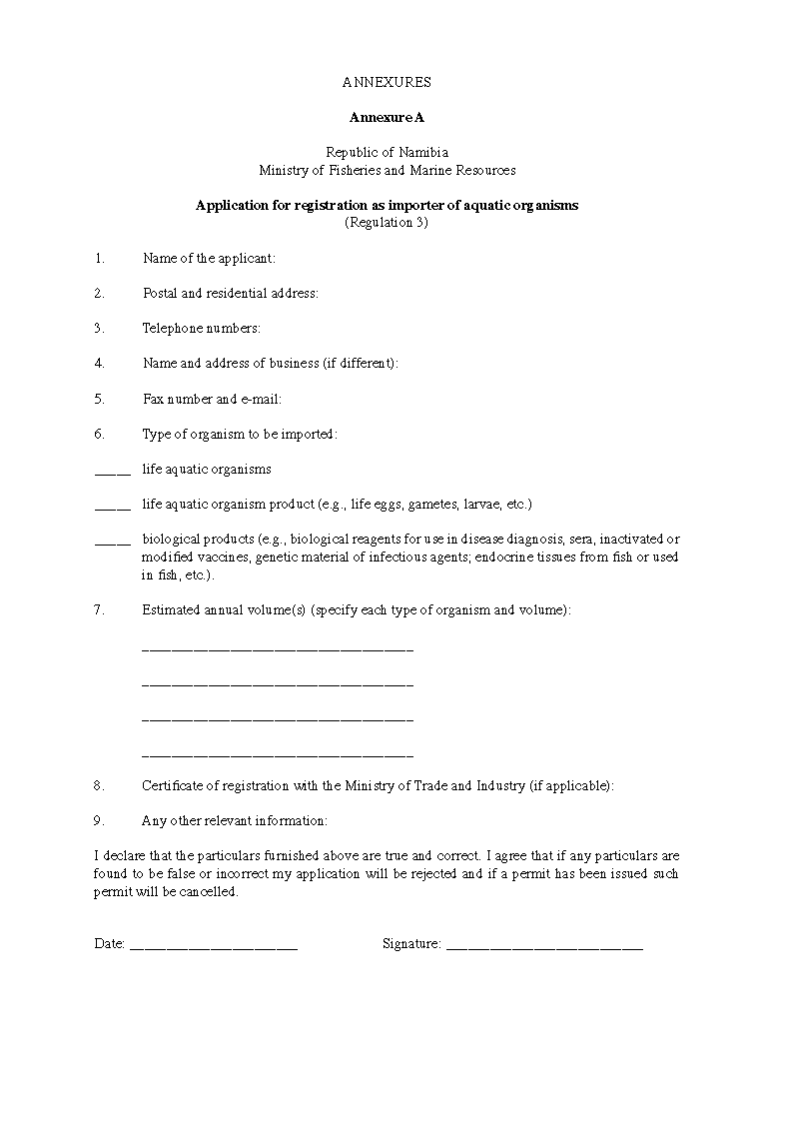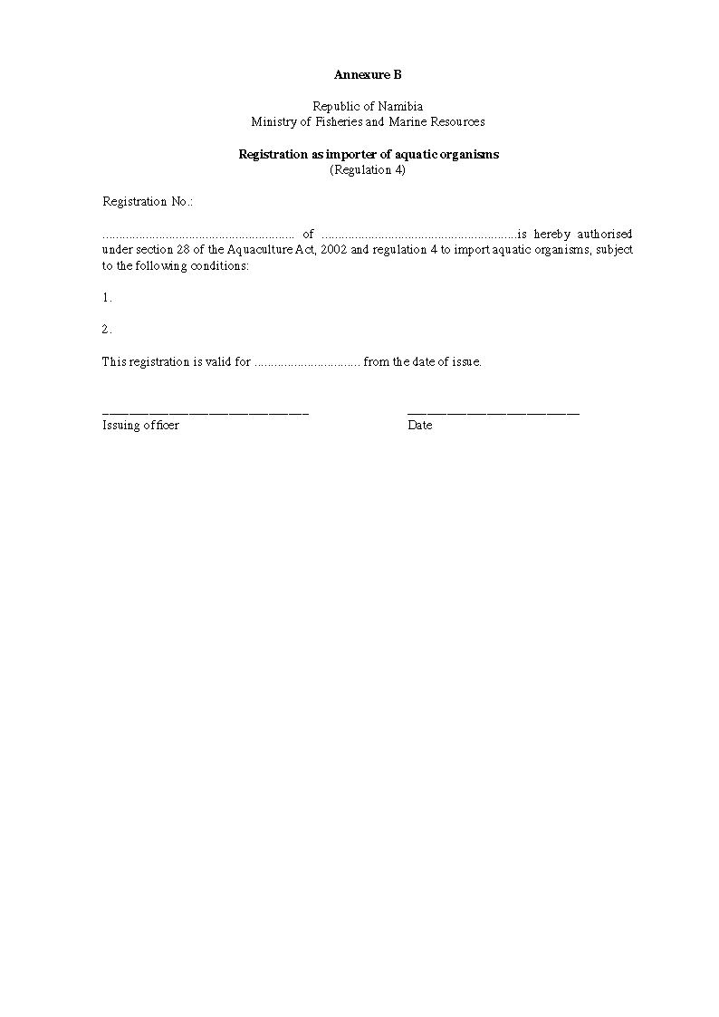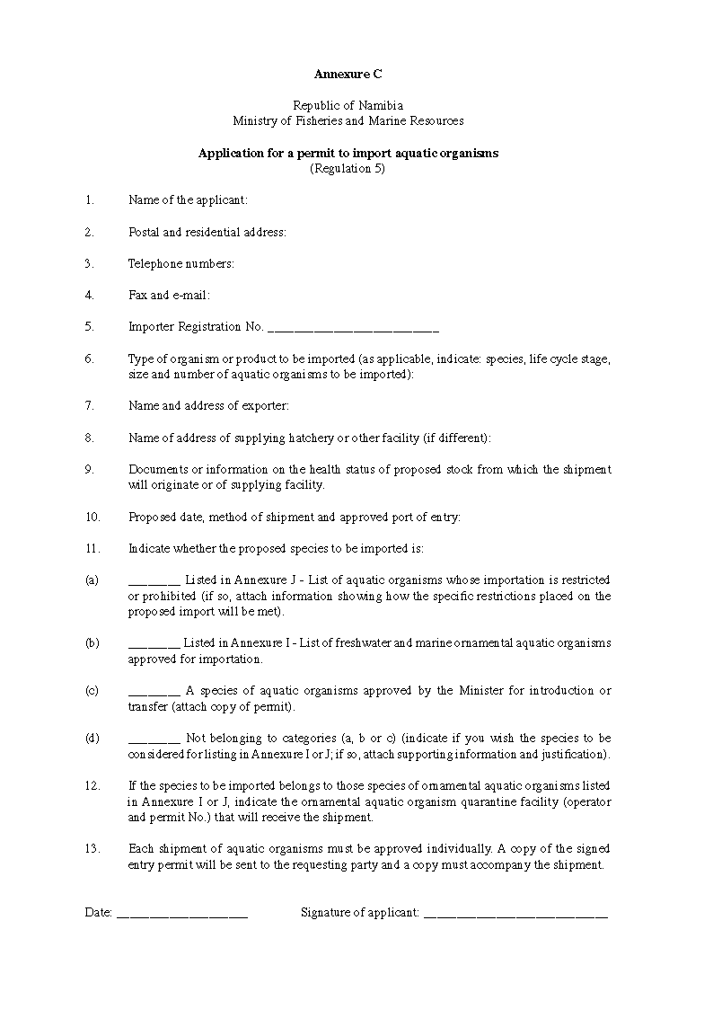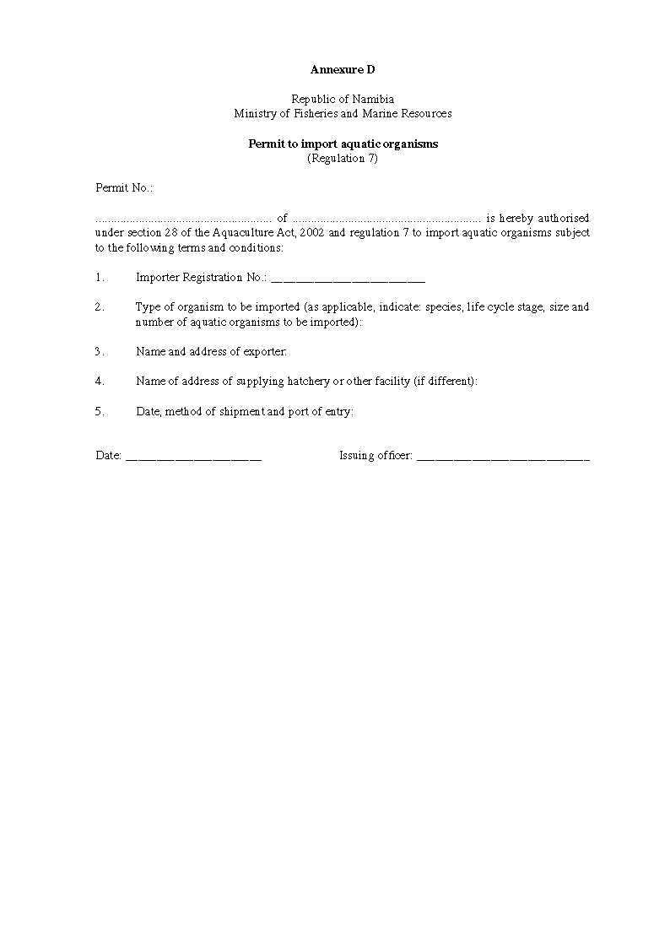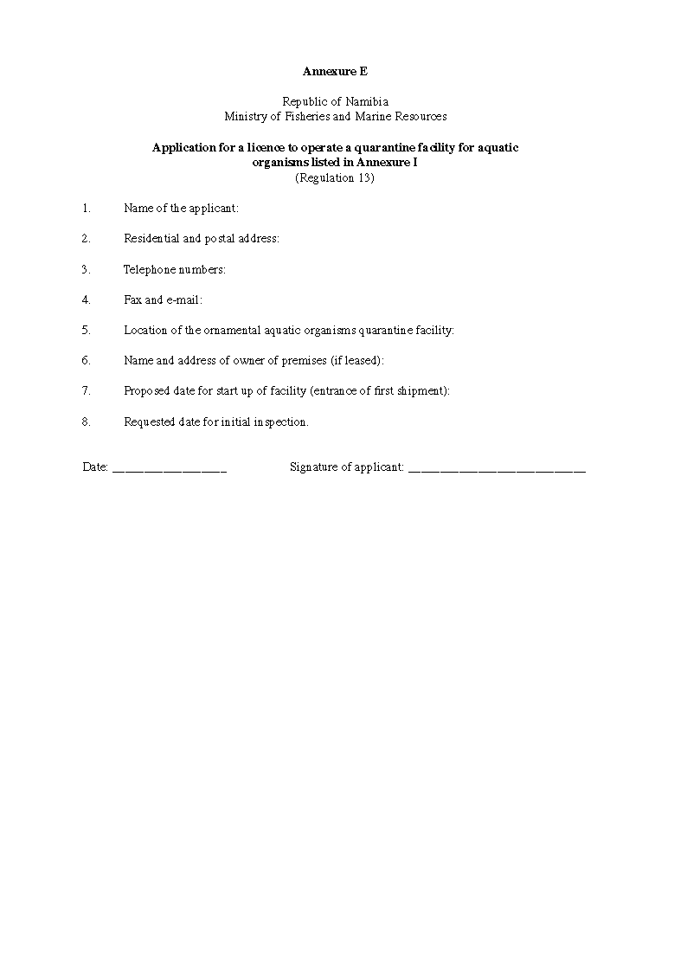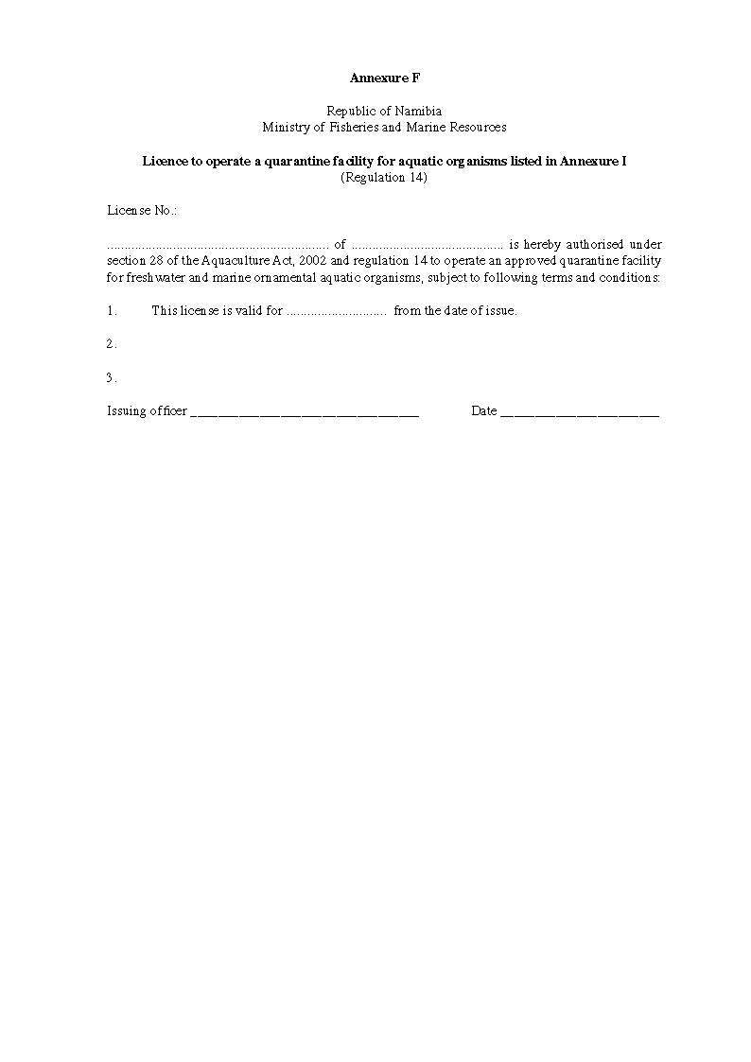

Annexure G

Republic of Namibia
Ministry of Fisheries and Marine Resources

Standards of construction, security and operation for quarantine facilities for aquatic organisms and aquaculture products listed in Annexure I

1. Period of quarantine

(a) The normal minimum period of quarantine is six weeks for shipments of freshwater ornamental aquatic organisms and three weeks for marine ornamental aquatic organisms.

(b) If at the end of the specified quarantine period, the quarantine officer has reason to believe that a shipment of aquatic organisms still presents an unacceptable risk of disease or pest introduction, the shipment may be held in quarantine for further investigation, observation, treatment, testing or for any other purpose appropriate to the circumstances. If the risk cannot be effectively managed destruction of the shipment is to be ordered.

2. Standards of construction

2.1 Location of quarantine facilities

(a) Quarantine facilities must be located within the local authority area and at an approved port that has a permanently based quarantine officer.

(b) Premises may not be approved in the vicinity of private or government fish hatcheries, aquaculture facilities, watercourses or areas subject to frequent flooding.

2.2 Specifications of quarantine facilities

(a) A quarantine facility must be accessible and the operator must arrange for such access through property owned, rented or leased by the operator, and such facility must be accessible to the quarantine officer during normal business hours and at such time that shipments are entering or leaving the premises. The operator must notify the quarantine officer of the times when the premises are attended and of any alterations to the normal business hours.

(b) The quarantine facility must be located within a single operational entity and as such be structurally separated from any other operations. The quarantine facility may share a building with other areas that are used for different purposes, including wholesale or retail activities involving live aquatic organisms or their products. The quarantine facility may not be used as an access way to other parts of the building.

(c) The quarantine facility must be weatherproof and maintained in a state of good condition.

(d) The quarantine facility must be located within a secure, lockable building, or within a building that is located in an area surrounded by a lockable person-proof security fence.

(e) The quarantine facility may not be used for any purpose, other than as a place for the performance of quarantine.

(f) The holding capacity of the quarantine facility must be commensurate with the proposed quantities and number of species of aquatic organisms to be handled.

(g) The quarantine facility must have facilities for the sterilization of all equipment that comes into contact with aquatic organisms or tank water during the quarantine period.

2.3 Specific construction and equipment requirements

The quarantine facility must comply with the following specific construction and equipment requirements:

(1) Windows must be screened to prevent the entry of insects.

(2) The floor and walls must be constructed of concrete, tiles or other impervious material to enable hose down and disinfections with retention of all water. The floor must be sufficiently smooth and with sufficient gradient to drain to an approved septic tank, local authority sewerage or enclosed holding tank.

(3) Floor to wall junctions and all gaps and cracks in the walls, floor and ceiling must be effectively sealed.

(4) Lighting must be of sufficient intensity to allow proper inspection of all aquatic organisms.

(5) A floor drainage with an insertable plug or other mechanism to prevent the accidental escape of aquatic organisms or uncontrolled release of water must be installed. Drainage must be to an approved septic tank, local authority sewer or an enclosed holding tank.

(6) Doors must have a self-closer to ensure that they remain shut after entry or a self-closing insect-proof screen door must be installed.

(7) Facilities must be provided at the quarantine facility for staff employed and quarantine officers to wash their hands before leaving such facility.

(8) All tanks used for the holding of aquatic organisms must -

(a) be identified with permanent numbers so that records for shipments may be correlated with them;

(b) be fitted with lids or other approved equivalents so as to prevent transmission of pathogens between adjacent tanks due to splash from the aeration or filter system and to prevent the escape of aquatic organisms;

(c) be arranged in a manner that permits ready access for inspection purposes, including a minimum width of 75 cm for corridors between rows of tanks or tanks and walls;

(d) contain only sterilizable materials (such as plastic) that do not interfere with inspection; and

(e) have at least the front transparent to provide good visibility of their contents and be stacked for adequate viewing.

(9) The use of shared water recirculation systems must be avoided. If separate shipments of aquatic organisms share a common water recirculation system, aquatic organisms may not be approved for release from quarantine until the last shipment to enter the system has satisfactorily completed its quarantine requirements. If diseases or pests of quarantine concern are known or suspected, all aquatic organisms sharing the same water recirculation system may be subject to quarantine risk management measures, including their destruction, treatment or detention beyond the normal quarantine period.

(10) All entry and exit points to the quarantine facility must prominently display a permanently affixed, professionally made, quarantine sign that states “Quarantine Area - Authorised Persons Only”, on a yellow background, with black lettering approximately 5 cm in height.

(11) A suitable wash-up trough must be located in the quarantine area for the cleaning and disinfecting of equipment. An approved disinfectant must be available at the wash-up trough. A suitable draining rack must be provided for air drying of equipment.

(12) A designated refrigerator or freezer must be provided solely for the storage and preservation of dead aquatic organisms. The refrigerator or freezer must be clearly identified as being for quarantine use only and located within or close to the quarantine area, and if outside the quarantine area it must be lockable.

(13) Equipment necessary to carry out the disinfection of all wastewater, including wastewater originating from Namibian waters and wastewater originating from other waters used in the quarantine facility, must be supplied.

(14) Contamination or infestation by pests is to be prevented by ensuring and providing secure storage facilities for food for aquatic organisms.

(15) A fully stocked first aid cabinet must he provided and maintained.

(16) Amenities to be provided for use by quarantine officers include access to a desk and chair, a telephone with a direct outside line, toilet facilities, hand washing facilities within the quarantine area and a hygienic means of drying hands, and suitable arrangements for daily cleaning of amenities.

3. Standards of operation

3.1 Wastewater disposal

3.1.1 Freshwater organisms

(a) All wastewater of domestic origin to be discharged from the quarantine facility and that has not been used for the transport or holding of aquatic organisms must enter directly to an approved septic tank or a local authority sewerage system, or may be sterilized as described under item 3.2, and where wastewater is sterilized, it may be discharged at a place determined by the Minister, but such water may not flow directly into natural waterways.

(b) All wastewater, whether of foreign or domestic origin, that has been used for the transport or holding of live freshwater organisms or for the cleaning of tanks and associated equipment, must be disinfected using an approved method before disposal.

(c) Disposal of wastewater must also comply with the applicable law governing the disposal of wastewater.

3.1.2 Marine organisms

All wastewater, including foreign water, discharged from the quarantine facility must enter directly to an approved septic tank, local authority sewerage system or may be sterilized as described under item 3.2 and sterilized wastewater may not be discharged directly into natural waterways.

3.2 Sterilization of wastewater

Where sterilization of wastewater is required before disposal, it must be sterilized in accordance with one of the following methods:

(a) Chlorination

(i) All water must pass through an approved filter capable of removing suspended organic material before hypochlorite treatment.

(ii) All water must pass to a retention vessel where sufficient hypochlorite (bleach) must be added to achieve a minimum concentration of 200 parts per million (ppm) (200 mg per liter) at 1 hour post-treatment. Sodium hypochlorite (bleach) must be used at 1.6 milliliters (ml) of hypochlorite solution (12.5% available chlorine) per liter of water, while calcium hypochlorite powder (such as, “Pool Chlor”, 65-70% available chlorine) must be used at 0.3 grams (g) of powder per liter of water.

(iii) Before the treatment period starts, the chlorinated effluent must be brought to a pH between 5.0 and 7.0.

(iv) Following addition of hypochlorite, wastewater must be agitated for at least 10 minutes to ensure thorough mixing of hypochlorite.

(v) After a retention period of not less than 1 hour, the chlorine concentration is measured using an approved method. Tanks not achieving a minimum chlorine concentration of 200 ppm (200 mg per liter) at the allotted time must be re-treated until the requirement is met.

(vi) The chlorine in the wastewater may be neutralized by adding sodium thiosulphate at a rate of 1.25 g (2.5 ml of 50% sodium thiosulphate solution) per liter of treated wastewater, then agitated for not less than 10 minutes before discharge.

(vii) Chlorination records must be maintained noting: the amount of compound added, the volume of effluent, the time that treatment period commenced, the pH at commencement of the treatment period and the 1 hour posttreatment concentration.

(viii) Chlorinated water may not be discharged directly into adjacent waterways.

(b) Heat treatment

Before discharge, wastewater must be heated to at least 85 degrees celsius for a minimum of 30 minutes. Water heating units must be approved by the competent authority and be fitted with temperature and flow recorders.

(c) Ultraviolet (UV) light radiation

(i) All water to be treated must pass through a filter capable of removing suspended organic material before irradiation.

(ii) Commercial UV water treatment units operating in the spectral range of 190-280 nm (254 nm recommended) delivering doses of at least 130 mWs/cm2 are required.

3.3 Disinfection of equipment

(a) Before removal from the quarantine area and before restocking with a new shipment of aquatic organisms, all tanks and tank equipment must be thoroughly cleaned and disinfected with -

(i) hypochlorite solution at 200 ppm concentration for 5 minutes;

(ii) an approved iodophore solution containing iodine at 0.5% available iodine for 5 minutes; or

(iii) another disinfection procedure approved by the quarantine officer.

(b) Filter material must be disposed of by incineration, by autoclaving and deep burial or by another approved method.

3.4 Disposal of dead aquatic organisms

Dead aquatic organisms may only be disposed of as directed by the competent authority. Aquatic organisms that have died while under quarantine must be held in an approved freezer, an approved refrigerator or preserved using another method as specified by the competent authority until removed for laboratory examination or released for disposal by the quarantine officer. Upon approval, dead aquatic organisms must be disposed of by incineration or by autoclaving and deep burial.

3.5 Disposal of packing materials

Wet bags, boxes and cartons must be either disinfected using the methods of disinfection specified under item 3.3 “Disinfection of Equipment” or disposed of by incineration or another method approved by the quarantine officer.

4. Work practices

4.1 Cleanliness and sanitation

(a) The quarantine facility and holding tanks must be kept clean at all times. Adequate cleaning facilities (such as pressurized water supplies, brooms and shovels) must be provided to enable maintenance of appropriate standards of hygiene.

(b) No animals or plants other than aquatic organisms and their live food are permitted in the quarantine area.

(c) Handling of all packaging material used to transport live aquatic organisms must comply with the following procedures:

(i) Damaged bags, damaged polystyrene boxes and cartons that are wet or contaminated with foreign water must be either incinerated or disinfected by an approved method referred to in item 3.3, before disposal.

(ii) Imported bags and polystyrene boxes containing leaked water that is not from Namibian waters and that are in good condition may be reused provided they are first disinfected by an approved method.

(iii) Boxes and cartons that are free of foreign water may be reused without disinfection.

(iv) The use of dedicated equipment (such as nets or cleaning equipment) for each individual tank or tanks connected by a shared water recirculation system is recommended. At minimum all nets and other equipment must be disinfected by an approved method of disinfection before being moved between tanks housing different shipments and before removal from the quarantine area.

(v) All equipment, footwear and protective clothing used in the quarantine area must be restricted to that site. Equipment may only be removed from the quarantine area after disinfection in an approved manner.

(vi) The operator must provide protective clothing (such as waterproof apron and footwear) to staff and visitors to use in the facility. Protective footwear (such as gumboots and aprons) must be kept inside the quarantine area and street footwear must be left outside the quarantine area. Before protective footwear or clothing are removed from the quarantine area they must be cleaned using an approved disinfectant such as Betadine (5% solution). Disposable overshoes may be used provided they are destroyed after use by incineration or by autoclaving followed by deep burial.

(vii) Wastewater disposal must comply with the applicable law on wastewater disposal, specifications for disposal referred to in item 3.1, and may not flow directly into natural waterways.

(viii) All filter material must be disinfected before removal from the quarantine area or disposed of by incineration or by autoclaving and deep burial.

(ix) Staff and visitors who have had contact with water or aquatic organisms must wash their hands and forearms with soap and water before exiting the quarantine facility.

4.2 Handling of aquatic organisms

(a) Upon arrival of a shipment of aquatic organisms at the approved port of entry and following verification of the accuracy of details of the shipment and its preliminary inspection by customs officers, the shipment must be transferred to the custody of the operator who must guarantee the secure transport of the shipment under quarantine conditions to the quarantine facility.

(b) Upon arrival at the quarantine facility, freshwater organisms must be transferred by net to new water and the foreign water must be subjected to an approved disinfection treatment referred to in item 3.2. Each tank used to contain freshwater aquatic organisms must only contain a single species of organism, and must be kept separate and isolated from other organisms.

(c) Each tank used to contain marine organisms may contain different species but only from the same shipment.

(d) If all or part of a shipment of imported aquatic organisms is incorrectly identified or listed by the exporter and includes species not on the list of ornamental aquatic organisms approved for importation, the operator must notify the quarantine officer within seven days of importation. The operator must re-export the unapproved species or have them humanely destroyed under supervision of the quarantine officer.

(e) The progeny of imported aquatic organisms that breed during the quarantine period may be removed to another tank in the facility but are subject to all quarantine conditions that applied to the parents.

(f) A standard tank record sheet must be maintained for each tank in accordance with item 6.2.

(g) Periodically throughout the day the operator must observe all aquatic organisms held in the quarantine facility for signs of illness and abnormal behavior.

(h) Dead aquatic organisms must be held for inspection by the quarantine officer. All organisms from a given shipment that are found dead on arrival or that die during the quarantine period must be placed in a labeled plastic bag as soon as possible and kept under refrigeration or preserved as specified by the quarantine officer until diagnostic examination is completed. Information on labels must identify the shipment, species, tank number and day of death.

(i) Any equipment that has been in contact with dead aquatic organisms must be disinfected before re-use.

(j) Any sudden occurrence of unusual levels of mortality or changes in behavior (such as levels of mortality or illness above 20% of a tank over a five-day period) or unusual signs of disease, parasites or pests must be immediately reported to the quarantine officer.

(k) The use of any drug or chemical to treat aquatic organisms must have the approval of the competent authority and be recorded on tank record sheets. The use of any treatments may result in the extension of quarantine detention or other measures as deemed necessary by the quarantine officer.

(l) The operator must ensure that no aquatic organisms leave the quarantine area under any circumstances without the approval of the quarantine officer (for example the granting of a biosecurity clearance), excepting dead organisms moved to a nearby lockable refrigerator or freezer.

(m) On completion of quarantine freshwater aquatic organisms are to be transferred by net into clean water before release from the quarantine facility.

(n) Aquatic organisms must be removed from the quarantine area following their satisfactory completion of the quarantine period.

5. Occurrence of an outbreak of a serious exotic disease

(a) If a serious exotic disease is diagnosed the operator must be immediately notified, and in such cases the quarantine officer or other representative of the competent authority may direct the management of disease control. Disease control measures may include the extension of quarantine or the destruction of stock.

(b) Measures to be taken under paragraph (a) may include:

(i) destruction of infected shipments or of all aquatic organisms present in the facility at the time of the outbreak, and their sanitary removal and incineration.

(ii) decontamination of the interior of the facility, and all tanks and equipment, and all waters present in the facility at the time of the outbreak.

(iii) approval of the competent authority before the re-use of the facility.

6. Record keeping requirements

6.1 Summary records

(a) Summary records in electronic and manual form, of all shipments of aquatic organisms entering the quarantine facility, must be maintained and records may include commercial documents, such as airway bills. The operator must, for auditing purposes, maintain such records for a minimum period of 36 months after release of the aquatic organisms from quarantine, during which time they must upon request, be readily made available to a quarantine officer.

(b) The following summary information must be recorded for each shipment:

(i) Overseas supplier and country of origin;

(ii) Dates of arrival;

(iii) Number of each aquatic species, in total and by tank;

(iv) Details of any accompanying health certificates;

(v) Details of any clinical signs of disease, and number of affected aquatic organisms, by species and tank;

(vi) Details of any mortalities, by species and tank;

(vii) Details of any treatments approved and applied; and

(viii) Date of release from quarantine.

6.2 Tank record sheets

(a) A corresponding approved tank record sheet must be maintained for each holding tank and must be kept up to date at all times. Tank record sheets must be retained for a minimum of 36 months following release of shipments from quarantine.

(b) Tank record sheet must display the following information:

(i) Tank number;

(ii) Number and species of aquatic organisms in tank;

(iii) Exporter identification details including country of export;

(iv) Importer’s name;

(v) Date of arrival;

(vi) Shipment or airway bill number;

(vii) Number/species of aquatic organisms dead on arrival;

(viii) Details of any observed disease conditions and number of sick aquatic organisms;

(ix) Daily record of number of aquatic organisms deaths in tank;

[The word “organisms” should be “organism” (singular) or “organisms’” (possessive).]

(x) Details of any prophylactic or therapeutic treatments given;

(xi) Disposal details;

(xii) Disinfection details;

(xiii) Signature of authorising quarantine officer and date released; and

(xiv) Number of aquatic organisms released.

6.3 Logbook

Details of wastewater treatment, including chlorination records, if applicable, filter disposal, general maintenance and auditing must be recorded in a logbook.

7. Auditing

(a) It is the responsibility of the operator to undertake systematic periodic internal audits at least on semiannual basis, to ensure that the standards for the operation of the quarantine facility as outlined in this Annexure are maintained and to identify and correct any deficiencies. The operator must record in the logbook, any variations from the prescribed criteria encountered and the corrective measures taken.

(b) Periodic external audits of the quarantine facility may be conducted by the quarantine officer or other approved personnel to verify the security and proper functioning of the quarantine facility.

8. Security

(a) Control and security of the quarantine facility are the responsibility of the operator. The quarantine facility must be securely locked when not in active use or when unattended.

(b) Procedures must be adopted to ensure that access to the premises is limited to authorised persons only. A prominent sign must be displayed at the entrance to the facility to show that it is a quarantine facility and that unauthorised entry is prohibited.

(c) The unnecessary entry of staff and visitors into the quarantine facility must be avoided. The operator must record the name and address of any visitors and the visit date in a logbook near the entrance.

Annexure H

Republic of Namibia
Ministry of Fisheries and Marine Resources

Standards of construction, security and operation for quarantine facilities for introductions or transfer of aquatic organisms and aquaculture products

1. Period of quarantine

(a) No set period of quarantine is established. The period of holding in the quarantine facility depends on the results of observation and testing of the imported stock of aquatic organisms and the resulting F1 generation. In all cases, once the competent authority is satisfied that the or a subsequent generation is safe for limited release, the parent stock must be destroyed and the quarantine facility thoroughly disinfected. An application to introduce or transfer aquatic organisms may be subject to condition to maintain the organisms under conditions of strict quarantine for a number of years.

(b) If, at any point while the imported aquatic organisms and their progeny are under quarantine an infectious disease is detected, the quarantine officer may require treatment and further testing. If the disease is of a serious or untreatable nature, destruction of all aquatic organisms held in the facility is to be ordered and complete disinfection of the building, water and all equipment is necessary before permission to restock is granted.

2. Standards of construction

2.1 Location of quarantine facilities

The location of an importation and transfer quarantine facility is to be determined on a case by case basis. Premises may not be approved in the vicinity of private or government fish hatcheries, aquaculture facilities, watercourses or areas subject to frequent flooding.

2.2 Specifications of quarantine facilities

(a) A quarantine facility must be accessible and the operator must arrange for access through property owned or leased on a long-term basis by the operator, and such facility must be accessible to a quarantine officer during normal business hours and at such time that aquatic organisms are entering or leaving the premises. The operator must notify the quarantine officer of the times when the premises are attended and any alterations to the regular hours.

(b) The quarantine facility must be located within a single operational entity that is structurally separated from all other operations and is dedicated solely to the holding of the shipments. A quarantine facility may not share a building having areas that are used for different purposes and must not serve as an access way to other buildings or activities. The quarantine facility may not to be used for any purpose, other than as a place for the performance of quarantine.

[The word “to” in the phrase “may not to be used” is superfluous.]

(c) The quarantine facility must be weatherproof and maintained in a state of good repair.

(d) The quarantine facility must be a secure and lockable building that is surrounded by a lockable person-proof security fence.

(e) The holding capacity of the quarantine facility must be commensurate with the proposed quantities of the species of aquatic organism for which a permit is granted. Provision must be made for the growth and maturation of the original parent stock and the holding of all F1 and subsequent generations.

(f) The quarantine facility must be equipped for the sterilization of all equipment that comes into contact with aquatic organisms or tank water during the quarantine period.

2.3 Specific construction and equipment requirements

(a) The quarantine facility must comply with the following specific construction and equipment requirements:

(i) windows must be screened to prevent the entry of insects;

(ii) floors and walls must be constructed of concrete, tiles or other impervious material to enable hose down and disinfection with retention of all wastewater. Floors must be sufficiently smooth and with sufficient gradient to drain to an enclosed holding tanks;

(iii) floor to wall junctions and all gaps and cracks in the walls, floors and ceilings must be effectively sealed such that the quarantine area is capable of containing all leaks and floods that might occur;

(iv) lighting must be of sufficient intensity to allow proper inspection of all aquatic organisms;

(v) floor drainage with an insertable plug or other mechanism to prevent the accidental escape of aquatic organisms or uncontrolled release of water must be installed. Drainage must be to an approved holding tank and the holding tank must be of suitable size to contain the total volume of all tanks used for the holding of aquatic organisms;

(vi) doors must have a self-closer to ensure that they remain shut after entry, or there must be a self-closing insect-proof screen door installed; and

(vii) access to the quarantine facility must only be through a personnel entrance leading to a separate outer change room provided with facilities for staff and quarantine officers to wash their hands and change outer clothing before entering or leaving the quarantine area;

(b) All holding tanks for aquatic organisms must -

(i) be identified with permanent numbers so that that individual tank records may be correlated with them;

(ii) be fitted with lids or other approved equivalents so as to prevent transmission of pathogens between adjacent tanks due to splash from the aeration or filter system, and to prevent the escape of aquatic organisms;

(iii) have water intake lines equipped with automatic shutoff valves;

(iv) be arranged in a manner that permits ready access for inspection purposes, including a minimum width of 75 cm for corridors between rows of tanks or tanks and walls;

(v) contain only sterilizable materials (such as plastic) that do not interfere with inspection; and

(vi) have at least the front transparent to provide good visibility of their contents, and be stacked for adequate viewing;

(c) If all aquatic organisms within the facility are considered to have the same quarantine status, the use of a shared water recirculation system is permissible;

(d) All entry and exit points to the quarantine facility must prominently display a permanently affixed, professionally made, quarantine sign that states “Quarantine Area - Authorised Persons Only”, on a yellow background, with black lettering approximately 5 cm in height;

(e) A suitable wash-up trough must be located in the quarantine area for the cleaning and disinfecting of equipment. An approved disinfectant must be available at the wash-up trough. A suitable draining rack must be provided for air drying of equipment;

(f) designated refrigerator or freezer must be provided solely for the storage and preservation of dead aquatic organisms. The refrigerator or freezer must be clearly identified as being for quarantine use only, be lockable and located within the quarantine area;

(g) equipment necessary to carry out the disinfection of all wastewater, foreign and domestic waters, used in the quarantine facility, must be supplied;

(h) secure storage facilities for food used for aquatic organisms must be provided so that contamination or infestation by pests is prevented;

(i) a fully stocked first aid cabinet must be provided and maintained; and

(j) amenities to be provided for use by quarantine officers include access to a desk and chair, a telephone with a direct outside line, toilet facilities, hand washing facilities within the quarantine area and a hygienic means of drying hands, and suitable arrangements for daily cleaning of amenities.

3. Standards of operation

3.1 Influent water

All influent water entering the quarantine facility must be from an approved groundwater source certified to be free from biological material, including any possible infective agents. Alternatively, water from other sources may be used, but it must be filtered to remove suspended matter and then sterilized using a method approved by the competent authority before being used in the quarantine facility.

3.2 Wastewater disposal

(a) All wastewater to be discharged from the quarantine facility must be sterilized as described under item 3.3, and sterilized wastewater may not be discharged directly into natural waterways.

(b) Disposal of wastewater must comply with the applicable law governing the disposal of wastewater.

3.3 Sterilization of wastewater

Wastewater must be sterilized in accordance with one of the following methods:

(a) Chlorination

(i) All water must pass through an approved filter capable of removing suspended organic material before hypochlorite treatment.

(ii) All water must pass to a retention vessel where sufficient hypochlorite (bleach) must be added to achieve a minimum concentration of 200 parts per million (ppm) (200 mg per liter at 1 hour post-treatment. Sodium hypochlorite (bleach) must be used at 1.6 milliliters (ml) of hypochlorite solution (12.5% available chlorine) per liter of water, while calcium hypochlorite powder (e.g., “Pool Chlor”, 65-70% available chlorine) must be used at 0.3 grams (g) of powder per liter of water.

(iii) Before the treatment period starts, the chlorinated effluent must be brought to a pH between 5.0 and 7.0.

(iv) Following addition of hypochlorite, wastewater must be agitated for at least 10 minutes to ensure thorough mixing of hypochlorite.

(v) After a retention period of not less than 1 hour, the chlorine concentration must be measured, using an approved method. Tanks not achieving a minimum chlorine concentration of 200 ppm (200 mg per liter) at the allotted time must he re-treated until the requirement is met.

(vi) The chlorine in the wastewater may he neutralized by adding sodium thiosulphate at a rate of 1.25 g (2.5 ml of 50% sodium thiosulphate solution) per liter of treated wastewater, then agitated for not less than 10 minutes before discharge.

[The phrase “he neutralized” should be “be neutralized”.]

(vii) Chlorination records must he maintained noting, the amount of compound added, the volume of effluent, the time that treatment period commenced, the pH at commencement of the treatment period and the 1 hour posttreatment concentration.

[The phrase “he maintained” should be “be maintained”. The comma after the word “noting” appears to be misplaced; it should probably appear after the word “maintained”. ]

(viii) Chlorinated water may not be discharged directly into adjacent waterways.

(b) Heat treatment

Before discharge, wastewater must be heated to at least 85 degrees celsius for a minimum of 30 minutes. Water heating units must be approved by the competent authority and be fitted with temperature and flow recorders.

(c) Ultraviolet (UV) light radiation

(a) All water to be treated must pass through a filter capable of removing suspended organic material before irradiation.

(b) Commercial UV water treatment units operating in the spectral range of 190-280 nm (254 nm recommended) delivering doses of at least 130 mWs/cm2 are required.

3.4 Disinfection of equipment

(a) Before removal from the quarantine area and before any restocking, all tanks and tank equipment must be thoroughly cleaned and disinfected with -

(i) hypochlorite solution at 200 ppm concentration for 5 minutes or with;

(ii) an approved iodophore solution containing iodine at 0.5% available iodine for 5 minutes; or

(iii) another disinfection procedure approved by the quarantine officer.

(b) Filter material must be disposed of by autoclaving followed by incineration or deep burial.

3.5 Disposal of dead aquatic organisms

Dead aquatic organisms may only be disposed of as directed by the competent authority. Aquatic organisms that have died during quarantine must be held in an approved freezer, an approved refrigerator or preserved using another method as specified by the competent authority until removed for laboratory examination or released for disposal by the quarantine officer. Upon approval, dead aquatic organisms must be disposed of by sterilization, followed by incineration or deep burial.

3.6 Disposal of packing materials

All containers (such as bags, boxes and cartons) used to hold aquatic organisms during transit must be disinfected using the methods of disinfection specified under item 3.4 “Disinfection of Equipment” and then disposed of by incineration, deep burial or another method approved by the quarantine officer.

4. Work practices

4.1 Cleanliness and sanitation

(a) The quarantine facility and holding tanks must be kept clean at all times. Adequate cleaning facilities (such as pressurized water supplies, brooms and shovels) must be provided to enable maintenance of appropriate standards of hygiene.

(b) No animals other than aquatic organisms and live food for aquatic organisms are permitted in the quarantine area. All feeds used within the quarantine facility must before use be approved by the quarantine officer and be of assured sanitary condition. Live foods may not be used unless no other alternative food is acceptable to the organisms under quarantine. Live foods must be certified to the specifications set by the competent authority to ensure their freedom from potential disease agents.

(c) Equipment used in the handling of aquatic organisms and tank cleaning and maintenance may not be shared between tanks. A separate set of equipment (such as nets and cleaning equipment) must be kept for each tank operated on an individual water filtration system. If several tanks are linked by a shared water recirculation system, a single set of equipment may be used for all tanks within the shared system.

(d) All nets and other equipment must be regularly disinfected by an approved method of disinfection. Equipment or other material is not to be removed from the quarantine area during the period that the shipment is under quarantine conditions. In exceptional circumstances and with the written approval of the quarantine officer and his verification that proper disinfection has been accomplished, a request to remove specific items of equipment may be granted.

(e) All footwear and protective clothing used in the quarantine area must be restricted to that site.

(f) The operator must provide protective clothing (such as jumpsuits, waterproof apron or outer-wear and rubberized footwear) to staff and visitors to use in the quarantine facility. Protective clothing must be kept inside the quarantine area, but street footwear must be left outside the quarantine area and within the changing area. Protective clothing that must be routinely washed may be removed from the quarantine area after washing for the purpose of drying. During the period in which aquatic organisms are under quarantine, protective clothing, with the exception of washed clothes removed for drying, must be removed only for destruction. If removal of unusable protective clothing is necessary, it must first be sterilized by autoclaving or use of an approved disinfectant such as Betadine (5% solution) and then removed and destroyed by incineration under the supervision of the quarantine officer.

(g) A footbath containing hypochlorite, Betadine or another approved disinfectant must be maintained at the entrance of the quarantine area proper. The bath must be routinely replenished for adequate disinfection and a record of bath maintenance maintained. A sign stating “Footwear must be Immersed in Footbath On Exit/Entry from Quarantine Area” must be appropriately displayed.

(h) Wastewater disposals must comply with the applicable law governing wastewater disposal, be by an approved method referred to in item 3.2, and must not flow directly into natural waterways.

(i) All filter material must be disinfected by autoclaving or another method approved by the quarantine officer before removal from the quarantine facility and then disposed of by incineration or deep burial.

(j) Staff and visitors who have had contact with water or aquatic organisms must wash their hands and forearms with soap and water before exiting the quarantine facility.

4.2 Handling of aquatic organisms

(a) Upon arrival of a shipment of aquatic organisms at the approved port of entry, and following verification of the accuracy of details of the shipment and its preliminary inspection and clearance by customs officers, the shipment must be resealed by the quarantine officer with an approved tamperproof seal (such as a tyden seal, lead seal or a padlock) and must be transferred to the custody of the operator, who must guarantee the secure transport of the aquatic organisms, under quarantine conditions, to the quarantine facility.

(b) Upon their arrival at the quarantine facility, the integrity of the seal must be verified by the quarantine officer, the seal removed and the organisms transferred by net to new water. Foreign water must be subjected to an approved disinfection treatment referred to in item 3.4.

(c) If a shipment of imported aquatic organisms is incorrectly represented in any manner, the shipment may be destroyed under supervision of the quarantine officer.

(d) The progeny of any aquatic organisms that breed during the quarantine period may be removed to another tank or room in the facility but are subject to all quarantine conditions.

(e) A standard tank record sheet must be maintained for each tank, in accordance with item 6.2.

(f) Periodically during the day, the operator must observe all aquatic organisms for signs of illness and abnormal behavior.

(g) All dead aquatic organisms must be held for inspection by the quarantine officer. All organisms found dead on arrival or that die during the quarantine period must be placed in a labeled plastic bag as soon as possible and kept under refrigeration or preserved as specified by the quarantine officer until examination is completed. Information on labels must identify the shipment, species, tank number, number of mortalities and date of death.

(h) Any equipment that has been in contact with dead aquatic organisms must be disinfected before re-use.

(i) Any unusual levels of mortality, changes in behavior or unusual signs of disease, parasites or pests must be immediately reported to the quarantine officer.

(j) The use of any drug or chemical to treat aquatic organisms must before use be approved by the competent authority and be recorded on tank record sheets.

(k) The operator must ensure that aquatic organisms do not leave the quarantine area under any circumstances without the approval of the quarantine officer (such as the granting of biosecurity clearance).

(l) On approval by the competent authority, F1 or subsequent generation aquatic organisms may be released from the introductions and transfers quarantine facility for limited trials in aquaculture facilities or in enclosed water bodies. The competent authority may specify the precise conditions, period and any further risk management measures under which the aquatic organisms are to be maintained. On completion of quarantine, aquatic organisms must be transferred by net into clean water before removal from the quarantine facility.

(m) All original stock and any F1 or subsequent generation aquatic organisms not approved for release from quarantine must remain under quarantine conditions.

(n) When determined by the competent authority or at the request of the operator, the operation of the quarantine facility may be terminated under the direct supervision of the quarantine officer, and in such a case, all remaining aquatic organisms, including all original parent stock, must be humanely killed by a method approved by the quarantine officer, sterilized by autoclaving, and then disposed of by incineration or deep burial. The quarantine facility and all tanks and equipment must be thoroughly cleaned and disinfected using approved disinfectants and all filters, clothing and other similar materials autoclaved or disinfected and then destroyed by incineration or deep burial. Upon written sanitary certification by the quarantine officer, the premises may then be disposed of as the operator considers appropriate, or may be used as the basis for a new application for an approved quarantine facility.

5. Occurrence of an outbreak of a serious exotic disease

(a) If a serious exotic disease is diagnosed, the operator must be immediately notified, and in such cases, the quarantine officer or other representative of the competent authority may direct the management of disease control. Disease control measures may include the extension of quarantine or the destruction of stock.

(b) Measures referred to in paragraph (a) may include -

(i) destruction of infected shipments or of all aquatic organisms present in the facility at the time of the outbreak, and their sanitary treatment, removal and incineration.

(ii) decontamination of the interior of the facility, all tanks and equipment, and all waters present in the facility at the time of the outbreak.

(iii) approval of the competent authority before the reuse of the facility.

6. Record keeping requirements

6.1 Summary records

(a) A complete history of all shipments of aquatic organisms entering the quarantine facility must be maintained. The operator must, for auditing purposes, maintain such records for a minimum period of 36 months after closure of the quarantine facility, during which time they must, upon request, be readily made available to a quarantine officer.

(b) The following summary information concerning the quarantined stock must be recorded:

(i) overseas supplier, country of origin and waybill;

(ii) date of arrival of parent stock;

(iii) date(s) of release of F1 or subsequent generation from quarantine;

(iv) total number of organisms in original shipment(s) and total mortalities in each shipment upon arrival;

(v) original number of organisms stocked in each tank;

(vi) details of any clinical signs of disease, number of affected individuals, by tank;

(vii) details of any mortalities, by tank;

(viii) details of any health certificates;

(ix) details of any F1 progeny produced (date and number) and their corresponding transfer tank number;

(x) for parent stock, and for any F1 or subsequent generation aquatic organisms that for any reason have not been approved for release from quarantine upon termination of the quarantine licence, number and size of aquatic organisms destroyed, date and method of destruction and disposal, and signature of the quarantine officer; and

(xi) for F1 or subsequent generation aquatic organisms, if approved for limited release from quarantine: number and size of aquatic organisms released, date of release, destination, summary of any risk management measures or restrictions to be employed and signature of the quarantine officer.

6.2 Tank record sheets

(a) A corresponding approved tank record sheet must be maintained for each holding tank and must be kept up to date at all times. Tank record sheets must be retained for a minimum of 36 months following release from quarantine of the portion of the shipment held in the specific tank or their destruction.

(b) This tank record sheet must display the following information:

(i) Tank number;

(ii) Number of aquatic organisms in tank;

(iii) Exporter identification details including country of export;

(iv) Importer’s name;

(v) Date of arrival;

(vi) Shipment or airway bill number;

(vii) Number of aquatic organisms dead on arrival;

(viii) Details of any observed disease conditions and number of sick aquatic organ organisms;

[The word “organ” before the word “organisms” is superfluous.]

(ix) Daily record of number of aquatic organisms deaths in tank;

[The word “organisms” should be “organism” (singular) or “organisms’” (possessive).]

(x) Details of any prophylactic or therapeutic treatments given;

(xi) Disposal details;

(xii) Disinfection details;

(xiii) Details of any F1 progeny produce (date and number) and their corresponding transfer tank number.

(xiv) Details of wastewater treatment, including chlorination records, if applicable, filter disposal, internal audit, and general maintenance must be recorded in a logbook.

(xv) A separate logbook must be used to record details of the entry and exit of authorised personnel into the quarantine facility.

7. Auditing

(a) It is the responsibility of the operator to undertake systematic periodic internal audits at least on a quarterly basis, to ensure that the standards for the operation of the introductions and transfers quarantine facility as outlined in this Annexure are maintained and to identify and correct any deficiencies. The operator must record in the logbook, any variations from the prescribed criteria encountered and the corrective measures taken.

(b) Periodic external audits of the quarantine facility may be conducted by the quarantine officer or other approved person to verify the security and proper functioning of the quarantine facility.

8. Security

(a) Control and security of the quarantine facility is of the utmost importance; and is the responsibility of the operator. The quarantine facility and its perimeter fencing must be securely locked when the facility is not in active use or when unattended.

(b) Procedures must be adopted to ensure that access to the premises is limited to authorised persons only. Signs must be prominently displayed on all sides of the external perimeter fencing and on all entrances to the facility to show that it is an introductions and transfers quarantine facility and that unauthorised entry is prohibited.

(c) The entry of staff into the quarantine facility must be restricted to the minimum required to perform necessary maintenance and observation of the quarantined organisms. A list of authorised staff must be provided to the quarantine officer by the operator. Except in an emergency situation, no other persons must enter the quarantine facility unless written approval has been obtained from the quarantine officer.

(d) A logbook of all entry and exit into and out of the quarantine facility must he maintained. All personnel entering the facility must enter the following information:

(i) Name of authorised person;

(ii) Date of entry/exit;

(iii) Time of entry;

(iv) Reason for entry;

(v) Time of exit;

(vi) Signature at exit; and

(vii) Notation of any irregularities.

(e) Signature at Exit indicates that the exiting staff member has confirmed that the quarantine area was in proper order at the time of his or her exit and that the premises have been left in a secure manner. The operator must ensure that all staff comply with these requirements and must verify the accuracy of record keeping on a weekly basis. The logbook must be made available for examination by the quarantine officer upon request.

9. Contingency plans

The operator must develop a contingency plan addressing actions to be taken in the event of a vehicle breakdown during the transport of aquatic organisms from customs arrival to the quarantine facility, and any on-site emergencies that may arise, such as fire, floods, electrical failure or breakdown of essential equipment such as aerators or pumps). In the case of an emergency, the quarantine officer must be notified immediate

Annexure I

Republic of Namibia
Ministry of Fisheries and Marine Resources

List of freshwater and marine ornamental aquatic organisms approved for importation

[Several entries appear to be missing brackets.
The table is reproduced as it appears in the Government Gazette.]

Freshwater aquarium fishes

Scientific Name Common name Family
Anostomus anostomus (Linnaeus) striped headstander Characiformes
Aphyocharax anisitsi Eigenmann bloodfin tetra Characidae
& Kennedy
Aphyosemion australe (Rachow) lyretail panchax Aplocheilidae
Aphyosemion bivittatum (Lonnber) twostripe lyretail Aplocheilidae
Aplocheilus lineatus (Valenciennes) striped panchax Aplocheilidae
Arnoldichthys spilopterus (Boulenger) Niger tetra Alestidae
Astronotus ocellatus (Agassiz) Oscar Cichlidae
Astyanax jordani (Hubbs & Innes) blind cave fish Characidae

Bedotia geayi Pellegrin red-tailed silverside Bedotidae
Betta splendens Regan Siamese fighting fish Belontidae
Boraras maculatus (Duncker) dwarf rasbora Cyprinidae
Botia hymenophysa (Bleeker) tiger loach Cobitidae
Botia macracanthus (Bleeker) clown loach Cobitidae
Botia sidthimunki Klausewitz dwarf botia Cobitidae
Brachygobius xanthozona (Bleeker) bumblebee fish Gobidae
Brycinus longipinnis (Gunther) longfin tetra Characiformes

Carnegiella strigata (Gunther) marbled hatchetfish Gasteropelecidae
Chilodus punctatus Muller & Troschel spotted headstander Chilodontidae
Colisa lalia (Hamilton) dwarf gourami Belontidae
Copella arnoldi (Regan) splash tetra Lebiasinidae
Corydoras aeneus (Gill) bronze corydoras Callichthyidae
Corydoras arcuatus Elwin skunk corydoras Callichthyidae
Corydoras julii Steindachner leopard corydoras Callichthyidae
Corydoras paleatus (Jenyns) peppered corydoras Callichthyidae
Corynopoma riisei Gill swordtail characin Characidae

Danio albolineatus (Blyth) pearl danio Cyprinidae
Danio frankei (Meinken) leopard danio Cyprinidae
Danio malabaricus (Jerdon) Malabar danio Cyprinidae
Danio nigrofasciatus (Day) dwarf danio Cyprinidae
Danio rerio (Hamilton) zebra danio Cyprinidae
Dermogenys pusilla Kuhl and van Hasselt wrestling halfbeak Hemiramphidae

Elassoma evergladei Jordon Everglades pygmy sunfish Elassomatidae
Epalzeorhynchus bicolor (Smith) readtail sharkminnow Cyprinidae
[The word “readtail” should possibly be “redtail”.]
Epiplatys dageti moroviae Arnoult & Daget Aplocheilidae
[The entry in Column 2 in the row above appears to be incorrect.]

Fundulopanchax arnoldi (Boulenger) Arnold’s killi Aplocheilidae
Fundulopanchax sjostedti (Lonnberg) blue gularis Aplocheilidae

Gasteropelecus sternicla (Linnaeus) river hatchetfish Gastropelecidae
Gnathonemus petersii (Gunther) elephantnose fish Mormyridae
Gyrinocheilus aymonieri (Tirant) Chinese algae-eater Gyrinochei lidae
Gymnocorymbus ternetzi (Boulenger) black tetra Characidae

Hasemania melanura Ellis copper tetra Characidae
Helostoma temminckii Cuvier kissing gourami Helostomatidae
Hemigrammus erythrozonus Durbin glow light tetra Characidae
Hemigrammus ocellifer (Steindachner) head-and-taillight tetra Characidae
Hemigrammus pulcher Ladiges garnet tetra Characidae
Hemigrammus rhodostomus Ahl rummy-nose tetra Characidae
Heterandria formosa Girard least killifish Poeciliidae
Hyphessobrycon anisiti (Eigenmann) Buenos Aires tetra Characidae
Hypessobrycon eques (Steindachner) serpa tetra Characidae
Hypessobrycon erythrostigma (Fowler) bleeding-heart tetra Characidae
Hypessobrycon flammeus Myers flame tetra Characidae
Hypessobrycon herbertaxelrodi Gery black neon tetra Characidae
Hypessobrycon heterorabdus (Ulrey) flag tetra Characidae
Hypessobrycon rosaceus Durbin rosy tetra Characidae
Hypessobrycon pulchripinnis Ahl lemon tetra Characidae
Hypessobrycon scholzei Ahl blackline tetra Characidae
Hyphessobrycon sweglesi (Gery) red phantom tetra Characidae
Hyphessobrycon megalopterus (Eigenmann) black phantom tetra Characidae

Jordanella floridae Goode & Bean flag-fish Cyprinodontidae

Kryptopterus bicirrhis (Valenciennes) glass catfish Siluridae

Leporinus fasciatus (Bloch) banded leporinus Anostomidae
Limia melanogaster (Gunther) blackbelly limia Poeciliidae

Macropodus opercularis (Linnaeus) paradise –fish Belontiidae
Marosatherina ladigesi (Ahl) Celebes rainbow-fish Telmatherinidae
Melanotaenia maccullochi Ogilby Macculloch’srainbowfish Melanotaeniidae
Metynnis hypsauchen (Muller & Troschel) silver dollar Characidae
Moenkhausia pittieri Eigenmann diamond tetra Characidae
Monodactylus argenteus (Linnaeus) silver moony Monodactylidae

Nannacara anomola Regan goldeneye cichlid Cichlidae
Nannostomus beckfordi Gunther golden pencilfish Lebiasinidae
Nannostomus eques Steindachner brown pencilfish Lebiasinidae
Nannostomus marginatus Eigenmann dwarf pencilfish Lebiasinidae
Nannostomus trifasciatus Steindachner threestripe pencilfish Lebiasinidae
Nematobrycon palmeri Eigenmann emperor tetra Characidae

Otocinchus vittatus Regan - Loricariidae

Pangio kuhlii (Valenciennes) coolie loach, kuhlie loach Cobitidae
Pantodon buchholzi Peters freshwater butterflyfish Pantodontidae
Paracheirodon axelrodi (Schultz) cardnal tetra Characidae

Paracheirodon innesi (Myers) neon tetra Characidae
Parambassis lala (Hamilton) highfin glassy perchlet Ambassidae
Phenacogrammus interruptus (Boulenger) Congo tetra Alestidae
Poecilia latipinna (Lesueur)⁵ sailfin molly Poeciliidae
Poecilia sphenops Valenciennes molly Poeciliidae
Pseudosphromenus capanus (Cuvier) spiketail paradisefish Belontiidae
Pristella maxillaris (Ulrey) x-ray tetra Characidae
Pterophyllum scalare (Lichtenstein) freshwater anglefish Cichlidae
Puntius conchonius (Hamilton) rosy barb Cyprinidae
Puntius everetti (Boulenger) clown barb Cyprinidae
Puntius lineatus (Duncker) lined barb Cyprinidae
Puntius nigrofasciatus (Gunther) black ruby barb Cyprinidae
Puntius oligolepis (Bleeker) checkered barb Cyprinidae
Puntius pentazona (Boulander) fiveband barb Cyprinidae
Puntius semifasciolatus (Gunther) Chinese barb Cyprinidae
Puntius tetrazona (Bleeker) Sumatra barb Cyprinidae
Puntius titteya Deraniyagala cherry barb Cyprinidae

Rasbora dorsiocellata Duncker eyespot rasbora Cyprinidae
Rasbora heteromorpha Duncker harlequin rasbora Cyprinidae
Rasbora somphongsi Meinken - Cyprinidae
Rasbora pauciperforata Weber & de Beaufort redstripe rasbora Cyprinidae
Rasbora trilineata Steindachner three-lined rasbora Cyprinidae
Rineloricaria parva (Boulenger) - Loricariidae
Rivulus cylindracaeus Poey green rivulus Rivulidae

Symphysodon aequifasciatus Pellegrin blue discus Cichlidae
Symphysodon discus Heckel red discus Cichlidae

Tanichthys albonubes Lin white cloud minnow Cyprinidae
Tetraodon fluviatilis Hamilton green pufferfish Tetraodontidae
Thayeria boehlkei Weitzman blackline penguinfish Characidae
Trichogaster labiosus Day thick lipped gourami Belontiidae
Trichogaster leerii (Bleeker) pearl gourami Belontiidae
Trichogaster microlepis (Gunther) moonlight gourami Belontiidae
Trichopis pumila (Arnold) pygmy gourami Belontiidae

Xiphophorus hellerii Heckel green swordtail Poeciliidae
Xiphophorus maculatus (Gunther) southern platyfish Poeciliidae
Xiphophorus variants (Meek) variable platyfish Poeciliidae

Annexure J

Republic of Namibia
Ministry of Fisheries and Marine Resources

List of aquatic organisms whose importation is restricted or prohibited

For the purpose of this Annexure “CITES” means the Convention on International Trade in Endangered Species of Wild Fauna and Flora drafted as a result of a resolution adopted in 1963 at a meeting of members of IUCN (The World Conservation Union), and the text of the Convention was finally agreed at a meeting of representatives of 80 countries in Washington DC., United States of America, on 3 March 1973, and on I July 1975 CITES entered in force.

Category I: Ornamental species that may be imported under certain health conditions:

Scientific name English common name

1. Cyprinus carpio Koi carp, coloured carp

Restriction: the species must originate from a country, area or stock certified as free from koi herpes virus (KEW).

2. Carassius auratus Goldfish

Restrictions:

(i) An international health certificate must be obtained from the exporting country attesting that the species is free from spring viraemia of carp virus (SVCV), goldfish haematopoietic necrosis virus (GFHNV) and Aeromonas salmonicida.

(ii) Goldfish must be treated with an effective parasiticide (e.g., Trichlorfon, formaldehyde, sodium chloride) during the 7 days before it being exported to Namibia to eliminate infestation by the gill flukes Dactylogyrus vastator and Dactylogyrus extensus.

Category II. Species listed by the Convention on International Trade in Endangered Species (CITES):

Trade in these species of aquatic organisms and their products requires appropriate CITES permit, as well as approval by the Minister and relevant government departments.

Appendix I includes species threatened with extinction. Trade in specimens of these species is permitted only in exceptional circumstances.

Appendix II includes species not necessarily threatened with extinction, but in which trade must be controlled in order to avoid utilisation that is incompatible with their survival.

Appendix III contains species that are protected in at least one country, which has asked other CITES parties for assistance in controlling the trade.

[The table below is reproduced as it appears in the Government Gazette, with punctuation
and spelling errors and some missing brackets. It has not been checked against CITES.]

CITES APPENDIX
I | II | III
CLASS REPTILIA (REPTILES)
TESTUDINATA
Dermatemydidae Central American river turtle
 | Dermatemys mawii
Platysternidae Big-headed turtle
 | Platysternon megacephalum
Emydidae Box turtle, freshwater turtle
Batagur baska  Clemmys muhlenbergi Geoclemys hamiltonii  Kachuga tecta  Melanochelys tricarinata Morenia ocellata  Terrapene coahuila | Annamemys annamensis  Callagur borneoensis Clemmys insculpta  Cuora spp.  Heosemys depressa Heosemys Heosemys grandis Heosemys leytensis Heosemys spinosa  Hieremys annandalii  Kachuga spp. (Except the species in Appendix I)  Leucocephalon yuwonoi Mauremys mutica  Orlitia borneensis Pyxidea mouhotii  Siebenrockiella crassicollis Terrapene spp. (Except the species included in Appendix I)
Cheloniidae Marine turtle
Cheloniidae spp.
Dermochelyidae Leatherback turtle
Dermochelys coriacea
Trionychidae Softshell turtle
Apalone ater Aspideretes gangeticus Aspideretes hurum Aspideretes nigricans | Chitra spp. Lissemys punctata Pelochelys spp. | Trionyx triunguis (Ghana)
Pelomedusidae Afro-American side-necked turtles
 | Erymnochelys madagascariensis Peltocephalus dumeriliana  Podocnemis spp. | Pelomedusa subrufa (Ghana)  Pelusios adansonii (Ghana)  Pelusios castaneus (Ghana)  Pelusios gabonensis (Ghana)  Pelusios niger (Ghana)
Chelidae Austro-American side-necked turtle
Pseudemydura umbrina
CROCODYLIA Alligators, caimans, crocodiles
CROCODYLIA spp.
Except the species included in Appendix I)
Alligatoridae Alligators, caimans
Alligator sinensis
Caiman crocodilus apaporiensis Caiman latirostris (Except the population of Argentina. which is included in Appendix II)
Melanosuchus niger (Except the population of Ecuador, which is included in Appendix II. and is subject to a zero annual export quota until an annual export quota has been approved by Secretariat and the IUCN/SSC Crocodile Spe- cialist Group)
Crocodylidae
Crocodylus acutus Crocodylus cataphractus Crocodylus intermedius Crocodylus mindorensis Crocodylus moreletii
Crocodylus niloticus (Except the populations of Botswana. Ethiopia. Kenya, Madagascar. Malawi. Mo- zambique. South Africa, Uganda, the United Republic of Tanzania [subject to an annual export quota of no more than 1000 wild speci- mens including hunting trophies. in addition to ranched specimens]. Zambia arid Zimbabwe; these populations are included in Ap- pendix II)
Crocodylus palustris
Crocodylus porosus (Except the populations of Australia, Indone- sia and Papua New Guinea, which are included in Appendix II) Crocodylus rhombifer
Crocodylus siamensis Osteolaemus tetraspis Tomistoma schlegelii
CLASS AMPHIBIA (AMPHIBIANS)
ANURA
Ranidae Frogs
 | Euphlyctis hexadactylus Hoplobatrachus tigerimus
CAUDATA
Ambystomidae Axolotls
 | Ambystoma dumerilii Ambystoma mexicanum
CLASS ELASMOBRANCHII (SHARKS)
ORECTOLOBIFORMES
Rhincodontidae Whale shark
 | Rhincodon typus
LAMNIFORMES
Lamnidae Great white shark
Carcharodon carcharias
(Australia)
Cetorhinidae Basking shark
 | Cetorhinus maximus
CLASS ACTINOPTERYGII (FISH)
ACIPENSERIFORMES Paddlefish, sturgeons
ACIPENSERIFORMES spp.
(Except the species included in Appendix 1)
Acipenseridae Sturgeons
Acipenser brevirostrum Acipenser sturio
OSTEOGLOSSIFORMES
Osteoglossidae Arapaima, bonytongue
Scleropages formosus | Arapaima gigas
CYPRINIFORMES
Cyprinidae Blind carps, plaeesok
Probarbus jullieni | Caecobarbus geertsi
Catostomidae Cui-ui
Chasmistes cujus
SILURIFORMES
Pangasiidae Pangasid catfish
Pangasicinoclon gigas
SYNGNATHIFORMES
Syngnathidae Pipefishes, seahorses
 | Hippocampus spp. (Enters into May 2004)
PERCIFORMES
Sciaenidae Totoaba
Totoaba macdonaldi
CLASS SARCOPTERYGII (LUNGFISHES)
COELACANTHIFORMES
Latimeriidae Coelacanths
Latimeria spp.
CERATODONTIFORMES
Ceratodontidae Australian lungfish
 | Neoceratodus forsteri
P H Y L U M A N N E L I D A
CLASS HIRUDINOIDEA (LEECHES)
ARHYNCHOBDELLIDA
Hirudinidae Medicinal leech
 | Hirudo medicinalis
P H Y L U M M O L L U S C A
CLASS BIVALVIA (CAMS. MUSSELS)
VENERIDA
Tridaenidae Giant clams
 | Tridacnida spp.
UNIONIDA
Unionidae Freshwater mussels pearly mussels
Conradilla caelata  Dromus dromas Epioblasma curtisi Epioblasma florentina Epioblasma sampsoni  Epioblasma sulcata perobliqua Epioblasma torulosa gubernaculum  Epiioblasma torulosa torulosa Epioblasma turgidula Epioblasma walkeri Fusconaia cuneolus Fusconaia edgariana Lampsilis higginsii  Lampsilis orbiculata orbiculata  Lampsilis satur Lampsilis virescens Plethobasus cicatricosus Plethobasus cooperianus  Pleurobema plenum Potamilus capax Quadrula intermedia Quadrula sparsa Toxolasma cylindrella Unio nickliniana  Unio tampicoensi tecomatensis Villosa trabalis | Cyprogenia aberti  Epioblasma torulosa rangiana  Pleurobema clava
CLASS GASTROPODA (SNAILS AND CONCHES)
MESOGASTROPODA
Strombidae Queen conch
 | Strombus gigas
P H Y L U M C N I D A R I A
CLASS ANTHOZOA (CORALS, SEA ANEMONES)
HELIOPORACEA Blue corals
Helioporidae (Includes only
Heliopora coerulea)
STOLONIFERA
Tubiporidae Organ-pipe corals
 | Tubiporidae spp.
ANTIPATHARIA Black corals
 | ANTIPATHARIA spp.
SCLERACTINIA Stony corals
 | SCLERACTINIA spp.
CLASS HYDROZOA (SEA FERNS, FIRE CORALS, STINGING MEDUSAE)
MILLEPORINA
Milleporidae Fire corals
 | Milleporidae spp.
STYLASTERINA
Stylasteridae Lace corals
 | Stylasteridae spp.

ANNEXURES K-N

To view content without printing, scroll down.

To print at full scale (A4), double-click the icon below.

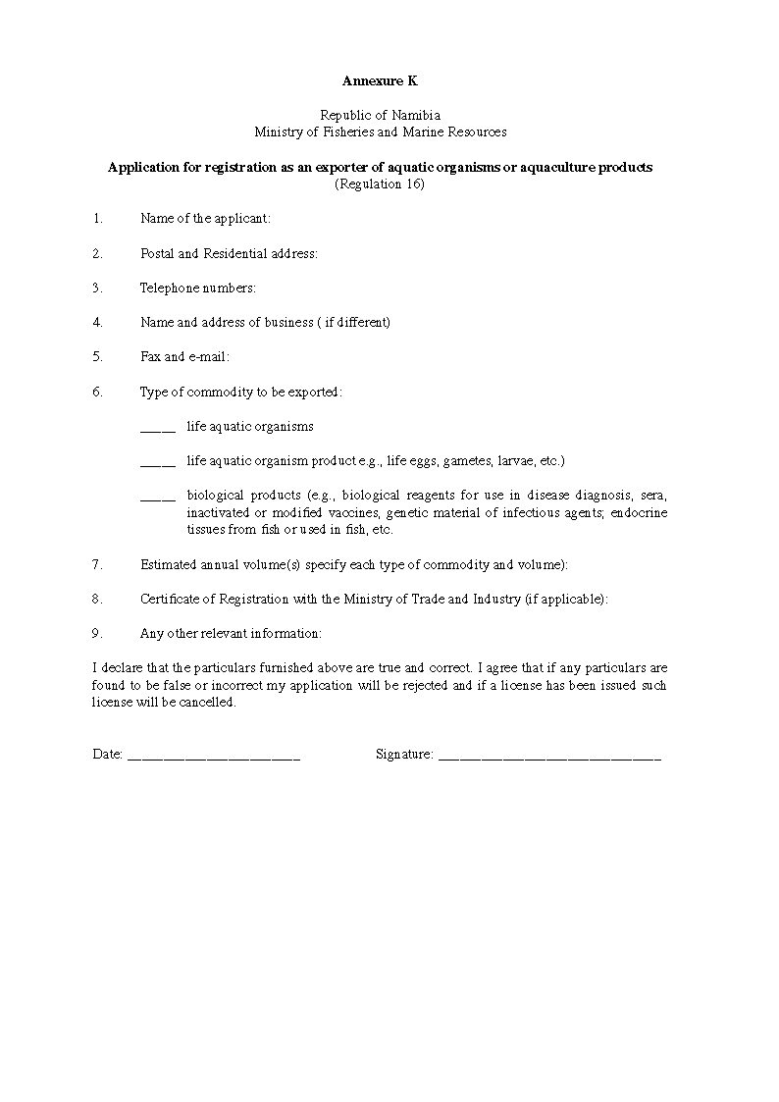

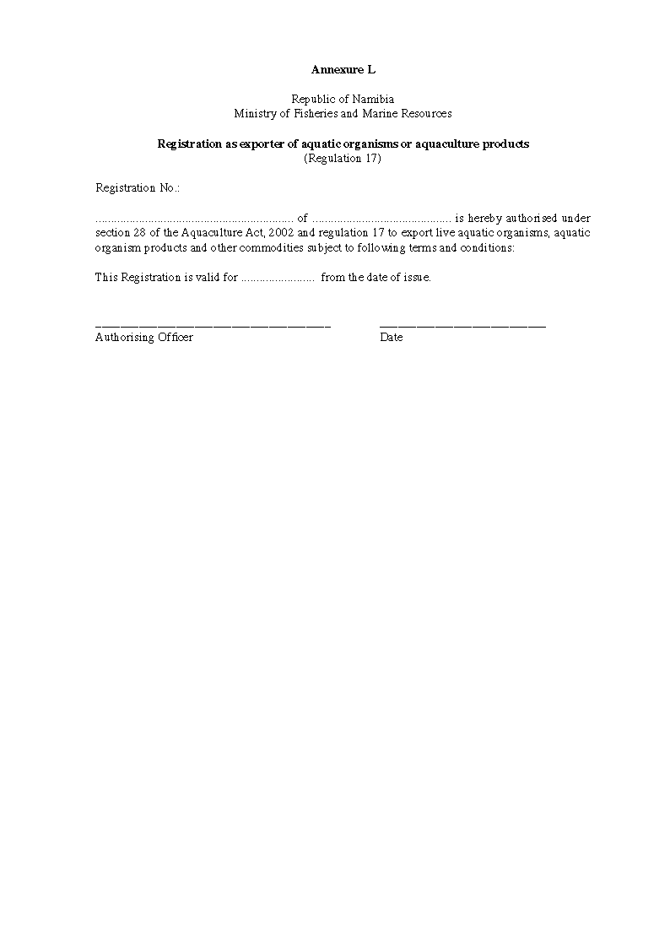

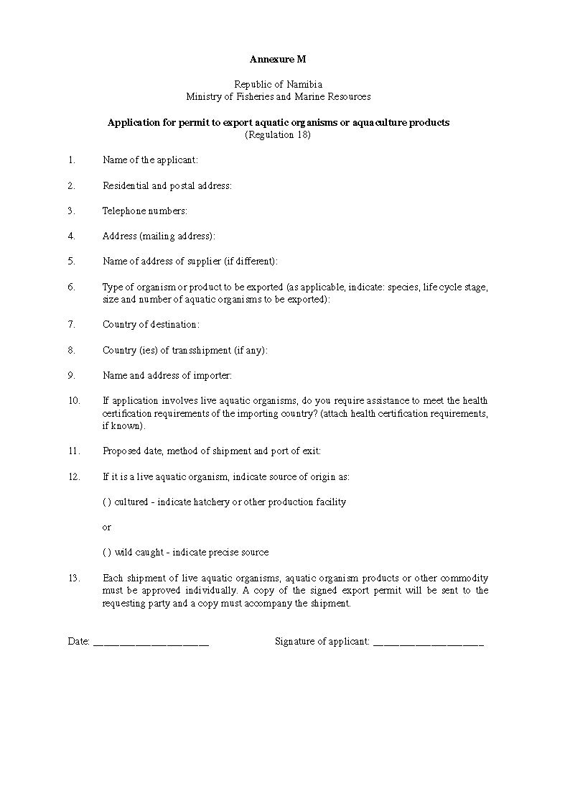

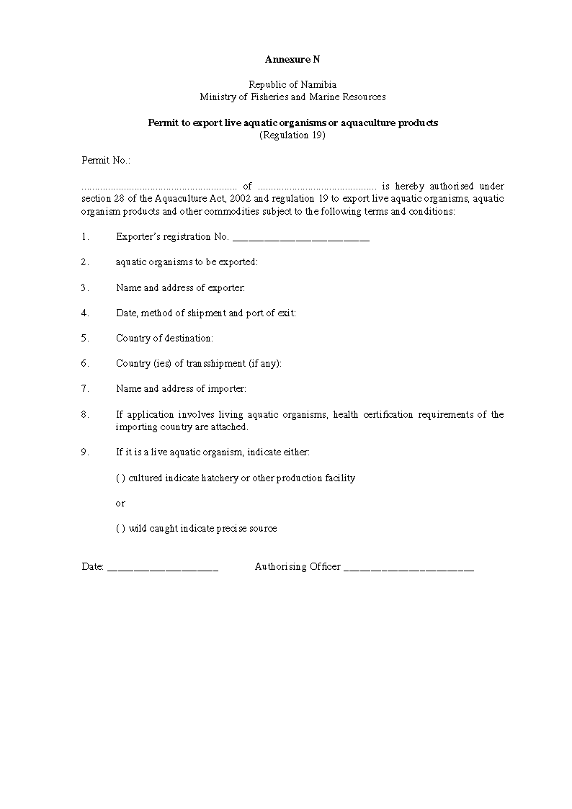

Annexure O

Republic of Namibia
Ministry of Fisheries and Marine Resources

List of aquatic organisms or aquaculture products whose exportation is prohibited

Live aquatic organisms originating from natural waters

(a) No species of wild-caught aquatic organism may be exported without the specific approval of the Minister.

(b) Exportation of the following fishes of conservation concern is expressly prohibited:

Scientific name | Common name | Distribution
Freshwater species
Austroglanis sclateri | Rock catfish | Apparently rare, endemic to Orange River System
Barbus breviceps | Shorthead barb | Isolated pools in Otjhipa Mountains near the Kunene River
Barbus hospes | Narmaqua barb | Endemic to lower Orange River and Fish River, abundant but vulnerable
Barhus kimberleyensis | Largemouth yellowfish | Present but declining in the Orange River System
Chetia welwitschi | Angolan happy | Known only from museum specimens, but present in the Kunene River
Clairiallabes platyprosopos | Broadhead catfish | Rare red data species from the Okavango and upper Zambezi rivers
Clariallabes sp. |  | Undescribed; found in the Kunene River in 1992
Clarias cavernicola | Cave catfish | Endangered; endemic to the Algamas Cave near Otavi, threatened by lowering water table
Kneria maydelli | Kunene kneria | Known only from the Kunene River
Nothobranchius sp. | Caprivi killifish | Endangered; endemic to the Caprivi Region; undescribed, threatened by road building and pollution
Sargochromis coulteri | Kunene happy | Endemic to the Kunene River, although abundant
Schwetzochromis mechadoi | Kunene dwarf happy | Endemic to the Kunene River
Thoracochromis albolabris | Thick-lipped happy | Endemic to the Kunene River
Thoracochromis buysi | Namib happy | Endemic to the Kunene River, although abundant
Tilapia guinesana | Otjikoto tilapia | Endangered; endemic to Namibian sinkhole lakes, threatened by lowering of water table in Lake Guinas, which will impede breeding.
Marine/Brackishwater Fishes
Dicrolene pallidus |  | Endemic brackishwater/marine species

Annexure P

Republic of Namibia
Ministry of Fisheries and Marine Resources

Lists of approved ports
(Regulation 21)

Airports

1. Chief Hosea Kutako International Airport, Windhoek
2. Walvis Bay
3. Lüderitz
4. Oranjemund

Border crossings

1. Ariamsvlei
2. Noordoewer
3. Vioolsdrif
4. Ngoma Bridge
5. Wanela
6. Oshikongo
7. Mohembo

Note that goldfish (Carassius auratus auratus) and Koi (Cyprinus carpio) are placed in Annexure J.
Note that although this species is a widely traded ornamental fish, it can grow to 30 cm in length and is an important commercial food fish cultured in Asia.
No FishBase common name available. Name is from American Fisheries Society.
AFS common name - belongs to a complex of “blood” tetras.
Requires further consideration. Several countries report adverse ecological impact after introduction.
Has aquaculture importance in Asia; maximum size is 12.0 cm.
Has minor commercial importance in Asia; maximum size in 13 cm.
At least one country reports adverse ecological impact after introduction.
At least one country reports adverse ecological impact after introduction.

