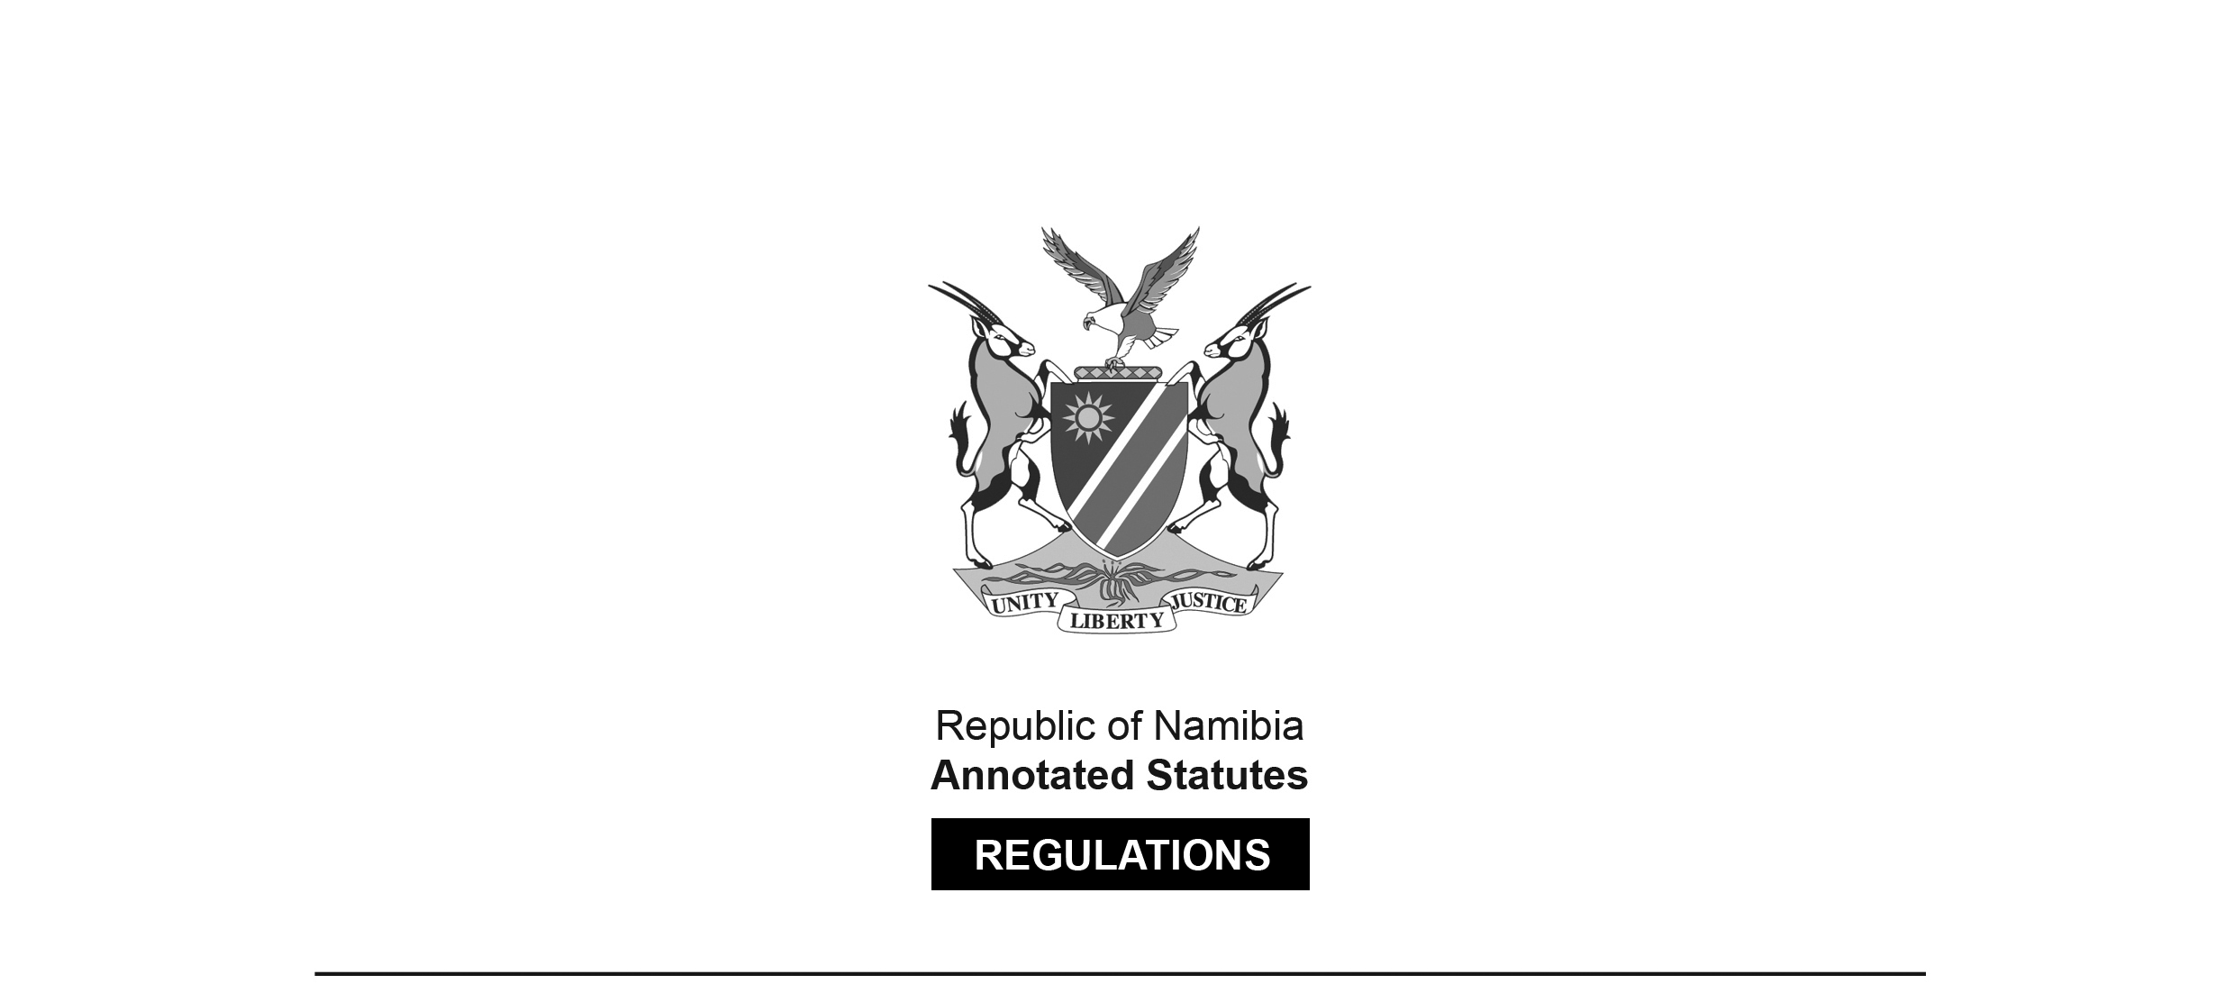

REGULATIONS MADE IN TERMS OF

Aquaculture Act 18 of 2002

section 43

Aquaculture (Licensing) Regulations

Government Notice 246 of 2003

(GG 3104)

came into force on date of publication: 3 December 2003

ARRANGEMENT OF REGULATIONS

**PART I**

**DEFINITIONS**

Sections

[This should say “Regulations”.]

1. Definitions

**PART II**

**LICENSING**

2. Form of application

3. Form of licence

**PART III**

**RECORDS AND REPORTS**

4. Maintenance of records by licensee

5. Provision of information

6. Register of licences

7. Record of exempted persons

8. Inspection of register

**PART IV**

**HEALTH MANAGEMENT IN AQUACULTURE FACILITIES**

9. Conformity with International Standards

10. Applicability to all commodities and situations

11. Record keeping

12. Disease reporting

13. Use of approved drugs, antibiotics or other chemicals

14. Eradication of disease in aquaculture facilities

15. Record of aquaculture facility subject to quarantine measures

**PART V**

**CONTROL OF DISEASE OUTBREAKS WITHIN NAMIBIAN WATERS**

16. Disease zoning

17. Emergency disease situations

18. Intra-national movements of live aquatic organisms

**PART VI**

**PROTECTION OF THE AQUATIC ENVIRONMENT**

19. Release and escape of aquaculture products

20. Discharge of waste

21. Introduction and transfer of aquatic organisms

22. Penalties

**ANNEXURES**

ANNEXURE A APPLICATION FOR LICENCE FORM OF LICENCE

ANNEXURE B FORM OF LICENCE

ANNEXURE C LIST OF REPTILES AND AMPHIBIANS DECLARED TO BE AQUATIC ORGANISMS

ANNEXURE D LIST OF SERIOUS DISEASES OF AQUATIC ORGANISMS

ANNEXURE E APPLICATION FOR A PERMIT TO INTRODUCE OR TRANSFER AQUATIC ORGANISMS

ANNEXURE F PERMIT TO INTRODUCE OR TRANSFER AQUATIC ORGANISMS

**PART I**

**DEFINITIONS**

**Definitions**

**1.** In these Regulations, any expression to which a meaning has been assigned in the

Act bears that meaning unless the context indicates otherwise -

“disease” means a clinical or non clinical infection with one or more of etiological agents of a biological nature (i.e., viruses, bacteria, parasites, fungi, etc.);

“farming” means the culture, husbandry, production, development or improvement of aquatic organisms, and includes placing enclosures or artificial structures in demarcated areas;

“indigenous aquatic organism” means an aquatic organism that occurs naturally in Namibian waters (i.e., a non-introduced or native species);

“introduction” means the human-mediated movement of a non-indigenous species in Namibian land and water;

“non-indigenous aquatic organism” means an aquatic organism not naturally occurring in Namibian waters including an “exotic”, “non-native” or “introduced” species;

“pathogen” means an infectious agent capable of causing disease;

“quarantine” means the holding or rearing of aquatic organisms under conditions that prevent their escape, and the escape of any pathogens they may be carrying, into the surrounding environment;

“quarantine measures” means measures developed to prevent the transfer of or escape of disease agents or pathogens;

“the Act” means the Aquaculture Act, 2002 (Act No. 18 of 2002);

“transfer” means the movement of an aquatic organism to an area within the established range of species.

**PART II**

**LICENSING**

**Form of Applications**

**2.** An application for a licence and for the renewal of a licence shall be made in the form and manner set out in Annexure A.

**Form of Licence**

**3.** A licence must be issued in the form set out in Annexure B.

**PART III**

**RECORDS AND REPORTS**

**Maintenance of records by licensees**

**4.** A licensee shall maintain accurate records with respect to the aquaculture facility relating to -

(a) the type and amount of food used in relation to the aquatic organisms at the site or aquaculture facility;

(b) the type of any medication, including drugs, antibiotics or other chemicals used in relation to aquatic organisms, including the dosage and treatment date and the duration of any veterinarian treatments;

(c) the source, number and specific location of all aquatic organisms;

(d) a record of all disposals and sales of aquaculture products, including the date, number or weight and destination of each disposal and sale.

**Provision of Information**

**5.** (a) A licensee shall keep and furnish the Permanent Secretary annually the information which the licensee is required to maintain under regulation 6;

(b) Upon the request of the Permanent Secretary or of any aquaculture inspector appointed under section 36 of the Act, a licensee or person who operates an aquaculture facility shall provide any of the information required to be kept by that licensee or person under regulation 4 and 5 in the time and manner determined by the Permanent Secretary or aquaculture inspector.

**Register of Licenses**

**6.** The Permanent Secretary must maintain at the Ministry a register which records all licences issued in Namibia including-

(a) the name of the licensee;

(b) the name of any group, business, partnership or company associated with the licensee;

(c) the type of aquaculture licensed at the licensee’s aquaculture facility;

(d) the aquatic organisms licensed at the aquaculture facility;

(e) the location, size and description of the aquaculture facility;

(f) the maximum annual production authorized at the aquaculture facility;

(g) the source of water supply at the aquaculture facility;

(h) the annual quantity and composition of any effluent to be discharged from the aquaculture facility;

(i) the duration of the licence;

(j) any variation to the terms and conditions attached to the licence;

(k) any occurrence of disease outbreak.

**Record of exempted person**

**7.** The Permanent Secretary must maintain a record which lists all persons engaged in aquaculture in Namibia and Namibian waters who are exempted under section 45 of the Act including -

(a) the name of person;

(b) the location of the aquaculture activities;

(c) where and when information referred to in regulation 5 was provided;

(d) the species farmed.

**Inspection of register**

**8.** (1) Any person may inspect the register maintained at the Ministry or at any regional office of the Ministry during ordinary business hours.

(2) Any person may, by submitting a request in writing to the Permanent Secretary, request to obtain a copy of the register or a portion of the register upon payment of a fee for such copy as the Permanent Secretary may determine.

**PART IV**

**HEALTH MANAGEMENT IN AQUACULTURE FACILITIES**

**Conformity with International Standards**

**9.** Regulations concerning aquatic organisms health management shall be in conformity with internationally accepted standards relating to aquatic organisms health management, and consistent with Namibia’s rights and obligations arising from its membership of the World Trade Organisation (WTO), and the Office International des Epizooties (OIE, the World Organisation for Animal Health).

**Applicability to all commodities and situations**

**10.** (1) These regulations shall apply to all aquatic organisms as defined under the Act, including those amphibians and reptiles declared to be aquatic organisms in Annexure C, and to all other commodities.

(2) These regulations shall apply equally to all aquatic organisms health management situations, regardless of whether the aquatic organisms in question are farmed or ranched for commercial or other purpose.

(3) For the purposes of this regulation “commodities” mean aquatic organisms, aquatic organism products, aquatic organism genetic material, feedstuffs, biological products and pathological material.

**Record Keeping**

[The word “keeping” should not be capitalised. It is not capitalised   
in the ARRANGEMENT OF REGULATIONS.]

**11.** (1) In order to facilitate control of disease outbreaks, any person, whether licensed or exempted, who engages in aquaculture shall keep accurate and up-to-date records of the aquatic organisms kept on the aquaculture facility, from their arrival on the facility to their final sale or disposal.

(2) For purposes of disease surveillance and control, such records shall include, among others, full information on any mortalities, any clinical signs observed, the nature and results of any diagnostic tests performed, and the nature and results of any treatments applied to cultured stocks.

**Disease reporting**

**12.** Any licensee or an exempted person engaged in aquaculture shall immediately report to the Permanent Secretary or an aquaculture inspector any suspected outbreak of those serious diseases listed on the National List of Diseases of Aquatic Organisms provided for in Annexure D or any occurrences of unusually high mortalities of cultured stocks.

**Use of Approved Drugs, antibiotics or other chemicals**

[The words “approved drugs” should not be capitalised. They are not capitalised   
in the ARRANGEMENT OF REGULATIONS.]

**13.** (1) The Minister shall specify and list by notice in the *Gazette* -

(a) those drugs, antibiotics or other chemicals which are not allowed to be used in aquaculture for the purposes of treatment and prevention of diseases of aquatic organisms; and

(b) those drugs, antibiotics or other chemicals which are not allowed to be used in aquaculture for the purposes of treatment and prevention of diseases of aquatic organisms and the application of which requires the consent and supervision by the Minister or other person designated by the Minister as to supervision as to dosages, handling methods, including application methods and withdrawal times.

(2) For treatment and prevention of diseases of aquatic organisms, any licensee or exempted person engaged in aquaculture may apply only those drugs, antibiotics or other chemicals which are not prohibited under this regulation.

**Eradiction of disease in aquaculture facilities**

[The word “Eradication” is misspelt in the heading, as reproduced above.   
It is spelt correctly in the ARRANGEMENT OF SECTIONS.]

**14.** (1) In the instance where a serious outbreak of disease is identified within an aquaculture facility, the Minister or any person designated by the Minister may order that all or a portion of a facility be placed under quarantine.

(2) During the period in which an aquaculture facility is under quarantine, the Permanent Secretary may require application of specific treatment methods, in the case of treatable diseases, or in the case on non-treatable diseases, the destruction of infected stocks, their sanitary disposal, and the disinfection on the aquaculture facility of premises and all associated equipment to standards set by the Ministry.

(3) Any costs associated with the measures referred to in this regulation shall be borne by the owner of the infected licensed aquaculture facility.

**Record of aquaculture facility subject to quarantine measures**

**15.** The Permanent Secretary must maintain a record of aquaculture facilities subject to quarantine measures, including disinfection measures which contains -

(a) the name of the licensee;

(b) type of aquaculture licensed at the licensee’s aquaculture facility;

(c) the aquatic organisms licensed at the aquaculture facility;

(d) date of occurrence of disease;

(e) summary and duration of quarantine measures prescribed.

**PART V**

**CONTROL OF DISEASE OUTBREAKS WITHIN NAMIBIAN WATERS**

**Disease zoning**

**16.** (1) In order to control the spread of infectious diseases of aquatic organisms, and to provide trading partners with assurances of the disease status of Namibian aquaculture and fisheries products, the Minister may, by notice in the *Gazette* establish and maintain zones which are free from specified serious diseases. Such zones may consist of a designated aquaculture facility or facilities, a drainage basin or basins or parts thereof, or defined coastal areas.

(2) The establishment of free, infected and surveillance zones shall be based on internationally accepted methods for disease zoning as outlined by the OIE’s *International Aquatic Animal Health Code of 1924,* and shall include the establishment of programmes for the surveillance and monitoring of aquaculture facilities and the natural waters of Namibia with respect to specific diseases appearing on the National List of Important Diseases of Aquatic Organisms, provided for in Annexure D.

(3) The Ministry may take whatever measures it deems necessary to maintain, reduce or expand disease-free zones, including restricting or prohibiting the movement of aquatic organisms and their products into and out of designated zones and the establishment of eradiction programmes.

[The word “eradication” is misspelt in the *Government Gazette*, as reproduced above.]

**Emergency disease situations**

**17.** To deal effectively with emergency situations involving the outbreak of highly contagious and pathogenic diseases of aquatic organisms of known or unknown etiology, the Minister shall develop and implement national contingency plans for disease control.

**Intra-national movements of live aquatic organisms**

**18.** (1) Any transport of aquatic organisms between aquaculture facilities or the removal of any aquatic organism from an aquaculture facility for any purpose shall be notified in writing to the Permanent Secretary or any person designated by the Permanent Secretary.

(2) The Permanent Secretary or any other person designated by the Permanent Secretary not having replied within 3 months from the date of notification shall be deemed to have approved the movement of aquatic organisms referred to under subregulation (1).

**PART VI**

**PROTECTION OF THE AQUATIC ENVIRONMENT**

**Release and escape of aquaculture products**

**19.** (1) No person shall cause, authorize or allow the escape of aquaculture products from an aquaculture facility.

(2) No person engaged in aquaculture shall release into the Namibian waters any aquaculture product from an aquaculture facility unless authorized to do so by the terms and conditions of an aquaculture licence or by the Minister if that person is exempted from holding an aquaculture licence in terms of Section 45 of the Act.

(3) All equipment, materials and structures employed on an aquaculture facility shall be constructed, installed and maintained so as to prevent escapes under any circumstances.

**Discharge of waste**

**20.** (1) No person shall discharge or cause to be discharged waste generated on the aquaculture facility and which has or may have a harmful or detrimental effect on human health or the environment.

(2) Waste referred to under subregulation (1) shall be treated or disposed of in accordance with the terms and conditions of the aquaculture licence.

**Introduction and transfer of live aquatic organisms**

**21.** (1) Applications for permission to introduce or transfer aquatic organisms for the purposes of aquaculture shall be made to the Minister in the form set out in Annexure E, and a permit issued to introduce or transfer aquatic organisms as set out in Annexure F.

(2) Applications for the introduction and transfer of aquatic organisms for the purposes of aquaculture shall be carefully examined in accordance with internationally accepted protocols.

(3) An application to introduce or transfer an aquatic organism into Namibia shall be submitted to the Minister at least 3 months prior to the intended date of introduction or transfer.

**Penalties**

**22.** (1) A person who contravenes regulation 19(1) and (2) is on conviction liable to a fine of N$1 000,00 or to imprisonment for a period not exceeding three months.

(2) A person who contravenes regulation 20(1) is on conviction liable to a fine of N$800,00 or to imprisonment for a period not exceeding three months.

ANNEXURes a-C

To view content without printing, scroll down.

To print at full scale (A4), double-click the icon below.



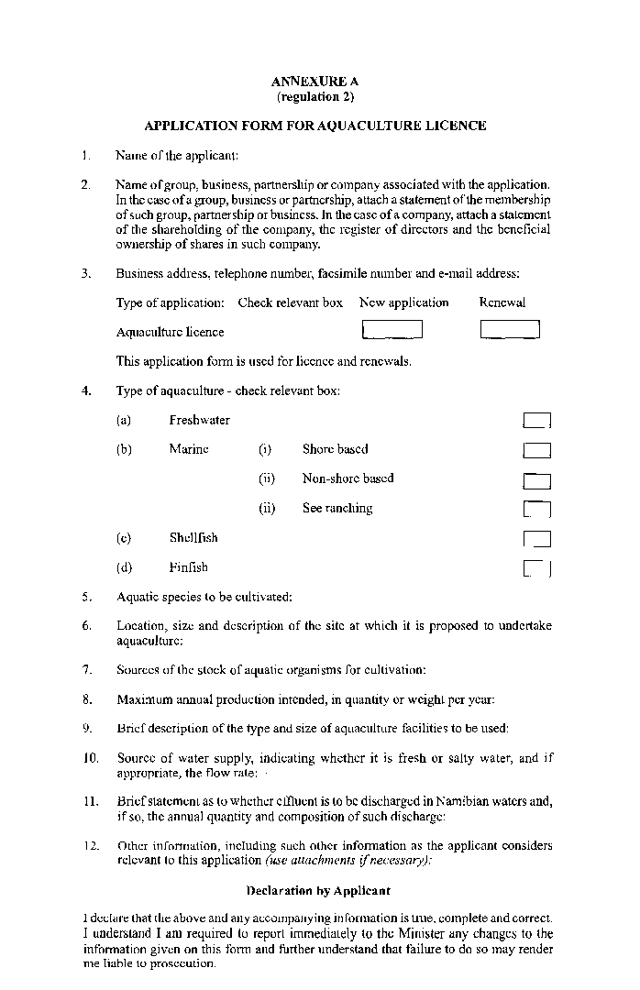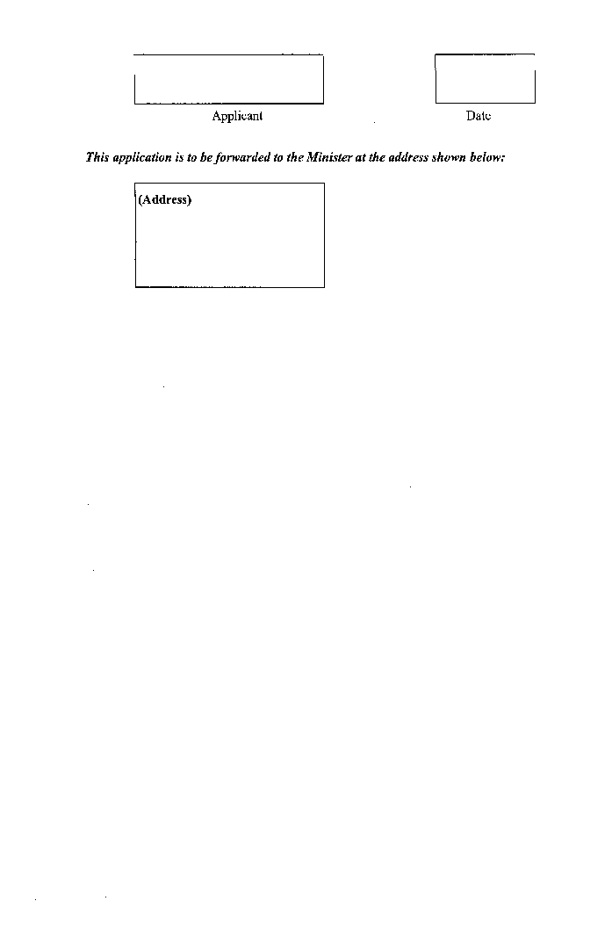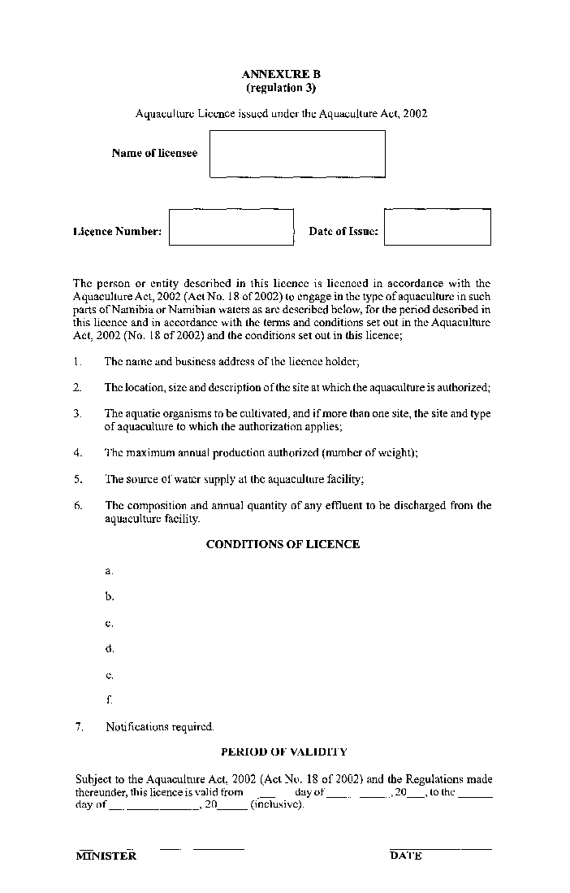

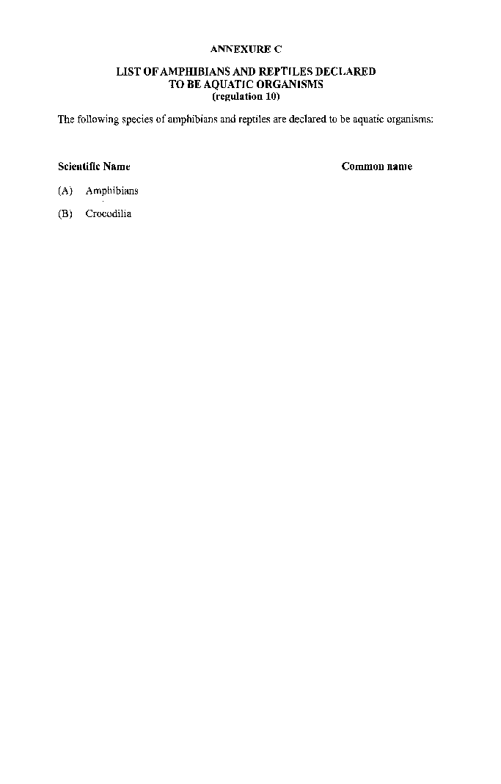 Annexure D

**NATIONAL LIST OF DISEASES OF AQUATIC ORGANISMS**

**(regulation 12)**

The following diseases are declared to be serious diseases:

**1. Diseases of fish**

Epizootic haematopoietic necrosis

Infectious haematopoietic necrosis

*Oncorhynchus masou* virus disease

Spring viraemia of carp

Viral haemorrhagic septicaemia

Channel catfish virus disease

Viral encephalopathy and retinopathy

Infectious pancreatic necrosis

Infectious salmon anaemia

Epizootic ulcerative syndrome

Bacterial kidney disease (*Renibacterium salmoninarum*)

Enteric septicaemia of catfish (*Edwardsiella ictaluri*)

Piscirickettsiosis (*Piscirickettsia salmonis*)

Gyrodactylosis (*Gyrodactylus safaris*)

Red sea bream iridoviral disease

White Sturgeon iridoviral disease

**2. Diseases of molluscs**

Bonamiosis (*Bonamia exitiosus, B. ostreae, Mikrocytos roughleyi*)

MSX disease (*Haplosporidium nelsoni*)

Marteiliosis (*Marteilia refringens, M. sydneyi*)

Mikrocytosis (*Mikrocytos mackini*)

Perkinsosis (*Perkinsus marinus, P. olseni/atlanticus*)

SSO disease (*Haplosporidium costale*)

Withering syndrome of abalones (*Candidatus* Xenohaliotis californiensis)

**3. Diseases of crustaceans**

Taura syndrome

White spot disease

Yellowhead disease

Tetrahedral baculovirosis (*Baculovirus penaei*)

Spherical baculovirosis (*Penaeus monodon*-type baculovirus)

Infectious hypodermal and haematopoietic necrosis

Crayfish plague (*Aphanomyces astaci*)

Spawner-isolated mortality virus disease

ANNEXURes E-F

To view content without printing, scroll down.

To print at full scale (A4), double-click the icon below.



