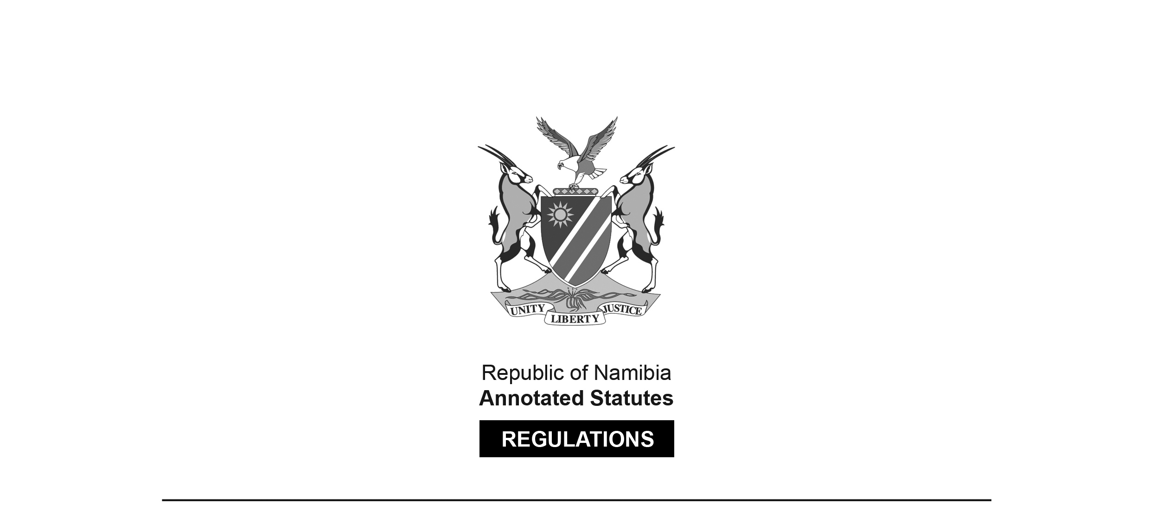
REGULATIONS MADE IN TERMS OF

Allied Health Professions Act 7 of 2004
section 55(1)

Regulations relating to Scope of Practice for Chiropractors
Government Notice 336 of 2022
(GG 7938)
came into force on date of publication: 25 October 2022

The Government Notice which publishes these regulations notes that they were made
on the recommendation of the Allied Health Professions Council of Namibia. It also repeals
the regulations contained in GN 229/2010 (GG 4581).

ARRANGEMENT OF REGULATIONS

1. Definitions
2. Scope of practice of chiropractor

Definitions

1. In these regulations a word or an expression to which a meaning has been given in the Act has that meaning, and unless the context otherwise indicates -

“practitioner” means a practitioner as defined in section 1 of the Hospital and Health Facilities Act, 1994 (Act No. 36 of 1994); and

“the Act” means the Allied Health Professions Act, 2004 (Act No. 7 of 2004).

Scope of practice of chiropractor

2. The following acts fall within the scope of practice of a chiropractor -

(a) diagnosing and treatment or prevention of physical or mental diseases, illnesses and deficiencies in humans;

(b) prescribing, selling or dispensing of medicines, and the providing or prescribing of treatment to cure, prevent or alleviate the conditions referred to in paragraph (a);

(c) diagnosing, treatment or preventing of a physical or mental defect, illness or deficiency in patients by the use of case history taking, physical examination, referral for tests and interpretation of laboratory tests and specialised imaging, and perform urine dipstick, cholesterol tests, use glucometers or any other relevant office tests;

(d) the referral of a person to a medical practitioner or specialist registered under the Medical and Dental Act, 2004 (Act No. 10 of 2004) or to any practitioner for any special examination or treatment; and

(e) the treatment or prevention of any physical defect, illness or deficiency related to all spinal, pelvic, cranial, extremity, spino-visceral and general neuro-musculoskeletal conditions in a person by means of -

(i) manipulation or adjustment;

(ii) electrotherapy;

(iii) exercise therapy;

(iv) hydrotherapy;

(v) traction therapy;

(vi) thermal therapy;

(vii) vibration therapy;

(viii) immobilisation therapy;

(ix) neuro-muscular therapies;

(x) massage therapy;

(xi) acupuncture, acupressure therapy and myofascial needling;

(xii) remedies;

(xiii) dietary advice or dietary supplementation;

(xiv) injectable therapy;

(xv) prescribe and fit orthotic aids; or

(xvi) prescribe patient neuro-muscular education and life skills training.

