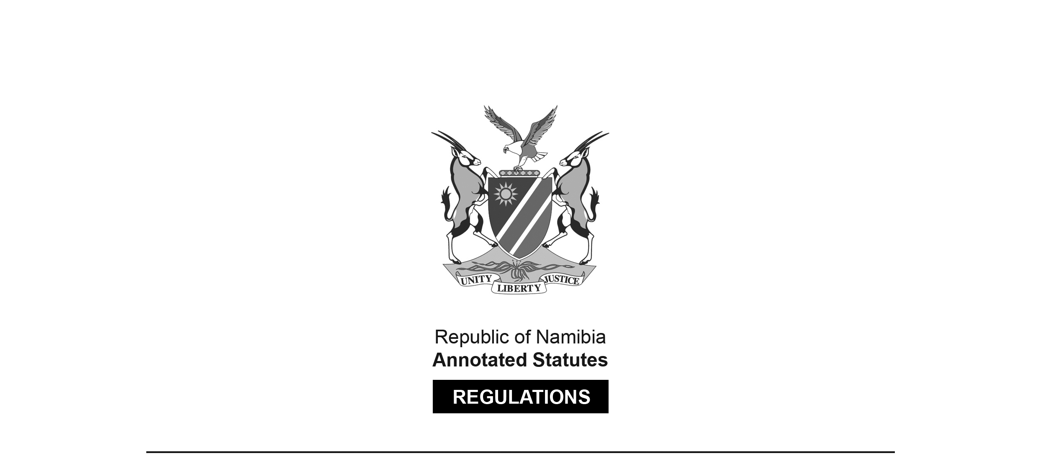
REGULATIONS MADE IN TERMS OF

Allied Health Professions Act 7 of 2004
section 55

Regulations relating to Minimum Requirements of
Study for Registration as Radiography Assistant and
Scope of Practice of Radiography Assistant
Government Notice 313 of 2020
(GG 7412)
came into force on date of publication: 9 December 2020

The Government Notice which publishes these regulations notes that they were
made on the recommendation of the Allied Health Professions Council of Namibia.

ARRANGEMENT OF REGULATIONS

1. Definitions
2. Minimum requirements of study for registration as radiography assistant
3. Application for registration as radiography assistant
4. Register of radiography assistants
5. Restoration of names to register
6. Language of forms and documents
7. Scope of practice of radiography assistants

Definitions

1. In these regulations a word or an expression to which a meaning has been given in the Act has that meaning, and unless the context otherwise indicates -

“certified” means certified as a true copy of the original by a commissioner of oaths appointed under section 5, or designated under section 6, of the Justices of the Peace and Commissioners of Oaths Act, 1963 (Act No. 16 of 1963);

“equivalent qualification’ means a qualification obtained after fulltime education, tuition and training in a similar course or programme and comprising of similar subjects set out in these regulations;

[The closing quotation mark should be a double quote like the opening one.]

“medical practitioner” means a medical practitioner as defined in section 1 of the Medical and Dental Act, 2004 (Act No. 10 of 2004); and

“the Act” means the Allied Health Professions Act, 2004 (Act No. 7 of 2004).

Minimum requirements of study for registration as radiography assistant

2. (1) Subject to other requirements of the Act, the Council may register a person as a radiography assistant, if the person holds any of the following qualifications -

(a) certificate in radiography; or

(b) an equivalent qualification, awarded by an educational institution,

after receiving fulltime education, tuition and training at that educational institution for a period of not less than two years.

(2) The education, tuition and training for the qualification referred to in subregulation (1) must include the following subjects -

(a) food and nutrition;

(b) anatomy and physiology;

(c) sociology;

(d) introduction to primary health care;

(e) radiographic technique;

(f) radiographic equipment; and

(g) image recording.

Application for registration as radiography assistant

3. (1) An application for registration as a radiography assistant in terms of section 20 of the Act must, in addition to the documents and particulars specified in subsection (2) of that section, be accompanied by a certified copy of the identity document or passport of the applicant.

(2) The Council may require the applicant to furnish proof of the proficiency of the applicant in the English language.

Register of radiography assistants

4. In addition to the particulars specified in subsection (3) of section 24 of the Act, the register of radiography assistants established and kept in terms of subsection (2) of that section, must contain -

(a) any particulars that the Council may determine; and

(b) any change of the particulars recorded in the register.

Restoration of names to register

5. In addition to the documents and particulars referred to in subsection (2) of section 26 of the Act, an application in terms of subsection (1) of that section for the restoration of the name of a person to a register must be accompanied by -

(a) a certified copy of the identity document or passport of the applicant; and

(b) the original registration certificate issued to the applicant and a certified copy of the registration certificate.

Language of forms and documents

6. (1) Subject to subregulation (2), a form or a document required to be submitted to the Council or registrar in terms of these regulations must be in the English language.

(2) A form or a document which is not in the English language must be accompanied by a sworn translation into the English language.

Scope of practice of radiography assistants

7. (1) A radiography assistant may only perform an act after obtaining a referral from a medical practitioner to perform an act.

(2) Subject to subregulation (1) the following acts fall within the scope of practice of a radiography assistant -

(a) analysing, correlating procedure requests and clinical information provided by medical practitioner or patient for pre-procedure determination of the appropriate examination, its extent, and its scope;

[The comma after the word “analysing” should be replaced with
the word “and” to be grammatically correct. There should be an article
such as “a” or “the” before “medical practitioner”.]

(b) evaluating the physical and emotional status of the patient with respect to the ability to undergo the procedure required;

(c) selecting, preparing, operating radiography equipment and accessories to perform procedures;

[The comma after the word “preparing” should be replaced with
the word “and” to be grammatically correct.]

(d) positioning patients to best demonstrate anatomy of interest, while respecting patient’s physical limitations and comfort;

[There should be an article such as “a” or “the” before “patient’s”.]

(e) determining exposure factors needed to produce the best radiographs possible with minimum radiation exposure to the patient;

(f) practising radiation protection for the patient, himself or herself, patients and other persons;

(g) recognising the difference between diagnostic quality and inferior radiographs;

(h) administering image processing standards and the appropriate labeling of images regarding patient identification, date and documentation of technical parameters;

(i) providing basic patient care and comfort, pre-procedure determination of the appropriate examination, anticipating patient needs as well as providing appropriate patient education;

[The comma after the word “examination” should be replaced with
the word “and” to be grammatically correct.]

(j) evaluating the performance of radiographic systems, knowing the safe limits of equipment operation and report malfunctions to the responsible person; and

[The word “report” should be “reporting” to be grammatically correct.]

(k) performing excretory urography examinations after consultation with and under supervision of a medical practitioner who is physically available.

(3) A radiography assistant may -

(a) only perform professional acts in radiography under the supervision of a medical practitioner;

(b) limit the acts referred to in paragraph (a) to acts directly related to his or her education and training in radiography; and

(c) not perform any diagnostic X-ray examination at any place other than a hospital, health facility or such other facility as may be determined under the Hospitals and Health Facilities Act, 1994 (Act No. 36 of 1994).

