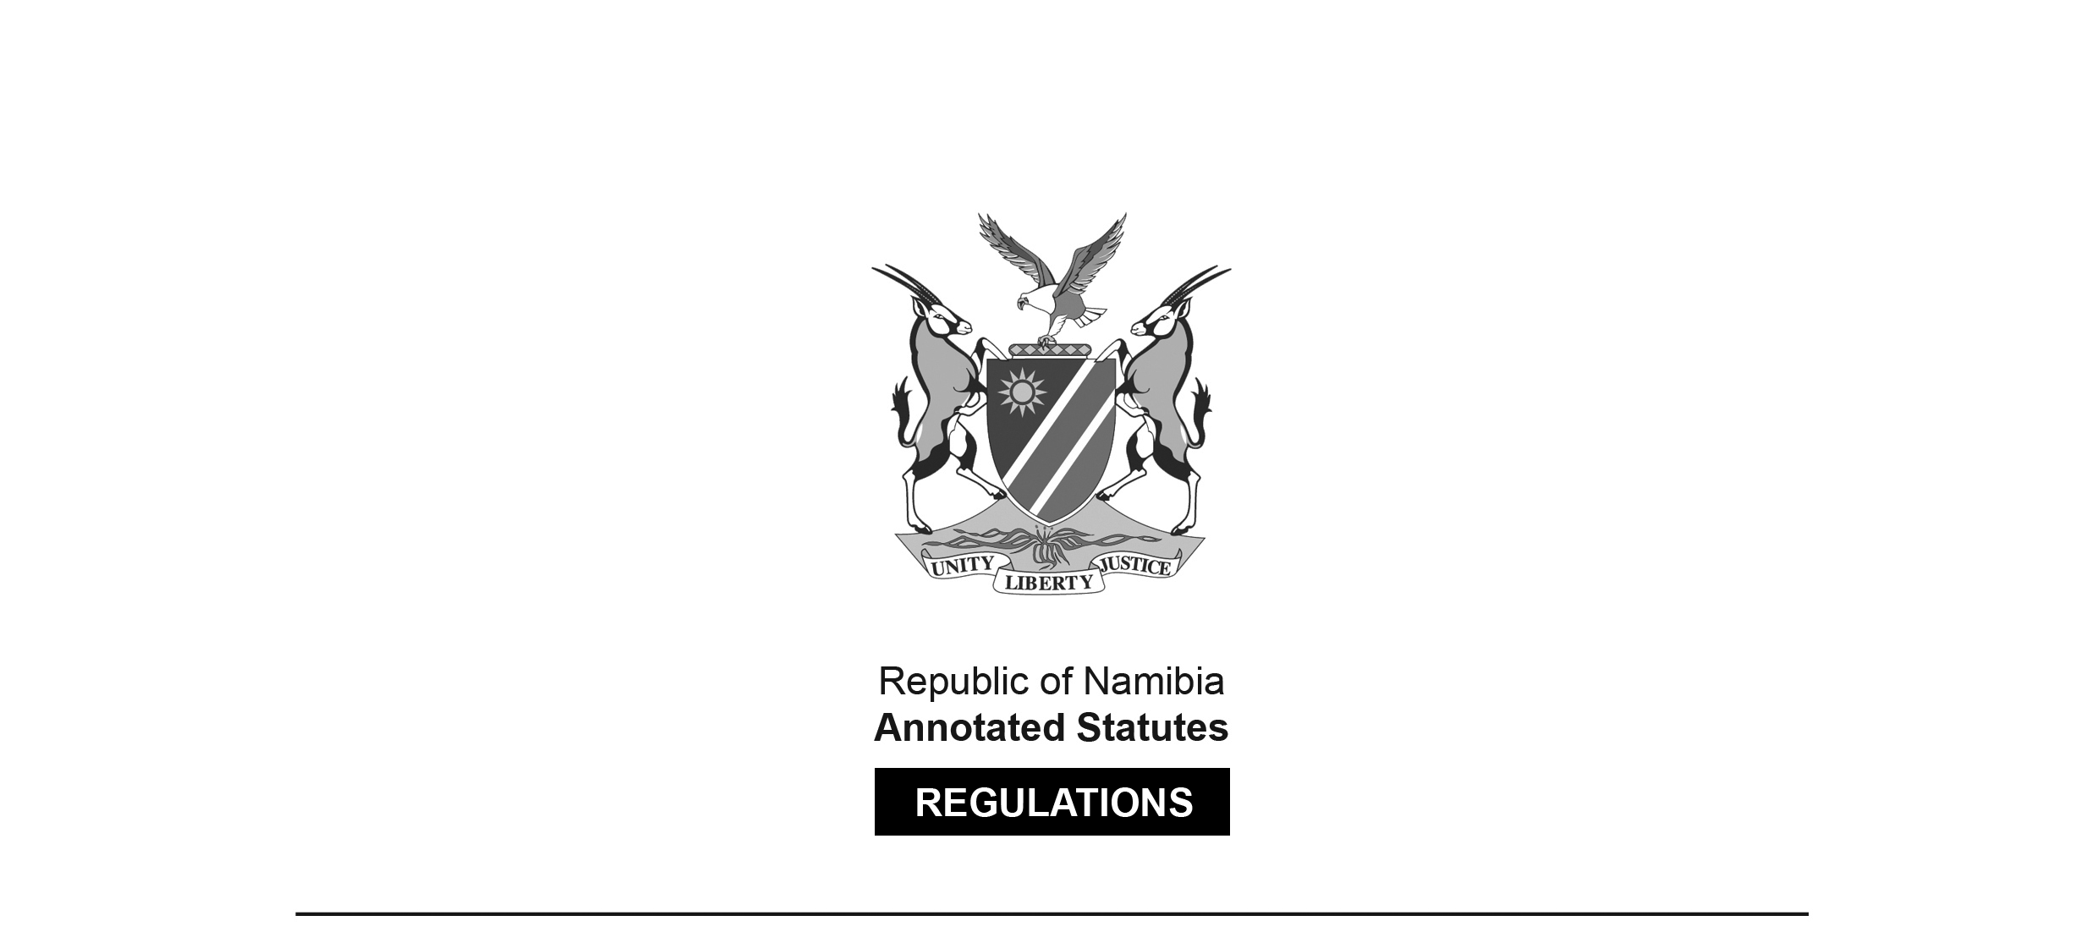
REGULATIONS MADE IN TERMS OF

Allied Health Professions Act 7 of 2004
section 55

Regulations relating to the Scope of Practice
of a Therapeutic Reflexologist
Government Notice 296 of 2013
(GG 5333)
came into force on date of publication: 6 November 2013

The Government Notice which publishes these regulations notes that they were made
on the recommendation of the Allied Health Professions Council of Namibia.

ARRANGEMENT OF REGULATIONS

1. Definitions
2. Scope of practice of therapeutic reflexologist

Definitions

1. In these regulations a word or an expression defined in the Allied Health Professions Act, 2004 (Act No. 7 of 2004) has that meaning.

Scope of practice of therapeutic reflexologist

2. (1) Therapeutic reflexology is the stimulation of the hands, feet, ears and body of a patient, including specific pressure techniques or the mobilisation of the hands and feet, aimed at a therapeutic outcome.

(2) The acts especially pertaining to therapeutic reflexology are -

(a) the verbal and physical assessment and evaluation of a patient’s condition for the purpose of evaluating that patient’s state of health; and

(b) the delivery of a treatment protocol to meet the needs of the patient.

(3) The acts specified by subregulation (2) may include -

(a) the taking of a comprehensive case history of the patient by -

(i) assessing of the integumentary and myofascial structures with special attention to reflex regions of the feet and hands;

(ii) determining and preparing a suitable patient-specific treatment protocol;

(iii) maintaining comprehensive case records regarding the conditions and progress of, and of all actions performed in connection with, the patient;

(b) the application of therapeutic reflexology treatments with reference to the treatment and prevention of conditions of illness in patients by -

(i) therapeutic reflexology methods and routines of stimulation, including the manual mobilisation of the different tissue structures, and reflex stimulation via the feet, hands and meridians;

(ii) relaxation techniques and methods;

(iii) home care advice;

(iv) nutritional and lifestyle advice;

(v) the recommendation of unscheduled preparations;

(vi) the use of other modalities to enhance the reflexology treatment, after appropriate training;

(vii) listening skills;

(viii) mobilisation of extremities;

(ix) primary health care screening methods; and

(x) attending to patients outside of practice by means of home visits;

(c) the promotion and maintaining of the health of the patient through -

(i) attention to hygiene, physical comfort and re-assurance of the patient;

(ii) promotion of lifestyle changes, including dietary advice, exercise, rest and sleep with a view to assisting in the rehabilitation of the patient;

(iii) education leading to the attainment of optimal health for the patient;

(iv) delivery of emergency first aid treatment, including cardiopulmonary resuscitation, if necessary; and

(v) the consultation with, or the referral of the patient to, any other registered person, or medical practitioner or dentist registered as such under the Medical and Dental Act, 2004 (Act No. 10 of 2004), or pharmacist registered as such under the Pharmacy Act, 2004 (Act No. 9 of 2004), or psychologist registered as such under the Social Work and Psychology Act, 2004 (Act No. 6 of 2004), or nurse registered under the Nursing Act, 2004 (Act No. 8 of 2004).

