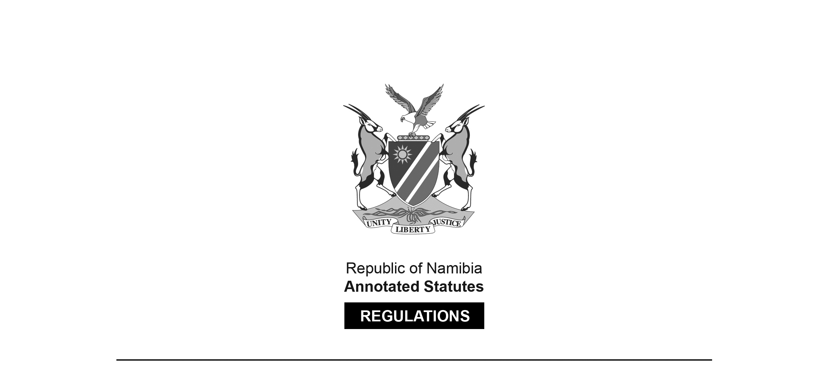
REGULATIONS MADE IN TERMS OF

Allied Health Professions Act 7 of 2004
section 55

Regulations relating to the Scope of Practice
of a Therapeutic Masseur
Government Notice 290 of 2013
(GG 5331)
came into force on date of publication: 4 November 2013

The Government Notice which publishes these regulations notes that they were made
on the recommendation of the Allied Health Professions Council of Namibia.

ARRANGEMENT OF REGULATIONS

1. Definitions
2. Scope of practice of a therapeutic masseur

Definitions

1. In these regulations a word or an expression defined in the Allied Health Professions Act, 2004 (Act No. 7 of 2004) has that meaning.

Scope of practice of a therapeutic masseur

2. (1) Therapeutic massage therapy is the manipulation of the soft tissues of the human body by rubbing, kneading or tapping, with the use of touch, aimed at a specific therapeutic outcome.

(2) The acts especially pertaining to therapeutic masseurs are -

(a) the verbal and physical assessment and evaluation of a patient’s condition for the purpose of determining the state of health and the delivery of a treatment regime to meet the needs of the patient, including -

(i) the assessment of the health history;

(ii) the observing of the posture and movement;

(iii) the assessment and palpation of the integumentary and myofascial structures;

(iv) the assessment of the range of motion by making use of a specific test for this purpose;

(v) the determining and preparing of a suitable patient-specific treatment protocol; and

(vi) the maintaining of comprehensive case records relating to the conditions and progress, and of all actions performed,

of or in connection with the patient;

(b) the application of therapeutic massage treatment relating to the treatment and prevention of conditions or illnesses in a patient by the use of or applying non- invasive -

(i) therapeutic massage techniques such as the manual mobilisation of soft tissue structures;

(ii) touch through pressure, stroking, gliding, effleurage, kneading, petrissage, lifting, percussion, tapotement, compression, holding, vibration, friction, pulling, movement and stretching by the digits, hands forearms, elbows, knees, feet or mechanical appliances which enhance massage therapy techniques;

(iii) active or passive movement within the normal physiological range of motion, active assisted and resisted movement and stretching;

(iv) other modalities or equipment to enhance the therapeutic massage treatment, including -

(aa) acupressure techniques;

(ab) myofascial trigger point therapy;

(ac) neuromuscular techniques;

(ad) train and counter-strain techniques;

(ae) hydrotherapy, cryotherapy and electrotherapy;

(af) myofascial release technique;

(ag) deep tissue massage;

(ah) stretching (passive and active);

(ai) manual joint mobilisation;

(aj) strapping and taping that does not restrict joint movement;

(ak) ice and heat therapy;

(al) manual lymph drainage;

(am) connective tissue manipulation and massage;

(an) proprioceptive neuro-muscular facilitation (PNF);

(ao) various advance massage techniques including, but not limited to, transverse friction;

(pp) reflexology restricted to the training received by the therapeutic masseur;

(aq) nutritional and lifestyle advise;

(rr) primary health care screening methods;

(ss) safe use of essential oils;

(tt) application of therapeutic procedures, including topical non- prescription applications of herbs, salts, poultices and mudpacks, and tools and electric massages for the purpose of therapeutic benefit;

(uu) intra-oral and intra-nasal work, with additional informed consent, to address the specific considerations; and

(vv) female breast massage, with additional informed consent, to address the specific considerations; and

[The lettering of the sub-subparagraphs is inconsistent.]

(c) the promotion and maintaining of the health of the patient through -

(i) attention to hygiene, physical comfort and reassurance of and to the patient;

(ii) the promotion of lifestyle changes that may include dietary advice, exercise, rest and sleep to assist in the rehabilitation of the patient;

(iii) the offering of specific suggestions and recommendations of self care and health maintenance activities including, but not limited to, self massage, movement, self-administered hydrotherapy applications, stress reduction and stress management techniques, and stretching activities;

(iv) the education of a patient leading to the attainment of optimal health by that patient;

(v) the recommendation of preparations that are not medicines, complementary medicines or scheduled substances; and

(vi) the consultation with, or the referral of the patient to, any other registered person, or medical practitioner or dentist registered as such under the Medical and Dental Act, 2004 (Act No. 10 of 2004), or pharmacist registered as such under the Pharmacy Act, 2004 (Act No. 9 of 2004), or psychologist registered as such under the Social Work and Psychology Act, 2004 (Act No. 6 of 2004), or nurse registered under the Nursing Act, 2004 (Act No. 8 of 2004).

(2) The manipulation of soft tissue prescribed by subregulation (1), excluding sub- subparagraph (vv) of subparagraph (iv) of paragraph (b) of that subregulation, is limited to external tissues.

