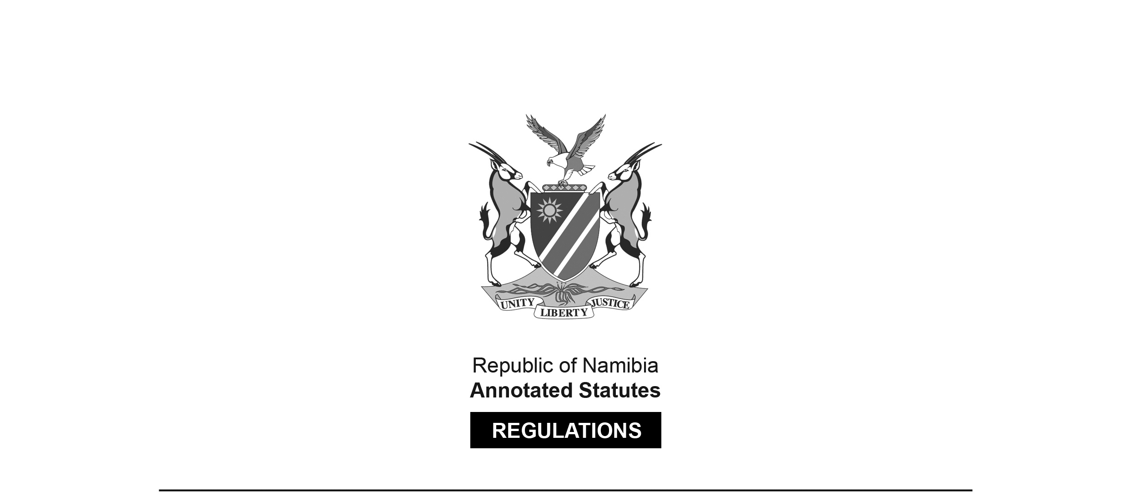
REGULATIONS MADE IN TERMS OF

Allied Health Professions Act 7 of 2004
section 55

Regulations relating to the Scope of Practice of an Optometrist
Government Notice 104 of 2011
(GG 4752)
came into force on date of publication: 13 July 2011

The Government Notice which publishes these regulations notes that they were made
on the recommendation of the Allied Health Professions Council of Namibia.

ARRANGEMENT OF REGULATIONS

1. Definitions
2. Scope of practice of an optometrist

Definitions

1. In these regulations, unless the context otherwise indicates, a word or expression defined in the Act has that meaning.

Scope of practice of an optometrist

2. (1) Optometry includes the examination of, and the ascertaining of the presence of defects and disorders in, the human eye and related structures, and the treatment of those defects and disorders.

(2) The acts especially pertaining to an optometrist in the conducting of his or her practice are -

(a) the examination of a patient’s eyes with the purpose of detecting errors in the vision of that patient;

(b) the treatment of the errors in the vision of a patient detected through an examination in accordance with paragraph (a) by means of the -

(i) prescribing or provision of spectacle lenses, spectacle frames, prisms or therapeutic or refractive contact lenses, and visual aids or appliances;

(ii) fitting, adjustment and maintenance of spectacle-frames and lenses, contact lenses, visual aids and appliances; and

(iii) ascertaining of the perceptive, neural and muscular condition of the visual system;

(iv) prescribing or providing of visual therapy, therapeutic aids and other optical devices;

(v) screening of the visual system for pathological conditions, and the referral of the patient to an appropriate medical practitioner for the treatment of those conditions not treatable within the scope of practice of an optometrist;

(vi) use of scheduled substances, subject to subregulation (3), for diagnostic and therapeutic purposes, in accordance with the Medicines and Related Substances Control Act, 2003 (Act No. 13 of 2003); and

(vii) use of diagnostic instruments or devices for the examination or analysis of the human visual system,

in order to provide the patient with clear, comfortable and efficient vision; and

(c) the fitting of prosthetic eyes.

(3) The pharmaceutical treatment referred to in subregulation (2)(b)(vi) must be limited to the eyelids, conjunctiva and superficial cornea.

