LEAD PUBLICATIONS

LAND

Policy and Legislative Framework

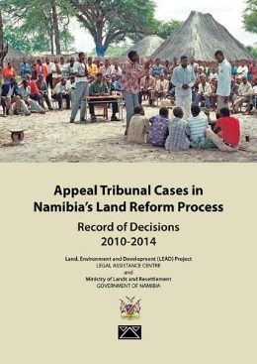 | Appeal Tribunal Cases in  Namibia’s Land Reform Process:  Record of Decisions 2010-2014  (2014)
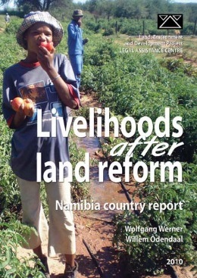 | 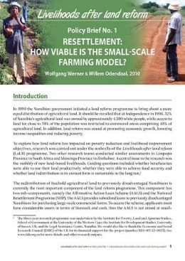 | 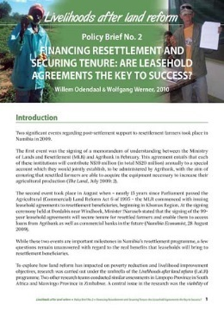
Livelihoods after land reform – Namibia country report
and accompanying Policy Briefs
(2010)

Policy Brief No. 1:
Resettlement: How viable is the small-scale farming model?

Policy Brief No. 2:
Financing Resettlement and Securing Tenure:
Are Leasehold agreements the key to success?

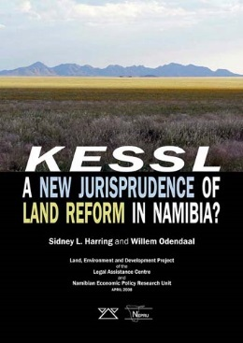 | Kessl: A New Jurisprudence of  Land Reform in Namibia?  (2008)
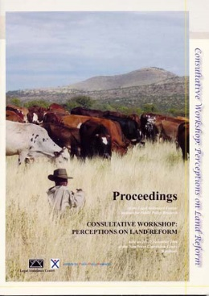 | Proceedings – Consultative Workshop: Perceptions on Land Reform  (2007)
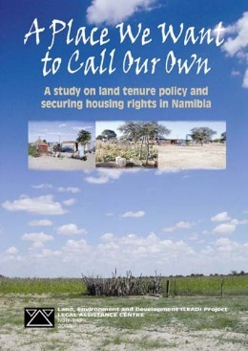 | A Place We Want to Call Our Own:  A study on land tenure policy and  securing housing rights in Namibia  (2005)

Communal Land

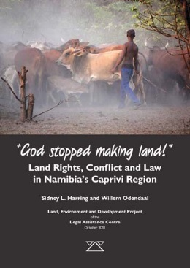 | “God stopped making land!”:  Land Rights, Conflict and Law  in Namibia’s Caprivi Region  (2012)
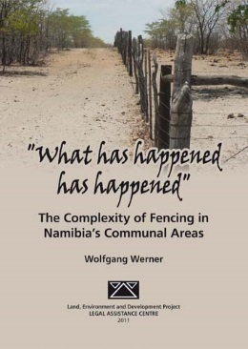 | “What has happened has happened”:  The Complexity of Fencing in  Namibia’s Communal Areas  (2011)
http://www.lac.org.na/pub/publications.php | Policy Brief 33  Elite land grabbing in Namibian  communal areas and its impact on subsistence farmers’ livelihoods  (2011)
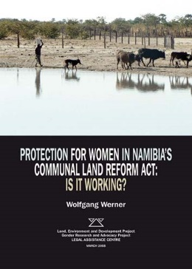 | Protection for Women in Namibia’s  Communal Land Reform Act:  Is It Working?  (2008)
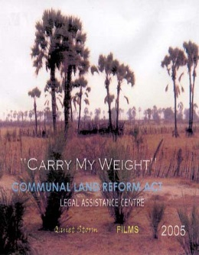 | Video  “Carry My Weight”  Communal Land Reform Act  (2005)
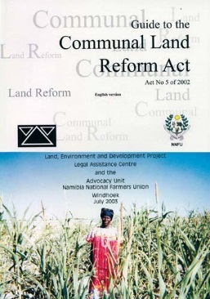 | Guide to the Communal Land Reform Act –  Act No. 5 of 2002  (2005,2003 and updated 2009)
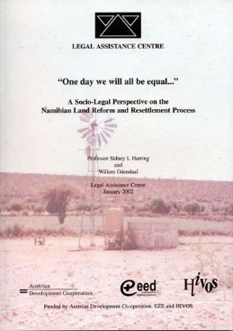 | “One day we will all be equal …”:  A Socio-Legal Perspective on the Namibian Land Reform and Resettlement Process  (2002)
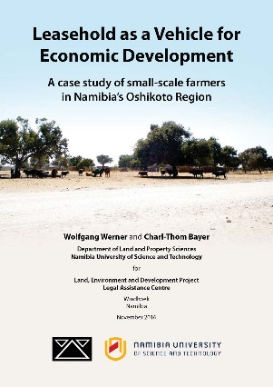 | Leasehold as a Vehicle for Economic Development: A case study of small-scale farmers in Namibia’s Oshikoto Region  (2016)

Urban Land

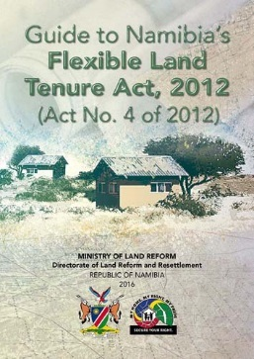 | Guide to Namibia’s Flexible Land Tenure Act, 2012 (Act No. 4 of 2012)  (2016)  It’s an MLR publication that LEAD and GIZ produced.
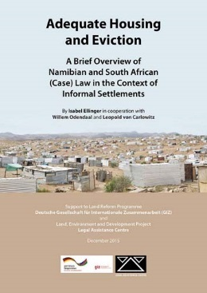 | Adequate Housing and Eviction:  A Brief Overview of Namibian and  South African (Case) Law in the  Context of Informal Settlements  (2015)

Freehold Land

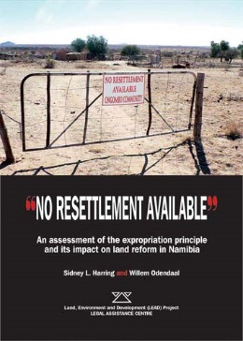 | No resettlement available”:  An assessment of the expropriation principle and its impact on land reform in Namibia  (2007)
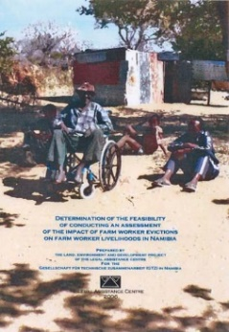 | Determination of the feasibility of conducting an assessment of the impact of farm worker evictions on farm workers’ livelihoods in Namibia  (2006)
http://www.lac.org.na/pub/publications.php | Written Paper  Is there an Absolute Right to Private Ownership of Commercial Land in Namibia?  (2003)
http://www.lac.org.na/pub/publications.php | Written Paper  Confiscation of compensation? An analysis of the Namibian Commercial Agricultural Land Reform Process  (2005)
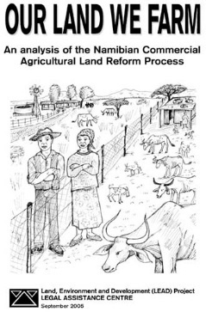 | Our Land We Farm:  An Analysis of the Namibian Commercial Agricultural Land Reform Process  (2006)

ENVIRONMENT

Ecosystems and Biodiversity

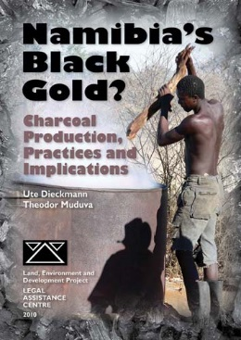 | Namibia’s Black Gold?  Charcoal Production, Practices  and Implications  (2010)
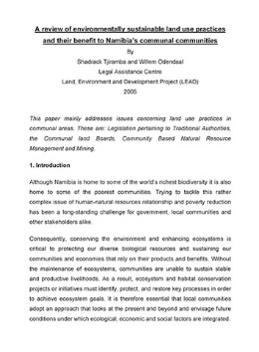 | Research Paper:  “A review of environmentally sustainable land use practices and their benefit to Namibia’s communal communities”  (2005)
Speak up against Wildlife Crime!
Comic
(2016)

Climate Change

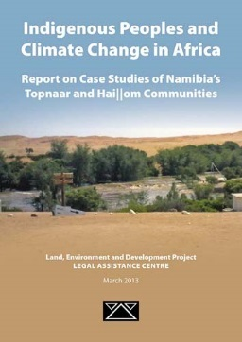 | Indigenous Peoples and Climate Change  in Africa: Report on Case Studies of Namibia’s Topnaar and Hai||om Communities  (2013)

Water

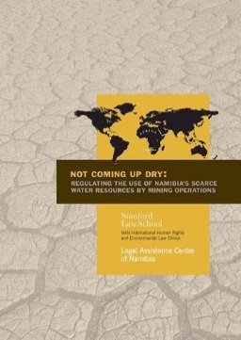 | Not Coming Up Dry:  Regulating the Use of Namibia’s Scarce Water Resources by Mining Operations  (2009)

Mining

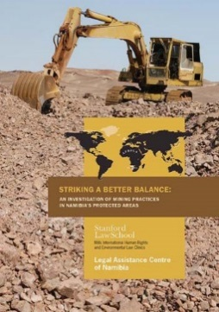 | Striking a Better Balance:  An Investigation of Mining Practices in Namibia’s Protected Areas  (2009)
www.lac.org.na/pup/publications.php | Written Paper  Mining vs the Environment:  Does Namibia need another mine?  (2005)

Community-Based Natural Resource Management (CBNRM)

http://www.lac.org.na/pub/publications.php | Written Paper  Legislation and Policies Affecting Community-Based Natural Resources Management in Namibia  (1996)  .
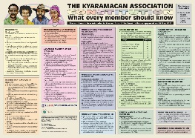 | POSTERS (A1)  A series of seven posters summarising the constitutions of seven community-based conservancies in northern Namibia  (LEAD and IRDNC, 2013)

Support for Marginalised Indigenous Peoples

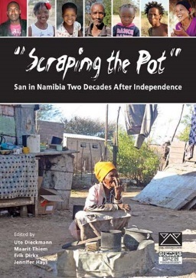 |  | “Scraping the Pot”: San in Namibia  Two Decades After Independence  (2014)
Born in Etosha:
Homage to the cultural heritage of the Hai//om
(2009)

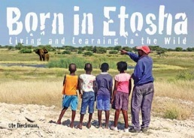 |  | Born in Etosha:  Living and Learning in the Wild  (2012)
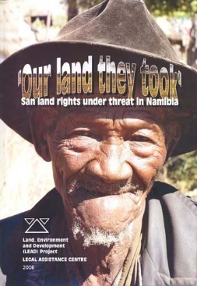 |  | “Our land they took”:  San land rights under threat in Namibia  (2006)
http://www.lac.org.na/pub/publications.php |  | Research Paper:  “San Communal Lands Contested:  The battle over N‡a Jaqna Conservancy”  (2006)
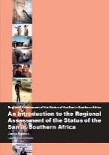 | 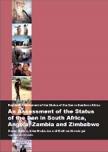 |  | 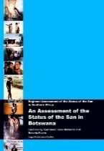 | 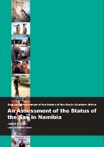 | 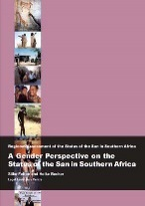
Regional Assessment of the Status of the
San in Southern Africa – Report Series
(2001)

1. An Introduction to the Regional Assessment of the Status of the San in Southern Africa
2. An Assessment of the Status of the San in South Africa, Angola, Zambia and Zimbabwe
3. An Assessment of the Status of the San in Botswana
4. An Assessment of the San in Namibia
5. A Gender Perspective on the Status of the San in Southern Africa

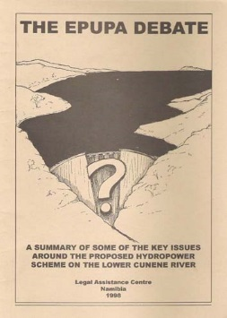 |  | The Epupa Debate:  A summary of some of the key issues  around the proposed hydropower scheme  on the lower Cunene River  (1998)

