Fourth Schedule

[The Fourth Schedule was originally the International Convention respecting Load Lines, 1930. It was substituted by the International Convention on Load Lines, 1966 (RSA Proc. R.280 of 1968, as amended by RSA Proc. R.209 of 1972).]

INTERNATIONAL CONVENTION ON LOAD LINES, 1966

[Namibia acceded to the Convention on 22 February 2002, and it became binding on Namibia on 22 May 2002 (Article 28(3) of the Convention).

The depositary for the Convention is the Secretary-General of the International Maritime Organization (IMO). This body was previously known as the Inter-Governmental Maritime Consultative Organization. The name was changed to “International Maritime Organization” by virtue of amendments to the Convention which established the Organisation, with these amendments taking effect on 22 May 1982.

The authentic text deposited with the IMO does not appear to be accessible online. A reliable text of the Convention can be found on the United Nations Treaty Series website at <https://treaties.un.org/doc/Publication/UNTS/Volume%20640/volume-640-I-9159-English.pdf>.

The Convention provides for amendments to be made by positive acceptance, with such amendments coming into force 12 months after being accepted by two-thirds of the Contracting Parties. Amendments were proposed in 1971, 1975, 1979, 1983 and 1995 (with the last-mentioned being later superseded by the 2003 amendments to the 1988 Protocol), but none of these has received enough acceptances to enter into force internationally. (Namibia did not agree to the 1971, 1975, 1979, 1983 or 1995 amendments to the Convention.) The Protocol of 1988 relating to the International Convention on Load Lines, 1966 introduced a new tacit amendment procedure, applicable to those parties bound by the Protocol. The Convention was subsequently amended in 2005, with these amendments having come into force internationally on 3 February 2010. Other amendments to the Convention agreed to in terms of the new tacit amendment procedure are set to come into force in the future.

Namibia is a party to the Protocol of 1988 relating to the International Convention on Load Lines, 1966. Namibia acceded to this Protocol on 22 February 2002 (source: IMO), and it became binding on Namibia on 22 May 2002 (Article V(3) of the Protocol). Annex B of the Protocol of 1988 was amended in 2003, with these amendments having come into force internationally on 1 January 2005. Namibia is bound by these amendments, having not objected to them in terms of the new procedure of tacit acceptance introduced by that Protocol. According to the IMO, these amendments amount to a comprehensive revision of the technical regulations of the original Load Lines Convention for ships flying the flags of States which are party to the Protocol. There are also a number of other amendments to the Protocol of 1988, many of which have already come into force internationally. The Protocol of 1988 and its amendments are not reflected in this Schedule.

For up-to-date information on amendments to the Convention and to the Protocol of 1988, consult the IMO website at <www.imo.org/en/About/Conventions/StatusOfConventions/Pages/Default.aspx>.

The text presented below follows the Government Gazette in cases where it differs from the Convention. The Convention inconsistently uses both hyphenated and unhyphenated forms of the word “subparagraph” while the Gazette uses the hyphenated word “sub-paragraph” throughout. The Convention uses the one-word term “companionway”, while the Gazette uses the two-word term “companion way”. The Gazette uses the terms “waterline” and “water line” interchangeably, where the Convention uses only the one-word term “waterline”. The Convention always prefaces lists with a colon, whereas the Gazette uses dashes and colons interchangeably to preface lists. Both the Convention and the Gazette separate list items with full stops and semi-colons interchangeably. Likewise, both the Convention and the Gazette sometimes capitalise the first word of a list item, and sometimes omit such capitalisation. The Convention and the Gazette place figures in different locations; figures are placed here where they appear in the Gazette. When the Convention references a figure, it sometimes provides a page number reference, which the Gazette omits. When referencing a ship type, the Gazette places the relevant classification letter in quotation marks and capitalises the letter “T” (for example: Type “A”); the Convention omits the quotation marks around the classification letter and is inconsistent in its use of capitalisation (for example: Type A, type A). The Gazette interchangeably utilises both full stops and the marks “·” as decimal points, while the Convention interchangeably utilises full stop and commas as decimal points. These discrepancies have not been individually annotated. There are also a few other minor differences in format between the Convention and the Gazette which are inconsequential and have not been annotated.

The source of the amendments made by RSA Proc. R.209 of 1972 is unclear. Some versions of the Convention text sourced online incorporate some of the same amendments, but their origin could not be ascertained.]

The Contracting Governments,

Desiring to establish uniform principles and rules with respect to the limits to which ships on international voyages may be loaded having regard to the need for safeguarding life and property at sea;

Considering that this end may best be achieved by conclusion of a Convention;

Have Agreed as follows:

Article 1

General Obligation under the Convention

(1) The Contracting Governments undertake to give effect to the provisions of the present Convention and the Annexes hereto, which shall constitute an integral part of the present Convention. Every reference to the present Convention constitutes at the same time a reference to the Annexes.

(2) The Contracting Governments shall undertake all measures which may be necessary to give effect to the present Convention.

Article 2

Definitions

For the purpose of the present Convention, unless expressly provided otherwise:

(1) “Regulations” means the Regulations annexed to the present Convention.

(2) “Administration” means the Government of the State whose flag the ship is flying.

(3) “Approved” means approved by the Administration.

(4) “International voyage” means a sea voyage from a country to which the present Convention applies to a port outside such country, or conversely. For this purpose, every territory for the international relations of which a Contracting Government is responsible or for which the United Nations are the administering authority is regarded as a separate country.

(5) A “fishing vessel” is a ship used for catching fish, whales, seals, walrus or other living resources of the sea.

(6) “New ship” means a ship the keel of which is laid, or which is at a similar stage of construction, on or after the date of coming into force of the present Convention for each Contracting Government.

(7) “Existing ship” means a ship which is not a new ship.

(8) “Length” means 96 per cent of the total length on a waterline at 85 per cent of the least moulded depth measured from the top of the keel, or the length from the fore side of the stem to the axis of the rudder stock on that waterline, if that be greater. In ships designed with a rake of keel the waterline on which this length is measured shall be parallel to the designed waterline.

Article 3

General Provisions

(1) No ship to which the present Convention applies shall proceed to sea on an international voyage after the date on which the present Convention comes into force unless it has been surveyed, marked and provided with an International Load Line Certificate (1966) or, where appropriate, an International Load Line Exemption Certificate in accordance with the provisions of the present Convention.

(2) Nothing in this Convention shall prevent an Administration from assigning a greater freeboard than the minimum freeboard determined in accordance with Annex

[Paragraph (2) of the Convention ends with “Annex I.”; the Government Gazette
omits the Roman numeral “I” and the full stop, as reproduced above.]

Article 4

Application

(1) The present Convention shall apply to -

(a) ships registered in countries the Governments of which are Contracting Governments;

(b) ships registered in territories to which the present Convention is extended under Article 32; and

(c) unregistered ships flying the flag of a State, the Government of which is a Contracting Government.

(2) The present Convention shall apply to ships engaged on international voyages.

(3) The Regulations contained in Annex I are specifically applicable to new ships.

(4) Existing ships which do not fully comply with the requirements of the Regulations contained in Annex I or any part thereof shall meet at least such lesser related requirements as the Administration applied to ships on international voyages prior to the coming into force of the present Convention; in no case shall such ships be required to increase their freeboards. In order to take advantage of any reduction in freeboard from that previously assigned, existing ships shall comply with all the requirements of the present Convention.

(5) The Regulations contained in Annex II are applicable to new and existing ships to which the present Convention applies.

Article 5

Exceptions

(1) The present Convention shall not apply to ­

(a) ships of war;

(b) new ships of less than 24 metres (79 feet) in length;

(c) existing ships of less than 150 tons gross:

(d) pleasure yachts not engaged in trade;

(e) fishing vessels.

(2) Nothing herein shall apply to ships solely navigating -

(a) the Great Lakes of North America and the River St. Lawrence as far east as a rhumb line drawn from Cap des Rosiers to West Point, Anticosti Island, and, on the north side of Anticosti Island, the meridian of longitude 63° W;

(b) the Caspian Sea;

(c) the Plate, Parana and Uruguay Rivers as far east as a rhumb line drawn between Punta Norte, Argentina, and Punta del Este, Uruguay.

Article 6

Exemptions

(1) Ships when engaged on international voyages between the near neighbouring ports of two or more States may be exempted by the Administration from the provisions of the present Convention, so long as they shall remain engaged on such voyages, if the Governments of the States in which such ports are situated shall be satisfied that the sheltered nature or conditions of such voyages between such ports make it unreasonable or impracticable to apply the provisions of the present Convention to ships engaged on such voyages.

(2) The Administration may exempt any ship which embodies features of a novel kind from any of the provisions of this Convention the application of which might seriously impede research into the development of such features and their incorporation in ships enagaged on international voyages. Any such ship shall, however, comply with safety requirements which, in the opinion of that Administration, are adequate for the service for which it is intended and are such as to ensure the overall safety of the ship and which are acceptable to the Governments of the States to be visited by the ship.

[The word “engaged” is misspelt in the Government Gazette,
as reproduced above. It is spelt correctly in the Convention.]

(3) The Administration which allows any exemption under paragraphs (1) and (2) of this Article shall communicate to the Inter-Governmental Maritime Consultative Organization (hereinafter called the Organization) particulars of the same and reasons therefor which the Organization shall circulate to the Contracting Governments for their information.

[The Convention has quotation marks around the phrase “the Organization” where it
appears inside the brackets. The Government Gazette omits these quotation marks.]

(4) A ship which is not normally engaged on international voyages but which, in exceptional circumstances, is required to undertake a single international voyage may be exempted by the Administration from any of the requirements of the present Convention, provided that it complies with safety requirements which, in the opinion of that Administration, are adequate for the voyage which is to be undertaken by the ship.

Article 7

Force Majeure

(1) A ship which is not subject to the provisions of the present Convention at the time of its departure on any voyage shall not become subject to such provisions on account of any deviation from its intended voyage due to stress of weather or any other cause of force majeure.

(2) In applying the provisions of the present Convention, the Contracting Government shall give due consideration to any deviation or delay caused to any ship owing to stress of weather or any other cause of force majeure.

[The Convention uses the plural word “Governments”. The Government
Gazette uses the singular word “Government”, as reproduced above.]

Article 8

Equivalents

(1) The Administration may allow any fitting, material, appliance or apparatus to be fitted, or any other provision to be made in a ship, other than that required by the present Convention, if it is satisfied by trial thereof or otherwise that such fitting, material, appliance or apparatus, or provision, is at least as effective as that required by the Convention.

(2) The Administration which allows a fitting, material, appliance or apparatus, or provision, other than that required by the present Convention, shall communicate to the Organization for circulation to the Contracting Governments particulars thereof, together with a report on any trials made.

Article 9

Approvals for Experimental Purposes

(1) Nothing in the present Convention shall prevent an Administration from making specific approvals for experimental purposes in respect of a ship to which the Convention applies.

(2) An Administration which makes any such approval shall communicate to the Organization for circulation to the Contracting Governments particulars thereof.

Article 10

Repairs, Alterations and Modifications

(1) A ship which undergoes repairs, alterations, modifications and outfitting related thereto shall continue to comply with at least the requirements previously applicable to the ship. An existing ship in such a case shall not, as a rule, comply to a lesser extent with the requirements for a new ship than it did before.

(2) Repairs, alterations and modifications of a major character and outfitting related thereto should meet the requirements for a new ship in so far as the Administration deems reasonable and practicable.

Article 11

Zones and Areas

(1) A ship to which the present Convention applies shall comply with the requirements applicable to that ship in the zones and areas described in Annex II.

(2) A port standing on the boundary line between two zones or areas shall be regarded as within the zone or area from or into which the ship arrives or departs.

Article 12

Submersion

(1) Except as provided in paragraphs (2) and (3) of this Article, the appropriate load lines on the sides of the ship corresponding to the season of the year and the zone or area in which the ship may be shall not be submerged at any time when the ship puts to sea, during the voyage or on arrival.

(2) When a ship is in fresh water of unit density the appropriate load line may be submerged by the amount of the fresh water allowance shown on the International Load Line Certificate (1966). Where the density is other than unity, an allowance shall be made proportional to the difference between 1.025 and the actual density.

(3) When a ship departs from a port situated on a river or inland waters, deeper loading shall be permitted corresponding to the weight of fuel and all other materials required for consumption between the point of departure and the sea.

Article 13

Survey, Inspection and Marking

The survey, inspection and marking of ships, as regards the enforcement of the provisions of the present Convention and the granting of exemptions therefrom, shall be carried out by officers of the Administration. The Administration may, however, entrust the survey, inspection and marking either to surveyors nominated for the purpose or to organizations recognized by it. In every case the Administration concerned fully guarantees the completeness and efficiency of the survey, inspection and marking.

Article 14

Initial and Periodical Surveys and Inspections

(1) A ship shall be subjected to the surveys and inspections specified below:

(a) A survey before the ship is put in service, which shall include a complete inspection of its structure and equipment in so far as the ship is covered by the present Convention. This survey shall be such as to ensure that the arrangements, material, and scantlings fully comply with the requirements of the present Convention.

(b) A periodical survey at intervals specified by the Administration, but not exceeding five years, which shall be such as to ensure that the structure, equipment, arrangements, material and scantlings fully comply with the requirements of the present Convention.

(c) A periodical inspection within three months either way of each annual anniversary date of the certificate, to ensure that alterations have not been made to the hull or superstructures which would affect the calculations determining the position of the load line and so as to ensure the maintenance in an effective condition of fittings and appliances for -

(i) protection of openings;

(ii) guard rails;

(iii) freeing ports; and

(iv) means of access to crew’s quarters.

(2) The periodical inspections referred to in paragraph (1) (c) of this Article shall be endorsed on the International Load Line Certificate 0966) or on the International Load Line Exemption Certificate issued to a ship exempted under paragraph (2) of Article 6 of the present Convention.

Article 15

Maintenance of Conditions after Survey

After any survey of the ship under Article 14 has been completed, no change shall be made in the structure, equipment, arrangements, material or scantlings covered by the survey, without the sanction of the Administration.

Article 16

Issue of Certificates

(1) An International Load Line Certificate (1966) shall be issued to every ship which has been surveyed and marked in accordance with the present Convention.

(2) An International Load Line Exemption Certificate shall be issued to any ship to which an exemption has been granted under and in accordance with paragraph (2) or (4) of Article 6.

(3) Such certificates shall be issued by the Administration or by any person or organization duly authorized by it. In every case, the Administration assumes full responsibility for the certificate.

(4) Notwithstanding any other provision of the present Convention, any international load line certificate which is current when the present Convention comes into force in respect of the Government of the State whose flag the ship is flying shall remain valid for two years or until it expires, whichever is earlier. After that time an International Load Line Certificate (1966) shall be required.

Article 17

Issue of Certificate by another Government

(1) A Contracting Government may, at the request of another Contracting Government, cause a ship to be surveyed and, if satisfied that the provisions of the present Convention are complied with, shall issue or authorize the issue of an International Load Line Certificate (1966) to the ship in accordance with the present Convention.

(2) A copy of the certificate, a copy of the survey report used for computing the freeboard, and a copy of the computations shall be transmitted as early as possible to the requesting Government.

(3) A certificate so issued must contain a statement to the effect that it has been issued at the request of the Government of the State whose flag the ship is or will be flying and it shall have the same force and receive the same recognition as a certificate issued under Article 16.

(4) No International Load Line Certificate (1966) shall be issued to a ship which is flying the flag of a State the Government of which is not a Contracting Government.

Article 18

Form of Certificates

(1) The certificates shall be drawn up in the official language or languages of the issuing country. If the language used is neither English nor French, the text shall include a translation into one of these languages.

(2) The form of the certificates shall be that of the models given in Annex III. The arrangement of the printed part of each model certificate shall be exactly reproduced in any certificates issued, and in any certified copies thereof.

Article 19

Duration of Certificates

(1) An International Load Line Certificate (1966) shall be issued for a period specified by the Administration, which shall not exceed five years from the date of issue.

(2) If, after the periodical survey referred to in paragraph (1) (b) of Article 14, a new certificate cannot be issued to the ship before the expiry of the certificate originally issued, the person or organization carrying out the survey may extend the validity of the original certificate for a period which shall not exceed five months. This extension shall be endorsed on the certificate, and shall be granted only where there have been no alterations in the structure, equipment, arrangements, material or scantlings which affect the ship’s freeboard.

(3) An International Load Line Certificate (1966) shall be cancelled by the Administration if any of the following circumstances exist -

(a) material alterations have taken place in the hull or superstructures of the ship such as would necessitate the assignment of an increased freeboard;

(b) the fittings and applicances mentioned in sub-paragraph (c) of paragraph (1) of Article 14 are not maintained in an effective condition;

[The word “appliances” is misspelt in the Government Gazette,
as reproduced above. It is spelt correctly in the Convention.]

(c) the certificate is not endorsed to show that the ship has been inspected as provided in sub-paragraph (c) of paragraph (1) of Article 14;

(d) the structural strength of the ship is lowered to such an extent that the ship is unsafe.

(4) (a) The duration of an International Load Line Exemption Certificate issued by an Administration to a ship exempted under paragraph (2) of Article 6 shall not exceed five years from the date of issue. Such certificate shall be subject to a renewal, endorsement and cancellation procedure similar to that provided for an International Load Line Certificate (1966) under this Article.

(b) The duration of an International Load Line Exemption Certificate issued to a ship exempted under paragraph (4) of Article 6 shall be limited to the single voyage for which it is issued.

(5) A certificate issued to a ship by an Administration shall cease to be valid upon the transfer of such a ship to the flag of another State.

Article 20

Acceptance of Certificates

The certificates issued under the authority of a Contracting Government in accordance with the present Convention shall be accepted by the other Contracting Governments and regarded for all purposes covered by the present Convention as having the same force as certificates issued by them.

Article 21

Control

(1) Ships holding a certificate issued under Article 16 or Article 17 are subject, when in the ports of other Contracting Governments, to control by officers duly authorized by such Governments. Contracting Governments shall ensure that such control is exercised as far as is reasonable and practicable with a view to verifying that there is on board a valid certificate under the present Convention. If there is a valid International Load Line Certificate (1966) on board the ship, such control shall be limited to the purpose of determining that -

(a) the ship is not loaded beyond the limits allowed by the certificate;

(b) the position of the load line of the ship corresponds with the certificate; and

(c) the ship has not been so materially altered in respect to the matters set out in sub-paragraphs (a) and (b) of paragraph (3) of Article 19 that the ship is manifestly unfit to proceed to sea without danger to human life.

If there is a valid International Load Line Exemption Certificate on board, such control shall be limited to the purpose of determining that any conditions stipulated in that certificate are complied with.

(2) If such control is exercised under sub-paragraph (c) of paragraph (1) of this Article, it shall only be exercised in so far as may be necessary to ensure that the ship shall not sail until it can proceed to sea without danger to the passengers or the crew.

(3) In the event of the control provided for in this Article giving rise to intervention of any kind, the officer carrying out the control shall immediately inform in writing the Consul or the diplomatic representative of the State whose flag the ship is flying of this decision and of all the circumstances in which intervention was deemed to be necessary.

Article 22

Privileges

The privileges of the present Convention may not be claimed in favour of any ship unless it holds a valid certificate under the Convention.

Article 23

Casualties

(1) Each Administration undertakes to conduct an investigation of any casualty occurring to ships for which it is responsible and which are subject to the provisions of the present Convention when it judges that such an investigation may assist in determining what changes in the Convention might be desirable.

(2) Each Contracting Government undertakes to supply the Organization with the pertinent information concerning the findings of such investigations. No reports or recommendations of the Organization based upon such information shall disclose the identity or nationality of the ships concerned or in any manner fix or imply responsibility upon any ship or person.

Article 24

Prior Treaties and Conventions

(1) All other treaties, conventions and arrangements relating to load line matters at present in force between Governments parties to the present Convention shall continue to have full and complete effect during the terms thereof as regards -

(a) ships to which the present Convention does not apply; and

(b) ships to which the present Convention applies, in respect of matters for which it has not expressly provided.

(2) To the extent, however, that such treaties, conventions or arrangements conflict with the provisions of the present Convention, the provisions of the present Convention shall prevail.

Article 25

Special Rules drawn up by Agreement

When in accordance with the present Convention special rules are drawn up by agreement among all or some of the Contracting Governments, such rules shall be communicated to the Organization for circulation to all Contracting Governments.

Article 26

Communication of Information

(1) The Contracting Governments undertake to communicate to and deposit with the Organization -

(a) a sufficient number of specimens of their certificates issued under the provisions of the present Convention for circulation to the Contracting Governments;

(b) the text of the laws, decrees, orders, regulations and other instruments which shall have been promulgated on the various matters within the scope of the present Convention; and

(c) a list of non-governmental agencies which are authorized to act in their behalf in the administration of load line matters for circulation to the Contracting Governments.

(2) Each Contracting Government agrees to make its strength standards available to any other Contracting Government, upon request.

Article 27

Signature, Acceptance and Accession

(1) The present Convention shall remain open for signature for three months from 5 April, 1966, and shall thereafter remain open for accession. Governments of States members of the United Nations, or of any of the Specialized Agencies, or of the International Atomic Energy Agency, or parties to the Statute of the International Court of Justice may become parties to the Convention by -

[The Government Gazette has commas after the words “April”
and “1966” which are not present in the Convention.]

(a) signature without reservation as to acceptance;

(b) signature subject to acceptance followed by acceptance; or

(c) accession.

(2) Acceptance or accession shall be effected by the deposit of an instrument of acceptance or accession with the Organization which shall inform all Governments that have signed the Convention or acceded to it of each new acceptance or accession and of the date of its deposit.

Article 28

Coming into Force

(1) The present Convention shall come into force twelve months after the date on which not less than fifteen Governments of States, including seven each with not less than one million gross tons of shipping, have signed without reservation as to acceptance or deposited instruments of acceptance or accession in accordance with Article 27. The Organization shall inform all Governments which have signed or acceded to the present Convention of the date on which it comes into force.

[Paragraph (1) is amended by RSA Proc. R.209 of 1972 to delete the word
“the” which previously appeared in the phrase ‘Government of the States”,
thus bringing the Schedule in line with the Convention.]

(2) For Governments which have deposited an instrument of acceptance of or accession to the present Convention during the twelve months mentioned in paragraph (1) of this Article, the acceptance or accession shall take effect on the coming into force of the present Convention or three months after the date of deposit of the instrument of acceptance or accession, whichever is the later date.

(3) For Governments which have deposited an instrument of acceptance of or accession to the present Convention after the date on which it comes into force, the Convention shall come into force three months after the date of the desposit of such instrument.

[The word “deposit” is misspelt in the Government Gazette,
as reproduced above. It is spelt correctly in the Convention.]

(4) After the date on which all the measures required to bring an amendment to the present Convention into force have been completed, or all necessary acceptances are deemed to have been given under sub-paragraph (b) of paragraph (2) of Article 29 in case of amendment by unanimous acceptance, any instrument of acceptance or accession deposited shall be deemed to apply to the Convention as amended.

Article 29

Amendments

(1) The present Convention may be amended upon the proposal of a Contracting Government by any of the procedures specified in this Article.

(2) Amendment by unanimous acceptance:

(a) Upon the request of a Contracting Government, any amendment proposed by it to the present Convention shall be communicated by the Organization to all Contracting Governments for consideration with a view to unanimous acceptance.

(b) Any such amendment shall enter into force twelve months after the date of its acceptance by all Contracting Governments unless an earlier date is agreed upon. A Contracting Government which does not communicate its acceptance or rejection of the amendment to the Organization within three years of its first communication by the latter shall be deemed to have accepted the amendment.

(c) Any proposed amendment shall be deemed to be rejected if it is not accepted under sub-paragraph (b) of the present paragraph within three years after it has been first communicated to all Contracting Governments by the Organization.

(3) Amendment after consideration in the Organization:

(a) Upon the request of a Contracting Government, any amendment proposed by it to the present Convention will be considered in the Organization. If adopted by a majority of two-thirds of those present and voting in the Maritime Safety Committee of the Organization, such amendment shall be communicated to all Members of the Organization and all Contracting Governments at least six months prior to its consideration by the Assembly of the Organization.

(b) If adopted by a two-thirds majority of those present and voting in the Assembly, the amendment shall be communicated by the Organization to all Contracting Governments for their acceptance.

(c) Such amendment shall come into force twelve months after the date on which it is accepted by two-thirds of the Contracting Governments. The amendment shall come into force with respect to all Contracting Governments except those which, before it comes into force, make a declaration that they do not accept the amendment.

(d) The Assembly, by a two-thirds majority of those present and voting, including two-thirds of the Governments represented on the Maritime Safety Committee and present and voting in the Assembly, may propose a determination at the time of its adoption that an amendment is of such an important nature that any Contracting Government which makes a declaration under sub-paragraph (c), and which does not accept the amendment within a period of twelve months after it comes into force, shall cease to be a party to the present Convention upon the expiry of that period. This determination shall be subject to the prior acceptance of two-thirds of the Contracting Governments to the present Convention.

(e) Nothing in this paragraph shall prevent the Contracting Government which first proposed action under this paragraph on an amendment to the present Convention from taking at any time such alternative action as it deems desirable in accordance with paragraph (2) or (4) of this Article.

(4) Amendment by a conference:

(a) Upon the request of a Contracting Government, concurred in by at least one-third of the Contracting Governments, a conference of Governments will be convened by the Organization to consider amendments to the present Convention.

(b) Every amendment adopted by such a conference by a two-thirds majority of those present and voting of the Contracting Governments shall be communicated by the Organization to all Contracting Governments for their acceptance.

(c) Such amendment shall come into force twelve months after the date on which it is accepted by two-thirds of the Contracting Governments. The amendment shall come into force with respect to all Contracting Governments except those which, before it comes into force, make a declaration that they do not accept the amendment.

(d) By a two-thirds majority of those present and voting, a conference convened under sub-paragraph (a) may determine at the time of its adoption that an amendment is of such an important nature that any Contracting Government which makes a declaration under sub-paragraph (c), and which does not accept the amendment within a period of twelve months after it comes into force, shall cease to be a party to the present Convention upon the expiry of that period.

(5) Any amendments to the present Convention made under this Article which relate to the structure of a ship shall apply only to ships the keels of which are laid, or which are at a similar stage of construction, on or after the date on which the amendment comes into force.

(6) The Organization shall inform all Contracting Governments of any amendments which come into force under this Article, together with the date on which each such amendment will come into force.

(7) Any acceptance or declaration under this Article shall be made by a notification in writing to the Organization which shall notify all Contracting Governments of the receipt of the acceptance or declaration.

Article 30

Denunciation

(1) The present Convention may be denounced by any Contracting Government at any time after the expiry of five years from the date on which the Convention comes into force for that Government.

(2) Denunciation shall be effected by a notification in writing addressed to the Organization which shall inform all the other Contracting Governments of any such notification received and of the date of its receipt.

(3) A denunciation shall take effect one year, or such longer period as may be specified in the notification, after its receipt by the Organization.

Article 31

Suspension

(1) In case of hostilities or other extraordinary circumstances which affect the vital interests of a State the Government of which is a Contracting Government, that Government may suspend the operation of the whole or any part of the present Convention. The suspending Government shall immediately give notice of any such suspension to the Organization.

(2) Such suspension shall not deprive other Contracting Governments of any right of control under the present Convention over the ships of the suspending Government when such ships are within their ports.

(3) The suspending Government may at any time terminate such suspension and shall immediately give notice of such termination to the Organization.

(4) The Organization shall notify all Contracting Governments of any suspension or termination of suspension under this Article.

Article 32

Territories

(1) (a) The United Nations, in cases where they are the administering authority for a territory, or any Contracting Government responsible for the international relations of a territory, shall as soon as possible consult with such territory in an endeavour to extend the present Convention to that territory and may at any time by notification in writing to the Organization declare that the present Convention shall extend to such territory.

(b) The present Convention shall, from the date of the receipt of the notification or from such other date as may be specified in the notification, extend to the territory named therein.

(2) (a) The United Nations, or any Contracting Government which has made a declaration under sub-paragraph (a) of paragraph (1) of this Article, at any time after the expiry of a period of five years from the date on which the Convention has been so extended to any territory, may by notification in writing to the Organization declare that the present Convention shall cease to extend to any such territory named in the notification.

(b) The present Convention shall cease to extend to any territory mentioned in such notification one year, or such longer period as may be specified therein, after the date of receipt of the notification by the Organization.

(3) The Organization shall inform all the Contracting Governments of the extension of the present Convention to any territories under paragraph (1) of this Article, and of the termination of any such extension under the provisions of paragraph (2), stating in each case the date from which the present Convention has been or will cease to be so extended.

Article 33

Registration

(1) The present Convention shall be deposited with the Organization and the Secretary-General of the Organization shall transmit certified true copies thereof to all Signatory Governments and to all Governments which accede to the present Convention.

(2) As soon as the present Convention comes into force it shall be registered by the Organization in accordance with Article 102 of the Charter of the United Nations.

Article 34

Languages

The present Convention is established in a single copy in the English and French languages, both texts being equally authentic. Official translations in the Russian and Spanish languages shall be prepared and deposited with the signed original.

IN WITNESS WHEREOF the undersigned being duly authorized by their respective Governments for that purpose have signed the present Convention.

Done at London this fifth day of April, 1966.

[The Government Gazette places a comma after “April” which is not present in the Convention.]

ANNEX I

REGULATIONS FOR DETERMINING LOAD LINES

CHAPTER I—GENERAL

The Regulations assume that the nature and stowage of the cargo, ballast, etc., are such as to secure sufficient stability of the ship and the avoidance of excessive structural stress.

The Regulations also assume that where there are international requirements relating to stability or subdivision, these requirements have been complied with.

Regulation 1

Strength of Hull

The Administration shall satisfy itself that the general structural strength of the hull is sufficient for the draught corresponding to the freeboard assigned. Ships built and maintained in conformity with the requirements of a classification society recognized by the Administration may be considered to possess adequate strength.

Regulation 2

Application

(1) Ships with mechanical means of propulsion or lighters, barges or other ships without independent means of propulsion, shall be assigned freeboards in accordance with the provisions of Regulations 1-40 inclusive of this Annex.

(2) Ships carrying timber deck cargoes may be assigned, in addition to the freeboards prescribed in paragraph (1) of this Regulation, timber freeboards in accordance with the provisions of Regulations 41-45 inclusive of this Annex.

[Paragraph (2) is amended by RSA Proc. R.209 of 1972 to insert the
word “inclusive”, thus bringing the Schedule in line with the Convention.]

(3) Ships designed to carry sail, whether as the sole means of propulsion or as a supplementary means, and tugs, shall be assigned freeboards in accordance with the provisions of Regulations 1-40 inclusive of this Annex. Such additional freeboard shall be required as determined by the Administration.

(4) Ships of wood or of composite construction, or of other materials the use of which the Administration has approved, or ships whose constructional features are such as to render the application of the provisions of this Annex unreasonable or impracticable, shall be assigned freeboards as determined by the Administration.

(5) Regulations 10 to 26 inclusive of this Annex shall apply to every ship to which a minimum freeboard is assigned. Relaxations from these requirements may be granted to a ship to which a greater than minimum freeboard is assigned on condition that the Administration is satisfied with the safety conditions provided.

Regulation 3

[The Convention incorrectly labels Regulation 3 as “Regulation 2”;
the Government Gazette labels Regulation 3 correctly, as reproduced above.]

Definitions of Terms used in the Annexes

(1) Length. The length (L) shall be taken as 96 per cent of the total length on a waterline at 85 per cent of the least moulded depth measured from the top of the keel, or as the length from the fore side of the stem to the axis of the rudder stock on that waterline, if that be greater. In ships designed with a rake of keel the waterline on which this length is measured shall be parallel to the designed waterline.

(2) Perpendiculars. The forward and after perpendiculars shall be taken at the forward and after ends of the length (L). The forward perpendicular shall coincide with the foreside of the stem on the waterline on which the length is measured.

(3) Amidships. Amidships is at the middle of the length (L).

(4) Breadth. Unless expressly provided otherwise, the breadth (B) is the maximum breadth of the ship, measured amidships to the moulded line of the frame in a ship with a metal shell and to the outer surface of the hull in a ship with a shell of any other material.

(5) Moulded Depth:

(a) The moulded depth is the vertical distance measured from the top of the keel to the top of the freeboard deck beam at side. In wood and composite ships the distance is measured from the lower edge of the keel rabbet. Where the form at the lower part of the midship section is of a hollow character, or where thick garboards are fitted, the distance is measured from the point where the line of the flat of the bottom continued inwards cuts the side of the keel.

(b) In ships having rounded gunwales, the moulded depth shall be measured to the point of intersection of the moulded lines of the deck and side shell plating, the lines extending as though the gunwale were of angular design.

(c) Where the freeboard deck is stepped and the raised part of the deck extends over the point at which the moulded depth is to be determined, the moulded depth shall be measured to a line of reference extending from the lower part of the deck along a line parallel with the raised part.

(6) Depth for Freeboard (D):

(a) The depth for freeboard (D) is the moulded depth amidships, plus the thickness of the freeboard deck stringer plate, where fitted, plus $\frac{\text{T(L-S)}}{\text{L}}$ if the exposed freeboard deck is sheathed, where

T is the mean thickness of the exposed sheathing clear of deck openings, and

S is the total length of superstructures as defined in sub-paragraph (10) (d) of this Regulation.

(b) The depth for freeboard (D) in a ship having a rounded gunwale with a radius greater than 4 per cent of the breadth (B) or having topsides of unusual form is the depth for freeboard of a ship having a midship section with vertical topsides and with the same round of beam and area of topside section equal to that provided by the actual midship section.

(7) Block Coefficient. The block coefficient (Cb) is given by $\text{C}\text{b} \text{= }\frac{\text{∇}}{\text{L.B.d}\text{1}}$; where

∇ is the volume of the moulded displacement of the ship, excluding bossing, in a ship with a metal shell, and is the volume of displacement to the outer surface of the hull in a ship with a shell of any other material, both taken at a moulded draught of d₁; and where
d₁ is 85 per cent of the least moulded depth.

(8) Freeboard. The freeboard assigned is the distance measured vertically downwards amidships from the upper edge of the deck line to the upper edge of the related load line.

(9) Freeboard Deck. The freeboard deck is normally the uppermost complete deck exposed to weather and sea, which has permanent means of closing all openings in the weather part thereof, and below which all openings in the sides of the ship are fitted with permanent means of watertight closing. In a ship having a discontinuous freeboard deck, the lowest line of the exposed deck and the continuation of that line parallel to the upper part of the deck is taken as the freeboard deck. At the option of the owner and subject to the approval of the Administration, a lower deck may be designated as the freeboard deck, provided it is a complete and permanent deck continuous in a fore and aft direction at least between the machinery space and peak bulkheads and continuous athwartships. When this lower deck is stepped the lowest line of the deck and the continuation of that line parallel to the upper part of the deck is taken as the freeboard deck. When a lower deck is designated as the freeboard deck, that part of the hull which extends above the freeboard deck is treated as a superstructure so far as concerns the application of the conditions of assignment and the calculation of freeboard. It is from this deck that the freeboard is calculated.

(10) Superstructure:

(a) A superstructure is a decked structure on the freeboard deck, extending from side to side of the ship or with the side plating not being inboard of the shell plating more than 4 per cent of the breadth (B). A raised quarter-deck is regarded as a superstructure.

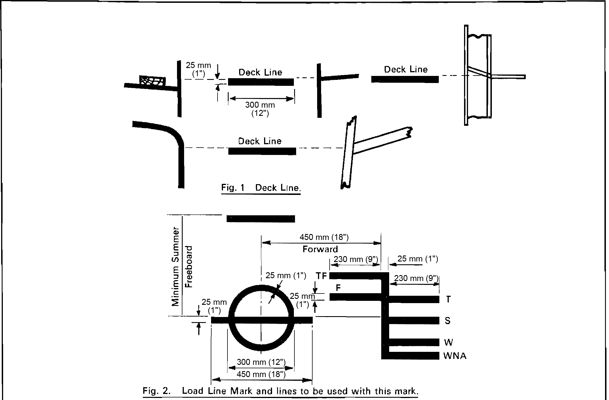

[Figures 1 and 2 are amended by RSA Proc. R.209 of 1972 to give measurements
in millimetres as well as inches The Convention provides measurements only in inches.]
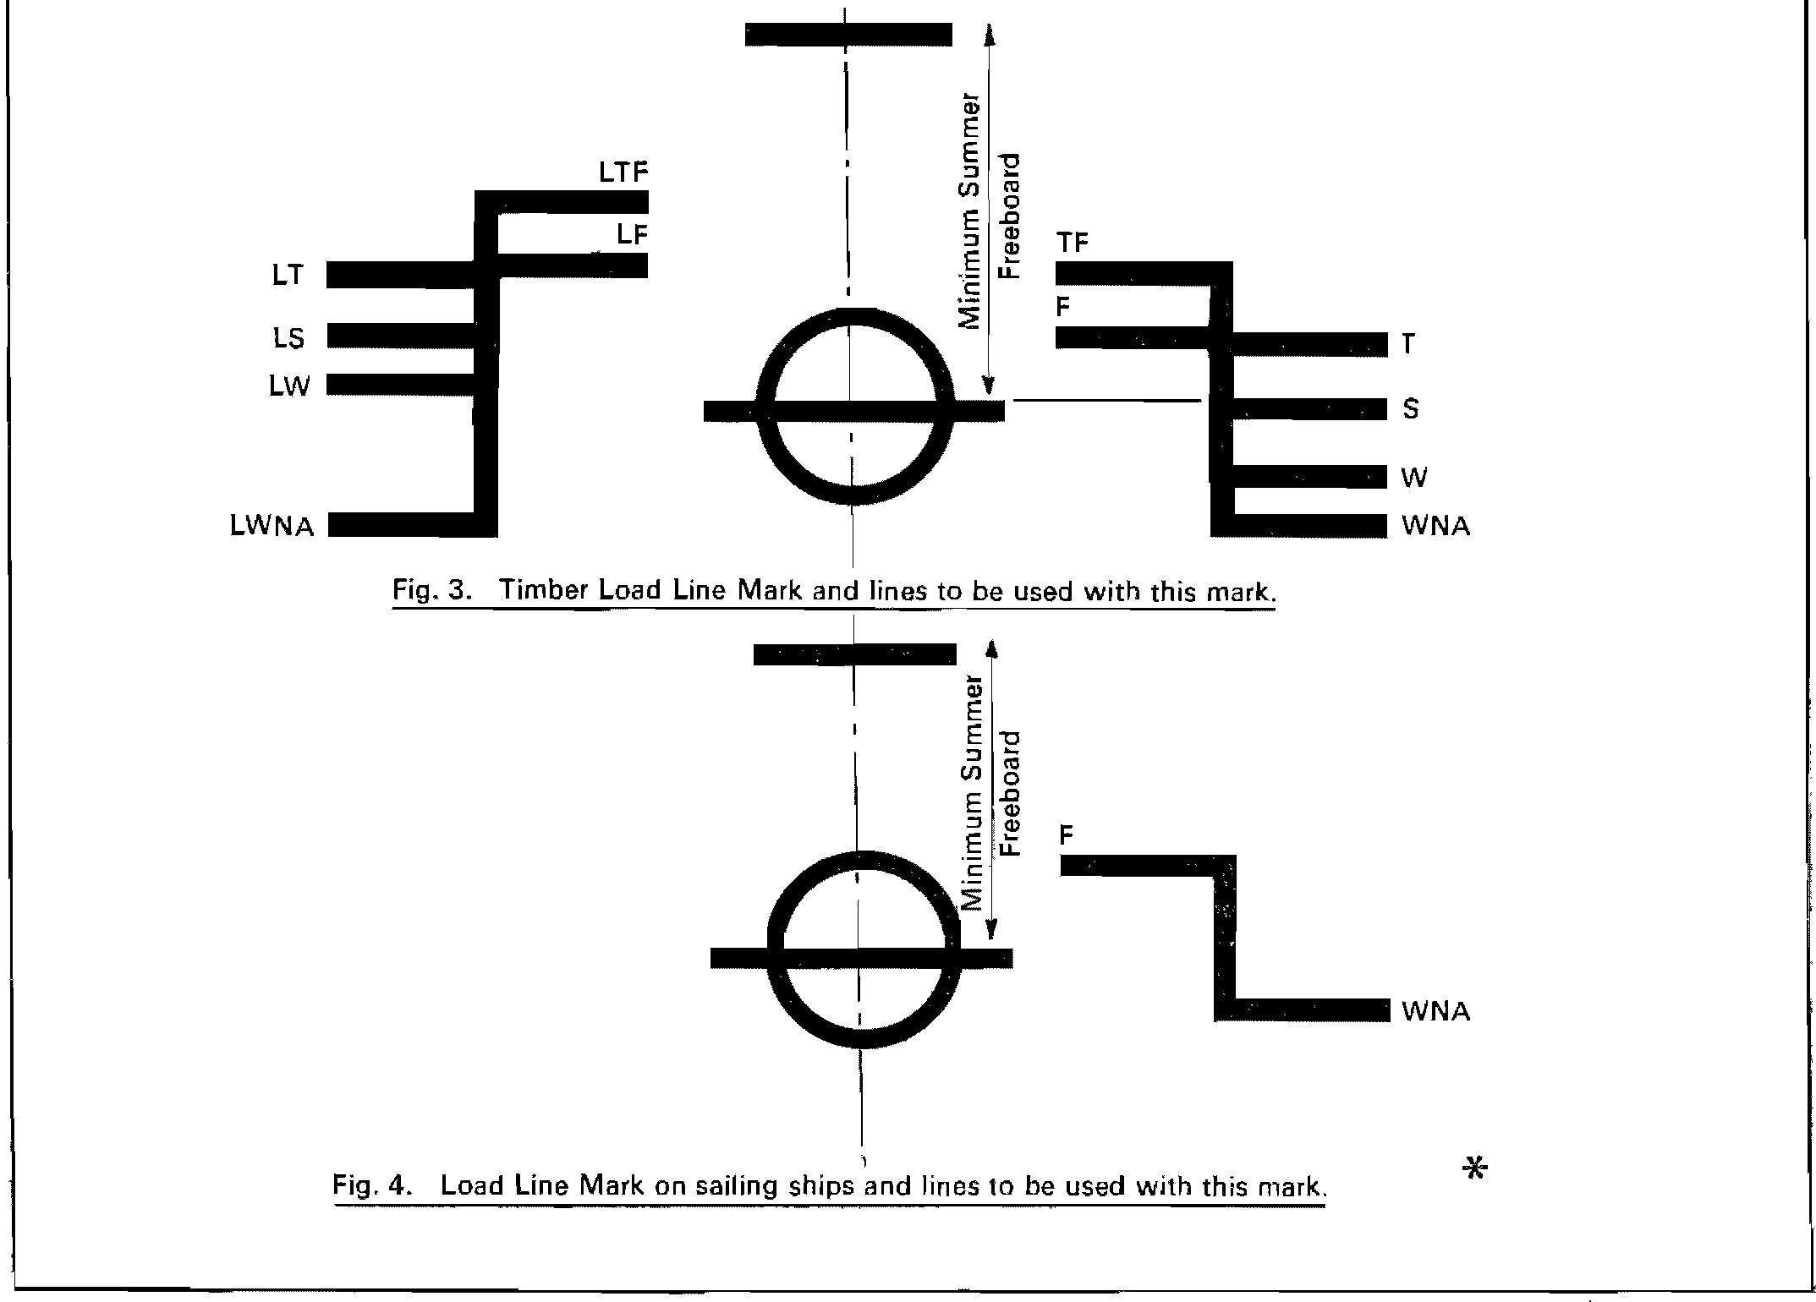

[The asterisk at Figure 4 does not have an accompanying note in the
Government Gazette, and the Convention has no such asterisk.]

(b) An enclosed superstructure is a superstructure with:

(i) enclosing bulkheads of efficient construction.

(ii) access openings, if any, in these bulkheads fitted with doors complying with the requirements of Regulation 12;

(iii) all other openings in sides or ends of the superstructure fitted with efficient weathertight means of closing.

A bridge or poop shall not be regarded as enclosed unless access is provided for the crew to reach machinery and other working spaces inside these superstructures by alternative means which are available at all times when bulkhead openings are closed.

(c) The height of a superstructure is the least vertical height measured at side from the top of the superstructure deck beams to the top of the freeboard deck beams.

(d) The length of a superstructure (S) is the mean length of the part of the superstructure which lies within the length (L).

(11) Flush Deck Ship. A flush deck ship is one which has no superstructure on the freeboard deck.

(12) Weathertight. Weathertight means that in any sea conditions water will not penetrate into the ship.

Regulation 4

Deck Line

The deck line is a horizontal line 300 millimetres (12 inches) in length and 25 millimetres (1 inch) in breadth. It shall be marked amidships on each side of the ship, and its upper edge shall normally pass through the point where the continuation outwards of the upper surface of the freeboard deck intersects the outer surface of the shell (as illustrated in Figure 1), provided that the deck line may be placed with reference to another fixed point in the ship on condition that the freeboard is correspondingly corrected. The location of the reference point and the identification of the freeboard deck shall in all cases be indicated on the International Load Line Certificate (1966).

Regulation 5

Load Line M ark

The Load Line Mark shall consist of a ring 300 millimetres (12 inches) in outside diameter and 25 millimetres (l inch) wide which is intersected by a horizontal line 450 millimetres (18 inches) in length and 25 millimetres (1 inch) in breadth, the upper edge of which passes through the centre of the ring. The centre of the ring shall be placed amidships and at a distance equal to the assigned summer freeboard measured vertically below the upper edge of the deck line (as illustrated in Figure 2).

[The Convention places the words in the phrase “The Load Line Mark” in an incorrect
order (“Line The Load Mark”); the Government Gazette places the words
in the correct order, as reproduced above.]

Regulation 6

Lines to be used with the Load Line Mark

(1) The lines which indicate the load line assigned in accordance with these Regulations shall be horizontal lines 230 millimetres (9 inches) in length and 25 millimetres (1 inch) in breadth which extend forward of, unless expressly provided otherwise, and at right angles to, a vertical line 25 millimetres (1 inch) in breadth marked at a distance 540 millimetres (21 inches) forward of the centre of the ring (as illustrated in Figure 2).

(2) The following load lines shall be used:

(a) The Summer Load Line indicated by the upper edge of the line which passes through the centre of the ring and also by a line marked S.

(b) The Winter Load Line indicated by the upper edge of a line marked W.

(c) The Winter North Atlantic Load Line indicated by the upper edge of a line marked WNA.

(d) The Tropical Load Line indicated by the upper edge of a line marked T.

(e) The Fresh Water Load Line in summer indicated by the upper edge of a line marked F. The Fresh Water Load Line in summer is marked abaft the vertical line. The difference between the Fresh Water Load Line in summer and the Summer Load Line is the allowance to be made for loading in fresh water at the other load lines.

(f) The Tropical Fresh Water Load Line indicated by the upper edge of a line marked TF, and marked abaft the vertical line.

[The Convention has a comma after the phrase “The Tropical
Fresh Water Load Line” which is omitted in the Government Gazette.]

(3) If timber freeboards are assigned in accordance with these Regulations, the timber load lines shall be marked in addition to ordinary load lines. These lines shall be horizontal lines 230 millimetres (9 inches) in length and 25 millimetres (1 inch) in breadth which extend abaft unless expressly provided otherwise, and are at right angles to, a vertical line 25 millimetres (1 inch) in breadth marked at a distance 540 millimetres (21 inches) abaft the centre of the ring (as illustrated in Figure 3).

(4) The following timber load lines shall be used:

(a) The Summer Timber Load Line indicated by the upper edge of a line marked LS.

(b) The Winter Timber Load Line indicated by the upper edge of a line marked LW.

(c) The Winter North Atlantic Timber Load Line indicated by the upper edge of a line marked LWNA.

(d) The Tropical Timber Load Line indicated by the upper edge of a line marked LT.

[The Convention has commas after the names of the Lines in subparagraphs
(a), (b), (c) and (d) which are omitted in the Government Gazette.]

(e) The Fresh Water Timber Load Line in summer indicated by the upper edge of a line marked LF and marked forward of the vertical line.
The difference between the Fresh Water Timber Load Line in summer and the Summer Timber Load Line is the allowance to be made for loading in fresh water at the other timber load lines.

[The Convention incorrectly uses the term “French Water” instead of “Fresh Water”,
and has a comma after the uncapitalised word “summer”. The Government Gazette
uses the correct term “Fresh Water” and omits the comma, as reproduced above.
Additionally, the Convention places the description of the difference between the
Fresh Water Timber Load Line in summer and the Summer Timber Load Line
inside brackets which are omitted in the Government Gazette.]

(f) The Tropical Fresh Water Timber Load Line indicated by the upper edge of a line marked LTF and marked forward of the vertical line.

[Subparagraph (f) is amended by RSA Proc. R.209 of 1972 to replace the words
“The Fresh Water Timber Load Line in the Tropical Zone” with the words
“The Tropical Fresh Water Timber Load Line". The result is to make this
paragraph different from the one in the Convention, which states:

“(f) The Fresh Water Timber Load Line in the Tropical Zone, indicated by upper edge of a line marked LTF and marked forward of the vertical line.” ]

(5) Where the characteristics of a ship or the nature of the ship’s service or navigational limits make any of the seasonal lines inapplicable, these lines may be omitted.

(6) Where a ship is assigned a greater than minimum freeboard so that the load line is marked at a position corresponding to, or lower than, the lowest seasonal load line assigned at minimum freeboard in accordance with the present Convention, only the Fresh Water Load Line need be marked.

(7) On sailing ships only the Fresh Water Load Line and the Winter North Atlantic Load Line need be marked (as illustrated in Figure 4).

(8) Where a Winter North Atlantic Load Line is identical with the Winter Load Line corresponding to the same vertical line, this load line shall be marked W.

(9) Additional load lines required by other international conventions in force may be marked at right angles to and abaft the vertical line specified in paragraph (1) of this Regulation.

Regulation 7

M ark of Assigning Authority

The mark of the Authority by whom the load lines are assigned may be indicated alongside the load line ring above the horizontal line which passes through the centre of the ring, or above and below it. This mark shall consist of not more than four initials to identify the Authority’s name, each measuring approximately 115 millimetres (4½ inches) in height and 75 millimetres (3 inches) in width.

Regulation 8

Details of Marking

The ring, lines and letters shall be painted in white or yellow on a dark ground or in black on a light ground. They shall also be permanently marked on the sides of the ships to the satisfaction of the Administration. The marks shall be plainly visible and, if necessary, special arrangements shall be made for this purpose.

Regulation 9

Verification of M arks

The International Load Line Certificate (1966) shall not be delivered to the ship until the officer or surveyor acting under the provisions of Article 13 of the present Convention has certified that the marks are correctly and permanently indicated on the ship’s sides.

CHAPTER II—CONDITIONS OF
ASSIGNMENT OF FREEBOARD

Regulation 10

Information to be supplied to the Master

(1) The master of every new ship shall be supplied with sufficient information, in an approved form, to enable him to arrange for the loading and ballasting of his ship in such a way as to avoid the creation of any unacceptable stresses in the ship’s structure, provided that this requirement need not apply to any particular length, design of class of ship where the Administration consider it to be unnecessary.

(2) The master of every new ship which is not already provided with stability information under an international convention for the safety of life at sea in force shall be supplied with sufficient information in an approved form to give him guidance as to the stability of the ship under varying conditions of service, and a copy shall be furnished to the Administration.

Regulation 11

Superstructure End Bulkheads

Bulkheads at exposed ends of enclosed superstructures shall be of efficient construction and shall be to the satisfaction of the Administration.

Regulation 12

Doors

(1) All access openings in bulkheads at ends of enclosed superstructures shall be fitted with doors of steel or other equivalent material, permanently and strongly attached to the bulkhead, and framed, stiffened and fitted so that the whole structure is of equivalent strength to the unpierced bulkhead and weathertight when closed. The means for securing these doors weathertight shall consist of gaskets and clamping devices or other equivalent means and shall be permanently attached to the bulkhead or to the doors themselves, and the doors shall be so arranged that they can be operated from both sides of the bulkhead.

(2) Except as otherwise provided in these Regulations, the height of the sills of access openings in bulkheads at ends of enclosed superstructures shall be at least 380 millimetres (15 inches) above the deck.

Regulation 13

Position of Hatchways, Doorways and Ventilators

For the purpose of the Regulations, two positions of hatchways, doorways and ventilators are defined as follows:

Position 1— Upon exposed freeboard and raised quarter decks, and upon exposed superstructure decks situated forward of a point located a quarter of the ship’s length from the forward perpendicular.
Position 2— Upon exposed superstructure decks situated abaft a quarter of the ship’s length from the forward perpendicular.

Regulation 14

Cargo and Other Hatchways

(1) The construction and the means for securing the weathertightness of cargo and other hatchways in positions 1 and 2 shall be at least equivalent to the requirements of Regulations 15 and 16 of this Annex.

(2) Coamings and hatchway covers to exposed hatchways on decks above the superstructure deck shall comply with the requirements of the Administration.

Regulation 15

Hatchways closed by Portable Covers and secured
weathertight by Tarpaulins and Battening Devices

Hatchway Coamings

(1) The coamings of hatchways closed by portable covers secured weathertight by tarpaulins and battening devices shall be of substantial construction, and their height above the deck shall be at least as follows:

600 milimetres (23½ inches) if in position 1.
450 millimetres (17½ inches) if in position 2.

[The word “millimetres” in the phrase “600 millimetres” is misspelt in the
Government Gazette, as reproduced above. It is spelt correctly in the Convention.]

Hatchway Covers

(2) The width of each bearing surface for hatchway covers shall be at least 65 millimetres (2½ inches).

(3) Where covers are made of wood, the finished thickness shall be at least 60 millimetres (2³/₈ inches) in association with a span of not more than 1.5 metres (4.9 feet).

(4) Where covers are made of mild steel the strength shall be calculated with assumed loads not less than 1.75 metric tons per square metre (358 pounds per square foot) on hatchways in position 1, and not less than 1.30 metric tons per square metre (266 pounds per square foot) on hatchways in position 2, and the product of the maximum stress thus calculated and the factor 4.25 shall not exceed the minimum ultimate strength of the material. They shall be so designed as to limit the deflection to not more than 0.0028 times the span under these loads.

(5) The assumed loads on hatchways in position 1 may be reduced to 1 metric ton per square metre (205 pounds per square foot) for ships of 24 metres (79 feet) in length and shall be not less than 1.75 metric tons per square metre (358 pounds per square foot) for ships of 100 metres (328 feet) in length. The corresponding loads on hatchways in position 2 may be reduced to 0.75 metric tons per square metre (154 pounds per square foot) and 1.30 metric tons per square metre (266 pounds per square foot) respectively. In all cases values at intermediate lengths shall be obtained by interpolation.

[Paragraph (5) is amended by RSA Proc. R.209 of 1972 to insert the word “of” before
the terms “24 metres” and “100 metres”. This word does not appear in the Convention.]

Portable beams

(6) Where portable beams for supporting hatchway covers are made of mild steel the strength shall be calculated with assumed loads not less than 1.75 metric tons per square metre (358 pounds per square foot) on hatchways in position 1 and not less than 1.30 metric tons per square metre (266 pounds per square foot) on hatchways in position 2 and the product of the maximum stress thus calculated and the factor 5 shall not exceed the minimum ultimate strength of the material. They shall be so designed as to limit the deflection to not more than 0.0022 times the span under these loads. For ships of not more than 100 metres (328 feet) in length the requirements of paragraph (5) of this Regulation are applicable.

[Paragraph (6) is amended by RSA Proc. R.209 of 1972 to replace the closing phrase “shall be applicable” with the phrase “are applicable”. The Convention says “shall be applicable”.]

Pontoon Covers

(7) Where pontoon covers used in place of portable beams and covers are made of mild steel the strength shall be calculated with the assumed loads given in paragraph (4) of this Regulation, and the product of the maximum stress thus calculated and the factor 5 shall not exceed the minimum ultimate strength of the material. They shall be so designed as to limit the deflection to not more than 0.0022 times the span. Mild steel plating forming the tops of covers shall be not less in thickness than one per cent of the spacing of stiffeners or 6 millimetres (0.24 inches) if that be greater. For ships of not more than 100 metres (328 feet) in length the requirements of paragraph (5) of this Regulation are applicable.

(8) The strength and stiffness of covers made of materials other than mild steel shall be equivalent to those of mild steel to the satisfaction of the Administration.

Carriers or Sockets

(9) Carriers or sockets for portable beams shall be of substantial construction, and shall provide means for the efficient fitting and securing of the beams. Where rolling types of beams are used, the arrangements shall ensure that the beams remain properly in position when the hatchway is closed.

Cleats

(10) Cleats shall be set to fit the taper of the wedges. They shall be at least 65 millimetres (2½ inches) wide and spaced not more than 600 millimetres (23½ inches) centre to centre; the cleats along each side or end shall be not more than 150 millimetres (6 inches) from the hatch corners.

Battens and Wedges

(11) Battens and wedges shall be efficient and in good condition. Wedges shall be of tough wood or other equivalent material. They shall have a taper of not more than 1 in 6 and shall be not less than 13 millimetres (½ inch) thick at the toes.

Tarpaulins

(12) At least two layers of tarpaulin in good condition shall be provided for each hatchway in position 1 or 2. The tarpaulins shall be waterproof and of ample strength. They shall be of a material of at least an approved standard weight and quality.

Security of hatchway covers

(13) For all hatchways in position 1 or 2 steel bars or other equivalent means shall be provided in order efficiently and independently to secure each section of hatchway covers after the tarpaulins are battened down. Hatchway covers of more than 1.5 metres (4.9 feet) in length shall be secured by at least two such securing appliances.

Regulation 16

Hatchways closed by Weathertight Covers of Steel or Other Equivalent
Material fitted with Gaskets and Clamping Devices

Hatchway Coamings

(1) At positions 1 and 2 the height above the deck of hatchway coamings fitted with weathertight hatch covers of steel or other equivalent material fitted with gaskets and clamping devices shall be as specified in Regulation 15(1). The height of these coamings may be reduced, or the coamings omitted entirely, on condition that the Administration is satisfied that the safety of the ship is not thereby impaired in any sea conditions. Where coamings are provided they shall be of substantial construction.

[The Convention has the singular word “position” in paragraph (1) where the
Government Gazette uses the plural word “positions”, as reproduced above.]

Weathertight Covers

(2) Where weathertight covers are of mild steel the strength shall be calculated with assumed loads not less than 1.75 metric tons per square metre (358 pounds per square foot) on hatchways in position 1, and not less than 1.30 metric tons per square metre (266 pounds per square foot) on hatchways in position 2, and the product of the maximum stress thus calculated and the factor of 4.25 shall not exceed the minimum ultimate strength of the material. They shall be so designed as to limit the deflection to not more than 0.0028 times the span under these loads. Mild steel plating forming the tops of covers shall be not less in thickness than one per cent of the spacing of stiffeners or 6 millimetres (0.24 inches) if that be greater. The provisions of Regulation 15(5) are applicable for ships of not more than 100 metres (328 feet) in length.

(3) The strength and stiffness of covers made of materials other than mild steel shall be equivalent to those of mild steel to the satisfaction of the Administration.

Means for Securing Weathertightness

(4) The means for securing and maintaining weathertightness shall be to the satisfaction of the Administration. The arrangements shall ensure that the tightness can be maintained in any sea conditions, and for this purpose tests for tightness shall be required at the initial survey, and may be required at periodical surveys and at annual inspections or at more frequent intervals.

Regulation 17

Machinery Space Openings

(1) Machinery space openings in position 1 or 2 shall be properly framed and efficiently enclosed by steel casings of ample strength, and where the casings are not protected by other structures their strength shall be specially considered. Access openings in such casings shall be fitted with doors complying with the requirements of Regulation 12(1), the sills of which shall be at least 600 millimetres (23½ inches) above the deck if in position 1, and at least 380 millimetres (15 inches) above the deck if in position 2. Other openings in such casings shall be fitted with equivalent covers, permanently attached in their proper positions.

(2) Coamings of any fiddley, funnel or machinery space ventilator in an exposed position on the freeboard or superstructure deck shall be as high above the deck as is reasonable and practicable. Fiddley openings shall be fitted with strong covers of steel or other equivalent material permanently attached in their proper positions and capable of being secured weathertight.

Regulation 18

Miscellaneous Openings in Freeboard and Superstructure Decks

(1) Manholes and flush scuttles in position 1 or 2 or within superstructures other than enclosed superstructures shall be closed by substantial covers capable of being made watertight. Unless secured by closely spaced bolts, the covers shall be permanently attached.

(2) Openings in freeboard decks other than hatchways, machinery space openings, manholes and flush scuttles shall be protected an enclosed superstructure, or by a deckhouse or companion way of equivalent strength and weathertightness. Any such opening in an exposed superstructure deck or in the top of a deckhouse on the freeboard deck which gives access to a space below the freeboard deck or a space within an enclosed superstructure shall be protected by an efficient deckhouse or companion way. Doorways in such deckhouses or companion ways shall be fitted with doors complying with the requirements of Regulation 12(1).

(3) In position 1 the height above the deck of sills to the doorways in companion ways shall be at least 600 millimetres (23½ inches). In position 2 it shall be at least 380 millimetres (15 inches).

Regulation 19

Ventilators

(1) Ventilators in position 1 or 2 to spaces below freeboard decks or decks of enclosed superstructures shall have coamings of steel or other equivalent material, substantially constructed and efficiently connected to the deck. Where the coaming of any ventilator exceeds 900 millimetres (35½ inches) in height it shall be specially supported.

(2) Ventilators passing through superstructures other than enclosed superstructures shall have substantially constructed coamings of steel or other equivalent material at the freeboard deck.

(3) Ventilators in position 1 the coamings of which extend to more than 4.5 metres (14.8 feet) above the deck, and in position 2 the coamings of which extend to more than 2.3 metres (7.5 feet) above the deck, need not be fitted with closing arrangements unless specifically required by the Administration.

(4) Except as provided in paragraph (3) of this Regulation, ventilator openings shall be provided with efficient weathertight closing appliances. In ships of not more than 100 metres (328 feet) in length the closing appliances shall be permanently attached; where not so provided in other ships, they shall be conveniently stowed near the ventilators to which they are to be fitted. Ventilators in position 1 shall have coamings of a height of at least 900 millimetres (35½ inches) above the deck; in position 2 the coamings shall be of a height at least 760 millimetres (30 inches) above the deck.

(5) In exposed positions, the height of coamings may be required to be increased to the satisfaction of the Administration.

Regulation 20

Air Pipes

Where air pipes to ballast and other tanks extend above the freeboard or superstructure decks, the exposed parts of the pipes shall be of substantial construction; the height from the deck to the point where water may have access below shall be at least 760 millimetres (30 inches) on the freeboard deck and 450 millimetres (17½ inches) on the superstructure deck. Where these heights may interfere with the working of the ship, a lower height may be approved, provided the Administration is satisfied that the closing arrangements and other circumstances justify a lower height. Satisfactory means permanently attached, shall be provided for closing the openings of the air pipes.

Regulation 21

Cargo Ports and other similar Openings

(1) Cargo ports and other similar openings in the sides of ships below the freeboard deck shall be fitted with doors so designed as to ensure watertightness and structural integrity commensurate with the surrounding shell plating. The number of such openings shall be the minimum compatible with the design and proper working of the ship.

(2) Unless permitted by the Administration, the lower edge of such openings shall not be below a line drawn parallel to the freeboard deck at side, which has at its lowest point the upper edge of the uppermost load line.

Regulation 22

Scuppers, Inlets and Discharges

(1) Discharges led through the shell either from spaces below the freeboard deck or from within superstructures and deckhouses on the freeboard deck fitted with doors complying with the requirements of Regulation 12 shall be fitted with efficient and accessible means for preventing water from passing inboard. Normally each separate discharge shall have one automatic non-return valve with a positive means of closing it from a position above the freeboard deck. Where, however, the vertical distance from the summer load water line to the inboard end of the discharge pipe exceeds 0.01 L, the discharge may have two automatic non-return valves without positive means of closing, provided that the inboard valve is always accessible for examination under service conditions; where that vertical distance exceeds 0.02 L a single automatic non-return valve without positive means of closing may be accepted subject to the approval of the Administration. The means for operating the positive action valve shall be readily accessible and provided with an indicator showing whether the valve is open or closed.

(2) In manned machinery spaces main and auxiliary sea inlets and discharges in connexion with the operation of machinery may be controlled locally. The controls shall be readily accessible and shall be provided with indicators showing whether the valves are open or closed.

(3) Scuppers and discharge pipes originating at any level and penetrating the shell either more than 450 millimeters (17½ inches) below the freeboard deck or less than 600 millimetres (23½ inches) above the summer load waterline shall be provided with a non-return valve at the shell. This valve, unless required by paragraph (1), may be omitted if the piping is of substantial thickness.

[The word “millimetres” is misspelt in the Government Gazette,
as reproduced above. It is spelt correctly in the Convention.]

(4) Scuppers leading from superstructures or deckhouses not fitted with doors complying with the requirements of Regulation 12 shall be led overboard.

(5) All valves and shell fittings required by this Regulation shall be of steel, bronze or other approved ductile material. Valves of ordinary cast iron or similar material are not acceptable. All pipes to which this Regulation refers shall be of steel or other equivalent material to the satisfaction of the Administration.

Regulation 23

Side Scuttles

(1) Side scuttles to spaces below the freeboard deck or to spaces within enclosed superstructures shall be fitted with efficient hinged inside deadlights arranged so that they can be effectively closed and secured watertight.

(2) No side scuttle shall be fitted in a position so that its sill is below a line drawn parallel to the freeboard deck at side and having its lowest point 2.5 per cent of the breadth (B) above the load waterline, or 500 millimetres (19½ inches), whichever is the greater distance.

(3) The side scuttles, together with their glasses, if fitted, and deadlights, shall be of substantial and approved construction.

Regulation 24

Freeing Ports

(1) Where bulwarks on the weather portions of freeboard or superstructure decks form wells, ample provision shall be made for rapidly freeing the decks of water and for draining them. Except as provided in paragraphs (2) and (3) of this Regulation, the minimum freeing port area (A) on each side of the ship for each well on the freeboard deck shall be that given by the following formulae in cases where the sheer in way of the well is standard or greater than standard. The minimum area for each well on superstructure decks shall be one-half of the area given by the formulae.

Where the length of bulwark (e) in the well is 20 metres or less
A = 0·7 + 0·035e square metres,
where e exceeds 20 metres
A = 0·07e square metres.
e need in no case be taken as greater than 0·7L.
If the bulwark is more than 1·2 metres in average height the required area shall be increased by 0·004 square metre per metre of length of well for each 0·1 metre difference in height. If the bulwark is less than 0·9 metre in average height, the required area may be decreased by 0·004 square metre per metre of length of well for each 0·1 metre difference in height.
Or
where the length of bulwark (e) in the well is 66 feet or less
A = 7·6 + 0·115e square feet,
where e exceeds 66 feet
A = 0·23e square feet.
e need in no case be taken as greater than 0·7L.
If the bulwark is more than 3·9 feet in average height the required area shall be increased by 0·04 square feet per foot of length of well for each foot difference in height. If the bulwark is less than 3 feet in average height, the required area may be decreased by 0·04 square feet per foot of length for each foot difference in height.

[The Convention uses the letter “(l)” to represent the length of bulwark in the formulae
of paragraph (1). The Government Gazette uses the letter “(e)”, as reproduced above.
The Convention places the unit of measure after each formula in paragraph (1) in brackets
- for example, “(square metres)”. The Government Gazette omits these brackets, as reproduced above. The Government Gazette prefaces the phrase “where the length of bulwark (e) in the
well is 66 feet or less” with the word “Or”, as reproduced above. This word is absent in
the Convention, which capitalises the following word “where”.]

(2) In ships with no sheer the calculated area shall be increased by 50 per cent. Where the sheer is less than the standard the percentage shall be obtained by interpolation.

(3) Where a ship is fitted with a trunk which does not comply with the requirements of Regulation 36(1)(e) or where continuous or substantially continuous hatchway side coamings are fitted between detached superstructures the minimum area of the freeing port openings shall be calculated from the following Table:

Breadth of hatchway or trunk  in relation to the breadth of ship | Area of freeing ports in relation  to the total area of the bulwarks
40% or less  75% or more | 20%  10%

The area of freeing ports at intermediate breadths shall be obtained by linear interpolation.

(4) In ships having superstructures which are open at either or both ends, adequate provision for freeing the space within such superstructures shall be provided to the satisfaction of the Administration.

(5) The lower edges of the freeing ports shall be as near the deck as practicable. Two-thirds of the freeing port area required shall be provided in the half of the well nearest the lowest point of the sheer curve.

(6) All such openings in the bulwarks shall be protected by rails or bars spaced approximately 230 millimetres (9 inches) apart. If shutters are fitted to freeing ports, ample clearance shall be provided to prevent jamming. Hinges shall have pins or bearings of non-corrodible material. If shutters are fitted with securing appliances, these appliances shall be of approved construction.

Regulation 25

Protection of the Crew

(1) The strength of the deckhouses used for the accommodation of the crew shall be to the satisfaction of the Administration.

(2) Efficient guard rails or bulwarks shall be fitted on all exposed parts of the freeboard and superstructure decks. The height of the bulwarks or guard rails shall be at least 1 metre (39½ inches) from the deck, provided that where this height would interfere with the normal operation of the ship, a lesser height may be approved if the Administration is satisfied that adequate protection is provided.

(3) The opening below the lowest course of the guard rails shall not exceed 230 millimetres (9 inches). The other courses shall be not more than 380 millimetres (15 inches) apart. In the case of ships with rounded gunwales the guard rail supports shall be placed on the fiat of the deck.

(4) Satisfactory means (in the form of guard rails, life lines, gangways or underdeck passages, etc.) shall be provided for the protection of the crew in getting to and from their quarters, the machinery space and all other parts used in the necessary work of the ship.

(5) Deck cargo carried on any ship shall be so stowed that any opening which is in way of the cargo and which gives access to and from the crew’s quarters, the machinery space and all other parts used in the necessary work of the ship, can be properly closed and secured against the admission of water. Effective protection for the crew in the form of guard rails or life lines shall be provided above the deck cargo if there is no convenient passage on or below the deck of the ship.

REGULATION 26

Special Conditions of Assignment for Type “A” Ships

Machinery Casings

(1) Machinery casings on Type “A” ships as defined in Regulation 27 shall be protected by an enclosed poop or bridge of at least standard height, or by a deckhouse of equal height and equivalent strength, provided that machinery casings may be exposed if there are no openings giving direct access from the freeboard deck to the machinery space. A door complying with the requirements of Regulation 12 may, however, be permitted in the machinery casing, provided that it leads to a space or passageway which is as strongly constructed as the casing and is separated from the stairway to the engine room by a second weathertight door of steel or other equivalent material.

Gangway and Access

(2) An efficiently constructed fore and aft permanent gangway of sufficient strength shall be fitted on Type “A” ships at the level of the superstructure deck between the poop and the midship bridge or deckhouse where fitted, or equivalent means of access shall be provided to carry out the purpose of the gangway, such as passages below deck. Elsewhere, and on Type “A” ships without a midship bridge, arrangements to the satisfaction of the Administration shall be provided to safeguard the crew in reaching all parts used in the necessary work of the ship.

(3) Safe and satisfactory access from the gangway level shall be available between separate crew accommodations and also between crew accommodations and the machinery space.

Hatchways

(4) Exposed hatchways on the freeboard and forecastle decks or on the tops of expansion trunks on Type “A” ships shall be provided with efficient watertight covers of steel or other equivalent material.

Freeing Arrangements

(5) Type “A” ships with bulwarks shall have open rails fitted for at least half the length of the exposed parts of the weather deck or other effective freeing arrangements. The upper edge of the sheer strake shall be kept as low as practicable.

(6) Where superstructures are connected by trunks, open rails shall be fitted for the whole length of the exposed parts of the freeboard deck.

CHAPTER III—FREEBOARDS

Regulation 27

Types of Ships

(1) For the purposes of freeboard computation ships shall be divided into Type “A” and Type “B”.

Type “A” Ships

(2) A type “A’’ ship is one which is designed to carry only liquid cargoes in bulk, and in which cargo tanks have only small access openings closed by watertight gasketed covers of steel or equivalent material. Such a ship necessarily has the following inherent features:

(a) high integrity of the exposed deck; and

(b) high degree of safety against flooding, resulting from the low permeability of loaded cargo spaces and the degree of subdivision usually provided.

(3) A type “A” ship, if over 150 metres (492 feet) in length, and designed to have empty compartments when loaded to its summer load water line, shall be able to withstand the flooding of any one of these empty compartments at an assumed permeability of 0.95, and remain afloat in a condition of equilibrium considered to be satisfactory by the Administration. In such a ship, if over 225 metres (738 feet) in length, the machinery space shall be treated as a floodable compartment but with a permeability of 0.85.

[The first part of paragraph (3) is amended by RSA Proc. R.209 of 1972 to replace the words
“her summer load water line” with the words “its summer load water line”. The Convention
says “her summer load water line”. The amendment also inserts the word “if” before
the phrase “over 225 metres (738 feet) in length”. This word is not in the Convention,]

For the guidance of Administrations the following limits may be regarded as satisfactory -

(a) the final water line after flooding is below the lower edge of any opening through which progressive flooding may take place;

(b) the maximum angle of heel due to unsymmetrical flooding is of the order of 15 degrees;

[Subparagraph (b) is amended by RSA Proc. R.209 of 1972
to replace “15°” with “15 degrees”; the Convention says “15°”.]

(c) the metacentric height in the flooded condition is positive.

(4) A Type “A” ship shall be assigned a freeboard not less than that based on Table A of Regulation 28.

Type “B” Ships

(5) All ships which do not come within the provisions regarding Type “A” ships in paragraphs (2) and (3) of this Regulation shall be considered as Type “B” ships.

(6) Type “B” ships, which in position 1 have hatchways fitted with hatch covers complying with the requirements of Regulations 15(7) or 16 shall, except as provided in paragraphs (7) to (10) inclusive of this Regulation, be assigned freeboards based on Table B of Regulation 28.

(7) Any Type “B” ships of over 100 metres (328 feet) in length may be assigned freeboards less than those required under paragraph (6) of this Regulation provided that, in relation to the amount of reduction granted, the Administration is satisfied that -

(a) the measures provided for the protection of the crew are adequate;

(b) the freeing arrangements are adequate;

(c) the covers in positions 1 and 2 comply with the provisions of Regulation 16 and have adequate strength; special care being given to their sealing and securing arrangements;

(d) the ship, when loaded to its summer load water line, will remain afloat in a satisfactory condition of equilibrium after flooding of any single damaged compartment at an assumed permeability of 0.95 excluding the machinery space; and

[Subparagraph (d) is amended by RSA Proc. R.209 of 1972 to replace the words
“her summer load water line” with the words "its summer load water line”.
The Convention says “her summer load water line”.]

(e) in such a ship, if over 225 metres (738 feet) in length, the machinery space shall be treated as a floodable compartment but with a permeability of 0.85.

[Subparagraph (e) is amended by RSA Proc. R.209 of 1972 to insert the word “if” before
the phrase “over 225 metres (738 feet) in length”. This word is not in the Convention.]

For the guidance of Administrations in applying sub-paragraphs (d) and (e) of this paragraph the limits given in sub-paragraphs (3)(a), (b) and (c) may be regarded as satisfactory.

The relevant calculations may be based upon the following main assumptions:

— the vertical extent of damage is equal to the depth of the ship;
— the penetration of damage is not more than B/5;
— no main transverse bulkhead is damaged;
— the height of the centre of gravity above the base line is assessed allowing for homogeneous loading of cargo holds, and for 50 per cent of the designed capacity of consumable fluids and stores, etc.

(8) In calculating the freeboards for Type “B” ships which comply with the requirements of paragraph (7) of this Regulation, the values from Table B of Regulation 28 shall not be reduced by more than 60 per cent of the difference between the “B” and “A” tabular values for the appropriate ship lengths.

(9) The reduction in tabular freeboard allowed under paragraph (8) of this Regulation may be increased up to the total difference between the values in Table A and those in Table B of Regulation 28 on condition that the ship complies with the requirements of Regulation 26(1), (2), (3), (5) and (6), as if it were a type “A” ship, and further complies with the provisions of paragraph (7)(a) to (d) inclusive of this Regulation except that the reference in sub-paragraph (d) to the flooding of any single damaged compartment shall be treated as a reference to the flooding of any two adjacent fore and aft compartments, neither of which is the machinery space. Also any such ship of over 225 metres (738 feet) in length, when loaded to its summer load water line, shall remain afloat in a satisfactory condition of equilibrium after flooding of the machinery space, taken alone, at an assumed permeability of 0.85.

[Paragraph (9) is amended by RSA Proc. R.209 of 1972 to replace the words “her summer load water line” in the last sentence with the words "its summer load water line”.
The Convention says “her summer load water line”.]

(10) Type “B” ships, which in position 1 have hatchways fitted with hatch covers which comply with the requirements of Regulation 15, other than paragraph (7), shall be assigned freeboards based upon the values given in Table B of Regulation 28 increased by the values given in the following table:

Freeboard increase over tabular freeboard for type ‘B’ ships,
for ships with hatch covers not complying with Regulation 15(7) or 16.

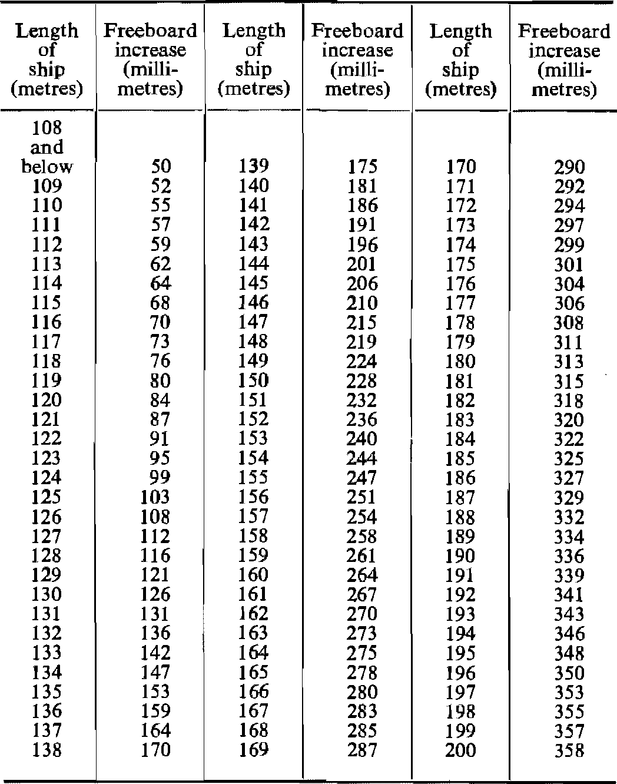

Freeboards at intermediate lengths of ship shall be obtained by linear interpolation.
Ships above 200 metres in length shall be dealt with by the Administration.

[The Convention has the plural word “Administrations” in the note after the table where the Government Gazette has the singular word “Administration”, as reproduced above.]

Freeboard increase over tabular freeboard for type ‘B’ ships,
for ships with hatch covers not complying with Regulations 15(7) or 16

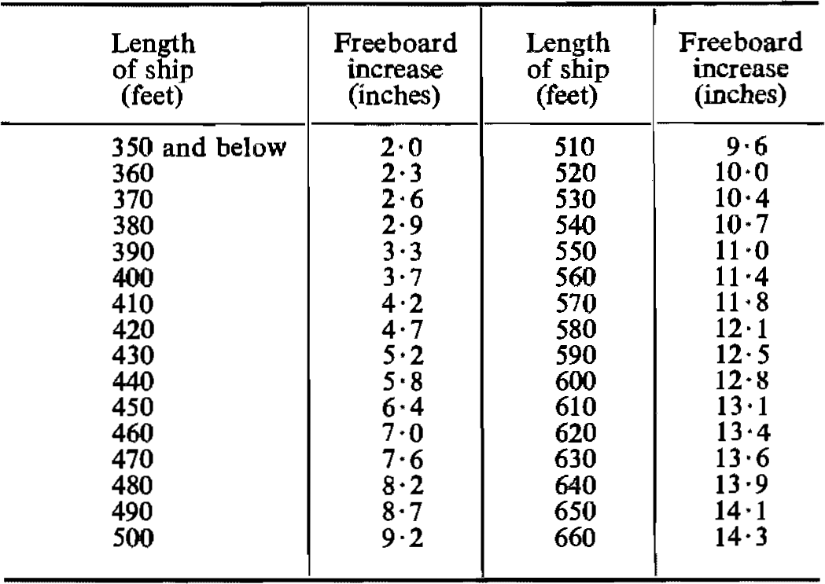

Freeboards at intermediate lengths of ship shall be obtained by linear interpolation.
Ships above 660 feet in length shall be dealt with by the Administration.

[The Convention has the plural word “Administrations” in the note after the table where the Government Gazette has the singular word “Administration”, as reproduced above.]

(11) A lighter, barge or other ship without independent means of propulsion shall be assigned a freeboard in accordance with the provisions of these Regulations. However, in the case of barges which are unmanned the requirements of Regulations 25, 26(2) and (3) and 39 shall not apply. Such unmanned barges which have on the freeboard deck only small access openings closed by weathertight gasketed covers of steel or equivalent material may be assigned freeboards 25 per cent less than those calculated in accordance with these Regulations.

Regulation 28

Freeboard Tables

Type “A” ships

(1) The tabular freeboard for type “A” ships shall be determined from the following table:

TABLE A
Freeboard Table for Type ‘A’ Ships

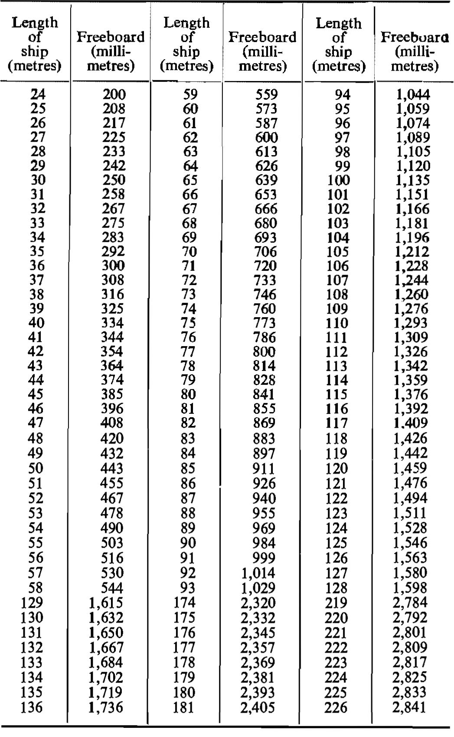

Table A continued.

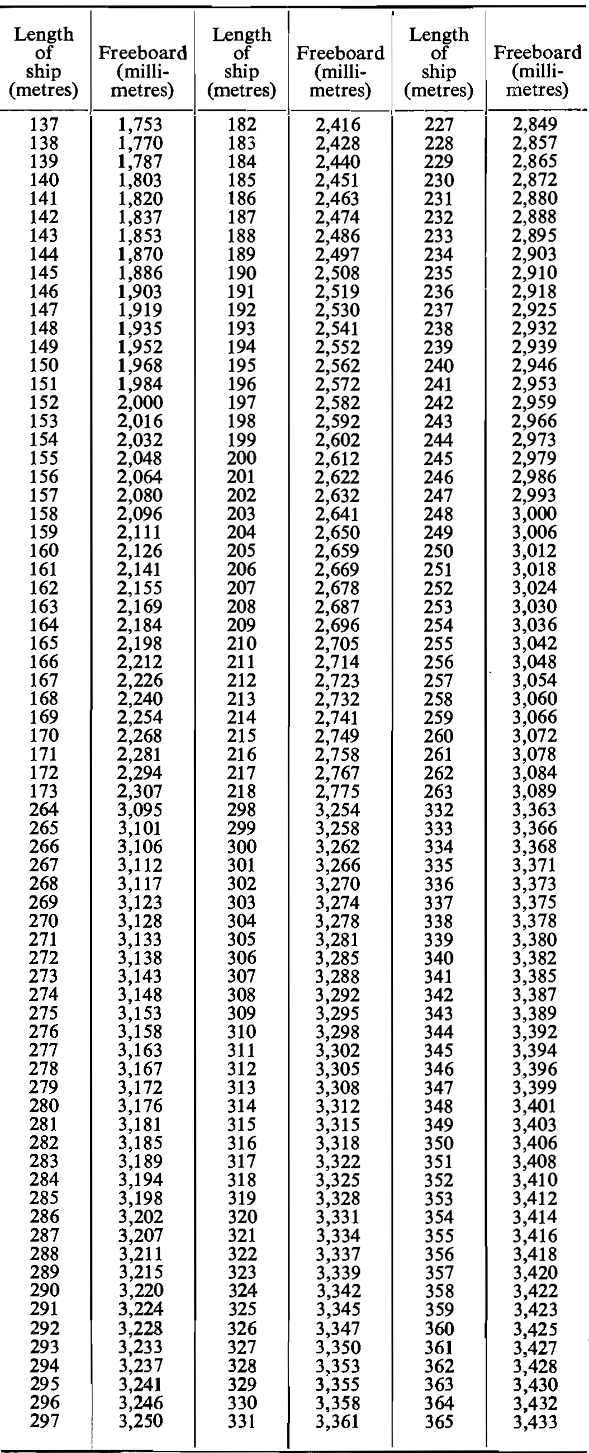

Freeboards at intermediate lengths of ship shall be obtained by linear interpolation.
Ships above 365 metres in length shall be dealt with by the Administration.

[The Convention has the plural word “Administrations” in the note after the table where the Government Gazette has the singular word “Administration”, as reproduced above.]

TABLE A
Freeboard Table for Type ‘A’ Ships
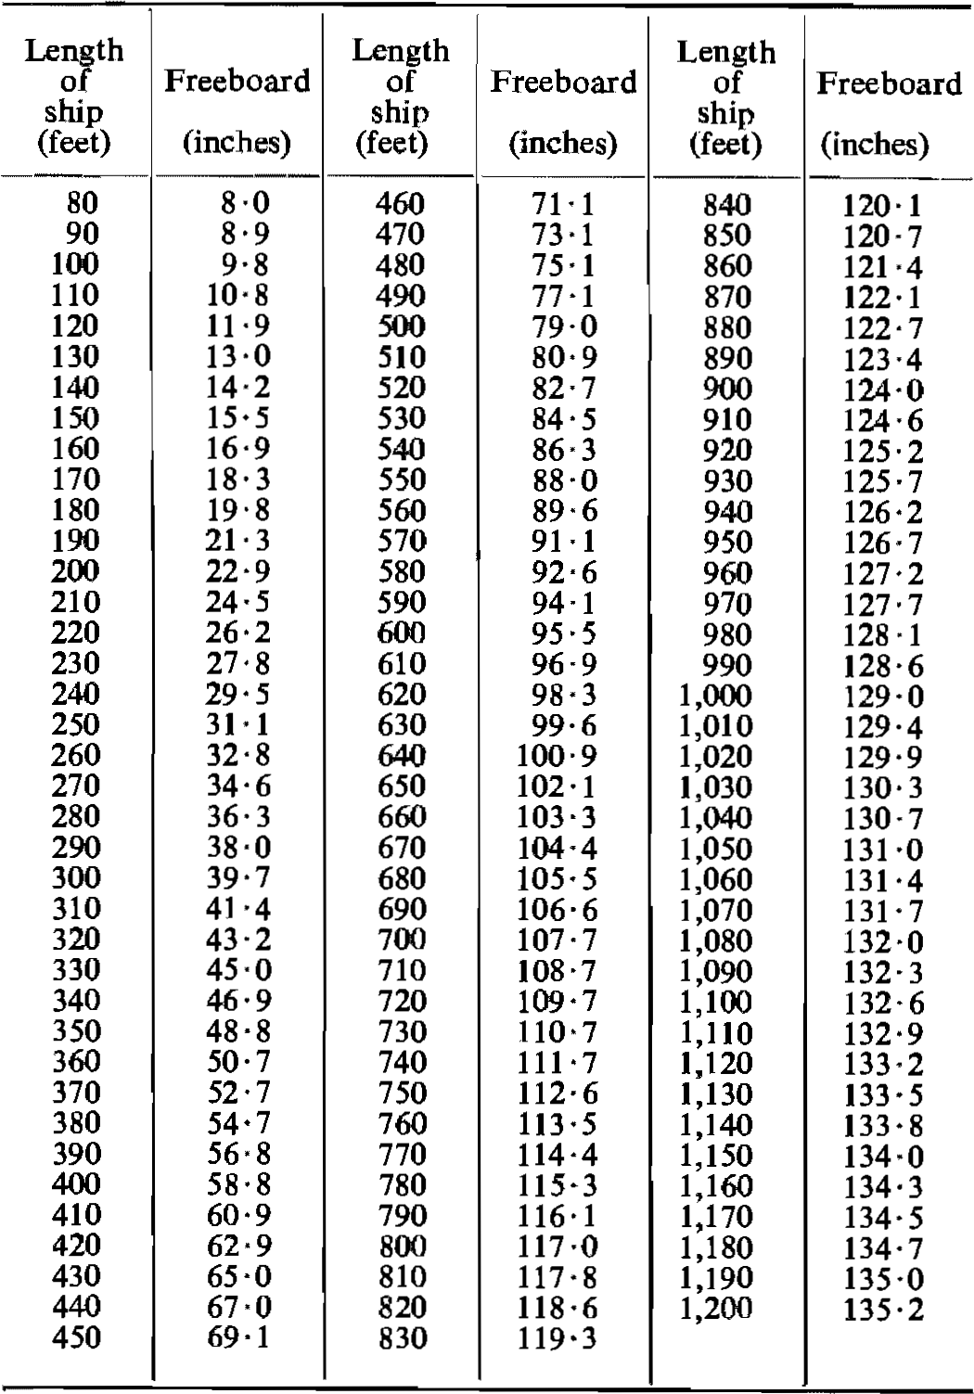

Freeboards at intermediate lengths of ship shall be obtained by linear interpolation.
Ships above 1,200 feet in length shall be dealt with by the Administration.

[The Convention has the plural word “Administrations” in the note after the table where the Government Gazette has the singular word “Administration”, as reproduced above.]

Type “B” ships

(2) The tabular freeboard for type “B” ships shall be determined from the following table:

TABLE B
Freeboard Table for Type ‘B’ Ships

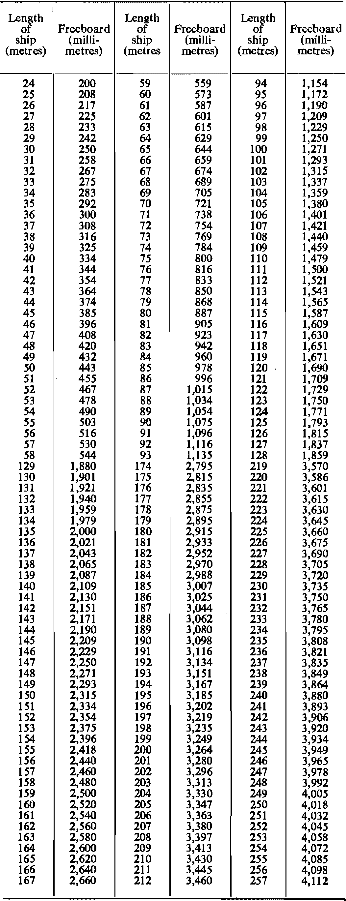

Table B continued.

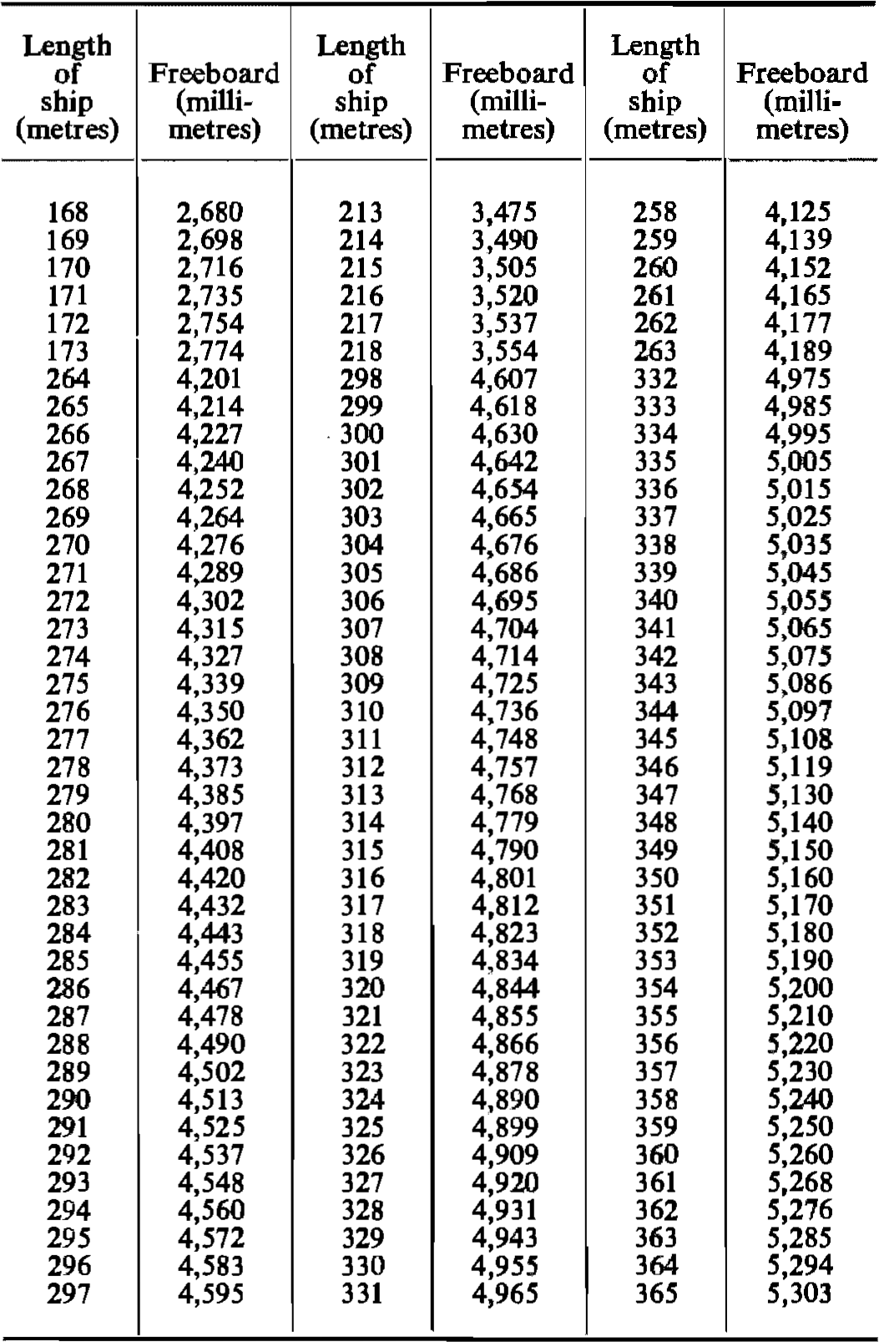

Freeboards at intermediate lengths of ship shall be obtained by linear interpolation.
Ships above 365 metres in length shall be dealt with by the Administration.

[The Convention has the plural word “Administrations” in the note after the table where the Government Gazette has the singular word “Administration”, as reproduced above.]

TABLE B
Freeboard Table for Type ‘B’ Ships

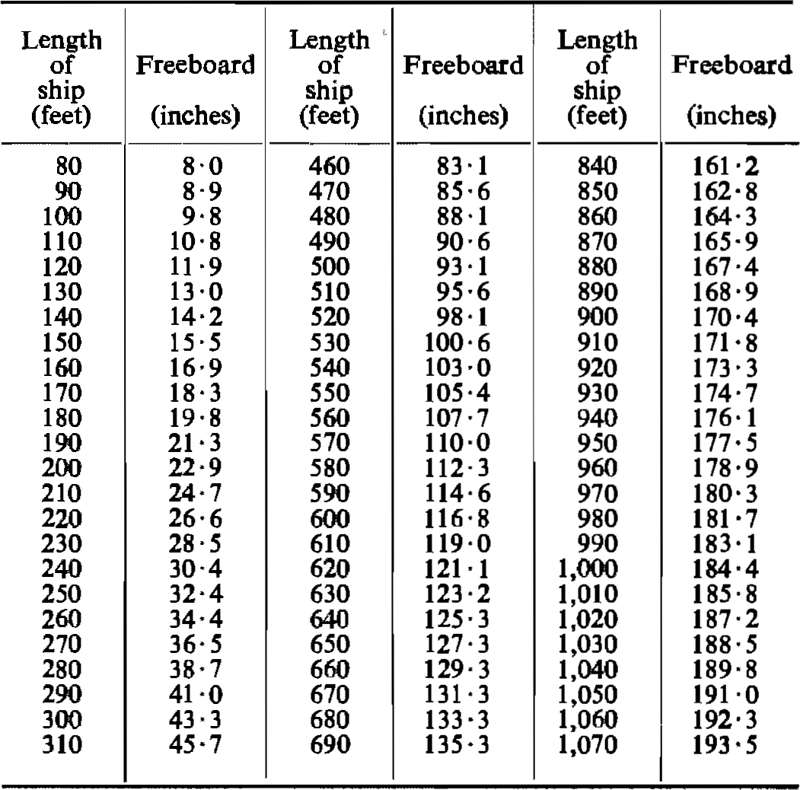
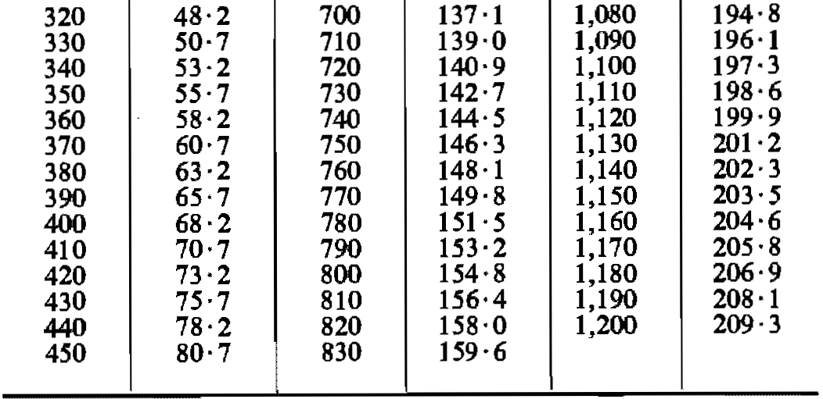

Freeboards at intermediate lengths of ship shall be obtained by linear interpolation.
Ships above 1,200 feet in length shall be dealt with by the Administration.

[The Convention has the plural word “Administrations” in the note after the table where the Government Gazette has the singular word “Administration”, as reproduced above.]

Regulation 29

Correction to the Freeboard for Ships under 100 metres (328 feet) in length

The tabular freeboard for a Type ‘B’ ship of between 24 metres (79 feet) and 100 metres (328 feet) in length having enclosed superstructures with an effective length of up to 35 per cent of the length of the ship shall be increased by:

$$\text{7∙5 }\left(\text{100-L}\right)\text{ (0∙35 – }\frac{\text{E}}{\text{L}}\text{ ) millimetres}$$

where L = length of ship in metres,
E = effective length of superstructure in metres as defined in Regulation 35;

or

$$\text{0}\text{∙}\text{09} \left(\text{328} \text{–} \text{L}\right)\text{ (0∙35} \text{– }\frac{\text{E}}{\text{L}}\text{ ) inches}$$

where L = length of ship in feet
E = effective length of superstructure in feet as defined in Regulation 35.

Regulation 30

Correction for Block Coefficient

Where the block coefficient (Cb) exceeds 0·68, the tabular freeboard specified in Regulation 28 as modified, if applicable, by Regulations 27(8), 27(10) and 29 shall be multiplied by the factor $\frac{{\text{C}}_{\text{b}}\text{ + 0∙68}}{\text{1∙36}}$ .

Regulation 31

Correction for Depth

(1) Where D exceeds $\frac{\text{L}}{\text{15}}$ the freeboard shall be increased by $\text{(D –}\frac{\text{L}}{\text{15}}\text{)}$ R millimetres where R is $\frac{\text{L}}{\text{0∙48}}$ at lengths less than 120 metres and 250 at 120 metres length and above, or $\text{(D –}\frac{\text{L}}{\text{15}}\text{)}$ R inches, where R is $\frac{\text{L}}{\text{131∙2}}$ at lengths less than 393·6 feet and 3 at 393·6 feet length and above.

(2) Where D is less than $\frac{\text{L}}{\text{15}}$ no reduction shall be made except in a ship with an enclosed superstructure covering at least 0.6 L amidships, with a complete trunk, or combination of detached enclosed superstructures and trunks which extend all fore and aft, where the freeboard shall be reduced at the rate prescribed in paragraph (1) of this Regulation.

(3) Where the height of superstructure or trunk is less than the standard height, the reduction shall be in the ratio of the actual to the standard height as defined in Regulation 33.

Regulation 32

Correction for position of deck line

Where the actual depth to the upper edge of the deck line is greater or less than D, the difference between the depths shall be added to or deducted from the freeboard.

Regulation 33

Standard Height of Superstructure

The standard height of a superstructure shall be as given in the following table:

Standard height (in metres)
L  (metres) | Raised  Quarter Deck | All other Superstructures
30 or less  75  125 or more | 0·90  1·20  1·80 | 1·80  1·80  2·30

Standard height (in feet)
L  (feet) | Raised  Quarter Deck | All Other Superstructures
98·5 or less  246  410 or more | 3·0  3·9  5·9 | 5·9  5·9  7·5
The standard heights at intermediate lengths of the ship shall be obtained by linear interpolation.

Regulation 34

Length of Superstructure

(1) Except as provided in paragraph (2) of this Regulation, the length of a superstructure (S) shall be the mean length of the parts of the superstructure which lie within the length (L).

(2) Where the end bulkhead of an enclosed superstructure extends in a fair convex curve beyond its intersection with the superstructure sides, the length of the superstructure may be increased on the basis of an equivalent plane bulkhead. This increase shall be two-thirds of the fore and aft extent of the curvature. The maximum curvature which may be taken into account in determining this increase is one-half the breadth of the superstructure at the point of intersection of the curved end of the superstructure with its side.

Regulation 35

Effective Length of Superstructure

(1) Except as provided for in paragraph (2) of this Regulation, the effective length (E) of an enclosed superstructure of standard height shall be its length.

(2) In all cases where an enclosed superstructure of standard height is set in from the sides of the ship as permitted in Regulation 3(10), the effective length shall be the length modified by the ratio of b/Bs, where

“b” is the breadth of the superstructure at the middle of its length; and
“Bs” is the breadth of the ship at the middle of the length of the superstructure.

Where a superstructure is set in for a part of its length, this modification shall be applied only to the set in part.

(3) Where the height of an enclosed superstructure is less than the standard height, the effective length shall be its length reduced in the ratio of the actual height to the standard height. Where the height exceeds the standard, no increase shall be made to the effective length of the superstructure.

(4) The effective length of a raised quarter deck, if fitted with an intact front bulkhead, shall be its length up to a maximum of 0.6 L. Where the bulkhead is not intact, the raised quarter deck shall be treated as a poop of less than standard height.

(5) Superstructures which are not enclosed shall have no effective length.

Regulation 36

Trunks

(1) A trunk or similar structure which does not extend to the sides of the ship shall be regarded as efficient on the following conditions -

(a) the trunk is at least as strong as a superstructure;

(b) the hatchways are in the trunk deck, and the hatchway coamings and covers comply with the requirements of Regulations 13 to 16 inclusive and the width of the trunk deck stringer provides a satisfactory gangway and sufficient lateral stiffness. However, small access openings with watertight covers may be permitted in the freeboard deck;

(c) a permanent working platform fore and aft fitted with guard rails is provided by the trunk deck, or by detached trunks connected to superstructures by efficient permanent gangways;

(d) ventilators are protected by the trunk, by watertight covers or by other equivalent means;

(e) open rails are fitted on the weather parts of the freeboard deck in way of the trunk for at least half their length;

(f) the machinery casings are protected by the trunk, by a superstructure of at least standard height, or by a deckhouse of the same height and of equivalent strength;

(g) the breadth of the trunk is at least 60 per cent of the breadth of the ship; and

(h) where there is no superstructure, the length of the trunk is at least 0.6 L.

(2) The full length of an efficient trunk reduced in the ratio of its mean breadth to B shall be its effective length.

(3) The standard height of a trunk is the standard height of a superstructure other than a raised quarter deck.

(4) Where the height of a trunk is less than the standard height, its effective length shall be reduced in the ratio of the actual to the standard height. Where the height of hatchway coamings on the trunk deck is less than that required under Regulation 15(1), a reduction from the actual height of trunk shall be made which corresponds to the difference between the actual and the required height of coaming.

Regulation 37

Deduction for Superstructures and Trunks

(1) Where the effective length of superstructures and trunks is 1.0 L, the deduction from the freeboard shall be 350 millimetres at 24 metres length of ship, 860 millimetres at 85 metres length, and 1,070 millimetres at 122 metres length and above (14 inches at 79 feet length of ship, 34 inches at 279 feet length, and 42 inches at 400 feet length and above); deductions at intermediate lengths shall be obtained by linear interpolation.

(2) Where the total effective length of superstructures and trunks is less than 1.0 L the deduction shall be a percentage obtained from one of the following Tables:

Percentage of Deduction for Type ‘A’ Ships
 |  | Total Effective Length of Superstructures and Trunks
 |  | 0 | 0∙1 L | 0∙2 L | 0∙3 L | 0∙4 L | 0∙5 L | 0∙6 L | 0∙7 L | 0∙8 L | 0∙9 L | 1∙0 L
Percentage of deduction for all types of superstructures |  | 0 | 7 | 14 | 21 | 31 | 41 | 52 | 63 | 75∙3 | 87∙7 | 100

Percentages at intermediate lengths of superstructures shall be obtained by linear interpolation.

[In this table, the Government Gazette has a value of “75.3” in the column
headed “0.8 L”. The Convention has a value of “75.5” in this spot.]

Percentage of Deduction for Type ‘B’ Ships
 |  | Total Effective Length of Superstructures and Trunks
 |  | Line | 0 | 0∙1 L | 0∙2 L | 0∙3 L | 0∙4 L | 0∙5 L | 0∙6 L | 0∙7 L | 0∙8 L | 0∙9 L | 1∙0 L
Ships with forecastle and without detached bridge |  | I | 0 | 5 | 10 | 15 | 23∙5 | 32 | 46 | 63 | 75∙3 | 87∙7 | 100
Ships with forecastle and detached bridge |  | II | 0 | 6∙3 | 12∙7 | 19 | 27∙5 | 36 | 46 | 63 | 75∙3 | 87∙7 | 100

Percentages at intermediate lengths of superstructures shall be obtained by linear interpolation.

[In this table, the Government Gazette includes a column headed “Line”, as reproduced
above. In the Convention, that heading is “Ligne”, which is the French word
for “line”, and the table is structured differently:

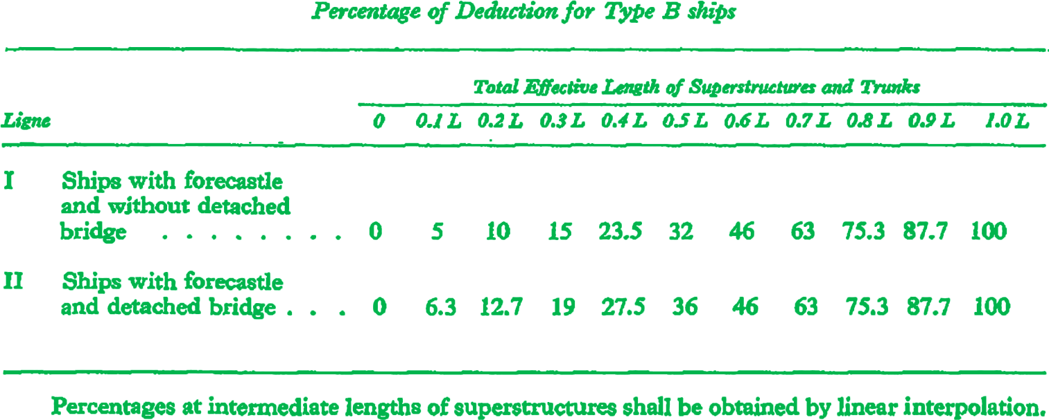
]

(3) For ships of Type “B”:

(a) Where the effective length of a bridge is less than 0.2 L, the percentages shall be obtained by linear interpolation between lines I and II.

(b) Where the effective length of a forecastle is more than 0.4 L, the percentages shall be obtained from line II.

(c) Where the effective length of a forecastle is less than 0.07 L, the above percentages shall be reduced by:

$$\text{5 x }\frac{\text{(0.07 L – f)}}{\text{0.07 L}}$$

where f is the effective length of the forecastle.

Regulation 38

Sheer

General

(1) The sheer shall be measured from the deck at side to a line of reference drawn parallel to the keel through the sheer line amidships.

[Paragraph (1) is amended by RSA Proc. R.209 of 1972 to delete the word “at”
before the word “amidships”. The Convention has the word “at” in this spot.]

(2) In ships designed with a rake of keel, the sheer shall be measured in relation to a reference line drawn parallel to the design load water line.

(3) In flush deck ships and in ships with detached superstructures the sheer shall be measured at the freeboard deck.

(4) In ships with topsides of unusual form in which there is a step or break in the topsides, the sheer shall be considered in relation to the equivalent depth amidships.

(5) In ships with a superstructure of standard height which extends over the whole length of the freeboard deck, the sheer shall be measured at the superstructure deck. Where the height exceeds the standard the least difference (Z) between the actual and standard heights shall be added to each end ordinate. Similarly, the intermediate ordinates at distances of ¹/₆ L and ¹/₃ L from each perpendicular shall be increased by 0.444 Z and 0.111 Z respectively.

(6) Where the deck of an enclosed superstructure has at least the same sheer as the exposed freeboard deck, the sheer of the enclosed portion of the freeboard deck shall not be taken into account.

(7) Where an enclosed poop or forecastle is of standard height with greater sheer than that of the freeboard deck, or is of more than standard height, an addition to the sheer of the freeboard deck shall be made as provided in paragraph (12) of this Regulation.

Standard Sheer Profile

(8) The ordinates of the standard sheer profile are given in the following table.

Standard Sheer Profile
(Where L is in metres)
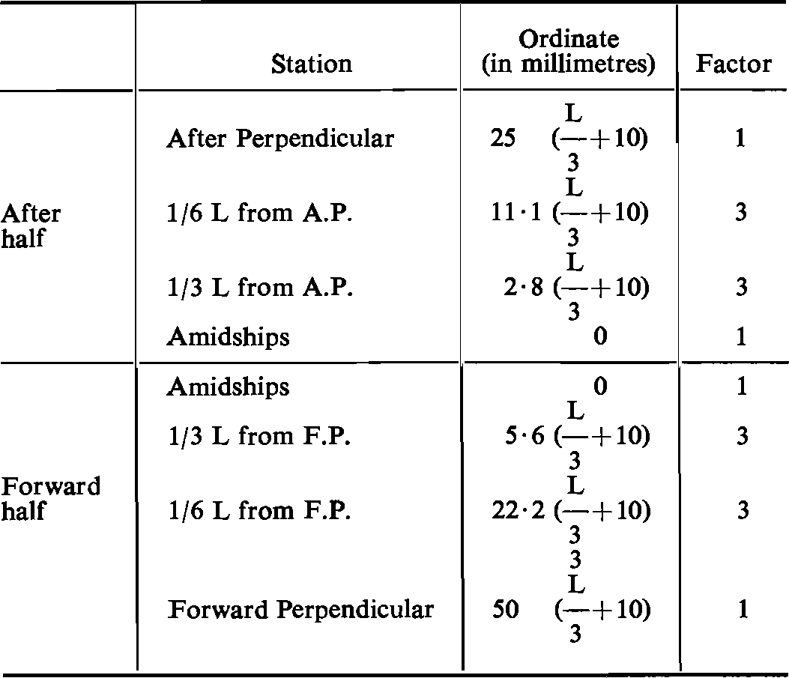

Standard Sheer Profile
(Where L is in feet)
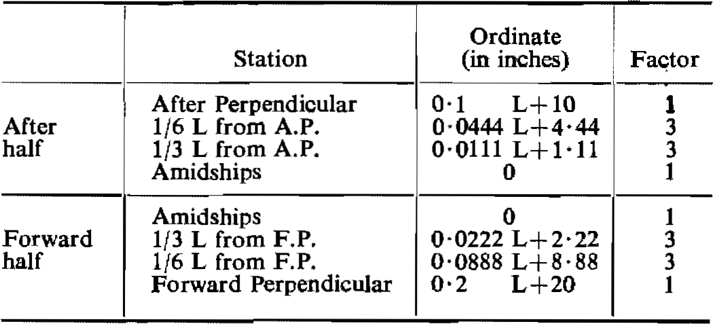

[The word “where” in the headings of both tables above is not capitalised in the Convention.]

Measurement of Variation from Standard Sheer Profile

(9) Where the sheer profile differs from the standard, the four ordinates of each profile in the forward or after half shall be multiplied by the appropriate factors given in the Table of ordinates. The difference between the sums of the respective products and those of the standard divided by 8 measures the deficiency or excess of sheer in the forward or after half. The arithmetical mean of the excess or deficiency in the forward and after halves measures the excess or deficiency of sheer.

(10) Where the after half of the sheer profile is greater than the standard and the forward half is less than the standard, no credit shall be allowed for the part in excess and deficiency only shall be measured.

(11) Where the forward half of the sheer profile exceeds the standard, and the after portion of the sheer profile is not less than 75 per cent of the standard, credit shall be allowed for the part in excess; where the after part is less than 50 per cent of the standard no credit shall be given for the excess sheer forward. Where the after sheer is betwen 50 per cent and 75 per cent of the standard, intermediate allowances may be granted for excess sheer forward.

[The word “between” is misspelt in the Government Gazette,
as reproduced above. It is spelt correctly in the Convention.]

(12) Where sheer credit is given for a poop or forecastle the following formula shall be used:

$$\text{s = }\frac{\text{y}}{\text{3}} \frac{\text{L}\text{'}}{\text{L}}$$

where s = sheer credit, to be deducted from the deficiency or added to the excess of sheer,
y = difference between actual and standard height of superstructure at the end of sheer,
$\text{L}\text{'}$ = mean enclosed length of poop or forecastle up to a maximum length of 0.5 L,
L = length of ship as defined in Regulation 3(1) of this Annex.

The above formula provides a curve in the form of a parabola tangent to the actual sheer curve at the freeboard deck and intersecting the end ordinate at a point below the superstructure deck a distance equal to the standard height of a superstructure. The superstructure deck shall not be less than standard height above this curve at any point. This curve shall be used in determining the sheer profile for forward and after halves of the ship,

Correction for Variations from Standard Sheer Profile

(13) The correction for sheer shall be the deficiency or excess of sheer (see paragraphs (9) to (11) inclusive of this Regulation), multiplied by

$$\text{0.75} \text{–} \frac{\text{S}}{\text{2L}}$$

where S is the total length of enclosed superstructures.

Addition for Deficiency in Sheer

(14) Where the sheer is less than the standard, the correction for deficiency in sheer (see paragraph (13) of this Regulation) shall be added to the freeboard.

Deduction for Excess Sheer

(15) In ships where an enclosed superstructure covers 0.1 L before and 0.1 L abaft amidships, the correction for excess of sheer as calculated under the provisions of paragraph (13) of this Regulation shall be deducted from the freeboard; in ships where no enclosed superstructure covers amidships, no deduction shall be made from the freeboard; where an enclosed superstructure covers less than 0.1 L before and 0.1 L abaft amidships, the deduction shall be obtained by linear interpolation. The maximum deduction for excess sheer shall be at the rate of 125 millimetres per 100 metres of length (1½ inches per 100 feet of length).

Regulation 39

Minimum bow height

(1) The bow height defined as the vertical distance at the forward perpendicular between the waterline corresponding to the assigned summer freeboard and the designed trim and the top of the exposed deck at side shall be not less than -

for ships below 250 metres in length,

$$\text{56 L (1 – }\frac{\text{L}}{\text{500}}\text{) }\frac{\text{1∙36}}{\text{C}\text{b}\text{+0∙}\text{68}}\text{ millimetres}\text{;}$$

for ships of 250 metres and above in length,

$$\text{7,000 }\frac{\text{1∙36}}{\text{C}\text{b}\text{+0∙}\text{68}}\text{ millimet}\text{er}\text{s}\text{;}$$

Where L is the length of the ship in metres,
Cb is the block coefficient which is to be taken as not less than 0·68

or,

for ships below 820 feet in length,

$$\text{0}\text{∙}\text{672}\text{ L (1 – }\frac{\text{L}}{\text{1640}}\text{) }\frac{\text{1∙36}}{\text{C}\text{b}\text{+0∙}\text{68}}\text{ inches}\text{;}$$

for ships of 820 feet and above in length,

$$\text{275∙6 }\frac{\text{1∙36}}{\text{C}\text{b}\text{+0∙}\text{68}}\text{ inches;}$$

Where L is the length of the ship in feet,
Cb is the block coefficient which is to be taken as not less than 0·68.

[The word “millimetres” is misspelt as “millimeters” in the second formula
of paragraph (1), as reproduced above. It is spelt correctly in the Convention.]

(2) Where the bow height required in paragraph (1) of this Regulation is obtained by sheer, the sheer shall extend for at least 15 per cent of the length of the ship measured from the forward perpendicular. Where it is obtained by fitting a superstructure, such superstructure shall extend from the stem to a point at least 0.07 L abaft the forward perpendicular, and it shall comply with the following requirements -

(a) for ships not over 100 metres (328 feet) in length it shall be enclosed as defined in Regulation 3(10), and

(b) for ships over 100 metres (328 feet) in length it need not comply with Regulation 3(10) but shall be fitted with closing appliances to the satisfaction of the Administration.

(3) Ships which, to suit excpetional operational requirements, cannot meet the requirements of paragraphs (1) and (2) of this Regulation may be given special consideration by the Administration.

[The word “exceptional” is misspelt in the Government Gazette,
as reproduced above. It is spelt correctly in the Convention.]

Regulation 40

Minimum Freeboards

Summer Freeboard

(1) The minimum freeboard in summer shall be the freeboard derived from the Tables in Regulation 28 as modified by the corrections in Regulations 27, as applicable, 29, 30, 31, 32, 37, 38 and, if applicable, 39.

(2) The freeboard in salt water as calculated in accordance with paragraph (1) of this Regulation, but without the correction for deck line, as provided by Regulation 32, shall not be less than 50 millimetres (2 inches). For ships having in position 1 hatchways with covers which do not comply with the requirements of Regulations 15(7), 16 or 26, the freeboard shall be not less than 150 millimetres (6 inches).

Tropical Freeboard

(3) The minimum freeboard in the Tropical Zone shall be the freeboard obtained by a deduction from the summer freeboard of one forty-eighth of the summer draught measured from the top of the keel to the centre of the ring of the load line mark.

(4) The freeboard in salt water, as calculated in accordance with paragraph (1) of this Regulation, but without the correction for deck line, as provided by Regulation 32, shall not be less than 50 millimetres (2 inches). For ships having in position 1 hatchways with covers which do not comply with the requirements of Regulations 15(7), 16 or 26, the freeboard shall be not less than 150 millimetres (6 inches).

Winter Freeboard

(5) The minimum freeboard in winter shall be the freeboard obtained by an addition to the summer freeboard of one forty-eighth of summer draught, measured from the top of the keel to the centre of the ring of the load line mark.

Winter North Atlantic Freeboard

(6) The minimum freeboard for ships of not more than 100 metres (328 feet) in length, which enter any part of the North Atlantic defined in Regulation 52 (Annex II) during the winter seasonal period, shall be the winter freeboard plus 50 millimetres (2 inches). For other ships, the Winter North Atlantic Freeboard shall be the winter freeboard.

Fresh Water Freeboard

(7) The minimum freeboard in fresh water of unit density shall be obtained by deducting from the minimum freeboard in salt water -

$$\frac{\text{∆}}{\text{40 T}}\text{ centimetres (inches}\text{)}$$

where ∆ = displacement in salt water in tons at the summer load water line,
T = tons per centimetre (inch) immersion in salt water at the summer load water line.

(8) Where the displacement at the summer load water line cannot be certified, the deduction shall be one forty-eighth of summer draught, measured from the top of the keel to the centre of the ring of the load line mark.

CHAPTER IV—SPECIAL REQUIREMENTS FOR
SHIPS ASSIGNED TIMBER FREEBOARDS

Regulation 41

Application of this Chapter

Regulations 42 to 45 inclusive apply only to ships to which timber load lines are assigned.

Regulation 42

Definitions

(1) Timber Deck Cargo. The term “timber deck cargo” means a cargo of timber carried on an uncovered part of a freeboard or superstructure deck. The term does not include wood pulp or similar cargo.

(2) Timber Load Line. A timber deck cargo may be regarded as giving a ship a certain additional buoyancy and a greater degree of protection against the sea. For that reason, ships carrying a timber deck cargo may be granted a reduction of freeboard calculated according to the provisions of Regulation 45 and marked on the ship’s side in accordance with the provisions of Regulation 6(3) and (4). However, in order that such special freeboard may be granted and used, the timber deck cargo shall comply with certain conditions which are laid down in Regulation 44, and the ship itself shall also comply with certain conditions relating to its construction which are set out in Regulation 43.

Regulation 43

Construction of Ship

Superstructure

(1) Ships shall have a forecastle of at least standard height and a length of at least 0.07 L. In addition, if the ship is less than 100 metres (328 feet) in length, a poop of at least standard height, or a raised quarter-deck with either a deckhouse or a strong steel hood of at least the same total height shall be fitted aft.

[The Government Gazette hyphenates “quarter-deck” in this paragraph,
while the Convention uses the two-word term “quarter deck”.]

Double Bottom Tanks

(2) Double bottom tanks where fitted within the midship half length of the ship shall have adequate watertight longitudinal subdivision.

Bulwarks

(3) The ship shall be fitted either with permanent bulwarks at least 1 metre (39½ inches) in height, specially stiffened on the upper edge and supported by strong bulwark stays attached to the deck and provided with necessary freeing ports, or with efficient rails of the same height and of specially strong construction.

Regulation 44

Stowage

General

(1) Openings in the weather deck over which cargo is stowed shall be securely closed and battened down. The ventilators shall be efficiently protected.

(2) Timber deck cargo shall extend over at least the entire available length which is the total length of the well or wells between superstructures. Where there is no limiting superstructure at the after end, the timber shall extend at least to the after end of the aftermost hatchway. The timber shall be stowed as solidly as possible to at least the standard height of the superstructure.

(3) On a ship within a seasonal winter zone in winter, the height of the deck cargo above the weather deck shall not exceed one-third of the extreme breadth of the ship.

(4) The timber deck cargo shall be compactly stowed, lashed and secured. It shall not interfere in any way with the navigation and necessary work of the ship.

Uprights

(5) Uprights, when required by the nature of the timber, shall be of adequate strength considering the breadth of the ship; the spacing shall be suitable for the length and character of timber carried, but shall not exceed 3 metres (9.8 feet). Strong angles or metal sockets or equally efficient means shall be provided for securing the uprights.

Lashings

(6) Timber deck cargo shall be efficiently secured throughout its length by independent over-all lashings spaced not more than 3 metres (9.8 feet) apart. Eye plates for these lashings shall be efficiently attached to the sheer strake or to the deck stringer plate at intervals of not more than 3 metres (9.8 feet). The distance from an end bulkhead of a superstructure to the first eye plate shall be not more than 2 metres (6.6 feet). Eye plates and lashings shall be provided 0.6 metres (23½ inches) and 1.5 metres (4.9 feet) from the ends of timber deck cargoes where there is no bulkhead.

(7) Lashings shall be not less than 19 millimetres (¾ inch) close link chain or flexible wire rope of equivalent strength, fitted with sliphooks and turnbuckles, which shall be accessible at all times. Wire rope lashings shall have a short length of long link chain to permit the length of lashings to be regulated.

(8) When timber is in lengths less than 3.6 metres (11.8 feet) the spacing of the lashings shall be reduced or other suitable provisions made to suit the length of timber.

(9) All fittings required for securing the lashings shall be of strength corresponding to the strength of the lashings.

Stability

(10) Provisions shall be made for a safe margin of stability at all stages of the voyage, regard being given to additions of weight, such as those due to absorption of water and icing and to losses of weight such as those due to consumption of fuel and stores.

Protection of Crew, Access to Machinery Spaces, etc.

(11) In addition to the requirements of Regulation 25(5) of this Annex guard rails or life lines spaced not more than 330 millimetres (13 inches) apart vertically shall be provided on each side of the deck cargo to a height of at least 1 metre (391½ inches) above the cargo.

[Paragraph (11) is amended by RSA Proc. R.209 of 1972 to replace “33 centimetres”
with “330 millimetres". The Convention uses the former measurement.
The Convention uses the single word “guardrails” where the Government
Gazette uses the two words “guard rails”, as reproduced above.]

Steering Arrangements

(12) Steering arrangements shall be effectively protected from damage by cargo and, as far as practicable, shall be accessible. Efficient provision shall be made for steering in the event of a breakdown in the main steering arrangements.

Regulation 45

Computation for Freeboard

(1) The minimum summer freeboards are computed in accordance with Regulations 27(5), 27(6), 27(11), 28, 29, 30, 31, 32, 37 and 38, except that Regulation 37 is modified by substituting the following percentages for those given in Regulation 37:

 |  | Total Effective Length of Superstructures
 |  | 0 | 0∙1 L | 0∙2 L | 0∙3 L | 0∙4 L | 0∙5 L | 0∙6 L | 0∙7 L | 0∙8 L | 0∙9 L | 1∙0 L
Percentage of deduction for all types of superstructure |  | 20 | 31 | 42 | 53 | 64 | 70 | 76 | 82 | 88 | 94 | 100

Percentages at intermediate lengths of superstructures shall be obtained by linear interpolation.

[Paragraph (1) is amended by RSA Proc. R.209 of 1972 to substitute the phrase
“freeboards are” for the phrase “freeboards shall be”. This brings
the paragraph in line with the Convention.]

(2) The Winter Timber Freeboard shall be obtained by adding to the Summer Timber Freeboard one thirty-sixth of the moulded summer timber draught.

(3) The Winter North Atlantic Timber Freeboard shall be the same as the Winter North Atlantic Freeboard prescribed in Regulation 40(6).

(4) The Tropical Timber Freeboard shall be obtained by deducting from the Summer Timber Freeboard one forty-eighth of the moulded summer timber draught.

[The Convention uses “forty-eight” instead of “forty-eighth”.
This term is corrected in the Government Gazette, as reproduced above.]

(5) The Fresh Water Timber Freeboard shall be computed in accordance with Regulation 40(7) based on the summer timber load water line.

ANNEX II

ZONES, AREAS AND SEASONAL PERIODS

The zones and areas in this Annex are, in general, based on the following criteria:

Summer — not more than 10 per cent winds of force 8 Beaufort (34 knots) or more.

Tropical — not more than 1 per cent winds of force 8 Beaufort (34 knots) or more. Not more than one tropical storm in 10 years in an area of 5° square in any one separate calendar month.

In certain special areas, for practical reasons, some degree of relaxation has been found acceptable.

A chart is attached to this Annex to illustrate the zones and areas defined below.

Regulation 46

Northern Winter Seasonal Zones and Area

(1) North Atlantic Winter Seasonal Zones I and II

(a) The North Atlantic Winter Seasonal Zone I lies within the meridian of longitude 50° W from the coast of Greenland to latitude 45° N, thence the parallel of latitude 45° N to longitude 15° W, thence the meridian of longitude 15° W to latitude 60° N, thence the parallel of latitude 60° N to the Greenwich Meridian, thence this meridian northwards.

Seasonal periods:

Winter: 16 October to 15 April.
Summer: 16 April to 15 October.

(b) The North Atlantic Winter Seasonal Zone II lies within the meridian of longitude 68° 30' W from the coast of the United States to latitude 40° N, thence the rhumb line to the point latitude 36° N, longitude 73° W, thence the parallel of latitude 36° N to longitude 25° W and thence the rhumb line to Cape Toriñana.
Excluded from this zone are the North Atlantic Winter Seasonal Zone I and the Baltic Sea bounded by the parallel of the latitude of The Skaw in the Skagerrak.

Seasonal periods:

Winter: 1 November to 31 March.
Summer: 1 April to 31 October.

(2) North Atlantic Winter Seasonal Area

The boundary of the North Atlantic Winter Seasonal Area is -

the meridian of longitude 68° 30' W from the coast of the United States to latitude 40° N, thence the rhumb line to the southernmost intersection of the meridian of longitude 61° W with the coast of Canada and thence the east coasts of Canada and the United States.

Seasonal periods:
For ships over 100 metres (328 feet) in length:

Winter: 16 December to 15 February.
Summer: 16 February to 15 December.

For ships of 100 metres (328 feet) and under in length:

Winter: 1 November to 31 March.
Summer: 1 April to 31 October.

(3) North Pacific Winter Seasonal Zone

The southern boundary of the North Pacific Winter Seasonal Zone is -

the parallel of latitude 50° N from the east coast of the USSR to the west coast of Sakhalin, thence the west coast of Sakhalin to the southern extremity of Cape Kril’ on, thence the rhumb line to Wakkanai, Hokkaido, Japan, thence the east and south coasts of Hokkaido to longitude 145° E, thence the meridian of longitude 145° E to latitude 35° N, thence the parallel of latitude 35° N to longitude 150° W and thence the rhumb line to the southern extremity of Dall Island, Alaska.

Seasonal periods:

Winter: 16 October to 15 April.
Summer: 16 April to 15 October.

[Paragraph (3) is amended by RSA Proc. R.209 of 1972 to replace the word
“Kurilion” with the words “Cape Kril' on”. The Convention has the former wording.]

Regulation 47

Southern Winter Seasonal Zone

The northern boundary of the Southern Winter Seasonal Zone is -

the rhumb line from the east coast of the American continent at Cape Tres Puntas to the point latitude 34° S, longitude 50° W, thence the parallel of latitude 34° S to longitude 17° E, thence the rhumb line to the point latitude 35° 10' S, longitude 20° E, thence the rhumb line to the point latitude 34° S, longitude 28° E, thence along the rhumb line to the point latitude 35° 30' S, longitude 118° E, and thence the rhumb line to Cape Grim on the northwest coast of Tasmania; thence along the north and east coasts of Tasmania to the southernmost point of Bruny Island, thence the rhumb line to Black Rock Point on Stewart Island, thence the rhumb line to the point latitude 47° S, longitude 170° E, thence along the rhumb line to the point latitude 33° S, longitude 170° W, and thence the parallel of latitude 33° S to the west coast of the American continent.

Seasonal periods:

Winter: 16 April to 15 October.
Summer: 16 October to 15 April.

Regulation 48

Tropical Zone

(1) Northern Boundary of the Tropical Zone

The northern boundary of the Tropical Zone is -

the parallel of latitude 13° N from the east coast of the American continent to longitude 60° W, thence the rhumb line to the point latitude 10° N, longitude 58° W, thence the parallel of latitude 10° N to longitude 20° W, thence the meridian of longitude 20° W to latitude 30° N and thence the parallel of latitude 30° N to the west coast of Africa; from the east coast of Africa the parallel of latitude 8° N to longitude 70° E, thence the meridian of longitude 70° E to latitude 13° N, thence the parallel of latitude 13° N to the west coast of India; thence the south coast of India to latitude 10° 30' N on the east coast of India, thence the rhumb line to the point latitude 9° N, longitude 82° E, thence the meridian of longitude 82° E to latitude 8° N, thence the parallel of latitude 8° N to the west coast of Malaysia, thence the coast of South-East Asia to the east Coast of Vietnam at latitude 10° N, thence the parallel of latitude 10° N to longitude 145° E, thence the meridian of longitude 145° E to latitude 13° N and thence the parallel of latitude 13° N to the west coast of the American continent.
Saigon is to be considered as being on the boundary line of the Tropical Zone and the Seasonal Tropical Area.

(2) Southern Boundary of the Tropical Zone

The southern boundary of the Tropical Zone is -

the rhumb line from the Port of Santos, Brazil, to the point where the meridian of longitude 40° W intersects the Tropic of Capricorn; thence the Tropic of Capricorn to the west coast of Africa; from the east coast of Africa the parallel of latitude 20° S to the west coast of Madagascar, thence the west and north coasts of Madagascar to longitude 50° E, thence the meridian of longitude 50° E to latitude 10° S, thence the parallel of latitude 10° S to longitude 98° E, thence the rhumb line to Port Darwin, Australia, thence the coasts of Australia and Wessel Island eastwards to Cape Wessel, thence the parallel of latitude 11° S to the west side of Cape York; from the east side of Cape York the parallel of latitude 11° S to longitude 150° W, thence the rhumb line to the point latitude 26° S, longitude 75° W, and thence the rumb line to the west coast of the American continent at latitude 30° S.
Coquimbo and Santos are to be considered as being on the boundary line of the Tropical and Summer Zones.

[The word “rhumb” is misspelt as “rumb” in the Government Gazette in its
final instance in paragraph (2). It is spelt correctly in the Convention.]

(3) Areas to be included in the Tropical Zone

The following areas are to be treated as included in the Tropical Zone -

(a) The Suez Canal, the Red Sea and the Gulf of Aden, from Port Said to the meridian of longitude 45° E.
Aden and Berbera are to be considered as being on the boundary line of the Tropical Zone and the Seasonal Tropical Area.

(b) The Persian Gulf to the meridian of longitude 59° E.

(c) The area bounded by the parallel of latitude 22° S from the east coast of Australia to the Great Barrier Reef, thence the Great Barrier Reef to latitude 11° S. The northern boundary of the area is the southern boundary of the Tropical Zone.

Regulation 49

Seasonal Tropical Areas

The following are Seasonal Tropical Areas:

(1) In the North Atlantic

An area bounded -

on the north by the rhumb line from Cape Catoche, Yucatan, to Cape San Antonio, Cuba, the north coast of Cuba to latitude 20° N and thence the parallel of latitude 20° N to longitude 20° W;

on the west by the coast of the American continent;

on the south and east by the northern boundary of the Tropical Zone.

Seasonal periods:

Tropical: 1 November to 15 July.
Summer: 16 July to 31 October.

(2) In the Arabian Sea

An area bounded -

on the west by the coast of Africa, the meridian of longitude 45° E in the Gulf of Aden, the coast of South Arabia and the meridian of longitude 59° E in the Gulf of Oman;

on the north and east by the coasts of Pakistan and India;

on the south by the northern boundary of the Tropical Zone.

Seasonal periods:

Tropical: 1 September to 31 May.
Summer: 1 June to 31 August.

(3) In the Bay of Bengal

The Bay of Bengal north of the northern boundary of the Tropical Zone.

Seasonal periods:

Tropical: 1 December to 30 April.
Summer: 1 May to 30 November.

[The Government Gazette inverts the order of the seasonal periods listed
in paragraph (3). “Summer” is listed before “Tropical” in the Convention.]

(4) In the South Indian Ocean

(a) An area bounded -

on the north and west by the southern boundary of the Tropical Zone and the east coast of Madagascar;

on the south by the parallel of latitude 20° S;

on the east by the rhumb line from the point latitude 20° S, longitude 50° E, to the point latitude 15° S, longitude 51° 30' E and thence by the meridian of longitude 51° 30' E to latitude 10° S.

Seasonal periods:

Tropical: 1 April to 30 November.
Summer: 1 December to 31 March.

(b) An area bounded -

on the north by the southern boundary of the Tropical Zone;

on the east by the coast of Australia;

on the south by the parallel of latitude 15° S from longitude 51° 30' E, to longitude 120° E and thence the meridian of longitude 120° E to the coast of Australia;

on the west by the meridian of longitude 51° 30' E.

Seasonal periods:

Tropical: 1 May to 30 November.
Summer: 1 December to 30 April.

[The Government Gazette inverts the order of the seasonal periods listed
in subparagraph (b). “Summer” is listed before “Tropical” in the Convention.]

(5) In the China Sea

An area bounded -

on the west and north by the coasts of Vietnam and China from latitude 10° N to Hong Kong;

on the east by the rhumb line from Hong Kong to the Port of Sual (Luzon Island) and the west coasts of the Islands of Luzon, Samar and Leyte to latitude 10° N;

on the south by the parallel of latitude 10° N.

Hong Kong and Sual are to be considered as being on the boundary of the Seasonal Tropical Area and Summer Zone.

Seasonal periods:

Tropical: 21 January to 30 April.
Summer: 1 May to 20 January.

(6) In the North Pacific

(a) An area bounded -

on the north by the parallel of latitude 25° N;

on the west by the meridian of longitude 160° E;

on the south by the parallel of latitude 13° N;

on the east by the meridian of longitude 130° W.

Seasonal periods:

Tropical: 1 April to 31 October.
Summer: 1 November to 31 March.

(b) An area bounded -

on the north and east by the west coast of the American continent;

on the west by the meridian of longitude 123° W from the coast of the American continent to latitude 33° N and by the rhumb line from the point latitude 33° N, longitude 123° W, to the point latitude 13° N, longitude 105° W;

on the south by the parallel of latitude 13° N.

Seasonal periods:

Tropical: l March to 30 June and
1 November to 30 November.
Summer: 1 July to 31 October and
1 December to 28/29 February.

(7) In the South Pacific

(a) The Gulf of Carpentaria south of latitude 11° S.

Seasonal periods:

Tropical: 1 April to 30 November.
Summer: 1 December to 31 March.

(b) An area bounded -

on the north and east by the southern boundary of the Tropical Zone;

on the south by the Tropic of Capricorn from the east coast of Australia to longitude 150° W, thence by the meridian of longitude 150° W to latitude 20° S and thence by the parallel of latitude 20° S to the point where it intersects the southern boundary of the Tropical Zone;

on the west by the boundaries of the area within the Great Barrier Reef included in the Tropical Zone and by the east coast of Australia.

Seasonal periods:

Tropical: 1 April to 30 November.
Summer: I December to 31 March.

Regulation 50

Summer Zones

The remaining areas constitute the Summer Zones.

However, for ships of 100 metres (328 feet) and under in length, the area bounded -

on the north and west by the east coast of the United States;

on the east by the meridian of longitude 68° 30' W from the coast of the United States to latitude 40° N and thence by the rhumb line to the point latitude 36° N, longitude 73° W;

on the south by the parallel of latitude 36° N;

is a Winter Seasonal Area.

Seasonal periods:

Winter: 1 November to 31 March.
Summer: 1 April to 31 October.

Regulation 51

Enclosed Seas

(1) Baltic Sea

This sea bounded by the parallel of latitude of The Skaw in the Skagerrak is included in the Summer Zones.

However, for ships of 100 metres (328 feet) and under in length, it is a Winter Seasonal Area.

Seasonal periods:

Winter: 1 November to 31 March.
Summer: 1 April to 31 October.

(2) Black Sea

This sea is included in the Summer Zones.

However, for ships of 100 metres (328 feet) and under in length, the area north of latitude 44° N is a Winter Seasonal Area.

Seasonal periods;

Winter: 1 December to 28/ 29 February.
Summer: 1 March to 30 November.

(3) Mediterranean

This sea is included in the Summer Zones.

However, for ships of 100 metres (328 feet) and under in length, the area bounded -

on the north and west by the coasts of France and Spain and the meridian of longitude 3° E from the coast of Spain to latitude 40° N;

on the south by the parallel of latitude 40° N from longitude 3° E to the west coast of Sardinia;

on the east by the west and north coasts of Sardinia from latitude 40° N to longitude 9° E, thence by the meridian of longitude 9° E to the south coast of Corsica, thence by the west and north coasts of Corsica to longitude 9° E and thence by the rhumb line to Cape Sicié;

is a Winter Seasonal Area.

Seasonal periods:

Winter: 16 December to 15 March.
Summer: 16 March to 15 December.

(4) Sea of Japan

This sea south of latitude 50° N is included in the Summer Zones.

However, for ships of 100 metres (328 feet) and under in length, the area between the parallel of latitude 50° N and the rhumb line from the east coast of Korea at latitude 38° N to the west coast of Hokkaido, Japan, at latitude 43° 12' N is a Winter Seasonal Area.

Seasonal periods:

Winter: 1 December to 28/ 29 February.
Summer: 1 March to 30 November.

Regulation 52

The Winter North Atlantic Load Line

The part of the North Atlantic referred to in Regulation 40(6) (Annex I) comprises -

(a) that part of the North Atlantic Winter Seasonal Zone II which lies between the meridians of 15° W and 50° W;

(b) the whole of the North Atlantic Winter Seasonal Zone I, the Shetland Islands to be considered as being on the boundary.

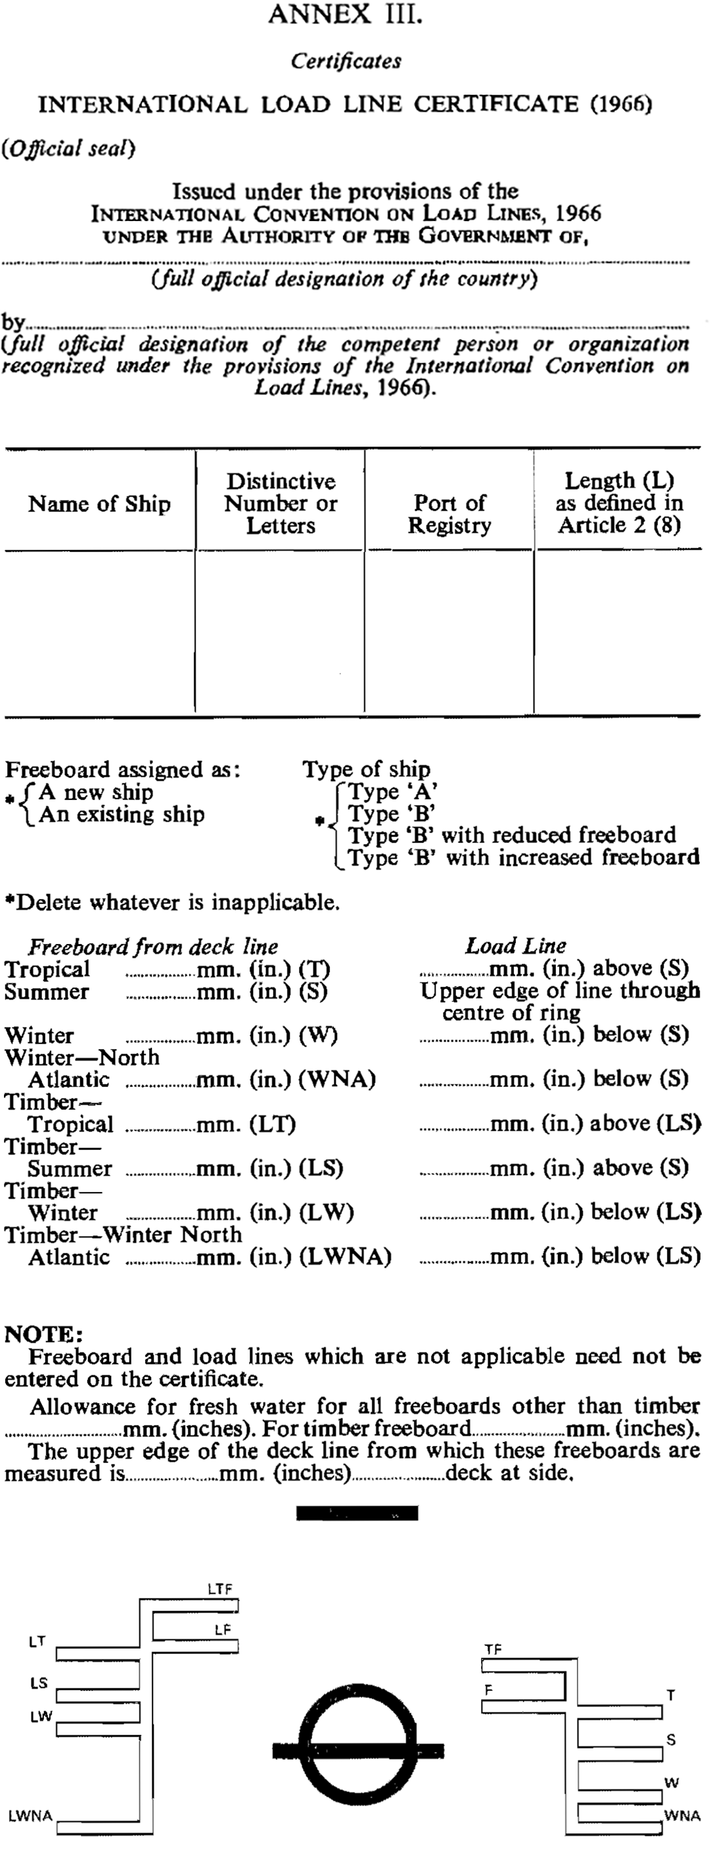
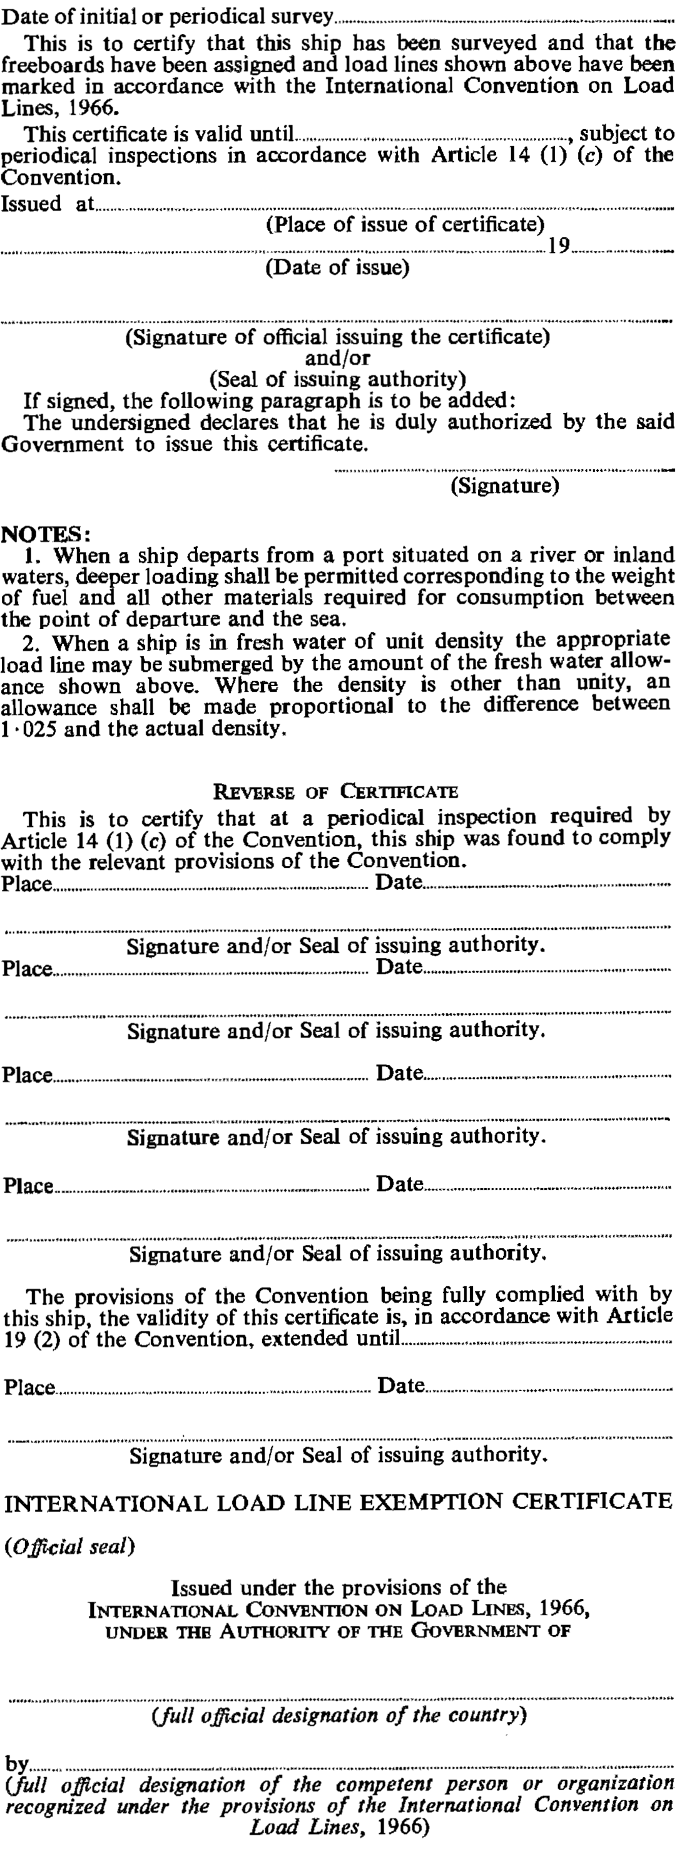
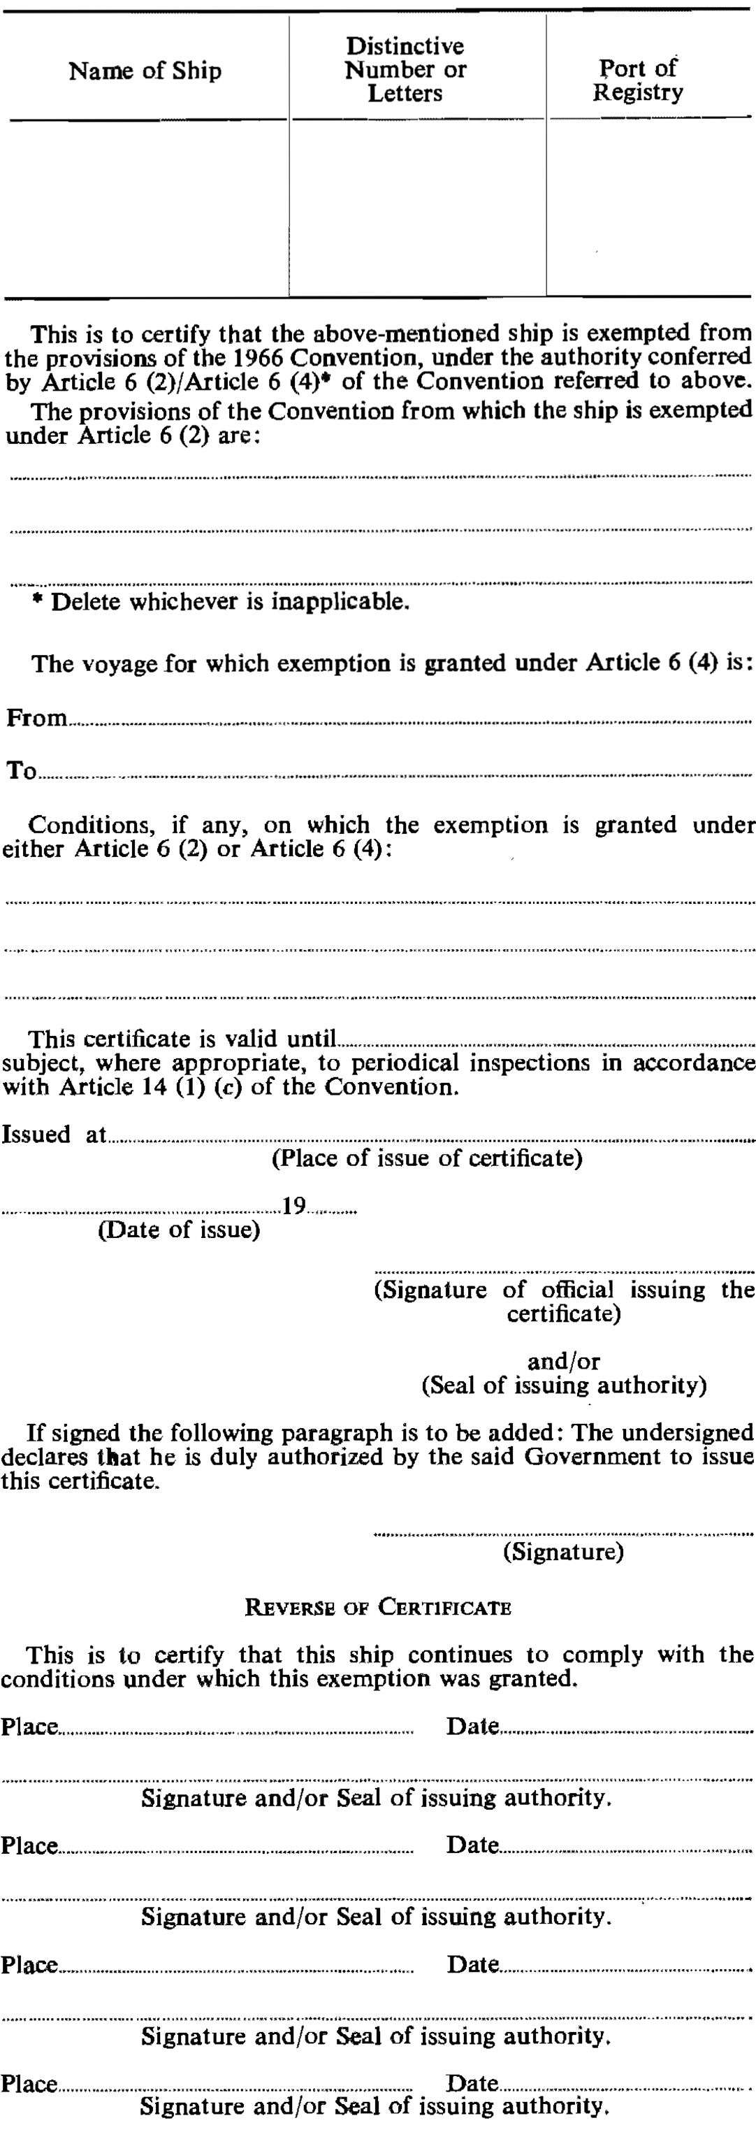
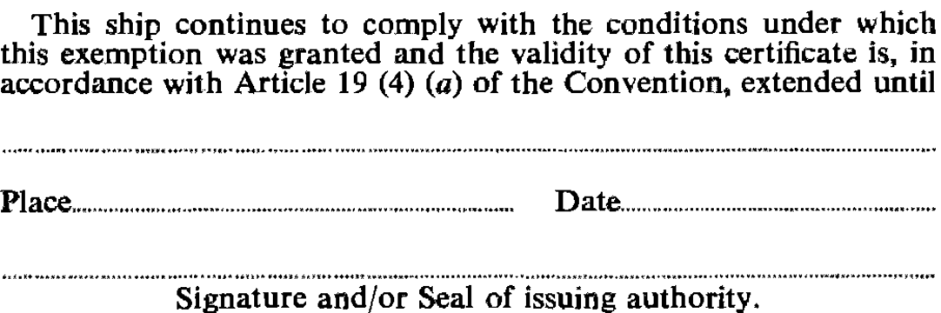

Not reproduced in this Proclamation.

