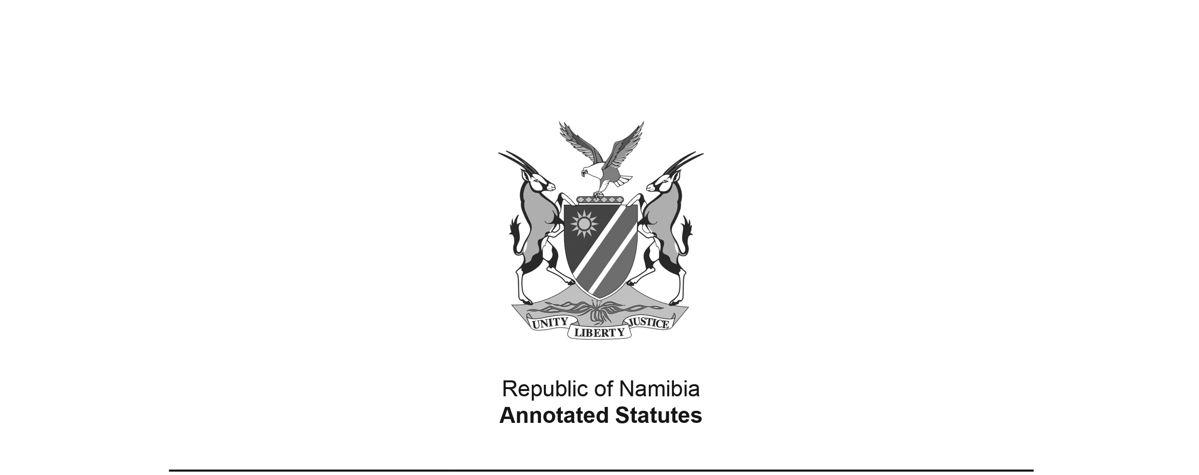
Intestate Succession Ordinance 12 of 1946
(OG 1259)
came into force on date of publication: 3 July 1946

as amended by

Intestate Succession Amendment Ordinance 6 of 1963 (OG 2460)
came into force on date of publication: 30 March 1963
Intestate Succession Amendment Act 15 of 1982 (OG 4721)
came into force on date of publication: 21 December 1982

ORDINANCE

To provide for the amendment of the law relating to intestate succession.

(Assented to 1st July, 1946)
(Afrikaans text signed by the Administrator)

ARRANGEMENT OF SECTIONS

[The provisions of this Proclamation have no headings.]

BE IT ORDAINED by the Legislative Assembly for the Territory of South West Africa as follows:-

1. (1) The surviving spouse of every person who after the commencement of this Ordinance dies either wholly or partly intestate, is hereby declared to be an intestate heir of the deceased spouse according to the following rules:-

(a) if the spouses were married in community of property and if the deceased spouse leaves any descendant who is entitled to succeed ab intestato, the surviving spouse shall succeed to the extent of a child’s share or to so much as together with the surviving spouse’s share in the joint estate, does not exceed fifty thousand rand in value (whichever is the greater);

[paragraph (a) amended by Ord. 6 of 1963 and substituted by Act 15 of 1982]

(b) if the spouses were married out of community of property and if the deceased spouse leaves any descendant who is entitled to succeed ab intestato, the surviving spouse shall succeed to the extent of a child’s share or to so much as does no exceed fifty thousand rand in value (whichever is the greater);

[Paragraph (b) is amended by Ord. 6 of 1963 and substituted by Act 15 of 1982. The
phrase “does no exceed” in the substituted provision should be “does not exceed”.]

(c) if the spouses were married either in or out of community of property, and the deceased spouse leaves no descendant who is entitled to succeed ab intestato, but leaves a parent or a brother or a sister (whether of the full or half blood) who is entitled so to succeed, the surviving spouse shall succeed to the extent of a half share or to so much as does not exceed fifty thousand rand in value (whichever is the greater);

[paragraph (c) amended by Ord. 6 of 1963 and substituted by Act 15 of 1982]

(d) in any case not covered by paragraph (a), (b), or (c) the surviving spouse shall be the sole intestate heir.

(2) For the purposes of this Ordinance any relationship by adoption under the provisions of the Adoption of Children Ordinance, 1927 (Ordinance No. 10 of 1927), shall be equivalent to blood relationship.

[The Adoption of Children Ordinance 10 of 1927 was repealed by the Children’s Ordinance 31 of 1961, which was repealed in turn by the Children’s Amendment Act 74 of 1973 (RSA GG 3966) – which was brought into force on 1 January 1977 by RSA Proc. 264/1976 (RSA GG 5360) and which made the Children’s Act 33 of 1960 (SA GG 6417) applicable to South West Africa.
The Children’s Act 33 of 1960 has now been replaced
by the Child Care and Protection Act 3 of 2015.]

2. This Ordinance may be cited as the Intestate Succession Ordinance, 1946.

