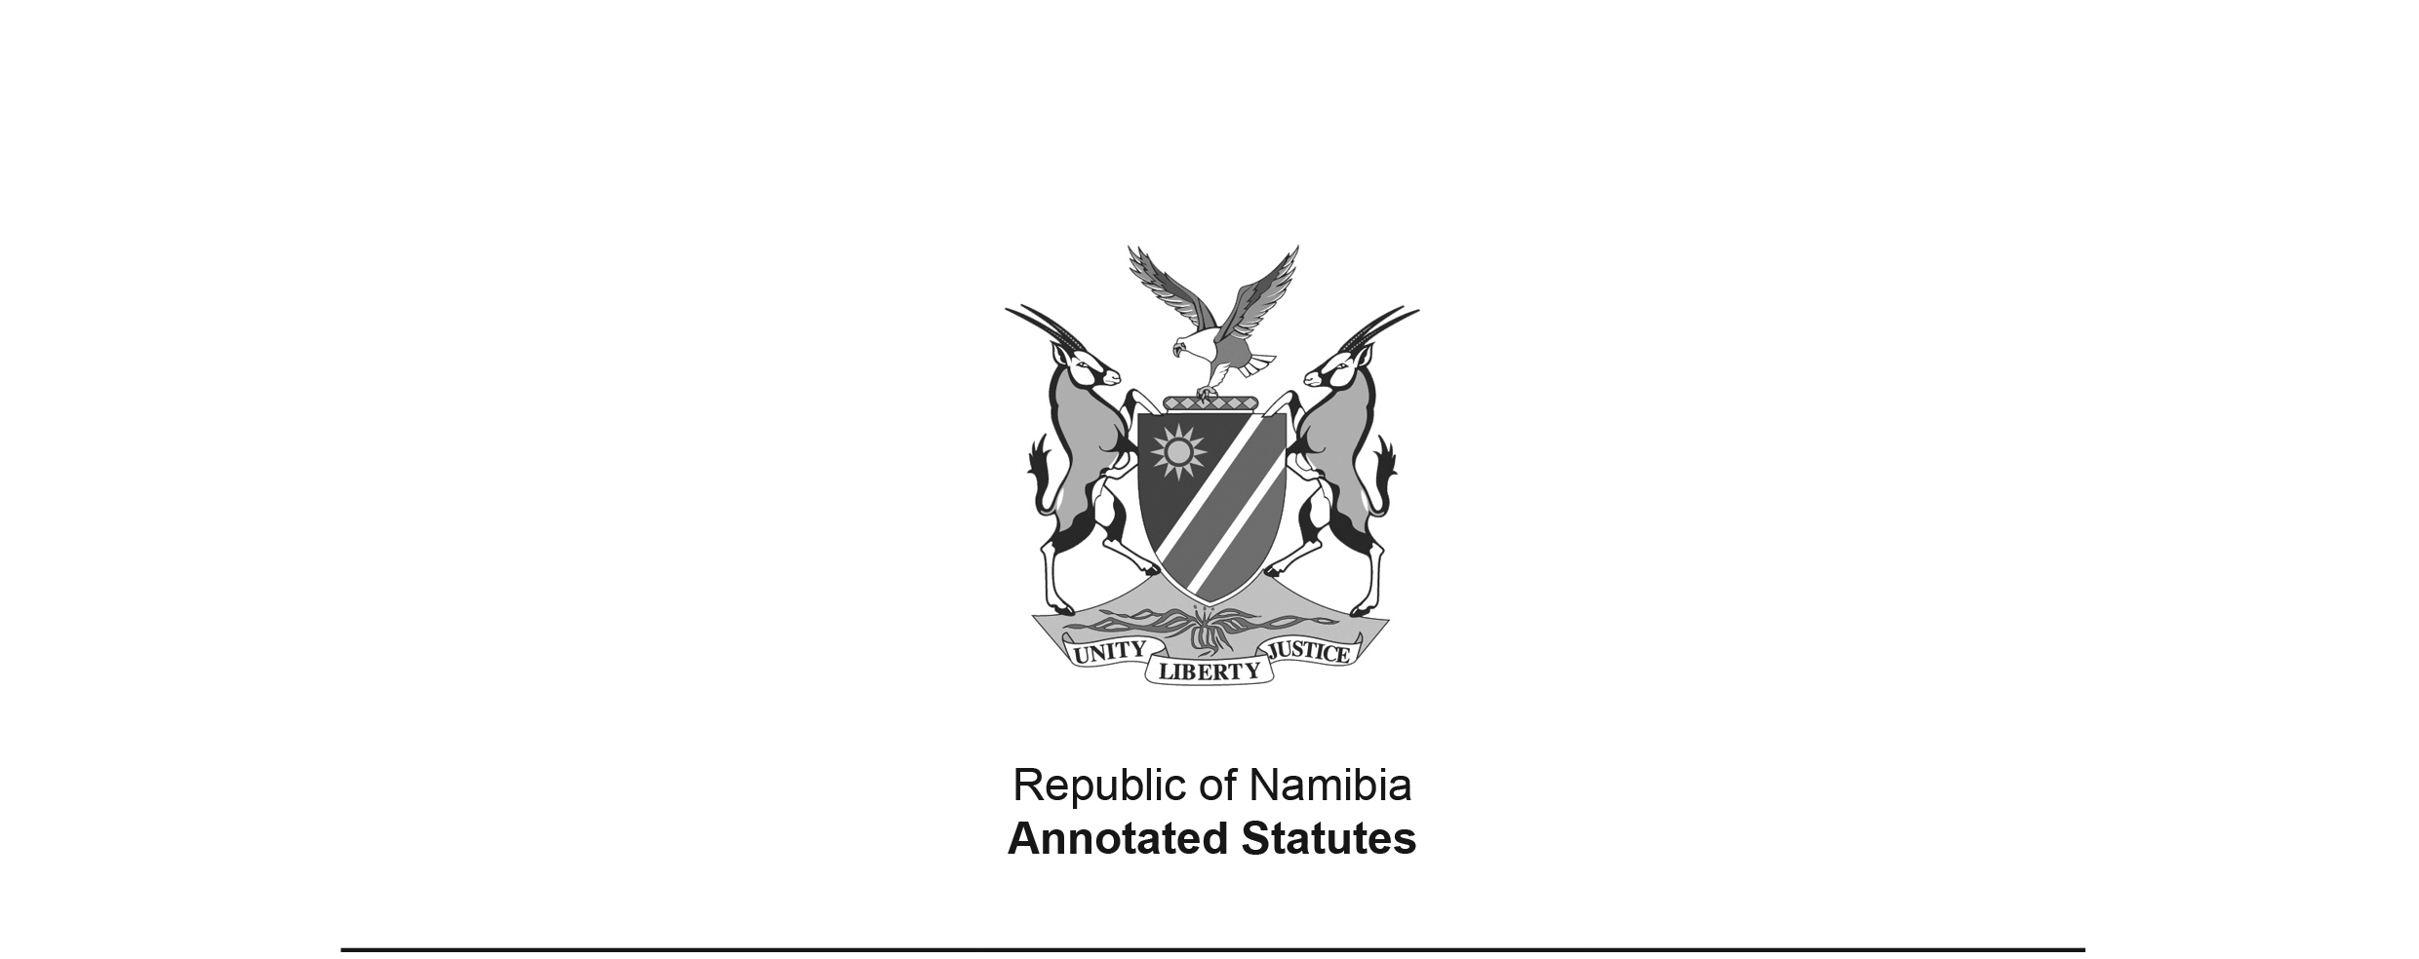
Council for Health and Social Services Professions Repeal Act 3 of 2004
(GG 3241)
brought into force on 10 January 2005 by GN 6/2005 (GG 3369)

ACT

To repeal the Council for Health and Social Services Professions Act, 1993; to provide for the transfer of moneys standing to that Council’s credit; and to provide for incidental matters.

(Signed by the President on 13 July 2004)

ARRANGEMENT OF SECTIONS

1. Definitions
2. Repeal of Act No. 29 of 1993
3. Transfer of moneys
3. Short title and commencement
[The final section is incorrectly numbered as a second section 3
in the Government Gazette. It should be section 4.]

BE IT ENACTED by the Parliament of the Republic of Namibia as follows:-

Definitions

1. In this Act, unless the context otherwise indicates, “the Council” means the Council for Health and Social Services Professions established by section 2 of the Council for Health and Social Services Professions Act, 1993 (Act No. 29 of 1993).

Repeal of Act No. 29 of 1993

2. Subject to section 3, the Council for Health and Social Services Professions Act, 1993, is hereby repealed.

Transfer of moneys

3. (1) For the purposes of this section the Council for Health and Social Services Professions Act, 1993, is regarded not to have been repealed by section 2, until the date the written report and financial statements referred to in subsection (6) are tabled in the National Assembly in terms of subsection (9).

(2) The moneys standing to the credit of the Council on the date immediately before the commencement of this Act must be paid over, subject to subsections (3) and (4), by the Council to the Councils established by law for the allied health professions, the medical and dental professions, the pharmacy profession, the nursing profession and the social work and psychology professions.

(3) The Council must -

(a) before any distribution of moneys is made in terms of subsection (1), determine the proportionate share of the contribution of each Board as defined in section 1 of the Council for Health and Social Services Professions Act, 1993, according to the ratio of its recorded financial contribution to the total amount available for final distribution; and

(b) proceed to pay to the relevant Councils that are in terms of any law the relevant successors of the Boards referred to in paragraph (a) an amount equivalent in value to its share of the total amount to be distributed.

(4) No moneys of the Council may in terms of subsection (1) be distributed to the Councils referred to in that subsection, unless all liabilities to the creditors of the Council, whose claims have arisen before the commencement of this Act, have been discharged.

(5) The Council must employ for its account the services of a person registered in terms of the Public Accountants’ and Auditors’ Act, 1951 (Act No. 51 of 1951), as an accountant and auditor to assist it with its duties under this section.

(6) The person referred to in subsection (5) must submit to the registrar of the Council as soon as practicable a written report relating to the distribution of moneys and the payment of claims in terms of this section, including the final audited financial statements of the Council.

(7) For the purposes of subsection (4), the costs incurred by the Council in terms of subsection (5) and (6) will be regarded as a claim which has arisen before the commencement of this Act.

(8) The registrar of the Council must submit the written report and audited financial statements referred to in subsection (6), together with his or her comments thereto, if any, to the Minister responsible for Health.

(9) The Minister responsible for Health must table the report and audited financial statements referred to in subsection (8) in the National Assembly within a period of six months after the date of receiving such report and statements.

Short title and commencement

3. This Act will be called the Council for Health and Social Services Professions Repeal Act, 2004, and will come into operation on a date to be determined by the Minister responsible for Health by notice in the Gazette.

[The final section is incorrectly numbered as a second section 3
in the Government Gazette. It should be section 4.]

