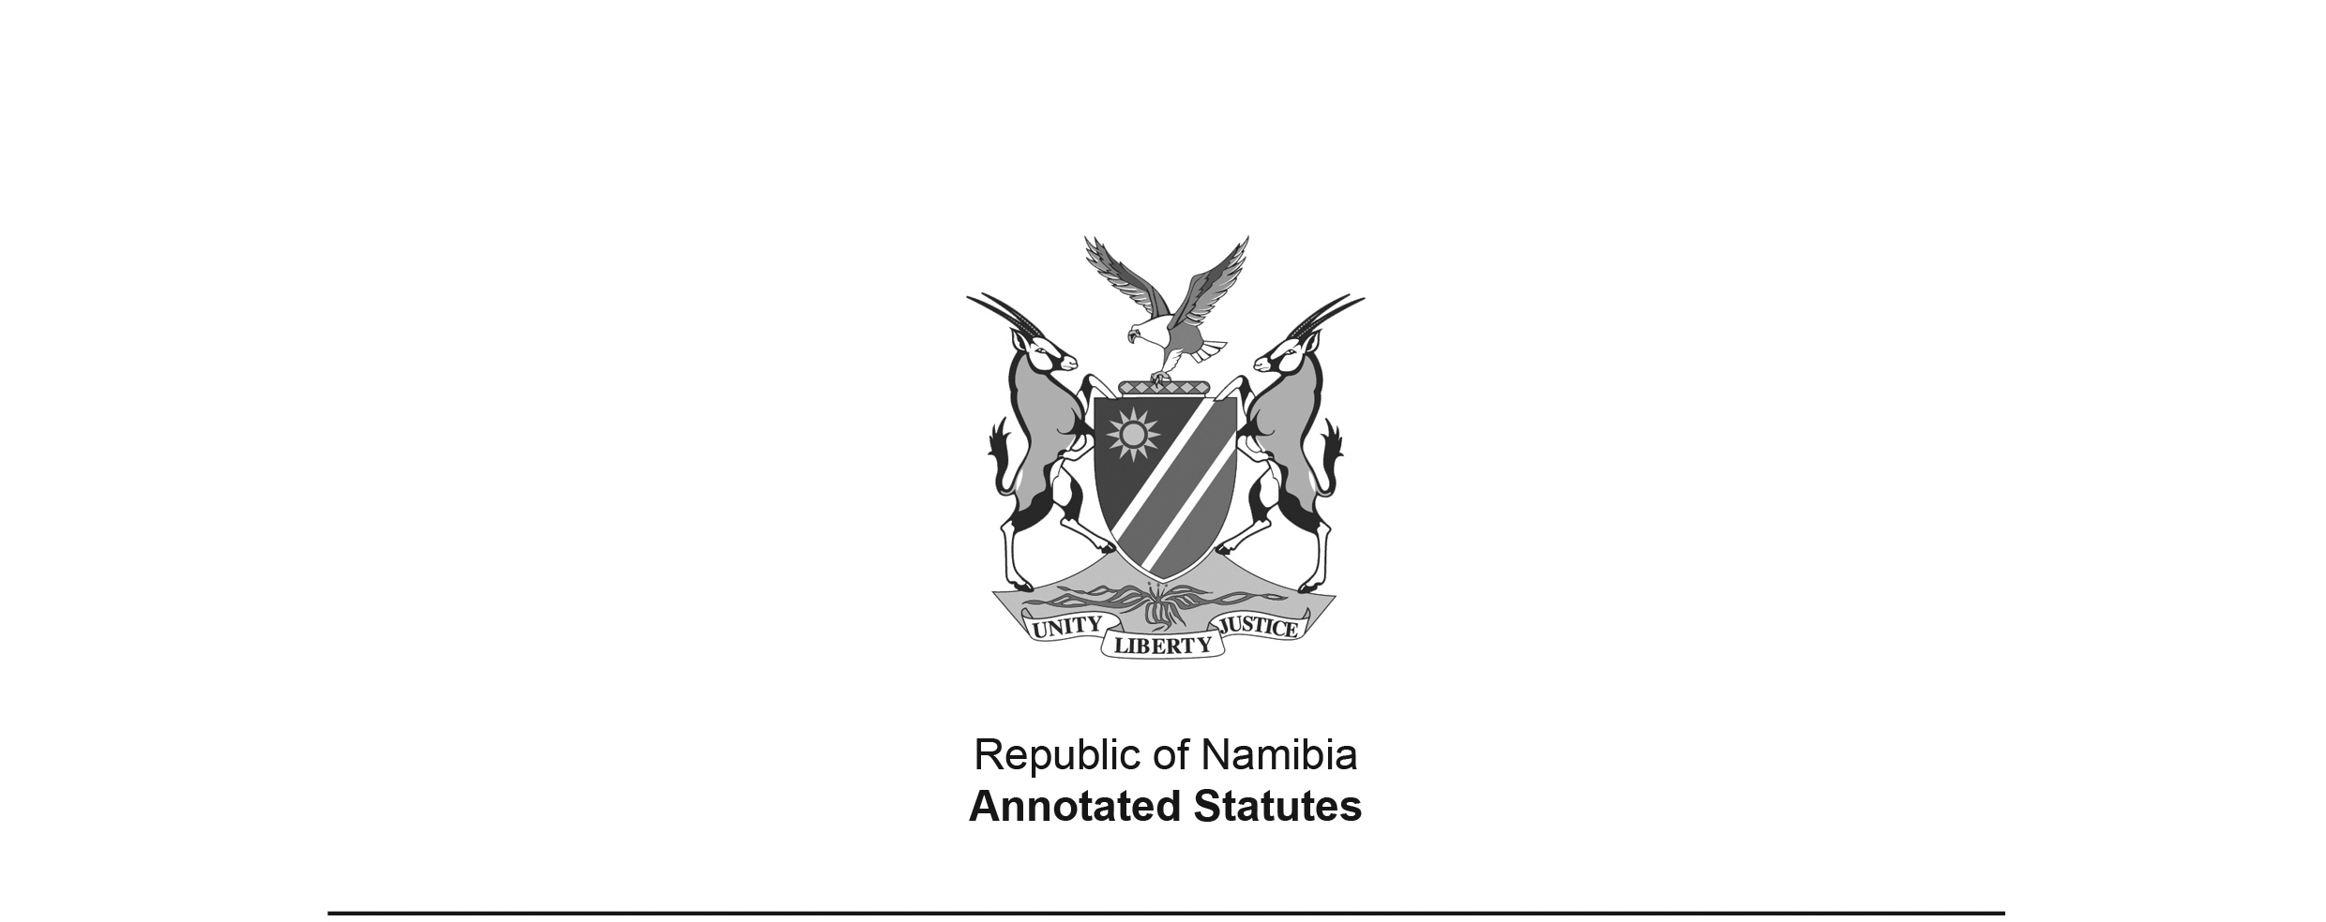
Appropriation Act 9 of 2010
(GG 4515)
came into force on date of publication: 1 July 2010

ACT

To appropriate amounts of money to meet the financial requirements of the State during the financial year ending 31 March 2011.

(Signed by the President on 25 June 2010)

BE IT ENACTED by the Parliament of the Republic of Namibia, as follows:

Appropriation of amounts of money for financial requirements of State

1. Subject to the State Finance Act, 1991 (Act No. 31 of 1991), the amounts of money shown in the Schedule are appropriated for the financial requirements of the State during the financial year ending 31 March 2011 as a charge to the State Revenue Fund.

Short title

2. This Act is called the Appropriation Act, 2010.

SCHEDULE

Vote | Title | Amount Appropriated  N$
01 | President | 360 399 000
02 | Prime Minister | 164 509 000
03 | National Assembly | 117 536 000
04 | Auditor-General | 52 867 000
05 | Home Affairs and Immigration | 174 284 000
06 | Police | 1 890 448 000
07 | Foreign Affairs | 505 480 000
08 | Defence | 3 014 774 000
09 | Finance | 2 650 427 000
10 | Education | 6 476 391 000
11 | National Council | 51 016 000
12 | Gender Equality and Child Welfare | 521 659 000
13 | Health and Social Services | 2 593 039 000
14 | Labour and Social Welfare | 1 140 182 000
15 | Mines and Energy | 177 161 000
16 | Justice | 326 735 000
17 | Regional and Local Government, Housing and Rural Development | 958 693 000
18 | Environment and Tourism | 347 927 000
19 | Trade and Industry | 490 689 000
20 | Agriculture, Water and Forestry | 1 518 737 000
21 | Prisons and Correctional Services | 419 526 000
22 | Fisheries and Marine Resources | 322 180 000
23 | Works | 462 877 000
24 | Transport | 1 308 829 000
25 | Lands and Resettlement | 190 196 000
26 | National Planning Commission | 134 012 000
27 | Youth, National Service, Sport and Culture | 459 260 000
28 | Electoral Commission | 181 997 000
29 | Information and Communication Technology | 251 487 000
30 | Anti-Corruption Commission | 36 786 000
31 | Veterans Affairs | 274 538 000
 | TOTAL | 27 574 641 000

