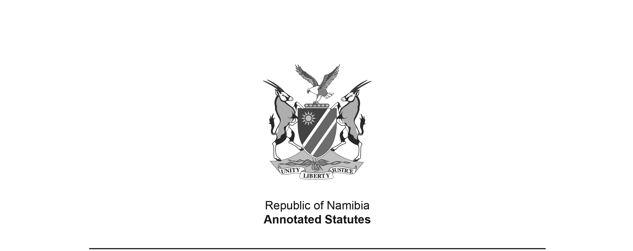

Appropriation Act 7 of 2016

(GG 6050)

came into force on date of publication: 24 June 2016

as amended by

Appropriation Amendment Act 15 of 2016 **(GG 6199)**

**came into force on date of publication: 16 December 2016**

ACT

**To appropriate amounts of money to meet the financial requirements of the State during the financial year ending 31 March 2017.**

*(Signed by the President on 9 May 2016)*

**BE IT ENACTED** as passed by the Parliament, and assented to by the President, of the Republic of Namibia as follows:

**Appropriation of amounts of money for financial requirements of State**

**1.** Subject to the State Finance Act, 1991 (Act No. 31 of 1991), the amounts of money shown in the Schedule are appropriated for the financial requirements of the State during the financial year ending 31 March 2017 as a charge to the State Revenue Fund.

**Short title**

**2.** This Act is called the Appropriation Act, 2016.

SCHEDULE

**[The Schedule is substituted by Act 10 of 2015.**

**Some of the “APPROPRIATED AMOUNTS” in the substituted Schedule do not match those in the original Schedule to the Appropriation Act 7 of 2015. They seem to have been erroneously copied from the Schedule to the Appropriation Act 1 of 2016, which was promulgated by GN 94/2016   
(GG 6006) and withdrawn by GN 139/2016 (GG 6049). The total appropriation amount is not   
affected by the discrepancies, which effectively cancel each other out.]**

|  |  |  |  |
| --- | --- | --- | --- |
| **VOTE** | **TITLE** | **APPROPRIATED AMOUNTS N$** | **AMENDED AMOUNTS N$** |
| 01 | Office of the President | 679 129 000 | 642 878 000 |
| 02 | Office of the Prime Minister | 485 744 000 | 510 486 000 |
| 03 | National Assembly | 227 628 000 | 203 033 000 |
| 04 | Auditor General | 85 498 000 | 74 924 000 |
| 05 | Home Affairs and Immigration | 497 243 000 | 470 196 000 |
| 06 | Safety and Security | 5 134 567 000 | 4 992 867 000 |
| 07 | International Relations and Cooperation | 900 862 000 | 867 744 000 |
| 08 | Defence | 6 600 539 000 | 5 946 745 000 |
| 09 | Finance | 3 290 898 000 | 3 078 127 000 |
| 10 | Education, Arts and Culture | 12 794 882 000 | 12 322 672 000 |
| 11 | National Council | 146 533 000 | 112 144 000 |
| 12 | Gender Equality and Child Welfare | 858 051 000 | 982 070 000 |
| 13 | Health and Social Services | 7 230 983 000 | 6 955 536 000 |
| 14 | Labour, Industrial Relations and Employment Creation | 207 473 000 | 168 397 000 |
| 15 | Mines and Energy | 246 565 000 | 177 685 000 |
| 16 | Justice | 293 551 000  [The amount in the original Appropriation Act 7 of 2016 was  N$300 764 000.] | 279 147 000 |
| 17 | Urban and Rural Development | 2 808 922 000 | 2 621 620 000 |
| 18 | Environment and Tourism | 581 961 000 | 487 106 000 |
| 19 | Industrialisation, Trade and SME Development | 840 733 000 | 531 314 000 |
| 20 | Agriculture, Water and Forestry | 2 301 487 000 | 2 524 509 000 |
| 21 | Judiciary | 278 481 000 | 268 884 000 |
| 22 | Fisheries and Marine Resources | 295 040 000 | 265 540 000 |
| 23 | Works | 667 393 000 | 628 851 000 |
| 24 | Transport | 4 155 600 000 | 3 466 461 000 |
| 25 | Land Reform | 613 027 000 | 474 761 000 |
| 26 | National Planning Commission | 215 910 000 | 199 068 000 |
| 27 | Sport, Youth and National Service | 491 045 000 | 380 259 000 |
| 28 | Electoral Commission of Namibia | 193 254 000 | 153 484 000 |
| 29 | Information and Communication Technology | 494 980 000 | 453 876 000 |
| 30 | Anti-Corruption Commission | 49 860 000 | 48 080 000 |
| 31 | Veterans Affairs | 910 987 000 | 803 546 000 |
| 32 | Higher Education, Training and Innovation | 3 409 891 000 | 3 498 489 000 |
| 33 | Poverty Eradication and Social Welfare | 2 926 544 000 | 2 870 167 000 |
| 34 | Public Enterprises | 77 423 000 | 40 981 000 |
| 35 | Attorney-General | 127 953 000  [The amount in the original Appropriation Act 7 of 2016 was  N$120 740 000.] | 118 990 000 |
|  | **TOTAL** | **61 120 637 000** | **57 620 637 000** |