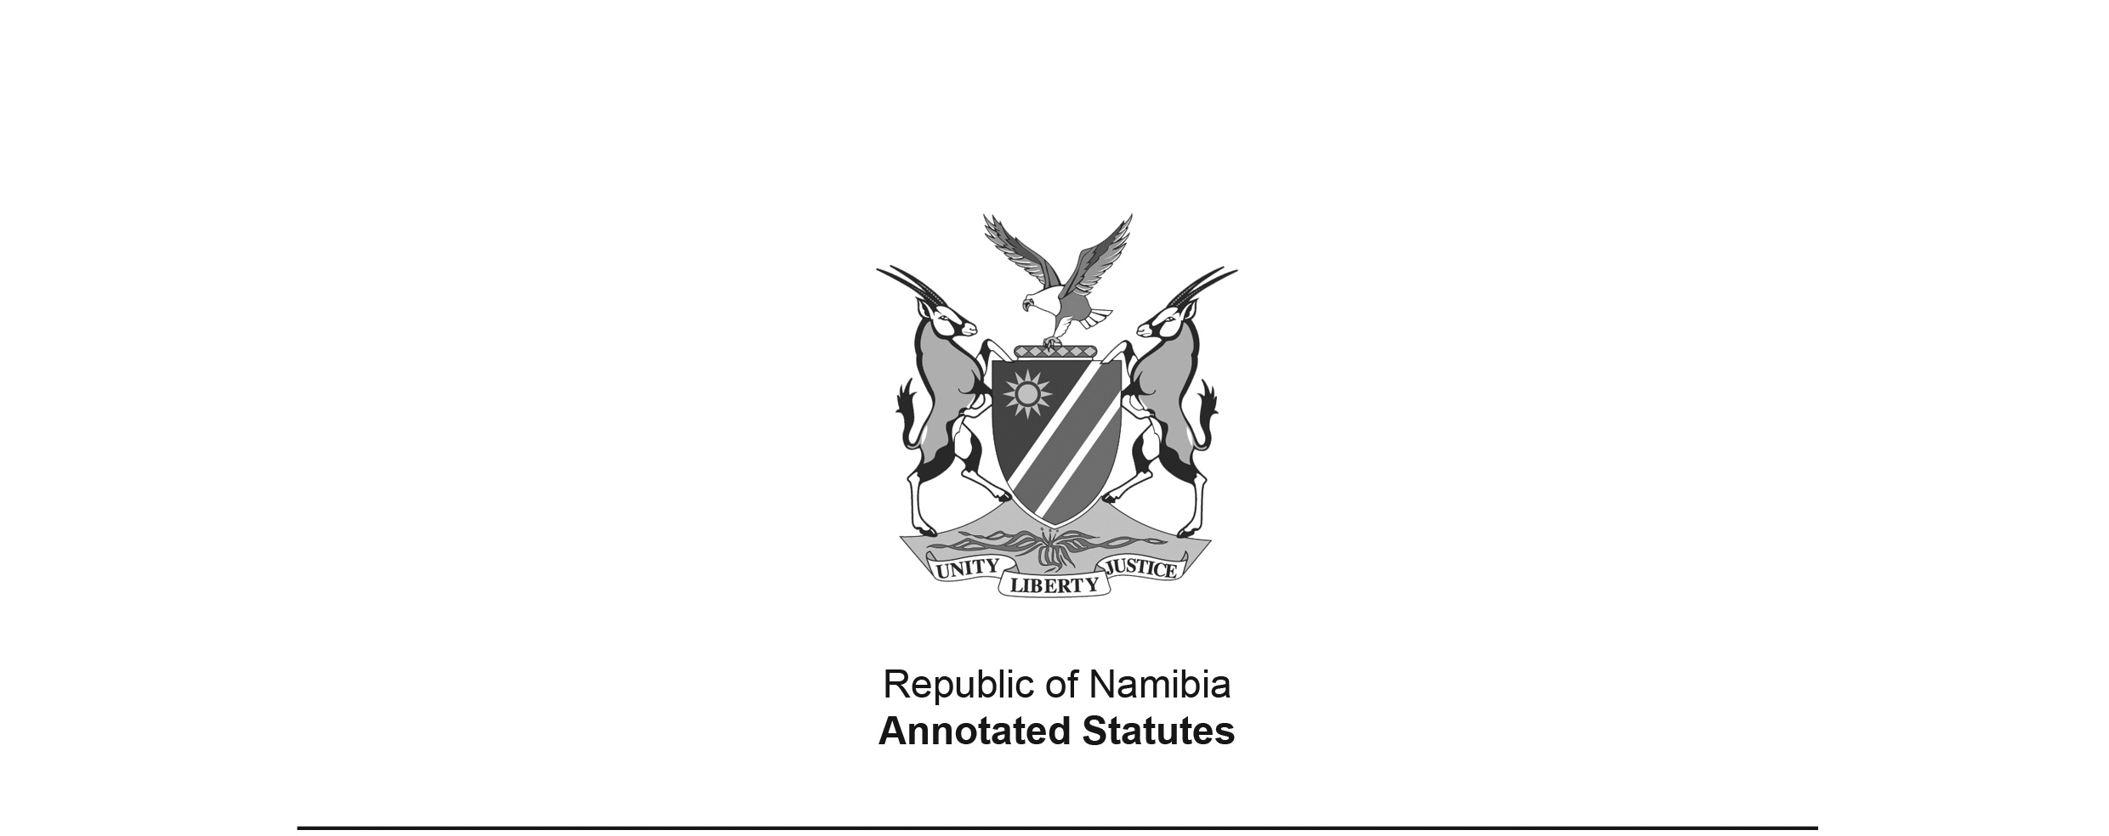
Appropriation Act 7 of 2005
(GG 3477)
came into force on date of publication: 5 August 2005

ACT

To appropriate amounts of money to meet the financial requirements of the State during the financial year ending on 31 March 2006.

(Signed by the President on 27 July 2005)

BE IT ENACTED by the Parliament of the Republic of Namibia, as follows:-

Appropriation of amounts of money to meet the financial requirements of the State

1. Subject to the State Finance Act, 1991 (Act No. 31 of 1991), the amounts of money shown in the Schedule are appropriated as a charge to the State Revenue Fund to meet the financial requirements of the State during the financial year ending on 31 March 2006.

Short title

2. This Act is called the Appropriation Act, 2005.

SCHEDULE

VOTE NO | TITLE | AMOUNT APPROPRIATED  N$
01 | President | 186 278 000
02 | Prime Minister | 71 035 000
03 | National Assembly | 54 560 000
04 | Auditor-General | 20 545 000
05 | Home Affairs and Immigration | 81 000 000
06 | Police | 731 684 000
07 | Foreign Affairs | 217 089 000
08 | Defence | 1 220 475 000
09 | Finance | 1 199 095 000
10 | Education | 2 783 905 000
11 | National Council | 25 794 000
12 | Gender Equality and Child Welfare | 144 728 000
13 | Health and Social Services | 1 308 768 000
14 | Labour and Social Welfare | 564 429 000
15 | Mines and Energy | 98 039 000
16 | Justice | 196 232 000
17 | Regional and Local Government, Housing and Rural Development | 437 831 000
18 | Environment and Tourism | 120 621 000
19 | Trade and Industry | 114 815 000
20 | Agriculture, Water and Forestry | 668 629 000
21 | Prisons and Correctional Services | 156 704 000
22 | Fisheries and Marine Resources | 118 142 000
23 | Works | 291 219 000
24 | Transport and Communication | 284 999 000
25 | Lands and Resettlement | 138 681 000
26 | National Planning Commission | 63 128 000
27 | Youth, National Service, Sport and Culture | 164 130 000
28 | Electoral Commission | 8 684 000
29 | Information and Broadcasting | 184 832 000
 | TOTAL | 11 656071 000  [Error in numeral reproduced from Government Gazette.]

