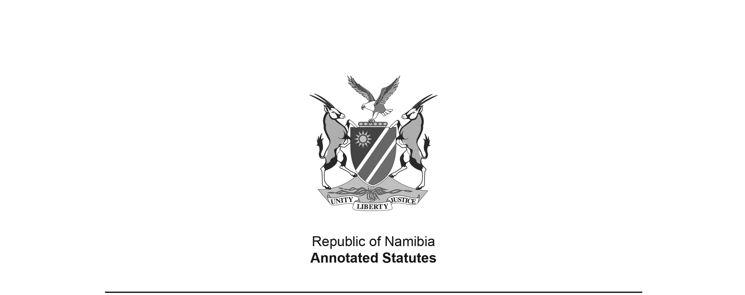
Appropriation Act 3 of 2008
(GG 4067)
came into force on date of publication: 17 June 2008

ACT

To appropriate amounts of money to meet the financial requirements of the State during the financial year ending 31 March 2009.

(Signed by the President on 6 June 2008)

BE IT ENACTED by the Parliament of the Republic of Namibia, as follows:

Appropriation of amounts of money for financial requirements of State

1. Subject to the State Finance Act, 1991 (Act No. 31 of 1991), the amounts of money shown in the Schedule are appropriated for the financial requirements of the State during the financial year ending 31 March 2009 as a charge to the State Revenue Fund.

Short title

2. This Act is called the Appropriation Act, 2008.

SCHEDULE

VOTE  NO. | TITLE | AMOUNT IN NAMIBIA DOLLARS
01 | President | 253 428 000
02 | Prime Minister | 420 762 000
03 | National Assembly | 90 053 000
04 | Auditor General | 28 323 000
05 | Home Affairs and Immigration | 151 741 000
06 | Police | 1 289 985 000
07 | Foreign Affairs | 320 714 000
08 | Defence | 2 371 780 000
09 | Finance | 2 818 465 000
10 | Education | 4 782 761 000
11 | National Council | 39 989 000
12 | Gender Equality and Child Welfare | 264 887 000
13 | Health and Social Services | 2 130 873 000
14 | Labour and Social Welfare | 996 336 000
15 | Mines and Energy | 152 330 000
16 | Justice | 236 359 000
17 | Regional and Local Government, Housing and Rural Development | 593 854 000
18 | Environment and Tourism | 209 290 000
19 | Trade and Industry | 185 904 000
20 | Agriculture, Water and Forestry | 948 631 000
21 | Prisons and Correctional Services | 228 486 000
22 | Fisheries and Marine Resources | 168 081 000
23 | Works | 388 984 000
24 | Transport | 1 017 056 000
25 | Lands and Resettlement | 161 184 000
26 | National Planning Commission | 79 491 000
27 | Youth, National Service, Sport and Culture | 319 168 000
28 | Electoral Commission | 78 191 000
29 | Information and Communication Technology | 225 298 000
30 | Anti-Corruption Commission | 14 144 000
31 | Veterans Affairs | 167 120 000
 | TOTAL | 21 133 668 000

