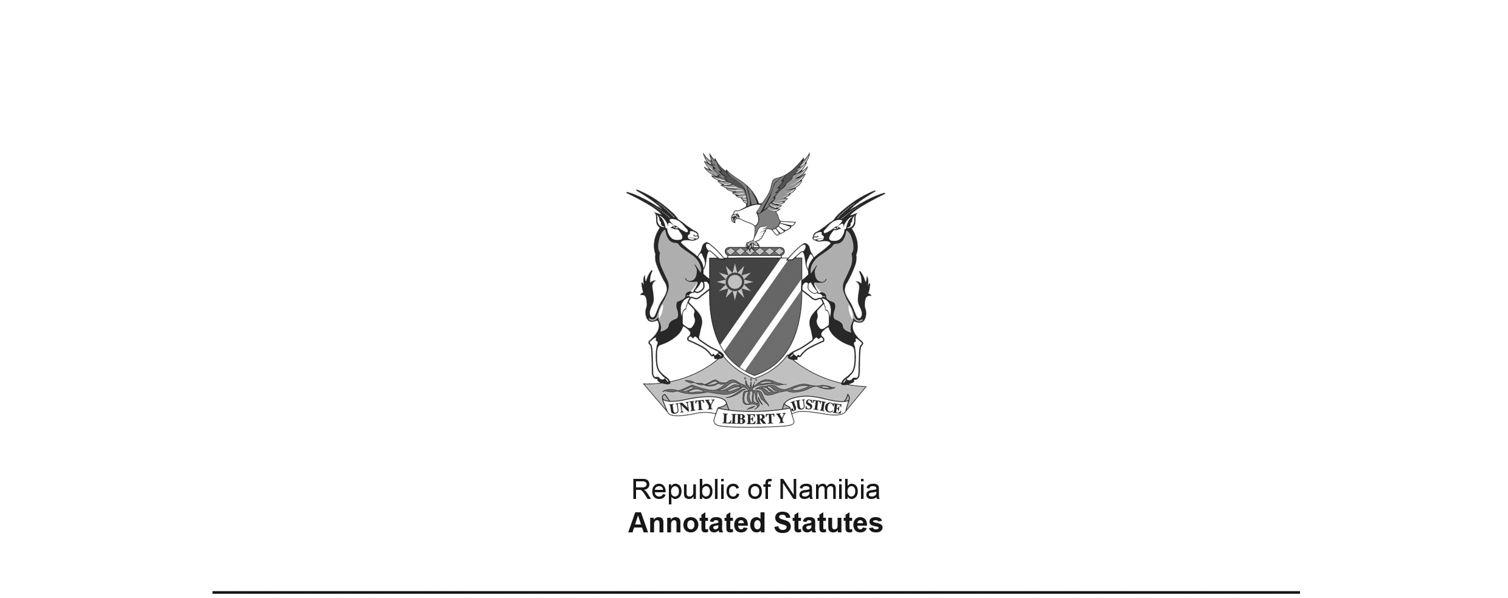
Appropriation Act 1 of 2021
(GG 7550)
came into force on date of publication: 7 June 2021

as amended by

Appropriation Amendment Act 4 of 2021 (GG 7704)
came into force on date of publication: 16 December 2021

ACT

To appropriate amounts of money to meet the financial requirements of the State during the financial year ending 31 March 2022.

(Signed by the President on 3 June 2021)

BE IT ENACTED as passed by the Parliament, and assented to by the President, of the Republic of Namibia, as follows:

Appropriation of amounts of money for the financial requirements of State

1. Subject to the State Finance Act, 1991 (Act No. 31 of 1991) the amounts of money shown in the Schedule are appropriated for the financial requirements of the State during the financial year ending 31 March 2022 as a charge to the State Revenue Fund.

Short title

2. This Act is called the Appropriation Act, 2021.

SCHEDULE

[Schedule substituted by Act 4 of 2021]

VOTE  NO. | TITLE | APPROPRIATED AMOUNTS  N$’000 | AMENDED AMOUNTS  N$’000
01 | President | 609,152 | 600,152
02 | Prime Minister | 416,998 | 397,598
03 | National Assembly | 117,187 | 111,187
04 | Auditor General | 108,267 | 108,267
07 | International Relations and Cooperation | 827,698 | 827,698
08 | Defence | 5,428,595 | 5,884,095
09 | Finance | 4,696,983 | 4,916,983
10 | Education, Arts and Culture | 13,777,815 | 14,173,815
11 | National Council | 88,367 | 85,967
13 | Health and Social Services | 8,081,016 | 8,429,816
14 | Labour, Industrial Relations and Employment Creation | 162,692 | 162,092
15 | Mines and Energy | 212,441 | 198,441
16 | Justice | 491,405 | 489,405
17 | Urban and Rural Development | 1,613,925 | 1,575,300
18 | Environment, Forestry and Tourism | 524,688 | 502,288
19 | Industrialisation and Trade | 159,797 | 200,450
21 | Judiciary | 371,152 | 381,152
22 | Fisheries and Marine Resources | 191,426 | 188,426
23 | Works | 492,589 | 575,089
24 | Transport | 2,506,644 | 2,448,644
26 | National Planning Commission | 182,781 | 182,781
27 | Sport, Youth and National Service | 278,750 | 276,250
28 | Electoral Commission of Namibia | 72,419 | 69,419
29 | Information and Communication Technology | 354,050 | 495,750
30 | Anti-Corruption Commission | 62,771 | 62,771
31 | Veterans Affairs | 861,344 | 878,444
32 | Higher Education, Technology and Innovation | 3,147,300 | 3,313,100
34 | Public Enterprises | 733,396 | 953,828
36 | Gender Equality, Poverty Eradication and Social Welfare | 5,444,795 | 5,450,306
37 | Agriculture and Land Reform | 1,255,940 | 1,222,640
38 | Water | 465,262 | 463,262
39 | Home Affairs, Immigration, Safety and Security | 5,712,272 | 5,750,272
 | TOTAL | 59,449,917 | 61,375,688

