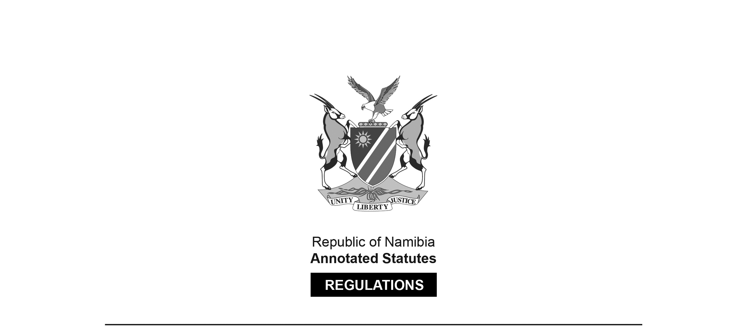
REGULATIONS MADE IN TERMS OF

Social Work and Psychology Act 6 of 2004
section 56 read with section 42(1)(d)

Maximum Fine that Council or Professional
Conduct Committee May Impose
Government Notice 19 of 2018
(GG 6527)
came into force on date of publication: 15 February 2018
Note that GG 6527 was initially numbered incorrectly as GG 6528.
A corrected version was subsequently issued.

The Government Notice which publishes these regulations notes that they were
made on the recommendation of the Social Work and Psychology Council of Namibia.
It also repeals GN 157/2014 (GG 5559).

ARRANGEMENT OF REGULATIONS

1. Definitions
2. Maximum fine that may be imposed by Council or professional conduct committee

Definitions

1. In these regulations a word or expression to which a meaning has been assigned in the Act has that meaning and, unless the context indicates otherwise -

“the Act” means the Social Work and Psychology Act, 2004 (Act No. 6 of 2004).

Maximum fine that may be imposed by Council or professional conduct committee

2. Under section 42(1)(d) of the Act, the Council or the professional conduct committee
may impose a fine not exceeding the amount of N$200,000.00 per charge.

