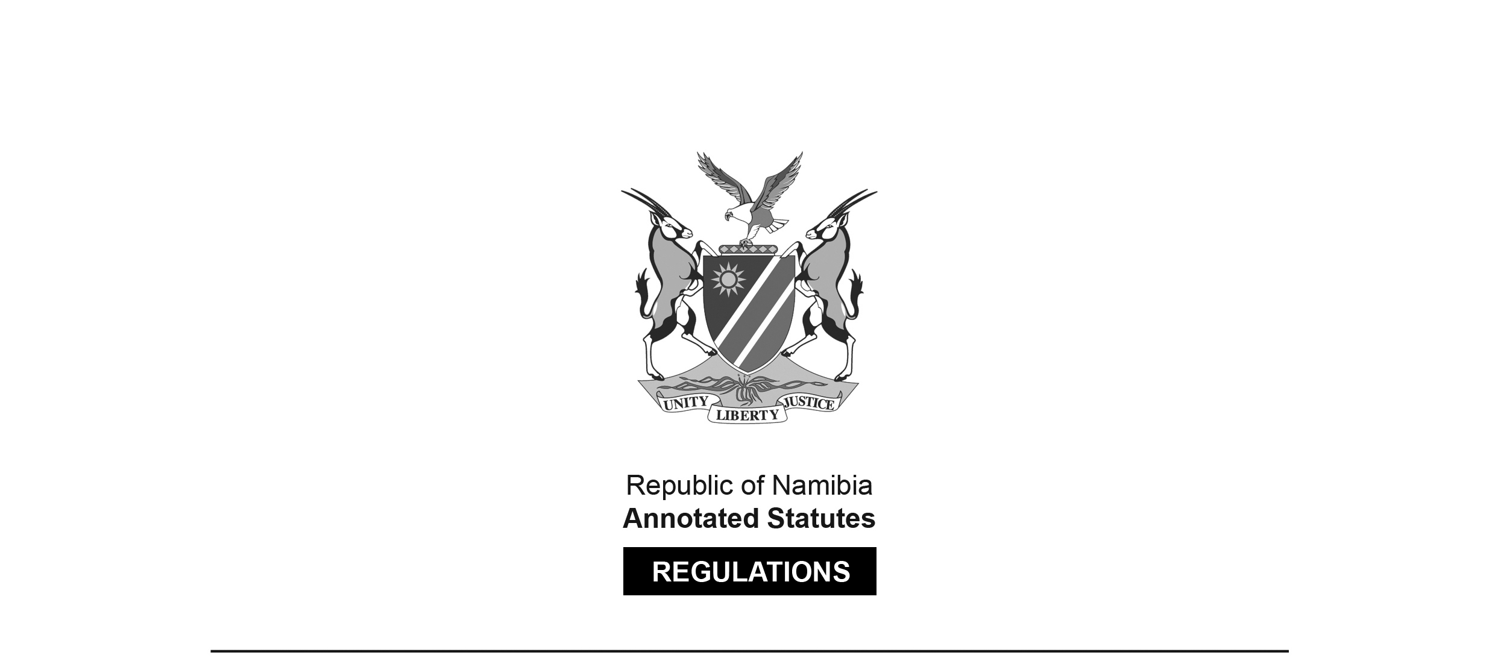
REGULATIONS MADE IN TERMS OF

Nursing Act 8 of 2004
section 59(1)

Regulations relating to Uniforms, Badges
and Other Distinguishing Devices Worn by
Registered Persons or Enrolled Persons
Government Notice 17 of 2019
(GG 6836)
came into force on date of publication: 1 February 2019

The Government Notice which publishes these regulations notes that they were made on the recommendation of the Nursing Council of Namibia. It also repeals a set of regulations on the same topic contained in GN 56/1999 (GG 2077), as amended by GN 116/2009 (GG 4264).

ARRANGEMENT OF REGULATIONS

1. Definitions
2. Epaulettes
3. Badge
4. Wearing of distinguishing devices
5. Accessories
6. Registered and enrolled persons who are members of the police, military or prison services
7. Offences and penalties

Definitions

1. In these regulations, a word or an expression to which a meaning has been assigned in the Act has that meaning, and unless the context otherwise indicates -

“distinguishing devices” means a cloth epaulette of the appropriate colour as prescribed by regulation 2, worn with a badge as prescribed by regulation 3;

“enrolled nurse” includes enrolled midwife or accoucheur;

“midwife” includes an accoucheur;

“registered midwife” includes a person authorised under section 62(4) of the Act to practice as a midwife;

“registered nurse” includes a person authorised under section 62(4) of the Act to practice as a nurse; and

“the Act” means the Nursing Act, 2004 (Act No. 8 of 2004).

Epaulettes

2. (1) A person registered as a midwife must wear epaulettes of a green colour.

(2) A person enrolled as a nursing auxiliary must wear epaulettes of a navy blue colour.

(3) A person enrolled as a nurse must wear epaulettes of a royal blue colour.

(4) A person registered as a nurse must wear epaulettes of a maroon colour.

(5) A person registered as a nurse or midwife must wear a colour coded bar of approximately 25 millimetres by five millimetres on every epaulette to indicate the additional qualification, or the additional qualifications registered against that person’s name -

Colour of bar Additional Qualification

Green Midwifery;
Yellow Community Health Nursing Science;
Silver Nursing Management;
White Nursing Education;
Black Psychiatric Nursing Science.

Badge

3. The badge of the Council must be the design appearing below and must be of a silver colour with the outer lettered border enameled blue:
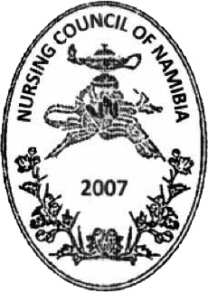

Wearing of distinguishing devices

4. (1) Subject to regulation 6, a registered nurse, registered midwife, enrolled nurse and nursing auxiliary must, in all areas of clinical nursing and midwifery practice, wear the distinguishing devices applicable to them, as prescribed by these regulations.

(2) The badge referred to in regulation 3 must be affixed to the distinguishing device, unless the Council determines otherwise.

(3) A distinguishing device must be worn as set out in subregulation (1) and may not be worn as part of or in combination with any device or badge other than the badge referred to in regulation 3.

(4) Distinguishing devices must be worn on a uniform that is of -

(a) a plain tailored style which may include respectable full length tailored trousers, and in the case of men, may include long trousers and in the case of woman, the skirt must be at knee length; and

(b) a plain colour.

Accessories

5. The accessories to a uniform referred to in regulation 4(4) must be -

(a) plain matching shoes in a matching colour;

(b) full length stockings for females; and

(c) a tailored jacket, jersey, coat of a plain colour.

[The word “or” should have been used in paragraph (c)
after the word “jersey” instead of a comma for correct list format.]

Registered persons who are members of police, military or prison services

6. A registered nurse, registered midwife, nursing auxiliary or enrolled nurse who is a member of -

(a) the Namibian Police Force; or

(b) the nursing services of the Namibian Defence Force or the Namibian Correctional Service,

do not have to wear the distinguishing devices referred to in these regulations when wearing a uniform of the Namibian Police Force, the Namibian Defence Force or the Namibian Correctional Service.

[The verb “do” should be “does” to be grammatically correct.]

Offences and penalties

7. A -

(a) person who manufactures, sells or supplies any distinguishing device referred to in these regulations without the written authority of the Council;

(b) registered midwife who contravenes or fails to comply with regulations 2(1), 4 or 5;

(c) nursing auxiliary enrolled who contravenes or fails to comply with regulations 2(2), 4 or 5,

(d) enrolled nurse who contravenes or fails to comply with regulations 2(3), 4 or 5; or

(e) registered nurse who contravenes or fails to comply with regulations 2(4), 4 or 5,

commits an offence and is liable to a fine not exceeding N$ 4000 or to imprisonment for a period not exceeding 12 months, or to both such fine and such imprisonment.

