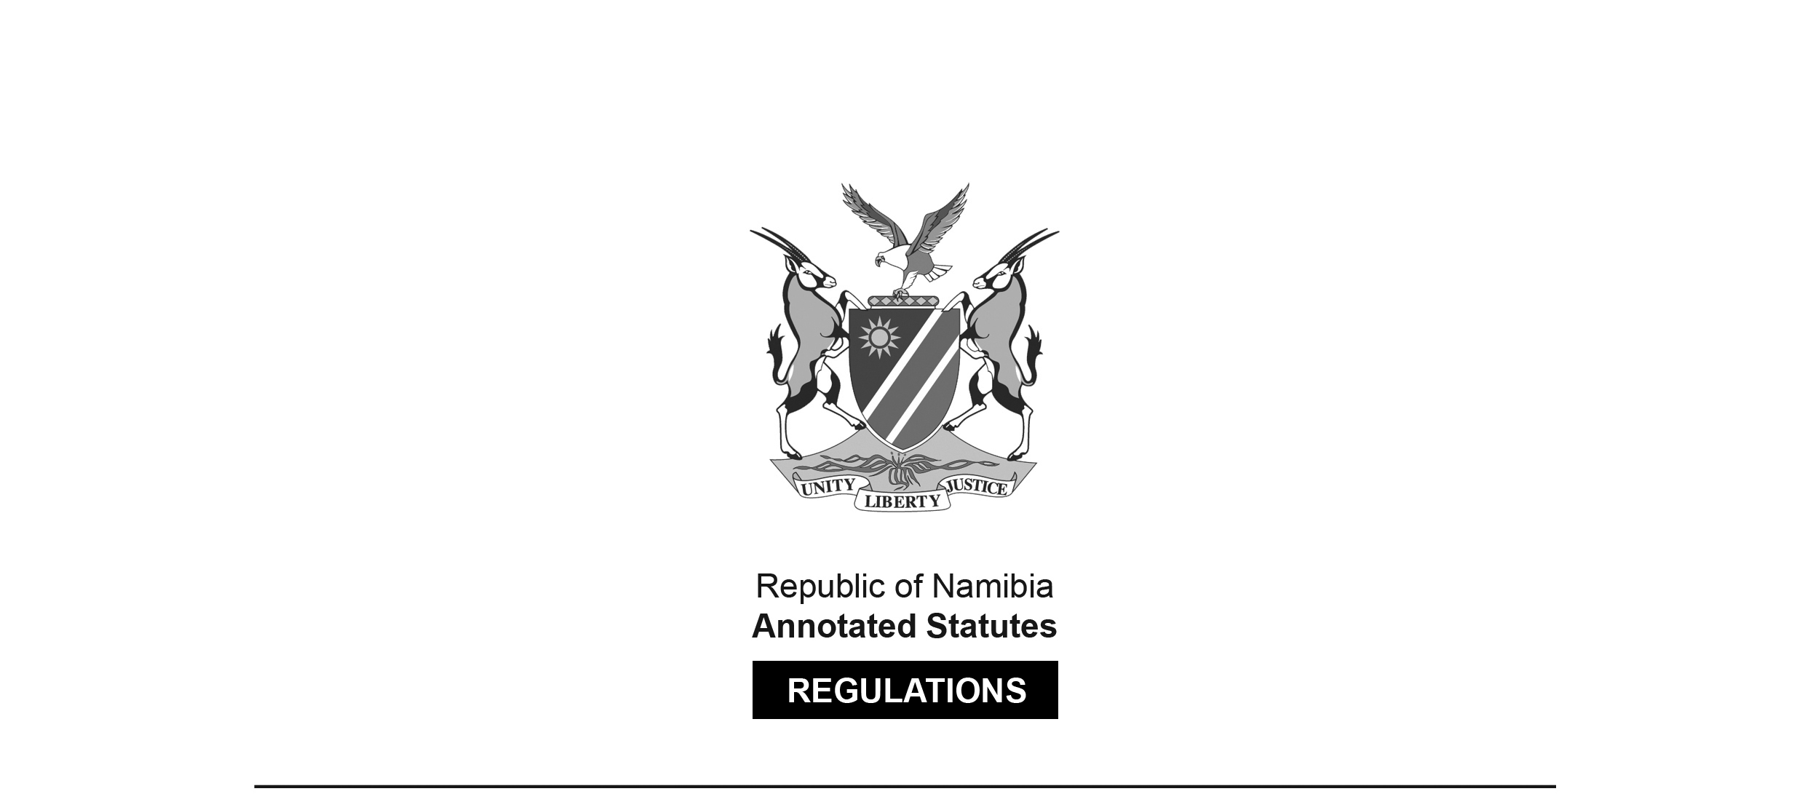
REGULATIONS MADE IN TERMS OF

Namibia Tourism Board Act 21 of 2000
section 30

Regulations relating to Levy Payable by
Accommodation Establishments
Government Notice 137 of 2004
(GG 3235)
came into force on 1 November 2004 (GN 137/2004)

ARRANGEMENT OF REGULATIONS

1. Definitions
2. Tourism levy
3. Basis for calculating levy
4. Levy period and time and manner of payment
5. Additional charge on late payment
6. Offences and penalties

Definitions

1. In these regulations, unless the context otherwise indicates, a word or expression to which a meaning has been assigned in the Act has that meaning, and -

“Board” means the Namibia Tourism Board established by section 2 of the Act;

“levy period” means the period prescribed by regulation 4(1) in respect of which the levy referred to in regulation 3 is payable;

“owner” in relation to a registered accommodation establishment, means any person -

(a) who, either solely or jointly with one or more other persons, is the holder of a certificate of registration issued under section 20 of the Act to conduct that accommodation establishment; or

(b) who for the time being receives or is entitled to receive the proceeds of the profits arising from the accommodation establishment;

“registered accommodation establishment” means an accommodation establishment registered under section 20 of the Act;

“the Act” means the Namibia Tourism Board Act, 2000 (Act No. 21 of 2000).

Tourism levy

2. Every owner of a registered accommodation establishment, other than a campsite or a camping and caravan park, must pay a levy to the Namibia Tourism Board in the amount, and at the times and in the manner, prescribed by these regulations.

Basis for calculating levy

3. (1) The levy payable in terms of regulation 2 is -

(a) the amount equal to two percent (2%) of the total amount charged to guests over a levy period in accordance with the establishment’s tariff -

(i) for bed and breakfast; or,

(ii) if breakfast is not included, for bed-night accommodation; or

(b) in the case of an accommodation establishment where a single tariff, inclusive of accommodation, food and beverages and recreational activities (if any) is charged, the amount equal to one percent (1%) of the total amount charged to guests over the levy period, calculated in accordance with the single tariff.

(2) Any amount representing value-added tax charged and collected in terms of the Value-Added Tax Act, 2000 (Act No. 10 of 2000) in respect of the provision of a service, must be disregarded for the purpose of calculating the amount of levy payable in terms of subregulation (1).

Levy period and time and manner of payment

4. (1) The levy payable in terms of regulation 2 must be paid in respect of every period of two months calculated with effect from -

(a) the date of commencement of these regulations; or

(b) the date of registration, in the case of an accommodation establishment registered after the date of commencement of these regulations.

(2) Payment of the amount of the levy must -

(a) be made to the Board not later than -

(i) the last day of the calendar month that follows a levy period; or

(ii) if the last day of that month falls on a Saturday, Sunday or public holiday, on the first business day after that day;

(b) be made at an office of the Board or in accordance with any other arrangement approved by the Board; and

(c) be accompanied by a statement, in a form determined by the Board, in respect of the levy period for which the payment is made.

Additional charge on late payment

5. An owner, who fails to pay the levy in full by the last day for payment prescribed by regulation 4(2)(a), must pay, in addition to the levy, a charge equal to 5 percent of any outstanding amount of the levy in respect of each month or a part of a month during which the outstanding amount remains unpaid.

Offences and penalties

6. An owner who, on expiry of a period of 14 days after the Board has sent a written demand to the owner requiring him or her to pay any outstanding amount of the levy or of interest accrued in terms of regulation 5, fails to pay that amount is guilty of an offence and is liable to a fine not exceeding N$ 4000 or to a sentence of imprisonment not exceeding one year or to both such fine and such imprisonment.

