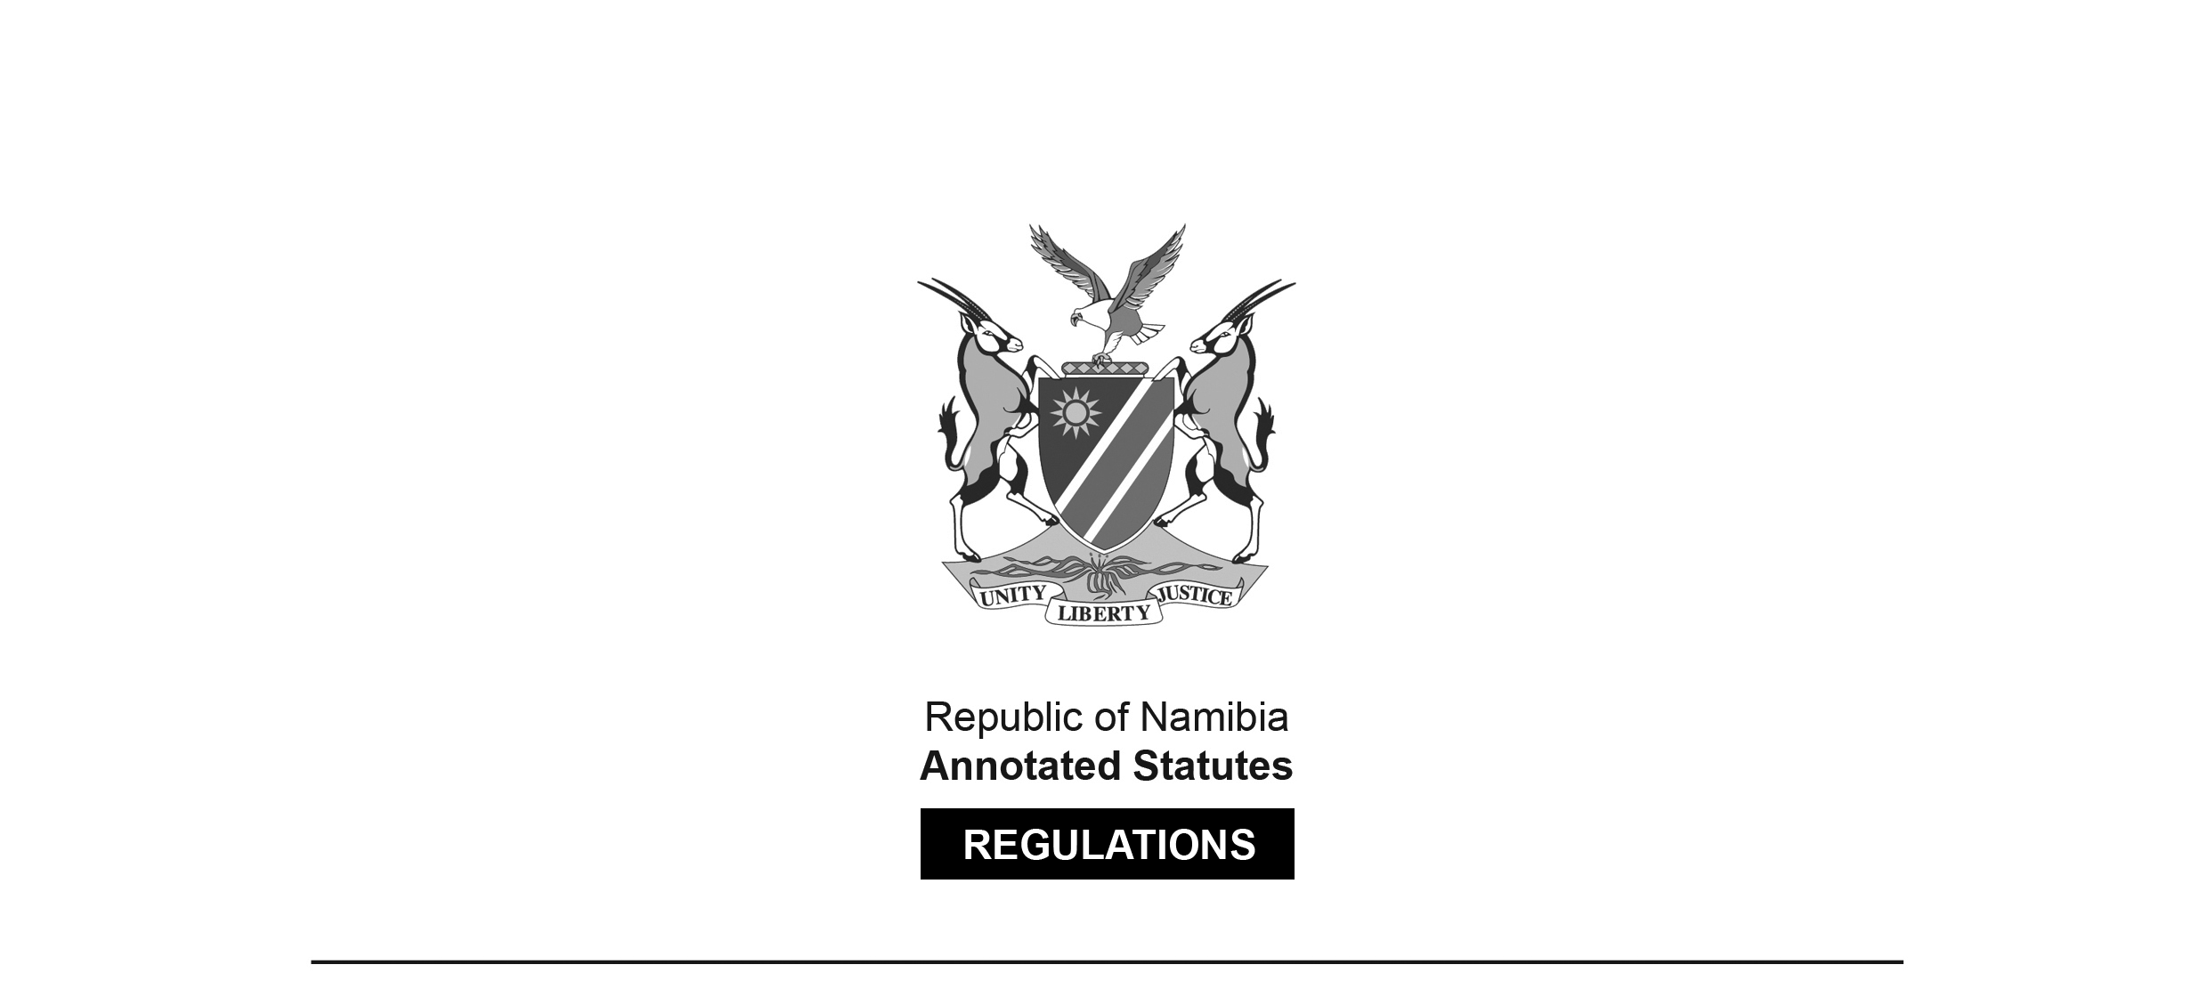

REGULATIONS MADE IN TERMS OF

Medical and Dental Act 10 of 2004

section 59 read with section 41(1)(d)

Maximum Fine that Council or   
Professional Conduct Committee May Impose

Government Notice 62 of 2018

(GG 6564)

came into force on date of publication: 8 April 2018

The Government Notice which publishes these regulations notes that they were   
made on the recommendation of the Medical and Dental Council of Namibia.   
It also repeals GN 23/2018 (GG 6527), which in turn repealed GN 155/2014 (GG 5559).

Note that GG 6527 was initially numbered incorrectly as GG 6528.   
A corrected version was subsequently issued.

ARRANGEMENT OF REGULATIONS

1. Definitions

2. Maximum fine that may be imposed by Council or professional conduct committee

**Definitions**

**1.** In these regulations a word or expression to which a meaning has been assigned in the Act has that meaning and, unless the context indicates otherwise -

“the Act” means the Medical and Dental Act, 2004 (Act No. 10 of 2004).

**Maximum fine that may be imposed by Council or professional conduct committee**

**2.** Under section 41(1)(d) of the Act, the Council or the professional conduct committee may impose a fine not exceeding the amount of N$200,000.00 per charge.