REGULATIONS MADE IN TERMS OF

Marine Resources Act 27 of 2000
section 37 read with section 61

Regulations relating to Licensing of Foreign Flag Vessels
for the Purpose of Harvesting Namibia’s
Share of Marine Resources
Government Notice 147 of 2006
(GG 3696)
came into force on date of publication: 8 September 2006

ARRANGEMENT OF REGULATIONS

1. Definitions
2. Application of regulations
3. Application for licence
4. Issue of licence
5. Validity of licence
6. Cancellation and suspension of licence
7. Compliance

ANNEXURE A
Application for a licence to use a foreign flag vessel
to harvest Namibia’s share of marine resources

ANNEXURE B
Licence to use a foreign flag vessel to harvest Namibia’s share of marine resources

ANNEXURE C
Fee payable for a licence

ANNEXURE D
International Convention for the Conservation of Atlantic Tunas

Definitions

1. In these regulations, unless the context otherwise indicates, a word or expression defined in the Act has the same meaning, and -

“conservation and management measures” means the conservation and management measures published by Government Notice No. 126 of 30 August 2006;

The reference to “conservation and management measures published by Government Notice No. 126 of 30 August 2006” appears to be an error. GN 126/2006 is dated 1 September 2006 and contains Otjiwarongo Amendment Scheme No. 8 (GG 3688). No Government Gazette was published on 30 August 2006.
The definition probably intended to refer to the conservation and management measures
published by Government Notice 148 of 8 September 2006 (GG 3696).

“licence” means a licence issued in terms of regulation 4;

“Namibia’s share of marine resources” means Namibia’s share of tuna and tuna like fishes found in the Convention area, as defined in the International Convention for the Conservation of Atlantic Tunas, a copy of which is set out in Annexure D;

“responsible party” in relation to the International Convention for the Conservation of Atlantic Tunas, means -

(a) a contracting party;

(b) a cooperating non-contracting party, entity or fishing entity; or

(c) a non-contracting party, entity or fishing entity, which agrees to apply the conservation and management measures and,

to which a foreign flag vessel is registered;

“the Act” means the Marine Resources Act, 2000 (Act No. 27 of 2000).

Application of regulations

2. These regulations apply to any person who intends to use, or uses a foreign flag vessel to harvest Namibia’s share of marine resources.

Application for licence

3. (1) A person -

(a) who holds a right under section 33 of the Act; or

(b) who is nominated under section 35(2) of the Act,

and who intends to use a foreign flag vessel to harvest Namibia’s share of marine resources, must apply to the Permanent Secretary for a licence in the form substantially corresponding with the Annexure A.

(2) An application referred to in subregulation (1) must be accompanied by the appropriate fee specified in Annexure C.

(3) The Permanent Secretary must within seven days of receiving an application made in terms of subregulation (1) and the fee referred to in subregulation (2), forward the application to the Minister.

(4) On receipt of an application in terms of subregulation (3), the Minister may request further information as is reasonably necessary in respect of the application.

Issue of licence

4. (1) The Minister must consider an application made in terms of regulation 3, and may -

(a) subject to any condition which is reasonably necessary, grant the application; or

(b) refuse the application in accordance with subregulation (3), and may provide the applicant with reasons for the refusal.

(2) If the Minister grants the application in terms of subregulation (1), the Minister must issue a licence to the applicant in the form substantially corresponding with Annexure B.

(3) The Minister may refuse an application made in terms of regulation 3, if the Minister is satisfied that -

(a) the information furnished in the application is incomplete or incorrect;

(b) the vessel in respect of which an application is made is not intended to be used as a fishing vessel;

(c) the granting of the application will not be in the interest of the fishing industry harvesting Namibia’s share of marine resources; or

(d) the granting of the application might threaten the sustainability of a particular marine resource.

(4) If -

(a) any change has occurred in the information submitted by a licence holder in connection with the application made in terms of regulation 3; or

(b) the vessel in respect of which the licence is issued ceases to be used as a fishing vessel,

the licence holder must, within 21 days of the change having occurred and in writing or in any other manner determined by the Permanent Secretary, inform the Permanent Secretary of the change.

Validity of licence

5. (1) A licence is valid for a period not exceeding one year, but may be renewed on application in accordance with subregulation (2).

(2) A person who intends to renew a licence must apply for renewal in accordance with regulation 3, but the Minister may on the application for a renewal of a licence -

(a) attach new conditions to the licence; or

(b) vary the conditions of the original licence.

Cancellation and suspension of licence

6. (1) Subject to subregulations (2) and (3), the Minister may suspend, cancel or amend a licence if -

(a) the foreign flag vessel ceases to be registered to its responsible party;

(b) the licence holder has, in the application for a licence, furnished information which is not true or complete;

(c) the licence holder contravenes or fails to comply with a condition attached to the licence;

(d) the licence holder contravenes the Act;

(e) the licence holder is convicted of an offence in terms of the Act or any regulation made under the Act; or

(f) the licence holder fails to comply with the conservation and management measures.

(2) If any of the circumstances contemplated in subregulation (1) occur, the Permanent Secretary must, by written notice delivered to licence holder or sent by registered post to the licence holder’s last known address, request the licence holder to show cause, in writing and within a period of 21 days from the date of the notice, why the licence must not be suspended, cancelled or amended.

(3) The Permanent Secretary must, after expiry of the period referred to in subregulation (2), refer the matter together with any reason furnished by the licence holder referred to in that subregulation to the Minister for the Minister’s decision.

(4) Where a matter is referred to the Minister in terms of subregulation (3), the Minister may -

(a) suspend the licence for a period determined by the Minister;

(b) cancel the licence from a date determined by the Minister;

(c) amend the duration of the licence; or

(d) amend the terms or conditions of the licence.

(5) The Minister may, whenever the Minister considers it necessary in the interests of the promotion, protection or utilisation on a sustainable basis of the Namibia’s share of marine resources, at any time by written notice to a licence holder, suspend, cancel or amend that licence holder’s licence.

Compliance

7. (1) The

(a) Vessel Monitoring Regulations published by Government Notice No. 65 of 14 June 2005; and

(b) Parts IV, V, VI, VII, VIII and IX of the Regulations, relating to the exploitation of marine resources, published by Government Notice No. 241 of 7 December 2001,

apply, reading in changes required in the context, to any person who uses a foreign flag vessels to harvest Namibia’s share of marine resources.

(2) Any person who uses a foreign flag vessel to harvest Namibia’s share of marine resources must comply with the conservation and management measures.

(3) A person who contravenes subregulation (2) is guilty of an offence and is on conviction liable to a penalty mentioned in section 52 of the Act.

ANNEXURES A-B

To view content without printing, scroll down.

To print at full scale (A4), double-click the icon below.

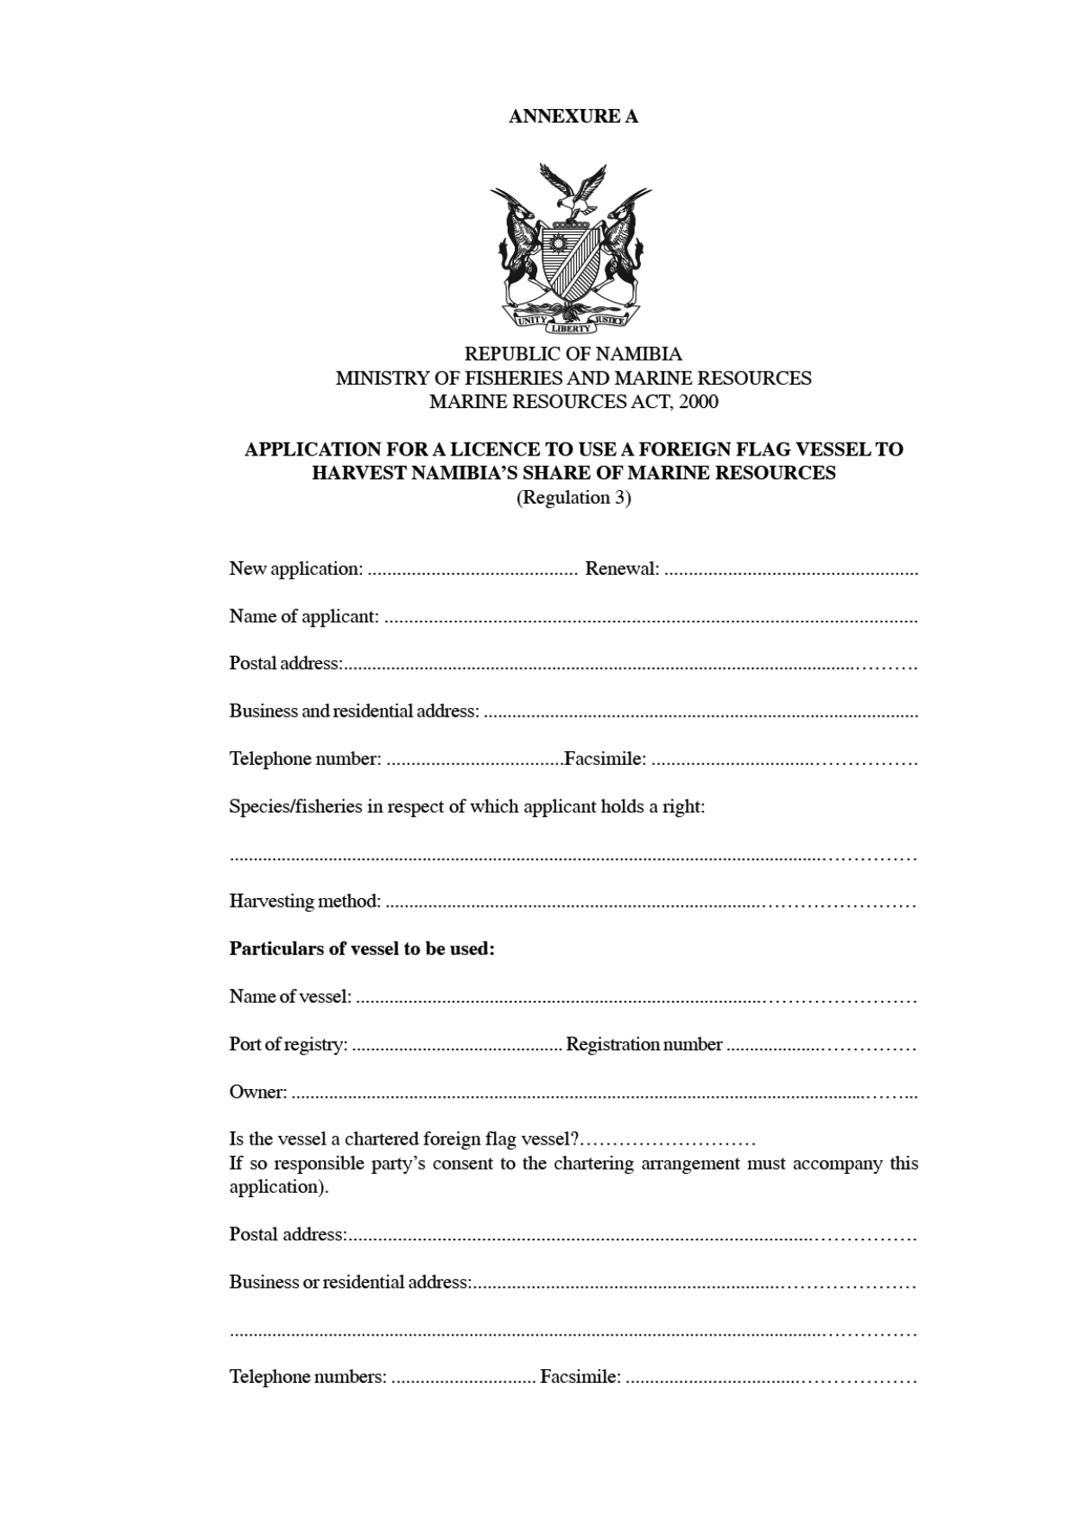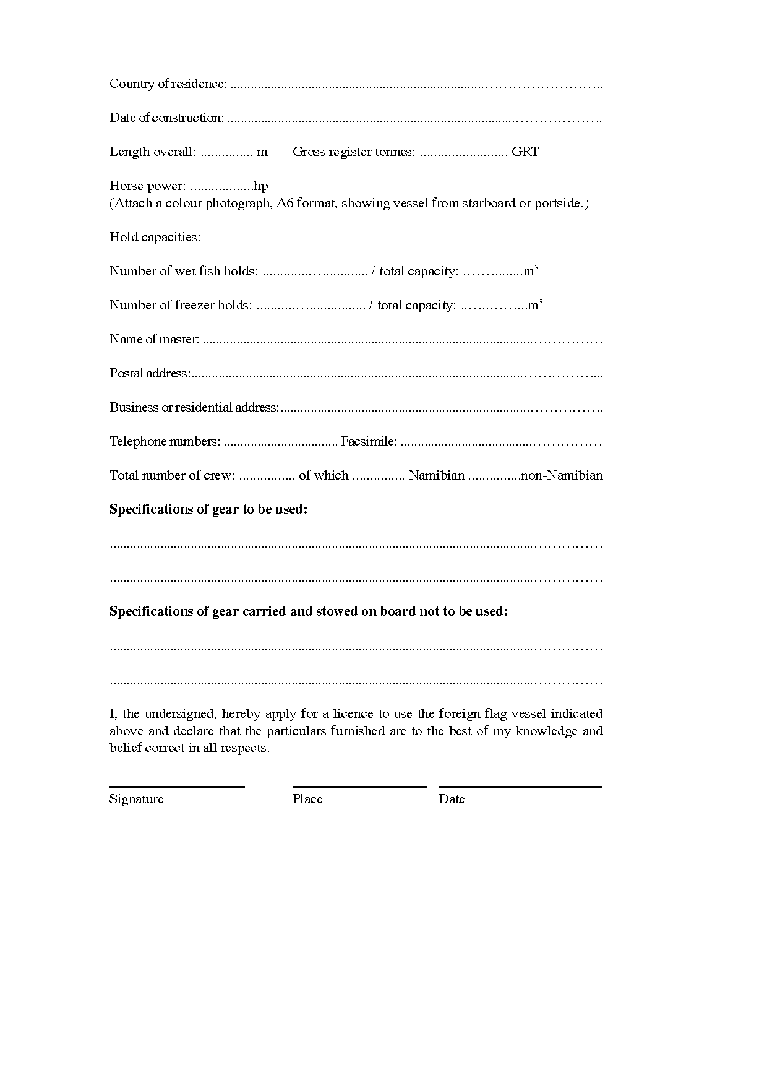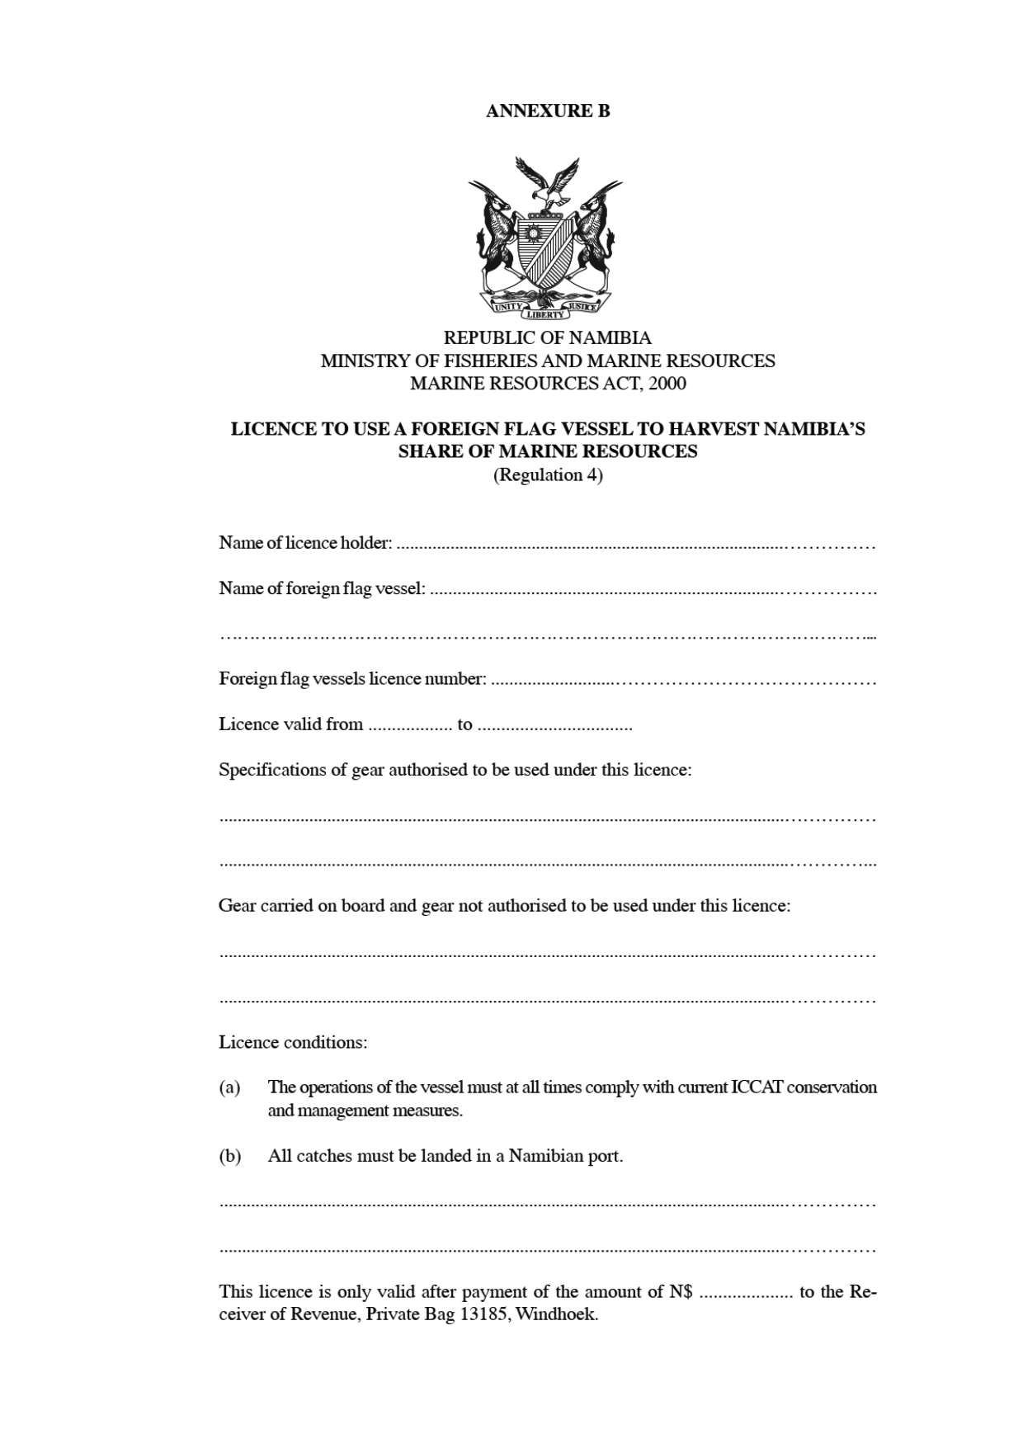

ANNEXURE C

REPUBLIC OF NAMIBIA
MINISTRY OF FISHERIES AND MARINE RESOURCES
MARINE RESOURCES ACT, 2000

FEE PAYABLE FOR A LICENCE
(Regulation 3)

The following fee is payable for a licence:

(a) N$ 20 in respect of a foreign flag vessel with a gross tonnage of less than 10 tons;

(b) N$ 50 in respect of a foreign flag vessel with a gross tonnage of 10 tons or more but less than 50 tons;

(c) N$ 100 in respect of a foreign flag vessel with a gross tonnage of 50 tons or more but less than 100 tons;

(d) N$ 200 in respect of a foreign flag vessel with a gross tonnage of 100 tons or more but less than 2500 tons;

(e) N$ 500 in respect of a foreign flag vessel with a gross tonnage of 2500 tons or more but less than 4500 tons;

(f) N$ 1000 in respect of a foreign flag vessel with a gross tonnage of 4500 tons or more but less than 9000 tons; and

(g) N$ 1500 in respect of a foreign flag vessel with a gross tonnage of 9000 tons or more.

ANNEXURE D

INTERNATIONAL CONVENTION FOR THE CONSERVATION
OF ATLANTIC TUNAS

DONE AT RIO DE JANEIRO this fourteenth day of May 1966 in a single copy in the English, French and Spanish languages, each text being equally authentic. The original texts shall be deposited in the archives of the Food and Agriculture Organization of the United Nations.

PREAMBLE

The Governments whose duly authorized representatives have subscribed hereto, considering their mutual interest in the populations of tuna and tuna-like fishes found in the Atlantic Ocean, and desiring to co-operate in maintaining the populations of these fishes at levels which will permit the maximum sustainable catch for food and other purposes, resolve to conclude a Convention for the conservation of the resources of tuna and tuna-like fishes of the Atlantic Ocean, and to that end agree as follows:

ARTICLE I

The area to which this Convention shall apply, hereinafter referred to as the “Convention area”, shall be all waters of the Atlantic Ocean, including the adjacent Seas.

ARTICLE II

Nothing in this Convention shall be considered as affecting the rights, claims or views of any Contracting Party in regard to the limits of territorial waters or the extent of jurisdiction over fisheries under international law.

ARTICLE III

1. The Contracting Parties hereby agree to establish and maintain a Commission to be known as the International Commission for the Conservation of Atlantic Tunas, hereinafter referred to as “the Commission”, which shall carry out the objectives set forth in this Convention.

2. Each of the Contracting Parties shall be represented on the Commission by not more than three Delegates. Such Delegates may be assisted by experts and advisors.

3. Except as may otherwise be provided in this Convention, decisions of the Commission shall be taken by a majority of the Contracting Parties, each Contracting Party having one vote. Two-thirds of the Contracting Parties shall constitute a quorum.

4. The Commission shall hold a regular meeting once every two years. A special meeting may be called at any time at the request of a majority of the Contracting Parties or by decision of the Council as constituted in Article V.

5. At its first meeting, and thereafter at each regular meeting, the Commission shall elect from among its Members a Chairman, a first Vice-Chairman and a second Vice-Chairman who shall not be re-elected for more than one term.

6. The meetings of the Commission and its subsidiary bodies shall be public unless the Commission otherwise decides.

7. The official languages of the Commission shall be English, French and Spanish.

8. The Commission shall have authority to adopt such rules of procedure and financial regulations as are necessary to carry out its functions.

9. The Commission shall submit a report to the Contracting Parties every two years on its work and findings and shall also inform any Contracting Party, whenever requested, on any matter relating to the objectives of the Convention.

ARTICLE IV

1. In order to carry out the objectives of this Convention the Commission shall be responsible for the study of the populations of tuna and tuna-like fishes (the Scombriformes with the exception of the families Trichiuridae and Gempylidae and the genus Scomber) and such other species of fishes exploited in tuna fishing in the Convention area as are not under investigation by another international fishery organization. Such study shall include research on the abundance, biometry and ecology of the fishes; the oceanography of their environment; and the effects of natural and human factors upon their abundance. The Commission, in carrying out these responsibilities shall, insofar as feasible, utilise the technical and scientific services of, and information from, official agencies of the Contracting Parties and their political sub-divisions and may, when desirable, utilise the available services and information of any public or private institution, organization or individual, and may undertake within the limits of its budget independent research to supplement the research work being done by governments, national institutions or other international organizations.

2. The carrying out of the provisions in paragraph 1 of this Article shall include:

(a) collecting and analysing statistical information relating to the current conditions and trends of the tuna fishery resources of the Convention area;

(b) studying and appraising information concerning measures and methods to ensure maintenance of the populations of tuna and tuna-like fishes in the Convention area at levels which will permit the maximum sustainable catch and which will ensure the effective exploitation of these fishes in a manner consistent with this catch;

(c) recommending studies and investigations to the Contracting Parties;

(d) publishing and otherwise disseminating reports of its findings and statistical, biological and other scientific information relative to the tuna fisheries of the Convention area.

ARTICLE V

1. There is established within the Commission a Council which shall consist of the Chairman and the Vice-Chairmen of the Commission together with the representatives of not less than four and not more than eight Contracting Parties. The Contracting Parties represented on the Council shall be elected at each regular meeting of the Commission. However, if at any time the number of the Contracting Parties exceeds forty, the Commission may elect an additional two Contracting Parties to be represented on the Council. The Contracting Parties of which the Chairman and Vice-Chairmen are nationals shall not be elected to the Council. In elections to the Council the Commission shall give due consideration to the geographic, tuna fishing and tuna processing interests of the Contracting Parties, as well as to the equal right of the Contracting Parties to be represented on the Council.

2. The Council shall perform such functions as are assigned to it by this Convention or are designated by the Commission, and shall meet at least once in the interim between regular meetings of the Commission. Between meetings of the Commission the Council shall make necessary decisions on the duties to be carried out by the staff and shall issue necessary instructions to the Executive Secretary. Decisions of the Council shall be made in accordance with rules to be established by the Commission.

ARTICLE VI

To carry out the objectives of this Convention the Commission may establish Panels on the basis of species, group of species, or of geographic areas. Each Panel in such case:

(a) shall be responsible for keeping under review the species, group of species, or geographic area under its purview, and for collecting scientific and other information relating thereto;

(b) may propose to the Commission, upon the basis of scientific investigations, recommendations for joint action by the Contracting Parties;

(c) may recommend to the Commission studies and investigations necessary for obtaining information relating to its species, group of species, or geographic area, as well as the co-ordination of programmes of investigation by the Contracting Parties.

ARTICLE VII

The Commission shall appoint an Executive Secretary who shall serve at the pleasure of the Commission. The Executive Secretary, subject to such rules and procedures as may be determined by the Commission, shall have authority with respect to the selection and administration of the staff of the Commission. He shall also perform, inter alia, the following functions as the Commission may prescribe:

(a) co-ordinating the programmes of investigation by the Contracting Parties;

(b) preparing budget estimates for review by the Commission;

(C) AUTHORISING THE DISBURSEMENT OF FUNDS IN ACCORDANCE WITH THE COMMISSION’S BUDGET;

[This paragraph is presented in upper case in the Government Gazette, as reproduced above.]

(d) accounting for the funds of the Commission;

(e) arranging for co-operation with the organizations referred to in Article XI of this Convention;

(f) preparing the collection and analysis of data necessary to accomplish the purposes of the Convention particularly those data relating to the current and maximum sustainable catch of tuna stocks;

(g) preparing for approval by the Commission scientific, administrative and other reports of the Commission and its subsidiary bodies.

ARTICLE VIII

1. (a) The Commission may, on the basis of scientific evidence, make recommendations designed to maintain the populations of tuna and tuna-like fishes that may be taken in the Convention area at levels which will permit the maximum sustainable catch. These recommendations shall be applicable to the Contracting Parties under the conditions laid down in paragraphs 2 and 3 of this Article.

(b) The recommendations referred to above shall be made:

(i) at the initiative of the Commission if an appropriate Panel has not been established or with the approval of at least two-thirds of all the Contracting Parties if an appropriate Panel has been established;

(ii) on the proposal of an appropriate Panel if such a Panel has been established;

(iii) on the proposal of the appropriate Panels if the recommendation in question relates to more than one geographic area, species or group of species.

2. Each recommendation made under paragraph 1 of this Article shall become effective for all Contracting Parties six months after the date of the notification from the Commission transmitting the recommendation to the Contracting Parties, except as provided in paragraph 3 of this Article.

3. (a) If any contracting party in the case of a recommendation made under paragraph 1(b)(i) above, or any Contracting Party member of a Panel concerned in the case of a recommendation made under paragraph 1(b)(ii) or (iii) above, presents to the Commission an objection to such recommendation within the six months period provided for in paragraph 2 above, the recommendation shall not become effective for an additional sixty days.

(b) Thereupon any other Contracting Party may present an objection prior to the expiration of the additional sixty days period, or within forty-five days of the date of the notification of an objection made by another Contracting Party within such additional sixty days, whichever date shall be the later.

(c) The recommendation shall become effective at the end of the extended period or periods for objection, except for those Contracting Parties that have presented an objection.

(d) However, if a recommendation has met with an objection presented by only one or less than one-fourth of the Contracting Parties, in accordance with sub-paragraphs (a) and (b) above, the Commission shall immediately notify the Contracting Party or Parties having presented such objection that it is to be considered as having no effect.

(e) In the case referred to in sub-paragraph (d) above the Contracting Party or Parties concerned shall have an additional period of sixty days from the date of said notification in which to reaffirm their objection. On the expiry of this period the recommendation shall become effective, except with respect to any Contracting Party having presented an objection and reaffirmed it within the delay provided for.

(f) If a recommendation has met with objection from more than one-fourth but less than the majority of the Contracting Parties, in accordance with sub-paragraphs (a) and (b) above, the recommendation shall become effective for the Contracting Parties that have not presented an objection thereto.

(g) If objections have been presented by a majority of the Contracting Parties the recommendation shall not become effective.

4. Any Contracting Party objecting to a recommendation may at any time withdraw that objection, and the recommendation shall become effective with respect to such Contracting Party immediately if the recommendation is already in effect, or at such time as it may become effective under the terms of this Article.

5. The Commission shall notify each Contracting Party immediately upon receipt of each objection and of each withdrawal of an objection, and of the entry into force of any recommendation.

ARTICLE IX

1. The Contracting Parties agree to take all action necessary to ensure the enforcement of this Convention. Each Contracting Party shall transmit to the Commission, biennially or at such other time as may be required by the Commission, a statement of the action taken by it for these purposes.

2. The Contracting Parties agree:

(a) to furnish, on the request of the Commission, any available statistical, biological and other scientific information the Commission may need for the purposes of this Convention;

(b) when their official agencies are unable to obtain and furnish the said information, to allow the Commission, through the Contracting Parties, to obtain it on a voluntary basis direct from companies and individual fishermen.

3. The Contracting Parties undertake to collaborate with each other with a view to the adoption of suitable effective measures to ensure the application of the provisions of this Convention and in particular to set up a system of international enforcement to be applied to the Convention area except the territorial sea and other waters, if any, in which a state is entitled under international law to exercise jurisdiction over fisheries.

ARTICLE X

1. The Commission shall adopt a budget for the joint expenses of the Commission for the biennium following each regular meeting.

2. Each Contracting Party shall contribute annually to the budget of the Commission an amount calculated in accordance with a scheme provided for in the Financial Regulations, as adopted by the Commission. The Commission, in adopting this scheme, should consider inter alia each Contracting Party’s fixed basic fees for Commission and Panel membership, the total round weight of catch and net weight of canned products of Atlantic tuna and tuna-like fishes and the degree of economic development of the Contracting Parties.

The scheme of annual contributions in the Financial Regulations shall be established or modified only through the agreement of all the Contracting Parties present and voting. The Contracting Parties shall be informed of this ninety days in advance.

3. The Council shall review the second half of the biennial budget at its regular meeting between Commission meetings and, on the basis of current and anticipated developments, may authorise reapportionment of amounts in the Commission budget for the second year within the total budget approved by the Commission.

4. The Executive Secretary of the Commission shall notify each contracting Party of its yearly assessment. The contributions shall be payable on January first of the year for which the assessment was levied. Contributions not received before January first of the succeeding year shall be considered as in arrears.

5. Contributions to the biennial budget shall be payable in such currencies as the Commission may decide.

6. At its first meeting the Commission shall approve a budget for the balance of the first year the Commission functions and for the following biennium. It shall immediately transmit to the Contracting Parties copies of these budgets together with notices of the respective assessments for the first annual contribution.

7. Thereafter, within a period not less than sixty days before the regular meeting of the Commission which precedes the biennium, the Executive Secretary shall submit to each Contracting Party a draft biennial budget together with a schedule of proposed assessments.

8. The Commission may suspend the voting rights of any Contracting Party when its arrears of contributions equal or exceed the amount due from it for the two preceding years.

9. The Commission shall establish a Working Capital Fund to finance operations of the Commission prior to receiving annual contributions, and for such other purposes as the Commission may determine. The Commission shall determine the level of the Fund, assess advances necessary for its establishment, and adopt regulations governing the use of the Fund.

10. The Commission shall arrange an annual independent audit of the Commission’s accounts. The reports of such audits shall be reviewed and approved by the Commission, or by the Council in years when there is no regular Commission meeting.

11. The Commission may accept contributions, other than provided for in paragraph 2 of this Article, for the prosecution of its work.

ARTICLE XI

1. The Contracting Parties agree that there should be a working relationship between the Commission and the Food and Agriculture Organization of the United Nations. To this end the Commission shall enter into negotiations with the Food and Agriculture Organization of the United Nations with a view to concluding an agreement pursuant to Article XIII of the Organization’s Constitution. Such agreement should provide, inter alia, for the Director-General of the Food and Agriculture Organization of the United Nations to appoint a Representative who would participate in all meetings of the Commission and its subsidiary bodies, but without the right to vote.

2. The Contracting Parties agree that there should be co-operation between the Commission and other international fisheries commissions and scientific organizations which might contribute to the work of the Commission. The Commission may enter into agreements with such commissions and organizations.

3. The Commission may invite any appropriate international organization and any Government which is a member of the United Nations or of any Specialized Agency of the United Nations and which is not a member of the Commission, to send observers to meetings of the Commission and its subsidiary bodies.

ARTICLE XII

1. This Convention shall remain in force for ten years and thereafter until a majority of Contracting Parties agree to terminate it.

2. At any time after ten years from the date of entry into force of this Convention, any Contracting Party may withdraw from the Convention on December thirty-first of any year including the tenth year by written notification of withdrawal given on or before December thirty-first of the preceding year to the Director-General of the Food and Agriculture Organization of the United Nations.

3. Any other Contracting Party may thereupon withdraw from this Convention with effect from the same December thirty-first by giving written notification of withdrawal to the Director-General of the Food and Agriculture Organization of the United Nations not later than one month from the date of receipt of information from the Director-General of the Food and Agriculture Organization of the United Nations concerning any withdrawal, but not later than April first of that year.

ARTICLE XIII

1. Any Contracting Party or the Commission may propose amendments to this Convention. The Director-General of the Food and Agriculture Organization of the United Nations shall transmit a certified copy of the text of any proposed amendment to all the Contracting Parties. Any amendment not involving new obligations shall take effect for all Contracting Parties on the thirtieth day after its acceptance by three-fourths of the Contracting Parties. Any amendment involving new obligations shall take effect for each Contracting Party accepting the amendment on the ninetieth day after its acceptance by three-fourths of the Contracting Parties and thereafter for each remaining Contracting Party upon acceptance by it. Any amendment considered by one or more Contracting Parties to involve new obligations shall be deemed to involve new obligations and shall take effect accordingly. A government which becomes a Contracting Party after an amendment to this Convention has been opened for acceptance pursuant to the provisions of this Article shall be bound by the Convention as amended when the said amendment comes into force.

2. Proposed amendments shall be deposited with the Director-General of the Food and Agriculture Organization of the United Nations. Notifications of acceptance of amendments shall be deposited with the Director-General of the Food and Agriculture Organization of the United Nations.

ARTICLE XIV

1. This Convention shall be open for signature by any Government of any State which is a Member of the United Nations or of any Specialized Agency of the United Nations. Any such Government which does not sign this Convention may adhere to it at any time.

2. This Convention shall be subject to ratification or approval by signatory countries in accordance with their constitutions. Instruments of ratification, approval, or adherence shall be deposited with the Director-General of the Food and Agriculture Organization of the United Nations.

3. This Convention shall enter into force upon the deposit of instruments of ratification, approval, or adherence by seven Governments and shall enter into force with respect to each Government which subsequently deposits an instrument of ratification, approval or adherence on the date of such deposit.

4. This Convention shall be open for signature or adherence by any inter-governmental economic integration organization constituted by States that have transferred to it competence over the matters governed by this Convention, including the competence to enter into treaties in respect of those matters.

5. Upon the deposit of its instrument of formal confirmation or adherence, any organization referred to in paragraph 4 shall be a Contracting Party having the same rights and obligations in respect of the provisions of the Convention as the other Contracting Parties. Reference in the text of the Convention to the term “State” in Article IX, paragraph 3, and to the term “government” in the Preamble and in Article XIII, paragraph 1, shall be interpreted in this manner.

6. When an organization referred to in paragraph 4 becomes a Contracting Party to this Convention, the member states of that organization and those which adhere to it in the future shall cease to be parties to the Convention; they shall transmit a written notification to this effect to the Director-General of the Food and Agriculture Organization of the United Nations.

ARTICLE XV

The Director-General of the Food and Agriculture Organization of the United Nations shall inform all Governments referred to in paragraph 1 of Article XIV and all the organizations referred to in paragraph 4 of the same Article of deposits of instruments of ratification, approval, formal confirmation or adherence, the entry into force of this Convention, proposals for amendments, notifications of acceptance of amendments, entry into force of amendments, and notifications of withdrawal.

ARTICLE XVI

The original of this Convention shall be deposited with the Director-General of the Food and Agriculture Organization of the United Nations who shall send certified copies of it to the Governments referred to in paragraph 1 of Article XIV and to the organizations referred to in paragraph 4 of the same Article.

IN WITNESS WHEREOF the representatives duly authorized by their respective Governments have signed the present Convention. Done at Rio de Janeiro this fourteenth day of May 1966 in a single copy in the English, French and Spanish languages, each version being equally authoritative.

