REGULATIONS MADE IN TERMS OF

Magistrates Act 3 of 2003
section 27

Regulations regarding Magistrates, 2003
Government Notice 130 of 2003
(GG 3007)
came into force on 30 June 2003 (regulation 35)

The Government Notice which publishes these regulations notes that they
were made on the recommendation of the Magistrates Commission.

as amended by

Government Notice 200 of 2015 (GG 5828)
came into force on date of publication: 15 September 2015
The Government Notice which publishes these amendments notes that they
were made on the recommendation of the Magistrates Commission.

ARRANGEMENT OF REGULATIONS

PART I
PRELIMINARY

Regulation

l. Definitions

PART II
RECRUITING OF AND APPLICATION BY CANDIDATES
FOR APPOINTMENT AS MAGISTRATES

2. Advertising of vacancies in magistracy
3. Application for appointment as magistrate
4. Privileges on appointment as magistrate

PART III
CONDITIONS OF SERVICE AND BENEFITS
OF MAGISTRATES

5. Remuneration of magistrates
6. Transfer and resettlement costs
7. Subsistence allowances
8. Overtime
9. Official hours of attendance
10. Absence during official hours of attendance
11. Abscondment
12. Leave of absence
13: Leave gratuity
14. Official residential quarters

PART IV
INCAPACITY TO PERFORM DUTIES EFFICIENTLY

15. Procedure of investigation into magistrate’s incapacity
16. Procedure after finding of incapacity

PART V
DISMISSAL FROM AND VACATION OF OFFICE
ON ACCOUNT OF CONTINUED ILL-HEALTH

17. Procedure of investigation into magistrate’s continued ill-health
18. Vacation of office at own request on account of continued ill-health

PART VA
CATEGORIES AND PENALTIES OF ACTS OF MISCONDUCT

[Part VA, comprising sections 18A-18H, is inserted by GN 200/2015.]

18A. Acts of misconduct and penalties
18B. Conduct sheet
18C. Corrective counseling
18D. Verbal warning
18E. Written warning
18F. Final written warning
18G. No formal hearing of minor acts of misconduct
18H. Serious acts of misconduct

PART VI
COMPLAINTS AND GRIEVANCES

Complaints and grievance of magistrates

19. Procedure regarding investigation of complaints and grievances
20. Decision of Commission regarding complaints and grievances

Complaints from members of the public

21. Procedure regarding investigation of complaints
22. Decision of Commission regarding complaints

PART VII
OFFICIAL TRAVELLING AND TRANSPORT

23. Official journeys
24. Transport
25. Government motor transport

PART VIII
GENERAL PROVISIONS

26. Medical examinations
27. Official channels of communication
28. Private financial transactions
29. Legal proceedings for debt
30. Acceptance of gifts or benefits
31. Replying to questions
32. Confidential nature of documents
33. Recognition of professional association
34. Exceptional cases
35. Short title and commencement

SCHEDULE 1
Remuneration of magistrates

SCHEDULE 2
Forms

SCHEDULE 3
Classification of Acts of Misconduct

[Schedule 3 is inserted by GN 200/2015.]

PART I
PRELIMINARY

Definitions

1. In these regulations any word or expression to which a meaning has been assigned in the Act, bears the meaning so assigned to it, and unless the context otherwise indicates -
“accommodation” means lodging, meals (including non-alcoholic beverages with meals) and laundry;

“candidate” means a person who applies for appointment as a magistrate;

“Code” means the Code of Conduct for Magistrates published under Government Notice No. 190 of 25 August 2010.

[The definition of “Code” is inserted by GN 200/2015.
This definition should end with a semicolon instead of a full stop.]

“head of office” means -

(a) the Chief: Lower Courts; or

(b) where more than one magistrate is appointed for a regional division, district division, district or subdistrict, the magistrate designated in terms of section 11(2)(b) of the Act as the head of that regional division, district division, district or subdistrict: Provided that in respect of the magistrate so designated, the Chief: Lower Courts is deemed to be the head of office;

“household”, in relation to a magistrate, means -

(a) the spouse of the magistrate;

(b) the magistrate’s or the spouse of the magistrate’s of necessity dependent child who is bona fide resident with the magistrate: Provided that if such child studies at an institution for post-school education, whether intramurally or extramurally, he or she is deemed to be a member of the household, but only -

(i) if he or she did not, after leaving school, take up any permanent full-time employment (including any type of vocational training to which remuneration is attached), excluding work during vacations or any temporary full-time employment which he or she had taken up between leaving school and the commencement of the academic year, and he or she had commenced his or her studies at such an institution at the commencement of the academic year following the completion of his or her schooling; and

(ii) until -

(aa) he or she attains the minimum post-school qualification (or minimum combination of post-school qualifications) which will enable him or her to take up employment in the field of study for which he or she originally intended to qualify himself or herself; or

(bb) the normal prescribed duration of the study period, as prescribed by the institution concerned for the study course, plus one academic year, expires if it takes him or her longer than such prescribed period to attain the relevant qualification as a result of poor academic performance; or

(cc) he or she discontinues the course of study concerned; or

(dd) he or she changes his or her course of study,

whichever of the said four events occurs first;

(c) the magistrate’s or the spouse of the magistrate’s relative who is permanently resident with him or her and who is of necessity dependent on him or her and whose income, from any source, does not exceed the sum of the appropriate maximum basic state pension payable in terms of the National Pensions Act, 1992 (Act No. 10 of 1992): Provided that where two relatives so reside with the magistrate and are dependent on his or her and where the one relative would normally have been a dependant of the other relative, both such relatives may be regarded as members of his or her household only if half of their joint income, from any source, does not exceed the sum of the said maximum basic state pension; and

(d) not more than two domestic workers (including nursemaids) employed in a full­time capacity by the magistrate;

“official residential quarters” means those quarters, inclusive of buildings, outbuildings, grounds, fixtures, fittings, machines and equipment, but exclusive of furniture, that are owned or are held on lease or are otherwise in the lawful possession of the State, and that are available to the Permanent Secretary for assignment in terms of regulation H4 of the Public Service Regulations or that have been allotted to a magistrate in terms of regulation H5 of the Public Service Regulations;

“Permanent Secretary” means the Permanent Secretary: Justice;

“personal belongings” means the movable property of a magistrate and his or her household, which is normally intended for personal use, including vehicles, but excluding domestic animals, pets and livestock;

“Public Service Regulations” means the Public Service Regulations made under the Public Service Act, 1980 (Act No. 2 of 1980), and which -

(a) are published in Government Notice No. AG. 28 of 1 April 1981; and

(b) continue to exist by virtue of section 37(1) of the Public Service Act, 1995 (Act No. 13 of 1995);

“Public Service Staff Rules” means the Public Service Staff Rules referred to in section 35(f) of the Public Service Act 1995 (Act No. 13 of 1995);

“scheme vehicle” means a motor vehicle in respect of which a motor vehicle allowance is payable in accordance with Chapter D.VIII of the Public Service Staff Rules;

“State” means the Government of the Republic of Namibia;

“station”, in relation to a magistrate, means the city, town or other place where the principal duties of a magistrate are or have to be performed;

“subsistence allowance” means payment designed to reimburse a magistrate in respect of reasonable expenses necessarily incurred by him or her on accommodation, whilst absent from his or her station on official duty, over and above his or her normal living expenses at home;

“the Act” means the Magistrates Act, 2003 (Act No. 3 of 2003).

PART II
RECRUITING OF AND APPLICATION BY CANDIDATES
FOR APPOINTMENT AS MAGISTRATES

Advertising of vacancies in magistracy

2. The Commission must advertise or cause to be advertised a vacancy in the magistracy -

(a) by circular in the Public Service; and

(b) in at least two newspapers circulating throughout Namibia,

in the official language of Namibia.

Application for appointment as magistrate

3. (1) A candidate must make an application for appointment as magistrate in writing on a form which corresponds substantially with Form 1 of Schedule 2 and hand it in to the Chief: Lower Courts or at a magistrate’s office.

(2) An application in terms of subregulation (1) must be accompanied by the following documents:

(a) A certified copy of the candidate’s identity document;

(b) a completed health questionnaire which corresponds substantially with Form 2 of Schedule 2;

(c) certified copies of all educational qualifications;

(d) certificates of service or, if not available, an affidavit by the candidate in respect of previous periods of service;

(e) testimonials from previous employers, if available;

(f) an affidavit setting out the candidate’s assets and liabilities;

(g) a statement of the names and addresses of two references; and

(h) a certified copy of the candidate’s permanent residence permit if the candidate is a permanent resident (other than a citizen) of Namibia.

(3) If the documents referred to in subregulations (1) and (2) are handed in at a magistrate’s office, such documents must promptly be sent to the Chief: Lower Courts by the head of office or, where there is only one magistrate, by that magistrate.

(4) The Chief: Lower Courts must submit every application received by him or her in terms of subregulation (1) or (3), together with all accompanying documents, to the Commission for consideration regarding the suitability of the applicant for appointment as a magistrate.

(5) The Commission may not consider an application submitted to it in terms of this regulation unless -

(a) the application form is duly completed and accompanied by the documents prescribed by subregulation (2); and

(b) the applicant has signed the declaration contained in the application form that the particulars furnished in that form are complete and correct.

(6) A candidate must, at the time and place determined by the Commission, appear before the Commission to be examined for his or her suitability for appointment as a magistrate.

(7) A confidential report substantially in the form of Form 3 of Schedule 2 must be completed by the Commission when interviewing a candidate.

(8) The Commission must make a recommendation to the Minister regarding the suitability of a candidate for appointment as a magistrate.

Privileges on appointment as magistrate

4. (1) A person who, when appointed as magistrate, necessarily has to relocate his or her household to assume office is entitled to reimbursement of the reasonable actual expenses incurred as a result of such relocation in respect of travelling, as well as the transport, insurance and storage costs of his or her personal belongings for a period not exceeding one month, on the same basis as that set out in Chapter F of the Public Service Regulations.

(2) A magistrate to whom expenses are paid under subregulation (1) must conclude a written contract with the State, substantially in the form of Form 4 of Schedule 2, in which he or she undertakes to serve as magistrate for a period of not less than 12 months.

(3) If a magistrate does not comply with the terms of a contract concluded in terms of subregulation (2), he or she must, in respect of the remaining period, repay a proportional part of the amount which was paid to him or her under subregulation (1).

(4) The Commission must determine the conditions, guidelines, procedures and requirements in respect of the payment of the expenses referred to in this regulation.

(5) The Commission may lengthen the periods referred to in subregulations (1) and (2).

PART III
CONDITIONS OF SERVICE AND BENEFITS
OF MAGISTRATES

Remuneration of magistrates

5. The remuneration payable to a magistrate in terms of section 18 of the Act is as set out in Schedule 1 opposite his or her grade.

Transfer and resettlement costs

6. If a magistrate who is transferred under section 19(1) of the Act is entitled to reimbursement of such expenses actually and necessarily incurred as a result of such transfer as are provided for in Chapter F of the Public Service Regulations.

(2) For the purposes of subregulation (1), any reference in Chapter F of the Public Service Regulations to -

(a) an officer or employee, is to be construed as a reference to a magistrate;

(b) the Public Service Commission, is to be construed as a reference to the Magistrates Commission;

(c) headquarters, is to be construed as a reference to the station of a magistrate.

Subsistence allowances

7. (1) A magistrate who is on official duty away from his or her station is entitled to such subsistence allowances as are prescribed by or under Chapter D of the Public Service Regulations and Chapter D.III of the Public Service Staff Rules.

(2) For the purposes of subregulation (1), any reference in Chapter D of the Public Service Regulations and Chapter D.III of the Public Service Staff Rules to -

(a) an officer or employee, is to be construed as a reference to a magistrate;

(b) the Public Service Commission, is to be construed as a reference to the Magistrates Commission;

(c) headquarters, is to be construed as a reference to the station of a magistrate.

Overtime

8. When a magistrate is required to perform official duties outside his or her official hours of attendance, he or she is, subject to the approval of the Commission, entitled to remuneration as approved for public servants of equal rank.

Official hours of attendance

9. The official hours of attendance of a magistrate are Mondays to Fridays, excluding public holidays, from 08:00 to 17:00, with a lunch interval from 13:00 to 14:00.

Absence during official hours of attendance

10. A magistrate may not be absent from his or her place of duty during the official hours of attendance referred to in regulation 9 without the consent of his or her head of office.

Abscondment

11. (1) If a magistrate is absent without leave or valid cause from his or her office or duty for a period of 30 days or longer, the Chief: Lower Courts must promptly inform the Commission accordingly, and it is then deemed that the magistrate has absconded and made himself or herself guilty of misconduct.

(2) After the Commission has been informed in terms of subregulation (1) of the absence of a magistrate, the Commission -

(a) may suspend the magistrate under section 21(1) of the Act; and

(b) must deal with the magistrate in accordance with Part V of the Act.

Leave of absence

12. (1) The provisions of Chapter C of the Public Service Regulations and Chapter D.I of the Public Service Staff Rules apply with the necessary changes to magistrates, but the granting of any leave to magistrates is subject to approval by the Chief: Lower Courts.

(2) For the purposes of subregulation (1), any reference in Chapter C of the Public Service Regulations and Chapter D.I of the Public Service Staff Rules to -

(a) an officer or employee, is to be construed as a reference to a magistrate;

(b) the Public Service Commission, is to be construed as a reference to the Magistrates Commission.

Leave gratuity

13. The provisions of the Public Service Staff Rules relating to leave gratuity apply with the necessary changes to magistrates.

Official residential quarters

14. (1) A magistrate may, subject to subregulation (2), make use of official residential quarters if such quarters are available.

(2) If a magistrate makes use of official residential quarters, the provisions of Chapter H of the Public Service Regulations and Chapter D.VII of the Public Service Staff Rules apply with the necessary changes thereto, and for that purpose any reference in those provisions to an officer or employee is to be construed as a reference to a magistrate.

PART IV
INCAPACITY TO PERFORM DUTIES EFFICIENTLY

Procedure of investigation into magistrate’s incapacity

15. (1) If the Commission has reason to believe that a magistrate has become incapable of performing the duties of his or her office efficiently, the Commission may cause an investigation to be carried out into the capacity of the magistrate to perform the duties of his or her office efficiently.

(2) An investigation under subregulation (1) must be carried out as soon as possible by a magistrate or any other person designated by the Commission, and for that purpose that magistrate or other person has the powers conferred by section 26(6) of the Act.

(3) The magistrate with regard to whom an investigation is to be carried out under subregulation (1) -

(a) must be informed in writing by the person who is to conduct the investigation of the date, time and place of the investigation; and

(b) has the right -

(i) to a statement, in writing, of the grounds upon which it is alleged that he or she no longer has the capacity to perform the duties of his or her office in an efficient manner;

(ii) to be present at the investigation;

(iii) to be assisted or represented by a legal practitioner;

(iv) to give evidence; and

(v) either personally or through a legal practitioner -

(aa) to be heard;

(bb) to call witnesses;

(cc) to cross-examine any person called as a witness in support of the allegations against him or her; and

(dd) to examine any book, document or object produced in evidence.

(4) The magistrate in respect of whom an investigation is carried out, must answer fully all relevant questions put to him or her by the person who conducts the investigation.

(5) After the conclusion of an investigation under subregulation (1), the person who conducted the investigation must make a finding and, subject to regulation 16, inform the Commission and the magistrate concerned in writing of his or her finding.

Procedure after finding of incapacity

16. (1) If the person who conducts an investigation under regulation 15 finds that the magistrate concerned does not have the capacity to perform the duties of his or her office efficiently, he or she must, within seven days after the conclusion of the investigation -

(a) forward to the Commission -

(i) the record of the proceedings at the investigation, including any documentary evidence adduced thereat;

(ii) a written statement of his or her finding and the reasons therefor; and

(iii) any observations which he or she may wish to make on the matter; and

(b) furnish the magistrate concerned with a copy of the statement of his or her finding and the reasons therefor.

(2) The magistrate concerned may, within 14 days of receipt of a copy of the statement referred to in subregulation (1)(b), submit to the Commission comments in writing regarding the finding and the reasons therefor.

(3) If the Commission for whatever reason considers it necessary, the Commission may cause a further investigation to be carried out into the capacity of the magistrate concerned to perform the duties of his or her office efficiently.

(4) If, after consideration of the record of the proceedings at the investigation (including the finding and the reasons therefor) and all other documents relating to the investigation, the Commission is satisfied that the magistrate concerned is incapable of performing the duties of his or her office efficiently, the Commission must -

(a) notify that magistrate in writing of its decision and afford him or her an opportunity to resign as magistrate within 14 days of receipt of the notice; and

(b) if that magistrate refuses or fails to resign within the period mentioned in paragraph (a), make a written recommendation to the Minister that the magistrate be dismissed from office in terms of section 21(3)(b)(ii) of the Act and submit, together with the recommendation, such record and other relevant documents to the Minister.

PART V
DISMISSAL FROM AND VACATION OF OFFICE
ON ACCOUNT OF CONTINUED ILL-HEALTH

Procedure of investigation into magistrate’s continued ill-health

17. (1) If the Commission has reason to believe that a magistrate is on account of continued ill-health no longer fit to hold office, the Commission may carry out an investigation into the continued ill-health of the magistrate.

(2) The Commission must, before the commencement of an investigation under subregulation (1), inform the magistrate concerned in writing of the investigation.

(3) The magistrate with regard to whom an investigation is carried out under subregulation (l) must, within 30 days of receipt of the notice of the investigation, submit to the Commission a medical report from a registered medical practitioner of his or her own choice, together with such observations as he or she may wish to make.

(4) The Commission may require the magistrate concerned to also submit himself or herself to a medical examination by a medical practitioner designated by the Commission, whereafter the medical practitioner must submit a medical report to the Commission.

(5) The costs incidental to the medical examinations referred to in subregulations (3) and (4) must be paid by the State.

(6) On receipt of a medical report in terms of subregulation (4), if any, the Commission must furnish the magistrate concerned with a copy thereof.

(7) The magistrate concerned may, within 14 days of receipt of a copy of the medical report referred to in subregulation (6), submit to the Commission comments in writing regarding that report.

(8) If after consideration of all the medical reports and other documents relating to the investigation, the Commission is satisfied that the magistrate concerned is on account of continued ill-health no longer fit to hold office, the Commission must -

(a) notify that magistrate in writing of its decision and afford him or her an opportunity to resign as magistrate within 14 days of receipt of the notice; and

(b) if that magistrate refuses or fails to resign within the period mentioned in paragraph (a), make a written recommendation to the Minister that the magistrate be dismissed from office in terms of section 21(3)(b)(i) of the Act and submit, together with the recommendation, all relevant medical reports and other documents to the Minister.

Vacation of office at own request on account of continued ill-health

18. (1) A magistrate who wishes to vacate his or her office under paragraph (a)(i) of section 21(5) of the Act on account of continued ill-health must, in accordance with paragraph (b) or that section, submit such request in writing to the Commission, together with full particulars in support thereof.

(2) A request under section 21(5)(a)(i) of the Act must be accompanied by a medical report from a registered medical practitioner of the magistrate’s own choice, setting out the medical history, including the present medical condition, of the magistrate.

(3) The Commission may, after receipt of a request referred to in subregulation (1) and the accompanying medical report referred to in subregulation (2), require the magistrate concerned to also submit himself or herself to a medical examination by a medical practitioner designated by the Commission, whereafter the medical practitioner must submit a medical report to the Commission.

(4) After consideration of a request and all relevant medical reports submitted to it in terms of this regulation, the Commission must, in accordance with section 21(5)(c) of the Act, submit the request, together with its recommendation whether or not the magistrate concerned should be allowed to vacate his office on account of continued ill-health, to the Minister.

(5) The costs incidental to the medical examinations referred to in subregulations (2) and (3) must be paid by the magistrate concerned.

PART VA
CATEGORIES AND PENALTIES OF ACTS OF MISCONDUCT

[Part VA, comprising sections 18A-18H, is inserted by GN 200/2015.
The heading is shown in boldface type to match the format of the other headings
in the regulations; it does not appear in bold in GN 200/2015.]

Acts of misconduct and penalties

18A. (1) Categories of minor and serious acts of misconduct and their appropriate penalties are set out in Schedule 3.

(2) If a magistrate is found guilty of an act of misconduct referred to in section 24 of the Act or in the Code, the Commission after having complied with section 26 of the Act may -

(a) caution or reprimand the magistrate;

(b) caution and impose a fine not exceeding N$1 000;

(c) caution and transfer the magistrate;

(d) call upon the magistrate to resign as magistrate; or

(e) dismiss the magistrate.
(3) If a magistrate, after having been heard or given his or her representation, without a formal misconduct hearing in terms of section 26 of the Act being held, is found guilty of a minor act of misconduct that warrants a warning as classified in Schedule 3 -

(a) a divisional magistrate may, in the case of a magistrate -

(i) give verbal warning;

(ii) give written warning; or

(iii) give a final written warning;

(b) the Chief Magistrate may, in the case of a divisional magistrate, regional court magistrate or deputy chief magistrate -

(i) give verbal warning;

(ii) give written warning; or

(iii) final written warning;

[The words “give a” appear to have been omitted at the beginning of
subparagraph (iii); compare subparagraph (a)(iii).]

(c) the Commission may, in the case of the Chief Magistrate -

(i) give verbal warning;

(ii) give written warning; or

(iii) final written warning.

[The words “give a” appear to have been omitted at the beginning of
subparagraph (iii); compare subparagraph (a)(iii).]

(4) If a magistrate is not satisfied with the ruling and final written warning given to him or her under subregulation (3) -

(a) by a divisional magistrate the magistrate may appeal to the Chief Magistrate;

(b) by the Chief Magistrate the magistrate may appeal to the Commission,

within 14 days of receipt of the final written warning, to have the final written warning cancelled upon such grounds as the magistrate may provide.

(5) The Chief Magistrate or Commission, within 30 days of receipt of an appeal submitted under subregulation (4), after consideration of all the representations and arguments provided in favour and against the appeal may -

(a) allow the appeal in whole or in part and vary or set aside the finding;

(b) dismiss the appeal and confirm the finding; or

(c) send the matter back to the divisional magistrate or Chief Magistrate to reconsider the matter and to make a finding in terms of subregulation (3).

[Regulation 18A is inserted by GN 200/2015.]

Conduct sheet

18B. (1) A divisional magistrate must -

(a) keep a conduct sheet in the form of Form 5 in respect of a magistrate found guilty in terms of regulation 18A;

(b) record every transgression on the conduct sheet of the magistrate;

(c) file a conduct sheet in the personal file of the magistrate; and

(d) forward a copy of the conduct sheet filed under paragraph (c) to the office of the Chief Magistrate for filing in the personal file of the magistrate.

(2) A divisional magistrate must keep the record of the conduct sheet referred to in subregulation (1) for a period of five years and where there is no further transgression within that period all entries are deleted.

[Regulation 18B is inserted by GN 200/2015.]

Corrective counseling

18C. (1) If under regulation 18A a magistrate is given a penalty for any act of misconduct, except where a magistrate is dismissed or called upon to resign, and the Commission upon reasonable grounds submitted by the divisional magistrate or Chief Magistrate is satisfied that the misconduct warrants corrective counseling, the Commission may -

(a) direct the magistrate to go for corrective counseling for a period determined by the Commission after a recommendation of a divisional magistrate or Chief Magistrate made after consultation with the magistrate concerned; and

(b) direct the divisional magistrate or Chief Magistrate to implement the agreed course of action.

(2) Corrective counseling may be conducted by way of mentoring, further training interventions, referral for medical treatment, professional counseling and rehabilitation.

(3) This regulation applies with the necessary changes to the Chief Magistrate if it is found to be necessary and appropriate for the Chief Magistrate to undergo corrective counseling.

[Regulation 18C is inserted by GN 200/2015.]

Verbal warning

18D. (1) Where a minor act of misconduct warrants a verbal warning, the divisional magistrate must -

(a) verbally bring the misconduct to the attention of the magistrate;

(b) determine reasons for the misconduct verbally;

(c) give the magistrate an opportunity to respond verbally;

(d) give a verbal warning and inform the magistrate that further misconduct may result in more stringent disciplinary action;

(e) note the verbal warning on the conduct sheet of the magistrate in the presence of such magistrate; and

(f) report the verbal warning to the Chief Magistrate.

(2) A verbal warning is valid for a period of six months.

[Regulation 18D is inserted by GN 200/2015.]

Written warning

18E. (1) Where a minor act of misconduct warrants a written warning, a divisional magistrate after having complied with subregulation (2), may give a magistrate a written warning in the form of Form 6 as set out in Schedule 2.

(2) If the facts come to the attention of a divisional magistrate that a magistrate has committed a minor act of misconduct, the divisional magistrate must in writing -

(a) bring the act of misconduct to the attention of the magistrate;

(b) stating the facts upon which the act of misconduct is based; and

(c) give the magistrate an opportunity to respond in writing.

(3) If upon consideration of the response of the magistrate made in terms of subregulation (2)(c) the divisional magistrate is satisfied that the magistrate is guilty of minor act of misconduct, the divisional magistrate must -

(a) give a written warning to the magistrate who must sign for the receipt;

(b) record the misconduct in the conduct sheet of the magistrate;

(c) file a copy of the written warning in the personal file of the magistrate; and

(d) forward a copy of such written warning to the Chief Magistrate office for filing in the personal file of the magistrate.

(4) If a magistrate refuses to sign acknowledgement of receipt of a written warning, the divisional magistrate must -

(a) hand the written warning to him or her in the presence of another magistrate;

(b) make such other magistrate to sign as witness in confirming that the written warning was handed to the magistrate found guilty of misconduct under subregulation (3) in his or her presence; and

(c) record the refusal by the magistrate to sign the receipt of the written warning in the personal file of the magistrate.

(5) A written warning is valid for a period of 12 months.

[Regulation 18E is inserted by GN 200/2015.]

Final written warning

18F. (1) Where a minor act of misconduct warrants a final written warning, a divisional magistrate after having complied with subregulation (2) may give a final written warning to a magistrate in the form of Form 7 as set out in Schedule 2.

(2) If sufficient facts come to the attention of a divisional magistrate that a magistrate has committed a similar minor act of misconduct for which the magistrate has been given a written warning that is still running, the divisional magistrate must, in writing -

(a) bring the act of misconduct to the attention of the magistrate;

(b) state the facts upon which the act of misconduct is based and that a written warning on the similar act of misconduct is still running; and

(c) give the magistrate an opportunity to respond in writing.

(3) If upon consideration of the response of the magistrate made in terms of subregulation (2)(c) the divisional magistrate is satisfied that the magistrate is guilty of the similar minor act of misconduct for which a written warning has been given to him or her and is still running, the divisional magistrate must -

(a) give a final written warning to the magistrate who must sign for the receipt;

(b) record the misconduct in the conduct sheet of the magistrate;

(c) file a copy of the final written warning in the personal file of the magistrate;

(d) advise the magistrate of his or her right to appeal to the Chief Magistrate for the cancellation of the final written warning, if he or she is not satisfied with the ruling of the divisional magistrate; and

(e) forward a copy of such final written warning to the Chief Magistrate office for filing in the personal file of the magistrate.

(4) If a magistrate refuses to sign acknowledgement of receipt of a final written warning, the divisional magistrate must -

(a) hand the final written warning to him or her in the presence of another magistrate;

(b) make such other magistrate to sign as witness in confirming that the final written warning was handed to the magistrate found guilty of similar misconduct under subregulation (3) in his or her presence; and

(c) record the refusal by the magistrate to sign the receipt of the final written warning in the personal file of the magistrate.

(5) A final written warning is valid for a period of two years.

(6) A magistrate may appeal to the Chief Magistrate within 14 days of receipt of the final written warning to have his or her final written warning cancelled upon grounds as the magistrate may provide, and the Chief Magistrate must act in accordance with regulation 18A(5).

(7) Regulations 18B, 18D, 18E and this regulation apply with the necessary changes to the Chief Magistrate and Commission regarding the misconduct and discipline of a divisional magistrate, regional magistrate and deputy chief magistrate and the Chief Magistrate, respectively.

[Regulation 18F is inserted by GN 200/2015.]

No formal hearing of minor acts of misconduct

18G. (1) For a minor act of misconduct classified under Schedule 3 that warrants a warning as penalty no formal hearing as contemplated in section 26 of the Act is held for the purpose of making a determination and imposing appropriate penalty for the misconduct.

[The word “an” appears to have been omitted before the phrase “appropriate penalty”.]

(2) A hearing or representation for a minor act of misconduct is considered and determined by -

(a) the divisional magistrate for all magistrates falling under his or her division;

(b) the Chief Magistrate for all divisional magistrates, regional magistrates and deputy chief magistrates; or

(c) the Commission for the Chief Magistrate.

(3) A divisional magistrate, regional magistrate or deputy chief magistrate who is not satisfied with the decision made or penalty given by the Chief Magistrate may appeal to the Commission to have his or her final written warning cancelled upon grounds as he or she provides.

[Regulation 18G is inserted by GN 200/2015.]

Serious acts of misconduct

18H. (1) If after the verbal warning, written warning and final written warning have been given and the same act of misconduct is repeated, such act of misconduct becomes serious and is dealt with in terms of section 26 of the Act.

(2) Despite subregulation (1), a minor act of misconduct may become serious act of misconduct if it is repeated after a verbal warning or written warning if the circumstances are so serious to warrant a serious penalty that is dealt with in terms of section 26 of the Act.

[The word “a” appears to have been omitted before the phrase “serious act of misconduct”,
and the word “as” appears to have been omitted before the phrase “to warrant”.]

(3) Where an alleged misconduct is classified under Schedule 3 as serious act of misconduct that warrants a serious penalty than in the case of a minor act of misconduct, such alleged misconduct is dealt with in terms of section 26 of the Act.

[Regulation 18H is inserted by GN 200/2015. The word “a” appears
to have been omitted before the phrase “serious act of misconduct”.]

PART VI
COMPLAINTS AND GRIEVANCES

Complaints and grievances of magistrates

Procedure regarding investigation of complaints and grievances

19. (1) If a magistrate is dissatisfied or discontented with an official act or omission, he or she may submit his or her complaint or grievance in writing to his or her head of office, giving full particulars of the complaint or grievance.

(2) On receipt of a complaint or grievance under subregulation (1), the head of office must investigate the complaint or grievance and inform the magistrate concerned in writing of the result of the investigation.

(3) (a) If -

(i) a head of office fails to carry out an investigation in terms of subregulation (2) within 10 working days of receipt of a complaint or grievance, the magistrate concerned may, within 10 working days after expiry of the aforesaid period, submit his or her complaint or grievance in writing to the Commission; or

(ii) a magistrate is dissatisfied with the outcome of the investigation by his or her head of office, the magistrate may, within 10 working days of receipt of the result of the investigation, submit his or her complaint or grievance in writing to the Commission, together with a copy of the reply of his or her head of office.

(b) On receipt of a complaint or grievance under paragraph (a), the Commission must deal therewith in such manner as it may consider appropriate, and may designate a magistrate or any other person to investigate that complaint or grievance.

(c) After the conclusion of an investigation under paragraph (b), the magistrate or other person who conducted the investigation must submit his or her recommendation and all documents relating to the investigation to the Commission.

(d) The Commission may, after receipt of a recommendation in terms of paragraph (c), cause such further investigation to be carried out as it may consider necessary.

Decision of Commission regarding complaints and grievances

20. After completion of an investigation under regulation 19(3) into a complaint or grievance, the Commission must -

(a) take such steps with regard to the complaint or grievance as it may consider necessary to redress the wrong or otherwise to satisfy the magistrate concerned; and

(b) inform the magistrate concerned in writing of the steps so taken.

Complaints from members of the public

Procedure regarding investigation of complaints

21. (1) A member of the public (hereinafter referred to as the complainant) may, by written declaration under oath or affirmation, lodge a complaint with the Commission on the alleged improper conduct of a magistrate or alleged maladministration of justice in a lower court.

(2) A declaration referred to in subregulation (1) must at least contain the following particulars:

(a) The date and time of the incident to which the complaint relates;

(b) the nature of the matter in question;

(c) the names of the persons involved and of any witnesses;

(d) the grounds on which the complainant is of the opinion that an investigation is justified; and

(e) all other relevant information known to the complainant.

(3) On receipt of a complaint under subregulation (1), the Commission -

(a) must -

(i) acknowledge receipt thereof in writing to the complainant; and

(ii) deal with the complaint in such manner as it may consider appropriate; and

(b) may designate a magistrate or any other person to investigate the complaint.

(4) After the conclusion of an investigation under subregulation (3)(b), the magistrate or other person who conducted the investigation must submit his or her recommendation and all documents relating to the investigation to the Commission.

(5) The Commission may, after receipt of a recommendation in terms of subregulation (4), cause such further investigation to be carried out as it may consider necessary.

Decision of Commission regarding complaints

22. After completion of an investigation under regulation 21 into a complaint, the Commission must -

(a) take-such steps with regard to the complaint as it may consider necessary to redress the wrong or otherwise to satisfy the complainant; and

(b) inform the complainant in writing of the steps so taken.

PART VII
OFFICIAL TRAVELLING AND TRANSPORT

Official journeys

23. (1) All official journeys must be authorized in writing by the head of office concerned who must ensure that the journeys are necessary and in the interests of the administration of justice.

(2) The head of office referred to in subregulation (l) must consider each application for an official journey, having regard to costs, availability of transport, route, duration and any other relevant circumstances.

Transport

24. (1) A magistrate who performs official duties away from his or her station or after hours at his or her station -

(a) must, if a scheme vehicle has been made available to him or her, for purposes of an official journey make use of that scheme vehicle;

(b) is, if a scheme vehicle has not been made available to him or her, for purposes of an official journey entitled to official transport as if he or she were a staff member of die Ministry of Justice.

(2) If a magistrate makes use of official transport, the provisions of Chapter E of the Public Service Regulations (in so far as they can be applied) apply with the necessary changes thereto, and for that purpose any reference in those provisions to -

(a) an officer or employee, is to be construed as a reference to a magistrate;

(b) the Public Service Commission, is to be construed as a reference to the Magistrates Commission.

Government motor transport

25. A motor vehicle which is the property of the State may, subject to regulation 24(1), be made available to a magistrate for use on an official journey subject to the same conditions under which such a vehicle is made available to staff members in the service of the State or under such amended or other conditions as the Commission and the Ministry of Justice with the concurrence of the Ministry of Works, Transport and Communication may agree.

PART VIII
GENERAL PROVISIONS

Medical examinations

26. (1) A magistrate may, for any reason related to his or her employment or continued employment in the magistracy, at any time be required by the Commission to submit himself or herself to a medical examination by a registered medical practitioner or a medical board constituted or designated by the Permanent Secretary: Health and Social Services or any other person authorized thereto by him or her.

(2) The costs incidental to a medical examination referred to in subregulation (1) must be paid by the State

(3) A magistrate who is in terms of subregulation (1) required to be examined may, if he or she so desires, arrange at his or her own expense for his or her private medical practitioner to be present at the examination.

(4) After completion of a medical examination in terms of subregulation (1), the medical practitioner or medical board by whom the medical examination was conducted must submit a medical report to the Commission.

(5) If there are reasonable grounds to suspect that a magistrate is under the influence of intoxicants or stupefying drugs during official hours of attendance, the head of office may notwithstanding subregulation (1), require the magistrate to submit himself or herself to a medical examination by a registered medical practitioner or to any other test which may lawfully be performed by any other person in order to determine whether he or she is so under the influence.

(6) Medical reports must be in such form as may be determined by the Commission.

Official channels of communication

27. A request or communication to the Commission from a magistrate in connection with any matter falling within the scope of the Commission’s powers, duties or functions, must, unless otherwise provided in these regulations, be addressed to the Chief: Lower Courts through the head of office or, where the Chief: Lower Courts is the head of office, directly to the Chief: Lower Courts for submission to the Commission.

Private financial transactions

28. (1) A magistrate may not become a party to any form of promissory note for compromising purposes or pay bail on behalf of an accused or sign as surety to any contract.

(2) A magistrate may under no circumstances borrow money from a subordinate.

(3) A magistrate must, if it is evident that he or she is in debt to an unreasonable extent or if he or she becomes insolvent or assigns his or her estate for the benefit of his or her creditors, or if a judgment for debt has been obtained against him or her in a court of law, and he or she is so requested, furnish the Chief: Lower Courts with an explanation in writing as to how the liabilities were incurred and how he or she proposes to liquidate them.

Legal proceedings for debt

29. (1) The issue of a process for debt, judgment or insolvency proceedings, including the granting of an administration order in terms of the Magistrates’ Courts Act, in which a magistrate is the defendant must, together with full particulars thereof, promptly be reported in writing to the Chief: Lower Courts by the registrar of the High Court or the clerk of the lower court which issued the process.

(2) On receipt of a report in terms of subregulation (1), the Chief: Lower Courts must inform the Commission accordingly.

Acceptance of gifts or benefits

30. A magistrate may not accept any gift or benefit, pecuniary or otherwise, offered to him or her by a member of the public by reason of his or her occupying or having occupied a particular office as magistrate.

Replying to questions

31. A magistrate must reply explicitly to a lawful question put to him or her by a judge of the High Court, his or her head of office or any other person who is competent to put such question to him or her.

Confidential nature of documents

32. All documents, files and correspondence concerning anything which is required or permitted to be done under the Act or these regulations and which are under the control of the Ministry of Justice, the Commission or the Chief: Lower Courts are of a confidential nature and no unauthorized person has access thereto.

Recognition of professional association

33. The Judges’ and Magistrates’ Association of Namibia is recognized as a professional society representing the interests of magistrates.

Exceptional cases

34. If circumstances for which no provision is made in these regulations arise which justify a departure from the regulations, the Minister may, on the recommendation of the Commission, in writing approve such departure.

Short title and commencement

35. These regulations are called the Regulations regarding Magistrates, 2003, and come into operation on 30 June 2003.

SCHEDULE 1

Remuneration of magistrates
(Regulation 5)

[Although this Schedule has not been amended, note that the remuneration of magistrates is increased by GN 44/2009 (GG 4236), GN 297/2012 (GG 5094), GN 236/2014 (GG 5613),
GN 96/2016 (GG 6008), GN 202/2017 (GG 6377) and GN 155/2023 (GG 8101).]

Grade of magistrate | Salary  scale | Housing Benefits | Motor vehicle allowance |  |  | Total annual package
 |  |  | Capital | Running | Total
Chief: Lower Courts (Grade 5B)  Deputy Chief: Lower  Courts (Grade 5A)  Chief Legal Officer  (Grade 4A Level 2)  Principal Legal Officer  (Grade 4A Level 1)  Senior Legal Officer  (Grade 3B Level 1)  Legal Officer  (Grade 3A Level 1) | 218 865 (F)  213 468 (F)  175 638 x 5751-  187 140  164 136 x 5751 -  175 638  105 537 x 3189 -  118 293  86 322 x 2745 –  102 792 | 58 000  48 000  Subsidy  Subsidy  Subsidy  Subsidy | 59 394  52 406  38 431  38 431  -  - | 14 451  13 35 1  10 851  10 851  -  - | 73 845  65 757  49 282  49 282  -  - | 350 710  327 225  224 920  (Top - 236 422)  213 418  (Top - 224 920)  105 537  (Top - 118 293)  86 322  (Top - 102 792)

SCHEDULE 2
Forms 1-4

To view content without printing, scroll down.

To print at full scale (A4), double-click the icon below.

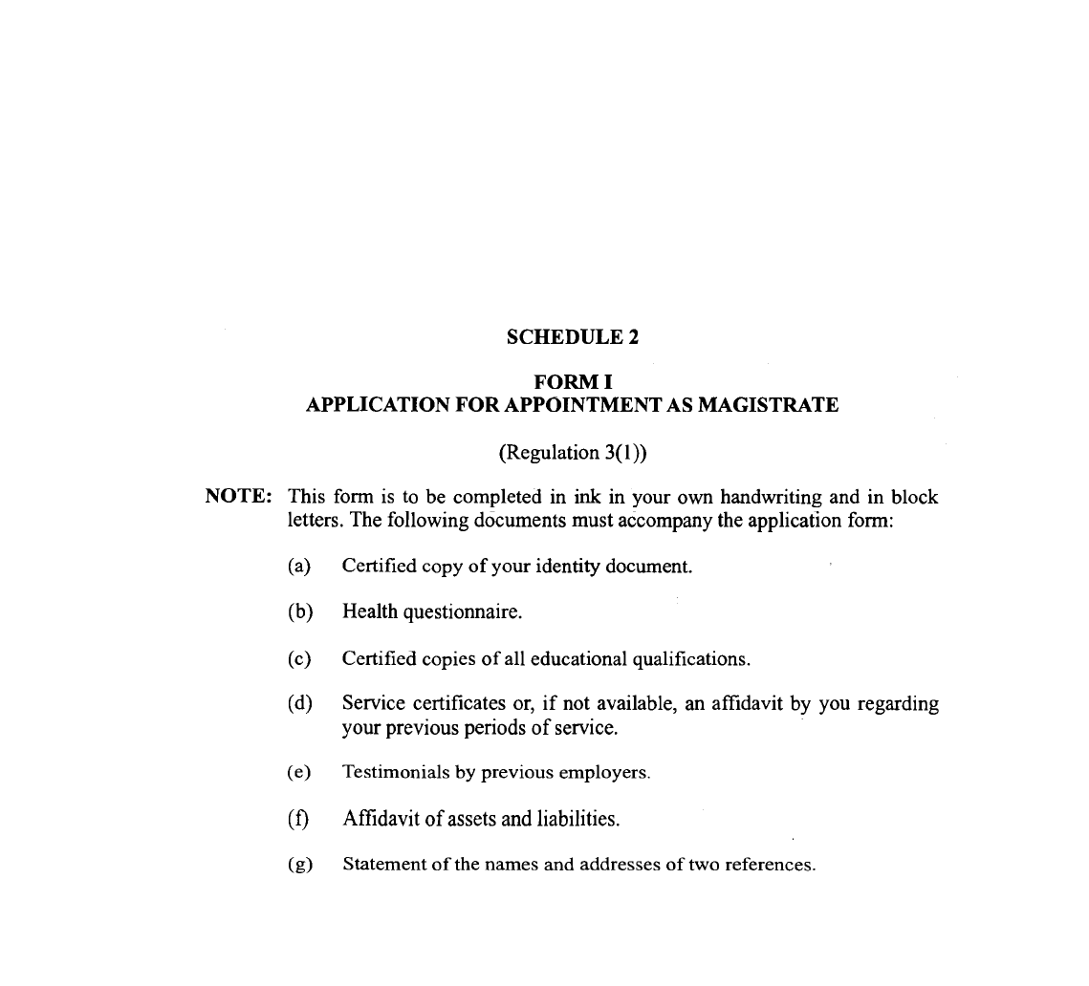
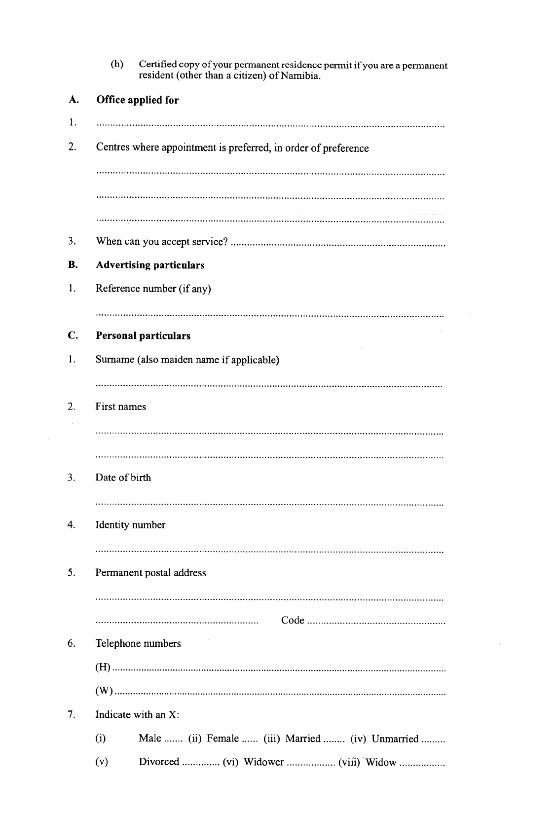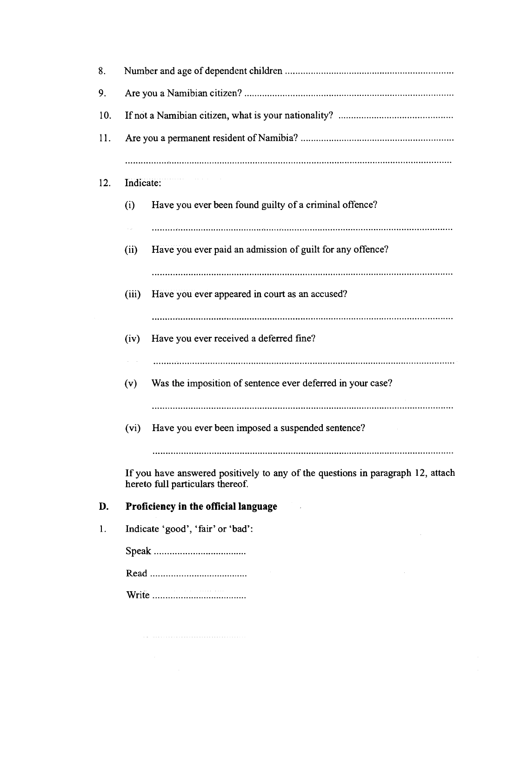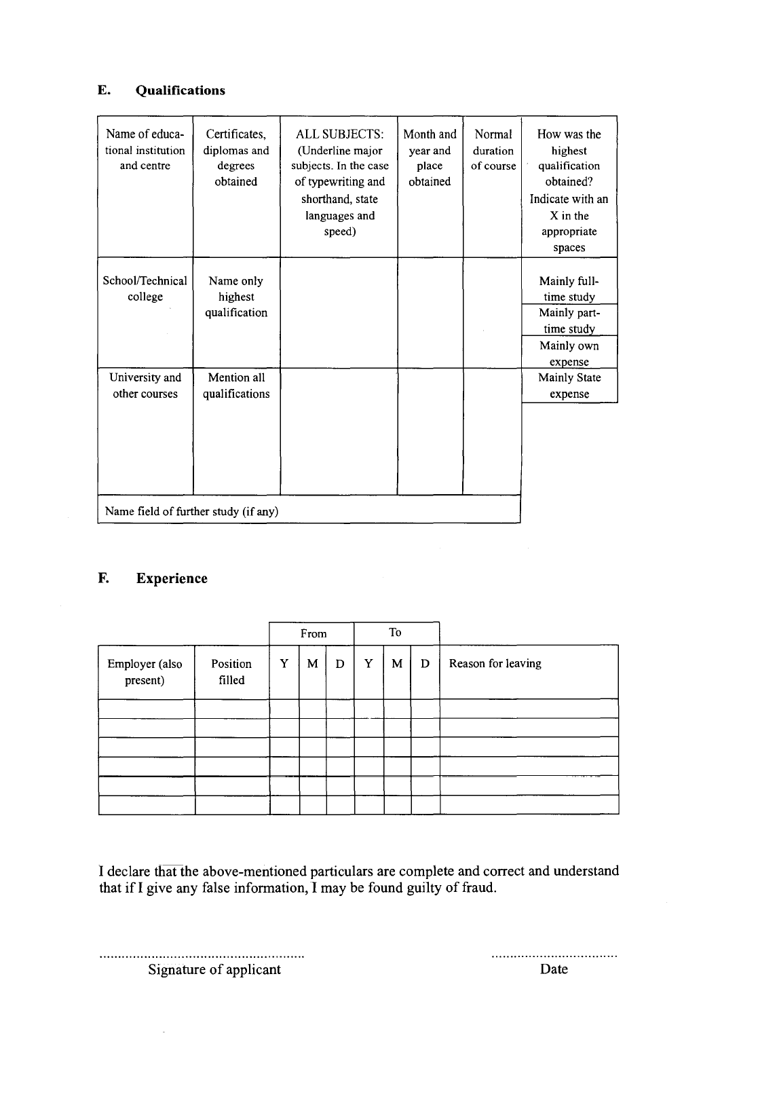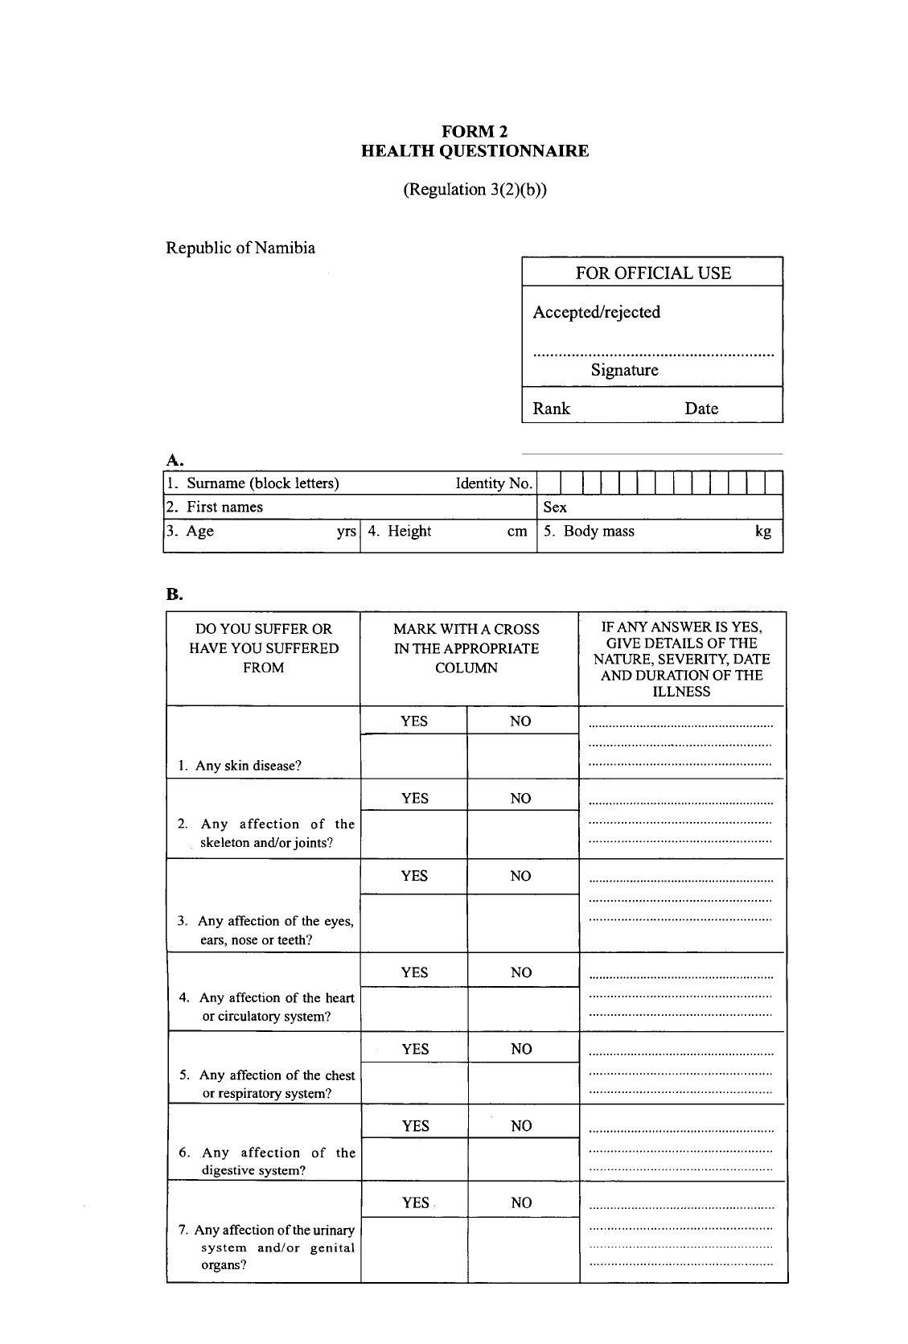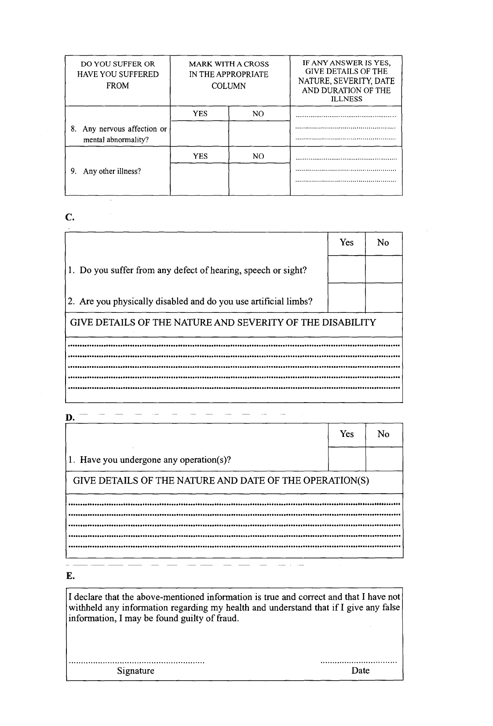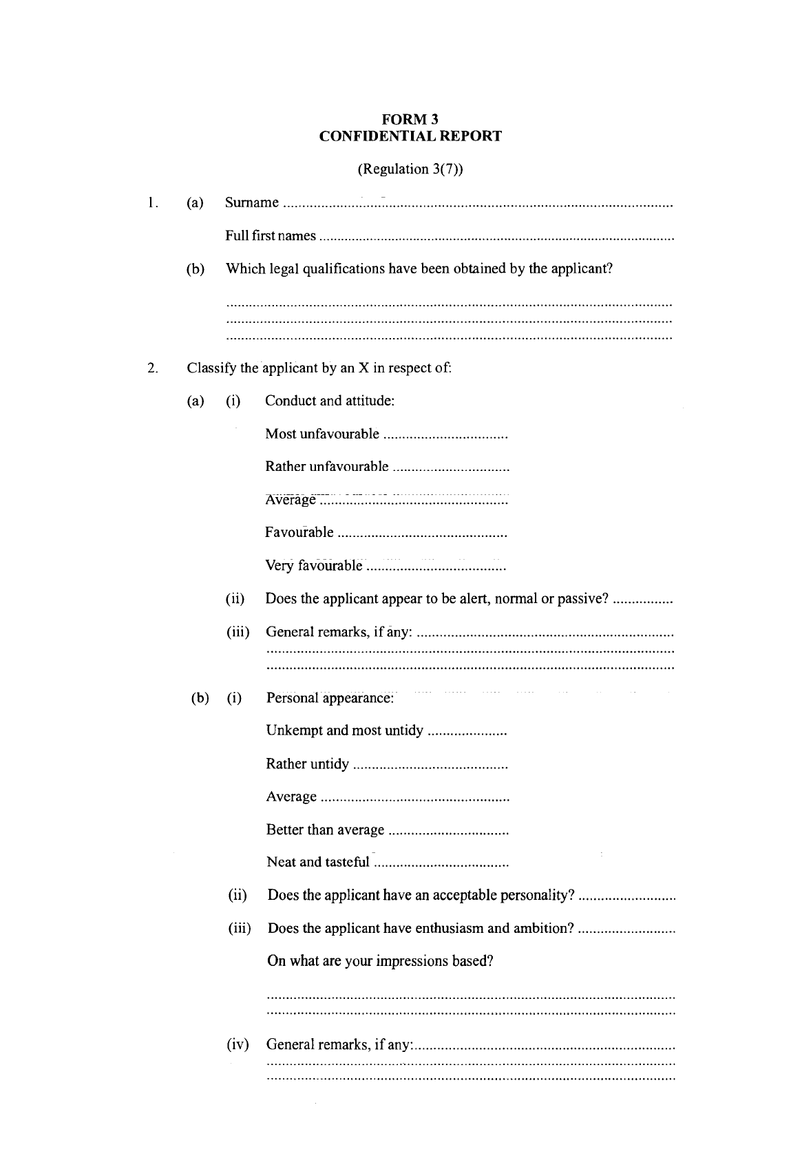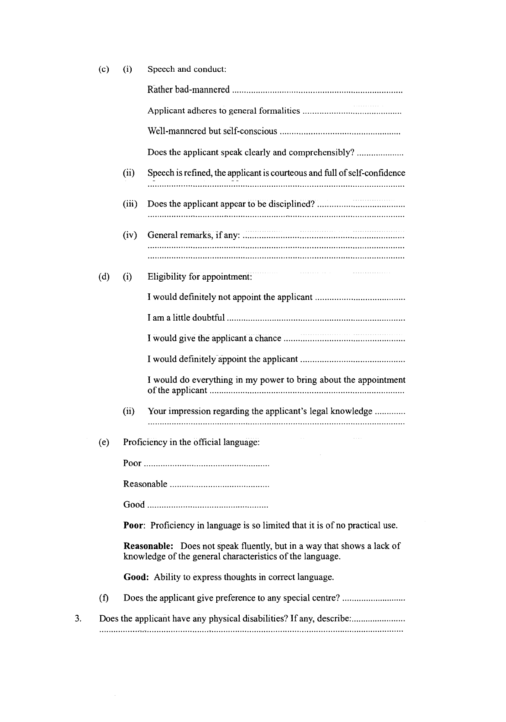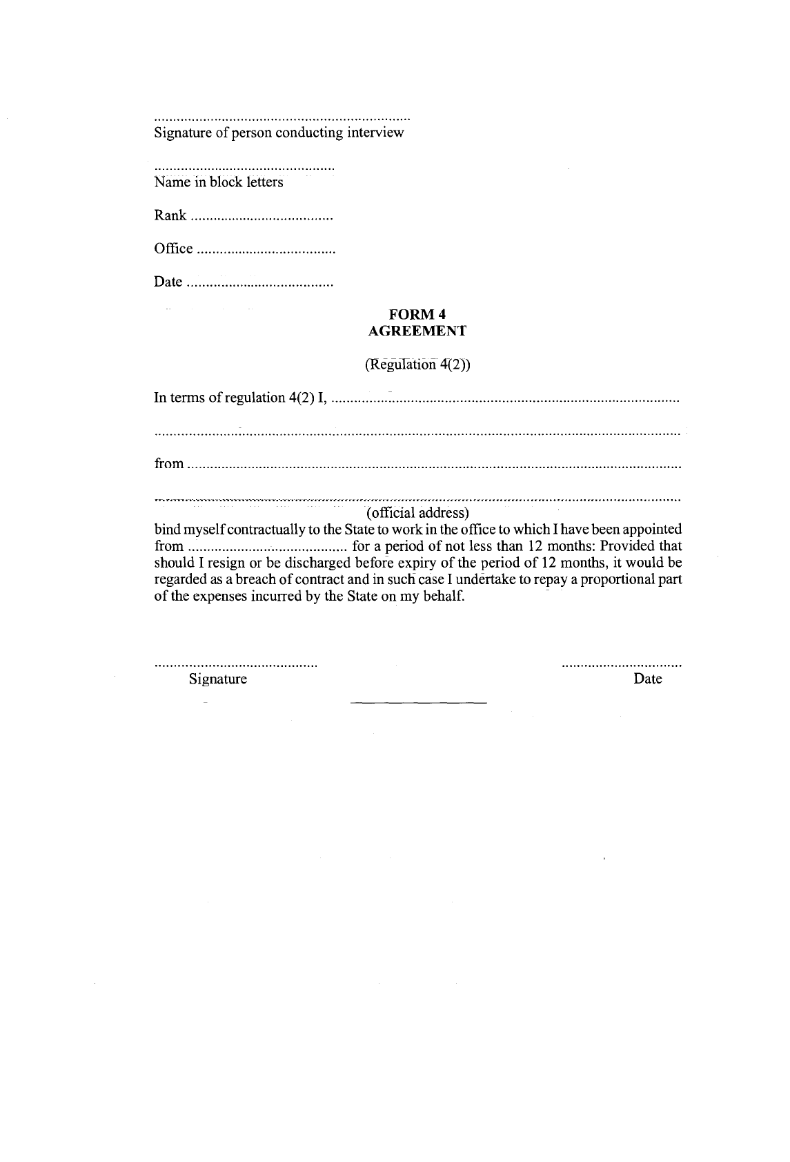

[Forms 5-7 inserted into Schedule 2 by GN 200/2015]

FORM 5

CONDUCT SHEET
(Regulation 18B)

NAME OF MAGISTRATE:
Date | Misconduct | Penalty | Erased (Date)

FORM 6

WRITTEN WARNING
(Regulation 18E)

Date: ____________________________

Name and rank of Magistrate: Mr/Ms/Dr _________________________________________

_____________________________________________________________________________

1. This is a written warning against you in terms of the Regulations. Should you engage in further transgression of similar nature, it could lead to formal misconduct proceedings being instituted against you in terms of section 26 of the Act.

2. The copy of the written warning is filed in your personal file.

3. If you object to the warning, you may direct your appeal to the Chief Magistrate/Magistrates Commission, within 14 days of receipt of this written warning.

4. The nature of the misconduct is that ___________________________________________

________________________________________________________________________

________________________________________________________________________

SIGNATURE:......................................................................... DATE ...........................................
divisional magistrate/Chief Magistrate/Chairperson: Magistrate Commission

SIGNATURE: ......................................................................... DATE ..........................................
Magistrate:

SIGNATURE: ......................................................................... DATE ..........................................
Witness

FORM 7

FINAL WRITTEN WARNING
(Regulation 18F)

Date: ____________________________

Name and rank of Magistrate: Mr/Ms/Dr _________________________________________

_____________________________________________________________________________

1. This is a final written warning against you in terms of the Regulations. Should you engage in further transgression of similar nature, it could lead to formal misconduct proceedings being instituted against you in terms of section 26 of the Act.

2. The copy of the final written warning is filed in your personal file.

3. If you object to the warning, you may direct your appeal to the Chief Magistrate/Magistrates Commission, within 14 days of receipt of this final written warning.

4. The nature of the misconduct is that ___________________________________________

________________________________________________________________________

________________________________________________________________________

SIGNATURE:......................................................................... DATE ...........................................
divisional magistrate/Chief Magistrate/Chairperson: Magistrate Commission

SIGNATURE: ......................................................................... DATE ..........................................
Magistrate:

SIGNATURE: ......................................................................... DATE ..........................................
Witness

[Schedule 3 inserted by GN 200/2015]

SCHEDULE 3

CLASSIFICATION OF ACTS OF MISCONDUCT
(Regulation 18A)

Note: The classification under this Schedule is not to be construed in any manner as exhaustive or to in any manner limit or prescribe the discretion of a divisional magistrate, the Chief Magistrate or the Commission regarding misconduct and discipline.

ACTS OF MISCONDUCT |  | PENALTY
Description | Type of offence | First misconduct | Second misconduct | Third  misconduct
1. Where a magistrate is found guilty of a criminal offence relating to the performance of the duties of his or her office | Serious | Resignation or dismissal
2. Where a magistrate found guilty of an offence for which he or she is sentenced to any term of imprisonment without the option of a fine | Serious | Dismissal
3. If found guilty of an of- fence and is sentenced to term of imprisonment exceeding three months with the option of a fine | Serious | Caution and repri- mand, caution and transfer, resignation or dismissal | Dismissal
4. Contravenes or fails to comply with a provision of the Act, Regulations or Code | Minor/ Serious | Verbal warning, writ- ten warning, final written warning or fine and final written warning, caution and transfer, resignation or dismissal | Final written warn- ing, Fine and final written warning, caution and transfer, resignation or dis- missal | Caution and trans- fer, resignation or dismissal
5. Is negligent or indolent in the performance of duties of his or her office | Minor/ Serious | Written warning, fi-nal written warning, fine and final writ-ten warning, caution and transfer, resig-nation or dismissal | Final written warn-ing, caution and transfer, resignation or dismissal | Resignation or dismissal
6. Uses intoxicants or stupe- fying drugs excessively with- out a prescription of a medical practitioner resulting in his or her incapacity to perform the duties of his or her office efficiently | Serious | Final written warn- ing and corrective counselling, or fine and final written warning and cor- rective counselling, caution and transfer, resignation or dis- missal | Resignation or dismissal
7. Uses or is under influence of intoxicants or stupefying drugs during official hours of attendance without prescript-tion of medical practitioner | Serious | Final written warn- ing and corrective counselling, or fine and final written warning and cor- rective counselling, caution and transfer, resignation or dis- missal | Resignation or dismissal
8. Accepts or demands in re- spect of performance of or failure to perform his or her duties any commission, fee or pecuniary or other award to which he or she is not entitled by virtue of his or her office | Serious | Resignation or dismissal
9. Operates or undertakes, without the approval of the Commission, any private agency or private work in re- gard to any matter directly or indirectly related to the per- formance of the functions of his or her office or any matter directly or indirectly related to the field of operations of a magistrate, or fails to declare that a member of his or her household operates or under- takes any such private agency or private work | Serious | Final written warn- ing, fine and final written warning, caution and transfer, resignation or dis- missal | Resignation or dismissal
10. Misappropriates or makes improper use of any property of the State | Minor/ Serious | Final written warn- ing, fine and final written warning, caution and transfer, resignation or dis- missal | Caution and transfer resignation or dis- missal | Resignation or dismissal
11. Absents himself or herself from his or her office or duty without leave or valid cause | Minor/ Serious | Final written warn- ing, fine and final written warning, caution and transfer, resignation or dis- missal | Caution and trans- fer, resignation, or dismissal | Resignation or dismissal
12. Make a false or incorrect statement, knowing it to be false or incorrect, with a view to obtain any privilege or ad- vantage in relation to his or her official position or his or her duties or to the prejudice of the administration of jus- tice | Serious | Resignation or dismissal
13. Commits any act which brings or is likely to bring the administration of justice or the magistracy into disrepute | Minor/ Serious | Fine and final writ- ten warning, caution and transfer, resig- nation or dismissal | Resignation or dis- missal
14. Refuses to execute a law- ful order | Minor/ Serious | Final written warn- ing, fine and final written warning, caution and transfer, resignation or dis- missal | Fine and final writ- ten warning, caution and transfer, resig- nation or dismissal | Resignation or dis- missal
15. Fails to maintain high standards of conduct in both professional and personal ca-pacity, in and out of court | Minor/Serious | Verbal warning, written warning, fi-nal written warning, fine and final written warning, caution and transfer, resignation or dismissal | Written warning, fi-nal written warning, fine and final writ-ten warning, caution and transfer, resig-nation or dismissal | Final written warning, fine and final written warning, caution and transfer, resignation or dis-  missal
16. Divulges any confidential information which has come to his or her knowledge in his or her official capacity, except in so far as it is necessary in the execution of his or her du- ties | Serious | Final written warn- ing, fine and final written warning, caution and transfer, resignation or dis- missal | Resignation or dis- missal
17. Fails to adhere to the of- ficial dress code | Minor/ Serious | Written warning, fine and written warning | Final written warn- ing, fine and final written warning, caution and transfer, resignation or dis- missal | Resignation or dis- missal
18. Fails to meet the perfor- mance standard expected of magistrate and fails to im- prove his or her performance standard after the interven- tions contemplated in section 24(4)(a) | Minor/ Serious | Written warning, caution and trans- fer, plus corrective counselling, resig- nation or dismissal | Final written warn- ing, resignation or dismissal | Resignation or dis- missal

