REGULATIONS MADE IN TERMS OF

Liquor Act 6 of 1998
section 79 read with section 12(3) of the
Interpretation of Laws Proclamation 37 of 1920

Liquor Regulations
Government Notice 142 of 2001
(GG 2575)
came into force on the date on which the Act came into force:
22 December 2002 (see GN 250/2001, GG 2670)

The Government Notice which issues these regulations repeals
the regulations contained in GN 49/1969 (OG 2984), as amended.

as amended by

Government Notice 105 of 2006 (GG 3665)
came into force on date of publication: 20 July 2006
Government Notice 18 of 2015 (GG 5668)
came into force on 1 March 2015 (GN 18/2015)

ARRANGEMENT OF REGULATIONS

PART I
PRELIMINARY

1. Definitions

PART II
TERMS AND CONDITIONS OF TENURE OF OFFICE OF MEMBERS
OF COMMITTEES AND MEETINGS OF COMMITTEES

2. Term of office
3. Vacation of office and filling of casual vacancies
4. Remuneration of members
5. Meetings of Committees for hearing applications

PART III
GENERAL FORMALITIES AND PROCEDURES
CONCERNING APPLICATIONS

6. Prescribed forms
7. Attachment of documents
8. Application by body corporate, organisation or association
9. Affidavit of financial interest
10. Advertising of application
11. Objections and submissions in relation to applications
12. Reply to objection or submission

PART IV
APPLICATION FOR A LICENCE IN TERMS OF SECTION 27

13. Application for licence
13A. Application for shebeen liquor licence
[regulation 13A inserted by GN 105/2006]
14. Notice of application
15. Procedure on receipt of application
16. Display of notice by secretary
17. Report by local authority or regional council in relation to application
18. Licence granted subject to conditional authority
19. Objections or submissions
20. Procedure after grant of application

PART V
TEMPORARY LIQUOR LICENCE

21. Application for temporary liquor licence
22. Issue of licence

PART VI
HOTEL LIQUOR LICENCES AND PARKS LIQUOR LICENCES

23. Application for hotel liquor licence or parks liquor licence
24. Issue of licence

PART VII
AMENDMENT OF CONDITIONS, RESTRICTIONS OR
PRIVILEGES RELATING TO A LICENCE

25. Application for amendment of licence
26. Notice of application
27. Procedure on receipt of application
28. Display of notice by secretary
29. Report by local authority or regional council in relation to application
30. Objections or submission
31. Procedure after grant of application

PART VIII
PERMANENT OR TEMPORARY REMOVAL OF A LICENCE

32. Application for removal of licence
33. Notice of application
34. Procedure on receipt of application
35. Display of notice by secretary
36. Report by local authority or regional council in relation to application
37. Objections or submissions
38. Procedure after grant of application

PART IX
TRANSFER OF A LICENCE

39. Application for transfer of licence
40. Notice of application
41. Objections or submissions
42. Public hearing of application

PART X
ACQUISITION OF CONTROLLING INTEREST
IN LICENSED BUSINESS

43. Application for acquisition of controlling interest
44. Notice of application
45. Objections or submissions
46. Public hearing of application

PART XI
CHANGE OF A TRADE NAME OF LICENSED BUSINESS

47. Application for change of trade name of licensed business
48. Notice of application
49. Objections or submissions
50. Public hearing of application

PART XII
LEASE OF A LICENSED BUSINESS

51. Application for lease of licensed business
52. Procedure after receipt of application

PART XIII
GENERAL

53. Notice of change of manager
54. Submission of copies of licences and certificates of renewal issued
55. Register of licences and extracts from register
56. Notice of appeal and procedure
57. Application for approval to supply samples of liquor for consumption on licensed bottle store premises
58. Notice to be displayed in relation to sale or supply of liquor to persons under 18 years
59. Application for approval to make structural alterations to licensed premises
60. Exemption from obligation of residence of manager on licensed premises
61. Receipt to be issued for articles seized
62. Meeting of Committee to consider report or petition in relation to licensed premises
63. Temporary closure of licensed premises in certain circumstances
64. Request by magistrate for report in relation to application
65. Payment of fees
66. Manner of display of notices on notice board
67. Commencement of meetings
68. Manner in which notice shall be given or documents served

PART XIV
TIMES OF BUSINESS FOR SALE, SUPPLY
OR DELIVERY OF LIQUOR

69. Times of business applicable to bottle store licence
70. Times of business applicable to grocery liquor licence
71. Times of business applicable to wholesale liquor licence and brewery depot liquor
licence
72. Times of business applicable to distillery licence
73. Times of business applicable to parks off-sales liquor licence
74. Times of business applicable to vineyard liquor licence
75. Times of business applicable to shebeen liquor licence
76. Times of business applicable to club liquor licence
77. Times of business applicable to hotel on-consumption liquor licence, restaurant liquor licence or parks on-consumption licence

PART XV
OFFENCES AND PENALTIES

78. Offences and penalties

ANNEXURE

PART I
PRELIMINARY

Definitions

1. In these regulations, unless the context otherwise indicates, a word or expression defined in the Act has a corresponding meaning, and -

“certified copy” in relation to any certificate, licence or other document, means a copy of the original of such document, duly certified as a copy thereof by a commissioner of oaths;

“clerk of the court”, in relation to a licence or an application for, or relating to, a licence, means the clerk of the magistrate’s court of the district in which the premises to which the licence or application relates are situated;

“secretary of the Committee”, in relation to any application for a licence or a licence, means the secretary of the Committe of the region in which the premises to which such application or licence relates are situated;

[The word “Committee” is misspelt in the Government Gazette in its
second use in this definition, as reproduced above.]

“the Act” means the Liquor Act, 1998 (Act No. 6 of 1998).

PART II
TERMS AND CONDITIONS OF TENURE OF OFFICE OF MEMBERS
OF COMMITTEES AND MEETINGS OF COMMITTEES

Term of office

2. (1) The members of a Committee referred to in section 24(2)(b) and (c) of the Act -

(a) are appointed for a period of 5 years; and

(b) are eligible for reappointment upon expiry of that period.

(2) The member referred to in section 24(2)(c) of the Act must be appointed by the regional council by notice in writing addressed and delivered or sent to the member and the Committee Chairperson concerned.

Vacation of office and filling of casual vacancies

3. (1) The office of a member referred to in section 24(2)(b) or (c) of the Act becomes vacant if the member -

(a) resigns from office by notice in writing to the Minister;

(b) becomes disqualified to be a member in terms of section 24(4) of the Act; or

(c) is removed from office under subregulation (2) or (3).

(2) The Minister may remove a member referred to in subregulation (1) from office if the Minister, after affording the member a reasonable opportunity to be heard, is satisfied that the member -

(a) is incapacitated by physical or mental illness;

(b) has failed to perform his or her functions as member efficiently; or

(c) has been guilty of misconduct.

(3) A regional council which has appointed a member referred to in section 24(2)(c) of the Act may at any time terminate the appointment of that member by notice in writing to the member and to the Committee Chairperson.

(4) If the office of a member referred to in subregulation (1) becomes vacant, the vacancy must be filled by the appointment, in accordance with section 24(2)(b) or (c) of the Act, as the case may be, of another person as member for the unexpired portion of the term of office of the person who ceased to be a member.

Remuneration of members

4. (1) The members of a Committee who are not in the full-time employment of the State must be paid the allowances, including travelling and subsistence allowances, as prescribed in respect of office bearers of statutory institutions or boards in terms of the Public Service Staff Rules, and as set out in Annexure A of PSSR E.IIII/3 thereof.

(2) Every claim for payment of remuneration in terms of subregulation (1) must -

(a) be certified as correct by the Committee Chairperson concerned; and

(b) be submitted for payment to the Permanent Secretary.

Meetings of Committees for hearing applications

5. (1) A Committee must hold 12 meetings during a year for hearing applications in terms of section 27 of the Act, namely -

(a) on the second Wednesday of every month; or

(b) if any such Wednesday is a public holiday, on the Wednesday following that public holiday.

[subregulation (1) substituted by GN 105/2006]

(2) If no application is scheduled for hearing by the Committee at a meeting referred to in subregulation (1), the Committee shall not meet on that day.

(3) The Committee Chairperson determines the procedure to be followed at a meeting of the Committee.

(4) A meeting of a Committee is open to the public, except when the Committee deliberates and vote on any matter.

(5) The Chairperson of the Committee must ensure that proper minutes are kept of the proceedings of every meeting of the Committee, and separate minutes must be kept -

(a) in respect of proceedings open to the public; and

(b) in respect of proceedings during the deliberations and voting on any matter.

(6) The minutes referred to in subregulation (5) must be retained at the office of the Committee Chairperson.

(7) Any person may during normal office hours -

(a) inspect and make extracts from the minutes in respect of the public proceedings of a meeting referred to in subregulation (5)(a);

(b) obtain from the secretary of a Committee a copy of the minutes referred to in paragraph (a) against payment of a fee of N$ 3.00 per single page copied.

(8) The minutes referred to in subregulation (5)(b) may not be disclosed by any person, except to -

(a) the Minister;

(b) a person by whom it is required for the performance of any function in terms of the Act; or

(c) any other person -

(i) on the instructions of the Minister; or

(ii) in terms of an order of the High Court of Namibia.

PART III
GENERAL FORMALITIES AND PROCEDURES
CONCERNING APPLICATIONS

Prescribed forms

6. (1) Any application, notice, licence, certificate, authority or other document which is required in terms of these regulations to be made, given or issued in a prescribed form, must be framed substantially in the relevant form as specified and as set out in the Annexure to these regulations.

Attachment of documents

7. (1) An applicant must ensure -

(a) that all information or documents required to be included in, attached to or to accompany an application, are furnished and are true and complete at the time the application is lodged; and

(b) if afterward, before the hearing of the application, any fact occurs that necessitates a change of any information or document so furnished, the applicant must forthwith notify the Committee or the magistrate by whom the application is to be considered in writing of the changes and of the effect thereof on the application.

(2) Any documents required to accompany an application, must be attached to the original application and copies thereof to the original duplicate or duplicates of the application.

Application by body corporate, organisation or association

8. (1) An application form or other document required to be signed by an applicant, licensee or other person must be signed, if the applicant, licensee or person is a body corporate, an organization, partnersship or other association of persons, by a person who is authorised to make the application or sign the document on behalf of the body corporate, organisation, partnership or other association by virtue of a resolution of the executive authority or the members or partners of the body corporate, organization or association concerned.

[The word “partnership” is misspelt in the Government Gazette in its
first use in subregulation (1), as reproduced above.]

(2) An extract of the resolution referred to in subregulation (1) must be attached to the application form or other document concerned.

Affidavit of financial interest

9. [(1)] An application for -

(a) a licence in terms of section 27 of the Act:

(b) a hotel liquor licence in terms of section 3 of the Act;

(c) a parks liquor licence in terms of section 15 of the Act; or

(d) the transfer of a licence in terms of section 33 of the Act; or

(e) the acquisition of a controlling interest in terms of section 34 of the Act, must be accompanied by an affidavit of financial interest made in accordance with subregulation (2).

(1)[(2)]An affidavit of financial interest referred to in subregulation must be made by the applicant, or a person having knowledge of the particular facts, setting forth -

(a) the name, identity number and address of each person, who will have a financial interest in the business to which the application relates; and

(b) the nature and extent of the interest,

(2)[(3)]Notwithstanding subregulation (1)[(2)], in the case of a financial interest of a public company, statutory institution or a co-operative contemplated in the Co-operatives Act, 1996 (Act No. 23 of 1996) it is sufficient to furnish in the affidavit only -

(a) the name, address and registration number (if any) of the company, statutory institution or co-operative;

(b) the nature and extent of the financial interest of the company, statutory institution or co-operative; and

(c) the name, address and identity number of each director of the company, statutory institution or co-operative.

[The subregulations in regulation 9 appear to be misnumbered. There is no number for what appears to be the first subregulation. If this subregulation becomes number (1), then the other subregulation numbers would need to be adjusted accordingly to (2) and (3). The cross-references in the regulation seem to be partly based on the erroneous numbering and partly on the intended numbering. The numbers inserted in green probably reflect what was intended.]

Advertising of application

10. (1) Any advertisement of an application required to be published in terms of these regulations must be published in the prescribed form, subject to subregulation (2), in a daily newspaper which is printed and circulated in the region in which the premises to which the application relates are situated.

(2) If a newspaper is not printed and circulated in the region concerned, the applicant must cause the notice of application to be displayed, with effect from the date on which the advertisement is required to be published, on the notice board, or at any other conspicuous place -

(a) at the office of the regional council concerned; and

(b) at a police station or a post office or the office of a traditional authority nearest to the place where the premises concerned are situated:

Provided that the applicant is not precluded from advertising the application in any newspaper which, although not printed in the region, circulates in the region.

(3) Proof of publication of the notice must be furnished by the applicant, before or on the date of the hearing of the application by the submission of -

(a) a newspaper clipping, showing the date of application; or

(b) in a case contemplated in subregulation (2), a copy of the notice bearing the date stamp of the relevant office referred to in that subregulation at which the notice was displayed.

Objections and submissions in relation to applications

11. (1) Any objection or written submission lodged in terms of section 28 or 32(4) of the Act in relation to an application referred to in these regulations must -

(a) be in writing, signed by the person making the objection or submission; and

(b) be lodged in duplicate.

(2) An objection or a submission referred to in subregulation (1) must state -

(a) the name and address of the person by whom the objection or submission is made;

(b) the application in respect of which it is lodged, including -

(i) the name and address of the applicant; and

(ii) the address of the premises to which the application relates; and

(c) the grounds on which the objection or submission is made.

(3) The secretary of a Committee or the magistrate with whom any objection or submission is lodged must furnish the applicant with a copy of the objection or submission -

(a) in the form as set out in Form 3;

(b) not less than seven days before the date of the meeting of the Committee or the public hearing by the magistrate, as the case may be, at which the application is to be heard.

Reply to objection or submission

12. (1) Not less than one day before the commencement of a meeting or a public hearing referred to in regulation 11, an applicant may lodge with the secretary of the Committee or the magistrate, as the case may be, a written reply to any objection or submission.

(2) Failure to lodge a written reply in terms of subregulation (1) does not preclude an applicant from giving a reply at the hearing of the application.

(3) If, when hearing an application, a Committee or a magistrate of own accord raises an objection in relation to an application, the Committee or the magistrate must, if the applicant so requests, grant a postponement of the application for a reasonable time to allow the applicant to prepare a reply to the objection.

PART IV

APPLICATION FOR A LICENCE IN TERMS OF SECTION 27

Application for licence

13. (1) An application in terms of section 27 of the Act for the grant of a licence (other than a shebeen liquor licence and hotel liquor licence, a parks liquor licence or a temporary liquor licence) must -

[subregulation (1) amended by GN 105/2006]

(a) be made in the form as set out in Form 1;

(b) be lodged in eightfold with the clerk of the court; and

(c) be lodged not more than 60 days and not less than 42 days before the date of the meeting of the Committee at which the application is to be heard.

(2) An application referred to in subregulation (1) must be accompanied by -

(a) a plan of the premises concerned, clearly showing -

(i) the dimensions of each room on the premises;

(ii) all doors, windows, and counters, if applicable, including places of entry into the premises; and

(iii) the streets or other places from which the premises may be entered;

(b) a description of the premises with reference to the construction, lay-out, furnishing, fixtures, fittings, wall finishing and floor covering;

(c) an affidavit of financial interest referred to in regulation 9;

(d) a certified copy of the agreement relating to a financial interest contemplated in paragraph (c);

(e) a certified copy of a title deed, an agreement of lease or any other instrument showing the applicant’s right of occupation of the premises in respect of which the application is made;

(f) if applicable, an extract of the resolution referred to in regulation 8(2);

(g) if the premises in respect of which the licence is applied for is situated within a local authority area as defined in section 1 of the Local Authorities Act, 1992 (Act No. 23 of 1992), a certificate issued by the local authority council concerned in which it is specified that the conduct of the proposed business on the premises concerned will not be in conflict with any town planning scheme or any township condition applicable to the premises;

(h) any written representations which the applicant may wish to submit in support of the application.

(3) Upon the lodging of an application in terms of subregulation (1), the applicant must furnish to the clerk of the court -

(a) the receipt in respect of payment of the application fee; and

(b) three copies of the notice referred to in regulation 14, duly completed.

(4) If an application for a licence in terms of section 27 of the Act relates to a train, a motor vehicle, a ship, an aircraft or any other conveyance, not being immovable premises, the application must be lodged with the clerk of the magistrate’s court for the district in which the registered office or the head office of the applicant is situated.

Application for shebeen liquor licence

13A. (1) An application in terms of section 27 of the Act for the grant of a shebeen liquor licence must -

(a) be made in the form as set out in Form 1A;

(b) be lodged with the clerk of the court; and

(c) be lodged not more than 60 days and not less than 42 days before the date of the meeting of the Committee at which the application is to be heard.

(2) Subject to subregulation (5), an application referred to in subregulation (1) must be accompanied by -

(a) a sketch of the premises concerned, showing -

(i) the dimensions of each room on the premises;

(ii) all doors, windows, and counters, if applicable, including places of entry into the premises; and

(iii) the streets or other places from which the premises may be entered;

(b) a description of the premises with reference to the construction, layout, furnishing, fixtures, fittings, wall finishing and floor covering;

(c) an affidavit of financial interest referred to in regulation 9;

(d) a certified copy of the agreement relating to a financial interest contemplated in paragraph (c);

(e) a certified copy of a title deed, an agreement of lease or any other instrument showing or describing the applicant’s right of occupation of the premises in respect of which the application is made or if the applicant cannot obtain such title deed, agreement or instrument, an affidavit setting out the conditions relating to the occupation of the premises concerned by the applicant;

(f) if applicable, an extract of the resolution referred to in regulation 8(2);

(g) any written representations which the applicant may wish to submit in support of the application.

(3) Upon the lodging of an application in terms of subregulation (1), the applicant must furnish to the clerk of the court -

(a) the receipt in respect of payment of the application fee; and

(b) three copies of the notice referred to in regulation 14, duly completed.

(4) It is the duty of the clerk of the court to render such assistance to an applicant for a shebeen licence as may be necessary to ensure that the applicant complies with the provisions of these regulations and the Act and to ensure that all relevant information is provided by the applicant.

(5) The Chairperson of a Committee may draw up forms or questionnaires which the applicant may complete and which the committee may accept in stead of or in addition to the documents prescribed by subregulation (2)(a) or (b).

(6) Forms or questionnaires referred to in subregulation (5) must -

(a) be confirmed by oath or affirmation; and

(b) be provided to applicants by the clerk of the court.

[regulation 13A inserted by GN 105/2006]

Notice of application

14. A person who intends to lodge an application referred to in regulation 13 must advertise the application by publishing a notice, in the manner as prescribed by regulation 10 -

(a) in the form as set out in Form 2;

(b) not more than 14 days and not less than 7 days before the date on which the application will be lodged with the clerk of the court.

Procedure on receipt of application

15. On receipt of an application lodged with the clerk of the court in terms of regulation 13, the magistrate concerned must-

(a) if the magistrate is not the Committee Chairperson stationed at the seat of the region as contemplated in section 24(2)(a)(i) of the Act, cause one of the copies of the applicant’s notice of application referred to in regulation 10(3)(b) to be displayed on the notice board of the magistrate’s court for a period of not less than 30 days before the date of the meeting of the Committee at which the application is to be heard;

(b) transmit to the secretary of the Committee the original and four copies of the application and two copies of the applicant’s notice of application referred to in regulation 10(3)(b);

(c) if the premises are situated in a local authority area, transmit one copy of the application to the chief executive officer of the local authority council;

(d) if the premises are situated outside a local authority area, transmit two copies of the application to the chief executive officer of the regional council of the region in which the premises to which the application relates arc situated; and

(e) retain one copy of the application for the records of the magistrate.

Display of notice by secretary

16. On receipt of the application and copies of the notice of application in terms of regulation 15(b), the secretary of the Committee must display one copy of the notice on the notice board at the seat of the Committee.

Report by local authority or regional council in relation to application

17. (1) On receipt of the copy of an application in terms of regulation 15(c) or (d) the chief executive officer of the local authority council or the regional council, as the case may be, must -

(a) compile a report in relation to the application concerning the considerations referred to in section 16 of the Act and such other matters relating to the application or the applicant as the chief executive officer may consider relevant; and

(b) submit that report to the secretary of the Committee not less than 7 days before the date of the meeting of the Committee at which the application is to be heard.

(2) For the purpose of compiling the report referred to in subregulation (1), the chief executive officer concerned may -

(a) consult any person in connection with any matter referred to in section 16 of the Act or the application or the applicant; or

(b) procure from any other person or authority whom the chief executive authority considers appropriate, any comments in writing in relation to any such matter, and attach such comments to the report.

Licence granted subject to conditional authority

18. (1) If an application for a licence is granted subject to a conditional authority referred to in section 30(1) of the Act, the conditional authority must be issued to the applicant in the form as set out in Form 4.

(2) Confirmation by a magistrate that premises specified in a conditional authority have been completed and comply with the conditions set out in the conditional authority must be issued in the form as set out in Form 5.

(3) An application in terms of section 30(4) of the Act for extension of the period of time specified in a conditional authority must-

(a) be made in the form as set out in Part A of Form 6; and

(b) be lodged with the magistrate in duplicate before the expiry of the period specified in the conditional authority.

(4) If an application for extension of time referred to in subregulation (3) is granted, the magistrate must issue to the applicant a certificate of extension in the form as set out in Part B of Form 6.

Objections or submissions

19. Any objection or written submission in terms of section 28(1) of the Act in relation to an application referred to in regulation 13 must be lodged, subject to regulation 11 -

(a) in duplicate;

(b) with the secretary of the Committee;

(c) not less than 21 days before the date of the meeting of the Committee at which the application is to be heard.

Procedure after grant of application

20. (1) If an application referred to in regulation 13 is granted by a Committee under section 29(7) of the Act, the secretary of the Committee must issue to the applicant a certificate in the form as set out in Form 7.

(2) On submission -

(a) of the certificate referred to in subregulation (1); and

(b) proof of payment of the relevant licence fee,

the magistrate of the district in which the premises are situated must issue to the applicant a licence in the form as set out in Form 8.

PART V
TEMPORARY LIQUOR LICENCE

Application for temporary liquor licence

21. (1) An application in terms of section 32 of the Act for a temporary liquor licence must -

(a) be made in the form as set out in Form 9; and

(b) be lodged with the magistrate of the district in which the premises are situated where the event to which the application relates will take place.

(2) An application referred to in subregulation (1) must be accompanied by -

(a) the receipt in respect of payment of the application fee; and

(b) an affidavit by the applicant or a person having knowledge of the facts stating-

(i) the purpose and event, as contemplated in section 8(1) of the Act, for which the licence is required; and

(ii) the capacity in which application is made by the applicant and that he or she is qualified in accordance with section 8(4) of the Act to be issued with a temporary liquor licence.

(3) The magistrate must determine the application within three working days of the date on which it is lodged and must -

(a) if the licence is refused, inform the applicant in writing accordingly and of the reasons for the refusal in accordance with part B of Form 9; or

(b) if the licence is granted, issue to the applicant a certificate in the form as set out in Part B of Form 9.

Issue of licence

22. On submission -

(a) of the certificate referred to in regulation 21(3)(b); and

(b) proof of payment of the licence fee,

the magistrate must issue to the applicant a temporary liquor licence in the form as set out in Form 10.

PART VI
HOTEL LIQUOR LICENCES AND PARKS LIQUOR LICENCES

Application for hotel liquor licence or parks liquor licence

23. (1) An application in terms of section 3 of the Act for a hotel liquor licence, or in terms of section 15 of the Act for a parks liquor licence, must -

(a) be made in the form as set out in Form 11; and

(b) be lodged in triplicate with the Chairperson of the Committee referred to in section 3(2)(b) or 15(2) of the Act, as the case may be.

(2) An application referred to in subregulation (1) must be accompanied by -

(a) an affidavit of financial interest referred to in regulation 9;

(b) the receipt in respect of payment of the application fee;

(c) such other documents or information as the Committee Chairperson may require.

(3) If the licence applied for is granted under section 3(3) or section 15(3) of the Act, as the case may be, the Committee Chairperson must issue to the applicant a certificate in the form as set out in Form 12.

Issue of licence

24. On submission -

(a) of the certificate referred to in subregulation (3); and

(b) proof of payment the relevant licence fee,

the magistrate of the district in which the premises arc situated must issue to the applicant the licence concerned in the form as set out in Form 13.

PART VII
AMENDMENT OF CONDITIONS, RESTRICTIONS OR PRIVILEGES
RELATING TO A LICENCE

Application for amendment of licence

25. (1) An application in terms of section 27(1)(d) for the amendment of any condition, restriction or privilege relating to a licence must-

(a) be made in the form as set out in Form 14;

(b) be lodged in eightfold with the clerk of the court; and

(c) be lodged not more than 60 days and not less than 42 days before the date of the meeting of the Committee at which the application is to be considered.

(2) An application referred to in subregulation (1) must be accompanied by -

(a) a certified copy of the licence concerned;

(b) a statement by the applicant setting forth the reasons for the proposed amendment; and

(c) if applicable, an extract of the resolution referred to in regulation 8(2);

(d) any written representations which the applicant may wish to submit in support of the application.

(3) Upon the lodging of an application in terms of subregulation (1), the applicant must furnish to the clerk of the court -

(a) the receipt in respect of payment of the application fee; and

(b) three copies of the notice referred to in regulation 26, duly completed.

Notice of application

26. A person who intends to lodge an application referred to in regulation 25 must advertise the application by publishing a notice, in the manner as prescribed by regulation 10 -

(a) in the form as set out in Form 2;

(b) not more than 14 days and not less than 7 days before the date on which the application will be lodged with the clerk of the court.

Procedure on receipt of application

27. On receipt of an application lodged with the clerk of the court in terms of regulation 25, the magistrate concerned must-

(a) if the magistrate is not the Committee Chairperson stationed at the seat of the region as contemplated in section 24(2)(a)(i) of the Act, cause one of the copies of the applicant’s notice of application referred to in regulation 25(3)(b) to be displayed on the notice board of the magistrate’s court for a period of not less than 30 days before the date of the meeting of the Committee at which the application is to be heard;

(b) transmit to the secretary of the Committee the original and four copies of the application and two copies of the notice of the applicant’s application referred to in regulation 25(3)(b);

(c) if the premises arc situated in a local authority area, transmit one copy of the application to the chief executive officer of the local authority council;

(d) if the premises are situated outside a local authority area, transmit two copies of the application to the chief executive officer of the regional council of the region in which the premises to which the application relates are situated; and

(e) retain one copy of the application for the records of the magistrate.

Display of notice by secretary

28. On receipt of the application and copies of the notice of application in terms of regulation 27(b), the secretary of the Committee must display one copy of the notice on the notice board at the seat of the Committee.

Report by local authority or regional council in relation to application

29. (1) On receipt of the copy of an application in terms of regulation 27(c) or (d) the chief executive officer of the local authority council or the regional council, as the case may be, must -

(a) compile a report in relation to the application concerning the considerations referred to in section 16 of the Act and such other matters relating to the application or the applicant as the chief executive officer may consider relevant; and

(b) submit that report to the secretary of the Committee not less than 7 days before the date of the meeting of the Committee at which the application is to be heard.

(2) For the purpose of compiling the report referred to in subregulation (1), the chief executive officer concerned may -

(a) consult any person in connection with any matter referred to in section 16 of the Act or the application or the applicant; or

(b) procure from any other person or authority whom the chief executive authority considers appropriate any comments in writing in relation to any such matter, and attach such comments to the report.

Objections or submission

30. Any objection or written submission in terms of section 28(1) of the Act in relation to an application referred to in regulation 25 must be lodged, subject to regulation 11 -

(a) in duplicate;

(b) with the secretary of the Committee;

(c) not less than 21 days before the date of the meeting of the Committee at which the application is to be considered.

Procedure after grant of application

31. (1) If an application referred to in regulation 25 is granted by the Committee, and upon proof of payment of the prescribed fee, the secretary of the Committee must -

(a) issue to the applicant a certificate in the form as set out in Form 15; and

(b) transmit a duplicate of the certificate referred to in paragraph (a) to the magistrate of the district in which the licensed premises concerned arc situated.

(2) The licensee must append the certificate referred tin subregulation (1)(a) to the original licence.

PART VIII
PERMANENT OR TEMPORARY REMOVAL OF A LICENCE

Application for removal of licence

32. (1) An application in terms of section 31 of the Act for the permanent or temporary removal of a licence must -

(a) be made in the form as set out in Form 16; and

(b) be lodged in eightfold with the clerk of the court; and

(c) be lodged not more than 60 days and not less than 42 days before the date of the meeting of the Committee at which the application is to be considered.

(2) An application referred to in subregulation (1) must be accompanied by -

(a) a statement by the applicant setting forth the reasons for the removal of the licence; and

(b) a certified copy of the existing licence.

(3) Upon the lodging of an application in terms of subregulation (1), the applicant must furnish to the clerk of the court -

(a) the receipt in respect of payment of the application fee; and

(b) three copies of the notice referred to in regulation 33, duly completed.

Notice of application

33. A licensee who intends to lodge an application referred to in regulation 32 must advertise the application by publishing a notice, in the manner as prescribed by regulation 10 -

(a) in the form as set out in Form 2;

(b) not more than 14 days and not less than 7 days before the date on which the application will be lodged with the clerk of the court.

Procedure on receipt of application

34. On receipt of an application lodged with the clerk of the court in terms of regulation 32, the magistrate concerned must -

(a) if the magistrate is not the Committee Chairperson stationed at the seat of the region as contemplated in section 24(2)(a)(i) of the Act, cause one of the copies of the applicant’s notice of application referred to in regulation 32(3)(b) to be displayed on the notice board of the magistrate’s court for a period of not less than 30 days before the date of the meeting of the Committee at which the application is to be heard;

(b) transmit to the secretary of the Committee the original and four copies of the application and two copies of the applicant’s notice of application referred to in regulation 32(3)(b);

(c) if the premises are situated in a local authority area, transmit one copy of the application to the chief executive officer of the local authority council;

(d) if the premises are situated outside a local authority area, transmit two copies of the application to the chief executive officer of the regional council of the region in which the premises to which the application relates are situated; and

(e) retain one copy of the application for the records of the magistrate.

Display of notice by secretary

35. On receipt of the application and copies of the applicant’s notice of application in terms of regulation 34(b) the secretary of the Committee must display one copy of the notice on the notice board at the seat of the Committee.

Report by local authority or regional council in relation to application

36. (1) On receipt of the copy of an application in terms of regulation 34(c) or (d) the chief executive officer of the local authority council or the regional council, as the case may be, must -

(a) compile a report in relation to the application concerning the considerations referred to in section 16 of the Act and any other matter relating to the application or the applicant as the chief executive officer may consider relevant; and

(b) submit that report to the secretary of the Committee not less than 7 days before the date of the meeting of the Committee at which the application is to be heard.

(2) For the purpose of compiling the report referred to in subregulation (1), the chief executive officer concerned may -

(a) consult any person in connection with any matter referred to in section 16 of the Act or the application or the applicant; or

(b) procure from any other person or authority whom the chief executive authority considers appropriate any comments in writing in relation to any such matter, and attach such comments to the report.

Objections or submissions

37. Any objection or written submission in terms of section 28(1) of the Act in relation to an application referred to in regulation 32 must be lodged, subject to regulation 11 -

(a) in duplicate;

(b) with the secretary of the Committee;

(c) not less than 21 days before the date of the meeting of the Committee at which the application is to be considered.

Procedure after grant of application

38. (1) If the Committee approves an application referred to in regulation 32, the secretary of the Committee must-

(a) if the application is approved subject to conditions contemplated in section 31(4) of the Act, issue to the applicant a conditional authority of removal in the form as set out in Form 17; or

(b) if the application is approved free of any condition referred to in paragraph (a) -

(i) issue to the applicant a certificate of removal in the form as set out in Form 18; and

(ii) transmit a duplicate of that certificate to the magistrate of the district in which the premises concerned arc situated.

(2) An application in terms of section 30(4) of the Act for the extension of time specified in a conditional authority referred to in subregulation (1)(a), must -

(a) be made in the form as set out in Part A of Form 6; and

(b) be lodged with the magistrate in duplicate before the expiry of the period specified in the conditional authority.

(3) If an application for extension of time referred to in subregulation (2) is granted, the magistrate must issue to the applicant a certificate of extension in the form as set out in Part B of Form 6.

(4) Confirmation by a magistrate that the conditions specified in a conditional authority referred to in subregulation (l)(a) have been complied with must be issued in the form as set out in Form 5.

(5) On submission -

(a) of the certificate referred to in subregulation (1)(b) or the confirmation referred to in subregulation (4);

(b) the original licence; and

(c) proof of payment of the relevant fee,

the magistrate of the district in which the premises are situated must issue to the applicant an amended licence in the form as set out in Form 8.

PART IX
TRANSFER OF A LICENCE

Application for transfer of licence

39. (1) An application in terms of section 33 of the Act for the transfer of a licence, must -

(a) be made in the form as set out in Form 19, jointly by the licensee and by the person to whom the licence is to be transferred;

(b) be lodged in duplicate with the magistrate of the district in which the licensed premises are situated.

(2) An application referred to in subregulation (1) must be accompanied by -

(a) an affidavit of financial interest referred to in regulation 9, made by the applicant who is the proposed transferee;

(b) a certified copy of the agreement relating to any financial interest, if any, referred to in paragraph (c);

(c) a certified copy of a title deed, an agreement of lease or any other instrument showing the transferee’s right of occupation of the licensed premises;

(d) a copy of the notice of application published in terms of regulation 40 and proof of the publication and the date of publication thereof;

(e) the receipt in respect of payment of the application fee;

(f) if applicable, an extract of the resolution referred to in regulation 8(2);

(g) a certified copy of the licence concerned; and

(h) any written representations which the licensee or transferee may wish to lodge in support of the application.

Notice of application

40. (1) The applicant who is the licensee must advertise the application by publishing a notice, in the manner as prescribed by regulation 10 -

(a) in the form as set out in Form 20,

(b) not more than 14 days and not less than 7 days before the date on which the application is to be lodged with the magistrate.

(2) Not more than 7 days and not less than one day before the date on which the notice referred to in subregulation (1) is published, the licensee must lodge a copy of that notice with the clerk of court.

(3) On receipt of the notice of application in terms of subregulation (2) the clerk of the court must display that copy on the notice board at the magistrate=s court.

[The word “magistrate=s” should be “magistrate’s”.]

Objections or submissions

41. Any objection or written submission in terms of section 28(1) of the Act in relation to an application referred to in regulation 39 must be lodged, subject to regulation 11 -

(a) in duplicate;

(b) with the magistrate;

(c) within 7 days after the date on which the application was lodged with the magistrate.

Public hearing of application

42. (1) The magistrate must -

(a) determine a date for a public hearing of the application for transfer of the licence, which must be not more than 28 days after the date on which the application is lodged; and

(b) not less than seven days before the date of the hearing -

(i) give notice thereof, in the form as set out in Form 43, to the applicant and every person who has lodged an objection or submission in relation to the application; and

(ii) cause a copy of that notice to be displayed on the notice board at the magistrate’s court.

(2) If an application for the transfer of a licence is approved, the magistrate must issue to the transferee a certificate in the form as set out in Form 21.

(3) On submission of -

(a) the certificate referred to in subregulation (2);

(b) the original licence; and

(c) proof of payment of the relevant licence fee,

the magistrate must cancel the existing licence and issue to the transferee a new licence in the form as set out in Form 8 in accordance with section 20 of the Act.

PART X
ACQUISITION OF CONTROLLING INTEREST
IN LICENSED BUSINESS

Application for acquisition of controlling interest

43. (1) An application in terms of section 34 of the Act for the grant of approval for acquisition of the controlling interest in a licensed business, must -

(a) be made in the form as set out in Form 22, jointly by the licensee and by the person who wishes to acquire the controlling interest in the licensed business;

(b) be lodged in duplicate with the magistrate of the district in which the licensed business is situated.

(2) An application referred to in subregulation (1) must be accompanied by -

(a) a receipt in respect of the payment of the application fee;

(b) a certified copy of the agreement in terms of which the controlling interest is to be acquired;

(c) a copy of the notice of application published in terms of regulation 44 and proof of the publication and the date of publication thereof;

(c) if applicable, an extract of the resolution referred to in regulation 8(2);

(d) a certified copy of the licence concerned; and

(e) any written representations which the applicants, or either of them, may wish to submit in support of the application.

[There are two paragraphs labelled (c) above.
The last three paragraphs should be labelled (d), (e) and (f).]

Notice of application

44. (1) The applicant who is the licensee must advertise the application by publishing a notice, in the manner as prescribed by regulation 10 -

(a) in the form as set out in Form 20,

(b) not more than 14 days and not less than 7 days before the date on which the application is to be lodged with the magistrate.

(2) Not more than 7 days and not less than one day before the date on which the notice referred to in subregulation (1) is published, the licensee must lodge a copy of that notice with the clerk of court.

(3) On receipt of the notice of application in terms of subregulation (2) the clerk of the court must display that copy on the notice board at the magistrate=s court.

[The word “magistrate=s” should be “magistrate’s”.]

Objections or submissions

45. Any objection or written submission in terms of section 28(1) of the Act in relation to an application referred to in regulation 43 must be lodged, subject to regulation 11 -

(a) in duplicate;

(b) with the magistrate;

(c) within 7 days after the date on which the application was lodged with the magistrate.

Public hearing of application

46. (1) The magistrate must -

(a) determine a date for a public hearing of the application for acquisition of a controlling interest, which must be not more than 28 days after the date on which the application was lodged; and

(b) not less than 7 days before the date of the hearing -

(i) give notice thereof, in the form as set out in Form 43, to both the applicants and every person who has lodged an objection or submission in relation to the application; and

(ii) cause a copy of that notice to be displayed on the notice board at the magistrate’s court.

(2) If the application is approved; the magistrate must, on payment of the relevant licence fee, issue to the person acquiring the controlling interest a certificate of acquisition of the controlling interest in the form as set out in Form 23.

PART XI
CHANGE OF A TRADE NAME OF LICENSED BUSINESS

Application for change of trade name of licensed business

47. (1) An application in terms of section 35 of the Act for the grant of approval for change of the trade name of a licensed business must -

(a) be made in the form as set out in Form 24; and

(b) be lodged in duplicate with the magistrate of the district in which the licensed business is situated.

(2) An application referred to in subregulation (1) must be accompanied by -

(a) a receipt in respect of the payment of the relevant application fee;

(b) a copy of the notice of application published in terms of regulation 48 and proof of the publication and the date of publication thereof;

(c) if applicable, an extract of the resolution referred to in regulation 8(2);

(d) the licence concerned; and

(c) any written representations which the applicant may wish to submit in support of the application.

[The last paragraph should be labelled “(e)” instead of “(c)”.]

Notice of application

48. (1) The licensee must advertise the application by publishing a notice, in the manner as prescribed by regulation 10 -

(a) in the form as set out in Form 20;

(b) not more than 14 days and not less than 7 days before the date on which the application is to be lodged with the magistrate.

(2) Not more than 7 days and not less than one day before the date on which the notice referred to in subregulation (1) is published, the licensee must lodge a copy of that notice with the clerk of court.

(3) On receipt of the notice of application in terms of subregulation (2) the clerk of the court must display that copy on the notice board at the magistrate=s court.

[The word “magistrate=s” should be “magistrate’s”.]

Objections or submissions

49. Any objection or written submission in relation to an application referred to in regulation 47 must, subject to regulation 11, be lodged -

(a) in duplicate;

(b) with the magistrate;

(c) within 7 days after the date on which the application was lodged with the magistrate.

Public hearing of application

50. (1) The magistrate must -

(a) determine a date for a public hearing of the application for the change of a trade name, which must be not more than 28 days after the date on which the application was lodged; and

(b) not less than 7 days before the date of the hearing -

(i) give notice thereof, in the form as set out in Form 43, to the applicant and every person who has lodged an objection or submission in relation to the application; and

(ii) cause a copy of that notice to be displayed on the notice board at the magistrate’s court.

(2) If the application for change of the trade name is approved, the magistrate must issue to the applicant a certificate of approval in the form as set out in Form 25.

(3) On production of -

(a) the certificate referred to in sub-regulation (2);

(b) the original licence; and

(c) proof of payment of the relevant licence fee,

the clerk of the court must issue to the licensee an amended liquor licence reflecting the new trade name.

PART XII
LEASE OF A LICENSED BUSINESS

Application for lease of licensed business

51. (1) An application in terms of section 36 of the Act for the leasing of a licensed business must -

(a) be made in the form as set out in Form 26, jointly by the licensee and by the proposed lessee; and

(b) be lodged in duplicate with the magistrate of the district in which the licensed premises are situated.

(2) An application referred to in subregulation (1) must be accompanied by -

(a) a receipt in respect of the payment of the relevant application fee;

(b) a certified copy of the proposed agreement of lease between the applicants in respect of the licensed business;

(c) if applicable, an extract of the resolution referred to in regulation 8(2);

(d) the licence concerned; and

(e) any written representations which the applicants, or either of them, may wish to submit in support of the application.

Procedure after receipt of application

52. If the application referred to in regulation 51 is granted by the magistrate, the magistrate must, upon payment of the relevant licence fee, issue to the lessee a certificate of approval of lease of the licensed business in the form as set out in Form 27.

PART XIII
GENERAL

Notice of change of manager

53. Notification of an occurrence contemplated in section 37(1) of the Act in relation to a manager appointed under section 18 of the Act must be given to the magistrate -

(a) in the form as set out in Form 28;

(b) within 7 days after the occurrence.

Submission of copies of licences and certificates of renewal issued

54. A person who, in terms of subsection (7) of section 38, is required to submit to the authorities mentioned in that subsection and subsection (8) of that section, copies of licences and certificates of renewal issued by that person, must submit such copies -

(a) within 7 days after the end of the month in which they were issued;

(b) by personal delivery or by registered post addressed to those authorities.

Register of licences and extracts from register

55. (1) The register which a magistrate, or a person authorised by the magistrate, is required to keep in terms of section 39(1) of the Act must -

(a) be in the form as set out in Form 29; and

(b) be affixed to the inside of the front cover of the subject file opened in respect of a licence issued in terms of the Act.

(2) The clerk of the court must keep a register of payments (card register) in the form as set out in Form 30 in which must be reflected payments received in respect of licence fees and renewal fees specified in the First Schedule to the Act.

(3) No register is required to be kept in respect of temporary liquor licenses issued in terms of the Act.

(4) The fee payable in terms of section 39(2) of the Act for the issue of a certified extract from the register is N$ 3.00 per single page, or part thereof, of every extract or copy made.

Notice of appeal and procedure

56. (1) A notice of appeal referred to in section 41(1) Of the Act must be lodged in the form as set out in Form 31;

(2) The notice of appeal referred to in subregulation (1) must be accompanied by -

(a) a receipt in respect of the payment of the fee prescribed in Part III of the First Schedule to the Act for the lodging of a notice of appeal;

(b) if the appellant is a body corporate, a certified copy of the resolution authorising the person who signed the notice of appeal to note and conduct the appeal on behalf of the appellant.

(3) Service of a notice of appeal in terms of section 41(4) must be effected by the secretary of the Committee or the clerk of the magistrate’s court concerned by delivery thereof to the applicant or by dispatch by registered post.

(4) The clerk of the court or the secretary of the Committee receiving a notice of appeal must submit to the Committee Chairperson or magistrate concerned -

(a) the notice of appeal; and

(b) the record of the proceedings in which the decision was made to which the appeal relates.

(5) The Committee Chairperson or magistrate concerned must -

(a) certify the record as correct;

(b) prepare and add a statement setting out the reasons for the decision against which the appeal is lodged; and

(c) return the documents relating to the matter to the clerk of the court or the secretary of the Committee, as the case may be, for transmission to the Chief of Lower Courts in terms of section 41(5).

(6) On receipt of the documents referred to in subregulation (4), the Chief of Lower Courts must -

(a) determine a date for the hearing of the appeal, which must be within 60 days of the date of lodging of the notice of appeal in terms of section 41(1); and

(b) cause a notice of the hearing of the appeal, in the form as set out in Form 32, to be served on the appellant and every other person who is a party to the appeal, so as to reach them not later than 30 days before the date determined for the hearing.

(7) The Minister may extend the period of 60 days referred to in subregulation 6(a).

Application for approval to supply samples of liquor for consumption on licensed bottle store premises

57. (1) An application in terms of section 45(3) of the Act for approval to supply samples of liquor free of charge to customers on licensed bottle store premises for consumption on or away from the premises, must -

(a) be made in the form as set out in Form 33; and

(b) be lodged in triplicate with the magistrate of the district in which the licensed premises are situated.

(2) An application referred to in subregulation (1) must be accompanied -

(a) if applicable, by an extract of the resolution referred to in regulation 8(3); and

(b) the receipt in respect of payment of the application fee.

(3) A magistrate with whom an application is lodged in terms of subregulation (1) must determine the application within three working days of the date on which it was lodged, and must -

(a) if the approval is refused, inform the applicant accordingly in the form as set out in Part A of Form 33; or

(b) if the approval is granted, issue to the applicant an approval in the form as set out in Part B of Form 33.

Notice to be displayed in relation to sale or supply of liquor to persons under 18 years

58. (1) A licensee must display in or on the licensed premises a notice in the form as set out in Form 34 of the prohibition imposed by section 56 of the Act concerning the sale or supply of liquor to persons under the age of 18 years.

(2) The notice referred to in subregulation (1) must be displayed -

(a) in letters not less than two centimetres in height; and

(b) at a conspicuous place in or on the licensed premises.

Application for approval to make structural alterations to licensed premises

59. (1) An application for approval by a Committee Chairperson or a magistrate in terms of section 50 of the Act to make any structural alteration or addition to licensed premises, must -

(a) be made in the form as set out in Form 35; and

(b) be lodged in triplicate with the magistrate of the district in which the licensed premises are situated.

(2) An application referred to in subregulation (1) must be accompanied by -

(a) a plan of the premises, showing -

(i) the specific portion of the premises on or to which the proposed alteration or addition is to be made;

(ii) the proposed alteration or addition and how it links up with the existing premises;

(iii) the dimensions of each room on the premises, except if the premises are that of an accommodation establishment;

(vi) all doors, windows and counters (where applicable), including places of entry into or on or relating to the premises; and

(v) the streets or other places from which the premises may be entered;

(b) a description of the specific portion of the licensed premises with reference to the construction, lay-out, furnishing, fixtures, fittings, wall finishing and floor covering;

(c) if applicable, an extract of the resolution referred to in regulation 8(2);

(d) the receipt in respect of payment of the relevant application fee;

(e) a certified copy of the licence relating to the licensed premises; and

(f) any written representations which the applicant may wish to submit in support of the application.

(3) If an application referred to in subregulation (1) is made in relation to premises of an accommodation establishment, the magistrate must refer the application, together with any recommendations which he or she may wish to make in relation to the application, to the Committee Chairperson, who must determine the application in accordance with section 50(a) of the Act.

(4) An application in relation to licensed premises other than an accommodation establishment must be determined by the magistrate concerned.

(5) If an application referred to in subregulation (1) is granted, the Committee Chairperson or the magistrate, as the case may be, must issue to the licensee a certificate of approval, in the form as set out in Form 36, to effect the alteration or addition as approved, and the licensee must append such authority to the original licence.

Exemption from obligation of residence of manager on licensed premises

60. (1) An application in terms of section 51 of the Act by a licensee for exemption from the obligation imposed by that section that the manager of a hotel must reside on the licensed premises, must -

(a) be made in the form as set out in Form 37; and

(b) be lodged in duplicate with the Committee Chairperson of the region in which the licensed premises are situated.

(2) An application referred to in subregulation (1) must be accompanied by -

(a) a certified copy of the licence concerned;

(b) the receipt in respect of payment of the application fee;

(c) if applicable, an extract of the resolution referred to in regulation 8(3); and

(d) any written representations which the applicant may wish to submit in support of the application.

(3) If the application is granted by the Committee Chairperson, the secretary of the Committee must issue to the applicant a certificate of exemption in the form as set out in Form 38.

Receipt to be issued for articles seized

61. The receipt to be issued by a member of the police in terms of subsection (5) of section 63 of the Act in respect of any article or thing seized under subsection (2) of that section, must be issued in the form as set out in Form 39.

Meeting of Committee to consider report or petition in relation to licensed premises

62. (1) A meeting which a Committee Chairperson is required to convene -

(a) in terms of subsection (2)(a) of section 64 of the Act to consider a report of a district health officer or a police officer made in terms of subsection (1) of that section in relation to any licensed premises; or

(b) in terms of subsection (3)(a) of section 65 of the Act to consider a petition lodged by residents in terms of subsection (1) of that section in relation to any licensed premises,

must be convened, by notice in writing in the form as set out in Form 42, to take place within 21 days of the date of receipt of the report or the petition, as the case may be.

(2) The secretary of the Committee must -

(a) in the case of a meeting convened in terms of section 64 of the Act, comply with subsection (2)(b) of that section;

(b) in the case of a meeting convened in terms of section 65, comply with subsection (3)(b) of that section,

not later than 10 days before the date for which the meeting is convened.

Temporary closure of licensed premises in certain circumstances

63. (1) An order for the temporary closure of any licensed premises in situations contemplated in section 66(1) of the Act, must be issued in the form as set out in Form 40.

(2) The person issuing the order must cause the order to be served on the licensee of the licensed premises concerned, or, if the licensee is not available, on the manager of the licensed business or, if neither the licensee or the manager is available, on any other person who, in the opinion of the person serving the order, appears to be in charge of the licensed premises and to be over the age of 18 years.

(3) The cancellation of an order in terms of section 66(3) of the Act must be issued in the form as set out in Form 41 and be served in the manner prescribed by subregulation (2).

(4) If an order referred to in subregulation (1) or a cancellation order referred to in subregulation (3) is issued by a person contemplated in section 66(1) of the Act other than the magistrate of the district, that person must deliver a copy of the order or cancellation order concerned to the magistrate of the district.

Request by magistrate for report in relation to application

64. A request in terms of section 32(3)(a) by a magistrate to any person or authority for a report in relation to an application or an applicant, must -

(a) be in writing;

(b) specify the information which is required to be furnished in the report; and

(c) be delivered or sent by registered post to the person or authority to which the request is directed.

Payment of fees

65. (1) Application fees, licence fees and annual licence fees referred to in section 22 of the Act and fees payable in terms of these regulations, must be paid -

(a) in relation to licensed premises or premises to which an application in terms of the Act relates, to the magistrate of the district in which the premises are situated; or

(b) in relation to premises contemplated in regulation 13(4), not being immovable premises, to the magistrate of the district referred to in that regulation.

(2) Payment of any fees referred to in subregulation (1) may not be accepted unless the relevant application, licence, certificate or authority, as the case may be, in respect of which the fees are payable, is produced to the magistrate.

Manner of display of notices on notice board

66. (1) Notices which in terms of these regulations are required to be displayed on a notice board at the seat of a Committee or at a magistrate’s court, may -

(a) be contained in bound volumes, with an index of their contents, affixed to the notice board; or

(b) may be retained for inspection in an office of the secretary of a Committee or of the magistrate, as the case may be, provided a notice in writing, the letters whereof must be at least one centimetre in height, is displayed on the notice board stating -

(i) that the notices of application are available for inspection; and

(ii) the office number where they can be inspected.

Commencement of meetings

67. Unless otherwise provided in the Act or these regulations, a Committee or magistrate, as the case may be, shall commence with a meeting convened in terms of the Act or of these regulations at 09:00 or as soon thereafter as may be practicable.

Manner in which notice shall be given or documents served

68. (1) Unless otherwise provided for in the Act or in these regulations, any notice to be given or anything to be notified or any document to be served to or on any person in terms of these regulations must -

(a) be in writing in the official language; and

(b) be given, notified or served by means of delivery by hand or dispatch by registered post to the person concerned.

(3) A notice sent by registered post shall be deemed, unless the contrary is proved, to have been delivered to the addressee on a date five days after the date on which the notice was delivered at a post office for dispatch.

(2) In a region where newspapers are not circulated or not regularly circulated, a notice prescribed to be published in a newspaper may be publicly communicated by broadcast through a local radio service.

[The subregulations in regulation 68 should be numbered
(1), (2) and (3) instead of (1), (3) and (2).]

PART XIV
TIMES OF BUSINESS FOR SALE, SUPPLY OR
DELIVERY OF LIQUOR

Times of business applicable to bottle store licence

69. The holder of a bottle store licence -

(a) may sell liquor -

(i) on any day, excluding a closed day and Saturday, from 08:00 to 19:00;

(ii) on a Saturday, excluding a closed day, from 08:00 to 13:00;

(b) may deliver liquor -

(i) on any day, excluding a closed day and Saturday, from 09:00 to 20:00;

(ii) on a Saturday, excluding a closed day, from 09:00 to 15:00;

Times of business applicable to grocery liquor licence

70. The holder of a grocery liquor licence may sell liquor -

(a) on any day, excluding a closed day and Saturday, from 08:00 to 19:00;

(b) on a Saturday, excluding a closed day, from 08:00 to 13:00;

Times of business applicable to wholesale liquor licence and brewery depot liquor licence

71. The holder of a wholesale liquor licence or a brewery depot liquor licence may sell or deliver liquor -

(i) on any day, excluding a Saturday, a Sunday, Christmas Day, Good Friday and Ascension Day, from 07:00 to 18:00;

(ii) on a Saturday, excluding a closed day, from 08:00 to 13:00;

Times of business applicable to distillery licence

72. The holder of a distillery licence may sell or deliver liquor -

(a) on any day, excluding a closed day or Saturday, from 07:00 to 18:00;

(b) on a Saturday, excluding a closed day, from 07:00 to 13:00;

Times of business applicable to parks off-sales liquor licence

73. The holder of a parks off-sales liquor licence may sell or deliver liquor -

(a) on any day, excluding a closed day or Saturday, from 08:00 to 18:00;

(b) on a Saturday, excluding a closed day, from 07:00 to 13:00;

Times of business applicable to vineyard liquor licence

74. The holder of a vineyard liquor licence may sell liquor -

(a) for consumption on the premises -

(i) on any day, excluding a Sunday, from 10:00 to 24:00;

(ii) on a Sunday, from 12:00 to 14:30 and from 18:00 to 21:00;

(b) in sealed containers for removal from the licensed premises -

(i) on any day, excluding a closed day or Saturday, from 8:00 to 19:00;

(ii) on a Saturday, from 8:00 to 13:00;

Times of business applicable to shebeen liquor licence

75. The holder of a shebeen licence may sell liquor on -

(a) Monday to Thursday from 10:00 to 22:00;

(b) Friday and Saturday from 10:00 to 24:00;

(c) Sunday from 14:00 to 22:00.

[regulation 75 substituted by GN 18/2015]

Times of business applicable to club liquor licence

76. The holder of a club liquor licence may sell liquor -

(a) on any day, excluding Christmas Day, Good Friday, Ascension Day or Sunday, from 10:00 to 02:00 the following day;

(b) on a Sunday, from 10:00 to 24:00;

Times of business applicable to hotel on-consumption liquor licence, restaurant liquor licence and parks on-consumption licence

77. (1) The holder of hotel on-consumption liquor licence, a restaurant liquor licence or a parks on-consumption liquor licence may sell liquor -

(a) on any day, excluding a Sunday, from 10:00 to 24:00;

(b) on a Sunday, from 10:00 to 14:30 and from 18:00 to 24:00.

(2) Notwithstanding subregulation (1), a licensee in respect of an accommodation establishment registered or deemed to be registered under the Namibia Tourism Board Act, 2000 (Act No. 21 of 2000) which has been allocated a grading in accordance with that Act, may sell liquor to a guest lodging at that establishment for consumption in the room by the guest, including visitors of the guest-

(a) if the establishment is graded as a one-star, a two-star or a three-star establishment, on any day from 10:00 to 02:00 the following day, irrespective if any such day is a closed day; or

(b) if the establishment is graded as a four-star, a five-star establishment, at any time on any day, including a closed day.

[The comma between the phrases “a four-star” and “a five-star” should be the word “or”.]

PART XV
OFFENCES AND PENALTIES

Offences and penalties

78. Any person who contravenes, or fails to comply with, any provision of these regulations is guilty of an offence and liable to a fine not exceeding N$ 4000 or to imprisonment for a period not exceeding one year or to both such fine and such imprisonment.

ANNEXURE
INDEX TO FORMS

Number of  Form | Description | Regulation
1. | Application to a Committee for a licence | 13
1A. | Application to a committee for a shebeen licence  [Form 1A inserted by GN 105/2006] | 13A
2. | Notice of application to a commitee in terms of the Liquor  Act, 1989  [The word “committee” is misspelt.] | 14, 26 & 33
3. | Notice to applicant of objection or submission | 11(3)
4. | Conditional authority for a licence in respect of incomplete premises | 18(1)
5. | Confirmation of compliance with conditions of conditional authority | 18(2) & 38(4)
6. | Application for extension of conditional authority | 18(3) & 38(2)
7. | Certificate of grant of a licence | 20(1)
8. | Licence (New licence/Renewal/Amended Licence) | 20(2)
9. | Application for a temporary liquor licence | 21
10. | Temporary liquor licence | 22
11. | Application for a hotel liquor licence or a parks liquor licence | 23(1)
12. | Certificate of grant of hotel liquor licence or parks liquor licence | 23(3)
13. | Hotel liquor licence/parks liquor licence | 24
14. | Application for amendment of conditions, restrictions or  privileges | 25
15. | Certificate of grant of amendment of conditions, restrictions or privileges applicable to licence | 31
16. | Application for permanent or temporary removal of a licence | 32
17. | Conditional authority for temporary/permanent removal of licence | 38(1)(a)
18. | Certificate of approval for removal of a licence | 38(1)(b)
19. | Application for transfer of a licence | 39
20. | Notice of application to a magistrate in terms of the Liquor Act, 1998 | 39, 43 & 47
21. | Certificate of approval for transfer of a licence | 42(2)
22. | Application for acquisition of controlling interest in licensed business | 43
23. | Certificate of acquisition of controlling interest in licensed  business | 46(2)
24. | Application for change of trade name of licensed business | 47
25. | Certificate of approval of change of trade name of licensed  business | 50(2)
26. | Application for lease of a licensed business | 51
27. | Certificate of approval of lease of a licensed business | 52
28. | Notice of change of manager | 53
29. | Register of licences | 55(1)
30. | Register of payments | 55(2)
31. | Notice of appeal | 56(1)
32. | Notice of hearing of appeal | 56(6)
33. | Application for approval to supply free samples of liquor for  consumption on premises of bottle store | 57
34. | Notice concerning sale and supply of liquor to persons under the age of 18 years | 58
35. | Application for approval of alterations or additions to licensed  premises | 59
36. | Certificate of approval of alterations or additions to licensed  premises | 59(5)
37. | Application for exemption from obligation of residence of  manager on licensed hotel premises | 60(1)
38. | Certificate of exemption from obligation of residence  of manager on licensed hotel premises | 60(3)
39. | Receipt in respect of articles seized | 61
40. | Order for temporary closure of licensed premises | 63(1)
41. | Cancellation of order of closure of licensed premises | 63(3)
42. | Notice of meeting of Regional Liquor Licensing Committee | 62
43. | Notice by magistrate of public hearing of application | 42, 46 & 50

ANNEXURES

To view content without printing, scroll down.

To print at full scale (A4), double-click the icon below.

[Form 1A is inserted by GN 105/2006.]

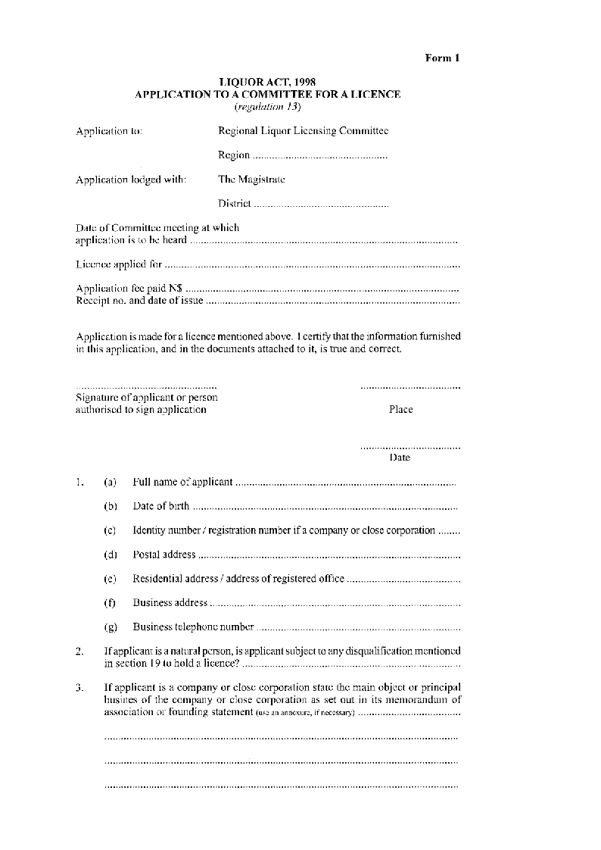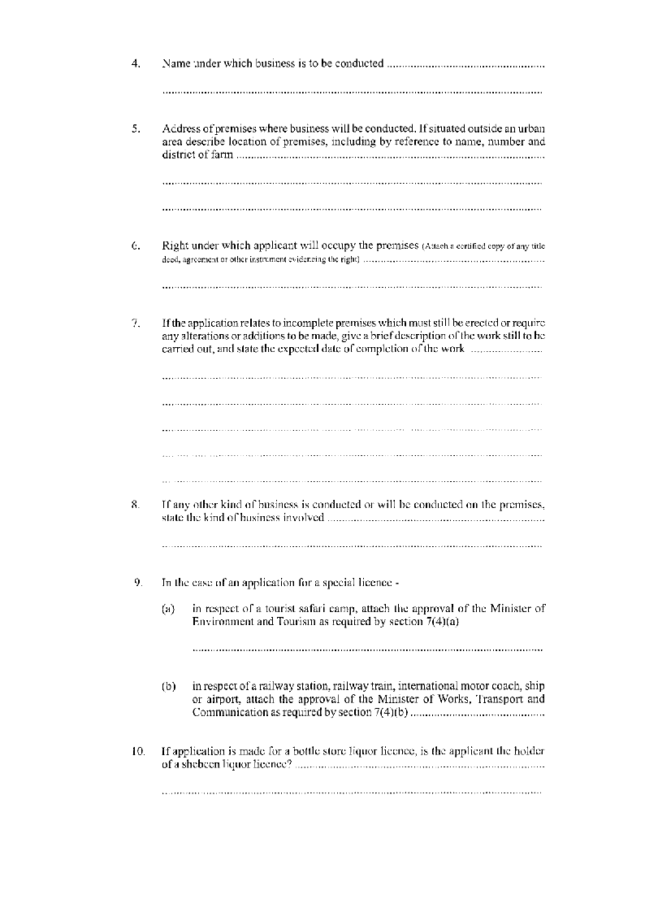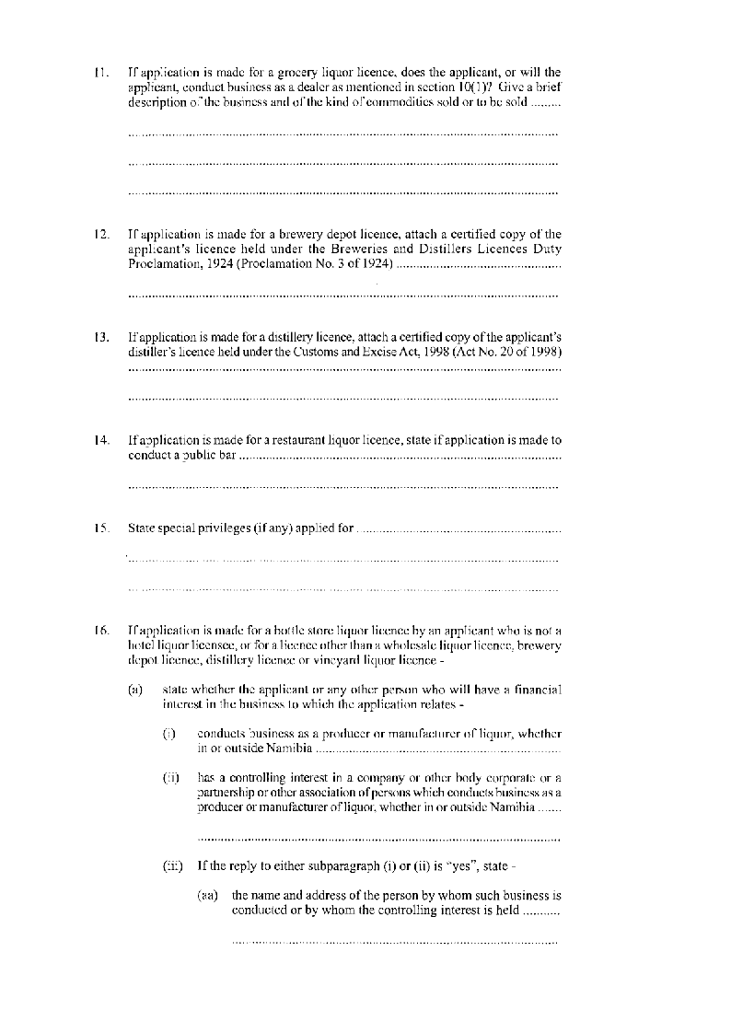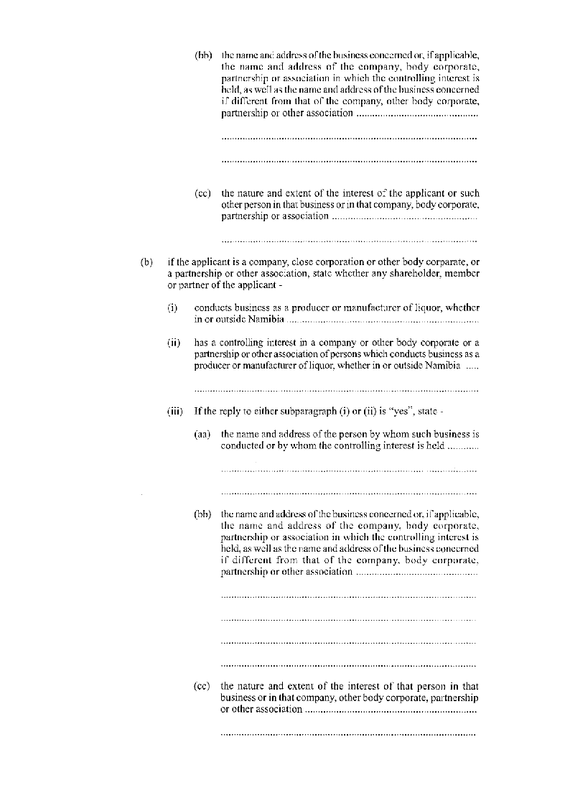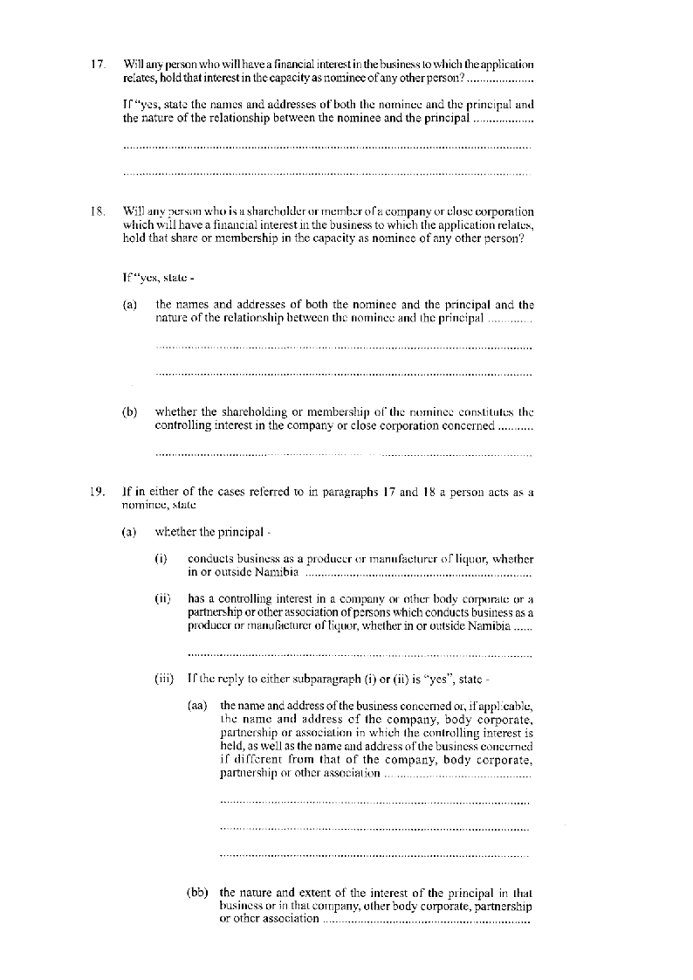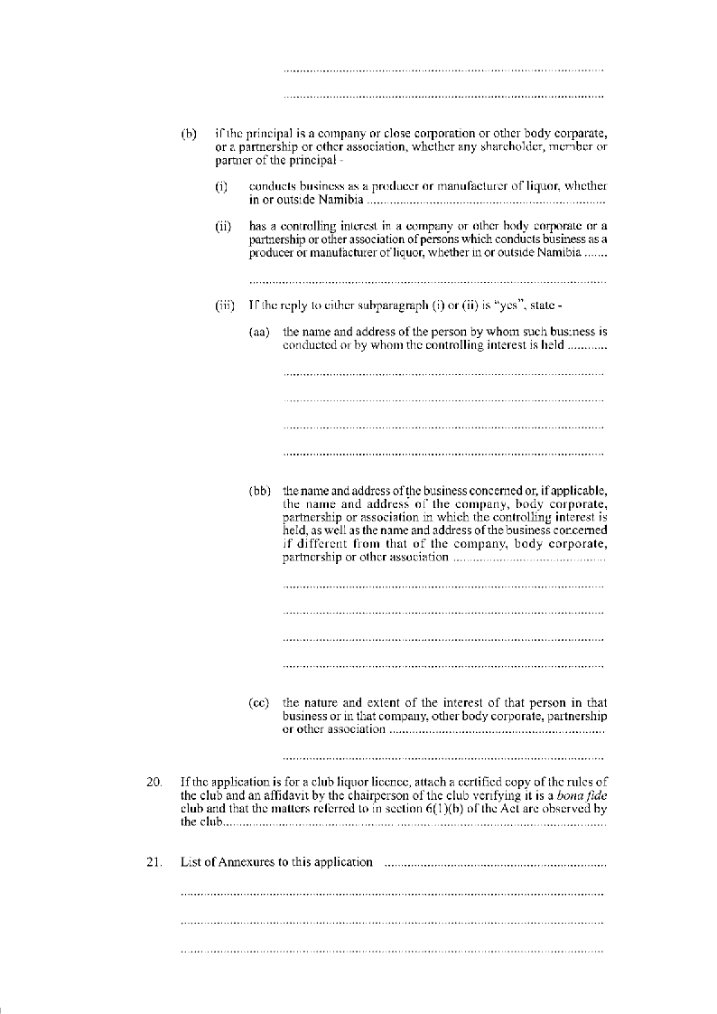

[Form 1A is inserted by GN 105/2006.]