

REGULATIONS MADE IN TERMS OF

Geoscience Professions Act 3 of 2012

section 41

Regulations relating to Registration of and

Fees Payable by Geoscientists

Government Notice 320 of 2017

(GG 6488)

came into force on date of publication: 15 December 2017

The Government Notice which publishes these regulations notes that they were   
made after consultation with the Geoscience Council of Namibia.

ARRANGEMENT OF REGULATIONS

1. Definitions

2. Language of forms and documents

3. Minimum qualifications required for registration as geoscientist

4. Application for registration as geoscientist

5. Annual fees

6. Lost registration certificate

7. Keeping of register

8. Inspection of register

9. Institution of unprofessional conduct

10. Notification of investigation into unlawful conduct

11. Inquiry by Council

12. Summoning of persons by Council

13. Findings of Council

14. Restoration of name to register

Annexure 1: Forms

Annexure 2: Fees

**Definitions**

**1.** In these regulations, a word or an expression to which a meaning has been assigned in the Act, has that meaning, and unless the context indicates otherwise -

“registration fee” means the fee payable when a person applies for registration in terms of section 20 of the Act;

“the Act” means the Geoscience Professions Act, 2012 (Act No. 3 of 2012); and

“year” means the 12 months for which the full annual fee is payable and which runs from 1 January to 31 December in any year.

**Language of forms and documents**

**2.** (1) Any form or document required to be submitted to the Council or to the registrar in terms of these regulations must, subject to subregulation (2), be in the English language.

(2) A form or document referred to in subregulation (1) that is not in the English language must be accompanied by a sworn translation into English acceptable to the Council.

**Minimum qualifications required for registration as geoscientist**

**3.** The minimum qualifications required for registration as a registered geoscientist are -

(a) a four year Degree of Bachelor of Science with Honours in Geosciences, awarded at a university or technical college recognised for this purpose by the Council;

(b) a three-year Bachelor of Science degree (BSc or BTech) in geoscience, awarded at a university or technical college recognised for this purpose by the Council, followed by two years of relevant work experience; or

(c) a qualification, which in the opinion of the Council is equivalent to qualifications stated in paragraphs (a) or (b).

**Application for registration as geoscientist**

**4.** (1) A person who wants to be registered as a geoscientist in terms of section 20 of the Act must, in writing, apply to the Council using Form 1 set out in Annexure 1.

(2) The application referred to in subsection (1) must be accompanied by -

(a) certified copies of the qualifications of the applicant;

(b) if requested by the Council, verification from the Namibia Qualifications Authority, in case of foreign qualifications;

(c) two original completed references as set out in Form 1 of Annexure 1; and

(d) the application fee as set out in the Annexure 2.

(3) The Council reserves the right to contact present or past employer, referees and academic institutions referred to in the application or reference forms in connection with determining the qualifications of the applicant, experience and capacity for independent work or work without supervision.

(4) The registrar must, in terms of section 20(2) or (3) of the Act, issue a certificate of registration to the applicant on Form 2 set out in Annexure 1.

**Annual fees**

**5.** (1) A registered person must within 30 days of registration in terms of section 20 of the Act and annually thereafter by 31 January pay to the registrar the appropriate annual fee.

(2) If the payment for an annual fee has to be made for less than a full year, the Council may grant a reduction of not more than 50 per cent of the fee that is due and payable.

(3) The Council or a committee of the Council to which the power has been assigned, may on application and on good cause being shown, grant an exemption, or a further exemption, either in whole or in part, from payment of the annual fee payable by that person.

**Lost registration certificate**

**6.** (1) A registered person who has lost his or her original certificate of registration must apply to the registrar for a duplicate.

(2) The application referred to in subregulation (1) must be accompanied by an affidavit stating the following -

(a) that the original certificate is lost;

(b) every effort has been made to trace it; and

(c) he or she did not succeed.

(3) The registrar must charge a registered person who wishes to obtain a duplicate copy of the registration certificate the appropriate fee as set out in Annexure 2.

**Keeping of register**

**7.** Subject to section 28(1) of the Act, the register established for the registered persons, must be on Form 4 of Annexure 1.

**Inspection of register**

**8.** (1) A person who wishes to inspect the register must pay the fee set out in Annexure 2.

(2) A person who wishes to obtain a certified copy of an entry or a certified extract from the register must pay the fee for making the copy and for certifying set out in Annexure 2.

**Institution of unprofessional conduct**

**9.** A person who wishes to lodge a complaint of unprofessional conduct as contemplated in section 34(1) of the Act -

(a) must do so in writing; and

(b) must set out in full the allegations made against that registered person.

**Notification of investigation into unlawful conduct**

**10.** A registered person accused of unlawful conduct must, in terms of section 34(5) of the Act -

(a) be notified in writing of the nature of the unlawful conduct by the Council;

(b) be afforded an opportunity to give an explanation into the matter within 30 days from the date of the notice by the Council; and

(c) be notified that if he or she furnishes the explanation contemplated in subparagraph (b), that explanation may be used in evidence by the Council.

**Inquiry by Council**

**11.** (1) If the Council decides to hold an inquiry, in terms of section 35 of the Act, into any alleged unlawful conduct, the Council must notify the registered person accused of the unlawful conduct in writing of the inquiry.

(2) The notice referred to in subregulation (1) must -

(a) be in writing;

(b) contain the information the Council may determine;

(c) set out in full the allegations made against the registered person;

(d) specify the venue, date and time of the inquiry to be conducted;

(e) inform the registered person that he or she must be present at the inquiry to answer the allegations and if he or she fails to be present the inquiry may be conducted in his or her absence; and

(f) be served on the registered person accused of the unlawful conduct personally by a person designated by the Council for that purpose in writing.

(3) If the person designated under subregulation (2)(f), certifies that the registered person referred to in that subregulation -

(a) cannot be traced; or

(b) refuses to accept service of the notice; or

(c) refuses to sign an acknowledgement of receipt relating to the service of the notice,

the Council may send that notice by prepaid registered post, not less than 21 days before the commencement date of the intended inquiry, to the registered person, addressed to his or her postal address as it appears in the register.

**Summoning of persons by Council**

**12.** (1) A summons for the attendance before the Council in terms of section 37 of the Act, of a person or for the production of any evidence must -

(a) be in writing; and

(b) be served on the person personally by a person designated by the Council for that purpose in writing.

(2) If the person designated under subregulation (1)(b), certifies that the registered person referred to in that subregulation -

(a) cannot be traced; or

(b) refuses to accept service of the notice; or

(c) refuses to sign an acknowledgement of receipt relating to the service of the notice,

the Council may send that notice by prepaid registered post, not less than 21 days before the commencement date of the intended inquiry, to the person, addressed to his or her postal address as it appears in the register.

**Findings of Council**

**13.** (1) The Council, after having conducted an inquiry under regulation 11 in respect of a registered person, may make a finding that on the evidence before the Council that the registered person is -

(a) guilty of unlawful conduct; or

(b) not guilty of unlawful conduct.

(2) The secretary of the Council must inform a registered person in writing of the findings of the Council in terms of section 38(6) of the Act.

**Restoration of name to register**

**14.** (1) An application for restoration of registration referred to in section 27(1) of the Act must be made on Form 3 set out in Annexure 1.

(2) An application for restoration referred to in subregulation (1) must be accompanied by -

(a) certified copy of the qualifications of the applicant;

[The article “a” should appear at the beginning of paragraph (a).]

(b) if requested by the Council, verification from the Namibia Qualifications Authority in case of foreign qualifications;

(c) two original completed references as set out in Form 1 of Annexure 1; and

(d) the fee set out in Annexure 2.

ANNEXURE 1

(Forms)

Form 1: Application for Registration and Reference Form

Form 2: Certificate of Registration

Form 3: Application for Restoration of Registration

Form 4: Register

Form 5: Notice of inquiry

To view content without printing, scroll down.

To print at full scale (A4), double-click the icon below.



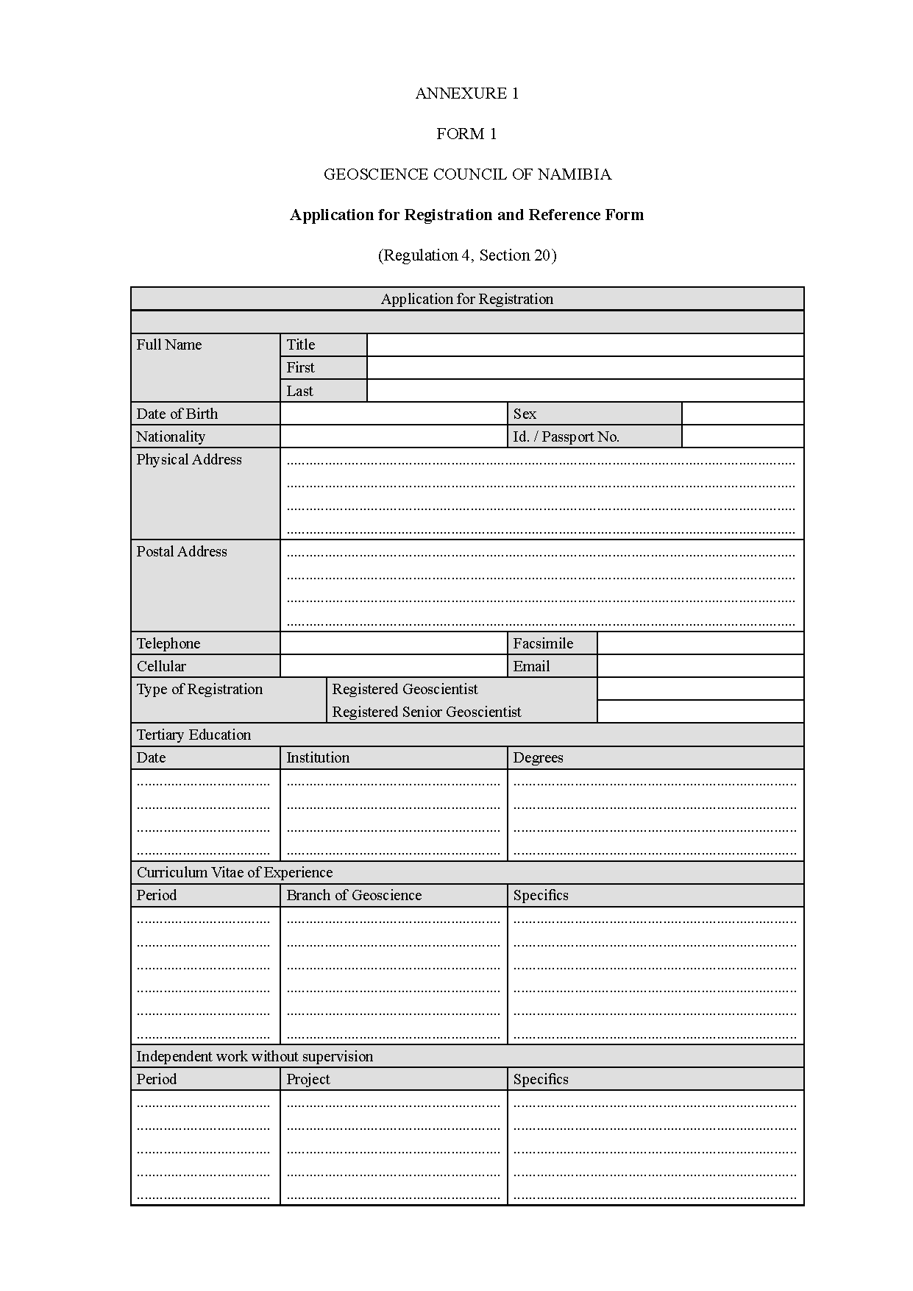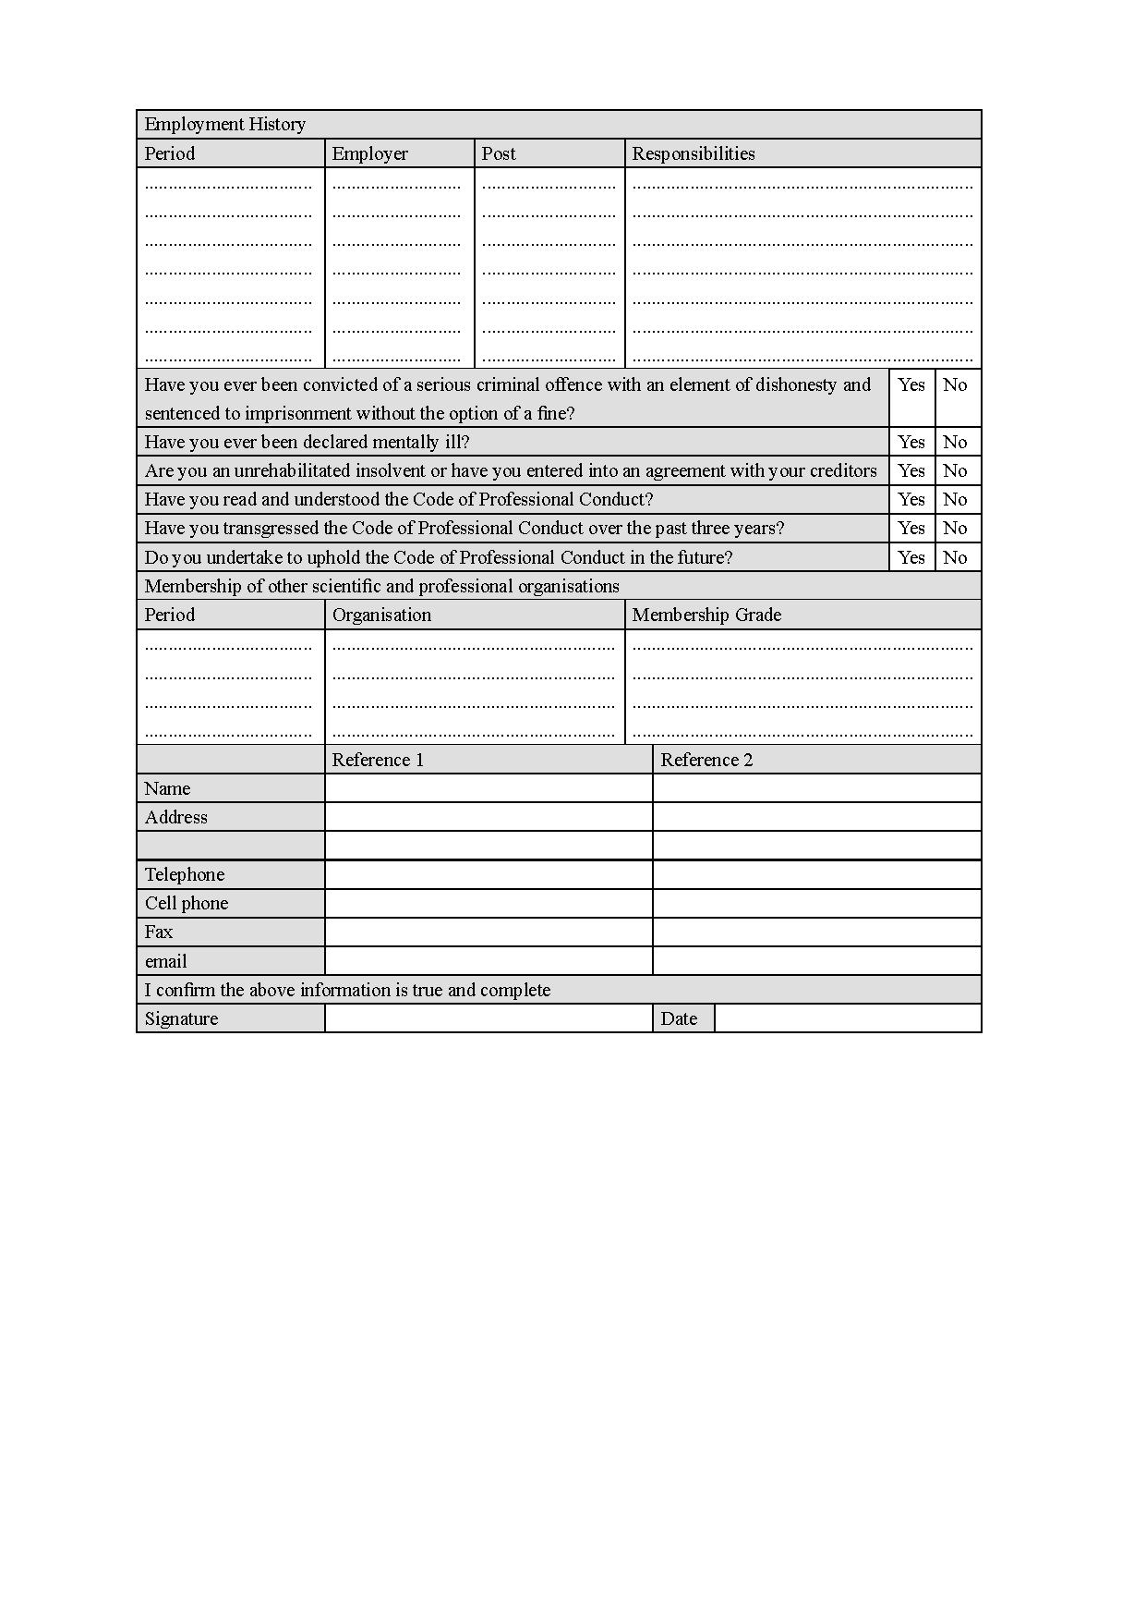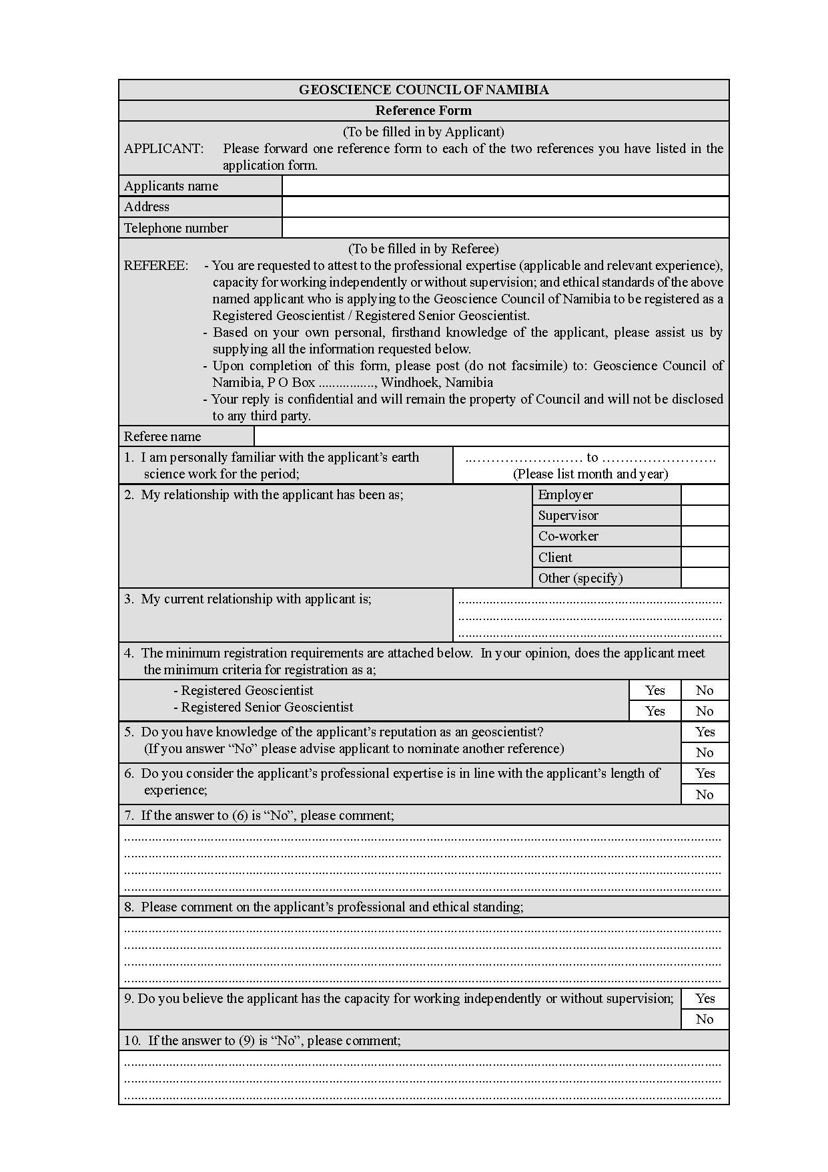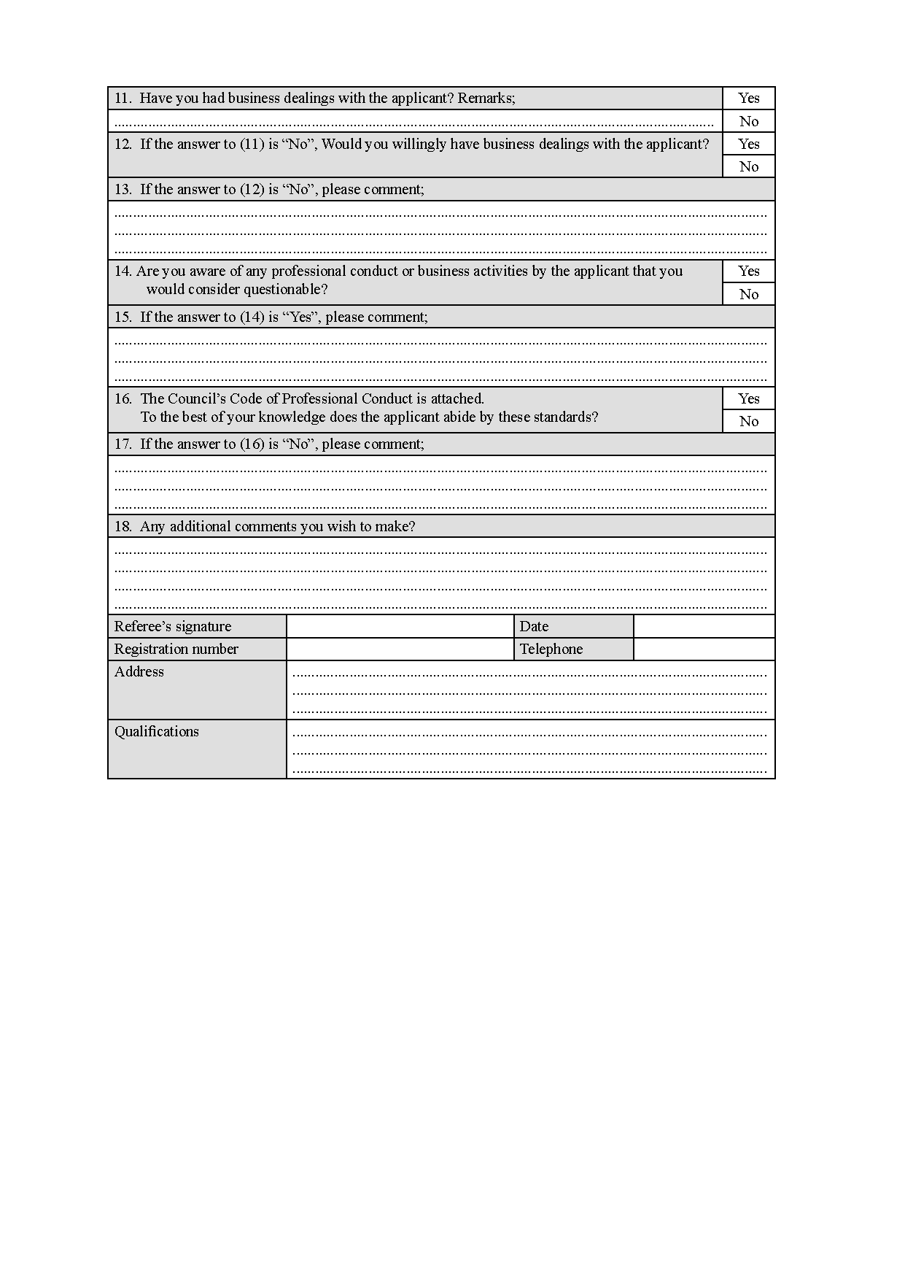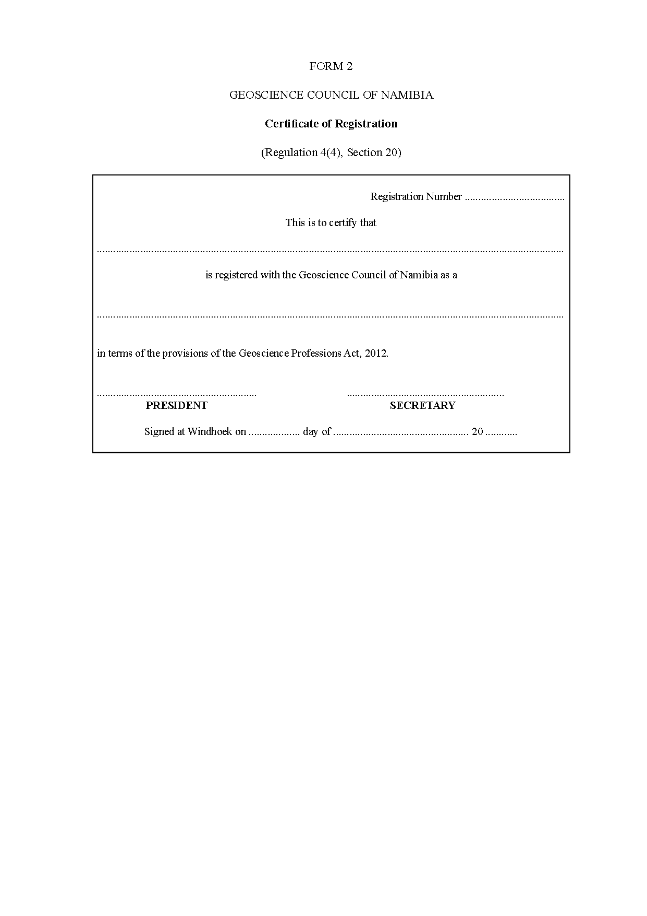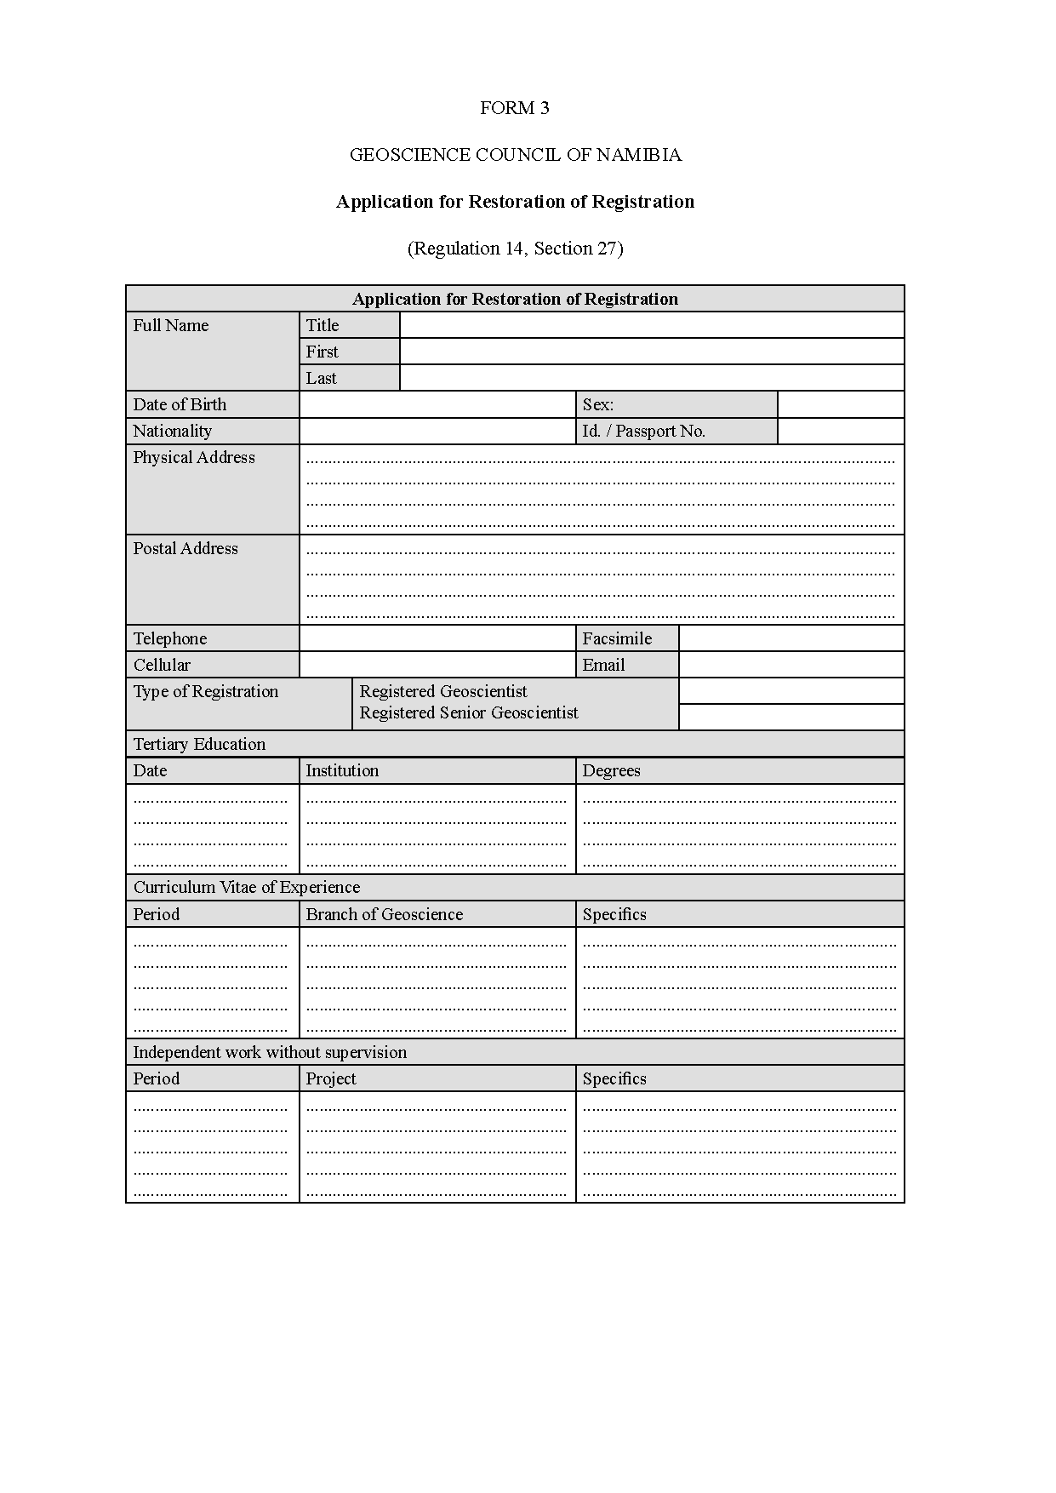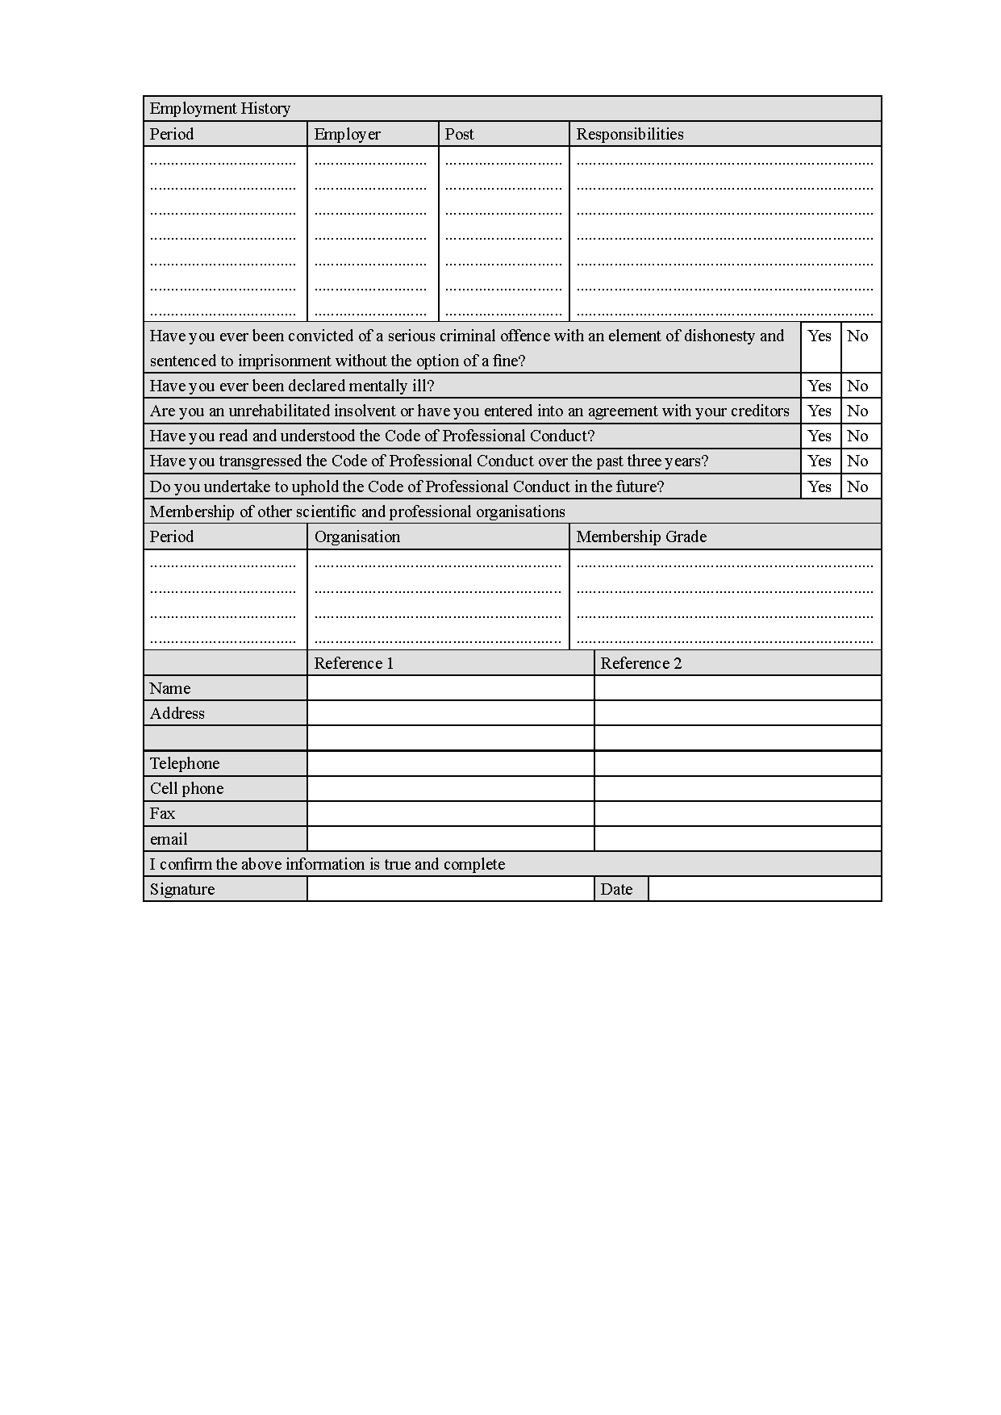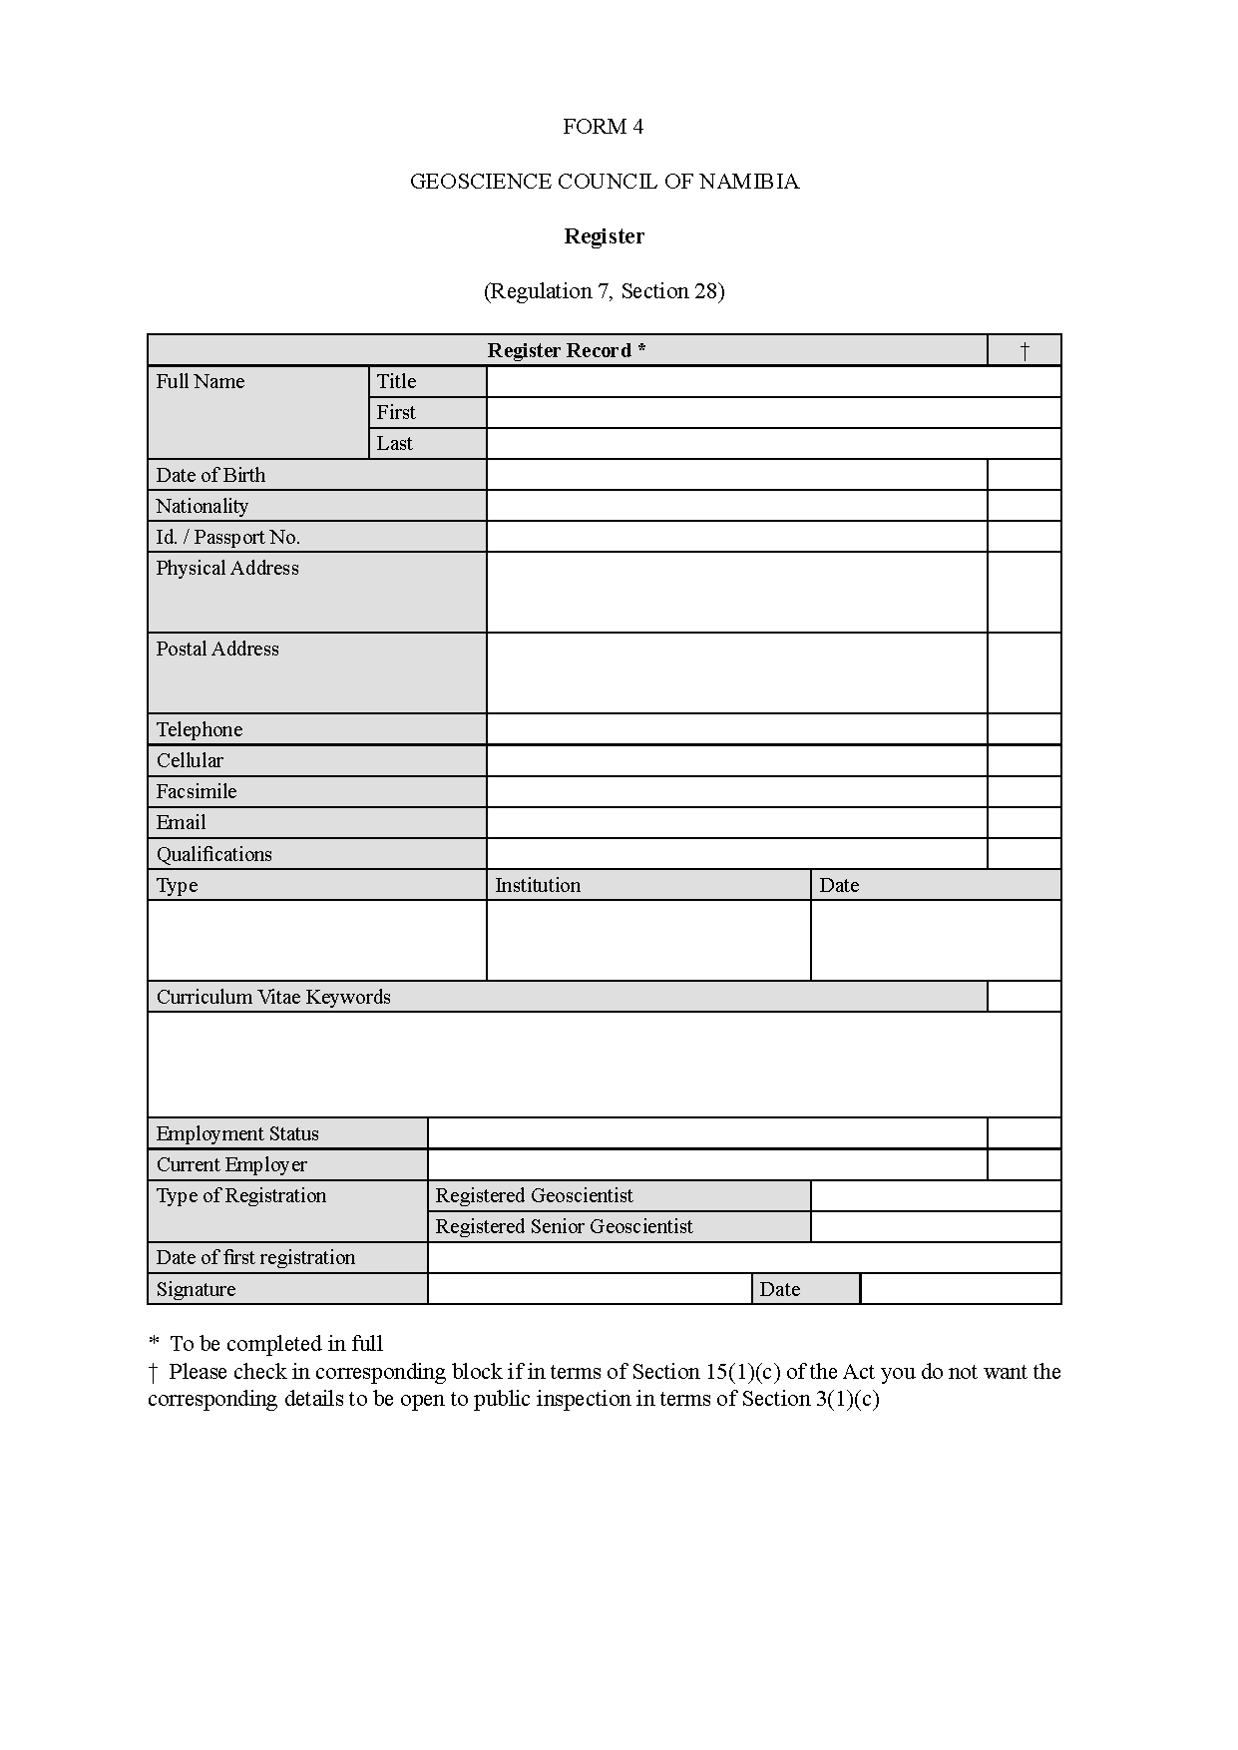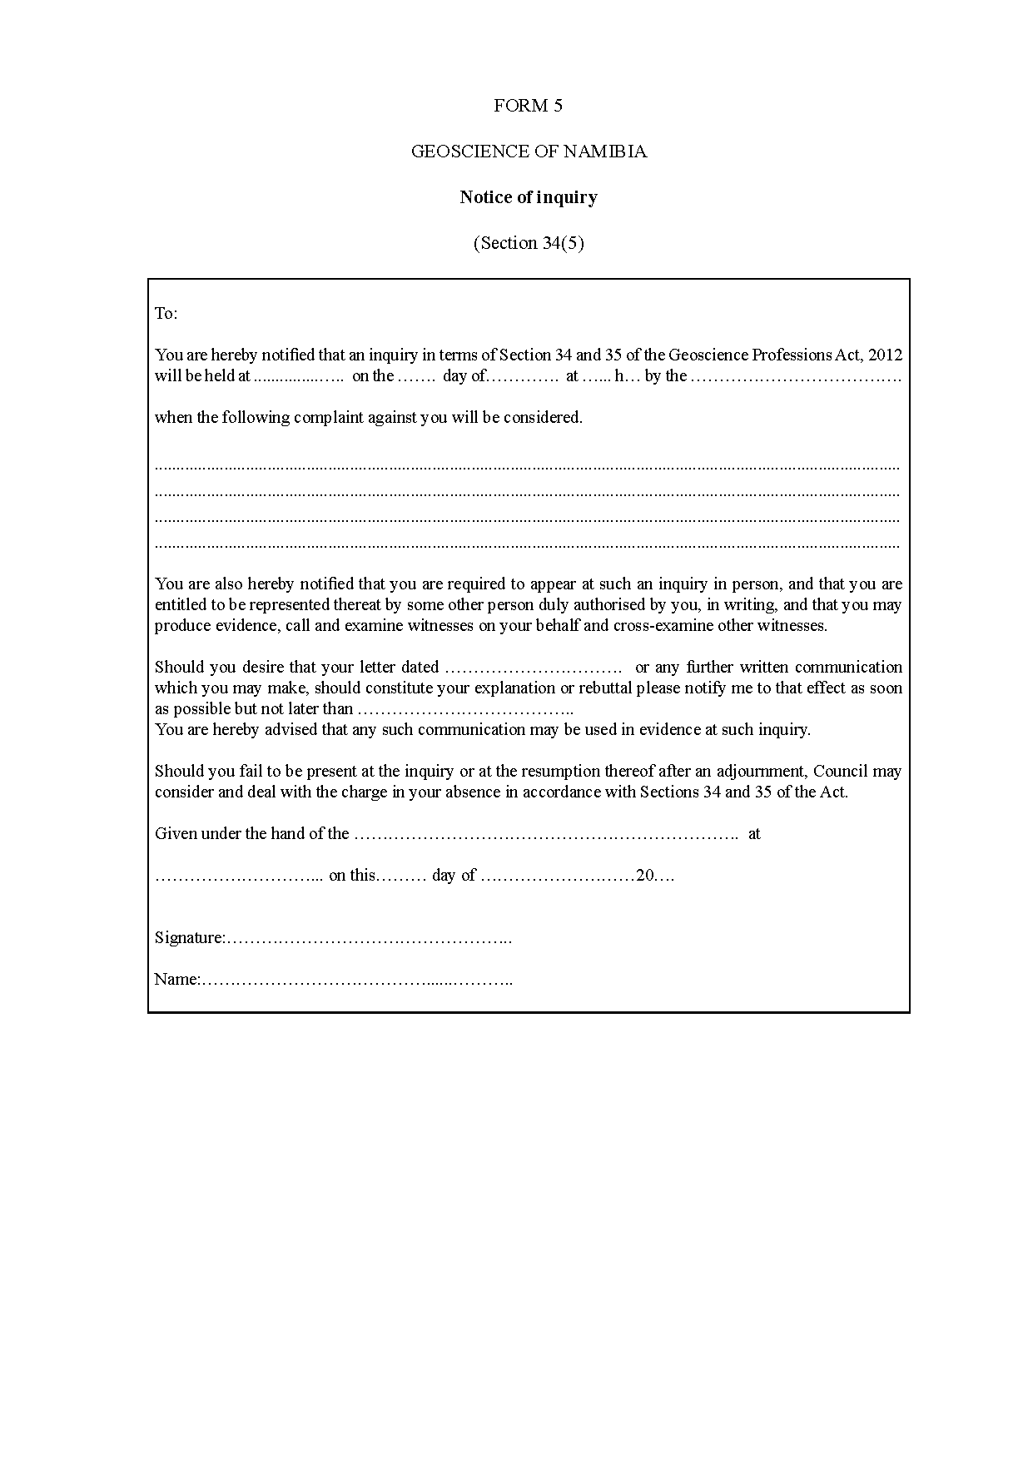

ANNEXURE 2

GEOSCIENCE OF NAMIBIA

**Fees**

(Regulation 4, Section 29)

[Capitalisation of items in the table follows the *Government Gazette*.   
Closing brackets are missing in the *Gazette* in several places, as reproduced below.]

|  |  |
| --- | --- |
| **Type of certificate** | **Amount** |
| Application fee for registration (Regulation 4(2)(d) | N$650 |
| Annual fee (section 20(1), Regulation 5) | N$500 |
| Duplicate Registration Certificate (Regulation 6) | N$100 |
| Inspection of Register (Regulation 8(1) | N$100 |
| Extract from Register (Regulation 8(2) | N$100 |
| Restoration of name to Register (Regulation 10) | N$650 |
| Fee for Lodging complaint (Regulation 9(1) | N$100 |
| Penalty for unprofessional conduct (section 38(b), Regulation 9(3) | N$5 000 |