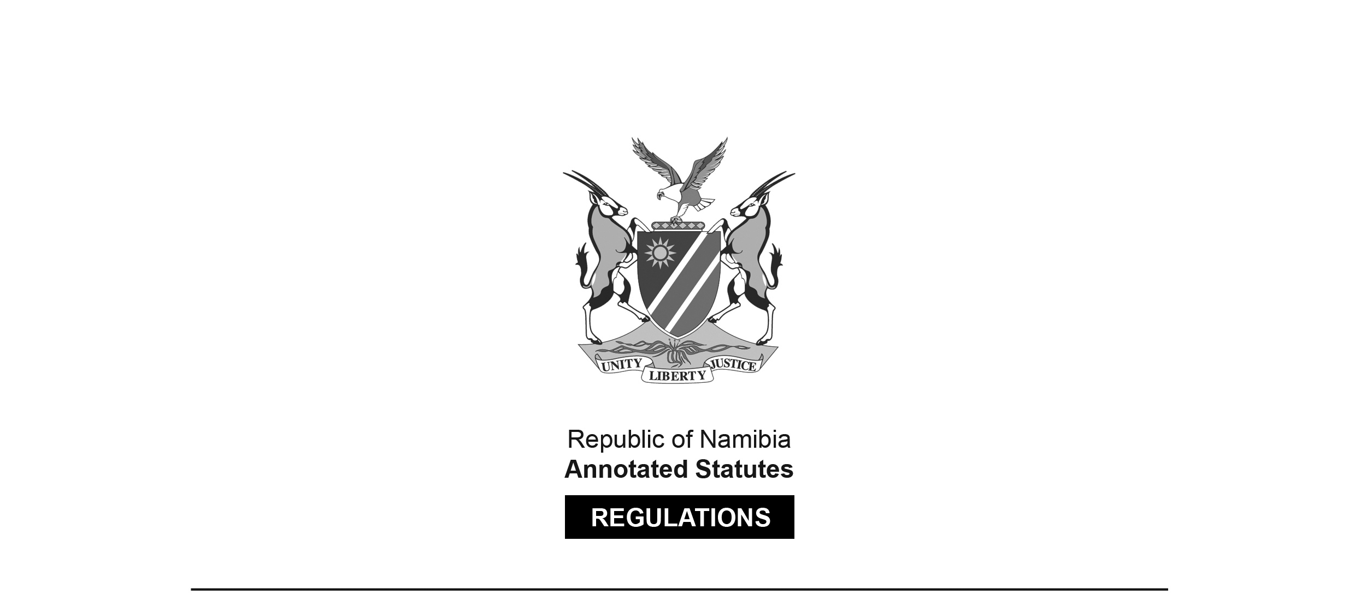
REGULATIONS SURVIVING IN TERMS OF

Electoral Act 5 of 2014
section 205

Regulations relating to Declaration of Assets and Liabilities
of Political Parties and Disclosure of Foreign and
Domestic Financing of Political Parties, Organisations, Members or Other Persons
Government Notice 357 of 2019
(GG 7053)
came into force on date of publication: 18 November 2019

These regulations were made by the Electoral Commission of Namibia.

ARRANGEMENT OF REGULATIONS

1. Definitions
2. Date of first submission of declaration of assets and liabilities
3. Submission of declaration of assets and liabilities
4. Disclosure of foreign and domestic financing

ANNEXURES

Forms Regulation

Form 33 Declaration of Assets and Liabilities 3

Form 34 Disclosure of Foreign and Domestic Financing 4

Definitions

1. In these regulations a word or an expression to which a meaning has been assigned in the Act has that meaning and unless the content indicates otherwise -

“Annexure” means the Annexure to these Regulations;

“authorised body” means the governing or decision making body of a political party;

“foreign institution” means an institution which is not a Namibian institution;

“foreign person” means an individual who is not a Namibian person;

“Namibian institution” means a company incorporated in or registered in Namibia or a trust registered in Namibia;

“Namibian person” means a citizen of Namibia within the meaning of Article 4 of the Namibian Constitution and a person lawfully admitted for permanent residence in Namibia; and

“the Act” means the Electoral Act, 2014 (Act No. 5 of 2014).

Date of first submission of declaration of assets and liabilities

2. (1) For the purposes of section 139(1)(a) of the Act, the Commission must, on the commencement of these regulations, in writing request registered political parties to submit a declaration of assets and liabilities.

(2) After subregulation (1) has been complied with, a registered political party must as required by section 139(1)(b), annually, 21 days after the official opening of the National Assembly, submit to the Commission a declaration of assets and liabilities.

Submission of declaration of assets and liabilities

3. (1) The declaration of assets and liabilities must be made by completing Form 33 in the Annexure.

(2) The declaration of assets and liabilities must be signed by the members of the authorised body of the registered political party and be submitted by the authorised representative of that registered political party.

Disclosure of foreign and domestic financing

4. (1) A registered political party, a registered organisation, a member of a registered political party or registered organisation or a person who is required in terms of section 141(1) of the Act to disclose donations must submit details of the donations to the Commission by completing Form 34 in the Annexure not later than 60 days after the end of June every year.

(2) The total donation amount that a registered political party, registered organisation, member of a registered political party or registered organisation or a person contemplated in section 141(1) can receive in a financial year may not -

(a) exceed N$ 4 million, if the donation is received from a Namibian person or Namibian institution; and

(b) exceed N$ 2 million if the donation is received from a foreign person or a foreign institution.

(3) A registered political party, registered organisation, a member of a registered political party or registered organisation or a person contemplated in section 141(1) of the Act, that has received more than the prescribed amount of donation referred to in subregulation (2), must disclose to the public, the donations received, within a period of 30 days after it was received, by publishing a notice in two newspapers circulating in Namibia, specifying -

[The noun “donations” should be singular to match the pronoun “it” and the preceding portion of the sentence. The comma after the phrase “disclose to the public” is superfluous.]

(a) the amount of money received;

(b) the source from which the money was received;

(c) any conditions upon which the money was donated; and

(d) the manner in which the money is intended to be used.

(4) A Namibian person or Namibian institution contemplated in section 141(2), that donated more than the amount prescribed in subregulation (2) to any registered political party, registered organisation, a member of a registered political party or registered organisation or a person contemplated in section 141(1), must disclose to the public, the donations given within a period of 30 days after it was donated, by publishing a notice in two newspapers circulating in Namibia, specifying -

[The noun “donations” should be singular to match the pronoun “it” and the preceding portion of the sentence. The comma after the phrase “disclose to the public” is superfluous.]

(a) the amount of money donated;

(b) the source from which such money was received;

(c) any conditions upon which such money was donated; and

(d) the manner in which such money is intended to be used.

ANNEXURES

To view content without printing, scroll down.

To print at full scale (A4), double-click the icon below.

