REGULATIONS MADE IN TERMS OF

Education Act 16 of 2001
section 80

General Regulations
Government Notice 187 of 2002
(GG 2841)
came into force on date of publication: 28 October 2002

The Government Notice which issues these regulations repeals the regulations contained in
AG GN 73 of 15 May 1982, AG GN 74 of 15 May 1982 and AG GN 215 of 28 December 1987.
The previous regulations were issued under the National Education Act 30 of 1980
and deemed to have been made under the Education Act 16 of 2002 by section 81(5) of that Act.

as amended by

Government Notice 15 of 2004
(GG 3144)
came into force on data of publication: 6 February 2004

ARRANGEMENT OF REGULATIONS

PART I
SCHOOL BOARD AT STATE SCHOOL

1. Definitions
2. Qualifications for school parent to serve as member of school board
3. Election of members of school board
4. Election of school board office-bearers
5. Meetings of school board and committee of school board
6. Confidentiality
7. Powers and functions of school board
8. Expenses incurred by school board or committee of school board

PART II
SCHOOL DEVELOPMENT FUND

9. Failing or refusing to pay school development fund contribution
10. Guidelines for determination of school development fund contribution amount
11. Procedure for exemption from payment of school development fund contribution
12. Utilization of school development fund
13. School development fund accounts and investment
14. Bookkeeping
15. Function arranged in aid of school development fund
16. Payment from school development fund
17. Stores register, inventory and stock-taking
18. Writing-off and selling of certain assets
19. Appointment of auditor
20. Inspection by staff member of Ministry
21. Handover of assets when state school closed
22. Using of certain government property by school board

PART III
LEARNER IN STATE SCHOOL

23. Admission to state school
24. School attendance
25. Transfer of learner
26. Misconduct by learner
27. Learners’ Representative Council
28. Election committee
29. Nomination and election of members of LRC
30. Powers and functions of LRC
31. Vacation of LRC office
32. Meetings and decision of LRC

PART IV
HOSTEL AT STATE SCHOOL

33. Hostel committee
34. Vacation of office of member of hostel committee
35. Vacancies on hostel committee
36. Functions of hostel committee
37. Superintendent
38. Lodging of superintendent
39. Supervisory teacher or person
40. Household staff, hostel matrons and institutional workers
41. Quotas for boarding in state hostel
42. Criteria for admission of boarders in state hostel
43. Control over boarders
44. Medical attention of boarders
45. Accommodation during school holidays
46. Accommodation of persons other than learners

PART V
BASIC EDUCATION AND CULTURE SERVICE POINT

47. Establishment of service point
48. Head of service point
49. User of service point
50. Service point user fees
51. Committee of service point
52. Annual general meeting of users
53. Service point development fund
54. Handover of accounts and other financial documents
55. Closure of service point

PART VI
PRIVATE SCHOOLS

56. Registration of private school
57. Further conditions for registration of private school
58. Aid to private school
59. Conditions for granting of aid to private school
60. Curriculum, medium of instruction or examining body for private school
61. Participation of private schools in national and regional programmes and competitions
62. Inspection of private school

PART VII
CODE OF CONDUCT FOR TEACHING SERVICE

[Part VII, comprising regulations 63-65, is inserted by GN 15/2004.]

63. Purpose of Code
64. Objectives of Code
65. Professional conduct for teachers

ANNEXURE A
ANNEXURE B
ANNEXURE C

PART I

SCHOOL BOARD AT STATE SCHOOL

Definitions

1. In these regulations a word or an expression defined in the Act has that meaning, and -

“auditor” means a person appointed in terms of section 25(14) of the Act;

“chairperson” means the chairperson of the school board in question;

“hostel committee” means a hostel committee of a school board established under section 21 of the Act;

“presiding officer”, in relation to an election of a school board election, means the staff member designated in terms of section 19 of the Act;

“service point” means a teachers’ resource centre, a community learning and development centre, an arts centre, a cultural centre, a community library, or any other establishment of the Ministry, not being a school, where service is provided to assist learners, teachers and other members of public in any field of teaching, learning and entertainment;

“superintendent” means a teacher designated as superintendent of a hostel in terms of regulation 38;

“the Act” means the Education Act, 2001, (Act No. 16 of 2001); and

[The comma before the bracketed phrase is superfluous.]

“user” means a user of a service point registered in terms regulation 49.

Qualifications for school parent to serve as member of school board

2. (1) A school parent may not be elected as a member of a school board in terms of regulation 3, if such parent -

(a) has been convicted of an offence and sentenced to a period of imprisonment without the option of a fine, expect that he or she has received a free pardon in respect of such offence, or such period of imprisonment has expired at least five years prior to the date of his or her election as a member of the school board;

[The word “expect” in the phrase “expect that he or she has
received a free pardon” should be “except”.]

(b) is employed as a staff member in the management cadre in the Ministry or as an inspector of education at the national or regional level;

(c) is not a Namibian citizen or ordinarily resident in Namibia for at least two years;

(d) is the spouse of a teacher who is attached to the state school for which the school board is to be elected; or

(e) despite the fact that he or she has a child at the school for which the school board is to be elected, is a member of a school board of another state school.

Election of members of school board

3. (1) Subject to section 81 of the Act, the Permanent Secretary, must determine the date for the election of members of school boards, and subsequent elections must be held 30 days before the expiry of a three years term of office of a school board.

(2) A staff member designated by the Permanent Secretary in terms of section 19 of the Act must act as presiding officer at every school board election.

(3) Whenever a subsequent election contemplated in subregulation (1) is due, the chairperson of the school board concerned must inform the Permanent Secretary in writing of the expiry date of the term of office of that school board.

(4) The number of members of a school board are determined on the basis of the number of learners receiving tuition at the school as set out in Annexure A.

[The verb “are” should be “is” to be grammatically correct (“number … is”).]

(5) For the purpose of holding an election of school parents and teachers for representation on a school board, the presiding officer, as soon as possible after his or her appointment, must convene a meeting of the parents and teachers of the state school concerned by means of a 14 days’ written notice served on the school, and, if necessary, also broadcasted over the radio and published in newspapers circulating in the area, indicating the date, time, purpose and venue of the meeting.

(6) (a) The quorum of a meeting referred to in subregulation (5) must be 10 per cent of the school parents and the majority of the teachers of the school.

(b) If a quorum is not present at such meeting, the presiding officer must convene a second meeting within 30 days from the date of the meeting referred to in paragraph (a).

(c) If the quorum requirement referred to in paragraph (a) is not met at the second meeting referred to in paragraph (b), the parents and teachers of the school present at that meeting constitute a quorum for the parents and teachers, respectively.

(d) If at meeting convened under this regulation the parents and teachers of the school both form quorums as required under this regulation, the election as members of the school board must be held simultaneously, and only in cases where either the school parents or the school teachers do not form a quorum at that meeting.

(7) (a) After a notice of a meeting of school parents and teachers has been given in terms of subregulation (5), the school parents and teachers, respectively, may submit to the presiding officer the names of school parents and teachers, respectively, as candidates for the election as members of the school board.

(b) A nomination of a parent or teacher of a school for election as member of a school board must be in writing and signed by a nominator and two seconders, who must also provide, on the nomination form, their names and the names of their children enrolled as learners at the school.

(c) Only a school parent or teacher of the school may nominate a candidate for election as member of a school board or second a nomination.

(d) A nominee who accepts the nomination as a candidate for election as member of a school board must put the acceptance of nomination in writing.

(8) (a) If on a date of the election of members of a school board at a meeting properly constituted in terms of subregulation (6) the presiding officer realized that the nominees for that election do not meet the required number candidates, the presiding officer must call for further nominations of school parents or teachers, whatever the case may be, and any nomination so made must comply with subregulation (7)(b) and (c).

(b) After having satisfied himself or herself that every nominated school parent or teacher is qualified to be elected as member of the school board and that the nominees meet the required number of candidates, the presiding officer must declare the nominations closed and announce the names of the duly nominated candidates.

(9) If, after the closing of nominations, the number of candidates for election as members of the school board -

(a) is equal the number of members determined in terms of subregulation (4), the presiding officer must declare the candidates as duly elected members of the school board; and

(b) is more than the number of members determined in terms of subregulation (4) for the school parents and teachers, the presiding officer must conduct an election for school parents or teachers, as the case may be, or both such parents and teachers, in accordance with subregulations (10), (11) and (12).

(10) In the event of an election of school board members, every school parent present at a meeting properly constituted in terms of subregulation (6) -

(a) is entitled to vote in that election; and

(b) may cast a number of votes equal to the number of members to be elected, but may not cast more than one vote in respect of any particular candidate.

(11) The presiding officer in the election held in terms of subregulation (9)(b), must -

(a) announce whether the election is to be conducted by secret ballot or whether there is a prior approval of the Minister for the election to be conducted by a show of hands; and

(b) determine the procedure to be followed in that election and assign a sufficient number of persons to count the votes.

(12) After ascertaining the results of an election held in terms of this regulation, the presiding officer -

(a) must declare the candidates who received the highest number of votes, but not exceeding the number of members determined in terms of subregulation (4) for representation of school parents and teachers on the school board, as duly elected members of the school board; and

(b) in the event of an equality of votes resulting in more members than the number of members determined in terms of subregulation (4) for representation of school parents and teachers on the school board, must announce a re-election between the candidates who received equal number of votes, and the candidate, or where applicable the candidates, who receive the highest number of votes in such re-election must be declared duly elected member or members of the school board.

(13) Before an election for a school board members starts, in the case of a secondary school, the Head of the Learners’ Representative Council must furnish the presiding officer with the names of one or two learners nominated to represent learners on the school board.

[The word “a” should not appear in the phrase “a school board members”.]
(14) An oath of secrecy referred to in section 19(6) of the Act, and which must be kept on record with other classified documents, must be in the form of Form 2 set out in Annexure C.

Election of school board office-bearers

4. (1) After having declared the candidates duly elected in terms of subregulation (12), the presiding officer must then preside over the election of the school board office-bearers, the chairperson, secretary and treasurer as referred to in section 19(3) of the Act.

(2) The secretary of the school board, within 14 days after the first meeting of a school board, must submit to the Permanent Secretary the names and addresses of the chairperson, secretary, treasurer and other school board members.

Meetings of school board and committee of school board

5. (1) A school board or committee of school board must hold at least one meeting in each school term.

(2) The chairperson in consultation with the principal must convene the first meeting of the school board and any subsequent meeting must be held on a date and at a time and place determined by the school board.

(3) The chairperson of the school board or committee of school board may convene a special meeting of the school board or committee on his or her own initiative or on written request of at least one third of the members of the school board or committee, as the case may be.

(4) A secretary must notify the members of a school board or committee of the school board in writing of the date, time and place of any meeting of the school board at least eight days before the meeting.

(5) If a school board has not made rules for conducting its meetings as contemplated in section 22(6) of the Act, the chairperson or any other person who acts as chairperson must determine the procedure at the meeting over which he or she presides.

(6) (a) If members of a school board or committee of a school board present at a meeting which has been properly convened do not form a quorum, the school board or committee of the school board must postpone the meeting to a venue and a date not less than eight days, but not exceeding 14 days.

(b) The secretary must give all members of the school board or committee of the school board notice in writing of the date and venue of a meeting determined in terms of paragraph (a).

(7) A school board or committee of a school board may allow any person, who in its opinion is able to furnish it with information on a matter which falls within its powers, to attend a meeting of the school board or committee of the school board, and while so attending such person may take part in the deliberations of that matter, but is not entitled to vote.

(8) When requested thereto by a school board or committee of the school board a the staff member of the state school concerned must attend a meeting of the school board or committee of the school board, but may not be compelled to furnish information or reply to a charge against him or her.

[The word “a” following the first use of the phrase “committee of the school board”
is superfluous; there should rather be a comma at this spot.]

(9) The Permanent Secretary may attend, or nominate a staff member in the Ministry, to attend any meeting of a school board or committee of a school board as observer or in an advisory capacity.

(10) (a) A secretary must keep minutes of every meeting of a school board or committee of a school board in a book kept for this purpose, and, at every meeting of such school board or committee of such school board, must record in that book the names of the members of the school board or committee of the school board who are present and absent, as the case may be.

(b) The minutes of each meeting must be laid before the school board or committee of the school board at its next meeting for adoption.

(c) If requested thereto by the Permanent Secretary, the secretary must forward to him or her a copy of the minutes of any meeting referred to in paragraph (a).

(d) A member of a school board or committee of a school board or a duly authorized staff member in the Ministry has access to the minutes of any meeting of the school board or committee of the school board.

(11) The validity of any act, decision or proceedings of a school board or committee of a school board may not be invalidated by the reason that there was a vacancy amongst its members or by any defect in the appointment of any of its members.

(12) A member of a school board or committee of a school board may not receive remuneration for being such a member, or be entitled to transport or accommodation allowance, but such member may be compensated for expense s incurred by him or her to which the school development fund is liable, if the school board or committee has given a prior approval.

Confidentiality

6. Where a school board or committee of a school board has decided that an information before it is of a confidential nature, a board or committee member who may disclose such information pursuant to section 22(7)(a) of the Act may only do so after having obtained permission of the school board or committee of the school board in writing.

Powers and functions of school board

7. In addition to the powers and functions referred to in section 17 of the Act, a school board -

(a) functions as the body through which the community of the school is able to participate in the administration of the school and its activities;

(b) advises and makes recommendations to the Permanent Secretary regarding matters which concern the welfare and interest of the school;

(c) subject to the Public Service Act, makes recommendations to the Permanent Secretary with regard to the promotion and transfer of teachers and other staff members;

(d) investigates any complaint affecting the school, and, if necessary, refers such complaint to the Permanent Secretary;

(e) considers inspection reports referred to in section 66 of the Act and, where necessary, makes recommendations to the Permanent Secretary on any matter mentioned in or resulting from such reports.

(f) is responsible for the supervision of buildings, sites, fencing and accessories of the school concerned, and advises the Permanent Secretary on any shortcomings regarding such buildings, sites, fencing and accessories; and

(g) performs any task which the Permanent Secretary may direct school boards in general or a school board in particular to perform.

Expenses incurred by school board or committee of school board

8. Expenses incurred by a school board or committee of school board in the performance of its functions or in the exercise of its powers may be paid from moneys available in the school development fund of the state school concerned.

PART II

SCHOOL DEVELOPMENT FUND

Failing or refusing to pay school development fund contribution

9. Subject to sections 25(12) and 59 of the Act, a principal or teacher of a state school may not, in any way, prejudice a learner or discriminate against a learner on the reason that a parent has failed or refused to pay the school development fund contribution for such learner.

Guidelines for determination of school development fund contribution amount

10. (1) Subject to subregulation (3), a school development fund contribution amount determined under section 25(9) of the Act by a school board may not exceed N$500 for secondary school, or N$250 for primary school, per learner per year.

(2) Any school development fund contribution which is higher than the amount referred to in subregulation (1) at the commencement of these regulations may not be increased without the Minister’s written approval obtained in the manner referred to in subregulation (3).

(3) If a school board wish to determine a school development fund contribution amount higher than the amount referred to in subregulation (1), or contemplated in subregulation (2), the school board, after consultation with the school parents at a meeting convened for that purpose by the school board by at least 30 days’ notice to such parents, may apply in writing to the Minister for written approval to determine such higher contribution amount.

(4) The written application referred to in subregulation (3) must include -

(a) the fully detailed estimates of income and expenditure of the state school for the current and the following year and a financial statement of the previous year;

(b) a statement from a bank, building society or the Post Office Savings Bank referred to in section 25(4) of the Act, reflecting the current balance on the school development fund account;

(c) a certified statement fully reflecting all monies invested with any institution to the benefit of the school development fund;

(d) a statement motivating all projects, additional services, amenities or materials to be financed by the school development fund in the following years;

(e) any further motivation to justify a school development fund contribution amount exceeding the amount referred to in subregulation (1) or contemplated in subregulation (2); and

(f) the list of names and signatures of school parents who attended the meeting referred to in subregulation (3).

(5) The Minister, within 30 days of receipt of the application contemplated in subregulation (3), may -

(a) grant the application with or without conditions;

(b) dismiss the application; or

(c) recommend an appropriate amount.

Procedure for exemption from payment of school development fund contribution

11. (1) A school board that considers to fully or partially exempt a parent from payment of the school development fund contribution under section 25(10) of the Act, apart from the procedure the school board may determine under section 25(9)(b) of the Act, must follow the procedure set out in this regulation.

(2) A parent may apply to the school board in writing for full or partial exemption on a form determined by the school board, and must provide the following information -

(a) the name, grade and date of birth of his or her child or children enrolled at the school;

(b) the name, grade and date of birth of other children enrolled at other schools, in a form of statement written under oath that he or she is responsible for such other children’s school development fund contributions and other fees applicable to them.

(c) the name, residential address, postal address and alternative contact details of the parent;

(d) occupation, employer and annual or monthly income of the parent, or both parents, where applicable, or particular of any other income the parent receives;

(e) immovable and moveable property owned by the parent;

(f) a motivation for the application for full or partial exemption; and

(g) the parent’s ability to make a school development fund contribution in kind as referred to in subregulation (7).

(3) Except where it is written under oath, a statement of annual or monthly income required under subregulation (2)(d) which is not a salary slip must be substantiated by documentation from the employer of the parent, or a signed statement from a community leader, church leader or any reliable person who is familiar with the social and financial position of the parent.

(4) In the case where both biological parents of a learner are deceased the learner is classified as an orphan and the school board must fully exempt the learner from payment of contribution to the school development fund, if there is proof that there is no provision for the learner’s education.

(5) After considering the application for exemption referred to in subregulation (2), the school board -

(a) may fully or partly exempt, or not exempt, the applicant from the payment of contribution to the school development fund;

(b) may approve payment of school development fund contribution in kind; and

(c) must inform the applicant in writing of its decision within 60 days of receipt of the application.

(6) (a) A parent, whether partly exempted or not, must be given an option to pay school development fund contribution, either for the full year, per school term or monthly, and the school board must ensure that an effective bookkeeping system is maintained when recording all payments and issuing receipts.

(b) A learner may not be denied enrolment at a state school solely on the ground that the parent fails to pay the full annual contribution to the school development fund for the previous year.

(c) Despite paragraph (b), a parent who fails to pay the full annual contribution to the school development fund is held liable for all contributions in arrear and must commit himself or herself to one of the methods of payment referred to in paragraph (a), otherwise a civil action may be taken against the parent.

(7) The school board may accept a contribution in kind in the case where a parent is unable to make a financial contribution, but offers to render services to the school which may include -

(a) the maintenance and renovation work on the buildings and equipments of the school and hostel and the cleaning of the school and hostel premises;

[The word “equipment” should be used in paragraph (a) rather than the word “equipments”.]

(b) working with or assisting, school staff during bazaars, sport days or other occasions;

(c) assisting with coaching of sport teams, or cultural activities of learners; or

(d) any other service or contribution which the school board considers to be beneficial to the school and the learners.

Utilization of school development fund

12. A school development fund may be utilized for -

(a) the purchase of educational materials and books;

(b) the provision of sporting and cultural requisites;

(c) the erection of buildings, stadiums and other structures, and the building of swimming-pools, the laying out of sports fields and the maintenance thereof, with the approval of the Permanent Secretary and the Ministry of Works, Transport and Communication.

(d) the establishment of libraries and the maintenance thereof with the approval of the Permanent Secretary;

(e) the undertaking of educational, sports and cultural tours;

(f) the purchase, maintenance and operating of vehicles;

(g) the payment of auditor’s fees;

(h) the payment of expenses incurred by the school board in the performance of its duties;

(i) purposes which a school board thinks it necessary to promote the welfare and interests of a state school or the learners of the school.

School development fund accounts and investment

13. (1) All moneys received on behalf of a school development fund must be deposited in the account contemplated in section 25(4) of the Act within a period of 14 days of receipt.

(2) Moneys standing to the credit of a school development fund account and which is not required for immediate use or as a reasonable working balance must be invested in such manner as a school board may determine.

Bookkeeping

14. (1) The principal of a state school is responsible for the issue of all receipts for all moneys received on behalf of a school development fund, the keeping of cash registers and all receipt books, and for the safe custody of all books of account, including banking books, vouchers, certificates and other related documents.

(2) (a) A receipt must be issued for any money received on behalf of a school development fund or for any cash payment made out of the school development fund.

(b) Receipts must be made out in duplicate with carbon paper in serial number order and no alterations to the name or amount in words or figures thereon is be permissible.

(c) If an error is made on a receipt, that receipt and its duplicate must be cancelled and another receipt issued.

(d) A duplicate of a receipt which has been issued and the original of a cancelled receipt together with its duplicate must be kept safely in their original positions in the receipt book for inspection and auditing.

(3) (a) Particulars of receipts issued must be entered weekly into the cash book.

(b) The cash book must be balanced and reconciled with the school development fund account at the end of every month.

(4) The principal of a state school in consultation with the treasurer must determine and maintain an effective control system for the collection of school development fund contributions from parents by ensuring that -

(a) a receipt is issued to a parent on payment; and

(b) a staff member is designated to receive all payments and issue receipts, or alternatively, implement effective control measures to reconcile monies received with receipts and the lists of learners in cases where contributions are received by more than one staff member.

Function arranged in aid of school development fund

15. Whenever a function is arranged in aid of a school development fund by a state school or school board, the principal and the secretary of the school board, as soon as possible after the conclusion of such function, must jointly check the expenditure and revenue in regard thereto and draw up and sign a statement in connection therewith for submission to the school board.

Payment from school development fund

16. (1) The principal of a state school may keep a petty cash not exceeding N$500 obtained by way of an advance from the school development fund.

(2) Payment from a school development fund which is not in accordance with the estimate of expenditure approved by the school board in terms of section 25(14) of the Act, may only be made -

(a) with special authorization of the school board;

(b) in urgent cases, with the approval of the chairperson in which case the approval of the chairperson must be put on the agenda of the next school board meeting for confirmation;

(3) No installment sale transaction as defined in section 1 of the Credit Agreements Act, 1980 (Act No. 75 or 1980), may be entered into on behalf of a school development fund.

[Act 75 of 1980 uses the spelling “instalment sale transaction”.]

(4) A school board that wants to effect any expenditure of not less than N$5000 for the acquisition of goods or services for its school must obtain three quotations from the goods or service providers from which the school board may choose the best quotation.

(5) A person who contrary to the Act or these regulations approves any expenditure or makes any payment from a school development fund may be held liable for any loss the school development fund may incur as a result.

Stores register, inventory and stock-taking

17. (1) The principal of a state school must keep a stores register and inventory in which all stores, equipment and other movable property over which a school board exercises control must be entered.

(2) The Permanent Secretary must determine the manner in which the stores register and inventory referred to in subregulation (1) must be kept.

(3) A voucher must be made out in duplicate whenever stores, equipment or other movable property referred to in subregulation (1) are to be issued out and subsequently returned or consumed, and such voucher must be retained for inspection.

(4) (a) The principal and the treasurer of a school board must take stock of all stores, equipment and other movable property over which the school board exercises control not later than 30 November in each year.

(b) The principal and the treasurer must draw up and sign a certificate stating that stock has been taken, and reflect any shortage or surplus in stock, equipment or other movable property, as well as any worn, unserviceable, damaged or redundant stores, equipment and other movable property found during such stock-taking.

(c) The certificate referred to in paragraph (b) must be retained for inspection and auditing and a copy of the certificate must be forwarded to the regional director concerned and another copy to the school board.

(5) If the principal resigns or leaves his or her post for one reason or another, a person who takes over the principal’s position, either on permanent or temporary basis, may only accept the responsibilities referred to in regulation 14, after having satisfied himself or herself as to the position of all the registers, books of account, petty cash and inventory referred to in regulations 14 and 16 and this regulation.

Writing off and selling of certain assets

18. A school board may not write off or alienate any asset over which the school board exercises control without the Minister’s approval as referred to in section 25(15) of the Act, and such assets may only be sold at a public auction or by a procedure approved by the Permanent Secretary, and the proceeds must accrue to the school development fund concerned.

Appointment of auditor

19. (1) Subject to subregulation (2), a school board, at the beginning of every financial year, must appoint an auditor to audit the books and accounts of the school development fund for that year.

(2) If a school board is of the opinion that circumstances are such that the appointment of registered auditor is not practicable or desirable, the school board may ask the Permanent Secretary to approve the appointment as auditor of any other suitable person with adequate knowledge of bookkeeping.

(3) A member of a school board does not qualify for appointment as auditor for the school development fund of the school to which he or she is a member of the school board.

Inspection by staff member of Ministry

20. (1) A staff member of the Ministry authorized in writing by the Permanent Secretary may at all reasonable times and without notice call upon the principal of a state school to submit the books of account, receipts books, registers, vouchers, certificates, other documents, cheque books, bank books, and cash on hand with regard to the school development fund for inspection by him or her.

(2) The staff member must submit the findings on the inspection referred to in subregulation (1) to the Permanent Secretary, the regional director and the chairperson of the school board concerned.

(3) If it appears that any loss or shortfall of cash, stores, equipment or other movable property over which a school board exercises control has been caused, or that any improper or unauthorized payment from a school development fund has occurred, in circumstances which indicate the commission of an offence, the staff member who did the inspection must notify the regional director and the school board not later than five days from the date the staff member finished with the inspection.

Handover of assets when state school closed

21. (1) If a state school is closed as contemplated in section 34 of the Act, the school board, on a date and in the manner determined by the regional director concerned, must hand over to the regional director or a staff member designated by the regional director -

(a) all books of account, receipt books, registers, vouchers, certificates, cash in hand, cheque books, bank statement, bank books and the other documents in connection with the school development fund; and

(b) inventory relating to stores, equipment and other movable property over which the school board concerned exercises control.

(2) The regional director must acknowledge in writing receipt of all documents and moneys referred to in subregulation (1).

(3) Any costs incurred in connection with the handing over in terms of this regulation must be charged against the school development fund concerned.

Using of certain government property by school board

22. A school or school board may not use government stores, including stationery and official franking facility for the business of the school board or the benefit of its school development fund.

PART III

LEARNER IN STATE SCHOOL

Admission to state school

23. (1) An application for admission of a learner to a state school referred to in section 54(1) of the Act must be in the form of Form 1 set out in Annexure C. ·

(2) A child who is older than 10 years of age may not be admitted to the first grade in a state school without the approval of the Permanent Secretary.

(3) If the child referred to in subregulation (2) is under 16 years of age and the Permanent Secretary has not approved such child’s admission to a state school, the Ministry must admit such child to an alternative learning programme.

(4) A child may not be admitted to a state school without the approval of the Permanent Secretary -

(a) unless the child reaches the age of six years before January of the year in which the child’s admission is applied for; or

(b) at any other stage than during the course of the first 10 school days of the first school term of the year concerned, unless such child -

(i) has already been admitted to one school during the course of those days and is only being transferred to another school;

(ii) for health reason or other reason approved by the Permanent Secretary, was unable to attend state school or another school during the course of those days; or

(iii) is subject to compulsory school attendance in terms of section 53 of the Act.

(5) A person who is older than 21 years of age may not be admitted to any grade in a state school, unless such person had already been enrolled in a state school the previous year and was promoted to the next grade, but rather be admitted to an adult education referred to in section 67 of the Act or proceed with his or her education with a private education institution.

School attendance

24. (1) If a learner is absent from a state school, it is the responsibility of the parent or the superintendent in the case of a boarder to inform the principal of the school of the learner’s absence.

(2) If the learner is absent for more than two consecutive school days because of illness, the principal of a state school may require a certificate by a medical practitioner or senior nurse on the establishment of a medical centre, hospital or clinic, which -

(a) indicates the nature of the learner’s illness; and

(b) declares that the learner is unable to attend school during a specified period.

(3) If a learner is absent from a state school for five consecutive school days, the principal must ascertain the cause for the learner’s absence, if it is not known.

(4) If the cause contemplated in subregulation (3) is that the parent of the learner referred to in that subregulation has taken that learner out of the state school contrary to the Act or these regulations or that the learner is absent from a state school without good cause, the principal must direct the parent of the learner in writing to return such learner to the state school within 3 days from the date of receipt of the direction.

(5) If a parent fails or refuses to comply with the written direction referred to in subregulation (4), -

(a) the principal must refer the matter to the Minister to be dealt with in terms of section 53(5) of the Act, if the learner referred to in subregulation (3) is under compulsory school attendance in terms of that section; and

(b) the learner is deemed to have been dismissed from the state school, if he or she is not under compulsory school attendance in terms of section 53 of the Act.

Transfer of learner

25. (1) The Permanent Secretary, -

(a) after consultation with the parents, may transfer learners from one state school to another state school as a result of any division, classification or combination of schools as contemplated in section 33 of the Act; or the closure of a school in terms of section 34 of the Act; or

(b) after consultation with the parent, transfer a child in need of special education from an ordinary state school to a special state school.

(2) The Permanent Secretary must advise a parent in writing of any learner transferred from a state school to another state school in terms of this regulation.

Misconduct by learners, suspension and disciplinary hearing

26. (1) A learner commits a misconduct, if such learner -

(a) fails or refuses to comply with the general rules of conduct or learners’ code of conduct made in terms of section 55(1) and (2) of the Act, respectively, or these regulations or the Act; or

(b) is convicted of a criminal offence in a court of law and sentenced to a period of imprisonment or to a fine exceeding N$100.

(2) When a principal is of the opinion that a learner is guilty of misconduct as contemplated in section 57(1) of the Act, the principal may charge the learner in writing with misconduct, and may suspend such learner from the school or hostel or both school and hostel in terms of section 57(2) of the Act by denying the learner further access to the school or hostel.

(3) Suspension of a learner from a school or hostel in terms of subregulation (2) may, in addition to conditions set out in section 57(3) of the Act, be done in circumstances where the principal is convinced that the further presence of the learner -

(a) poses a threat to the safety and well-being of other learners or staff, or to the property of the school or other persons; or

(b) is detrimental or possibly detrimental to the good order and discipline of the school or hostel and to the progress of other learners.

(4) When a principal charges a learner with misconduct as contemplated in subregulation (2), the principal must -

(a) within 3 days from the date the learner was charged, notify the parent in writing of the charge, and of the suspension, if the learner is suspended, and attach a copy of the charge and inform the parent that a disciplinary hearing in terms of section 57(6) of the Act must be held within 20 days from the date the learner was charged and that the school board will advise the parent as to the date, time and place of hearing accordingly;

(b) advise the chairperson of the school board to convene a meeting of the school board, not later than 10 days after the charge of a learner, and provide, in writing, to the school board at that meeting -

(i) the name, age and grade of the learner;

(ii) the nature of the misconduct;

(iii) the circumstances under which the misconduct took place;

(iv) the previous disciplinary record of the learner and any steps taken to correct the learner’s previous conduct, if any; and

(v) any additional information and particulars that the school board may require in connection with the misconduct.

(5) At the meeting referred to in subregulation (4)(a), the school board must decide on the date, time and place of the hearing, and thereafter notify the parent and the learner accordingly.

(6) At a hearing -

(a) a school board may lead evidence in support of the charge, and also cross-examine the witnesses which a learner may call in support of his or her defence;

(b) a learner or parent may cross-examine any witness who gave evidence in support of the charge;

(c) after having closed its case, a school board must grant the learner charged an opportunity to state his or her case and to present witnesses in support of his or her defence, and grant the parent an opportunity to make a written or verbal submission to the school board;

(d) after the learner charged having closed his or her case, the school board must then consider, in camera, all the evidence presented and any argument and submission made for and against the charge, and deliberate on the merit of the charge; and

(e) after deliberation, the school board may find the learner guilty or not guilty of misconduct and must inform the learner and the parent of the finding forthwith.

(f) If a learner is found guilty for a contravention of any of the general rules of conduct or the Learners’ code of conduct made in terms of section 55(1) and (2) of the Act, respectively, a school board, apart from a recommendation it may make to the Permanent Secretary to expel a learner from school or hostel as referred to in section 57(6)(b) of the Act -

(i) may impose any of the following disciplinary measures -

(aa) a final written warning;

(bb) a deprivation of a privilege to the learner for a specified period; or

(cc) suspension of the learner from school or hostel for a specified period; and

(ii) must inform the parent of the appeal procedure referred to in section 57(8), (9) and (10) of the Act.

Learners’ Representative Council

27. (1) A Learners Representative Council established in terms of section 60(1) of the Act; and which may be referred to as LRC in short, must be constituted annually during the last school term and before the final examinations start, and must conduct its affairs in terms of its constitution and these regulations.

[There should be an apostrophe after the word “Learners”
in the phrase “Learners’ Representative Council”.]

(2) The LRC must be composed as follows -

(a) an equal number of elected boys and girls, except where a school enrolls only boys or only girls, and which number is one member for every 40 learners of the school, rounded off to the nearest even number;

(b) a teacher designate by the principal from amongst the senior staff members of the school to be the liaison teacher between LRC and the school management, and who may attend any meeting of the LRC, but has no right to vote.

(3) Annually, within seven days after the election of members of the LRC, the elected members must meet under the chairmanship of the liaison teacher and, by secret ballot and simple majority vote, elect LRC office-bearers of whom at least one must be a female -

(a) a chairperson;

(b) treasurer; and

(c) a secretary.

Election committee

28. (a) The principal must appoint an election committee consist of four members, a senior teacher as chairperson and another teacher, both nominated by the teaching staff, and two learners nominated by the learners.

(b) The election committee must organize and conduct the election referred to in regulation 30, count the votes and announce the results of the election at a time and place approved by the principal.

Nomination and election of members of the LRC

29. (1) (a) The election committee referred to in regulation 28, after consultation with the teaching staff of the school and the learners, must determine the procedure for the nomination and election of candidates for the election as members of the LRC.

(b) A learner who has been charged with misconduct as contemplated in regulation 7 during the preceding 12 months, may not be nominated.

(c) Only a learner who will be in one of the two highest grades at the school in the following year may be nominated.

(d) A learner who is a member of the existing LRC may also nominate a candidate, and be nominated for re-election.

(2) The nomination and election of members of the LRC is an internal matter of the school and no campaigning, influence or involvement by a person, organization or group from outside the school is allowed.

Powers and functions of LRC

30. (1) The LRC, as a highest body of elected leaders of the learners of the school, must

(a) promote the best interest and welfare of the school and its learners;

(b) liaise between learners and the school management;

(c) with approval of the principal, undertake projects and programmes aimed at -

(i) improving and maintaining the school environment and facilities;

(ii) providing cultural, sport and social activities for learners; and

(iii) improving the health and welfare of learners;

(d) assist the principal and teachers to ensure adherence to the code of conduct of the school by all learners so as to create and maintain an orderly and disciplined school environment conducive to learning; and

(e) perform any other reasonable tasks assigned to the LRC by the principal.

(2) The LRC may establish committees for specific functions or projects of the LRC, which may include learners who are not members of the LRC as members, and must designate a member of the LRC as chairperson of such committee.

Vacation of LRC office

31. (1) A member of the LRC vacates office, if such member is found guilty of misconduct under these regulations, or resign from office after giving a 30 days’ notice to the chairperson of the LRC, or ceases to be a learner of the school.

(2) Any vacancy on the LRC that occurs during the term of the elected LRC must be filled by a learner selected by the principal in consultation with the teaching staff from a list of three learners nominated by the LRC.

Meetings and decision of LRC

32. (1) A Learners’ Representative Council must hold at least two meetings during each school term.

(2) The secretary of the LRC must keep minutes of the proceedings of all meetings of the LRC and must present such minutes at the next meeting for adoption.

(3) The chairperson must chair all meetings of the LRC, and in the absence of the chairperson, the members present may elect any member to chair that meeting.

(4) The majority of all the members of the LRC forms a quorum for any meeting and the majority vote of members present at any meeting constitute a decision of the LRC.

PART IV

HOSTEL AT STATE SCHOOL

Hostel committee

33. (1) Every school board of a state school with a hostel must, for the efficient running of a hostel, establish a hostel committee under section 21 of the Act, consist of not less than three and not more than five members as the school board may designate from its membership to the committee, and may include parents of learners boarding at the hostel concerned as the school board may appoint.

(2) A member of a hostel committee holds office -

(a) for as long as such member is a member of the school board concerned; or

(b) for such period, not exceeding three years, as the school board may determine in writing at the time of the member’s appointment, in case of a member who is not a school board member.

(3) Where learners from more state schools are boarding and lodging in a hostel, each school board of every such school must designate an equal number of their members to the hostel committee of that hostel, and members of such committee may appoint an additional member from the school parents of such learners.

(4) A school parent may not be appointed as member of a hostel committee if such parent is the spouse of a staff member who is on the establishment of that state hostel.

(5) (a) Subject to paragraph (b), the superintendent of a hostel is an ex officio member of the hostel committee, and may take part in the deliberations of any matter before such committee, but has no right to vote.

(b) A hostel committee may exclude the superintendent of a hostel or any other member of the committee from attending any meeting of the committee for any reason, including a conflict of interests.

(6) A school board, under section 21 of the Act, must designate any member of the hostel committee to be the chairperson of the committee.

(7) A hostel committee must appoint one of its members as secretary of the committee.

(8) The secretary of a hostel committee, within 14 days of his or her appointment, must submit to the Permanent Secretary his or her name and address and the names and addresses of the chairperson and other hostel committee members.

Vacation of office of member of hostel committee

34. (1) A school parent member of a hostel committee vacates office, if such member -

(a) has been absent from three consecutive meetings of that committee without the prior approval of the chairperson of the committee; or

(b) resigns from office after giving a 30 days’ written notice to the chairperson of the committee, and if such member is the chairperson of the hostel committee, written notice to the chairperson of the school board.

(2) A school board may remove from office a school parent member of a hostel committee, if the school board is satisfied that such member -

(a) is physically or mentally incapable of performing his or her duties;

(b) has conducted himself or herself dishonestly or in a disgraceful manner; or

(c) has neglected his or her duty.

Vacancies on hostel committee

35. (1) Any vacancy on a hostel committee arising from any circumstance referred to in section 23 of the Act or regulation 34 must be filled for the unexpired portion in the manner referred to in regulation 33.

(2) If the office of an office-bearer referred to in regulation 33(7) becomes vacant on a hostel committee, the members of that committee must elect a member from amongst themselves to fill the vacancy for the unexpired portion of that member’s term of office.

(3) The secretary of the hostel committee, within 14 days of the appointment referred to in subregulation (1), must furnish the Permanent Secretary with the name and address of any member of a hostel committee who has been so appointed.

Functions of hostel committee

36. (1) The functions of a hostel committee in relation to a hostel concerned are -

(a) to advise the superintendent of a hostel and the school board in matters pertaining to the hostel;

(b) to receive regular reports on the affairs of the hostel;

(c) to inform itself on the conditions of hostel facilities, and advise the school board concerned in respect thereof;

(d) to receive representations of boarders and parents of boarders and advise the superintendent with regard to such representations;

(e) to investigate and advise upon such matters as the school board concerned or the Permanent Secretary may refer to it for investigation and report;

(f) to exercise overall control over the management, bookkeeping and affairs of the hostel fund, where a hostel fund is opened by the school board, subject to the provisions of the Act regarding school development fund which apply with necessary change to hostel funds;

(g) to recommend hostel rules and a code of conduct for boarders to the school board; and

(h) to promote the general health, welfare and hygiene of boarders.

(2) Nothing contained in subregulation (1) may be construed as giving a hostel committee or any member thereof any powers to instruct any hostel staff to perform or refrain from performing any act.

(3) For the purposes of regulation (2) “hostel staff’’ means a person designated in terms of regulation 37 or 39, or a person appointed in terms of the Public Service Act to perform functions at a hostel, and includes household staff that perform domestic functions in such hostel.

Superintendent

37. (1) The Permanent Secretary, subject to the Public Service Act and upon such remuneration, allowances and conditions of service approved by the Public Service Commission, must designate a teacher on the establishment of a state school for which a hostel has been established to be a superintendent for that hostel.

(2) Subject to subregulations (4) and (5), a superintendent is designated for such period, not exceeding three years, as the Permanent Secretary may determine, and may be re-designated at the expiration of such period.

(3) The superintendent -

(a) subject to these regulations, has direct supervision and control over the staff, boarders, buildings, equipment and materials of the hostel;

(b) works under the direction supervision and control of the principal of the state school concerned; and

(c) may recommend rules for the internal management and behavior of boarders, including periods of study to the hostel committee.

(4) The superintendent of a hostel must determine effective measures and procedures to control access of persons to the hostel to ensure the safety and security of boarders and staff of the hostel and the protection of properties.

(5) Subject to the Public Service Act, the Permanent Secretary may terminate the service of a superintendent, if the Permanent Secretary is reasonably satisfied that such superintendent is not performing his or her duties to the best interest of the boarders.

(6) A superintendent -

(a) is suspended from his or her position as superintendent, if he or she is suspended as teacher in terms of the Public Service Act; or

(b) vacates office, if found guilty of misconduct in terms of the Act or the Public Service Act.

Lodging of superintendent

38. (1) A superintendent may lodge in the hostel for which he or she has been designated as superintendent, or in a residence on the premises of the state school or hostel concerned.

(2) Subject to subregulation (3), a superintendent may lodge in the official accommodation with his or her dependant children under the age of seven years free of charge and is entitled to free meals and all hostel supplies and services.

[The spelling “dependent” is normal when the word is used is an adjective.]

(3) During school holidays the persons referred to in subregulation (2) are entitled to official accommodation free of charge, but is not entitled to free meals or the use of hostel supplies or services, except the use of electricity and water.

(4) The spouse, dependant children of seven years of age and older or other relatives of a superintendent sharing accommodation in a state hostel with the superintendent must pay for such accommodation, and provide for their own meals, supplies and services.

[The spelling “dependent” is usual when the word is used is an adjective.]

(5) If a superintendent is granted leave other than sick leave for a period of more than 30 days he or she, with the written permission of the Permanent Secretary, may -

(a) retain the position of superintendent; or

(b) continue lodging and boarding with his or her family referred to in subregulation (2) in the official accommodation free of charge, but if such leave is a period longer than one school term he or she and his or her family must vacate such official accommodation on the day such leave commences.

(6) If a superintendent is granted sick leave in terms of the Public Service Act for a period exceeding 60 days, he or she, with the written permission of the Permanent Secretary, may continue lodging and boarding with his or her family in the official accommodation free of charge for such period as the Permanent Secretary may determine.

Supervisory teacher or person

39. (1) The Permanent Secretary, in consultation with the principal of a state school and the superintendent of the hostel concerned, and based on the staffing norms for supervisors in a state hostel, may -

(a) designate, from amongst the teaching staff on the establishment of that school, a teacher or teachers to assist as supervisory teacher in that hostel; or

(b) subject to the Public Service Act, appoint on contract any other person to assist as supervisory person in that hostel.

(2) A person designated or appointed in terms of subregulation (1) must be of the same gender as the boarders accommodated in the hostel for which he or she has been designated or appointed, as the case may be.

(3) The Permanent Secretary may, in consultation with the principal of a state school and the superintendent of the hostel, at any time terminate a designation or appointment made in terms of subregulation (1), after giving the person concerned an opportunity to be heard.

(4) A supervisory teacher or person must perform his or her functions under the direction and control of the superintendent of the hostel concerned, and comply with all reasonable instructions given by the superintendent in relation to his or her duties as supervisory teacher or person.

(5) A supervisory teacher or person is entitled to such remuneration and allowances and conditions, for his or her services as may be determined in accordance with the Public Service Act.

(6) The supervisory teacher or person must lodge in the hostel for which he or she has been appointed, or in a residence on the premises of such hostel and is entitled to free meals and all hostel supplies and services, and his or her children under the age of seven years are also entitled to the same benefits.

(7) A spouse, dependant children of seven years of age and older or other relatives of a supervisory teacher or person sharing accommodation in a state hostel with the supervisory teacher must pay for such accommodation, and provide for their own meals, supplies and services.

[The spelling “dependent” is usual when the word is used is an adjective.]

(8) During school holidays a supervisory teacher or person and his or her dependant children under seven years of age are entitled to free lodging in the official accommodation, but are not entitled to free meals or use of hostel supplies or services, except the use of electricity and water.

[The spelling “dependent” is usual when the word is used is an adjective.]

(9) If a supervisory teacher or person is granted leave other than sick leave for a period longer than 30 days, he or she, with the written permission of the Permanent Secretary, may retain the position of supervisory teacher or person and continue lodging and boarding with his family in the official accommodation, but if such leave is for a period longer than one school term he and his family must vacate the official accommodation.

(10) If a supervisory teacher or person is granted sick leave in terms of the Public Service Act, for a period exceeding two months, he or she, with the written permission of the Permanent Secretary may continue lodging and boarding with his or her family in the official accommodation for such period as the Permanent Secretary may determine.

Household staff, hostel matrons and institutional workers

40. (1) (a) Posts of chief hostel matron, matron and institutional workers are created, retained or abolished on the establishment of each hostel according to quota’s approved by the Public Service Commission.

(b) The chief hostel matron and, in the case of hostels that accommodate primary learners, the hostel matron (child care) and their dependant children under the age of seven years are entitled to free lodging in the hostel, and regulation 38(3), (4), (5), (6) apply with necessary change.

[The spelling “dependent” is usual when the word is used is an adjective.]

(2) (a) In terms of section 65 of the Act, all household staff in a hostel, on assumption of duty and annually thereafter, must be medically examined for tuberculosis and other infections or contagious deceases, but a staff member may exercise the option referred to in section 65(4) of the Act.

(b) The superintendent must immediately notify the Permanent Secretary of any case of tuberculosis, any infections or contagious disease found during medical examination of household staff members, and the Permanent Secretary must determine the appropriate steps to be taken, subject to the Public Service Act.

(3) (a) Except staff members mentioned in paragraph (b) of subregulation (1), all matrons and institutional workers may receive free meals at the hostel only when they are both on duty and physically present at the hostel during regular meal times.

(b) All meals provided at a hostel must be taken in the dining room or another suitable place designated by the superintendent, or in another place by a person entitled to such meals if such person is unable to take meals at the designated place due to illness.

(c) The superintendent, supervisors and other staff of a state hostel or any other person may not remove any food, supplies, accessories, equipment or other hostel property from the hostel or the hostel premises, unless written authorization is obtained from the Permanent Secretary.

Quotas for boarding in state hostel

41. The Permanent Secretary must determine the number of boarders in a state hostel, and such number may not be exceeded without the written approval of the Permanent Secretary.

Criteria for admission of boarders in state hostel

42. (1) Subject to regulations 38, 39 and 40, only learners may board in a state hostel.

(2) A learner may board in a state hostel, if such learner is a learner of the school to which the hostel is attached, and -

(a) his or her parent is ordinarily resident in Namibia, or resident outside Namibia and the learner is in possession of a valid study permit and a written approval of the school board; and

(b) does not live within a five kilometer radius from the hostel, or within the same local authority area in which the hostel is located.

(3) Upon a written application by a parent, learner or any concerned person and on the recommendation of a social worker, the Permanent Secretary, after consultation with the superintendent of a hostel, may approve a learner to board in a hostel, if such learner is a learner -

(a) whose parent is absent from home for a considerable period and there is no other person to take care of the learner;

(b) with disability that warrants hostel accommodation;

(c) who is an orphan and does not receive proper guardianship at a place where he or she lives;

(d) who is being neglected or abused in one way or the other at a place where he or she lives; or

(e) who lives in unsafe conditions.

(4) A parent whose learner desires accommodation in a hostel may apply to the superintendent for admission of the learner in the form of Form 1 set out in Annexure C.

(5) A parent whose learner has been admitted in a state hostel must pay the boarding fees as set out in Annexure B.

(6) A parent whose learner is boarding in a hostel and who cannot afford to pay boarding fees in terms of section 38(3) of the Act, may apply to the Minister for partial or full exemption from payment of boarding fees in the form of Form 3 set out in Annexure c.

(7) The Minister may grant the exemption referred to in subregulation (6) upon such conditions as the Minister may determine under section 39 of the Act.

Control over boarders

43. (1) A superintendent must act in the place of parents and has control over, and apply discipline to, the boarders in the hostel for which he or she has been designated.

(2) A superintendent exercises the powers referred to in subregulation (1) during the period commencing on the date of a boarder’s arrival for boarding in a hostel up to and including the date of such boarder’s departure from such hostel at the close of each school term, whether or not such boarder is inside or outside the hostel premises or school premises.

Medical attention of boarders

44. (1) The parents of a boarder is responsible for the boarder’s medical attention and expenses.

[The verb “is” should be “are” to be grammatically correct (“parents…are”).]

(2) Despite subregulation (1), the Permanent Secretary may provide to the superintendent for use by boarders in his or her hostel such medical supplies or first aid equipment as he or she may think necessary.

Accommodation during school holidays

45. (1) Boarders may only board in a hostel during a school holiday with a prior written approval of the Permanent Secretary.

(2) A learner boarding in a hostel during a school holiday in terms of subregulation (1) must pay boarding fees as set out in Annexure B.

Accommodation of persons other than learners

46. (1) The Permanent Secretary, at the request of the principal of a state school or the superintendent of a hostel and after consultation with the school board, may grant written approval that persons other than boarders may temporarily be granted boarding or lodging in that hostel.

(2) Persons referred to in subregulation (1) must pay such fees for the boarding and lodging referred to in that subregulation as the Minister, in consultation with the Minister of Finance, may determine.

PART V

BASIC EDUCATION AND CULTURE SERVICE POINT

Establishment of service point

47. (1) Before establishing a service point under section 33(1)(b) or 68 of the Act to provide learning resources, cultural activities, and related services to learners, teachers and other members of public, the Minister -

(a) must consult with the regional authority or local authority in which the service point will be located;

(b) may collaborate with any ministry, an educational institution, or a non­governmental body having similar objectives to those of the Ministry.

(2) The Permanent Secretary must keep and maintain a register of service points referred to in subregulation (1), indicating at least the name, location, facilities available, and contact details of the service point.

Head of service point

48. (1) The Permanent Secretary, for each service point, must appoint a staff member to be the head of service point, and such staff member is responsible for the administration of the service point and must carry out duties assigned to him or her in by this regulation or the Permanent Secretary in writing.

(2) The head of service point is an ex officio member of the committee of service point referred to in regulation 5, but has no right to vote on any matter at any meeting of the committee, and serves as a secretary to the committee.

User of service point

49. (1) A person may apply for registration as a user of a service point for any period not more than 12 months in a form determined by the service point concerned.

(2) A user may be issued with an identification card to give him or her access to a service point in a form determined by the service point concerned, and a user who is not in possession of such card may be refused access to the service point.

Service point user fees

50. A user of a service point may be charged fees as determined by the committee of service point -

(a) for registration as user;

(b) for the use of specified facilities at a service point;

(c) for specified service rendered by staff and volunteers at a service point; and

(d) as fines for non-compliance with the rules of a service point.

Committee of service point

51. (1) Each service point must have a committee to assist the head of service point in the running of the service point.

(2) A committee of service point consists of seven members elected by users of a service point -

[The introductory phrase states that seven members are elected, but paragraphs
(a) and (b) indicate that four members are elected and three are appointed.]

(a) four members are be elected at an annual general meeting of the users of the service point;

[The phrase “four members are be elected” should be
“four members are elected” or “four members are to be elected”.]

(b) three members are appointed by the Permanent Secretary from a list of responsible persons in the local community submitted 30 days before the Annual General Meeting of users by the head of service point, after consultation with the Governor of the Region in which the service point is located.

(4) The members of a committee of service must elect a chairperson, deputy- chairperson and treasurer.

(5) Elected members of a committee of service point may serve until the next annual general meeting.

(6) The secretary of committee of service point must convene the first meeting of the committee within 14 days after the annual general meeting.

(7) Members of the committee of service point are not entitled to any remuneration or allowances for attendance at meetings of the committee.

(8) A committee of a service point must determine rules of the service point, subject to such guidelines and restrictions as the Permanent Secretary may determined.

[The phrase “may determined” should be “may determine” to be grammatically correct.]

(9) A committee of a service point may recruit and utilize volunteers to assist in the work of the service point, and such volunteers may not receive any monetary reward.

(10) A committee of service point may enter into agreements or contracts to further the work of the service point, and if there are any financial implications, such agreement or contract must first be approved by the Permanent Secretary.

(11) The secretary of the committee of service point must keep minutes of all meetings of the committee, and the Permanent Secretary may at any time request copies of the minutes of any meeting of the committee.

(12) The Permanent Secretary may attend, or nominate a staff member of the Ministry to attend, any meeting of the committee of service point as an observer or advisor.

(13) The majority of the members of a committee of service point forms a quorum for a meeting of the committee, and the majority members present at a meeting constitutes a decision of the committee, and in the event of an equality of votes on any question the chairperson of the committee has a casting vote, in addition to his or her deliberative vote.

(14) Meetings of a committee of service point must be held at times and places as determined by the chairperson of the committee.

(15) A committee of service point must meet at least three times per year.

(16) A committee of service point must open a banking or post office savings bank account for the purposes of a service point development fund established in terms of regulation 53.

(17) Should any member of the committee of service point resign from the committee, or die, or otherwise vacate his or her office, the committee must appoint a suitable person to replace him or her for the remainder of the period up to the next annual general meeting, and -

(a) if the member to be replaced was elected by the users then the person replacing must be out of users;

(b) if the member to be replaced was appointed by the Permanent Secretary, then the person replacing must be appointed after consultation with the Governor of the Region in which the service point is located;

(c) if any replacement is made the Permanent Secretary must be notified forthwith of all such changes in the membership of the committee.

(18) The Permanent Secretary may, after consultation with a committee of service point, terminate the membership of any member of the committee, if he or she has reason to believe that it is in the interest of the service point or of the Ministry to do so, and that such member must be informed in writing of such an intention and must be given an opportunity to respond before his or her membership is terminated.

Annual general meeting of users

52. (1) The head of service point must organize an annual general meeting of users to take place in April or May each year.

(2) Written notice must be sent to all users 14 days before the annual general meeting is due to take place.

(3) The chairperson of the committee of service point, or his or her deputy, must preside at the annual general meeting.

(4) The quorum for the holding of an annual general meeting is 10 per cent of the users, and if the quorum required is not present at the meeting called in terms of this regulation, the secretary of the committee of service point must convene a second meeting within 30 days, and if the required quorum is still not present at the second meeting, the users present forms a quorum.

(5) The head of service point must submit a report on the activities of the service point during the previous year at the annual general meeting.

(6) The financial report and the income and expenditure estimate as recommended by the committee must also be laid before the annual general meeting.

(7) The four members of the committee referred to in regulation 51(2)(a) will be elected by the users present at the annual general meeting, on the basis of written nominations, and through secret ballot.

(8) The head of service point must within seven days after the election of members inform the Permanent Secretary in writing of the names and addresses of the persons so elected.

Service point development fund

53. (1) A committee of service point may establish and maintain a service point development fund for the service point.

(2) Any fund established for a service point before the date of commencement of these regulations is deemed to have been established in terms of this regulation and therefore subject to these regulations from that date of commencement.

(3) A service point development fund consists of -

(a) fees determined in accordance with regulation 50;

(b) other monies collected for the use of the facilities of the service point;

(c) donations and grants from government or other source; and

(d) proceeds from fundraising events such as bazaars, entertainment or cultural events.

(4) Receipts must be issued immediately for all income received, and monies so received must be paid into a bank or post office savings account of the service point within two working days of receipt.

(5) The head of service point, in consultation with the treasurer of the committee of service point, must draft an annual budget for the service point based on an estimation of the service point’s likely income and expenditure in a particular year.

(6) When drafting a service point budget consideration must be given to the financial and other support that government is able to provide to the service point through the national budget, the draft budget must then be laid before the committee of service point at the annual general meeting for discussion and approval.

(7) The Permanent Secretary may in writing require a service point to pay from its development fund for the purchase of specified goods and services, including telecommunication, photocopying, and the maintenance of equipment.

(8) The head of service point must keep books of account for all transactions of the service point development fund, and, at the expense of the service point development fund, must annually cause financial statements to be drawn up and laid before the committee of service point and the annual general meeting of users.

(9) The Permanent Secretary must inform heads of service points in writing of the format that such financial statements must follow.

(10) Where the turnover of a service point exceeds N$100 000, the Permanent Secretary may require that the accounts be audited by a suitably qualified professional person at the expense of the service point.

(11) The annual financial statements of the service point development fund, as approved by the committee and the annual general meeting of users, must be forwarded to the Permanent Secretary by the end of April each year.

(12) The Permanent Secretary may at any time cause an inspection or audit of the financial records and accounts of a service point to be carried out.

(13) Subject to the control of a committee of service point, the ownership of moneys of a service point development fund, as well as any property, stores or equipment purchased with such moneys vests in the Ministry.

(14) The financial year of a development fund ends 31 December in each year.

(15) The overdrawing of an account of the development fund is not permitted.

(16) Payments from a service point development fund may only be made if authorized by the committee of service point, or in urgent cases with the approval of the chairperson of the committee, provided that it must be reported to the next meeting of the committee.

(17) Any expenditure not in accordance with the approved budget may only be made with the approval of the committee of service point.

(18) A payment may not be made from the development fund by way of a loan or an advance to any person whatsoever.

(19) Any negotiable instrument to be issued on behalf of a service point development fund must be signed by the head of service point and the chairperson of the committee of service point, and if one of them is not available, the committee may designate treasurer or any other member of the committee to sign on his or her behalf.

(20) Any person who contrary to these regulations approves, authorizes or incurs any expenditure from a service point development fund or approves, authorizes or makes any payment from a service point development fund may be held liable for any loss suffered by the service point development fund.

Handover of accounts and other financial documents

54. (1) When a new head of service point is appointed to a service point, the outgoing head must arrange for the handover of all moneys, account books, bank statements and documents relating to the development fund, and after joint checking of such records and accounts, a certificate of such handover in a form determined by the service point concerned must be signed by both the incoming and outgoing heads of service point.

(2) If, due to death or other serious cause, the head of a service point is unable to perform the hand over, the treasurer of the committee of service point must perform that function on behalf of the head of service point.

(3) Copies of the certificate referred to in subregulation (1) must be forwarded to the chairperson of the committee of the service point concerned and the Permanent Secretary.

Closure of service point

55. (1) If a service point is closed for whatever reason, the head of service point, on a date and in the manner determined by the Permanent Secretary, must hand over to the Permanent Secretary or a staff member designated by the Permanent Secretary -

(a) all account-books, receipt books, registers, vouchers, accounts, certificates, cheque-books, bank-books and statements and other documents connected to the service point development fund; and

(b) all cash in hand, stores, equipment and other movable property over which the committee of service point concerned exercises control.

(2) If, due to death or other serious cause, the head of service point is unable to perform the handover as contemplated in this regulation, the treasurer of the committee of service point must perform such function on behalf of the head of service point.

(3) The Permanent Secretary must in writing acknowledge receipt of all documents and money referred to in subregulation (1).

(4) Any costs incurred in connection with a handover in terms of this regulation must be paid from service point development fund concerned.

PART VI

PRIVATE SCHOOLS

Registration of private school

56. (1) An application for registration of a private school referred to in section 42(1) of the Act must -

(a) be in the form of Form 4 set out in Annexure C;

(b) be accompanied by a motivation letter for the establishment of the private school detailing some of the factors referred to in subsection (2) of that section, and other supporting documentation, if any; and

(c) be submitted to the regional director concerned who will submit it to the Minister.

(2) Upon receipt of the application referred to in subregulation (1), the Minister must verify every detail of the application, evaluate the application, motivation letter and other documents, and may ask for any missing information to be furnished to him or her.

(3) In determining the standard of education referred to in section 42(2)(b)(iii) of the Act, the Minister must consider -

(a) the experience and competence of the owner or members of the controlling body of the school with regard to education and the management of a school;

(b) the availability, number and suitability of physical facilities of the school, including classrooms, laboratories, libraries, workshops, offices, store rooms, toilets and other relevant structures;

(c) the curriculum to be offered by the school, with special consideration of the weekly and daily hours of tuition, the number and combination of subjects offered in each grade, the syllabus of each subject offered and the policy, method and frequency of assessment;

(d) the qualifications, teaching experience and competency of teachers of the school; and

(e) the availability and suitability of textbooks and other teaching and learning materials.

(4) Upon registration, the Minister must issue to the owner of the private school so registered a reference number, and a certificate of registration in the form of Form 5 set out in Annexure C.

(5) The register of private schools referred to in section 43 of the Act must be in the form of Form 6 set out in Annexure C, and the reference number referred to in subregulation (4), the name of the owner of a private school and the name of the school contemplated in section 41(2) of the Act must be entered and clearly indicated in that register.

(6) If the Minister declines any application for registration as private school that does not meet the requirements in terms of the Act and these regulations, the Minister must inform the applicant in writing of the reasons for his or her decision, and grant the applicant an opportunity to make further presentations in support of the application.

Further conditions for registration as private school

57. A private school that applies for registration in terms of section 42 of the Act, apart from the conditions referred to in that section, must meet the following further conditions before it is registered -

(a) the school may not carry out or pursue any objectives or activities other than those which are purely educational or allowed under the Act;

(b) the school must furnish any applicant with full details concerning school fees and the conditions of payment, before a learner is enrolled at the school;

(c) the school must furnish the Minister with details of its school fee structure, and a copy of its prospectus, and thereafter any revised or amended school fee structure or prospectus;

(d) the school may not, without the approval of the Minister -

(i) cancel a subject or course that is part of the approved curriculum; and

(ii) offer a subject or course which is not part of the approved curriculum;

(e) members of the teaching staff of the school must be in possession of at least a three year teacher’s diploma, or such other qualification as the Minister may accept as sufficient qualification contemplated in section 42(2)(b)(ii) of the Act;

(f) the school must keep and maintain registers for enrolment of learners, learners attendance, pass records, misconduct records, financial records and other necessary documents for the school, and must furnish all information and data from these registers, records and documents to the Minister at such times as the Minister may determine;

[An apostrophe should be used after the word “learners” in the phrase “learners attendance”.]

(g) the school’s accommodation and toilet facilities comply with the requirements of the Ministry of Health and Social Services;

(h) in the event of an unsuccessful application for admission, the school provides the applicant with a letter stating the reason why the application was unsuccessful, and a copy of the letter is kept on file at the school;

(i) the school must keep record of all unsuccessful applications for admission to the school in a page numbered bound book, detailing -

(i) the date of application;

(ii) the name and date of birth of learner;

(iii) the grade applied for;

(iv) the name, address and telephone number of parent; and

(v) the reason why application was unsuccessful.

[The full stop at the end of subparagraph (v) should be a semicolon.]

(j) where an admission or language test is to be administered, whether in written or oral form -

(i) it must be administered to all applicants for a particular grade and not selectively; and

(ii) the results of the test, including answer papers and tape recordings of orally administered tests, must be retained for a period of 12 months, and be available for inspection by officials of the Ministry.

[The full stop at the end of subparagraph (ii) should be a semicolon.]

(k) the school must place a sign in its foyer indicate clearly the following words:

“(The name of the school) is registered with the Ministry of Basic Education, Sport and Culture of the Republic of Namibia, registered (number). Admission is open to all learners irrespective of race, colour, ethnic origin or creed.”;

(1) the owner or controlling body of a private school may not -

(i) make excessive, misleading, or false claims about the effectiveness of its education;

(ii) guarantee success in examination to any learner; or

(iii) furnish any person with any prospectus or other information material which does not clearly indicate the words referred to in paragraph (k).

Aid to private school

58. (1) The owner or controlling body of a private school may apply in writing to the Minister to receive aid in any form contemplated in subsection 49(5) of the Act.

(2) The Minister, subject the form of aid a private school receives, must place a private school in a category specified in a notice made under section 49(2) of the Act, and inform the owner or controlling body of the school in writing of the school’s category.

(3) The Minister provides aid to private schools at times and according to procedures determined by the Minister from time to time.

Conditions for granting of aid to private school

59. A private school applies for aid in terms of regulation 58 must satisfy the Minister that -

(a) the school provides an educational service or educational opportunity to learners that the Ministry cannot adequately provide, or fails to provide;

(b) the school will not use the aid to pay salaries for pre-primary-school teachers, administrative or cleaning staff; and

(c) the school will not use the aid to pay salary for any additional teacher appointed by the owner or the controlling body of the school, or in respect of any administrative or supporting staff, in the case where the salaries of teachers are subsidized by the Minister.

Curriculum, medium of instruction or examining body for private school

60. (1) The application for approval of a curriculum, language as medium of instruction, or examining body for a private school different from that applicable to state schools as referred to in section 50 of the Act must be accompanied by -

(a) a full motivation and reasons for the use of a different medium of instruction, curriculum or examining body;

(b) a full broad curriculum document or documents, examples of subject syllabuses, principles of assessment and examples of subject textbooks, in the case of different curriculum; and

(c) the credentials of the examining body, proof of regional and international recognition of the certificates issued by the examining body, in the case of different examining body.

(2) A private school that offer the curriculum applicable to state schools may enroll learners to examinations applicable to state schools and is subject to all the policies, procedures and prescriptions of the National Examination, Assessment and Certification Board and the Directorate of National Examinations and Assessment of the Ministry.

(3) A Learner registered with a private school who enters for external examination other than the external examination applicable to learners in state schools may not receive a state subsidy for that external examination entry fees.

Participation of private schools in national and regional training programmes and competitions

61. (1) A teacher who teaches at a private school and who is not a staff member of the Ministry may, at the written request of the owner or principal of the private school, participate in in-service training and professional upgrading programmes managed by the Ministry, but the Permanent Secretary may determine that all costs of such participation may be covered by the private school.

(2) All private schools, their teachers and learners may participate in any national or regional programme, event or competition organized by or in cooperation with the Ministry, but the Permanent Secretary may determine that the cost of such participation may be covered by the school, in the case of a private school that does not receive aid or state-aided private school that receives subsidy for teachers salaries.

[An apostrophe should be used after the word “teachers” in the phrase “teachers salaries”.]

Inspection of private school

62. (1) The owner or the principal of a private school, or state-aided private school that receives subsidy for teachers salaries may, in writing, request the Minister to conduct an inspection or investigation of the school in order to monitor the educational standard and quality of teaching and learning at the school, and the Minister may determine that the cost of such inspection or investigation requested by the school be paid by the school.

(2) All state-aided private schools, except a state-aided private school that receives only subsidy for teachers salaries, are subject to inspections, investigation and the provision of advisory services on the same basis as is applicable to state schools.

[An apostrophe should be used after the word “teachers”
in the phrase “teachers salaries” in subregulations (1) and (2).]

PART VII

CODE OF CONDUCT FOR TEACHING SERVICE

[Part VII, comprising regulations 63-65, is inserted by GN 15/2004.]

Purpose of Code

63. The Code of Conduct for Teaching Service has the following purposes -

(a) to set the basic professional requirements and minimum standards of professional conduct for teachers;

(b) to guide the teaching profession in its quest to deliver a professional service; and

(c) to promote a sense of professionalism, accountability and responsibility among teachers to improve effective teaching and learning.

[regulation 63 inserted by GN 15/2004]

Objectives of Code

64. (1) The objectives of the Code of Conduct for the Teaching Service are that teachers are generally expected to -

(a) establish a safe, disciplined and purposeful school environment dedicated to the improvement and maintenance of the quality of the learning and teaching process;

(b) create a caring and nurturing environment for learners to enable them to develop into caring, honest and responsible adults;

(c) act responsibly and in a clear and transparent manner, bearing in mind the responsibility they hold in their communities and in society;

(d) be aware of the imbalances that exist in any teaching situation and vow to not use their position to override the best interests of their learners;

(e) undertake to avoid using violence as a teaching and disciplinary tool;

(f) execute their duty of care as imposed upon them by any Act, regulation or rule in the best interest of the learners; and

(g) inform themselves about the diverse cultural backgrounds of the learners under their care, to respect and accommodate this diversity and to adapt their classroom approaches accordingly.

(2) The Teaching Service is committed to the general principles of public service delivery as contained in the Public Service Charter, namely:

STANDARDS

Setting, monitoring and publishing clear standards of service that individual members of the public can reasonably expect.

INFORMATION

Providing information about public services in a straightforward and open manner which is readily understandable.

COURTESY AND HELPFULNESS

Providing a courteous and helpful service which is run to suit the convenience of those entitled to the service: services being provided by public servants who can be identified readily, through wearing name badges, by their customers.

CONSULTATION AND CHOICE

Ensuring that there is regular consultation and communication with those who use the service and, having taken their views and priorities into account, providing a choice wherever possible.

ACCOUNTABILITY

Providing details of performance against targets and identifying who is responsible.

OPENNESS

Disclosing how public services are managed, and the cost and performance of specific services.

NON-DISCRIMINATION

Ensuring that services are available and applied equally to all.

QUALITY OF SERVICE

Publicising straightforward complaints procedures with independent reviews where possible. Providing, where errors have been made, an apology, full explanation and early correction of the error.

VALUE FOR MONEY

Providing efficient and economic public services within affordable resources.

(3) The Teaching Service commits itself to provide a basic education to all learners in Namibia that promotes -

(a) functional literacy and language development;

(b) functional numeracy and logical reasoning;

(c) intellectual development;

(d) emotional development;

(e) physical development;

(f) spiritual development;

(g) social and cultural development;

(h) political development;

(i) national unity and international understanding;

(j) civic responsibility;

(k) vocational orientation and economic development; and

(l) development of environmental awareness.

[regulation 64 inserted by GN 15/2004]

Professional conduct for teachers

65. (1) In this regulation -

“dress in an appropriate manner” means to be dressed neatly and decently, and in clothing suited to the task of teaching (e.g. not too revealing by being too low-cut, too short, too transparent in respect of female teachers, or too tight in respect of female and male teachers);

“ethical conduct or behaviour” means a conduct or behaviour based on or influenced by a system of principles and values and beliefs about right and wrong, good and bad;

“gender equality” means equal status of women and men and the roles of women and men as equal partners;

“moral standards” means the principles and values based on what the society believes are the right and acceptable ways of behaving;

“sexual abuse” means a behaviour by a teacher directed towards a learner that is likely to harm the learner and deprive her or him of a sense of physical or psychological safety, that includes -

(a) all contact (e.g. touching, fondling, stroking);

(b) non-contact (e.g. through gestures, sexually explicit pictures);

(c) verbal or non-verbal (e.g. sexual comments, jokes) violent or non-violent, coerced and seduced sexual activities; and

(d) love affairs and exploitative acts (e.g. use of gifts) between a teacher and a learner; and

“sexual harassment” means unwanted behaviour or advance of a sexual nature which may include physical acts of unsolicited and unwanted touching, verbal, non-verbal, written or electronic invitations, suggestive and obscene remarks or jokes by a teacher towards a learner.

(2) Teachers must maintain and adhere to the following minimum standards of professional conduct:

A. TEACHER AND LEARNER

A teacher, in relation to learners -

(a) must take the place of parents when a learner is officially at school and when he or she participates in official school programmes and activities in and outside school;

(b) must execute his or her teaching duties and assistance to learners within the framework of the policies of the Ministry regarding the Teaching Service;

(c) must ensure that effective teaching and learning are developed and maintained to the maximum at school;

(d) must respect the dignity and constitutional rights of every learner without prejudice, including the right to education, equality of culture, and the right to privacy;

(e) must promote gender equality and refrain from any form of discrimination including on the basis of HIV/AIDS status or health reasons;

(f) must promote acceptable moral standards and development among learners;

(g) must promote a sense of responsibility among learners toward themselves, their school, peers and their community;

(h) may not, in any form, humiliate or abuse a learner (i.e. physically, emotionally or psychologically);

(i) may not administer corporal or any other degrading punishment upon a learner;

(j) may not divulge information about a learner received in confidence or in the course of professional duties;

(k) may not accept any form of payment for tutoring of a learner in any school subject without the necessary permission;

(l) may not withhold a learner’s progress report as a form of disciplinary measure or for non-payment of contribution to a school development fund;

(m) may not abuse his or her position for financial, political or personal gain;

(n) may not use language or behaviour that will undermine the confidence and respect of any learner;

(o) may not become involved in any form of romance or sexual relations with a learner or sexual harassment or abuse of a learner; and

(p) may not discriminate against any learner on the basis of physical or mental impairment or disability, but assist every learner to reach his or her full potential.

B. TEACHER AND SCHOOL AUTHORITIES AND MINISTRY

A teacher, in relation to school authorities such as school boards and learners’ representative councils and the Ministry as employer, must -

(a) recognise such authorities and the employer as partners;

(b) acknowledge that such authorities and the employer have certain responsibilities and authority;

(c) assist such authorities and serve the employer to the best of his or her ability;

(d) fulfil his or her contractual obligations to the best of his or her ability to the employer until released by mutual consent or according to law;

(e) act responsibly in relation to the execution of professional, organisational and administrative duties; and

(f) refrain from discussing or disclosing confidential information which he or she has obtained in the course of his or her duties as a teacher.

C. TEACHER AND PARENTS AND COMMUNITY

A teacher, in relation to parents and a community, must -

(a) recognise parents and the community at large as partners in education and promote good relationship with them;

(b) create effective communication channels between the school, parents and the community;

(c) keep parents adequately and timeously informed about the well being and progress of their children;

[The word “well-being” is normally hyphenated.]

(d) acknowledge and recognise that his or her school serves the community, and accept different customs, codes and beliefs within the community but simultaneously promote national reconciliation; and

(e) inform and advise parents and the community on matters relating to HIV/AIDS and disability, and ministerial policies regarding HIV/AIDS and disability.

D. TEACHER AND COLLEAGUES

A teacher, in relation to colleagues -

(a) must acknowledge the fact that his or her duties require cooperation with and the support of colleagues;

(b) must promote the motto of cooperation, collaboration and consultation among colleagues on matters related to their teaching tasks;

(c) must, as an administrator, provide opportunities for colleagues to express their opinion and bring forth suggestions regarding the administration of the school;

(d) must respect the various responsibilities assigned to colleagues and the authority that arises thereof, to ensure the smooth running of the school;

(e) may not undermine the confidence of parents, the community or learners in any colleague;

(f) may not undermine the status, authority or confidence of any colleague;

(g) may not criticise the professional competence or professional reputation of a colleague in public, but use proper procedures to report infringements of the law, sexual relations with a leaner, any harassment or abuse of a learner, professional incompetence and misconduct by a colleague;

(h) may not take, because of animosity or for personal advantage, any step to secure the dismissal of another teacher;

(i) may not discriminate against a colleague on the basis of his or her health, disability or HIV/AIDS status; and

(j) may not sexually harass, or in any way abuse, a colleague.

E. TEACHER AND PROFESSION

A teacher, in relation to the teaching profession, must -

(a) take his or her task as an educator seriously;

(b) act in a manner which maintains the honour and dignity of the profession inside and outside of school time;

(c) accept that he or she has a professional obligation towards the continuous development of teaching as a profession and therefore should keep abreast of developments in education;

(d) not engage in activities which may adversely affect the quality of the teacher’s professional service;

(e) acknowledge that his or her attitude, dedication, self-discipline, integrity, and training determine the quality of education;

(f) dress in an appropriate manner for specific duties in order to enhance the image of the profession;

(g) under no circumstance attend school activities whether during or after formal classes while under the influence of alcohol or any other drug;

(h) uphold the professional conduct in order to enhance the image and status of the profession; and

(i) take the necessary steps to contribute through the profession to the eradication of HIV/AIDS in the spirit of the National Policy on HIV/AIDS for the Education Sector.

F. TEACHER AND LEARNING AND TEACHING ENVIRONMENT

A teacher, in relation to a learning and teaching environment, must -

(a) take reasonable steps to ensure and protect the safety of learners in schools and hostels;

(b) ensure that schools and hostels become institutions that promote the well being and happiness of learners;

[The word “well-being” is normally hyphenated.]

(c) take pride and ownership in and responsibility for the school and hostel facilities entrusted to him or her;

(d) foster a sense of pride and ownership in the school and hostel facilities amongst learners, parents and the community;

(e) inculcate in learners knowledge of and respect for Namibian National Symbols and assets;

(f) instil in learners from an early age the need to protect, preserve and conserve the environment.

(3) A teacher who contravenes or fails to comply with any provision of the Code commits a misconduct and must be dealt with in terms of the Public Service Act.

(4) Subject to subsection (3), a teacher who commits a misconduct, depending on the seriousness of the act or omission that constitutes a misconduct, may be given the necessary counseling and advice and opportunity to correct his or her behaviour.

(5) A teacher charged with a criminal offence in a court of law, whether the matter is still pending, or he or she is found guilty or not guilty of such offence, may be charged with misconduct, if the offence constitutes a misconduct in terms of or under the Education Act or the Public Service Act.

(6) A teacher who is aggrieved or dissatisfied with an official action, order or directive may follow the procedures provided for in Part III of Chapter J.I of the Public Service Staff Code.

[Regulation 65 is inserted by GN 15/2004. The word “a” before the
word “misconduct” in subregulations (3), (4) and (5) is superfluous.]

ANNEXURE A

TABLE FOR DETERMINATION OF NUMBER OF
SCHOOL BOARD MEMBERS
(Regulation 3(4))

Number of learners at school | Number of members of school board
Less than 100 | 5
100 to 199 | 7
200 to 399 | 9
400 to 599 | 11
600 and more | 13

ANNEXURE B

BOARDING AND LODGING FEES
(Section 38, regulations 42(5) and 45)

PART I

Boarding fees for learners in state school hostels

HOSTEL GRADE | HOSTEL FEES
 | 1  CHILD  N$ | 2  CHILD  N$ | 3  CHILD  N$ | 4  CHILD  N$ | 5  CHILD  N$ | MORE THAN 5 CHILDREN  N$
A  Per year  Per trimester Per month | 198  65  16 | 356  119  33 | 475  158  40 | 554  185  46 | 594  198  50 | Amount for 5 children divided by 5  119  40  10
B  Per year  Per trimester Per month | 248  83  21 | 446  149  37 | 595  198  50 | 694  231  58 | 744  248  62 | 149  50  12
c  Per year  Per trimester Per month | 298  99  23 | 536  179  45 | 715  238  60 | 834  278  70 | 894  298  75 | 179  60  15
D  Per year  Per trimester Per month | 619  206  52 | 1 114  371  93 | 1 486  495  124 | 1 733  578  144 | 1 857  619  155 | 371  124  31
E  Per year  Per trimester Per month | 825  279  69 | 1 486  495  124 | 1 980  660  165 | 2 310  770  193 | 2475  825  206 | 495  169  41

Annexure B

PART II

Tariffs for meals and accommodation for essential boarders in state school hostels

PERSONS MAKING USE OF ACCOMMODATION |  | TARIFFS
1 | ESSENTIAL BOARDERS
1.1 | Superintendent, husband/wife and legally dependent children
1.1.1 | Superintendent | Free
1.1.2 | Spouse | Full hostel fees as applicable for that hostel
1.1.3 | Children, 0-6 years of age | Free
1.1.4 | Children, 7 years and older, accommodated in same allocated quarters as the superintendent | Full hostel fees as applicable for that hostel
1.1.5 | Children, 7 years and older, accommodated outside allocated quarters as the superintendent | Full hostel fees as applicable for that hostel
1.2 | Supervisory personnel, husband/wife and legally dependent children
1.2.1 | Supervisor | Free
1.2.2 | Spouse | Full hostel fees as applicable for that hostel
1.2.3 | Children, 0-6 years of age | Free
1.2.4 | Children, 7 years and older, accommodated in same allocated quarters as the supervisor | Full hostel fees as applicable for that hostel
1.2.5 | Children, 7 years and older, accommodated outside allocated supervisor quarters | Full hostel fees as applicable for that hostel
1.3 | Chief hostel matron and hostel matron (child care)
1.3.1 | Chief hostel matron and hostel matron (child care) | Free
1.3.2 | Spouse | Full hostel fees as applicable for that hostel
1.3.3 | Children, 0-6 years of age | Free
1.3.4 | Children, 7 years and older, accommodated outside allocated matrons quarters | Full hostel fees as applicable for that hostel
1.4 | Hostel matrons, other than the hostel matron (child care) if space is available and with the permission of the regional director | Pay house rent in terms of tariffs approved by PSC. Children pay the same amounts as children of chief hostel matron

Annexure B

PART III

Tariffs of meals and accommodation for non-essential boarders in state school hostels

PERSONS MAKING USE OF ACCOMMODATION | TARIFFS
1. Non-essential boarders (only teachers)
1.1 Adult non-essential boarder | House rent in terms of tariffs approved by PSC plus N$ 10.00 per day per person for 3 meals
1.2 Children of non-essential boarders under 3 years of age | Free lodging, parents are responsible for their needs
1.3 Children of non-essential boarders over 3 years of age | Full hostel fees as applicable for  the hostel
2. Adult visitors during school terms (only groups and individuals for educational purposes will be accommodated)
2.1 Per meal | N$10.00
2.2 Meal per day | N$30.00
2.3 Tea/Coffee | N$2.00
2.4 Tea/Coffee with snacks | N$3.00
2.5 Overnight per bed | N$30.00
2.6 Accommodation per day (meals included) | N$60.00
2.7 Accommodation per week | N$420.00
2.8 Accommodation per month (meals included) | N$1600.00
3. Adult visitors during school holidays when personnel have to be specially on duty (only groups and individuals for educational purposes will be accommodated)
3.1 Lodging per day (meals excluded) | N$40.00
3.2 Accommodation per day (meals included) | N$70.00
4. Visiting children and supervisory staff
4.1 Namibian learners (Admission members of hostel boarders needed for exemption)
4.2 Children and learners from outside Namibia
4.3 Namibian learners
(a) Per meal | N$3.00
(b) Meals per day | N$9.00
(c) Coffee/Tea | N$1.00
(d) Tea/Coffee with snacks | N$1.50
(e) Overnight per bed | N$5.00
(f) Accommodation per day (meals included) | N$14.00
(g) Accommodation per week (meals included) | N$90.00
5. Guests of essential and non-essential boarders (if accommodation is available and provided that guests only accepted with the knowledge and approval of the superintendent)
5.1 Lodging per day during school terms and holidays (meals excluded) | N$20.00
5.2 Accommodation per day during school terms (meals included) | N$30.00

ANNEXURE C

FORMS

ARRANGEMENT OF FORMS

Form | Regulation
1. Application for admission of learner to state school and hostel | 23 and 42(4)
2. Oath of secrecy by school board member | 3
[The heading “MERGEFORMAT” on this form appears to be in error.]
3. Application for partial or full exemption from payment of boarding fees | 42(6)
4. Application for registration of private school | 56(l)(a)
5. Certificate of registration as private school | 56(3)
[The word “EDUCATION” is misspelt on this form in the phrase
“MINISTRY OF BASIC EDUCATION, SPORT AND CULTURE”.]
6. Register of private schools | 56(4)

FORMS 1-6

To view content without printing, scroll down.

To print at full scale (A4), double-click the icon below.

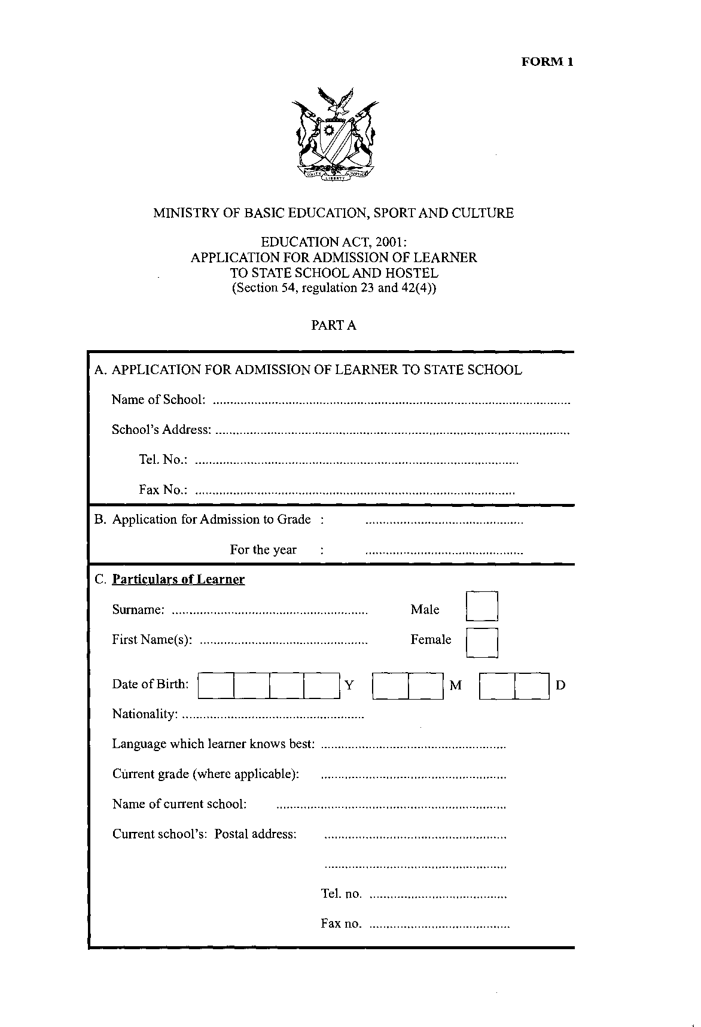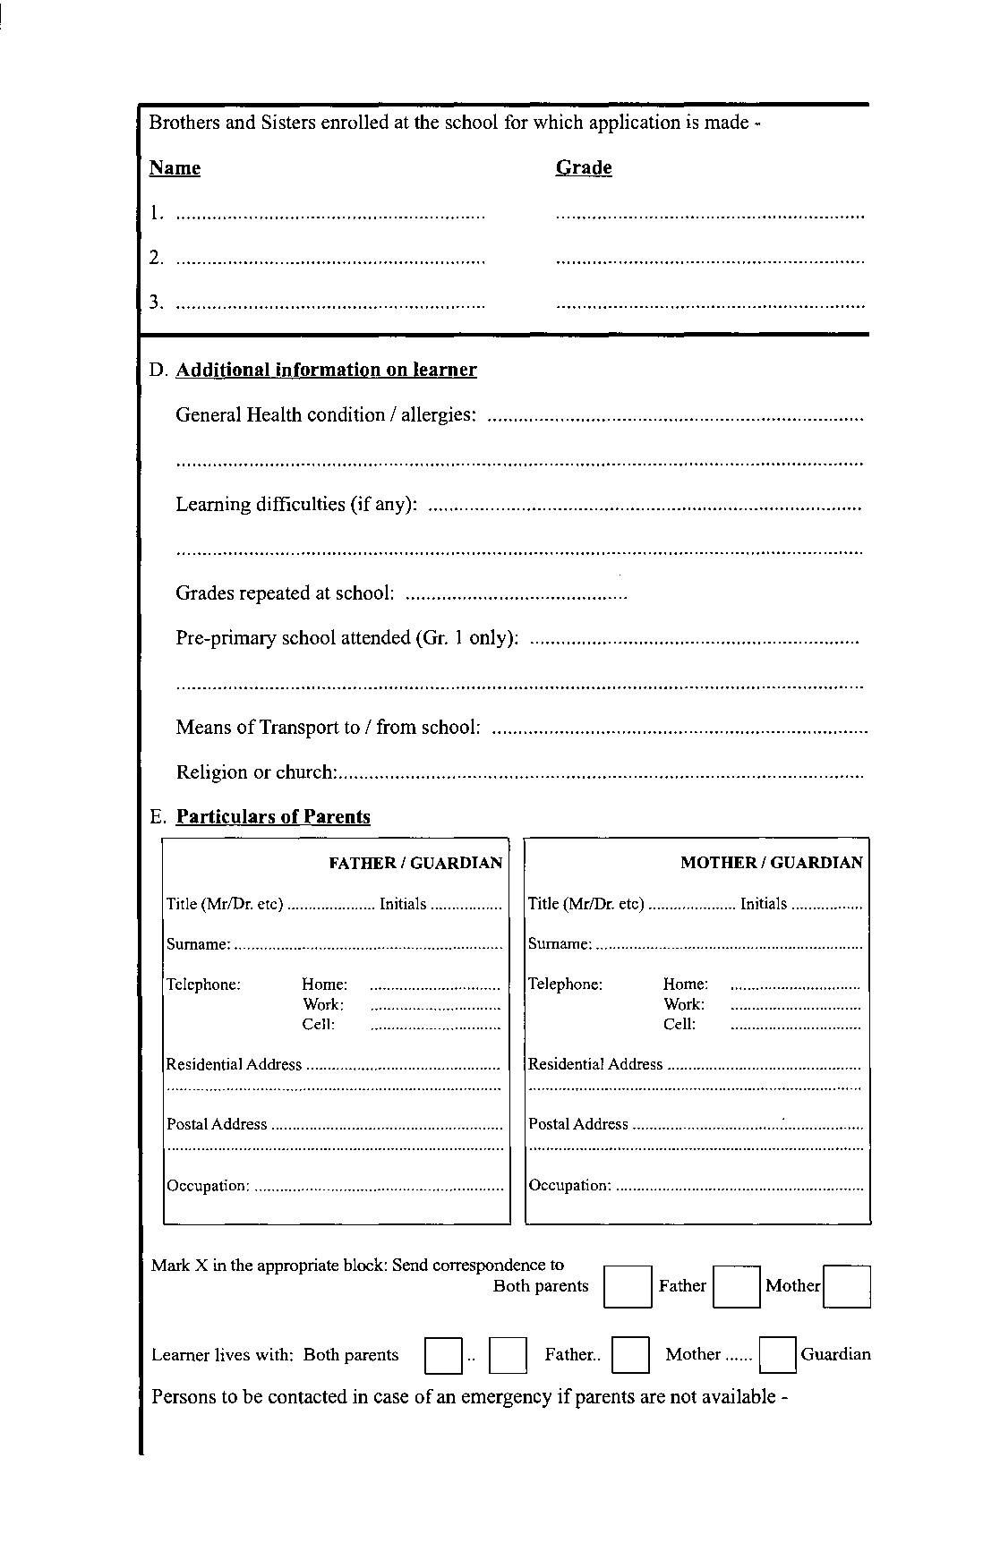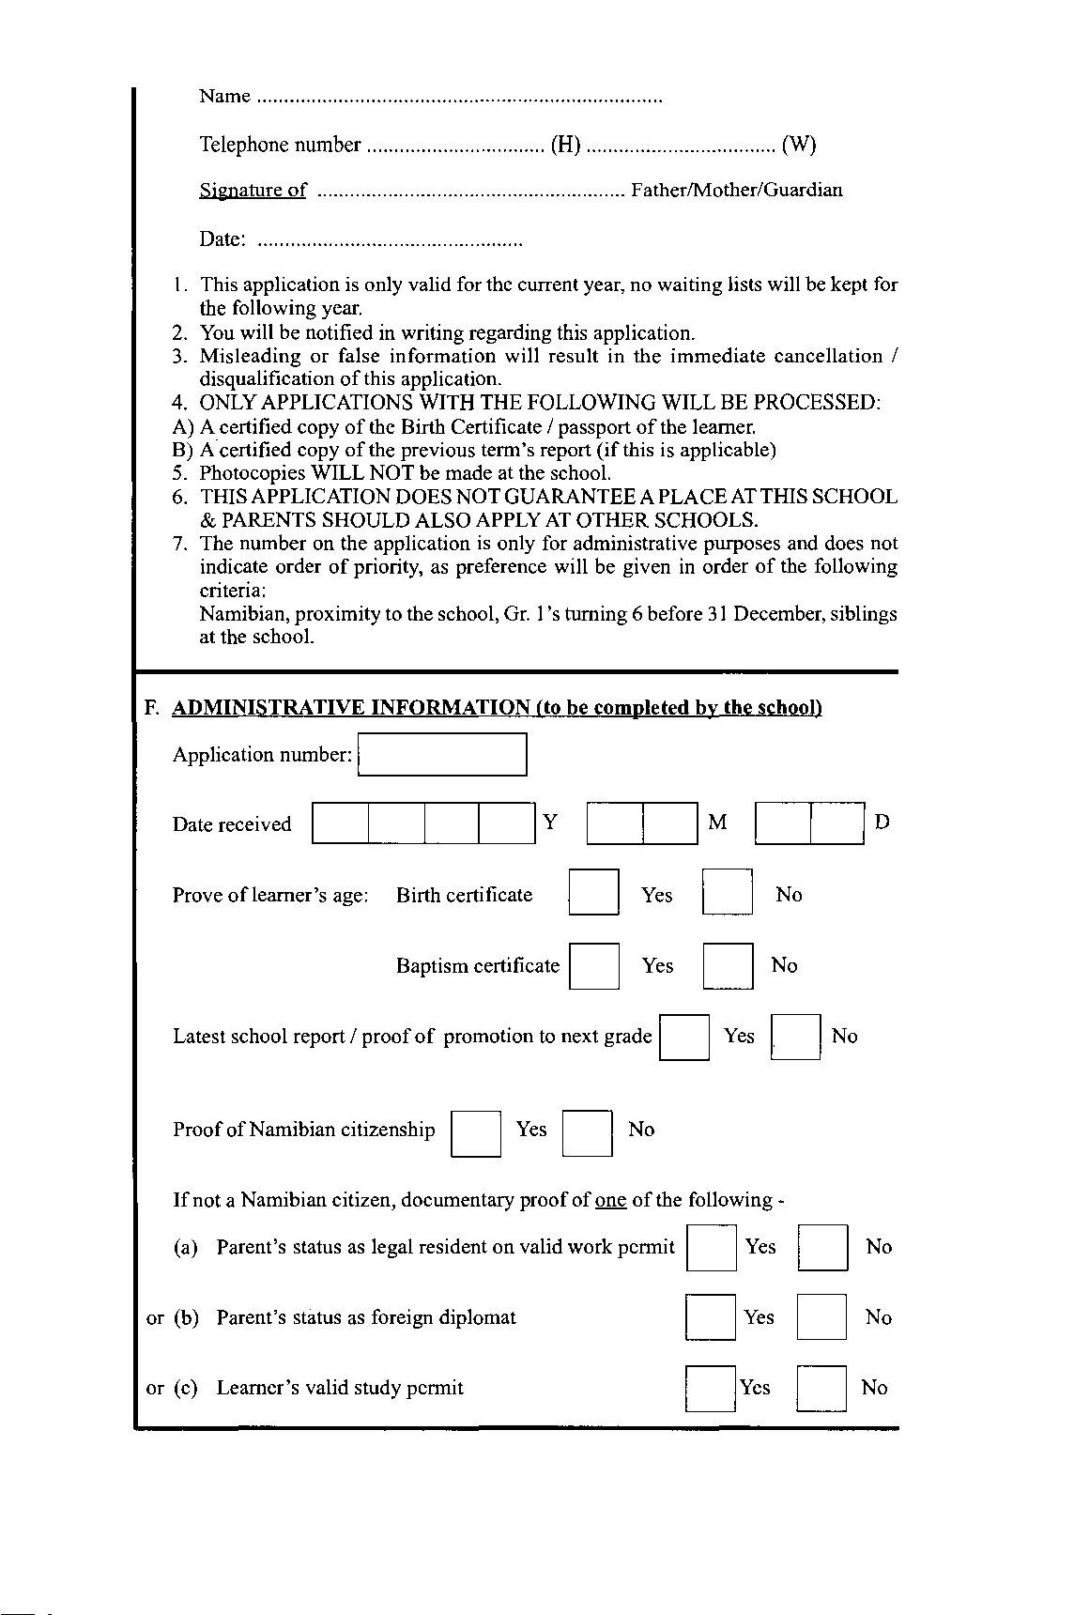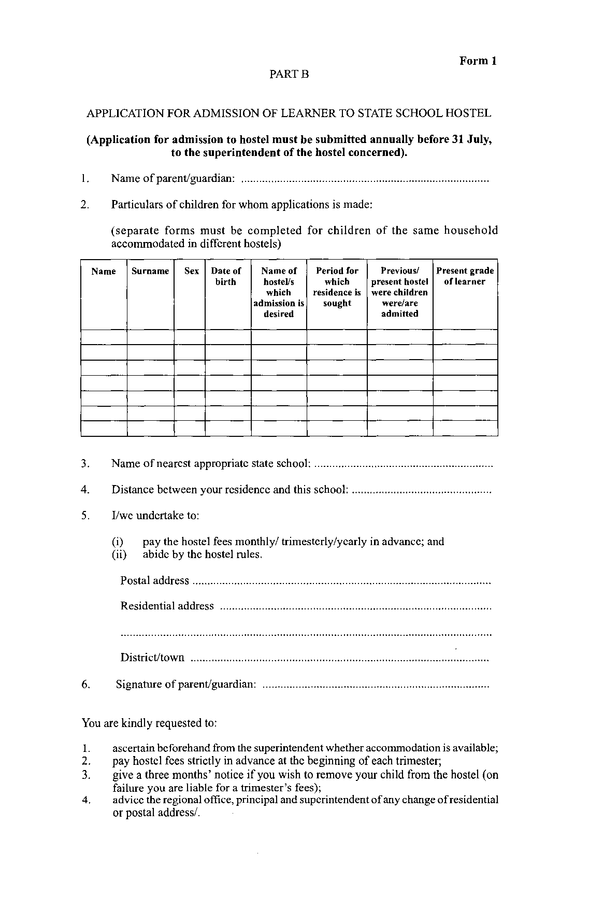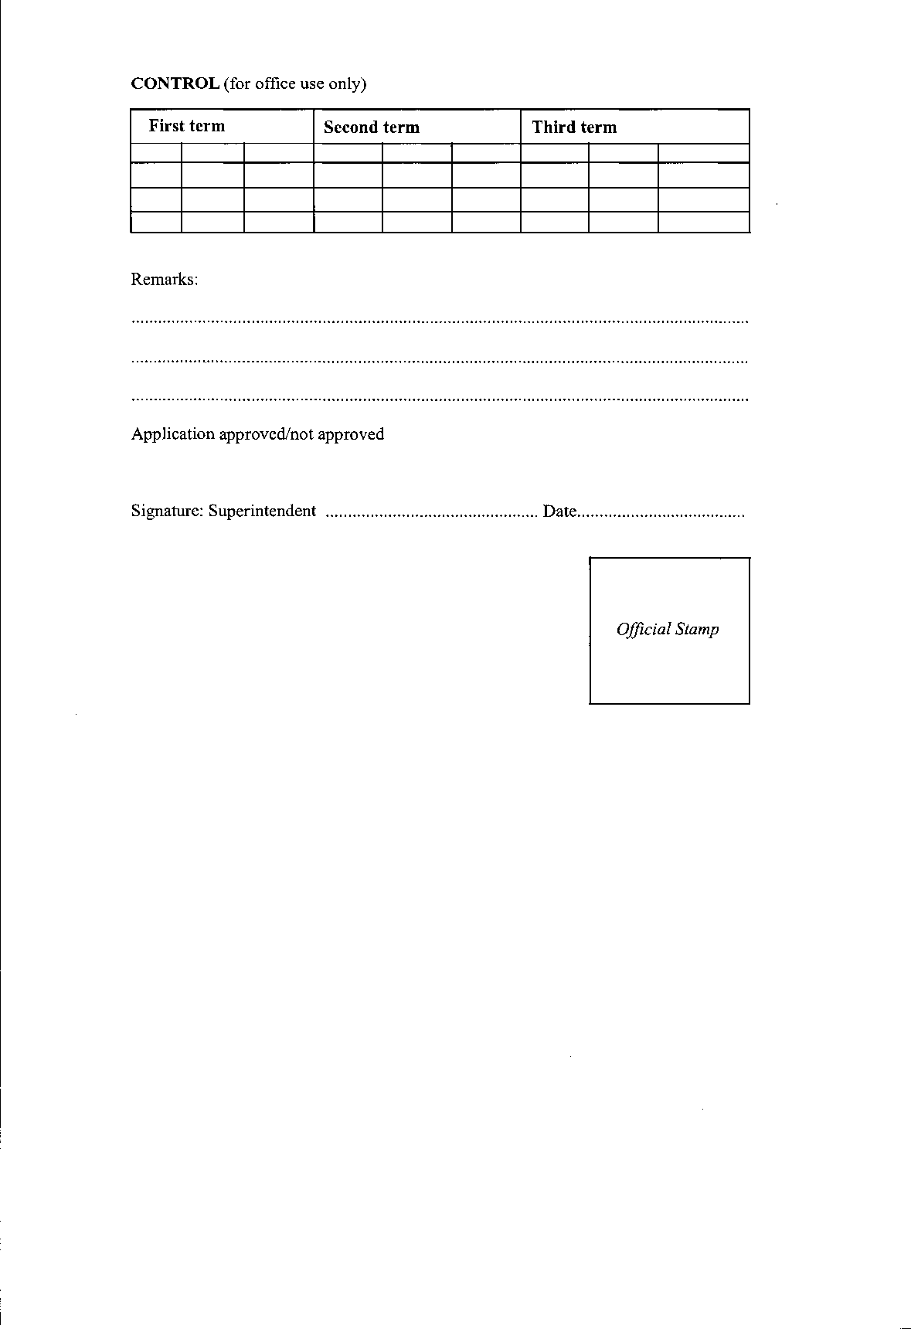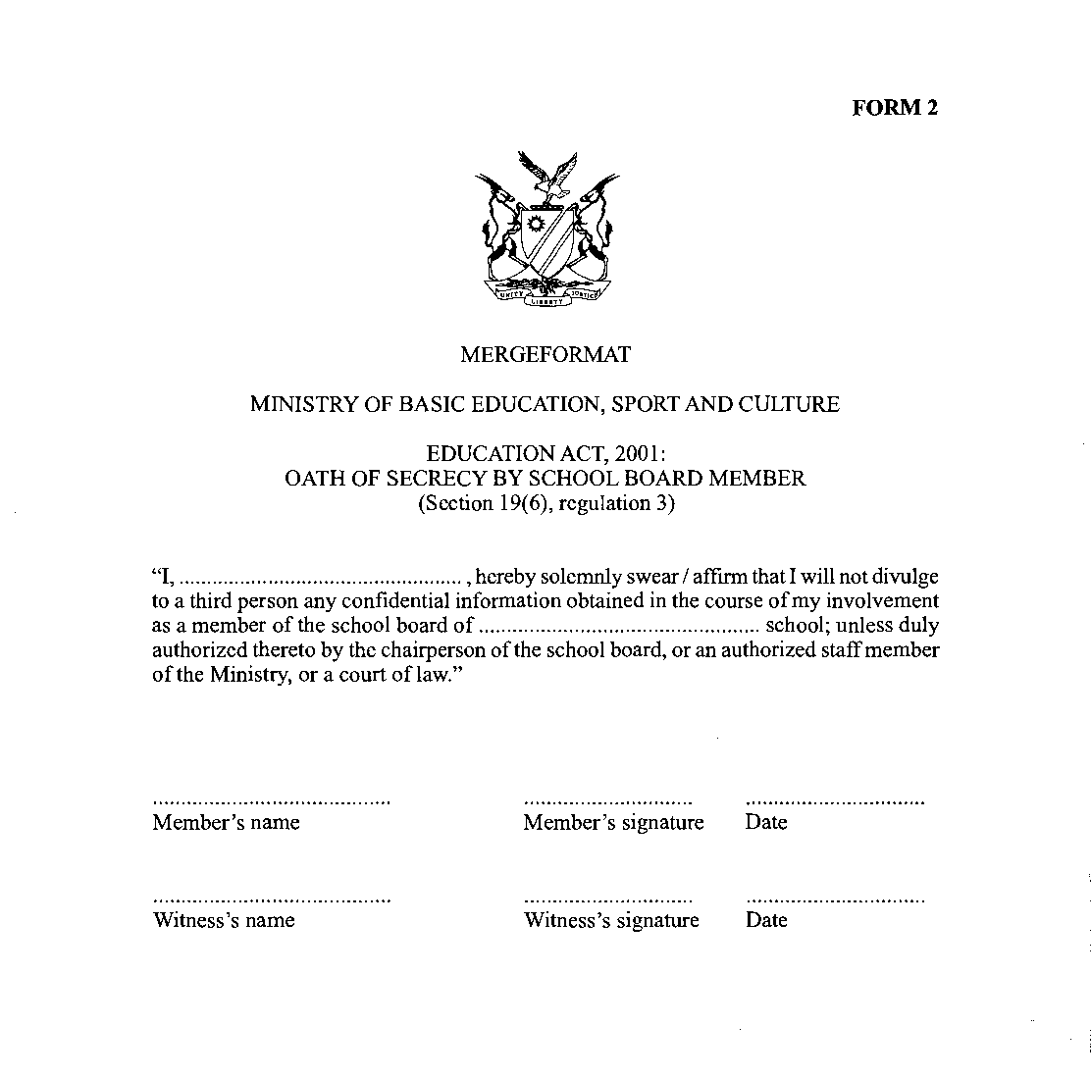
[The heading “MERGEFORMAT” appears to be in error.]

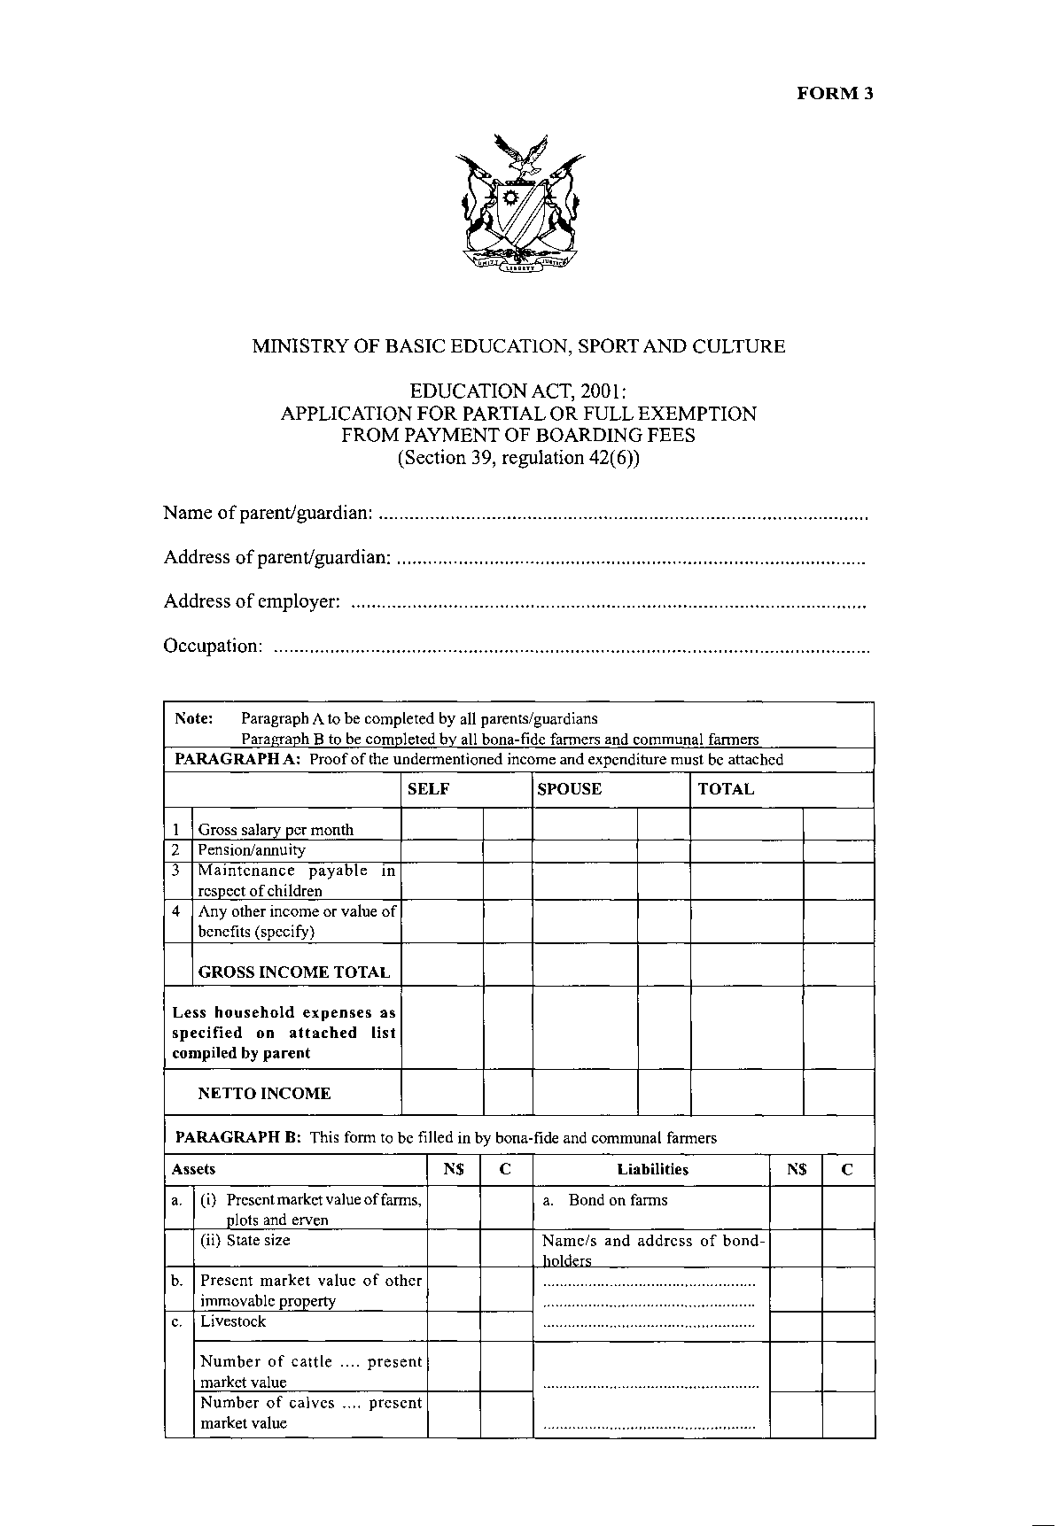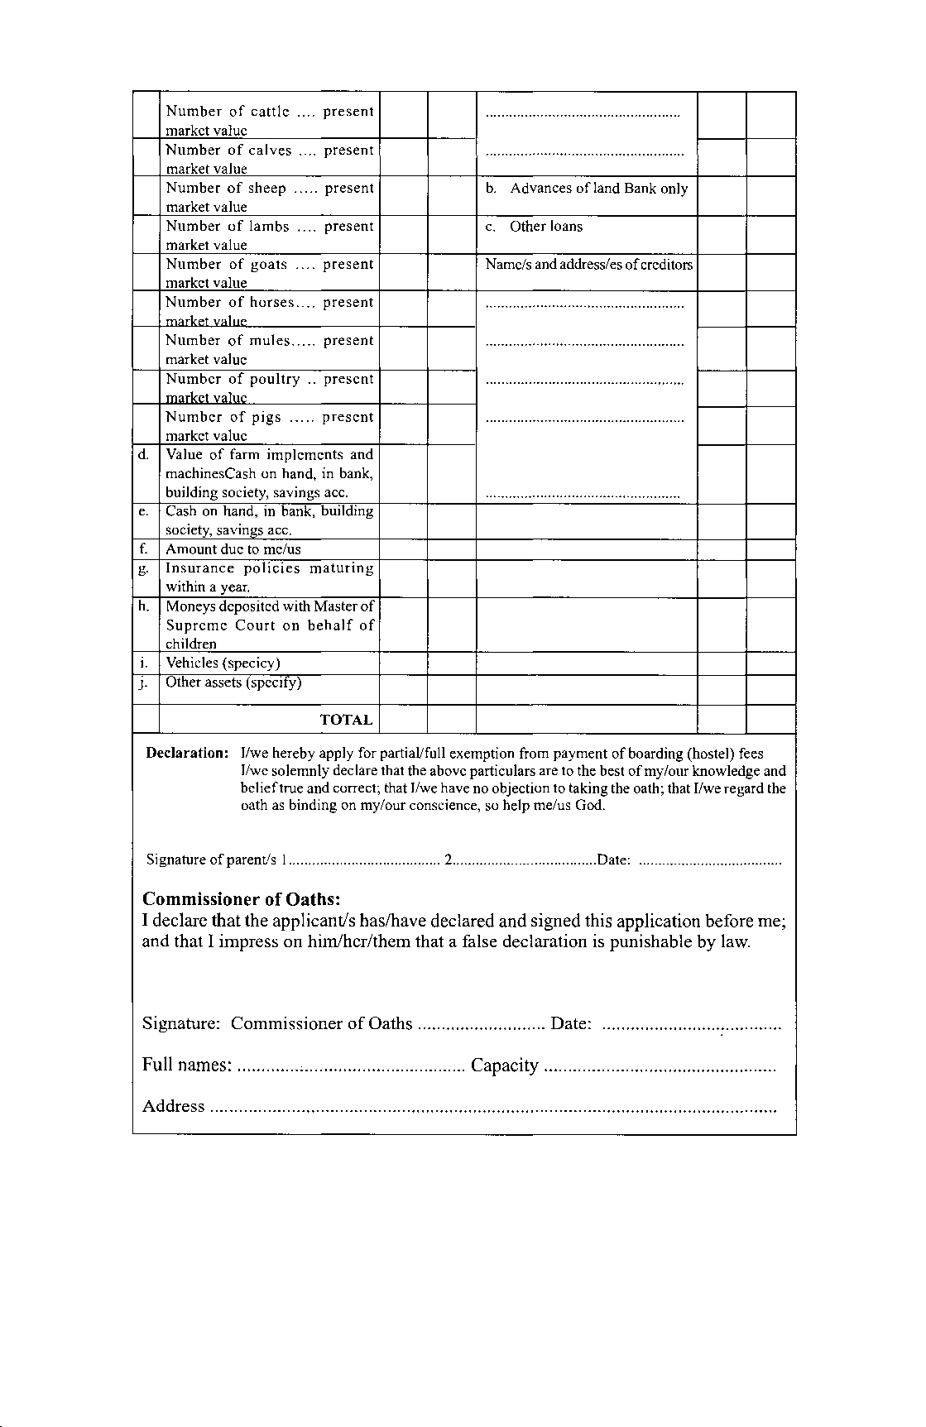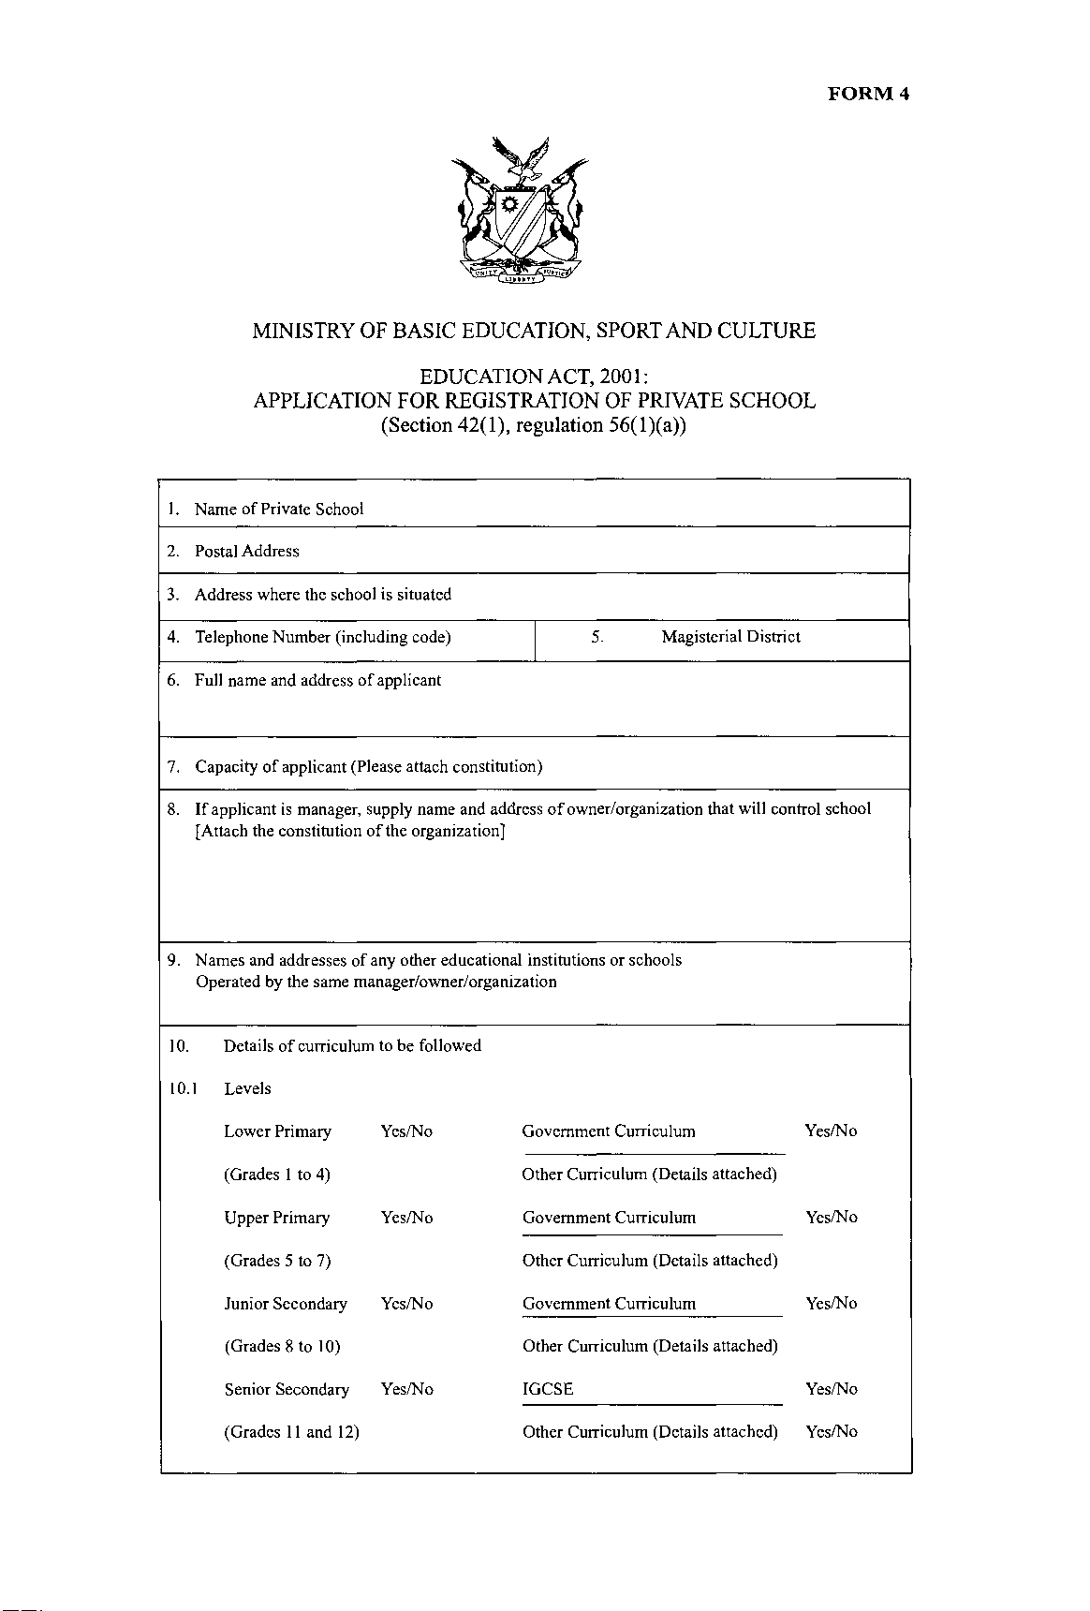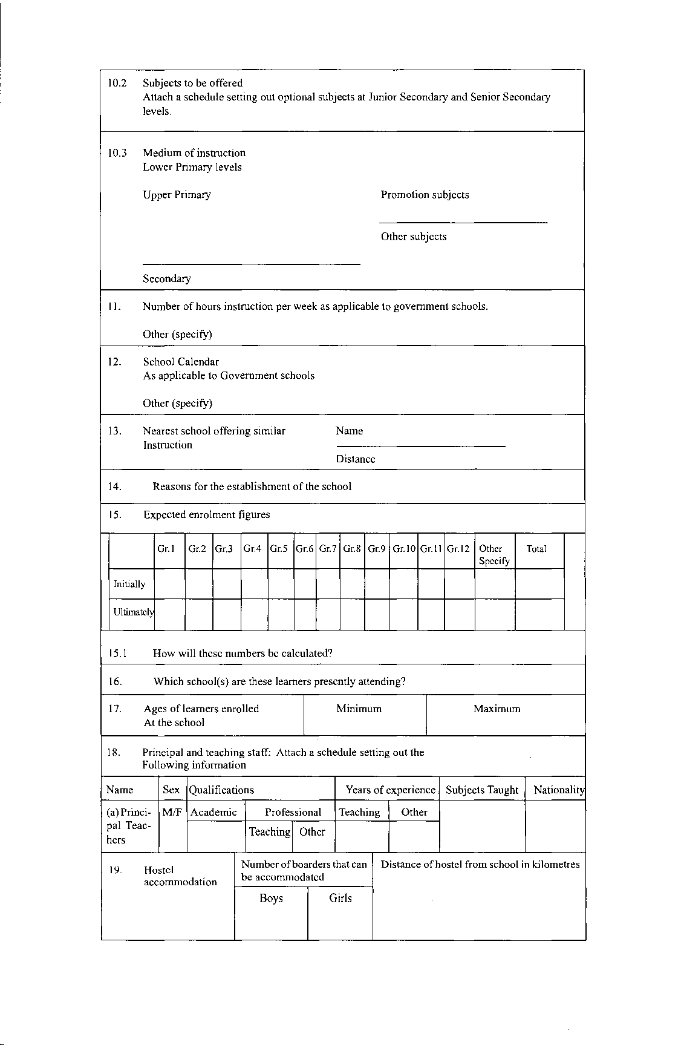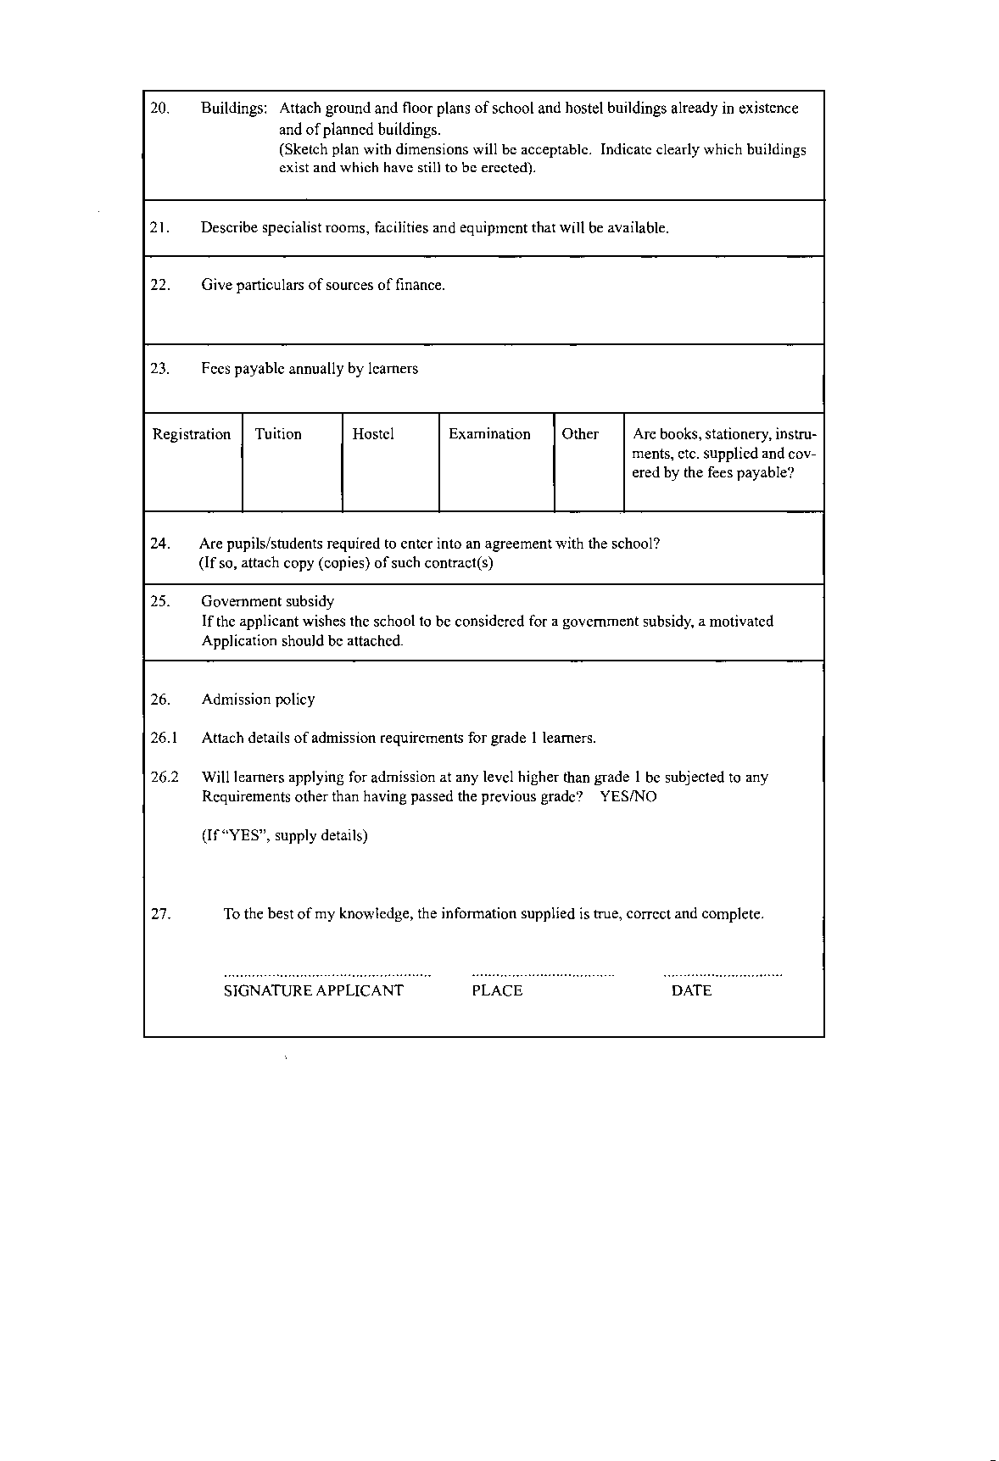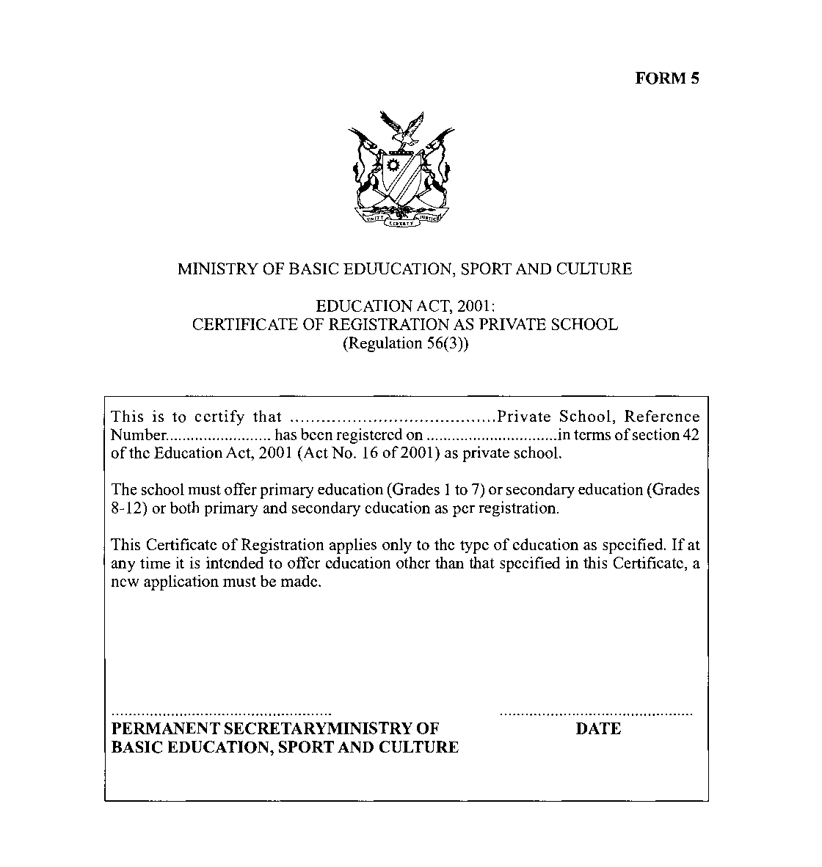
[The word “EDUCATION” is misspelt in the phrase
“MINISTRY OF BASIC EDUCATION, SPORT AND CULTURE”.]
