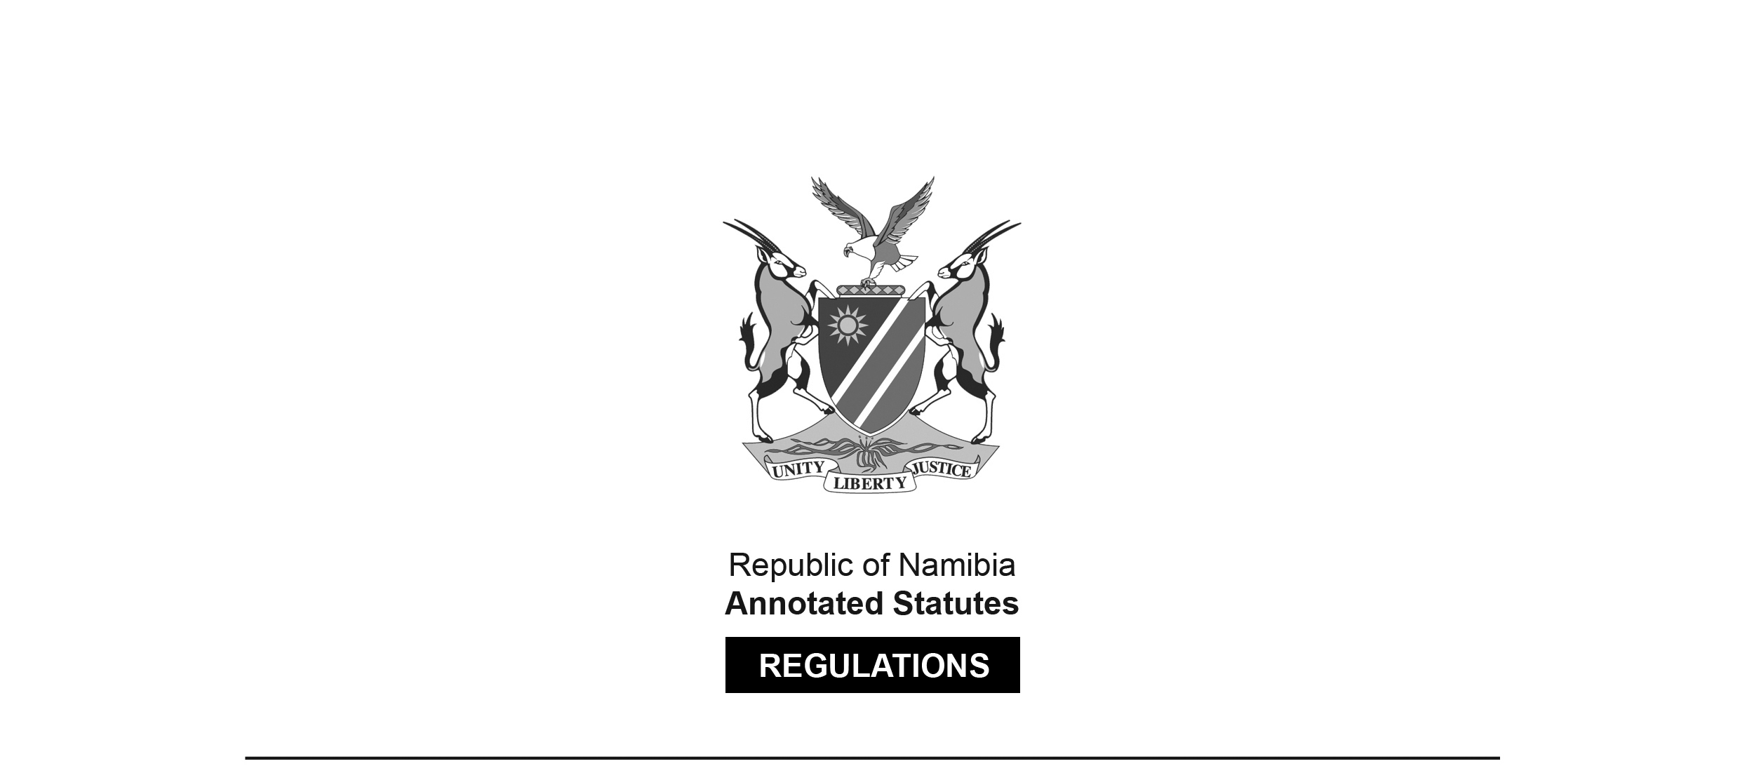
REGULATIONS SURVIVING IN TERMS OF

Customs and Excise Act 20 of 1998
section 13(2)

Regulations under the Customs and Excise Act, 1964:
Export Processing Zones
Government Notice 87 of 1996
(GG 1298)
came into force on date of publication: 29 April 1996

These regulations were originally made in terms of section 120(1) of the RSA Customs and
Excise Act 91 of 1964, which was repealed by the Customs and Excise Act 20 of 1998.
Pursuant to section 131(2) of the Customs and Excise Act 20 of 1998,
these regulations are deemed to have been made under that Act.

ARRANGEMENT OF REGULATIONS

PART I
INTERPRETATION AND APPLICATION

1. Interpretation

PART ii
CUSTOMS SUPERVISION

2. Supervision
3. Authority to examine goods
4. Persons and conveyances

PART iii
COMPETENT AUTHORITY RESPONSIBILITY AND SUPERVISION

5. Supervision
6. Customs and Excise Access
[Only the word “Customs” in this heading should be capitalised.]
7. Maintenance and records
8. Procedures Manual
9. Goods security
10. Storage and handling
11. Annual reconciliation

PART IV
IMPORT AND EXPORT OF GOODS INTO OR
FROM AN EXPORT PROCESSING ZONE

12. Use of NAMSAD
13. Waste and scrap
14. Penalties

PART I
INTERPRETATION AND APPLICATION

Interpretation

1. (1) In these regulations, unless the context otherwise indicates, an expression defined in the Act has a corresponding meaning, and -

“competent authority” means a competent authority as defined in the Export Processing Zones Act, 1995 (Act 9 of 1995);

“export processing zone” means an export processing zone as defined in the Export Processing Zones Act, 1995;

“export processing zone enterprise” means an export processing zone enterprise as defined in the Export Processing Zones Act, 1995;

“section” means a section of the Act; and

“the Act” means the Customs and Excise Act, 1964 (Act 91 of 1964).

[The Customs and Excise Act 91 of 1964 has been replaced
by the Customs and Excise Act 20 of 1998.]

(2) These regulations shall apply in export processing zones.

PART II
CUSTOMS SUPERVISION

Supervision

2. The Commissioner, a Controller or any officer designated by the Commissioner, may supervise any transaction or procedure of or by an export processing zone enterprise in an export processing zone, which supervision may be performed by means of a periodic or an occasional -

(a) audit of the records;

(b) quantity count of the goods reflected in an inventory;

(c) examination of selected transactions or procedures;

(d) review of the record-keeping, security of conditions of storage in an export processing zone,

of or by such export processing zone enterprise.

Authority to examine goods

3. An officer may, at any time after the admission of any goods to an export processing zone, examine such goods in accordance with section 4(4) of the Act, and shall in such examination be given the necessary assistance by the competent authority, which assistance shall include the opening, weighing or closing of any package or container.

Persons and conveyances subject to search

4. (1) Any person entering, leaving, or finding himself or herself in an export processing zone, the vehicle of such person or any package or container such person may be conveying or may have in his or her possession, may be searched by an officer.

(2) For the purposes of subregulation (1), an officer may stop and board any vehicle referred to in that subregulation.

PART III
COMPETENT AUTHORITY RESPONSIBILITY AND SUPERVISION

Supervision

5. (1) The competent authority shall supervise the admission or entry into, transfers or removals from, manufacturing, exhibition or destruction in, an export processing zone of goods, and the record-keeping, physical or procedural security and conditions of storage of such goods in an export processing zone.

(2) The supervision by a competent authority contemplated in subregulation (1) -

(a) shall be performed in such manner and to such degree as a prudent manager of a manufacturing or storage facility would exercise; and

(b) may take into account the degree of supervision performed by the ex­ port processing zone enterprise which has the physical possession of the goods contemplated in subregulation (1).

(3) The provisions of this regulation shall not be construed so as to in any manner whatsoever detract from the powers, duties and functions of the Commissioner or any officer, or the duty of any person to comply with a request of the Commissioner or an officer.

Customs and Excise Access

[Only the word “Customs” in this heading should be capitalised.]

6. (1) The competent authority shall, for the purposes of the Act and of these regulations, not in any manner impede the right of access of an officer to or in an export processing zone.

(2) An export processing zone enterprise which has possession of or control over a manufacturing or storage facility or area in the export processing zone concerned, shall, for the purposes contemplated in subregulation (1), allow an officer access to such facility or area.

Maintenance of records

7. (1) The competent authority shall in writing maintain inventory control and record-keeping systems, which systems shall -

(a) account for all goods, including domestic items, brought into an export processing zone;

(b) be capable of producing accurate and prompt reports as may be required by the Commissioner;

(c) reflect shortages or excess of goods in detail, including the quantity, description, tariff classification or value of such goods;

(d) provide all the information necessary to make an entry in respect of goods being removed from the export processing zone;

(e) provide to the Commissioner sufficient particulars to identify any goods from the date such goods were brought into the export processing zone, particulars of the process of manufacturing or destruction, or removal from the export processing zone of such goods.

(1) The records contemplated in subregulation (1) shall include -

(a) particulars of all goods brought into or removed from the export processing zone;

(b) references to the relevant bills of entry or of import, or bills of exit or of export, as the case may be,

and shall at all reasonable times be accessible to officers.

(3) An officer may inspect and make copies of the records contemplated in subregulation (1) as well as the commercial trading or stock records of export processing zone enterprises.

(4) The competent authority and the export processing zone enterprises shall make the records contemplated in subregulation (1), as well as other commercial and trading records of the competent authority or the export processing zone enterprise, available to officers for inspection.

(5) The competent authority shall -

(a) retain the records contemplated in subregulation (1) for a period of five years as from the date the goods concerned are removed from the export processing zone; and

(b) annually conduct a review of the inventory and records contemplated in subregulation (1) and shall report to the Commissioner the deficiencies, if any, discovered and the corrective action taken in respect of any deficiency discovered.

Procedures Manual

8. (1) The competent authority -

(a) shall furnish the Commissioner with a copy of its manual or guidelines in respect of inventory control and record-keeping systems and procedures;

(b) may authorise an export processing zone enterprise to maintain its own individual inventory control and record-keeping system and procedures manual;

(c) shall furnish the Commissioner with a copy of the manual contemplated in paragraph (b); and

(d) shall furnish the Commissioner with copies of all amendments to manuals contemplated in paragraphs (a) or (b),

upon receipt of a request in writing by the Commissioner or the export processing zone enterprise concerned, as the case may be.

(2) The competent authority shall, in consultation with the Commissioner, further develop the manual or guidelines referred to in paragraph (a) of subregulation (1) in respect of inventory control and record-keeping systems and procedures.

(3) The provisions of subregulation (1) shall not release the competent authority from its duties of supervision as set out in regulation 7, and the manuals referred to in subregulation (1) shall be furnished to the Commissioner for information purposes only.

(4) The mere receipt by the Commissioner of a manual or guidelines referred to in subregulation (1) shall not infer the approval or rejection by the Commissioner of the system concerned.

Goods security

9. The competent authority shall establish and maintain procedures and control measures which shall be adequate to ensure the security and protection of goods in an export processing zone in accordance with security standards and specifications approved by the Commissioner.

Storage and handling

10. (1) The export processing zone enterprise concerned shall handle and store goods in an export processing zone in a safe, sanitary and hygienic manner and condition in order to -

(a) minimize damage to such goods;

(b) avoid circumstances hazardous or detrimental to persons or the environment; and

(c) meet national and local requirements applicable to specific types of goods.

(2) Refuse and waste shall be promptly removed from the export processing zone as prescribed by the Export Processing Zones Act, 1995 (Act 9 of 1995).

(3) The premises of export processing zone enterprises, including all buildings on such premises, shall at all reasonable times be made accessible to officers or other persons in the execution of their official duties.

Annual reconciliation

11. (1) Every export processing zone enterprise shall, within a period of 90 days after the close of its financial year as defined in the Income Tax Act, 1981 (Act 24 of 1981), prepare and submit to the Commissioner a reconciliation report as set out in subregulation (2).

(2) The reconciliation report contemplated in subregulation (1) shall contain -

(a) a description and quantities of the goods on hand on the first day of;

(b) a description and quantities of the goods received and disposed of during; and

(c) a description and quantities of the goods on hand on the last day of,

the financial year referred to in subregulation (1).

(3) The Commissioner may, on good cause shown, extend the period of 90 days as referred to in subregulation (1) by a further period of not more than 30 days.

PART IV
IMPORT AND EXPORT OF GOODS INTO OR
FROM AN EXPORT PROCESSING ZONE

Use of NAMSAD

12. (1) Subject to subsection (1)(b), (3) or (5) of section 5 of the Export Processing Zones Act, 1995 (Act 9 of 1995) -

(a) goods entering or leaving an export processing zone shall, for customs and excise purposes, be controlled by means of the use of the Namibian Single Administrative Document (NAMSAD), FormNA500/NA550;

(b) no goods shall be admitted into or be removed from an export processing zone unless a duly completed NAMSAD (NA500/NA550) form has been submitted to Customs and Excise and the relevant import du­ ties or other charges, if any, have been paid or security provided in respect of the payment of such duties or charges.

(2) The NA500/NA550 form referred to in subregulation (1) shall indicate the ultimate destination of the goods concerned.

Waste and scrap

13. Waste and scrap resulting from processing in an export processing zone may be exported from such zone and imported into Namibia subject to such conditions, accounting procedures and control as the Commissioner may determine.

Penalties

14. Any person who fails to comply with or contravenes any of these regulations shall be guilty of an offence and on conviction be liable to the penalties prescribed in the Act.

