REGULATIONS MADE IN TERMS OF

Copyright and Neighbouring Rights
Protection Act 6 of 1994
section 61

General Regulations
Government Notice 32 of 1996
(GG 1257)
came into force on date of publication: 2 February 1996

The Government Notice which publishes these regulations notes that the tariff of fees
payable in respect of proceedings before the Tribunal (Annexure B)
was prescribed in consultation with the Minister of Finance.

ARRANGEMENT OF REGULATIONS

PRELIMINARY

1. Definitions

CHAPTER 1
REPRODUCTION OF WORKS

2. Permitted reproduction
3. Reproduction and distribution by libraries or archives depots
4. Exemptions and savings
5. Copyright warning
6. Copies for teaching or research purposes
7. Reproduction of building plans by local authorities

CHAPTER 2
SOUND RECORDING ROYALTIES

8. Notices
9. Manner and time of payment of royalties
10. Enquiries
11. Determination of royalties
12. Inspection
13. Agreement contrary to this Chapter

CHAPTER 3
AUTHORS OF CINEMATOGRAPH FILMS

14. Indication of name of author on cinematograph films
15. Indication of name by registered trade mark

CHAPTER 4
COPYRIGHT TRIBUNAL

16. Registrar of Copyright Tribunal
17. Commencement of proceedings
18. Advertisement of references or applications
19. Application to be made a party
20. Objection to references or applications
21. Consideration of references and applications, and procedure for proceedings
22. Interlocutory applications
23. Consolidation of proceedings
24. Disclosure of documents
25. Evidence
26. Right of audience
27. Withdrawal of references or applications
28. Decisions of Tribunal
29. Suspension by Tribunal of order pending appeal
30. Costs of proceedings
31. Fees
32. Services of documents
33. Time

CHAPTER 5
MISCELLANEOUS

34. Office hours
35. Repeal of regulations

ANNEXURE A
FORMS

ANNEXURE B
FEES

PRELIMINARY

Definitions

1. In these regulations any word or expression to which a meaning has been assigned in the Act, shall have the meaning so assigned to it and, unless the context otherwise indicates -

“archives depot” means an archives depot established under section 5 of the Archives Act, 1992 (Act 12 of 992);

“manufacturer” means a manufacturer referred to in paragraph (a) of regulation 8;

“Registrar” means the Registrar of the Copyright Tribunal referred to in regulation 16;

“retail selling price”, in relation to a record, means -

(a) if there is an agreement in existence between the manufacturer and the owner of the copyright determining the retail selling price, such agreed price; or

(b) if there is not agreement as contemplated in paragraph (a), the manufacturer’s bona fide recommended retail selling price, less any tax or duty payable to the Government; or

(c) if there is no agreement as contemplated in paragraph (a) and no recommended manufacturer’s retail selling price as contemplated in paragraph (b), the manufacturer’s highest published wholesale list price of that type of record plus 50 per cent thereof, less any tax or duty payable to the Government;

“teacher” means any person giving instruction or doing research at any school, university or any other educational institution, by whatever name he or she may be known;

“the Act” means the Copyright and Neighbouring Rights Protection Act, 1994 (Act 6 of 1994).

CHAPTER 1

REPRODUCTION OF WORKS
(Section 16 of Act)

Permitted reproduction

2. Any person may reproduce a work, provided he or she makes, unless otherwise provided in these regulations, only one copy of a reasonable portion of a work, having regard to the totality and meaning of the work.

Reproduction and distribution by libraries or archives depots

3. (1) Subject to the provisions of subregulation (2), the person in control of a library or archives depot or an employee thereof who is acting within the scope of his or her employment may reproduce a work and may after reproduction of the work distribute such reproduction, provided -

(a) the making or distribution of such reproduction is not made for the purposes of deriving direct or indirect commercial advantage;

(b) the collections of the library or archives depot are -

(i) open to the public; or

(ii) available to researchers affiliated to the library or archives depot or to the institution of which the library or archives depot is a part or to other persons doing research in a specialised field; and

(c) the library or archives depot complies with the provisions of regulation 5 and such reproduction incorporates a copyright warning in the form prescribed in subregulation (3) of the said regulation.

(2) A library or archives depot may under subregulation (1) -

(a) reproduce only one copy of a published work in facsimile form solely for the purposes of replacement of a copy that is deteriorating or that has been damaged, lost or stolen, provided the library or archives depot has after a reasonable investigation determined that an unused replacement cannot be obtained at a fair price;

(b) reproduce and distribute only one copy -

(i) of an unpublished work in facsimile form solely for -

(aa) the purposes of preservation and security; or

(bb) deposit, for research use, in a library or archives depot other than the library or archives depot which has that work in its collection,

provided the copy reproduced shall be placed in the collection of that library or archives depot;

(ii) of -

(aa) one article or other contribution to a collection or issue of a periodical in which copyright subsists; or

(bb) a reasonable portion of any other work in which copyright subsists,

which is copied from the collection of the library or archives depot to which the user has addressed his or her request in writing for a copy thereof or from the collection of another library or archives depot, provided -

(A) the copy shall become the property of the user; and

(B) such library or archives depot has had no knowledge that the copy would be used for any purposes other than for private study or the personal or private use of the person making the request;

(iii) of an entire work, or a substantial portion of the work, which is copied from the collection of the library or archives depot to which the user has addressed his or her request in writing for a copy thereof or from the collection of another library or archives depot, provided the library or archives depot has after reasonable investigation determined that an unused copy of the work in which copyright subsists cannot be obtained at a fair price, and provided -

(aa) the copy shall become the property of the user; and

(bb) such library or archives depot has had no knowledge that the copy would be used for any purposes other than for private study or the personal or private use of the person making the request;

Provided that a library or archives depot may not reproduce or distribute works other than literary works, except that such limitation shall not apply with respect to works reproduced or distributed under paragraph (a) or (b)(i) or with respect to pictorial or graphic works published as illustrations, diagrams, or similar adjuncts to works of which copies are reproduced or distributed in accordance with paragraph (b)(ii) or (iii).

(3) The provisions of subregulation (2) shall not be construed so as to prohibit the reproduction or distribution by a library or archives depot of multiple copies of the same material if the reproduction thereof occurs on diverse occasions and is unrelated to the copying of that material on any other occasion or is purely coincidental.

(4) Notwithstanding the provisions of subregulation (3), the person in control of a library or archives depot or an employee thereof may not reproduce or distribute more than one copy of the same material if he or she -

(a) is aware or has substantial reason to believe that he or she is engaging in the related or concerted reproduction or distribution of multiple copies of the same material, excluding periodical articles of a scientific or technical nature -

(i) whether made on one occasion or on diverse occasions over a period of time; or

(ii) whether intended for aggregate use by one or more individuals or for separate use by individual members of a group; or

(b) is engaging in the systematic reproduction or distribution of single or multiple copies of material referred to in paragraph (b)(ii) of subregulation (2), excluding periodical articles of a scientific or technical nature:

Provided that a library or archives depot shall not be prohibited from participating in interlibrary arrangements that are not designed to or do not have the effect of providing the library or archives depot receiving such copies for distribution with such aggregate quantities that such copies are a substitute for a subscription to or purchase of the work in question.

Exemptions and savings

4. Nothing in these regulations -

(a) shall be construed as imposing any liability for the infringement of copyright upon a library or archives depot or its employees for the unsupervised use of reproducing equipment located on its premises, provided the library or archives depot complies with the provisions of regulation 5;

(b) shall exempt any person who uses such reproducing equipment or who requests a copy contemplated in regulation 3(2)(b)(ii) from liability for the infringement of copyright as a result of any such use or request, or any later use of such copy, if it exceeds the extent of the copying permitted in terms of the Act;

(c) shall in any way affect any contractual obligation s incurred by the library or archives depot when it obtained a copy of a work for its collection.

Copyright warning

5. (1) A copyright warning in the form prescribed in subregulation (3) shall be displayed at the place where orders for copies are accepted by a library or archives depot or where unsupervised equipment is located in such manner and position as to be clearly visible, legible and comprehensible to a casual observer in the immediate vicinity of such place and shall be printed on heavy paper or other durable material in type at least 18 points in size.

(2) A copyright warning in the form prescribed in subregulation (3) shall be incorporated in every form supplied by a library or archives depot and used by a subscriber or a member of the public for ordering a copy of a work and shall be printed -

(a) within a block located prominently on such form, either on the face of such form or immediately adjacent to the space provided for the name or signature of the person using such form;

(b) in type size not smaller than that used predominantly in such form, provided the type size shall not be smaller than 8 points; and

(c) in such a manner as to be clearly visible, legible and comprehensive to a casual reader of the form.

(3) A copyright warning shall consist of a verbatim reproduction of the notice shown below:

COPYRIGHT WARNING

The Copyright and Neighbouring Rights Protection Act, 1994 (Act 6 of 1994), governs the making of photocopies or other reproductions of copyrighted material. Under the provisions of the Act libraries and archives depots are authorised to supply photocopies or other reproductions. One of these provisions is that the photocopy or reproduction is not to be used for any purposes other than private study or personal or private use.

If a user makes a request for, or later uses, a photocopy or reproduction for purposes not permitted in terms of the Act, that user may be liable for the infringement of copyright. This institution reserves the right to refuse to accept an order for copying if, in its opinion, fulfilment of the order might involve violation of the Act.

Copies for teaching or research purposes

6. (1) Subject to the provisions of subregulation (2) -

(a) a single copy of a reasonable portion of a work may be made by or for a teacher for research or teaching purposes;

(b) multiple copies of a reasonable portion of the same material, but not exceeding one copy per pupil per course, may be made by or for a teacher for classroom use or discussion.

(2) A copy may not be under subregulation (1) of a work intended to be ephemeral, including any workbook, exercise, and standardised test, test booklet and answer sheet, and similar ephemeral material.

(3) A copy made under subregulation (1) may not -

(a) be used to create or replace or substitute any anthology, compilation or collective work;

(b) be used as a substitute for the purchase of a book, publishers’ reprint or periodical and be repeated in respect of the same material by the same teacher from term to term.

Reproduction of building plans by local authorities

7. (1) Notwithstanding the provisions of regulation 2, the copyright in a building plan shall not be infringed if a person (or a person acting on his or her authority) in charge of a office of a local authority in which the original or a reproduction of the building plan is lodged for purposes of record, makes a reproduction of that plan, or of a portion thereof, for the owner of land on which a building has been erected in accordance with that plan and such owner requires that plan, or a portion thereof , for the purposes of making an addition or alteration to the building.

[The phrase “a office” should be “an office” to be grammatically correct.]

(2) In subregulation (1) “local authority” means the council of any area declared to be a municipality, town or village under section 3 of the Local Authorities Act, 1992 (Act 23 of 1992).

CHAPTER 2

SOUND RECORDING ROYALTIES
(Section 17 of Act)

Notices

8. A notice referred to in section 17(1)(b) or 17(2)(c) of the Act, as the case may be, shall contain the following particulars:

(a) The name and address of the person by whom the notice is given (in this Chapter referred to as “the manufacturer”);

[The word “The” at the beginning of paragraph (a) should not be capitalised.]

(b) the name of the work to which the notice refers (in this Chapter referred to as “the work”), a description sufficient to identify the work, and the name of the author and the publisher;

(c) a statement that the manufacturer intends to make records of the work or of an adaptation thereof and the address of the place at which he or she intends to make such records;

(d) sufficient particulars to identify the record of the work or an adaptation thereof for the purposes of section 17(1)(a) of the Act;

(e) the type or types of record on which it is intended to reproduce the work or adaptation and an estimate of the number of recordings of each type that will be manufactured for sale by retail or for the purposes of being supplied for resale by retail;

(f) the retail selling price of the records or, where it is intended to reproduce the work on more than one type or record, the retail selling price of each type of record which the manufacturer intends to make, and the amount of royalty payable in respect of each record;

(g) the earliest date on wich any of the records will be delivered to a purchaser or to another person for the purposes of resale by retail;

[The word “which” is misspelt in the Government Gazette, as reproduced above.]

(h) whether any other musical or literary work is to be reproduced on the same record with the musical work in question and, in relation to any such other musical work or literary work, the particulars specified in paragraph (b).

Manner and time of payment of royalties

9. (1) The royalties payable in respect of a record referred to in section 17(1)(d) of the Act shall be paid in such manner and at such times -

(a) as determined in an agreement concluded between the manufacturer and the owner of the copyright in the musical work in question; or

(b) if no such agreement has been concluded, as stipulated in the following provisions of this regulation.

(2) A notice referred to in regulation 8 shall, at least 30 days before any record embodying the musical work in question is sold by retail or supplied for the purposes of resale by retail -

(a) if the name and address of the owner of the copyright or of his or her agent, for the receipt of notice, are known or can be ascertained by reasonable enquiry, be sent by registered post to such owner or agent at that address;

(b) if such name and address are not known and cannot be ascertained by reasonable enquiry, be published in the Gazette giving the particulars required in terms of paragraphs (a), (b), (c) and (d) of regulation 8 and stating an address from which the particulars required in terms of paragraph s (e), (f), (g) and (h) of the said regulation can be obtained.

(3) If within 14 days from -

- in the case where the notice referred to in regultion 8 is required to be sent by registered post, the date which is two days after the date of the posting of such notice;

[The word “regulation” is misspelt in the Government Gazette, as reproduced above.]

(b) in the case where such notice is required to be published in the Gazette, the date of the publication of such notice,

the owner of the copyright indicates to the manufacturer, by notice in writing sent by registered post, some convenient place within Namibia from which labels, which shall be in the form prescribed in subregulation (8), can be obtained, the manufacturer shall by notice in writing to such owner specify the number and denomination of the labels he or she requires and tender a sum equivalent to the amount of royalty represented by the labels so required.

(4) If, within 14 days from the date of receipt of a notice given by the manufacturer in terms of subregulation (3), the owner of the copyright supplies the labels required, the manufacturer shall not deliver to a purchaser or to another person for the purposes of resale by retail any record made by him or her and to which a notice referred to in regulation 8 refers, unless the manufacturer has attached to -

(a) the record; or

(b) the container in which the record is intended to be delivered to such purchaser or person, if the type of the record is such that it is not practical to attach an adhesive label thereto,

a label so supplied representing the amount of the royalty payable in respect of the record.

(5) If the owner of the copyright fails to take any of the steps stipulated in subregulations (3) and (4) within the times therein respectively specified, the manufacturer may, subject to the provisions of subregulation (6), deliver to a purchaser or to another person for the purposes of resale by retail any record to which a notice referred to in regulation 8 refers, without complying with the provisions of subregulations (3) and (4).

(6) The manufacturer shall keep an account of all records delivered under subregulation (5), and the amount of the royalties due to the owner of the copyright in respect of that records shall be transferred to a special account and held in trust for such owner.

(7) If the manufacturer takes the steps stipulated in subregulation s (3) and (4), or in subregulations (5) and (6), as the case may be, with respect to any records, the taking of those steps shall be deemed to constitute the payment of royalties in respect of such records in accordance with the provisions of section 17(1)(d) of the Act.

(8) A label referred to in subregulation (3) shall -

(a) be adhesive and square, of which any side is not more than 2 centimetre;

(b) have a design which shall be entirely enclosed within a circle;

(c) not contain -

(i) the effigy of any person; or

(ii) any word, mark or design such as to suggest that such label is issued by or under the authority of the Government for the purposes of denoting any duty payable to the Government.

Enquiries

10. (1) The enquiries referred to in section 17(4) of the Act shall be directed to the owner of the copyright or, if his or her name is not known and cannot be ascertained by reasonable enquiry, to his or her duly authorised agent, in general terms indicated as “the owner of the copyright” in the musical or literary work in respect of which the enquiries are made or to the copyright owners’ collecting society concerned, and shall contain -

(a) a statement of the name of the work, a description sufficient to identify it, and the name of the author and publisher thereof;

(b) a statement of the name and address of the person making such enquiries;

(c) a statement that a record of the work or an adaptation thereof has previously been made in or imported into Namibia for the purposes of sale by retail, with the trade name (if any) and a description of such record sufficient to identify it;

(d) an enquiry whether the recored so described was made in or imported into Namibia for the purposes of sale by retail by or with the licence of the owner of the copyright.

[The word “record” is misspelt in the Government Gazette, as reproduced above.]

(2) Such enquiries shall -

(a) if an address in Namibia of the owner of the copyright or of his or her agent or of the copyright owners’ collecting society concerned is known or can be ascertained by reasonable enquiry, be sent by registered post to such address;

(b) if such an address is not known and cannot be ascertained by reasonable enquiry, be advertised in the Gazette.

(3) The period for reply by the owner of the copyright to any such enquiry shall -

(a) in the case of subregulation (2)(a), be 16 days after the date of the posting of the enquiry;

(b) in the case of subregulation (2)(b), be 14 days after the date of the advertising of the enquiry.

Determination of royalties

11. (1) The royalty payable in terms of section 17(1)(d) of the Act shall be as determined in an agreement contemplated in regulation 9(1)(a), but, if no such an agreement has been concluded, it shall be five per cent of the retail selling price of the record: Provided that, if the amount so calculated includes a fraction of a cent, being -

(a) less than half a cent, that fraction shall not be reckoned as part of such royalty;

(b) half or more than half a cent, that fraction shall be deemed to be one cent.

(2) In the case of a record comprising two or more musical works (with or without other material and either in their original form or in the form of adaptations) in which copyright subsists -

(a) the minimum royalty in the absence of an agreement contemplated in regulation 9(1)(a) shall be one half of one cent in respect of each of those works; and

(b) if the owners of the copyright in those works are different persons, the royalty shall be apportioned among such owners in such manner as agreed upon by such owners or, in default of such agreement, as determined in accordance with the provisions of the Arbitration Act, 1965 (Act 42 of 1965).

Inspection

12. Upon the request of the owner of the copyright or his or her duly authorised agent, the manufacturer shall permit such owner or agent, as the case may be -

(a) to inspect and check all stock of records held by or on behalf of the manufacturer;

(b) to examine the stock-book of the manufacturer kept in respect of -

(i) the number of records manufactured;

(ii) the number of records sold or delivered; and

(iii) the number of records on hand.

Agreement contrary to this Chapter

13. Notwithstanding the provisions of this Chapter, but subject to the provisions of the Act, any person who would otherwise be bound by the first­mentioned provisions may enter into an agreement in writing of which a term or condition is contrary to any provision of this Chapter.

CHAPTER 3

AUTHORS OF CINEMATOGRAPH FILMS
(Section 32(6) of Act)

Indication of name of author on cinematograph films

14. For the purposes of section 32(6) of the Act the name of the author of a cinematographic film may appear in any sequence or in any frame of the film, whether the name is visible or not when the film is shown as a moving picture: Provided that such name shall be preceded or followed by the word “copyright”, or the symbol “c”, or the expression “all rights reserved”, or any other obvious or ordinary symbol therefor or abbreviation thereof, either with or without letters or digits indicating a date.

Indication of name by registered trade mark

15. The name of the author referred to in regulation 14 may be indicated by a trade mark of which the author is the registered proprietor or a registered user in terms of the Trade Marks in South West Africa Act, 1973 (Act 48 of 1973).

CHAPTER 4

COPYRIGHT TRIBUNAL
(Sections 35 to 44 of Act)

Registrar of Copyright Tribunal

16. The Registrar of the High Court of Namibia or any member of his or her staff designated by him or her shall act as Registrar of the Copyright Tribunal.

Commencement of proceedings

17. (1) Any -

(a) reference of a licence scheme under section 36(1) of the Act;

(b) further reference of a licence scheme under section 37(I) of the Act;

(c) application for special leave under section 37(2) of the Act;

(d) application for an order under section 38(2) or (3) of the Act,

shall be made by serving on the Registrar a notice which is substantially in the form as set out in Form 1, 2, 3 or 4 of Annexure A, respectively -

(2) In the case of -

(a) paragraph (a) or (d) of subregulation (1), the organisation or person at whose instance such reference or application, as the case may be, is made, shall at the same time serve a copy of the notice referred to in the said subregulation on the licensing body or person mentioned in that notice;

(b) paragraph (b) or (c) of the said subregulation, the licensing body, organisation or person at whose instance such further reference or application, as the case may be, is made, shall at the same time serve a copy of that notice on all the parties to the reference on which the Tribunal made the previous order under section 36 of the Act with respect to the licence scheme in question.

(3) The Tribunal shall deal with and dispose of an application referred to in subregulation (1)(c) as it thinks just after consideration of any representations made in writing, within 30 days after service of the notice of application, by any person on whom such notice was served in terms of subregulation (2)(b), and, if the Tribunal thinks fit, after giving the applicant and all parties concerned an opportunity of being heard on the application.

Advertisement of references or applications

18. (1) Except where the Tribunal otherwise directs and subject to the provisions of subregulation (2), the licensing body, organisation or person, as the case may be, who makes -

(a) any reference under section 36(1) or 37(1) of the Act; or

(b) an application under section 38(2) or (3) of the Act,

shall give notice of such reference or application, as the case may be, by advertisement in the Gazette.

(2) Any reference contemplated in subregulation (1)(a) by an organisation claiming to be representative of persons requiring licenses shall not be advertised until the Tribunal has decided in terms of regulation 20 that the organisation is reasonably representative of such persons.

(3) An advertisement referred to in subregulation (1) shall state -

(a) the name and address of the licensing body, organisation or person at whose instance the reference or application is made;

(b) the names and addresses of the licensing body and of all other persons on whom copies of the reference or application have been served;

(c) the nature of the reference or application;

(d) the time, being not less than 30 days from the publication of the advertisement, within which any organisation or person may apply to the Tribunal to be made a party to the proceedings.

Application to be made a party

19. An application by an organisation or person to be made a party to -

(a) any reference under section 36(1) or 37(1) of the Act; or

(b) an application under section 38(2) or (3) of the Act,

shall be made by serving a notice which is substantially in the form as set out in Form 5 of Annexure A on the Registrar and on all the parties mentioned in the advertisement referred to in regulation 18, or, if the Tribunal directs under the said regulation that no such advertisement is necessary, on such persons as the Tribunal directs.

Objection to references and applications

20. (1) A licensing body operating the licence scheme to which any reference under section 36(1) or 37(1) of the Act relates may object to any such reference made by an organisation claiming to be representative of persons requiring licences on the grounds that the organisation is not reasonably representative of the class of persons it claims to represent.

(2) A licensing body, organisation or person at whose instance any reference under section 36(1) or 37(1), or an application under section 38(2) or (3), of the Act, is made, or a licensing body operating the licence scheme in question, may object to any application by an organisation or person to be made a party to the proceedings on the grounds that such organisation or person has no substantial interest in the matter in dispute.

(3) An objection contemplated in subregulation (1) or (2) shall be made by serving a notice which is substantially in the form as set out in Form 6 or 7 of Annexure A, as the case may be, on the Registrar within 30 days after service of the notice of the reference or application which is the subject of the objection.

(4) A copy of the notice referred to in subregulation (3) shall at the same time be served -

(a) in the case of an objection to any reference, on the organisation at whose instance the reference is made;

(b) in the case of an objection to an application to be made a party to any reference or an application under section 38(2) or (3) of the Act, on the organisation or person applying to be made a party and on any licensing body, organisation or person which or who may object under subregulation (2).

(5) If notice of an objection is given in terms of subregulation (3), the Tribunal, before determining whether the organisation is reasonably representative of the class of persons it claims to represent or whether the organisation or person applying to be made a party to the proceedings has a substantial interest in the matter in dispute and ought to be made a party to the proceedings, as the case may be -

(a) shall give such organisation or person an opportunity to make representations in writing in respect of an objection of which notice has been given under subregulation (3); and

(b) may, if it thinks fit, give such organisation or person, the objector and any licensing body or person concerned an opportunity of being heard in respect of the objection.

(6) If no notice of an objection is given in terms of subregulation (3), the Tribunal shall as soon as practicable consider whether the organisation at whose instance the reference is made is reasonably representative of the class of persons it claims to represent or whether the organisation or person applying to be made a party to the proceedings has a substantial interest in the matter in dispute and ought reasonably to be made a party to the proceedings, as the case may be: Provided that the Tribunal shall not reach an adverse decision without giving the organisation or person concerned an opportunity of making representations in writing to the Tribunal, or, if the Tribunal thinks fit and such organisation or person so desires, of being heard.

(7) The Registrar shall give notice in writing of the Tribunal’s decision to -

(a) the organisation at whose instance the reference is made or to the organisation or person applying to be made a party to the proceedings, as the case may be;

(b) all other parties to the proceedings; and

(c) in the case of a further reference under section 37(1) of the Act, any other person who was a party to the reference on which the Tribunal made an order under section 36 of the Act with respect to the licence scheme in question.

Consideration of references and applications, and procedure for proceedings

21. (1) The Registrar shall, as soon as practicable after the Tribunal has disposed of any application contemplated in section 6(3) or 38(4) of the Act, as the case may be, and complied with the provisions of section 36(4) of the Act, fix a date, time and place for the consideration by the Tribunal of any reference under section 36(1) or 37(1), or an application under section 38(2) or (3), of the Act, as the case may be.

(2) The Registrar shall give at least 30 days prior notice in writing of the date, time and place fixed in terms of subregulation (1) to all parties to such reference or application, as the case may be.

(3) A party to any reference or application referred to in subregulation (1) who wishes to make representations in writing to the Tribunal shall, at least 14 days before the date fixed in terms of the said subregulation, serve a copy of such representations on the Registrar and every other party to such reference or application.

(4) A party to any reference or application referred to in subregulation (1) who wishes to be heard by the Tribunal on the date fixed in terms of the said subregulation shall, at least seven days before that date, give notice to that effect by serving a notice which is substantially in the form as set out in Form 8 of Annexure A on the Registrar and every other party to such reference or application.

(5) If notice is given in terms of subregulation (4) by any party, every other party to the reference or application may attend the proceedings and address the Tribunal.

(6) Subject to the provisions of the Act and of these regulations, the Tribunal when considering any reference or application referred to in subregulation (1) -

(a) shall have the jurisdiction and powers of a single judge of the High Court of Namibia sitting to hear a civil matter; and

(b) may regulate the proceedings before it in accordance with the rules of the High Court of Namibia made under section 39 of the High Court Act, 1990 (Act 16 of 1990).

Interlocutory applications

22. (1) Any proceedings before the Tribunal not leading to a final order shall be disposed by the Tribunal.

(2) An interlocutory application shall be made in writing, stating the grounds upon which it is made, and shall be served on the Registrar.

(3) If all the parties to the proceedings consent to an interlocutory application, such application shall be accompanied by consents signed by all such parties or on their behalf, and, in any other case, a copy of such application shall, before it is made, be served by the applicant on every other party, and such application shall state that such service took place.

(4) Any party who objects to an interlocutory application may, within seven days after service of a copy thereof, send a notice of objection in writing to the Registrar and the applicant.

(5) If notice of an objection was given under subregulation (4), the Tribunal shall, before disposing of the interlocutory application, consider any such objection and may, if it thinks fit, give all parties concerned an opportunity of being heard in respect of the objection.

Consolidation of proceedings

23. If more than one -

(a) reference under section 36(1) or 37(1) of the Act relating to the same licence scheme; or

(b) application under section 38(2) or (3) of the Act relating to the same licencing body or person,

is pending before the Tribunal, the Tribunal may, if it thinks fit, either of its own motion or upon an interlocutory application made under regulation 22, order that some or all of the references or applications, as the case may be, be considered together, and may give such consequential directions as may be necessary: Provided that the Tribunal shall not make an order under this regulation of its own motion without giving all parties concerned a reasonable opportunity of objecting to the proposed order.

Disclosure of documents

24. (1) Every party to proceedings before the Tribunal shall send to the Registrar and every other party to such proceedings a copy of any document relevant to the proceedings which is in or under that party’s possession or control.

(2) If any party fails without just cause to comply with the provisions of subregulation (1), the Tribunal may -

(a) order such party to comply with those provisions;

(b) give such consequential directions concerning the adjournment of the hearing or otherwise as may be necessary;

(c) order such party to pay any costs caused by his or her default.

(3) If a party fails, within the period determined by the Tribunal, to comply with an order made under subregulation (2), the Tribunal may order that that party shall be deemed to have abandoned any interest that party may have had in the proceedings in question and dismiss the reference or application, as the case may be, and make an order as to costs in accordance with the provisions of section 41 of the Act.

Evidence

25. (1) Evidence at any hearing before the Tribunal shall be given orally or, if the parties agree or the Tribunal so orders, by affidavit, but the Tribunal may at any stage of the proceedings require the personal attendance of any deponent for examination and cross-examination.

(2) The law relating to the attendance of a witness or his or her failure to attend on a subpoena or order by the High Court of Namibia in a civil matter, shall apply mutatis mutandis in respect of a witness subpoenaed or ordered by the Tribunal to attend its proceedings.

Right of audience

26. In any proceedings before the Tribunal any party thereto may, subject to the provisions of regulations 17(3), 20(5) and (6) and 22(5), appear and be heard, either personally or through a legal practitioner.

Withdrawal of references or applications

27. (1) Subject to the provisions of subregulations (2) and (3), any reference under section 36(1) or 37(1), or an application under section 38(2) or (3), of the Act, as the case may be, may by notice in writing served on the Registrar and all the parties to the proceedings be withdrawn at any time before such reference or application has been finally disposed of.

(2) A withdrawal contemplated in subregulation (1) shall be without prejudice to the Tribunal’s power to make an order as to the payment of costs or expenses incurred by a party up to the time of service of the notice of withdrawal.

(3) Notwithstanding the service of a notice of withdrawal under subregulation (1) in respect of a reference, the Tribunal may, upon the application of the licensing body mentioned in the reference, proceed with the reference.

Decisions of Tribunal

28. (1) Every final decision of the Tribunal on any reference under section 36(1) or 37(1), and on an application under section 38(2) or (3), of the Act shall be given in writing and shall include a statement of the Tribunal’s reasons for such decision.

(2) Except where the operation of an order of the Tribunal is suspended under regulation 29(1), the Registrar shall send to every party to the proceedings a copy of the Tribunal’s decision and shall cause a copy to be made available at hi s or her office for public inspection.

Suspension by Tribunal of order pending appeal

29. (1) If an appeal against an order of the Tribunal is noted in accordance with the provisions of section 43 of the Act, the Tribunal may suspend the operation of such order until the matter in question has been finally decided upon by the High Court or the Supreme Court, as the case may be.

(2) Such a suspension shall not exceed a period of six months from the date of the Tribunal’s order, unless the Tribunal, upon the application of the parties, extends such period.

Costs of proceedings

30. When no order for payment of costs or expenses incurred by a party in respect of any proceedings before the Tribunal has been made by the Tribunal in accordance with the provisions of section 41 of the Act, the Registrar shall, if so required by any party to the proceedings, undertake the taxation of any bill of costs, and any proceedings relating to such taxation shall mutatis mutandis be subject to the rules applicable to the taxation of costs by the Registrar of the High Court with respect to bills presented to him or her for taxation.

Fees

31. (1) The fees payable in respect of proceedings before the Tribunal are as set out in Annexure B, and shall be paid -

(a) by affixing revenue stamps to the notice or other document in question, which stamps may be cancelled by the Permanent Secretary: Finance or the Registrar;

(b) by impressing a stamp on the notice or other document in question by means of a die approved by the Permanent Secretary: Finance; or

(c) in such other manner as the Registrar may direct.

(2) If the prescribed fees have not been paid in accordance with the provisions of subregulation (1), the Registrar may refuse to accept a notice or other document served on or sent to him or her, and such notice or other document so refused shall not be admissible in any proceedings until the prescribed fees have been paid.

Service of documents

32. (1) A notice or other document required in terms of these regulations to be served on or sent to -

(a) any person may be sent to such person by prepaid post at his or her address for service or, where no address for service has been given, at his or her registered office, principal place of business or last-known address;

(b) the Tribunal may be sent by prepaid post to the Registrar. Copyright Tribunal, Private Bag 13179, Windhoek.

(2) Any notice or other document required to be served on a licensing body or organisation which is not a body corporate may be sent to the secretary, manager or other similar officer of such body or organisation.

(3) The Tribunal may direct that service of any notice or other document be dispensed with or effected otherwise than in the manner provided by these regulations.

Time

33. (1) Whenever any period is specified by these regulations within which any act is to be performed, that period may -

(a) be shortened by agreement between all parties concerned; or

(b) at any time, whether before or after the expiry of that period, be extended by a judge of the Tribunal or the Registrar, as the case may be.

(2) If the last day for the performance of any act falls on a day on which the office of the Registrar is closed and by reason thereof the act cannot be performed on that day, that act may be performed on the next day on which such office is open.

CHAPTER 5

MISCELLANEOUS

Office hours

34. The office of the Registrar shall be open from 08:00 to 12:30 and from 14:00 to 15:30 from Mondays to Fridays except on the following days:

(a) All public holiday s referred to in, or declared under, section 1 of the Public Holidays Act, 1990 (Act 26 of 1990);

(b) days which may from time to time be indicated by a placard posted in a conspicuous place at the office of the Registrar.

Repeal of regulations

35. The regulations published under Government Notices Nos. R.407 of 1966, R.408 of 1966, R.414 of 1966, R415 of 1966 and R1289 of 1972 are hereby repealed.

ANNEXURE A
FORMS

To view content without printing, scroll down.

To print at full scale (A4), double-click the icon below.

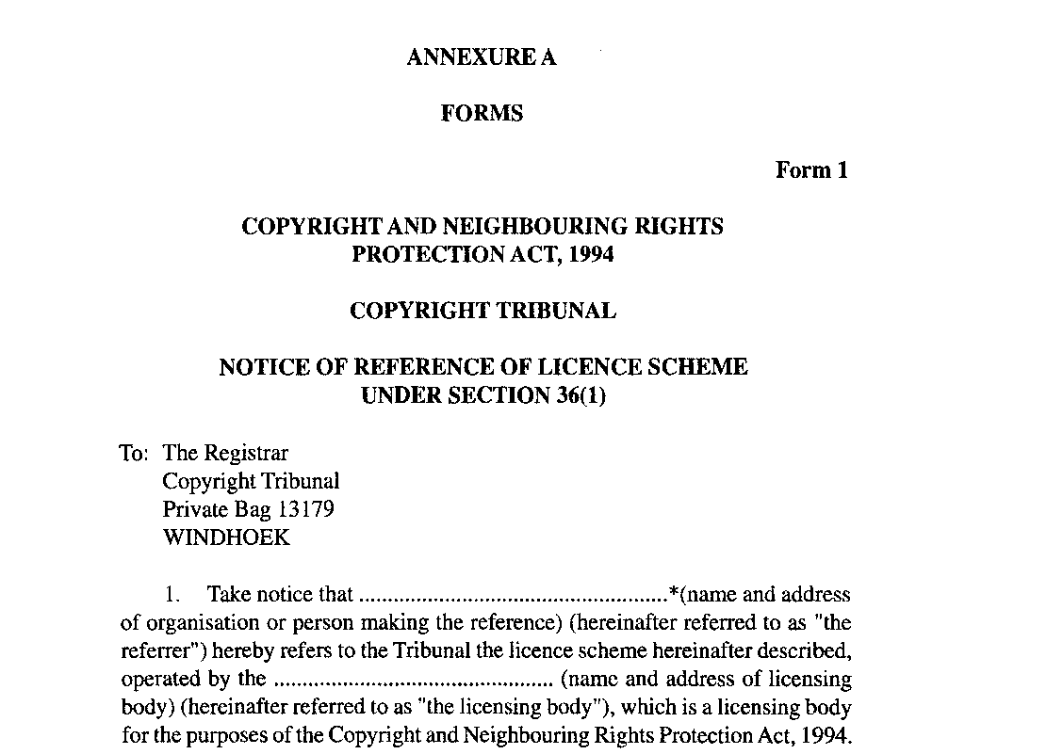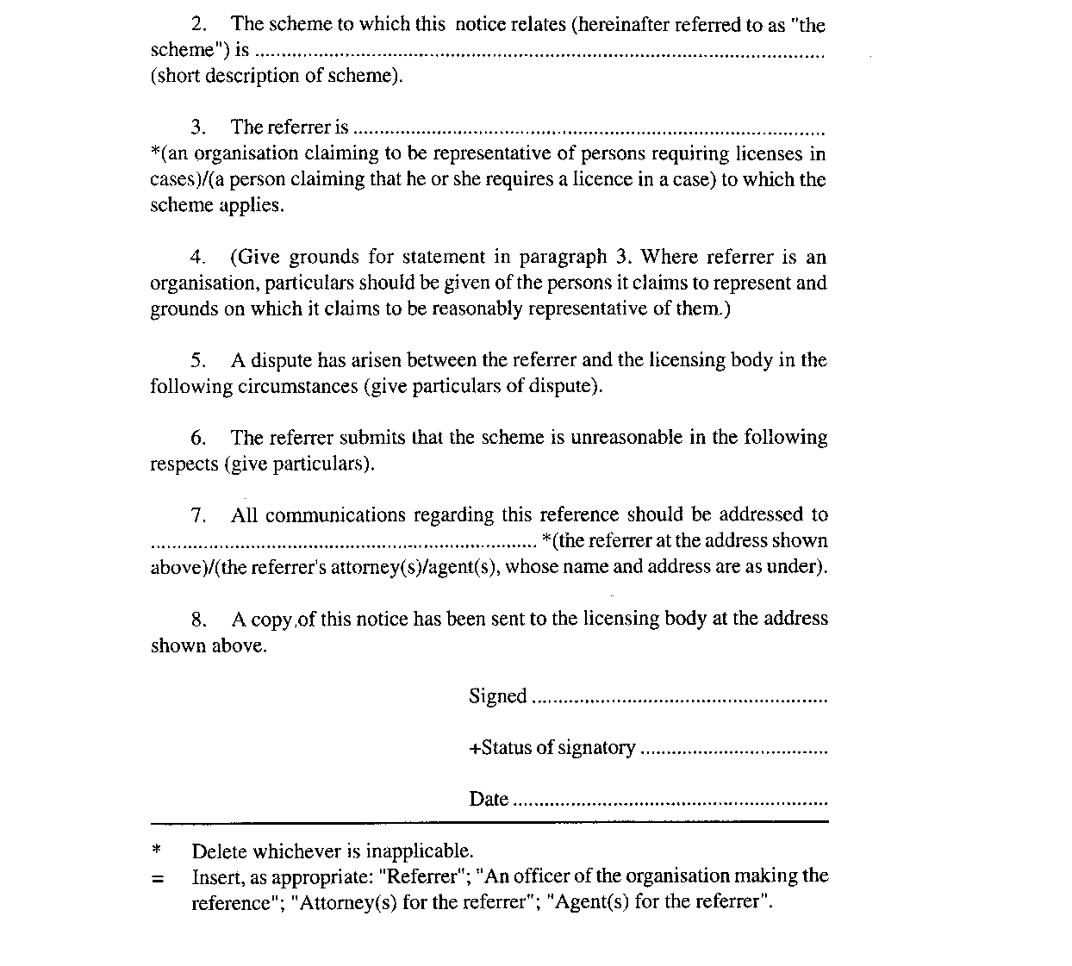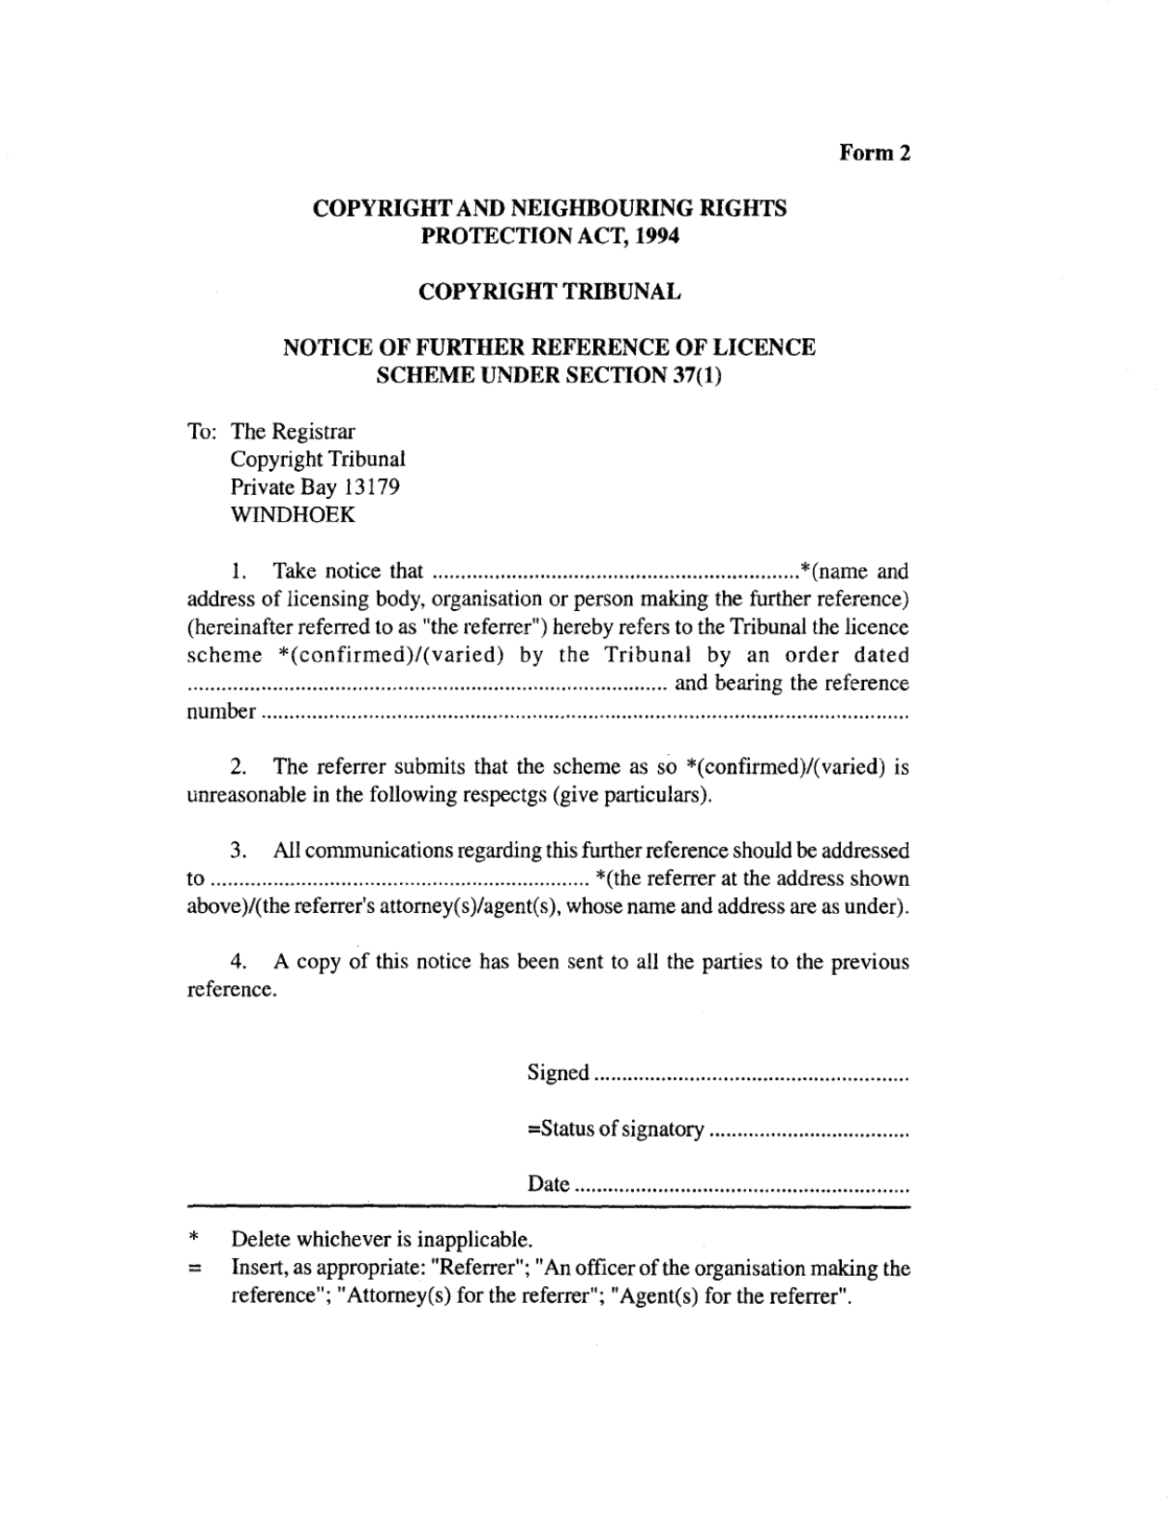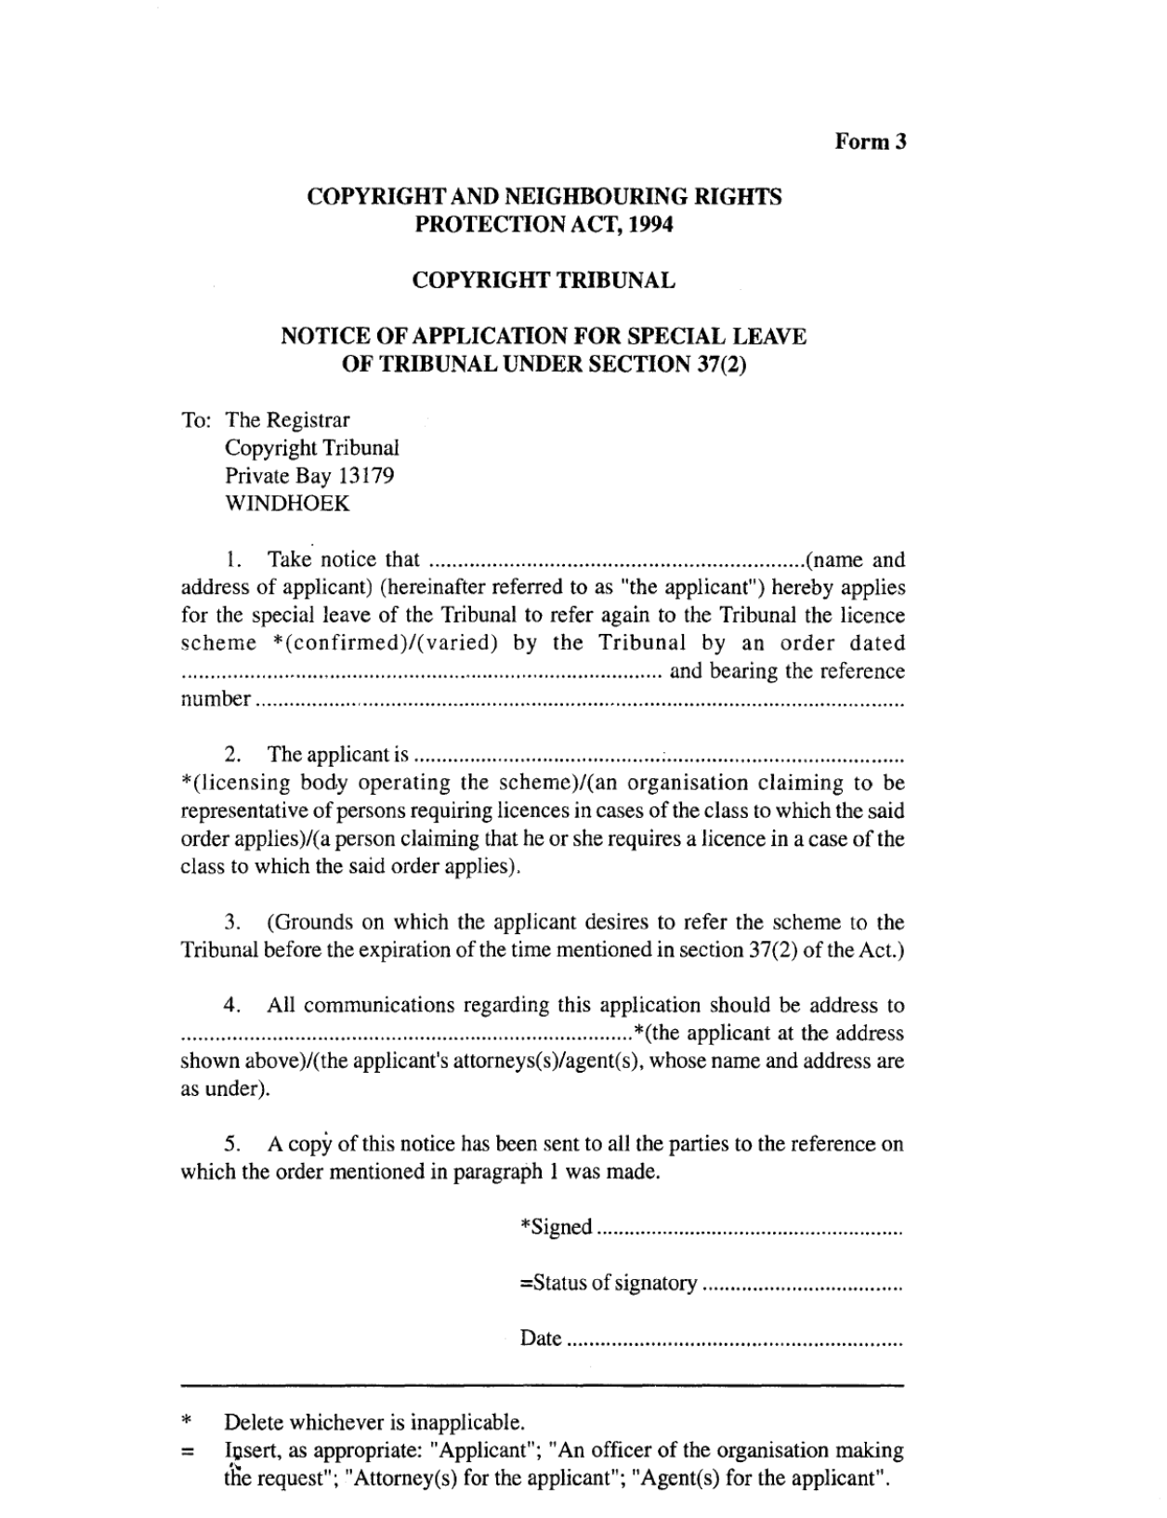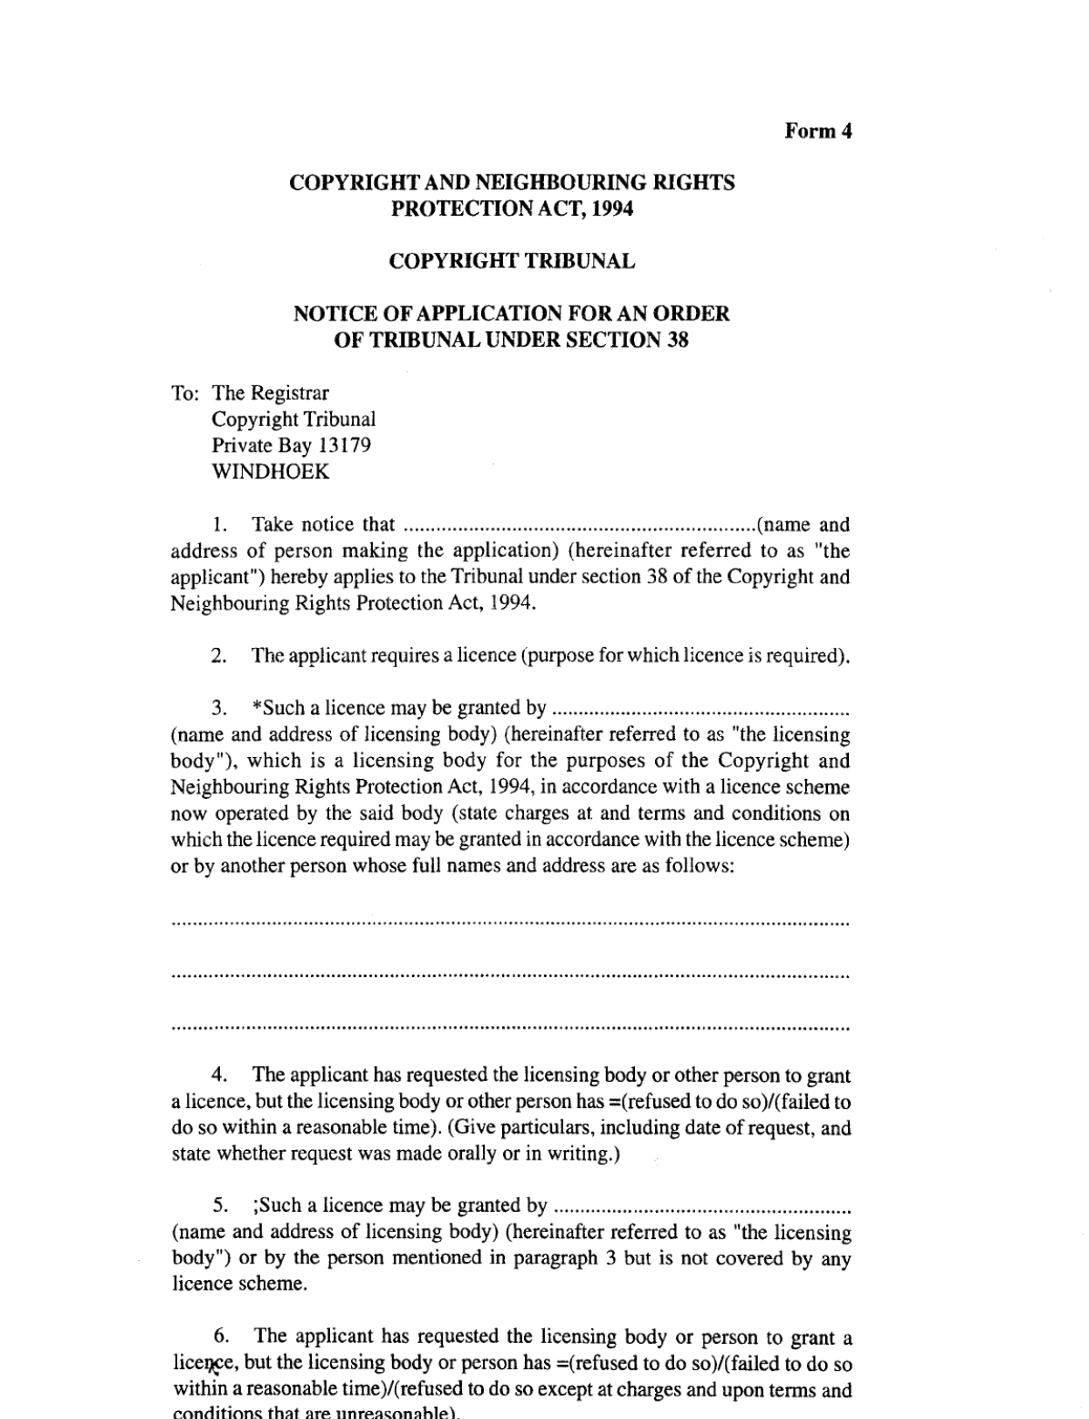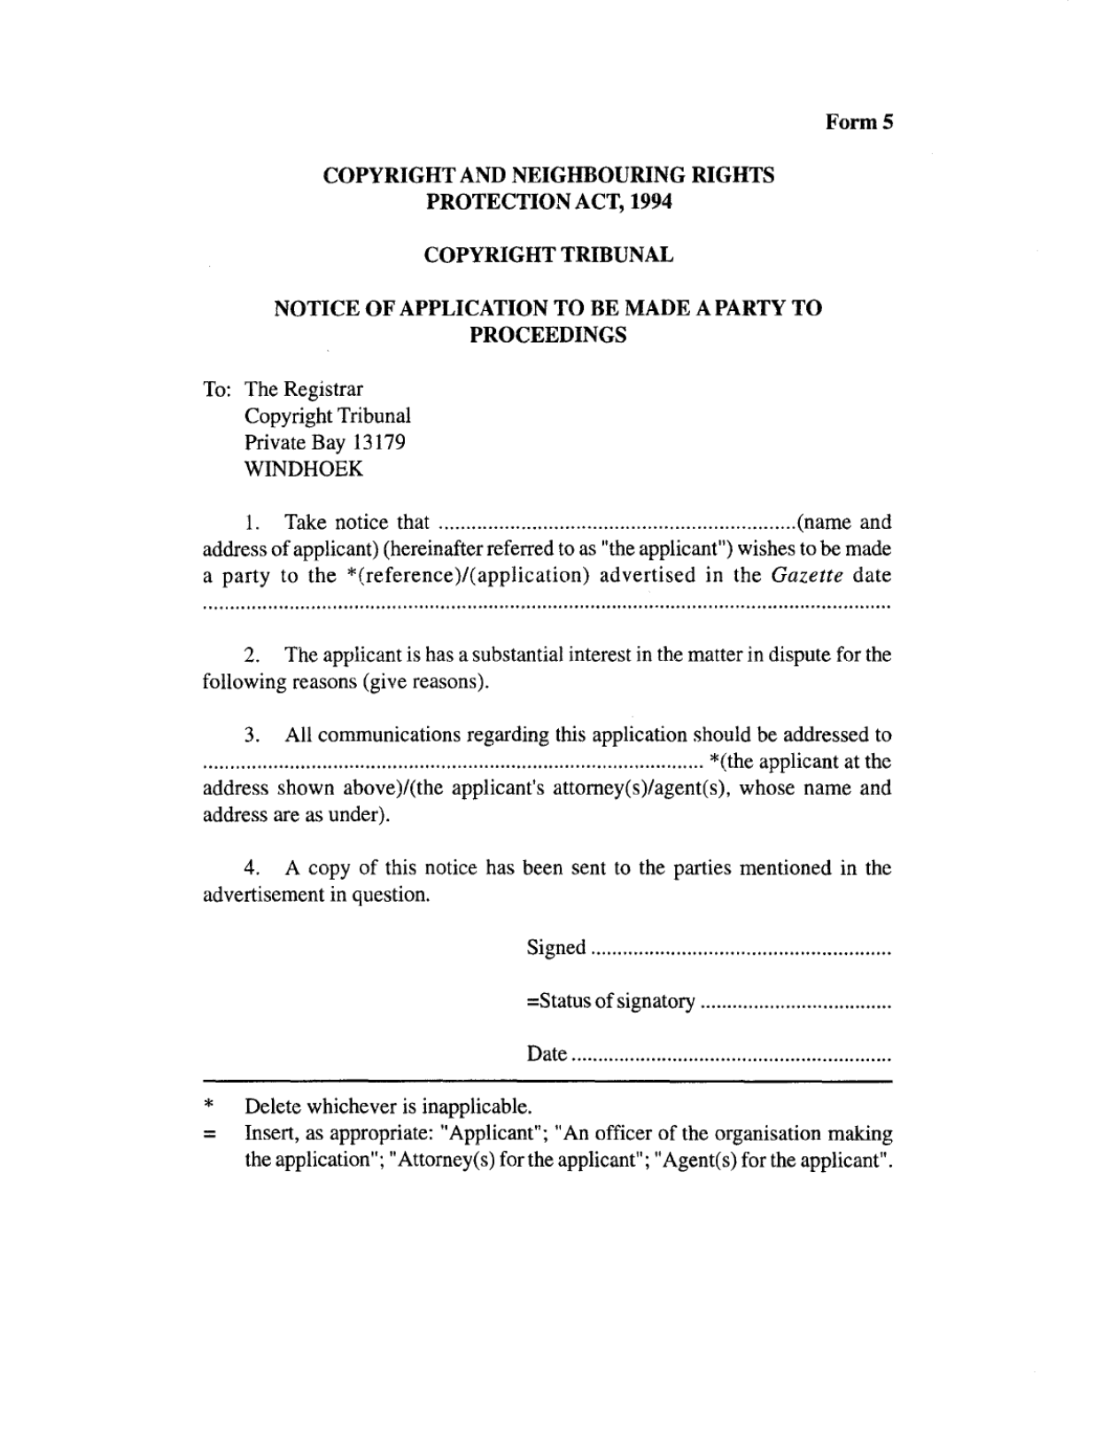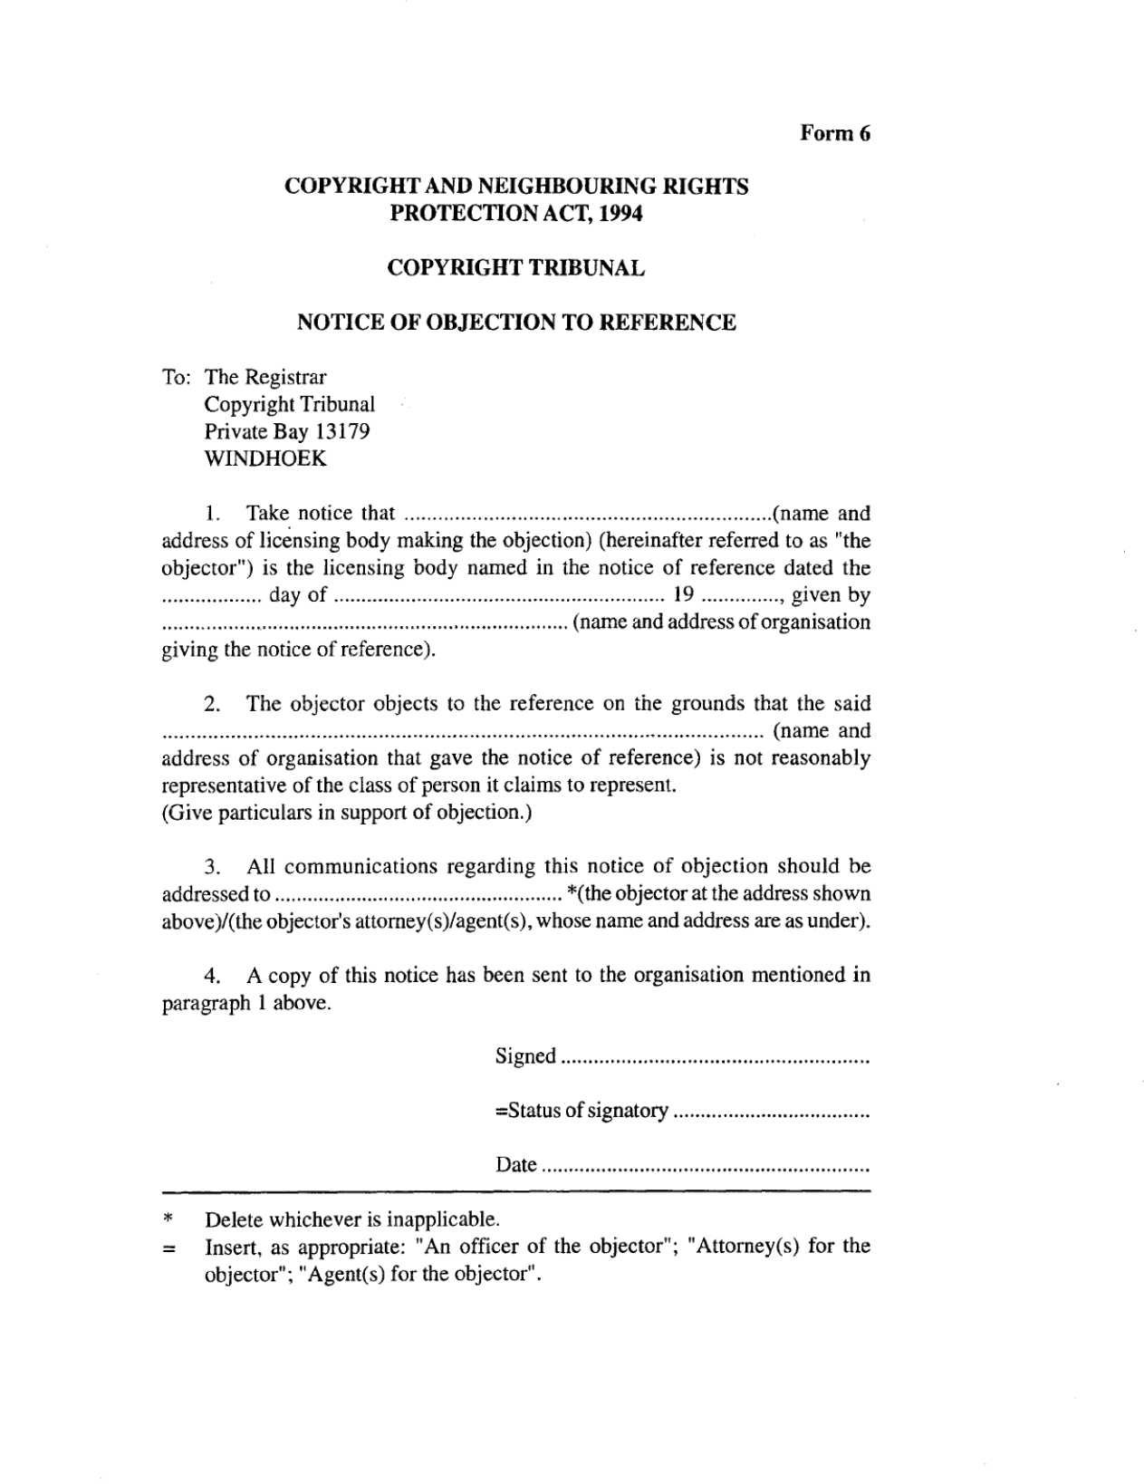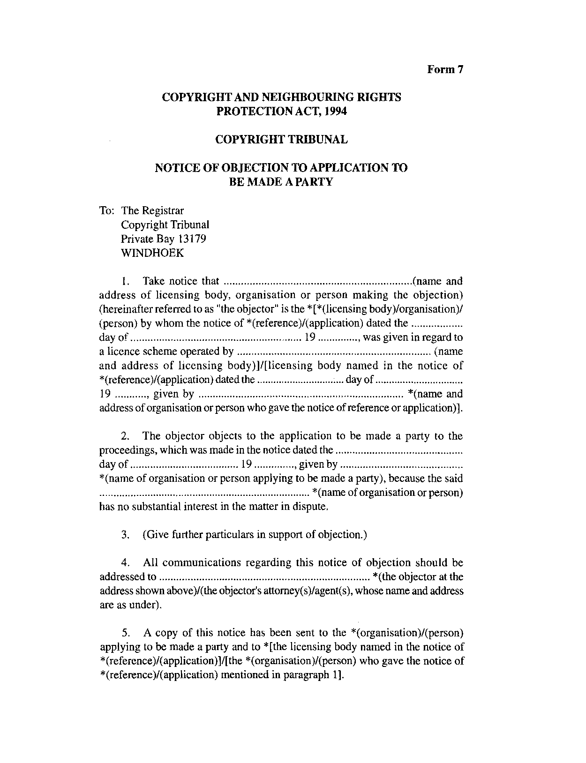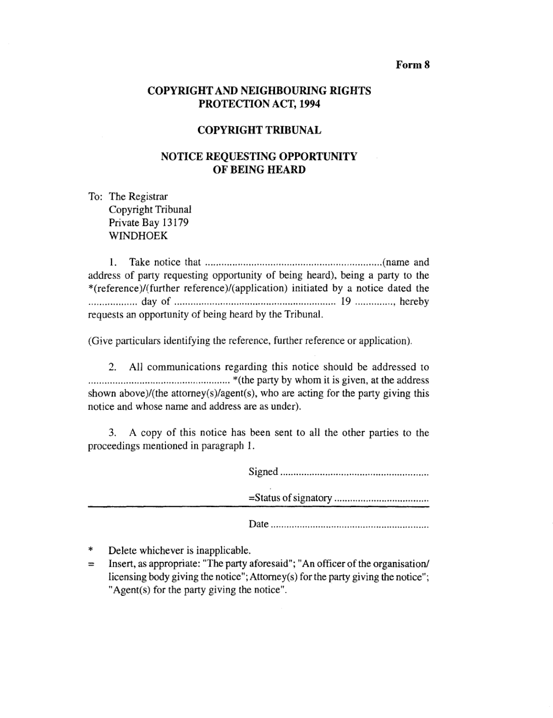

ANNEXURE B

FEES
(regulation 31)

The fees payable in respect of proceedings before the Tribunal are as set out below in the second column opposite the type of proceeding set out in the first column:

Type of proceeding | Fees payable  N$
1. Notice of reference or application  (Form 1, 2, 3, 4 or 5) | 30
2. Notice of objection (Form 6 or 7) | 10
3. Notice requesting hearing (Form 8) | 35
4. Interlocutory application | 10
5. Notice of objection to an interlocutory application | 10

