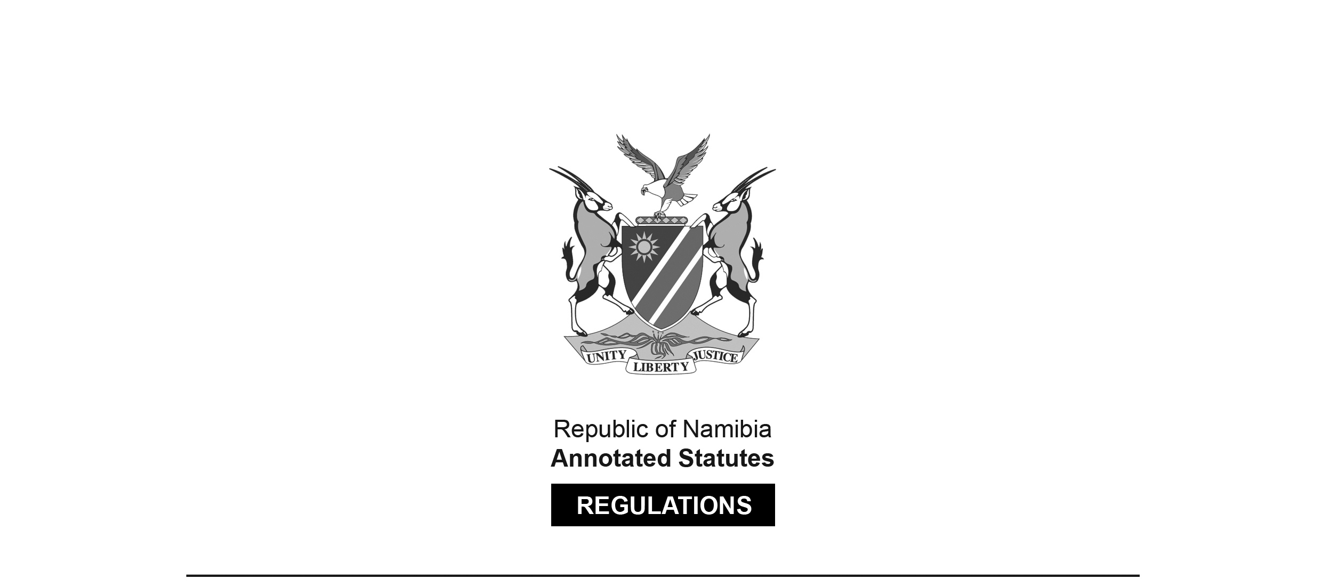

REGULATIONS MADE IN TERMS OF

Communications Act 8 of 2009

section 80 read with section 129 and the “Regulations Regarding Rule-Making Procedures: Communications Act, 2009”,   
General Notice 334/2010 (GG 4630)

Regulations in respect of Type Approval and Technical Standards for Telecommunications Equipment

General Notice 22 of 2015

(GG 5659)

came into force on 3 August 2015 in terms of General Notice 22 of 2015 (GG 5659)

as affected by

General Notice 265 of 2015 **(GG 5765)**

came into force on date of publication: 26 June 2015

General Notice 269 of 2016 **(GG 6074)**

came into force on date of publication: 18 July 2016

General Notice 177 of 2018 **(GG 6588)**

came into force on date of publication: 8 May 2018

and as amended by

General Notice 361 of 2019 **(GG 6992)**

came into force on date of publication: 11 September 2019

General Notice 159 of 2020 **(GG 7197)**

came into force on date of publication: 29 April 2020

These regulations and their amendments were made by the   
Communications Regulatory Authority of Namibia.

General Notice 265/2015 (GG 5765) states that it “amends the Regulations in respect of Type Approval and Technical Standards for Telecommunications Equipment published in General Notice No. 22 of 30 January 2015 by substituting the preamble thereof”. In fact, there is no Preamble. What is substituted is the text of the General Notice which promulgated the regulations. The substituted text contains transitional provisions which apply until 30 November 2015. General Notice 269/2016 (GG 6074) similarly substitutes the text of the General Notice which promulgated the regulations to provide for a transitional period up to 31 October 2016. The text as substituted by General Notice 269/2016 reads as follows:

“The Communications Regulatory Authority of Namibia, in terms of section 80 read with section 129 of the Communications Act, 2009 (Act No. 8 of 2009) and the “Regulations Regarding Rule-Making Procedures: Communications Act, 2009” published as a General Notice No. 334 in Government Gazette No. 4630 dated 17 December 2010, hereby publishes these Regulations in respect of Type Approval and Technical Standards for Telecommunications Equipment which will be in force and effective from date of publication of this Notice in the *Gazette* [18 July 2016]. There will be a transitional period within which applicants must obtain approval from the Authority in respect of telecommunications equipment, which transition period shall commence from the date of publication hereof and shall lapse on **31 October 2016**.

The transition period for the implementation of the Regulations in respect of Type Approval and Technical Standards for Telecommunications Equipment is extended from **01 May 2016** to **31 October 2016** subject to the following conditions:

a) All applications must be submitted within 90 days commencing from 01 May 2016 which period will lapse on 31 July 2016;

b) The Authority must process all applications received within the 90 days referred to above within a period of 90 days which period lapses on 31 October 2016;

c) All applications received after 31 July 2016, will be processed on a first come first serve basis, except if the applicant can prove that the telecommunications equipment was manufactured/introduced in the market after 31 July 2016, in which case the Authority must process the application by 31 October 2016; and

d) All applications submitted after 30 September 2016 must ensure that they receive type approval certificates before they import any telecommunications equipment into the country.

The purpose of the extension is to allow all persons to whom the Regulations are applicable, to submit and obtain type approval certificates.”

ARRANGEMENT OF REGULATIONS

1. Definitions

2. Submission of documents to the Authority

3. Purpose

4. Applicability

5. Telecommunication equipment requiring type approval

6. Registration of supplier

7. Application procedures

8. Declaration of conformity and criteria for approval

9. Decision by the Authority

10. Effect of successful application for type approval

11. Monitoring compliance and inspections

12. Revocation of type approval certificate

13. Fees

14. Prohibited telecommunications equipment

15. Amendment of technical standards

16. Non-compliance, Offences and Enforcement

17. Oral Hearings

18. Condonation

19. Ex parte communications

20. Record of proceedings

21. Reconsideration

ANNEXURE 1

Form 1: Application form Telecommunications equipment type approval

ANNEXURE 2

Type approval fees

ANNEXURE 3

Form 2: Renewal form Telecommunications equipment type approval

**Definitions**

**1.** In these regulations, any word or expression to which a meaning is assigned in the Act, shall have the same meaning and -

**“accredited test laboratory”** means any laboratory accredited by its own national accreditation body or another recognised accreditation body in terms of International Organisation for Standardisation/ International Electrotechnical Commission(ISO/IEC) requirements;

**“Act”** means the Communications Act, 2009 (Act No. 8 of 2009);

**“applicant”** means a person applying for type approval of telecommunications equipment in accordance with these regulations;

**“Authority”** means the Communications Regulatory Authority of Namibia as established in terms of Section 4 of the Communications Act, Act 8 of 2009;

**“Customs”** means the Department of Customs and Excise within the Ministry of Finance.

**“declaration of conformity”** means a written declaration issued by an applicant or manufacturer or supplier of telecommunications equipment in accordance with ISO/IEC 17050-1 requirements for which type approval is sought conforms to these regulations and applicable technical standards;

**“electronic communications”** means any emission, transmission or reception of sound, pictures, text or any other information by wire, radio waves, optical media, electromagnetic systems or any other means of a like nature;

**“electronic communications network”** means any system of electronic communications facilities, including without limitation -

(a) satellite systems;

(b) fixed systems (circuit- and packet-switched);

(c) mobile systems;

(d) fibre optic cables (undersea and land-based);

(e) electricity cable systems (to the extent used for electronic communications services); and

(f) other transmission systems, used for conveyance of electronic communications;

**“electronic communications service”** means a service provided to the public, sections of the public, the State, or the subscribers to such service, which consists wholly or mainly of the conveyance by any means of electronic communications over an electronic communications network;

**“foreign regulatory authority”** means a regulatory authority outside Namibia, which performs the same or substantially the same functions as the Authority and whose standards are acceptable to the Authority;

**“telecommunications equipment”** means communications or networking equipment with an interface to public network or wide area network services and includes but not limited to telecommunications terminal equipment, information technology equipment (including but not limited to a digital set-top box decoder), radio communication equipment powered by means of an internal or external electrical AC/DC energy source and electronic communications network equipment.

General Notice 177/2018 (GG 6588) contains a definition of “Telecommunications Equipment” for purposes of type approval. Schedule 1 of this notice lists equipment which will not require type approval from the date of publication of the notice (8 May 2018).

“STATEMENT OF INTERPRETATION OF THE DEFINITION OF “TELECOMMUNICATIONS EQUIPMENT” AS PER THE REGULATIONS IN RESPECT OF TYPE APPROVAL AND TECHNICAL STANDARDS FOR TELECOMMUNICATIONS EQUIPMENT: COMMUNICATIONS ACT, 2009

In terms of section 27(1)(d), and with reference to the Regulations in Respect of Type Approval and Technical Standards for Telecommunications Equipment, published in Government Gazette No. 5659, General Notice No. 22, dated 30 January 2015, and Regulations regarding Licence Exempt Spectrum published in Government Gazette No. 4839, General Notice No. 395 dated 25 November 2011, the Communications Regulatory Authority of Namibia hereby informs the public that:

1. In terms of the Regulations in Respect of Type Approval and Technical Standards for Telecommunications Equipment, “Telecommunications Equipment” is defined as:

“**communications** or **networking** equipment **with an interface to public network** or **wide area network services** and includes but not limited to telecommunications **terminal equipment**, **information technology** equipment (including but not limited to a digital set-top box decoder), **radio communication** equipment powered by means of an internal or external electrical AC/DC energy source and **electronic communications network equipment**.”

2. From a technical and legal perspective, only communications or networking equipment which interfaces with public network services or wide area network services require type approval.

3. This Notice therefore serves to inform the public of the interpretation formulated and adopted by the Authority with regards to the definition of “Telecommunications Equipment” for purposes of the requirements of type approval;

4. And further that in light of this interpretation, all equipment listed in Schedule 1 to this notice do **[sic]** not require type approval, effective from date of publication of this notice in the Government Gazette;

5. This Notice does not constitute or replace legal advice on obligations under the Communications Act, the Regulations in Respect of Type Approval and Technical Standards for Telecommunications Equipment, and the Regulations regarding Licence Exempt Spectrum; and

6. The aim of this Notice is to bring clarity and consistency to the type approval compliance procedure and is designed to contribute to fairness, integrity and good public administration.

The public may seek further clarity from the Authority at or through the following addresses:

a) Head Offices - Communications House, 56 Robert Mugabe Avenue, Windhoek;

b) Post - Private Bag 13309, Windhoek 9000;

c) Electronic mail - [legal@cran.na](mailto:legal@cran.na);

d) Facsimile - +264 61 222790; or

e) Fax to e-mail to 088642748.”

**SCHEDULE 1**

**[capitalisation and punctuation reproduced as it appears in *Government Gazette*]**

|  |  |  |
| --- | --- | --- |
| **EQUIPMENT TYPE** | **DESCRIPTION** | **SPECIFIED TECHNOLOGIES** |
| Vehicles components and systems (embedded in the vehicle) | Remote car keys (Immobilizer), Car parking sensor/systems, Car Radio with or without Bluetooth functionalities | Short Range Device  Lower power - With maximum radiated power limit of 10 Mw erp. |
| Gate/Garage remote control equipment | Gate/Garage door opener | Short Range Device  Lower power with maximum radiated power limit of 10 Mw erp. |
| Smart Watches | With Bluetooth only (without Wi-Fi functionality and SIM or Tracking features) | Short Range Device  Lower power |
| Speakers | With Bluetooth | Short Range Device  Lower power |
| Alarms and Movement detectors | Lower power Alarms and Movement detectors terminal. | Short Range Device  Lower power - With maximum radiated power limit of 10 Mw erp. |
| Audio devices | Cordless Audio devices, including wireless microphones | Short Range Device  Lower power - With maximum radiated power limit of 10 Mw erp. |
| Broadcast receivers | Receivers equipment’s only e.g. FM/AM Radio both analogue and digital  **[should read “equipment”]** |  |
| Broadcast Transmitters | FM/AM transmitter equipment’s (both analogue and digital)  **[should read “equipment”]** |  |

**“the website”** means the website of the Authority with URL: [www.cran.na.](http://www.cran.na/)

**“type approval”** means -

(a) The process undertaken by the Authority of authorising the use of telecommunications equipment in Namibia, involving the verification of such equipment’s conformity to and compatibility with the Act, applicable technical standards and other regulatory requirements; or

(b) the process undertaken by the Authority of examining and testing telecommunications equipment so as to determine whether such equipment has passed performance tests and quality assurance tests, and meets qualification criteria in accordance with applicable technical standards and other regulatory requirements.

**“type approval fees”** means fees relating to type approval as set out in Annexure 2 of these regulations;

**“type approval certificate”** means a certificate issued by the Authority to an applicant confirming that such applicant’s telecommunications equipment has been type approved;

**“type approval register”** means a register kept by the Authority pursuant to section 27 of the Act that contains basic technical and compliance information on all type approved telecommunications equipment, including any conditions the Authority attached to such type approval.

**Submission of documents to the Authority**

**2.** In these regulations “submit in writing to the Authority” means either physically or electronically -

(1) by hand to the head offices of the Authority, namely Communication House, 56 Robert Mugabe Avenue, Windhoek;

(2) by post to the head offices of the Authority, namely Private Bag 13309, Windhoek 9000;

(3) by electronic mail to the following address: operations@cran.na;

(4) by facsimile to the following facsimile number: +264 61 222 790; or

(5) in any other manner or at alternative addresses set out by the Authority from time to time.

**Purpose**

**3.** (1) The purpose of these regulations is to establish a type approval procedure to ensure that -

(a) telecommunications equipment used in Namibia comply with international standards applicable in Namibia;

(b) no sub-standard equipment which may represent health and safety hazards to consumers in general are operated in Namibia;

[The verb “are” should be “is” to be grammatically correct.]

(c) consumers are protected from products that are incompatible with local networks; and

(d) the operating frequency of telecommunications equipment, generally and radio apparatus in particular are in conformance with the national frequency band plan in Namibia so that no harmful interference is caused to essential services.

**Applicability**

**4.** (1) These regulations apply to -

(a) all persons (whether legal or natural persons) who use, sell, offer for sale or connect telecommunications equipment to an electronic communications network within the Republic of Namibia; and

(b) all telecommunications equipment used, sold, offered for sale or connected to an electronic communications network within the Republic Namibia.

(c) all radio communications equipment or apparatus’ pursuant to the Regulations regarding Licence Exempt Spectrum published in Government Gazette No. 4839, General Notice No. 395 dated 25 November 2011.

(2) These Regulations shall bind the State.

**Telecommunication equipment requiring type approval**

**5.** (1) A person or entity that intends to -

(a) connect any equipment to an electronic communication network in Namibia for purposes of electronic communications; or

(b) use, sell or offer for sale or re-sale telecommunications equipment in Namibia,

that is not type approved or exempted from type approval in terms of these regulations, must apply on Form 1 set out in Annexure 1 and submit the telecommunications equipment to the Authority for type approval in accordance with regulation 7 prior to the use, connection, sale or re-sale.

(2) The Authority must publish on its website -

(a) a list of telecommunications equipment that have been type approved; and

[The verb “have” should be “has” to be grammatically correct.]

(b) a list of telecommunications equipment exempted from type approval.

(3) Despite subregulation (1), but subject to subregulation (4), telecommunications equipment that -

(a) is temporarily imported into Namibia for re-export; or

(b) is used solely for the research and development of the equipment, demonstration of prototypes, testing or trials,

does not require type approval.

(4) A person or entity may not import telecommunications equipment that does not require type approval without the authorisation of the Authority, and the application for the authorisation must specify -

(a) the particulars of the equipment;

(b) the location where the equipment is to be based;

(c) the purpose of importing the equipment and use thereof; and

(d) the period of stay of the equipment in Namibia.

(5) A person or entity that intends to -

(a) connect any equipment to an electronic communication network in Namibia for purposes of electronic communications; or

(b) use, sell or offer for sale or re-sale telecommunications equipment in Namibia,

that has already been type approved in terms of these regulations must apply in a simplified certification process on Form 3 set out in Annexure 4 and in accordance with regulation 7 for a certificate to use, connect, sale or re-sale the already type approved telecommunications equipment.

[regulation 5 substituted by General Notice 361/2019]

**Registration of supplier**

**6.** (1) An applicant will be registered as a supplier of telecommunications equipment on the database of the Authority upon approval of such Applicant’s application for type approval.

(2) Registration of an applicant as supplier will happen once the supplier of telecommunications equipment applies for type approval for such equipment.

(3) Suppliers must inform the Authority if any of their registration details have changed within fourteen (14) days from the date when such registration details have changed.

**Application procedures**

**7.** (1) An applicant must submit an application on Form 1 set out in Annexure 1 of these Regulations in respect of telecommunications equipment requiring type approval.

(2) An application for type approval must be accompanied by-

(a) personal identification, a certificate of incorporation or a valid trade licence in the name of the applicant;

(b) a declaration of conformity in accordance with regulation 7;

(c) technical, physical, operational, installation and user information;

(d) software and firmware numbers of the telecommunications equipment being type approved;

(e) all other documentation as required by Part 5 of the application form;

(f) proof of payment of the applicable type approval fees as stipulated in Annexure 2.

(3) All copies of original documents submitted to the Authority in respect hereof should be certified copies, which has been certified by a Commissioner of Oath.

(4) The Authority may require an applicant to submit additional information as proof of complying with the applicable technical standards.

(5) An application form is not complete unless accompanied by the documents required in terms of sub-regulation (2) and where applicable, sub-regulation (4).

(6) In addition to the requirements of sub-regulation (2), the Authority may request an applicant for a sample of the telecommunications equipment requiring type approval for examination and testing to determine whether such equipment has passed performance tests and quality assurance tests, and meets the qualification criteria in accordance with applicable technical standards and other regulatory requirements.

(7) Samples of telecommunications communications equipment referred to in sub- regulation (6) must be -

(a) in good and proper working condition;

(b) properly configured for testing, complete with the necessary test adaptors, and

(c) clearly marked with the trade name, model and serial number.

(8) If the Authority requires clarification in respect of technical details or other specifications of the telecommunications equipment requiring type approval, or any other information or documentation required in terms hereof, the Authority may require the applicant to provide such clarification within fourteen (14) days from the date of such request by the Authority.

(9) The Authority will not be able to consider an application for type approval favourably if the applicant fails to respond to a request for clarification contemplated by sub-regulation (8) or fails to respond within the timeframe specified by the Authority.

(10) If an application for type approval does not comply with criteria and / or requirements as contained in these regulations the Authority must reject the application and notify the applicant in which respects the application is non-compliant.

(11) An unsuccessful applicant may address any non-compliance and submit a new application for type approval in terms of the procedures provided for in these regulations.

(12) If the Authority is satisfied that all the requirements of these regulations have been met, the Authority may issue a type approval certificate to the successful applicant, subject to such conditions that the Authority may impose.

(13) The type approval certificate referred to in sub-regulation (12) shall contain a registration number.

(14) All type approved telecommunications equipment must be entered on the type approval register which the Authority will publish on its website from time to time.

(15) If type approved telecommunications equipment undergoes a change of model, design, function and/or specifications, the type approval certificate will no longer be valid for the telecommunications equipment that underwent such change of model, design and/or specifications.

(16) A type approval certificate is no longer valid, if in terms of sub-regulation (15), the telecommunications equipment that underwent a change of model, design, function or specifications will require to be type approved in terms of these regulations.

**Declaration of conformity and criteria for approval**

**8.** (1) The Authority may accept a declaration of conformity by an applicant if accompanied by a certified copy of test reports and data issued by an accredited test laboratory confirming conformity of the telecommunications equipment for which type approval is sought with the applicable technical standards.

(2) In an application for type approval, the applicant must submit the test reports and data referred to in sub-regulation (1) without any modification whatsoever.

(3) In assessing an application for type approval, the Authority will take into account whether the test reports and data referred to in sub-regulation (1) were submitted and accepted by a foreign regulatory authority.

(4) The Authority shall not have regard to any test report and data accompanying a declaration of conformity in terms of sub-regulation (1) if such report and data are older than 5 years.

(5) The Authority may regard a declaration of conformity and its accompanying test reports and data as valid if such declaration, test report and data were prepared for the telecommunications equipment for which application for type approval is made and if no modification to the equipment was made following the completion of the test reports.

(6) The Authority is under no obligation to accept the test reports and may at its sole discretion require equipment to undergo another test

**Decision by the Authority**

**9.** (1) The Authority shall consider only complete applications for type approval and make a decision as to whether the application is approved or not, within fourty (40) days from the date of the submission of the application to the Authority by the Applicant.

[The word “forty” Is misspelt in the *Government Gazette*, as reproduced above.]

(2) The Authority should determine and/ or confirm whether the telecommunications equipment, for which type approval is applied for, complies with the required technical standards in respect of that particular telecommunications equipment.

(3) In the event that an application for type approval has been approved by the Authority, such decision shall in addition, be published on the official website of the Authority with the reasons for its decision, within seven (7) days from the date that the decision has been made.

(4) In the event that an application for type approval has been approved by the Authority, such applicant shall then be accordingly issued with a type approval certificate by the Authority.

**Effect of successful application for type approval**

**10.** (1) The holder of a type approval certificate or the owner of a telecommunications equipment that has been type approved by the Authority may only use, sell, offer for sale or connect telecommunications equipment to an electronic communications network which are identical in all material respects to the type approved telecommunications equipment in respect of which the type approval certificate has been issued.

[The verb “are” should be “is” to be grammatically correct.]

(2) After registration, any telecommunications equipment sample submitted at the request of the Authority may be returned to the applicant but the Authority may retain any related documents for reference purposes.

(3) A type approval certificate is valid for a period of three (3) years, and may be renewed by the Authority on application made -

(a) by the holder of such certificate on Form 2 set out in Annexure 3; and

(b) within a period of not less than thirty (30) days and not more than sixty (60) days prior to the date of expiry.

(4) An application for renewal of type approval certificate referred to in subregulation (3) is granted upon the submission of such information or documents as the Authority may require and on conditions that -

(a) no modification in respect of the model, design, function, or other information recorded in the type approval certificate or type approval register is made to the type approved telecommunications equipment;

(b) no significant changes are made to the technical specifications of the type approved telecommunications equipment, including but not limited to -

(i) the operating frequency band; and

(ii) RF power and technical standards upon which the telecommunications equipment was type approved; and

(c) the application is accompanied by a letter from the manufacturer confirming that the telecommunications equipment is still under their support.

(5) Neither the grant of type approval, nor the acceptance of test results in terms of these regulations may be construed as a guarantee by the Authority for the proper functioning, performance or quality of the type approved telecommunications equipment.

[There should be a comma after the phrase “nor the acceptance of test results   
in terms of these regulations” to offset that phrase properly.]

(6) A person or entity who or which connects telecommunications equipment to an electronic communications network in Namibia must ensure that such telecommunications equipment -

(a) is type approved; and

(b) inter-connects properly with the electronic communications network.

(7) The Authority is not liable for interference caused to other equipment, injury, loss of life or damage to property arising from the direct or indirect use of the type approved telecommunications equipment.

(8) A network operator may not refuse connection of type approved telecommunications equipment unless there are reasonable grounds, as determined by the Authority, that such connection should be refused.

[regulation 10 substituted by General Notice 361/2019]

**Monitoring compliance and inspections**

**11.** (1) The Authority may perform market surveillance activities from time to time in accordance with the provisions of Chapter X of the Act.

(2) The holders of type approval certificates must cooperate in such activities and may be required by the Authority to provide, without charge to the Authority, samples of telecommunications equipment and documentation.

(3) If any person is found to be in non-compliance with these regulations or the applicable technical standards, the person must forthwith cease to use, sell or offer for sell or connect the telecommunications equipment to an electronic communications network or type of telecommunications equipment concerned and dispose thereof at their own expense as directed by the Authority.

(4) The Authority may seize non type approved telecommunications equipment that does not comply with applicable technical standards or these regulations or that belongs to a category of telecommunications equipment for which type approval is required as contemplated in these regulations and that has not been so approved.

**Revocation of type approval certificate**

**12.** (1) Where the Authority is satisfied upon an investigation conducted in terms of Chapter X of the Act that -

(a) any information provided to the Authority by the holder of a type approval certificate is found to be counterfeited or false;

(b) type approved telecommunications equipment does not comply with applicable technical standards or these regulations;

(c) there is a breach of any condition endorsed on the type approval certificate;

(d) type approved telecommunications equipment is causing or likely to cause harmful interference to an electronic communications network or is a risk to human health or the environment,

the Authority may by written notice to the holder of a type approval certificate inform such holder that the Authority intends to cancel the type approval certificate, and in such notice state the grounds for such intended action and require the holder of the type approval certificate to cease the distribution and selling of such equipment with immediate effect.

(2) A holder of a type approval certificate may, within fifteen (15) days from the date of receipt of a notice referred to in sub-regulation (1), make written representations to the Authority on good cause shown as to why the certificate should not be cancelled.

(3) After consideration of the representations referred to in sub-regulation (2) or, if no such representations have been made, upon the expiry of the period mentioned in that sub-regulation, the Authority may -

(a) if the Authority is satisfied that it is just and equitable to do so in the particular case, by written notice to the registered holder of a type approval certificate withdraw the notice referred to in sub-regulation (1); or

(b) by written notice to the holder of the type approval certificate cancel the certificate.

(4) All telecommunications equipment that is the subject of a cancelled type approval certificate must be withdrawn from the market at the cost of the holder of the cancelled certificate within thirty (30) days from the date of receipt of the written notice referred to in paragraph (b) of sub-regulation (3).

**Fees**

**13.** (1) The Authority will charge type approval fees in accordance with Annexure 2 of these regulations which shall be applicable per equipment category as indicated in Annexure 2 hereof.

(2) All fees are payable in advance and are non-refundable.

(3) The fees set out in Annexure 2 will be adjusted in accordance with the Consumer Price Index as published by the Namibia Statistics Agency from time to time or such other percentage determined by the Authority.

(4) Fees adjusted annually as contemplated in sub-regulation (3) must be published annually in the Government Gazette by the Authority.

**Prohibited telecommunications equipment**

**14.** (1) The Authority may from time to time publish a list of prohibited telecommunications equipment on its website.

(2) No person may import, sell, offer for sale or connect telecommunications equipment appearing on the list referred to in sub-regulation (1).

(3) The Authority may in conjunction with relevant Government agencies restrict the importation of any telecommunications equipment into Namibia, where the Authority is satisfied that such equipment may cause damage or harmful interference to electronic communications networks or poses a risk to public health and safety or the environment.

(4) An applicant, being a natural and/or legal person, who intends to use, sell, offer for sale or connect telecommunications equipment to an electronic communications network within the Republic of Namibia, shall not be allowed to import such telecommunications equipment into the Republic of Namibia without a type approval certificate issued by the Authority.

**Amendment of technical standards**

**15.** (1) Whenever technical standards are amended, the holder of such type approved telecommunications equipment must ensure that such equipment is re-assessed by the Authority to determine if due to the amended standard, the equipment requires further type approval in terms of these regulations.

(2) If the equipment referred to in sub-regulation (1) requires further type approval, an application must be made to the Authority in this regard in terms of regulation 7 hereof before the date when the amended technical standards comes into operation and subject to regulation 13 of these regulations.

[The verb “comes” should be “come” to be grammatically correct.]

**Non-compliance, Offences and Enforcement**

[The capitalisation of this heading is reproduced as it appears in the *Government Gazette*.]

**16.** (1) It shall be the duty of every person who uses, sells, offers for sale or connects to an electronic communication network any telecommunications equipment requiring type approval in terms of these regulations to ensure that such equipment is type approved by the Authority and complies with the provisions of the Act and these regulations.

(2)

[subregulation (2) deleted by General Notice 159/2020]

**Oral Hearings**

[The capitalisation of this heading is reproduced as it appears in the *Government Gazette*.]

**17.** (1) If the Authority considers it necessary and appropriate, it will also hear oral submissions in respect of applications made in terms of these regulations.

(2) The Authority will invite the public, at least fourteen (14) days prior to the hearing, to make oral submissions.

(3) Unless otherwise specified by the Authority, such hearings will be open to the public.

(4) The format and agenda of the hearing is at the discretion of the Authority, depending on the nature of the proceedings, provided however, that the hearing should be informal in nature.

(5) All oral submissions must -

(a) include a statement indicating the name and contact details of the person making the oral submission and the name and contact details of the person for whom the oral submission is made, if different;

(b) be clear and concise; and

(c) conform to any further requirements determined by the authority from time to time.

(6) If the Authority considers it necessary, it will provide the opportunity to the Applicant to respond to oral submissions.

(7) The Authority may request further oral or written submissions, for example, further information or clarification, which must be provided to the Authority in the time and in the manner as set out in regulation 7(8) and regulation 2 respectively in these regulations.

(8) At the conclusion of the hearing, a concise report summarizing the oral submissions must be prepared and placed in the relevant application file by the Authority.

**Condonation**

**18.** (1) In the event an applicant is unable to comply with any time set out in these regulations, it may request from the Authority an extension of time at least seven (7) days prior to the time set out or within such other time period agreed by the Authority upon good cause shown.

(2) The Authority will respond to the request for condonation as soon as practicable, and may at its sole discretion either grant or deny the request, in its sole discretion, based on, among other things, the nature of the information and the reasons for non-compliance with the time set out.

**Ex parte communications**

**19.** (1) A person may not communicate with the members of the Board, the CEO or staff members of, or consultants to the Authority, to discuss the subject matter of an application proceeding in terms of these regulations, except as provided for herein.

**Record of proceedings**

**20.** (1) All documents deemed relevant by the Authority to the application proceedings contemplated by these regulations, including information and documentation provided in terms of these regulations and decisions made by the Authority, must be maintained by the Authority separately for each application in files located at the Head offices of the Authority and, if practicable, on the Authority’s website.

(2) Except for information deemed to be confidential in terms of section 28 of the Act, any person may examine the application proceeding files either at the Head offices of the Authority during normal business hours and copies may be made on payment of a fee determined by the Authority from time to time, and, if available, on the Authority’s website where copies may be downloaded free of charge.

**Reconsideration**

**21.** (1) The Authority may, on its own motion, reconsider any decision made in terms of these regulations within ninety (90) days from the date of making decision.

[The word “the” appears to have been omitted between “making” and “decision”.]

(2) Any person may submit to the Authority in writing a request to reconsider any decision made in terms of these regulations within thirty (30) days from the date that the decision has been made, and the Authority may reconsider the decision within ninety (90) days from the date that the decision has ben made.

[The word “been” in the phrase “the decision has been made” is   
misspelt in the *Government Gazette*, as reproduced above.]

(3) The Authority may publish its decision on reconsideration in terms of the provisions of these Regulations.

ANNEXURE 1

(FORM 1)

To view content without printing, scroll down.

To print at full scale (A4), double-click the icon below.



[Annexure 1 substituted by General Notice 361/2019]

[Annexure 1 substituted by General Notice 361/2019]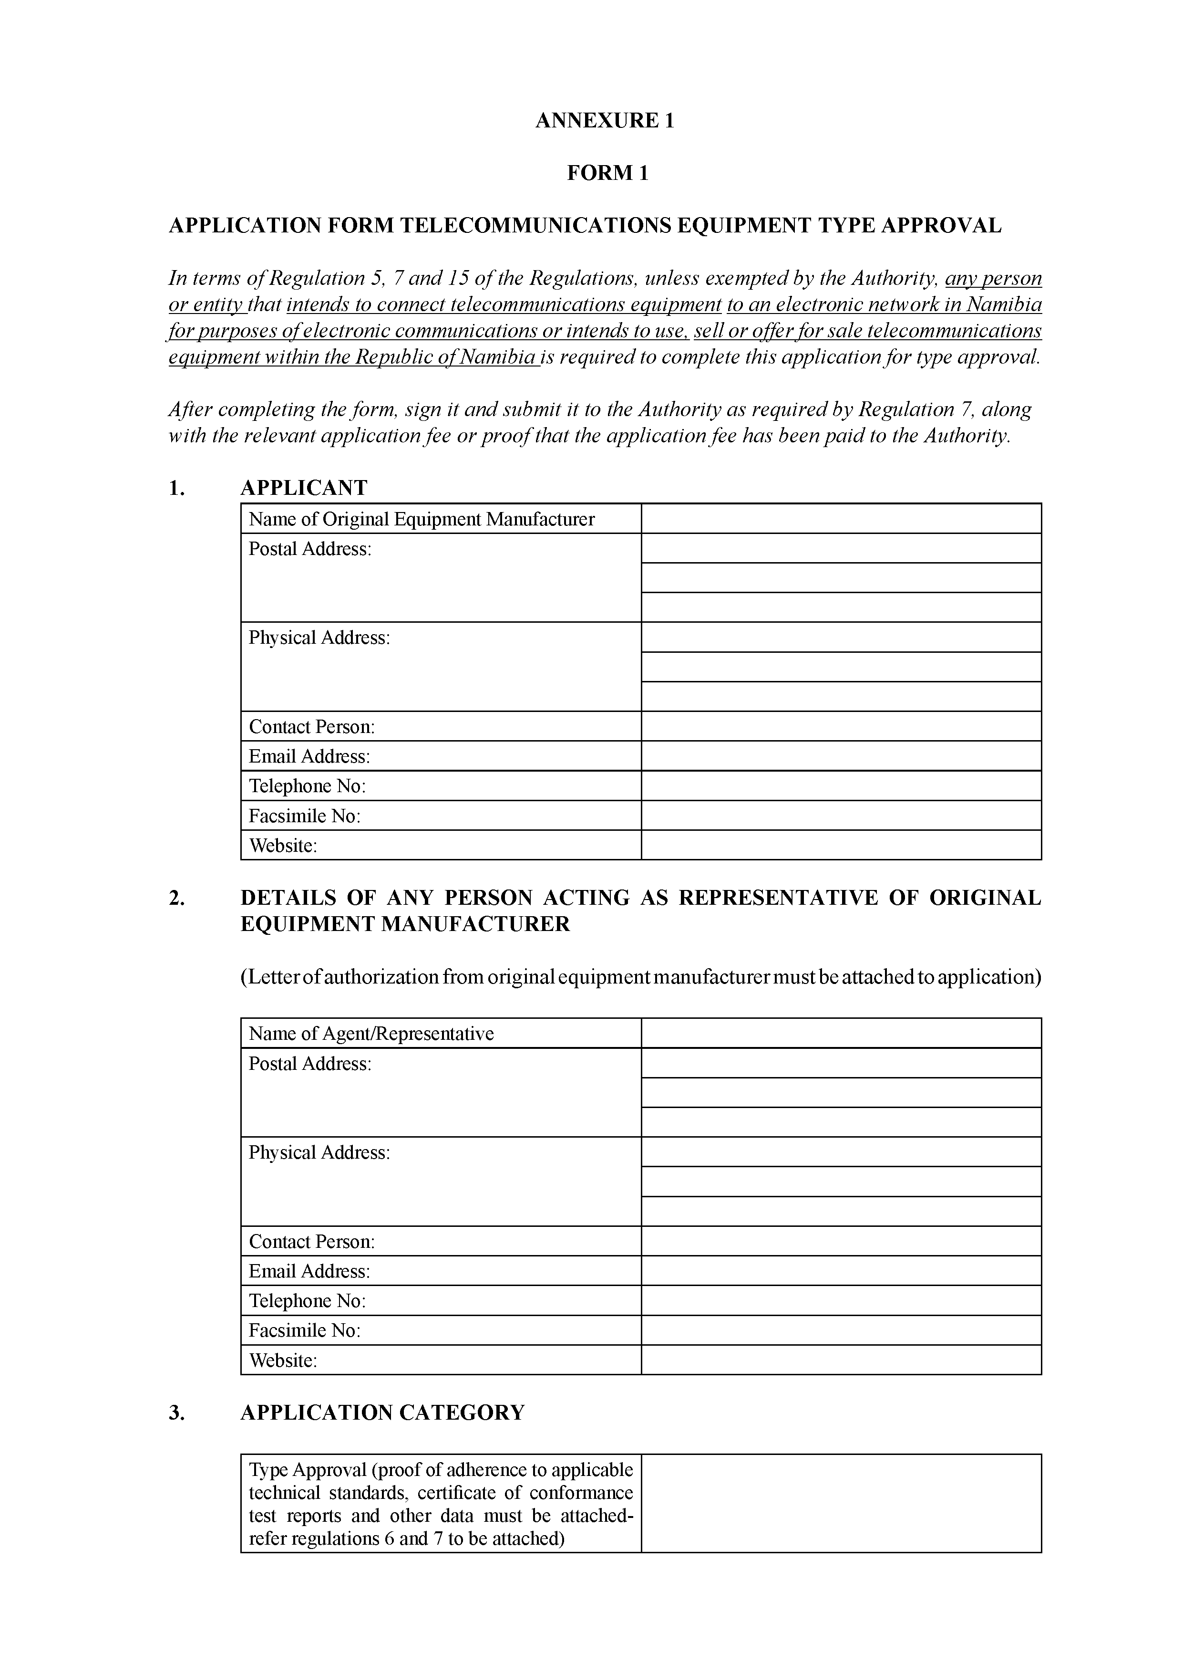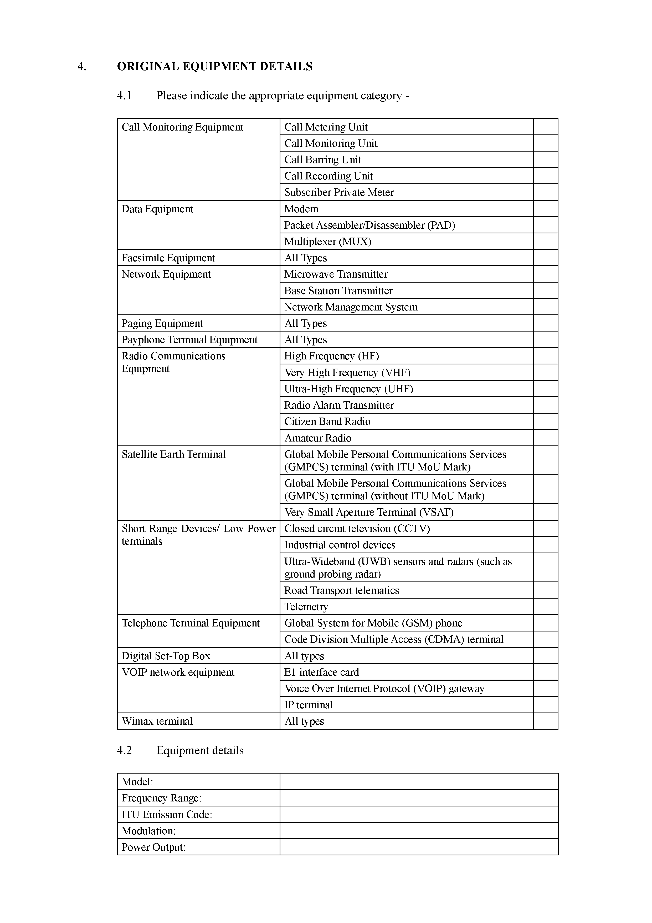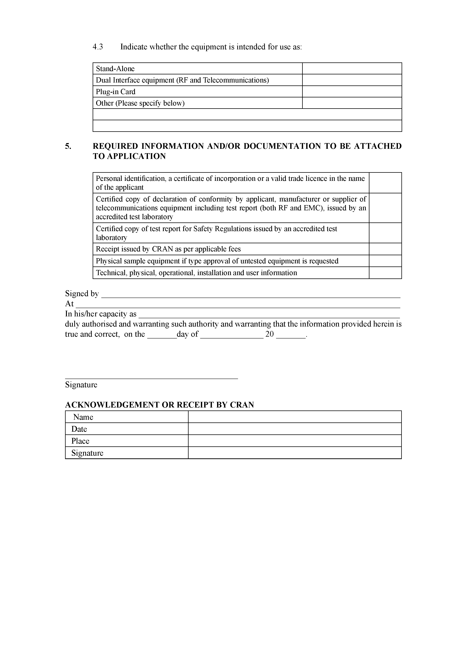

**ANNEXURE 2**

**TYPE APPROVAL FEES**

|  |  |  |
| --- | --- | --- |
| **EQUIPMENT CATEGORY** | **EQUIPMENT INCLUDED IN THIS CATEGORY** | **FEES (N$)** |
| **Radio Transmitter Equipment** | **Community Radio Transmitter** | **1,000.00** |
| **Call Monitoring Equipment** | **Call metering unit** | **250.00** |
| **Call monitoring unit** | **250.00** |
| **Call barring unit** | **250.00** |
| **Call recording unit** | **250.00** |
| **Subscriber private meter** | **250.00** |
| **Data Equipment** | **Modem** | **450.00** |
| **Router** | **450.00** |
| **Switch** | **450.00** |
| **Packet Assembler/Disassembler (PAD)** | **450.00** |
| **Multiplexer (MUX)** | **450.00** |
| **Facsimile Equipment** | **All types** | **450.00** |
| **Network Equipment** | **Microwave transmitter** | **3,000.00** |
| **Base Station transmitter** | **3,000.00** |
| **Network Management System** | **3,000.00** |
| **Paging Equipment** | **All types** | **450.00** |
| **Payphone Terminal Equipment** | **All types** | **450.00** |
| **Private Exchange Equipment** | **Private Manual Branch Exchange (PMBX)** | **1,500.00** |
| **Private Manual Branch Exchange (PABX)** | **1,500.00** |
| **Voice messaging system** | **1,500.00** |
| **Switchboard equipment** | **1,500.00** |
| **Media convergence server** | **1,500.00** |
| **Radio Communications Equipment** | **High Frequency (HF)** | **450.00** |
| **Very High Frequency (VHF)** | **450.00** |
| **Ultra-Hugh Frequency (UHF)** | **450.00** |
| **Radio alarm transmitter** | **450.00** |
| **Citizen band** | **450.00** |
| **Amateur** | **450.00** |
| **Satellite Earth Terminal** | **Global Mobile Personal Communications Services (GMPCS) terminal (with ITU MoU Mark)** | **100.00** |
| **Global Mobile Personal Communications Services (GMPCS) terminal (without ITU MoU Mark)** | **450.00** |
| **Very Small Aperture Terminal (VSAT)** | **1,500.00** |
| **Short Range Devices/Low power terminals** | **Access control (including door and gate openers)** | **250.00** |
| **Alarms and movement detectors** | **250.00** |
| **Closed-circuit television (CCTV)** | **250.00** |
| **Cordless audio devices, including wireless microphones** | **250.00** |
| **Industrial control** | **350.00** |
| **Local Area Networks** | **350.00** |
| **Medical implants** | **350.00** |
| **Ultra-Wideband (UWB) Sensors & Radars (such as ground probing radar)** | **250.00** |
| **Remote control** | **250.00** |
| **Radio frequency identification (RFID)** | **250.00** |
| **Road Transport Telematics** | **250.00** |
| **Bluetooth Devices** | **250.00** |
| **Car Radios** | **250.00** |
| **Telemetry.**  [superfluous full stop] | **250.00** |
| **Telephone Terminal Equipment** | **Ordinary telephone** | **250.00** |
| **Executive telephone** | **250.00** |
| **Cordless telephone** | **250.00** |
| **Answer machine integrated into the telephone** | **250.00** |
| **2 line Executive telephone** | **450.00** |
| **Cordless executive telephone** | **450.00** |
| **Intelligent executive telephone** | **450.00** |
| **Answering machine unit** | **450.00** |
| **Global System for Mobile (GSM) terminal** | **450.00** |
| **Code Division Multiple Access (CDMA) terminal** | **450.00** |
| **Digital Set-Top Box** | **All Types** | **450.00** |
| **Voice Over Internet Protocol (VOIP) Network Equipment** | **E1 interface card** | **2,500.00** |
| **VoIP gateway** | **2,500.00** |
| **IP terminal** | **2,500.00** |
| **WiMAX terminal** | **All types** | **450.00** |

ANNEXURE 3

(FORM 2)

To view content without printing, scroll down.

To print at full scale (A4), double-click the icon below.



