REGULATIONS MADE IN TERMS OF

Combating of Domestic Violence Act 4 of 2003
section 32

Domestic Violence Regulations
Government Notice 235 of 2003
(GG 3094)
came into force on date of publication: 17 November 2003

ARRANGEMENT OF REGULATIONS

1. Definitions
2. Manner of application for a protection order
3. Notice to attend enquiry
4. Procedure for enquiry
5. Service of documents
6. Interim protection order
7. Notice to oppose
8. Postponement of enquiry
9. Notice upon non-attendance by complainant at enquiry
10. Final protection order
11. Application for modification or cancellation of protection orders
12. Formal warning
13. Notice of court proceedings on bail or sentencing
14. Record of domestic violence incidents
15. Fees
16. Procedure for speedy hearing of domestic violence offences
17. Short title

FORMS

Form 1: Application for protection order
Form 2: Consent by the complainant for application for a protection order by someone else acting on his or her behalf
Form 3: Consent to be covered by a no-contact provision
Form 4: Notice to attend enquiry
Form 5: Interim protection order
Form 6: Notice of intention to oppose confirmation of protection order
Form 7: Notice of postponement of enquiry
Form 8A: Notice to station commander to enquire into reasons for complainant's non-attendance at enquiry
Form 8B: Report of station commander
Form 9A: Final protection order
Form 9B: Protection order
Form 10A: Application for modification or cancellation of protection order
Form 10B: Order for modification or cancellation of protection order
Form 11: Formal warning
Form 12: Notice of court proceedings on bail or sentencing
Form 13: Notice of bail and bail conditions
Form 14: Record of domestic violence incident

Definitions

1. In these regulations a word or expression to which a meaning has been given in the Act bears that meaning and, unless the context indicates otherwise -

“the Act” means the Combating of Domestic Violence Act, 2003 (Act No. 4 of 2003); and

“signature” includes writing a person’s name on a document or placing a person’s mark or thumb print on a document.

Manner of application for a protection order

2. (1) A person who makes an application for a protection order as contemplated in section 6(1) of the Act must make the application on a form corresponding substantially to Form I of the Annexure.

[Subregulation (1) refers to “Form I” (with a Roman numeral), but it should refer to “Form 1”.]

(2) Where an application is brought on behalf of a complainant by another person as contemplated in section 4 of the Act, the application must set out or contain -

(a) the basis for the applicant’s interest in the well being of the complainant; and

[The word “well-being” is normally hyphenated.]

(b) the written consent of the complainant, or the grounds for dispensing with such consent as contemplated in section 4(4) of the Act.

(3) The written consent to be given by the complainant as contemplated in section 4 of the Act must be in the form substantially corresponding to Form 2.

(4) Where an applicant for a protection order requests a no-contact provision in respect of a person other than the complainant, a child or other person in the care of the complainant as provided as contemplated in section 14(2)(b) of the Act, consent of that person, or where that person is a child, the consent of a parent or person in whose care that child is to the proposed no-contact provision must be attached to the application in the form substantially corresponding to Form 3.

(5) An application for a protection order must be dealt with as a matter of urgency and the court may sit after ordinary court hours and on days which are normally not considered as court days to hear such applications if the need arises.

Notice to attend enquiry

3. The notice to attend an enquiry as contemplated in section 11(1) must be in a form substantially corresponding to Form 4.

Procedure for enquiry

4. (1) Where it considers it appropriate in the interests of the moral welfare or safety of the applicant, the court may order that the public or press be excluded from a domestic violence enquiry.

(2) A court holding an enquiry must administer an oath to, or accept an affirmation from any witness appearing before it and record the evidence of that witness.

(3) The enquiry referred to in subregulation (1) must be held in the presence of the respondent or in his or her absence, on production of proof that the respondent was served with the notice referred to in regulation 3.

(4) Unless otherwise provided for in the Act or in these regulations, proceedings at an enquiry must be conducted in accordance with practice and procedure followed in civil proceedings in the magistrates courts in Namibia.

[There should be an apostrophe after the word “magistrates” (“magistrates’ courts”).]

(5) The court may, when conducting an enquiry, depart from any strict rule of practice or procedure as contemplated in subregulation (4), if the court considers that departure from that practice or procedure would ensure that substantial justice is achieved between the parties to the enquiry.

(6) The court must, where both or one of the parties are not represented, assist such parties in the quest to ensure that substantial justice is achieved and may use its discretion to ensure that the inquiry is held in a relaxed atmosphere where the parties can express themselves freely.

(7) The court holding an inquiry must play an active role in the proceedings and may at any time during the inquiry cause any person to be summoned as a witness or examine any person who is present at the inquiry, although that person was not summoned as a witness, and may recall and re-examine any person already examined, in an objective attempt to determine the facts in a manner that is aimed at ensuring that substantial justice is achieved between the parties.

(8) The court holding an inquiry must keep record of the proceedings or cause the proceedings to be recorded in full be it in shorthand or by mechanical means by a person directed by the presiding officer to do so.

(9) Notwithstanding anything contained in any other law, the following evidence is admissible at an enquiry -

(a) previous convictions as far as it pertains to acts of violence be it domestic or otherwise;

[The phrase “it pertains” should be “they pertain” to be grammatically
correct, and the phrase “be it” should be “be they”.]

(b) records of previous protection orders refused or granted against any of the parties;

(c) reports of acts of domestic violence reported to the police;

(d) formal warnings issued by the police; or

(e) variations or cancellation of protection orders.

(10) At the inquiry, a statement in writing by any person, other than one of the parties, is admissible as evidence to the same extend as oral evidence to the same effect by the person concerned, but, a copy of the statement must, at least 14 days before the date on which the statement is to be submitted as evidence, be served on the other party and he or she may at least seven days before the commencement of the inquiry, object to the statement.

(11) Where a party wishes to arrange to summon witnesses through the court, the clerk of the court must assist such person to identify and summon such witnesses where the court considers it necessary, it may however limit the number of persons to be called as witnesses.

[One or more words appear to have been omitted after the word “necessary,”.]

(12) If a person -

(a) objects to the production of a statement as contemplated in subregulation (10), the court must inquire into the reasons for such objection and after doing so give a ruling as to whether such statement is admissible as evidence or not; or

(b) does not object, the statement contemplated in subregulation (10) may on its production at the inquiry be admitted as evidence in the inquiry.

Service of documents

5. (1) Service of any documents which are required to be served under the Act or these regulations must, subject to subregulation (2), be served by a member of the Namibian Police as part of that member’s duties under section 26 of the Act.

(2) Subject to any guidelines made under section 26(1), the Station Commander of the relevant police station must ensure that reasonable efforts are made by a member of the police to serve the documents as provided in subregulation (1) within 5 days of receiving them from the clerk of the court.

(3) Where documents cannot be served by the police as contemplated in subregulation (1), service must be effected without delay by the clerk of the court by -

(a) handing or presenting a certified copy of the document to the person on whom the document is to be served;

(b) sending a certified copy of the document to that person by registered mail and endorsing the original document to this effect; or

(c) directing the messenger of the court to forthwith serve the document on the person to be served by delivering a certified copy of the document in any one of the following manners -

(i) handing or presenting it to that person personally;

(ii) handing or presenting it at that person’s residence or place of business to a person apparently not less than 16 years of age residing or employed there; or

(iii) handing or presenting it at that person’s place of employment to a person apparently not less than 16 years of age and apparently in authority over that person or in the absence of such a person in authority, to a person apparently not less than 16 years of age and apparently in charge at that person’s place of employment.

(3) Where the person on whom a document is to be served keeps his or her residence, place of business or place of employment closed and thereby prevents the messenger of the court from serving the document in the manner described in subregulation (2), the messenger of court must effect service of the document by affixing it to the outer or principal door or security gate of such residence, place of business or place of employment.

[There are two subregulations numbered “(3)”. This subregulation should
be numbered “(4)”, with the remaining subregulations changed accordingly.]

(4) Subject to section 20 of the Act, any costs which are incurred when service of documents is effected by the messenger of court must be borne by the State.

(5) Any matter relating to the service of documents not provided for in the Act or in these regulations must be carried out in the same manner in which service of court process is carried out in the magistrates court.

[There should be an apostrophe in the word “magistrates” (“magistrate’s court”).]

(6) For the purposes of this regulation “residence” means, where the building is occupied by more than one person or family, that portion of the building occupied by the person on whom service is to be effected.

Interim protection order

6. An interim protection order made in terms of section 8 of the Act must be in a form substantially corresponding to Form 5.

Notice to oppose

7. A notice of an intention to oppose on the part of the respondent as contemplated in section 11 of the Act must be in a form substantially corresponding to Form 6.

Postponement of enquiry

8. If an enquiry held in terms of section 12 of the Act is postponed in the absence of one of the parties, notice of the new court date must be prepared in a form substantially corresponding to Form 7 and served on the absent party in the manner prescribed in Regulation 5.

Notice upon non-attendance by complainant at enquiry

9. (1) If an applicant fails to appear at an enquiry under the circumstances set out in section 12(15) of the Act, notice to the station commander of the police station named in the application to enquire into the reasons for such non-appearance must be made in a form substantially corresponding to Form 8A.

(2) The report of the station commander to the notice referred to in subregulation (1) must be in a form substantially corresponding to Form 8B and that notice forms part of the official record of the proceedings.

(3) If the court, on consideration of the response of the station commander, is satisfied that the non-appearance of the applicant was due to intimidation of the applicant or to a fear of harm on the part of the applicant, the court must set a new date for the enquiry and make an order for such police protection as will be sufficient to enable the safe attendance of the complainant on court date.

Final protection order

10. A final protection order contemplated in section 13(1) of the Act, whether or not it is preceded by an interim protection order, or an order for the modification or cancellation of a protection order as contemplated in section 17 of the Act, must be in a form substantially corresponding to Form 9A, accompanied by Form 9B where appropriate.

Application for modification or cancellation of protection orders

11. (1) An application for the modification or cancellation of a protection order in terms of section 17 of the Act must be in a form substantially corresponding to Form 10A.

(2) Where the court has granted the application contemplated in subregulation (1) notice must be given to the other party and that notice must be in a form substantially corresponding to form 10B of the annexure.

[The word “Form” in the phrase “”Form 10B” should be capitalised.]

Formal warning

12. (1) A formal warning as contemplated in section 23(1)(b) of the Act must be in a form substantially corresponding to Form 11.

(2) Whenever a formal warning is issued in terms of section 23(1)(b) of the Act, the station commander of the police station in question must place a copy of the warning on file at that police station and must forthwith transmit a copy of the formal warning to the Office of the Prosecutor-General either by hand or by post.

(3) The Prosecutor-General must cause all formal warnings received in terms of these Regulations to be filed in a register kept for such purposes.

(4) Any person who fails to comply with a warning issued in accordance with subregulation (1) commits an offence and is liable on conviction to a fine not exceeding N$2000 or to imprisonment for a period not exceeding six months.

Notice of court proceedings on bail or sentencing

13. (1) Notice to the complainant of proceedings for sentencing as contemplated in section 25(1) of the Act, or for bail as contemplated in section 60A of the Criminal Procedure Act, 1977 (Act No. 51 of 1977) must be in a form substantially corresponding to Form 12.

(2) If the bail proceedings contemplated in subregulation (1) are postponed in the absence of the complainant, the complainant must be notified of the new date in a form substantially corresponding to Form 12.

(3) If bail is granted to the accused in the absence of the complainant, the complainant must be notified of the fact that bail was granted, and of any bail conditions, in a form substantially corresponding to Form 13.

(4) All notices in terms of this regulation must be served on the complainant in the manner prescribed in Regulation 5.

Record of domestic violence incidents

14. Records of domestic violence incidents as contemplated in section 27 of the Act must be kept in a form substantially corresponding to Form 14.

Fees

15. Fees in terms of section 29(1) of the Act must be the same as those prescribed in Rule 34 of the Magistrates Court Rules of Court promulgated by Government Notice No. R1108 of 21 June 1968.

[This regulation should refer to the “Magistrates’ Courts Rules of Court”.]

Procedure for speedy hearing of domestic violence offences

16. (1) In pursuance of the speedy hearing, verdict and sentencing of domestic violence offences as contemplated in section 32(1)(d), the prosecutor must, as a matter of priority, place a criminal case involving any domestic violence offence on the court roll as soon as it is received.

(2) Where a postponement in a criminal case concerning a domestic violence offence is granted at the request of the accused, the court may remand the defendant in custody until the new court date regardless of whether or not the accused was previously in custody or out on bail as long as -

(a) there is a prima facie evidence that a domestic violence offence has been committed; and

[The word “a” in the phrase “a prima facie evidence” is superfluous.]

(b) the court is satisfied that the victim of the alleged offence may be at risk if defendant is not confined until the conclusion of the case.

(3) If a postponement is granted for any reason in a case involving a domestic violence offence, the prosecutor must re-schedule the case on the court roll in order to ensure that the case is heard as a matter of priority.

Short title

17. These regulations shall be called the Domestic Violence Regulations.

FORMS

To view content without printing, scroll down.

To print at full scale (A4), double-click the icon below.

[On Form 4, the heading “CONSENT TO BE COVERED BY A NO-CONTACT PROVISION”
is in error. That topic is covered by Form 3.]

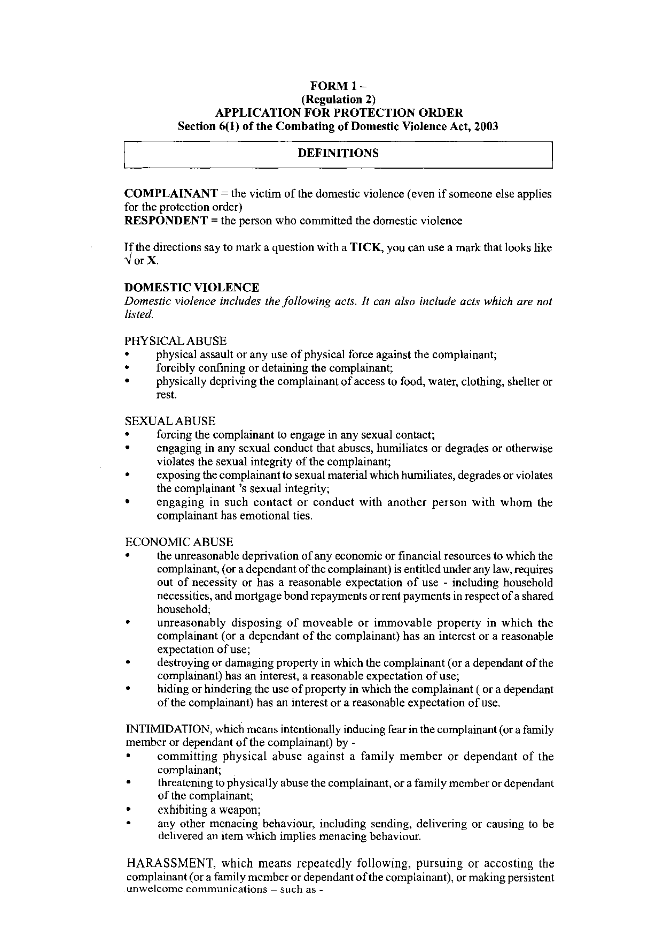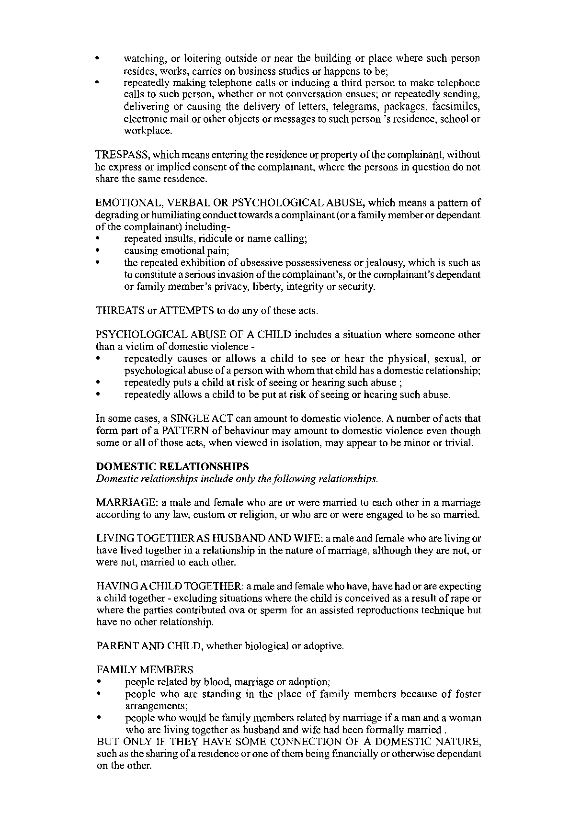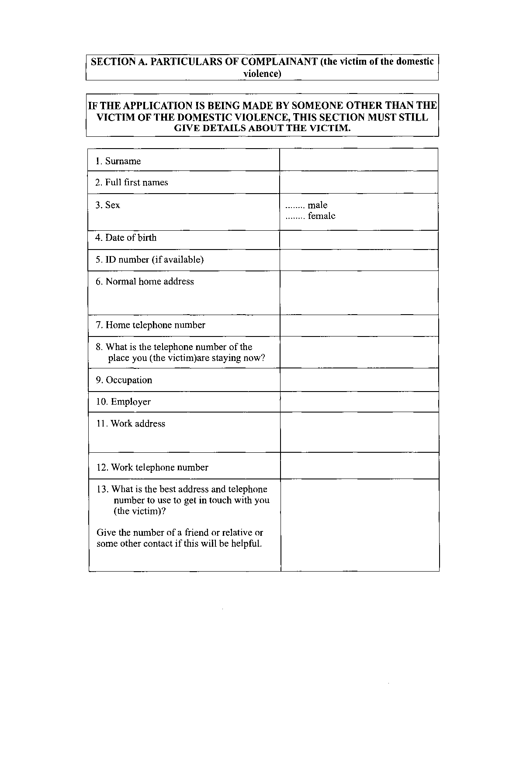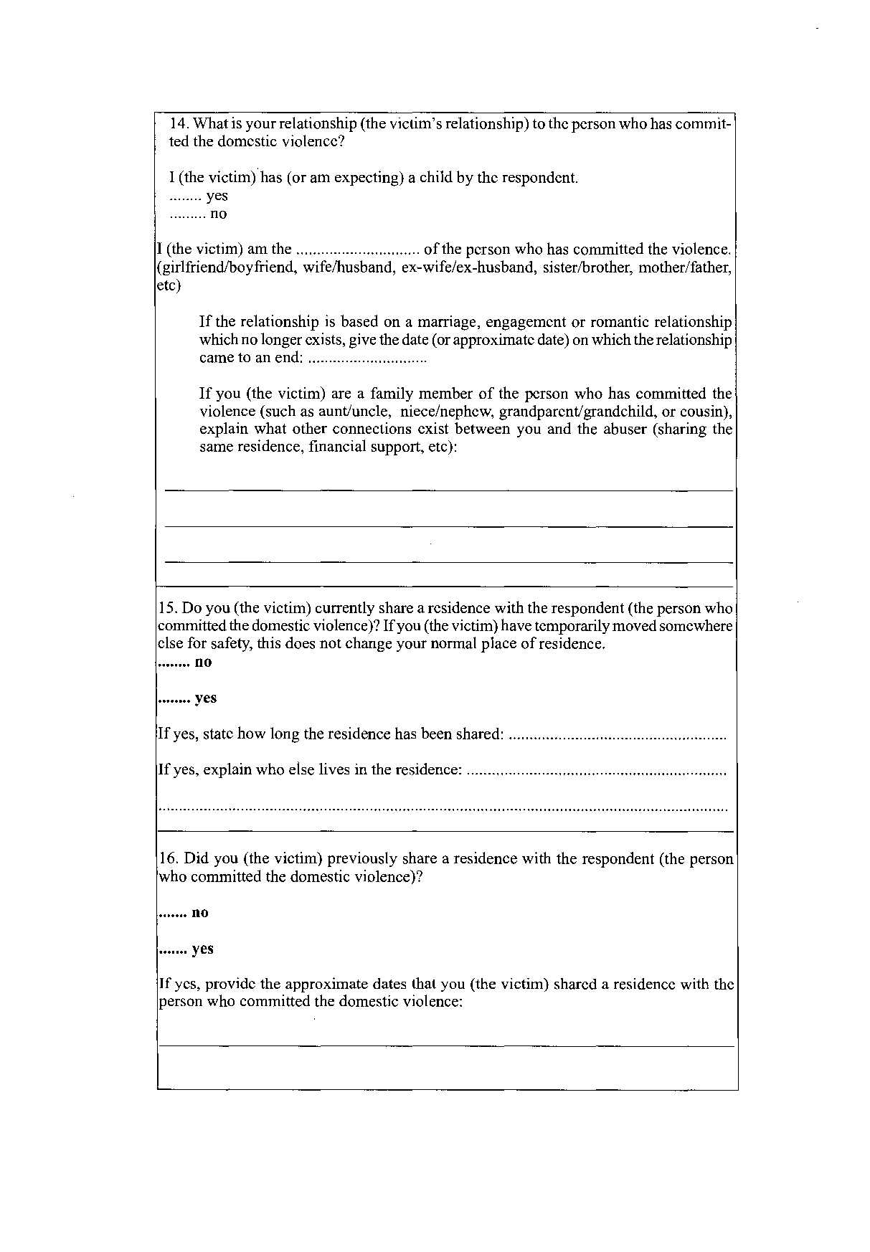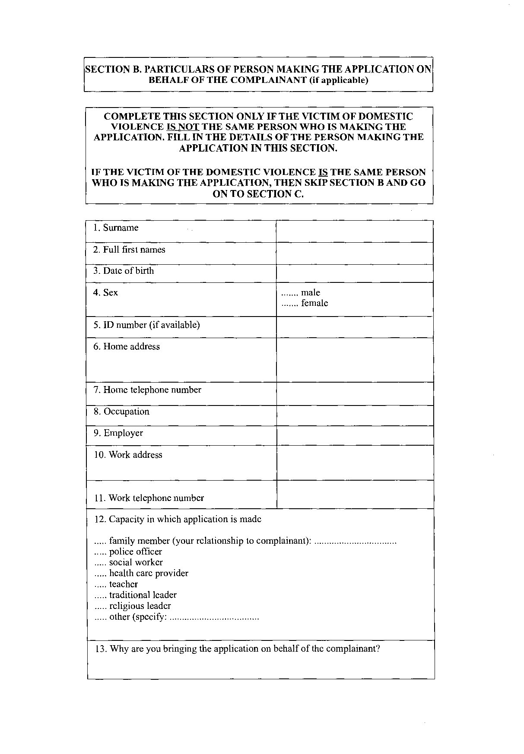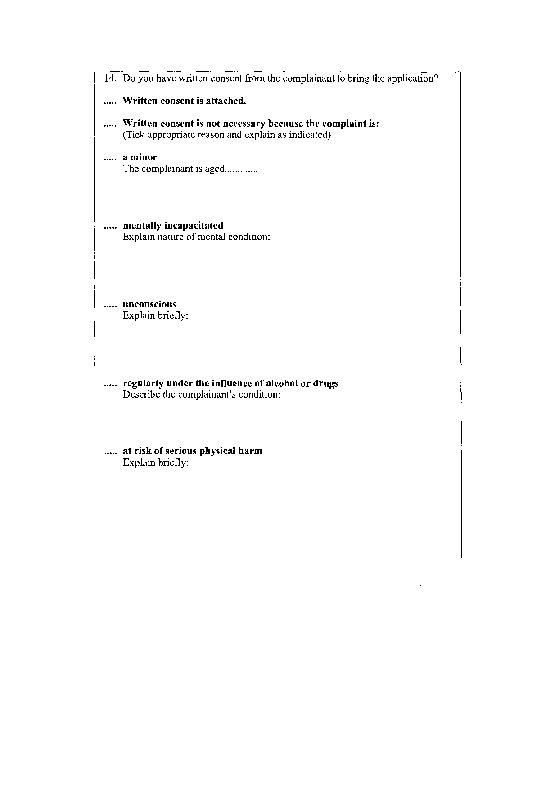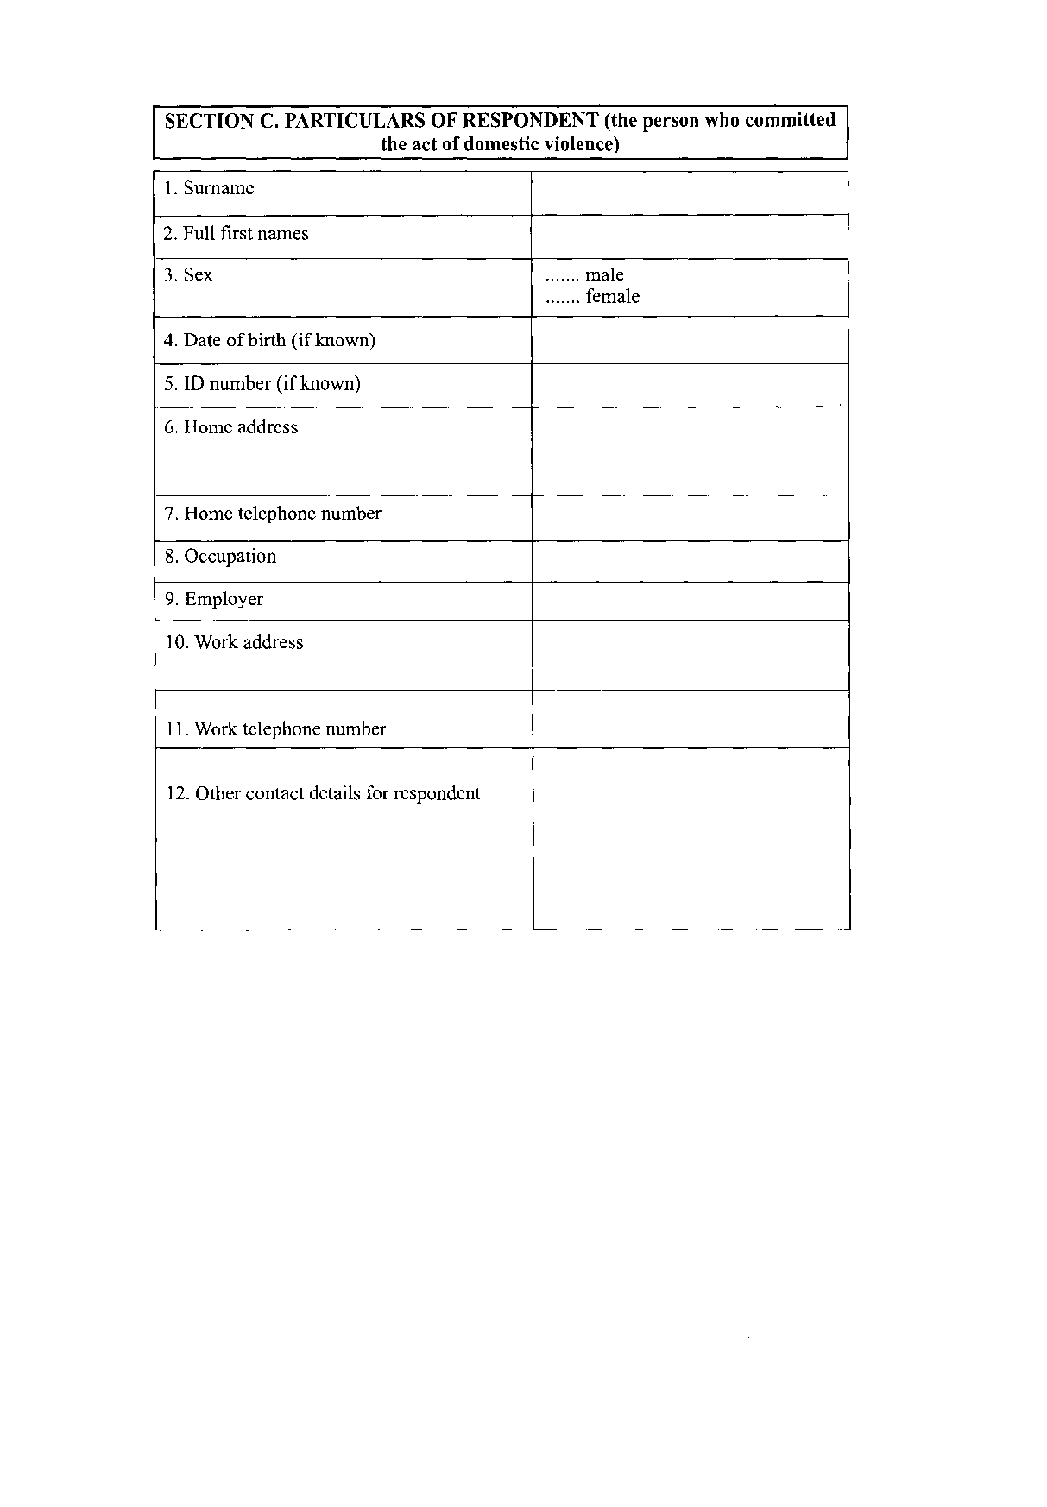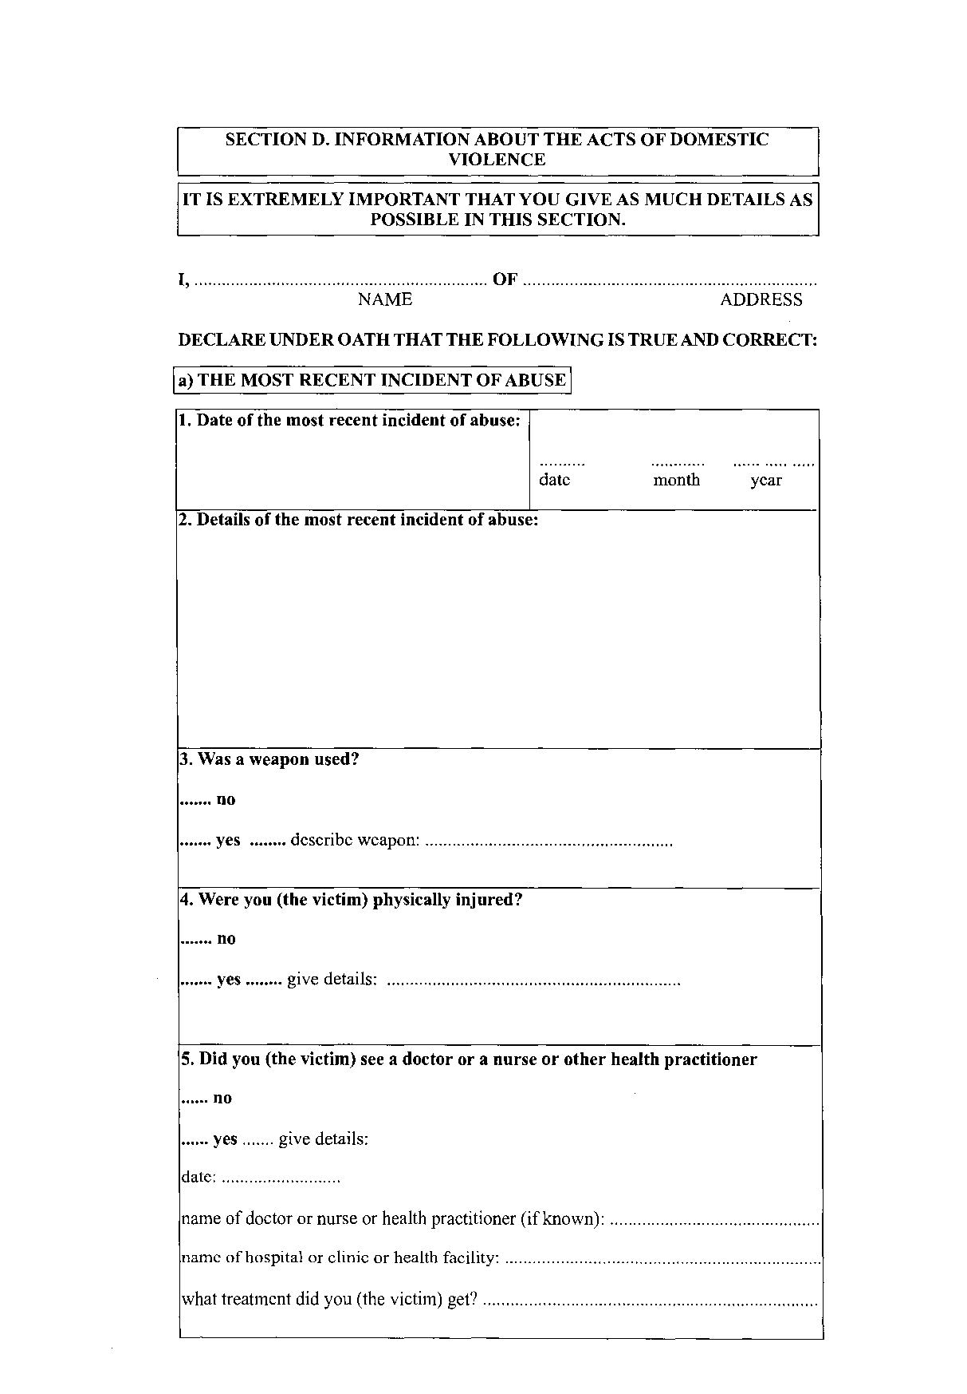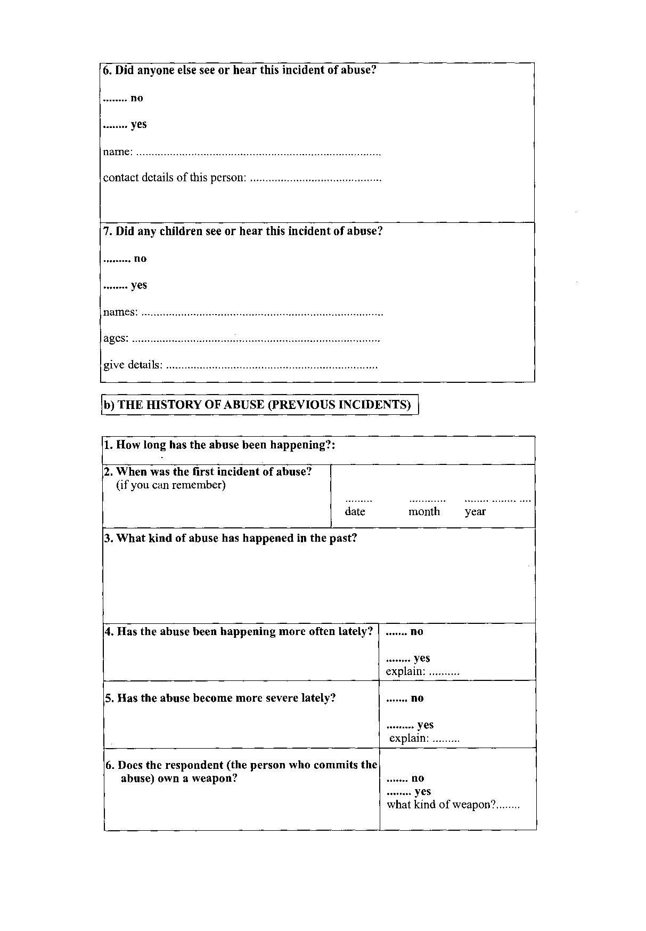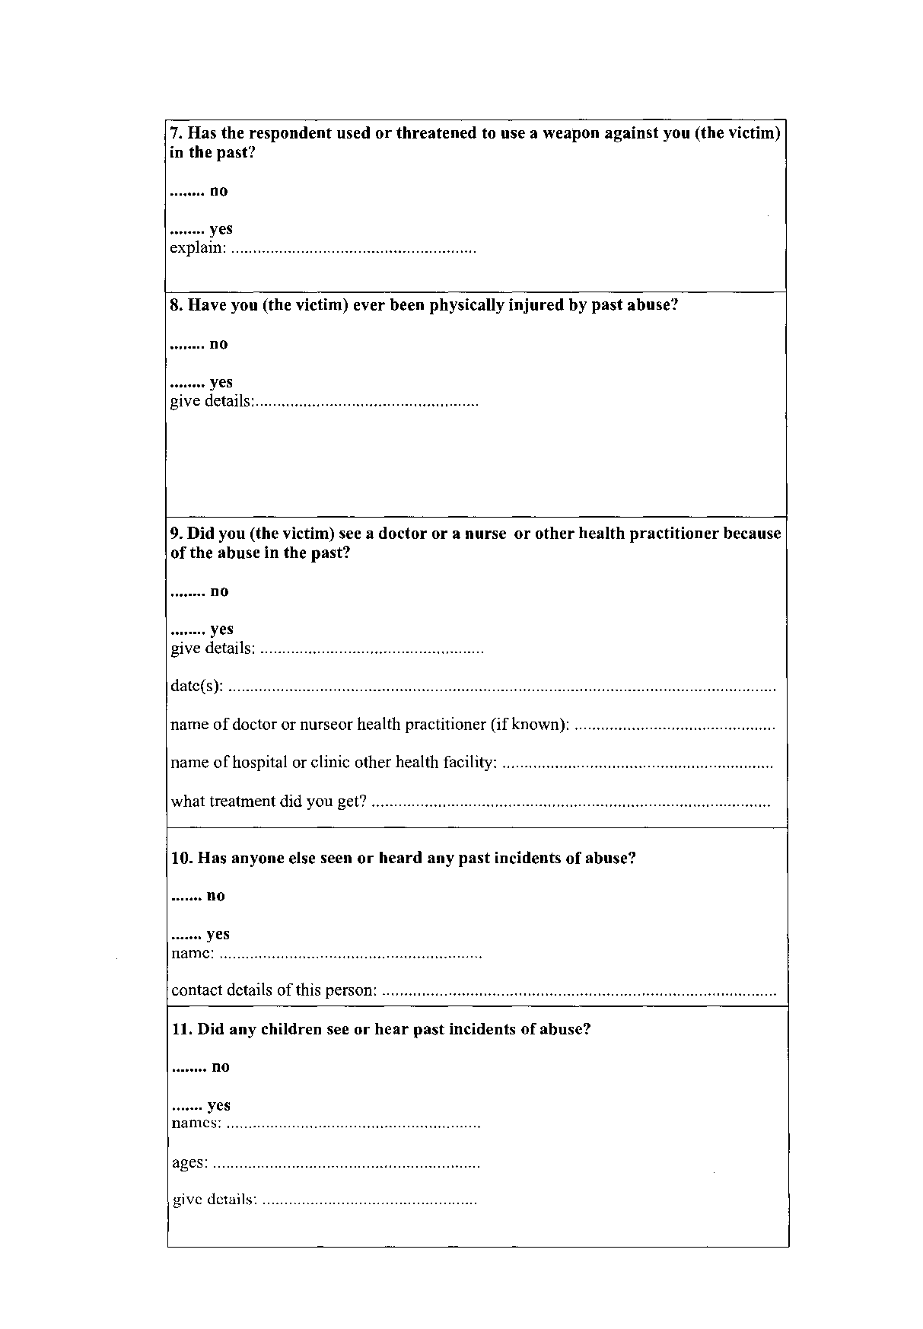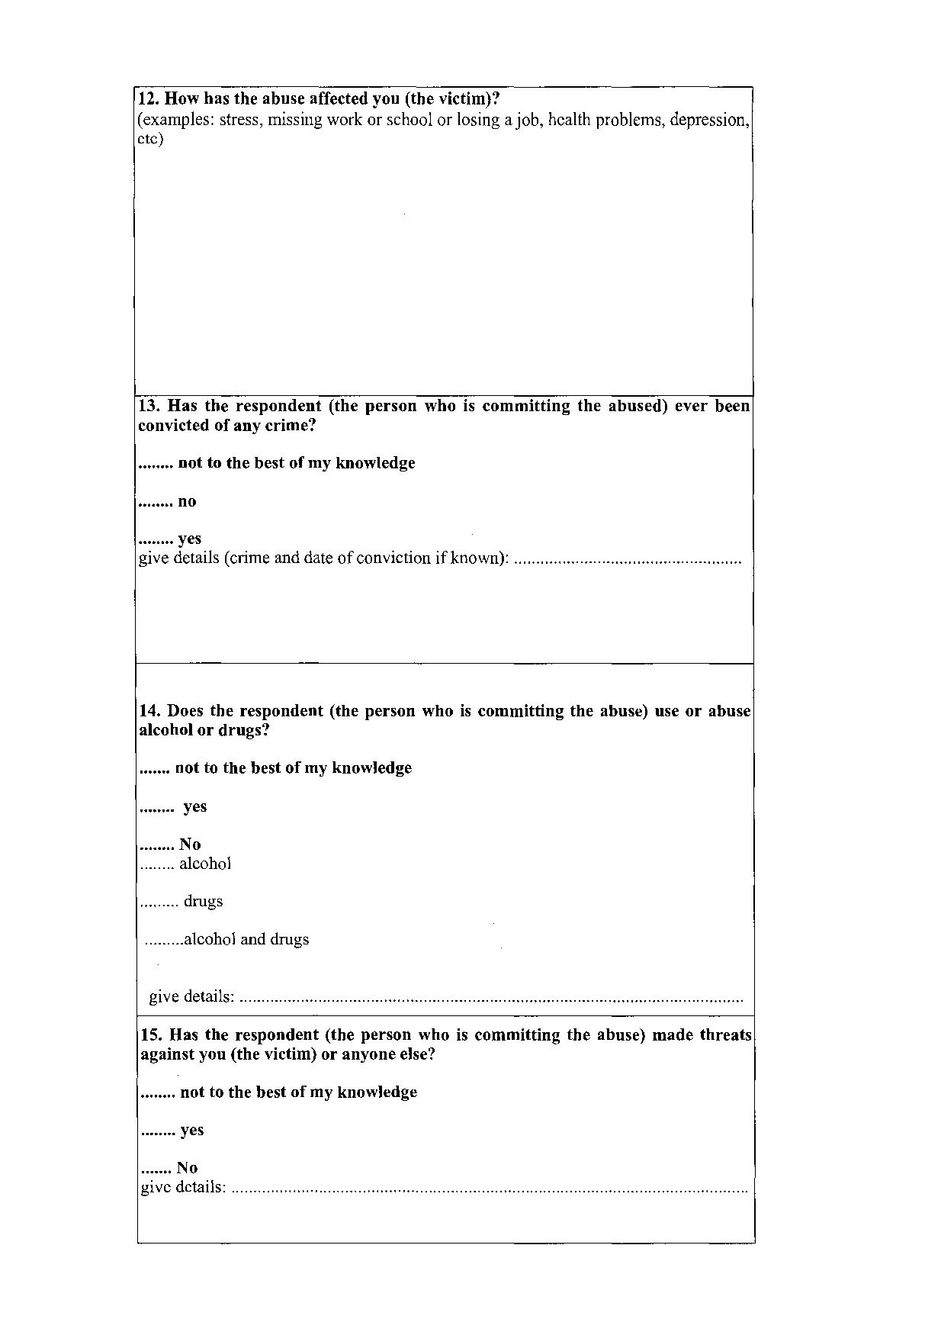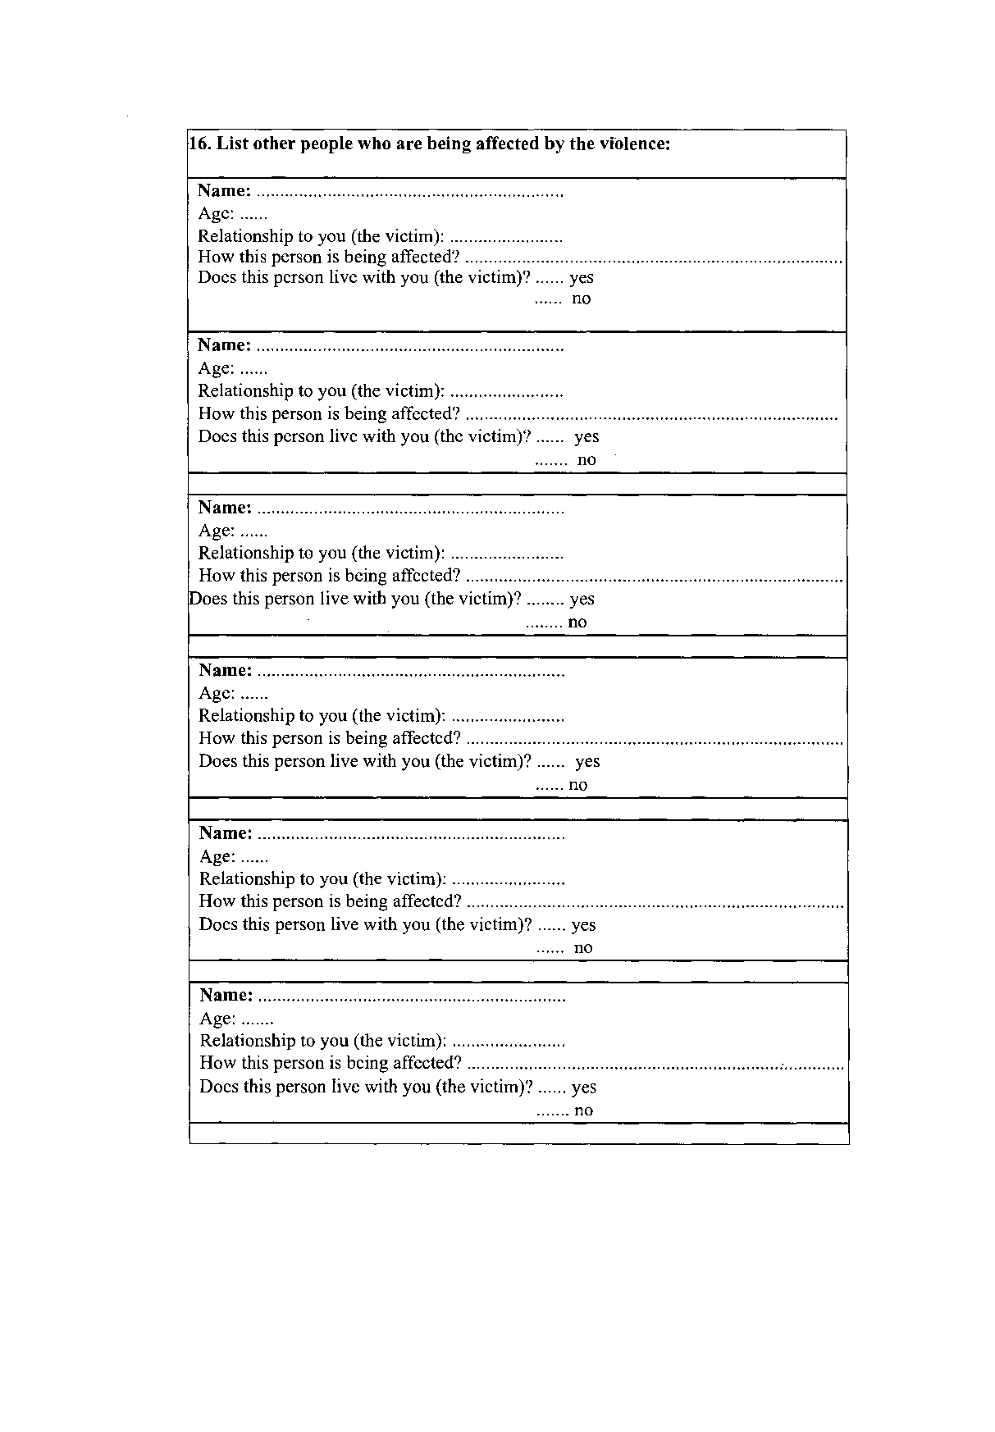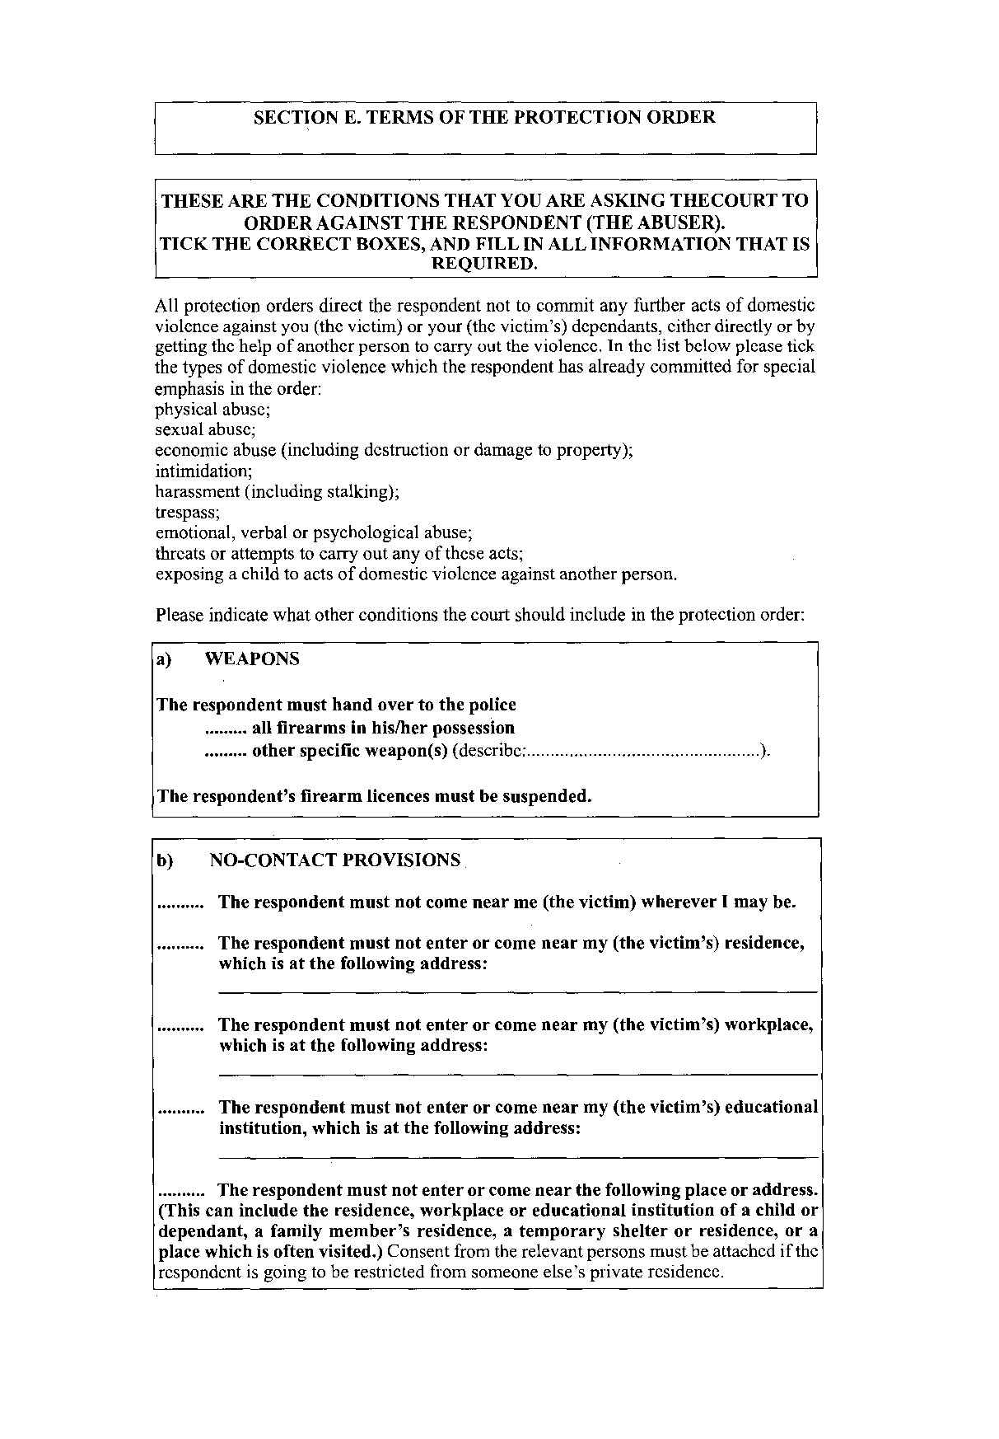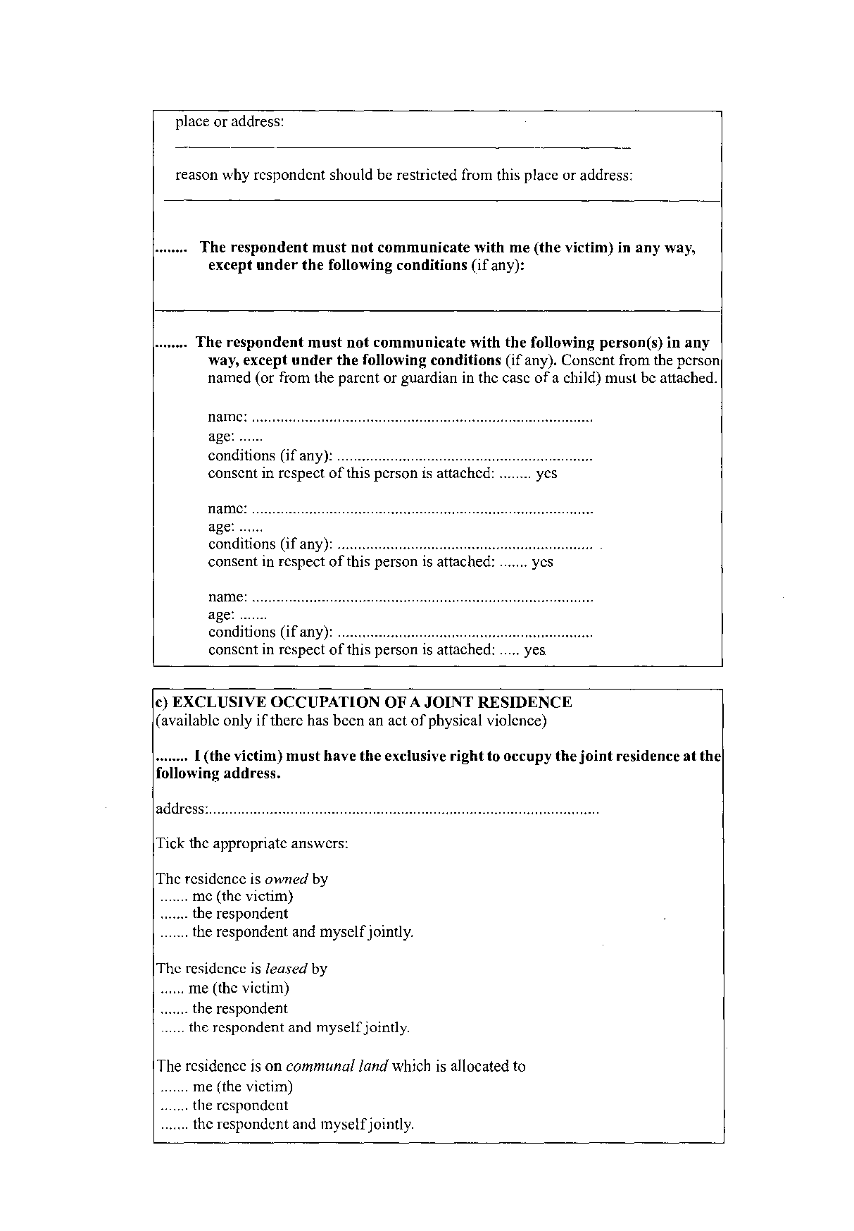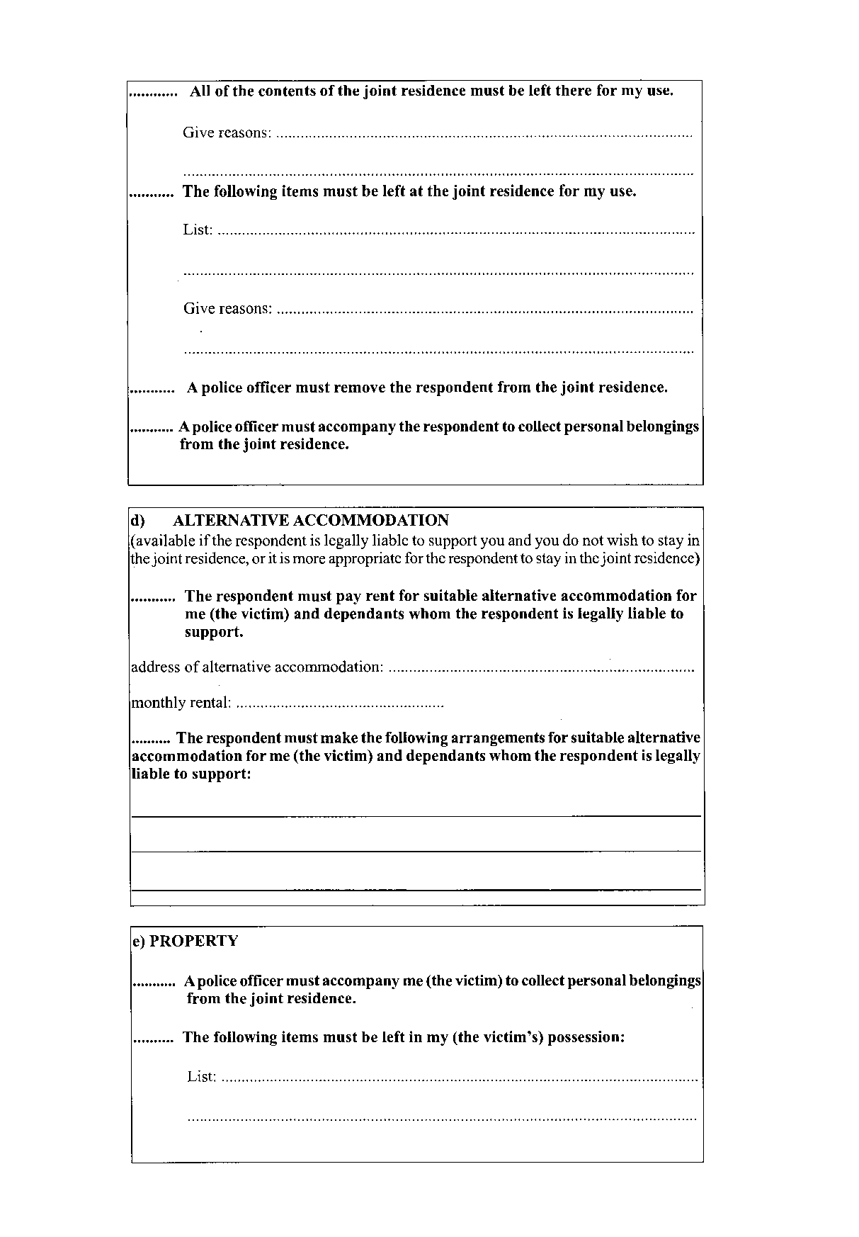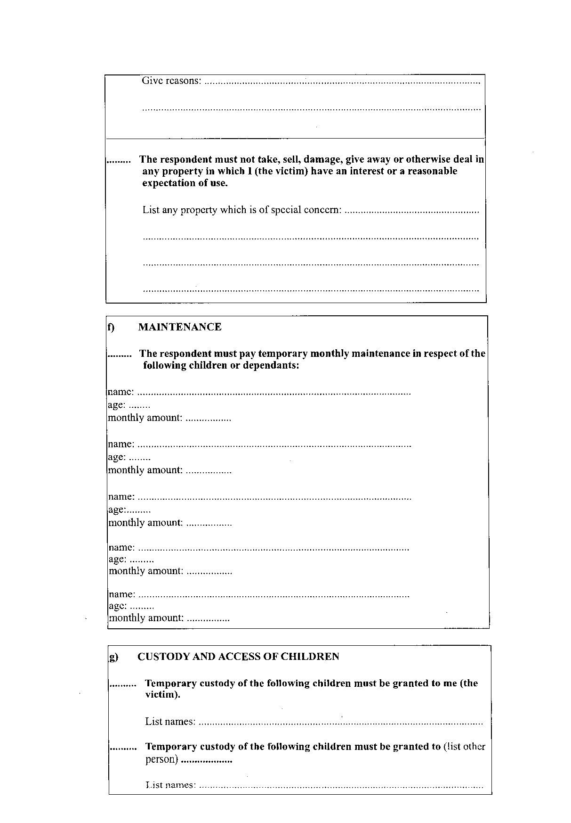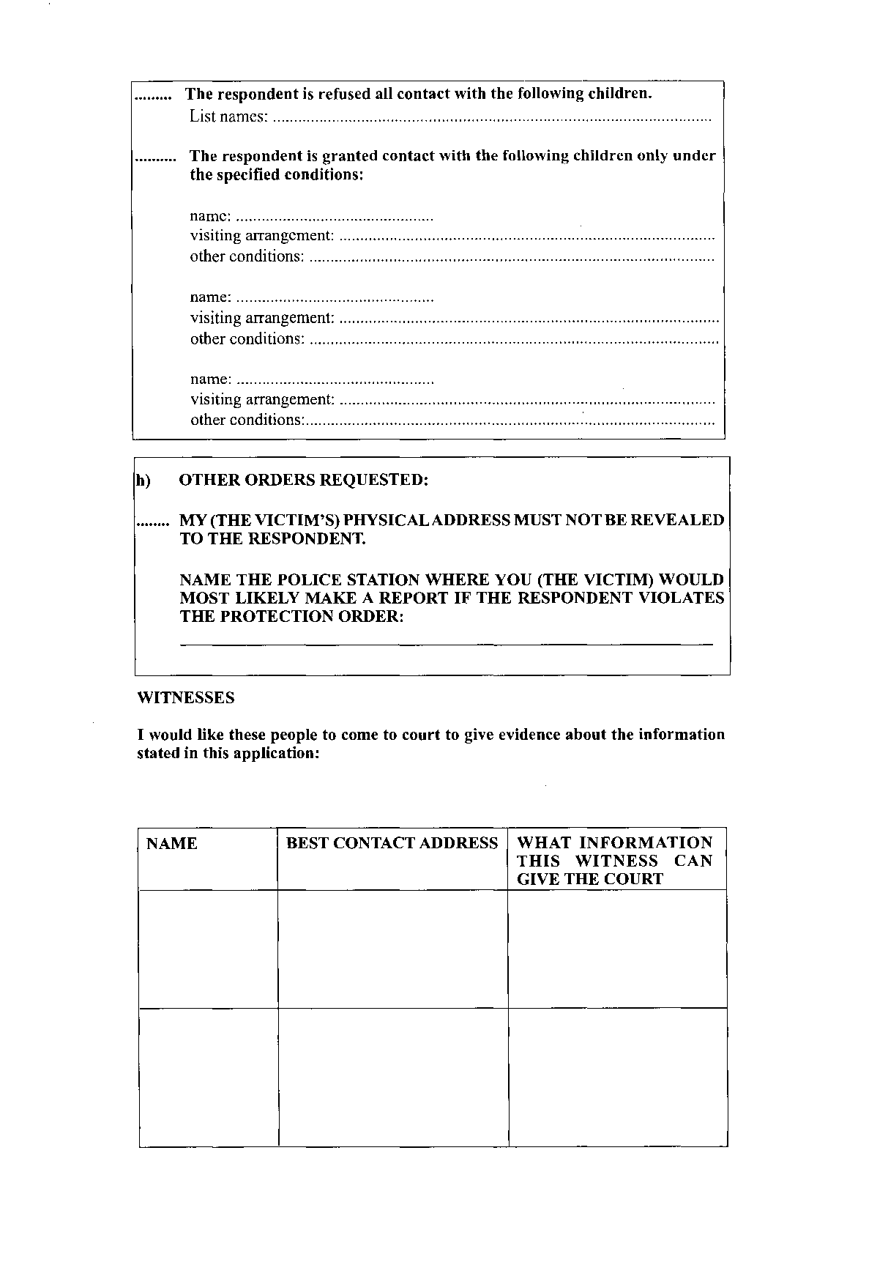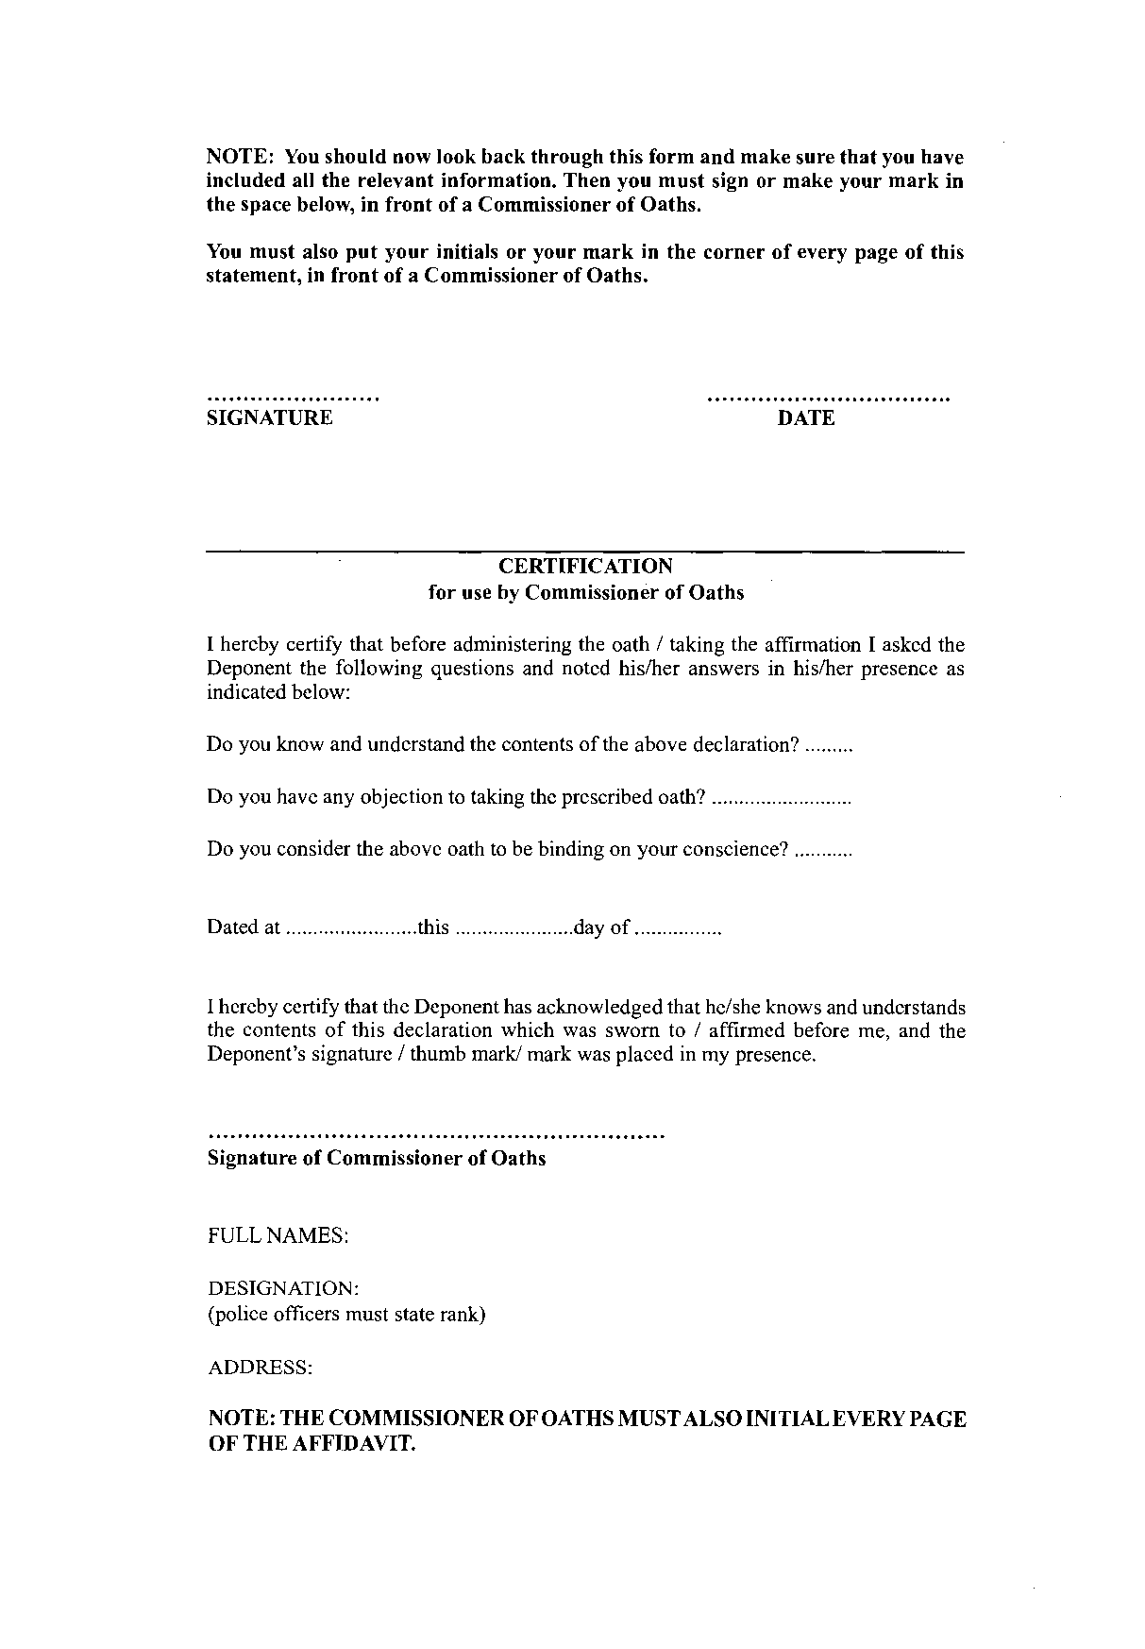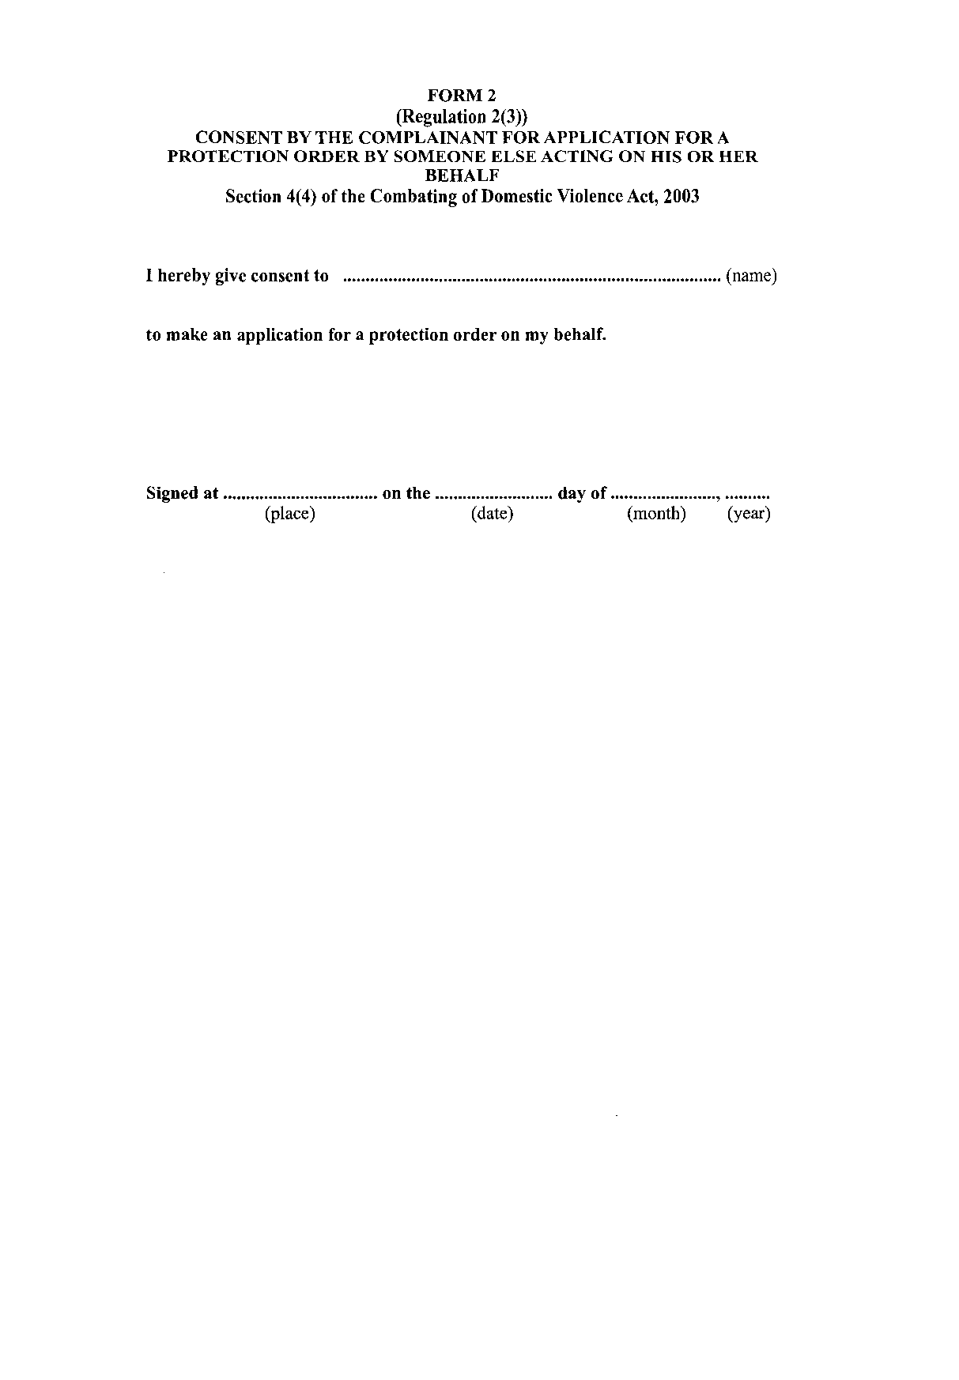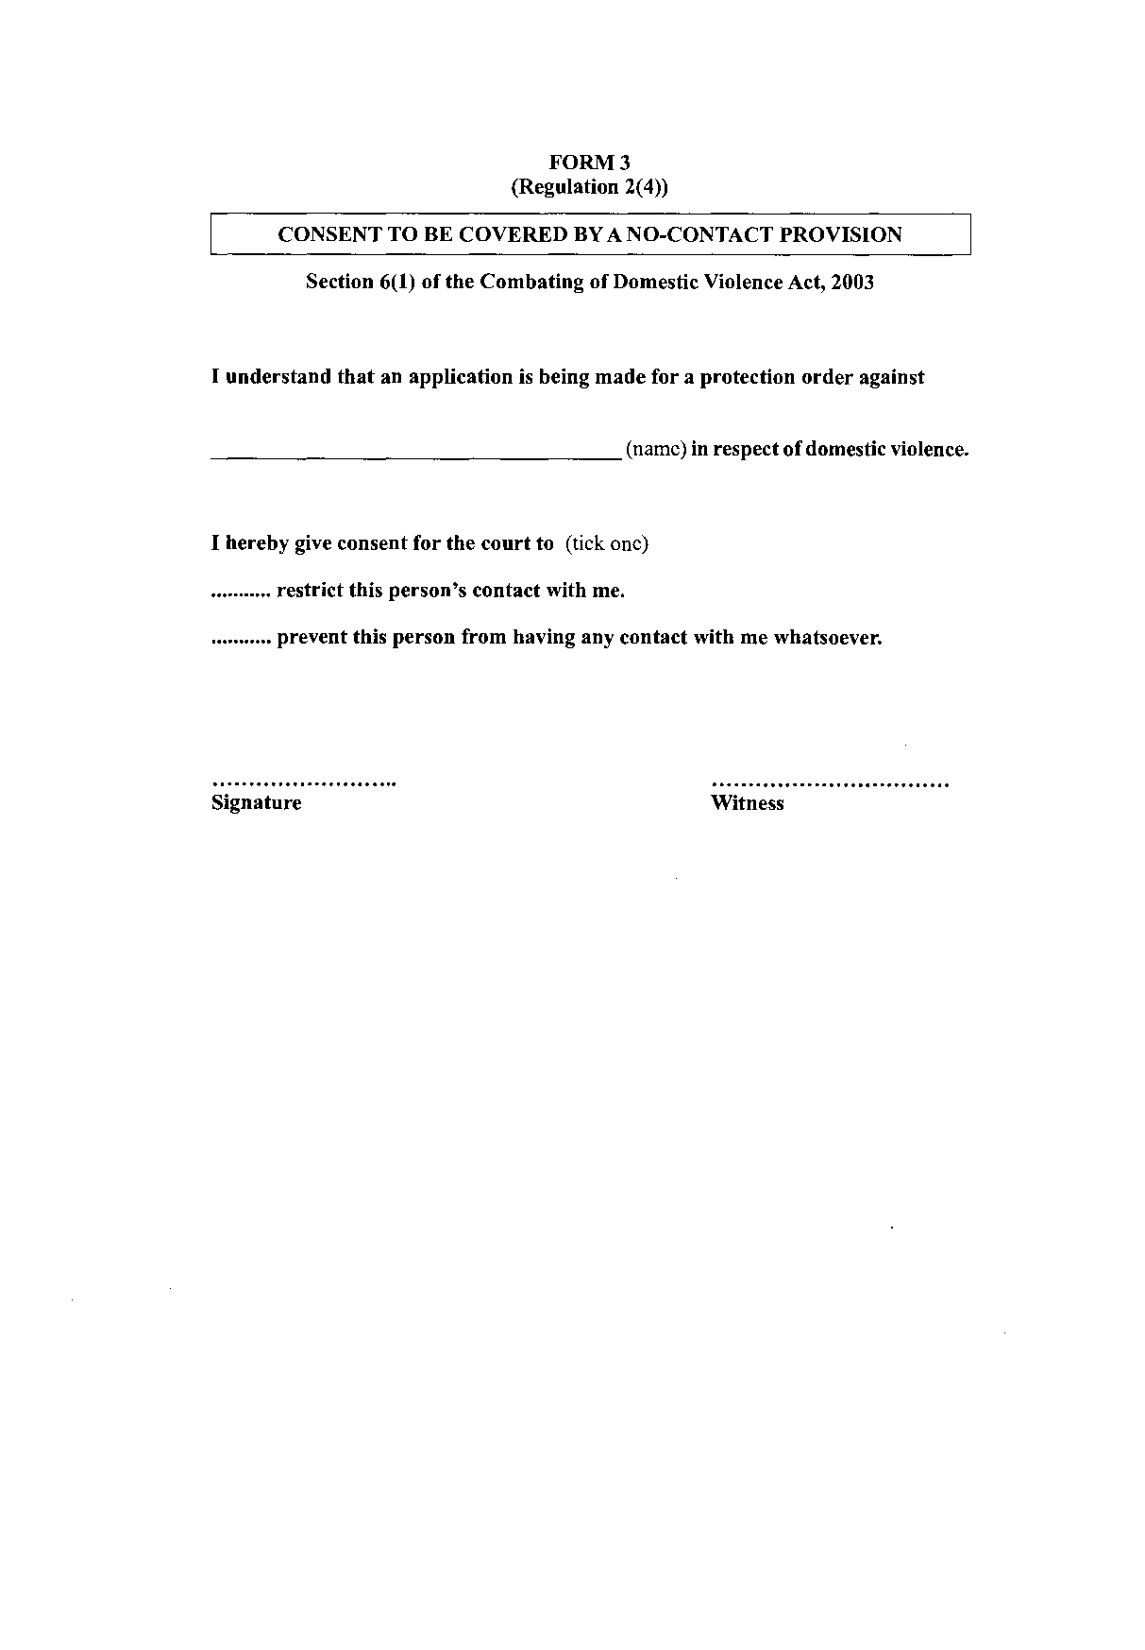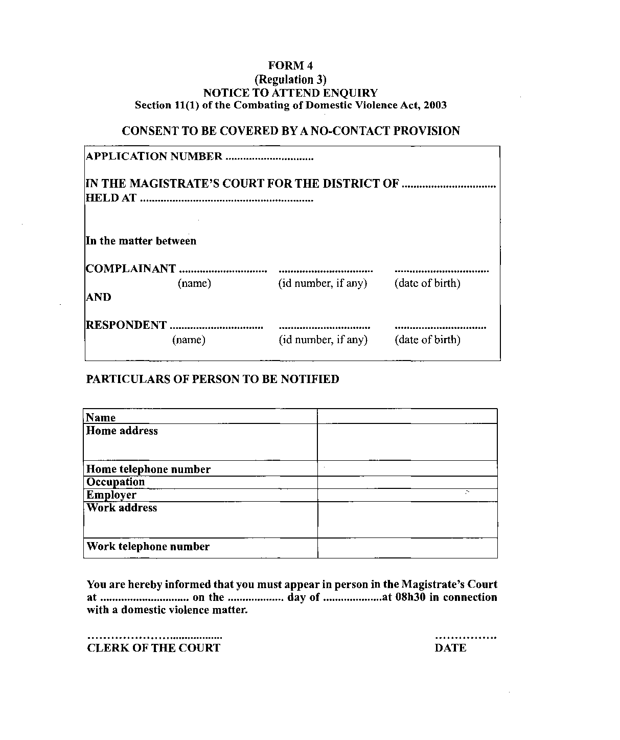
[The heading “CONSENT TO BE COVERED BY A NO-CONTACT PROVISION”
is in error. That topic is covered by Form 3.]
