REGULATIONS MADE IN TERMS OF

Close Corporations Act 26 of 1988
section 10 read with section 12(3) of the
Interpretation of Laws Proclamation 37 of 1920

General Regulations
Government Notice 43 of 1994
(GG 829)
came into force on date of publication: 30 March 1994

as amended by

Government Notice 83 of 1994 (GG 863)
came into force on date of publication: 1 June 1994
Government Notice 97 of 2006 (GG 3658)
came into force on date of publication: 1 July 2006
Government Notice 20 of 2015 (GG 5668)
came into force on date of publication: 13 February 2015
Government Notice 310 of 2019 (GG 7032)
came into force on date of publication: 31 October 2019
Government Notice 27 of 2021 (GG 7062)
came into force on date of publication: 18 February 2021

The regulations were also amended by Government Notice 294 of 2012 (GG 5094), which came into force on its date of publication (14 December 2012), but this Government Notice was withdrawn by GN 20/2015 (which substitutes the only subregulation amended by GN 294/2012).
All of the amendments prior to 2015 affect regulation 17(1), which is substituted by GN 20/2015.
GN 20/2015 withdraws one of the previous amendments to that subregulation.
None of the other amendents to that regulation have been withdrawn or repealed,
even though they are now irrelevant.

ARRANGEMENT OF REGULATIONS

1. Definitions
2. Office Hours
3. Documents
4. [There is no heading for regulation 4.]
5. Forms and Fees
6. Inspection into and copies of documents
7. [There is no heading for regulation 7.]
8. Certification of reproduction of records of corporation on microfilm.
9. Retention of records
10. Registration of founding statement
11. Annual duty
12. Registration of amended founding statement
13. Conversion of companies into corporation
14. Restoration of the registration of a corporation
15. Order of court for the alteration of or addition to a founding statement
16. Voluntary winding-up
17. Accounting officer
18. Lodging of additional copy of certain prescribed forms
19. Standing advisory committee

SCHEDULE 1
Fees
[Schedule 1 substituted by GN 310/2019]

SCHEDULE 2
Certificate of authenticity by member or officer of close corporation

SCHEDULE 3
Certificate of authenticity by member or officer of close corporation

SCHEDULE 4
Retention periods of corporation documents and records

SCHEDULE 5
Forms CC1-CC9
[Schedule 5 substituted by GN 27/2021]

[The capitalisation of the regulation headings
is reproduced here as it appears in the Government Gazette.]

Definitions

1. In these regulations, unless the context otherwise indicates, any expression to which a meaning has been assigned in the Close Corporations Act, 1988, bears that meaning, and -

“Schedule” means the appropriate schedule to these regulations;

“the Act” means the Close Corporations Act, 1988 (Act 26 of 1988).

Office Hours

2. The Registration Office shall be open to the public from 08h30 to 12h30 and from 14h00 to 16h00 from Mondays to Fridays except -

(a) on a public holiday specified by or declared under the Public Holidays Act, 1990 (Act 26 of 1990); or

(b) on any day of which prior notification is given by means of a notice displayed at a conspicuous place at the Registration Office or in such other manner as the Registrar thinks fit.

Documents

3. (1) Any document lodged with the Registration Office -

(a) shall, unless the Registrar otherwise directs, be written in block capitals or be typewritten, lithographed or printed in legible characters with deep permanent black ink on one side only of strong white paper being of international paper size A4: Provided that the Registrar may determine paper of a different size or different colour in respect of any form to be lodged with him or her; and

(b) shall be in the official language of Namibia.

(2) Any document lodged with the Registration Office may be reproduced by the Registrar by microfilm.

(3) Documents or copies of documents to be transmitted or returned to any corporation or person may, unless the Registrar otherwise directs in any particular case, be carbon copies of originals.

(4) The Registrar may reject any document which in his or her opinion is unsuitable for record-keeping purposes.

(5) A copy of any document lodged with the Registration Office or a copy of any such document reproduced by microfilm, and purporting to be certified by the Registrar or an officer or employee referred to in section 4(3) of the Act, shall, without proof or production of the original, upon the mere production thereof in proceedings, whether in a court of law or otherwise, be admissible as evidence in respect of the contents of such document.

(6) All forms to be lodged with the Registration Office shall comply with the printing specifications determined by the Registrar from time to time.

[There is no heading for regulation 4.]

4. A document required to be sent or lodged with the Registrar may be transmitted by post except Forms CCI and CC2, which shall, if not lodged personally with the Registration Office, be transmitted by registered or certified post.

Forms and Fees

5. (1) The forms contained in Schedule 5 shall be used in the appropriate instances but the Registrar may direct any modification to be made to such forms in order to meet the circumstances in a particular instance.

(2) The fees payable in terms of the Act and these regulations shall be those set out in Schedule 1.

(3) Subject to the provisions of section 6(1) of the Act, any fee, additional fee or other money payable to the Registrar may, except where otherwise provided in these regulations, be paid at any office of the Receiver of Revenue.

Inspection into and copies of documents

6. (1) Any person requiring to inspect any document or to obtain a copy of any document kept in the Registration Office shall -

(a) if he or she calls at the Registration Office in person, complete a form provided for that purpose;

(b) pay the appropriate fee.

[There is no heading for regulation 7.]

7. Any person who, knowingly and without the consent of the Registrar -

(a) removes from the custody of the Registrar or from the Registration Office any document kept by the Registrar or in that Office;

(b) makes or causes to be made any entry on such document;

(c) destroys or damages such document; or

(d) alters or causes to be altered any entry on such document,

shall be guilty of an offence and liable on conviction to a fine not exceeding N$2 000 or to imprisonment for a period not exceeding six months or to both such fine and such imprisonment.

Certification of reproduction of records of corporation on microfilm

8. (1) A corporation may reproduce or cause to be reproduced on microfilm any records required to be kept by it in terms of section 56 of the Act.

(2) Any copy of a record of a corporation made from a reproduction of such record on microfilm shall be certified by a member or officer of such corporation to be a true and accurate reproduction of the original of such record, and such certificate shall be in the form contained in Schedule 2.

(3) Any reproduction referred to in subregulation (1) shall for all purposes be deemed to be the original record of the corporation concerned, and a copy obtained by means of such reproduction and certified by a member or officer of such corporation as a true and accurate copy of such reproduction shall upon the mere production thereof in proceedings, whether in a court of law or otherwise, be admissible as evidence, in respect of the contents of such record.

(4) A corporation shall take the necessary steps to ensure the safe preservation of any microfilm on which any record of such corporation has been reproduced.

Retention of records

9. (1) Subject to the provisions of subregulation (2), the minimum period of retention of the documents and records of a corporation which it is required to keep in terms of this Act shall be the period specified in Schedule 4 and such period shall, where applicable, run from the date of a particular document or record or the date of the last entry in a particular document or record referred to in the said Schedule.

(2) Notwithstanding the provisions of subregulation (1), the original of any record required to be kept by a corporation in terms of section 56 of the Act that has been reproduced on microfilm and duly certified in terms of regulation 8(2) may be destroyed after a period of three years from the date on which the record concerned was so reproduced.

Registration of founding statement

10. (1) The founding statement of a corporation shall be in the form as set out in Form CCI.

(2) The original and two copies of Form CCI shall be lodged with the Registrar for registration and incorporation of the corporation.

(3) The fee payable for the registration of a founding statement shall be as prescribed in Schedule 1.

(4) The written consent of the accounting officer of a corporation to his or her appointment in that capacity shall be attached to Form CCI.

Annual duty

11. (1) A corporation shall -

(a) not later than one month after the end of every financial year pay the annual duty as prescribed in Schedule I; and

(b) lodge proof of such payment not later than forty-two days after the end of every financial year on Form CC7 with the Registrar.

(2) If a corporation changes its financial year as contemplated in section 57(2), the amount of annual duty payable for the additional period shall be half of the annual duty payable for a full financial year as prescribed in Schedule I.

(3) A corporation which fails to pay the annual duty within the time referred to in subregulation (l)(a), may thereafter pay such annual duty subject to the payment of additional fees according to the following scale:

Where, after the last date on which the annual duty was required to be paid, payment is made within -

Additional fee.

(a) one month ............................................................... half the prescribed annual
duty unpaid.

(b) two months ............................................................ the prescribed annual duty
unpaid.

(c) three months........................................................... twice the prescribed annual
duty unpaid.

(d) four months ........................................................... three times the prescribed
annual duty unpaid.

(e) exceeding four months .......................................... five times the prescribed
annual duty unpaid.

Registration of amended founding statement

12. (1) An amended founding statement referred to in section 15 of the Act shall be in the form as set out in Form CC2.

(2) An amended founding statement shall be completed in full, even in respect of particulars which have not or will not be changed.

(3) The original and two copies of Form CC2 shall be lodged with the Registrar for registration.

(4) The fee payable for the registration of an amended founding statement shall be as prescribed in Schedule 1.

(5) If a new accounting officer is appointed by a corporation his or her written consent to such appointment shall be attached to Form CC2.

Conversion of companies into corporation

13. (1) An application for the conversion of a company into a corporation shall be in the form as set out in Form CC4.

(2) The original and one copy of Form CC4 and the original and two copies of Form CCI shall be lodged with the Registrar.

(3) The fee payable for the conversion of a company into a corporation shall be as prescribed in Schedule 1.

Restoration of the registration of a corporation

14. (1) An application for the restoration of the registration of a corporation shall be in the form as set out in Form CC3.

(2) The original and one copy of Form CC3 shall be lodged with the Registrar and, if a change has occurred or will occur in respect of any matter particulars of which were stated in the founding statement of the corporation at the time of its deregistration, be accompanied by the original and two copies of Form CC2.

(3) The fee payable for the restoration of the registration of a corporation shall be as prescribed in Schedule 1.

Order of court for the alteration of or addition to a founding statement

15. (1) If by order of the court in terms of section 49 of the Act any alteration or addition is made to a founding statement there shall be lodged with the Registrar for registration -

(a) a copy of such order of court under cover of Form CC5; and

(b) the original and two copies of Form CC2.

(2) The fee payable for the registration of an order of the court referred to in subregulation (1) shall be as prescribed in Schedule 1.

Voluntary winding-up

16. (1) If, in terms of section 67 of the Act, a corporation resolves that the corporation should be wound-up voluntarily by its members or creditors the original and one copy of Form CC6 containing such resolution shall be lodged with the Registrar for registration.

(2) The fee payable for the registration of the voluntary winding-up of a corporation shall be as prescribed in Schedule 1.

Accounting officer

17. (1) For the purposes of section 60(1) of the Act, any person who is a resident in Namibia and is a member of any of the following associations or bodies is qualified to be appointed as an accounting officer of a corporation:

(a) Chartered Institute of Business Management;
(b) South African Institute of Professional Accountants;
(c) The Association of Chartered Certified Accounts;
(d) The Chartered Institute of Management Accountants;
(e) The Institute of Administration and Commerce of South Africa;
(f) The Institute of Chartered Accountants of Namibia;
(g) The Namibian Institute of Professional Accountants;
(h) The Southern African Institute of Business Accountants;
(i) The Southern African Institute of Chartered Accountants; and
(j) The Southern African Institute of Chartered Secretaries and Administrators.

[Subregulation (1) is amended by GN 83/1994, GN 97/2006
and GN 294/2012 (which was withdrawn by GN 20/2015), and substituted by GN 20/2015.]

(2) An accounting officer who signs any documents for or in respect of a corporation in his or her capacity as accounting officer of such corporation, shall state the name of the said profession of which he or she is a member beneath his or her signature.

Lodging of additional copy of certain prescribed forms

18. (1) The Registrar may from time to time by written notice sent to a corporation or an officer thereof at the registered office or postal address of the corporation, require such corporation or officer to lodge with the Registrar, within a period stated in the notice, which shall not be less than thirty days, a copy of any record required to be kept by the corporation under the Act, and he or she may further require a member or officer or such corporation to certify that copy, in the form set out in Schedule 3, to be a true and accurate reproduction of such record.

(2) A corporation or an officer thereof to whom a notice referred to in subregulation (1) was sent, and who fails to comply with a requirement stated in such notice within the specified period, shall be guilty of an offence and liable on conviction to a fine not exceeding N$100.

Standing advisory committee

19. Any recommendation or submission made to a standing advisory committee on company law referred to in section II of the Act in relation to its functions, shall be in writing and three copies of such recommendation or submission shall be lodged with the Registrar of Close Corporations, P.O. Box 21214, Windhoek.

Schedule 1

[Schedule 1 is substituted by GN 310/2019. Capitalisation and bold type
are reproduced here as they appear in the Government Gazette.]

The following fees are payable in terms of the Act and these regulations in the manner prescribed in regulation 5.

Item | Services | Fees Payable (N$) | Corresponding CC Form  (if any)
1 | Registration of a Founding Statement | 150.00 | CC1
2 | Registration of an Amended Founding Statement in respect of particulars in Part A thereof | 60.00 | CC2
3 | Restoration of the registration of a Corporation | 225.00 | CC3
4 | Registration of an order of the Court | 60.00 | CC5
5 | Registration of a resolution to wind-up voluntarily | 60.00 | CC6
6 | Annual Duty | 120.00 | CC7
7 | Application for reservation of a name | 75.00 | CC8
8 | Change of the end of the current financial year | 60.00 | CC9
9 | Consideration of an objection to a name | 450.00 | See note
10 | Inspection into a corporation file in the Registration Office |  | See note
 | (a) Personally by applicant | 10.00 | See note
 | (b) On the written request of an applicant (*includes up to 20 photocopies of documents thereafter 0.50c per copy) | 20.00 | See note
11 | Photocopies
 | (a) Photocopy of a document, approximately 298mm by 210mm in size or smaller (per copy) | 1.00 | See note
 | (b) Photocopy on paper reproduced on micro film (per copy) | 1.00 | See note
 | (c) Photocopy on diazo reproduced from micro film (per copy) | 2.00 | See note
12 | Certification of a document or part of a document (per document) | 10.00 | See note
13 | Issuing of a typed certificate in respect of the contents of a form or other document or part thereof | 40.00 | See note

(Note: Corresponding form to be provided by the Registration Office)

schedules 2-5

To view content without printing, scroll down.

To print at full scale (A4), double-click the icon below.

[Schedule 5 substituted by GN 27/2021]

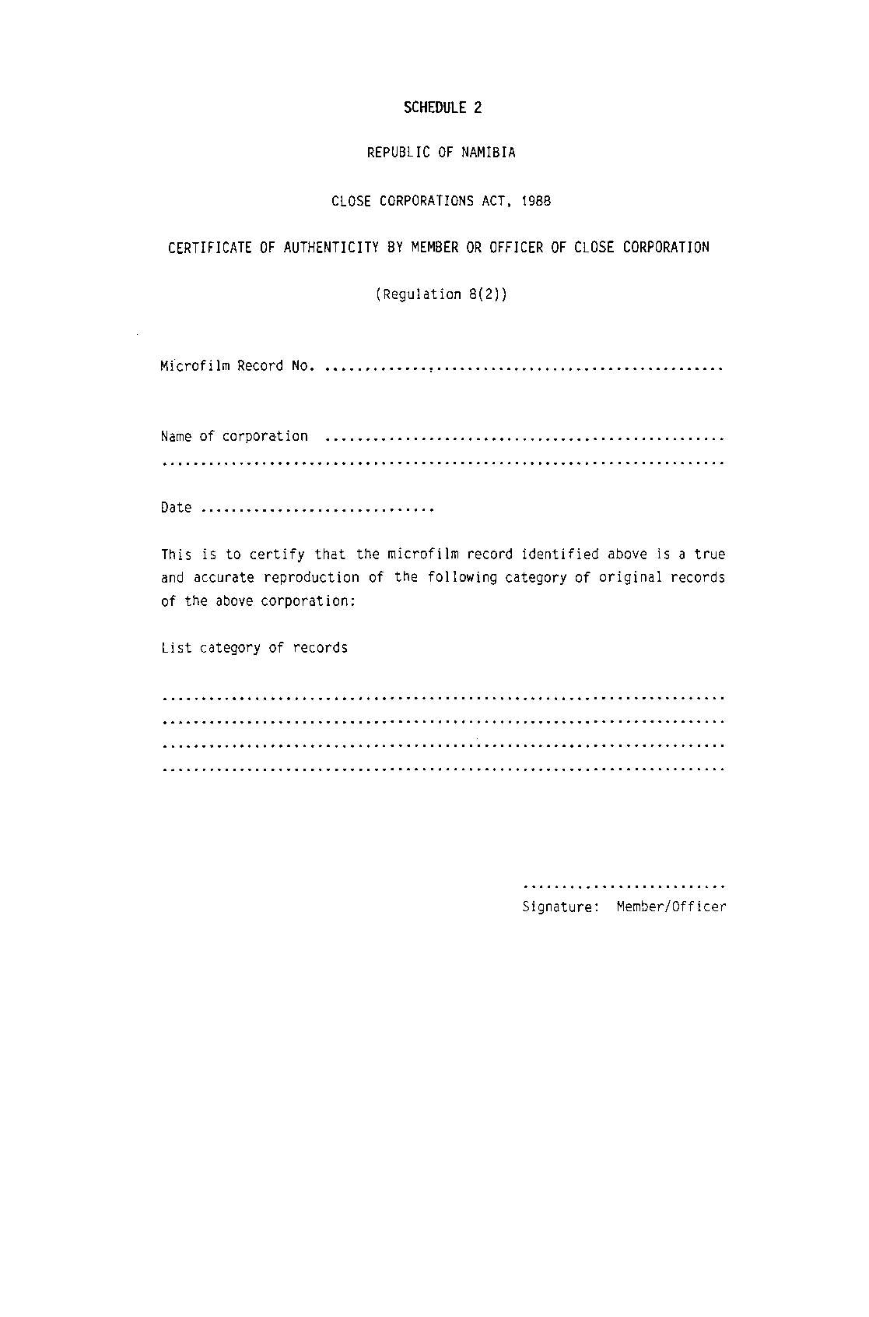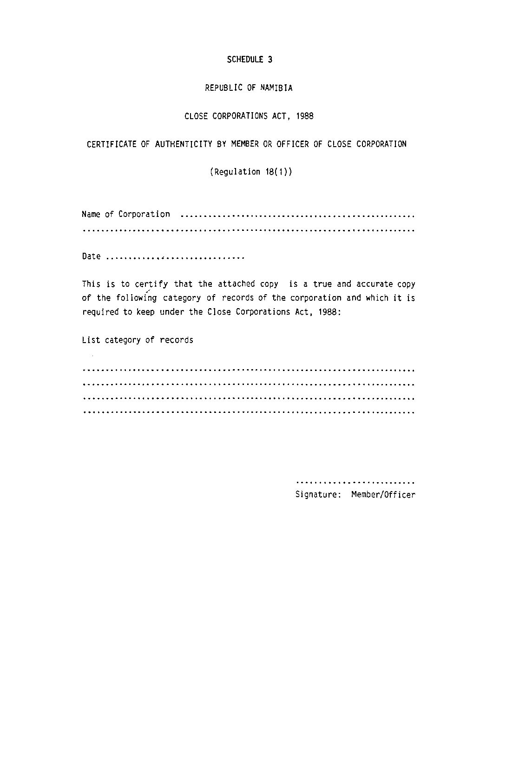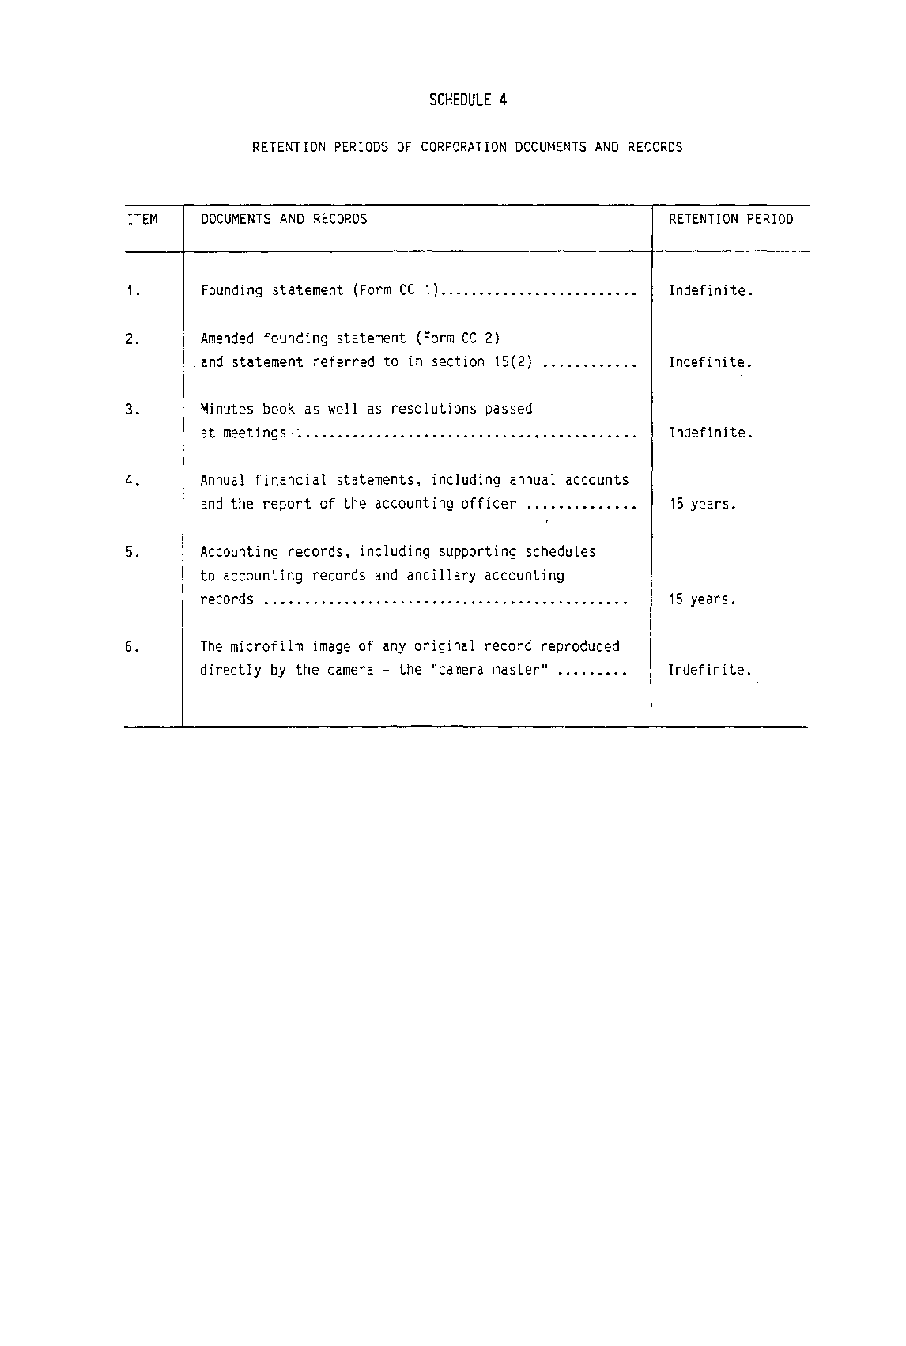

[Schedule 5 substituted by GN 27/2021]
