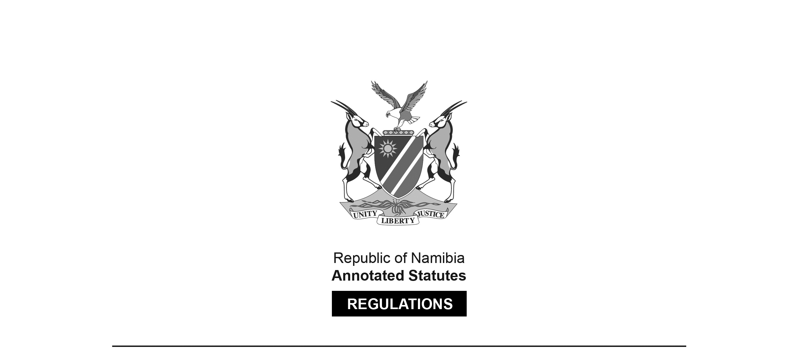
REGULATIONS MADE IN TERMS OF

Allied Health Professions Act 7 of 2004
section 55

Regulations relating to Scope of Practice of Acupuncturist
Government Notice 269 of 2019
(GG 6999)
came into force on date of publication: 18 September 2019

The Government Notice which publishes these regulations notes that they were made
on the recommendation of the Allied Health Professions Council of Namibia.

ARRANGEMENT OF REGULATIONS

1. Definitions
2. Scope of practice of acupuncturist

Definitions

1. In these regulations, a word or expression defined in the Act bears that meaning and, unless the context indicates otherwise -

“acupuncturist” means a health professional who is qualified to provide acupunctural treatment to patients; and

“the Act” means the Allied Health Professions Act, 2004 (Act No. 7 of 2004).

Scope of practice of acupuncturist

2. The following acts are regarded as acts falling within the scope of practice of an acupuncturist -

(a) conducting the necessary diagnostic procedures including -

(i) pulse reading;

(ii) tongue examination;

(iii) temperament evaluation;

(iv) history taking; and

(v) palpation;

(b) applying treatment plans including the treatment principles of acupuncture, methods and therapeutic choice, which includes -

(i) acupuncture;

(ii) acupressure;

(iii) acupotomy treatment;

(iv) ahshi acupuncture;

(v) auricular therapy;

(vi) bone setting;

(vii) catgut embedding therapy;

(viii) coining or spooning therapy (Gua Sha);

(ix) cupping therapy (Ba Guan);

(x) cosmetic acupuncture;

(xi) electro-acupuncture;

(xii) embedding therapy;

(xiii) healthy exercise (Gong Fa);

(xiv) lifestyle management;

(xv) magnet therapy;

(xvi) medical acupuncture;

(xvii) moxibustion;

(xviii) needling point injection;

(xix) scalp acupuncture;

(xx) Tai Chi; and

(xxi) Tui Na.

