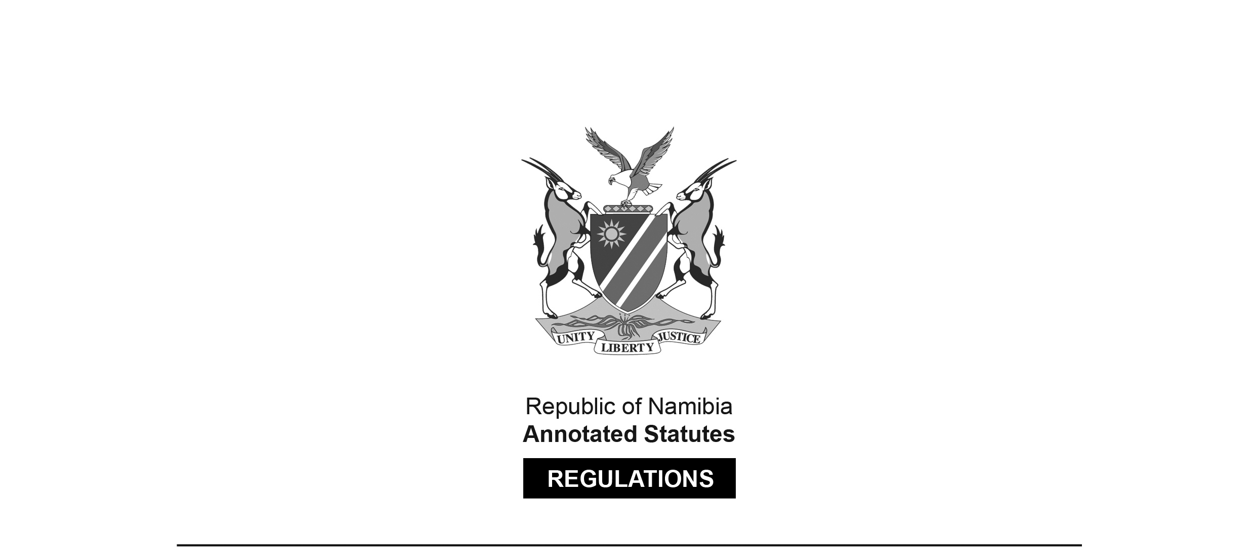
REGULATIONS MADE IN TERMS OF

Allied Health Professions Act 7 of 2004
section 55

Regulations relating to Examinations by the Allied Health Professions Council of Namibia for Dental Technicians
Government Notice 19 of 2010
(GG 4426)
came into force on date of publication: 19 February 2010

The Government Notice which publishes these regulations notes that they were made
on the recommendation of the Allied Health Professions Council of Namibia.

ARRANGEMENT OF REGULATIONS

1. Definitions
2. Prescribed additional examinations for dental technicians
3. Conducting of examinations

Definitions

1. In these regulations, unless the context otherwise indicates, a word or expression defined in the Act has that meaning, and -

“conditional registration” means the conditional registration, under section 22(2) of the Act, of a person as a dental technician, and “registered conditionally” has a corresponding meaning;

“full registration” means the registration, under section 21(2) of the Act, of a person as a dental technician and does not include conditional registration as a dental technician; and

“the Act” means the Allied Health Professions Act, 2004 (Act No. 7 of 2004).

Prescribed additional examinations for dental technicians

2. (1) A person registered conditionally as a dental technician under section 22(2) of the Act, before he or she becomes entitled to full registration as a dental technician under section 21(2) of the Act, must pass, in addition to the other requirements prescribed by or under the Act, the additional examinations prescribed by subregulation (2).

(2) The prescribed additional examinations referred to in section 22(1)(b) of the Act and in subregulation (1), are examinations in or relating to -

(a) each of the following domain -

[The word “domain” should be plural.]

(i) Dental technology;

(ii) Applied dental technology;

(iii) Dental material science;

(iv) Oral anatomy;

(v) Tooth morphology;

(b) the ethics relating to dental technology; and

(c) the provisions made under that Act and regulations which relate to dental technicians.

Conducting of examinations

3. (1) Any of the examinations prescribed by regulation 4 -

(a) must be conducted -

(i) by the Council; or

(ii) for and on behalf of the Council by a person or institution, whether in Namibia or elsewhere, appointed by the Council for that purpose; or

(iii) by an institution outside Namibia recognised by the Council as competent to conduct examinations in the domain prescribed by regulation 4;

(b) may be written, oral or practical examinations, or written, oral and practical examinations; and

(c) must be taken by the applicant on the date and at the time and venue notified in writing to the applicant by the Council.

(2) A notice by the Council in terms of subregulation (1) (c) must be sent -

(a) by pre-paid registered post to the applicant, addressed to his or her postal address as it appears on his or her application for registration; and

(b) not less than 30 days and not more than 60 days before the date of the examinations prescribed by subregulation (1).

