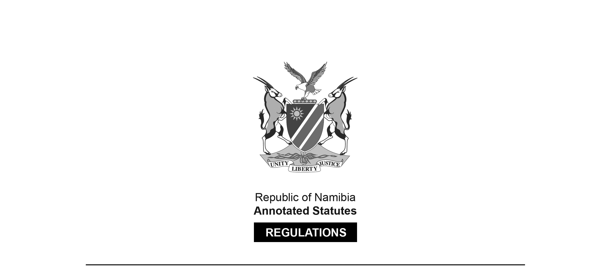
REGULATIONS MADE IN TERMS OF

Allied Health Professions Act 7 of 2004
section 55 read with section 19(1)

Regulations relating to the Minimum Requirements of Study
for Registration as Medical Rehabilitation Worker
Government Notice 152 of 2008
(GG 4068)
came into force on date of publication: 18 June 2008

The Government Notice which publishes these regulations notes that they were made
on the recommendation of the Interim Allied Health Professions Council of Namibia.

ARRANGEMENT OF REGULATIONS

1. Definitions
2. Minimum requirements of study for registration as a medical rehabilitation worker

Definitions

1. In these regulations, unless the context otherwise indicates, a word or expression defined in the Act has that meaning, and -

“the Act” means the Allied Health Professions Act, 2004 (Act No. 7 of 2004).

Minimum requirements of study for registration as a medical rehabilitation worker

2. The minimum requirements referred to in section 19(1) of the Act, insofar as such minimum requirements apply to the registration of any person as a medical rehabilitation worker, are a certificate in medical rehabilitation obtained at an educational institution after the full time study for a period of not less than two years at such educational institution, which study for such diploma must include -

Subject Minimum hours Minimum hours
theoretical training practical training

Introduction to Primary Health
Care, including Health and
Development; the Concept of
Primary Health Care; the
Implementation of Primary Health
Care in Namibia; the History of
Health Care in Namibia; Community
Health Assessment; and Integrated
Health Care: 35 35

Health Education, including
Health information, education,
communication and motivation;
Educational Techniques and
Materials; Training Skills; and
Conducting of Health Education: 40 10

Sociology, including the relevance
of Sociology in Health and Health
Care Delivery; Concepts of
Sociology; Culture, Health and
Illness; Human Development and
Crisis Points; Sociology of Normal
and Deviant Behaviour; Sociology
of the Family and Community: 40 8

First Aid, including Managing of
External Bleeding; Managing of
Wounds, including Burns;
Treatment of Shock; Managing of
Fractures; Resuscitation Techniques;
Managing of Unconscious Persons;
Managing of Poisoning in Persons;
Handling and Transportation of
Injured Persons; Managing
Emergency Deliveries: 10 30

Management, including the
Introduction to Management;
Planning of Health Care Activities
and Resources; Organising Health
Care Activities and Resources;
Leadership and Supervisory Skills
in Health Care; Controlling of
Resources in Health Care;
Monitoring and Evaluation of
Health Care Activities in the
Hospital, Health Centre, Clinic
and Community; The Prosthetic and
Orthotic Supply System: 30 30

Research Methods relating to Medical
Rehabilitation Workers, including
Managing of Existing Data, including
the collection compilation, analyses,
interpretation and use of Data: 25 25

Food and Nutrition relating to
Medical Rehabilitation: 25 25

Basic Medical Sciences relating to
Medical Rehabilitation: 113 27

Community Based Rehabilitation
(Medical Rehabilitation): 157 131

Psychology and Counselling relating
to Medical Rehabilitation: 40 40

Respiratory Disorders and Appropriate
Interventions: 35 65

Communication Disorders and
Interventions for Children: 90 30

Child Development: 141 259

Basic Rehabilitation Skills
and Directed Techniques: 193 217

Visual Disorders and the Training of
People with Visual Disabilities: 80 31

Strange Behaviour in People and
Appropriate Intervention: 65 35

Neuromuscular Disorders and
Interventions: 189 81

Orthopaedic Disorders and Burns,
and Appropriate Interventions: 141 59

