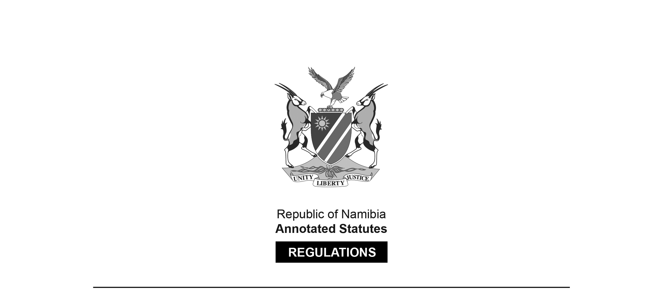
REGULATIONS MADE IN TERMS OF

Allied Health Profession Act 7 of 2004
section 55 read with section 19(1)

Regulations relating to the Minimum Requirements for Registration as Medical Technologist
Government Notice 36 of 2007
(GG 3795)
came into force on date of publication: 22 February 2007

The Government Notice which publishes these regulations notes that they were made on the recommendation of the Interim Allied Health Professions Council of Namibia. It withdraws the rules published in RSA GN R.2304/1976 (RSA GG 5349). These previous rules were made in terms of the RSA Medical, Dental and Supplementary Health Service Professions Act 56 of 1974. They survived in terms of section 50(2) of the Allied Health Services Professions Act 20 of 1993 (GG 710) and section 62(2) of its successor, the Allied Health Professions Act 7 of 2004 (GG 3247).

The word “Technologist” is misspelt in the heading of GN 36/2007;
the spelling has been corrected here.

ARRANGEMENT OF REGULATIONS

1. Minimum requirements for registration as a medical technologist

Minimum requirements for registration as a medical technologist

1. (1) The minimum requirement referred to in section 19(1) of the Allied Health Professions Act, 2004 (Act No. 7 of 2004), which entitles a person to be registered as a medical technologist in terms of the Act is a degree in medical technology or a diploma in medical technology obtained at an educational institution after the full time study of medical technology for a period of not less than three years at such educational institution.

(2) The study for a degree or degree diploma referred to in subregulation (1) must include -

(a) not less than 190 hours of tuition in anatomy and physiology;

(b) not less than 95 hours tuition in chemistry;

(c) not less than 95 hours tuition in physics;

(d) not less than 95 hours of tuition in calculation and statistics;

(e) not less than 120 hours of tuition in the introduction to medical technology;

(f) not less than 95 hours of tuition in biochemistry;

(g) not less than 95 hours of tuition in immunology;

(h) not less than 60 hours of tuition in pathophysiology;

(i) not less than 285 hours of tuition in microbiology;

(j) not less than 285 hours of tuition in chemical pathology;

(k) not less than 250 hours of tuition in cellular pathology;

(l) not less than 95 hours of tuition in blood transfusion technology;

(m) not less than 190 hours of tuition in haematology; and

(n) not less than twelve months experimental training in laboratory practice covering the disciplines of microbiology, chemical pathology, haematology (including blood transfusion), serology and cellular pathology.

